Original Research Article

Mapping Chamber Bias and Microanatomical Niches in Human Ventricular Development

Abstract
A chamber-, time-, and niche-aware spatial transcriptomic analysis of human ventricular development spanning 13 to15 post-conception weeks (PCW) was performed. Using the Farah et al. atlas as a scaffold, we reproduced major cardiac lineages and applied pseudobulk differential expression with false discovery rate (FDR) control, cross-checked against single-cell contrasts, to quantify left–right asymmetry and temporal change. At 13 PCW, left ventricle (LV)-biased programs contrasted with right ventricle (RV)-biased signatures, indicating broad chamber-specific regulation rather than isolated outliers. Across 13 to 15 PCW, maturation was dominated by global consolidation with selective increases and decreases. Spatial neighborhood metrics—including cell–cell enrichment, nearest-neighbor distances, and cardiomyocyte-centric partner profiles—mapped coherent niches linking trabecular cardiomyocytes with endocardium and compact cardiomyocytes with fibroblast/pericyte compartments, and separated conduction and non-canonical cardiomyocyte (CM) classes into distinct microenvironments. Together, these results connect chamber-biased and temporal gene programs to reproducible tissue neighborhoods during ventricular maturation, yielding a quantitative framework and machine-readable outputs for mechanistic studies of human cardiac development.
Keywords: Cardiac Microenvironment, Chamber-Specific Regulation, Gene Expression Dynamics, Spatial Transcriptomics, Ventricular Development

Introduction
Cardiac morphogenesis depends on the coordinated emergence of chamber identity and tissue-specific maturation programs. During mid-gestation, left and right ventricles diversify in structure and function while conductive elements and stromal compartments consolidate (Bruneau, 2013, Pervolaraki et al., 2017), setting the stage for postnatal physiology. Despite extensive single-cell atlases, we still lack an integrated, chamber-aware and time-aware account that situates transcriptional programs within their in situ neighborhoods during the critical 13 to 15 post-conception week (PCW) window—precisely when human ventricular architecture and lineage contributions are being specified (Farah et al., 2024). Filling this gap is essential for connecting gene programs to the microenvironments that shape ventricular development and, ultimately, congenital heart disease risk.
Spatial transcriptomics now enables joint readout of cell states and their physical coordinates, allowing quantitative tests of whether particular programs arise within specific tissue niches. Beyond cataloging cell types, spatial analysis links myocardial subtypes to nearby endocardium, perivascular, and stromal partners through statistics such as neighborhood enrichment, co-occurrence, and nearest-neighbor distances. These tools convert static maps into testable hypotheses about paracrine signaling, extracellular matrix dynamics, and conduction system patterning that are invisible to dissociated RNA-seq alone (Moses & Pachter, 2022; Williams et al., 2022). Method frameworks like Squidpy (Palla et al., 2022) implement these statistics on annotated spatial graphs, making it practical to quantify cellular proximities and enriched interactions.
We leverage a recent developmental human heart atlas spanning ~13 to 15 PCW that resolves ventricular cardiomyocyte subpopulations (compact, trabecular, proliferative/conduction-adjacent) together with endothelial, endocardial, fibroblast/mesenchymal, epicardial-derived, immune, and neural lineages at cellular resolution (Farah et al., 2024). Its stage coverage, curated annotations, and spatial coordinates make it uniquely suited to interrogate chamber asymmetry and temporal maturation while explicitly tying transcriptional differences to microanatomical context.
In this study, we quantify LV to RV transcriptional asymmetry at 13 PCW, chart how ventricular programs shift by 15 PCW, and test whether these changes align with reproducible cellular neighborhoods. We apply a pseudobulk differential-expression framework with multiple-testing control for chamber and temporal contrasts, then couple results to spatial neighbor-enrichment and nearest-neighbor distance analyses with clustering to identify recurring niches. We find robust LV to RV asymmetry at 13 PCW, a 13 to 15 PCW consolidation characterized by a focused set of up-signals, and stable cardiomyocyte partnerships with endocardial, perivascular, and stromal lineages that contextualize these programs in situ. Together, this chamber-, time-, and niche-aware analysis provides a scaffold for mechanistic studies of human ventricular maturation.

Methods

Data access and formats
We used the publicly developed human heart atlas from Farah et al. in AnnData (H5AD) format. Two objects were read: a whole-heart dataset at 13 post-conception weeks (PCW) (overall_merfish.h5ad) and a ventricle-focused dataset at 15 PCW (ventricle_15PCW_merfish.h5ad). Reads were performed with Scanpy (sc.read_h5ad). The 13 PCW object contained per-cell spatial coordinates in obsm['spatial'] and categorical annotations in obs (e.g., populations, communities, subpopulations, sample_id, QC-style fields such as complexity and purity).

Reproduction/validation of source embeddings and labels
To validate successful ingestion and labeling, we reproduced spatial scatterplots and UMAPs, colored by populations, communities, leiden, and sample_id, and generated per-sample spatial maps for populations, communities, complexity, and purity. These visual checks confirmed concordance with the published atlas manifold and classes. Figures were generated using sc.pl.embedding and sc.pl.umap.

Ventricular subset definition and chamber assignment
For 13 PCW, ventricular cells were subset by restricting obs['communities'] to ['Outer-LV','Inner-LV','Outer-RV','Inner-RV','VCS']. A helper mapped text tokens in population/subpopulation names to chamber labels LV, RV, IVS, or Other. For 15 PCW, chambers were derived from subpopulations. These assignments were stored in obs['chamber']. Timepoint labels (13PCW, 15PCW) were added to obs['timepoint'].

Differential expression (DE): two complementary implementations

(A) Pseudobulk-based DE (primary)
We performed random-cell pseudobulking within biological groups (LV vs RV; 13 PCW vs 15 PCW). For each group, the code creates a specified number of pseudobulks by sampling fixed numbers of cells (defaults: 20 bulks × 500 cells for LV/RV; 15 bulks × 300 cells for temporal), sums raw counts per gene within each bulk, and returns a pseudobulk expression matrix with a matching metadata frame (group, replicate).
For each contrast, we computed log2 fold-change (FC) of group means with a pseudocount of 1 to stabilize division and performed a Wilcoxon rank-sum test (SciPy) across pseudobulks. P values were corrected by Benjamini–Hochberg FDR; significance was defined at adjusted p < 0.05. The function returns a table with per-gene means in each group, log2FC, raw p, and FDR (padj). The same pipeline was used for overall temporal and chamber-stratified temporal comparisons.
Outputs include MA plots, volcano plots, clustered heatmaps for top DE genes, and CSVs of all results (e.g., DE_pseudobulk_13PCW_LV_vs_RV.csv, DE_pseudobulk_temporal_overall.csv, and DE_pseudobulk_temporal_{LV,RV}.csv).

(B) Single-cell DE (cross-check)
As a confirmatory analysis, we also ran single-cell DE using scanpy.tl.rank_genes_groups (Wilcoxon) for LV vs RV at 13 PCW and 15 PCW, and for 15 PCW vs 13 PCW overall and per chamber, retaining genes with pvals_adj < 0.05 and ranking by logfoldchanges. Volcano plots and CSV summaries were produced for these runs.

Gene-set summarization and categorical tallies
Significant pseudobulk DE tables were further summarized into magnitude categories by |log2FC| (Weak if less than 0.5; Moderate if 0.5 to 1; Strong if 1 to 1.5; Very Strong if larger than 1.5) and significance bins based on negative log10(padj) (p < 0.01; p < 1e−5; p < 1e−10; deepest bin). Direction was defined by the sign of log2FC (LV > RV or 15 PCW > 13 PCW as “Up”). These tallies generated stacked bar graphs used in the results figures.

Spatial neighbor enrichment and distance analyses
To contextualize DE signals, we quantified spatial co-occurrence between labeled cell populations. For each cell, the 10 nearest neighbors within a 50 µm radius were queried using a KD-tree on obsm['spatial']. We formed (source to neighbor) co-occurrence counts, converted them to row-normalized proportions, and computed enrichment as observed proportion divided by an expected proportion estimated from the global neighbor pool. The enrichment matrix (Observed/Expected) was symmetrized for visualization, transformed to a dissimilarity (1/(enrichment+0.1)), and hierarchically clustered to reveal co-localization communities. The top enriched and depleted pairs, as well as the entire matrix, were saved as PNG and CSV files.
Pairwise nearest-neighbor distance distributions were computed for biologically motivated pairs (e.g., Trabecular CM to Endocardial, Compact CM to Fibroblast, VIC to VEC, BEC to Pericyte), reporting n, median, quartiles, and means; histograms and a summary CSV were saved. A focused “cardiomyocyte neighborhood” panel was extracted, per CM subtype, to identify the top five enriched neighbors (bar plots with enrichment and a reference line at 1×).

Visualization and reporting
Plots include: per-sample spatial maps and UMAPs; LV vs. RV and temporal MA/volcano plots; clustered heatmaps of top DE genes; stacked bar graphs by effect size and significance bins; co-localization enrichment heatmaps with hierarchical clustering; pairwise distance histograms; and CM-centric neighbor bar charts. All figures and machine-readable CSVs are written to disk with descriptive filenames to support full reproducibility.

Results

Data validation
To validate data integrity before new analyses, we reconstituted the core embeddings from the developing human heart atlas of Farah and colleagues. Our reproduced spatial/UMAP views mirror the published manifold structure and major classes—ventricular cardiomyocytes (compact, trabecular, proliferative), fibroblast/mesenchymal populations, endocardial/vascular endothelium including lymphatic EC (LEC), epicardial-derived cells (EPDC), immune lineages, and neuronal cells—confirming that our data fetch and label transfer faithfully reflect the original resource (Figs. 1 and 2). This concordance establishes a reliable foundation for downstream comparisons.
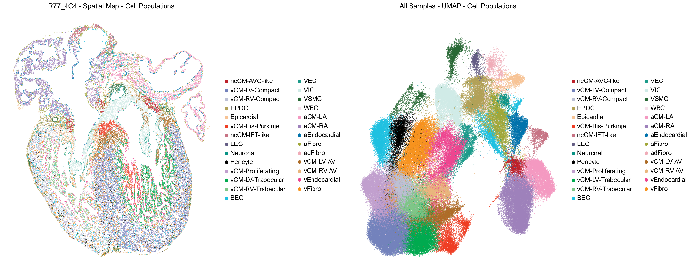
Fig. 1. Spatial/UMAP concordance with the source atlas. Side-by-side spatial maps and UMAP embeddings reproduced from the Farah et al. developing human heart atlas show that our imported coordinates, cell labels, and overall manifold structure match the published resource, confirming correct data access and preprocessing.
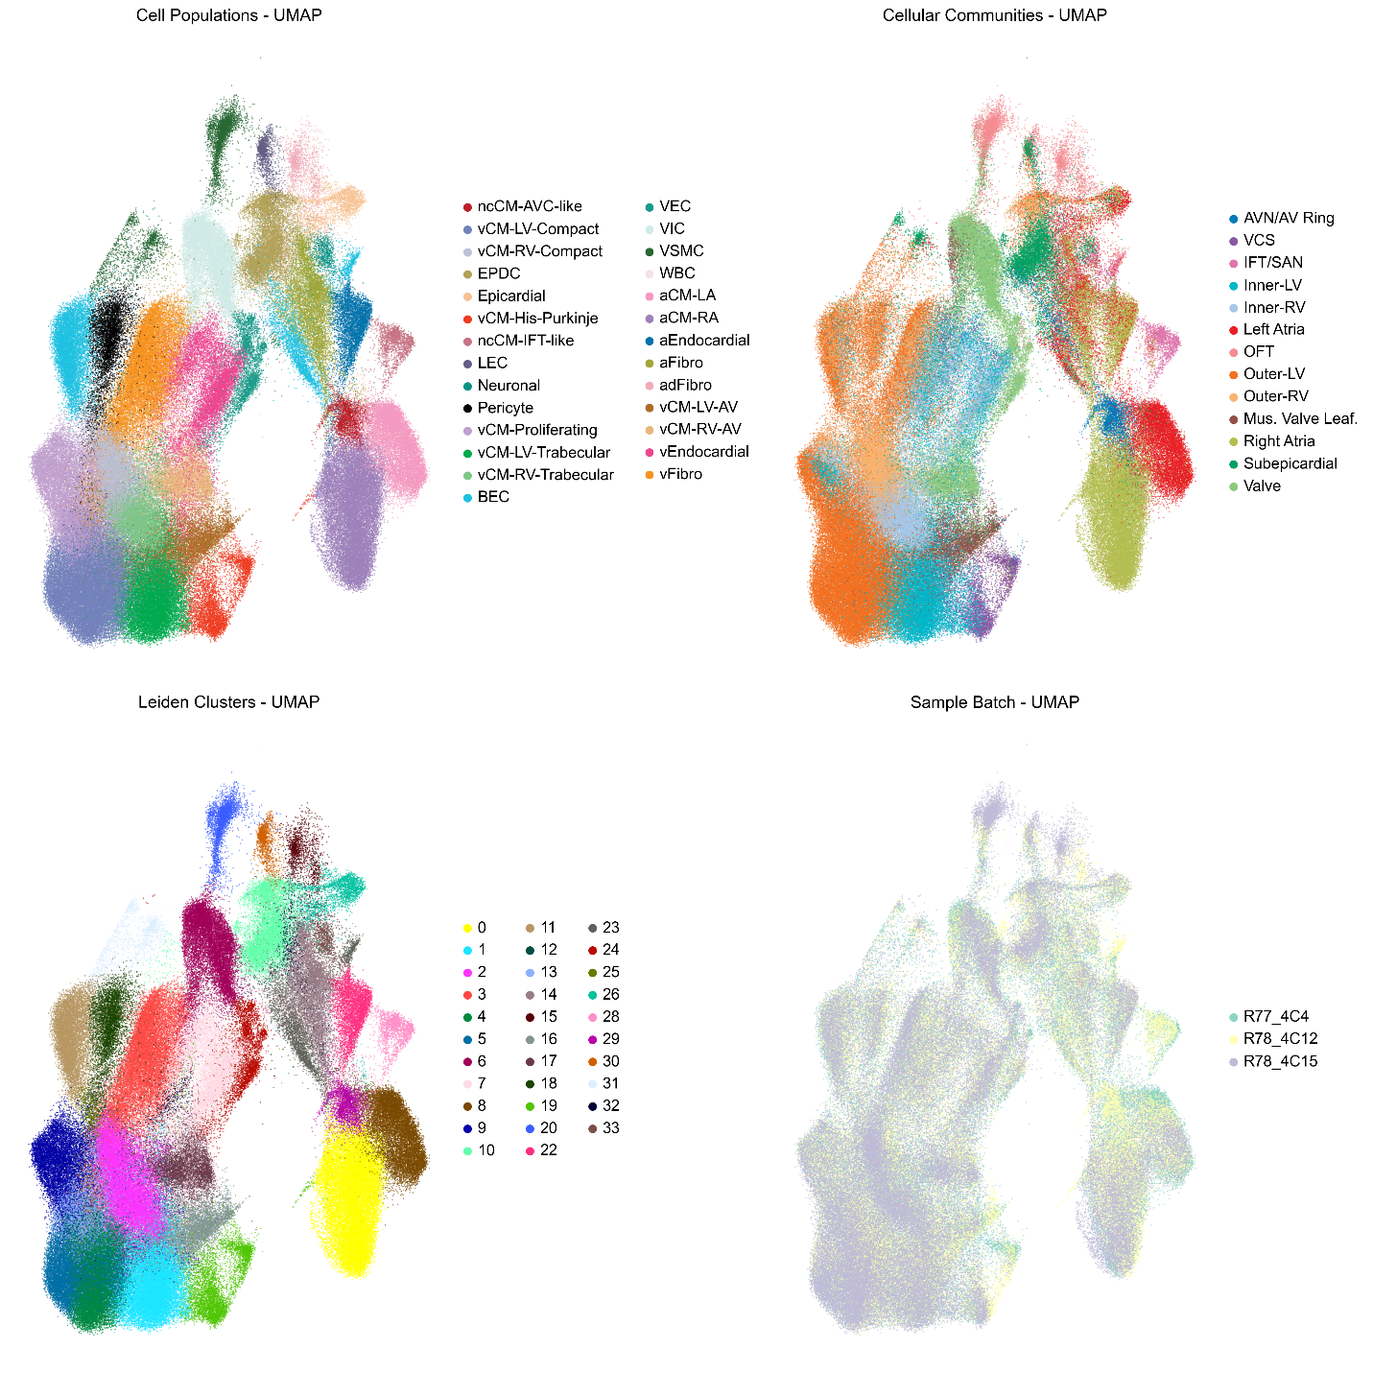
Fig. 2. Global UMAP of major cardiac classes. The harmonized UMAP recapitulates the atlas’ separation of ventricular cardiomyocytes (compact, trabecular, proliferative), fibroblast/mesenchymal, endocardial/vascular endothelium including LEC, EPDC, immune, and neuronal populations, demonstrating fidelity of our data import and label transfer.

Differential expression analysis
With validation in place, we contrasted ventricles at 13 PCW. The LV vs RV MA plot shows a broad distribution of differentially expressed genes spanning the full mean-expression range, indicating a pervasive chamber effect rather than one confined to low- or high-abundance features (Fig. 3). The summary bar graph confirms that RV greater than LV (Down) genes outnumber LV>RV (Up) genes in this contrast, consistent with the overall left–right imbalance observed in the MA distribution (Fig. 4). Together, Figs. 3 and 4 establish that chamber bias at 13 PCW is widespread and directionally skewed toward RV enrichment, while remaining agnostic about individual markers beyond those labeled in the panels. We next examined developmental change between 13 PCW and 15 PCW. The temporal MA plot shows that differentially expressed points span the full mean-expression axis yet are visibly skewed toward Down (13 PCW greater than 15 PCW), indicating a widespread reduction at 15 PCW rather than a shift confined to low- or high-abundance transcripts (Fig. 5). The temporal summary bars corroborate this pattern: Down counts dominate, with only a small Up (15 PCW greater 13 PCW) component, and this imbalance is consistent across the panels shown (Fig. 6). To make these contrasts directly comparable, Figure 7 reports gene counts on the y-axis by direction on the x-axis (Down = RV>LV or 13PCW>15PCW; Up = LV>RV or 15PCW>13PCW) using two criteria for each comparison: magnitude bins (weak, moderate, strong, very strong) and statistical bins (p<0.01, p<1e-5, p<1e-10, deepest bin). In LV–RV, Down (RV>LV) exceeds Up (LV>RV), with most effects weak-to-moderate but a large fraction extremely significant; in the temporal contrast, Down (13PCW>15PCW) overwhelmingly dominates, and many decreases are both very strong in magnitude and highly significant, whereas Up counts are sparse.
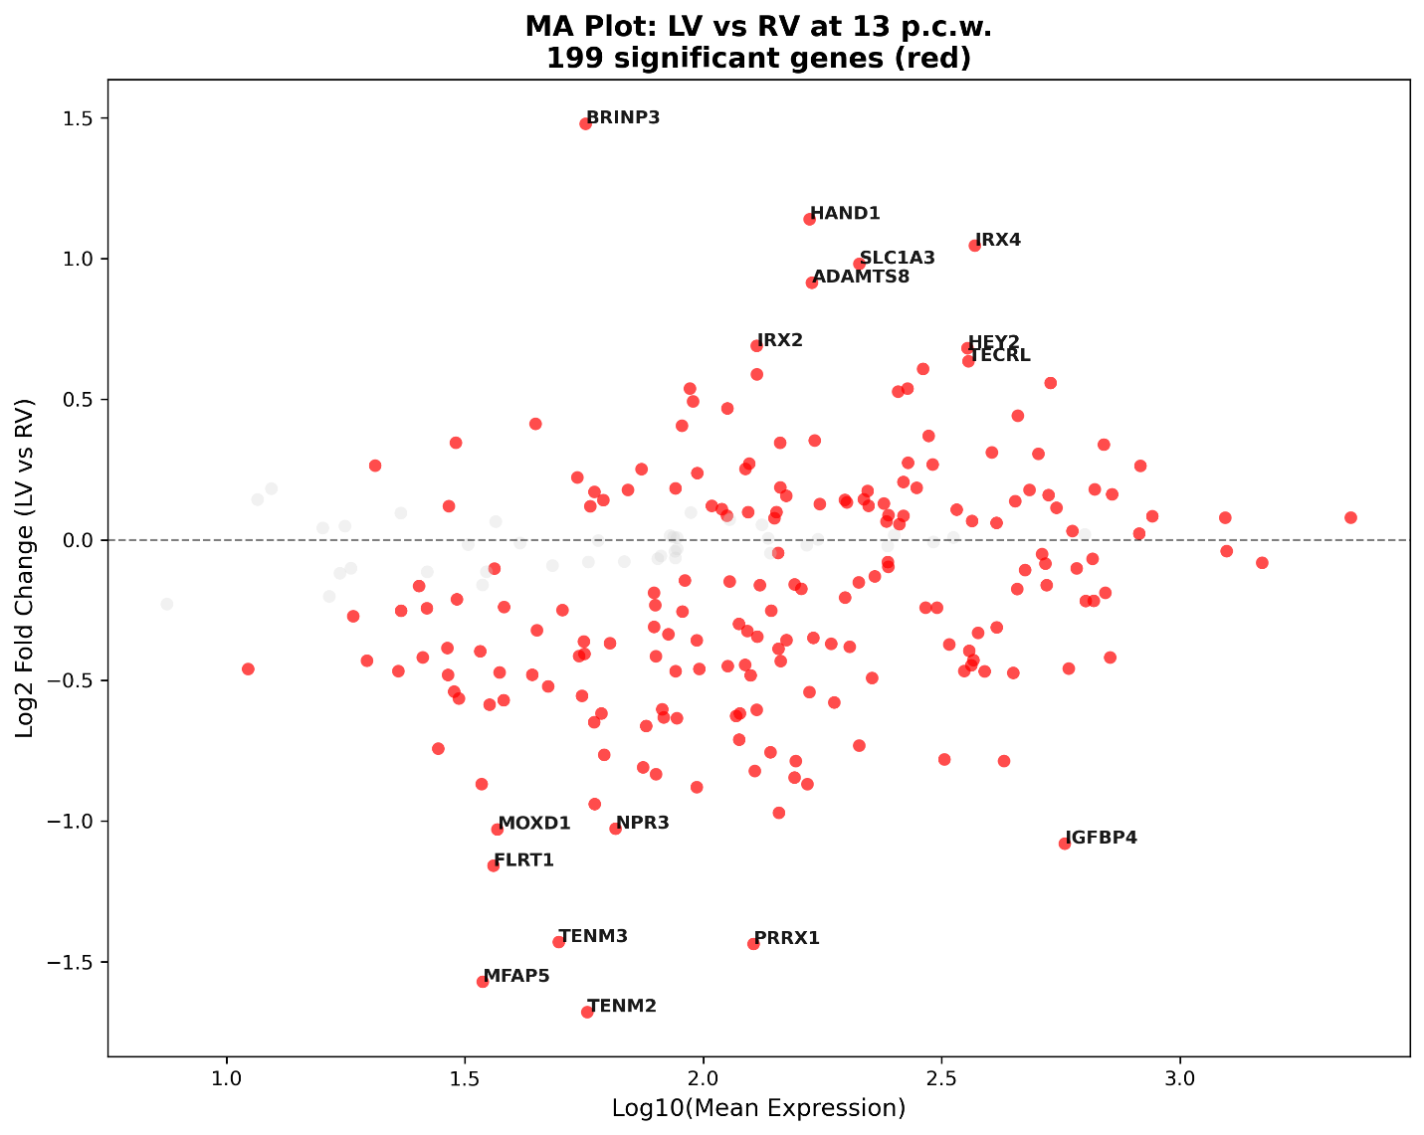
Fig. 3. LV vs RV at 13 PCW—MA plot. MA plot of the LV vs RV contrast at 13 PCW. Points are colored by significance; the cloud spans a broad mean-expression range. The visible skew toward Down (RV>LV) demonstrates a pervasive chamber bias without confinement to a specific expression regime.
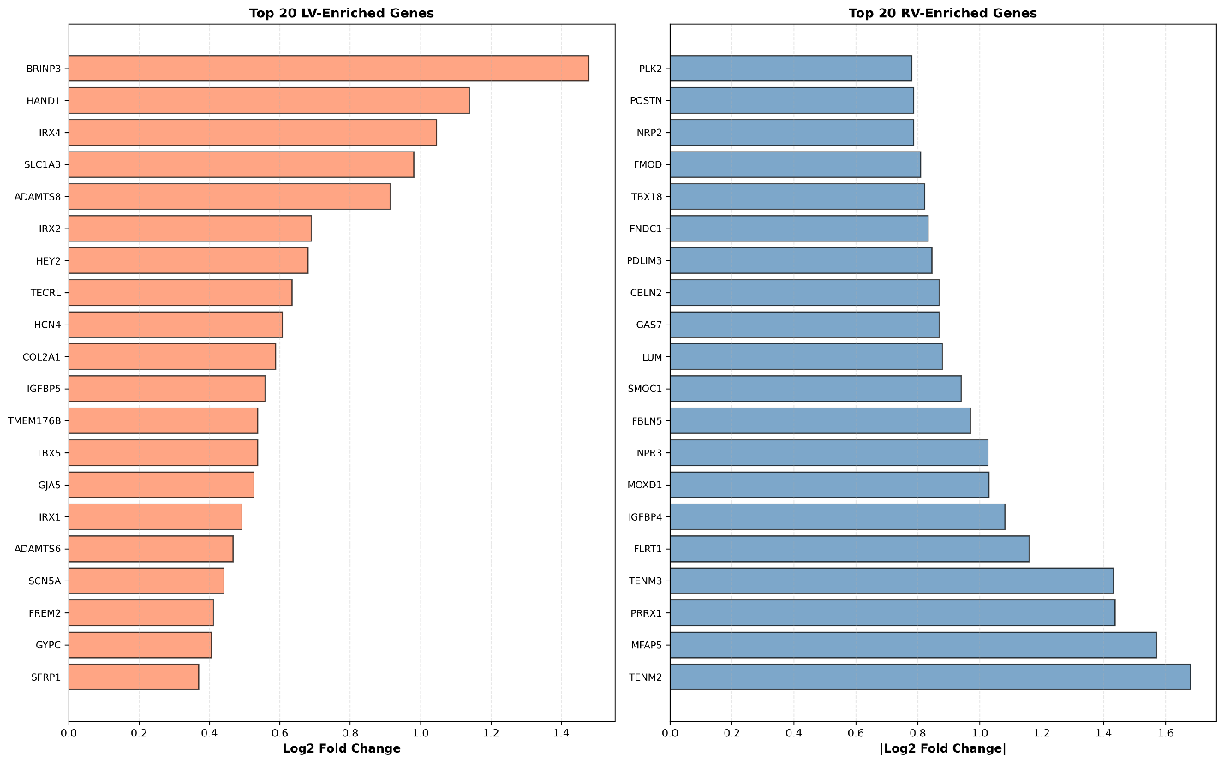
Fig. 4. LV vs RV at 13 PCW—summary counts. Bar graph summarizing the number of Up (LV>RV) and Down (RV>LV) genes passing the differential-expression threshold(s). The Down bar is higher than Up, confirming the RV-leaning imbalance seen in the MA plot.
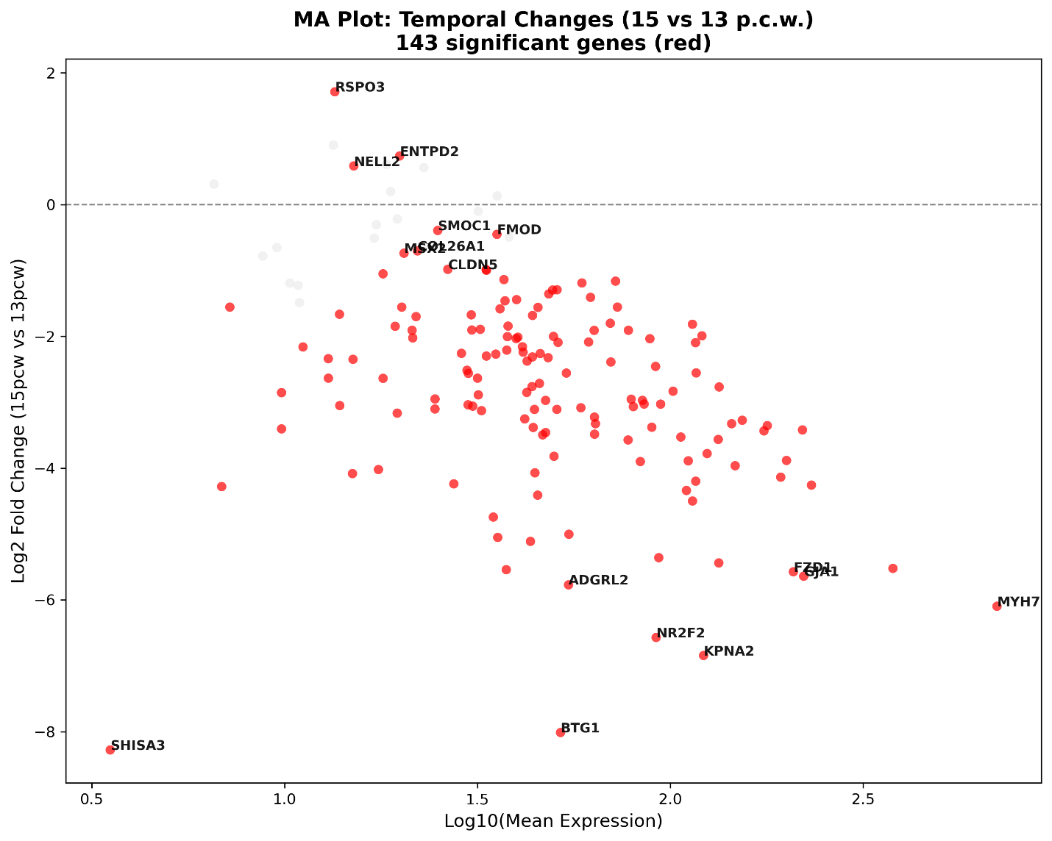
Fig. 5. Temporal (13 to 15 PCW)—MA plot. MA plot for the 13 PCW vs 15 PCW contrast. Points are colored by significance. The distribution spans a broad mean-expression range and is skewed toward Down (13 PCW > 15 PCW), indicating a pervasive decrease at 15 PCW.
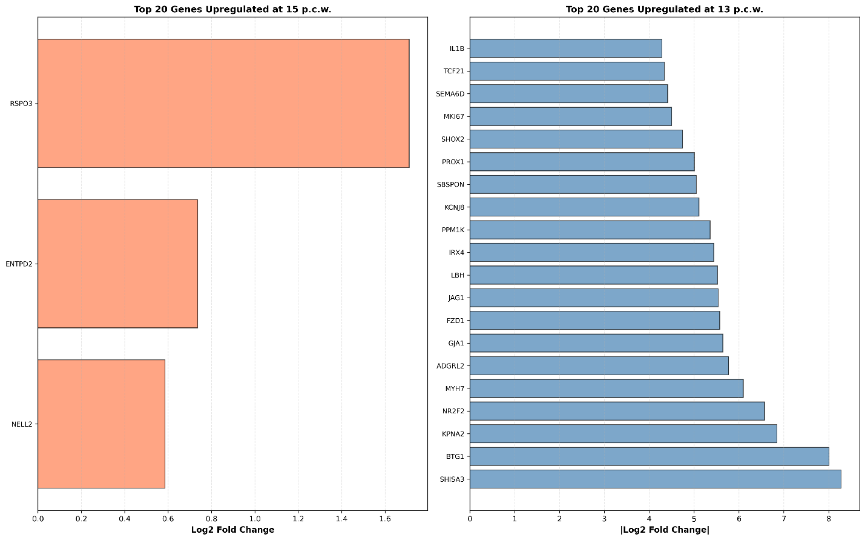
Fig. 6. Temporal (13 to 15 PCW)—summary counts. Bar graph summarizing Up (15 PCW > 13 PCW) and Down (13 PCW > 15 PCW) differential-expression counts. Down substantially exceeds Up, mirroring the imbalance visible in the MA plot.
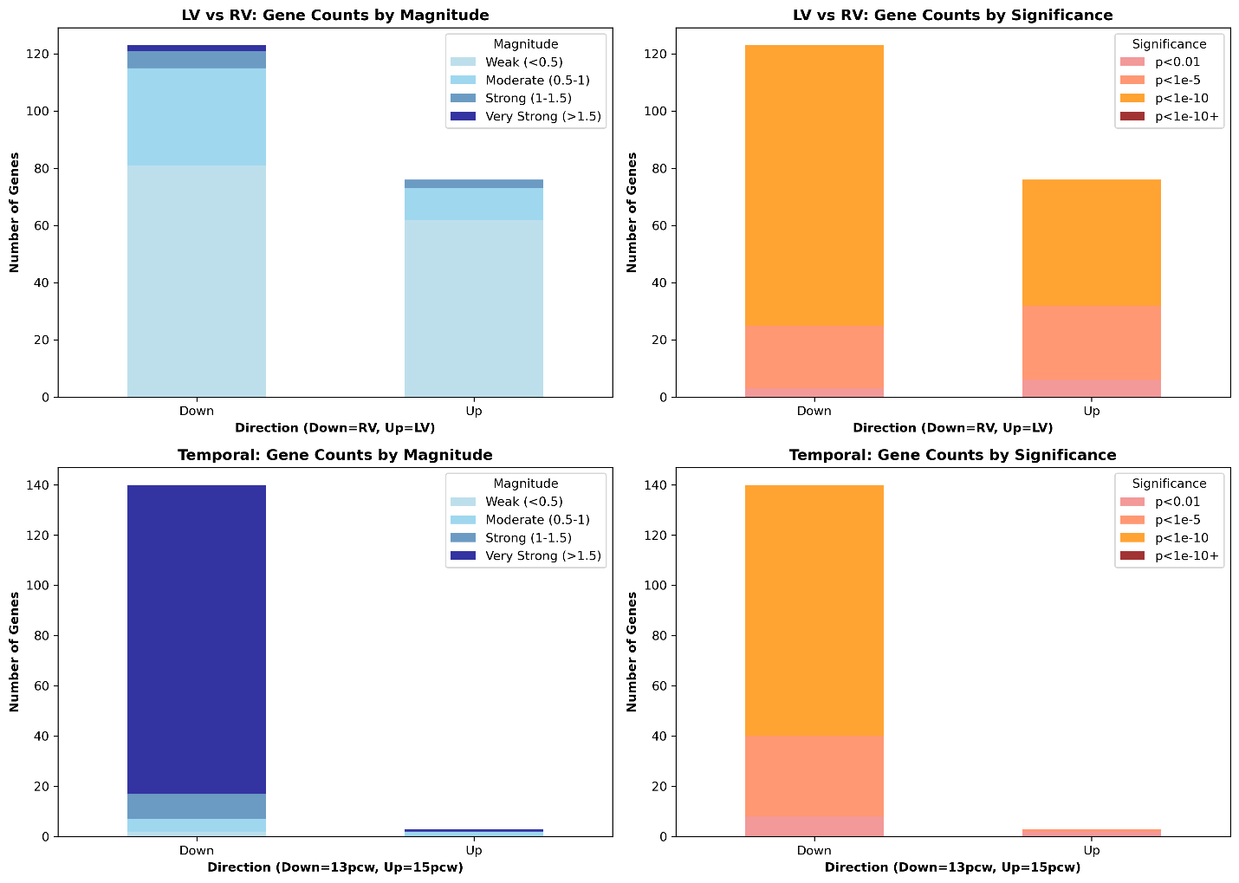
Fig. 7. Differential‐expression summary by direction, effect‐size magnitude, and statistical significance. LV vs RV: counts of up- and down-regulated genes stratified by absolute log₂-fold-change magnitude (Weak <0.5, Moderate 0.5 to 1, Strong 1 to 1.5, Very Strong >1.5). LV vs RV: counts stratified by significance (p<0.01, p<1e⁻⁵, p<1e-10, p<1e⁻¹⁰⁺). Temporal (13 PCW vs 15 PCW): magnitude-stratified counts as in A (Down = higher at 13 PCW; Up = higher at 15 PCW). Temporal: significance-stratified counts as in B. Bars show total genes per direction with stacked bins indicating category composition.

Spatial expression analysis
Finally, spatial analyses place these transcriptional differences in microanatomical context: the co-localization heatmap shows vCM-Trabecular, vEndocardial, vCM-Compact, vFibro/Pericyte, valve (VIC/VEC) clustering, a stromal/lymphatic axis (LEC–adFibro–EPDC), and ncCM-IFT-like to Neuronal (Fig. 8). Nearest-neighbor distances are shortest for Compact CM ~ Fibroblast, Atrial CM ~ Fibroblast, Myocardium Vascularization, and Trabecular CM ~ Endocardial, and broader for Valve: Interstitial ~ Endothelial and Epicardial Development (Fig. 9). Cardiomyocyte neighborhood enrichment mirrors this: vCM-LV-Compact favors vCM-Proliferating/Pericyte/vFibro/BEC; vCM-RV-Compact favors Pericyte/vFibro/BEC (plus vCM-RV-Trabecular); vCM-His-Purkinje aligns with vEndocardial; ncCM-IFT-like with Neuronal; and ncCM-AVC-like with aFibro (Fig. 10).

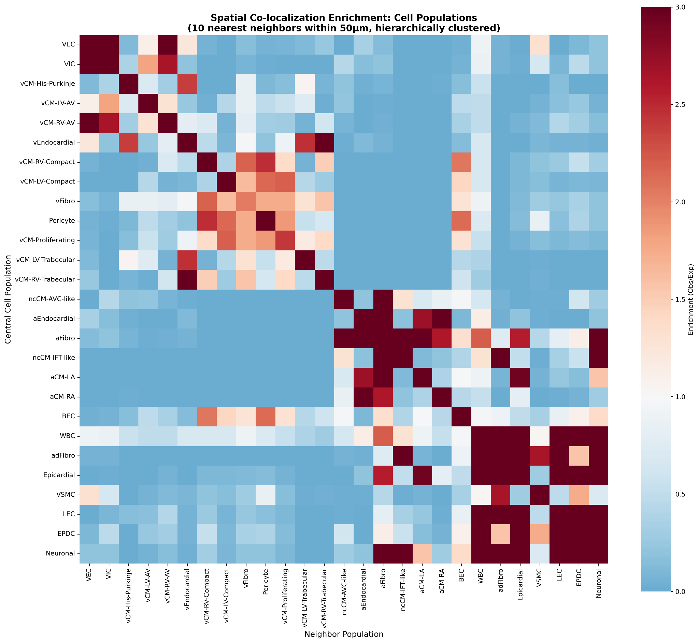Fig. 8. Spatial co-localization enrichment (Observed/Expected). Heatmap of pairwise enrichment among labeled populations. Ventricular patterns include vCM-Trabecular ↔ vEndocardial and vCM-Compact ↔ vFibro/Pericyte; valve populations (VIC, VEC) co-cluster; a stromal/lymphatic axis involves LEC, adFibro, EPDC; and ncCM-IFT-like ↔ Neuronal and ncCM-AVC-like ↔ aFibro stand out. Scale denotes Observed/Expected enrichment.

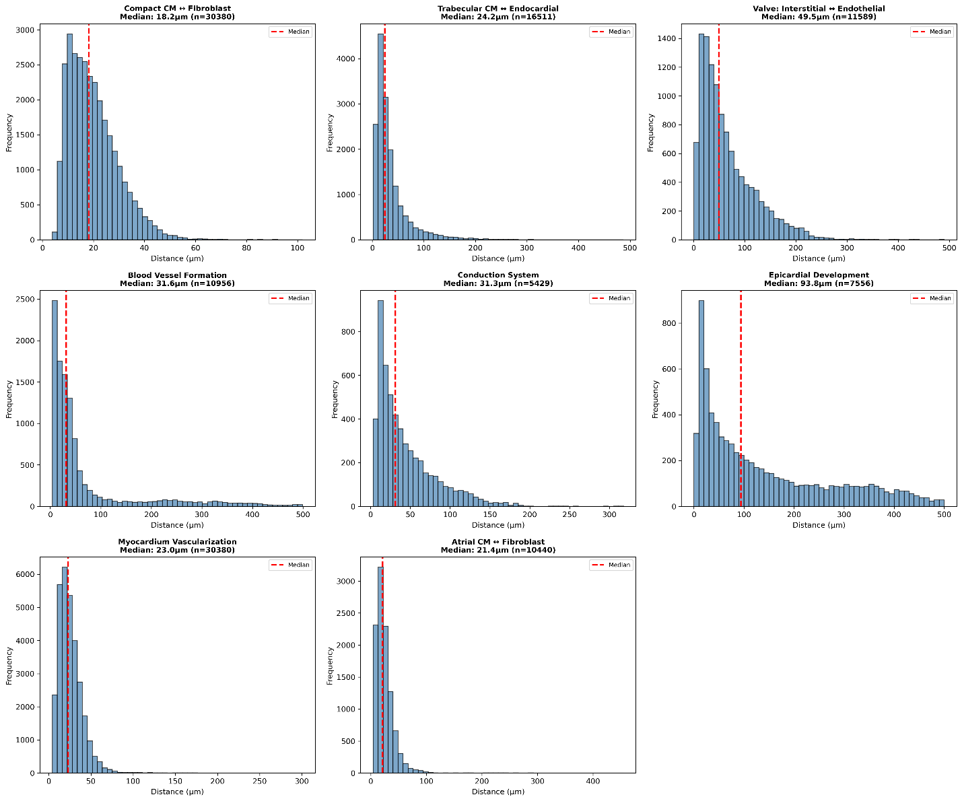
Fig. 9. Nearest-neighbor distance distributions. Histograms with dashed medians for selected pairs show short separations for Compact CM for Fibroblast (approx. 18.2 µm), Atrial CM for Fibroblast (approx. 21.4 µm), Myocardium Vascularization (approx. 23.6 µm), and Trabecular CM for Endocardial (approx. 24.2 µm); intermediate for Blood Vessel Formation (approx. 31.6 µm) and Conduction System (approx. 31.3 µm); broader for Valve: Interstitial for Endothelial (approx. 49.5 µm) and Epicardial Development (approx. 93.8 µm).
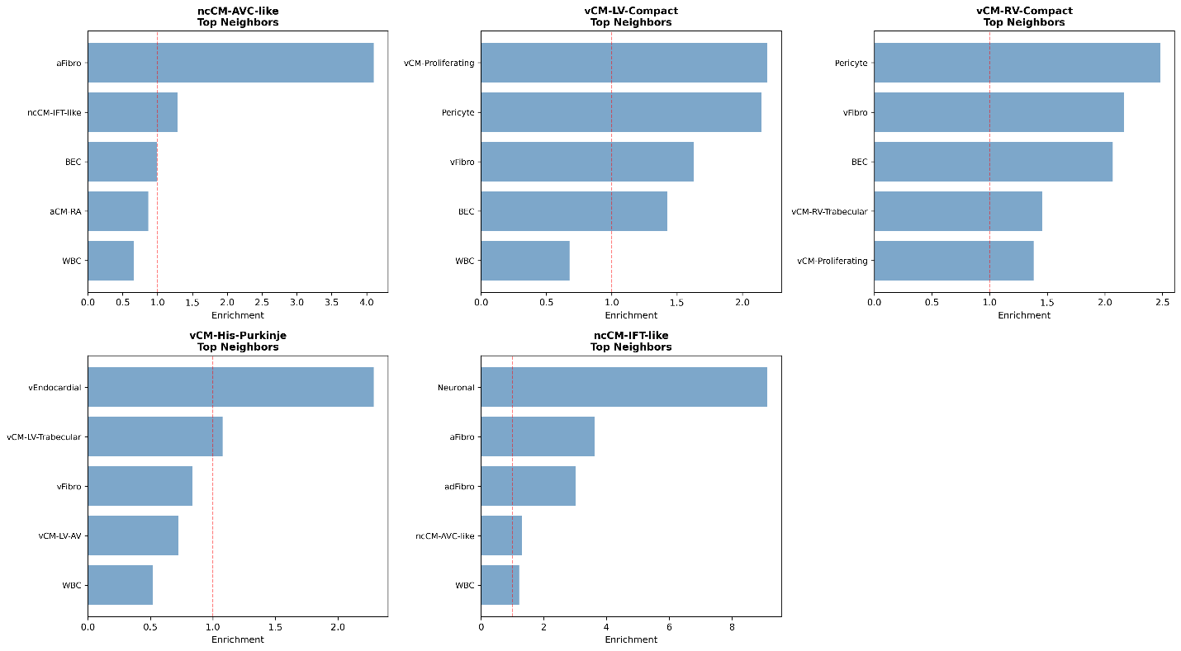
Fig. 10. Cardiomyocyte subtype top neighbors (enrichment). Bars list over-represented neighbors (enrichment > 1 dashed line). vCM-LV-Compact: vCM-Proliferating, Pericyte, vFibro, BEC. vCM-RV-Compact: Pericyte, vFibro, BEC, vCM-RV-Trabecular, vCM-Proliferating. vCM-His-Purkinje: vEndocardial (highest), then vCM-LV-Trabecular, vFibro. ncCM-IFT-like: Neuronal (largest), aFibro, adFibro, ncCM-AVC-like. ncCM-AVC-like: aFibro (largest), with smaller ncCM-IFT-like, BEC, aCM-RA.

Discussion
Our first goal was to ensure that downstream inferences rest on a faithful reconstruction of the published atlas. The side-by-side spatial/UMAP views and the global class map confirm that our imported coordinates and labels reproduce the source manifold and major cardiac classes, providing a solid scaffold for interpretation (Figs. 1 and 2).
Against this validated backdrop, the LV to RV comparison at 13 PCW shows broad, directionally consistent differences rather than a handful of outliers (Figs. 3 and 4). In the LV-enriched set (Up), the figure highlights BRINP3, HAND1, IRX4, SLC1A3, ADAMTS8, HEY2, IRX2, TECRL; in the RV-enriched set (Down), it highlights TENM2, MFAP5, TENM3, PRRX1, IGFBP4, FLR1, NPR3, MOXD1. Notably among LV-Up: HAND1 (LV/chamber specification) (McFadden et al., 2005; Vincentz et al., 2019) and IRX4 (ventricular identity) (Nelson et al., 2014) are canonical chamber-patterning factors; HEY2 is a Notch target implicated in ventricular wall maturation/compaction (Miao et al., 2018; Niessen & Karsan, 2008); TECRL is linked to inherited ventricular arrhythmia(Devalla et al., 2016); ADAMTS8 points to ECM/fibrotic remodeling potential (Zha et al., 2022). Among RV-Up: MFAP5 (microfibril-associated) (Cheng et al., 2022)MFAP and IGFBP4/5 family support ECM/secreted-factor milieus (Zhao et al., 2024); PRRX1 marks epicardial-derived/mesenchymal programs (de Bakker et al., 2021); NPR3 encodes the natriuretic peptide clearance receptor (Wong et al., 2015); TENM2/3 encode teneurins (adhesion/axon-guidance–like) (Tucker & Chiquet-Ehrismann, 2006). These gene-level signals reinforce the chamber-biased program at 13 PCW that is evident from the MA skew and the Up/Down summary counts.
Developmental change across the 13→15 PCW window is likewise global in character (Figs. 5–6). The temporal MA plot and bar graph are accompanied by a concise gene panel: RSPO3, NELL2, ENTPD2 are Up at 15 PCW, whereas SHISA3, BTG1, ADGRL2, NR2F2, KPNA2, MYH7, FZD1, GJA1 are Down (13 PCW > 15 PCW). Here RSPO3 is a WNT potentiator with roles in cardiogenesis and vascular/angiogenic development(Cambier et al., 2014; Da Silva et al., 2018; T. Liu et al., 2023), and ENTPD ectonucleotidases tune extracellular nucleotide (purinergic) signaling (Robson et al., 2006); NELL2 is a neuronal/guidance factor often marking neuro-/conduction-adjacent niches(H. R. Kim et al., 2020). Among genes decreasing by 15 PCW: NR2F2 (COUP-TFII) is critical for AV canal/venous programs and congenital heart morphogenesis (Al Turki et al., 2014; Dohn et al., 2019); GJA1 (Connexin-43) underpins ventricular gap-junction coupling (Palatinus et al., 2012, 2012); MYH7 encodes β-myosin heavy chain with developmental isoform dynamics (Gacita et al., 2021); FZD1 is a WNT receptor implicated in cardiac remodeling (Fan et al., 2017); SHISA3 antagonizes WNT (Noack et al., 2019); BTG1 is an antiproliferative regulator consistent with waning proliferation (S. H. Kim et al., 2022); ADGRL2 (LPHN2) is an adhesion GPCR with emerging roles in vascular/endothelial biology (Jakobs et al., 2024). Together, these gene-level shifts match the overall dominance of decreases by 15 PCW and point to maturation-linked consolidation.
When aggregated across contrasts, the direction/effect-size/significance summary clarifies that these are not marginal effects: the tally of significant genes remains imbalanced across Up/Down and is enriched in larger |log₂FC| and stronger significance bins (Fig. 7). The LV–RV genes named in 3–4 and the temporal genes named in 5–6 exemplify the dominant categories driving this imbalance.
Spatial context situates these transcriptional patterns within coherent microenvironments. Co-localization enrichment recovers expected community pairings—vCM-Trabecular with vEndocardial (Grego-Bessa et al., 2007; J. Liu et al., 2010; Luxán et al., 2016); vCM-Compact with vFibro, Pericyte, and BEC (Fang et al., 2016; Quijada et al., 2020; Volz et al., 2015; Winter & Gittenberger-de Groot, 2007); and valve units with VIC/VEC (Combs & Yutzey, 2009; Hinton & Yutzey, 2011)—alongside stromal/lymphatic (Klaourakis et al., 2021; X. Liu & Oliver, 2023) and neuromuscular axes (Fig. 8). Physical separation analyses agree: the shortest inter-type distances occur for CM–endocardial (Samsa et al., 2015) and CM–mesenchymal pairings (Quijada et al., 2020; Winter & Gittenberger-de Groot, 2007), whereas valve and epicardial lineages are more distant (Fig. 9). Cardiomyocyte neighborhood enrichment then localizes these partnerships to specific CM subtypes—LV-Compact with vCM-Proliferating/Pericyte/vFibro/BEC; RV-Compact with Pericyte/vFibro/BEC (often alongside RV-Trabecular); His–Purkinje with vEndocardial (Choquet et al., 2021); ncCM-IFT-like with Neuronal; and ncCM-AVC-like with aFibro—mapping conduction and non-canonical CM classes to distinct, repeating microenvironments (Fig. 10). While the spatial figures do not label genes directly, the LV–RV and temporal gene sets above (e.g., HAND1/IRX4/HEY2/TECRL; RSPO3/ENTPD2/GJA1/MYH7/NR2F2) provide plausible molecular readouts embedded in these neighborhoods.

Conclusion
Our chamber-, time-, and niche-aware spatial transcriptomic analysis of human ventricular development between 13 to 15 post-conception weeks establishes a high-resolution framework linking molecular programs to tissue architecture. By integrating pseudobulk differential expression with single-cell validation, we reveal broad chamber-specific transcriptional programs, with left ventricular–biased signatures at 13 PCW contrasting with right ventricular–biased patterns, highlighting intrinsic molecular asymmetry. Temporal dynamics show dominant global consolidation accompanied by selective gene modulation, reflecting coordinated maturation alongside compartment-specific specialization.
Spatial neighborhood analysis further uncovers reproducible microenvironments, connecting trabecular cardiomyocytes with endocardium and compact cardiomyocytes with fibroblast and pericyte niches. In contrast, conduction and non-canonical cardiomyocyte populations occupy distinct spatial domains. These findings demonstrate that transcriptional programs and cellular neighborhoods are tightly interwoven during ventricular maturation, providing mechanistic insight into human cardiac morphogenesis.
This study demonstrates a quantitative, machine-readable resource that links chamber-biased and temporal gene expression to structured tissue organization, offering a scalable platform for mechanistic investigations into cardiac development, congenital heart disease, and regenerative strategies. By integrating spatial and temporal dimensions, our work underscores the critical importance of context-aware analyses in elucidating human heart development.

Disclaimer (Artificial intelligence)
Author(s) hereby declare that NO generative AI technologies such as Large Language Models (ChatGPT, COPILOT, etc.) and text-to-image generators have been used during the writing or editing of this manuscript.

Reference
- Bruneau, B. G. (2013). Signaling and transcriptional networks in heart development and regeneration. Cold Spring Harbor Perspectives in Biology, 5(3), a008292. https://doi.org/10.1101/cshperspect.a008292
- Farah, E. N., Hu, R. K., Kern, C., Zhang, Q., Lu, T.-Y., Ma, Q., Tran, S., Zhang, B., Carlin, D., Monell, A., Blair, A. P., Wang, Z., Eschbach, J., Li, B., Destici, E., Ren, B., Evans, S. M., Chen, S., Zhu, Q., & Chi, N. C. (2024). Spatially organized cellular communities form the developing human heart. Nature, 627(8005), 854–864. https://doi.org/10.1038/s41586-024-07171-z
- Moses, L., & Pachter, L. (2022). Museum of spatial transcriptomics. Nature Methods, 19(5), 534–546. https://doi.org/10.1038/s41592-022-01409-2
- Palla, G., Spitzer, H., Klein, M., Fischer, D., Schaar, A. C., Kuemmerle, L. B., Rybakov, S., Ibarra, I. L., Holmberg, O., Virshup, I., Lotfollahi, M., Richter, S., & Theis, F. J. (2022). Squidpy: A scalable framework for spatial omics analysis. Nature Methods, 19(2), 171–178. https://doi.org/10.1038/s41592-021-01358-2
- Williams, C. G., Lee, H. J., Asatsuma, T., Vento-Tormo, R., & Haque, A. (2022). An introduction to spatial transcriptomics for biomedical research. Genome Medicine, 14(1), 68. https://doi.org/10.1186/s13073-022-01075-1
- Al Turki, S., Manickaraj, A. K., Mercer, C. L., Gerety, S. S., Hitz, M.-P., Lindsay, S., D’Alessandro, L. C. A., Swaminathan, G. J., Bentham, J., Arndt, A.-K., Low, J., Breckpot, J., Gewillig, M., Thienpont, B., Abdul-Khaliq, H., Harnack, C., Hoff, K., Kramer, H.-H., Schubert, S., … Hurles, M. E. (2014). Rare Variants in NR2F2 Cause Congenital Heart Defects in Humans. American Journal of Human Genetics, 94(4), 574–585. https://doi.org/10.1016/j.ajhg.2014.03.007
- Cambier, L., Plate, M., Sucov, H. M., & Pashmforoush, M. (2014). Nkx2-5 regulates cardiac growth through modulation of Wnt signaling by R-spondin3. Development (Cambridge, England), 141(15), 2959–2971. https://doi.org/10.1242/dev.103416
- Cheng, B., Zhong, J.-P., Fu, W.-J., Chen, H.-J., Fang, L., Li, G.-L., Li, J.-W., Wen, M.-H., Lv, Y.-B., & Wang, H.-B. (2022). Microfiber-associated protein 5 (MFAP5): A promising approach to discover new biomarkers for heart failure and cardiac remodeling. International Journal of Cardiology, 366, 68–69. https://doi.org/10.1016/j.ijcard.2022.07.008
- Choquet, C., Boulgakoff, L., Kelly, R. G., & Miquerol, L. (2021). New Insights into the Development and Morphogenesis of the Cardiac Purkinje Fiber Network: Linking Architecture and Function. Journal of Cardiovascular Development and Disease, 8(8), 95. https://doi.org/10.3390/jcdd8080095
- Combs, M. D., & Yutzey, K. E. (2009). Heart Valve Development. Circulation Research, 105(5), 408–421. https://doi.org/10.1161/CIRCRESAHA.109.201566
- Da Silva, F., Massa, F., Motamedi, F. J., Vidal, V., Rocha, A. S., Gregoire, E. P., Cai, C.-L., Wagner, K. D., & Schedl, A. (2018). Myocardial-specific R-spondin3 drives proliferation of the coronary stems primarily through the Leucine Rich Repeat G Protein coupled receptor LGR4. Developmental Biology, 441(1), 42–51. https://doi.org/10.1016/j.ydbio.2018.05.024
- de Bakker, D. E. M., Bouwman, M., Dronkers, E., Simões, F. C., Riley, P. R., Goumans, M.-J., Smits, A. M., & Bakkers, J. (2021). Prrx1b restricts fibrosis and promotes Nrg1-dependent cardiomyocyte proliferation during zebrafish heart regeneration. Development, 148(19), dev198937. https://doi.org/10.1242/dev.198937
- Devalla, H. D., Gélinas, R., Aburawi, E. H., Beqqali, A., Goyette, P., Freund, C., Chaix, M., Tadros, R., Jiang, H., Le Béchec, A., Monshouwer‐Kloots, J. J., Zwetsloot, T., Kosmidis, G., Latour, F., Alikashani, A., Hoekstra, M., Schlaepfer, J., Mummery, C. L., Stevenson, B., … Passier, R. (2016). TECRL, a new life‐threatening inherited arrhythmia gene associated with overlapping clinical features of both LQTS and CPVT. EMBO Molecular Medicine, 8(12), 1390–1408. https://doi.org/10.15252/emmm.201505719
- Dohn, T. E., Ravisankar, P., Tirera, F. T., Martin, K. E., Gafranek, J. T., Duong, T. B., VanDyke, T. L., Touvron, M., Barske, L. A., Crump, J. G., & Waxman, J. S. (2019). Nr2f-dependent allocation of ventricular cardiomyocyte and pharyngeal muscle progenitors. PLoS Genetics, 15(2), e1007962. https://doi.org/10.1371/journal.pgen.1007962
- Fan, J., Qiu, L., Shu, H., Ma, B., Hagenmueller, M., Riffel, J. H., Meryer, S., Zhang, M., Hardt, S. E., Wang, L., Wang, D. W., Qiu, H., & Zhou, N. (2017). Recombinant frizzled1 protein attenuated cardiac hypertrophy after myocardial infarction via the canonical Wnt signaling pathway. Oncotarget, 9(3), 3069–3080. https://doi.org/10.18632/oncotarget.23149
- Fang, M., Xiang, F.-L., Braitsch, C. M., & Yutzey, K. E. (2016). Epicardium-derived fibroblasts in heart development and disease. Journal of Molecular and Cellular Cardiology, 91, 23–27. https://doi.org/10.1016/j.yjmcc.2015.12.019
- Gacita, A. M., Fullenkamp, D. E., Ohiri, J., Pottinger, T., Puckelwartz, M. J., Nobrega, M. A., & McNally, E. M. (2021). Genetic Variation in Enhancers Modifies Cardiomyopathy Gene Expression and Progression. Circulation, 143(13), 1302–1316. https://doi.org/10.1161/CIRCULATIONAHA.120.050432
- Grego-Bessa, J., Luna-Zurita, L., Monte, G. del, Bolós, V., Melgar, P., Arandilla, A., Garratt, A. N., Zang, H., Mukouyama, Y., Chen, H., Shou, W., Ballestar, E., Esteller, M., Rojas, A., Pérez-Pomares, J. M., & de la Pompa, J. L. (2007). Notch Signaling is Essential for Ventricular Chamber Development. Developmental Cell, 12(3), 415–429. https://doi.org/10.1016/j.devcel.2006.12.011
- Hinton, R. B., & Yutzey, K. E. (2011). Heart Valve Structure and Function in Development and Disease. Annual Review of Physiology, 73, 29–46. https://doi.org/10.1146/annurev-physiol-012110-142145
- Jakobs, P., Rafflenbeul, A., Post, W. B., Ale-Agha, N., Groß, V. E., Pick, S., Dolata, S., Cox, F. F., von Ameln, F., Eckermann, O., Altschmied, J., Prömel, S., & Haendeler, J. (2024). The Adhesion GPCR ADGRL2/LPHN2 Can Protect Against Cellular and Organismal Dysfunction. Cells, 13(22), 1826. https://doi.org/10.3390/cells13221826
- Kim, H. R., Kim, D. H., An, J. Y., Kang, D., Park, J. W., Hwang, E. M., Seo, E. J., Jang, I. H., Ha, C. M., & Lee, B. J. (2020). NELL2 Function in Axon Development of Hippocampal Neurons. Molecules and Cells, 43(6), 581–589. https://doi.org/10.14348/molcells.2020.0032
- Kim, S. H., Jung, I. R., & Hwang, S. S. (2022). Emerging role of antiproliferative protein BTG1 and BTG2. BMB Reports, 55(8), 380–388. https://doi.org/10.5483/BMBRep.2022.55.8.092
- Klaourakis, K., Vieira, J. M., & Riley, P. R. (2021). The evolving cardiac lymphatic vasculature in development, repair and regeneration. Nature Reviews. Cardiology, 18(5), 368–379. https://doi.org/10.1038/s41569-020-00489-x
- Liu, J., Bressan, M., Hassel, D., Huisken, J., Staudt, D., Kikuchi, K., Poss, K. D., Mikawa, T., & Stainier, D. Y. R. (2010). A dual role for ErbB2 signaling in cardiac trabeculation. Development, 137(22), 3867–3875. https://doi.org/10.1242/dev.053736
- Liu, T., Shi, X., Hu, H., Chen, J., Jiang, Q., Zhen, Y.-F., Cao, C., Liu, X., & Liu, J. (2023). Endothelial cell-derived RSPO3 activates Gαi1/3-Erk signaling and protects neurons from ischemia/reperfusion injury. Cell Death & Disease, 14(10), 654. https://doi.org/10.1038/s41419-023-06176-2
- Liu, X., & Oliver, G. (2023). The Lymphatic Vasculature in Cardiac Development and Ischemic Heart Disease. Circulation Research, 132(9), 1246–1253. https://doi.org/10.1161/CIRCRESAHA.122.321672
- Luxán, G., D’Amato, G., MacGrogan, D., & de la Pompa, J. L. (2016). Endocardial Notch Signaling in Cardiac Development and Disease. Circulation Research, 118(1), e1–e18. https://doi.org/10.1161/CIRCRESAHA.115.305350
- McFadden, D. G., Barbosa, A. C., Richardson, J. A., Schneider, M. D., Srivastava, D., & Olson, E. N. (2005). The Hand1 and Hand2 transcription factors regulate expansion of the embryonic cardiac ventricles in a gene dosage-dependent manner. Development, 132(1), 189–201. https://doi.org/10.1242/dev.01562
- Miao, L., Li, J., Li, J., Tian, X., Lu, Y., Hu, S., Shieh, D., Kanai, R., Zhou, B., Zhou, B., Liu, J., Firulli, A. B., Martin, J. F., Singer, H., Zhou, B., Xin, H., & Wu, M. (2018). Notch signaling regulates Hey2 expression in a spatiotemporal dependent manner during cardiac morphogenesis and trabecular specification. Scientific Reports, 8(1), 2678. https://doi.org/10.1038/s41598-018-20917-w
- Nelson, D. O., Jin, D., Downs, K., Kamp, T. J., & Lyons, G. E. (2014). Irx4 identifies a chamber-specific cell population that contributes to ventricular myocardium development. Developmental Dynamics : An Official Publication of the American Association of Anatomists, 243(3), 381–392. https://doi.org/10.1002/dvdy.24078
- Niessen, K., & Karsan, A. (2008). Notch Signaling in Cardiac Development. Circulation Research, 102(10), 1169–1181. https://doi.org/10.1161/CIRCRESAHA.108.174318
- Noack, C., Iyer, L. M., Liaw, N. Y., Schoger, E., Khadjeh, S., Wagner, E., Woelfer, M., Zafiriou, M.-P., Milting, H., Sossalla, S., Streckfuss-Boemeke, K., Hasenfuß, G., Zimmermann, W.-H., & Zelarayán, L. C. (2019). KLF15-Wnt-Dependent Cardiac Reprogramming Up-Regulates SHISA3 in the Mammalian Heart. Journal of the American College of Cardiology, 74(14), 1804–1819. https://doi.org/10.1016/j.jacc.2019.07.076
- Palatinus, J. A., Rhett, J. M., & Gourdie, R. G. (2012). The Connexin43 Carboxyl Terminus and Cardiac Gap Junction Organization. Biochimica et Biophysica Acta, 1818(8), 1831–1843. https://doi.org/10.1016/j.bbamem.2011.08.006
- Pervolaraki, E., Dachtler, J., Anderson, R. A., & Holden, A. V. (2017). Ventricular myocardium development and the role of connexins in the human fetal heart. Scientific reports, 7(1), 12272.
- Quijada, P., Trembley, M. A., & Small, E. M. (2020). The Role of the Epicardium During Heart Development and Repair. Circulation Research, 126(3), 377–394. https://doi.org/10.1161/CIRCRESAHA.119.315857
- Robson, S. C., Sévigny, J., & Zimmermann, H. (2006). The E-NTPDase family of ectonucleotidases: Structure function relationships and pathophysiological significance. Purinergic Signalling, 2(2), 409–430. https://doi.org/10.1007/s11302-006-9003-5
- Samsa, L. A., Givens, C., Tzima, E., Stainier, D. Y. R., Qian, L., & Liu, J. (2015). Cardiac contraction activates endocardial Notch signaling to modulate chamber maturation in zebrafish. Development, 142(23), 4080–4091. https://doi.org/10.1242/dev.125724
- Tucker, R. P., & Chiquet-Ehrismann, R. (2006). Teneurins: A conserved family of transmembrane proteins involved in intercellular signaling during development. Developmental Biology, 290(2), 237–245. https://doi.org/10.1016/j.ydbio.2005.11.038
- Vincentz, J. W., Firulli, B. A., Toolan, K. P., Arking, D. E., Sotoodehnia, N., Wan, J., Chen, P.-S., de Gier-de Vries, C., Christoffels, V. M., Rubart-von der Lohe, M., & Firulli, A. B. (2019). Variation in a Left Ventricle–Specific Hand1 Enhancer Impairs GATA Transcription Factor Binding and Disrupts Conduction System Development and Function. Circulation Research, 125(6), 575–589. https://doi.org/10.1161/CIRCRESAHA.119.315313
- Volz, K. S., Jacobs, A. H., Chen, H. I., Poduri, A., McKay, A. S., Riordan, D. P., Kofler, N., Kitajewski, J., Weissman, I., & Red-Horse, K. (2015). Pericytes are progenitors for coronary artery smooth muscle. eLife, 4, e10036. https://doi.org/10.7554/eLife.10036
- Winter, E. M., & Gittenberger-de Groot, A. C. (2007). Cardiovascular development: Towards biomedical applicability. Cellular and Molecular Life Sciences: CMLS, 64(6), 692–703. https://doi.org/10.1007/s00018-007-6522-3
- Wong, L. L., Wee, A. S. Y., Lim, J. Y., Ng, J. Y. X., Chong, J. P. C., Liew, O. W., Lilyanna, S., Martinez, E. C., Ackers-Johnson, M. A., Vardy, L. A., Armugam, A., Jeyaseelan, K., Ng, T. P., Lam, C. S. P., Foo, R. S. Y., Richards, A. M., & Chen, Y.-T. (2015). Natriuretic peptide receptor 3 (NPR3) is regulated by microRNA-100. Journal of Molecular and Cellular Cardiology, 82, 13–21. https://doi.org/10.1016/j.yjmcc.2015.02.019
- Zha, Y., Li, Y., Ge, Z., Wang, J., Jiao, Y., Zhang, J., & Zhang, S. (2022). ADAMTS8 Promotes Cardiac Fibrosis Partly Through Activating EGFR Dependent Pathway. Frontiers in Cardiovascular Medicine, 9, 797137. https://doi.org/10.3389/fcvm.2022.797137
- Zhao, Q., Shao, T., Huang, S., Zhang, J., Zong, G., Zhuo, L., Xu, Y., & Hong, W. (2024). The insulin-like growth factor binding protein–microfibrillar associated protein–sterol regulatory element binding protein axis regulates fibroblast–myofibroblast transition and cardiac fibrosis. British Journal of Pharmacology, 181(15), 2492–2508. https://doi.org/10.1111/bph.16314

