Comprehensive Review of Genotoxic Impurities: Current Trend, Challenges and Control Strategies for Pharmaceutical Drug Products

ABSTRACT:

Genotoxic impurities (GIs) in pharmaceuticals pose a significant risk due to their potential to induce DNA damage, mutations, and carcinogenesis even at trace levels. Regulatory frameworks, including ICH M7 (R1), FDA, and EMA guidelines, have established stringent impurity assessment and control strategies based on the Threshold of Toxicological Concern (TTC) approach. This review explores the sources of GIs, including synthetic process-related byproducts, degradation products, excipient interactions, and environmental contaminants. The mechanisms of genotoxicity, encompassing DNA alkylation, chromosomal aberrations, and oxidative stress, are discussed alongside structural alerts for impurity risk prediction. Advanced analytical techniques such as LC-MS/MS, GC-MS, NMR, and in silico modeling (DEREK, TOPKAT, MCASE) facilitate impurity detection and risk assessment. Control strategies, including process optimization, solvent selection, purification techniques, and green chemistry approaches, are key to mitigating impurity formation. Future directions emphasize harmonization of global regulatory limits, AI-driven predictive toxicology, and next-generation analytical methodologies for improved impurity management. This review provides a comprehensive scientific framework for genotoxic impurity risk assessment, control, and regulatory compliance, ensuring drug safety and quality.

KEYWORDS: Genotoxic impurities, Pharmaceutical Drug Product, Nitrosamine, Artificial Intelligence, Impurity profiling, Analytical techniques, Green Chemistry, ICH.

INTRODUCTION:
Significance of Genotoxic Impurities in Pharmaceuticals.

“Genotoxic impurities (GIs) are trace-level chemical contaminants present in pharmaceutical products that have the potential to interact with DNA, leading to mutations, chromosomal damage, and carcinogenesis. Unlike general impurities that may impact drug stability or pharmacokinetics, GIs directly threatens patient safety due to their ability to cause irreversible genetic alterations. Even at low concentrations, these impurities can significantly elevate the risk of long-term toxicological effects. Thus, stringent regulatory control and advanced analytical techniques are required to ensure adequate identification, quantification, and elimination”. ^{[1]}

Historical Context and Impact of Genotoxic Impurities on Drug Safety

Historically, the pharmaceutical industry has encountered several incidents emphasizing the critical need for impurity profiling and genotoxicity assessments. The thalidomide tragedy in the 1960s was a pivotal moment that led to increased scrutiny of drug safety, despite its teratogenic effects being unrelated to GIs. However, more direct examples include:

Diethylene Glycol Contamination (1937 & 1969): The presence of diethylene glycol as a solvent in pharmaceutical formulations led to mass poisonings in the United States and South Africa, causing acute renal toxicity and death.

Ethyl Methanesulfonate (EMS) in Nelfinavir (2007): The detection of EMS, a known genotoxin, in an antiretroviral drug resulted in immediate market recalls and highlighted the need for stringent impurity qualification.

Nitrosamine Contamination in Sartans (2018–2020): The presence of N-nitrosodimethylamine (NDMA) and N-nitrosodiethylamine (NDEA) in valsartan, ranitidine, and metformin prompted widespread regulatory action, demonstrating the necessity of robust impurity control strategies.
These cases underscore the necessity of continuous monitoring and stringent regulatory compliance to mitigate genotoxic risks in pharmaceutical manufacturing. ^{[2]}

Regulatory Importance and Evolving Landscape

Regulatory agencies worldwide have established guidelines to manage genotoxic impurities, with the International Council for Harmonization (ICH) M7 (R1) being a cornerstone for global impurity risk assessment. Key regulatory milestones include:

ICH M7 (R1) Guidelines: These guidelines introduced a Threshold of Toxicological Concern (TTC) approach, setting permissible exposure limits for GIs based on lifetime carcinogenic risk.

US FDA Guidance: Focuses on impurity control strategies and risk-based regulatory frameworks.

European Medicines Agency (EMA): EMA enforces stringent limits for mutagenic impurities and mandates genotoxicity testing for new drug applications.

These evolving frameworks underscore the industry's shift towards data-driven risk assessment models, integrating in silico predictions, Ames tests, and advanced chromatographic techniques, or impurity qualification. ^{[3]}
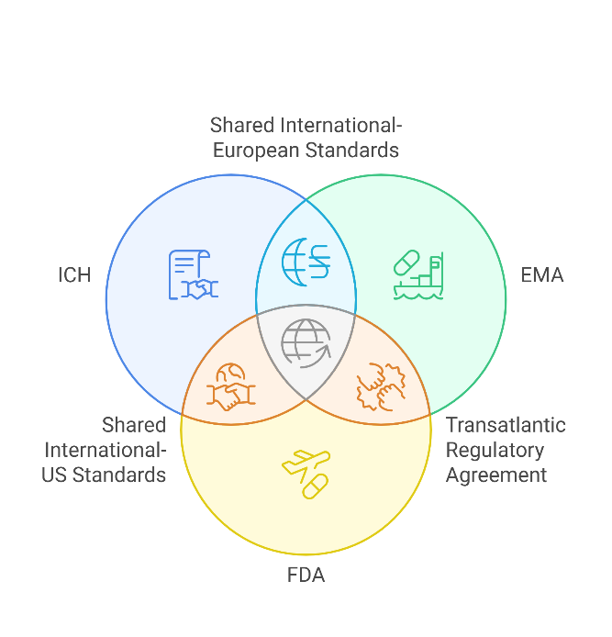
Figure 1: Global Alignment on Genotoxic Impurity Control

Mechanisms of Genotoxicity and Structural Alerts

Genotoxicity is classified based on the nature of DNA damage and the mechanisms through which chemical entities interact with genetic material. The primary modes of genotoxic action include:

- Mutagenicity: Direct modification of DNA bases leading to point mutations

- Clastogenicity: Induction of chromosomal aberrations, including deletions, translocations, and breaks.

- Aneugenicity: Disruption of mitotic spindle function, leading to abnormal chromosome segregation and aneuploidy.
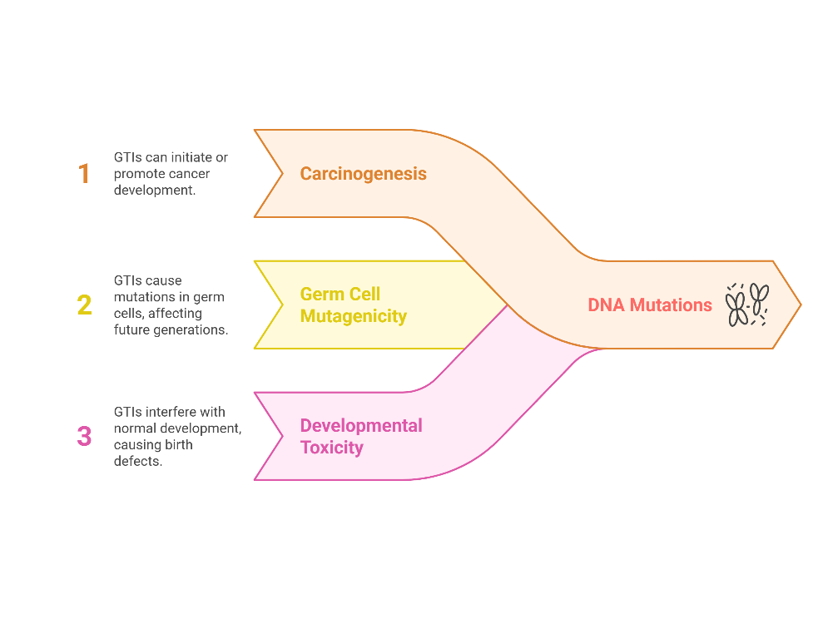
Figure 2: Risks of Genotoxic Impurities

Many genotoxic impurities are identified based on structural alerts (SAs) - chemical moieties that are highly likely to induce DNA damage. These alerts do not guarantee genotoxicity, but they necessitate further testing and risk assessment
Table 1 Common Structural Alerts for Genotoxicity
Structural Class | Example Compounds | Genotoxic Mechanism
Epoxides | Ethylene oxide | DNA alkylation, mutagenicity
Aromatic Amines | 2-Naphthylamine | Bioactivation to reactive metabolites
Alkylating Agents | Methyl methanesulfonate | Direct covalent DNA modification
Hydrazines | Hydrazine sulphate | Oxidative stress, DNA strand breaks
Aldehydes | Formaldehyde, Acrolein | Protein-DNA crosslinking
Nitrosamines | NDMA, NDEA | DNA alkylation and base modifications

These alerts are commonly screened using in silico models (e.g., DEREK, TOPKAT, Toxtree), Ames mutagenicity tests, and in vitro genotoxicity assays to assess their biological impact [4].

Role of Analytical Methods and Risk Assessment

Given the minute concentrations at which GIs must be controlled (often in the parts-per-billion range), highly sensitive and specific analytical techniques are required. The pharmaceutical industry employs a combination of:

Chromatographic Techniques: High-performance liquid chromatography (HPLC), gas chromatography-mass spectrometry (GC-MS), and liquid chromatography-tandem mass spectrometry (LC-MS/MS).

Spectroscopic Methods: Nuclear magnetic resonance (NMR), UV-Vis spectroscopy, and infrared (IR) spectroscopy.

Bioassays: Ames test, micronucleus assay, and comet assay for DNA damage detection.
These methodologies enable quantification, qualification, and mitigation of genotoxic impurities, forming the backbone of regulatory compliance and risk management strategies. ^{[4]}

SOURCES OF GENOTOXIC IMPURITIES
Genotoxic impurities (GIs) can originate from various sources throughout the pharmaceutical lifecycle, including synthesis, degradation, excipient interactions, and external contamination. Understanding these sources is critical for implementing effective risk mitigation strategies and ensuring compliance with regulatory guidelines such as ICH M7 (R1). This section explores the major contributors to genotoxic impurities and their impact on drug safety.

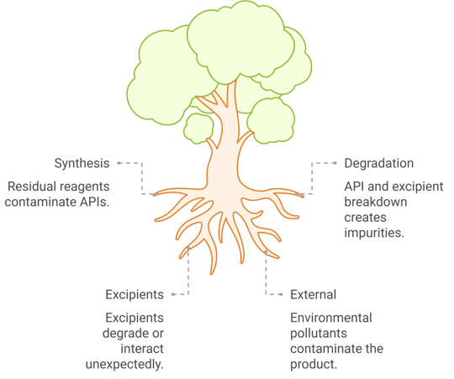

Figure 3: Sources of Genotoxic Impurities
Synthetic Process-Related Impurities

The synthesis of active pharmaceutical ingredients (APIs) involves multiple chemical reactions, often using reagents, catalysts, and solvents that can contribute to impurity formation. These impurities may be introduced at different synthesis stages, either as residual reactants, unintended byproducts, or carryover contaminants.

Carryover of Reagents, Intermediates, and Byproducts:

Many genotoxic impurities originate from unreacted starting materials, process intermediates, or unwanted byproducts formed during the reaction. These impurities may be present in trace amounts and require advanced purification techniques for removal.
Table 2: Potential genotoxic mechanisms of various compounds
Category | Example Compounds | Potential Genotoxic Mechanism
Alkylating agents | Methyl methanesulfonate, ethyl bromide | DNA alkylation leading to mutations
Aromatic amines | 2-Naphthylamine, benzidine | Metabolic activation to electrophiles
Halogenated compounds | Bromoethane, chloroacetaldehyde | DNA crosslinking and strand breaks
Sulfonate esters | Methanesulfonic acid derivatives | Direct DNA modification
Aziridines and epoxides | Ethylene oxide, aziridine | Covalent DNA binding and mutagenicity

These compounds exhibit high electrophilicity, increasing their reactivity with nucleophilic sites in DNA, proteins, and cellular macromolecules.

Residual Solvents and Catalysts:

Solvents and catalysts used in chemical synthesis can introduce genotoxic risks if not effectively removed during purification. Some residual solvents, particularly halogenated hydrocarbons and nitro-containing compounds, have been identified as genotoxic and carcinogenic.
Table 3. Genotoxic risks of solvents and catalysts used in chemical synthesis
Class of Residual Impurity | Examples | Genotoxic Potential
Halogenated solvents | Dichloromethane, chloroform | Clastogenic, DNA damage
Nitro solvents | Nitrobenzene, nitromethane | Ames-positive mutagens
Heavy metal catalysts | Palladium, platinum, arsenic | DNA strand breaks, ROS-induced damage
Peroxides | Hydrogen peroxide, benzoyl peroxide | Oxidative stress, DNA damage

Solvent residue control is crucial, especially for Class 1 solvents (ICH Q3C guideline), which have the highest toxicity potential.

Degradation Products

Pharmaceutical degradation can occur due to thermal stress, oxidation, hydrolysis, photolysis, and interactions with excipients or packaging materials. Some degradation products have been identified as genotoxic and carcinogenic, necessitating stability testing and impurity profiling.
Stability-Related Impurities Formed During Storage:
Certain APIs and excipients degrade over time, forming reactive degradation products.

Table 4. APIs-related impurities formed during storage
API Class | Common Degradation Products | Genotoxic Concerns
β-lactam antibiotics | Penicilloic acid, cephalexin lactone | DNA alkylation, mutagenicity
NSAIDs | Quinone-imine derivatives | Oxidative DNA damage
Sulfonylureas | Sulfoxides, sulfones | Ames test-positive mutagens
Steroidal drugs | Epoxide and ketone derivatives | Covalent DNA modification

Storage conditions such as humidity, temperature, and exposure to light significantly influence impurity formation.

Environmental and Packaging Interactions:

Interactions with packaging materials (e.g., plasticizers, adhesives, stabilizers) can introduce genotoxic contaminants into the formulation. Some polymeric materials degrade over time, releasing bisphenols, phthalates, and aldehydes, which exhibit DNA-damaging properties.

Table 5. Genotoxic impact of packaging components
Packaging Component | Potential Contaminants | Genotoxic Impact
Plastic containers | Bisphenol A, phthalates | Endocrine disruption, DNA damage
Rubber closures | N-nitrosamines | DNA alkylation, carcinogenicity
Glass vials | Heavy metal leachates | Oxidative stress, genotoxicity

Excipients and Formulation-Related Impurities

Though typically considered inert, excipients can undergo degradation, oxidation, or unintended chemical interactions, leading to genotoxic impurities in the final formulation.

Table 6. Potential genotoxic impurities of excipients
Excipient Class | Potential Genotoxic Impurities | Risk Factor
Polysorbates (Tween-80, PEGs) | Peroxides, aldehydes | Oxidative stress
Lactose (as diluent) | Maillard reaction products | Mutagenicity
Cellulose derivatives | Ethylene oxide residues | DNA alkylation
Parabens (preservatives) | Reactive acyl groups | Chromosomal damage

External Contaminants

External contaminants, particularly environmental pollutants, residual reagents, and cross-contaminants, pose a serious challenge in pharmaceutical impurity control.

Nitrosamine Impurities:

Nitrosamines, a class of potent mutagens and carcinogens, can form via secondary amines reacting with nitrosating agents in drug synthesis or storage.

Table 7. Risks of the nitrosamine compound
Nitrosamine Compound | Source in Pharmaceuticals | Carcinogenic Risk
NDMA (N-Nitrosodimethylamine) | Solvent impurities, degradation of ranitidine | Hepatocarcinogenic
NDEA (N-Nitrosodiethylamine) | API synthesis, rubber stoppers | DNA alkylation
NPIP (N-Nitrosopiperidine) | Piperidine-based drugs | Mutagenic, Ames-positive

Regulatory agencies mandate stringent control over nitrosamine levels, with acceptable daily intake limits set as low as 0.03 µg/day for high-risk compounds (ICH M7).

Heavy Metal Impurities:
Heavy metals, including arsenic, cadmium, and lead, can enter pharmaceutical products via raw materials, water sources, or manufacturing equipment.

Table 8. Genotoxicity of heavy metals
Heavy Metal | Source in Pharmaceuticals | Genotoxic Mechanism
Arsenic | Contaminated water, excipients | Oxidative stress, DNA breaks
Cadmium | Industrial catalysts, soil contamination | Epigenetic modification, carcinogenic
Lead | Glass leachates, stabilizers | Chromosomal aberrations

Genotoxic impurities arise from multiple sources, including chemical synthesis, degradation pathways, excipient interactions, and environmental contamination. Understanding these sources enables targeted risk mitigation strategies, ensuring regulatory compliance and patient safety. [5], [6], [7], [8], [9], [10], [11]

MECHANISMS OF GENOTOXICITY
Genotoxic impurities (GIs) exhibit their toxicological effects by directly or indirectly interacting with DNA, leading to mutations, chromosomal aberrations, or genomic instability. These alterations can initiate carcinogenesis, compromise cellular function, or cause heritable genetic changes. Understanding the mechanistic pathways of genotoxicity is crucial for risk assessment, regulatory compliance, and developing safer pharmaceutical products.

DNA Damage and Mutations:
DNA damage can occur through various mechanisms, including direct covalent modification, oxidative stress, and DNA replication errors or repair. The major types of genotoxic events are:

Point Mutations:
Point mutations arise when genotoxic agents alter individual nucleotide bases, leading to substitutions, deletions, or insertions. Point mutation can disrupt gene expression, alter protein function, or induce oncogenic transformation.

Table 9. Point mutations and genotoxicity
Type of Mutation | Description | Example of Genotoxic Agents | Biological Consequences
Base Substitution | Replacement of one nucleotide with another | Alkylating agents (e.g., EMS) | Codon changes, protein dysfunction
Frame Shift Mutation | Insertion/deletion of nucleotides | Acridines, aflatoxins | Altered reading frame, premature termination
Depurination/ Depyrimidination | Loss of purine/pyrimidine bases | Formaldehyde, nitrogen mustard | Abasic sites, replication arrest

Point mutations in critical genes, such as tumor suppressors (TP53, BRCA1) or proto-oncogenes (RAS, MYC), can significantly contribute to carcinogenesis.

Chromosomal Aberrations:
Chromosomal aberrations involve large-scale structural alterations that can result in genetic instability, aneuploidy, or apoptosis. These changes can be visualized through cytogenetic assays like the micronucleus test, chromosomal aberration assay, and comet assay.

Table 10. Chromosomal aberrations and genotoxicity
Type of Aberration | Description | Example of Genotoxic Agents | Impact on Genomic Stability
Deletions | Loss of chromosomal segments | Ionizing radiation, benzopyrene | Loss of gene function, cancer predisposition
Translocations | Exchange of segments between chromosomes | Alkylating agents (e.g., cyclophosphamide) | Oncogene activation, leukemia
Dicentric Chromosomes | Formation of two centromeres | DNA crosslinking agents (e.g., mitomycin C) | Mitotic errors, cell death
Aneuploidy | Gain or loss of entire chromosomes | Heavy metals, colchicine | Altered gene dosage, developmental defects

Chromosomal aberrations have been implicated in conditions such as chronic myeloid leukaemia (BCR-ABL translocation) and Down syndrome (trisomy 21).

Structural Alerts for Genotoxicity

Certain chemical moieties are recognized as high-risk structural alerts (SAs) due to their ability to interact with DNA or its associated proteins. These alerts serve as predictive markers for genotoxic potential, guiding risk assessment in early drug development.
Electrophilic Groups and DNA Reactivity:

Electrophilic compounds react with nucleophilic sites on DNA (e.g., guanine N7, cytosine N3), forming covalent adducts. This can cause DNA mispairing, strand breaks, or replication errors.

Table 11. Electrophilic groups and DNA reactivity
Structural Alert Class | Representative Compounds | Genotoxic Mechanism | Example Drugs with Risk
Alkylating Agents | Ethyl methanesulfonate (EMS), nitrogen mustard | DNA alkylation, crosslinking | Cyclophosphamide, Busulfan
Aromatic Amines | 2-Naphthylamine, benzidine | Bioactivation to electrophiles | Chloroquine, Dapsone
Epoxides | Ethylene oxide, styrene oxide | Covalent DNA binding | Carbamazepine epoxide (metabolite)
Nitrosamines | NDMA, NDEA | DNA alkylation, O6-methylguanine adducts | Ranitidine, Valsartan
Aziridines | Aziridine, mitomycin C | DNA interstrand crosslinking | Mitomycin C, Thiotepa

Regulatory agencies mandate extensive testing for these structural alerts to ensure they remain below permissible thresholds.

In Silico and Predictive Modelling of Genotoxic Potential

Advancements in computational toxicology allow for early prediction of genotoxic risks using in silico models. These tools analyse molecular structures and compare them to existing genotoxic databases, reducing reliance on animal testing.

Computational Approaches for Genotoxicity Prediction:

Table 12. Computational approaches for genotoxicity prediction
Method | Description | Examples of Tools
Quantitative Structure-Activity Relationship (QSAR) | Predicts genotoxic potential based on chemical structure | DEREK, TOPKAT, MCASE
Molecular Docking | Simulates interaction of chemicals with DNA/proteins | AutoDock, MOE
Machine Learning Models | Uses AI to analyse large datasets for genotoxic trends | DeepChem, TensorFlow AI
Read-Across Methods | Infers toxicity based on structurally similar compounds | OECD Toolbox

These computational tools allow for rapid screening of drug candidates before proceeding to in vitro or in vivo studies.

Genotoxicity mechanisms encompass DNA damage, mutagenesis, and chromosomal instability, driven by reactive chemical moieties. Structural alerts such as alkylating agents, nitrosamines, and aromatic amines play a pivotal role in risk assessment. Integrating in silico models has revolutionized genotoxicity prediction, aiding pharmaceutical industries in early-stage impurity profiling and regulatory compliance. ^{[12], [13], [14], [15], [16]}

REGULATORY GUIDELINES AND RISK ASSESSMENT
Genotoxic impurities (GIs) present a significant challenge in pharmaceutical development due to their potential to cause mutations and carcinogenic effects even at trace levels. Regulatory agencies have established stringent guidelines to identify, assess, and control GIs, ensuring drug safety and compliance. The International Council for Harmonisation (ICH) M7 (R1) guideline is the primary regulatory framework for evaluating mutagenic impurities, incorporating risk assessment and impurity control strategies.
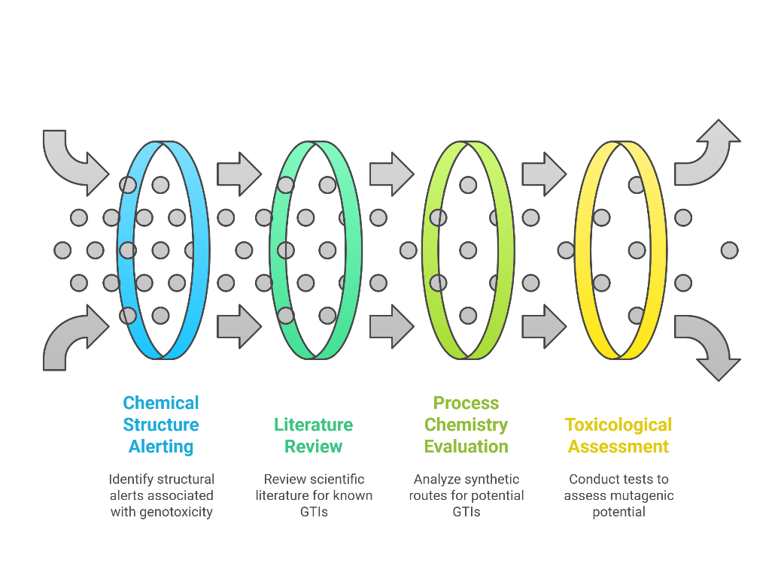
Figure 4. Genotoxic Impurity Identification Process

ICH M7 (R1) Guidelines and the Threshold of Toxicological Concern (TTC) Approach

ICH M7 (R1) Overview:
The ICH M7 (R1) guideline, titled "Assessment and Control of DNA Reactive (Mutagenic) Impurities in Pharmaceuticals to Limit Potential Carcinogenic Risk," provides a risk-based approach to impurity classification, assessment, and control. The key principles of ICH M7 (R1) include:
- Identify genotoxic impurities using in silico, in vitro, and in vivo assays.
- Use the Threshold of Toxicological Concern (TTC) for acceptable exposure limits.
- Impurity classification system based on mutagenicity data.
- Control strategies based on the likelihood of patient exposure.
Threshold of Toxicological Concern (TTC) Approach:
The TTC concept is a risk-based strategy that establishes exposure limits for genotoxic impurities to ensure that potential carcinogenic risks remain below a 1 in 100,000 lifetime cancer risk.

Table 13. Threshold of Toxicological Concern
Exposure Duration | Acceptable Daily Intake (µg/day) | Application
Lifetime (≥10 years) | 1.5 µg/day | Standard pharmaceuticals
Short-term (1–10 years) | 10 µg/day | Oncology drugs, chronic conditions
Intermediate exposure (≤1 year) | 20 µg/day | Acute treatment, limited duration
Single-dose exposure | 120 µg/day | Rare, emergency use

The TTC approach ensures that impurities with unknown carcinogenic potential remain at doses unlikely to pose significant risk.

Regulatory Perspectives from the US FDA, EMA, and Other Global Agencies

US FDA Guidelines:

The FDA mandates a risk-based assessment for genotoxic impurities, aligning with ICH M7, while incorporating additional requirements such as:
- Evaluation of impurities at all stages of drug development.
- Requirement for Ames testing or equivalent mutagenicity assessments.
- Use of analytical techniques to ensure impurities remain below acceptable limits.

European Medicines Agency (EMA) Guidelines:

The EMA follows ICH M7 principles but places additional emphasis on:
- Genotoxicity risk assessment for excipients and degradation products.
- Stricter limits for nitrosamines and alkyl sulfonates.
- In-depth impurity profiling before drug approval.

Other Regulatory Agencies:
Table 14. Regulatory Agencies
Regulatory Body | Key Guidelines | Genotoxic Impurity Control Measures
Japan PMDA | ICH M7, JP Pharmacopoeia | Requires in silico assessment and Ames test confirmation
China NMPA | Chinese Pharmacopoeia | Mandates stringent control of nitrosamines
WHO | WHO Technical Report | Emphasizes risk assessment for global drug supply

Risk Assessment Strategies and Classification of Genotoxic Impurities
The ICH M7 guideline categorizes impurities into five classes based on their mutagenic and carcinogenic potential. ^{[17]}

Table 15. Classification of Genotoxic Impurities
Class | Description | Regulatory Action
Class 1 | Known mutagenic carcinogens | Strict elimination required
Class 2 | Mutagenic but unknown carcinogenicity | Control to TTC limits
Class 3 | Structural alerts present, but no evidence of mutagenicity | Requires additional testing
Class 4 | Structural alerts similar to API but proven non-genotoxic | No additional control required
Class 5 | No structural alerts or genotoxicity concerns | Standard impurity limits apply

Acceptable Limits and Control Strategies
Control strategies for genotoxic impurities are based on their classification, synthetic process risk, and degradation pathways. ^{[18], [19], [20]}

Table 16. Control strategies for genotoxic impurities
Control Strategy | Application | Example Techniques
Process optimization | Reducing impurity formation | Alternative synthetic routes, reagent selection
Analytical monitoring | Ensuring levels remain within limits | LC-MS, GC-MS, NMR
Purification techniques | Removing impurities before final formulation | Crystallization, filtration
Regulatory compliance | Ensuring alignment with ICH M7 | Risk assessment reports, TTC application

ANALYTICAL TECHNIQUES FOR DETECTION AND QUANTIFICATION
Accurate detection of genotoxic impurities requires highly sensitive analytical techniques due to their low permissible limits.

Chromatographic Methods

High-Performance Liquid Chromatography (HPLC)
- Used for quantitative impurity profiling.
- Ideal for polar, non-volatile impurities.
Liquid Chromatography-Mass Spectrometry (LC-MS/MS)
- High sensitivity for low-level impurity detection.
- Detects specific fragmentation patterns of genotoxic compounds.
Gas Chromatography-Mass Spectrometry (GC-MS)
- Suitable for volatile and semi-volatile impurities.
- Detects residual solvents and nitrosamines.

Table 17. Chromatographic methods for detection and quantification
Technique | Application | Detection Limit
HPLC | General impurity profiling | 1–10 ppm
LC-MS/MS | Trace impurity detection | ppb level
GC-MS | Volatile impurity analysis | 0.1–1 ppm

Spectroscopic Approaches

Nuclear Magnetic Resonance (NMR) Spectroscopy
- Provides structural elucidation of unknown impurities.
UV-Visible Spectroscopy (UV-Vis)
- Detects chromophoric genotoxic impurities.
Infrared (IR) Spectroscopy
- Identifies functional groups in impurities ^{[21], [22]}

Table 18. Spectroscopic approaches for detection and quantification
Spectroscopic Method | Application
NMR Spectroscopy | Structural identification of impurities
UV-Vis Spectroscopy | Detection of aromatic nitrosamines
IR Spectroscopy | Functional group analysis in unknown compounds

Genotoxicity Assays ^{[23], [24]}

Table 19. Genotoxicity assays
Assay | Description | Genotoxicity Endpoint
Ames Test | Bacterial mutation assay | Point mutations
Micronucleus Assay | Identifies chromosomal damage | Clastogenicity
Chromosomal Aberration Test | Detects structural DNA changes | DNA breakage

In Silico Tools for Predictive Toxicology

In silico tools help predict genotoxic potential based on chemical structure. ^{[25]}

Table 20. In Silico tools for predictive toxicology
Tool | Application
DEREK Nexus | Identifies structural alerts
TOPKAT | QSAR-based mutagenicity predictions
MCASE | DNA-reactive compound screening

Regulatory frameworks such as ICH M7 (R1), FDA, and EMA guidelines have established strict risk assessment strategies for genotoxic impurities. Advances in analytical techniques—including HPLC, LC-MS/MS, GC-MS, and in silico predictive models—play a crucial role in impurity detection and regulatory compliance.

CONTROL STRATEGIES FOR GENOTOXIC IMPURITIES
Controlling genotoxic impurities (GIs) in pharmaceuticals is essential to ensure patient safety and regulatory compliance. The most effective control strategies involve process optimization, synthetic route modification, solvent and reagent selection, advanced purification techniques, and green chemistry approaches. These strategies help minimize impurity formation, reduce risks, and enhance impurity removal during drug synthesis and formulation.
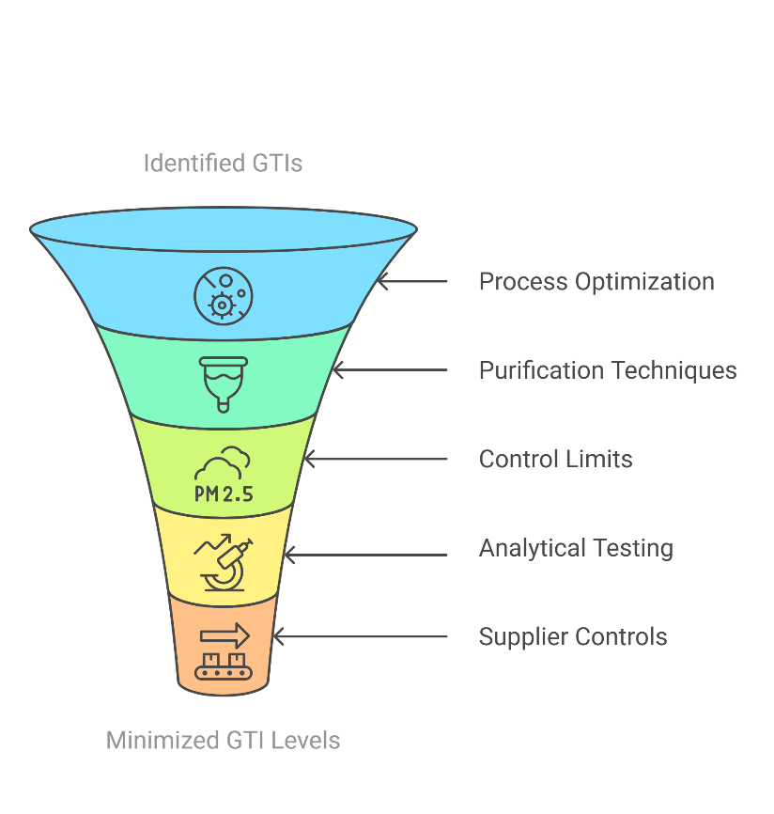
Figure 5. GTI Control Strategies Funnel

Process Optimization and Synthetic Route Modification

Process optimization involves designing synthetic pathways that inherently minimize or eliminate the formation of genotoxic impurities. Key approaches include:
- Modifying reaction conditions (e.g., pH, temperature, reaction time) to prevent side reactions leading to impurity formation.
- Alternative synthetic routes shall be used to avoid intermediates with known genotoxic potential.
- Employing protective groups to reduce the reactivity of functional moieties that contribute to impurity formation.

Table 21. Control strategies for genotoxic impurities
Optimization Strategy | Example Applications | Impact on Genotoxic Impurity Control
Alternative synthetic pathways | Avoiding nitrosamine formation in Sartan drugs | Eliminates genotoxic precursors
Catalyst selection | Switching from Pd/C to Ru-based catalysts | Reduces residual heavy metal contamination
Reaction condition modification | Lowering the reaction temperature for alkylation steps | Minimizes formation of alkylating impurities

Selection of Alternative Solvents and Reagents

Solvents and reagents play a critical role in impurity generation, particularly in pharmaceutical synthesis. Certain halogenated solvents, nitrosating agents, and alkylating reagents are known to introduce genotoxic risks.
- Replacing hazardous solvents (e.g., dichloromethane, nitromethane) with safer alternatives (e.g., ethanol, ethyl acetate).
- Using non-mutagenic bases and acids (e.g., phosphate buffers instead of nitrites).
- Employing safer reagents that do not form electrophilic intermediates.

Table 22. Safer alternative solvents and reagents
Traditional Solvent/Reagent | Genotoxic Concern | Safer Alternative
Dichloromethane (DCM) | Clastogenic potential | Ethyl acetate
Nitromethane | Potential nitrosamine formation | Acetonitrile
Dimethyl sulfate (DMS) | DNA alkylation risk | Tosyl chloride
Sodium nitrite | Nitrosating agent | Phosphate buffer

Pharmaceutical manufacturers can significantly reduce the risk of genotoxic impurity formation by selecting safer solvents and reagents.

Purification and Removal Techniques
Even with optimized synthesis, trace levels of genotoxic impurities may still be present. Purification techniques play a crucial role in impurity removal:
- Filtration and Adsorption: Removes particulate and residual impurities using activated carbon or adsorbent resins.
- Crystallization: Purifies the final product by selectively excluding impurities from the crystalline lattice.
- Distillation: Eliminates volatile impurities such as nitrosamines.
- Chromatographic Techniques: High-performance liquid chromatography (HPLC) or preparative chromatography isolates pure drug substances

Table 23. Purification techniques in impurity removal
Purification Technique | Target Impurities | Effectiveness
Crystallization | Small organic impurities | High
Filtration (adsorbents) | Nitrosamines, peroxides | Moderate-High
Distillation | Volatile genotoxic solvents | High
HPLC purification | Process-related and degradation impurities | Very High

The combination of these methods ensures impurity levels remain within regulatory limits while maintaining drug quality.

Application of Green Chemistry for Safer Synthesis

Green chemistry principles are increasingly being applied to minimize impurity formation and promote sustainable pharmaceutical manufacturing.
- Atom Economy: Maximizing the use of raw materials in the final product to reduce byproducts.
- Biocatalysis: Using enzymatic reactions to replace chemical processes that generate toxic impurities.
- Solvent-Free Reactions: Eliminating hazardous solvents to prevent impurity formation.
- Flow Chemistry: Enhancing reaction control and reducing impurity accumulation.

Table 24. Analytical challenge, impact, and potential solution
Green Chemistry Approach | Example | Benefit
Solvent-free synthesis | Direct amination of carboxylic acids | Eliminates solvent-derived impurities
Biocatalysis | Enzyme-mediated ketone reduction | Avoids toxic metal catalysts
Flow chemistry | Continuous flow hydrogenation | Reduces impurity accumulation

Green chemistry approaches enhance drug safety, reduce environmental impact, and improve process efficiency. [26], [27], [28], [29], [30], [31], [32]

CHALLENGES and Future Perspectives
Limitations of Current Analytical Methods
- Low detection limits required: Many GIs must be quantified at ppb (parts per billion) levels, which can be challenging for standard analytical techniques.
- Matrix effects: Drug formulations can interfere with impurity detection.
- Complex degradation pathways: Some impurities form over time, requiring long-term stability studies.^{[33]}

Table 25. Analytical challenge, impact, and potential solution
Analytical Challenge | Impact | Potential Solution
Low impurity levels | Difficult quantification | High-sensitivity LC-MS/MS
Matrix interference | False positives/negatives | Sample pre-treatment methods
Degradation product variability | Missed impurity detection | Forced degradation studies

Difficulties in Impurity Qualification and Classification
- Structural alerts may not always translate into genotoxicity (false positives).
- Lack of robust in vivo data for many potential impurities.
- Difficulty in setting universal impurity limits due to interspecies variation in carcinogenicity.
Regulatory Gaps and the Need for Harmonization
- Inconsistent global impurity limits: Some countries impose stricter limits than others.
- Evolving scientific knowledge requires constant updates to guidelines.
- Need for a universal database for genotoxic impurities to streamline risk assessment.
Advances in AI and Machine Learning for Impurity Prediction
- Predictive toxicology models (AI-based QSAR, deep learning) improve impurity risk assessment.
- AI-driven chromatographic method development enhances impurity detection.
- Machine learning algorithms identify trends in impurity formation, reducing experimental workload.
- AI and machine learning offer a promising future for genotoxic impurity prediction and control^{.[34], [35], [36], [37]}

Table 26. AI and Machine learning for impurity prediction
AI-Based Application | Function | Example Tools
QSAR Modelling | Predicts genotoxic potential | DEREK Nexus, TOPKAT
Deep Learning | Analyses impurity patterns | TensorFlow AI
Automated Chromatography Optimization | Enhances impurity separation | AI-LC Method Development

Conclusion
Genotoxic impurities (GIs) pose a significant threat to pharmaceutical safety due to their potential to induce DNA damage, mutations, and carcinogenic effects, even at trace levels. Their presence in drug formulations necessitates stringent regulatory oversight and robust analytical methodologies to ensure patient safety. Regulatory bodies such as the International Council for Harmonization (ICH M7 R1), the U.S. Food and Drug Administration (FDA), and the European Medicines Agency (EMA) have established comprehensive guidelines that provide a risk-based framework for impurity identification, classification, and control. These regulations enforce strict thresholds based on the Threshold of Toxicological Concern (TTC) concept, ensuring that exposure levels remain below carcinogenic risk thresholds.

Advanced analytical techniques have significantly improved impurity detection, quantification, and risk assessment. High-resolution methods such as liquid chromatography-mass spectrometry (LC-MS/MS) and gas chromatography-mass spectrometry (GC-MS) enable precise detection of impurities at parts-per-billion (ppb) levels. At the same time, in silico predictive models (e.g., DEREK, TOPKAT, MCASE) provide early-stage impurity risk assessment, reducing reliance on extensive laboratory testing. Moreover, a multi-tiered control strategy—encompassing process optimization, synthetic route modification, selective solvent and reagent usage, purification techniques, and the adoption of green chemistry principles—has proven instrumental in minimizing genotoxic impurities in pharmaceutical manufacturing. The integration of these approaches ensures not only regulatory compliance but also enhances drug purity, efficacy, and long-term patient safety.

As the pharmaceutical industry evolves, several key areas demand further advancements to enhance impurity control. One of the most pressing needs is harmonizing global regulatory limits, ensuring uniform impurity control strategies across different jurisdictions. Establishing standardized impurity databases and universally accepted TTC thresholds would streamline risk assessment and improve regulatory compliance worldwide.

Integrating artificial intelligence (AI) and machine learning in predictive toxicology is poised to revolutionize impurity assessment. AI-driven models can rapidly analyze chemical structures, identify structural alerts for genotoxicity, and predict potential toxicological outcomes in real-time. This will enable early impurity detection and facilitate proactive mitigation strategies during drug development.

Simultaneously, next-generation analytical techniques are expected to push the boundaries of sensitivity and specificity. Innovations such as ultra-high-resolution mass spectrometry (HRMS), nuclear magnetic resonance (NMR) advancements, and microfluidic-based chromatographic methods will offer unparalleled precision in impurity profiling. The refinement of these technologies will allow for better impurity characterization, even at ultra-trace levels, thereby strengthening pharmaceutical quality assurance.

Moreover, the adoption of green chemistry principles is gaining momentum as an effective strategy for sustainable pharmaceutical manufacturing. The transition towards solvent-free synthesis, biocatalysis, continuous flow chemistry, and atom-economy-driven synthetic pathways will significantly reduce impurity formation while minimizing environmental impact. The industry can achieve impurity reduction and sustainable development goals by integrating eco-friendly synthesis methods into the routine drug manufacturing.

Ultimately, the continuous evolution of regulatory frameworks, analytical advancements, AI-driven impurity profiling, and sustainable chemistry approaches will further enhance the pharmaceutical sector's ability to detect, control, and mitigate genotoxic impurities. As research in this domain progresses, interdisciplinary collaboration among regulators, pharmaceutical scientists, analytical chemists, and computational toxicologists will ensure that impurity control measures remain at the forefront of drug safety and innovation.

Conflict of Interest
The author declares that there are no conflicts of interest regarding the publication of this article.
COMPETING INTERESTS
Authors have declared that they have no known competing financial interests OR non-financial interests OR personal relationships that could have appeared to influence the work reported in this paper.
Disclaimer (Artificial intelligence)
Option 1:
Author(s) hereby declare that NO generative AI technologies such as Large Language Models (ChatGPT, COPILOT, etc.) and text-to-image generators have been used during the writing or editing of this manuscript.
Option 2:
Author(s) hereby declare that generative AI technologies such as Large Language Models, etc. have been used during the writing or editing of manuscripts. This explanation will include the name, version, model, and source of the generative AI technology and as well as all input prompts provided to the generative AI technology
Details of the AI usage are given below:
1.
2.
3.

references

[1] M. Kumari, D. B. Tripathy, and A. Gupta, “Analytical Methods and Their Significance in Pharmaceutical Process Impurities: A Review,” Macromol Symp, vol. 413, no. 1, 2024, doi: 10.1002/masy.202300026.
[2] I. C. Munro, G. L. Carloi, and J. C. Orr, “Kansas State University,” Saxon Graham, vol. 11, 1992.
[3] O. Tcheremenskaia and R. Benigni, “Toward regulatory acceptance and improving the prediction confidence of in silico approaches: a case study of genotoxicity,” Expert Opin Drug Metab Toxicol, vol. 17, no. 8, 2021, doi: 10.1080/17425255.2021.1938540.
[4] R. D. Snyder, G. S. Pearl, G. Mandakas, W. N. Choy, F. Goodsaid, and I. Y. Rosenblum, “Assessment of the sensitivity of the computational programs DEREK, TOPKAT, and MCASE in the prediction of the genotoxicity of pharmaceutical molecules,” Environ Mol Mutagen, vol. 43, no. 3, 2004, doi: 10.1002/em.20013.
[5] S. S. Bharate, “Critical Analysis of Drug Product Recalls due to Nitrosamine Impurities,” J Med Chem, vol. 64, no. 6, 2021, doi: 10.1021/acs.jmedchem.0c02120.
[6] A. B. Patel, A. H. Asnani, A. J. Vyas, N. K. Patel, A. I. Patel, and A. N. Lumbhani, “A Brief Review on Genotoxic impurities in Pharmaceuticals,” Asian Journal of Pharmaceutical Research. Published online, 2021, doi: 10.52711/2231-5691.2021.00034.
[7] J. Fahrer and M. Christmann, “DNA Alkylation Damage by Nitrosamines and Relevant DNA Repair Pathways,” Int J Mol Sci, vol. 24, no. 5, 2023, doi: 10.3390/ijms24054684.
[8] S. Wang and T. J. Hang, “Strategies for determination of genotoxic impurities in pharmaceuticals,” Chinese Journal of New Drugs, vol. 28, no. 23, 2019.
[9] G. Szekely, M. C. A. Sousa, M. Gil, F. C. Ferreira, and W. Heggie, “Genotoxic impurities in pharmaceutical manufacturing: Sources, regulations, and mitigation,” Chem Rev, vol. 115, no. 16, 2015, doi: 10.1021/cr300095f.
[10] T. Shaikh, “Genotoxic Impurities and Its Risk Assessment in Drug Compounds,” DDIPIJ, vol. 2, no. 4, Oct. 2018, doi: 10.32474/DDIPIJ.2018.02.000143.
[11] S. Swain, B. R. Jena, A. A. Rao, N. Malothu, N. J. Kothakota, and S. N. Tripathy, “Genotoxic Impurities in Critical Analysis of Product Development: Recent Advancements, Patents, and Current Challenges,” Current Pharmaceutical Biotechnology, vol. 25, no. 4. Bentham Science Publishers, pp. 385–395, 2024. doi: https://doi.org/10.2174/1389201024666230726152629.
[12] R. P. F. Schins, “Mechanisms of genotoxicity of particles and fibers,” Inhal Toxicol, vol. 14, no. 1, 2002, doi: 10.1080/089583701753338631.
[13] H. Ellinger-Ziegelbauer, J. Aubrecht, J. C. Kleinjans, and H. J. Ahr, “Application of toxicogenomics to study mechanisms of genotoxicity and carcinogenicity,” Toxicol Lett, vol. 186, no. 1, 2009, doi: 10.1016/j.toxlet.2008.08.017.
[14] K. Morker, R. Patel, and D. Purohit, “PLGA based nanomaterials in Drug Delivery for cancer treatment: Innovations and Emerging Applications,” Mar. 2025, doi: 10.5281/ZENODO.15064506.
[15] Z. Magdolenova, A. Collins, A. Kumar, A. Dhawan, V. Stone, and D. M. M. genotoxicity, “A review of in vitro and in vivo studies with engineered nanoparticles,” Nanotoxicology, vol. 8, no. 3, 2014, doi: 10.3109/17435390.2013.773464.
[16] R. Wysocki, J. I. Rodrigues, I. Litwin, and M. J. Tamás, “Mechanisms of genotoxicity and proteotoxicity induced by the metalloids arsenic and antimony,” Cellular and Molecular Life Sciences, vol. 80, no. 11, 2023, doi: 10.1007/s00018-023-04992-5.
[17] A. Dande et al., “Risk Assessment, Detection and Control of Mutagenic Impurities in Pharmaceuticals: Emphasis on Nitrosamines,” Critical Reviews in Analytical Chemistry, pp. 1–42, June 2025, doi: 10.1080/10408347.2025.2517357.
[18] A. Vettorazzi, A. L. Cerain, J. Sanz-Serrano, A. G. Gil, and A. Azqueta, “European regulatory framework and safety assessment of food-related bioactive compounds,” Nutrients, vol. 12, no. 3, 2020, doi: 10.3390/nu12030613.
[19] S. M. Galloway, “International regulatory requirements for genotoxicity testing for pharmaceuticals used in human medicine, and their impurities and metabolites,” Environ Mol Mutagen, vol. 58, no. 5, 2017, doi: 10.1002/em.22077.
[20] K. L. Dearfield, M. C. Cimino, N. E. McCarroll, I. Mauer, and L. R. Valcovic, “Genotoxicity risk assessment: A proposed classification strategy,” Mutat Res Genet Toxicol Environ Mutagen, vol. 521, no. 1–2, 2002, doi: 10.1016/S1383-5718(02)00236-X.
[21] E. M. Buchner, O. Happel, and C. K. Schmidt, “Approach for analytical characterization and toxicological assessment of ozonation products in drinking water on the example of acesulfame,” Water Res, vol. 153, 2019, doi: 10.1016/j.watres.2019.01.018.
[22] V. B. R. A, V. N, and M. G, “A selective and sensitive LC-MS/MS method for the simultaneous determination of two potential genotoxic impurities in celecoxib,” J Anal Sci Technol, vol. 5, no. 1, 2014, doi: 10.1186/s40543-014-0018-1.
[23] W. Lai and H. Wang, “Detection and Quantification of UV-irradiation-induced DNA Damages by Liquid Chromatography–Mass Spectrometry and Immunoassay†,” Photochem Photobiol, vol. 98, no. 3, 2022, doi: 10.1111/php.13546.
[24] G. Sponchiado, M. L. Adam, and C. D. Silva, “Quantitative genotoxicity assays for analysis of medicinal plants: A systematic review,” J Ethnopharmacol, vol. 178, 2016, doi: 10.1016/j.jep.2015.10.026.
[25] A. Kizhedath, S. Wilkinson, and J. Glassey, “Applicability of predictive toxicology methods for monoclonal antibody therapeutics: status Quo and scope,” Arch Toxicol, vol. 91, no. 4, 2017, doi: 10.1007/s00204-016-1876-7.
[26] R. Patel, K. Morker, and D. Purohit, “Development and Analytical Characterization of Liposomes: A Comprehensive Approach,” Mar. 2025, doi: 10.5281/ZENODO.15062406.
[27] Z. Cimarosti, F. Bravo, P. Stonestreet, F. Tinazzi, O. Vecchi, and G. Camurri, “Application of quality by design principles to support development of a control strategy for the control of genotoxic impurities in the manufacturing process of a drug substance,” Org Process Res Dev, vol. 14, no. 4, 2010, doi: 10.1021/op900242x.
[28] M. Kumari, D. B. Tripathy, and A. Gupta, “Analytical Methods and Their Significance in Pharmaceutical Process Impurities: A Review,” Macromol Symp, vol. 413, no. 1, 2024, doi: 10.1002/masy.202300026.
[29] D. Singh and R. Isharani, “A Detailed Review on Analytical Methods to Manage the Impurities in Drug Substances,” OALib, vol. 10, no. 08, pp. 1–18, 2023, doi: 10.4236/oalib.1110223.
[30] A. V. B. Reddy, J. Jaafar, and K. Umar, “Identification, control strategies, and analytical approaches for the determination of potential genotoxic impurities in pharmaceuticals: A comprehensive review,” J Sep Sci, vol. 38, no. 5, 2015, doi: 10.1002/jssc.201401143.
[31] R. NVVSS, P. AVSS, and R. R. K, “Strategies for the identification, control and determination of genotoxic impurities in drug substances: A pharmaceutical industry perspective,” J Pharm Biomed Anal, vol. 55, no. 4, 2011, doi: 10.1016/j.jpba.2010.11.039.
[32] M. K. Sethi, R. Guha, R. Shukla, S. Mahajan, P. Chakraborty, and T. Anil, “Genotoxic impurities evaluation in active pharmaceutical ingredients (API)/drug substance,” Pharmacia Lettre, vol. 8, no. 12, 2016.
[33] K. Morker, R. Patel, and D. Purohit, “A Comprehensive Review on the Stability and Degradation of Polysorbates in Biopharmaceuticals,” EJPPS, vol. 3, no. 30, Oct. 2025, doi: 10.37521/ejpps30301.
[34] V. R. Kalidindi, B. M. Somalanka, S. M. Seethamraju, and L. P. Nori, “Pharmaceutical Impurities and Their Regulatory Aspects with a Special Focus on Genotoxic Impurities,” Int J Pharm Res Allied Sci, vol. 13, no. 2, pp. 1–15, 2024, doi: 10.51847/kEAkHOrcWf.
[35] K. Lee, W. Yoo, and J. H. Jeong, “Analytical Method Development for 19 Alkyl Halides as Potential Genotoxic Impurities by Analytical Quality by Design,” Molecules, vol. 27, no. 14, p. 4437, July 2022, doi: 10.3390/molecules27144437.
[36] A. Sharma and S. . K. Kumar, “Review on identification and quantification of genotoxic impurities,” ijhs, pp. 4043–4065, Sept. 2022, doi: 10.53730/ijhs.v6nS7.12710.
[37] M. Rahman, “Strategic Impurity Control in Next-Generation Pharmaceuticals: Analytical Technologies, Toxicological Assessment, and Regulatory Integration,” Int. Biomed. Res., vol. 9, no. 1, pp. 1–15, Aug. 2025, doi: 10.25163/biomedical.9110292.

