Extraction and Characterisation of Cellulose of Chrysophyllum albidum (African Star Apple) Fruit Waste Using Infrared Spectroscopy

Abstract

The growing demand for plastics in daily applications has intensified concerns about plastic pollution due to their non-biodegradable nature. Cellulose, the most abundant biopolymer in nature, offers great promise as a renewable and biodegradable material. Traditionally, cellulose is sourced from wood and cotton, but recent studies have shifted toward agricultural wastes to reduce competition with food resources and enhance circular economy practices. This has created an urgent need for sustainable alternatives such as bioplastics derived from renewable, non-food feedstocks. To address this challenge, the present study investigates the potential of Chrysophyllum albidum (African star apple) fruit waste, seeds and peels, as a cellulose source for bioplastic production, thereby avoiding competition with food resources. Cellulose was extracted from the seeds and peels using the Kraft pulping method and characterised by Fourier Transform Infrared Spectroscopy (FTIR). The FTIR spectra confirmed the presence of characteristic cellulose functional groups in both seed- and peel-derived samples. Comparative yield analysis showed that 29.2 g of seeds produced 38% cellulose, whereas the same mass of peels yielded 8.6%. These results were consistent across multiple extraction batches, indicating the reliability of the process. The findings demonstrate that the seeds of C. albidum provide a significantly higher cellulose yield than the peels, establishing them as a more viable and productive feedstock for bioplastic development. This study highlights the potential of underutilised agro-waste in advancing sustainable materials while mitigating both plastic pollution and food insecurity concerns. These findings establish the seeds of C. albidum as a more reliable and productive feedstock for cellulose-based bioplastic production compared to the peels. Importantly, since both seeds and peels are by-products and not staple food sources, their utilisation does not pose any risk of food insecurity. Instead, it promotes the valorisation of agricultural waste and contributes to the advancement of eco-friendly alternatives to synthetic plastics. Future research should investigate the conversion of this cellulose into bioplastics and assess its mechanical, thermal, and biodegradability properties to fully establish its industrial potential.

Graphical abstract

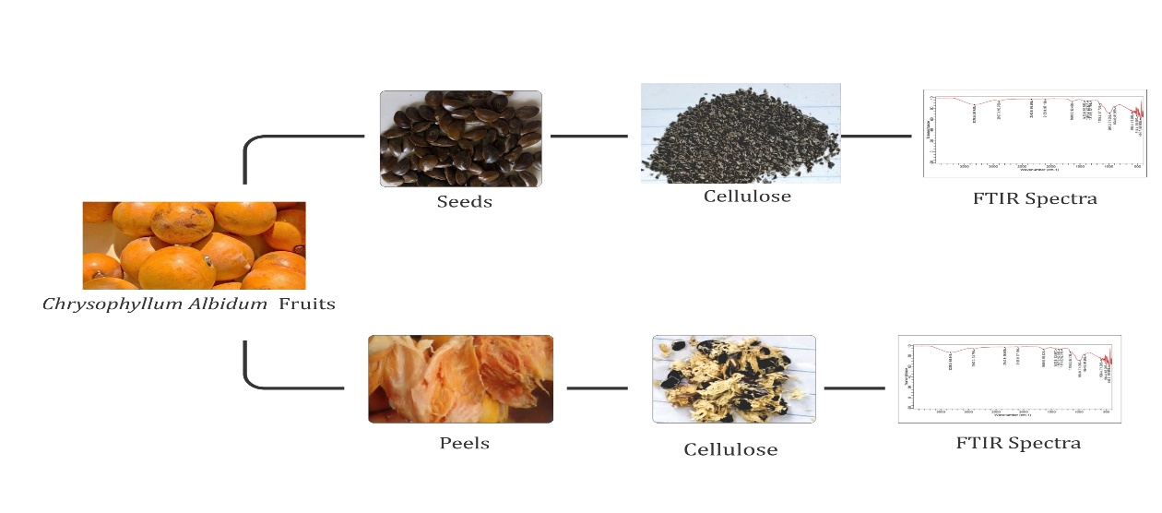
Keywords
Cellulose; Bioplastic; Chrysophyllum albidum; Fourier Transform Infrared Spectroscopy; biodegradable; seeds; peels

- Introduction

Plastics have revolutionised modern society by providing lightweight, durable, and versatile materials for applications ranging from packaging to healthcare. Plastic usage is increasing the number of pollutants in the environment. Plastic particles and other plastic-based pollutants are found in our environment and food chain, posing a threat to human health (Moshood et al., 2022). However, their non-biodegradability and dependence on fossil fuels have led to severe environmental consequences. The global production of plastics exceeded 390 million tonnes in 2021, with only about 9% being recycled (UNEP, 2021). The remaining bulk often ends up in landfills, oceans, or as litter in terrestrial ecosystems, contributing to long-term ecological damage. Microplastics are small plastic pieces ranging in size from 1μ to <5 mm in diameter, are water-soluble, and can be either primary as they are initially created in small sizes or secondary, as they develop due to plastic degradation. Approximately 360 million tons of plastic are produced globally every year, with only 7% recycled, leaving the majority of waste to accumulate in the environment and pose a serious threat in the form of microplastics (Thacharodi et al., 2024; O'Brien et al., 2023). Microplastics, tiny fragments resulting from the degradation of larger plastics, have been detected in the atmosphere, oceans, food chains, and even human biological fluids (Boucher, n.d.). These particles are associated with adverse health outcomes such as reproductive, developmental, and immune system disorders (Smith et al., 2018). This has intensified the urgency for sustainable alternatives.

The search for sustainable alternatives to petroleum-based plastics has not only focused on new polymers but also on the valorisation of agricultural wastes. According to the United Nations Environment Programme (2021), mismanaged plastic waste accounts for over 19–23 million tonnes annually, with significant portions leaking into aquatic and terrestrial ecosystems. This crisis has increased interest in renewable biopolymers, particularly cellulose, due to its abundance, biodegradability, and ability to be processed into a variety of useful derivatives such as nanocellulose, cellulose acetate, and cellulose films (Klemm et al., 2005). Unlike synthetic polymers, cellulose-based materials can reintegrate into natural biogeochemical cycles, reducing long-term ecological footprints.

Cellulose, the most abundant biopolymer in nature, offers great promise as a renewable and biodegradable material (Klemm et al., 2005). It is an important polymer that can be tailored to meet specific requirements and can also be used as a functional and structural material in the creation of valuable composites. It is the most common type of organic compound on the planet and has been around for a very long time. Furthermore, it is naturally occurring, inexpensive, biodegradable, a low-density compound, and perfectly suited to the topic of renewability (Nsude & Orie, 2022; Shrivastava & Dash, 2025). It is a linear polysaccharide composed of β(1-4)-linked D-glucose units, giving it remarkable tensile strength, chemical stability, and renewability. Traditionally, cellulose is sourced from wood and cotton, but recent studies have shifted toward agricultural wastes to reduce competition with food resources and enhance circular economy practices (Reddy & Yang, 2004). Various lignocellulosic residues, such as sugarcane bagasse, rice husks, banana peels, and corn stover, have been explored for cellulose extraction (John & Thomas, 2008). Despite this, many locally available fruit wastes remain underutilised, presenting opportunities for novel and sustainable raw materials.

Chrysophyllum albidum (African Star Apple) is one such resource with high potential. It has been shown to contain a high ascorbic acid concentration estimated to be a hundred times higher than oranges and ten times higher than guava or cashew. More importantly, the fruit is eaten fresh and used to make jelly, jam, stewed fruit, various soft drinks, marmalade, and syrup, making it a valuable source of vitamin C in the daily diet (Oguntimehin et al., 2022). Native to West and Central Africa, this fruit is widely consumed for its sweet-sour pulp, leaving behind seeds and peels that are often discarded as waste (Odeyemi & Fawole, 2022). Preliminary studies have shown that the seeds contain significant cellulose content alongside proteins, lipids, and fibre (Odeyemi & Fawole, 2022). However, little research has been conducted on systematically extracting and characterising this cellulose for material applications. This represents a unique research gap, as valorisation of African Star Apple waste could not only provide a sustainable cellulose source but also contribute to waste reduction and value addition in local communities.
This study aims to extract cellulose from both the peels and seeds of Chrysophyllum albidum (African Star Apple) fruit waste, compare their respective cellulose yields, and characterise the extracts using Fourier Transform Infrared Spectroscopy (FTIR) to confirm successful cellulose isolation. The novelty of this work lies in its utilisation of an underexplored tropical fruit waste as a cellulose source, contributing both to environmental sustainability and the advancement of renewable materials science.

Cellulose extraction from biomass typically involves chemical pretreatments to remove non-cellulosic components such as lignin and hemicellulose. Commonly, an alkali treatment (using sodium hydroxide) is applied to break down hemicellulose, followed by bleaching with sodium hypochlorite or hydrogen peroxide to eliminate lignin and enhance cellulose purity (John & Thomas, 2008). Advanced treatments such as acid hydrolysis may then be used to produce cellulose nanocrystals with improved mechanical and optical properties (Reddy & Yang, 2004). These methods have been successfully applied to various agricultural residues, including rice husks, sugarcane bagasse, banana peels, and cassava waste, suggesting similar potential for underutilised fruit wastes like Chrysophyllum albidum.

Fourier Transform Infrared Spectroscopy (FTIR) has become an essential tool in cellulose characterisation. Fourier Transform-Infrared (FTIR) spectroscopy has emerged as an exceptionally versatile and indispensable tool, revolutionising molecular analysis across a spectrum of scientific domains, including microbiology. FTIR spectroscopy has been a valuable tool in various biological studies across different scientific areas. In the field of microbiology, it has significantly aided in the rapid and accurate identification of microorganisms (Kassem et al., 2023; Zhang et al., 2024). It allows researchers to confirm the presence of functional groups associated with cellulose, such as O–H and C–O stretching vibrations, while also indicating the effective removal of lignin and hemicellulose (Poletto et al., 2014). The use of FTIR provides quick, non-destructive verification of cellulose extraction and offers insight into structural modifications introduced during chemical treatments. Employing FTIR in this study ensures that cellulose isolation from both seeds and peels of African Star Apple is validated with accuracy.

While studies have examined cellulose extraction from other tropical fruit wastes, research on Chrysophyllum albidum remains scarce. More importantly, few investigations have compared different anatomical parts of the same fruit, such as seeds and peels, despite their potential differences in cellulose yield and composition. By addressing this gap, the present research not only contributes to waste valorisation strategies in West Africa but also provides a comparative framework for selecting optimal sources of cellulose for future biopolymer development. This comparative approach strengthens the novelty of the study and underscores its potential significance for both scientific advancement and sustainable material innovation.

- Experimental
  - Materials

African star apple fruit was purchased from Choba market and consumed, while the fruit waste was set aside for this research study. Sodium Hydroxide, Sodium Sulphide and Sodium Hypochlorite were purchased from JeoChem, Nigeria. All the chemicals used were analytical grade.

  - Extraction of Cellulose

The extraction of Cellulose from African star apple waste was done by the Kraft pulping method as described by Ikese et al. (2024). 38% and 8.6% cellulose were extracted from the seeds and peels, respectively,using 18% NaOH, 12% Na₂S.9H₂O and 5% NaOCl. The cellulose was dried and preserved for analysis.
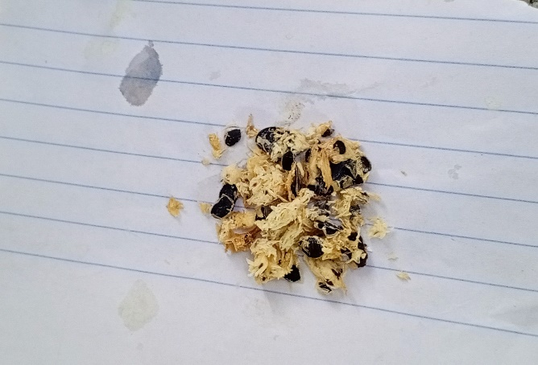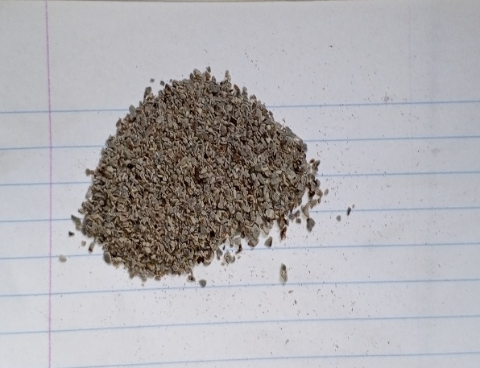
Fig. 1&2; Cellulose extracted from Chrysophyllum albidum peels and seeds, respectively

The research flow chart of the work carried out when extracting cellulose from the peels and seeds of C. albidum is shown in Fig. 3.

Chrysophyllum albidum

Extraction of Waste

Seeds
Peels

Drying
Drying

Blending
Blending

Cellulose extraction – 38%
Cellulose extraction – 8.6%

8

Characterization by FTIR
Characterization by FTIR

Fig. 3. Schematic representation of the study carried out for the abstraction of cellulose from Chrysophyllum albidum fruit waste.

  - Characterisation by FTIR

The Fourier Transform Infrared Spectroscopy of the extracted cellulose from peels and seeds of C. albidum fruit were done, and their different spectra were generated within the range of 4000cm⁻¹ to 400cm-1 at a resolution of 8cm^{-1,} and a total of 32 cumulative Scans were taken.

- Results and Discussion
3.1 Cellulose Yield from Seeds and Peels

The cellulose extraction from both seeds and peels of Chrysophyllum albidum revealed a significant difference in yield. From an initial weight of 29.2g, the seeds produced 38% cellulose, while the peels yielded only 8.6%. This consistent observation across repeated extraction trials highlights that the seeds are a richer and more reliable source of cellulose compared to the peels. The relatively higher cellulose yield from the seeds can be attributed to their dense structural composition and lower proportion of non-cellulosic compounds such as lignin and hemicellulose compared to the peels. Conversely, the lower yield from the peels may be due to the higher content of waxes, pigments, and other extractives that reduce the efficiency of cellulose isolation. These findings suggest that the seeds of C. albidum, which are often discarded as waste, can serve as a more productive feedstock for bioplastic production.

3.2 FTIR Characterisation of Extracted Cellulose

Fourier Transform Infrared Spectroscopy (FTIR) analysis was employed to confirm the presence of functional groups characteristic of cellulose in the extracted samples. The cellulose obtained from seeds showed peaks at 3328.5cm⁻¹ (O–H stretching vibration), 2907.3cm⁻¹ (C–H stretching vibration), 1423.8cm⁻¹ and 1315.8cm⁻¹ (CH₂ bending and C–H deformation), 1159.2cm⁻¹ (C–O–C asymmetric stretching), 894.6cm⁻¹ (β-glycosidic linkages), 984.0cm⁻¹ (C–O stretching), and 1640.0cm⁻¹ (absorbed water bending vibration).
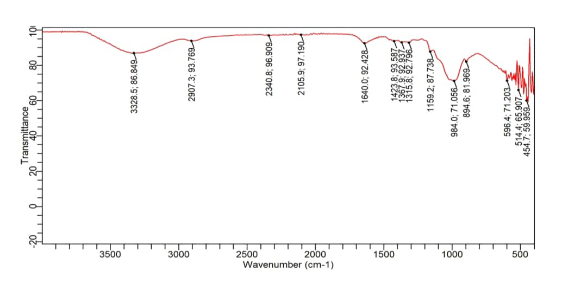Fig. 4. FTIR Spectra for Cellulose extracted from Seeds
Similarly, the cellulose extracted from the peels exhibited peaks at 3354.6 cm⁻¹, 2922.2cm⁻¹, 1457.4cm⁻¹, 1364.2cm⁻¹, 1148.0cm⁻¹, 1095.8cm⁻¹, 905.7cm⁻¹, and 1640.0cm⁻¹, which align with the characteristic absorption bands of cellulose. The presence of these peaks confirms successful cellulose extraction from both sources, with slight variations in wavenumber intensity that may reflect differences in crystallinity, degree of polymerisation, or residual non-cellulosic impurities between the two samples.

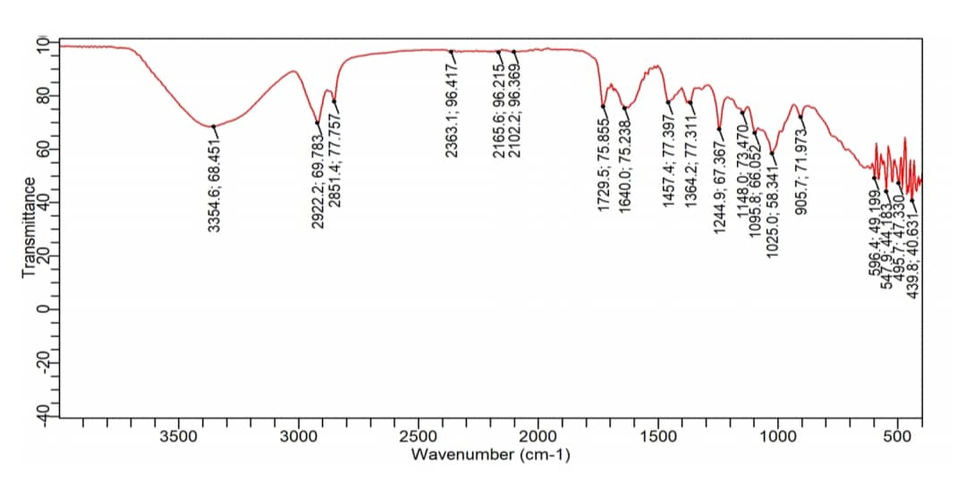
Fig. 5. FTIR Spectra for Cellulose extracted from Peels

3.3 Comparative Suitability of Seeds and Peels as Feedstock

While both seeds and peels were shown to contain extractable cellulose, the higher yield from seeds indicates that they are more suitable as a feedstock for bioplastic production. Importantly, using seeds and peels, which are typically discarded as agricultural waste, addresses the concern of food insecurity since these materials are not staple food sources. This approach aligns with the circular economy model by promoting value addition to fruit waste while reducing environmental burden. The study also demonstrates the potential of C. albidum as a novel and underutilised raw material for sustainable bioplastic production. However, the lower cellulose yield from peels suggests that further pretreatment strategies, such as delignification or chemical modification, may be required to improve their suitability.

3.4 Implications for Bioplastic Development

The findings indicate that seed-derived cellulose from C. albidum is a promising candidate for bioplastic applications, given its higher yield and confirmed chemical composition. This is significant because one of the main challenges in bioplastic production is securing low-cost and sustainable feedstock without compromising food availability. By utilising non-edible fruit waste, this study offers a pathway to sustainable raw material sourcing. Future studies should focus on evaluating the mechanical and thermal properties of bioplastics synthesised from C. albidum cellulose and exploring possible blends with other biopolymers to optimise performance.

- Conclusions

This study successfully demonstrated the extraction of cellulose from the seeds and peels of Chrysophyllum albidum fruit using the Kraft pulping method and subsequent characterisation with FTIR. The FTIR spectra confirmed the presence of characteristic cellulose functional groups in both samples, validating that cellulose was effectively isolated. However, a significant difference in yield was observed: the seeds produced 38% cellulose, while the peels yielded only 8.6% under similar extraction conditions.

These findings establish the seeds of C. albidum as a more reliable and productive feedstock for cellulose-based bioplastic production compared to the peels. Importantly, since both seeds and peels are by-products and not staple food sources, their utilisation does not pose any risk of food insecurity. Instead, it promotes the valorisation of agricultural waste and contributes to the advancement of eco-friendly alternatives to synthetic plastics. Future research should investigate the conversion of this cellulose into bioplastics and assess its mechanical, thermal, and biodegradability properties to fully establish its industrial potential.

Declaration of Competing Interest

The author declares that there are no known financial or personal competing interests that could have appeared to influence the work reported in this paper.

Disclaimer (Artificial intelligence)
Option 1:
Author(s) hereby declare that NO generative AI technologies such as Large Language Models (ChatGPT, COPILOT, etc.) and text-to-image generators have been used during the writing or editing of this manuscript.
Option 2:
Author(s) hereby declare that generative AI technologies such as Large Language Models, etc. have been used during the writing or editing of manuscripts. This explanation will include the name, version, model, and source of the generative AI technology and as well as all input prompts provided to the generative AI technology
Details of the AI usage are given below:
1.
2.
3.

References
Boucher, J. F. D. (n.d.). Primary microplastics in the oceans. IUCN. https://iucn.org/resources/publication/primary-microplastics-oceans
John, M. J., & Thomas, S. (2008). Biofibres and biocomposites. Carbohydrate Polymers, 71(3), 343–364. https://doi.org/10.1016/j.carbpol.2007.05.040
Klemm, D., Heublein, B., Fink, H., & Bohn, A. (2005). Cellulose: fascinating biopolymer and sustainable raw material. Angewandte Chemie International Edition, 44(22), 3358–3393. https://doi.org/10.1002/anie.200460587
Odeyemi, O. M., & Fawole, O. A. (2022). African Star Apple ( Chrysophyllum albidum ). In CABI eBooks (pp. 376–389). https://doi.org/10.1079/9781789248067.0026
Poletto, M., Ornaghi, H. L., & Zattera, A. J. (2014). Native cellulose: Structure, characterization and thermal properties. Materials, 7(9), 6105–6119. https://doi.org/10.3390/ma7096105
Reddy, N., & Yang, Y. (2004). Biofibers from agricultural byproducts for industrial applications. Trends in Biotechnology, 23(1), 22–27. https://doi.org/10.1016/j.tibtech.2004.11.002
Smith, M., Love, D. C., Rochman, C. M., & Neff, R. A. (2018). Microplastics in seafood and the implications for human health. Current Environmental Health Reports, 5(3), 375–386. https://doi.org/10.1007/s40572-018-0206-z
United Nations Environment Programme (UNEP). (2022). From pollution to solution: A global assessment of marine litter and plastic pollution. UNEP. Retrieved from https://www.unep.org/resources/pollution-solution-global-assessment-marine-litter-and-plastic-pollution
United Nations Environment Programme (UNEP). (2021). From pollution to solution: A global assessment of marine litter and plastic pollution. UNEP. https://www.unep.org/news-and-stories/press-release/comprehensive-assessment-marine-litter-and-plastic-pollution.

Nsude, O. P., & Orie, K. J. (2022). Microcrystalline cellulose of oil bean pod: Extraction, physico-chemical, Brunauer–Emmett–Teller (BET), and flow-ability analysis. Asian Journal of Applied Chemistry Research, 12(4), 1–12. Shrivastava, A., & Dash, D. (2025). Isolation, purification and characterization of cellulose‑degrading bacteria from soil in Chhattisgarh, India. Asian Journal of Soil Science and Plant Nutrition, 11(1), 323–327.
Oguntimehin, M. O., Badejo, A. A., & Enujiugha, V. N. (2022). The biochemical attributes of African star apple fruits are influenced by salicylic acid treatment during ambient storage. DYSONA-Applied Science, 3(2), 56-67.
Thacharodi, A., Meenatchi, R., Hassan, S., Hussain, N., Bhat, M. A., Arockiaraj, J., ... & Pugazhendhi, A. (2024). Microplastics in the environment: a critical overview on its fate, toxicity, implications, management, and bioremediation strategies. Journal of Environmental Management, 349, 119433.

O'Brien, S., Rauert, C., Ribeiro, F., Okoffo, E. D., Burrows, S. D., O'Brien, J. W., ... & Thomas, K. V. (2023). There's something in the air: a review of sources, prevalence and behaviour of microplastics in the atmosphere. Science of the Total Environment, 874, 162193.

Kassem, A., Abbas, L., Coutinho, O., Opara, S., Najaf, H., Kasperek, D., ... & Tiquia-Arashiro, S. (2023). Applications of Fourier Transform-Infrared spectroscopy in microbial cell biology and environmental microbiology: advances, challenges, and future perspectives. Frontiers in microbiology, 14, 1304081.

Zhang, H., Zheng, F., Zhang, J., Hu, D., Minelli, M., Pei, J., & Sangiorgi, C. (2024). Contributions of fourier-transform infrared spectroscopy technologies to the research of asphalt materials: A comprehensive review. Fuel, 371, 132078.

Moshood, T. D., Nawanir, G., Mahmud, F., Mohamad, F., Ahmad, M. H., & AbdulGhani, A. (2022). Sustainability of biodegradable plastics: New problem or solution to solve the global plastic pollution?. Current Research in Green and Sustainable Chemistry, 5, 100273.

