Herbicide Residues in Soil of Former Phosphate Sludge Basins Converted to Agricultural Land in Mboro (Niayes area-Senegal)
Original Research Article

Abstract
Herbicides have been widely used in agriculture for many years to control weeds. Triazines are one group of herbicides. Their degradation products are mobile and soluble in water, and can be strongly adsorbed to soil. They are highly toxic and a source of concern in terms of environmental safety. Open-pit mining of the Taïba phosphate mines by Chemical Industries of Senegal (ICS) leaves deep basins on the mined sites. Downstream, these basins serve as storage areas for phosphate washing sludge. This highly fertile farmland is used by over 2,000 local farmers of all kinds. In such a context, it is essential to study the evolution of the behavior and fate of herbicides in the soil of the ponds. In this study, residue levels of three herbicides (atrazine, Terbutryne and Cybutryne) were determined in the soil of four of these ponds (B9, B10, B11 and B17). Extraction was performed using the QuEChERS method. Analyses were carried out by gas chromatography coupled with tandem mass spectrophotometry (GC-MS/MS). Statistical analysis of the results shows an abundance of active substances in the following descending order: Terbutryne ˃ Atrazine ˃ Cybutryne. It also shows that: Terbutryne residue levels range from 2.351 to 83.457 µg.kg⁻¹, with a mean of 32.172±5.777 µg.kg⁻¹ and a median value of 31.681±1.810 µg.kg⁻¹. Atrazine residue levels range from 0.059 to 0.444 µg. kg⁻¹, with a mean value of 0.312±0.082 µg.kg⁻¹ and a median value of 0.318±0.004 µg.kg⁻¹. Cybutryne residue levels range from 0.300 to 0.402 µg.kg^{-1,} with mean and median values of 0.309±0.006 and 0.304±0.002 µg.kg⁻¹ respectively. The presence of these three pesticides in sometimes significant quantities is partly due to the clayey nature of the soil studied. Their behavior depends on agricultural practices in the basins: the timing of herbicide application, soil turning, crop rotation and soil dilution by watering and rain. This study shows soil contamination by unregistered pesticides. The search for these and other more toxic and banned phytosanitary substances in the soils of the entire Niayes area and the market garden produce grown there is therefore essential to protect the environment and ensure the health and food safety of the population.
Keywords : Soil, herbicides, pollution, QuEChERS, GC-MS/MS

- Introduction
Herbicides are the plant protection products most widely used to control or inhibit weed growth. They account for around 50% of all pesticides [1]. Triazines are among the main agrochemicals currently used for pre- and post-emergence weed control in both agricultural and non-agricultural applications[2]. They have been widely used in agriculture for many years, due to their high weed control capacity. Triazine herbicides are probably the most important class of agricultural chemicals ever developed. For five decades, triazines have provided weed control in over 50 crops worldwide, helping farmers to increase yields and produce enough food to feed a growing world population [3]. Their widespread use has led to serious environmental pollution. Triazines and their degradation products are mobile and soluble in water. They can also be strongly adsorbed to soil. Triazines are highly toxic and are a cause for concern in terms of environmental safety [4]. However, small quantities of residual pesticides are present in the environment, often in the form of chemical mixtures that contaminate drinking water and foodstuffs and thus constitute a source of chronic exposure for humans [5]. Consequently, a number of studies have explored the toxicity of triazine herbicides to mammals, which have been shown to be toxic at inappropriate levels[4]. Herbicides disrupt several metabolic, stress and survival pathways in humans. Such disruptions in pathways involved in cellular protection may eventually explain the initiation of pathologies or reduced drug efficacy in humans exposed to multiple environmental contaminants [5]. The impact of pesticide pollution on agricultural soils has also attracted considerable attention in recent years. The Taïba mining site is operated by Industries Chimiques du Sénégal (ICS). Mining at Taïba is an open-pit operation. The stripping of the layers covering the ore and the extraction of the phosphate itself leave deep basins on the mining sites. Since mining began, 18 ponds have been dug, ranging in size from 50 to 200 ha [6]. To be marketed, mined phosphate must undergo a beneficiation process. This involves scalping, settling, cycloning and crushing/screening, before finally eliminating minerals smaller than 40 µm, which are too fine to be enriched. These are known as phosphate sludge, waste clays or schlamms. Every year, ICS plants produce between 2 and 2.3 million tonnes of this type of sludge. This represents between 35 and 38% by weight of the raw ore [6]. This waste is pumped by pipelines to the tailings ponds left upstream by the mining operation, where it is slowly deposited. To date, there is no strategy for recycling this waste. Moreover, after natural settling and consolidation, the sludge releases some of its water, which is recovered by the industry. In addition, in Basins filled with phosphate sludge and abandoned by industry, nature reclaims its rights. This becomes an important reserve of arable land and water in an arid sub-Saharan region. This highly fertile land is farmed by over 2,000 men and women who live along its banks, and for most of them, it is their main source of income. To date, there have been no studies on pesticide pollution of this agricultural land, despite its great economic potential. In such a context, it is vital to study the evolution of herbicide behaviour and fate in the soil of the basins. The aim of this study is to determine the residue levels of three triazines (atrazine, terbutryne and cybutryne) in these former ICS phosphate sludge storage basins, which have been transformed into market gardening basins in the central Niayes area of Mboro.

- Materials and methods

  - Characteristics of analyzed substances
Table1 : General status and chemical structures of the herbicides studied [7].

Pesticides | Chemical formula | molar mass (g/mol) | Structure | IUPAC Name
Terbutryne | C₁₀H₁₉N₅S | 241.36 | 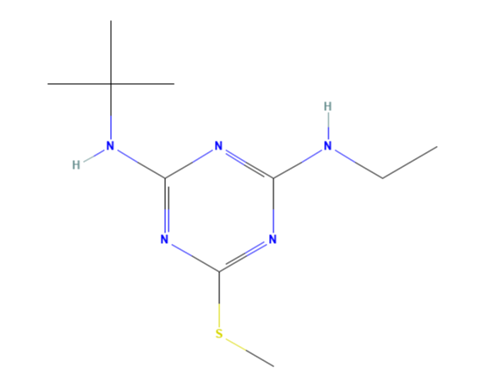 | 2-N-tert-butyl-4-N-ethyl-6-methylsulfanyl-1,3,5-triazine-2,4-diamine
Atrazine | C₈H₁₄ClN₅ | 215.68 | 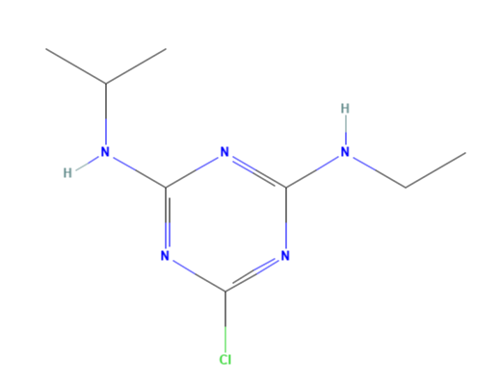 | 6-chloro-4-N-ethyl-2-N-propan-2-yl-1,3,5-triazine-2,4-diamine
Cybutryne | C₁₁H₁₉N₅S | 253.37 | 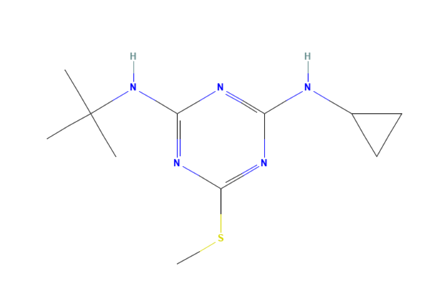 | 2-N-tert-butyl-4-N-cyclopropyl-6-methylsulfanyl-1,3,5-triazine-2,4-diamine

Table 2: Some physico-chemical features of the pesticides studied [8].

Properties |  | Compounds | Values | Interpretations
Soil degradation (days) (aerobic) DT₅₀ (field) |  | Atrazine | 29 | Non-persistent
 |  | Cybutryne | - | -
 |  | Terbutryn | 52 | Moderate persistence
Aqueous photolysis DT₅₀ (days) at pH 7 |  | Atrazine | 2.6 | Moderately fast
 |  | Cybutryne | 14 | Slow
 |  | Terbutryn | 0.5 | Fast
Aqueous hydrolysis DT₅₀ (days) at 20 °C and pH 7 |  | Atrazine | 86 | Moderate persistence
 |  | Cybutryne | - | Stable
 |  | Terbutryn | - | Stable
Solubility - In water at 20°C (mg.L⁻¹) |  | Atrazine | 35
 |  | Cybutryne | 7.0 | Fast
 |  | Terbutryn | 25 | Low
Vapour pressure at 20°C (mPa) |  | Atrazine | 0.039 | Low-volatility
 |  | Cybutryne | 0.088 | Low-volatility
 |  | Terbutryn | 0.13 | Low-volatility

  - Presentation of the study area
The study site is located in the Niayes area, around 90 km north of the Dakar region[9]. The Niayes zone stretches for 180 km along the coast between Dakar and Saint Louis, and is between 5 and 30 km wide. Thanks to its fertile soils, mild climate and accessible water table, it offers favourable conditions for agriculture [9]. The sampling site is surrounded by the communes of Mboro and Darou Khoudoss to the north-west, Taïba Ndiaye to the south-west, Méouane to the east, Tivaouane and Pire Gourey to the south. A large part of the site is occupied by the ICS mining concession, which covers an area of around 250 km² [10]. Since phosphate mining began, three mines have been opened: Keur Mor Fall in the north, Ndomor Diop in the centre of Tobène in the south (Figure 1) [10]. These blogs were named after the village closest to the drilling sites. These three panels cover an area of 48,000 hectares, 45,000 of which are at Ndomor Diop and Keur Mor Fall and 3,000 at Tobène [10]. Mining at Ndomor Diop and Keur Mor Fall has been completed, while mining at Tobène has been underway since 2003 [10]. As mining progresses, land is being acquired and all the villages on the land being mined are being relocated [10] . This has led to the disappearance of much traditional agricultural land. Today, the relocations have affected 13 villages with a total population of more than 5,100 people [10]. As a result, the populations of the relocated villages and neighbouring villages are generally forced to fall back on market gardening in the phosphate sludge ponds abandoned by the industry [10].

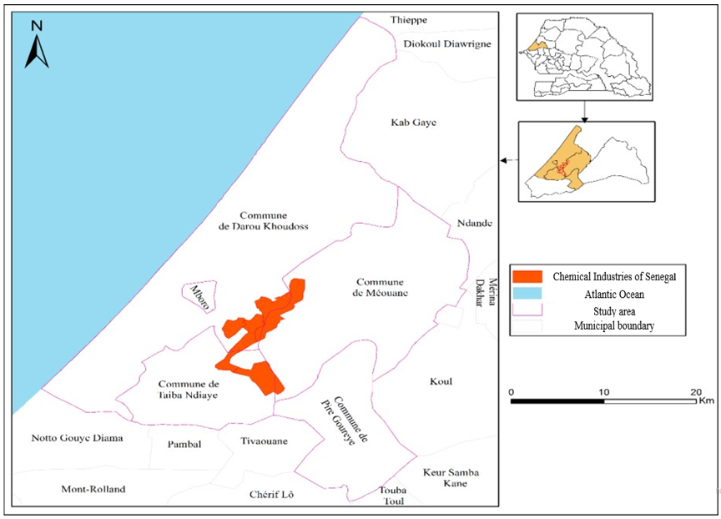

Figure 1 : Location of the study area and sampling site [11]

  - Farming practices and pesticide use in the study area
In the study area, herbicides are generally used in three periods: as a preventive anti-germinative (between June and July); between grass germination and planting (between July and September). During these two periods, herbicides are used for total weed control, acting on all the plant species present. Two herbicides known respectively as RAFALE and BIN'FLA 720 WC (active ingredient: Glyphosate) are widely used by farmers as weedkillers. After weeds have germinated and grown (between September and November). Most farmers use mechanical weeding tools to eliminate weeds. However, to a lesser extent, farmers use selective herbicides to destroy weeds without affecting crops. Most farmers do not respect the doses indicated on the labels of phytosanitary substances. A raw pesticide volume of 20 to 40 mL, or a sachet (for granulated pesticides), is often solubilised in a 16L backpack tank. The 16 mL are used to treat around 1 hectare of land. The application of plant protection products by spraying is practised by both men and women. This method of preparing the pesticide solution, developed by farmers considered to be experienced, is generally applied by most farmers. Agricultural land is farmed by small farmers and farm labourers. However, they make little use of risk mitigation measures due to their exorbitant prices. Indeed, most farmers cannot afford to buy backpack sprayers, masks, protective suits or good quality gloves. This is due to the financial pressure exerted by the sale of their harvest. As a result, most of them do not know or do not respect the minimum time between pesticide application and harvesting. What's more, once the purchase has been made in the shop, farmers transfer the pesticides to another container that contains no instructions on how to use the products safely. Some species, such as amaranths (espinosus L, reflexus L,) and tridax precumbens L, are highly resistant to the selective herbicides used.
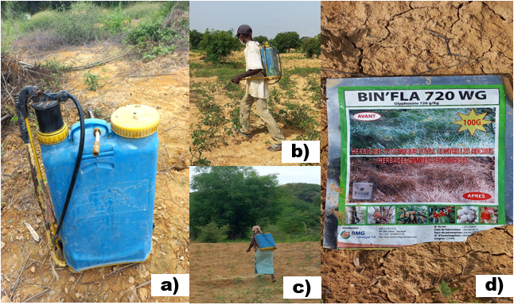
Figure 2: Some photos taken on the study site: a) 16L backpack tank; b) man spraying pesticides on his field; c) woman spraying pesticides on her field; d) bag of a total systematic pesticide found on the site.
  - Sampling
Soil samples (phosphate sludge) were collected in four (4) basins at surface horizon level (10 Cm depth) over a period from September 2021 to March 2022. A total of sixteen (16) samples were taken, four per basin (one sample every 2 months). Sampling was carried out using a wooden spatula. The sampling points were selected taking into account the agricultural activities of the basins. Samples were placed in plastic bags for transport to the laboratory.
  - Soil sample processing
The soil samples collected in the basins were first dried in the open air and then ground manually. Then they were sieved with a 2 mm square mesh sieve to remove coarse particles. Samples with diameters less than 2 mm are then sieved using a 63µm square mesh sieve to obtain samples of very fine particles. Finally, the resulting samples were put into 30*40cm plastic sample bags and stored in the laboratory at room temperature until use.
  - Extraction and dosage of pesticides
For the determination of active substances, an analytical method developed by Dione et al. was used. This method is based on QuEChERS extraction, gas chromatography separation and mass spectrophotometry (GC-MS/MS) detection [12].
  - Material and Products

QuEChERS kits and RESTEK brand centrifuge tubes, a Vortex, a Centrifuge and SPME Supelco Polyacylate (85µm) and PDMS (100µm) fibers, obtained from Sigma-Aldrich (St Quention Fallavier, France) were used for the sample preparation. SPME fiber was used to inject the samples into the chromatographic column. Acetonitrile (ACN) from Merck (Darmstadt, Germany) is the nonpolar solvent used for pesticide extraction. Acetone technique (Merck, Darmstadt, Germany) was used to wash the glassware. For calibration, pesticide standard solutions with a purity of 96 to 99.9% from Sigma-Aldrich (St Quention Fallavier, France) were used to prepare the solutions necessary for drawing the calibration lines. Internal standards (Diphenylamine-d6, Trifluralin-d14, Pendimethalin-d5) were obtained from Sigma-Aldrich (St Quention Fallavier, France). The chromatographic equipment used for analyte separation is from Thermo Fischer Scientific and consists of a TRACE GC coupled to an ion trap (ITQ 700) operating in MSMS mode. The stationary phase used is a 5% phenyl/95% dimethyl polysiloxane with sylarene groups inserted to increase thermal stability and prevent falling, allowing the column to be heated to 340°C routinely and 360°C specifically. The mass spectrometer used for detection is based on ion trap technology with an electron impact (EI) source and allows tandem analysis (MSMS) thanks to the refragmentation of the daughter ions of the compounds.

  - Preparing solutions

The solutions of the different analytes were prepared in acetonitrile (ACN) at 1 g.L-1 and stored in vials at -20°C. Standard solutions at different concentrations (between 1 and 250µg.L-1) containing all analytes were prepared by appropriate dilution of the individual stock solutions. They were used to plot 10-point calibration curves and as spike solutions during method development and validation. A solution containing the mixture of internal standards at a concentration of 10 mg.L-1 was also prepared.

  - Sample extraction and purification

For the extraction phase, weigh a mass of approximately two grams (2g) of each finely ground dry soil sample into a 50 mL polypropylene centrifuge tube, containing 10 mg of QuEChERS Q110 extraction salts, containing 4g of MgSO₄, 1g of NaCl, 1g of trisodium citrate dihydrate, 0.5g of disodium hydrogen citrate sesquihydrate, the method is buffered with buffer EN15662 (RESTEK, France). For dispersive solid phase extraction (dSPE) of the sample, add 10 mL of acetonitrile. Finally, vortex the sample vigorously for 1 min, then centrifuge for 10 min at 4000 rpm. For the purification phase, transfer 8 mL of the supernatant obtained after the extraction phase into a 15 mL centrifuge tube (Q-sep. QuEChERS, dSPE, RESTEK, France), containing 400 mg of primary secondary amine (PSA ), 400 mg of C18 and 1200 mg of anhydrous MgSO₄. After this step, Vortex the sample for 1 minute and centrifuge it for 15 minutes at 4,000 rpm, transfer the supernatant to a 2mL vial, then evaporate the supernatant down to 1mL in a fume hood.
PSA sorbent removes polar interferences such as certain sugars, polar pigments and organic acids. C₁₈ sorbent removes non-polar impurities. Anhydrous MgSO₄ is added to remove excess water and increase process efficiency.
  - Separation and detection of pollutants, control and data processing
The extract solution is made up to 20mL with water acidified to pH=3, then extracted with SPME fiber at 60°C for 40 min. The fiber is then introduced into the injector maintained at 280°C in splitless mode for 3 min. The compounds were separated on an Optima XLB column (Macherey Nagel) with an internal diameter of 30 m × 0.25 mm and a film thickness of 0.25 μm. The temperature gradient was set as follows: 50°C for 3 min, then 240°C at 40°C/min, then 255°C for 5 min at 1.5°C/min, then 330°C for 18 min at 20°C/min. Identification and quantification were carried out by electronic impact using an ion trap maintained at 210°C in MSMS mode. The transfer line was maintained at 300°C. Data control and processing was carried out using Thermo Scientific™ Xcalibur™ software.
- Results and discussions
Soil pH values ​​vary between 6.6 and 7.2. They are generally lower in September and higher in November (Table 3). All the data recorded indicates that the soil studied, made up of phosphate sludge, has a slightly acidic to neutral pH. This is due to the abundance of minerals such as carbonates [13]. The electrical conductivity (EC) varies between 690 and 2020 µS/cm. Soil salinity can therefore be considered salty to very salty [14]. The three herbicides studied were found in all basins sampled at residue levels ranging from 0.251 to 84.013 µg.kg⁻¹.
Researchers have shown that the type of soil studied (phosphate sludge) is very rich in clay minerals [15]. Furthermore, according to some studies, triazines are strongly adsorbed by clay colloids[16]. This could explain why these three active substances are sometimes present in large quantities.

Table 3 : Physico-chemical parameters and residue contents of triazines studied.

Basins | Month | pH |  | EC |  | Terbutryne | Atrazine | Cybutryne | Σ Herbicides
Basins | Month | pH |  | µs/Cm |  | Content in µg.kg⁻¹ of dry weight
B9 | September | 6.6 |  | 690 |  | 2.3505 | 0.270 | 0.304 | 2.925
B9 | November | 7.2 |  | 854 |  | 23.76 | 0.402 | 0.303 | 24.465
B9 | January | 6.6 |  | 1053 |  | 83.456 | 0.251 | 0.305 | 84.013
B9 | March | 6.6 |  | 972 |  | 51.044 | 0.273 | 0.301 | 51.620
Average  ±  Standard deviation |  | 6.750  ±  0.300 |  | 892.250  ±  157.658 |  | 40.152  ±  35.078 | 0.299  ±  0.069 | 0.303  ±  0.001 | 40.755  ±  35.051
B10 | September | 6.9 |  | 790 |  | 8.689 | 0.411 | 0.304 | 9.405
B10 | November | 7.1 |  | 918 |  | 39.095 | 0.320 | 0.303 | 39.719
B10 | January | 6.4 |  | 986 |  | 8.32 | 0.265 | 0.304 | 8.890
B10 | March | 6.6 |  | 1017 |  | 34.334 | 0.342 | 0.301 | 34.977
Average  ±  Standard deviation |  | 6.750  ±  0.310 |  | 927.750  ±  100.712 |  | 22.609  ±  16.403 | 0.334  ±  0.060 | 0.303  ±  0.001 | 23.247  ±  16.397
B11 | September | 7.1 |  | 810 |  | 10.018 | 0.444 | 0.300 | 10.763
B11 | November | 7.2 |  | 937 |  | 39.094 | 0.265 | 0.304 | 39.664
B11 | January | 6.5 |  | 1184 |  | 46.819 | 0.317 | 0.304 | 47.441
B11 | March | 6.2 |  | 2140 |  | 34.711 | 0.417 | 0.299 | 35.429
Average  ±  Standard deviation |  | 6.750  ±  0.479 |  | 1267.750  ±  601.876 |  | 32.660  ±  15.903 | 0.360  ±  0.084 | 0.301  ±  0.002 | 33.324  ±  15.842
B17 | September | 5.9 |  | 830 |  | 9.372 | 0.280 | 0.304 | 9.957
B17 | November | 7.2 |  | 863 |  | 23.422 | 0.353 | 0.401 | 24.178
B17 | January | 6.7 |  | 2020 |  | 71.241 | 0.288 | 0.303 | 71.834
B17 | March | 6.7 |  | 951 |  | 29.028 | 0.330 | 0.302 | 29.661
Average  ±  Standard deviation |  | 6.625  ±  0.537 |  | 1166.000  ±  571.619 |  | 33.265  ±  26.632 | 0.312  ±  0.034 | 0.327  ±  0.049 | 33.907  ±  26.612

The statistical study shows that on average, the residue levels of the three herbicides studied are in the following decreasing order of abundance: Terbutryne ˃ Atrazine ˃ Cybutryne. The average residue concentration of Terbutryne is several orders of magnitude higher than that of Atrazine and Cybutryne. Among these three herbicides, only Terbutryne appears in the list of pesticides authorized by the Sahelian Pesticides Committee of which Senegal is a signatory [17].
This may explain its high concentration compared to the other two. It is important to note that the committee legalizes the use of Terbutryn only for cotton weeds. So the latter like the other two are used fraudulently. Terbutryn residue levels range from 2.351 to 83.457 µg.kg⁻¹, with a mean of 32.172±5.777 µg.kg⁻¹ and a median value of 31.681±1,810 µg.kg⁻¹. The minimum residue levels were recorded in September and the maximum residue levels in January for all basins except for basin B10 where the maximum residue levels were recorded in November. September marks the beginning of the end of the rainy season, with abundant rains and vegetation at its peak. However, the low levels of Terbutryn residues can be explained by the umbrella effect exerted by vegetation and/or the phenomenon of dilution by rainwater. Atrazine residue levels range from 0.059 to 0.444 µg.kg⁻¹, with a mean value of 0.312±0.082 µg.kg⁻¹ and a median value of 0.318±0.004 µg.kg⁻¹. The minimum levels of Atrazine residues were found in January for basins B9 and B10, in November for basins B11 and in September for basins B17, while the maximum levels were recorded in November for basins B9 and B17, and in September for basins B10 and B11. For Cybutryne, residue concentrations were between 0.300 and 0.402 µg.kg⁻¹, with mean and median values ​​of 0.309±0.006 and 0.304±0.002 µg.kg⁻¹ respectively. The minimum Cybutryne residue values ​​were recorded in March for all four ponds and the maximum residue levels were found in January for basins B9 and B10, and in November for ponds B11 and B17.

Figure 3 : variation of triazine residue concentrations as a function of time (µg.kg⁻¹).

Figure 4 : variation of the sum of residue contents of each basin as a function of time.

Atrazine and Cybutryne have approximately equal mean and median values. This shows that their distribution in the soil is symmetrical. Atrazine and Cybutryne show similar trends in the four basins studied. They vary with Terbutryne, in an identical manner in basins B9 and B17. On the other hand, Terbutryne varies randomly in basins B10 and B11.
At the significant level of 0.1%, basins B9 and B17 are strongly correlated (R²= 0.999999955 and P-value = 0.000190759). The same goes for basins B10 and B11 (R²=0.999999939 and P-value = 0.000223065) (table 4). In the sampled part of basins B10 and B11, market gardening is practiced throughout the year, unlike basins B9 and B17 which are only cultivated during the winter season. The correlations obtained are consistent with agricultural practices in the basins: the timing of herbicide application, soil turning, crop rotation and soil dilution by watering, for example, which are higher in the two basins cultivated all year round (B10 and B11). The use of pesticides in combination to increase their effectiveness in controlling weeds resistant to a single herbicide may also explain the observed correlations [18]. Atrazine and Cybutryne have similar structures [19]. This may be the reason for their correlation.

Table 4 : descriptive statistics of the triazine residue contents studied.
 | Terbutryne | Atrazine | Cybutryne | Σ Herbicides
 | µg.kg⁻¹
Minimum | 2.350 | 0.251 | 0.300 | 2.901
Percentile 25% (Q1) | 9.856 | 0.273 | 0.302 | 10.431
Average | 3.172 | 0.327 | 0.309 | 32.808
Standard error (of the average) | 5.777 | 0.015 | 0.006 | 5.798
Median | 31.681 | 0.318 | 0.304 | 32.303
Median error | 1.810 | 0.004 | 0.002 | 1.816
Percentile 75% (Q3) | 41.026 | 0.365 | 0.305 | 41.696
Maximum | 83.456 | 0.444 | 0.402 | 84.302

Table 5: Pearson correlation matrix of sampled basins
Basins |  | B9 | B10 | B11 | B17
B9 | Pearson Correlation Coefficient | 1
 | R standard error
 | P-value
 | H0 (0.1%)
B10 | Pearson Correlation Coefficient | 0.999999141 | 1
 | R standard error | 1.72E-06
 | P-value | 0.000834364
 | H0 (0.1%) | rejected
B11 | Pearson Correlation Coefficient | 0.999998621 | 0.999999939 | 1
 | R standard error | 2.76E-06 | 1.23E-07
 | P-value | 0.001057429 | 0.000223065
 | H0 (0.1%) | rejected | rejected
B17 | Pearson Correlation Coefficient | 0.999999955 | 0.999998704 | 0.999998078 | 1
 | R standard error | 8.98E-08 | 2.59E-06 | 3.84E-06
 | P-value | 0.000190759 | 0.001025123 | 0.001248189
 | H0 (0.1%) | rejected | rejected | rejected

0.1% : Critical value
The differences in residue concentrations between the three pesticides in soil samples can be explained by their physicochemical properties. The very large difference between the concentrations of Terbutryne and Atrazine can be linked to their DT₅₀ in the field (table 1). Indeed, Terbutryne, with a DT₅₀ of 52 days, is approximately twice as persistent in the field as atrazine, which has a DT₅₀ of 29 days (table 1). Therefore, in the field, Terbutryn is more persistent than atrazine and therefore has a higher bioconcentration potential. Banned in the European Union since 2004 due to its toxicity, Atrazine was detected in the soil 22 years after its application [20]. Also of concern is the presence of high concentrations of Terbutryne, which is approximately twice as persistent as atrazine. Both Atrazine and Terbutryne are low volatile, with saturation vapor pressures of 0.039 and 0.13 mPa respectively (Table 1). However, the risk of contamination of neighboring ecosystems by wind is negligible. In addition, Atrazine, whose solubility in water is 35 mg.l-1, is more soluble than Terbutryne, whose solubility in water is 25 mg.l-1. This may promote greater transfer of Atrazine to groundwater due to its gradual desorption. Cybutryn also belongs to the group of biocides. However, it is not often used for agricultural purposes, which may explain its low concentration in soil samples.The differences in concentration can also be explained by the greater use of plant protection products based on Terbutryne, or by a much higher concentration of this active substance in the pesticides used in these areas.

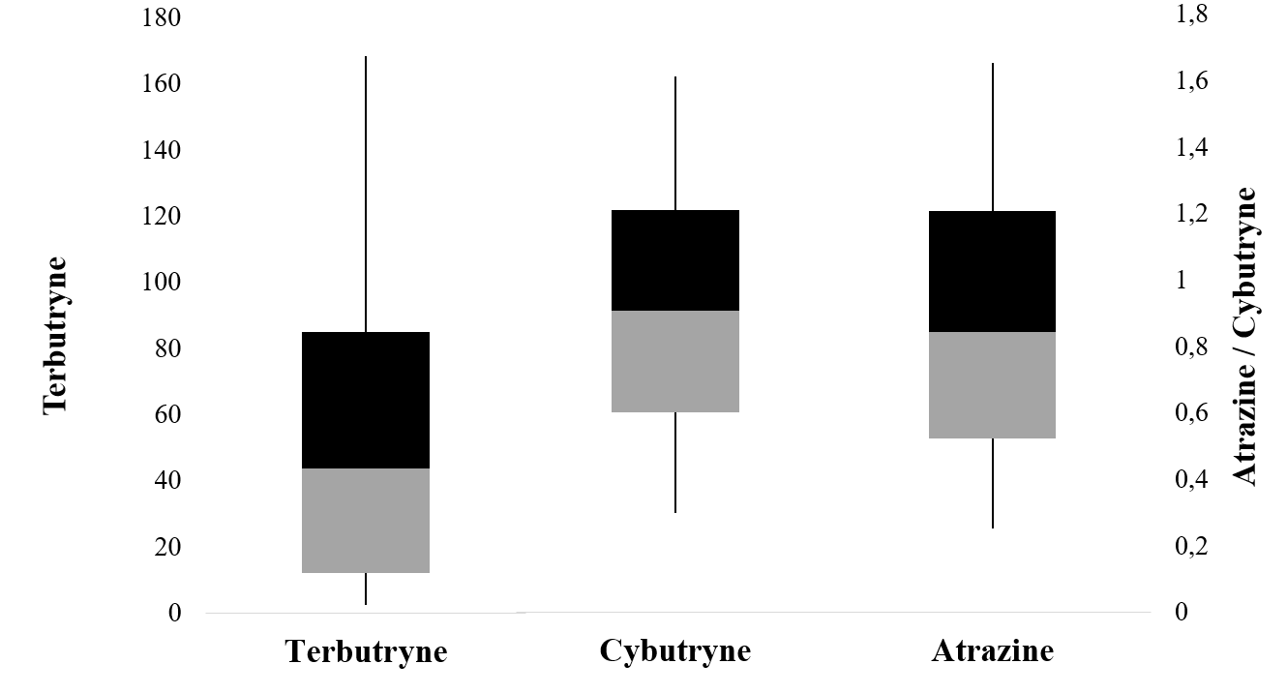

Figure 5: Box and whisker plot of the residue content of the triazines studied (µg.kg⁻¹).

- Conclusion

The objective of this study was to study the residues of three triazines (Atrazine, Terbutryne and Cybutryne) in the soil of the former ICS phosphate sludge storage basins converted into market gardening ponds in the central area of ​​Niayes de Mboro. It shows the presence of the three herbicides studied. This proves that the soil in the ponds is contaminated by these three herbicides. Indeed, this study shows that the presence of these three pesticides in sometimes significant quantities is partly due to the clayey nature of the soil studied. It also shows that the behavior of active substances depends on agricultural practices in the basins: the time of application of herbicides, turning of the soil, crop rotation and dilution of the soil by watering and rain. The statistical study of the results shows that the abundance of active substances is in the following descending order: Terbutryne ˃ Atrazine ˃ Cybutryne. The average residue concentration of Terbutryne is several orders of magnitude higher than that of Atrazine and Cybutryne. The presence of Atrazine and Cybutryne residues not approved by the Sahelian Pesticides Committee of which Senegal is a member, as well as Terbutryne only authorized for cotton plants in the soils studied, shows fraudulent use or supply of the latter. This work provided interesting information on soil pollution linked to pesticide residues in the Niayes area of ​​Mboro. It shows soil contamination by unapproved phytosanitary products. Thus the search for these phytosanitary substances and other more toxic and prohibited ones in the soils of the entire Niayes area and the market garden products grown there is essential to protect the environment and ensure the food security of the population.

Disclaimer (Artificial intelligence)
Option 1:
Author(s) hereby declare that NO generative AI technologies such as Large Language Models (ChatGPT, COPILOT, etc.) and text-to-image generators have been used during the writing or editing of this manuscript.
Option 2:
Author(s) hereby declare that generative AI technologies such as Large Language Models, etc. have been used during the writing or editing of manuscripts. This explanation will include the name, version, model, and source of the generative AI technology and as well as all input prompts provided to the generative AI technology
Details of the AI usage are given below:
1.
2.
3.

- Références

[1] Q. Ma, Q. Li, J. Wang, R. E. Parales, L. Li, et Z. Ruan, « Exposure to three herbicide mixtures influenced maize root-associated microbial community structure, function and the network complexity », Environmental Pollution, vol. 336, p. 122393, 2023, doi: https://doi.org/10.1016/j.envpol.2023.122393.
[2] H. Wang et al., « Determination of triazine herbicides in cereals using dynamic microwave-assisted extraction with solidification of floating organic drop followed by high-performance liquid chromatography », Journal of Chromatography A, vol. 1233, p. 36‑43, 2012, doi: https://doi.org/10.1016/j.chroma.2012.02.034.
[3] E. C. Martins, V. de F. Melo, J. B. Bohone, et G. Abate, « Sorption and desorption of atrazine on soils: The effect of different soil fractions », Geoderma, vol. 322, p. 131‑139, 2018, doi: https://doi.org/10.1016/j.geoderma.2018.02.028.
[4] Q.-X. Zhou et Y.-Y. Gao, « Combination of ionic liquid dispersive liquid-phase microextraction and high performance liquid chromatography for the determination of triazine herbicides in water samples », Chinese Chemical Letters, vol. 25, nº 5, p. 745‑748, 2014, doi: https://doi.org/10.1016/j.cclet.2014.01.026.
[5] P. Rouimi et al., « Impacts of low doses of pesticide mixtures on liver cell defence systems », Toxicology in vitro : an international journal published in association with BIBRA, vol. 26, p. 718‑26, avr. 2012, doi: 10.1016/j.tiv.2012.03.015.
[6] H. Calba, C. Chevassus, and D. Montange, “Agronomic study of market gardening in the ICS basins in Mboro: Agronomic use of phosphate sludge from Taïba, Senegal (Gospel project)”, Montpellier, monographbiblioteca, 2008. [Online]. Available at: https://publications.cirad.fr
[7] National Center for Biotechnology Information. "PubChem Compound Summary for CID 2256, Atrazine" PubChem, https://pubchem.ncbi.nlm.nih.gov/compound/Atrazine. Accessed 10 August, 2024.
[8] K. Lewis, J. Tzilivakis, D. Warner, et A. Green, « An international database for pesticide risk assessments and management », Human and Ecological Risk Assessment: An International Journal, vol. 22, p. 1‑15, janv. 2016, doi: 10.1080/10807039.2015.1133242.
[9] S. Kesseler and V. Tine, “A necessary evil? Industrial influences at the urban-rural interface, the impact of ICS on the Mboro area, Senegal”. December 2004. Accessed: July 4, 2024. [Online]. Available at: www.ecocite.org
[10] S. M. Seck, “Socio-economic study of market gardening in the ICS basins in Mboro (annex 1): Agronomic use of phosphate sludge from Taïba, Senegal (Gospel project)”, GOSPEL PROJECT, Montpellier, France, Technical and research document CD_RP17134, 2007. Accessed: June 20, 2024. [Online]. Available at: http://agritrop.cirad.fr/546392/1/document_546392.pdf
[11] H. Seck, E. Hadji, E. Dièye, T. Sané, and B. Solly, “Mining extraction and management of enschlammed basins in the communities alongside the Chemical Industries of Senegal (ICS)”, Jan. 2023.
[12] C. T. Dione O. Delhomme, I. Diagne, C. Diebakate, B. Ndiaye, D. Cisse, M. Hane, M. M. Dione, S. Diouf, A. Diop et M. Millet, « Application of the QuEChERS method for the determination of pesticides, PAHs and PCBs in fish in Senegal », Journal of Environmental Science and Health, Part A, vol. 57, nº 10, p. 869‑879, 2022, doi: 10.1080/10934529.2022.2123188.
[13] L. Arroug, M. Elaatmani, M. Afqir, M. Ibnoussina, et M. Babram, « Effects of long-term storage of phosphate sludges on their physicochemical properties, the distribution and mobility of heavy metals, and acid generation », Environment Protection Engineering, vol. 47, janv. 2021, doi: 10.37190/epe210205.
[14] B. Sane, M. Faye, and C. Sadibou, “Vertical and Horizontal Spatialization of Land Salinity in the North of the Saloum Estuary (Senegal)”, vol. Vol 9, pp. 1-13, June 2020, doi: 10.9790/1813-0906020113.
[15] W. Oats, O. Ozdemir, et A. Nguyen, « Effect of mechanical and chemical clay removals by hydrocyclone and dispersants on coal flotation », Minerals Engineering, vol. 23, p. 413‑419, avr. 2010, doi: 10.1016/j.mineng.2009.12.002.
[16] J. Boesten, « Effects of Random and Systematic Errors on Freundlich Parameters for Pesticide Sorption », Soil Science Society of America Journal, vol. 79, oct. 2015, doi: 10.2136/sssaj2015.03.0116.
[17] Sahelian Pesticides Committee (CSP), “Global list of pesticides authorized by the Sahelian Pesticides Committee”. 2023. [Online]. Available at: http://www.insah.org/
[18] E. C. Martins, V. de F. Melo, J. B. Bohone, et G. Abate, « Sorption and desorption of atrazine on soils: The effect of different soil fractions », Geoderma, vol. 322, p. 131‑139, 2018, doi: https://doi.org/10.1016/j.geoderma.2018.02.028.
[19] M. V. Fernandez et P. R. Gardinali, « Risk assessment of triazine herbicides in surface waters and bioaccumulation of Irgarol and M1 by submerged aquatic vegetation in Southeast Florida », Science of The Total Environment, vol. 541, p. 1556‑1571, 2016, doi: https://doi.org/10.1016/j.scitotenv.2015.09.035.
[20] E. C. Martins, V. de F. Melo, J. B. Bohone, et G. Abate, « Sorption and desorption of atrazine on soils: The effect of different soil fractions », Geoderma, vol. 322, p. 131‑139, 2018, doi: https://doi.org/10.1016/j.geoderma.2018.02.028.

