PCB Defect Detection Based on Improved YOLOv8

Abstract. With the rapid advancement of the electronics manufacturing industry, the quality requirements for circuit board production continue to increase. To effectively reduce product defect rates, PCB appearance defect detection has become critical in industrial production. Initially, PCB defect inspection relied on manual visual checks. However, with the increasing integration of electronic devices, this manual approach can no longer meet the practical demands of industrial production. To address these challenges, this study proposes a computer vision-based algorithm for detecting product appearance defects and develops a user-friendly PCB defect detection system using Python and PyQt5. First, we examined the characteristics and detection requirements of PCB board appearance defect detection. We analyzed the features of defects that may arise during PCB board production, collected existing datasets, and analyzed the current challenges in PCB board appearance defect detection. We designed the overall structural framework of the system solution and the detection workflow for the defect detection algorithm. Second, we selected the YOLOv8 deep learning model, which excels in the field of object detection due to its efficient detection speed and high detection accuracy. We trained the YOLOv8 model using the dataset, adjusting model parameters and optimizing algorithms to achieve optimal detection performance. Following training, we evaluated the model's performance metrics, including detection accuracy and recall rate. Based on the evaluation results, we implement necessary optimizations to enhance the model's generalization capability and detection performance. Finally, we integrate the trained YOLOv8 model into the PCB board defect detection system and conduct comprehensive testing to ensure the system's stability and reliability in actual production environments. The improved YOLOv8_SE achieved 89.1% mAP and 52.3 FPS, outperforming prior models.
Keywords: PCB board, Defect Detection, YOLOv8,Model Training,Computer Vision.
- Introduction
In 2015, China introduced the “Made in China 2025” initiative. By 2025, the nation aims to elevate its overall manufacturing sector to a new level, enhance production quality, boost independent innovation capabilities, deeply integrate informatization with industrialization, and take a significant stride towards intelligent manufacturing. China currently the challenge of transforming and advancing its manufacturing industry, necessitating the coordinated development and mutual reinforcement of advanced manufacturing and intelligent technologies. Manufacturing automation not only drives current global economic growth but also provides a crucial direction for modern industrial development. It represents an essential path for international industrial structure upgrading and profoundly reflects the new technological revolution confronting the world today. As China's traditional manufacturing sector evolves towards intelligent manufacturing, technologies such as big data, machine vision, and artificial intelligence have become core and enabling technologies in this transformation and upgrading process. The quality standards for a product depend on its internal performance and external integrity. Quality inspection of product appearance encompasses surface defect detection and surface marking verification. Product appearance defects not only impact the product's aesthetic appeal and sales volume but can also negatively affect its usability, performance, and effectiveness. Conducting quality inspections on product appearance can significantly reduce the number of defective products reaching the market, thereby preventing potential economic losses and legal disputes. Currently, across numerous industrial sectors—including steel production, semiconductor manufacturing, automotive assembly, and polymer material processing—intelligent appearance inspection equipment is increasingly being adopted to replace traditional manual inspection. This shift effectively addresses issues inherent in manual inspection, such as high labor intensity, poor detection stability and consistency, low automation levels, and low production efficiency. Simultaneously, it helps enterprises tackle challenges like high labor costs, training difficulties, and recruitment shortages. Various automation technologies, such as machine vision, infrared detection, eddy current, and ultrasonic testing, are employed for inspecting the appearance of industrial products made from different materials. However, current appearance inspection primarily faces the following challenges:
(1) Traditional inspection techniques are susceptible to complex factory environments, with detection quality compromised by various interference factors and noise.
- Machine vision-based inspection methods suffer from slow speeds and low efficiency due to limitations inherent in traditional algorithms and computational performance constraints.
In 2006, deep learning began to flourish and has since been widely applied across various domains. Research on object detection algorithms within the field of deep learning has advanced rapidly. Compared to previous machine vision methods, this technology enables more profound feature extraction for surface defects in images, without requiring manual specification of target feature ranges. By autonomously learning the features of targets, deep learning offers significant advantages and convenience in terms of the detection process, speed, and accuracy. Precisely for these reasons, algorithmic research on industrial product appearance inspection based on deep learning holds substantial academic and practical significance.
- Related works
Although international research on PCB defect detection technology started earlier than in China, but it has essentially evolved from conventional defect detection methods to recent studies focusing on deep learning-based defect detection technologies.
(1)Traditional image processing methods
Raj et al. ^{[6]} proposed image processing techniques for detecting defects in industrial application circuit boards. They first compared a standard printed circuit board image with the test PCB image, using a simple subtraction algorithm to highlight potential problem areas. They also investigated the impact of noise in PCB images on the detection of faulty images.Kaur K. et al. ^{[7]} provided a comprehensive overview of various technical issues related to PCB defect detection and classification using image processing techniques.Srimani K. P. ^{[8]} proposed an adaptive data mining approach for PCB defect detection, utilizing a neural network classifier for prediction and classification, and genetic algorithms for data preprocessing to achieve feature reduction and confidence measurement. Lu Z. et al. ^{[9]} proposed a Bayesian feature fusion-based method for PCB defect detection. This approach extracts Histogram of Oriented Gradients (HOG) and Local Binary Pattern (LBP) features from each PCB image, inputs them into separate Support Vector Machines (SVM) to obtain two independent models, and then fuses these models based on Bayesian fusion theory for defect detection and classification. Kim, J. et al. ^{[10]} proposed using deep learning for printed circuit board defect detection via skip-connected convolutional autoencoders. This method trains a deep autoencoder model to reconstruct the original non-defective image from a defective input image. The reconstructed image is then compared with the input image to identify the defect locations. To address issues such as limited sample size and uneven distribution in the early production stages, we employed appropriate image augmentation methods to enhance the model's training performance.
(2) Feature Learning Methods
Yuk, E.H. et al. ^{[11]} proposed a feature-learning-based printed circuit board (PCB) inspection method using accelerated robust features and random forests. This approach first extracts features via the Accelerated Robust Feature (SURF) algorithm, then learns failure patterns to construct a probability-weighted feature weight kernel density estimation (WKDE) that accounts for feature density issues. F. Raihan et al. ^{[12]} proposed using OpenCV and image subtraction to detect PCB defects. By leveraging image extraction and blob detection techniques, numerous visual flaws within PCBs can be readily identified and analyzed. The method highlights differences in the output images, enabling rapid detection of printed circuit boards and locating problematic components. Hua G et al. ^{[13]} proposed a Recurrent Spatial Transformer Network for high-precision image registration. By estimating the affine transformation between captured test images and reference images, it achieves precise image registration. This network is primarily used for mobile PCB defect detection and classification. Zhichao L et al. ^{[14]} proposed a machine vision-based online detection method for printed circuit board defects. Onshaunjit J et al. ^{[15]} proposed an algorithmic approach for detecting and classifying printed circuit board defects. Prior to defect detection, image segmentation was performed using fuzzy c-means clustering via image subtraction. Arithmetic and logical operations, circular Hough transform (CHT), morphological reconstruction (MR), and connected component labeling (CCL) were employed for defect classification. Blanka B et al. ^{[16]} proposed a novel data mining approach for defect detection in printed circuit board manufacturing processes, integrating LWSVM and PCA methods with AOI technology.
- Deep learning methods
Overseas, research on utilizing deep learning methods for PCB fault identification continues to advance. R. Augustauskas et al. ^{[17]} proposed image defect localization based on deep learning classification and CAM output, enhancing deep neural network-based image classification algorithms by generating attention maps indicating defect regions. C. Luo et al. ^{[18]} proposed TPBAS-YOLOv5-based PCB surface defect detection. This method incorporates a transformer module into the model, adds a P2 detection layer at the neck of the model layer, introduces a weighted bidirectional feature pyramid network (BiFPN), and includes an adaptive feature fusion layer (ASFF). Y.-T. Li et al. ^{[19]} proposed an effective adaptive approach: collecting “anomaly data,” where AI models infer error-prone samples from automated optical inspection at the edge, then retrain on the server using anomaly data before redeploying to the edge. Fridman et al. ^{[20]} proposed a reference-based unsupervised change detection method integrating machine vision with ChangeChip, an automated change detection system combining UL. Chung S.-T. et al. ^{[21]} introduced a keypoint-based automatic recognition method for PCB component locations, identifying components via object recognition of key points and converting them into neural networks for detection through front-end and back-end networks. Pham T. T. A. et al. ^{[22]} proposed a semi-supervised learning approach employing both labeled and unlabeled data augmentation for PCB defect detection. This method utilizes an automated final visual inspection system capable of acquiring images for both training and testing circuit boards. Chen I.-C. et al. ^{[23]} proposed a deep learning-based printed circuit board (PCB) fault detection method. This approach classifies defects in PCBs by constructing two detection models. Leveraging the discriminative capabilities of both models, they combined them into a primary model to enhance PCB defect detection accuracy. Adibhatla V. A. et al. ^{[24]} proposed an unsupervised anomaly detection algorithm based on a student-teacher feature pyramid. Its key feature is establishing an unsupervised anomaly detection method based on a student-teacher feature pyramid structure to learn the distribution of non-anomalous images. Q. Ling et al.^{[25]} introduced a novel PCB defect detection method integrating image processing, machine learning, and deep learning, conducting a systematic comparative study.
Deep learning is a crucial branch of machine vision, designed for image and video processing tasks. It effectively extracts features to enhance model accuracy, achieving higher precision and speed when applied to object detection. Significant progress has been made in deep learning-based PCB surface defect research. Current improvements primarily focus on refining existing networks, yielding detection results superior to traditional methods. However, deep learning-based detection methods still face certain challenges: (1) Due to the small size of PCB surface defects and the difficulty in extracting critical features, the accuracy of defect detection for small objects remains low. (2) PCB surface defect detection networks suffer from issues such as excessive layers, complex structures, large parameter counts, low lightweighting, and slow detection speeds.
- Method
This paper addresses the challenges associated with existing methods for detecting surface defects on printed circuit boards (PCBs). Specifically, it tackles the issues of small target sizes making key features difficult to extract, as well as the drawbacks of detection network models being deeply layered, heavyweight, and slow. The main contributions are as follows:
- Dataset Construction: In current PCB board appearance defect detection, this paper defines a more comprehensive PCB board appearance defect dataset based on the open-source PCB defect images from Peking University's Intelligent Robotics Laboratory. Subsequently, preprocessing was performed on the PCB defect images.
- Object detection models are employed to identify cosmetic defects in cigarette sticks. Building upon the aforementioned defined dataset, this study explores the application of mainstream object detection models—Faster R-CNN, SSD, YOLOv3, YOLOv5s (n, s, m, and 1), YOLOv7 tiny, and YOLOv8—on real-world datasets. Considering both model accuracy and detection speed in accordance with factory requirements, YOLOv8 was ultimately selected as the benchmark model for this research.
Improvements to the YOLOv8 Model. Addressing the issues of missed detections and false positives encountered by the YOLOv8 model in PCB board appearance quality inspection, multiple experimental validations were conducted. By incorporating the attention mechanism SE, detection performance was enhanced, enabling the selection of the optimal model for PCB board appearance quality inspection.
3.1 YOLOv8
YOLOv8, as the next-generation object detection framework released by Ultralytics in 2023, builds upon the outstanding engineering characteristics of YOLOv5 while achieving comprehensive performance enhancements through multi-dimensional innovations. The model focuses on three key improvements: network architecture optimization, training strategy innovation, and adaptive technology implementation. First, it reconstructs the feature extraction network with more efficient module designs. Second, it introduces dynamic training strategies to enhance model generalization capabilities. Finally, it refines adaptive anchor calculation and intelligent scaling mechanisms. These technological innovations propel YOLOv8 to new heights in both detection accuracy and inference speed. As the latest iteration in the continuously evolving YOLO series, YOLOv8 remains under active optimization and upgrade. Its technical framework also lays a crucial foundation for subsequent versions, such as YOLOv10 and YOLOv11.
3.2 Data collection
This experimental dataset originates from the printed circuit board defect dataset publicly released by Peking University's Intelligent Robotics Open Laboratory, containing images of six defect categories. As shown in Fig.1, missing holes primarily result from bubbles during soldering or improper solder solidification. Mouse bites are often caused by uneven solder distribution or physical damage during mechanical processing. Such defects may lead to circuit board open circuits or other failures. Shorts typically result from imperfect etching processes or improper chemical agent ratios, with operational errors and equipment malfunctions also being significant contributing factors. These can damage the circuit board, potentially rendering the product unusable. Spurious copper primarily relates to missing plating stencils or ink residue during solder mask application, affecting both the appearance and functionality of the circuit board. Spurs are usually caused by worn cutting tools or improper operation. These defect types are typical and highly prevalent in PCB manufacturing, posing significant threats to the functionality and reliability of the circuit board.

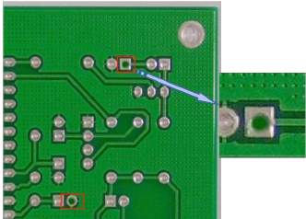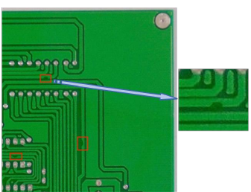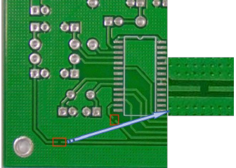
- Missing holes (b) Mouse bite marks (c) Open circuit

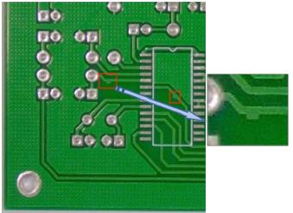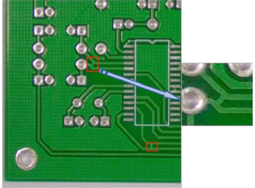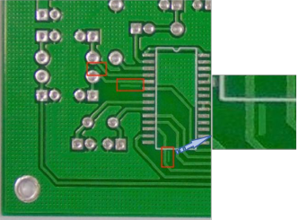
(d) Short circuit (e) Burrs (f) Copper slag
Fig. 1. Six Common Defect Categories
First, a dedicated folder named “data” was created to store PCB defect images, and images of printed circuit boards with defects were selected and placed within it. Through extensive collection efforts, a total of over 1,400 images of defective printed circuit boards were selected. During image collection, each image had a unique filename. To facilitate subsequent data processing, these images were categorized into three sets: test (test), training (train), and validation (val). The filenames of these defective PCB images were annotated accordingly. The data annotation is illustrated in Fig.2.
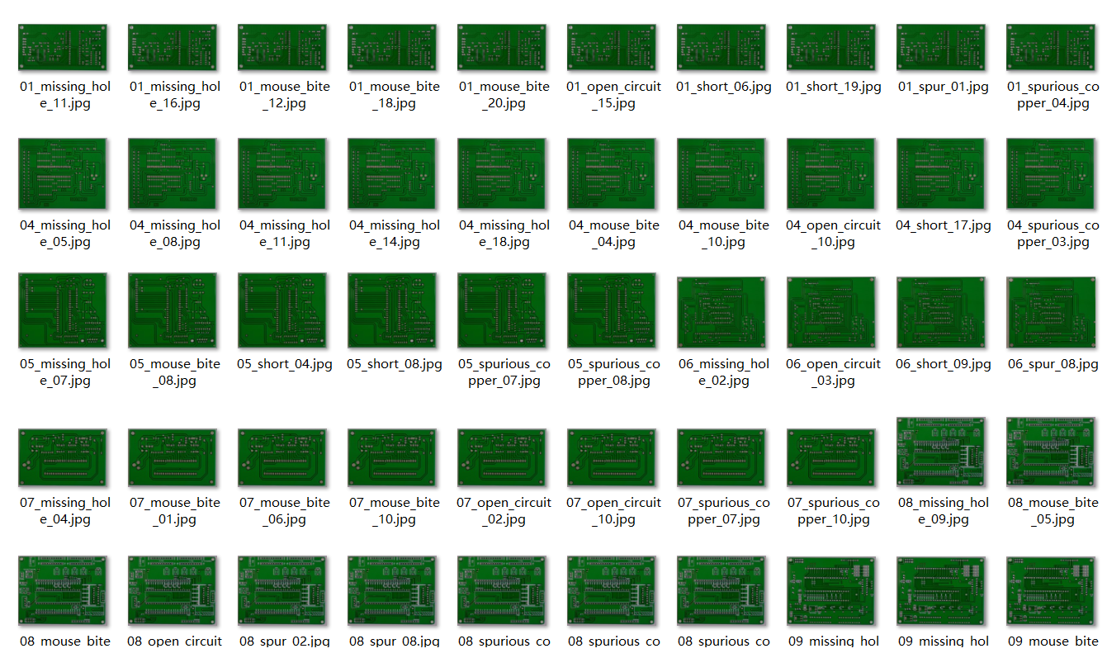
Fig. 2. Image Caption Annotation

3.3 Improved YOLOv8
In recent years, deep learning technologies have achieved breakthrough progress in object detection, with the YOLO series algorithms emerging as mainstream solutions in industrial inspection due to their outstanding real-time performance and detection accuracy. However, in specialized applications like PCB defect detection, the traditional YOLOv8 algorithm faces three critical challenges: (1) Insufficient sensitivity for identifying sub-millimeter-level micro-defects; (2) Interference issues caused by complex circuit texture backgrounds; (3) Misclassification phenomena resulting from the similarity of features across multiple defect categories.
To address these technical bottlenecks, this section proposes an enhanced YOLOv8 algorithm based on the SE (Squeeze-and-Excitation) attention mechanism. This approach dynamically adjusts feature response weights through a channel attention mechanism, significantly improving performance in three key areas: First, the SE module's feature recalibration mechanism effectively enhances the representation capability of minute defects such as missing holes and copper slag. Second, the adaptive background suppression function reduces interference from complex backgrounds like circuit trace textures. Finally, by establishing differentiated representations for defect features, it significantly improves the distinguishability of easily confused defect categories such as burrs and mouse bite marks. Experiments demonstrate that this improved solution maintains the original real-time performance while achieving a slight increase in mean average precision (mAP). It exhibits notable advantages, particularly in addressing critical issues like localization errors, false positives, and false negatives.
The SE (Squeeze and Excitation) attention mechanism ^{[52]} employs a weight distribution approach within channel attention to achieve prioritization by assigning weights across different channels. It assigns higher weights to important features while assigning lower weights or no weights to irrelevant attributes. Based on this, the model focuses on extracting features from regions of interest, ultimately establishing a neural network model with strong robustness. The SE attention mechanism primarily consists of two operations: Squeeze and Excitation.
(1) Squeeze Operation: Employing global average pooling, the spatial dimensions of each channel are compressed to a single order of magnitude, yielding a holistic feature descriptor at the channel level. This operation can be viewed as a global fusion of channel-specific characteristics to derive channel-level statistics.
(2) Excitation Operation: Nonlinear transformations are applied to the compressed features using fully connected layers and activation functions (e.g., Sigmoid). This yields channel-specific weights, which are then used to weight the features. This operation can be interpreted as assigning importance scores to each channel, thereby adjusting the characteristics of each channel accordingly.
By introducing the SE module, the model can focus more on feature channels useful for the task while suppressing irrelevant or noisy channels, thereby enhancing its feature representation capabilities. Fig. 3 shows the flowchart of the SE attention mechanism.
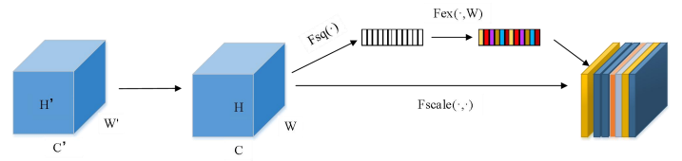

Fig. 3 SE Attention Mechanism Flowchart

Here,${\text{F}}_{\text{sq}}\left(\text{∙}\right)$denotes the feature map compression operation. After obtaining different feature maps, dimensionality reduction is performed via global average pooling, transforming them from size (N, C, H, W) to (N, C, 1, 1). Each channel is represented by a single pixel value, and the compressed feature map is expressed as a vector. This process discards the spatial dimension while preserving the channel dimension, enabling fusion with contextual feature information. The formula is shown in Equation (1).
${\text{z}}_{\text{c}}$ = ${\text{F}}_{\text{sq}}\left(\text{∙}\right)$= $\frac{\text{1}}{\text{H×W}} \sum_{\text{i=1}}^{\text{H}}{\sum_{\text{j=1}}^{\text{W}}{{\text{u}}_{\text{c}}}}\left(\text{i,j}\right)$ (1)

Here, ${\text{Z}}_{\text{c}}$ represents the compressed weight value of the cth channel, ${\text{F}}_{\text{sq}}$ denotes the compression objective function, $\text{W}$ and $\text{H}$ denote the width and height of the feature map, and $\text{i}$ and $\text{j}$ denote the position of a pixel on the feature map.
The ${\text{F}}_{\text{ex}}\left(\text{∙,w}\right)$ operation represents an extraction operation, which generates a weight value for each feature channel from the compressed feature map obtained through the compression operation, thereby calculating the size of the adaptive convolution kernel. The weights for each channel are computed via one-dimensional convolution. Finally, the output values are mapped to the range (0,1) using the sigmoid activation function. The weighted feature map is then multiplied by the original feature map to obtain the feature map under different weighting conditions, as shown in Equation (2).

$\hat{X}$=X$∙σ\left(\hat{Z}\right)$ (2)

Here, $\hat{X}$denotes the feature map representing the weight distribution of each channel after multiplication, where$\text{X}$is the initial channel, $\text{σ}$ represents the activation function $\text{Sigmoid}$, and$\hat{Z}$denotes the weight coefficient of the channel. This SE attention module enables information sharing across the global receptive field, significantly enhancing the model's feature extraction capabilities while improving the network's representational learning efficiency. Specifically, this mechanism first employs global average pooling combined with a fully connected layer to optimize feature representations. Subsequently, it effectively reduces the number of parameters through dimensionality reduction. This design not only minimizes computational overhead but also further enhances the model's overall performance.
To incorporate the Self-Attention mechanism into YOLOv8, we can insert SE modules at key positions within its backbone network and Feature Pyramid Network (FPN). The specific implementation steps are as follows:
(1) Backbone Network Improvement: In the CSPDarknet53 backbone of YOLOv8, selectively add SE modules after certain CSP modules, such as after the last CSP module in each stage.
(2) Feature Pyramid Network Improvement: In the FPN network of YOLOv8, SE modules can be added after each feature fusion layer to enhance the representation capability of features at different scales.
- Experiments
4.1 Experimental setting
The computer operating system used in this experiment is Windows 11. The programming language employed is Python, specifically version 3.8.10. The deep learning framework utilized is PyTorch, version 1.9.0. PyTorch is an open-source deep learning framework developed by an artificial intelligence research team, characterized by its ease of use, straightforward debugging, and efficient GPU utilization.

The parallel computing architecture used in the experiment is CUDA, specifically version 11.1. The integrated development environment (IDE) used is PyCharm, serving as the experimental program's integrated compilation environment. Its workspace interface features a well-organized layout, offering coding assistance and code analysis capabilities that significantly streamline the code writing process. Furthermore, this IDE incorporates extensive built-in toolkit support for convenient access, while effectively scheduling GPU resources to enable efficient parallel computation and maximize hardware computational utilization. The specific configuration of the experimental environment is detailed in Table 1.
Table 1. Experimental Environment Setup
Device Name | Configuration
Processor | Intel(R) Core(TM) i7-10875H CPU @ 2.30GHz 2.30 GHz
Operating System | Windouws11
OS Type | 64-bit operating system
CPU Memory | 16GB
Laptop Memory | 512G
Parallel Computing Architecture | CUDA11.1
Graphics Card | NVIDIA GeForce RTX 2060
Programming Language | Python3.8.10
Integrated Development Environment | Pycharm
Deep Learning Framework | Pytorch 1.9.0
Graphics Memory | 6G
4.2 Parameters
Under consistent experimental conditions, all models were trained on input images of 640×640 pixels and underwent identical training processes, including identical training parameters and a training cycle of 200 epochs. During training on both datasets, all models were configured and optimized according to the settings listed in Table 2.
Table 2 Training Parameter Settings
Parameters | Settings
imgsz | 640
epochs | 200
batch | 2
workers | 0
device | ‘0’
optimizer | ‘SGD’

4.3 Evaluation metrics
(1) Confusion Matrix
The confusion matrix, also known as the error matrix, is primarily used to compare classification results with actual observed values. By incorporating classification accuracy into the confusion matrix, model performance can be intuitively evaluated. Each column represents a predicted category, while each row corresponds to a true category.
Table 3 Confusion Matrix
Confusion Matrix |  | Actual value
 |  | Positive | Negative
Predicted value | Positive | TP | FP
Predicted value | Negative | FN | TN
Table 3 presents the classification statistics of prediction results in the confusion matrix. TP represents the model accurately identifying positive samples; FN represents the model incorrectly identifying positive samples as negative samples. FP indicates the model incorrectly identifying negative samples as positive. TN denotes the model accurately identifying negative samples. From the confusion matrix, four metrics for model evaluation can be derived: Precision, Recall, F1 score, and the PR curve.
(1) Recall rate: The proportion of positive samples to the total number of true positive samples.
$\text{Recall=}\frac{\text{TP}}{\text{TP+FN}}$ (3)
(2) Precision: The proportion of positive samples that are correctly classified as positive by the classifier.
$Precision=\frac{TP}{TP+FP}$ (4)
(3) F1 Score: The harmonic mean of precision and recall.
$F1=2∙\frac{Precision∙Recall}{Precison+Recall}$ (5)
(4) Receiver Operating Characteristic (ROC) Curve: Illustrates the relationship between precision and recall.
The confusion matrix is constructed based on the comparison between the intersection-over-union (IoU) of detection results and a preset threshold. The threshold setting directly influences the statistical distribution of parameters in the confusion matrix (such as true positives, false positives, etc.), thereby significantly affecting the model's precision and recall. As the threshold gradually increases from 0 to 1, precision and recall exhibit an inverse relationship. Plotting this relationship with recall on the x-axis and precision on the y-axis yields the Precision-Recall curve (PR curve). High-performance models typically display a PR curve that bulges upward to the right, indicating the ability to maintain both high precision and high recall simultaneously. Model detection performance can be quantified by calculating the area under the PR curve (Average Precision, AP). A higher AP value indicates stronger recognition capability for that category, making AP a core metric for evaluating single-class detection effectiveness.

$AP=\int_{0}^{1}{p\left(r\right)dr=\sum_{k=1}^{N}{p\left(k\right)Δr\left(k\right)}}$ (6)

Here, p denotes precision; p(r) represents precision as a function of recall. Calculations typically employ discrete summation.
The fundamental formula for Mean Average Precision (mAP) is:
$mAP=\frac{1}{N}\sum_{k=1}^{N}{AP_{k}}$ (7)
Provides a comprehensive evaluation of the model's average detection performance across all categories. When the IoU threshold is set to 0.5, the average AP across all classes is denoted as mAP@0.5. Meanwhile, mAP@[.5:.95] represents the average mAP obtained by averaging the values when the IoU threshold is incrementally increased from 0.5 to 0.95 in 0.05 increments.
We will run all generations of the YOLO series alongside our improved model on the same experimental platform and under identical parameter settings. To more intuitively demonstrate the model's improvements, see Fig. 4.
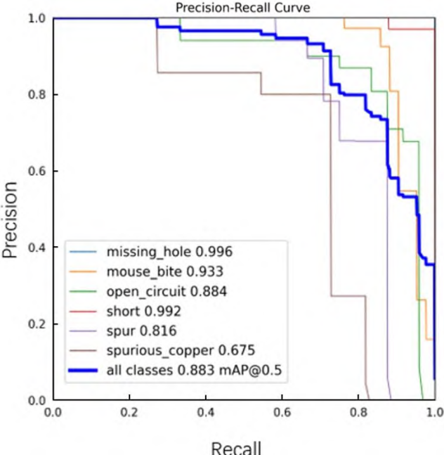
（a）YOLOv5
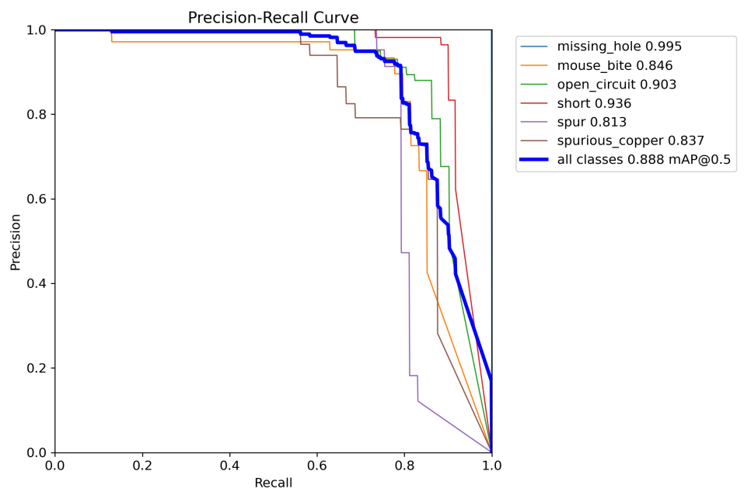

（b）YOLOv8
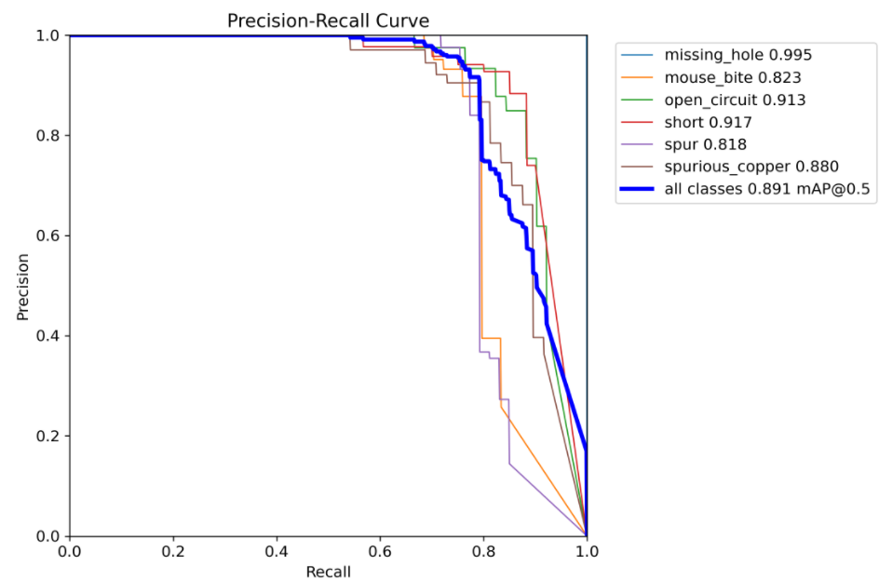
(c) The improved YOLOv8_SE model described herein
Fig. 4 PR Curves for Each Model
As observed in Fig.4, the YOLO series models demonstrate a continuous improvement trend in object detection performance throughout their iterative upgrades. To systematically evaluate the detection performance of the improved model proposed in this paper, we compare it with representative networks such as Faster R-CNN, YOLOv4, YOLOv5s, YOLOv8, and other YOLO variants optimized for detecting small defects on PCBs. The experimental results are shown in Table 4. YOLOv4, due to its excessive parameter count and computational demands, struggles to meet practical hardware deployment requirements. while the lightweight YOLOv5s, despite its lower model complexity, performs poorly on small object detection tasks. Given the small size characteristics of objects in PCB defect detection, existing benchmark models struggle to achieve ideal detection performance requirements.
Table 4: Model Comparison Experiments
Model | mAP@0.5 | P% | R% | FPS
Faster R-CNN | 79.3% | 76.62 | 75.19 | 36.2
YOLOv4 | 83.6% | 82.79 | 82.16 | 42.8
YOLOv5s | 88.3% | 89.47 | 88.43 | 39.7
YOLOv8 | 88.8% | 95.1 | 88.89 | 46.6
Ours | 89.1% | 95.2 | 89.46 | 52.3
Experimental results indicate that despite being a classic two-stage object detection algorithm, Faster R-CNN achieves only 79.3% mAP in PCB small-object defect detection, demonstrating its limited capability for detecting small targets. Moreover, its frame rate of 36.2 FPS indicates relatively slow detection speed, making it unsuitable for small defect detection scenarios. YOLOv4 demonstrates improvements in both mAP and FPS, achieving 83.6% and 42.8 FPS respectively, showcasing superior detection accuracy and speed. However, in PCB small-object defect detection, model size and real-time performance are equally critical. YOLOv4's excessive model parameters hinder its deployability. The YOLOv5s model is the smallest in the YOLOv5 series. Although its mAP value is slightly lower, the reduction in parameters significantly enhances deployability. Compared to YOLOv4, it achieves a 4.7% improvement in mAP and offers a clear advantage in detection speed. However, as model accuracy improves, model size may correspondingly increase, posing challenges for deployment and real-time performance. To further reduce model size and parameters, YOLOv8 achieves a high mAP value while maintaining a remarkable 46.6 FPS based on YOLOv5s. This result enables YOLOv8 to strike a better balance between real-time performance and accuracy in PCB small-object defect detection. As the foundation for the improved model in this paper, YOLOv8 achieved an outstanding mAP of 88.8%. However, in PCB small-object defect detection, its 46.3 FPS and relatively large model size somewhat limit its practical deployment.
The improved YOLOv8_SE model demonstrates exceptional performance in detecting small-target defects on PCBs. It achieves an mAP@0.5 of 89.1%, representing a slight improvement over the original YOLOv8. This indicates the model's enhanced capability to identify defects more accurately and provide precise bounding boxes in PCB small-object defect detection. Furthermore, the improved model attains a frame rate of 51.3 FPS, marking a significant increase compared to the original version. This showcases its excellent real-time performance, enabling rapid processing and detection of input images. Through optimization of the model architecture and parameters, the enhanced YOLOv8_SE reduces the model size and parameter count while maintaining high accuracy. This reduction facilitates easier deployment onto edge devices or embedded systems, meeting the practical requirements for model size and computational resources in real-world applications.
Through in-depth analysis of comparative experimental results, it is evident that the improved YOLOv8_SE algorithm demonstrates significant advantages in detecting small defects on PCBs within complex backgrounds. Compared to the original algorithm and other mainstream object detection algorithms currently available on the market, the enhanced YOLOv8 achieves substantial improvements in detection accuracy. This fully meets the anticipated optimization outcomes for small defect detection on PCBs and fully complies with the stringent requirements of practical application scenarios.
- Conclusions
With the rapid development of the manufacturing industry, the demand for PCBs—an indispensable component in electronic devices—has shown a continuous upward trend. However, during PCB manufacturing, various defects may arise due to multiple factors. These defects not only compromise normal device operation but can also lead to serious safety hazards. PCB defect detection faces several key challenges: On one hand, defects occupy only a small area within the overall layout. On the other hand, the presence of numerous similar features and background interference within images further complicates detection.
First, to enhance the accuracy of PCB defect detection, after comparing with other attention mechanisms such as SBAM and ECA, the attention mechanism SE was selected for integration into the original YOLOv8 model. This choice balanced computational complexity, effectiveness, and versatility, thereby strengthening the original YOLOv8 model's ability to extract features for various types of defects on PCB boards. Subsequently, comparative experiments were conducted between the improved YOLOv8_SE model and other YOLO series models for PCB defect detection. The final experimental results demonstrate that the enhanced YOLOv8_SE model achieves significant improvements over the original YOLOv4, YOLOv5, and YOLOv8 models. It substantially reduces both false negatives and false positives in PCB defect detection, effectively boosting the overall performance of the PCB defect detection system.
Although improvements to the YOLOv8 model have enhanced accuracy and speed in PCB defect detection, there remains significant room for further refinement. Therefore, subsequent research can continue to optimize in the following directions:
(1) This paper introduces the attention mechanism model SE. Based on this, efforts should be made to compress the model through operations such as quantization and model pruning. This will further reduce storage requirements on devices, decrease computational load and complexity, and enhance model inference speed.
(2) In the PCB defect detection studied here, the primary targets are six common defects found in PCBs. However, in actual production applications, PCB defects are not limited to the bare board manufacturing stage; subsequent processes like assembly and transportation may also cause damage. Therefore, future research could focus more on other types of PCB defects.
(3) In real industrial settings, production environments are more complex and variable. Factors like lighting and noise may affect detection outcomes, leading to reduced accuracy. Future work should incorporate these environmental complexities and explore enhancing model robustness in challenging conditions to ensure stable detection performance.

Disclaimer (Artificial intelligence)
Option 1:
Author(s) hereby declare that NO generative AI technologies such as Large Language Models (ChatGPT, COPILOT, etc.) and text-to-image generators have been used during the writing or editing of this manuscript.
Option 2:
Author(s) hereby declare that generative AI technologies such as Large Language Models, etc. have been used during the writing or editing of manuscripts. This explanation will include the name, version, model, and source of the generative AI technology and as well as all input prompts provided to the generative AI technology
Details of the AI usage are given below:
1.
2.
3.

References
- Gong Yonglin.[J]. Printed Circuit Information, 2023, 31(11): 1-7.
- Li Lei.Application Research on PCBA Defect Detection Based on AOI [D]. Beihua University of Aeronautics and Astronautics, 2023.
- Li Neng, Peng Heping. Machine Vision Inspection Method for Dimensions and Errors of Retaining Ring Parts [J]. Metrology and Testing Technology, 2023, 50(11): 9-12.
- Park J H, Kim Y S, Seo H, et al. Analysis of training deep learning models for pcb defect detection[J]. Sensors, 2023, 23(5): 2766.
- Xiao, Chengcheng. Research on Hierarchical Loss Functions for Lightweight Convolutional Neural Networks in Image Classification [D]. China University of Mining and Technology, 2023.
- Raj A, Sajeena A. Defects detection in PCB using image processing for industrial applications[C]//2018 Second International Conference on Inventive Communication and Computational Technologies (ICICCT). IEEE, 2018: 1077-1079.
- Kaur K. Various techniques for PCB defect detection[J]. Int. J. Eng. Sci, 2016, 17: 175-178.
- Srimani P K, Prathiba V. Adaptive data mining approach for PCB defect detection and classification[J]. Indian journal of science and technology, 2016, 9(44): 1-9.
- Lu Z, He Q, Xiang X, et al. Defect detection of PCB based on Bayes feature fusion[J]. The Journal of Engineering, 2018, 2018(16): 1741-1745.
- Kim J, Ko J, Choi H, et al. Printed circuit board defect detection using deep learning via a skip-connected convolutional autoencoder[J]. Sensors, 2021, 21(15): 4968.
- Yuk E H, Park S H, Park C S, et al. Feature-learning-based printed circuit board inspection via speeded-up robust features and random forest[J]. Applied Sciences, 2018, 8(6): 932.
- Raihan F I, Ce W. PCB defect detection USING OPENCV with image subtraction method[C]//2017 International Conference on Information Management and Technology (ICIMTech). IEEE, 2017: 204-209.
- Huang W, Hua G, Yu Z, et al. Recurrent spatial transformer network for high‐accuracy image registration in moving PCB defect detection[J]. The Journal of Engineering, 2020, 2020(13): 438-443.
- Liu Z, Qu B. Machine vision based online detection of PCB defect[J]. Microprocessors and Microsystems, 2021, 82: 103807.
- Onshaunjit J, Srinonchat J. Algorithmic Scheme for Concurrent Detection and Classification of Printed Circuit Board Defects[J]. Computers, Materials & Continua, 2022, 71(1).
- Bártová B, Bína V. A novel data mining approach for defect detection in the printed circuit board manufacturing process[J]. Engineering Management in Production and Services, 2022, 14(2): 13-25.
- Augustauskas R, Zabulis L, Lipnickas A, et al. Defects localization in images using deep learning-based classification with CAM output[C]//2023 IEEE 12th International Conference on Intelligent Data Acquisition and Advanced Computing Systems: Technology and Applications (IDAACS). IEEE, 2023, 1: 487-492.
- Luo C, Chen S, Wang K, et al. PCB surface defect detection based on TPBAS-YOLOv5[C]//2023 IEEE 3rd International Conference on Digital Twins and Parallel Intelligence (DTPI). IEEE, 2023: 1-6.
- Li Y T, Kuo P, Guo J I. Automatic industry PCB board DIP process defect detection system based on deep ensemble self-adaption method[J]. IEEE Transactions on Components, Packaging and Manufacturing Technology, 2020, 11(2): 312-323.
- Fridman Y, Rusanovsky M, Oren G. ChangeChip: A reference-based unsupervised change detection for PCB defect detection[C]//2021 IEEE Physical Assurance and Inspection of Electronics (PAINE). IEEE, 2021: 1-8.
- Chung S T, Hwang W J, Tai T M. Keypoint-based automated component placement inspection for printed circuit boards[J]. Applied Sciences, 2023, 13(17): 9863.
- Pham T T A, Thoi D K T, Choi H, et al. Defect detection in printed circuit boards using semi-supervised learning[J]. Sensors, 2023, 23(6): 3246.
- Chen I C, Hwang R C, Huang H C. PCB defect detection based on deep learning algorithm[J]. Processes, 2023, 11(3): 775.
- Adibhatla V A, Huang Y C, Chang M C, et al. Unsupervised anomaly detection in printed circuit boards through student–teacher feature pyramid matching[J]. Electronics, 2021, 10(24): 3177.
- Ling Q, Isa N A M. Printed circuit board defect detection methods based on image processing, machine learning and deep learning: A survey[J]. IEEE access, 2023, 11: 15921-15944.
- Zhang Bo, Li Ruihua, Peng Niancai et al. Research on Visual Inspection Technology for PCB Defects Based on Wavelet Transform [J]. Journal of System Simulation, 2004, (08): 1864-1866.
- Guo Shigang. PCB Defect Detection Algorithm Based on Travel Encoding [J]. Computer Applications, 2009, 29(09): 2554-2555.
- Ma Can, Mao Jianxu, Shao Minsi. Research and Implementation of a Visual Sensor-Based PCB Defect Detection System [J]. Application of Electronic Technology, 2012, 38(06): 129-131.
- Guo Fenglin, Guan Shuan, Kong Yan. Research on AOI-Based Printed Circuit Image Alignment Algorithm [J]. Chinese Journal of Engineering Science, 2012, 14(11): 103-106.
- Wang Dong, Xie Zexiao. Rapid PCB Defect Detection Technology Based on Morphology [J]. Computer Science, 2016, 43(S1): 184-186+225.
- Wang Yongli, Cao Jiangtao, Ji Xiaofei, et al. Convolutional Neural Network-Based PCB Defect Detection and Recognition Algorithm [J]. Journal of Electronic Measurement and Instrumentation, 2019, 33(8): 2019,33(8):78-84
- Liu Xiaoyan, Li Zhaoming, Duan Jiaxu et al. Convolutional Neural Network-Based Detection and Localization Method for Color-Ring Resistors on Printed Circuit Boards [J]. Transactions of Electronics and Information Technology, 2020,42(09):2302-2311.
- Wang Yuping, Guo Fenglin. Key Technologies for Machine Vision-Based PCB Defect Detection Systems [J]. Science and Technology Bulletin, 2017, 33(01): 101-105.
- Zhou Y, Yuan M, Zhang J, et al. Review of vision-based defect detection research and its perspectives for printed circuit board[J]. Journal of Manufacturing Systems, 2023, 70: 557-578.
- Hu Shanshan, Xiao Yong, Wang Baoshuai et al. Research on PCB Defect Detection Based on Deep Learning [J]. Electrical Measurement and Instrumentation, 2021, 58(03): 139-145.
- Lu Xiaokang, Ouyang Huabing, Chen Tian et al. Deep Learning-Based PCB Solder Defect Detection [J/OL]. Radio Engineering, 1-8 [2023-12-29]
- Wu Jigang, Cheng Yuan, Shao Jun et al. Research on PCB Defect Detection Based on an Improved YOLOv4 Algorithm [J]. Journal of Instrument and Measurement, 2021, 42(10): 171-178.
- Sharma V K, Dhiman P, Rout R K. Improved traffic sign recognition algorithm based on YOLOv4-tiny[J]. Journal of Visual Communication and Image Representation, 2023, 91: 103774.
- Hu Jiangyu, Jia Shulin, Ma Shuangbao. PCB Surface Defect Detection Algorithm Based on Improved Cascaded Faster RCNN [J]. Instrumentation Technology and Sensors, 2022, (07): 106-110+126.
- Bian Baicheng, Chen Tian, Wu Rujun et al. PCB Defect Detection Algorithm Based on Improved YOLOv3 [J]. Journal of Zhejiang University (Engineering Science), 2023, 57(04): 735-743.
- Wang G, Yang W, Liu Y, et al. Potato malformation identification and classification based on improved YOLOv3 algorithm[J]. Electronics, 2023, 12(21): 4461.
- Shi Zhaoxiong, Mao Zhengchong. PCB Defect Detection Method Based on Improved YOLOv5 [J]. Electronic Measurement Technology, 2023, 46(14): 123-130.
- Hao S, Zhao Q, Ma X, et al. YOLO-MSFR: real-time natural disaster victim detection based on improved YOLOv5 network[J]. Journal of Real-Time Image Processing, 2024, 21(1): 7.
- Hu Xin, Hu Shuai, Ma Lijun et al. A PCB Defect Detection Method Based on MBAM and YOLOv5 Fusion [J/OL]. Journal of Graphics and Imaging, 1-9 [2023-12-29]
- Hu Lanlan, Deng Chao. A PCB Defect Detection Algorithm Based on SimAM-YOLOv5s [J/OL]. Radio Engineering, 1-10 [2023-12-29].
- Zhang Yinsheng, Yang Yulong, Ji Ru et al. Surface Defect Detection of Wind Turbines Using an Improved YOLOv5s [J]. Journal of Electronic Measurement and Instrumentation, 2023, 37(01): 40-49.
- Qian Wanming, Zhu Hongping, Zhu Hongzhi et al. Research on PCB Bare Board Defect Detection Based on Adaptive Weighted Feature Fusion [J]. Journal of Electronic Measurement and Instrumentation, 2022, 36(10): 92-99.
- Wu Yunfeng. Research on Deep Learning-Based Classification Algorithms for Medical CT Images of Pneumonia [D]. Fujian: Fujian University of Traditional Chinese Medicine, 2021. DOI: 10.27021/d.cnki.gfjzc.2021.000011.
- Gurcan M N, Sahiner B, Petrick N, et al. Lung nodule detection on thoracic computed tomography images: Preliminary evaluation of a computer‐aided diagnosis system[J]. Medical Physics, 2002, 29(11): 2552-2558.
- Lin H, Satapathy S C, Rajinikanth V. Medical Data Assessment with Traditional, Machine-learning and Deeplearning Techniques[J]. Current Medical Imaging Reviews, 2020, 16(10): 1185-1186.
- Li C J, Qu Z, Wang S Y, et al. A method of defect detection for focal hard samples PCB based on extended FPN model[J]. IEEE Transactions on Components, Packaging and Manufacturing Technology, 2021, 12(2): 217-227.
- Hu J, Shen L, Sun G. Squeeze-and-excitation networks[C]//Proceedings of the IEEE conference on computer vision and pattern recognition. 2018: 7132-7141.

