Original Research Article
Preserving Heritage Through Design: Sustainable Interventions for Revitalizing the Terracotta Craft and Empowering the PAAL Artisans of Murarikati, Bangladesh

Abstract:
Terracotta, which translates from Italian as "burnt clay", has long been woven into the fabric of ancient cultures and remains a vital material cherished for its historical and architectural significance. In the heart of South Asia, the dedicated PAAL artisans from Murarikati, Kolaroa, and Shatkhira have lovingly upheld their ancestral craft for generations, creating beautiful terracotta pieces since before 1947, once reaching customers around the globe. Among artisan villages in Bangladesh, the clay communities, locally known as Paal para, are notable for their distinctive pottery and terracotta traditions, tracing their heritage to the Pala Dynasty (8th–12th century AD), a period renowned for flourishing arts in architecture, sculpture, and painting. Terracotta products remain integral to local culture, serving ritualistic, decorative, and utilitarian purposes. However, the rapid pace of urbanization and industrial growth, along with the shift towards modern building materials, has led to a decline in demand, putting the rich legacy of PAAL craftsmanship and the livelihoods of these skilled artisans at risk.
The article examines the diverse issues of the artisans, like diminishing workspaces, industrial competition, increased cost of production, the seasonal character of work, and the inadequacy of infrastructural facilities like drying sheds, storage, and approach roads. Scanty vocational training, sparse promotional opportunities, and a lack of adequate community facilities—as the homebound women artisans suffer more especially—also contribute to their socio-economic marginalization.
Through a design-based research approach, the paper proposes sustainable interventions to revitalize terracotta craft and strengthen the socio-economic resilience of the PAAL community. Strategies include re-establishing terracotta’s professional and cultural reputation, integrating vocational training, enhancing trade networks, modernizing production systems, and improving community-level infrastructure. The proposed interventions aim to foster an environmentally responsible and economically viable terracotta industry that preserves cultural heritage, empowers artisans, and positions the PAAL community within contemporary markets.

Keywords:
PAAL Artisans in Murarikati, Sustainable Interventions, Terracotta Heritage, Cultural Preservation, Community Resilience, Socio-Economic Empowerment, Design for Development

Introduction
Terracotta, derived from the term meaning "burnt clay," has played a crucial role in architecture for centuries. This raw material occurs naturally and is made up of clay-related ceramics that are subjected to heat under high temperatures, producing a durable and aesthetically pleasant material (Britannica, n.d.). Its versatility has made it a favorite material for many ancient civilizations, such as the Greeks, the Romans, the Egyptians, and South Asian civilizations, especially the Indian subcontinent (Visual-Arts Cork, n.d.; Banglapedia, 2015). Terracotta, throughout history, has been employed for a variety of purposes, ranging from pottery and sculptures to tiles and bricks and ornate architectural elements (Uddin, 2007). The significance of terracotta transcends its practical applications and natural production; it is deeply intertwined with cultural heritage and identity.
The importance of terracotta within the field of architectural heritage is especially significant. The material can be seen within the development of roofing tiles, ornamenting features, and entire temples. In the ancient city of Babylon, for example, terracotta was used for the development of imposing walls (Britannica, n.d.). Likewise, the Terracotta Army within China illustrates the material's importance for the cultural expression of a society (Visual-Arts Cork, n.d.). In addition, the usage of terracotta also extends toward religious applications where it is an integral part of ritual and cultural edifices within many parts of the world (Banglapedia, 2015; Asia InCH, n.d.).
In Bangladesh, many villages exemplify rural tranquility, yet certain potter communities, locally known as Paal para, stand out for their distinctive clay craft traditions. These communities, renowned for pottery and terracotta works, trace their heritage to the Pala Dynasty (8th–12th century AD), a period marked by flourishing arts in architecture, sculpture, and painting. Clay products remain an integral part of local culture, serving ritual, decorative, and utilitarian purposes. The Paal community, traditionally Hindu and classified as Sudra, historically played a crucial cultural and economic role, producing religious statues, ceremonial items, and household products. During the zamindari period, their craftsmanship supported middle-class families and contributed to local economies (Dhar, Chawla, & Mulchandani, 2024; Anwar, 2012). Following the decline of zamindari, potters shifted to everyday household products and, later, commercially viable items such as exportable tiles, reflecting adaptive strategies for financial survival (Kiradoo, Ashifa, & Aliyev, 2022). Despite their resilience, the Paal community has faced social neglect and economic challenges, including declining market demand and limited opportunities for social mobility. This has led to both identity and economic crises, prompting artisans to balance tradition with contemporary livelihood needs. Today, while Paal communities are dispersed across Bangladesh, the group in Murarikati, Shatkhira, remains particularly notable for preserving traditional clay artistry.
PAAL artisans at Murarikati, within the jurisdiction of the Kolaroa upazilla of Satkhira district, Bangladesh, commenced their work on terracotta crafts prior to the year 1947. The artisans are recognized for their immense skill in producing elaborately designed taali or roof tiles, religious figures, and other decorative items. Their products were known worldwide in the past, and more especially in Italy, early within the first decade of the 2000s, when their terracotta sculptures were exported and, therefore, attracted worldwide interest in their artisans. Murarikati artisans have been dedicated to upholding an immense tradition of terracotta crafts passed down through generations of their people. The tradition runs deep among the people, where the artisans make their artistic items from readily available materials such as clay sourced from the nearby Betraboti river.
Over the past decades, the PAAL community has faced numerous challenges, notably because of urbanization and industrialization. The market for terracotta reduced considerably because of the development of modern building materials, and it threatens the sustainability of the craft and the financial stability of the artisans (Bproperty, 2022). However, the PAAL community has been determined to maintain their culture, and they aim to restore the previous status of their craft.
The artisans associated with PAAL are presently encountering numerous obstacles that impede their capacity for sustainable success. The phenomena of urbanization and industrialization have led to the proliferation of mass-produced, factory-manufactured goods that supersede the demand for traditional handmade terracotta (Asia InCH, n.d.; Banglapedia, 2015). The changing situation has led to a noticeable decline in the demand for artisanal terracotta, creating challenges for the PAAL artisans as they navigate a more competitive environment. Additionally, rising production costs, limited access to new technologies, and the departure of younger generations from the craft have made it even more difficult for the community of artisans to sustain their numbers and keep their traditions alive. In addition, the absence of adequate infrastructure—such as spaces for drying, facilities for storage, and service roads—has rendered it increasingly challenging for artisans to manufacture and market their products effectively. Collectively, these difficulties have intensified the socio-economic struggles experienced by the PAAL community.
This study aims to delve into the challenges faced by the PAAL artisans, shedding light on their struggles and aspirations. It seeks to propose thoughtful and sustainable design strategies that could breathe new life into the terracotta craft, ultimately uplifting the socio-economic conditions of these skilled artisans. The research will explore the intricacies of their production process, identify ways to improve their working environment, and advocate for the adoption of sustainable practices in their craft. By focusing on reducing environmental impact, enhancing their visibility in the market, and offering vocational training, this study aspires to empower the artisans, helping them reclaim their heritage and secure a brighter future for their craft and community.

Background and Possibilities for Sustainable Revitalization

Socio-Economic and Cultural Significance of the PAAL Community’s Craftsmanship
The PAAL community at Murarikati, Shatkhira (Figure 1) is one of the few remaining artisan groups in Bangladesh that continues producing terracotta through traditional methods. The craftsmanship within this community is deeply intertwined with a rich cultural legacy that has been passed down through generations. The production of terracotta tiles, sculptures, and other decorative elements has granted the community commercial viability for decades.
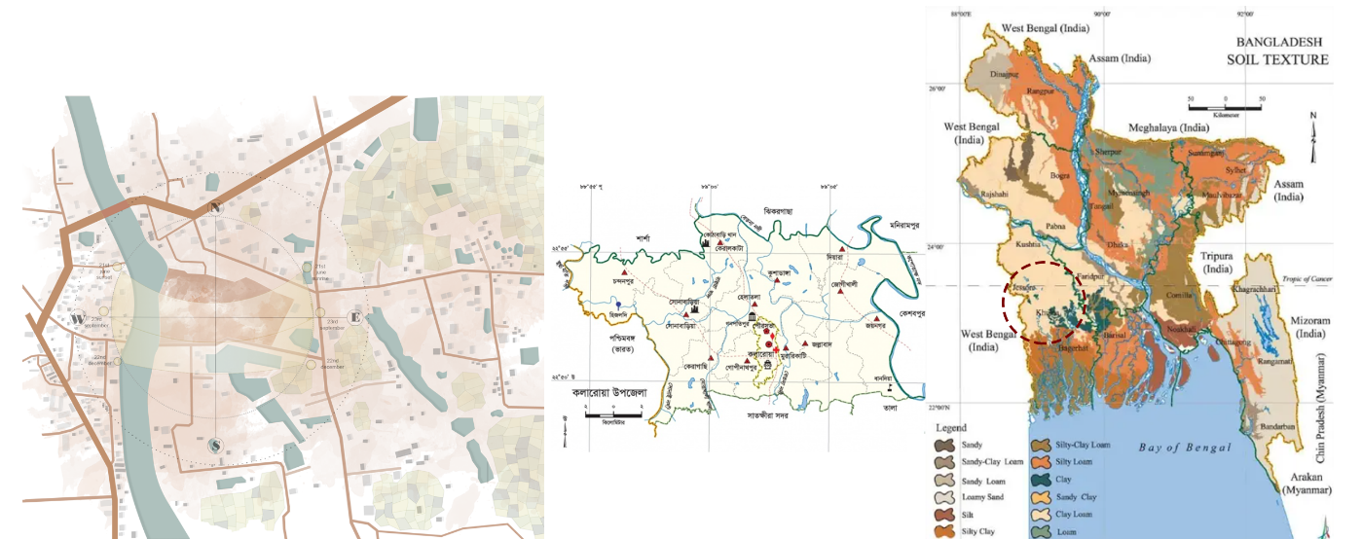

Figure 1: Location map of Murarikati in Bangladesh study area.
Source: Author and https://ontheworldmap.com/

The availability of raw materials such as clay and the waters of the nearby Betraboti River has thus made this region specifically favorable for the manufacturing of terracotta. In the past, craftspeople working for PAAL have produced their materials for such terracottas that were complex and durable and gained global recognition (Figure 2). In the year 2003, PAAL craftspeople embarked on the export of their terracottas back to Italy, marking a landmark moment for their global recognition. However, since the need for the traditional terracottas decreased as a result of industrialization, the group has faced numerous socio-economic challenges.
Today, PAAL artisans face an economically unstable situation, where many of the artisans struggle to support their livelihoods. Importantly, the younger population has moved into the city for better opportunities, leaving a widening gap between the traditional craftsmanship and the more recent technologically informed methodologies. Therefore, the PAAL population faces the shortage of working artisans, and their once-thriving craftsmanship is under threat of extinction.
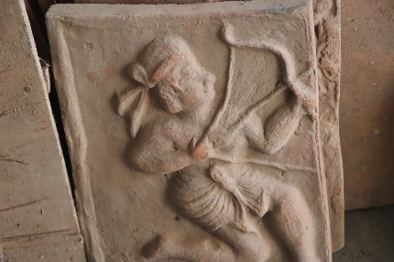
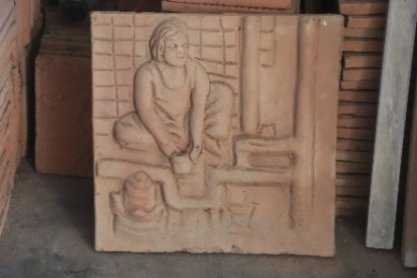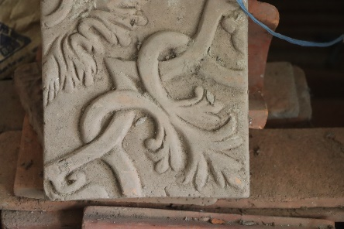
Figure 2: Terracotta production in recent times (Source: Author)

Global Challenges to Traditional Artisan Communities
PAAL artisans' struggles are part of broader global trends related to the decline of traditional crafts. In many places, urbanization and industrialization processes have driven artisan populations into the margins, where mass-produced items and modern building materials increasingly dominate the marketplace for handmade crafts (Figure 3). These changes have diminished the cultural appropriateness and the financial viability of traditional crafts.
The process of globalization has further muddled the working framework. While it has opened doors to international markets, it has also subjected these skilled individuals to fierce competition from cheaper, mass-produced goods. Experts highlight that inadequate infrastructure, a lack of vocational training, limited access to technology, and insufficient institutional or financial backing hinder artisans' ability to adapt to changing circumstances (Bishnoi, Kapoor, & Guru, 2024, Islam & Burmester, 2020). In the Indian subcontinent, these challenges have been particularly pronounced, resulting in diminished product quality, the erosion of traditional knowledge, and limited market access (Mohapatra & Dash, 2011). The PAAL community of Murarikati exemplifies these issues, characterized by outdated production techniques, minimal government assistance, and a decline in the passing down of knowledge from one generation to the next.
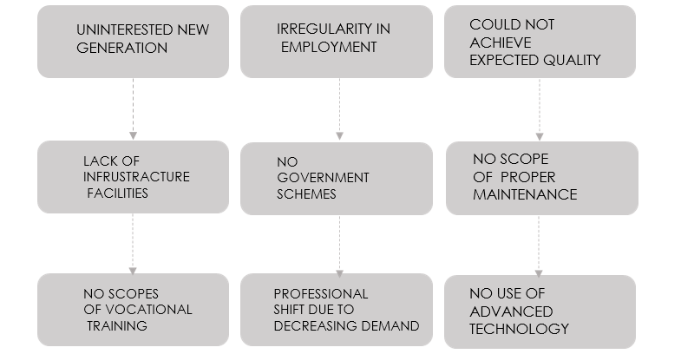
Figure 3: Problems faced by artisans around the world due to urbanization and industrialization

Pathways Through Sustainable Design and Community Development
In the midst of such challenges, sustainable design and robust community engagement become not just important but essential mechanisms for preserving and revitalizing traditional crafts—terracotta in particular, as shown in Figure 4. By integrating ecologically responsible technologies such as energy-efficient kilns or solar-firing methods, communities are able both to lessen environmental harm and to root these age-old practices more firmly within the context of today’s climate awareness (Kesaboina, Tiwar, & Sade, 2024).
It is equally significant to reconsider the sourcing of raw materials. Prioritizing indigenous, sustainable resources not only supports local economies but also reduces transportation emissions and reinforces cultural identity within the production process. Furthermore, innovative strategies like adopting fully biodegradable packaging and implementing closed-loop indigenous production cycles extend environmental consideration beyond mere creation and into the lifespan and eventual disposal of these crafts.
Taken together, these efforts don’t simply minimize ecological footprints—they forge meaningful continuities between cultural heritage, social responsibility, and economic viability. In fostering community ownership of both the process and its ecological impact, sustainable design ensures the relevance of terracotta crafts in the present while safeguarding them for the future.





Quality of life
Security
Participation
Social capital
Social welfare

Figure 4: Indicators of sustainable community development (adapted from Alanaa et al., 2019).
Social and economic interventions play an undeniably crucial role in fostering community resilience. Investments in vocational training, improved infrastructure, and better access to markets enable artisans to meet modern-day challenges more effectively. Additionally, the creation of specialized community centers—spaces dedicated to collaboration, exhibitions, and cultural exchange, as highlighted by Berger (2020) and Jiawei and Sangiamvibool (2025)—has emerged as a key strategy for driving innovation and ensuring the ongoing preservation of intangible cultural heritage. Collectively, these measures create a robust framework that not only protects traditional crafts from global pressures but also helps sustain artisans’ livelihoods into the future.

Conservation of Community Based Heritage in the Context of South Asia
Studies and practical examples indicate that heritage conservation requires deeper and more immersive engagement than simply romanticizing the concept (Coningham & Lewer, 2019; Younus, Gulzar, & Khan, 2025). Community-based heritage conservation is particularly nuanced, as it raises questions about whether heritage should always be “preserved” using traditional methods, or if modern approaches are sometimes necessary to ensure the survival and well-being of the community. Evidence from South Asia suggests that a straightforward, conventional approach to conservation may not always be appropriate. Heritage must be valued by communities and remain relevant in contemporary contexts (Younus, Gulzar, & Khan, 2025).
Consequently, conservation should not be reduced to merely “arresting decay,” “freezing time,” or restoring heritage to a perceived past glory. Instead, it should aim to maintain the essence of heritage while enhancing its significance for both present and future generations (Coningham & Lewer, 2019). This perspective calls for a contextual rethinking of heritage concepts and the strategies employed for its conservation. Effective conservation requires sensitive management that incorporates economic, social, and environmental sustainability. Interventions should facilitate the continuation of cultural practices and active engagement with heritage, rather than focusing solely on material preservation. While South Asia demonstrates diverse approaches to heritage conservation, similar variations are observed globally, highlighting the universality of diverse conservation practices (Coningham & Lewer, 2019; Younus, Gulzar, & Khan, 2025).

Methodology
Data collection involved on-site visits, direct interviews with PAAL-affiliated artisans, and questionnaires distributed among community members. The researchers’ primary objective was to investigate the socio-economic context, identify infrastructural challenges, and explore artisans’ perspectives on their current careers and potential future opportunities. Interviews also included community leaders, aiming to deepen understanding of the prevailing issues and to solicit possible solutions.
Findings presented a concerning scenario. Information from interviews and questionnaires indicated a noticeable decline in income levels, fewer available workstations, and minimal access to updated training methods or technological advancements. Artisans expressed significant concern about the sustainability of their crafts, citing threats such as environmental hazards, outdated production processes, and inadequate communal infrastructure. Furthermore, insufficient vocational training and limited career progression avenues were seen as considerable barriers, hindering these artisans from expanding their market reach or improving their financial situations.
A sustainable design framework is developed to address the problems faced by the PAAL artisans through design research. The framework consists of strategies for improving the production process, supplementing community resources, and incorporating sustainable approaches within the craft production. The key elements for consideration include reducing the environmental impact, enabling artisans through education and market access, and improving the quality of life for the artisans through basic amenities and social services.

Challenges Faced by the PAAL Community

Reduction in Workstations and Limited Exposure to Technological Advancements
The number of working workstations in Murarikati has also undergone a remarkable decline—from 41 to just 14—due to competition from large industries and the outward migration of younger artisans to the towns. It has restricted the scope of jobs, accelerated the loss of skills, and reduced the socio-economic base of the community further. In addition, the artisans receive little exposure to up-to-date technology or improved production techniques, which thus inhibit their ability to be competitively effective within the contemporary marketplace (Figure 5). Inadequate shaded storage for material and cramped workspace further hamper efficiency, and the heavy reliance upon the climatic factor, more pronounced throughout the rainy period, often results in production being delayed.
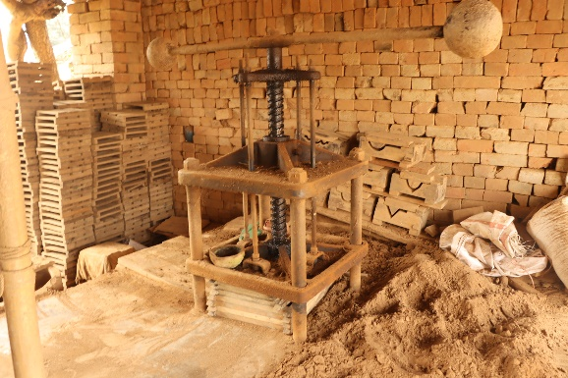
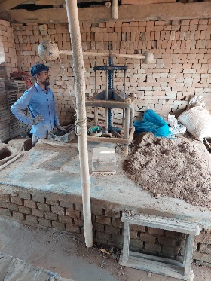
Figure 5: Outdated condition of the existing workspace (Source: Author)

Inadequate Infrastructure
Infrastructure remains one fundamental obstacle for the PAAL community. Inadequate storage facilities, drying sheds (Figure 6), and access roads seriously affect the efficiency of production and quality of output. Raw materials and final output are often exposed to undesirable weather, thus making them very prone to damage. Production halts for the entire monsoon period because there are insufficient proper drying and storage facilities.
The currently running kilns are obsolete, largely relying on wood as fuel and lacking facilities for controlling the temperatures. In such ineffective kilns, not only is the quality of the output compromised, but a lot of smoke is produced (Figure 6), leading to an unhealthy working environment and contributing heavily to carbon emissions. In addition, the storage warehouses are unsafe and overfilled, often experiencing rainwater intrusion that compromises finished terracotta products.
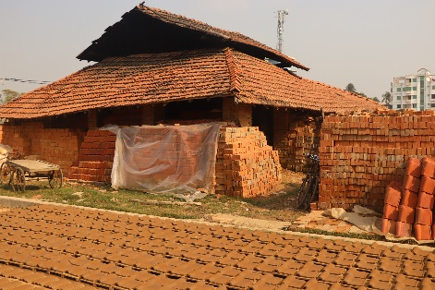
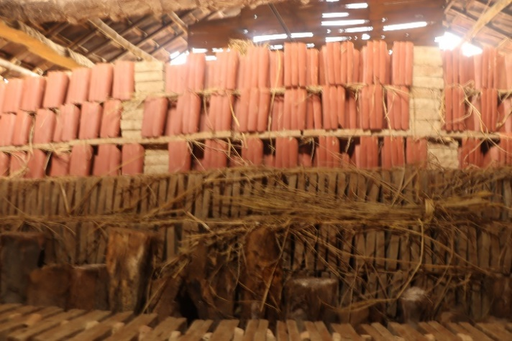
Figure 6: Situation of existing kiln and storage facilities. (Source: Author)

Limited Vocational Training and Market Opportunities
Inadequate vocational training programs prevent artisans from acquiring new skills or retooling established techniques to meet the standards of the present day. Therefore, the process of production remains inefficient, and product quality remains quite disparate. In addition, artisans face little access to markets and underperforming marketing opportunities, which inhibit their capacity for expanding their customer base or garnering higher earnings.
Poor branding, packaging, and online marketing also put them at a disadvantage regarding their competitiveness over mass commodities. Most artisans are also unaware of government programs, funding support programs, or cooperative agreements that can assist their craftsmanship and source of livelihood.

Environmental and Health Hazards
Traditional firing techniques mainly employ wood and cow-dung cakes, hence extensive deforestation, carbon emissions, and environmental degradation (Figure 7). Inefficiencies of the suboptimum designs of the kiln lead to excessive smoke emissions and, hence, health hazards like respiratory ailments and eye irritation for the artisans. The practices are non-environmentally sustainable and socially irresponsible, thus the an urgent need for cleaner and more environmentally friendly technologies.
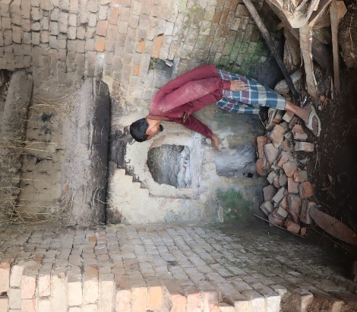
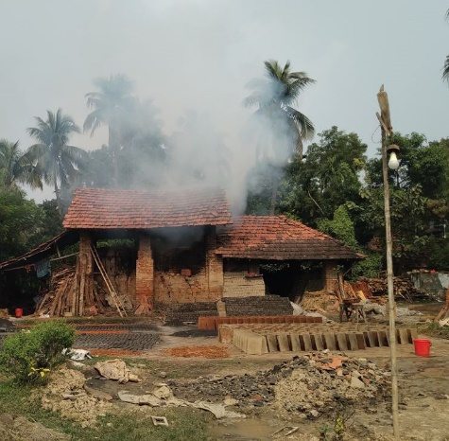
Figure 7: Cutting down trees for kiln fuel and resulting carbon emissions. (Source: Author)

Outdated and Unhygienic Work Processes
Production strategies utilized by the PAAL community are characterized by their obsolescence and failure to adhere properly to fundamental rules of hygiene (Figure 8). A lack of contemporary tools and machines prolongs production times, increases inefficiencies, and degrades the quality of final goods. Inefficient workflow and inappropriate health and safety standards deter the productivity and overall hardiness of artisans. Older methods, therefore, put PAAL artisans at a disadvantage compared to industrial producers who enjoy mechanized, efficient, and sustainable manufacturing strategies.
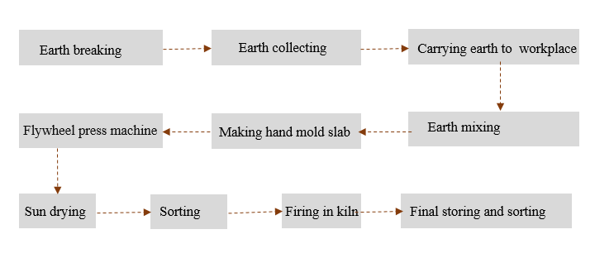
Figure 8: Existing inefficient workflow.

Design Recommendations
This paper proposes a multifaceted design approach for the challenges and the potential of the PAAL artisan community of Murarikati, Bangladesh. The recommendations narrow down to three core goals: implementing a viable production system, enhancing community facilities, and promoting socio-economic development (Figure 9). Based on site analysis, existing grievances, and the local populace’s needs, a master plan was prepared for the development of the site to guide a set of design interventions to focus on. These design interventions and considerations have been captured in Figure 10.
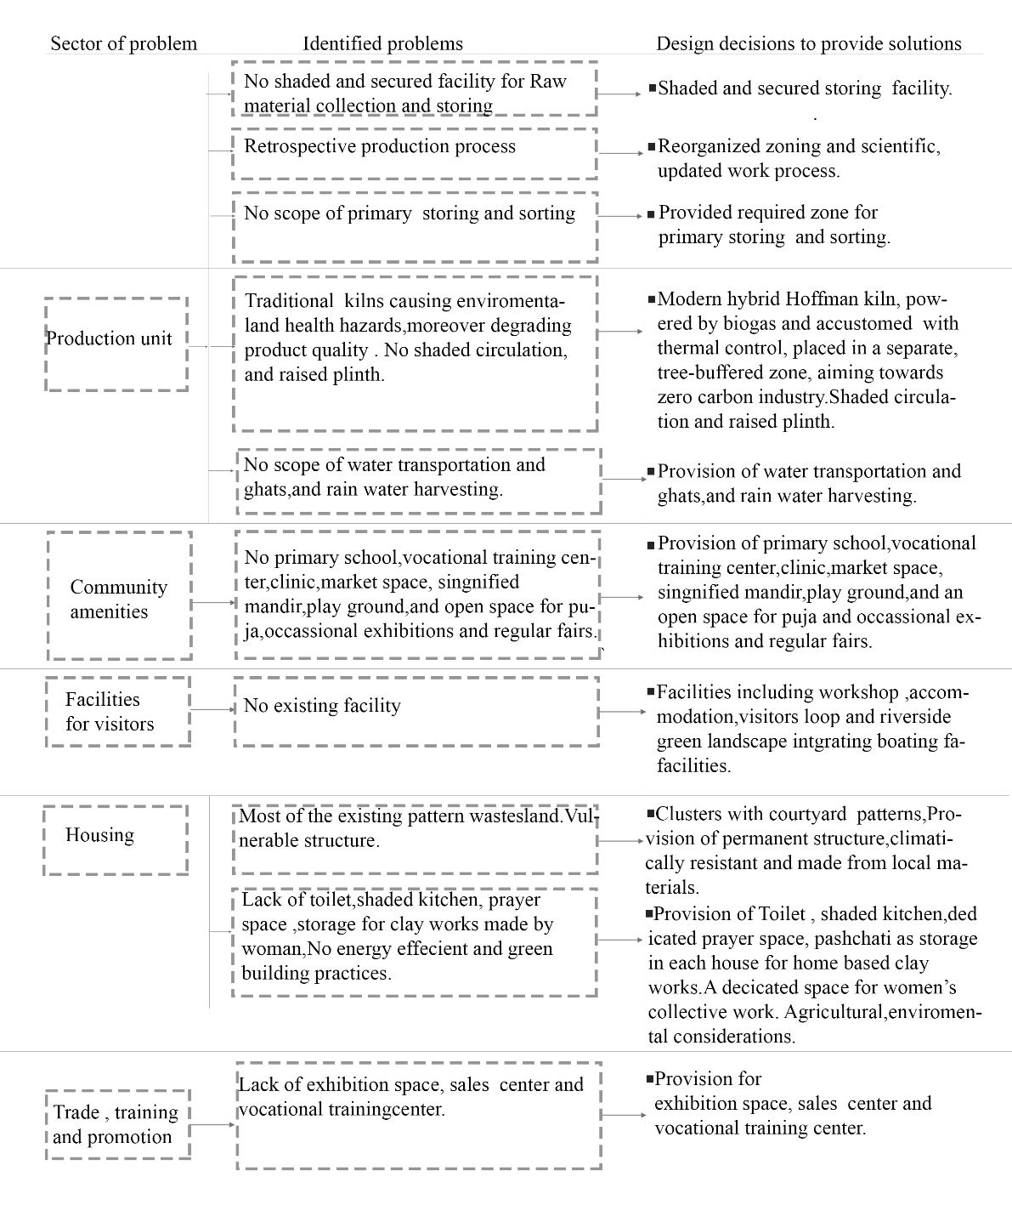
Figure 9: Process of design evaluation following the identified problem after analyzing the existing situation, site context, and demands of local people
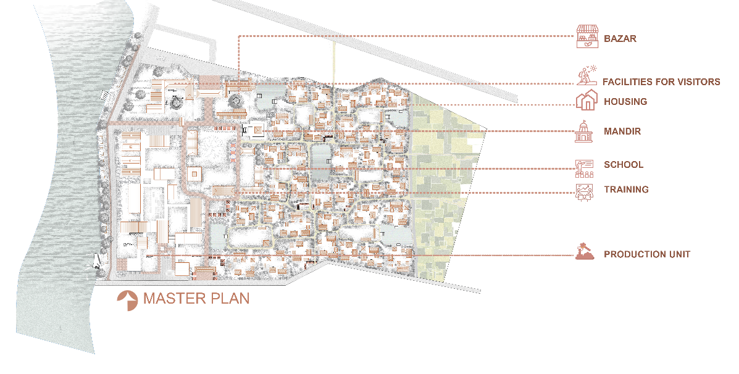
Figure 10: Master plan development as an outcome of the sustainable solution (north upwards)

5.1 Sustainable Production System
Terracotta production, accompanied by pottery, construction, and decorative crafts, has traditionally been dirtied and resource extravagant due to the use of inefficient kilns, timber, and archaic methods of production. For the PAAL community’s craft to have a future, a working, eco-friendly production system is suggested. The system will provide spatially optimized solutions, deal with workflow organization, and production units to lessen the community’s workflow ecological burden while growing the product quality and global market competitiveness (Figure 11).

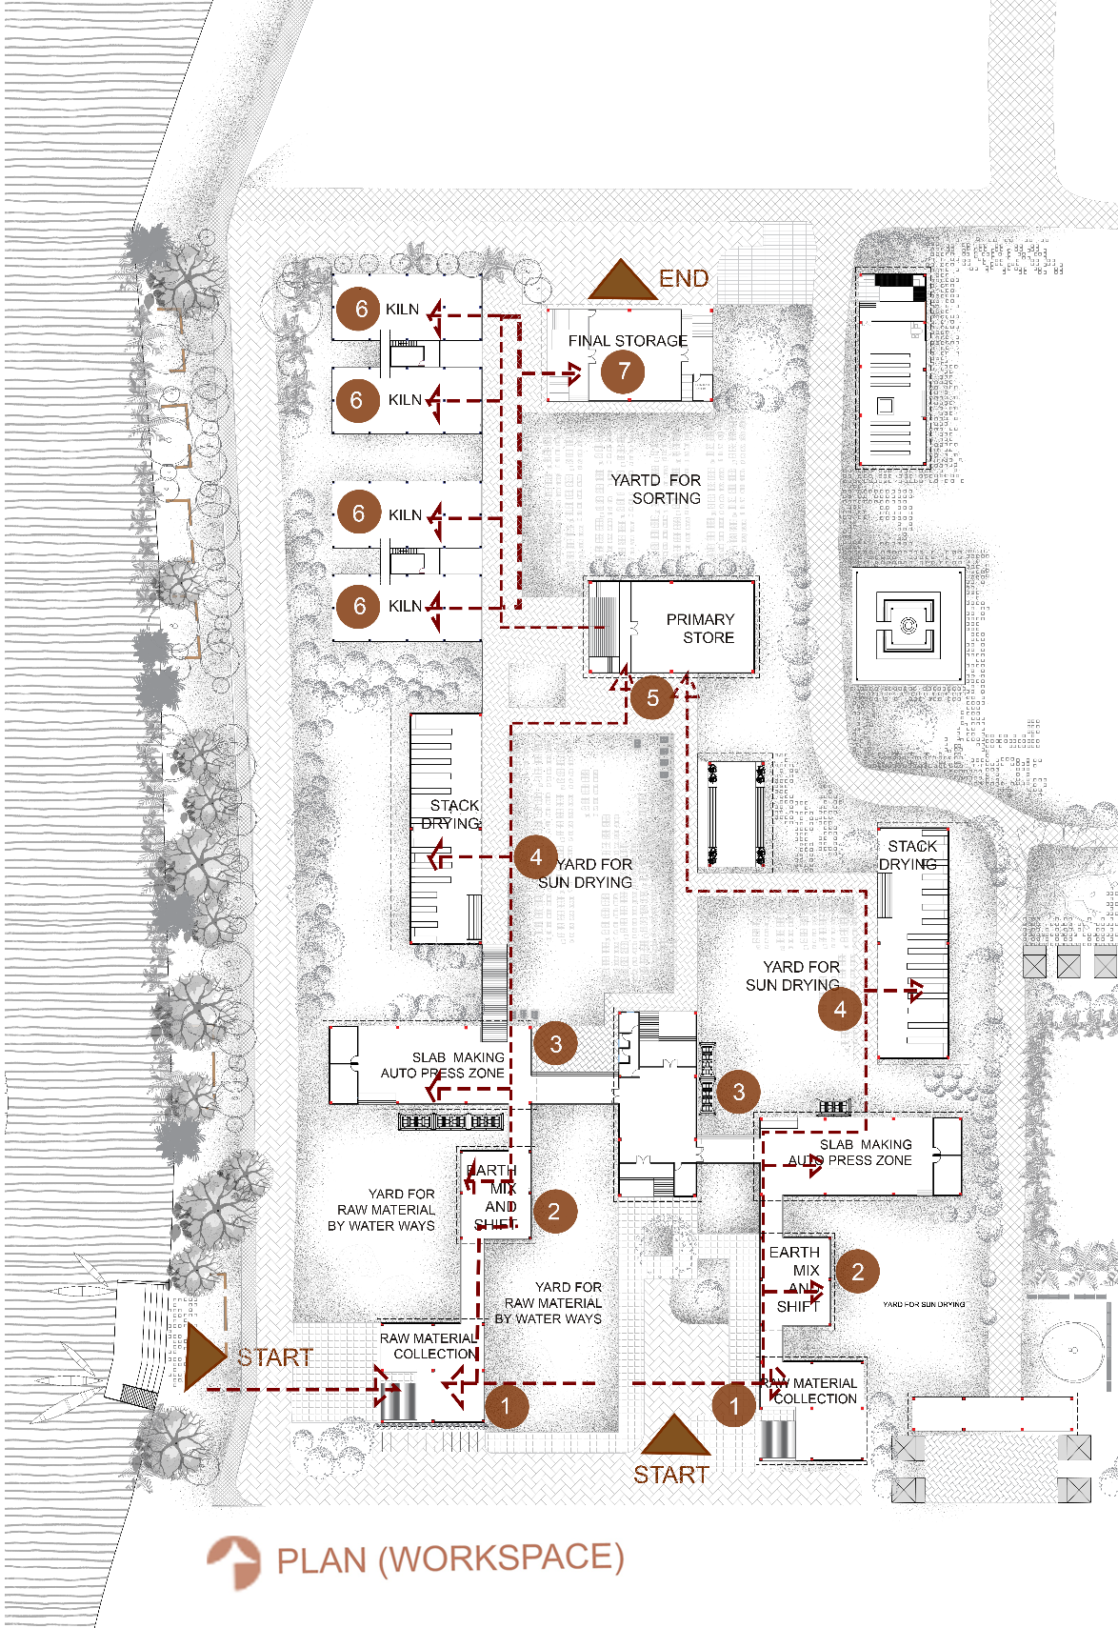

Figure 11: Workspace plan with workflow (north upwards)

Sustainable and Environmentally Responsible Production
The current reliance on timber-based kilns and open-air drying makes terracotta production in Murarikati environmentally damaging and highly inefficient. Traditional kilns generate excessive smoke, lack temperature control, and rely on unsustainable fuel sources such as wood and cow dung. These practices contribute significantly to deforestation, carbon emissions, and poor working conditions for artisans.
To address these issues, the adoption of biogas-powered hybrid Hoffman kilns is recommended. Studies comparing bull trench, fixed chimney, zigzag, vertical shaft, Hoffman, and hybrid Hoffman kilns demonstrate that hybrid Hoffman kilns are the most energy-efficient and cost-effective option for regions like Khulna, where renewable biogas is readily available (Figueroa et al., 2024; Abubakar, Shariff, & Sadiq, 2022). By using cow dung and organic waste as fuel, these kilns both reduce greenhouse gas emissions and create a circular energy system that benefits the community (Figure 12).
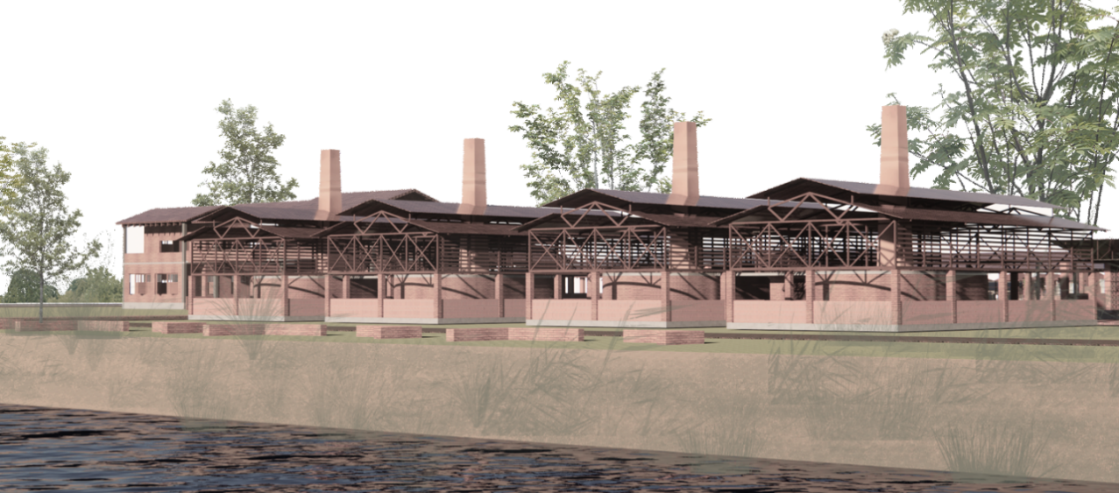
Figure 12: Energy-efficient biogas-powered Hoffman kiln.
In addition to kilns, solar-assisted firing technologies can be introduced as a complementary renewable solution. Solar kilns, already piloted in parts of India and Africa, have demonstrated reductions in fossil fuel use and greenhouse gas emissions (Kesaboina, Tiwar, & Sade, 2024).
Other environmentally sustainable measures include:
- Recycling of ceramic waste: Broken terracotta can be reintegrated into clay mixtures, reducing dependence on virgin clay resources and cutting waste.
- Rainwater harvesting: Using rainwater for clay preparation helps practice rainwater harvesting and makes it less necessary to use the groundwater. (Alanaa et al., 2019).
- Carbon capture and 3D printing: With the new technology for capturing carbon, it is possible to use 3D printers for carving. It is possible to create complex and accurate structures with lower energy, sometimes even capturing net carbon in the process.
Considering this set of practices, environmentally responsible, Murarikati can aim to develop a low-carbon production system, which makes terracotta a highly competitive and green material to use in modern days.

Modernized Workflows and Infrastructure
Currently, the workflow in terracotta production, starting from the collection of the raw materials and finishing with the storage of the fired material, is highly fragmented and labor-intensive, exposing the process to the rains and hindering production due to the seasonal conditions. During the monsoon, because there is no shaded drying and storage available, the work stops completely. Storage spaces for the fired materials are restricted and not properly coordinated, allowing for the loss of finished materials to exposure to moisture.
A systematization in the design of the storage system is coupled with an improvement in the modernization of the system. As evidenced from various studies on the artisan clusters across India and Egypt, work in certain highly mechanical centers flows better, and the final output of the product is of a higher quality, preserving the traditional craft (Berger, 2020; Mohapatra & Dash, 2011). For Murarikati, recommended interventions include (Figure 13):
- Mechanized clay processing: Earth-breaking machines and pugmills reduce labor costs, ensure consistent clay quality, and minimize health risks from manual mixing.
- Shaded drying and stack systems (Figure 14): Covered drying racks allow production continuity during rainy months, reducing downtime.
- Extrusion and automated presses: These replace outdated hand-molding and flywheel presses, increasing speed, precision, and uniformity.
- Upgraded kilns (Figure 12): Hybrid Hoffman kilns provide consistent firing quality, allowing artisans to expand their market presence.
- Organized storage and exhibition facilities (Figure 14): Racked storage protects finished products, while display spaces create opportunities for branding, marketing, and attracting buyers.
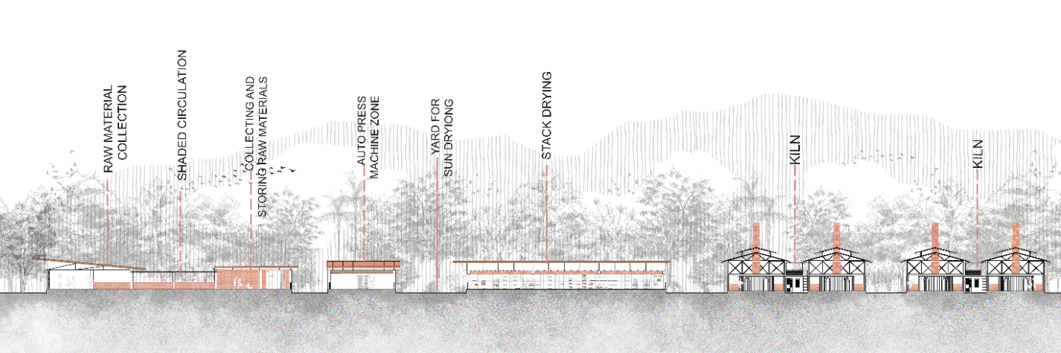

Figure 13: Section through production unit
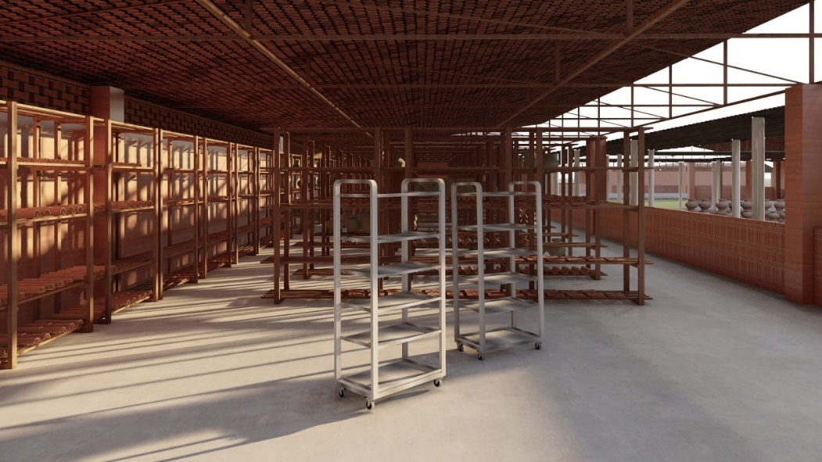

Figure 14: Stack drying in rainy days
Together, these measures establish a modern production unit that reduces inefficiencies, improves working conditions, and enhances market competitiveness while retaining artisanal authenticity.

Spatial Zoning and Community Well-being
The current scattered arrangement of kilns and workshops across Murarikati has major social and environmental consequences. Smoke from timber-fired kilns spreads throughout residential areas, exposing artisans and their families to respiratory health risks (Bishnoi, Kapoor, & Guru, 2024). Moreover, inefficiencies arise from transporting raw materials and finished products across dispersed workstations.
A zoning-based approach is therefore essential. Kilns should be relocated to designated non-residential zones to minimize pollution in living areas, while ensuring proximity to raw material collection sites and transportation routes (Figure 15). By centralizing production, transportation costs and time are reduced, while workflows become more efficient and organized.
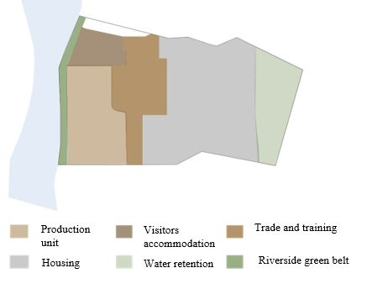

Figure 15: Zoning of functions based on suitability and locating kilns away from residential zones.
Connectivity is equally critical. Historically, the nearby river functioned as a lifeline for transporting goods. Reviving this network through the construction of a riverside service road would restore logistical efficiency, reduce road congestion, and create opportunities for regional and even international trade. Case studies from heritage craft clusters in Cairo and Jaipur demonstrate how strategic zoning and infrastructure upgrades can simultaneously preserve cultural heritage and enhance artisans’ quality of life (Alanaa et al., 2019).
Incorporating environmental technologies within this zoning framework—such as biogas kilns and closed-loop production systems where waste materials are recycled—further reduces the ecological footprint (Abubakar, Shariff, & Sadiq, 2022).
Ultimately, zoning fosters not only efficiency but also community well-being, ensuring that artisan households are no longer exposed to kiln smoke, that workplaces are safer, and that Murarikati evolves into a sustainable terracotta hub aligned with global sustainability goals.

Community Development
Community development is a crucial aspect of revitalizing the PAAL artisan community in Murarikati. Beyond production systems, strengthening social infrastructure and public spaces improves livelihoods, fosters social cohesion, and ensures long-term cultural preservation. The goal is to create community facilities that promote collective empowerment, provide essential services, and enable inclusive economic growth through sustainable practices (Figure 16).
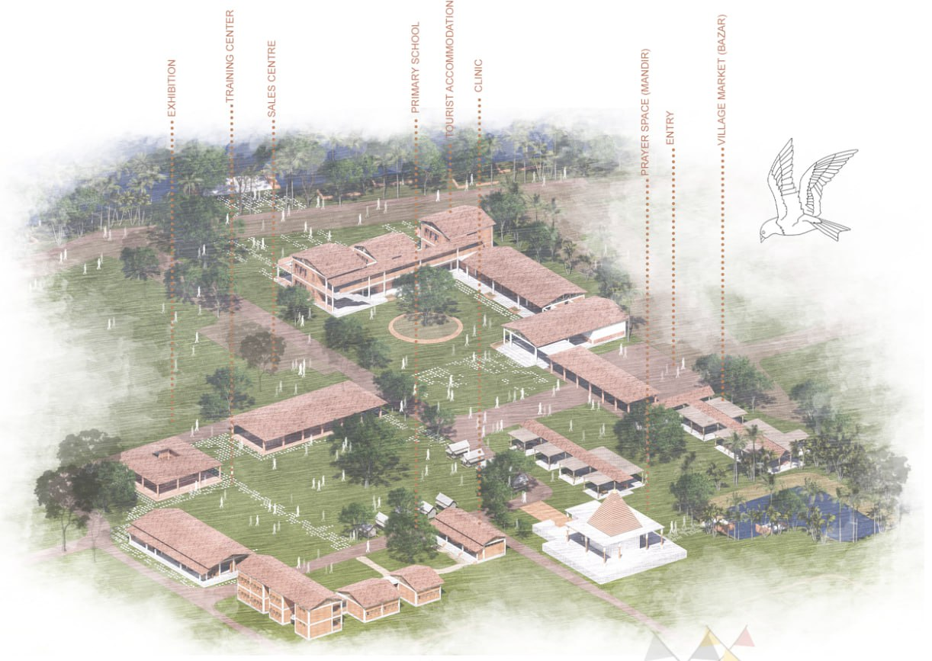
Figure 16: Proposed Community Facilities

Vocational Training and Skill Development
Despite terracotta being a craft associated with the PAAL community, the younger generation, over the years, seems to struggle with its longevity. To sustain its rich legacy, the community artisans must be trained through vocational schools, which will also teach inexpensive methods to terracotta production.
The virtues of vocational training go further than the individual artisans. Sustainable practices of energy saving, waste management, and green alternatives increase community social and economic growth (Tanjil, Hossain, Akter, Chowdhury, Hossain, & Ahmed, 2019). With this training, the artisans will be able to keep up with modern-day large-scale ceramic manufacturers while retaining the beauty of traditional terracotta.

Social Cohesion and Economic Development:
Establishing social spaces that authentically encourage interaction and community involvement is crucial to the vitality and sustainability of an artisan village. A central, multifunctional public area—encompassing a vocational training center, school, market, and healthcare facility—serves as the community’s nucleus. Such a space not only supports individuals’ well-being but also acts as a platform for collaboration and the exchange of knowledge, therefore strengthening both the social fabric and the village’s economic prospects.
The mandir (temple) (see Figure 17) holds a multifaceted role within the PAAL community, serving as a religious center as well as a focal point for social and cultural activities. When thoughtfully designed, the mandir becomes a gathering space for festivals, community fairs, educational programs, and more. This prominence provides artisans with the opportunity to publicly exhibit terracotta craftsmanship and related works, while simultaneously strengthening bonds among craftspeople, residents, and visitors.
Equally important is the enhancement of market spaces within the village development plan. For instance, daily markets in Kolaroa serve not only as commercial centers but also as vital sites for social engagement. Strategic improvements—such as shaded areas provided by trees—help maintain the traditional market atmosphere, creating an inviting environment where artisans can interact with buyers and promote their crafts. These enhancements enrich opportunities for both cultural exchange and economic advancement, further solidifying community cohesion.
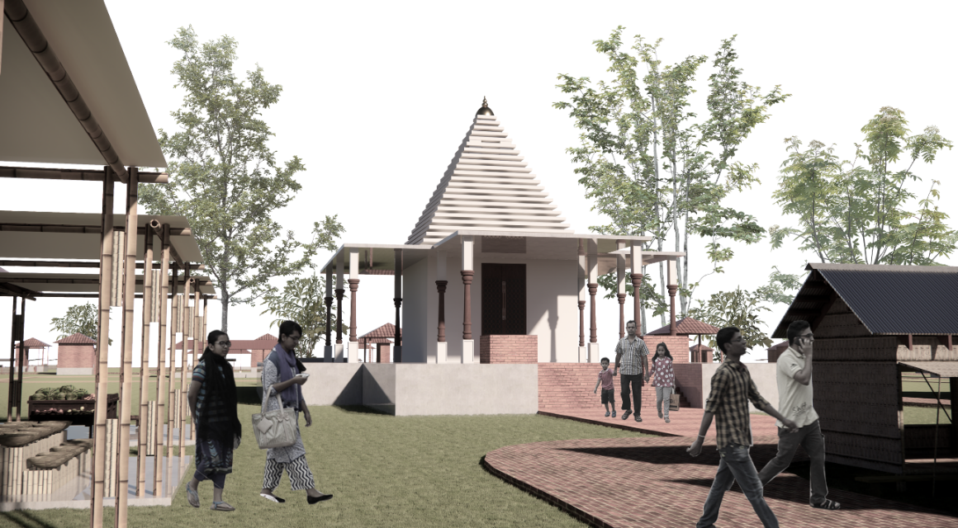
Figure 17: Mandir as a cultural and community hub.
Zoning within production areas, along with broader community development strategies, is essential for long-term sustainability and viability in the PAAL artisan community of Murarikati. The careful arrangement of workspaces—particularly those that integrate environmentally responsible technologies—can directly address operational challenges faced by artisans. Meanwhile, robust investments in community infrastructure that promote health, education, and social interaction are equally vital. Collectively, these approaches not only rejuvenate terracotta craftsmanship but also empower the PAAL community to adapt to evolving economic contexts, thereby ensuring the preservation and continuation of their cultural heritage for future generations.

Housing Improvements for Artisans
The PAAL community in Murarikati holds a distinct connection to tradition, which is visible not only in their cultural practices but also in the design of their homes. With urbanization gathering pace and climate change throwing new challenges into the mix, discussions around housing require more than just technical fixes. It’s essential that any approach to upgrading residences is attentive to long-standing customs—basically, upgrades shouldn’t feel like strangers in the neighborhood. New developments must respect and reflect the established character of the community, blending resilient construction with a genuine understanding of local identity. In short, preserving cultural integrity is just as important as ensuring structural durability.

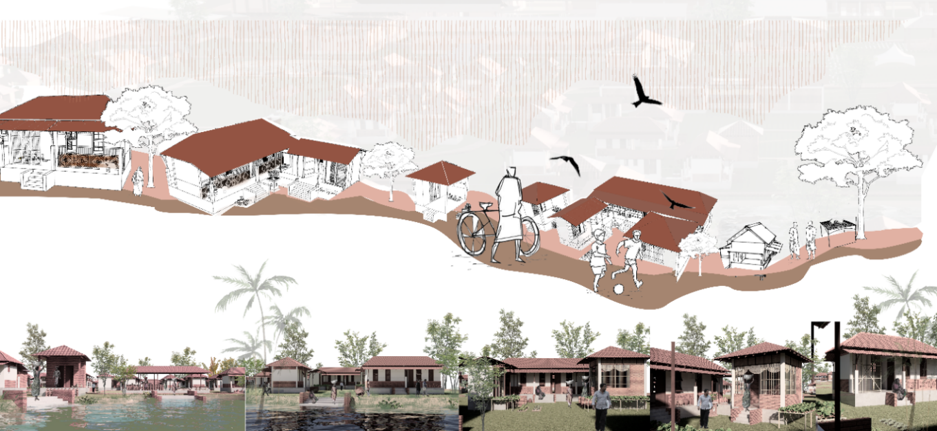
Figure 18: Housing ensuring cultural preservation

Culturally Sensitive Housing Designs:
The housing traditions of the PAAL community are intricately linked to their daily lives, embodying practices that have been cherished for generations. A prominent symbol of this connection is the tulsi mancha, the sacred basil stand that graces the entrance of every home. This is not just a decorative element; it serves as a vital ritual component, deeply rooted in spiritual beliefs that shape everyday life and community interactions. By integrating the Tulsi mancha into modern designs, it does more than preserve a relic; it sustains a living practice, anchoring contemporary households within a recognizable cultural framework that supports both identity and social cohesion.

In PAAL homes, the spatial organization has traditionally centered around a welcoming courtyard (uthan), creating a layout that encourages social interaction and practical living. This design typically features one or two rectangular rooms surrounding the open space, promoting neighborly connections, aiding in child-rearing, and enhancing daily community life—elements that are often lacking in modern designs characterized by high walls and compartmentalization. When considering improvements, it is essential to honor and maintain this communal heart. However, as family dynamics evolve, there is a need to thoughtfully expand this layout. Families increasingly seek more defined areas for activities with extended relatives, women’s economic initiatives, and personal privacy—all while preserving the unique openness that sets PAAL homes apart from standard urban designs.

Functional Spaces for Women and Family:
In the heart of traditional homes, women have long been recognized as skilled artisans, with their craft nurtured in the pashchati—a special space dedicated to clay work. This area has historically provided female artisans with the means to store their materials, hone their skills, and play a vital role in the household economy, all while remaining connected to the social life of the home. Considering modernizing PAAL houses, it is crucial that they do not lose these cherished workspaces. Instead, we have a wonderful opportunity to enhance these areas: by increasing privacy, improving storage for delicate terracotta items, and incorporating ergonomic features that ease physical strain. By ensuring that the pashchati is both accessible and discreet, we can create designs that honor communal traditions while celebrating the quiet dignity of individual craftsmanship.
In today's world, we must also pay closer attention to kitchens and sanitation facilities. Each household deserves its own connected kitchen and washroom, as this promotes privacy, hygiene, and meets the practical needs of modern living. Such arrangements help reduce the risk of disease, support the shift towards nuclear family structures, and empower women by enhancing their autonomy. When kitchens and washrooms are thoughtfully integrated with living spaces, daily routines become much easier to manage, especially during challenging weather conditions.

Addressing Water Logging and Environmental Conditions:
The PAAL community faces the ongoing struggle of monsoon flooding and persistent waterlogging, which threaten the safety and durability of their homes. To address these challenges, it is essential to design homes with a raised plinth, lifting the main structure above the usual flood levels. This thoughtful architectural choice significantly minimizes the risk of water entering homes during heavy rains. Additionally, implementing integrated water management systems—like beautifully landscaped retention basins and natural drainage corridors—plays a crucial role in managing increased rainfall. These systems not only safeguard homes but also protect the gardens and workspaces that are vital to the livelihoods of the PAAL community, ensuring that their way of life can flourish even in the face of environmental challenges.

Structure and Material Selection
When creating homes for the PAAL community, it’s essential to weave together the threads of climate resilience, cultural heritage, and the use of local materials. These elements are not just technical requirements; they are the very essence of what makes a house a home. By focusing on these aspects, we can build residences that are not only strong and sustainable but also resonate with the unique spirit and identity of the community (Figure 19).

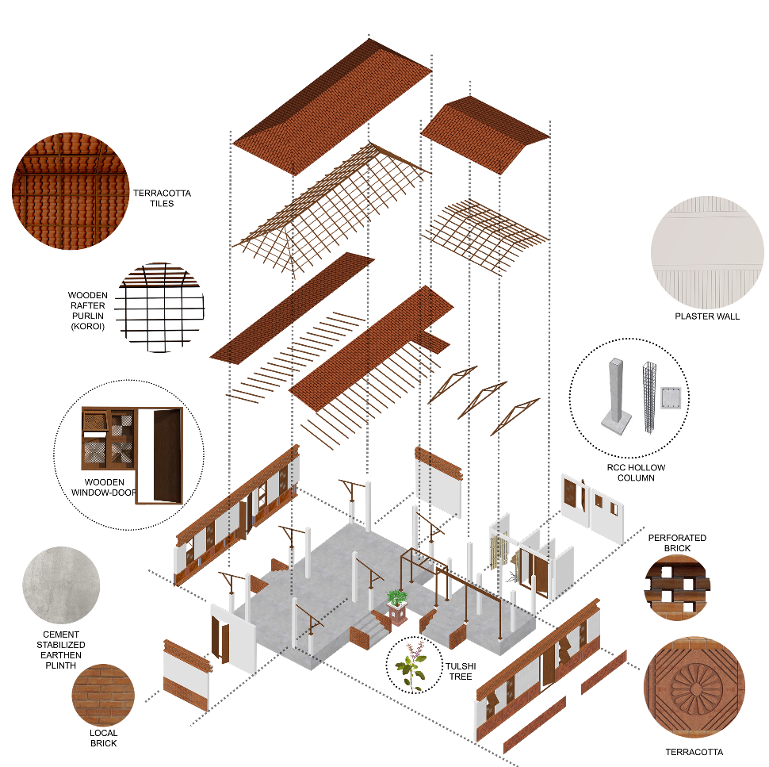

Figure 19: Locally Sourced and Sustainable Materials and structure

Locally Sourced and Sustainable Materials:
The structure of the homes should reflect the spirit of PAAL architecture by incorporating materials that are readily available in the local environment, such as taali (terracotta roof tiles) and bamboo. Taali, the traditional terracotta roof tiles, is not just a building material; it symbolizes a deep-rooted connection to the craftsmanship of PAAL artisans. Although bamboo has historical significance, its limitations in humid and saline conditions lead us to favor seasoned wood for the main structural supports, ensuring that the homes are both durable and safe for families.
For the walls, it prefers using locally made bricks, which have shown their ability to withstand the region's humidity and salt. To further protect these brick walls, there should be special plasters that enhance their resistance to moisture. Adding handcrafted terracotta panels to the façade of the house not only beautifies the structure but also honors the rich craft heritage of the community, blending aesthetic appeal with practical durability.

Improved Foundations and Structural Integrity:
In regions prone to flooding and high water tables during the monsoon season, paying attention to the foundation is crucial, yet it is often neglected in traditional building practices. A strong concrete plinth is advisable; it raises the main structure, reducing capillary action and keeping water from seeping into living areas. The durability and erosion resistance of concrete offer notable advantages over conventional stone or brick-only foundations, especially in areas where the soil becomes saturated seasonally. In the long run, these improved foundations lead to fewer repairs, a reduced risk of structural settling, and enhanced safety for residents.
When it comes to openings like doors and windows, it i important to focus on both the strength of materials and their alignment with local culture. Choosing locally sourced timber, selected for its natural oils and termite resistance, provides flexibility in design while honoring the PAAL architectural style. Using regional timber species not only supports local forestry practices but also promotes the conservation of suitable tree varieties, benefiting both the economy and the environment.

Sustainability Initiatives
At the heart of the PAAL community’s growth strategy lies a commitment to sustainability, which nurtures both the environment and the community's long-term prosperity. Embracing modern green technologies in housing and community infrastructure is not just a forward-thinking choice; it is essential for ensuring the community's strength and future. These initiatives demonstrate a steadfast dedication to minimizing environmental harm while fostering independence and adaptability.

Water Conservation through Rainwater Harvesting
In Murarikati, the urgency of addressing water scarcity cannot be overstated, especially given the vital role of agriculture in the PAAL community’s way of life. By implementing rainwater harvesting systems—capturing rainwater from rooftops and storing it safely—the community takes a practical and sustainable step forward. This approach not only lessens the community's dependence on strained groundwater sources but also ensures that agriculture can thrive even in dry spells, thereby enhancing overall water security (UNESCO, 2017; Varsha, 2024). Additionally, rainwater harvesting eases the burden on municipal water supplies and helps protect groundwater reserves, aligning with the community's needs and broader sustainability goals.
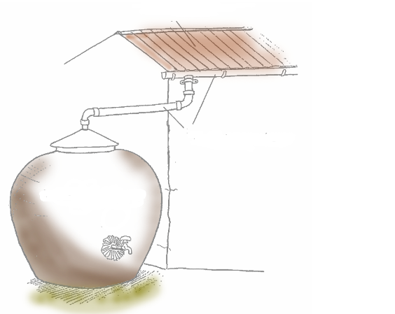
Figure 20: Stored rainwater for household use, including sanitation.

Waste Management and Biogas Production
Effective waste management is fundamental to any sustainability initiative. Transforming organic waste, particularly agricultural leftovers and livestock manure, into biogas offers a twofold benefit: it generates cleaner energy and enhances sanitation. By embracing biogas for cooking and heating, the PAAL community not only lessens its reliance on traditional biomass fuels but also curtails harmful emissions. Real-world examples from rural India and Bangladesh highlight the success of biogas systems in boosting energy access and improving sanitation (Tanjil, Hossain, Akter, Chowdhury, Hossain, & Ahmed, 2019).
This biogas initiative fosters a circular economy, turning waste into valuable resources and promoting the community’s energy independence. Moreover, it plays a crucial role in reducing environmental pollution by cutting down on biomass burning for fuel and supports better sanitation through an eco-friendly waste disposal approach.

Revitalizing the River and Agricultural Land
The Betraboti River has long been a lifeline for trade and agriculture, but its shrinking size now poses a significant challenge. Revitalizing the river and reconnecting it to the Sundarbans could open up new avenues for trade and improve the distribution of terracotta goods and agricultural products (Islam, 2019).
Moreover, innovative landscape changes, like converting sloped fields into water retention areas, can help reduce flood risks during the monsoon season and boost agricultural output year-round. These adaptive strategies not only enhance food security but also lessen vulnerabilities, showcasing the powerful link between restoring our environment and building economic resilience (Sami & Ghosh, 2017).
In fact, transforming sloped fields into water retention zones can effectively address the challenges of seasonal flooding while simultaneously increasing agricultural productivity throughout the year. Agholor (2013) emphasizes that these adaptive measures not only strengthen food security but also mitigate local vulnerabilities, illustrating how environmental restoration and economic stability can thrive together. By harmonizing river rehabilitation with sustainable farming practices, local communities can achieve greater food self-sufficiency, lessen their reliance on outside food sources, and manage their precious land resources more sustainably.

Energy Efficiency and Green Building Practices:
The adoption of energy-efficient design and construction is essential for lowering operational costs and minimizing the community's environmental impact. By integrating solar energy solutions, utilizing passive design principles, and applying advanced insulation techniques, the design initiative can significantly improve indoor comfort while reducing our dependence on nonrenewable energy sources. Research from the U.S. Green Building Council (2017), Ahn, Pearce, Wang, and Wang (2013) showed that these initiatives can lead to energy cost reductions of up to 40% and a decrease in carbon emissions by over 30%.
Incorporating these eco-friendly practices in both homes and production facilities greatly reduces overall energy use. Harnessing solar power for heating and lighting, combined with passive cooling and effective insulation, has proven to lower utility bills while substantially reducing the community’s carbon footprint. By adopting these sustainable approaches, the PAAL community not only promotes environmental stewardship but also strengthens its economic resilience.

Creating a Self-Sufficient, Sustainable Community:
The primary aim of these integrated efforts is to foster a community that thrives independently and stands strong against external challenges. By embracing energy-saving techniques, harnessing renewable energy, practicing sustainable agriculture, and implementing effective waste management, the PAAL community can greatly reduce its ecological footprint while creating more economic opportunities for both artisans and residents.
To achieve these goals, a comprehensive strategy is essential: enhancing housing quality, utilizing eco-friendly materials, and embracing cutting-edge green technologies work together to breathe new life into Murarikati. This harmonious blend of honoring cultural heritage and pursuing modern sustainability not only safeguards the art of terracotta craftsmanship as a living tradition but also ensures the community remains economically viable and adaptable to changing environmental and market dynamics.

Conclusion
The research has discussed the challenges faced by the PAAL artisans at Murarikati, particularly those pertaining to urbanization, industrial development, and environmental responsiveness. The decline in demand for traditional terracotta, outdated crafting systems, and inadequate infrastructure has placed the PAAL artisans at a crossroads. However, by means of the integration of sustainable design principles, there are opportunities to revamp the craft, empower the artisans, and enhance their socio-economic situation.
The terracotta industry could make itself more competitive and environmentally friendly by embracing green production methods, modernization of installed capacities, and integration with contemporary methods, i.e., energy-efficient kilns, solar-fired methods, and fuel use in the form of biogas. Additionally, fostering a warm and welcoming community atmosphere by offering essential facilities such as vocational training centers, educational institutions, healthcare services, and social gathering spaces can greatly improve the lives of artisans and their families. The envisioned designs for updated homes, along with the preservation of cultural features like the pashchati and the use of local materials, will enable the PAAL community to maintain a connection to their heritage while adapting to the evolving demands of contemporary life. These efforts not only safeguard the rich cultural legacy of terracotta craftsmanship but also promote enduring environmental sustainability and economic resilience.
Overall, the research underscores the significance of a holistic approach that combines sustainable practices, technological innovations, and community growth to secure a promising future for the artisans at PAAL. With the right initiatives, the PAAL community can navigate the challenges they encounter, restore the terracotta craft, and continue to enrich the vibrant cultural tapestry of Bangladesh. For the benefit of future generations, it is imperative to preserve the priceless tradition of terracotta craftsmanship while fostering a sustainable and prosperous future for artisans.

Disclaimer (Artificial intelligence)
Artificial intelligence (AI) tools were used to assist in language editing and formatting only. All interpretations, analyses, and conclusions remain the sole responsibility of the authors.

References:
- Abubakar, E., Shariff, R., & Sadiq, Y. (2022). Deployment of treated and compressed biogas as a sustainable fuel for ceramic kiln firing. Sustinere: Journal of Environment and Sustainability, 6, 14–25. https://doi.org/10.22515/sustinerejes.v6i1.192
- Agholor, I. (2013). The revitalisation of water resources for sustainable agricultural development in South Africa: A review. Journal of Agricultural Science, 5(5), 76. https://doi.org/10.5539/jas.v5n5p76
- Ahn, Y. H., Pearce, A. R., Wang, Y., & Wang, G. (2013). Drivers and barriers of sustainable design and construction: The perception of green building experience. International Journal of Sustainable Building Technology and Urban Development, 4(1), 35–45. https://doi.org/10.1080/2093761X.2012.759887
- Alanaa, H. A., Al-hagl, K. S., & Hasan, A. E. (2019). A framework for architects' role in attaining sustainable community development in heritage areas. Alexandria Engineering Journal, 58(1). https://doi.org/10.1016/j.aej.2018.11.015
- Anwar, S. (2012). Artisans and traditional crafts in Bangladesh: Socio-economic perspectives. Dhaka: University Press Limited.
- Asia InCH. (n.d.). Clay, terracotta and glazed ceramics of Bangladesh. Retrieved from https://asiainch.org/craft/clay-terracotta-glazed-ceramics/
- Banglapedia. (2015). Terracotta art. In Banglapedia: National Encyclopedia of Bangladesh. Asiatic Society of Bangladesh. Retrieved from https://en.banglapedia.org/index.php/Terracotta_Art
- Berger, E. (2020). Empowering artisans through design: A case study on the dynamics of collaborative projects. In S. Boess, M. Cheung, & R. Cain (Eds.), Synergy - DRS International Conference 2020, 11-14 August, held online (pp. 113–120). https://doi.org/10.21606/drs.2020.113
- Bishnoi, S., Kapoor, S., & Guru, R. (2024). A study on challenges to revival of handicrafts in India. Asian Textile Journal, 33, 57–60.
- Bproperty. (2022). History of terracotta in Bangladesh and its evolution. Retrieved from https://www.bproperty.com/blog/terracotta-bangladesh/
- Britannica. (n.d.). Terra-cotta. In Encyclopedia Britannica. Retrieved from https://www.britannica.com/art/terra-cotta
- Coningham, R., & Lewer, N. (Eds.). (2019). Archaeology, cultural heritage protection and community engagement in South Asia. Palgrave Pivot. https://doi.org/10.1007/978-981-13-6237-8
- Dhar, B. K., Chawla, U., & Mulchandani, D. (2024). Sustainable craft culture: Socio-cultural drivers and economic impact on sustainable development. Sustainable Development, 33(2), 3023–3042. https://doi.org/10.1002/sd.3282
- Figueroa, J., Valdes, H., Vilches, J., Schmidt, W., Valencia, F., Torres, V., Diaz-Robles, L., Muñoz, P., Letelier, V., Morales, V., & Bustamante, M. (2024). Comparative analysis of gas emissions from Ecokiln and artisanal brick kiln during the artisanal firing of bricks. Sustainability, 16(3), 1302. https://doi.org/10.3390/su16031302
- Islam, M. R., & Burmester, C. F. (2020). Impact of globalization on local traditional handicraft industries in Brazil. Journal of Globalization Studies, 11(2), 108–119. https://doi.org/10.30884/jogs/2020.02.08
- Islam, S. N. (2019). Sundarbans a dynamic ecosystem: An overview of opportunities, threats and tasks. In H. Sen (Ed.), The Sundarbans: A disaster-prone eco-region (Vol. 30, pp. 21–37). Coastal Research Library. Springer. https://doi.org/10.1007/978-3-030-00680-8_2
- Jiawei, Z., & Sangiamvibool, A. (2025). Empowering artists and preserving heritage: The role of community-led initiatives in the jade industry in China. Pakistan Journal of Life and Social Sciences, 23(1), 135. https://doi.org/10.57239/PJLSS-2025-23.1.0012
- Kesaboina, M., Tiwar, V., & Sade, A. (2024). Reviving tradition: Exploring sustainable practices in Kalamkari art for artisan empowerment and cultural preservation. Educational Administration Theory and Practice, 30(4), 560–571. https://doi.org/10.53555/kuey.v30i4.1505
- Kiradoo, G., Ashifa, K.M., & Aliyev, A. (2022). The transition of traditional pottery-making into advanced ceramics in context to the indian ceramic industry. Journal of Management Information and Decision Sciences, 25(S2), 1-12
- Mohapatra, S., & Dash, S. (2011). Problems associated with artisans in making of handicrafts in Orissa, India. Management Review, 6(1), 56–82.
- OnTheWorldMap.com. (n.d.). Soil type in Bangladesh: A summary. Retrieved from https://www.scribd.com/document/332026854/Soil-Type-in-Bangladesh-A-Summary?fbclid=IwY2xjawL931hleHRuA2FlbQIxMQABHvyCNJfDVCOE7kVRrQwM1NOo7sYPqPdTAC8PgvJaLBf3ovOJ59ADpa9PlcCH_aem_Mpe2FYCgoutZjzyumzk-FA
- Srinivasan, S. (2015). Biogas as an alternative energy source in rural communities: Lessons from South Asia. Energy for Sustainable Development, 27, 46–51.
- Tanjil, H., Hossain, S., Akter, S., Chowdhury, M. S., Hossain, M. S., & Ahmed, M. (2019). Biogas as an alternative energy source in rural areas and public awareness: A case study in Jessore District. Journal of Energy and Natural Resources, 8(1), 12–17. https://doi.org/10.11648/j.jenr.20190801.13
- Uddin, M. S. (2007). Terracotta art early historic to pre-medieval period. In S. M. Rahman (Ed.), Archaeological heritage: Cultural survey of Bangladesh series-1 (pp. 424–469). Asiatic Society of Bangladesh. Retrieved from https://www.academia.edu/43763553/Terracotta_Art_Early_Historic_to_Pre_Madieval_period
- UNESCO. (2017). Rainwater harvesting and its role in sustainable development in rural areas. UNESCO Publishing.
- Varsha, K. (2024). Rainwater harvesting in water management for sustainable development – A climatic impact. ComFin Research, 12, 90–93. https://doi.org/10.34293/commerce.v12iS1-Feb.7365
- U.S. Green Building Council. (2017). Green building and sustainable design in practice. USGBC.
- Visual-Arts Cork. (n.d.). Terracotta sculpture: History, characteristics. Retrieved from https://www.visual-arts-cork.com/sculpture/terracotta.htm
- Younus, S., Gulzar, S., & Khan, F. (2025). A cross-regional study of built heritage conservation in South Asia within the global heritage discourse. Journal of Development and Social Sciences, 6(3), 45–59. https://doi.org/10.47205/jdss.2025(6-III)05

