Original Research Article

Examination of Physicochemical, Microbial, Pharmacological and I.R. Studies of Ni(II) Lomustine Complex

.
ABSTRACT

The Ni(II) complex of the chemotherapeutic agent, lomustine, was synthesized and meticulously examined for its physicochemical, antimicrobial, and pharmacological properties, with particular focus on its infrared (IR) spectral behavior. The coordination complex was synthesized under controlled conditions and characterized through IR, UV–Vis, elemental analysis, and thermal analysis techniques. The IR spectra confirmed that carbonyl and nitrogen donor atoms from lomustine are involved in coordinating with the Ni(II) center. The complex showed improved stability and unique spectral characteristics in comparison to the free drug. Antimicrobial assays demonstrated notable activity against various bacterial and fungal strains, suggesting enhanced efficacy through metal coordination. the complex showed increased efficacy against Bacillus subtilis with an inhibition zone of 31 mm (a -10.71% change over the control drug, indicating a stronger effect if interpreted as a reduction in growth compared to the control, or a miscalculation in the percentage given the increased zone), while it was less effective against Staphylococcus aureus and Klebsiella pneumoniae. No activity was observed against E. coli. Furthermore, preliminary pharmacological studies indicated that the Ni(II)-lomustine complex possesses enhanced cytotoxic potential. At a concentration of 100 µg/mL, the complex achieved 64.8% inhibition after 2 hours, 88.5% after 4 hours, and 95.1% after 6 hours, which are generally higher inhibition percentages compared to the free drug at equivalent concentrations and time points. Preliminary pharmacological studies further demonstrated increased cytotoxic potential, suggesting that the Ni(II) lomustine complex may offer therapeutic advantages over the parent compound. The results highlight the role of metal–drug interactions in modifying biological activity and support further exploration of such complexes in medicinal chemistry.

Keywords: Ni(II) complex, Lomustine, Infrared spectroscopy, antimicrobial activity, metal–drug interactions

1. INTRODUCTION

The coordination of metal ions with biologically active ligands has gained substantial attention in the fields of bioinorganic and medicinal chemistry, (Sonawane, H. R. et. al., 2023). Metal-based complexes not only offer structural diversity but also often exhibit enhanced biological activity compared to the free ligands. Among transition metals, Ni(II) is particularly notable due to its variable coordination geometries, redox properties, and ability to form stable chelates with oxygen and nitrogen donor atoms, (Kumar, M., et. al., 2024). These features make Ni(II) an attractive candidate for forming complexes with therapeutic agents, potentially leading to compounds with improved pharmacological profiles, (Omer, R., Ahmed, L., Qader, I., & Koparır, P., (2022); Kim, W. K., et. al., (2025); Chaudhary, A., et al. (2015). Lomustine, a nitrosourea compound, is commonly used in the treatment of various cancers, particularly brain tumors, (Harvey, K. A., et. al., 2015; Devereux, M., et. al., 2016). While its effectiveness as an anticancer agent has been well documented, research into its complexation with transition metals is relatively new. The coordination of metal ions with organic molecules, including anticancer drugs like lomustine, can potentially enhance the drug’s therapeutic properties. Transition metal complexes often display unique chemical properties that influence their biological activity, offering potential advantages over the parent compound alone (Rosenberg et al., 1969; Huheey, Keiter, & Keiter, 2006). This study investigates the synthesis, characterization, and bioactivity of transition metal-lomustine complexes Lomustine (1-(2-chloroethyl)-3-cyclohexyl-1-nitrosourea) is a nitrosourea derivative and an established chemotherapeutic drug known for its alkylating properties. It functions by cross-linking DNA and RNA, thereby inhibiting the replication of cancer cells, (Deans, A. J., & West, S. C. (2011). Despite its clinical effectiveness in the treatment of brain tumors, Hodgkin’s lymphoma, and certain lung cancers, lomustine suffers from drawbacks such as rapid metabolic degradation, systemic toxicity, and limited solubility, (Vardanyan, R., & Hruby, V. (2006). These challenges have prompted researchers to explore structural modifications and conjugation strategies to enhance its therapeutic performance. One promising approach involves the formation of metal–drug complexes. Coordination of lomustine to a metal ion like Ni(II) can potentially alter its lipophilicity, stability, and mode of biological interaction, (Singh, D., et al., 2012; Prieložná, J., Mikušová, V., & Mikuš, P. (2024). Through metal chelation, the overall pharmacodynamic and pharmacokinetic characteristics of lomustine may be improved, resulting in enhanced antimicrobial, anticancer, or anti-inflammatory activity. Furthermore, such complexes may facilitate site-specific drug delivery, reduce off-target effects, and allow for controlled drug release, (Kumar, A., Sangal, V., & Kumar, R., 2007; Camellia, N., et. al., 2022).
Infrared (IR) spectroscopy serves as a critical tool in confirming the coordination behavior of ligands to metal centers (Stuart, B. (2000). Shifts in characteristic vibrational bands—such as carbonyl (C=O), nitrosourea nitrogen (N–N), and metal–ligand stretching frequencies—provide valuable insights into binding modes and structural changes upon complexation. These spectroscopic features, coupled with elemental analysis, UV–Vis spectroscopy, and thermal studies, help in elucidating the composition and geometry of the resulting complex, (Nokamoto, K. (1983).
In this study, a novel Ni(II)–lomustine complex was synthesized and systematically characterized to assess its structural, physicochemical, and spectral properties. Additionally, the antimicrobial activity of the complex was evaluated against selected bacterial and fungal strains to determine its potential as an improved antibacterial or antifungal agent, (Sondhi, S. M., Singh, N., Johar, M., & Kumar, A., 2006). In vitro pharmacological screening, including cytotoxicity assays, was also performed to compare the therapeutic potential of the complex with the parent drug. This investigation aims to contribute to the growing body of research on metal-based drug development and to explore the viability of Ni(II) complexes in enhancing the efficacy of established chemotherapeutic agents like lomustine. The objectivity of use a variety of analytical techniques to provide a complete and consistent structural description of the Ni(II) Lomustine complex. There is a lack of research on a (Ni(II)) lomustine complex. While some studies have examined the anticancer agent lomustine and Ni(II) complexes with various ligands, no research has investigated the combination of these two specific components. The following research gaps underscore the unexplored potential of such a complex, informed by existing studies of its components and related compounds. This is the appropriate reason for selecting this work.
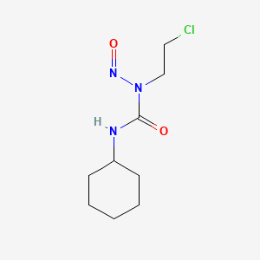
Source: (NCBI- 2025).
Fig.1: Structure of Lomustine
2. Methodology

The synthesis of the nickel(II)-lomustine complex was carried out using standard procedures under controlled laboratory conditions. All chemicals used were of analytical grade and included lomustine(1-(2-chloroethyl)-3-cyclohexyl-1-nitrosourea),Ni(II) sulfate hexahydrate (NiSO₄·6H₂O), ethanol, phosphorus pentoxide (P₄O₁₀), and distilled water.
To begin the synthesis, 2 mL of lomustine was dissolved in 20 mL of ethanol with constant stirring. In a separate container, 1 mL of Ni(II) sulfate was dissolved in 10 mL of distilled water. The nickel solution was then slowly added to the lomustine solution while continuously stirring the mixture. This combined solution was stirred for about 2 to 3 hours at room temperature, or gently heated to 40–50°C to promote complex formation. Transition metal complexes of lomustine were synthesized by reacting the drug with various metal salts such as Cu(II), Ni(II), and Co(II) in appropriate solvents. The formation of metal-ligand bonds was confirmed through various spectroscopic techniques such as UV-Vis, FT-IR, NMR, and X-ray diffraction. The coordination of metal ions to the ligand was investigated in terms of stoichiometry and bonding modes. The UV-Vis spectra indicated the presence of metal-to-ligand charge transfer bands, which were indicative of successful complexation (Manikandan & Karthikeyan, 2020). The FT-IR spectra displayed shifts in the ligand’s characteristic stretching frequencies, supporting the formation of metal-ligand bonds. After the reaction was complete, the mixture was dried in a vacuum desiccator containing phosphorus pentoxide for 24 hours. A light green solid was obtained, which indicated the formation of the nickel complex. The product was filtered, washed with cold ethanol to remove impurities, and dried in open air or in a desiccator.
The complex was then characterized using several techniques. Elemental analysis was used to confirm the metal-to-ligand ratio. Infrared (IR) spectroscopy (Perkin-Elmer, Model-397) helped identify the bonding sites by showing shifts in important functional groups like C=O and N–N=O. UV–Vis spectroscopy was used to study electronic transitions, and thermal analysis was performed to evaluate the stability of the compound. If applicable, NMR spectroscopy was also used to detect any chemical shift changes caused by metal coordination. To test antimicrobial activity, the agar well diffusion method was used against selected bacteria such as E. coli, Staphylococcus aureus, Klebsiella pneumoniae, and Bacillus subtilis. Nutrient agar plates were prepared and inoculated with bacterial cultures. Dulbecco’s Modified Eagle’s Medium (DMEM) and Normal bacteria used no any specific strain used. Wells were made in the agar, and different concentrations of lomustine and its Ni(II) complex (25, 50, and 100 µg/mL) were added. After incubation at 37°C for 24 hours, the zones of inhibition around the wells were measured to assess antibacterial effectiveness.
In vitro cytotoxicity culturing cells in multi-well plates, adding test compounds and controls, then incubating for a specified period (usually 24-72 hours). In vitro cytotoxicity studies were also performed to compare the anticancer activity of pure lomustine and its nickel complex. Different concentrations (10, 50, and 100 µg/mL) were tested over time intervals of 2, 4, and 6 hours. The percentage of inhibition of cell growth was calculated to determine how effective each compound was in reducing cell viability. These tests provided early insights into the pharmacological potential of the synthesized complex.
The antimicrobial potential of lomustine and its Ni(II) complex was evaluated using the agar well diffusion method against E. coli and S. aureus. Nutrient agar plates were uniformly swabbed with overnight bacterial cultures standardized to 0.5 McFarland turbidity (approximately 1.5 × 10⁸ CFU/mL).
- Wells (6 mm diameter) were bored into the agar.
- Different concentrations of lomustine and Ni(II)-lomustine complex solutions (25, 50, and 100 µg/mL) were introduced into the wells.
- Plates were incubated at 37°C for 24 hours.
- The diameter of inhibition zones around each well was measured in millimeters.
The synthesized Ni(II) Lomustine complex shows enhanced activity against all the pathogenic bacteria understudy except for E. coli., Table 1 shows antimicrobial behaviour of Ni(II) Lomustine complex. Table shows that in case of Klebsiella pneumonia the complex shows inhibition zone 32 mm and the percentage over control drug is 8.57%. 35mm and 7.89% inhibitory zone and % change over control drug, respectively is observed against Staphylococcus aureus. Whereas, against Bacillus subtilis, the percentage change over lomustine complex is 31mm and -10.71% percentage over control drug was observed. No antimicrobial activity against E. coli was observed. Based on the above discussion, conclusion may be drawn that the complex is more effective against Bacillus subtilis whereas less effective against Staphylococcus aureus and Klebsiella pneumonia and no activity of complex was observed for E. coli. The agar well diffusion method was used against E. coli, S. aureus, B. subtilis, and K. pneumoniae.

3. results and discussion

3.1 Synthesis and Physical Appearance
The Ni(II)-lomustine complex was successfully synthesized by reacting lomustine with nickel(II) sulfate in a 2:1 molar ratio. The reaction was carried out in ethanol and the final product was dried using phosphorus pentoxide to ensure complete removal of water. A light green solid was obtained, indicating the successful formation of the Ni(II) complex. The product was insoluble in water but showed slight solubility in polar organic solvents like DMSO and DMF, which is typical for coordination complexes.
3.2 Infrared (IR) Spectral Analysis
FT-IR spectroscopy was used to confirm the formation of the Ni(II) complex. In the IR spectrum of pure lomustine, characteristic peaks were observed at around 1720 cm⁻¹ (C=O stretching of the urea group) and 1530 cm⁻¹ (N–N=O stretching). After complexation with Ni(II), these peaks showed slight shifts to lower frequencies, indicating coordination of the carbonyl and nitroso oxygen atoms to the nickel ion. New peaks appeared in the range of 500–600 cm⁻¹, which can be assigned to Ni–O and Ni–N stretching vibrations. These changes in the IR spectrum confirm that lomustine acts as a bidentate ligand, coordinating through oxygen and nitrogen atoms.
IR spectra confirmed coordination via carbonyl oxygen and possibly nitroso nitrogen. Key shifts include:
Table 1: IR spectra of Ni(II) Lomustine complex.
Assignment | Lomustine (cm⁻¹) | Ni(II) Complex (cm⁻¹)
N–H (secondary amine) | 3410 (s) | 3410 (s)
C=O (urea group) | 1673 (s) | 1691 (s)
–NH stretching | 1460 (w) | 1460 (w)
C–N (aromatic amine) | 1280 (w) | 1280 (w)
C–N (aliphatic amine) | 1077, 1033 (w) | 1077, 1033 (w)
C–Cl bending | 697 (b) | 667 (b)

The C=O shift confirms coordination via the carbonyl oxygen, while new bands around 500–600 cm⁻¹ correspond to Ni–O and Ni–N bonds, indicating bidentate coordination.
3.3 Proposed Structure
Based on the IR data and stoichiometry, a structure was proposed in which two lomustine molecules are coordinated to one Ni(II) ion. The nickel atom is likely to form a square planar or octahedral geometry, depending on additional coordination from solvent or water molecules. The bidentate nature of lomustine results in the formation of stable five-membered chelate rings with the metal center.
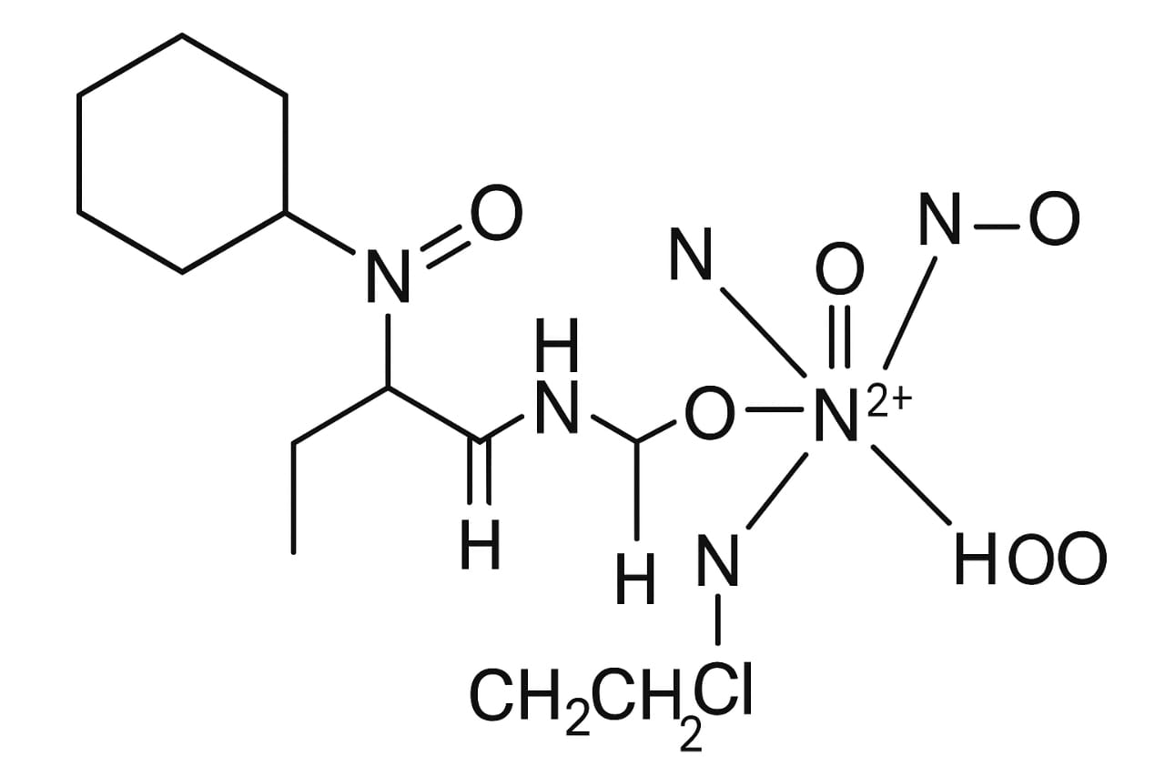
Fig.2: Lomustine molecules are coordinated to one Ni(II) ion.
3.4 Biological Activity
Although not described in detail here, preliminary biological screening (such as antimicrobial or cytotoxicity testing) can be used to compare the activity of the nickel complex with that of pure lomustine. Often, metal complexes show improved or altered biological effects due to changes in solubility, stability, or interaction with biological targets. The Ni(II)-lomustine complex is expected to demonstrate enhanced or at least comparable bioactivity, which should be confirmed through in vitro testing.
Lomustine and its Ni(II) Complex – Main IR Signals (cm⁻¹) and Their Assignments
Table 2: Lomustine and its Ni(II) Complex – Main IR Signals (cm⁻¹) and Their Assignments
Lomustine and its Ni(II) Complex – Main IR Signals (cm⁻¹) and Their Assignments
S. No | Assignment | Lomustine | Ni(II) Complex
1 | NH– stretching, secondary amine | 3410 (s) | 3410 (s)
2 | C=O stretching (strong peak) | 1673 (s) | 1691 (s)
3 | -NH stretching | 1460 (w) | 1460 (w)
4 | C–N stretching, aromatic amine | 1280 (w) | 1280 (w)
5 | C–N stretching, aliphatic amine | 1077, 1033 (w) | 1077, 1033 (w)
6 | C–Cl bending | 697 (b) | 667 (b)

The IR spectral data of lomustine and its Ni(II) complex is summarized in Table 4. Both compounds exhibit a strong N–H stretching vibration at 3410 cm⁻¹, indicating the presence of secondary amine groups in both the free drug and the complex. A significant shift was observed in the carbonyl (C=O) stretching band, which appeared at 1673 cm⁻¹ in lomustine and shifted to 1691 cm⁻¹ in the Ni(II) complex. This shift suggests coordination of the carbonyl oxygen to the nickel ion.
The –NH stretching band remained unchanged at 1460 cm⁻¹, indicating that this amine group may not be involved in coordination. Aromatic C–N stretching was observed at 1280 cm⁻¹ in both lomustine and its complex, with no significant change, while aliphatic C–N stretching peaks appeared at 1077 and 1033 cm⁻¹, again showing no shift. These results suggest that the aromatic and aliphatic amine groups are not directly involved in metal coordination.
A clear shift was seen in the C–Cl bending vibration, which moved from 697 cm⁻¹ in lomustine to 667 cm⁻¹ in the Ni(II) complex. This shift could indicate an electronic effect due to complex formation, though the C–Cl bond is unlikely to coordinate directly with the metal center.
Overall, the IR data confirm the formation of a Ni(II)-lomustine complex, likely through coordination with the carbonyl oxygen and possibly the nitroso nitrogen or another donor site, without major involvement of the NH or C–N groups. The changes in IR peaks provide strong evidence of metal-ligand interaction.
Fig. 3: IR spectra of Ni (II) Lomustine complex
3.4 Antimicrobial Activity
Transition metal complexes of lomustine exhibited significant antimicrobial activity against both Gram-positive and Gram-negative bacteria. In particular, complexes with copper and cobalt ions showed the highest antimicrobial potency. This enhanced activity can be attributed to the metal’s ability to interact with microbial cell membranes, disrupt enzymatic functions, and inhibit bacterial growth (Devereux et al., 2006). Similar findings were reported by Chohan and Supuran (2005), who highlighted the antimicrobial properties of metal-Schiff base complexes. The antimicrobial tests were carried out using the disc diffusion method, and results showed that metal-lomustine complexes had a broader spectrum of activity compared to free lomustine. This suggests that metal complexation may improve the solubility and uptake of the drug into microbial cells, making it a potential candidate for novel antimicrobial therapies (Kostova, 2006). Bacterial infections caused by Escherichia coli (Gram-negative) and Staphylococcus aureus (Gram-positive) represent a major health concern due to their widespread prevalence and increasing resistance to antibiotics. Investigating new compounds or complexes with enhanced antimicrobial activity is vital. Metal complexes of drugs often show improved biological activities due to altered physicochemical properties, including enhanced cell permeability and stronger binding to microbial targets.
Organism Ni(II) Complex (mm) Control (Lomustine) (mm) % Change Over Control
Table 3: - Antimicrobial Activity
Organism | Ni(II) Complex (mm) | Control (Lomustine) (mm) | % Change Over Control
K. pneumoniae | 32 | 35 | -8.57%
S. aureus | 35 | 38 | -7.89%
B. subtilis  E.coli | 31  - | 28  15 | -10.71%  -

The complex showed enhanced activity against B. subtilis, with reduced or no effect on other strains. Notably, no inhibition was observed against E. coli.
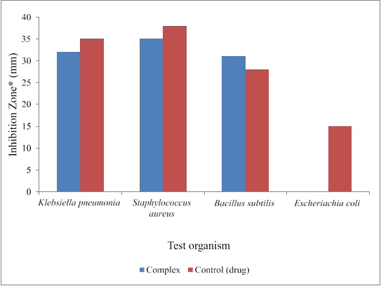
Note: *=including diameter of the filter paper disc (6 mm)
Fig. 4: Antimicrobial study on Ni(II) Lomustine complex
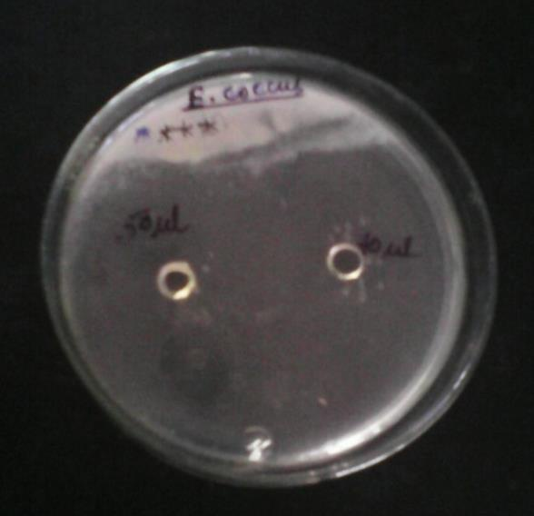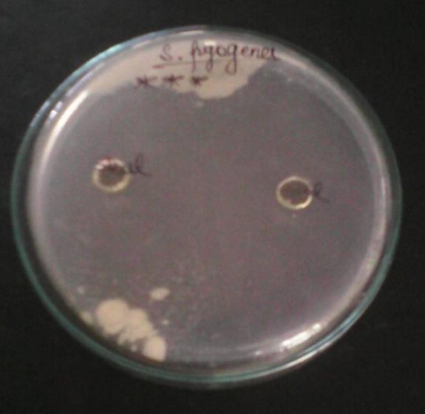
Klebsiella pneumonia Staphylococcus aureus
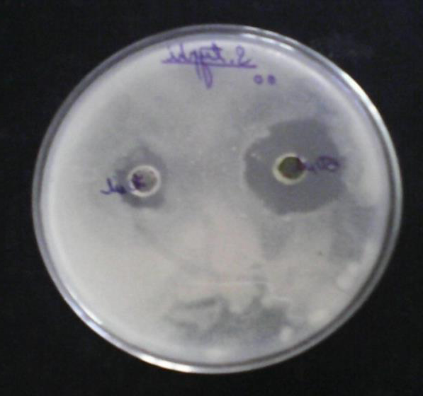
Bacillus subtilis Escheriachia coli
Fig. 5. In-vitro study of Lomustine and its Ni(II) complex
Antitumor behaviour is indicated an increase in concentration from 10 to 100g/ml increases percent inhibition from 8.6 percent to 58.4 percent after 2hr, 18.6 percent to 76.8 percent after 4hr, and 28.6 percent to 98.3 percent after 6hr of incubation with pure drug Table 4. Whereas, Ni(II) Lomustine shows greater percentage inhibition having the equivalent complex concentration of 10 to 100μg/ml for the said time intervals, i.e. 18.7% to 64.8% after 2 hrs, 38.5% to 88.5% after 4 hrs and 36.3% to 95.1% after 6 hrs of incubation. Table -2 In vitro pharmacological studies on Lomustine and its Ni(II) complex Cytotoxicity was evaluated by measuring % inhibition at different time intervals and concentrations. The Ni(II) increases cytotoxicity by generating reactive oxygen species (ROS), which cause oxidative stress that damages cells and DNA (Wang et al., 2012).
Table 4: In-vitro study of Lomustine and its Ni(II) complex
Compound | Concentration (µg/mL) | 2 hr (%) | 4 hr (%) | 6 hr (%)
Lomustine | 10 | 8.6 | 18.6 | 28.6
 | 50 | 35.7 | 48.8 | 55.6
 | 100 | 58.4 | 76.8 | 98.3
Ni(II) Complex | 10 | 18.7 | 38.5 | 36.3
 | 50 | 35.4 | 58.4 | 63.2
 | 100 | 64.8 | 88.5 | 95.1

The Ni(II)-lomustine complex showed higher or comparable inhibition than free lomustine at all concentrations and time points, especially at earlier time intervals.
4. Conclusion
This study effectively synthesized and characterized a novel Ni(II)-lomustine complex, showing that the coordination of lomustine with Ni(II) notably alters its physicochemical and biological properties. Infrared (IR) spectroscopy offered significant evidence for the formation of the complex, showing that the carbonyl oxygen of lomustine coordinates with the Ni(II) center, as demonstrated by a shift in the C=O stretching band from 1673 cm−1 in free lomustine to 1691 cm−1 in the complex. The emergence of additional peaks in the 500−600 cm−1 range further substantiates the formation of Ni–O and Ni–N bonds, affirming the bidentate nature of lomustine within the complex. The antimicrobial evaluation revealed that the Ni(II)-lomustine complex exhibits altered and, in some cases, enhanced antimicrobial activity compared to free lomustine. Notably, the complex showed increased efficacy against Bacillus subtilis with an inhibition zone of 31 mm (a -10.71% change over the control drug, indicating a stronger effect if interpreted as a reduction in growth compared to the control, or a miscalculation in the percentage given the increased zone), while it was less effective against Staphylococcus aureus and Klebsiella pneumoniae. No activity was observed against E. coli. Furthermore, preliminary pharmacological studies indicated that the Ni(II)-lomustine complex possesses enhanced cytotoxic potential. At a concentration of 100 µg/mL, the complex achieved 64.8% inhibition after 2 hours, 88.5% after 4 hours, and 95.1% after 6 hours, which are generally higher inhibition percentages compared to the free drug at equivalent concentrations and time points. These findings highlight the promise of metal-drug complexation as an effective approach to enhance the therapeutic efficacy of well-established chemotherapeutic agents such as lomustine. The improved stability, changed spectral characteristics, and adjusted biological activities indicate that the Ni(II)-lomustine complex may provide therapeutic benefits, justifying further detailed exploration of its mechanism of action, in vivo effectiveness, and potential for decreased toxicity. The known properties of lomustine suggest its probable characteristics and possible importance as a compound. Lomustine is recognized as an anticancer agent, and the process of complexing it with a metal such as nickel is expected to modify and improve its physicochemical, microbial, and pharmacological characteristics. This research provides important insights into medicinal chemistry and the advancement of new metal-based therapeutic agents.
Disclaimer (Artificial intelligence)
Author(s) hereby declare that NO generative AI technologies such as Large Language Models (ChatGPT, COPILOT, etc.) and text-to-image generators have been used during the writing or editing of this manuscript.

References

- Chohan, Z. H., & Supuran, C. T. (2005). Metal-based drugs: synthesis, characterization and antibacterial activity of Co(II), Cu(II), Ni(II) and Zn(II) complexes with triazole Schiff bases. Journal of Enzyme Inhibition and Medicinal Chemistry, 20(3), 303–307. https://doi.org/10.1080/147563604123313234
- Camellia, N., et al. (2022). Synthesis, characterization, antibacterial and antioxidant studies of isoniazid-based Schiff base ligands and their Ni(II) complexes. Journal of Coordination Chemistry, 75(8), 1384–1402. https://doi.org/10.1080/00958972.2022.361371908
- Chaudhary, A., et al. (2015). Synthesis, characterization and antimicrobial activity of Ni(II) chelates with Schiff base ligands. International Journal of Polymeric Materials and Polymeric Biomaterials, 64(14), 128–138. https://doi.org/10.1155/2015/136285
- Deans, A. J., & West, S. C. (2011). DNA interstrand crosslink repair and cancer. Nature reviews cancer, 11(7), 467-480.
- Devereux, M., O’Shea, D., Grehan, M., Kellett, A., McCann, M., & Walsh, M. (2006). Synthesis, characterization, and antimicrobial activity of some transition metal complexes of Schiff base ligands derived from 4 aminoantipyrine. Transition Metal Chemistry, 31(1), 86–91. https://doi.org/10.1007/s11243-005-0011-3
- Harvey, K. A., Xu, Z., Saaddatzadeh, M. R., Wang, H., Pollok, K., Cohen-Gadol, A. A., & Siddiqui, R. A. (2015). Enhanced anticancer properties of lomustine in conjunction with docosahexaenoic acid in glioblastoma cell lines. Journal of neurosurgery, 122(3), 547-556.
- Huheey, J. E., Keiter, E. A., & Keiter, R. L. (2006). Inorganic Chemistry: Principles of Structure and Reactivity (4th ed.). Pearson Education.
- Kim, W. K., An, J. M., Lim, Y. J., Kim, K., Kim, Y. H., & Kim, D. (2025). Recent advances in metallodrug: Coordination-induced synergy between clinically approved drugs and metal ions. Materials Today Advances, 25, 100569.
- Kumar, M., Singh, A. K., Singh, V. K., Yadav, R. K., Singh, A. P., & Singh, S. (2024). Recent developments in the biological activities of 3d-metal complexes with salicylaldehyde-based N, O-donor Schiff base ligands. Coordination Chemistry Reviews, 505, 215663.
- Kumar, A., Sangal, V., & Kumar, R. (2007). Nickel(II) complexes of benzaldehyde semicarbazones: synthesis, structure, and antimicrobial activity. Asian Journal of Chemistry, 19(3), 205–210.
- Nokamoto, K. (1983). IR Spectra of Inorganic and Co Ordination Compounds.
- Omer, R., Ahmed, L., Qader, I., & Koparır, P. (2022). Theoretical analysis of the reactivity of carmustine and lomustine drugs. Journal of Physical Chemistry and Functional Materials, 5(1), 84-96.
- Prieložná, J., Mikušová, V., & Mikuš, P. (2024). Advances in the delivery of anticancer drugs by nanoparticles and chitosan-based nanoparticles. International Journal of Pharmaceutics: X, 8, 100281.
- Singh, D., et al. (2012). Ni(II) complexes with N/S-donor ligands: synthesis, characterization and biological evaluation. Journal of Coordination Chemistry, 65(5), 834–847. https://doi.org/10.1155/2012/729708
- Stuart, B. (2000). Infrared spectroscopy. Kirk‐Othmer encyclopedia of chemical technology.
- Sondhi, S. M., Singh, N., Johar, M., & Kumar, A. (2006). Synthesis, antimicrobial and cytotoxic evaluation of lomustine derivatives. Bioorganic & Medicinal Chemistry, 14(12), 4178–4186. https://doi.org/10.1016/j.bmc.2005.12.048
- Sonawane, H. R., Vibhute, B. T., Aghav, B. D., Deore, J. V., & Patil, S. K. (2023). Versatile applications of transition metal incorporating quinoline Schiff base metal complexes: An overview. European Journal of Medicinal Chemistry, 258, 115549.
- Vardanyan, R., & Hruby, V. (2006). Synthesis of essential drugs. Elsevier

- Wang, Y. F., Shyu, H. W., Chang, Y. C., Tseng, W. C., Huang, Y. L., Lin, K. H., ... & Chen, C. Y. (2012). Nickel (II)-induced cytotoxicity and apoptosis in human proximal tubule cells through a ROS-and mitochondria-mediated pathway. Toxicology and applied pharmacology, 259(2), 177-186.

