Investigating the Role of Household Water Storage Practices in Shaping Microbial Contamination and Diarrheal Disease Burden in South East Nigeria
Abstract
In many developing countries like Nigeria, access to safe drinking water remains a major health challenge especially in Enugu state, because tap water is unavailable or unreliable. The majority of households store water for their daily use. However, this practice can lead to microbial contamination of the water, mostly when containers are not clean or covered properly. This study investigates how household water storage practices connect with water contamination and the spread of diarrhea cases in the South East region of Nigeria.
A cross-sectional study was conducted across 268 households in both urban and peri-urban communities in Enugu State. Structured questionnaires were used to assess and collect data on reported diarrhea cases and storage habits, while membrane filtration techniques were used to analyze sample water to check for total Coliforms and E. coli.
Out of the 268 households that were surveyed, 88% use stored water for drinking purposes, 58% relied on public taps, 62% used wide-mouthed plastic buckets, and 25% used containers with spigots. 36% clean their containers regularly, 27% covered their containers with tight-fitting lids. 46% reported at least one case of diarrhea in the past two weeks. 77% had E. coli, 29% reported no illness. 72% of water samples tested positive for total coliforms, and 48% were contaminated with E. coli. Salmonella spp. were isolated from 15% of the samples, and Shigella spp. from 8%.
This research highlights the importance of how household water is handled; it showed that even water from a good source can be contaminated if not managed well. It contributes to public health by drawing attention to how household water storage, including improved infrastructure, helps in keeping water safe. Our findings, despite its limitation by Cross-sectional design and the use of self-reported health data, offer insight that can guide improvements in water, sanitation and hygiene (WASH) strategies and public health campaigns focused on reducing diarrhea cases through safer water storage.
Keywords: Household water storage, Microbial contamination, Coliforms and pathogenic bacteria, Diarrheal diseases, Water quality, WASH practices,

Introduction
In most homes today water is stored for several hours or weeks sometimes without properly covered before they are being consumed [1] [2]. An average water tank used in countries like Nigeria contains over 1,000 liters of water and are being stored for long thereby increasing the growth of microbes in these stored water. In less developed areas with low income like Enugu state region of Nigeria, storing of water has been a major necessity and has led to a significant increase in microbes in stored water. This area has been often neglected and less attention has been paid to this [3].

Household water storage is common in places with limited or no access to pipe water and electricity. In underserved communities, people often make ends meet by storing water in tanks, gallons, buckets, drums, wells, and reservoirs. Growths of Pathogenic bacteria such as Legionella, Pseudomonas, and Escherichia coli are caused by this practice [3] [4]. Improper cleaning and covering of the containers increases contamination of this stored water, and this exposes the containers or tanks to insects, bird feces, dirty pipes, and contact with unclean hands. These factors cause an increase in household waterborne illnesses.

Water borne diseases which cause diarrhea have been one of the leading causes of death in children. According to [5] diarrhea is the leading cause of about 9% of deaths in children under five years globally. Much attention has been placed on improving water preservation with little attention to the effect of microbes in water after storage; also, attention has been placed on water purification at its source with less attention to water at the household level. Studies show that most drinking water contamination occurs between the point of collection and the point of consumption [6] [7]

Water storage has been one of the basic necessities in a household. Research by [8] showed that microbiological quality of drinking water increases after collection due to improper handling and unhygienic household storage. Similarly, studies by [9] [10] have demonstrated that water storage practices, such as the type of container, method of retrieval, and frequency of cleaning, have a direct impact on water quality and health outcomes.

Most of these containers used to store water have been proven to increase water contamination due to the presence of lead and other synthetic chemicals like PFAS used in the production of these containers, including the design [11]. For example, containers with wide mouths are open to contamination because they give access to easy contact with cups, hands and other household utensils. In contrast, containers with closed mouths and taps or spigots tend to preserve water quality better. Access to narrow-opening containers is limited due to its cost, especially in Enugu state, which highlights socioeconomic barriers to safe water storage.

The main causes of diarrhea are often connected to waterborne pathogens and this mainly affects children and can cause several health problems including diarrhea and death [12] [13]. Unfortunately researchers often focus on the quality of water at its source instead of examining the point of consumption where contamination is likely to occur. Enough attention has not been given to the study of contamination on where the water is sourced.

Many individuals are not aware of the Pathogenic organisms that can grow during water storage and the health risk it can cause. When water is stored in open or dirty containers in extremely hot and poor environments for long periods, it creates a perfect condition for bacteria to grow [14]

Human habits play an important role in waterborne disease. Households with improved hygiene, such as cleaning and covering stored water containers with lids and using clean utensils for collecting water from the storage, have been proven to report less rate of diarrhea and other water related diseases [15] [16]. However households with inadequate health education often do not practice this. Campaigns that focused on educating people on water handling have shown a mixed outcome, because they are not sustained or directed to local reality [17].

Health outcomes have been tried to be linked to microbial quality of water by many studies. Some of the studies found out the relationship, while some find it difficult to isolate variables, and not reporting illness well and difficulty in channeling disease exposure to one particular source [18] [19] [20]. Improving water quality at the point of consumption has been proven to reduce the growth of microbes and pathogens in household water especially in areas with inconsistent treated water supply and limited access.

This study highlights the link between contamination that occurs due to water storage and human health. It examines water both at the source and at the point of consumption, investigating the leading causes of diarrhea and other diseases related to contaminated water.
In States like those in the South East region of Nigeria (such as Imo, Enugu, Abia, Ebonyi, and Anambra), where water scarcity forces households to store water, poor storage practices often lead to contamination. This contributes to the spread of waterborne disease such as cholera, typhoid, dysentery, and giardiasis [21] [22] [23]. Improved hygiene practices like properly covering water and regular cleaning of tanks and pipes can reduce these diseases.

This study aims to focus on the relationship between household habits, microbial testing in stored water such as testing for E. coli, and self-reported health outcome in local areas in Enugu State Nigeria, based on existing studies. It combined survey data obtained from analyzing laboratory samples. It provides deeper insight on how household water can contribute in preventing illness caused by waterborne disease and what can be done about it.

While this study does not attempt to provide all the answers, it asks a simple but overlooked question: is the water people drink at home as safe as they think it is?

Materials and Methods

This study used a Cross-sectional design to examine the relationship between household water storage practices related to microbial contamination, and diarrheal disease in South East Nigeria specifically Enugu state. The investigation was carried out during the dry season, specifically January - March, a period when stored water use is most prevalent due to irregular tap water supply and limited rainfall. Urban and peri-urban neighborhoods were covered in this study to capture a range of socioeconomic and environmental conditions.
Stratified sampling approaches were used on 268 households who were selected to represent different neighborhoods. Only households that stored water for at least 24 hours and had at least one child under five years of age were included. This age group was chosen because children are vulnerable to waterborne diseases and often serve as sensitive indicators of household health risk when considering public health challenges.
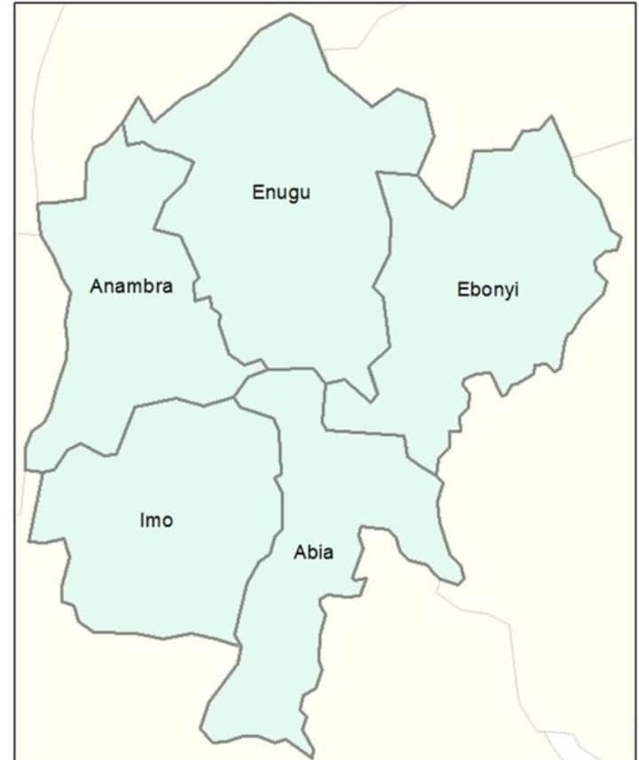
Figure 1: Map of South East Nigeria, showing the study area.

The two main components that were used for data collection are a structured household survey and microbiological analysis of stored water samples. Information on water sources, types of storage containers, cleaning schedules, covering practices, and methods of water retrieval (e.g., pouring vs. dipping) was obtained through the survey. Questions about recent cases of diarrhea in the past two-week, which is commonly used in public health research, were asked to the selected household [24] [25].

500 ml sterile bottles were used to collect all water samples directly from the stored containers which are used for drinking and were transported to the microbiology laboratory in cool boxes within three hours of collection. Microbial analysis was carried out by culturing the water samples with a focus on total Coliforms, Escherichia coli, Shigella spp., and Salmonella spp. Membrane filtration techniques using MacConkey agar were used to assess the presence and approximate counts of total Coliforms and E. coli. Saline was used to carry out three 10-fold Serial dilutions on samples that yield high bacterial loads, with dilution factors ranging from 10⁻¹ to 10⁻³. Plates with colony counts between 30 and 300 were considered valid for estimating colony-forming units (CFU) per 100 ml.

Selective enrichment using selenite F broth and alkaline peptone water was used to enhance the recovery of Salmonella and Shigella spp., respectively, followed by subculturing onto Salmonella-Shigella agar (SS agar).

Standard biochemical tests such as indole, methyl red, Voges-Proskauer, catalase, urease, citrate utilization, and lactose fermentation were performed to confirm and characterize the bacteria isolated from the water samples. We compared the result of the bacteria to WHO guidelines, which states that a safe threshold is zero detectable E. coli colonies per 100 ml of water [26]. Each household's survey responses with corresponding microbial data were matched with coded identifiers. The results of the survey were entered into a statistical package for the social science (SPSS) for descriptive analysis. Descriptive statistics, chi-square tests, and logistic regression were used to assess the relationship between the study variables.

Results
Out of the 268 households that were surveyed, 88% reported using stored water for drinking purposes, and 58% relied on public taps or borehole water as their primary source. 62% of the household used wide-mouthed plastic buckets which is the most common storage containers, while only 25% used containers with taps or spigots. 36% of households reported cleaning their containers regularly (at least once a week), and only 27% consistently covered their containers with tight-fitting lids.
Table 1 Survey: Household Water Storage and Handling Practices
Variable | % of Household (n=268)
Used stored water for drinking | 88%
Rely on public tap or borehole | 58%
Use wide-mouthed buckets | 62%
Use containers with taps/spigots | 25%
Clean containers weekly | 36%
Always cover containers tightly | 27%

Microbial analysis revealed that 72% of water samples tested positive for total Coliforms, and 48% were contaminated with E. coli. Using membrane filtration, E. coli colonies were observed on MacConkey agar, with counts ranging from 10 to over 300 CFU per 100 ml. Out of the total samples, 64 (approximately 24%) exhibited dense bacterial growth with uncountable colonies at full strength (100 ml undiluted). For these, serial dilutions ranging from 10⁻¹ to 10⁻³ were performed to obtain countable plates. Among the diluted samples, E. coli was isolated in 39 cases, with colony counts ranging between 123 and 285 CFU/100 ml after dilution. In addition, Salmonella spp. were isolated from 15 diluted samples, with counts ranging from 41 to 118 CFU/100 ml, while Shigella spp. were isolated from 8 samples, with colony counts ranging from 27 to 96 CFU/100 ml. All isolates were confirmed through standard biochemical tests.
Salmonella spp. were isolated from 15% of samples, and Shigella spp. from 8%, using selective enrichment and Salmonella-Shigella agar.
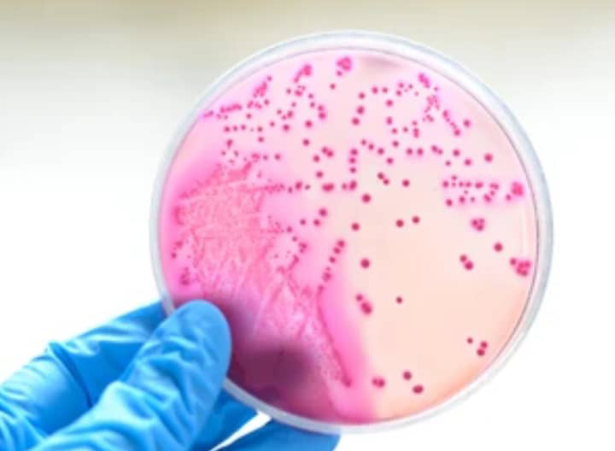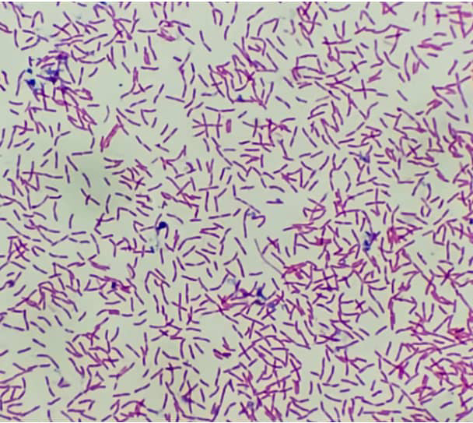
Figure 2 A Figure 2 B
Figure 2 A and B: showed the culture plate and microscopic image of E. coli
Table 2: Microbial Contamination in Stored Water Samples
Microorganisms | %of Positive samples | Cfu range (per 100 ml)
Total Coliforms | 72% | -
E. coli (overall) | 48% | 10 – 300+
E. coli (from diluted samples) | 39/64% | 123 - 285
Salmonella spp. | 15% | 41- 118
Shigella spp. | 8% | 27 - 96

The presence of these pathogens in household-stored drinking water indicates serious lapses in hygiene and storage practices, with potential public health implications.
Contamination was highest in wide-mouthed, uncovered containers that were not frequently cleaned, reinforcing the role of storage conditions and handling methods in determining water quality.
In terms of health outcomes, 46% of households reported at least one case of diarrhea in the past two weeks. Among these, 77% had E. coli contamination in their stored water, compared to only 29% among households without reported illness. This difference was statistically significant (p < 0.01), indicating a strong correlation between microbial water quality and diarrheal incidence.
Further analysis using logistic regression showed that households using uncovered containers had 2.8 times higher chance of reporting diarrhea (OR = 2.8, 95% CI: 1.7 – 4.5). Similarly, households that cleaned containers less than once a week had 3.2 times higher odds of having E. coli contamination (OR = 3.2, 95% CI: 1.9 – 5.0). Households with either Salmonella or Shigella detected in their water also showed elevated chances of reporting diarrhea, though these associations were not included in the regression due to smaller sample sizes. These findings suggest a clear link between habit, microbial contamination, and diarrheal disease.
Table 3 Summary of associations between E. coli contamination, storage practices, and reported diarrhea in 268 households in South East Nigeria
Exposure | Outcome measured | % Affected | Chances ratio (95% Cl) | P-value
Household with diarrhea having E. coli | E. coli in stored water | 77% | - | <0.01
Household reporting diarrhea | Diarrhea in past 2 weeks | 46% | - | -
Household without illness having E. coli | E. coli stored in water | 29% | - | <0.01
Use of uncovered containers | Likelihood of reporting diarrhea | - | 2.8 (1.7 – 4.5) | <0.01
Clean containers less than once per week | Likelihood of reporting E. coli | - | 3.2 (1.9 – 5.0) | <0

Figure 3: Showed the percentage of household reporting E. coli and diarrhea
15% of households with contaminated water had no reported diarrheal cases, highlighting possible variations in individual immunity, underreporting, or other protective factors such as boiling or chlorination. However, only 18% of households reported treating their stored water in any way, indicating that most were consuming it directly.
This result shows that households using uncovered containers or not cleaning their containers often are at higher risk of contracting waterborne disease and diarrhea. This reinforces the importance of addressing household habits as part of broader water safety initiatives.

Discussion
This study supports earlier research showing that water stored at home contributes to the spread of waterborne diseases. Even when the water is from clean and treated sources with little to no impurities, its quality often drops once it's stored. And this occurs due to poor hygiene practices [27].
It is common for stored water to harbour pathogenic organisms, including E. coli, Salmonella, Shigella, Legionella, viruses such as rotavirus and hepatitis viruses, and parasites like Giardia and Entamoeba which causes health problems to households [28]. Although many studies concentrated on water from taps, boreholes, and wells. Our research found out that contamination occurs not only at the source but also during storage at home.

As of March 2024, World Health Organization recorded high mortality of children who died of diarrhea disease; some are under five years of age 5. This report showed that diarrhea is the leading cause of death in children, highlighting the urgent need for public health help [5] More focus should be placed on how individuals store water at home. This study proves that focus should be placed on household water storage, especially in areas where people lack constant access to clean water.

Despite much evidence that was available on water getting contaminated, less attention has been given to the condition of water at the point of use, despite growing evidence that most contamination occurs after collection. This study highlights that diarrhea is strongly linked to poor water storage practices, and that more attention should be given to water storage methods, such as proper tank coverage, regular cleaning, safe container use, and avoiding long-term storage without treatment [29].

Diarrhea disease, which is linked to contaminated water in the home, is often overlooked, and this contributes to rising rates of these diseases. Many researchers focus on E.coli and Coliforms bacteria as an indicator of quality water, and overlook other pathogens like viruses and parasites, which are also responsible for causing several gastrointestinal diseases [30] ([31]
This study presents valuable insights into the health implications associated with inadequate water storage in various homes, a topic that has long been neglected. It underscores the importance of improving water handling, which can play a big role in reducing the spread of disease transmission, by lowering the rate of diarrhea, and improving the lives of children.

Conclusion
This study underscores the critical role of stored water in homes, which influences microbial contamination and diarrheal disease. Contamination of stored water in homes by E. coli and other organisms, alongside reported cases of diarrhea in children is one of the public health challenges which are often overlooked.

Our finding makes a clear case for re-balancing WASH interventions by placing more attention toward household habits of storing water. Infrastructure development and delivery of water treatment is often prioritized by public health, this research shows that individuals might lose the benefits of clean water from the source before consumption. To avoid this, behavior-based interventions, such as regular cleaning of containers, proper covering, and use of narrow-mouthed containers should be put into practice. This behavior-focused approach is low-cost, community-scalable, and immediately actionable.
Importantly, our study contributes to the existing body of knowledge by connecting microbiological testing with self-reported health outcomes. This integrated approach helps strengthen the case for behavior change, showing that it's not only detectable microbial contamination that matters but its real-world impact on community health especially among children, who are most vulnerable.
Despite that our research is cross-sectional, it does not determine the causal relationship between waterborne disease and its health outcome. However, future studies should include follow-up studies, molecular analysis and intervention components to assess the long-term effect of behavior changes on the spread of waterborne disease.

Improving how water is stored in homes and implementing a strategy that will help in reducing the spread and burden of diarrhea are essential in fighting waterborne disease. Ensuring the safety of drinking water should not end at the point of source, instead it should extend to how water is stored at homes. Addressing these overlooked challenges that cause waterborne disease will help in translating water access into a real health benefit, especially to the communities in Enugu State and all over the world that are vulnerable to waterborne disease.

Ethical approval and consent:
All participants gave their consent and no personal information was collected. The procedures used in this research followed established ethical standards for research that involves human participation. All the procedures involving sample collection and handling adhered to biosafety regulations. Results of the research were shared to the households, along with recommendations for safe storage practices when contamination was detected.
Disclaimer (Artificial intelligence)
Option 1:
Author(s) hereby declare that NO generative AI technologies such as Large Language Models (ChatGPT, COPILOT, etc.) and text-to-image generators have been used during the writing or editing of this manuscript.
Option 2:
Author(s) hereby declare that generative AI technologies such as Large Language Models, etc. have been used during the writing or editing of manuscripts. This explanation will include the name, version, model, and source of the generative AI technology and as well as all input prompts provided to the generative AI technology
Details of the AI usage are given below:
1.
2.
3.
Reference
- Manga, M., Ngobi, T. G., Okeny, L., Acheng, P., Namakula, H., & Kibwami, N. (2021).
The effect of household storage tanks/vessels and user practices on the quality of water: A systematic review of literature. Environmental Systems Research, 10(1), 1 – 12.
https://doi.org/10.1186/s40068-021-00221-9

- Aydamo, A. A., Gari, S. R., & Mereta, S. T. (2024).
Seasonal variations in household water use, microbiological water quality, and challenges to the provision of adequate drinking water: A case of peri-urban and informal settlements of Hosanna Town, Southern Ethiopia. Environmental Health Insights, 18, 11786302241238940. https://doi.org/10.1177/11786302241238940

- Obikpo, L., Onyia, F. C., Offe, I. M., Ezeilo, C. M., Ezebialu, C., & Afunwa, R. A. (2022). Bacteriological quality of community well water and public health concerns in Enugu urban, Nigeria. African Journal of Clinical and Experimental Microbiology, 23(2), 202‑210. https://doi.org/10.4314/ajcem.v23i2.10

- Mnisi, Z. F., Delair, Z., & Singh, A. (2025). Legionella in Urban and Rural Water, a Tale of Two Environments. Water, 17(10), Article 1491. https://doi.org/10.3390/w17101491

- World Health Organization. (2024, March 7). Diarrhoeal disease. https://www.who.int/news-room/fact-sheets/detail/diarrhoeal-disease

- Okeola, F., Abu, T., Mohammed, A., Orosun, M., Baba, A., & Adeboje, M. B. (2023). Investigation on the quality of prolonged storage of packaged water commonly produced in North Central, Nigeria. Journal of the Turkish Chemical Society, Section A: Chemistry, 10(2), 303 – 314. https://doi.org/10.18596/jotcsa.1116034

- Babalola, T., Oluwatuyi, M., & Sam-Ijadele, K. (2024). Physico-chemical and bacteriological quality of household drinking water from source to point of use in Akewu community in Ibadan, Oyo State, Southwest, Nigeria. International Journal of Research and Scientific Innovation (IJRSI), 11(4), 106 – 122. https://doi.org/10.51244/IJRSI.2024.1104008

- Okimiji, O. P., Atoro, T., Fasona, M. I., & Oni, O. O. (2024). Assessment of microbial contamination of drinking water and environment-related diseases in slum settlements around Lagos coastal areas, Southwest Nigeria. Nigerian Journal of Hydrological Sciences, 11(1). Retrieved from https://www.ajol.info/index.php/njhydrosci/article/view/280326

- Izah, S. C., & Ineyougha, E. R. (2015). A review of the microbial quality of potable water sources in Nigeria. Journal of Advances in Biological and Basic Research. Retrieved from https://www.asdpub.com/index.php/jabbr/article/view/144

- Bakari, B. A., Mwaura, J. W., & Yonge, S. A. (2022). Determination of microbial contamination of water used in the household for domestic purposes in Mombasa County, Kenya. International Journal of Community Medicine and Public Health, 9(4), 1389 – 1393. https://doi.org/10.18203/2394-6040.ijcmph20221747

- Packer, S., Sussman, B., & Bennett, K. (2023, March 7). New study shows PFAS chemicals rapidly migrate into products from fluorinated plastic containers. Center for Environmental Health. Retrieved from https://ceh.org/latest/press-releases/breaking-new-study-shows-pfas-chemicals-rapidly-migrate-into-products-from-fluorinated-plastic-containers/

- World Health Organization. (2023).
Drinking-water. https://www.who.int/news-room/fact-sheets/detail/drinking-water

- UNICEF. (2024, November 1). Diarrhoea remains a leading killer of young children, despite the availability of a simple treatment. UNICEF DATA. https://data.unicef.org/topic/child-health/diarrhoeal-disease/

- Tenebe, I. T., Babatunde, E. O., Ogarekpe, N. M., Emakhu, J., Etu, E.-E., Edo, O. C., Omeje, M., & Benson, N. U. (2024). Detection and measurement of bacterial contaminants in stored river water consumed in Ekpoma. Water, 16(18), 2696. https://doi.org/10.3390/w16182696

- Ok, Emmanuel. (2025). Impact of water, sanitation, and hygiene (WASH) interventions on diarrhea prevention in Pakistani households. ResearchGate. https://www.researchgate.net/publication/389435978_Impact_of_Water_Sanitation_and_Hygiene_WASH_Interventions_on_Diarrhea_Prevention_in_Pakistani_Households

- Alsammani, A., Farah, G. A. M. O., Mohammed, M. A. Y., & Yavuz, M. (2025). Cholera transmission dynamics with sanitation control measures. arXiv preprint arXiv:2505.08873. https://arxiv.org/abs/2505.08873

- Booysen, M. J., & Gerber, S. (2021). Water scarcity and poverty: The lasting impact of a maintenance campaign at South African schools across the affluence divide. Water Science & Technology, 84(10 – 11), 3246 – 3256. https://doi.org/10.2166/wst.2021.424

- Osiemo, M. M., Ogendi, G. M., & M’Erimba, C. (2019). Microbial quality of drinking water and prevalence of water related diseases in Marigat Urban Centre, Kenya. Environmental Health Insights, 13, Article 1178630219836988. https://doi.org/10.1177/1178630219836988

- Fewtrell, L., Kaufmann, R. B., Kay, D., Enanoria, W., Haller, L., & Colford, J. M., Jr. (2005). Water, sanitation, and hygiene interventions to reduce diarrhoea in less developed countries: A systematic review and meta-analysis. The Lancet Infectious Diseases, 5(1), 42 – 52. https://doi.org/10.1016/S1473-3099(04)01253-8

- Ng’andwe, S., Ogendi, G. M., Muoria, E., & Ngoma, J. (2025). Microbial Water Quality at the Point of Use: The Role of Socio Economic Factors and Water Handling Practices in Kitwe District, Zambia. Environmental Health Insights, 19(1). https://doi.org/10.1177/11786302251337563

- Okpasuo, O. J., Aguzie, I. O., Joy, A. T., & Okafor, F. C. (2020). Risk assessment of waterborne infections in Enugu State, Nigeria: Implications of household water choices, knowledge, and practices. AIMS Public Health, 7(3), 634 – 649. https://doi.org/10.3934/publichealth.2020050

- Ezeama, N., & Adogu, P. (2023). Preferred drinking water sources and waterborne infections among households in a rural community in Anambra State, South East, Nigeria. West African Journal on Sustainable Development. Retrieved from https://journals.unizik.edu.ng/wajsd/article/view/3970

- Vanguard News. (2023, January 27).
Cholera outbreak kills 3, sixteen hospitalized in Abia. https://www.vanguardngr.com/2023/01/cholera-outbreak-kills-3-sixteen-hospitalized-in-abia/

- World Health Organization. (2005). the treatment of diarrhoea: A manual for physicians and other senior health workers (4th rev. ed.). Geneva: World Health Organization. https://www.who.int/publications/i/item/9241593180

- Overbey, K. N., Schwab, K. J., & Exum, N. G. (2019). Comparison of 1‑week and 2‑week recall periods for caregiver reported diarrhoeal illness in children, using nationally representative household surveys. International Journal of Epidemiology, 48(4), 1228‑1239. https://doi.org/10.1093/ije/dyz043

- World Health Organization. (2017). Guidelines for drinking-water quality (4th ed., incorporating the 1st addendum). Geneva: World Health Organization. https://www.who.int/publications/i/item/9789241549950

- Nnaji, C. C., Nnaji, I. V., & Ekwule, R. O. (2019). Storage induced deterioration of domestic water quality. Journal of Water, Sanitation and Hygiene for Development, 9(2), 329 – 337. https://doi.org/10.2166/washdev.2019.151

- World Health Organization. (2025). Shigella: background document for the WHO guidelines for drinking-water quality and the WHO guidelines on sanitation and health. https://doi.org/10.2471/B09223

- Ogba, O. M., Olorode, O. A., Okon, M. P., & Umoh, N. O. (2021). Bacteriological quality analysis of water in storage tanks in a University Community, South Southern Nigeria. Sokoto Journal of Medical Laboratory Science, 6(3). https://doi.org/10.4314/sokjmls.v6i3.3

- Amadi, E. C., Eze, E. A., Nwangwu, C. C., Ani, P. N., Okpara, T. C., & Chukwuma, S. T. (2022). Evaluation of parasites as veritable indicators of faecal Escherichia coli contamination of surface waters: A case study of Adada River, Enugu State, Nigeria. American Journal of Water Resources, 10(1), 1– 5. https://doi.org/10.12691/ajwr-10-1-1

- Umeanaeto, P. U., Ani, E. G., Anyaoha, V. I., Anumba, J. U., Afulukwe, S. C., & Okoli, C. C. (2022). Parasitic and bacterial contamination of sachets water sold at Ngwo, Enugu State, Nigeria. Nigerian Journal of Parasitology, 43(2), 303 – 310. https://dx.doi.org/10.4314/njpar.v43i2.13

