Original Research Article
Effect of Plant Growth Regulators on In Vitro Morphogenesis in Tinospora cordifolia (Willd.) Miers Hook. F. & Thomson from Cultured Nodal Segments
Abstract
Tinospora cordifolia (Willd.) Miers ex Hook F & Thoms (Family: Menispermaceae), commonly known as heart-leaved Moonseed plant in English and Giloy in Hindi, is one of the important National Medicinal Plant Board (NMPB) listed medicinal plants. It is usually employed in conventional ayurvedic treatment. In present investigation, an efficient and reproducible plant regeneration system was developed through direct and indirect organogenesis from cultured nodal segments excised from one-year-old greenhouse-grown plant. An average (6-8) initiation days was recorded for callus initiation for inoculated nodal segments on MS medium supplemented with 3.0 mgl⁻¹ 2, 4-D with 100 percent callus induction competence with an average fresh weight of 12.00 g. Maximum shoot proliferation (98%), shoot numbers (5.16±0.13) with greater length (5.88±0.04 cm) and leaf numbers (6.16±0.13) were achieved on MS medium enriched with 1.5 mgl⁻¹ BAP in combination with 2.0 mgl⁻¹ Kn after 40 days of inoculation. During the shoot multiplication, leaching of phenolics was observed frequently and to evade this, two adjuvants viz., ascorbic acid and activated charcoal were employed. Addition of 100 mgl⁻¹ ascorbic acid in combination with 5.0 gl⁻¹ activated charcoal with optimized plant growth regulators to MS medium reduced phenol exudation ultimately leading to much healthier plant and decreased leaf defoliation. The highest (84%) response of root induction, number of roots (4.16±0.30) with higher root length (5.20±0.008 cm) was observed on half- strength MS medium augmented with 1.0 mgl⁻¹ IBA after 45 days of transfer in rooting medium. Among diverse potting mixture combinations, maximum survival (85%) with maximum plant height (16.16±0.13cm) was attained in combination of cocopeat: vermiculite (1:1) under greenhouse conditions after five weeks of hardening. Plants after acclimatization survived well in nature. Although the traits were not scored quantitatively, regenerated plantlets appeared phenotypically normal and as its mother plants.
Keywords: Direct and indirect organogenesis, mass in vitro propagation, nodal segment culture, plantlet regeneration and Tinospora cordifolia (Willd.).
1. Introduction
Tinospora cordifolia (Willd.) Miers ex Hook F & Thoms (Family: Menispermaceae), generally recognized as heart-leaved Moonseed plant in English and Giloy in Hindi, is one of the significant medicinal plants of pharmaceutical importance (Krishna et al., 2009). It is a climbing shrub found in tropical provinces of India, China, Sri Lanka and Bangladesh (Raghu et al., 2006; Singh et al., 2019). It is an amusing source of an array of natural chemical ingredients, including tinosporin, berberine, magnoflorine, cordifolioside, isocolumbin, palmetine, cordifolioside, tinocordiside, syringing etc (Priti and Sulekha, 2019; Adithya & Narasimhan, 2020; Kumar et al., 2020; Vikram et al., 2021; Prasad et al., 2023). These natural products qualified this plant to therapy of number of ailments like viral infections, cancer, diabetes, inflammation, neurological disorders, psychiatric problems, microbial infection, hypertension and HIV (Singh & Chaudhuri, 2017; Sharma et al., 2021; Azeem et al., 2023; Upadhya, 2023).
Owing to its uncommonness in natural habitats, T. cordifolia has been given precedence by National Medicinal Plant Board (NMPB) for use of biotechnological interventions. It is also among the 178 species of medicinal plants that has high value in market according to the NMPB (Mittal et al., 2014; Khan et al., 2019). According to NMPB in New Delhi, T. cordifolia is one of 29 highly priority medicinal plants in India's agroclimatic zone 8 (Rajasthan, Uttar Pradesh, and Madhya Pradesh). At the present yearly demand for plant stems is thought to be between 1000 and 2000 MT. The WHO estimates that 60% of people worldwide use herbal medicine and that in underdeveloped nations, 80% of people rely nearly exclusively on it for their basic medical requirements. Around $100 billion is shared by the herbal business globally, and it has reasonable development potential. WHO also suggested the commerce in herbal pharmaceuticals, raw materials, and therapeutic plants as it is expanding at a pace of around 15% each year (Khan, 2019).
Due to its considerable therapeutic benefits, pharmaceutical companies and individuals looking for conventional therapies have overused it, which has led to a major shortage of plants needed to meet current demand. Stem cuttings are the traditional method for propagating the plant because of its poor seed set and a low (57.5%) germination rate are both present (Warrier et al., 2008). In vitro propagation methods hold the promise of increasing the availability of plant resources for commercial utilization (Tripathi et al., 2021a; Tripathi et al., 2022a;). This technique enables the rapid multiplication and genetic enhancement of desirable genotypes through the use of biotechnological tools and processes (Baghel et al., 2008; Tripathi et al., 2022b;). This method assists the dual purpose of facilitating basic cellular, genetic, and biochemical research along with direct applications in commercial ventures (Tripathi et al., 2022c). Tissue culture has substantially expanded the possibilities and potential of micropropagation by harnessing the inherent regenerative aptitudes of selected horticultural and agricultural plants, including those of medicinal significance (Ahuja et al., 2016; Jhankare et al., 2011; Uikey et al., 2016; Tripathi et al., 2019; Tiwari et al., 2021).
In Tinospora cordifolia, plant regeneration has been reported from employing an array of explants for instance nodal segment (Bhalerao et al., 2013; Choudhury& Handique, 2013; Sultana & Handique, 2013; Sivakumar et al., 2014; Datta et al., 2015; Sinha & Sharma, 2015; Chatterjee & Ghosh, 2016; Mittal et al., 2017; Mridula et al., 2017; Sheema Dharmapal et al., 2017; Trivedi & Vegda, 2017; Gedam et al., 2019; Malik & Arya, 2019; Priti &Sulekha, 2019; Shankar et al., 2020; Sudan et al.,2020; Deshmukh, 2022; Patel and Pandya, 2022; Pandey et al., 2023), leaf (Datta et al., 2015; Gedam et al., 2019), shoot tip (Sharma & Vashistha, 2014; Sharma et al., 2015; Mridula et al., 2019) callus culture (Samarth et al., 2019; Pillai & Siril,2020) and encapsulated nodal segment (Singh et al., 2021; Singh et al., 2022) with varying degree of success.
In vitro morphogenesis, nevertheless, seems to be reliant on the genotype, explant source and nutrient medium, and therefore, it is essential to develop specific regeneration systems for each explant (Tripathi et al., 2021b; Tripathi et al., 2022d). Henceforth, the present study meant to establish an inclusive system for the extensive propagation of Tinospora cordifolia using nodal segments as an explant by computing optimal concentrations and combinations of plant growth regulators to be added in a culture medium exhibiting higher in vitro morphogenesis tracked by an efficient plant regeneration of elite cultivar (s).
2. Material & Methods
2.1 Explant material
The current study was conducted at the Plant Tissue Culture & Genetic Transformation Laboratory, Department of Plant Molecular Biology and Biotechnology, Rajmata Vijayaraje Scindia Agricultural University, Gwalior M.P., India during the July 2021 to October 2023. The nodal segments explants were acquired from one-year-old plants, grown at greenhouse (26°13’5.8332” N 78°10’58.1916” E) of the department, which were shifted from the Tapovan Nursery in the year 2020.
2.2 Culture media
To start with an initial study, two diverse basal media viz., MS (Murashige and Skoog, 1962) and B₅ (Gamborg et al., 1968) were adored to search out better in vitro response. In the preliminary study, MS basal medium was proved more responsive than B₅ media (data not presented); hereafter, for later studies basal MS medium was used during experimentation. All culture media were prepared utilizing readymade basal MS medium (HiMidiaTM) and added with three diverse sets of plant growth regulators to MS basal media. In first set: two different auxins, viz., 2, 4-D and NAA (solely), in second set: two diverse cytokinins viz., BAP and Kn as alone and in third set: two cytokinins i.e., BAP and Kn in varying concentrations and combinations to achieve the best in vitro response. In addition to MS basal macro and micro salts, vitamins, all culture media was supplemented with 30.0 gl⁻¹ sucrose and the final volume was made to 1000 ml and pH was attuned to 5.8 ± 0.1 with 1N KOH. After adjusting the pH, agar powder @ 7.5 gl⁻¹ was incorporated to the media as a semi-solidifying agent. Warm culture media, still in liquid state was poured into baby food bottles (50-60 ml / bottle) and culture tubes (15-20 ml/ tube) tracked by autoclaving at 121ºC under 15 psi pressures for 25 min. Readymade basal media, plant growth regulators and other ingredients were procured from Hi-media Laboratories, Mumbai, India.
2.3 Surface sterilization of donor plant
Nodal segments were collected from the elite plants. The explant was excised as single node segments, after removing shoot tips and leaves except for a small portion of the petiole. The node segments (1-2 cm) were cleaned gently using a paintbrush and dipped in tween 20 (3.0 mll⁻¹) solution followed by washing with double distilled water with gentle agitation. The explants were again dipped in a fungicide: bavistin (1.5 -3.0% w/v) solution along with the antibiotics viz., streptomycin sulfate and kanamycin acid sulfate in diverse concentrations and combinations in 100 ml distilled water and kept in a rotatory shaker for 20-45 min and then thoroughly washed with double distilled water. Further steps of surface sterilization were carried out inside the Laminar Air Flow Cabinet where they were treated with 0.1% (w/v) aqueous solution of mercuric chloride (HgCl₂) for 1.0 to 2.0 min following washing with distilled water four to five times. The explants were again treated with 7 0% (v/v) ethyl alcohol for different durations and then washed with autoclaved sterile double distilled water four to five times.
In order to check the phenol leaching from cut surface of explant, media were also fortified with different antioxidants/ phenol binding agents i.e., ascorbic acid and activated charcoal in varying concentrations and combinations.
2.4 Nodal segment excision and plating technique
The surface sterilized nodal explants were trimmed at cut ends with a surgical blade and nodal portion measuring 1.0 - 1.5 cm in length were inoculated on culture media.
2.5 Culture conditions
Baby food bottles/culture tubes containing cultures covered with Lab film (Parafilm®) were incubated under whole darkness at 25±2°C for one week. Later in vitro cultured nodal segments were exposed to photoperiod management of 16 hours light/8 hours dark series at an intensity of 2000-lux luminance providing combinations of fluorescent tubes and Photosynthetically Active Radiation lamps at 25±2⁰C and 70% relative humidity.
2.6 Subculture
The responding nodal segments were transferred regularly every 15 days into fresh media with the similar composition of the initial medium.
2.7 Regeneration of plantlets
After 3-4 weeks of preliminary inoculation, nodal segments followed either direct plant regeneration i.e., via auxiliary bud proliferation or indirect organogenesis via callus formation. Shootlets gotten from direct proliferation were transferred to MS elongation medium amended with 1.0 mgl⁻¹ GA₃, 20.0 gl⁻¹ sucrose and 7.5 gl⁻¹ agar. For regeneration, abridged dose of sucrose was used based on earlier work performed by various scientists as well as prior understandings of our laboratory (Tiwari et al., 2004; Mishra et al., 2021; Shyam et al., 2021; Bhatt et al., 2022; Sharde et al., 2023). Nevertheless, calli obtained from indirect organogenesis were subcultured once more on the initial medium after four weeks of inoculation. Cultures were subjected to 25±2ºC temperature and photoperiod commands of 60 μmolm²s⁻¹ luminance facilitated by cool fluorescent tubes for 16 hr.
2.8 In vitro rooting of regenerants
If root formation was not observed in regenerants, plantlets were transferred to full as well as half-strength MS medium amended with different concentrations of IBA and NAA, 15.0 gl⁻¹ sucrose and 7.5 gl⁻¹ agar subsequently. For rooting, reduced level of sucrose was applied on the basis of work conducted by various scientists as well as preliminary experiences of this laboratory (Tiwari & Tripathi, 2005; Tiwari et al., 2007; Tripathi et al., 2023a; Tripathi et al., 2024a; Tripathi et al., 2025a).
2.9 Acclimatization of regenerants
After regeneration of plantlets following consecutive culturing phases, the rooted healthy plants were prudently removed from the culture vessels and systematically splashed with distilled water to eradicate traces of agar. Before planting in plastic pro-trays filled with different potting mixtures including sand, soil, FYM, vermiculite, Cocopeat and vermicompost in different ratios and combinations, the plantlets treated with fungicide by submerging them in 0.25 percent bavistin solution for 2 min. Root trainers with transplanted plants were then transferred under 30±2ºC and 60±5% relative humidity for 40-45 days in greenhouse/polyhouse for hardening. Afterward these regenerants were transferred to the field.
2.10 Experimental design and analysis of data
All experiments were conducted in a Completely Randomized Design (CRD) with two replications. Each treatment and each replication contained 60-80 nodal segments. Phenotypic observations of the cultures were made every week and data interrelated to callus induction %, callus weight, texture, colour, shoot proliferating competence, numbers of shootlets, numbers of leaves, root proliferating efficiency, numbers of roots and root length were recorded at diverse time intervals. Data were analysed employing Duncan’s Multiple 35-Range Test (DMRT). Mean denoted with different letters in the same column differed significantly at p = 0.05. The SPSS version 23.0 programme was used. Whereas the survival and contamination percentages were analysed by employing arc-sine transformation since data were in percentage. The data were analysed for means and standard error in accordance to Snedecor and Cochran's (1997) suggestions.
Results and Discussion
3.1 Establishment of Aseptic Culture
Nodal segments isolated from greenhouse grown mother plants waterfront several microorganisms that must be eradicated before culture into the nutrient media. Contamination may spread from nodal segment to the cultures even if most of the bacteria are eliminated (Tripathi et al., 2023b; Tripathi et al., 2023c). Hence, one of the most crucial actions in the development of an aseptic culture is standardizing the explant surface sterilization method. In current study, nodal segments were employed to culture establishment. Thus, proper surface sterilization is essential for establishing aseptic cultures. The most commonly employed surface sterilant in plant tissue culture are bavistin (fungicide), mercuric chloride (HgCl₂), 70% (v/v) ethanol and antibiotics viz., streptomycin sulphate, kanamycin acid sulphate (Tripathi et al., 2023d; Tripathi et al., 2024b; Sharma et al., 2025). Diverse surface sterilants, their concentrations and exposure times are well described to influence the in vitro culture establishment up to a great extent (Vibhute et al., 2022).
Surface sterilization procedure for Tinospora cordifolia has been outlined by many workers in the past including Raghu et al. (2006), Bhalerao et al. (2013), Sharma and Vashistha (2014), Sivakumar et al. (2014), Sharma et al. (2015), Tupe and Pandhure (2015), Sinha and Sharma (2015), Sheema Dharmapal et al. (2017), Deshmukh (2022) and Pandey et al. (2023). However, depending on the tissue or explant type employed, a separate sterilizing procedure needs to be developed.
In the present study, there were highly significant (p<0.05) differences were recorded among the responses to diverse surface sterilizing, anti-bacterial and antifungal agents. The data presented in Table 1 and Fig.1 displayed that for nodal segments a remarkable reduction in microbial contamination was observed when nodal segments were treated with a combination of (Bavistin + Streptomycin + Kanamycin) + HgCl₂+Ethanol (3.0 g +0.1g +0.1g) +0.1+70% for {(50 min) +2 min +4 min}, correspondingly, ensuing in survival rate (85%) with the minimum contamination (15%). Earlier, Pandey et al. (2023) have displayed the effectiveness of 0.1% HgCl₂ for 5 min in the case of nodal section and Deshmukh (2022) was found more effective treatment with 1.0 % bavistin (w/v) for 5 min tracked by 3 times washing with autoclaved double distilled water then with 0.1% HgCl₂ for 6 min followed by 4 or 5 times rinsing with sterile double distilled water. In the study of Sheema Dharmapal et al. (2017), treatment of 70% ethanol and 0.1% mercuric chloride for 5 min, were found more effective for aseptic culture establishment.
Moreover, nodal segment excised from the top 1-10 nodes could not induce higher bud break, probably owing to the tender nature of buds (Kurmi et al., 2011). The exposure of explants to sterilants/antioxidants may harm these lenient tissues (Sharma et al., 2010). Maximum bud break was obtained from 10-20 nodes, possibly due to infantile status and capability to resist the toxic effect of surface sterilizing agents (Tripathi et al., 2023e). These results are in agreement to the findings of Tripathi et al. (2025a) and Tripathi et al. (2025b) who also achieved higher morphogenic response followed by plantlet regeneration that appears to be exceedingly reliant on position of explant in several horticultural and medicinal crop plants. Studies have also exposed that lower or mid portion of the branch are calmer to establish in vitro than upper portion (Vibhute et al., 2022).
3.2 Control of Phenol Exudation
To control phenolic leaching from cut ends of nodal section, two phenol controlling agents viz., ascorbic acid and activated charcoal were employed. Data presented in Table 2 revealed that addition of 100 mgl⁻¹ ascorbic acid in combination with 5.0 gl⁻¹ activated charcoal reduced phenol exudation ultimately leading to much healthier plant and decreased leaf loss. The reason may be attributed to complete blockage of outlet for phenolic compounds and thereby the establishment of explant on the media. The nutrient might have been absorbed by the side surface of nodal shoot. Parallel results have also been addressed by Patidar et al. (2010) in aonla, Mridula et al. (2019) and Patel and Pandya (2022) in Tinospora cordifolia. Mridula et al. (2019) obtained the higher shoot proliferating competence (98.3%) with higher number (16) of shoots/explants on a medium supplemented with 100 mgl⁻¹ ascorbic acid and 10 gl⁻¹ activated charcoal. In the experiment of Patel and Pandya (2022), culture medium supplemented with ascorbic acid and activated charcoal also promoted morphogenic response.
3.3 In Vitro Morphogenesis
In the current study, three diverse sets of plant growth regulators were supplemented to formulate MS basal media for inoculating nodal segments. Contingent on the type, concentration, and combination of plant growth regulators, cultured nodal segments tracked either a direct or an indirect route of plantlet regeneration. In direct mode, plantlets were regenerated on explant surface directly without intervening callus phase (via auxiliary bud proliferation); whereas in the indirect approach, plantlets initiated via callus formation (indirect organogenesis). In direct mode of regeneration, shootlets were developed directly from the meristematic zones of inoculated nodal segments (Fig.2: A-F). Shoot formation were started approximately 7 days after initial culturing (Fig. 2: B) and elongated gradually after increased time intervals (Fig. 2: C-F). In the indirect pathway, plantlets were regenerated via indirect organogenesis on the callus surface (Fig. 2: G-K). The first response of inoculated explants appeared after 4-7 days and was mostly independent of culture media. All explants became swollen and no callus proliferation was apparent during first few days (Fig.2: A). Callus proliferation generally started from the portion in contact with the medium and spread upward after a week of inoculation. Initiated callus tissue developed distinct phenotypes (Fig. 2: G-I). These pheno-variants were rough, hard, dense and glossy reflecting different developmental potentials (Fig. 2: G-I). Plantlet regeneration happened usually (Fig. 2: J-K) after sub culturing of these organogenic calli. Root initiation started after 14- 25 days of transferring shootlets to the rooting medium (Fig.2: L-M). Regenerated plantlets were transferred to green house (Fig. 2: N) circumstances for hardening before being shifted to the field.
3.4 In Vitro Callus Induction
Auxins, as an external source of plant growth regulators, were employed to initiate callus from various explants. In the current investigation, explant nodal section failed to begin callus or bud break when inoculated on a media devoid of plant growth regulators (Table 3). After addition of plant growth regulators in to basal MS medium, depending upon the concentration of auxins viz., NAA and 2,4-D, callus induction has been taken place and varied considerably (Table 3).
When nodal section explants were inoculated in MS basal medium amended with NAA in concentrations of 0.5-5.0 mgl⁻¹, callus initiation along with slight root formation were observed. After 6-18 days of inoculation, light yellowish green to dark brown coloured callus proliferation was seen. However, in some circumstances callus of green colour were also observed. The texture of callus was compact, semi-compact and friable. Application of NAA in diverse concentrations exhibited callus proliferation percentage in range of 67 to 84, while 100% callus proliferation was achieved with fresh weight of 8.72^{b}±0.20g after 40 days of inoculation with supplementation of NAA at the concentration of 3.0 mgl⁻¹. Average days taken for callus initiation were more frequent (7.35 days). Whereas, medium callusing (84%) was observed with 2.0 mgl⁻¹ NAA. while higher concentration (>3.0 mgl⁻¹) resulted in a progressive decline in callus induction efficiency. The lowest response was recorded at 5.0 mgl⁻¹ NAA, producing only 3.38±0.20 g fresh weight (Table 3). Pillai and Siril (2020) found the best results in terms of callus fresh weight (2531 mg) on medium supplemented with 5 μM NAA.
The inoculation of the nodal section on 2, 4-D supplemented media produced a friable, semi-compact and compact callus that ranged in color from yellowish green to green and from light brown to dark brown. The initiation of callus was taken an average of 6–14 days. An average (6-8) initiation days was recorded when medium was supplemented with 3.0 mgl⁻¹ 2, 4-D with 100 percent competence and average fresh weight of 12.00 g. Further, increasing the levels of 2, 4- D (beyond 3.0 mgl⁻¹) showed a decline in callus proliferation efficiency. While intermediate callusing was observed at 1.0 mgl⁻¹, 2.0 mgl⁻¹and 4.0 mgl⁻¹and slight callusing at 0.5 mgl⁻¹ and 5.0 mgl⁻¹ levels. In the study conducted by Datta et al. (2015) number of days taken was 5±0.28 for callus induction from cultured nodal segments on similar medium. Organogenic creamy brown friable callus was developed. Sheema Dharmpal et al. (2017) reported that application of 1.0 mgl⁻¹ 2,4-D proved the best for callus induction from cultured leaf disc. Although, callus proliferation was seen with application of NAA and 2,4-D, the best results were obtained with 2,4-D.
3.5 In Vitro Shooting Response
Cytokinins are commonly added to tissue culture media to promote the initiation of axillary shoots. The function of cytokinin in tissue culture is well understood, and the synergistic action of suitable cytokinin and their combination can result in the greatest morphogenetic response (Tripathi et al., 2023a; Tripathi et al., 2023b). Effects of cytokinins viz., BAP and Kn solitary or in combination in shooting and their proliferation were studied in present study. Enrichment of MS medium with different levels of BAP and Kn significantly increased the average number of shoots, leaf number per shoot and shoot length over control.
Augmentation of MS medium with diverse levels of BAP and Kn pointedly enhanced the shoot proliferating efficiency, average number of shoots shoot length and leaf number over the control. The nodal section explants started to grow within 8-10 days of inoculation on media containing BAP. After 18-22 days of culture, shoot formation and new leaves were observed on media supplemented with different levels of BAP. The best shoot proliferating efficiency (84%), number of shootlets (5.16±0.14) with greater length (5.05±0.01cm) and number of leaves (4.84±0.13) were observed with application of 2.0 mgl⁻¹BAP after 40 days of inoculation (Table 4). Among different concentrations of Kn, the nodal section explants started to initiate shootlets after 10-12 days of inoculation. The best multiple shoot proliferation (75 %), numbers of shoots (4.50±0.14) with greater length (4.33±0.08) and numbers of leaves (4.33) were observed at 2.0 mgl⁻¹ (Table 4).
When two cytokinins were compared for shoot proliferation, it was evident that shoot proliferating efficiency, numbers of shoots, leaf number and soot length was better on BAP supplemented medium than Kn. Sahu et al. (2020) also found that BAP was more effective than Kn among the cytokinins tested for shoot formation. An average multiplication rate of 6.3 shoots per explant was obtained with MS medium supplemented with 8.87 µM BAP alone. Patel and Pandya (2022) also achieved the best results on BAP containing medium. Pandey et al. (2023) also found the best results on MS +2.0 mgl⁻¹ BAP medium. Shoot initiation was started after 7 days of inoculation. However, elevated levels of cytokinin beyond 3.0 mg l⁻¹ significantly decreased the rate of multiplication.
To achieve a higher in vitro response, the basal medium was also fortified with two cytokinins viz., BAP and Kn in combination. The maximum shoot proliferation (98%), shoot numbers (5.16±0.13) with greater length (5.88±0.04cm), and leaf number (6.16±0.13) were recorded on MS medium amended with 1.5 mgl⁻¹ BAP in combination with 2.0 mgl⁻¹ Kn. Remarkable increment in the numbers of shoots was recorded at the concentration of BAP and Kn was recorded at the 2.0 mgl⁻¹each BAP and Kn; however, any further increment was not evident, with increased concentrations of BAP and Kn in combination and resulted in drastic reduction in numbers of shoots and led to callus formation at the basal ends of the nodal segments (Table 5). Numerous studies conducted by Sahu et al. (2020), Deshmukh (2022), Patel and Pandya (2022) and Pandey et al. (2023) have also been showed that cytokinins have a positive impact on the start of the shoot meristem, axillary bud bursting and multiple shoot development in Tinospora cordifolia.
3.6 In Vitro Rooting
The main endogenous plant growth hormones known for promoting the adventitious rooting process is an auxin (Tripathi et al., 2023c; Tripathi et al., 2023d). Auxins help in the mobilization of reserve food resources, the elongation of meristematic cells and the differentiation of cambial initials into root primordia, which may account for the rise in the proportion of rooting on auxin-rich medium (Tripathi et al., 2022c; Tripathi et al., 2023e). In general, a higher rooting efficiency is frequently linked to low auxin concentration during the initial phase of rooting (Tripathi et al., 2022d). It was discovered that Tinospora shoots can induce the formation of roots by providing an additional plant growth regulator. Moreover, the existence of an auxin induces more root initiation than actual root elongation (Tripathi et al., 2021a; Tripathi et al., 2021b). As a consequence, the application of auxins, mainly IBA and NAA, is crucial for the induction of functional and quality rootlets (Tripathi et al., 2024a; Tripathi et al., 2025a; Tripathi et al., 2025b).
In current study, significant improvement was observed in rooting with the supplementation of rooting media with various levels of auxins viz., IBA and NAA (Table 6; Table 7). Early induction of good quality roots along with the maximum numbers of roots per micro shoot (4.16±0.30) with higher length (5.20±0.08cm) was evident on half-strength MS media added with 1.0 mgl⁻¹ IBA after 45 days of transferring micro shoots to rooting media (Table 7). In comparison to NAA, IBA produced better results when the two auxins were employed to induce consistent, well-shaped roots. IBA was found to be the most effective than any other synthetic auxins in most of the cases, probably because it is not destroyed by IAA oxidase or other enzymes and therefore persists longer (Sharma et al., 2025). The effectiveness of IBA in inducing quality roots has earlier been proved by Sultana and Handique (2013), Sharma et al. (2015), Mittal and Sharma (2017), Mridula et al. (2017) and Pandey et al. (2023). Sharma et al. (2015) were found good rooting response with length of 2-3 cm on media supplemented with 1.0 mgl⁻¹ IAA and IBA. Mittal and Sharma (2017) also found 89% root proliferation with 8.3 ± 0.46 cm length with application of 0.5 mgl⁻¹ IBA. Mridula et al. (2017) reported that half-strength MS medium amended with 0.5 mgl⁻¹ IBA and 0.5 mgl⁻¹ NAA proved the best for inducing in vitro rooting. Pandey et al. (2023) also reported the best rooting response when shoots were inoculated on MS medium supplemented with 0.5 mgl⁻¹ IBA.
3.7 Standardization of In Vivo Hardening
The subsistence of tissue culture raised plantlets in the greenhouse/polyhouse or under field conditions, decides the ultimate success of any gainful tissue culture process (Bhatt et al., 2022). In the current study, the efficiency of in vitro hardening in increasing plant survival and plummeting mortality of in vitro regenerated plantlets was standardized.
The high danger of plantlet death is evident when in vitro regenerated regenerants are transplanted to an in vivo environment. This is mainly instigated by weak root systems and the necessity for newly raised regenerants to acclimatize to an array of abnormalities that exist in in vivo condition, including high levels of radiation, low relative humidity, a lack of water, etc. Among diverse potting mixture combinations, maximum survival (85%) with higher plant height (16.16±0.13cm) was achieved in combination of cocopeat: vermiculite (1:1) followed by vermiculite: soil: FYM in 1:1:1 ratio (80%) with (14.33±0.00 cm) plant height (Table 8). Parallel results have also been previously addressed by Sivakumar et al. (2014), Mittal and Sharma (2017) and Chaudhary et al. (2024).
Conclusion
The current study points that under suitable circumstances, nodal segment culture of Tinospora cordifolia is more capable in contrast to other hardy species. Higher morphogenic competence, regeneration frequency numbers of shoots with greater length have been attained in this experimentation as compared to the previous findings. Employing our regeneration system in Tinospora cordifolia could deliver an additional approach for the improvement of elite cultivar along with raising embryogenic cell suspension cultures which may be further employed for production of valuable secondary metabolites of pharmaceutical significance.

Disclaimer (Artificial Intelligence)
Author(s) hereby declares that no generative AI technologies such as Large Language Models (ChatGPT, COPILOT, etc.) and text-to-image generators have been used during the writing or editing of this manuscript.
Competing Interests
Authors have declared that no competing interests exist.
Abbreviations: B₅-Gamborg’s medium, BAP-6-benzylaminopurine; 2,4-D: 2,4-dichlorophenoxyacetic acid; IBA-Indole-3-butyric acid; GA₃: Gibberellic acid; Kn- Kinetin, MS-Murashige and Skoog’s medium; NAA-α-Naphthalene acetic acid; TDZ- Thidiazuron.

References

Adithya, E. & Narasimhan, S. (2020). In vitro synthesis of berberine, a pharmacologically important isoquinoline alkaloid in callus cultures of Tinospora cordifolia. Int. J. Pharm. Sci., 11(4), 7135- 7139.
- Ahuja, A., Tripathi, M.K. & Singh, S.P. (2016). Plant cell cultures-an efficient resource for the production of biologically important metabolites: recent developments-a review. Progressive Research, 11(1):1-8.

Azeem, M., Hanif, M. & Mahmood, K. (2023). An insight into anticancer, antioxidant, antimicrobial, antidiabetic and anti-inflammatory effects of quercetin: a review. Polym. Bull. 80, 241–262.
- Baghel, R.S., Tiwari, S. & Tripathi MK. (2008). Comparison of morphogenic and plant regeneration ability of some explants of teak (Tectona grandis L inn. F) J. Agric Technol. 4:125-136.

Bhalerao, B., Vishwakarma, K. & Maheshwari, V. (2013). Tinospora cordifolia (Willd.) Miers ex Hook. F. & Thosmas. plant tissue culture and comparative chemo-profiling study as a function of different supporting trees. Indian J. Nat. Prod. Resour., 4:380-386.
- Bhatt, D., Tripathi, M.K., Vidhya Sankar, M., Tiwari, S., Sharma, M.& Tripathi, N. (2022). Standardization of in vitro regeneration protocol in Gerbera jamesonii Bolus Ex Hooker F. In book: Current Topics in Agricultural Sciences. 7:105-121. DOI: 10.9734/bpi/ctas/v7/2303B

Chatterjee, T. & Ghosh, B. (2016). Efficient stable in vitro micropropagation and conservation of Tinospora cordifolia (Willd.) Miers: an anti-diabetic indigenous medicinal plant. Int. J. Bioresour. Stress Manag., 7. 814-822.
- Choudhary, R., Gurjar P.K.S., Tripathi, M.K., Kantwa, R.S.,Sharma, A.A., Khandoliya,S. & Ram, G. (2024). Effect of different potting mixtures on acclimatization of in vitro developed plants on survival percentage under glass house condition. International Journal of Environment & Climate Change.14 (3), 445-449.
- Choudhury, S.S. & Handique, P. J. (2013). TDZ enhances multiple shoot production from nodal explants of Tinospora cordifolia-a commercially important medicinal plant species of NE India. Res. J. Biotechnol., 8. 31-36.

Datta, R., Priyadarshni, M., Kumar, I. R. & Shukla, L. N. (2015). Induction of callus from leaf and internodal segment of Tinospora cordifolia, an important medicinal plant. Int. J. Exch. Knowl., 2(1): 17-24.
- Deshmukh, N.P. (2022). In vitro micropropagation of Tinospora cordifolia - an important medicinal plant. J. Emerg. Technol. Innov. Res., 9 (5):307-313.
- Gamborg, O.L., Miler, R.A.& Ojima, K. (1968). Nutrient requirement of suspension culture of soyabean root cells. Exp. Cells Res. 50:151-158.
- Gedam, V.V., Punyapwar, S.V., Raut, P.A. & Chahande, A.D. (2019). Rapid in vitro proliferation of Tinospora cordifolia callus biomass from stem and leaf with phytochemical and antimicrobial assessment. In: Ghosh, S. (eds) Waste Biomass Valorization. Springer, Singapore. 2:978- 981.
- Jhankare, A., Tiwari, G., Tripathi, M.K., Tiwari, S. & Baghel, B.S. (2011). Plant regeneration from mature cotyledon, embryo and hypocotyl explants of Withania somnifera (L.) Dunal. J Agric Technol. 7:1021-1033.
- Khan, M.A. (2019). Tinospora cordifolia aqueous extract ameliorates the systemic infection of Aspergillus fumigatus in Balb/c mice. Asian J Pharm Clin Res. 12(3):525-528.

Khan, A. M. S., Ahmad, I. & Chattopadhyay, D. (2019). Herbal medicine: Current trends and future prospects. new look to phytomedicine. Academic Press. 1: 3-13.
- Krishna, K. L., Bhatt, J., Patel, J. (2009). Guduchi (Tinospora cordifolia): Biological and medicinal properties. A review, Internet J. Altern. Med., 6(2).
- Kumar, P., Kamle, M., Mahato, D. K., Bora, H., Sharma, B., Rasane, P., and Bajpai, V. K. (2020). Tinospora cordifolia (Giloy): phytochemistry, ethnopharmacology, clinical application and conservation strategies. Curr. Pharm. Biotechnol, 21(12):1165-1175.
- Kurmi, U.S., Sharma, D.K., Tripathi, M.K., Tiwari, R., Baghel, B.S. &Tiwari, S. (2011). Plant regeneration of Vitis vinifera (L.) via direct and indirect organogenesis from cultured nodal segments. J Agric Technol. 7:721-737.
- Malik, A. & Arya, A. (2019). Studies on effect of hormone on in vitro regeneration of Tinospora cordifolia. Int. J. Curr. Microbiol. App. Sci., 8(10): 1386-1393.
- Mishra, N., Tripathi, M.K., Tiwari, S., Tripathi, N., Sapre, S., Ahuja, A. & Tiwari, S. (2021). Cell suspension culture and in vitro screening for drought tolerance in soybean using polyethylene glycol. Plants. 10(3):517-536.
- Mittal, J., Mishra, Y., Singh, A., Batra, A. & Sharma, M. M. (2017). An efficient micropropagation of Tinospora cordifolia (Willd.) Miers ex Hook F & Thoms: A NMPB prioritized medicinal plant. Indian J. Biotechnol.,16:133-137
- Mittal, J., Sharma, M. M. & Batra, A. (2014). Tinospora cordifolia: a multipurpose medicinal plant- a review. J. Med. Plant. Stud., 2:32–47.
- Mittal, J. & Sharma, M. M. (2017). Enhanced production of berberine in in vitro regenerated cell of Tinospora cordifolia and its analysis through LCMS QToF. Biotech., 7: 25.
- Mridula, K. R., Parthibhan, S., Kumar, T. S., Rao, A. S. and Rao, M. V., (2017). In vitro organogenesis from Tinospora cordifolia (Willd.) Miers - a highly valuable medicinal plant. S. Afr. J. Bot., 113: 84-90.
- Mridula, K. R., Parthibhan, S., Kumar, T. S., Rao, A. S. & Rao, M. V. (2019). In vitro micropropagation of Tinospora cordifolia (Willd.) Miers from shoot tip explants. Agr. Nat. Resour., 53: 449-456.
- Murashige, T.& Skoog, F. (1962). A revised medium for rapid growth and bioassays with tobacco tissue cultures. Physiol Plant. 15(3): 473–97.
- Pandey, S., Maharjan, L. & Pant, B. (2023). In vitro propagation and assessment of genetic homogeneity using RAPD and ISSR markers in Tinospora cordifolia (Wild.) Hook. F. & Thoms, an important medicinal plant. Nepal J. Biotechnol., 4 (1): 27-36.
- Patel, S.D. & Pandya, A. (2022). Combination of PGRs for rapid and enhanced micropropagation of Tinospora cordifolia. Int. j. Innov. Sci. Technol., 7(5): 233-240.
- Patidar, D.K., Tripathi, M.K., Tiwari, R., Baghel, B.S. & Tiwari, S. (2010). In vitro propagation of Emblica officinalis from nodal segment culture. Journal of Agricultural Technology, 6(2): 245-256.
- Pillai, S. K. & Siril, E. A. (2020). Enhanced production of berberine through callus culture of Tinospora cordifolia (Willd.) Miers ex Hook F. and Thoms. Proc. Natl. Acad. Sci., India, Sect. B Biol. Sci., 90: 323–331.
- Prasad, A., Patel, P., Kumari, M., Saxena, G., Chakrabarty, D. & Singh, S.S. (2023). A literature update on strategies for harnessing and conserving the bioactive phytochemicals from Tinospora cordifolia: Current status, challenges, and future prospects. In: Mishra, M.K., Kumari, N. (eds) Plants for Immunity and Conservation Strategies. Springer, Singapore: 1–20.
- Priti and Sulekha R. (2019). Estimation of total alkaloids in wild and in vitro regenerated Tinospora cordifolia. Int. J. Pharm Sci. Res., 10(6): 2777-2784.
- Raghu, A. V., Geetha, S. P. & Martin, G. (2006). In vitro clonal propagation through mature nodes of Tinospora cordifolia (Willd.) Hook. F. & Thoms.: an important ayurvedic medicinal plant. In Vitro Cell. Dev. Biol.-Plant, 42:584–588.
- Sahu, B., Behera, L., Priyadarshini, A. & Samal, C. H. (2020). In vitro plantlet regeneration from Tinospora cordifolia (Willd.) Miers-a highly valuable medicinal plant and its chemoprofiling. Int. J. chem. Stud., 8(3): 1424-1429.
- Samarth, V. D., Sinkar, S. R., Pandya, U. and Dhuldhaj, U. P. (2019). Phytohormonal effect on in vitro callus induction of Tinospora cordifolia (Willd.) Miers. Plant Cell Biotechnol. Mol. Biol., 20 (23&24):1383-1389.
- Shankar, G., Upadhyay, N., Soni, R. & Agnihotri, R. K. (2020). Optimization of quick in vitro regeneration protocol using nodal segments of Tinospora cordifolia: a therapeutic reservoir. Indian Res. J. Genet. & Biotech., 12(3): 200-208.
- Sharde, R., Tripathi, M.K., Bhatt, D., Tiwari, S., Sharma, M., Tomar, Y.S. & Tripathi, N. (2023). Influence of plant growth regulators on in vitro morphogenesis in sprout culture of potato (Solanum tuberosum L.) Potato Research, doi: https//doi.org. /10.1007/s11540-023-09640-w
- Sharma, H. and Vashistha, B. D. (2014). In vitro callus initiation and organogenesis from shoot tip explants of Tinospora cordifolia (Willd.) Miers Ex Hook. F & Thoms. CIBTech Journal of Biotechnology, 16 (1): 3 (4), 77-83.
- Sharma, H., Rao, P. S. & Singh, A. K. (2021). Fifty years of research on Tinospora cordifolia: From botanical plant to functional ingredient in foods. Trends Food Sci. Technol., 118, (A):189- 206.
- Sharma, H., Vashistha, B. D., Singh, N. & Kumar, R. (2015). Tinospora cordifolia (Willd.) Miers Ex Hook F and Thoms. (Menispermaceae): Rapid in vitro propagation through shoot tip explants. Int. J. Recent Sci. Res., 6(2): 2714-2718.
- Sharma, A., Tripathi, M.K. Pandey, A., Payasi, D. K., Sharma, M., Mishra, R., Patel, G., Verma, A., Sharma, S. & Tiwari, S. (2025). Standardization of in vitro propagation protocol for Asparagus racemosus employing nodal segments. Plant Cell Biotechnology & Molecular Biology, 26 (9-10):73–90. https://doi.org/10.56557/pcbmb/2025/v26i9-109693.
- Sharma, P., Tripathi, M.K., Tiwari, G., Tiwari, S. & Baghel, B.S. (2010). Regeneration of liquorice (Glycyrrhiza glabra L.) from cultured nodal segments. Indian J Plant Physiol. 15:1-10.
- Sheema Dharmapal, P., Najla, M., Swetha E. S., Udayan, P. S. & Elyas K. K. (2017). Callus induction and organogenesis from Tinospora formanii Udayan and Pradeep: A rare endemic plant. Trop. Plant Res., 4:71-76. DOI: 10.22271/tpr. 2017.v4.i1.010
- Shyam, C., Tripathi, M.K., Tiwari, S., Ahuja, A., Tripathi, N. & Gupta, N. (2021). In vitro regeneration from callus and cell suspension cultures in Indian mustard [Brassica juncea (Linn.) Czern & Coss]. International Journal of Agricultural Technology. 17(3):1095-1112.
- Snedecor, G.W.& Cochran, W. G. (1997). Statistical Methods. 6th ed. Delhi: Oxford and IBH Publishing Co.
- Singh, S., Tripathi, M.K., Tiwari. S. & Ahuja, A. (2019). Giloe (Tinospora cordifolia Willd.): Multi efficacious plant of medicinal value. International Journal of Advance & Innovative Research. 6(1):117-124.
- Singh, S., Tripathi, M.K., Tiwari, S., Tripathi, N., Tejovathi, G. & Ahuja A. (2021). Encapsulation of nodal segments for propagation and short-term storage of giloe (Tinospora cordifolia Willd.): A medicinally important plant species. Current Journal of Applied Science and Technology, 40(30): 15-24.
- Singh, S., Tripathi, M.K., Tiwari, S., Tripathi, N., Tejovathi, G. & Ahuja, A, (2022). Production of synthetic seed from encapsulated nodal segments of giloe (Tinospora cordifolia Willd.). In: Research Developments in Science and Technology. 2:156-170. doi:10.9734/bpi/rdst/v2/2400B
- Singh, D. & Chaudhuri, P. K. (2017). Chemistry and pharmacology of Tinospora cordifolia. Nat.Prod. Commun., 12:2.
- Sinha, A. & Sharma, H. P. (2015). Micropropagation and phytochemical screening of Tinospora cordifolia (Willd.) Miers Ex. Hook. F. & Thoms.: A medicinal plant. Int. J. Adv. Pharm. Biol. Chem., 4(1): 114-121.
- Sivakumar, V., Ranjan, M. S. D., Sadiq, A. M. & Jayanthi, M. (2014). In vitro micropropagation of Tinospora cordifolia (Willd.) Miers ex Hook. F. & Thoms-An important medicinal plant. J. Pharmacog. Phytochem., 3:5–10.
- Sudan, S. S., Batra, B., Gusain, T., Lal, A. & Pant, M., (2020). In vitro propagation of Tinospora cordifolia and estimation of berberine content by Chromatographic analysis. Eco. Env. & Cons., (S58-S62)
- Sultana, C. S., & Handique, P. J. (2013). TDZ enhances multiple shoot production from nodal explants of Tinospora cordifolia-a commercially important medicinal plant species of NE India. Res. J. Biotechnol., 8, 5.
- Tiwari, S., Shanker, P.& Tripathi, M. (2004). Effects of genotype and culture medium on in vitro androgenesis in soybean (Glycine max Merr.). Indian Journal of Biotechnology. 3(3):441-444.
- Tiwari, S. &Tripathi, M. K. (2005). Comparison of morphogenic ability of callus types induced from different explants of soybean (Glycine max L. Merrill). Legume Research. 28:115-118.
- Tiwari S, Tripathi MK, Khare UK, Rana R. (2007). Initiation of embryogenic suspension cultures and plant regeneration in onion (Allium cepa L.). Indian J. Biotechnol. 6:100-106.
- Tiwari, G., Tripathi, M.K., Tiwari, S., Tripathi, N., Uikey, D.S. & Patel, R.P. (2021). In vitro production of secondary metabolites reserpine and ajmalicine in Rauvolfia serpentina (L.) Benth. In book: Current Aspects in Pharmaceutical Research and Development. 4:132-152. DOI: 10.9734/bpi/caprd/v4/2136C
- Tripathi, M.K., Mishra, N., Tiwari, S., Singh, S., Shyam, C. & Ahuja, A. (2019). Plant tissue culture technology: Sustainable option for mining high value pharmaceutical compounds. Int J Curr Microbiol Appl Sci. 8(2):102-110.
- Tripathi, M.K., Tiwari, S., Tripathi, N., Tiwari, G., Mishra, N., Bhatt, D. et al. (2021a). Plant tissue culture techniques for conservation of biodiversity of some plants appropriate propagation in degraded and temperate areas. In: book: Current Topics in Agricultural Sciences. 4:30-60. DOI: 10.9734/bpi/ctas/v4/2119C
- Tripathi, M.K., Tripathi, N., Tiwari, S., Tiwari, G., Mishra, N., Bele, D., Patel, R.P., Sapre, S. & Tiwari, S. (2021b). Optimization of different factors for initiation of somatic embryogenesis in suspension cultures in sandalwood (Santalum album L.). Horticulturae. 7(5):118. Available: https://doi.org/10.3390/horticulturae7050118
- Tripathi, M.K., Tiwari, G., Tiwari, S., Tripathi, N., Payasi, D.K. & Tiwari, S. (2022a). In vitro regeneration of sandalwood (Santalum album Linn.) employing different explants. In book: Advances in Agricultural Biotechnology. 6:83-116. DOI: 10.22271/ed.book.2048
- Tripathi, M.K., Tiwari, G., Tiwari, S., Tripathi, N., Mishra, N. & Tomar, Y.S. (2022b). Plant regeneration in Rauvolfia serpentina (L.) Benth via organogenic mode. In book: Research Aspects in Biological Science. 7:124-155. DOI: 10.9734/bpi/rabs/v7/3678A
- Tripathi, M.K., Tiwari, G., Tiwari, S., Tripathi, N., Sharma, M., Bhargav, S. et al. (2022c). Influence of plant growth regulators on in vitro morphogenesis in Plumbago zeylanica Linn. In book: Research Aspects in Biological Science. 7:96-123. DOI: 10.9734/bpi/rabs/v7/3679A
- Tripathi, M.K., Bele, D., Tiwari, S., Mishra, N., Tripathi, N. & Tiwari, G. (2022d). Plantlet regeneration from cultured nodal segments in sandalwood (Santalum album Linn.). In book: Research Developments in Science and Technology. 2:1-21, DOI: 10.9734/bpi/rdst/v2/6011F
- Tripathi, M.K., Tiwari, G., Tiwari, S., Tripathi, N., Sharma, M. & Mishra, N. (2023a). Effect of diverse plant growth regulator concentrations and amalgamations in plantlet regeneration in Rauvolfia serpentina (L.) Benth from cell suspension culture. In book: Research Trends in Multidisciplinary Research. 42:125-153. DOI: 10.22271/ed.book.2087
- Tripathi, M.K., Tiwari, G., Patidar, S.L., Tiwari, S., Tripathi, N. & Tiwari, S. (2023b). Optimization of an effectual and reproducible plantlet regeneration protocol from embryogenic cell suspension culture in Plumbago zeylanica Linn. In Book Advances in Agricultural Biotechnology Volume 8: 105-135.
- Tripathi, M.K., Tripathi, N., Tiwari, S., Malviya, R.K., Tiwari, P.N., Tiwari, S. et al. (2023c). Plant regeneration from cultured cormel explants in gladiolus (Hort.) In book: Recent Advances in Molecular Biology and Plant Physiology, 4:139-167. DOI: 10.22271/ed.book.2230.
- Tripathi, M.K., Tripathi, N., Tiwari, S., Payasi, D.K., Bhatt, D., Tomar, Y.S. et al. (2023d). Effect of plant growth regulators on in vitro morphogenesis and regeneration of Amaryllis belladonna L. In book: Recent Advances in Molecular Biology and Plant Physiology. 4:99-138. DOI: 10.22271/ed.book.2230.
- Tripathi, M.K., Tiwari, S., Tripathi, N., Malviya, R.K., Bhatt, D., Tiwari, P.N.& Tiwari, S. (2023e) In vitro morphogenesis in gladiolus (Gladiolus hybridus Hort.) from corm slice. Advances in Agricultural Biotechnology 8: 73-103.
- Tripathi, M.K., Tripathi, N., Tiwari, P.N. & Tiwari, S. (2024a). Plant regeneration via direct shoot organogenesis from cultured stem disc in tuberose (Polianthes tuberosa Linn.). In book: Advances in Agricultural Biotechnology, 10: 81-111.
- Tripathi, M.K., Patidar, D.K., Tiwari, R., Tripathi, N. & Tiwari, S. (2024b). Massive in vitro propagation of Emblica officinalis from cultured nodal segments. In book: Advances in Agricultural Biotechnology, Volume 10, pp 57-80.
- Tripathi, M.K., Tiwari, R., Mishra, R., Sharma, S., Tripathi, N. and Tiwari, S. (2025a). Regeneration of Vitis vinifera (L) via organogenesis from nodal segments. In Book: Advances in Agricultural Biotechnology, Volume 12, pp 115-152.
- Tripathi, M.K., Tiwari, G., Jhankare, A., Sharma, S., Tripathi, N. and Tiwari, S. (2025b). In vitro regeneration from different explants cultures in Withania somnifera (L.) Dunal. Advances in Biotechnology & Bioscience, Volume 18, pp 43-75.
- Trivedi, A. and Vegda, V. (2017). Conservation of medicinal plant - Tinospora cordifolia through tissue culture techniques. Life Sci. Leafl., 94:34-36.
- Tupe, M. & Pandhure, N. (2015). In vitro propagation of ayurvedic important plant Tinospora cordifolia (Willd.) Miers. Int. J. Recent Trends Sci. Technol., 15(1): 62-64.
- Uikey, D.S., Tripathi, M.K., Tiwari, G., Patel, R.P.& Ahuja, A. (2016). Embryogenic cell suspension culture induction and plantlet regeneration of Rauwolfia serpentina (L.) Benth.: influence of different plant growth regulator concentrations and combinations. Med Plants Int J Phytomed Relat Ind. 8(2):153-162.
- Upadhyay, R. K. (2023). Giloy (Amrita) Tinospora cordifolia: Its phytochemical, therapeutic, and disease prevention potential. Int. J. Green Pharm., 17 (2):137-150.
- Vibhute, M., Tripathi, M.K., Tiwari, R., Tiwari, S., Tripathi, N. & Sharma, M. (2022). Massive in vitro propagation from cultured nodal segment of three Citrus species. In book: Research Aspects in Biological Science. 6:102-127. DOI: 10.9734/bpi/rabs/v6/3508B
- Vikram, V., Kishore, P. R., Kalaiyarasan, A. & Hariram, N. (2021). Protein profiling and isolation of bioactive hydrolysates with antioxidant activity from stem callus tissue of Tinospora cordifolia (Willd.) Miers exposed to cyclodextrin. Int. J. Pharm. Sci. & Res., 12(1): 524-535.
- Warrier, R. R., Singh, B.G., Sivalingam, R., Anandalakshmi, R.& Sivakumar, V. (2008). Fruit chromaticity: a maturity index in Tinospora cordifolia. Int. J. Integr. Biol., 3:118–122.

Table 1 Effects of different surface sterilizing, antifungal and antibacterial agents on aseptic culture establishment

S. N0. | Treatment | Concentra tion  gl⁻¹ / (%) | Duration (in  minute) | Numbers of  explant  inoculated | Numbers of explant survived* | Contaminated explant* | Percentage survival* | Contamination (%) *
1 | Bavistin + Ethanol | 1.5+70% | 20+2 | 20 | 5(12.92) | 15(22.78) | 25^{h} (30.00) | 75 (60.00)
2 | Bavistin + Ethanol | 2.0+70% | 25+2 | 20 | 6(14.18) | 14(21.97) | 30^{g} (33.21) | 70 (56.79)
3 | Bavistin + HgCl₂ + Ethanol | 2.5+0.1+70% | 25+2+2 | 20 | 7(15.34) | 13(21.13) | 35^{f} (36.27) | 65 (53.73)
4 | (Bavistin + Kanamycin)  + Ethanol | (2.5+0.2) +70% | (30) +4 | 20 | 8(16.43) | 12(20.27) | 40e (39.23) | 60 (50.78)
5 | (Bavistin+ Kanamycin) + HgCl₂ +Ethanol | (3.0+0.1) +0.2+70% | (30) +2+1 | 20 | 10(18.43) | 10(18.43) | 50^{d} (45.00) | 50 (45.00)
6 | (Bavistin+Streptomycin) +HgCl₂+Ethanol | (3.0+0.1) +0.2+70% | (30) +1+2 | 20 | 10(18.43) | 10(18.43) | 50^{d} (45.00) | 50 (45.00)
7 | (Bavistin+ Streptomycin) + HgCl₂+Ethanol | (3.0+0.3) +0.1+70% | (30) +1+2 | 20 | 11(19.37) | 9(17.46) | 55^{c} (47.86) | 45 (42.13)
8 | (Bavistin+ Streptomycin+  Kanamycin) + HgCl₂+Ethanol | (3.0+0.1+0.1) +0.1+70% | (50) +2+4 | 20 | 16(23.58) | 4(11.54) | 80ª (63.44) | 20 (26.56)
9 | (Bavistin+ Streptomycin+ Kanamycin) + HgCl₂+Ethanol | (2.5+0.1+0.1) +0.1+70% | (50) +2+4 | 20 | 14(21.97) | 6 (14.18) | 70^{b} (56.79) | 30 (33.21)
Mean |  |  |  |  | 9.60 | 10.40 | 48.33 | 51.67
CD_{0.05} |  |  |  |  |  |  | 3.89
* Figures in parenthesis are transformed values (Arc-sine transformation)
Mean values within the column followed by the different letters significantly differed by Duncan’s multiple range test (P>0.05)

Table 2 Effect of different antioxidants and absorbents on phenol exudation added in culture media
Phenol controlling additives | Concentration | Phenol exudation response
Phenol controlling additives | Concentration | After 15 days | After 25 days | After 40 days
Ascorbic acid (mgl⁻¹) | 50.00 | ++ | ++ | ++
Ascorbic acid (mgl⁻¹) | 75.00 | + | + | +
Ascorbic acid (mgl⁻¹) | 100.00 | - | - | -
Activated charcoal (gl⁻¹) | 2.0 | ++ | ++ | ++
Activated charcoal (gl⁻¹) | 3.0 | + | + | +
Activated charcoal (gl⁻¹) | 5.0 | - | - | -
Ascorbic acid (mgl⁻¹)  + Activated charcoal (gl⁻¹) | (100mgl⁻¹ +5.0gl⁻¹₎ | ++ | +++ | ++++
Response: (++++): Excellent exudation, (++): Moderately exudation, (+): less exudation, (-): no exudation

Table 3 Effect of added NAA and 2,4-D in varying concentrations on callus formation from cultured nodal segments
Culture medium combination | Plant growth  regulator s  (mgl⁻¹) |  | Days taken for  callus induction | Fresh weight of callus (in grams) |  |  | Visual growth observation | Colour | Callus proliferation competence (%)
Culture medium combination | NAA | 2,4-D | Days taken for  callus induction | 20 days | 30 days | 40 days | Visual growth observation | Colour | Callus proliferation competence (%)
MS0 | - | - | 0.00^{j} ±0.00 | 0.00^{j}±0.00 | 0.00^{i}±0.00 | 0.00^{h}±0.00 | - | - | 0.00^{d}
MS.5N | 0.5 | - | 11.67^{bc}±0.01 | 0.55^{i}±0.01 | 1.33^{h}±0.05 | 3.42^{g}±0.09 | + | Light green | 67.00^{c}
MSN | 1.0 | - | 10.50^{ef}±0.14 | 1.14^{fg}±0.02 | 1.84^{g}±0.03 | 4.56e±0.19 | + | Brown | 67.00^{c}
MS2N | 2.0 | - | 10.16^{f}±0.14 | 1.29e±0.002 | 4.52^{c}±0.05 | 7.01^{c}±0.07 | ++ | Light brown | 84.00^{b}
MS3N | 3.0 | - | 7.35^{h}±0.14 | 1.76^{b}±0.17 | 4.89^{b}±0.08 | 8.72^{b}±0.20 | +++ | Light brown | 100.00ª
MS4N | 4.0 | - | 9.50^{g}±0.14 | 1.04^{gh}±0.009 | 3.07e±0.01 | 5.10^{d}±0.18 | ++ | Yellowish brown | 84.00^{b}
MS5N | 5.0 | - | 11.67^{cd}±0.14 | 0.57^{i}±0.002 | 1.83^{g}±0.01 | 3.38^{g}±0.20 | + | Brown | 67.00^{c}
MS.5D | - | 0.5 | 13.00ª±0.27 | 1.20^{ef}±0.05 | 1.82^{g}±0.05 | 3.75^{fg}±0.08 | + | Dark brown | 67.00^{c}
MSD | - | 1.0 | 13.16ª±0.14 | 1.17^{efg}±0.01 | 2.04^{g}±0.06 | 4.65de±0.01 | + | Brown | 67.00^{c}
MS2D | - | 2.0 | 11.83^{b}±0.14 | 2.13^{b}±.0.005 | 3.35^{d}±0.08 | 7.43^{c}±0.07 | ++ | Brown | 84.00^{b}
MS3D | - | 3.0 | 6.83^{i}±0.14 | 2.69ª±0.12 | 6.01ª±0.07 | 12.00ª±0.05 | ++++ | Light brown | 100.00ª
MS4D | - | 4.0 | 10.83de±0.14 | 1.55^{d}±0.01 | 2.34^{h}±0.05 | 4.56d^{e}±0.13 | + | Brown | 84.00^{b}
MS5D | - | 5.0 | 12.83ª±0.14 | 0.95^{h}±0.02 | 1.32^{h}±0.01 | 3.99^{f}±0.004 | + | Brown | 67.00^{c}
CD_{0.05} |  |  | 0.525 | 0.143 | 0.226 | 0.468 |  |  | 3.49
In vitro response: (+) very less, (++) less, (+++) average, (++++) maximum amount of callus.
Mean values within the column followed by the different letters significantly differed by Duncan’s multiple range test (P>0.05)

Table 4 Effect of added different cytokinins as alone in varying concentrations on in vitro response of cultured nodal segments
Culture media combination | Plant growth regulator s  (mgl⁻¹) |  | Shoot proliferat-i ng  explant (%) | Numbers of shoots per explant |  |  | Numbers of leaf /shoot |  |  | Shoot length (cm)
Culture media combination | BA P | Kn | Shoot proliferat-i ng  explant (%) | 20 days | 30 days | 40 days | 20 days | 30 days | 40 days | 20 days | 30 days | 40 days
MS0 | - | - | 0 | 0.00d±0.00 | 0.00i±0.00 | 0.00i±0.00 | 0.00h±0.00 | 0.00h±0.00 | 0.00i±0.00 | 0.00e±0.00 | 0.00g±0.00 | 0.00l±0.00
MS.1B | 0.1 | -- | 33.30^{f} | 0.33de±0.13 | 0.67h±0.00 | 1.00g±0.00 | 0.67g±0.00 | 1.16fg±0.13 | 1.50h±0.13 | 0.42d±0.01 | 0.66f±0.02 | 0.92k±0.01
MS.5B | 0.5 | - | 50.00e | 0.50d±0.14 | 0.87h±0.00 | 1.16g±0.14 | 0.67g±0.00 | 0.84g±0.13 | 1.84gh±0.13 | 0.98c±0.01 | 1.45e±0.01 | 2.18j±0.04
MSB | 1.0 | - | 58.30^{d} | 1.84b±0.00 | 2.50c±0.14 | 4.16b±0.14 | 1.34cde±0.27 | 2.16cd±0.130 | .16b±0.13 | 1.05c±0.01 | 1.67cd±0.00 | 4.40c±0.03
MS2B | 2.0 | - | 84.00ª | 2.84ª±0.14 | 3.84ª±0.14 | 5.16ª±0.14 | 2.33ª±0.00 | 3.16ª±0.13 | 4.84ª±0.13 | 2.46ª±0.03 | 3.48ª±0.07 | 5.05ª±0.01
MS3B | 3.0 | - | 66.60^{c} | 1.33c±0.00 | 2.16cd±0.14 | 4.00bc±0.27 | 1.67bc±0.00 | 2.00cde±0.27 | 3.50cd±0.13 | 2.32b±0.04 | 3.02b±0.09 | 4.06d±0.02
MS4B | 4.0 | - | 50.00e | 1.00c±0.13 | 1.50ef±0.14 | 3.26de±0.14 | 1.00efg±0.00 | 1.50ef±0.13 | 3.00e±0.00 | 1.06c±0.03 | 1.58de±0.01 | 2.33hi±0.03
MS5B | 5.0 | - | 33.30^{f} | 0.50c±0.13 | 1.16fg±0.14 | 2.16f±0.14 | 1.05bcd±0.14 | 1.84de±0.13 | 2.84e±0.13 | 1.08c±0.04 | 1.75c±0.01 | 2.25ij±0.07
MS.1Kn | - | 0.1 | 33.30^{f} | 0.50d±0.14 | 0.67h±0.00 | 1.16g±0.14 | 0.83fg±0.14 | 1.16fg±0.13 | 1.50h±0.13 | 0.98c±0.03 | 0.61f±0.01 | 0.84k±0.03
MS.5Kn | - | 0.5 | 50.00e | 0.50d±0.14 | 0.84gh±0.14 | 1.50g±0.14 | 1.16def±0.14 | 1.50ef±0.13 | 2.16fg±0.13 | 0.98c±0.01 | 1.45e±0.01 | 2.23ij±0.05
MSKn | - | 1.0 | 66.60^{c} | 1.00b±0.00 | 1.50ef±0.14 | 3.16de±0.14 | 1.50cd±0.14 | 2.50bc±0.13 | 3.16de±0.13 | 1.05c±0.01 | 1.67cd±0.00 | 3.02f±0.04
MS2Kn | - | 2.0 | 75.00^{b} | 2.16^{b}±0.14 | 3.16^{b}±0.14 | 4.50^{b}±0.14 | 2.00ª±0.00 | 2.84^{ab}±0.13 | 4.33^{b}±0.00 | 2.44ª±0.050 | 3.48ª±0.06 | 4.83^{b}±0.08
MS3Kn | - | 3.0 | 66.60^{c} | 1.65c±0.14 | 1.84de±0.14 | 3.50cd±0.14 | 1.67bc±0.0 | 2.67ab±0.00 | 3.67c±0.00 | 2.23b±0.04 | 3.02b±0.09 | 3.88e±0.06
MS4Kn | - | 4.0 | 50.00e | 1.00c±0.00 | 1.50ef±0.14 | 3.16de±0.14 | 1.65def±0.14 | 2.16cd±0.13 | 2.84e±0.13 | 1.06c±0.030 | 1.58de±0.01 | 2.73g±0.27
MS5Kn | - | 5.0 | 33.30^{f} | 0.50d±0.14 | 1.16fg±0.14 | 2.84e±0.14 | 1.16def±0.13 | 1.67de±0.00 | 2.33f±0.00 | 1.08c±0.040 | 1.75c±0.01 | 2.48h±0.01
CD _{0.05} |  |  | 3.12 | 0.392 | 0.431 | 0.517 | 0.468 | 0.500 | 0.410 | 0.112 | 0.164 | 0.155

Mean values within column followed by the different letters significantly differed by Duncan’s multiple range test (P>0.05)

Table 5 Combined effect of added BAP and Kn in varying concentrations and combinations on in vitro response of cultured nodal segments

Culture medium combination | Plant growth regulators (mgl⁻¹). |  | Shoot proliferating  Explant (%) | Numbers of shoots per explant |  |  | Numbers of leaf shoot |  |  | Shoot length (cm)
Culture medium combination | BAP | Kn | Shoot proliferating  Explant (%) | 20 days | 30 days | 40 days | 20 days | 30 days | 40 days | 20 days | 30 days | 40 days
MS0 | 0.0 | 0.0 | 0.00 | 0.00g±0.00 | 0.00k±0.00 | 0.00k±0.00 | 0.00h±0.00 | 0.00m±0.00 | 0.00l±0.00 | 0.00k±0.00 | 0.00n±0.00 | 0.00k±0.00
MS.5BKn | 0.5 | 1.0 | 33.30^{f} | 0.50f±0.14 | 0.67j±0.01 | 1.26j±0.13 | 0.50g±0.13 | 0.83kl±0.13 | 1.50k±0.13 | 0.98h±0.02 | 1.45k±0.02 | 2.18i±0.04
MSBKn | 1.0 | 1.0 | 50.00e | 1.16d±0.14 | 1.40efg±0.14 | 2.50ghi±0.13 | 0.67fg±0.01 | 1.65jk±0.13 | 1.83ijk±0.13 | 1.05gh±0.02 | 1.67j±0.01 | 2.30i±0.03
MS1.5BKn | 1.5 | 1.0 | 58.30^{d} | 1.00de±0.01 | 1.50efg±0.13 | 2.33hi±0.01 | 1.50cd±0.13 | 1.835ghi±0.13 | 3.19efg±0.13 | 1.88d±0.01 | 1.68gh±0.04 | 3.88ef±0.09
MS2BKn | 2.0 | 1.0 | 66.60^{c} | 1.16d±0.13 | 1.83cde±0.13 | 2.67gh±0.01 | 1.69cd±0.01 | 2.67d±0.01 | 4.16cd±0.13 | 2.02c±0.01 | 2.65ef±0.06 | 4.06de±0.02
MS2.5BKn | 2.5 | 1.0 | 95.00ª | 2.16^{b}±0.13 | 2.83ª±0.13 | 4.84^{ab}±0.13 | 2.33^{b}±0.01 | 3.67^{b}±0.00 | 5.33^{b}±0.27 | 2.32^{b}±0.04 | 3.83^{b}±0.01 | 4.82^{b}±0.04
MS3BKn | 3.0 | 1.0 | 50.00e | 0.50f±0.13 | 1.16ghi±0.13 | 2.16i±0.13 | 1.33de±0.27 | 2.16efg±0.13 | 3.00fgh±0.01 | 1.08gh±0.04 | 1.75j±0.01 | 2.41i±0.01
MS.5B2Kn | 0.5 | 2.0 | 33.30^{f} | 0.67ef±0.01 | 1.00hij±0.00 | 1.16j±0.13 | 0.67fg±0.01 | 1.50ij±0.13 | 2.50ghi±0.13 | 0.46j±0.03 | 0.78m±0.01 | 1.25j±0.04
MSB2Kn | 1.0 | 2.0 | 33.30^{f} | 0.83def±0.13 | 1.84cde±0.13 | 3.33f±0.13 | 0.84fg±0.13 | 2.00fgh±.01 | 3.02fgh±0.27 | 1.03gh±0.03 | 1.68j±0.02 | 3.72ef±0.04
MS.15B2Kn | 1.5 | 2.0 | 98.00ª | 2.84ª±0.13 | 3.16ª±0.13 | 5.16ª±0.13 | 2.84ª±0.13 | 4.16ª±0.13 | 6.16ª±0.13 | 2.58ª±0.01 | 3.78ª±0.04 | 5.88ª±0.04
MS2B2Kn | 2.0 | 2.0 | 66.60^{c} | 1.18d±0.13 | 2.16bc±0.13 | 4.16cd±0.13 | 1.83c±0.13 | 2.50de±0.13 | 3.18efg±0.13 | 1.46f±0.03 | 3.13c±0.05 | 4.41cd±0.01
MS2.5B2Kn | 2.5 | 2.0 | 50.00e | 0.83def±0.13 | 1.67def±0.01 | 2.50ghi±0.01 | 1.00ef±0.27 | 2.00fgh±0.27 | 3.00fgh±0.27 | 1.12g±0.01 | 1.93i±0.27 | 2.53i±0.01
MS3B2Kn | 3.0 | 2.0 | 50.00e | 0.50f±0.13 | 0.84ij±0.13 | 1.19j±0.13 | 0.83fg±0.13 | 1.50ij±0.13 | 2.33hij±0.27 | 0.61i±0.01 | 1.02l±0.04 | 1.35j±0.04
MS.5B3Kn | 0.5 | 3.0 | 33.30^{f} | 1.00de±0.01 | 2.00bcd±0.01 | 4.10d±0.27 | 1.67cd±0.01 | 2.33def±0.27 | 3.50def±0.13 | 0.97h±0.08 | 1.69j±0.10 | 3.78ef±0.01
MSB3Kn | 1.0 | 3.0 | 75.00^{b} | 1.67c±0.01 | 2.33b±0.01 | 4.50bc±0.13 | 2.31b±0.01 | 3.16c±0.13 | 4.83bc±0.13 | 2.12c±0.04 | 3.23bc±0.05 | 4.53bc±.27
MS1.5B3Kn | 1.5 | 3.0 | 66.60^{c} | 1.16d±0.13 | 2.16bc±0.13 | 3.83de±0.13 | 1.67cd±0.13 | 2.18efg±0.13 | 3.83de±0.41 | 1.86d±0.05 | 2.81d±0.06 | 3.71ef±0.09
MS2B3Kn | 2.0 | 3.0 | 58.30^{d} | 1.00de±.01 | 2.23b±0.01 | 3.50ef±0.13 | 1.33de±0.01 | 2.00fgh±0.13 | 3.16efg±0.14 | 1.78de±0.01 | 2.72de±0.01 | 3.56fg±0.03
MS2.5B3Kn | 2.5 | 3.0 | 50.00e | 0.83def±0.13 | 1.33fgh±0.27 | 2.83g±0.13 | 1.00ef±0.13 | 1.67hi±0.01 | 2.83fgh±0.13 | 1.70e±0.06 | 2.55fg±0.01 | 3.25gh±0.01
MS3B3Kn | 3.0 | 3.0 | 50.00e | 0.50f±0.13 | 1.00hij±.00 | 2.50ghi±0.13 | 0.50g±0.13 | 0.67l±0.00 | 1.67jk±0.00 | 1.41f±0.01 | 2.33h±0.03 | 3.08h±0.42
CD_{0.05} |  |  | 3.19 | 0.408 | 0.423 | 0.47 | 0.438 | 0.479 | 0.678 | 0.113 | 0.15 | 0.390

Mean values within column followed by the different letters significantly differed by Duncan’s multiple range test (P>0.05)

Table 6 Effects of auxins IBA and NAA supplemented in full strength MS medium for inducing in vitro rooting
Rooting medium combination | Plant growth regulators  (mgl⁻¹) |  | Rooting response (%) | Numbers of roots initiated |  |  | Root length (cm)
Rooting medium combination | IBA | NAA | Rooting response (%) | 25 days | 35 days | 45 days | 25 days | 35 days | 45 days
MS0 | 0 | 0 | 0.00^{g} | 0.00^{h}±0.00 | 0.00^{g}±0.00 | 0.00^{g}±0.00 | 0.00^{h}±0.00 | 0.00^{j}±0.00 | 0.00^{h}±0.00
MS.5IB | 0.5 | - | 33.30^{f} | 1.16^{bcde}±0.01 | 1.50^{cde}±0.01 | 2.83^{d}±0.13 | 1.60^{bcd}±0.10 | 2.26^{ef}±.05 | 3.05^{def}±0.04
MSIB | 1.0 | - | 84.00ª | 1.84ª±0.13 | 2.84ª±0.13 | 4.50ª±0.13 | 2.15ª±0.04 | 3.15ª±0.06 | 4.48ª±0.04
MS1.5IB | 1.5 | - | 66.60^{c} | 1.50^{abcd}±0.13 | 2.33^{ab}±0.13 | 3.57^{bc}±0.01 | 1.75^{bc}±0.04 | 2.76^{bc} ±0.01 | 3.83^{b}±0.12
MS2IB | 2.0 | - | 50.00 | 1.00^{cdef}±0.01 | 1.33^{def}±0.01 | 2.66de±0.01 | 1.50^{bcde}±0.05 | 2.00^{fg}±0.05 | 2.98^{ef}±0.04
MS2.5IB | 2.5 | - | 33.30e | 0.83^{defg}±0.01 | 1.33^{def}±0.04 | 02.16^{ef}±0.01 | 1.10^{fg}±0.00 | 1.68^{h}±0.04 | 2.76^{fg}±0.03
MS3IB | 3.0 | - | 33.30e | 0.33^{gh}±0.01 | 1.16^{def}±0.04 | 1.83^{f}±0.04 | 0.96^{g}±0.05 | 1.25^{i}±0.01 | 2.65^{g}±0.04
MS.5N | - | 0.5 | 33.30e | 1.33^{abcd}±0.13 | 1.83^{bcd}±0.13 | 3.00^{d}±0.13 | 1.58^{bcd}±0.04 | 2.68^{bcd}±0.01 | 3.68^{b}±0.01
MSN | - | 1.0 | 50.00^{d} | 1.50^{abc}±0.04 | 2.33^{ab}±0.01 | 3.67^{bc}±0.13 | 1.68^{bcd}±0.04 | 2.51^{cde}±0.03 | 3.35^{cd}±0.27
MS1.5N | - | 1.5 | 75.00^{b} | 1.67^{ab}±0.01 | 2.66ª±0.13 | 4.16^{ab}±0.04 | 1.81^{ab}±0.01 | 2.84^{ab}±0.19 | 4.20^{ab}±0.05
MS2N | - | 2.0 | 66.60^{c} | 1.00^{cdef}±0.04 | 2.00^{bc}±0.01 | 3.16^{cd}±0.13 | 1.42^{cdef}±0.01 | 2.58^{bc}±0.09 | 3.54^{bc}±0.10
MS2.5N | - | 2.5 | 50.00^{d} | 0.66^{efg}±0.13 | 1.33^{def}±0.04 | 2.16^{ef}±0.13 | 1.35^{def}±0.25 | 2.35de±0.05 | 3.21^{cde}±0.23
MS3N | - | 3.0 | 33.30e | 0.50^{fgh}±0.13 | 0.83^{f}±0.01 | 1.66^{f}±0.13 | 1.15^{efg}±0.20 | 1.85^{gh}±0.17 | 2.90^{efg}±0.05
CD_{0.05} |  |  | 3.21 | 0.601 | 0.662 | 0.614 | 0.376 | 0.318 | 0.322
Mean values within column followed by the different letters significantly differed by Duncan’s multiple range test (P>0.05)

Table 7 Effects of auxins IBA and NAA supplemented in half-strength MS medium for inducing in vitro rooting
Rooting medium combination | Plant growth regulators (mgl⁻ ¹) |  | Rooting response (%) | Numbers of roots initiated |  |  | Root length (cm)
Rooting medium combination | IBA | NAA | Rooting response (%) | 25 days | 35 days | 45 days | 25 days | 35 days | 45 days
MS.5IB | 0.5 | - | 33.30e | 1.50^{bc}±0.13 | 1.84^{bc}±0.13 | 2.84^{c}±0.13 | 1.50^{def}±0.05 | 2.08^{ef}±0.04 | 2.68^{f}±0.07
MSIB | 1.0 | - | 84.00ª | 2.16ª±0.13 | 2.84ª±0.13 | 4.16ª±0.30 | 2.45ª±0.07 | 3.25ª±0.09 | 5.20ª±0.08
MS1.5IB | 1.5 | - | 66.60^{c} | 1.16^{cd}±0.04 | 1.67^{bcd}±0.04 | 2.67^{c}±0.27 | 1.88^{bc}±0.04 | 2.81^{bc}±0.04 | 3.30^{cd}±0.05
MS2IB | 2.0 | - | 50.00^{d} | 0.84de±0.00 | 1.00^{ef}±0.01 | 1.50de±0.13 | 1.65^{d}±004 | 2.58^{c}±0.09 | 3.25^{cd}±0.07
MS2.5IB | 2.5 | - | 33.30e | 0.50^{ef}±0.13 | 0.84^{fg}±0.13 | 1.00^{ef}±0.13 | 1.40^{f}±0.05 | 1.96^{f}±0.05 | 2.68^{f}±0.04
MS3IB | 3.0 | - | 33.30e | 0.33^{f}±0.13 | 0.33^{h}±0.27 | 0.50^{f}±0.13 | 1.35^{f}±0.04 | 2.00^{f}±0.05 | 2.90^{ef}±0.03
MS.5N | - | 0.5 | 33.30e | 1.16^{cd}±0.13 | 2.00^{b}±0.01 | 3.50^{b}±0.13 | 1.70^{cd}±0.05 | 2.30de±0.05 | 3.12de±0.07
MSN | - | 1.0 | 75.00^{b} | 1.84^{ab}±0.13 | 2.50ª±0.13 | 3.83^{ab}±0.13 | 2.35ª±0.09 | 2.98^{b}±0.07 | 4.23^{b}±0.08
MS1.5N | - | 1.5 | 66.60^{c} | 1.16^{cd}±0.13 | 1.50^{cd}±0.13 | 1.83^{d}±0.13 | 1.92^{b}±0.04 | 2.86^{bc}±0.05 | 3.43^{c}±0.05
MS2N | - | 2.0 | 66.60^{c} | 0.67^{ef}±0.04 | 1.33de±0.01 | 1.67^{d}±0.27 | 1.62de±0.04 | 2.33^{d}±0.08 | 2.85^{f}±0.01
MS2.5N | - | 2.5 | 50.00^{d} | 0.84de±0.27 | 0.83^{fg}±0.13 | 1.00^{ef}±0.13 | 1.42^{ef}±0.04 | 2.02^{f}±0.04 | 2.43^{g}±0.08
MS3N | - | 3.0 | 33.30e | 0.50^{ef}±0.13 | 0.50^{gh}±0.13 | 0.50^{f}±0.13 | 0.75^{g}±0.01 | 1.08^{g}±0.04 | 2.15^{h}±0.04
CD_{0.05} |  |  | 3.34 | 0.468 | 0.393 | 0.514 | 0.201 | 0.241 | 0.229

Mean values within column followed by the significantly different by Duncan’s multiple range test (P>0.05)

Table 8 Effect of different potting mixtures on acclimatization of In vitro developed plants

Treatment | Mixture  ratio | Survival percentage * |  |  | Plant height (in cm)
Treatment | Mixture  ratio | 15 days | 25days | 45days | 15days | 25days | 45days
Soil: sand | 01:01 | 35(36.27) | 35(36.27) | 35^{f} (36.27) | 4.50^{d}±0.00 | 6.66^{d}±0.27 | 9.66^{f}±0.27
Soil: sand | 03:01 | 40(33.21) | 40(33.21) | 40e (33.21) | 6.33^{b}±0.27 | 7.84^{c}±0.13 | 13.16^{c}±0.13
FYM: Soil | 01:01 | 60(50.77) | 60(50.77) | 60^{d} (50.77) | 6.66^{b}±0.27 | 9.16^{b}±0.13 | 14.00^{b}±0.27
Vermiculite: Soil | 01:01 | 65 (53.73) | 65 (53.73) | 65^{c} (53.73) | 6.83^{b}±0.40 | 9.33^{b}±0.00 | 11.33e±0.27
Cocopeat: Vermiculite | 01:01 | 85(67.21) | 85(67.21) | 85ª (67.21) | 8.00ª±0.27 | 11.16ª±0.13 | 16.16ª±0.13
Sand: Vermi compost | 01:01 | 75(60.00) | 75(60.00) | 75^{b}(60.00) | 5.84^{bc}±0.13 | 8.33^{c}±0.27 | 12.16^{d}±0.13
Vermiculite: Soil: FYM | 01:01:01 | 75(60.00) | 75(60.00) | 75^{b} (60.00) | 5.00^{cd}±0.13 | 7.00^{d}±0.00 | 14.33^{b}±0.00
Mean |  | 67.85 | 64.28 | 55.72
CD_{0.05} |  |  |  | 4.41 | 1.011 | 0.699 | 0.814
* Figures in parenthesis are transformed values (Arc-sine transformation)
Mean values within the column followed by the different letters significantly differed by Duncan’s multiple range test (P>0.05)

Fig. 1: Bar chart showing effects of surface sterilizing agents and their durations for aseptic culture establishment, percent survival and contamination for cultured nodal segments
90

80

70

60

50

40

30

20

10

0
1
2
3
4
5
Treatments
6
7
8
9
PERCENTAGE SURVIVAL
CONTAMINATED EXPLANT PERCENTAGE

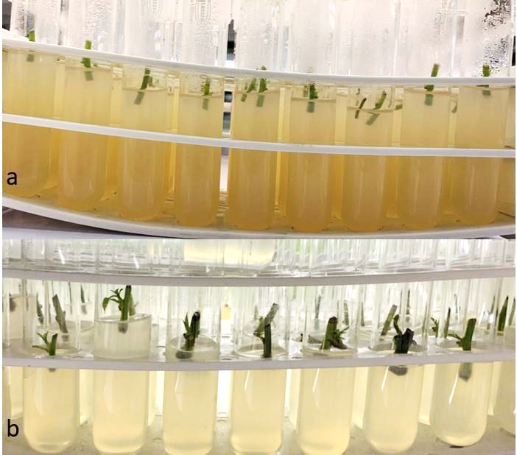

B
A

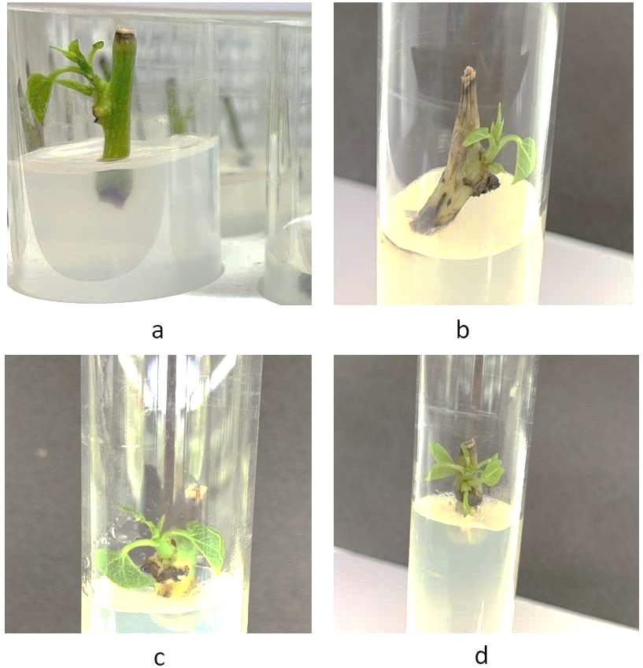
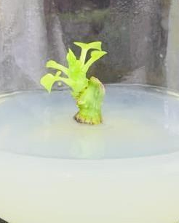
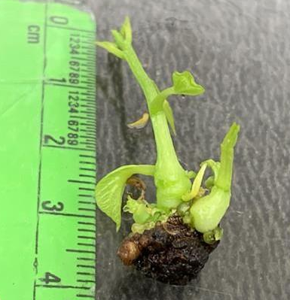

F
E
D
C

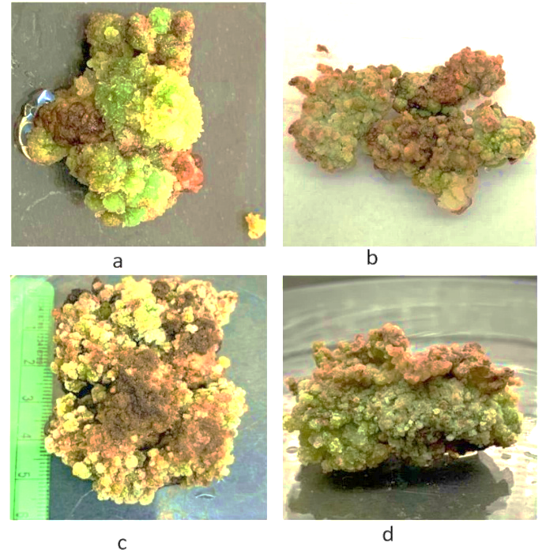
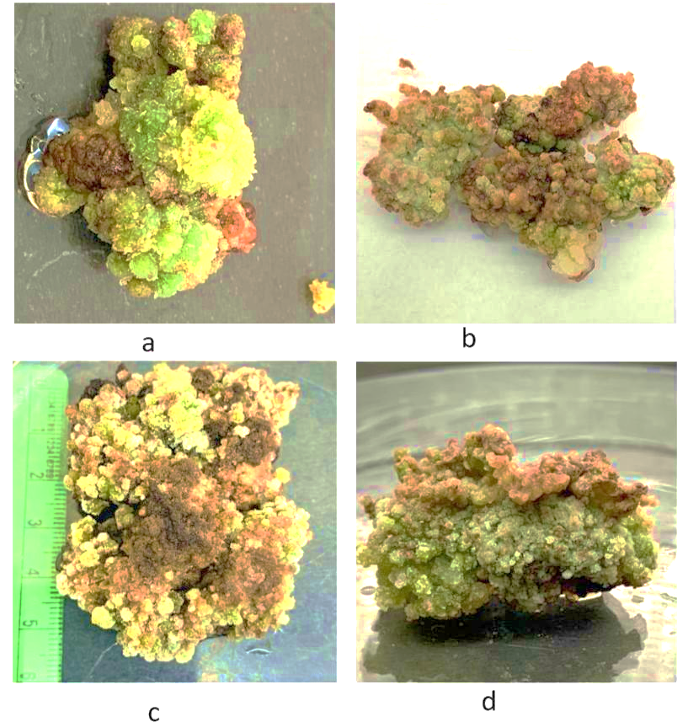
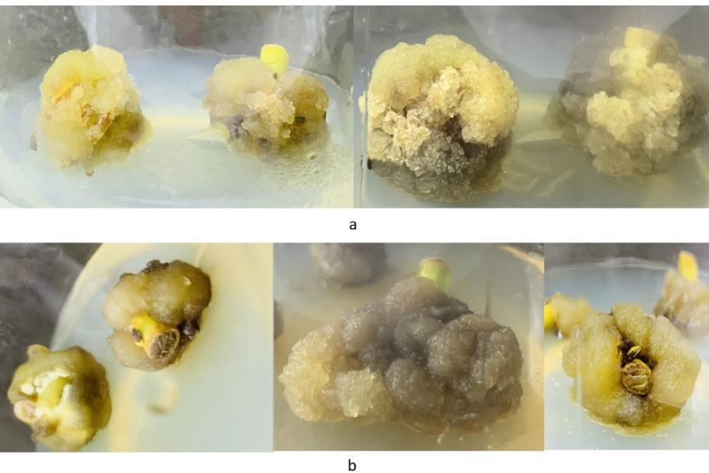
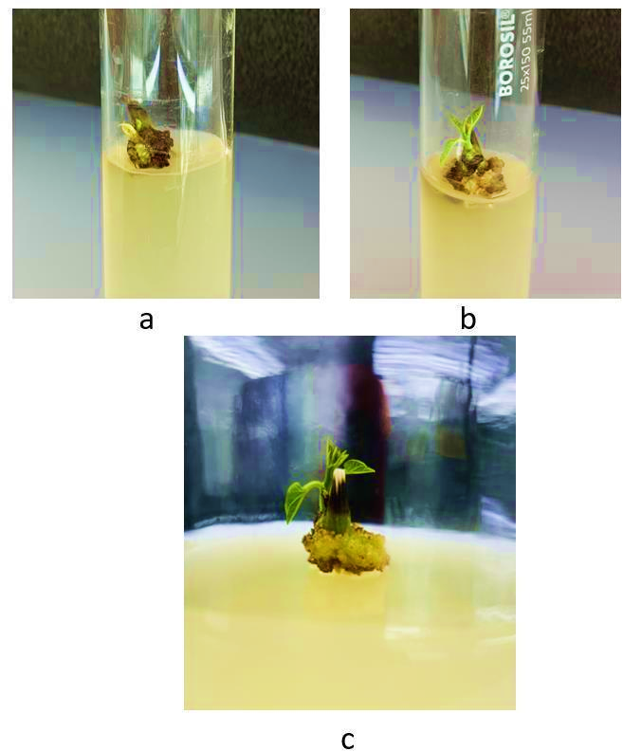

G
H
I
J
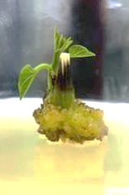
N
K
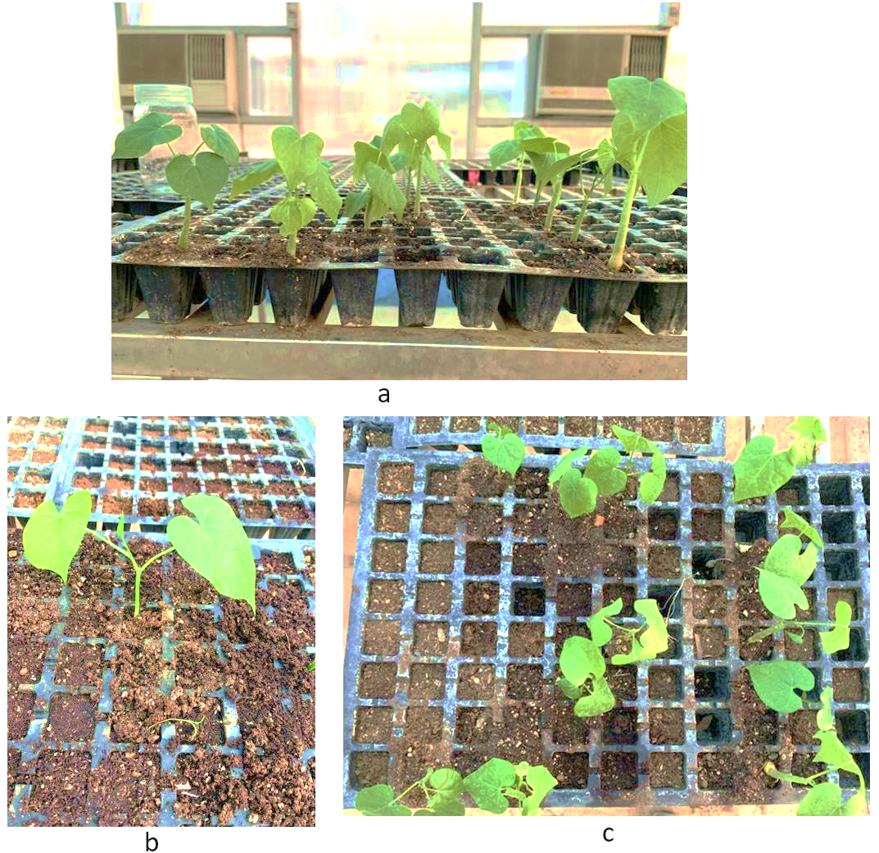
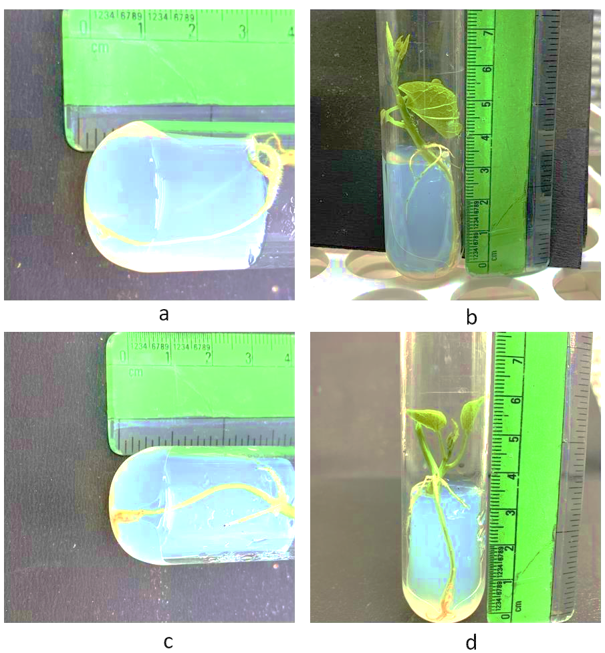

L
M

Fig. 2. Plantlet regeneration in Tinospora cordifolia Willd. From cultured nodal segments: A. Cultured nodal segments after first day in culture; B. Cultured nodal segments after 10 days in culture; C. Bud sprouting after 20 days of inoculation on medium supplemented with 2.0 mgl⁻¹ BAP; D. Initiation of shootlet after 30 days of inoculation on medium supplemented with 2.0 mgl⁻¹ BAP; E. Formation of shoot after 40 days of inoculation on medium amended with 1.5 mgl⁻¹ BAP in combination with 2.0mgl⁻¹ Kn; F. Leaves and shoot development after 45 days of inoculation on medium amended with 1.5 mgl⁻¹ BAP in combination with 2.0 mgl⁻¹ Kn; G. Formation of callus on media supplemented with NAA and 2,4-D after 25 days of inoculation; H-I. Formation of callus on media supplemented with NAA and 2,4-D after 45 days of inoculation; J. Initiation of shootlet via indirect organogenesis after 25 days of subculturing on medium fortified with 2.0 mgl⁻¹ BA; K. Leaves and shoot development after 35 days in culture on medium supplemented with 2.0 mgl⁻¹ BA; L. Initiation of in vitro rooting after 25 days of transferring on rooting medium; M. Formation of well-developed roots after 35 days transferring on rooting medium; and N. Regenerants transferred in greenhouse/ polyhouse after 40-45 days for hardening.

