Case report

NON-SURGICAL REHABILITATION OF POSTPARTUM PUBIC SYMPHYSIS DIASTASIS: A RARE ORTHOPAEDIC CASE
ABSTRACT
Background: Pubic Symphysis Diastasis (PSD) is a rare complication of childbirth, with an estimated incidence of 1 in 30,000 women. It is characterized by abnormal separation of the pubic symphysis joint beyond physiological limits. If left untreated, PSD can progress to chronic pain, gait disturbance, and long-term functional disability.
Case Study: A 36-year-old multiparous woman with no significant medical history presented with severe pelvic pain (NPRS 8/10), waddling gait, and inability to walk within hours of vaginal delivery. These findings raised concern for a traumatic event during childbirth. Radiological evaluation confirmed pubic symphysis diastasis with a 12 mm gap. Following initial medical management, she underwent an eight session structured physiotherapy rehabilitation program. Interventions included transcutaneous electrical nerve stimulation (TENS), cryotherapy to the suprapubic region, transversus abdominis activation, pelvic belt application, progressive strengthening exercises, and functional retraining. Outcome measures such as the Numerical Pain Rating Scale (NPRS) and Pelvic Girdle Questionnaire (PGQ) demonstrated significant improvements in pain, mobility, independence, and activity participation.
Conclusion: This case underscores the importance of early conservative intervention in restoring function and improving quality of life in postpartum PSD. It further highlights the essential role of physiotherapists in postpartum rehabilitation, offering an effective non-surgical alternative to optimize recovery.

INTRODUCTION
Pregnancy initiates a cascade of physiological and anatomical adaptations. One of these adaptations is the widening of the pubic symphysis, a fibrocartilaginous joint that allows the pelvis to accommodate the fetal head during delivery (Colla et al., 2017). Normally, the pubic symphysis measures about 4–5 mm and may widen by 2–3 mm as childbirth approaches (Cui et al., 2021; Zheng et al., 2022). When the gap exceeds 10 mm, it becomes pathological and is termed pubic symphysis diastasis (PSD) (Chaudhary et al., 2023; Herren et al., 2015). Although increased levels of relaxin and progesterone are believed to influence ligamentous laxity and pelvic instability, evidence confirming their direct causation in PSD is still lacking (Anastasio et al., 2023).
PSD manifests with pelvic pain, instability, and difficulty in walking or performing daily activities. These symptoms, according to the International Classification of Functioning, Disability and Health (ICF), are activity limitations that disrupt work, family, and social life (Chaudhary et al., 2023).
The reported incidence of PSD varies widely give specific countries/ regions, from 1 in 36 to 1 in 30,000 deliveries (Agten et al., 2019). This wide variation in reported incidence is largely due to cases with mild symptoms that go unnoticed or are mistaken for pelvic girdle pain or low back pain, as well as limited clinical awareness, underreporting, and inadequate use of imaging techniques (Balogh et al., 2015; Howell, 2012).
Although the exact cause remains unclear, PSD is believed to result from the combined effects of hormonal softening of pelvic ligaments and the mechanical stresses of childbirth. When these forces exceed the joint’s physiological limits, separation occurs, producing significant pain and restricted mobility. The following case highlights this uncommon complication and demonstrates how physiotherapy-led rehabilitation can restore stability, function, and quality of life (Anastasio et al., 2023).

CASE PRESENTATION
A 36-year-old married woman, a restauranteur by occupation, and mother of four (G4P4), presented to the Department of Physiotherapy, University of Port Harcourt Teaching Hospital (UPTH) on May 5, 2025, with complaints of severe pelvic pain and inability to walk properly. Sentence tool long.
Personal Information: Patient information ( use identity instead of information) was anonymized to protect confidentiality, and ethical principles of case reporting were strictly followed.
Chief complain: Her symptoms began seven days prior, following spontaneous vaginal delivery conducted by a nurse during a church vigil. Later that night, she slipped on the stairs in the dark while exiting her house and experienced a dull pain in the left pelvic region. Despite the discomfort, she managed to walk back to bed but noted progressive worsening of pain by midnight, accompanied by an inability to stand or ambulate. Relief was achieved only in a supine position.
History of Presenting Illness:
She presented to a private hospital, where she received an intramuscular injection (drug unspecified) and was subsequently referred to a diagnostic centre. Pelvic radiography revealed a widened pubic symphysis measuring 12 mm without evidence of fracture. She was thereafter referred to UPTH for expert physiotherapy management.
Consider attaching an image of the Pelvic Radiography
Medical and surgical history: Her past medical and surgical histories were unremarkable.
Family History:
Lifestyle: She occasionally consumed alcohol but did not smoke.
Past obstetric History: Obstetric history revealed four term pregnancies delivered via spontaneous vaginal delivery by a traditional birth attendant, with no history of miscarriage or complications. Mention about still birth, congenital anomalies, pregancy induced hypertension, multiple pregnancies, precipitate labour. Antenatal care was received in a traditional home. If possible include the birth weight, duration of labour and years of delivery.
Examination at the Initial assessment: On examination, the patient ambulated with a waddling gait and pain intensity was rated 8/10 on the Numerical Pain Rating Scale (NPRS). Palpation revealed tenderness over the pubic symphysis. Clinical tests were positive for the Active Straight Leg Raise and FABER’s test, though these were deferred until one week post-assessment due to initial pain severity.
Baseline outcome measures indicated severe functional impairment with NPRS of 8/10 and Pelvic Girdle Questionnaire (PGQ) of 84%.
Treatment Goals: The treatment aims were to relieve pelvic pain, reduce oedema, restore function, maintain muscle physiological properties, and minimize the symphyseal gap.
Clinical management: Physiotherapy intervention included soft tissue mobilization (STM) to the suprapubic and adductor regions, transversus abdominis activation exercises, adductor squeeze exercises, cryotherapy, transcutaneous electrical nerve stimulation (TENS), Kegel’s exercises, and pelvic binding. The patient was advised to be on bedrest and educated on lifestyle modification such as avoiding wide-legged activity and moving as a unit. Additionally, a home-based rehabilitation program was prescribed including gentle pelvic floor (Kegel) exercises, core stabilization, and bridging to improve pelvic stability and reduce pain.
Table 1 shows each intervention employed alongside the frequency, intensity and time:

Interventions | Week 1 | Week 2 | Week 3 | Week 4
Cryomassage | 15 minutes | 15 minutes | 12 minutes | 10 minutes
Pelvic Binding | Worn continuously except when bathing | Worn continuously except when bathing | Worn continuously except when bathing | Worn continuously except when bathing
Kegel Exercises | 5 secs hold, 10 reps 3sets. | 5 secs hold, 10 reps 3sets. | 10 secs hold, 10 reps 3sets. | 10 secs hold, 10 reps 3sets.
Adductor Squeeze | 2 sets of 10 reps | 3 sets of 10 reps | 3 sets of 10 reps | 3 sets of 10 reps
TENS | 50 Hz, low intensity, conventional TENS, 20 minutes. | 50 Hz, low intensity, conventional TENS, 20 minutes. | 50 Hz, low intensity, conventional TENS, 20 minutes. | 50 Hz, low intensity, conventional TENS, 20 minutes.
Tranversus Abdominis activation | 3 sets of 10 reps  Rests for 15 seconds  2x daily | 3 sets of 15 reps  Rests for 10 seconds  3x daily | 3 sets of 15 reps  Rests for 10 seconds  3x daily | 3 sets of 15 reps  Rests for 5 seconds  3x daily
Bridging Exercise | 3 sets of 10 reps  Rests for 15 seconds  2x daily | 3 sets of 15 reps  Rests for 10 seconds  2x daily | 3 sets of 15 reps  Rests for 10 seconds  2x daily | 3 sets of 20 reps  Rests for 10 seconds  2x daily
Home programmes | 2x daily | 2x daily | 2x daily | 2x daily

Table 1: showing 4 weeks of physiotherapy regimen including exercises, cryomassage, electrotherapy (TENS) and home programmes.

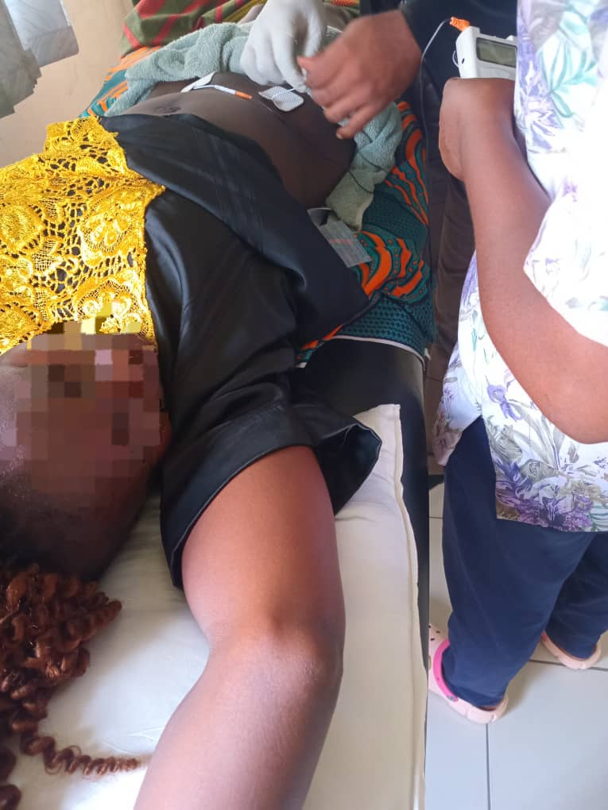
Figure 1: TENS to the suprapubic region to reduce pain (low intensity, frequency of 50Hz, conventional mode)
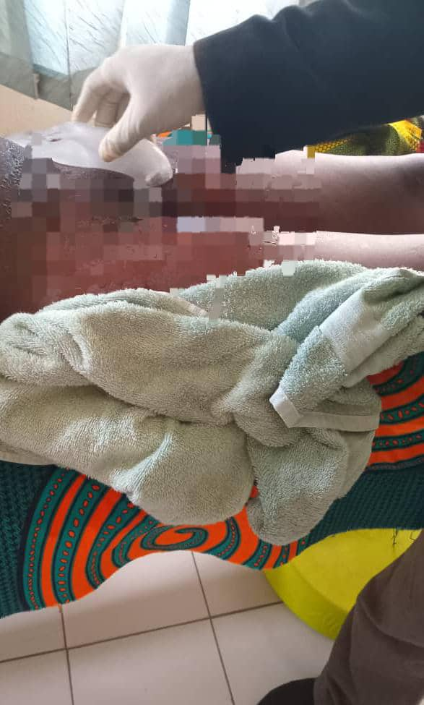
Fig 2: Cryomassage using ice applied to the suprabic region for 10 mins. Sensation test was performed prior to application.


Fig 3: Improvised pelvic binder tied around the pelvis, approximately 10 cm below the greater trochanters to stabilize the symphysis.

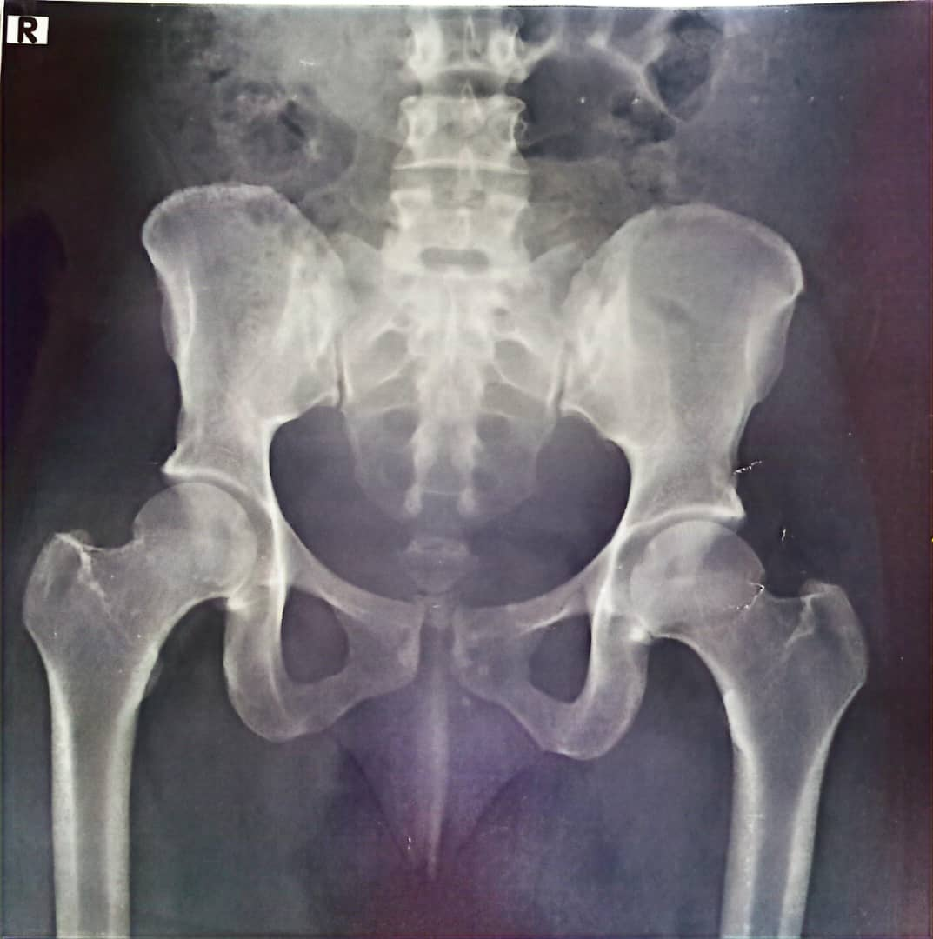Fig 4: Radiograph demonstrating 12 mm widening of the pubic symphysis.
After eight sessions of structured rehabilitation, significant improvement was recorded: pain reduced from a scale of 8/10 to 3/10 on the NPRS and PGQ decreased from 84% to 13% . The patient regained independent ambulation with minimal discomfort and was able to resume daily activities.
The use of a pelvic binder was very effective in managing the patient. Due to financial constraints at the start of treatment, an improvised binder instead of a pelvic belt was used. A wrapper was tied around the pelvis, approximately 10 cm below the iliac crest at the level of the greater trochanters, and tightened at the center to a comfortable level for the patient. This positioning helped prevent excessive hip abduction during bed mobility and ambulation and reduced the interpubic gap. In addition, the patient was instructed on safe techniques for getting out of bed, proper sleeping positions, and optimal sitting postures to support recovery.

DISCUSSION
This case report describes successful non-surgical rehabilitation of postpartum pubic symphysis diastasis (PSD) in a 36-year-old multiparous woman who developed acute pelvic pain and mobility limitation after a traumatic fall following vaginal delivery. Although rare (≈1 in 30,000 deliveries), PSD is an under-recognized cause of postpartum morbidity (citation missing). The patient presented with severe suprapubic pain, waddling gait, and inability to walk, with a 12 mm pubic symphysis separation confirmed radiologically
The pathophysiology of PSD is multifactorial. Hormonal influences, particularly relaxin-induced ligamentous laxity during pregnancy, increase pelvic joint mobility. When combined with mechanical stress such as trauma during childbirth or in the immediate postpartum period, this may result in disruption of the symphyseal joint. In this case, the patient’s postpartum fall likely exacerbated the physiological ligamentous laxity associated with the peripartum period, producing the diastasis. Similar mechanisms have been documented by Anastasio et al. (2023) and Zhang et al. (2020), who emphasized the combined hormonal and mechanical origins of the condition.
Several maternal and obstetric factors contribute to PSD, including primigravidity, multiple gestations, prolonged labour, operative deliveries, maternal age >35, fetal macrosomia, and prior pelvic trauma. Epidural analgesia and maneuvers such as shoulder dystocia or McRoberts have also been implicated (Sung et al., 2021). In this case, multiparity, maternal age and delivery by an unskilled birth attendant likely increased the risk of pelvic instability and diastasis.

PSD can be classified by severity, timing, etiology, and presentation. Mild separation (≤10 mm) is often asymptomatic, moderate (10–25 mm) causes pain and functional limitation, and severe (>25 mm) may require surgery (Herren et al., 2015). Timing can be antepartum, intrapartum, or postpartum, and etiology may be traumatic or non-traumatic (Zhang et al., 2020; Williams et al., 2018). While pelvic X-ray is commonly used to measure widening, ultrasound is preferred in pregnancy or postpartum to avoid radiation, and MRI is best for detailed soft tissue assessment (Agten et al.,2019)
Management of pubic symphysis diastasis (PSD) is generally consistent across intrapartum, peripartum, and postpartum cases, focusing on pain relief, pelvic stabilization, and gradual functional restoration through physiotherapy and supportive devices. The primary difference lies in timing and clinical considerations: intrapartum or peripartum PSD may require immediate stabilization to prevent obstetric complications, whereas postpartum PSD can often be managed conservatively once acute delivery-related factors have stabilized (citation is missing). Compare that with your management.
A key diagnostic challenge lies in differentiating PSD from pelvic girdle pain (PGP). Both present with pelvic discomfort, difficulty walking, and pain radiating to the groin or lower back, which often leads to misdiagnosis. The distinguishing feature, however, is objective widening of the symphysis pubis, typically greater than 10 mm, confirmed by imaging. PGP, in contrast, shows no measurable separation on radiographs or ultrasound (Borg-Stein et al., 2017). Accurate differentiation is essential, as mislabeling PSD as PGP can delay appropriate management.
Physiotherapy played a pivotal role in this patient’s recovery. The comprehensive intervention, which included transcutaneous electrical nerve stimulation (TENS), cryotherapy, soft tissue mobilization, pelvic binding, and strengthening exercises, targeted pain reduction, stabilization, and muscle re-education. Activation of the transversus abdominis and pelvic floor through Kegel’s exercises enhanced core stability and pelvic support, while cryotherapy and TENS provided analgesic and anti-inflammatory effects. These methods align with evidence-based recommendations by Urraca-Gesto et al. (2015) and Rai et al. (2024), who documented similar functional improvements following conservative rehabilitation.
After eight sessions of therapy, the patient achieved substantial improvement. Pain reduced from 8/10 to 3/10 and the Pelvic Girdle Questionnaire decreased from 84% to 13%. These outcomes demonstrate the effectiveness of early physiotherapy in restoring function, preventing chronic disability, and avoiding surgical intervention. The findings corroborate those of Chaudhary et al. (2023), who reported full recovery with conservative management in comparable postpartum cases.
Clinically, this case underscores the importance of early differentiation between PSD and PGP, timely referral for imaging, and initiation of physiotherapy-led intervention. In low-resource settings such as Nigeria, where surgical facilities may be limited, conservative management offers a safe, cost-effective, and efficient alternative. However, the lack of follow-up imaging remains a limitation, as objective confirmation of joint-space reduction could not be verified radiographically. This reflects a common challenge in postpartum women’s health, where patients may discontinue follow-up after symptomatic relief. Such behavior underscores the importance of patient education and strategies to ensure continued monitoring and objective assessment of recovery. Despite this, the case highlights that structured, physiotherapy-led conservative management can lead to meaningful functional recovery in postpartum pubic symphysis diastasis.
In conclusion, this case demonstrates that postpartum pubic symphysis diastasis can be effectively treated through non-surgical physiotherapy. Accurate diagnosis, early intervention, and individualized rehabilitation are key to achieving pain relief, restoring function, and improving quality of life. The case also reinforces the essential role of physiotherapists in distinguishing PSD from other pelvic pathologies and guiding postpartum recovery.

CONCLUSION
Beyond anatomy, this case underscores the power of physiotherapy in women’s health. With proper assessment and radiological evaluation, postpartum pubic symphysis diastasis can be accurately identified and effectively managed. Early, structured rehabilitation restores function and independence, reframing this condition not just as an orthopaedic concern, but as an opportunity for physiotherapy to reduce surgical dependence and restore mobility.
LIMITATIONS AND DELIMITATIONS
DISCLAIMER (ARTIFICIAL INTELLIGENCE)

Author(s) hereby declare that NO generative AI technologies such as Large Language Models (ChatGPT, COPILOT, etc) and text-to-image generators have been used during the writing or editing of the manuscript

CONSENT

As per international standards or university standards, written informed consent for publication was obtained from the patient, and all identifying information has been anonymized to preserve confidentiality.

ETHICAL APPROVAL

In line with international ethical standards and common institutional practice, single case reports are exempt from formal Institutional Review Board/Ethics Committee approval.

REFERENCES
1.Chawla JJ, Al-Mudhaffer R, Al-Mazrouei S, Al-Hadrami A. Pubic symphysis diastasis: A case series and literature review. Oman Med J. 2017 Nov;32(6):510–514. doi: 10.5001/omj.2017.97.
2. Zheng Y, Zhang J, Liu Y, Wang Y, Li Y, Cui X. Biomechanical evaluation of seven fixation methods to treat pubic symphysis diastasis using finite element analysis. J Orthop Surg Res. 2022 Mar 16;17(1):160. doi: 10.1186/s13018-022-02938-1.
3. Chaudhary B, Bidari S, Maharjan S, Adhikari G, Bata L. Postpartum symphysis pubis diastasis: A case report. JNMA J Nepal Med Assoc. 2023 Jul 31;61(268):953–955. doi: 10.31729/jnma.10542.
4. Herren C, Sobottke R, Dadgar A, Ringe MJ, Graf M, Keller K, et al. Peripartum pubic symphysis separation: Current strategies in diagnosis and therapy and presentation of two cases. Injury. 2015 Jun;46(6):1074–1080. doi: 10.1016/j.injury.2015.02.003.
5. Anastasio MK, Anastasio AT, Kuller JA. Peripartum pubic symphysis diastasis. Obstet Gynecol Surv. 2023 Jun;78(6):369–375. doi: 10.1097/OGX.0000000000001123.
6. Agten CA, Sutter R, Schmid MR, Aghayev E, Zimmermann R, von Knoch M, et al. MR imaging of pubic symphysis after uncomplicated vaginal delivery. Radiology. 2019 Mar;290(3):801–808. doi: 10.1148/radiol.2018181219.
7. Balogh ZJ, Papp Z, Puskás G, Szabó Z, Kóbor J, Varga I. Pregnancy-related symphysis pubis dysfunction: Analysis of risk factors and clinical outcomes. J Obstet Gynaecol Res. 2015 Oct;41(10):1594–1600. doi: 10.1111/jog.12798.
8. Howell CJ, Dugan SA, Gruber J. Pregnancy-related symphysis pubis dysfunction: Analysis of risk factors and clinical outcomes. J Obstet Gynaecol Res. 2012 Dec;38(12):1512–1517. doi: 10.1111/j.1447-0756.2012.01749.x.
9. Zhang S, Dumas G, Hemmerich A. Measurement of pubic symphysis width in different birthing positions using ultrasound. J Biomech. 2020 Jun 25;113:110114. doi: 10.1016/j.jbiomech.2020.110114.
10. Sung MS, Park YH, Park JS, Lee SK. Risk factors for peripartum pubic symphysis diastasis and its association with delivery method. J Obstet Gynaecol Res. 2021 Jun;47(6):2100–2107. doi: 10.1111/jog.14701.
11. Borg-Stein J, Dugan SA, Gruber J. Musculoskeletal aspects of pregnancy. Phys Med Rehabil Clin N Am. 2017 Aug;28(3):471–489. doi: 10.1016/j.pmr.2017.03.002.
12. Urraca-Gesto MA, Plaza-Manzano G, Ferragut-Garcías A, Pecos-Martín D, Gallego-Izquierdo T, Romero-Franco N. Diastasis of symphysis pubis and labor: A systematic review. J Rehabil Res Dev. 2015;52(6):629–640. doi: 10.1682/JRRD.2014.12.0272.
13. Rai S, Pradhan P, Dangal G, Shrestha S, Rajbhandari S, Yadav R, et al. Post-partum symphysis pubis diastasis. J Nepal Health Res Counc. 2024 Apr 30;22(2):461–463. doi: 10.33314/jnhrc.v22i2.3709.
14. Williams M, Vanacore F, Hing C. Pubic symphysis diastasis sustained from a waterslide injury. J Clin Orthop Trauma. 2018 Jun;9(Suppl 2):S32–S34. doi: 10.1016/j.jcot.2018.04.004.

