Effects of Different Sources of Organic Manure on Growth and Yield Performance of Sweet Pepper (Capsicum annuum L.)

Abstract
The indiscriminate use of chemical fertilizers has raised concerns about soil health and environmental sustainability. Organic manures are emerging as viable alternatives to improve soil fertility and crop productivity. This study was conducted at the Institute of Agriculture and Animal Science (IAAS), Lamjung Campus, Nepal, to evaluate the effects of different organic manures on the growth and yield of sweet pepper (Capsicum annuum L., variety Ganga). The experiment was laid out in a Complete Randomized Design (CRD) with eight treatments replicated thrice: control, vermicompost, goat manure, farmyard manure (FYM), poultry manure, bokashi compost, poultry manure + goat manure, and poultry manure + FYM. Parameters including plant height, leaf number, branch number, flowers, fruits, fruit diameter, fruit length, average fruit weight, and yield per plant were recorded. Results indicated that poultry manure significantly outperformed other treatments, recording the highest plant height (37.15 cm), leaf number (31), branch number (14), flowers (10), fruits (5.28), fruit length (8.37 cm), fruit diameter (5.8 cm), and yield (120.6 g/plant). Vermicompost and bokashi compost followed closely, while control plants showed the lowest performance. The study concludes that poultry manure is the most effective organic manure for enhancing sweet pepper growth and yield under Lamjung conditions, with vermicompost and bokashi as promising alternatives.

Keywords: Capsicum annuum, organic manure, poultry manure, vermicompost, bokashi compost, yield performance

Introduction
Sweet pepper (Capsicum annuum L.), also known as bell or green pepper, is a major vegetable crop that is cultivated worldwide due to its great nutritional and economic value. Being full of vitamins (especially vitamin C), polyphenols, carotenoids, minerals, and antioxidants, it is a very profitable and nutritionally important crop. But overuse of chemical fertilizers has caused soil deterioration, nutrient maladjustment, and environmental pollution. There is an increasing promotion of organic manures as sustainable sources of nutrients that improve soil health, increase crop productivity, and may minimize environmental risks.

The mid-hill belt of Nepal, such as Lamjung, offers an appropriate climatic condition for sweet pepper production. Nevertheless, not much information is available on the effect of diverse organic manures on capsicum yield under rain-fed conditions of the region. The present study has been conducted to compare the effectiveness of various organic manures on the growth and yield of sweet pepper under pot culture.

Materials and Methods

Research Site and Conditions
The experiment was conducted during 2023 at IAAS, Lamjung Campus, Nepal (625 masl), under subtropical climatic conditions. The region experiences a monsoon season (May–October), winter (November–February), and a hot pre-monsoon period (March–April). Average temperatures range from 6–10 °C in winter to 25–35 °C in summer, with annual rainfall concentrated from June to September.
The location of experiment site is shown in figure below
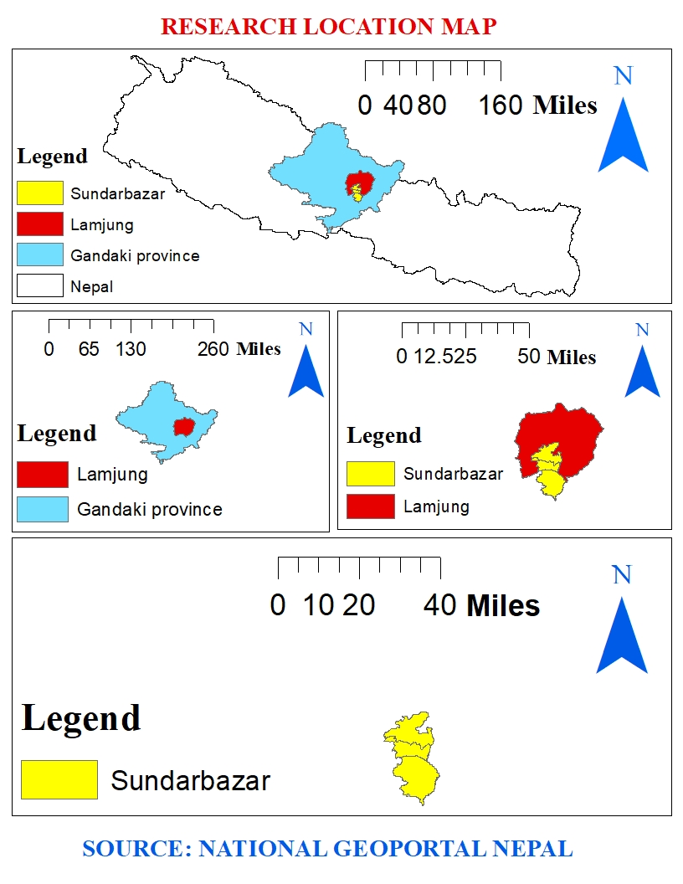
Map 1 : Research location Map of Nepal

Variety and seedlings selection
The F1 hybrid Ganga sweet pepper variety was selected for current experiment which was grown in horticulture nursery of IAAS ,Lamjung campus. The robust and vigorous seedlings at 5-6 true leaf stage were selected for transplanting into the research pots.

3.4 Design of experiment
The experiment was carried out in Complete Randomized Design (CRD) with 8 treatments replicated thrice. The treatments consisted different sources of organic manure compared to that of untreated control and chemical fertilizer.

Pot Filling
Soil was gathered for the experiment from the Lamjung campus's surrounding forest property. In order to make the soil fine, it was destroyed and distributed above the earth. Poultry manure, vermicompost, goat manure, farm yard manure, bokashi compost, fym + pm, and pm + gm were measured out and combined individually in the needed amounts. The plastic pot had a drainage hole in the bottom. And 24 plastic pots were filled with the prescribed amount of soil and the calculated amount of treatment.
Table 1 Treatment details
Treatment | Treatment details
T1 | Control
T2 | Vermicompost (VC)800g/pot
T3 | Goat manure (GM)900g/pot
T4 | Farm yard manure(FYM) 950g/pot
T5 | Poultry manure (PM)900g/pot
T6 | Poultry manure + Goat manure(50%PM+50%GM)
T8 | Goat manure + Farm yard manure(50%GM+50%FYM)
T9 | Bokashi compost(BC) 1kg/pot

These treatments were made during soil preparation and pot filling ,then mixed with different sources of organic manure as to maintain different treatments.
Field Layout:


Cultivation practices

Soil preparation and manure addition
The experiment was conducted in pots, with one plant treated in each pot for the duration of the experiment. Unneeded stubbles and plant materials were removed before taking upland soil from the orchard. Then, in order to preserve varied, soil was mixed with various sources of organic manures.

Weed control and plant protection
Each container was manually weeded by hand to prevent any competition from unwelcome plants. Regardless of the number of days till transplanting, weeding was done. During the establishment and expansion of the crop, little significant threats from insects or illnesses were seen. Aphid and fruit borer damage was seen during fruit production, however the impact was minimal. was negligible

Harvesting
First harvest was obtained from poultry manure exactly 62 days after transplanting .fruits were harvested manually after they obtained proper size, texture and color. Then fresh weight for individual fruit was taken.

Observations

Plant height (cm)
Plant height was measured from plants of each pot. It was measured with the help of measuring scale from the ground level to the tip of the main shoot. It was measured at 20 DAT,40DAT and 60 DAT.

Days to first flowering
It is the numbers of days to first flowering of the plants within a sample plant from the date of transplanting .It was taken from day to day supervision of pots. The first flowering was seen in
poultry manure within the 45 days after transplanting followed by vermicompost.

Days to first harvest
Numbers of days for first harvest in each plant after transplanting was observed.

Number of leaves
At 20, 40, and 60 days following transplanting, we manually counted the total number of leaves from each plant.

Number of branches
It is the total numbers of branches present on the each pot of panditas taken by counting the total numbers of branches of a plant .The result showed that maximum number of branches were seen in poultry manures.

Number of flowers
It is the number of flowers present on each plant which was observed by counting the total number of flowers from each plant at 20,40 and 60 days after transplanting.

Fruit length(cm)
During harvest, the mature fruits were removed from each pot and measured for length. Fruits were measured without the peduncle, from the base to the tip. Fruit length was measured by rope, which was then measured using a scale. Average fruit length was then calculated for each treatment pot.

Fruit diameter
The same fruit taken length. Fruits for measuring fruit length were used for calculating diameter of fruits from each treatment pot. Diameter were measured in the places of fruits at one base ,mid and near tip of the fruits and averaged to get average diameter.

Average fruit weight
Fruits were weighed after harvest to determine their fresh weight. After harvesting, the weights were taken immediately. The typical fruit weight for each treatment was then determined for each plant.

Yield per plant
For the purpose of calculating the yield per plant, the total quantity of fruits produced by each plant at various harvest dates were added.

Statistical analysis
Analysis of variance (ANOVA) was performed to determine the effects of organic manures on the growth and yield of sweet pepper. Data entry was carried out in Microsoft Excel, and statistical analyses were conducted using R software (version 4.0.2). The significance of treatment effects was tested using the F-test. Mean separation was performed using the Least Significant Difference (LSD) test at a 5% level of significance. The R package “agricolae” was used for mean separation, “pastecs” for Levene’s test to check homogeneity of variance, Shapiro–Wilk test for normality assessment, and “plotrix” for calculating the standard error of the mean (SEM).

Results

Plant Growth
Poultry manure treatment (T5) consistently produced the tallest plants across all sampling dates, reaching 37.15 cm at 60 DAT, followed by vermicompost (36.30 cm) and bokashi compost (33.11 cm). Control plants recorded the lowest height (19.95 cm).
Table 2. Effect of different sources of treatments used on plant height of sweet pepper at Sundarbazar Lamjung, Nepal.
Treatments | Plant height at 20 DAT (cm) | Plant height at 40 DAT(cm) | Plant height at 60 DAT(cm)
Control | 6.20^{f} | 13.18^{f} | 19.95e
Farm yard manure | 8.13de | 16.60^{d} | 25.11^{d}
Vermicompost | 11.97ª | 23.99ª | 36.30ª
Poultry manure | 12.3^{ab} | 24.55ª | 37.15ª
Goat manure | 7.47e | 14.12e | 21.38e
Poultry manure + Farm yard manure | 8.60^{cd} | 16.21^{d} | 24.55^{d}
Poultry manure + Goat manure | 9.38^{c} | 14.12^{c} | 28.18^{c}
Bokasi Compost | 11.23^{b} | 22.38^{b} | 33.11^{b}
F-test | *** | *** | ***
LSD_{(0.05)} | 1.00 | 0.02 | 0.03
Sem | 0.33 | 1.00 | 1.00
CV% | 2.12 | 1.10 | 1.18
Grand Mean | 9.41 | 18.62 | 27.58
The mean were separated by using Least Significant Difference(LSD) at 5% level of significance *** means highly significant and DAT means days after transplanting

Final plant height was different in accordance with various manures and fertilizers used.
It was found that the effect of several doses of organic manure on plant height was quite remarkable.
At 20 DAT, the most dramatic rise in plant height was obtained by applying poultry manure (12.3 cm), vermicompost (11.97 cm). The next-highest plant height came from Bokashi manure, and where there was no temperature control, raising the lowest plant heights (6.20 cm). On the trailing end of this spectrum were goat manure, farmyard manure, poultry manure + goat manure, and poultry manure + farmyard manure.
At 40 DAT with the Latvian Agricultural Academy, the same poultry manure had the highest plant height (24.55 cm) followed by vermicompost (23.99 cm). The second-best figure for plant height was Bokashi manure (22.38 cm), while control reversing then returned the lowest plant height (13.18 cm), followed by poultry manure + goat manure, goat manure, poultry manure + farmyard manure, and farmyard manure.

At 60 DAT, similar to the earlier two periods, poultry manure produced the biggest plant height (37.15 cm), followed by vermicompost (36.30 cm), Bokashi manure (33.11 cm), and control producing the lowest plant height, lastly goat manure, poultry manure + farmyard manure, farmyard manure, and poultry manure + goat manure.

The fastest release of nutrients, especially for nitrogen, the essential (protein) material of protoplasm, which is connected with cell division and growth rate in terms of cells is why, for example, poultry manure and vermicompost have the highest plant height (Muradi & Singh, 1983).
Table 3.Effect of different sources of organic manure used on leaf numbers of sweet pepper at Sundarbazar Lamjung, Nepal.
Treatments | Leaf numbers at 20 DAT | Leaf number at 40 DAT | Leaf number at 60 DAT
Control | 7.41de | 12.5e | 17^{g}
Farm yard manure | 7.94de | 14.0de | 20^{f}
Vermicompost | 13.80^{b} | 21.5^{b} | 29^{b}
Poultry manure | 19.95ª | 25.5ª | 31ª
Goat manure | 6.91e | 13.0e | 19^{f}
Poultry manure +Farm yard manure | 9.77^{cd} | 17.0^{c} | 24^{d}
Poultry manure Goat manure | 8.91^{cde} | 15.5^{cd} | 22e
Bokasi Compost | 11.77^{bc} | 19.5^{b} | 27^{c}
F-test | *** | *** | ***
LSD_{(0.05)} | 0.14 | 2.12 | 1.73
Sem | 1.01 | 1.50 | 1.00
CV% | 7.98 | 7.07 | 4.23
Grand Mean | 10.23 | 17.31 | 23.63
mean were separated by using Least Significant Difference(LSD) at 5% level of significance. *** means highly significant and DAT means days after transplanting.

Information on how many leaves each plant produced in capsicum is detailed in Table 2. The table reveals that the number of leaves produced is significantly affected by the application of different organic manures.

Goat manures, without manure, the lowest number of leaves produced happened to be found in the control capsicum plant. On the other hand, poultry manure treatment produced the highest number of leaves, followed by vermicompost and bokashi. It is possible that the nitrogen of poultry manure used in this treatment provided necessary nutrients for the capsicum plant, increasing chlorophyll content.

This is also reflected in the fact that nitrogen is a constituent of the chlorophyll molecule; on one hand, it is essential for starch in leaves and amino synthesis on the other (Amalitos, 2018). The results are concordant with figures from (Atta et al., 2020).

With reference to capsicum, Heave (2010) found that plant performance was positively correlated with manure. As nitrogen is a component of chlorophyll, it plays a pressing role in protein and amino synthesis, which contributes to the perfect atmosphere and nutrient conditions owing to increased numbers of leaves.

Based on the results, the results are remarkably similar to those reported by (Deore G. B., Limaye A. S., 2010). Ascending levels of liquid organic nitrogen increased the number of leaves per plant.

Table 4.Effect of different sources of organic manure on branch number of sweet pepper at Sundarbazar Lamjung, Nepal
Treatments | BN at20 DAT | BN at40 DAT | BN at60 DAT
Control | - | 2^{g} | 6^{f}
Farm yard manure | - | 4^{ef} | 8de
Vermicompost | - | 8^{ab} | 13^{ab}
Poultry manure | - | 9ª | 14ª
Goat manure | - | 3^{fg} | 7^{ef}
Poultry manure +Farm yard manure | - | 6^{cd} | 10^{c}
Poultry manure Goat manure | - | 5de | 9^{cd}
Bokasi Compost | - | 7^{bc} | 12^{b}
F-test | - | *** | ***
LSD_{(0.05)} | - | 1.73 | 1.73
mean were separated by using Least Significant Difference(LSD) at 5% level of significance .*** means highly significant and DAT means days after transplanting.
Table 4 demonstrates that there was a substantial variation in the number of branches seen under various applications of organic fertiliser. After 20 days of transplanting, no branches had appeared since The sweet pepper's branching process takes 3–4 weeks.
The control capsicum plant has the fewest branches( 2 , 6) at 40 and 60 days after transplanting per plant respectively. On the other hand, treatment of chicken manure resulted in the greatest number of branches( 9 ,14 )followed by vermicompost (8,13) and bokashi manure (7 ,12) at 40 and 60 days after transplanting per plant respectively.
The majority of macro- and micronutrients are present in the applied poultry manure, and the recommended NPK dose gives the plant nutrients and has a large impact on the number of branches per plant.
Because it stimulates vegetative development, the nitrogen provided by poultry manure had a considerable impact on the number of branches per plant. Tumbare and Bhoite (2002) reported a comparable outcome(Khandaker & Rohani, 2017).

Reproductive Traits
Poultry manure also led to the highest reproductive performance, producing the maximum flowers (10/plant) and fruits (5.28/plant), followed by vermicompost (9 flowers, 4.3 fruits) and bokashi compost (8 flowers, 3.83 fruits). Control treatment had the lowest reproductive traits.

Figure 1. Effect of organic manures on flower and fruit production of sweet pepper
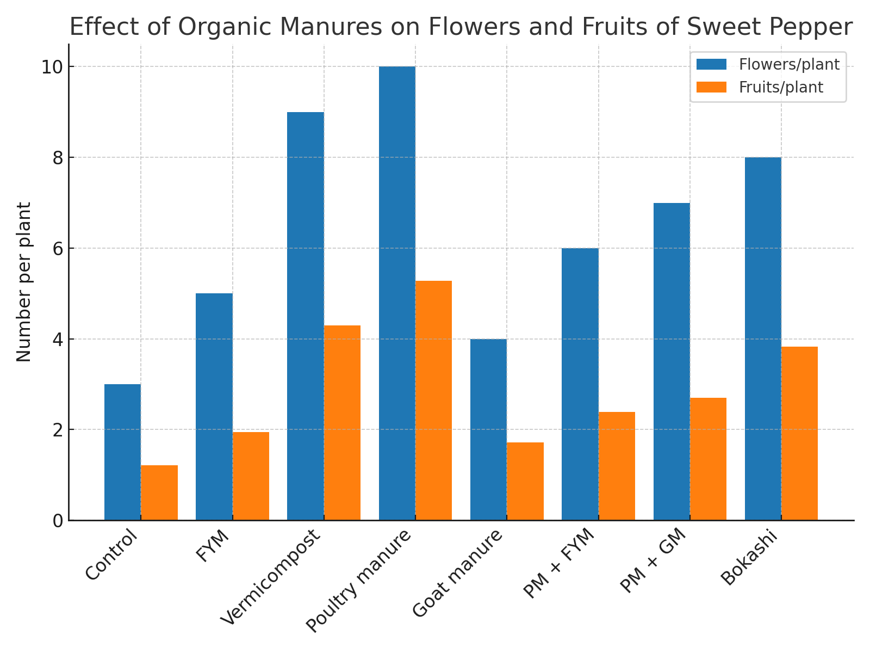
(Bar chart showing mean number of flowers and fruits per plant for each treatment)
Table 5.Effect of different sources of organic manures on numbers of flowers and fruits of sweet pepper at Sundarbazar Lamjung, Nepal.
Treatments | FLN | FRN
Control | 3^{g} | 1.21^{g}
Farm yard manure | 5^{ef} | 1.95^{f}
Vermicompost | 9^{ab} | 4.3^{b}
Poultry manure | 10ª | 5.28ª
Goat manure | 4^{fg} | 1.72^{f}
Poultry manure +Farm yard manure | 6de | 2.39e
Poultry manure + Goat manure | 7^{cd} | 2.70^{d}
Bokasi Compost | 8^{bc} | 3.83^{c}
F-test | *** | ***
LSD_{(0.05)} | 1.73 | 0.30
Sem | 1.00 | 0.03
CV% | 15.38 | 6.01
Grand Mean | 6.50 | 2.88
mean were separated by using Least Significant Difference(LSD) at 5% level of significance .*** means highly significant and DAT means days after transplanting: number of flowers, FRN: number of fruits .
As shown in Table 5, It looks like the number of flowers was highest in the poultry manure (10) treatment plant, then followed by vermicompost (9) and bokashi (8) treatment plants, while control produced the fewest flowers (3), together with pm + fym (6) and pm + gm (7) (see Table 5). The increased number of flowers per plant may be traced back to the translocation of plant nutrients from roots to aerial parts by PM application to a certain extent. After an adequate supply of nutrients is provided, this increased blossoming could also be seen as a result of large amounts of calcium (Ca), magnesium (Mg), zinc (Zn), and manganese (Mn) in poultry manure, which can lead to more branches with flowers per capsicum plant (more branching leads to shorter fruit-set days). By adding poultry manure, the plant nutrients are further dissolved, thus maximizing the uptake rates of nitrogen, phosphorus, and potassium, resulting in the highest number of flowers per plant (Atta et al., 2020). The results have been corroborated by the study of Atta et al. (2020).

Table 6. Effect of different sources of organic manures on fruit yield per treatment of sweet pepper at Sundarbazar Lamjung, Nepal.
Treatments | FY
Control | 82.55e
Farm yard manure | 105.37^{cd}
Vermicompost | 115.53^{ab}
Poultry manure | 120.60ª
Goat manure | 97.12^{d}
Poultry manure +Farm yard manure | 110.53^{bc}
Poultry manure + Goat manure | 108.50^{bc}
Bokasi Compost | 113.67^{abc}
F-test | ***
LSD_{(0.05)} | 8.92
Sem | 1.39
CV% | 4.83
Grand Mean | 106.73
mean were separated by using Least Significant Difference(LSD) at 5% level of significance .*** means highly significant and DAT means days after transplanting, FY:Fruit yield.

The production yields would be different for different treatments. In this sense, the treatments receiving poultry manure produce a higher number of fruits (5.2), followed by vermicompost (4.3) or mimicking nature through Bokashi (3.83); those plants with no supplementary treatment produce fewer on average (1.21) (from Table 5).

The highest number of fruits per plant (Khan et al., 2014) noted the highest fruit production is probably due to the vigor of the plant and more number of leaves per plant. Higher fruit production is closely related to high flower production, high fruit set rates, and less flower and fruit shedding than low-yielding plants. In addition, the increased C/N ratio and higher plant metabolism may be responsible for this.

Table 7.Effect of different sources of organic manure on fruit diameter and length of sweet pepper at Sundarbazar Lamjung, Nepal
Treatments | Fruit diameter | Fruit length
Control | 3.2^{h} | 5.77^{h}
FYM | 3.7^{f} | 6.47^{f}
Vermicompost | 5.6^{b} | 8.06^{b}
Poultry manure | 5.8ª | 8.37ª
Goat manure | 3.5^{g} | 6.17^{g}
Poultry manure +Farm yard manure | 4.6e | 6.97e
Poultry manure + Goat manure | 5.0^{d} | 7.4^{d}
Bokasi Compost | 5.3^{c} | 7.80^{c}
F-test | *** | ***
LSD_{(0.05)} | 0.17 | 0.24
Sem | 0.01 | 0.02
CV% | 2.18 | 1.98
Grand Mean | 4.59 | 17.12
mean were separated by using Least Significant Difference(LSD) at 5% level of significance .*** means highly significant and DAT means days after transplanting.
The maximum fresh weight yield of 120.60g per plant was recorded in the treatment poultry manure (T4) followed by vermicompost (115.53g).Fresh weight yield obtained from the application of treatment (pm +fym) and( pm +gm) were similar and the lowest fresh weight yield of 82.55g per plant was recorded in treatment control(T1).

Fruit diameter
Application of poultry manure recorded highest fruit diameter of 5.8cm followed by vermicompost (5.6cm) and bokashi(5.3cm) while control recorded least fruit diameter (3.2cm).
According to the Roychaudhury et al. 17, vermicompost gave the vermicompost gave the higher fruit diameter due to an improvement in fruit size with increasing nitrogen contents in organic manure (Khandaker & Rohani, 2017).

Fruit length
The maximum fruit length of 8.37 cm was recorded in the treatment poultry manure which was followed by vermicompost 8.06 cm both are statistically at par with each other. Fym, pm +fym and goat manure are statistically par with each other. The least fruit length of 5.77cm was recorded in the treatment control. According to (Ghimire et al., 2013)Fruit length was the highest (8.92 cm) with FYM 50% + urea 50% followed by vermicompost 100% (8.65cm) and vermicompost 50% + urea 50% (8.5 cm) due to improved N availability during early stage of growth increased pepper fruit size and length.

Discussion
This conclusion has confirmed that at Tibetan middle and low altitude, making sweet pepper productive, poultry manure is more effective than other organic manures. It overbalanced nutrition high in nitrogen, is probably supporting the vigorous growth of foliage and a rapid rise in chlorophyll synthesis and reproductive structural changes. Vermicompost likewise turned out effective, maybe due to its high organic matter content and substances that improve soil structure, such as humic acid. Bokashi compost improves yield structure by enhancing soil microbial biomass and nutrient cycling processes.

These results are consistent with other research findings, which have shown that the rate of crop growth and yield increase. However, this product falls short in fertilizer properties compared with chicken manure: its quick-acting tooth delivery of most elemental substances to plants may be responsible for this phenomenon. Both vermicompost and bokashi compost also enrich fruit yield and quality: Aminifard & Bayat (2017) and Álvarez-Solís & Jones (2016). Goat manure and FYM: less beneficial in pot culture experiments, slow nutrient release as the probable cause.

Conclusion
This was achieved by the application of two treatments—chicken manure and bokashi compost. Compared to other organic manures, poultry manure contributed the most to sweet pepper growth, fruit quality, and yield. Bokashi compost and vermiculture also played an important role. For Nepal's mid-hill regions in particular, chicken manure should be preferred as the source of organic nutrients. Farm-produced organic resources can provide low-cost alternatives to chemical fertilizers, thereby laying the foundation for sustainable cropping systems.

References
- Abid, A. A., et al. (2010). Effect of organic fertilization on growth and yield of pepper plants (Capsicum annuum L.). Folia Horticulturae, 22(1), 67-76
- Adhikari, P., Khanal, A., & Subedi, R. (2016). Effect of different sources of organic manure on growth and yield of sweet pepper. Advances in Plants & Agriculture Research, 3(5), 158–161. https://doi.org/10.15406/apar.2016.03.00111
- Ahmad, N., & Akbari, E. (2021). Preventive impact of vermicompost on bell pepper salinity resistance. African Journal of Agricultural Research, 17(1), 1–11. https://doi.org/10.5897/AJAR2020.14920
- Aminifard, M. H., & Bayat, H. (2017). Effect of vermicompost on fruit yield and quality of bell pepper. International Journal of Horticulture Science and Technology, 3(2), 1–9.
- Amalitos, T. and D. (2018). Growth and Yield Responses of Sweet Pepper ( Capsicum annum L . ) to Organic and NPK Mineral Fertilization under Plastic Houses Conditions at Arid Regions. J.Plant Production,Mansoura Univ, 9(3), 299–305.
- Álvarez-Solís, J. D., Mendoza-Núñez, J. A., León-Martínez, N. S., Castellanos-Albores, J., & Gutiérrez-Miceli, F. A. (2016). Effect of bokashi and vermicompost leachate on yield and quality of pepper and onion. Cien. Inv. Agr, 43(2), 1–10.
- Atta, P., Kyere, C. G., & Oppong, E. (2020). Effects of poultry manure and NPK fertilizer on sweet pepper growth and yield. Asian Journal of Agriculture and Horticulture Research, 5(1), 2–10.
- Deore G. B., Limaye A. S., S. B. M. and S. L. L. (2010). Effect of Novel Organic Liquid Fertilizer on Growth and Yield in Chilli ( L .) Effect of Novel Organic Liquid Fertilizer on Growth and Yield in Chilli ( Capsicum annum L .). ASIAN, July 2014.
- Ghimire, S., Shakya, S. M., & Srivastava, A. (2013). Effects of organic manures and their combination with urea on sweet pepper production in mid-hills of Nepal. Journal of Agriculture and Environment, 14, 1–8.
- Hameedi, A., et al. (2018). Effect of organic nutrient sources on growth and yield of bell pepper under Himachal Pradesh conditions. International Journal of Multidisciplinary Research and Development, 5(1), 1–4.
- Jamir, T., Rajwade, V. B., & Prasad, V. M. (2017). Effect of organic manures and fertilizers on sweet pepper growth and yield. International Journal of Horticulture, 6(8), 1010–1019.
- Khan, A., Noor, S., Shah, M., Rab, A., & Sajid, M. (2014). INFLUENCE OF NITROGEN AND POTASSIUM ( Capsicum annuum L .). April.
- Khandaker, M. M., & Rohani, F. (2017). Effects of different organic fertilizers on growth, yield and quality of Capsicum annuum L. var Kulai (Red Chili Kulai). Biosciences Biotechnology Research Asia, 14(1), 185–192
- Muradi, K. B., & Singh, D. (2023). Effect of organic manure and inorganic fertilizer on growth and yield of chilli ( Capsicum annum L .). The Pharma Innovation Journal, 12(3), 1;4.
- Shehu, A. A. (2019). Efficacy of poultry manure on the growth and yield of Capsicum species. African Journal of Agriculture, 7(2), 3–8.
- Tumbare, A. D., & Bhoite, S. U. (2002). Effect of solid soluble fertilizer applied through fertigation on growth and yield of chilli (Capsicum annuum L.). Indian Journal of Agricultural Sciences, 72(2), 109–111

