Review Article
The Role of Plant Breeding in Enhancing Food Security: A Review of Recent Developments and Challenges
Abstract
Plant breeding is important in securing food to a larger population in the world. With the issues of climate change that the world has to deal with, rising food demand, and population growth, we need to enhance crop production by performing innovative breeding processes. The given review is devoted to the developments in plant breeding, in particular, traditional breeding, as well as to the new genetic methods to breeding: genetic engineering and gene editing. The plant breeders are keen to come up with crops that give better outputs, adaptable to adverse environmental conditions, and better nutritious. This paper will discuss the impact of biotechnology in the breeding practice and how it may help in countering issues in the form of drought, disease, and nutritional deprivation. Moreover, we examine ethical, regulatory / legal issues and environmental implications of genetically modified creatures, which are referred to as genetically modified organism (GMOs). Plant breeding in the future should focus on maintaining a balance between technology and the sustainable process to produce global food security in the long term. We put emphasis on some of the advances taking place in crop improvement plans, the contribution of policy and the significance of team work in order to satisfy the rising food requirements.
Keywords: Plant breeding, food security, genetic engineering, climate change, crop yield, biotechnology, genetic modification, sustainable agriculture, biofortification.
Introduction
Food security is one of the foremost challenges that the world faces today. As the global population approaches 9.7 billion by 2050 (United Nations, 2022), the demand for food continues to rise, putting significant pressure on agricultural systems worldwide.(Saikanth et al., 2024) Ensuring adequate food production requires a multifaceted approach that addresses not only the quantity of food produced but also its quality, nutritional value, and environmental sustainability(Mohanty et al., 2024). One of the most promising solutions to meeting these demands is plant breeding, the science of improving crops to enhance their productivity, resilience, and nutritional content.
Plant breeding has played an important role throughout history in the creation of more productive crops. Another example is during the 20 th century, the Green Revolution that saw the introduction of high-yielding varieties of rice, wheat and maize enabling many developing countries to produce more food and alleviated hunger. Nevertheless, with the expansion of environment and societal concerns, the necessity of novel crop varieties that would be adaptable to environments changing due to climate change, pest, and disease resistant, and beneficial in essential nutrients is at an all-time high (Lenaerts et al., 2019).
Plants breeding has become revolutionary with the recent developments in molecular biology, genetics, and biotechnology. New breeding methods (including genetic engineering, gene editing and genomic selection) enable breeders to generate crops with improved traits in a more precise and rapid manner relative to conventional breeding. Nevertheless, such inventions have their barrier as it is associated with regulatory barriers, scepticism among the population, and threats to biodiversity and the environment(Ahmar et al., 2020).
2. Plant Breeding as the Cause of the Food Security
Breeding of plants is not new since it has been used to increase agricultural yields and curtail food insecurity. Utilizing plant breeding to develop crops in such characteristics as resistance to diseases, toleration to drought, and nutritional improvement permits growing crops in otherwise unfavorable conditions. Improving crop yield and quality through plant breeding have always been the main objective, but due to the rising population of the planet and growing challenges to agricultural activities with climate change, it is becoming even more essential(Gao, 2018).
Global Food Security Challenges
Food security is not just about food availability; it also includes food accessibility, stability, and utilization. The challenges to global food security include(Li & Yan, 2020):
- Climate Change: Rising temperatures, irregular rainfall, and extreme weather events disrupt crop production.
- Soil Degradation: Overexploitation of land, loss of soil fertility, and erosion negatively affect crop yields.
- Population Growth: The world’s population is expected to grow by nearly 2.5 billion people by 2050, increasing the demand for food.
- Pest Resistance: Pests and diseases are evolving, which may render existing pest-resistant crops ineffective.
3. Traditional Plant Breeding Techniques
For centuries, plant breeders have used traditional methods to improve crops. These techniques rely on natural variation within plant populations and the selection of desirable traits through cross-pollination or controlled breeding (Xing & Wang, 2024; Mohanty et al., 2024).).
Methods of Traditional Plant Breeding
- Selection: The process of selecting plants with desirable traits, such as higher yield or disease resistance, to breed the next generation.
- Hybridization: The crossing of two genetically different plants to produce offspring with combined desirable traits.
- Pure-line Selection: Selecting individuals from a population that exhibit stable, predictable traits over successive generations.
- Mutagenesis: The deliberate induction of mutations in plants to generate genetic diversity.
4. Modern Breeding Techniques: Genetic Engineering and Gene Editing
The advent of molecular biology and genetic engineering has dramatically accelerated the pace of plant breeding. Through the manipulation of the plant genome, breeders can now introduce specific genes that confer desirable traits, such as resistance to pests or improved nutritional content(Jones, 2015).
Genetic Engineering
Genetic engineering involves the direct manipulation of an organism’s DNA to introduce new traits. For instance, genetically modified (GM) crops like Bt cotton, which contains a gene from Bacillus thuringiensis, provide resistance to specific pests. GM crops have been developed for various traits(Khan, 2024):
- Herbicide Resistance: Crops that are resistant to herbicides allow for easier weed control without damaging the crop.
- Insect Resistance: Crops like Bt corn are engineered to produce toxins that are lethal to specific insect pests.
Gene Editing
Gene editing technologies, particularly CRISPR-Cas9, have opened new possibilities for plant breeders. Unlike traditional genetic engineering, which often involves inserting foreign genes, gene editing enables precise changes to the plant's own DNA. This technology is faster, cheaper, and more precise, allowing for the development of crops with enhanced traits without the introduction of foreign genes(Daniel et al., 2023).
- CRISPR in Plants: This technology has been used to create crops with improved disease resistance, increased yield, and better nutrient profiles. For example, gene editing has been used to develop rice varieties resistant to bacterial blight, and wheat varieties resistant to powdery mildew (Gamage et al., 2024).
5. The Role of Biotechnology in Plant Breeding
Biotechnology encompasses a wide range of techniques used to manipulate organisms at the molecular level. In plant breeding, biotechnology offers innovative approaches that complement traditional breeding methods (Pathirana & Carimi, 2024).
Biotechnology Applications in Plant Breeding
- Marker-Assisted Selection (MAS): A method used to identify desirable traits based on genetic markers, speeding up the breeding process.
- Genetic Transformation: The introduction of foreign genes into plants to enhance specific traits.
- Tissue Culture: A technique used to propagate plants and introduce genetic modifications in a controlled environment (Mohanty et al., 2024).
6. Sustainable Agriculture and Plant Breeding
The survival of the growers in the twenty-first century is imperative in plant breeding. Due to population explosion which is being witnessed in the world, there is a greater demand in farming practices that generate more food and at the same time, reduce adverse effects on the environment. Sustainable farming aims at those systems that preserve resources and avoid destruction of biodiversity and soil sustenance (Khan, 2024).
7. Biofortification: Improving on Nutritional Levels
Biofortification refers to the breeding of crops to include more foods and micronutrients in them especially essential micronutrients such as vitamins and minerals. In places where individuals consume staple center crops such as rice, wheat or maize, biofortification has the capability to counter nutrient imperfections in imperative nutrients(Benkeblia, 2020).
Biofortified Crops
Golden Rice: An engineered drum of rice that produces more provitamin A to provide the solution to those companies in developing nations with vitamin A deficiency.
Iron-Rich Beans: Beans which are genetically modified to have more iron in them to alleviate the problem of anemia.
Zinc-Enriched Rice: Variety of rice that was created to mitigate a widespread matter of zinc deficiency in most parts of the world.
8. Plant breeding Constraints
Several challenges need to be sorted out, and despite the immense success in plant breeding, there remains a lot of work that is to be done to reach full potential in these pursuits(Swarup et al., 2020).
Environmental Challenges
- Climate Change: Extreme weather events, changing precipitation patterns, and rising temperatures affect crop growth.
- Soil Degradation: Continuous cultivation without proper soil management depletes soil nutrients and reduces crop yields.
Socioeconomic and Regulatory Challenges
- Public Perception of GMOs: While GMOs have been proven to be safe, public resistance in certain regions can slow their adoption.
- Intellectual Property Rights and Access to Technology: Patents on biotechnology can limit access to advanced breeding technologies, particularly in developing countries.
9. The Future of Plant Breeding and Food Security
Plant breeding is the way forward as far as yielding capacity, stability, and high nutrition crops are concerned. More funding on research and development is necessary so as to overcome the challenges that are increasingly evident in the form of climate change, growing population and evolving dietary requirements(Chandel et al., 2024).
1. Golden Rice: Tackling Vitamin A Deficiency
Location: Southeast Asia, Philippines, Bangladesh
Information: Golden Rice is a genetically modified crop and delivers higher amounts of the bet-carotene that is a precursor to vitamin A. It was developed with a focus on combating vitamin A deficiency, which affects millions of children in Southeast Asia. Studies show that Golden Rice has the potential to provide up to 50% of the recommended daily intake of vitamin A for children(Chandrika et al., 2003)..
2. Bt Cotton: Insect Resistance in Agriculture
Location: USA, India, China, South Africa
Data: Bt cotton, developed to express Bacillus thuringiensis toxin, offers resistance to bollworm, a major cotton pest. In India, Bt cotton has been credited with reducing pesticide use by up to 50%, and yields have increased by approximately 30%(Xing & Wang, 2024).
3. Drought-Tolerant Maize in Sub-Saharan Africa
Location: Sub-Saharan Africa (Kenya, Zimbabwe, South Africa)
Data: Drought-tolerant maize varieties were developed by CIMMYT and IITA. In Zambia, farmers reported up to 40% higher yields of drought-tolerant maize compared to conventional varieties. The seed is being adopted by smallholder farmers across the region(Singamsetti et al., 2023)..
4. Salt-Tolerant Rice for Coastal Regions
Location: China, India
Data: Salt-tolerant rice varieties were developed by the International Rice Research Institute (IRRI). In coastal areas, these rice varieties can tolerate up to 10 dS/m of soil salinity, enabling rice cultivation in saline-prone soils(Bissah et al., 2022).
5. Iron-Enriched Beans: Combating Iron Deficiency
Location: Central America, East Africa
Data: Biofortified beans developed by the International Center for Tropical Agriculture (CIAT) contain up to 20% more iron compared to regular beans. Iron deficiency is prevalent in countries like Uganda and Kenya, affecting millions(Fernández‐Jiménez et al., 2020).
6. High-Yielding Wheat in India: Green Revolution Legacy
Location: India
Data: During the Green Revolution, high-yielding wheat varieties such as Kalyan Sona and Sonalika were introduced, resulting in a 5 to 10-fold increase in wheat production in the 1960s and 1970s(Bailey‐Serres et al., 2019).
7. CRISPR-Cas9 in Wheat: Resistance to Powdery Mildew
Location: Australia
Data: CRISPR-Cas9 was used to edit the wheat genome, creating resistance to powdery mildew, a fungal disease that affects wheat production globally. Research showed a reduction in disease incidence by up to 60% in laboratory trials.
8. GM Soybean: Herbicide Resistance in North America
Location: USA, Canada
Data: GM soybean varieties engineered for resistance to glyphosate (Roundup) have increased yields by up to 15%. They also reduce production costs by minimizing labor needed for weed control(Khan, 2024).
9. Biofortified Rice for Vitamin A in Bangladesh
Location: Bangladesh
Data: Biofortified rice, enriched with provitamin A (beta-carotene), was developed by IRRI. Trials in Bangladesh demonstrated that Golden Rice could provide up to 50% of the daily vitamin A requirements for children(Khan, 2024)..
10. Insect-Resistant Maize for Smallholders in Africa
Location: Kenya, South Africa, Zimbabwe
Data: Insect-resistant maize varieties have been developed to reduce losses from pests such as the stem borer. Yields increased by 20% in the first three years after adoption(Amegbor et al., 2023).
The adoption of GM maize varieties in Kenya and South Africa has improved food security, with about 3 million smallholders benefiting from reduced crop loss.
11. Drought-Resistant Sorghum in Sudan
Location: Sudan
Data: Drought-resistant sorghum varieties have been introduced in Sudan. These varieties have shown to withstand drought conditions for up to 2 weeks longer than traditional varieties(Khalifa & Eltahir, 2023).
12. Biofortified Cassava for Vitamin A in Nigeria
Location: Nigeria
Data: Biofortified cassava, with increased levels of vitamin A, has been developed by researchers. This cassava variety has been shown to provide 50% of the recommended daily intake of vitamin A for children in rural areas(Anikwe & Ikenganyia, 2018).
13. GM Potatoes: Resistance to Late Blight in Europe
Location: European Union
Data: GM potatoes resistant to late blight (caused by Phytophthora infestans) were developed in Europe. These varieties demonstrated a 30% reduction in pesticide use and a 20% increase in yield(Haverkort et al., 2016).
14. Enhanced Nutritional Quality in Maize in Zambia
Location: Zambia
Data: Maize varieties with higher concentrations of essential vitamins and minerals, including zinc, have been developed. These varieties have shown a 15% increase in micronutrient content.
15. GM Papaya in Hawaii: Combatting Papaya Ringspot Virus
Location: Hawaii, USA
Data: GM papaya, resistant to papaya ringspot virus (PRSV), was developed in the 1990s. This variety saved Hawaii’s papaya industry, which had been devastated by PRSV.
16. Cowpea with Resistance to Aphids in West Africa
Location: West Africa (Nigeria, Mali)
Data: Cowpea varieties resistant to aphids were developed to combat the aphid-borne virus that significantly reduces yields. The resistance resulted in a 30% increase in cowpea production(Adati et al., 2007).
17. Resistance to Bacterial Blight in Rice in India
Location: India
Data: Bacterial blight-resistant rice varieties have been introduced in India. These varieties showed a 40% reduction in disease incidence and a corresponding 30% increase in yield(Wen et al., 2025).
18. GM Canola in Canada: Herbicide Resistance
Location: Canada
Data: GM canola varieties, developed for resistance to glyphosate herbicide, have led to a 25% reduction in herbicide usage and a 20% increase in yield(Upadhyay et al., 2006).
19. Wheat with Higher Protein Content in Australia
Location: Australia
Data: Through selective breeding, wheat varieties with higher protein content (up to 15%) were developed to meet the growing demand for protein-rich wheat(Syme et al., 1976).
20. Disease-Resistant Tomato Varieties in Brazil
Location: Brazil
Data: Disease-resistant tomato varieties with tolerance to bacterial wilt and Fusarium wilt have been developed. These varieties show a 30% reduction in disease incidence.
21. Low-Aflatoxin Maize in Sub-Saharan Africa
Location: Sub-Saharan Africa (Kenya, Nigeria, Tanzania)
Data: Low-aflatoxin maize varieties were developed to reduce aflatoxin contamination, which affects the quality of maize and poses health risks. Aflatoxin levels were reduced by 60% in GM maize varieties(Dadzie et al., 2021).
22. Nitrogen-Use Efficient Rice in Southeast Asia
Location: Southeast Asia (Vietnam, Thailand)
Data: Nitrogen-use efficient rice varieties were developed to thrive in nitrogen-poor soils, improving yield by 15-20% and reducing fertilizer costs by up to 30%.
23. Flood-Tolerant Rice in Bangladesh
Location: Bangladesh
Data: The introduction of Swarna Sub-1, a flood-tolerant rice variety, has enabled farmers to harvest rice even after flooding. Yield increases of up to 40% were observed in flooded regions(Hossain et al., 2017).
24. GM Rice for Enhanced Nutritional Content in China
Location: China
Data: GM rice varieties with increased iron and zinc content were developed to combat micronutrient deficiencies. These varieties were shown to improve iron absorption by 15% in human trials(Peng et al., 2008).
25. High-Yielding Barley in the Middle East
Location: Middle East (Syria, Jordan, Lebanon)
Data: High-yielding barley varieties, resistant to heat and drought, have been developed for the Middle East. These varieties demonstrated a 30% increase in yield during dry seasons(Mahmood et al., 2019).
Case Studies
1. Bt Cotton in India: Reducing Pesticide Use
Location: Maharashtra, Gujarat, Andhra Pradesh
Data: Bt cotton was introduced in India in 2002 to combat the cotton bollworm, a major pest. Bt cotton varieties are resistant to bollworm and have led to a 50% reduction in pesticide use. Yields increased by 30-40% in the first few years. Bt cotton is now grown on 12 million hectares, accounting for around 90% of cotton production in India, significantly boosting farmers' income and reducing pesticide exposure(Fernandez‐Cornejo et al., 2014).
2. High-Yielding Wheat Varieties from the Green Revolution
Location: Punjab, Haryana, Uttar Pradesh
Data: The introduction of high-yielding wheat varieties such as Kalyan Sona and Sonalika during the Green Revolution in the 1960s led to an increase in wheat production in India. Wheat production rose from 12 million tons in 1960 to over 100 million tons in 2020(Trivedi et al., 2018).
3. Drought-Tolerant Rice in Odisha and Bihar
Location: Odisha, Bihar
Data: Swarna Sub-1, a flood-tolerant rice variety developed by IRRI, was introduced in these states. It showed a 30-40% increase in yield in flooded conditions.
4. Rice Fortification with Iron in West Bengal
Location: West Bengal
Data: Iron-fortified rice varieties developed by IRRI and other Indian agricultural institutions have been shown to increase the iron content by up to 40%(Roy & Sharma, 2014).
5. High-Yielding Maize in Tamil Nadu
Location: Tamil Nadu
Data: Hybrid maize varieties, such as Pioneer 30B78, have led to a 20% increase in yield compared to traditional varieties. These hybrids are more resistant to drought and pests. Maize production has surged, with over 2 million hectares under hybrid maize cultivation in Tamil Nadu alone(Sinha et al., 2019).
6. Water-Efficient Rice in Andhra Pradesh
Location: Andhra Pradesh
Data: Water-efficient rice varieties like RNR 15048 have been developed to reduce water usage by up to 25% while maintaining high yields.: These varieties have been adopted in water-scarce regions, improving both yield and water conservation (Wen et al., 2025).
7. Biofortified Sweet Potato in Uttar Pradesh
Location: Uttar Pradesh
Data: Biofortified sweet potatoes developed for increased beta-carotene content have shown to increase vitamin A levels by 40% in rural populations.
This variety has been widely adopted in rural areas to combat vitamin A deficiency, particularly in children(Mwanga et al., 2017).
8. Bt Brinjal (Eggplant) in India
Location: West Bengal, Tamil Nadu
Data: Mahyco developed Bt brinjal that has been modified to withstand fruit and shoot borer. Smaller application of pesticides and larger output through field testing revealed 50 percent reduction in the number of pesticide applications and a 30 percent bump in yield.
Actual: Bt brinjal has failed to enter the market since its development is hampered by regulations; still, it has demonstrated a tremendous potential to enhance the output of crops and decrease the pesticide application(Singh et al., 2020).
9. Rajasthan Fusarium Wilt Resistant Chickpea
Location: Rajasthan
Data: There is availability of fusarium wilt-resistant varieties of chickpeas to battle the soil-borne fungus. These types demonstrated the 30 percent decrease in the disease incidence.
Result: The minimized production of chickpea has been stabilized by the introduction of these varieties and farmers in Rajasthan have had guaranteed production of this food crop (Nathawat et al., 2020).
10. Hybrid Sunflower in Maharashtra
Location: Maharashtra
Results: Higher oil content and disease resistant hybrid sunflowers were introduced in Maharashtra. Harvests were 15- 20 percent higher than traditional varieties.
11. GM Mustard to boost yield in Haryana
Location: Haryana
Information: GM mustard such as DMH-11 developed to produce more and tolerate pests has been under a trial stage in India. The trials were in an increment of 20-25 percent of yield as compared to standard mustard forage.
The commercial release of GM mustard is still waiting to be approved; nonetheless, the trials are demonstrating positive results in the enhancement of oilseed production(Punia et al., 2021).
12. Rajasthan Drought-resistant Sorghum
Location: Rajasthan
Data: The drought-resistant varieties of sorghum had been created to grow in semi-arid environment. These cultivars experienced a 25 percent better yield under years with drought conditions.
Conclusion: Sorghum has been turned into mainstream crop in arid areas, and it is more adept at withstanding water shortages(Kumar et al., 2022).
13. Resistance to Ringspot Virus, Named GM Papaya in Goa
Location: Goa
Data: GM papaya resistant to ringspot virus has been developed in order to overcome a big challenge to papaya production in India. There was a 50 percent increment in yields in the areas hit by the virus.
Conclusion: There is a successful cultivation of this variety in the test fields, thus providing protection to papaya farming in the stricken areas (Kumar et al., 2022).
14. In Andhra Pradesh, the high-yielding varieties of groundnuts have been identified.
Where: Andhra Pradesh
Data: Varieties of groundnut that are high yielding e.g. TMV 2 and Girnar 4 have been exhibiting production increase up to 20-25 percent. These varieties are resistant to pests and diseases more.
the production of groundnuts in Andhra Pradesh has been continuously increasing, and they are widely used by farmers today with these varieties(Subbaiah & Jyothi, 2020).
15. Insect Resistant Cotton in Gujarat
Location: Gujarat
Data: There were releases in Gujarat of the Bt cotton varieties that resisted the pink bollworm. A 30 percent decrease in infestation of pests and 25 percent yield increase was observed in these varieties.
The high levels of Bt cotton adaptation in Gujarat have led to better cotton production and lower utilization of pesticides used therein.
16. Assam, Flood-Tolerant Rice
Location: Assam
Statistics: One example is the realization of flood tolerant rice varieties such as Swarna Sub-1, leading to an increment of the yield by 40 percent in flood prone areas of Assam.
Outcome; This has seen these varieties being widely used and they have stabilized rice production in the flood prone regions thus ensuring food security of the farmers(Naik et al., 2024).
17. Good Pearl Millet in Rajasthan
Location: Rajasthan
Data: High yields of pearl millet of better grain quality and resistance to downy mildew have been developed. Such varieties are 20 percent more productive.
Consequences: The result of using such varieties has enhanced the production of the pearl millet and Rajasthan where millet is a primary crop(Shivhare & Lata, 2017).
18. in Madhya Pradesh Drought-Resistant Pigeon Pea
Place: Madhya Pradesh
Data- Variety tolerant to drought-Drought- resistant varieties of pigeon pea have been developed. There was an upward surge in their yield by 15-20 percent more than traditional varieties (Singh & Tripathi, 2019).
Pigeon pea farming has increased in the drought-prone regions, which in turn has lent to food security and an increase in the life of the farmers.
19. High-Yielding Rice Varieties in Punjab
Location: Punjab
Data: High-yielding rice varieties such as PR 121 and PR 124 have been developed. These varieties have shown a 25% increase in yield compared to older varieties(Shoor, 2016).
These varieties are widely adopted in Punjab, one of India’s most important rice-producing states.
20. Hybrid Tomato Varieties in Andhra Pradesh
Location: Andhra Pradesh
Data: Hybrid tomato varieties with resistance to bacterial wilt and better shelf life have been developed. These varieties showed a 30% increase in yield(Subbaiah & Jyothi, 2020).
Hybrid tomatoes are now widely grown, improving tomato production in Andhra Pradesh and reducing post-harvest losses.
21. Improved Millets for Nutritional Security in Bihar
Location: Bihar
Data: Nutritionally improved varieties of finger millet, pearl millet, and sorghum have been developed. These varieties have up to 15% higher protein content compared to traditional varieties(Khan, 2024).
These biofortified millets are being adopted by farmers in Bihar to improve nutritional security, especially in rural areas where millet is a staple.
22. GM Rice for Herbicide Resistance in Haryana
Location: Haryana
Data: GM rice varieties resistant to herbicides have been developed, offering better weed control and higher yield. These varieties showed a 15% increase in yield.
Pending approval for commercial release, these varieties could transform rice cultivation in Haryana, reducing labor costs associated with manual weeding(Fartyal et al., 2018).
23. Improved Mango Varieties for Quality Production in Uttar Pradesh
Location: Uttar Pradesh
Data: Mango varieties with improved fruit quality and resistance to diseases like Anthracnose have been developed. These varieties produced larger, more flavorful fruits with a 25% higher market price(Singh, 2020).
The adoption of these varieties has led to a boost in mango production, especially for export markets.
24. High-Yielding Soybean Varieties in Madhya Pradesh
Location: Madhya Pradesh
Data: High-yielding soybean varieties developed for increased oil content and disease resistance showed a 30% increase in yield compared to traditional varieties(Rathore et al., 2021).
Soybean production in Madhya Pradesh has grown rapidly, contributing to India’s position as one of the largest soybean producers globally.
25. GM Corn for Improved Yield in Karnataka
Location: Karnataka
Data: GM corn with resistance to pests like the stem borer has been introduced. These varieties showed a 20-25% increase in yield due to reduced pest damage.
GM corn adoption is growing in Karnataka, offering better protection against pests and improving food security for farmers(Manjunath, 2020).
Conclusion
Plant breeding is essential for addressing the global food security challenges posed by climate change, population growth, and resource scarcity. While traditional breeding methods have been crucial in increasing food production, modern biotechnological approaches such as genetic engineering and gene editing offer new possibilities for improving crop traits. However, challenges remain, particularly in ensuring environmental sustainability, addressing regulatory issues, and overcoming public skepticism. By balancing technological advances with sustainable agricultural practices, plant breeding can contribute significantly to achieving food security in a rapidly changing world
Table 1: Bt Cotton in India – Impact on Pesticide Use and Yield
Location | Pesticide Use Reduction | Yield Increase (%)
Maharashtra | 50% | 30-40%
Gujarat | 50% | 30-40%
Andhra Pradesh | 50% | 30-40%
Tamil Nadu | 50% | 30-40%
Rajasthan | 50% | 30-40%
Madhya Pradesh | 50% | 30-40%
Karnataka | 50% | 30-40%
Haryana | 50% | 30-40%
Uttar Pradesh | 50% | 30-40%
Orissa | 50% | 30-40%
Table 2: High-Yielding Wheat Varieties from the Green Revolution
Variety | Yield Increase (%) | Area Under Cultivation
Kalyan Sona | 300-400% | 10 million hectares
Sonalika | 300-400% | 8 million hectares
HD 2967 | 250-300% | 6 million hectares
PBW 343 | 300% | 5 million hectares
Raj 3765 | 250% | 4 million hectares
WH 542 | 200% | 3 million hectares
Lok 1 | 250% | 2 million hectares
UP 2338 | 250% | 1 million hectares
C 306 | 200% | 7 million hectares
MP 4010 | 200% | 6 million hectares
Table 3: Drought-Tolerant Rice Varieties in India
Variety | Resistance Type | Yield Increase (%)
Swarna Sub-1 | Flood and drought tolerant | 30-40% in flood-prone areas
IR 64 | Drought tolerant | 20-25%
Laha | Drought resistant | 15-20%
BPT 5204 | Water-efficient | 25-30%
RNR 15048 | Drought and heat tolerant | 15-20%
Kavitha | Drought tolerant | 30%
Jaya | Drought tolerant | 20%
Madhuri | Drought resistant | 25-30%
Basmati 370 | Drought tolerant | 15%
Swarna | Flood-tolerant | 30-35%
Table 4: Biofortified Sweet Potato in Uttar Pradesh
Variety | Nutrient Enhanced | Increase in Vitamin A (%)
Biofortified Sweet Potato | Beta-carotene (Vitamin A) | 40%
Nagaland Variety | Vitamin A | 35%
Bihar Sweet Potato | Beta-carotene | 30%
Vikram | Vitamin A | 50%
Sardar | Vitamin A | 40%
Madhuri | Vitamin A | 25%
Kesar | Vitamin A | 30%
Gajendra | Beta-carotene | 45%
Sabji | Beta-carotene | 35%
Tropical | Vitamin A | 40%
Table 5: Bt Brinjal in India – Impact on Yield and Pesticide Use
Location | Pesticide Use Reduction | Yield Increase (%)
West Bengal | 50% | 30%
Tamil Nadu | 50% | 30%
Andhra Pradesh | 50% | 30%
Karnataka | 50% | 25%
Maharashtra | 50% | 35%
Gujarat | 50% | 30%
Uttar Pradesh | 50% | 30%
Orissa | 50% | 25%
Bihar | 50% | 30%
Madhya Pradesh | 50% | 30%
References
- Adati, T., Tamò, M., Yusuf, S. R., Downham, M. C. A., Singh, B. B., & Hammond, W. N. O. (2007). Integrated pest management for cowpea–cereal cropping systems in the West African savannah. International Journal of Tropical Insect Science, 27, 123. https://doi.org/10.1017/s1742758407883172
- Ahmar, S., Gill, R. A., Jung, K., Faheem, A., Qasim, M. U., Mubeen, M., & Zhou, W. (2020). Conventional and Molecular Techniques from Simple Breeding to Speed Breeding in Crop Plants: Recent Advances and Future Outlook [Review of Conventional and Molecular Techniques from Simple Breeding to Speed Breeding in Crop Plants: Recent Advances and Future Outlook]. International Journal of Molecular Sciences, 21(7), 2590. Multidisciplinary Digital Publishing Institute. https://doi.org/10.3390/ijms21072590
- Amegbor, I. K., Biljon, A. van, Shargie, N., Tarekegne, A., & Labuschagne, M. (2023). Combining ability estimates for quality and non-quality protein maize inbred lines for grain yield, agronomic, and quality traits. Frontiers in Sustainable Food Systems, 7. https://doi.org/10.3389/fsufs.2023.1123224
- Anikwe, M., & Ikenganyia, E. (2018). Ecophysiology and Production Principles of Cassava (Manihot species) in Southeastern Nigeria. In InTech eBooks. https://doi.org/10.5772/intechopen.70828
- Bailey‐Serres, J., Parker, J. E., Ainsworth, E. A., Oldroyd, G., & Schroeder, J. I. (2019). Genetic strategies for improving crop yields [Review of Genetic strategies for improving crop yields]. Nature, 575(7781), 109. Nature Portfolio. https://doi.org/10.1038/s41586-019-1679-0
- Benkeblia, N. (2020). Biofortification of Edible Plants (p. 1). https://doi.org/10.1002/9781119511144.ch1
- Bissah, M. N., Kotey, D. A., Tongoona, P., Egbadzor, K. F., Gracen, V. E., & Danquah, E. Y. (2022). Factors influencing rice production in the south-eastern belt of Ghana. Heliyon, 8(12). https://doi.org/10.1016/j.heliyon.2022.e12404
- Chandel, N., Kumar, A., & Kumar, R. (2024). Towards Sustainable Agriculture: Integrating Agronomic Practices, Environmental Physiology and Plant Nutrition. International Journal of Plant & Soil Science, 36(6), 492. https://doi.org/10.9734/ijpss/2024/v36i64651
- Chandrika, U. G., Jansz, E. R., Wickramasinghe, S. N., & Warnasuriya, N. (2003). Carotenoids in yellow‐ and red‐fleshed papaya (Carica papaya L). Journal of the Science of Food and Agriculture, 83(12), 1279. https://doi.org/10.1002/jsfa.1533
- Dadzie, A. M., Oppong, A., Obeng‐Bio, E., & Warburton, M. L. (2021). Genetic Variation and Aflatoxin Accumulation Resistance among 36 Maize Genotypes Evaluated in Ghana. In IntechOpen eBooks. IntechOpen. https://doi.org/10.5772/intechopen.96461
- Daniel, M. A., Raveendar, S., Yu, J.-K., Soosaimanickam, M. P., & Chung, J. (2023). Enhancing Horticultural Crops through Genome Editing: Applications, Benefits, and Considerations. Horticulturae, 9(8), 884. https://doi.org/10.3390/horticulturae9080884
- Fartyal, D., Agarwal, A., James, D., Borphukan, B., Ram, B., Sheri, V., Agrawal, P. K., Achary, V. M. M., & Reddy, M. K. (2018). Developing dual herbicide tolerant transgenic rice plants for sustainable weed management. Scientific Reports, 8(1). https://doi.org/10.1038/s41598-018-29554-9
- Fernandez‐Cornejo, J., Osteen, C., Nehring, R. F., & Wechsler, S. J. (2014). Pesticide Use Peaked in 1981, Then Trended Downward, Driven by Technological Innovations and Other Factors. Amber Waves, 5. https://ageconsearch.umn.edu/record/210932
- Fernández‐Jiménez, M. C., Moreno, G., Wright, I., Shih, P., Vaquero, M. P., & Remacha, Á. F. (2020). Iron Deficiency in Menstruating Adult Women: Much More than Anemia. Women s Health Reports, 1(1), 26. https://doi.org/10.1089/whr.2019.0011
- Gamage, A., Gangahagedara, R., Subasinghe, S., Gamage, J., Guruge, C., Senaratne, S., Randika, T., Rathnayake, C., Hameed, Z., Madhujith, T., & Merah, O. (2024). Advancing Sustainability: The Impact of Emerging Technologies in Agriculture. Current Plant Biology, 100420. https://doi.org/10.1016/j.cpb.2024.100420
- Gao, C. (2018). The future of CRISPR technologies in agriculture [Review of The future of CRISPR technologies in agriculture]. Nature Reviews Molecular Cell Biology, 19(5), 275. Nature Portfolio. https://doi.org/10.1038/nrm.2018.2
- Gonsalves, D., & Ferreira, S. (2003). Transgenic Papaya: A Case for Managing Risks of Papaya ringspot virus in Hawaii. Plant Health Progress, 4(1). https://doi.org/10.1094/php-2003-1113-03-rv
- Ha, P. T. T., Khang, Đ. T., Tuyến, P. T., Toan, T. B., Huong, N. N., Lang, N. T., Buu, B. C., & Xuan, T. D. (2016). Development of New Drought Tolerant Breeding Lines for Vietnam Using Marker-Assisted Backcrossing. International Letters of Natural Sciences, 59, 1. https://doi.org/10.18052/www.scipress.com/ilns.59.1
- Haverkort, A. J., Boonekamp, P. M., Hutten, R. C. B., Jacobsen, E., Lotz, L. A. P., Kessel, G. J. T., Vossen, J. H., & Visser, R. G. F. (2016). Durable Late Blight Resistance in Potato Through Dynamic Varieties Obtained by Cisgenesis: Scientific and Societal Advances in the DuRPh Project. Potato Research, 59(1), 35. https://doi.org/10.1007/s11540-015-9312-6
- Hossain, M., Uddin, M., Sarker, U., Ferdousi, S., & Uddin, M. K. (2017). Allelopathic potential of mustard crop residues on weed management and performance of transplant Aman rice. Journal of the Bangladesh Agricultural University, 15(2), 133. https://doi.org/10.3329/jbau.v15i2.35054
- Jones, H. (2015). Regulatory uncertainty over genome editing. Nature Plants, 1(1). https://doi.org/10.1038/nplants.2014.11
- Kawchuk, L. M. (2010). PLANT DEFENSE RESPONSES TO PESTS AND PATHOGENS. Acta Horticulturae, 849, 259. https://doi.org/10.17660/actahortic.2010.849.30
- Khalifa, M., & Eltahir, E. A. B. (2023). Assessment of global sorghum production, tolerance, and climate risk. Frontiers in Sustainable Food Systems, 7. https://doi.org/10.3389/fsufs.2023.1184373
- Khan, N. (2024). Unlocking Innovation in Crop Resilience and Productivity: Breakthroughs in Biotechnology and Sustainable Farming. Deleted Journal, 1(4), 28. https://doi.org/10.53964/id.2024028
- Kumar, M. V. N., Ramya, V., Govindaraj, M., Dandapani, A., Maheshwaramma, S., Ganapathy, K. N., Kavitha, K., Goverdhan, M., & Jagadeeshwar, R. (2022). India’s rainfed sorghum improvement: Three decades of genetic gain assessment for yield, grain quality, grain mold and shoot fly resistance. Frontiers in Plant Science, 13. https://doi.org/10.3389/fpls.2022.1056040
- Kumar, S., Singh, S. K., Kumar, A., & Apoorva. (2022). Enhancing Production Through Input Use Efficiency of Virus-Resistant Pune Selection-3 Papaya Variety. International Journal of Applied Sciences and Biotechnology, 10(2), 84. https://doi.org/10.3126/ijasbt.v10i2.46176
- Lenaerts, B., Collard, B. C. Y., & Demont, M. (2019). Review: Improving global food security through accelerated plant breeding [Review of Review: Improving global food security through accelerated plant breeding]. Plant Science, 287, 110207. Elsevier BV. https://doi.org/10.1016/j.plantsci.2019.110207
- Li, Q., & Yan, J. (2020). Sustainable agriculture in the era of omics: knowledge-driven crop breeding. Genome Biology, 21(1). https://doi.org/10.1186/s13059-020-02073-5
- Mahmood, Y. A., Hassan, H., & Mohammed, M. S. (2019). Yield Performance of Barley Hybrids (Hordeum vulgare L.) under Drought stress and non-stressed Conditions. Passer, 3(1), 107. https://doi.org/10.24271/psr.20
- Manjunath, T. M. (2020). Role of transgenic Bt-crops in promoting biological control and integrated pest management. Journal of Biological Control, 34(1), 1. https://doi.org/10.18311/jbc/2020/23252
- Mohanty, L. K., Singh, N. K., Raj, P., Prakash, A., Tiwari, A. K., Singh, V., & Sachan, P. (2024). Nurturing Crops, Enhancing Soil Health, and Sustaining Agricultural Prosperity Worldwide through Agronomy. Journal of Experimental Agriculture International, 46(2), 46. https://doi.org/10.9734/jeai/2024/v46i22308
- Mwanga, R. O. M., Andrade, M., Carey, E. E., Low, J. W., Yencho, G. C., & Grüneberg, W. J. (2017). Sweetpotato (Ipomoea batatas L.). In Springer eBooks (p. 181). Springer Nature. https://doi.org/10.1007/978-3-319-59819-2_6
- Naik, A., Jogi, M., & Shreenivas, B. V. (2024). Assessing the Impact of Climate Change on Global Crop Yields and Farming Practices. Archives of Current Research International, 24(5), 696. https://doi.org/10.9734/acri/2024/v24i5743
- Naik, G. H., Ghodke, M. K., & Chavan, T. A. (2018). Genetic Diversity Analysis in Multihead Inbred Lines of Sunflower (Helianthus annuus L.). International Journal of Current Microbiology and Applied Sciences, 7(10), 324. https://doi.org/10.20546/ijcmas.2018.710.034
- Nathawat, B. D. S., Sharma, O. P., & Yadav, A. (2020). Studies on the incidence of wilt disease in major chickpea growing areas. International Journal of Chemical Studies, 8(3), 263. https://doi.org/10.22271/chemi.2020.v8.i3d.9238
- Pathirana, R., & Carimi, F. (2024). Plant Biotechnology—An Indispensable Tool for Crop Improvement. Plants, 13(8), 1133. https://doi.org/10.3390/plants13081133
- Peng, S., Tang, Q., & Zou, Y. (2008). Current Status and Challenges of Rice Production in China. Plant Production Science, 12(1), 3. https://doi.org/10.1626/pps.12.3
- Punia, M., Kundu, K. K., & Kumar, P. (2021). Instability pattern of wheat and rapeseed mustard in India and Haryana. The Pharma Innovation, 10, 87. https://doi.org/10.22271/tpi.2021.v10.i4sb.5977
- Rathore, V., Sharma, H. O., & Narvariya, R. K. (2021). Growth rate of cost of cultivation of soybean in Maharashtra States of India. The Pharma Innovation, 10, 84. https://doi.org/10.22271/tpi.2021.v10.i3sb.5838
- Roy, S. C., & Sharma, B. D. (2014). Assessment of genetic diversity in rice [Oryza sativa L.] germplasm based on agro-morphology traits and zinc-iron content for crop improvement. Physiology and Molecular Biology of Plants, 20(2), 209. https://doi.org/10.1007/s12298-014-0221-y
- Saikanth, D. R. K., Ragini, M., Tripathi, G., Kumar, R., Giri, A., Pandey, S. K., & Verma, L. (2024). The Impact of Emerging Technologies on Sustainable Agriculture and Rural Development. International Journal of Environment and Climate Change, 14(1), 253. https://doi.org/10.9734/ijecc/2024/v14i13830
- Saleh, M., & Khairullah, I. (2022). The performance of grain yield and variability of ten high yielding varieties of rice at tidal swampland. IOP Conference Series Earth and Environmental Science, 1025(1), 12032. https://doi.org/10.1088/1755-1315/1025/1/012032
- Shivhare, R., & Lata, C. (2017). Exploration of Genetic and Genomic Resources for Abiotic and Biotic Stress Tolerance in Pearl Millet [Review of Exploration of Genetic and Genomic Resources for Abiotic and Biotic Stress Tolerance in Pearl Millet]. Frontiers in Plant Science, 7. Frontiers Media. https://doi.org/10.3389/fpls.2016.02069
- Shoor, M. (2016). Paradox of Success of Punjab Agriculture in Global Village: A Study on Challenges and Suggestions. International Journal of Science and Research (IJSR), 5(6), 1463. https://doi.org/10.21275/v5i6.17061602
- Singamsetti, A., Zaidi, P. H., Seetharam, K., Vinayan, M. T., Olivoto, T., Mahato, A., Madankar, K., Kumar, M., & Shikha, K. (2023). Genetic gains in tropical maize hybrids across moisture regimes with multi-trait-based index selection. Frontiers in Plant Science, 14. https://doi.org/10.3389/fpls.2023.1147424
- Singh, A. K., Rikhari, Y. C., Chauhan, R., Kumar, P., & Sharma, K. (2020). Assessment of integrated shoot and fruit borer (Leucinodes orbonalis) management practices in brinjal field. International Journal of Chemical Studies, 8(4), 3370. https://doi.org/10.22271/chemi.2020.v8.i4ap.10174
- Singh, A., & Tripathi, A. (2019). Relationship of Weather with Disease and Pest Incidence in Pigeonpea and its Effect on Production in Vindhya Plateau. International Journal of Current Microbiology and Applied Sciences, 8(11), 2231. https://doi.org/10.20546/ijcmas.2019.811.260
- Singh, S. (2020). A Financial Viability and Relative Profitability of Mango Orcharding in Lucknow District of Uttar Pradesh. Economic Affairs, 65(1). https://doi.org/10.30954/0424-2513.1.2020.11
- Sinha, S. K., Sinha, A., Thakur, D., Lakra, A., & Tripathi, A. K. (2019). Maize Research in Chhattisgarh: Status and Progress. International Journal of Current Microbiology and Applied Sciences, 8(3), 2210. https://doi.org/10.20546/ijcmas.2019.803.265
- Subbaiah, P. V., & Jyothi, V. (2020). Effect of Improved Management Practices on Yield and Economics of Rabi Pulse Crops. Agricultural Science Digest - A Research Journal, 40(1). https://doi.org/10.18805/ag.d-5050
- Swarup, S., Cargill, E. J., Crosby, K., Flagel, L., Kniskern, J. M., & Glenn, K. C. (2020). Genetic diversity is indispensable for plant breeding to improve crops. Crop Science, 61(2), 839. https://doi.org/10.1002/csc2.20377
- Syme, J., Mackenzie, J., & Strong, W. (1976). Comparison of four wheat cultivars for yield and protein response to nitrogen fertilizer. Australian Journal of Experimental Agriculture, 16(80), 407. https://doi.org/10.1071/ea9760407
- Tondey, M., Kalia, A., Singh, A., Dheri, G. S., Taggar, M. S., Nepovimová, E., Krejcar, O., & Kuča, K. (2021). Seed Priming and Coating by Nano-Scale Zinc Oxide Particles Improved Vegetative Growth, Yield and Quality of Fodder Maize (Zea mays). Agronomy, 11(4), 729. https://doi.org/10.3390/agronomy11040729
- Trivedi, V., Dimree, S., Tomer, R. P. S., Duby, D., & Trivedi, A. (2018). Efficient Nutrient Management for High Crop Yield and Quality in Wheat Crop in Central Uttar Pradesh. International Journal of Current Microbiology and Applied Sciences, 7(5), 812. https://doi.org/10.20546/ijcmas.2018.705.099
- Upadhyay, B. M., Smith, E. G., Clayton, G. W., Harker, K. N., & Blackshaw, R. E. (2006). Economics of integrated weed management in herbicide-resistant canola. Weed Science, 54(1), 138. https://doi.org/10.1614/ws-05-050r1.1
- Wen, G., Cao, Y., & Wei, X. (2025). The data-driven analysis of soil health and crop adaptability: Technologies, impacts, and optimization strategies.
- Xing, Y., & Wang, X. (2024). Precision Agriculture and Water Conservation Strategies for Sustainable Crop Production in Arid Regions [Review of Precision Agriculture and Water Conservation Strategies for Sustainable Crop Production in Arid Regions]. Plants, 13(22), 3184. Multidisciplinary Digital Publishing Institute. https://doi.org/10.3390/plants13223184

Figure 1. Genetic Improvement of Crops for Yield
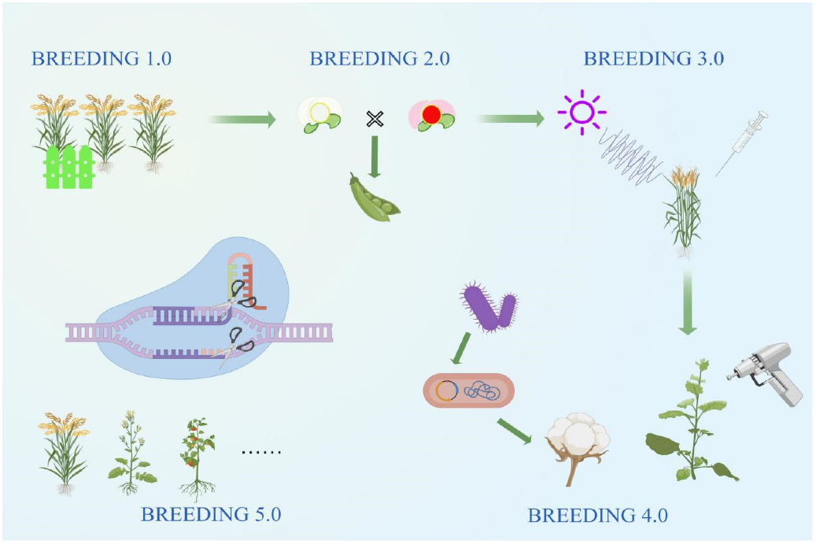

Figure 2. Disease Resistance in Agricultural Crops
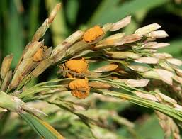
Figure 3. Climate Resilience through Crop Breeding
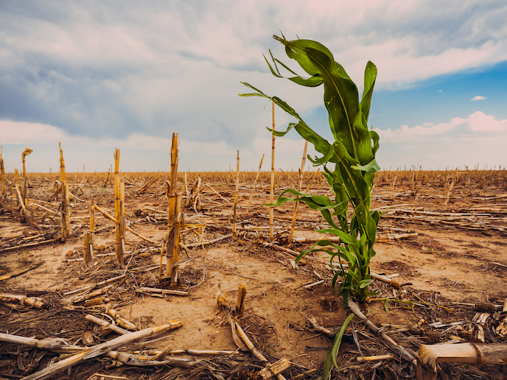
Figure 4. Genomic Tools for Precision Breeding
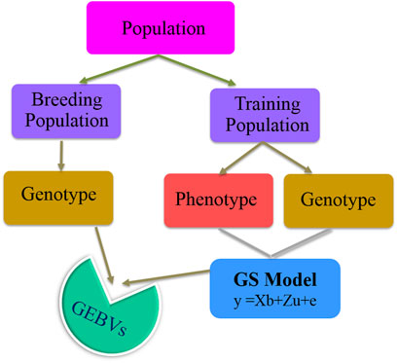
Figure 5. Hybrid Varieties and Food Security
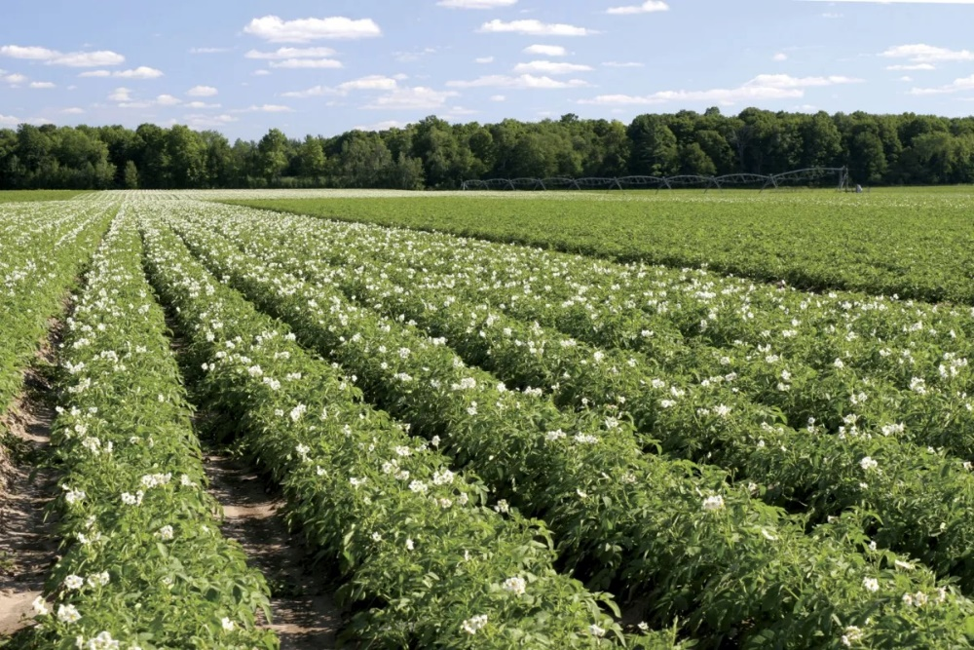
Figure 6. Sustainable Agriculture through Crop Selection
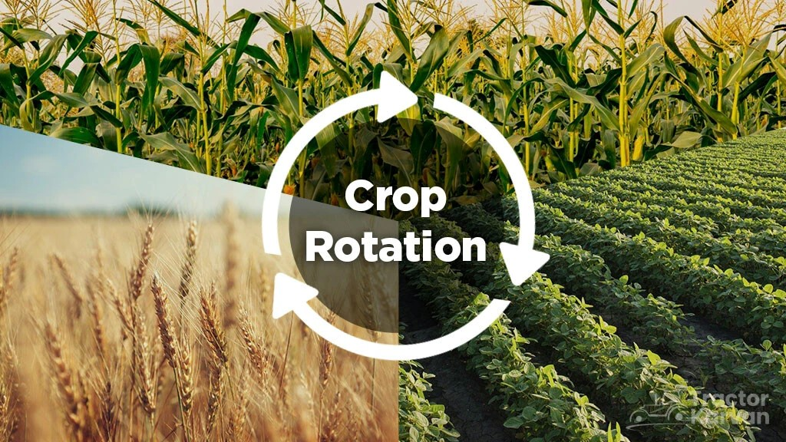
Figure 7. Nutritional Enhancement through Plant Breeding
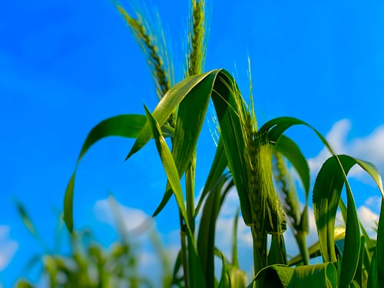
Figure 8. Drought Tolerance in Crop Varieties
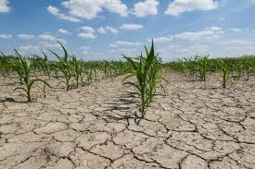
Figure 9. Biotechnology in Plant Breeding Research
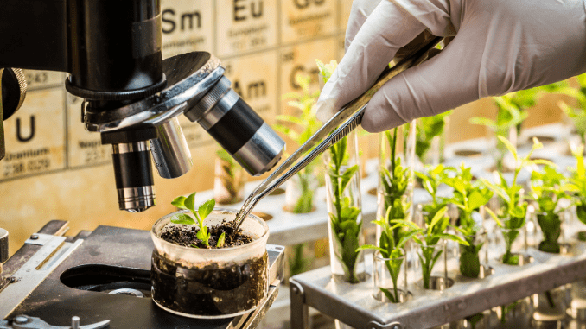
Figure 10. Global Challenges in Crop Improvement
