Dietary Protein Supplementation Reverses Spinal Cord Neurodegeneration in a Rat Model of Bitter Cassava-Induced Konzo

ABSTRACT
Background: Konzo, a neurological disorder linked to consumption of improperly processed bitter cassava, is characterized by motor neuron damage and paralysis, yet effective dietary interventions remain poorly understood. This study investigated the potential protective and rehabilitative effects of an eggshell and brown bean protein supplement on spinal cord histoarchitecture in a rat model of Konzo. Methods: Twenty-five female Wistar rats (200–250 g) were randomly assigned into five groups (n=5). Group 1 received standard feed, while Group 2 was fed bitter cassava chow to induce Konzo. Group 3 received cassava plus standard feed, Group 4 received cassava plus eggshell and brown bean supplement, and Group 5 received the supplement alone. Feeding lasted four weeks. After sacrifice, spinal cords were harvested at the C4–C6 level, processed histologically, and stained with Nissl to assess neuronal integrity. Results: Histological analysis revealed preserved cytoarchitecture in the control group, with intact anterior horn motor neurons containing abundant Nissl substances. Cassava-only rats displayed profound neurodegeneration, including distorted spinal cord structure, chromatolysis, and gliosis. Partial preservation was noted in the cassava plus standard feed group, where some neurons retained normal morphology. Remarkably, cassava plus supplement rats demonstrated substantial recovery, with well-organized grey and white matter, reduced degeneration, and restored motor neurons. Supplement-only rats exhibited generally normal spinal cord structure, though mild gliosis and occasional neuronal degeneration were observed. Conclusion: Supplementation with eggshell and brown beans conferred significant neuroprotective and rehabilitative effects against cassava-induced spinal cord damage, suggesting its potential as a dietary intervention for mitigating Konzo-related neurotoxicity.
Key words: Konzo, Bitter cassava, Neuroprotection, Spinal cord histology, Eggshell–brown bean supplement, Sulphur-rich diet, Wistar rats

INTRODUCTION
Konzo is an irreversible, non-progressive motor neuron disorder characterized by sudden-onset spastic paraparesis, predominantly affecting children and women of childbearing age in sub-Saharan Africa during periods of food insecurity (Kashala-Abotnes et al., 2019; David et al., 2022; Okpaku et al., 2024). The disease is intrinsically linked to chronic dietary reliance on insufficiently processed bitter cassava (Manihot esculenta Crantz), which contains high levels of cyanogenic glycosides, primarily linamarin and lotaustralin (Newton, 2017; Kashala-Abotnes et al., 2019). Under conditions of protein malnutrition, particularly deficiencies in sulphur-containing amino acids, the detoxification of cyanide to thiocyanate is impaired, leading to the accumulation of neurotoxic metabolites such as cyanate and thiocyanate (Mohidin et al., 2023). These compounds disrupt mitochondrial function, induce oxidative stress, and cause selective damage to upper motor neurons, particularly in the corticospinal tracts (Tylleskär et al., 1993; Enefa et al., 2020; Okpaku et al., 2024).
Epidemiological studies have consistently associated konzo outbreaks with agro-ecological collapse, drought, and conflict, where traditional cassava processing methods are compromised (Newton, 2017; Kashala-Abotnes et al., 2019). Neuropathologically, konzo presents with symmetrical degeneration of motor neurons in the spinal cord and brainstem, accompanied by gliosis and chromatolysis, as observed in histological and neurophysiological studies (Amadi et al., 2022; David et al., 2023). Despite the well-characterized clinical presentation, the exact molecular mechanisms underlying neuronal damage remain incompletely elucidated, and no curative or rehabilitative interventions exist.
Animal models have been critical in replicating konzo’s neuropathological features, with studies demonstrating that prolonged exposure to cyanogenic glycosides from bitter cassava induces motor deficits and neuronal degeneration in rodents. However, these models have primarily focused on disease induction rather than rehabilitation strategies. Recent evidence suggests that nutritional supplementation with sulphur-rich proteins may mitigate cyanide toxicity by enhancing detoxification pathways. For instance, protein supplements providing methionine and cysteine could potentially support the rhodanese-mediated conversion of cyanide to less toxic thiocyanate (Newton, 2017; Mohidin et al., 2023).
This study investigates the neuroprotective and rehabilitative potential of a protein-rich supplement comprising eggshell and brown beans in a rat model of konzo. Using histopathological analyses of the spinal cord, we evaluated whether supplementation could reverse or attenuate cassava-induced neuronal damage. The findings aim to inform nutritional interventions for populations at risk of konzo and contribute to understanding the role of protein supplementation in mitigating neurotoxicity associated with cyanogenic cassava consumption.
METHODS
Experimental Animals
Twenty-five female Wistar rats, weighing between 200-250 g, were procured from the Animal House of the Department of Pharmacology, Faculty of Basic Clinical Sciences, University of Port Harcourt. The animals were housed in clean, disinfected wooden cages lined with sawdust bedding and maintained under controlled environmental conditions: a 12-hour light/dark cycle, relative humidity of 50–60%, and a temperature of approximately 30 °C. Prior to the commencement of the experiment, the rats were acclimatized for two weeks with free access to clean water and standard animal feed.
Plant Collection, Identification, and Processing
Bitter cassava roots were collected from the Ministry of Agriculture, Agricultural Development Programme, and identified at the Faculty of Agricultural Science, University of Port Harcourt, Rivers State, Nigeria. Freshly harvested roots were immediately peeled with a knife to remove the brownish outer layer and expose the white inner portion. The peeled roots were then sliced into chips and sun-dried for three consecutive days, after which the dried pieces were ground into a fine powder using a grinding machine and administered to the experimental animals as cassava chow.
For the preparation of the protein food supplement, a mixture of eggshells and brown beans was used. The eggshells were washed, broken into small pieces, and sun-dried for 24 hours. Both the dried eggshells and brown beans were subsequently ground together into a fine powder using a grinding machine. This powder, serving as a sulphur amino acid protein supplement, was administered exclusively to group 4 and the group 5 rats in the experimental design.
Process of Inducing Konzo Disease in Rats
After a two-week acclimatization period of the Wistar rats, fifteen Wistar rats were exclusively and continuously fed with inappropriately processed bitter cassava flour for four weeks to induce Konzo disease and its associated manifestations (Amadi et al., 2022; David et al., 2022). The oral feeding method was adopted to closely mimic real-world consumption patterns, whereby the ingested cassava flour passed through the alimentary canal, beginning from the mouth, through the oesophagus, and into the stomach, thus coming in contact with relevant visceral organs and digestive secretions, including saliva, gastric juices, and potential sublingual or buccal absorption sites.
Rehabilitation of Rats
Following the induction period, the rehabilitation groups (Groups 3 and 4) were withdrawn completely from bitter cassava consumption. Group 3 received standard animal feed, while Group 4 was subsequently fed with eggshell and brown bean supplement. Feeding in both groups was carried out exclusively via oral ingestion.
Experimental design
Twenty-five adults female Wistar rats were randomly assigned into five experimental groups of 5 rats each (n=5) and treatments administered as shown in Table 1.
Table 1. Experimental design
Group | Identification | Treatment Description
1 | Control | Administered standard rat feed only for 4 weeks
2 | Cassava only | Administered bitter cassava chow (to induce Konzo disease) only for 4 weeks
3 | Cassava + Animal feed | Administered bitter cassava chow (to induce Konzo disease) + standard rat feed for 4 weeks
4 | Cassava + Eggshell and Brown beans | Administered bitter cassava chow (to induce Konzo disease) + eggshell and brown beans supplement for 4 weeks
5 | Eggshell and Brown beans only | Administered Eggshell and brown beans supplement only for 4 weeks

Bitter cassava chow and protein supplements were administered by oral ingestion for four weeks. The experiment lasted for a total duration of four weeks.
Histological Tissue Processing
The animals in each group were anesthetized by inhalation of chloroform in a desiccator, after which incisions were made to expose the thoracic and abdominal regions. Once fully exposed, transcardiac perfusion was performed using 10% formal saline, which was injected into the ventricular chamber of the heart. The spinal cord was then carefully harvested and further fixed by immersion in 10% formal saline solution. Coronal sections were taken at the spinal cord level C4–C6, a region that contains motor neurons critical for forelimb innervation and voluntary motor control, making it highly relevant for evaluating motor deficits such as those observed in Konzo. The tissue samples were fixed for 48 hours, processed using standard histological techniques, and subsequently stained with Nissl stain to visualize neuronal cell bodies and assess structural alterations.
Method of Data Analysis
No quantitative data were generated in this study. Instead, histological examination of spinal cord tissues was conducted using qualitative descriptive analysis. The stained sections were examined under a light microscope, and photomicrographs were captured to document structural and cellular features. Comparative assessment was carried out across experimental groups, focusing on neuronal morphology, cytoarchitecture of grey and white matter, presence of Nissl substances, and evidence of degenerative changes such as chromatolysis, gliosis, and neuronal loss. Observed patterns were described narratively, with emphasis on differences in degree of preservation or damage between control, cassava-fed, and supplement-treated groups. The findings were interpreted in relation to established histopathological markers of neurodegeneration and motor neuron integrity.
Ethical Clearance
The experimental animals were sourced from the Animal House of the Department of Pharmacology, Faculty of Basic Clinical Sciences, University of Port Harcourt. All experimental procedures were conducted in compliance with the guiding principles for research involving animals, as approved by the Research Ethics Committee of the University of Port Harcourt (Approval Reference No.: UPH/CEREMAD/REC/MM80/023). Animals were housed under standard laboratory conditions in metal cages at normal room temperature, with appropriate care provided throughout the study.
RESULTS
Histological Findings of the Spinal Cord
Histological examination of the spinal cord using Nissl staining revealed distinct structural and cellular alterations across experimental groups. In the control group (Figures 1A–B), the spinal cord architecture was well preserved, showing clearly demarcated anterior and posterior horns, with normal grey and white matter organization. The anterior horn contained motor neurons exhibiting intact morphology and abundant Nissl substances, indicating preserved neuronal integrity. Conversely, spinal cords from rats treated with cassava alone (Figures 2A–B) demonstrated marked pathological changes characterized by distorted and disorganized architecture in both anterior and posterior horns. The anterior horn exhibited pronounced neuronal degeneration, chromatolysis, and cellular gliosis, reflecting substantial neurotoxic injury.
Rats treated with cassava supplemented with standard animal feed (Figures 3A–B) showed partial improvement. While disorganized regions were still evident, some motor neurons retained normal morphology with visible Nissl substances, although degenerative features and gliotic changes persisted, suggesting incomplete neuroprotection. Notably, rats treated with cassava plus eggshell and brown beans (Figures 4A–B) displayed substantial recovery of spinal cord cytoarchitecture. The grey and white matter compartments were well organized, particularly in the anterior horn, where motor neurons appeared largely restored, exhibiting abundant Nissl substances and reduced signs of degeneration. Finally, in the group fed only eggshell and brown beans (Figures 5A–B), the spinal cord generally retained normal structure, though mild disruptions were noted, including few disorganized regions, increased perineural spaces, and evidence of astrogliosis alongside occasional degenerated neurons. These changes, though present, were less severe compared to the cassava-only group, highlighting the protective effects of amino acid supplementation.
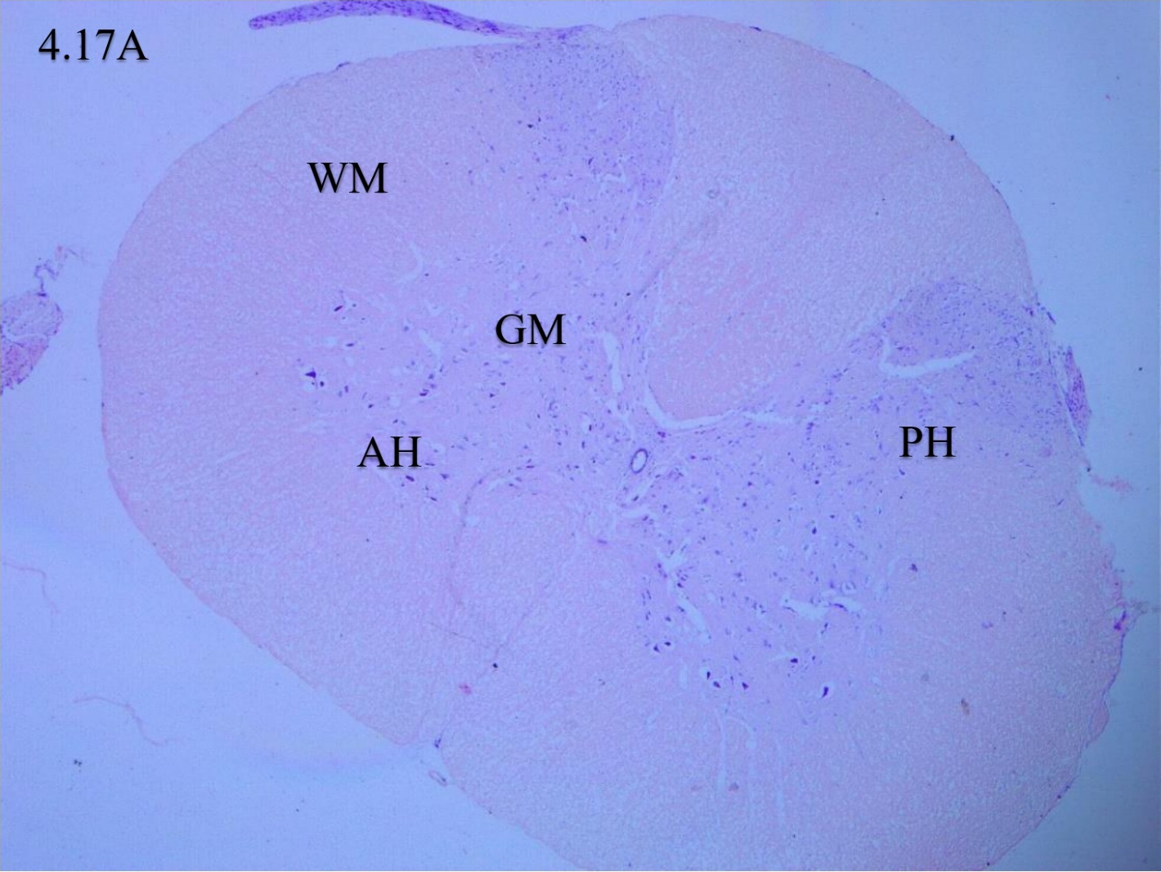
Figure 1A: Photomicrographs section of spinal cord tissue of Wistar rat from control group showing the different area of the spinal cord with anterior horn (AH), posterior horns (PH), white matter ((WM) and grey matter (GM). Nissl stain: ×100.

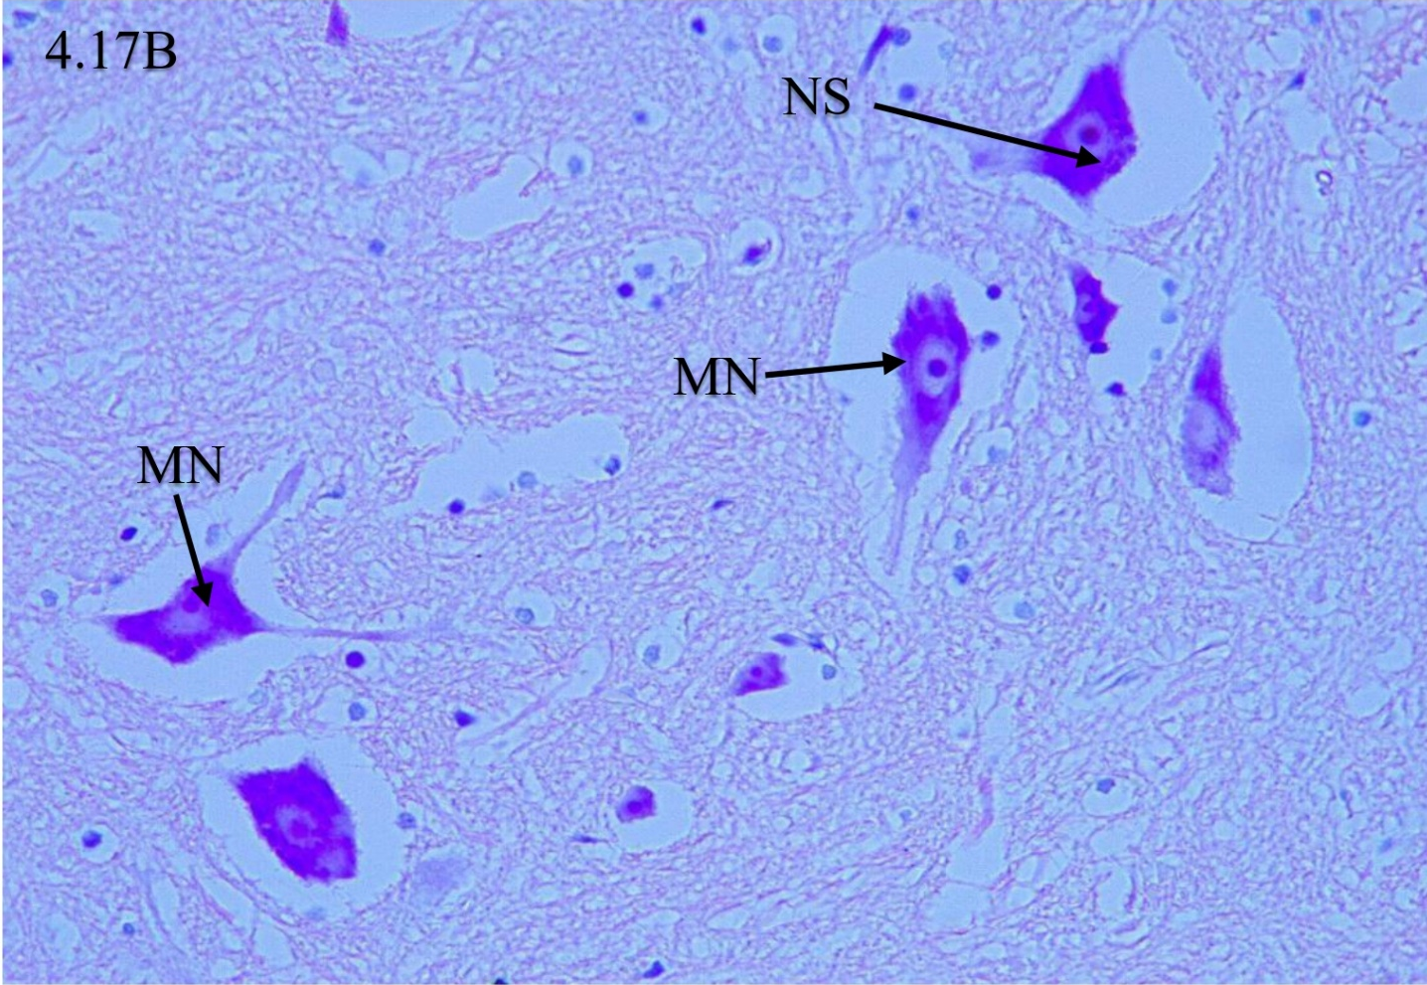
Figure 1B: Photomicrographs section of spinal cord tissue of Wistar rat from control group displaying grey matter areas of the anterior horn of the spinal cord with Motor neurons (MN) with abundance of Nissl substance (NS) in the anterior horn of the spinal cord. Nissl stain: x400.

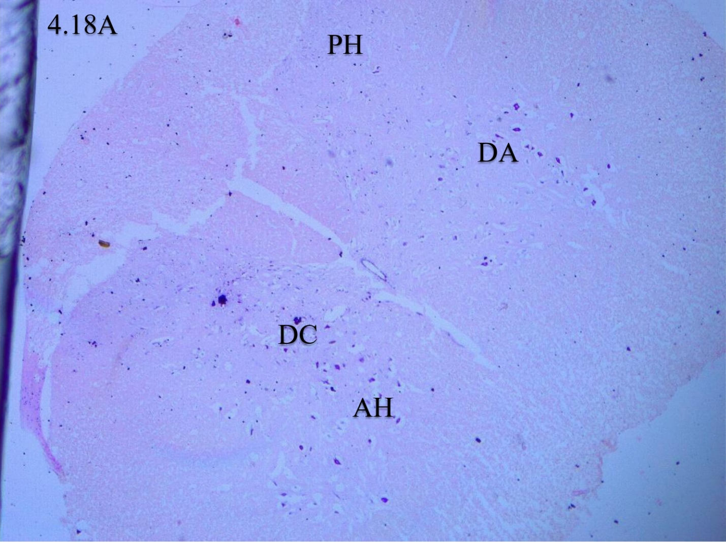
Figure 2A: Photomicrographs section of spinal cord tissue from Wistar rat treated with cassava alone. Figure 2A showed distorted and disorganized areas and cells in the anterior (AH) and posterior horns (PH) of the spinal cord.

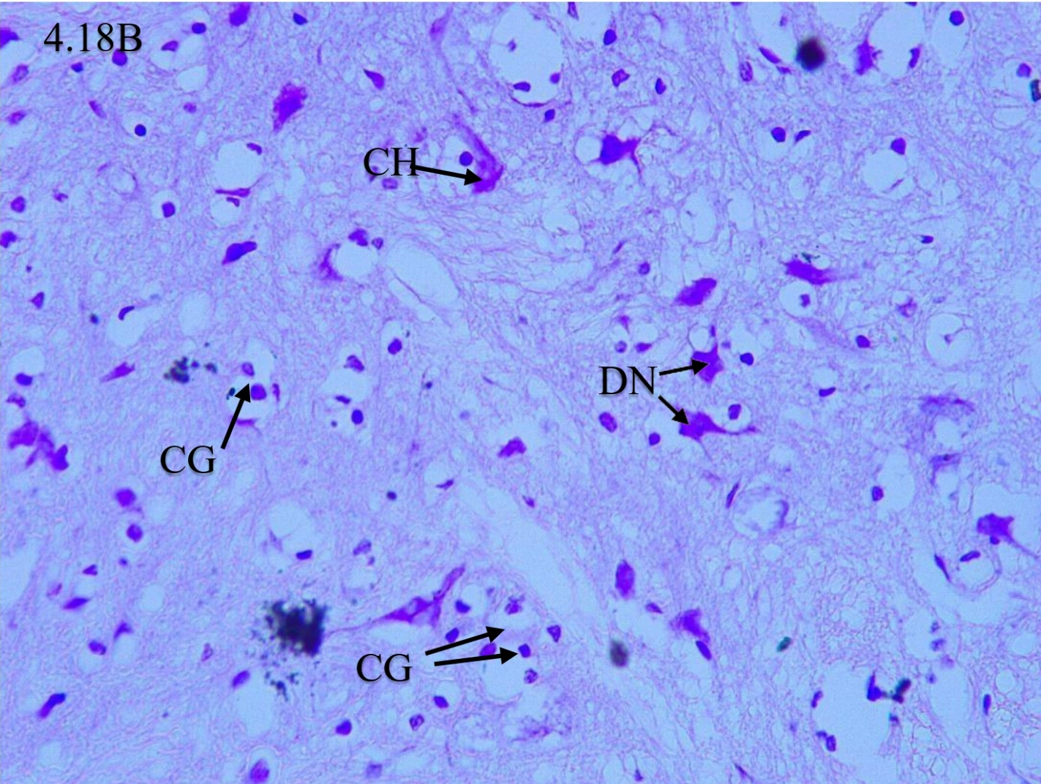
Figure 2B: Photomicrographs section of spinal cord tissue from Wistar rat treated with cassava alone displaying areas of the anterior horn with Motor neurons degeneration (DN), Chromatolysis (CH) and cellular gliosis (CG), Nissl stain: x400.
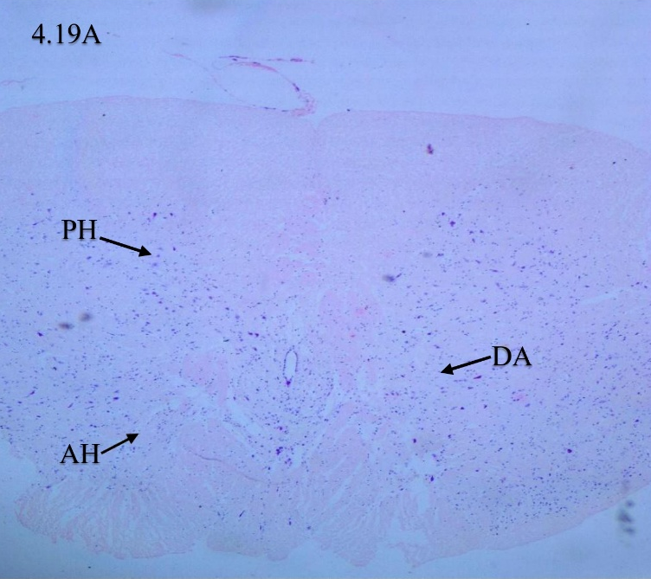
Figure 3A: Photomicrographs section of spinal cord tissue from rat treated with cassava and animal feed. It showed distorted and disorganized areas and cells in the anterior (AH) and posterior horns (PH) of the spinal cord. Nissl stain: ×40.

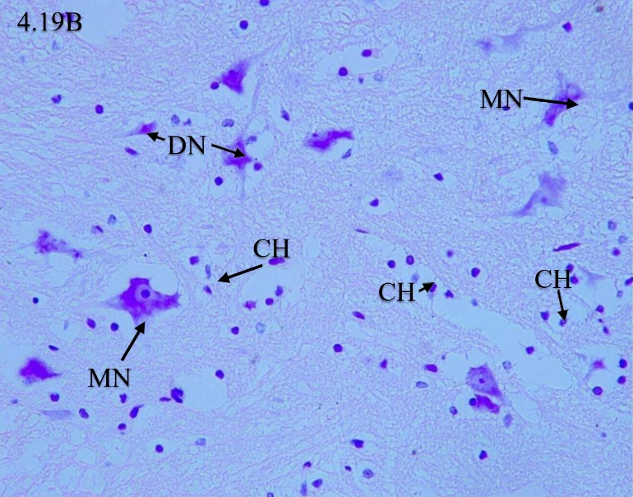
Figure 3B: Photomicrographs section of spinal cord tissue from Wistar rat treated with cassava and animal feed displaying grey matter areas with Normal Motor neurons (MN), degenerated motor neuron (DN) and connective cells gliosis (CH), Nissl stain: x400.
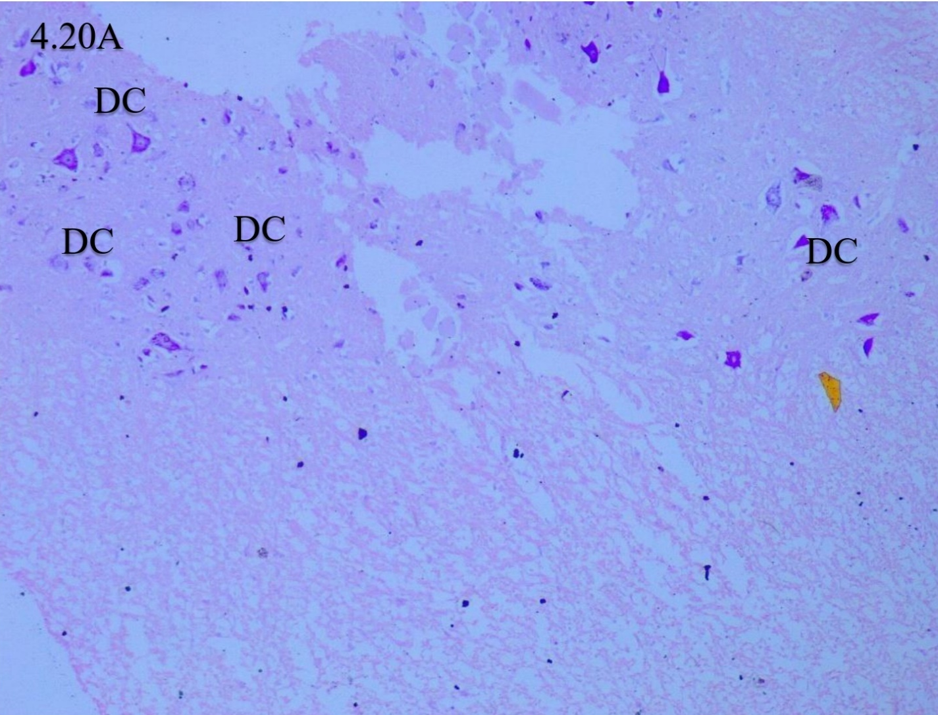
Figure 4A: Photomicrographs section of spinal cord tissue from Wistar rat treated with cassava plus eggshell and brown Beans. The Figure showed organized different area of the spinal cord especially the anterior horn (AH), white matter ((WM) and grey matter (GM). Magnification: X40.

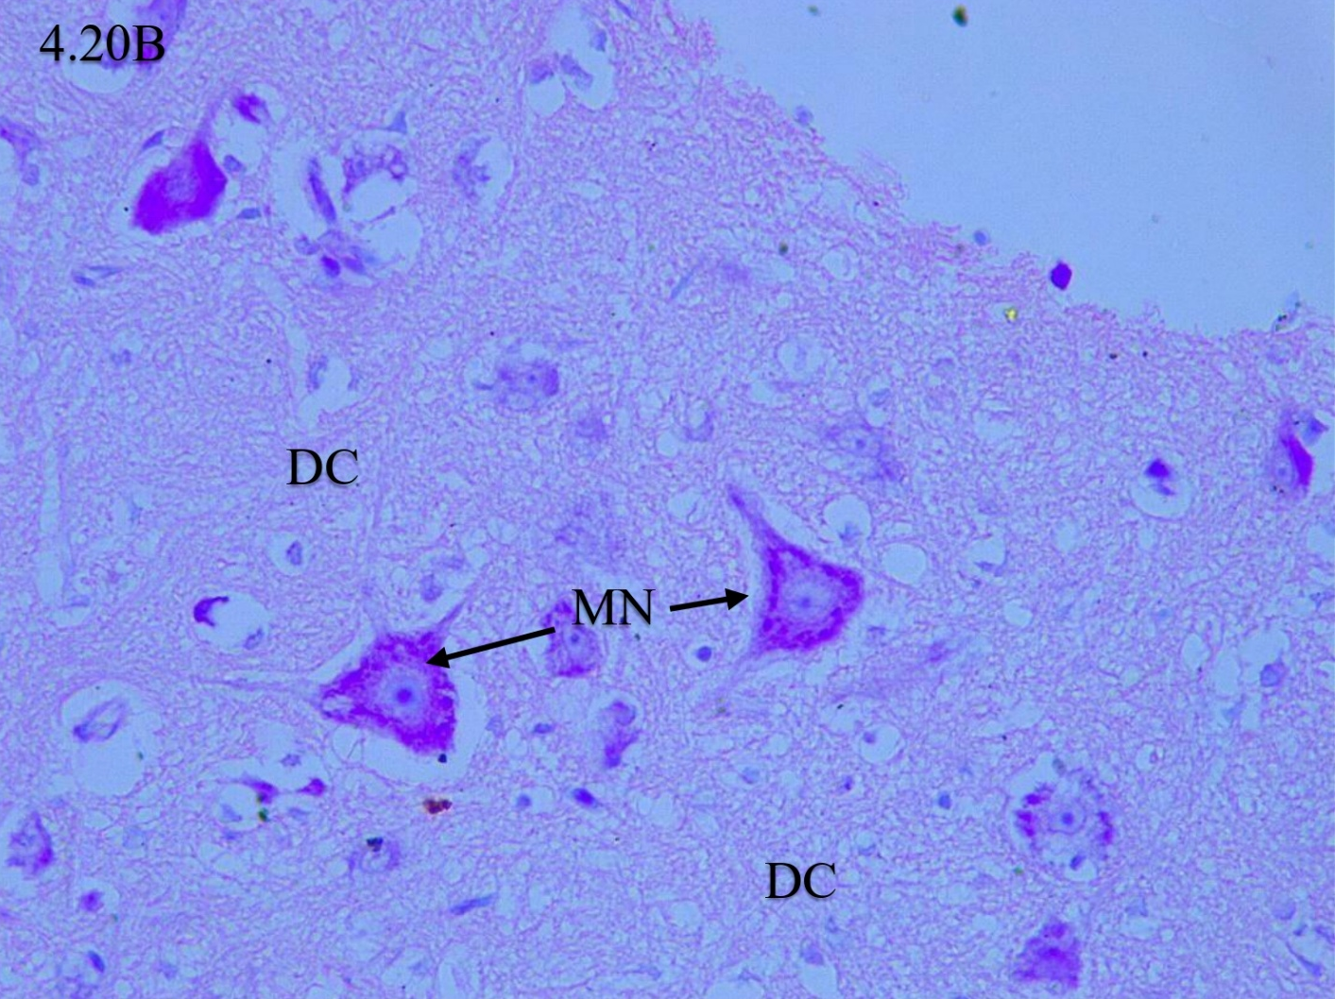
Figure 4B: Photomicrographs section of spinal cord tissue from Wistar rat treated with cassava plus eggshell and brown beans displaying grey matter areas of the anterior horn of the spinal cord with recovered Motor neurons (MN) with abundance of Nissl substances (NS). Nissl stain: x400.
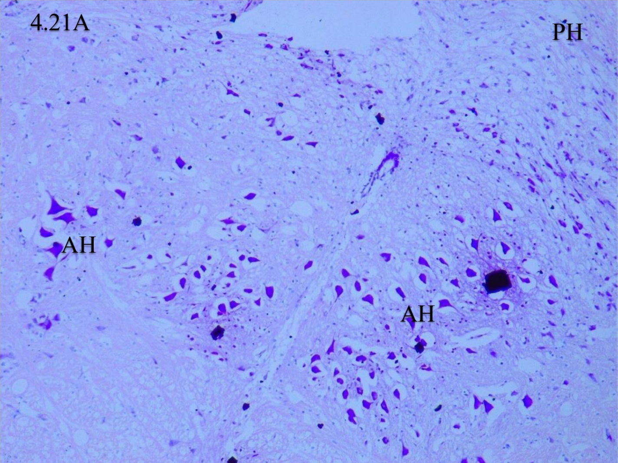
Figure 5A: Photomicrographs section of spinal cord tissue from Wistar rat treated with eggshell and brown beans only showing few disorganized areas and cells in the anterior (AH) and posterior horns (PH) of the spinal cord.
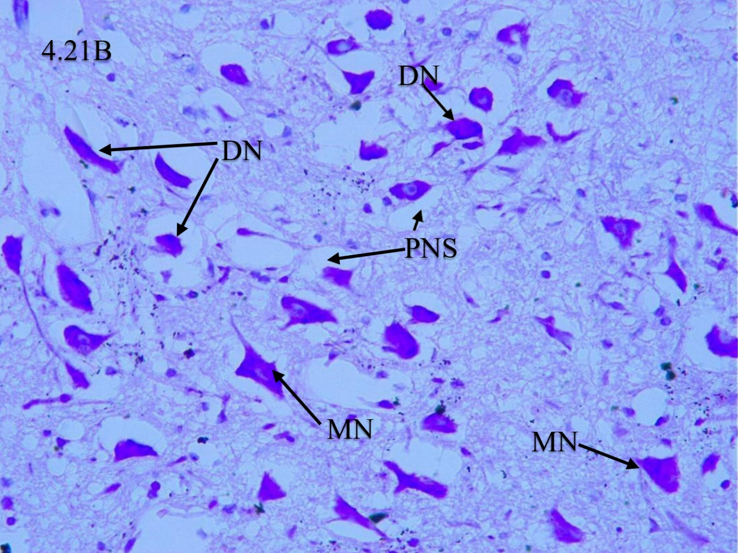
Figure 5B: Photomicrographs section of spinal cord tissue from Wistar rat treated with eggshell and brown beans only displaying grey matter areas of Normal Motor neurons (MN), degenerated motor neuron (DN), increase perineural spaces (PNS) and astrogliosis, Nissl stain: x400.

DISCUSSION
In this experimental model, chronic consumption of bitter cassava induced clear signs of neurodegeneration and systemic toxicity consistent with Konzo. Rats fed only on improperly processed cassava showed significant neurological impairment – such as motor incoordination – and physiological stress. For example, Amadi et al. (2022) reported that cassava-fed rats had significantly reduced body weight and elevated blood cyanide levels compared to controls. Likewise, Rivadeneyra-Domínguez et al. (2020) found that chronic cassava ingestion produced motor coordination deficits and correlated neuronal damage in rats. Histologically, our Nissl-stained spinal cord sections from the cassava-only group revealed neuronal loss and degeneration (e.g. pyknotic or chromatolytic motor neurons), whereas control rats showed normal neuronal architecture. This is in line with evidence that cassava toxins target neurons: Sreeja et al. (2003) demonstrated that linamarin (the cyanogenic glycoside in cassava) can directly kill neural cells via uptake through glucose transporters. In contrast, rats that received protein supplementation after cassava exposure showed markedly preserved spinal neurons. Both the cassava + animal-feed and cassava + eggshell-bean groups exhibited substantially less neuronal loss than the cassava-only rats. These histological findings mirror Okakpu et al. (2023)’s report that protein-rich supplements (soya and brown beans) ameliorated cassava-induced neuronal loss in the rat cortex. Similarly, Amadi et al. (2022) observed that rats fed eggshell + brown bean supplement had elevated blood methionine and cysteine, suggesting enhanced cyanide detoxification, whereas cassava-only rats had excess blood cyanide. In our study, the eggshell + bean group (and the standard-feed rehabilitation group) recovered more normal spinal cord structure, supporting the idea that dietary protein/sulphur amino acids counteract cassava neurotoxicity.
Our results are broadly consistent with prior research on cassava-induced neurotoxicity but also highlight some differences. The degeneration of spinal motor neurons we observed agrees with Konzo’s known pathology as a selective upper motor neuron disease (Baguma et al., 2021; Baguma et al., 2024). Baguma et al. (2024) showed that cyanate – a cyanide metabolite – triggers oxidative stress, apoptosis and excitotoxicity in spinal neurons, which would produce the kind of neuronal loss seen here. The fact that we saw structural neuronal damage parallels findings from other models: for example, Rivadeneyra-Domínguez et al. (2020) linked cassava and linamarin intake to neuronal damage in motor-control brain regions. By contrast, Okakpu et al. (2023) reported that cassava reduced NeuN-positive neuron counts in motor cortex, even though H&E histology appeared intact. This difference may reflect tissue or marker specificity: we used Nissl staining in spinal cord, which may reveal early chromatolytic changes that immunostaining could miss, whereas Okakpu’s cortical NeuN data shows protein changes in surviving neurons. Moreover, Okakpu used male rats and soya beans, while our model used female rats and eggshell + bean supplement; sex and the exact supplement composition might affect vulnerability (Okakpu et al., 2023). Nevertheless, both studies found that protein supplements mitigate neuronal loss, indicating a common theme that nutritional support can rescue cassava-induced damage.
Our data also align with the well-established concept that cassava neurotoxicity requires both cyanide exposure and poor nutrition. The cassava-only group’s severe pathology accords with reviews noting cassava-derived cyanide poisoning as a key Konzo risk factor (Baguma et al., 2021). At the same time, the preservation of neurons in protein-replete groups highlights protein malnutrition’s role in Konzo. Indeed, Baguma et al. (2021) emphasize that protein deficiency exacerbates Konzo risk because it limits cyanide detoxification. In our study, eggshells and brown beans provided sulphur amino acids (SAAs) such as methionine and cysteine, that likely bolstered detox pathways. Amadi et al. (2022) concluded that SAA such as methionine and cysteine “are essential for detoxification of the residual cyanogens” from cassava. Biochemically, cysteine is a glutathione precursor and methionine participates in cyanide conversion to thiocyanate, so their dietary provision helps neutralize cassava’s toxins (Amadi et al., 2022). Thus, our finding that SAA supplementation prevents neuronal loss supports the model that Konzo arises when cyanide overwhelms an SAA-deficient metabolism.
Mechanistically, our results suggest that cassava’s neurotoxicity involves oxidative stress and excitotoxic damage to motor neurons. Baguma et al. (2024) found that cyanate (a stable cyanide metabolite) increases reactive oxygen species and caspase activity in cultured neurons, indicating apoptosis and oxidative injury. This provides a plausible explanation for the neuronal degeneration we observed: insufficient detoxification of cassava cyanogens may allow accumulation of cyanate or other reactive metabolites that injure motor neurons. The improved neuronal survival in supplemented rats implies that enhanced detoxification prevented these downstream effects. Overall, our findings imply that consumption of high-protein, sulphur-rich foods can reverse or prevent the neuropathological sequelae of inadequately processed cassava.

CONCLUSION
Chronic bitter cassava feeding in rats caused selective upper motor neuron degeneration, recapitulating key features of Konzo. These effects were largely prevented by providing dietary protein and sulphur amino acids (from standard feed or eggshell + bean supplement), consistent with prior observations that such nutrition enhances cyanide detoxification. Our data reinforce the concept that Konzo is a toxico-nutritional condition wherein cassava cyanogens inflict neural injury only when dietary SAA are scarce. This study highlights the potential of simple dietary interventions in mitigating cassava neurotoxicity.

DISCLAIMER (ARTIFICIAL INTELLIGENCE)
Author hereby declares that NO generative AI technologies such as Large Language Models (ChatGPT, COPILOT, etc.) and text-to-image generators have been used during the writing or editing of this manuscript.

REFERENCES
Amadi, H., David, L. K., & Oghenemavwe, L. E. (2022). Compensatory mechanism of diet containing sulphur-rich amino acids in restoring neurotoxico-nutritional deficits in Konzo disease rat model. International Neuropsychiatric Disease Journal, 17(2), 22–31. https://doi.org/10.9734/indj/2022/v17i230197
Baguma, M., Kessels, S., Bito, V., Brône, B., Triller, A., Maynard, S., Legendre, P., Rigo, J. M., Le Corronc, H., & Chabwine, J. N. (2024). New insight into the molecular etiopathogenesis of konzo: Cyanate could be a plausible neurotoxin contributing to konzo, contrary to thiocyanate. Neurotoxicology, 105, 323–333. https://doi.org/10.1016/j.neuro.2024.11.004
Baguma, M., Nzabara, F., Maheshe Balemba, G., Malembaka, E. B., Migabo, C., Mudumbi, G., Bito, V., Cliff, J., Rigo, J. M., & Chabwine, J. N. (2021). Konzo risk factors, determinants and etiopathogenesis: What is new? A systematic review. Neurotoxicology, 85, 54–67. https://doi.org/10.1016/j.neuro.2021.05.001
Baguma, M., Nzabara, F., Maheshe Balemba, G., Malembaka, E. B., Migabo, C., Mudumbi, G., Bito, V., Cliff, J., Rigo, J. M., & Chabwine, J. N. (2021). Konzo risk factors, determinants and etiopathogenesis: What is new? A systematic review. Neurotoxicology, 85, 54–67. https://doi.org/10.1016/j.neuro.2021.05.001
C., Brubaker, G. R., & Rosling, H. (1993). Konzo: a distinct disease entity with selective upper motor neuron damage. Journal of neurology, neurosurgery, and psychiatry, 56(6), 638–643. https://doi.org/10.1136/jnnp.56.6.638
David, L. K., Idung, V. H., & Uahomo, P. O. (2022). Neurobehavioral and ameliorative effect of Complan milk and Bambara nut on rats fed with bitter cassava – A nutritional approach. International Neuropsychiatric Disease Journal, 17(1), 7–17. https://doi.org/10.9734/indj/2022/v17i130190
David, L. K., Uahomo, P. O., Idung, V. H., & Dakoru, R. D. (2023). Assessment of sensorimotor behaviour in Konzo-induced rats using the Irvine, Beattie, Bresnahan forelimb scale. Biology, Medicine and Natural Product Chemistry, 12(2), 431–435. https://doi.org/10.14421/biomedich.2023.122.431-435
Enefa, S., Chikwuogwo, W. P., & David, L. K. (2020). Model of Konzo disease: Reviewing the effect of bitter cassava neurotoxicity on the motor neurons of cassava-induced Konzo disease in Wistar rats. Saudi Journal of Medicine, 5(11), 336–348
Kashala-Abotnes, E., Okitundu, D., Mumba, D., Boivin, M. J., Tylleskär, T., & Tshala-Katumbay, D. (2019). Konzo: a distinct neurological disease associated with food (cassava) cyanogenic poisoning. Brain research bulletin, 145, 87–91. https://doi.org/10.1016/j.brainresbull.2018.07.001
Mohidin, S. R. N. S. P., Moshawih, S., Hermansyah, A., Asmuni, M. I., Shafqat, N., & Ming, L. C. (2023). Cassava (Manihot esculenta Crantz): A Systematic Review for the Pharmacological Activities, Traditional Uses, Nutritional Values, and Phytochemistry. Journal of evidence-based integrative medicine, 28, 2515690X231206227. https://doi.org/10.1177/2515690X231206227
Newton C. R. (2017). Cassava, konzo, and neurotoxicity. The Lancet. Global health, 5(9), e853–e854. https://doi.org/10.1016/S2214-109X(17)30306-6
Okakpu, E. E., David, L. K., & Okoseimiema, S. C. (2023). Effects of soya beans and brown beans in degenerative changes expressed in cortical NeuN immunoreactivity in a cassava-induced Konzo disease rat model. Scholars International Journal of Anatomy and Physiology, 6(7), 100–104. https://doi.org/10.36348/sijap.2023.v06i07.003
Okakpu, E. E., David, L. K., Okoseimiema, S. C., & Uahomo, P. O. (2024). Nutritional approach to ameliorate demyelinating changes expressed in spinal Olig2 immunoreactivity in a Konzo disease rat model. SAR Journal of Psychiatry and Neuroscience, 5(2), 23–31. https://doi.org/10.36346/sarjpn.2024.v05i02.001
Rivadeneyra-Domínguez, E., Pérez-Pérez, J. E., Vázquez-Luna, A., Díaz-Sobac, R., & Rodríguez-Landa, J. F. (2020). Effects of Cassava Juice (Manihot esculenta Crantz) on Renal and Hepatic Function and Motor Impairments in Male Rats. Toxins, 12(11), 708. https://doi.org/10.3390/toxins12110708
Sreeja, V. G., Nagahara, N., Li, Q., & Minami, M. (2003). New aspects in pathogenesis of konzo: neural cell damage directly caused by linamarin contained in cassava (Manihot esculenta Crantz). The British journal of nutrition, 90(2), 467–472. https://doi.org/10.1079/bjn2003902

