Pyrolysis Plant Design for Sustainable Conversion of Biomass and Tire Waste into Carbon Residues: Characterization and Environmental Impact.

Abstract: The growing challenge of managing biomass and synthetic waste materials, such as automotive tires, has prompted the need for sustainable recycling solutions. This study introduces the design and development of a prototype pyrolysis plant aimed at transforming diverse biomass and synthetic wastes into valuable carbon residues. The pyrolysis process utilized coconut shell, palm kernel shell, wood waste, and automotive tires as feedstock, achieving a batch processing capacity of approximately 17.5 liters. Experimental results indicate significant differences in the properties of carbon residues derived from biomass versus tire materials. Specifically, biomass-derived carbon exhibited an average pH of 9.33, bulk density of 0.56 g/ml, porosity of 0.043, ash content of 39.92%, and volatile matter loss of 68.68%. In comparison, tire-derived carbon showed a pH of 10.17, bulk density of 0.72 g/ml, porosity of 0.068, ash content of 67.30%, and volatile matter loss of 18.42%. These findings demonstrate the effectiveness of the plant in generating tailored carbon products with distinct properties suitable for various industrial applications. By offering an eco-friendly and efficient waste conversion process, this research contributes to advancing sustainable waste management practices and supporting the circular economy.
Keywords: Municipal Solid Wastes, Biomass, Sustainability, CAD, Pyrolysis, Carbon.
1. Introduction
Reliable and clean energy access is critical for economic growth, human well-being, and achieving sustainable development goals (SDGs). However, unmanaged carbon emissions from industrial and municipal solid waste exacerbate global warming and environmental degradation, underscoring the need for improved waste management practices [1-2]. Municipal solid waste, generated from households, businesses, and institutions, includes degradable and non-degradable materials. While traditional waste management methods address basic disposal needs, hazardous wastes such as tires pose unique challenges due to their durability and potential to pollute air, soil, and water [3-5].

Advancements in waste-to-energy technologies, including incineration, gasification, and pyrolysis, present promising solutions for transforming waste into energy [6-7]. Pyrolysis, a thermal process conducted in an oxygen-free environment, effectively decomposes organic materials such as biomass and synthetic wastes into biochar, bio-oil, and syngas [8-9]. Operating at temperatures between 300 and 900°C, pyrolysis avoids combustion, producing carbon-rich byproducts suitable for various industrial applications [10-12]. Compared to other processes, pyrolysis not only reduces waste volume but also generates valuable products that support renewable energy initiatives and contribute to circular economy models [13-15].

Recent studies on pyrolysis have demonstrated the potential of various biomass sources for producing biochar with unique properties suited for environmental and energy applications. For instance, biochar production from wheat straw, spent coffee grounds, and brewery grains was investigated under pyrolysis conditions of 400°C and 500°C by Małgorzata et al., [16]. This process led to a significant increase in carbon content, with spent coffee grounds achieving a rise from 45% to 73% at 400°C and to 77% at 500°C. Scanning electron microscopy and thermal analysis revealed structural and thermal characteristics conducive to enhanced performance as adsorbents and fuel. Chemical activation with KOH, paired with Brunauer-Emmett-Teller (BET) analysis to assess surface area and pore diameter, showed high sorption efficacy, especially for chromium ions (Cr3+), positioning biochar’s from brewery grains as having the highest surface area, while wheat straw biochar exhibited superior Cr3+ adsorption and optimal combustion properties. This indicates that diverse biomass feedstocks can produce biochar’s with tailored properties, adaptable to both environmental and energy-based applications.
Additionally, Zahid et al., [17], proposed a hybrid framework combining data-driven (Cascade forward neural network (CFNN), metaheuristic artificial bee colony (ABC), and mechanistic (Aspen simulation) modelling for bio-oil production from biomass pyrolysis. This method achieved high accuracy, with a correlation coefficient of 0.95 and a root mean square error (RMSE) of 0.39, effectively optimizing bio-oil yield predictions. Validated through Aspen simulations, this approach highlights the critical role of biomass characteristics in bio-oil yield and provides valuable process insights, ultimately advancing waste-to-energy technologies with reliable predictive modelling.
Similarly, Mohammed [18], designed a comprehensive pyrolysis unit featuring a steel frame, reactor, heat exchange system, and piping. This system yielded three valuable by-products—biochar, bio-oil, and syngas. Notably, bio-oil exhibited a high calorific value comparable to diesel, supporting its potential as an alternative fuel source. The unit efficiently converted 2 kg of waste into 55% pyrolysis oil and 25% char, emphasizing the technology’s effectiveness in waste conversion and energy recovery.
Lan et al., [19] addressed the negative impact of tar, a by-product in biomass gasification, by evaluating its chemical properties and pyrolysis behaviour. Using gas chromatography-mass spectrometry (GC-MS), the study identified complex tar compounds, including phenol and naphthalene derivatives, furans, and other macromolecular aromatics with carbon numbers ranging from 7 to 14. Thermogravimetric analysis (TGA) was conducted at two heating rates (10°C/min and 20°C/min) to observe the tar’s decomposition behaviour, while the Coats-Redfern method was applied to calculate kinetic parameters like activation energy (E) and pre-exponential factor (A). Findings indicate a two-stage degradation process: volatilization below 105°C and pyrolysis between 105°C and 380°C. High temperatures were found to facilitate tar breakdown, suggesting that temperature adjustments could enhance tar management in biomass gasification systems, potentially improving system design and efficiency.

Cedrone et al., [20] addressed the critical issue of sewage sludge management, highlighting the environmental risks of improper disposal. It investigates thermal pyrolysis as a promising technology for reducing sludge volume and recovering energy. Using a central composite design for experimentation, the research optimizes key parameters like temperature, heating rate, and residence time—to enhance biochar yield and CO₂ adsorption capacity. The findings reveal maximum values of 47.8 wt% for biochar yield and 0.514 mol CO₂/kg for adsorption capacity. Additionally, biochar produced under optimal conditions demonstrated a surface area of 124 m²/g and an ash content of 61 wt%. The study underscores the significant impact of reactor design and particle size on biochar quality, while also indicating that drying is the most energy-intensive step in the pyrolysis process.

Building on these studies, although a good number of research studies have been conducted in the area of utilizing pyrolysis technology for recycling biomass and synthetic wastes, where the extracted raw materials have found applications in composite materials for automobile, electrical, structural, aerospace, biomedical, electrical vehicle battery electrode (supercapacitor), and other solid systems [21 - 23]. However, this research addresses the need for a sustainable and versatile pyrolysis solution capable of processing diverse biomass and synthetic wastes, including automotive tires, which are less commonly studied. Unlike previous research, which often focuses solely on either biomass or single-waste types, this research approach aims to broaden the scope of pyrolysis by accommodating mixed waste types in a single pyrolysis system. The study's motivation stems from the environmental necessity of managing both biodegradable and non-biodegradable waste streams effectively, minimizing environmental harm, and creating value-added products. The unique contribution of this research lies in developing a prototype pyrolysis plant with enhanced performance characteristics, validated through practical trials, that not only produces biochar and bio-oil but also generates carbon residues with specific properties suited for engineering applications. This work thus offers a scalable and environmentally beneficial pathway for waste-to-energy conversion, aligning with sustainable waste management goals.
2. Materials and Method
In response to the escalating environmental challenges posed by increasing waste volumes, our research focuses on the design and development of an innovative pyrolysis plant, afterward, utilize the plant in extracting biochar, confirming some engineering properties of the product through experiment. The primary objective of this plant is to address the critical issue of waste mismanagement by converting diverse materials, specifically damaged automobile tyres and biomass wastes (coconut shells, palm kernel shells, and wood waste), into valuable carbon ash.

The significance of our prototype pyrolysis plant lies in its transformative role in waste conversion. Traditional waste disposal methods contribute to environmental pollution and resource depletion. By harnessing the potential of pyrolysis, we aim to provide a sustainable solution that not only mitigates the adverse impacts of waste but also generates valuable carbon residues. This process aligns with the broader goal of promoting eco-friendly practices, reducing environmental hazards, and contributing to the circular economy.

This section comprehensively discusses the materials and methods employed throughout the project, encompassing the design and fabrication of the pyrolysis plant, the pyrolysis process, carbon black activation, and batch adsorption testing.
2.1 Improvement in the Design of an Existing Pyrolysis Plant and Design Considerations
Although some good pyrolysis plants have been designed, but this research observed some considerations in the design, which includes the design of the melting pot, repositioning of the condensate column into the system, safety features incorporation, and the incorporation of an oil collector system. Some technical approach to the project includes:
- A close study of the existing pyrolysis plant to identify and address problem areas.
- Modification of the plant's design to incorporate improvements.
- Selection of the best design solution meeting performance goals.
- Detailed specifications of the designed improvements.
- Material selection, procurement, and planning for the manufacture of the redesigned pyrolysis plant.
- Manufacture and testing of the pyrolysis plant.
- Evaluation and final modification of the plant.
Consideration factors include the melting point of biomass, furnace temperature, capacity, pressure, power requirements, and feed rate.
2.2 Design Assumptions and Specifications of the System
Assumptions include the initial temperature of the melting pot, condenser temperature, minimal heat loss due to insulation, absence of oxygen in the furnace, and adequate consideration for vapours. Specifications for various components of the pyrolysis plant are detailed, covering the melting pot, condenser column, melting pot housing, charging and discharging systems, and water storage tank.

The conceptualization phase commenced with the utilization of SolidWorks (model 2019), a powerful CAD software. This industry-standard tool facilitated the creation of a detailed and intricate conceptual design for our prototype pyrolysis plant.

In all design certain factors are considered before carrying out a design. The factors to be considered include:
- The melting point of the Biomass: Low melting point enhances quick vaporization of the substance, hence more oil and carbon yield.
- Furnace temperature: The higher the furnace temperature, the greater the amount of vapor obtained.
- The furnace capacity: a greater furnace capacity provides a larger amount of tyre or biomass materials, hence, a greater oil and carbon residues yield.
- Pressure developed inside the furnace: excessively high pressure in the furnace brings about the development of the undue stresses in the plant components.
- Power required: The power required to run the plant must be high enough to melt the tyre or biomass at the least possible time.
- Feed rate: this depends on the oil and carbon demand and the maximum obtainable temperature.
- Cooling rate of the Heat Exchanger/ Condenser: A faster cooling rate is required to condensate the vapor. Hence, a tubular condensate column with counter flow direction of flow is used.
The specific design assumptions made includes:
- Melting pot initial temperature = 29ºC
- Temperature of condenser = 4ºC
- Minimal heat loss due to insulation
- Absence of oxygen in the furnace.
- Adequate consideration at the vapours.
The design specifications of the prototype include:
- Melting pot:
Diameter = 26cm
Height = 33cm
Thickness = 5mm
- Condenser column
Inner tube length = 103cm
Outer Tube length= 80cm
Water inlet and outlet opening = 2cm
Diameter = 10cm
Oil pipe inlet and outlet opening = 3.5cm
Vapour inlet = 6.35cm
- Melting pot housing
Diameter = 16cm
Height = 30cm
- Charging system
Cap Diameter = 6.35cm
Cap width = 3mm
Pipe size = 75.5mm
- Discharging system
Discharge cover diameter = 7.6cm
Operating handle diameter = 30mm
Operating handle length = 10cm
- Water storage tank
Length = 61cm
Width = 33cm
Height = 18cm

2.3 Fabrication
Once the design was finalized, materials were carefully selected based on calculated specifications. The fabrication process involved precision engineering techniques to transform the conceptual design into a physical prototype using the suitable material selected for the design as presented in table1. In essence, the design and conceptualization phase of our prototype pyrolysis plant encompassed a meticulous process leveraging SolidWorks, fundamental engineering equations, and a focus on key features and safety considerations. This methodical approach ensures the reliability, efficiency, and safety of our innovative waste conversion solution.
Table 1: The Fabrication Components of the Pyrolysis Plant
S/N | Items | Quantity
1. | 2’’ x 2’’ x 5mm thick angle iron | 4 lengths
2. | 33cm length x 26cm diameter x 5mm thick melting pot | 1
3. | 55cm length x 40cm diameter outer housing | 1
4. | 120cm length x 80mm diameter x 50 mm thickness condenser housing | 1
5. | 110cm length x 60mm diameter x 5mm thickness condenser tube | 1
6. | 63cm x 33cm x 60cm height evaporative condenser housing | 1
7. | Evaporative baffle plate (aluminium plate material) | 20
8. | Thermos-controller temperature display instrument | 1
9. | Thermocouple wire | 1
10. | Heat resistance wire (12m) | 1
11. | Heating ring (2000W) | 1
12. | Pump (0.5 hp) | 1
13. | Wood fibre insulating material | 4kg
14. | Fan | 1

Description of various components which were integrated to build the pyrolysis plant include:
- The melting pot: This is a component of the plant where the thermal decomposition of the biomass waste materials takes place. It contains a 2000W heating coil required to carry out the melting process.
- Condensate unit/Heat exchanger: This component is responsible for the transfer of heat energy between the biomass vapor and the cooled water. It is where condensation of the vapor into oil occurs. The flow of the fluid is in opposite direction (counter-flow) making for effective heat transfer.
- Water storage tank: this component is responsible for the supply of cold water to the condensate unit.
- Plumbing: This constitutes a series of pipes that ensures the delivery of fluids.
- Heating element: these are devices that provide the heat needed for the melting of waste tires and biomass.
- Thermo-controller: this contains the thermostat that regulates the temperature of the system.
- Power switch: It is used to control power applied to the plant by turning on and off.
- Bolts and nuts: they’re used for coupling the whole system.
- Angle iron stand: this device supports the weight of the plant
- Pump: For efficient water circulation and cooling.
- Fan: Aids to aid cooling of vapor.
- Aluminium Cooling fins: Helps to aid heat removal from the water.
- Insulating material: Helps prevent loss of heat

2.4 Calculations and Readings Procedure of the Proposed Plant
Parameters such as plant voltage, maximum melting pot temperature, furnace temperatures, and specific heat capacities are provided. Detailed calculations cover the melting pot capacity, mass of tire and biomass, quantity of heat required, time required, current flow, resistance of the coil, and heat exchanger temperature analysis.
  - Preparation of the Waste Materials and Test Procedures of the Developed Machine
The following procedures were adopted to produce the carbon and oil, firstly the biomass material was first washed and dried against any unwanted materials that would affect the extraction process, afterward, the specimens were segregated into two groups, as presented in Table 2 (where PKS = Palm Kernel shell, CS = Coconut Shell, and WD = Wood waste).

This experiment was carried out at the automobile workshop of Mechanical engineering department, School of Engineering and Engineering Technology, Federal University of Technology, Owerri, Nigeria. In this work, an automobile condemned tyre was shredded into chips of about 10 mm by 5 mm with the necessary removal of the bead, steel wires and fabrics. The tyre was washed and dried, after which was charged into the locally made plain carbon steel pyrolysis melting pot. The pyrolysis melting pot was built with an insulated cylindrical chamber of height 33 cm of diameter 26 cm. Vacuum was created in the pyrolysis reactor and then internally heated by means of a 2.0kW electric heating coil. A temperature controller was used to control the temperature in the melting pot, the process was carried at between 29 ºC and 370 ºC for about 4 hours for the tyre and about 2.5 hours for the biomass [18]. The products of the pyrolysis process in the form of vapor were sent to a condenser made up of a tubular heat exchanger where the cooling effect was achieved by the counter flow direction of the cooling water flowing against the vapor flow. The vapor condensed and formed a liquid (pyrolysis oil) and then the carbon deposited inside the melting pot was then discharged from the melting pot through the discharge tube. The melting pot was then dismantled, cleaned and coupled back for fresh charge of bio mass (coconut shell, palm kernel shell and wood waste). The same pyrolysis process and conditions were applied in the heating of the fresh bio mass materials and the carbon formed was also extracted. The two different carbons obtained from waste tyre and bio mass material was then taken to laboratory for characterization.
Table 2: Composition of the Specimens
Group One |  | Group Two
Name | Composition (%) | Name | Composition (%)
GA1 | 40 PKS + 30 CS + 30 WD | GB1 | 100 Tyer
GA2 | - PKS + 40 CS + 40 WD | GB2 | 100 Tyer

In order to comprehensively assess the quality and potential applications of the extracted material from waste materials through the designed plant, a series of essential tests, including pH, bulk density (g/ml), porosity, ash content (%), and volatile matter/ weight loss (%), were conducted. These analyses aim to provide valuable insights into the chemical properties and characteristics of the material, contributing to a thorough understanding of its suitability for specific applications and environmental impact. The test results will play a pivotal role in guiding further utilization strategies and ensuring the optimal integration of the extracted charcoal in various industries and environmental initiatives.

EcoLab pH Solutions digital pH meter was used to conduct the pH test, which is a reliable instrument designed for accurate pH measurement in solid samples like carbon residues, having the following specifications: 0 to 14 measuring range, it provides precise readings with an accuracy level of ±0.01 pH units, have two-point calibration system using standard pH 4.01 and pH 7.00 solutions which ensures calibration accuracy, featuring an automatic temperature compensation (ATC) and a flat glass membrane electrode, and it offers versatility and reliability in various testing conditions.
The experimental procedure involved preparing a small sample of the charcoal (5 grams) and immersing it in a clean container. A calibrated pH apparatus was then used to measure and record the pH value after stabilization in the sample. The obtained pH value provided insights into the acidity, neutrality, or alkalinity of the extracted charcoal, contributing valuable information to the overall characterization of the material.
The ash content which refers to the percentage of inorganic residue that remains after a material, such as biomass or waste, undergoes a combustion or pyrolysis process, was calculated using the formular:

Ash Content (%) = (W₃ – W₁) x 100 (1)
(W₂ – W₁) 1
Where: W₁ = Weight of empty crucible, W₂ = Weight of empty crucible + sample before the ash process, and W₃ = Weight of empty crucible + Ash
For the volatile matter content of the extracted ash refers to the proportion of combustible materials that are released as gas or vapor when the ash undergoes a heating or pyrolysis process. The volatile matter content provides insights into the organic components that were present in the original material and were released as gases during the pyrolysis process. Analysing the volatile matter content contributes to characterizing the thermal decomposition behaviour of the waste, aiding in the assessment of the efficiency and outcomes of the pyrolysis process.
Weight loss % = (W₂ - W₃) / (W₂ – W₁) x 100 /1 (2)
Where: W₁ = Initial weight of empty crucible + Cover (g), W₂ = Weight of crucible + Sample + cover (g), and W₃ = Weight of crucible + Cover + De-volatized Sample (g).

Bulk density refers to the mass of a material per unit volume, it provides the information about the compactness and packing arrangement of the ash particles, helping to characterize the physical properties of the material. Bulk density is calculated by dividing the total mass of the material by its total volume, and it aids in understanding the storage, handling, and transport characteristics of the ash. The measurement of bulk density is essential for assessing the practical applications and environmental impact of the generated ash, particularly in relation to waste management and disposal considerations, expressed in g/ml and calculated using:
Bulk Modulus (K) = 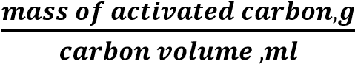 (3)
Porosity refers to the percentage of void spaces or empty pores within a material, often expressed as a ratio of the volume of voids to the total volume of the material. In this context of research on pyrolysis and the extraction of ash from waste materials, porosity is a key property that provides insights into the internal structure of the ash, the porosity of the specimens is calculated using:
Porosity (%) = 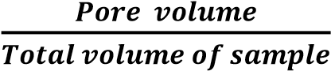 (4)
This terminology indicates how much of the material is composed of open spaces or gaps between particles.
3. Results and Discussion
3.1 Conceptual View of the Plant from the SolidWorks CAD Software
Figure 1-3 comprehensive illustration of the designed pyrolysis plant, intricate plant drawings were meticulously crafted utilizing SolidWorks, a robust and feature-rich computer-aided design (CAD) software.
Figure 1: The Isometric and Orthographic View of the Plant.
Figure 1 presents the image illustrates a detailed engineering drawing of a pyrolysis equipment setup, designed for converting biomass and waste materials into valuable by-products such as biochar. Key dimensions are highlighted, such as a main reactor chamber measuring 800 mm in length and 500 mm in height, which accommodates the thermal decomposition process. The feed inlet, with a diameter of 100 mm, allows for efficient loading of biomass, while the exhaust outlet, measuring 80 mm in diameter, facilitates the release of gases. The unit incorporates a robust structural support, providing stability and height elevation necessary for safe operation and easy access to the components. The setup includes a motorized system for controlling the flow and processing rate of materials. This design not only emphasizes durability but also ensures the controlled and efficient conversion of waste to high-quality carbon residues. The scaled dimensions and compact layout make it suitable for both laboratory-scale experimentation and potential industrial applications.

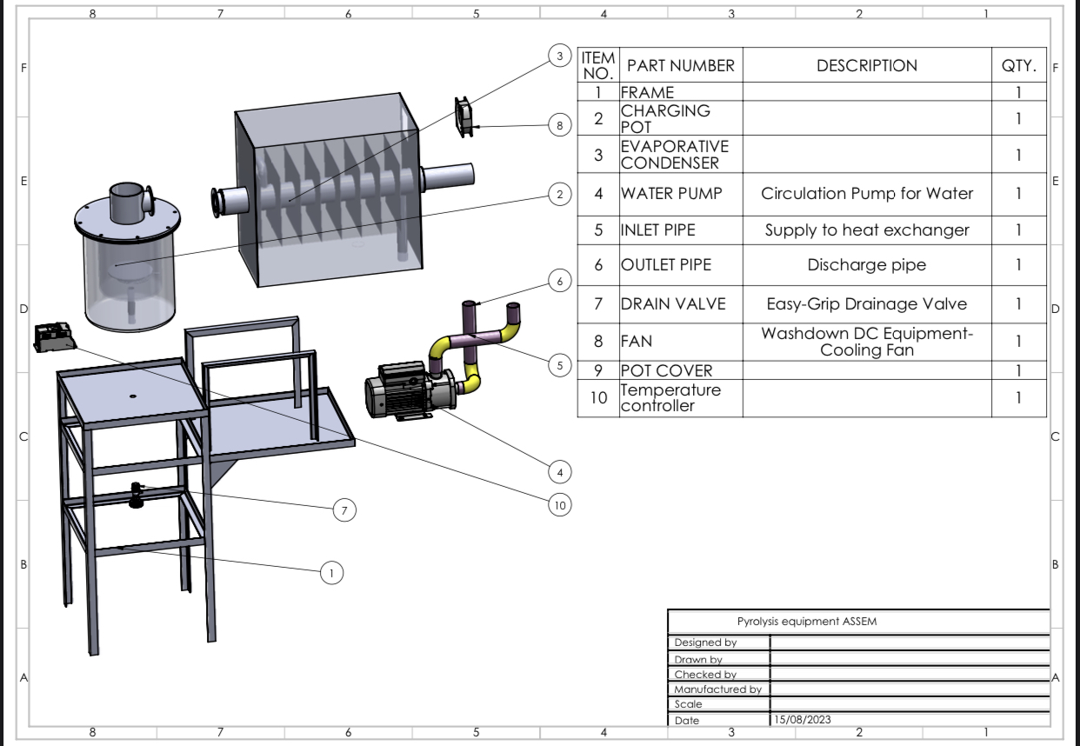

Figure 2: Disassemble 3D View of the Plant
Figure 2 illustrates an exploded view of a pyrolysis equipment assembly, featuring labelled components and a parts list for easy reference. The main frame (Item 1) provides structural support for the equipment. Key parts include the evaporative condenser (Item 3), which cools and condenses vaporized products, and the circulation pump for water (Item 4), essential for maintaining the cooling system’s efficiency. The inlet and outlet pipes (Items 5 and 6) manage the flow of materials and gases, while the drain valve (Item 7) allows for the convenient removal of residual liquids. Additional features include a fan (Item 8) for cooling and a temperature controller (Item 10) to regulate operational conditions, enhancing the system's safety and functionality. This design ensures efficient waste processing and ease of maintenance.
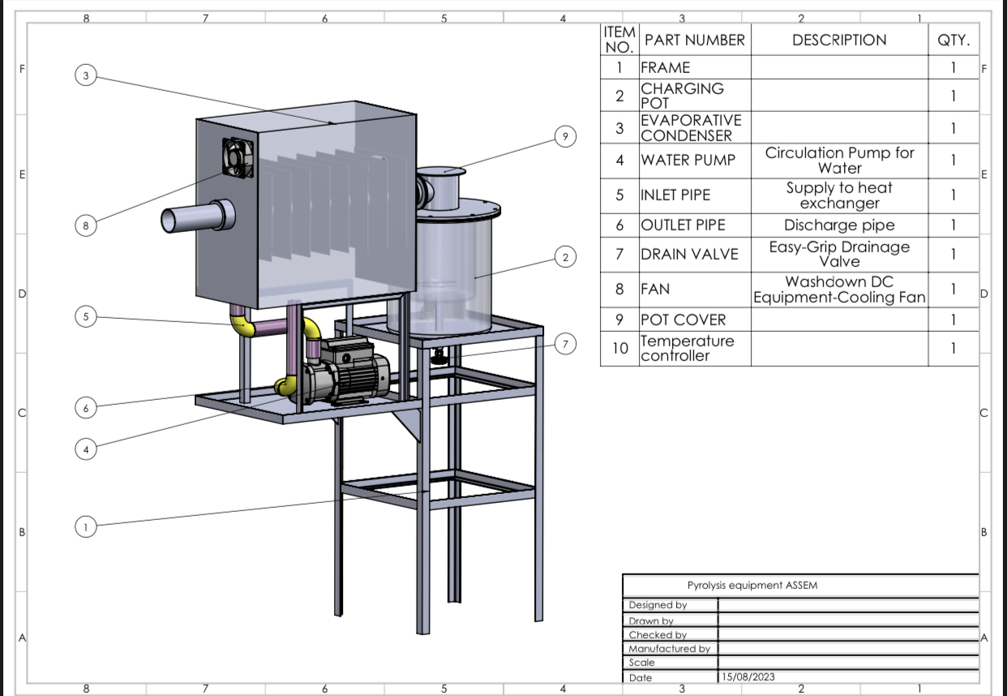
Figure 3: Assemble and Label View of the Plant
In Figure 3, the assembled 3D view utilizes a numbered labelling method, assigning specific functions to each part. Label 1 designates the Frame, providing structural integrity to the entire system. Label 2 identifies the Charging Pot, the chamber where waste materials undergo the pyrolysis process. Evaporation Condenser (Label 3) plays a crucial role in condensing vapours into pyrolysis oil. Water Pump (Label 4) facilitates water circulation for effective cooling, with Inlet Pipe (Label 5) supplying water to the heat exchanger. Outlet Pipe (Label 6) serves as the discharge outlet, allowing for the collection of processed materials. Drain Valve (Label 7) is strategically placed for easy drainage. The presence of a Fan (Label 8) contributes to efficient cooling of vapours. Pot cover (Label 9) prevents the escape of flames during the pyrolysis process. Temperature Controller (Label 10) ensures precise temperature regulation, a critical factor in optimizing the pyrolysis reactions.
3.2 Exploring Key Parameters for Efficient Waste Conversion of the Designed Plant
Table 3: Comprehensive Readings for Pyrolysis Plant Operation
Reading | Value
Plant Voltage | 240V
Maximum Temperature of Melting Pot | 450°C
Initial Furnace Temperature (T1) | 29°C
Vaporizing Temperature (T2) | 370°C
Tyre Density | 1.2 x 10^3 kg/m³
Density of Wood Waste | 1200 kg/m³
Density of Coconut Shell | 1600 kg/m³
Density of Palm Kernel Shell | 1800 kg/m³
Specific Heat Capacity of Tyre | 4.1 x 10^3 J/kgK
Specific Heat Capacity of Wood Waste | 2.4 kJ/kgK
Specific Heat Capacity of Coconut Shell | 1.77 kJ/kgK
Specific Heat Capacity of Palm Kernel Shell | 1.98 kJ/kgK

The result in Table 3 illustrates the readings which involved the crucial parameters for the efficient operation of the pyrolysis plant. The plant voltage of 240V indicates the electrical power supplied to the system. This voltage is within the standard range for effective operation. The maximum temperature reached by the melting pot is noteworthy, reaching 450°C during the pyrolysis process. This high temperature is instrumental in achieving the thermal decomposition of waste materials, ensuring optimal conversion. The initial furnace temperature (T1) and vaporizing temperature (T2) of 29°C and 370°C, respectively, demonstrate the controlled heating process within the pyrolysis reactor. This controlled temperature range is essential for the desired chemical reactions leading to the production of pyrolysis oil and carbon.
Density readings for tyre, wood waste, coconut shell, and palm kernel shell provide insights into the mass distribution of the input materials. These density values are critical in determining the overall efficiency of the pyrolysis process. Specific heat capacities are crucial parameters for understanding the heat transfer characteristics of the materials involved. The values provided for tyre, wood waste, coconut shell, and palm kernel shell aid in assessing the energy requirements for effective pyrolysis.
  - Thermal and Power Analysis for Pyrolysis Process
- Melting pot capacity = πR²H = π * (26² /4) * 33 = 17523 cm³

- Mass of Tyre to full capacity of the Melting pot = Density of tyre x volume of melting pot = 1.2*10³ * 1.7523*10⁻² = 21.03 Kg of tyre.
- Mass of biomass to full capacity of the melting pot = (0.4 * density of wood waste + 0.4 * density of coconut shell + 0.2 * density of palm kernel shell) * Melting pot capacity = (0.4*1200 + 0.4*1600 + 0.2*1800) * 1.7523*10-² = 25.93kg of biomass
- Quantity of heat required to melt 21.03 kg of tyre is given by Q = MC_{P}∆T = 21.03 * 4.1 * 10³ * (370 - 29) = 29402.043 KJ
- Quantity of heat required to melt 25.93kg of biomass is given as Q = MC_{P}∆T = (0.4 x 2.4*10³ + 0.4 * 1.77*10³ + 0.2 * 1.98*10³) * 25.93 * (370-29) = 18250.156 KJ
- Time required producing 29402.043 KJ of heat energy to melt the tyre with 2KW power of heating element. T = Q / Power = 29402.043 / 2 = 14701.02s =4.08hours
- Time required producing 18250.156 KJ of heat energy to melt the Biomass with 2KW power of heating element. T = Q / Power = 18250.156 / 2 = 9125.08s = 2.53hours
- Current flow = I = P / V = 2 * 10³ / 240 = 8.3 Ǻ
- Resistance of the coil R = V / I = 240 / 8.3 = 28.92Ω

- Heat exchanger temperature analysis
- Cold water Temperature, T_{w1} = 4⁰C
- Water outlet temperature, T_{w2} = 80⁰C
- Vapour inlet temperature, T_{v1} = 370⁰C
- Volume of water storage tank = 61 cm x 33 cm x 18 cm = 36234cm³
- Mass of water = density * volume = 1000 * 36234*10⁻⁶ = 36.2kg of water
- Mass flow rate of water (tyre) = 36.2 / 4.08 * 60 * 60 = 0.0025kg/s
- Mass flow rate of water (biomass)= 36.2 / 2.53 * 60 x 60 = 0.0039kg/s

- Quantity of heat absorbed by water
- Q_{w} = M_{w}C_{w}∆T_{w} = 36.2 * 4200 * (80 - 4) = 11555040J
- Power required for heat absorption in 4.08 hours for tyre = 11555040 / 4.08 x 60 x 60 = 786.7W
- Heat capacity of water, c = power / flowrate = 786.7 / 0.0025 = 314679.7 J/Kg
- The volume of vapour within the condensate column = V_{p =} π * 0.05² * 1.03 = 0.008 m³
- Mass of tyre vapour = 1.2 x 10³ x 0.008 = 9.6 kg
- Heat loss by vapour = heat gained by water Q_{v} = Q_{w} M_{V}C_{V}∆T_{V} = M_{W}C_{W}∆T_{W} = 9.6 * 4.1 * 10³ * (370-T₂) = 36.2 * 4.2*10³ * (80-4) = T₂ = 76.5 ⁰C

- Power required for heat absorption in 2.53 hours for Biomass = 11555040 / 2.53 * 60 * 60 = 1268W
- Heat capacity of water, c = power / flowrate = 1268 / 0.0039 = 325128.2 J/Kg
- The volume of vapour within the condensate column = V_{p} = π * 0.05² * 1.03 = 0.008 m³
- Mass of biomass vapour = (0.4 * 1200 + 0.4 * 1600 + 0.2 * 1800) * 0.008 = 11.84kg
- Heat loss by vapour = heat gained by water is given as Q_{v} = Q_{w} = M_{V}C_{V}∆T_{V} = M_{W}C_{W}∆T_{W} = 11.84 * 3.064*10³ * (370-T₂) = 36.2 * 4.2*10³ * (80-4) therefore T₂ = 51⁰C

  - Result on the Characterization of the Extracted Carbon from the Waste
In this study, an in-depth analysis was conducted to characterize the extracted carbon obtained from waste materials, shedding light on key properties and features that play a crucial role in the effectiveness and potential applications of the pyrolysis process. Figure 4 - 8 presents the various properties of the compositions after the extraction, using EcoLab pH Solutions digital meter for the pH values of the different specimens, while equation (1) – (4) were used to calculate the porosity, bulk density, ash content, and volatile matter/ weight loss values.

Figure 4: pH Characteristics of Extracted Carbon Specimens
As presented in Figure 4 the pH results indicate significant differences in the acidity and alkalinity of the carbon specimens. Group One (GA1 and GA2), composed of biomass feedstocks such as palm kernel shell, coconut shell, and wood waste, shows mildly alkaline pH values (9.42 and 9.23), likely due to natural organic acids in biomass that remain after pyrolysis. In contrast, Group Two (GB1 and GB2), derived from waste tires, displays more strongly alkaline pH values (10.21 and 10.13), reflecting the synthetic composition of tire-derived carbon, which tends to retain alkaline residues. This alkalinity may enhance the suitability of tire-based carbon for certain industrial applications, such as environmental adsorption processes where higher pH values are beneficial for pollutant binding. These pH characteristics illustrate the influence of feedstock composition on carbon residue, highlighting the potential for customizing carbon properties for specific applications based on the feedstock used in pyrolysis.

Figure 5: Porosity Characteristics of Extracted Carbon Specimens
As presented in Figure 5, the porosity measurements reveal distinct structural differences between the two groups. Group One specimens (GA1 and GA2) exhibit lower porosity values (0.38 and 0.47), indicating a denser structure likely due to the compact organic nature of biomass feedstocks. Conversely, Group Two specimens (GB1 and GB2), which use waste tires, display significantly higher porosity values (0.69 and 0.66). The porous structure in tire-derived carbon may arise from the synthetic material's decomposition characteristics, which leave a higher proportion of voids. This increased porosity could enhance the adsorption capacity of tire-based carbon, making it potentially useful in applications that require high surface area, such as filters and adsorbents for environmental remediation. The contrast in porosity underscores the potential of tailoring pyrolysis products for specific uses based on initial feedstock properties.

Figure 6: Bulk Density Characteristics of Extracted Carbon Specimens

As presented in Figure 6, the bulk density data indicate substantial differences in material compactness between biomass- and tire-derived carbon. Group One (GA1 and GA2) presents lower bulk densities (0.53 and 0.58 g/ml), reflecting a less compact structure that is characteristic of biomass-derived carbon. Group Two specimens (GB1 and GB2) from waste tires, however, show higher bulk densities (0.71 and 0.73 g/ml), which suggests that tire-derived carbon is denser. This difference in density could affect applications, as higher bulk density in tire-based carbon may provide better structural stability and weight-based durability in industrial applications. The results suggest that feedstock type significantly influences bulk density, and therefore, the handling, storage, and transport efficiency of the carbon products.

Figure 7: Ash Content of Extracted Carbon Specimens
The Ash content results presented in Figure 7 underscore a major compositional distinction between biomass and tire-derived carbons. Group One (GA1 and GA2) has notably lower ash contents (39.98% and 39.86%) compared to Group Two (GB1 and GB2), which has higher ash levels (67.31% and 67.28%). The high ash content in tire-derived carbon can be attributed to the substantial inorganic filler content in tires, which leaves more residue upon pyrolysis. This disparity in ash content is important as lower ash levels in biomass-derived carbon enhance its potential for use as a cleaner energy source, while the higher ash content in tire-derived carbon might limit its applications to areas where residual minerals do not interfere, such as filler material in construction. This variability in ash content reflects the inherent differences in the organic and synthetic nature of the feedstocks.

Figure 8: Volatile Matter Characteristics of Extracted Carbon Specimens
The analysis of volatile matter reveals clear distinctions between the two groups. Group One (GA1 and GA2), derived from biomass feedstocks, exhibits significantly higher volatile matter loss (68.64% and 68.72%) due to the decomposition of organic components in biomass. In contrast, Group Two specimens (GB1 and GB2) from waste tires show lower volatile matter (18.41% and 18.43%), reflecting the stability of synthetic rubber under pyrolysis conditions. The high volatile matter in biomass carbon indicates a greater release of combustible gases, which could enhance its calorific value, making it a preferable choice for energy applications. In contrast, the stability and lower volatility of tire-based carbon make it potentially better suited for applications that benefit from less reactive materials, such as structural fillers or adsorbents in controlled environments. These volatile matter results highlight how feedstock type impacts the thermal properties and application potential of carbon residues.

The fluctuating result values of the characterization is observed more in the biomass group (GAI and GA2) compare to tire, maybe due to the thermal and mechanical instability and porous microstructural composition of natural material that exist from animal and human remains, while that of materials from polymerization process or natural synthetics exhibits higher result due to their microstructural closeness composition [24 - 25].

4. Conclusion
This study successfully addresses the pressing environmental and management issues associated with biomass and synthetic waste through the development of a prototype pyrolysis plant capable of processing diverse feedstocks. The plant, with a batch capacity of 17.5 liters, efficiently converts coconut shell, palm kernel shell, wood waste, and automotive tires into valuable carbon residues. A comprehensive characterization of these carbon products highlights the significant influence of feedstock type on material properties. Biomass-derived carbon exhibited an average pH of 9.33, lower bulk density (0.56 g/ml), and moderate porosity (0.043), suggesting suitability for applications requiring relatively neutral pH and lighter carbon structures. Conversely, carbon derived from waste tires showed a higher pH of 10.17, greater bulk density (0.72 g/ml), and increased porosity (0.068), making it ideal for applications where a denser, more alkaline carbon structure is advantageous.

Further analysis revealed substantial differences in ash content and volatile matter between the two groups. Biomass-derived carbon had lower ash content (39.92%) and higher volatile matter loss (68.68%), reflecting its organic composition, which may enhance its potential as a clean energy source. In contrast, tire-derived carbon exhibited significantly higher ash content (67.30%) and lower volatile matter loss (18.42%), attributes that align with the more stable, mineral-rich nature of synthetic rubber, indicating its potential for use in construction or filtration. These findings underscore the plant’s effectiveness in producing tailored carbon materials for specific industrial applications, highlighting the advantages of pyrolysis in recycling complex waste streams. By demonstrating a scalable, environmentally sustainable waste-to-energy conversion pathway, this study contributes valuable insights into advancing circular economy practices and mitigating waste-related environmental impact.

However, this study highlights the effective conversion of biomass and synthetic waste into valuable carbon products through pyrolysis, yet some limitations remain. The plant’s batch processing design restricts continuous production, which may limit scalability for larger industrial applications. Additionally, while the characterization of carbon properties offers insights into potential uses, further investigation into long-term performance and durability is needed for specific applications. Future studies could explore optimizing reactor design for continuous processing and assessing the environmental impacts of biochar applications in different industries. Expanding this research to test various waste combinations and advanced pyrolysis conditions may further enhance the versatility and efficiency of carbon extraction processes.

References
[1] Leaders Summit on Climate. Available online: https://www.state.gov/leaders-summit-on-climate/ (accessed on 18 October 2024).
[2] Vassilev, S.V.; Vassileva, C.G.; and Vassilev, V.S., (2015) Advantages and disadvantages of composition and properties of biomass in comparison with coal: An overview. Fuel, 158, 330–350. https://doi.org/10.1016/j.fuel.2015.05.050
[3] Nimmanterdwong, P. Chalermsinsuwan, B.; and Piumsomboon (2021), P. Prediction of lignocellulosic biomass structural components from ultimate/proximate analysis. Energy, 222, 119945. https://doi.org/10.1016/j.energy.2021.119945
[4] Sieradzka, M.; Gao, N.; Quan, C.; Mlonka-M˛edrala, A.; Magdziarz, A. (2020). Biomass thermochemical conversion via pyrolysis with integrated CO₂ capture. Energies, 13, 1050. https://doi.org/10.3390/en13051050
[5] Szwaja, S.; Magdziarz, A.; Zajemska, M.; and Poskart, A (2019). A torrefaction of Sida hermaphrodita to improve fuel properties. Advanced analysis of torrefied products. Energy Renew, 141, 894–902. https://doi.org/10.1016/j.renene.2019.04.055
[6] Czerwińska, K.; Śliz, M.; and Wilk, M. (2022). Hydrothermal carbonization process: Fundamentals, main parameter characteristics and possible applications including an effective method of SARS-CoV-2 mitigation in sewage sludge: A review. Renew. Sustain. Energy Rev., 154, 111873. https://doi.org/10.1016/j.rser.2021.111873
[7] Mlonka-Mędrala, A.; Evangelopoulos, P.; Sieradzka, M.; Zajemska, M.; and Magdziarz, A. (2021). Pyrolysis of agriculture waste biomass towards gas fuel and high-quality char production-experimental and numerical investigations. Fuel, 296, 120611.
https://doi.org/10.1016/j.fuel.2021.120611
[8] Roman, K.; Barwicki, J.; Hryniewicz, M.; Szadkowska, D.; and Szadkowski, J. (2021). Production of electricity and heat from biomass wastes using a converted aircraft turbine AI-20. Processes, 9, 364. https://doi.org/10.3390/pr9020364
[9] Gao, N.; Li, A.; Quan, C.; Qu, Y.; Mao, L (2012). Characteristics of hydrogen-rich gas production of biomass gasification with porous ceramic reforming. Int. J. Hydrogen Energy, 37, 9610–9618. https://doi.org/10.1016/j.ijhydene.2012.03.069
[10] Sobek, S. and Werle, S. (2021). Solar pyrolysis of waste biomass: A comparative study of products distribution, in situ heating behavior, and application of model-free kinetic predictions. Fuel, 292, 120365. https://doi.org/10.1016/j.fuel.2021.120365
[11] Chai, Y.; Wang, M.; Gao, N.; Duan, Y.; and Li, J. (2020). Experimental study on pyrolysis/gasification of biomass and plastics for H₂ production under new dual-support catalyst. Chem. Eng. J., 396, 125260. https://doi.org/10.1016/j.cej.2020.125260
[12] Fernandez, E.; Santamaria, L.; Artetxe, M.; Amutio, M.; Arregi, A.; Lopez, G.; Bilbao, J.; and Olazar, M., (2022). Conditioning the volatile stream from biomass fast pyrolysis for the attenuation of steam reforming catalyst deactivation. Fuel, 312, 122910.
https://doi.org/10.1016/j.fuel.2021.122910
[13] Botha D. E. and Agachi P. S. (2023). Design and construction of a proof-of-concept poultry litter pyrolysis plant. STUDIA UBB CHEMIA, LXVIII, 1:23 pp 105-118). https://doi.org/10.24193/subbchem.2023.1.08
[14] Cuong, D.V.; Matsagar, B.M.; Lee, M.; Hossain, M.S.A.; Yamauchi, Y.; Vithanage, M.; Sarkar, B.; Ok, Y.S.; Wu, K.C.-W.; and Hou, C.-H., (2021). Critical review on biochar-based engineered hierarchical porous carbon for capacitive charge storage. Renew. Sustain. Energy Rev.,145,111029.https://doi.org/10.1016/j.rser.2021.111029
[15] Deng, Z.; Sun, S.; Li, H.; Pan, D.; Patil, R.R.; Guo, Z.; and Seok, I., (2021). Modification of coconut shell-based activated carbon and purification of wastewater. Adv. Compos. Hybrid Mater., 4, 65–73. https://doi.org/10.1007/s42114-021-00205-4
[16] Małgorzata, S., Cezary, K., Kalemba-Rec, I., Mlonka-Mędrala, A., and Magdziarz, A. (2022). Pyrolysis of Biomass Wastes into Carbon Materials. Energies, 15(5), 1941;
https://doi.org/10.3390/en15051941.
[17] Zahid U., Muzammil K., Salman R. N., Muhammad N. A., Wasif F., Muhammad W. A., Muhammad W. Y., Hamad A., and Fares A., (2022). An integrated framework of data-driven, metaheuristic, and mechanistic modeling approach for biomass pyrolysis. Journal of Process Safety and Environmental Protection 162:22 pp 337-345.
https://doi.org/10.1016/j.psep.2022.04.013
[18] Mohammed A. (2021). Design and development of a pyrolysis unit for different wastes. International Research Journal of Modernization in Engineering Technology and Science 03:12. Accessed online:
https://www.irjmets.com/uploadedfiles/paper/volume_3/issue_12_december_2021/17569/final/fin_irjmets1639373031.pdf
[19] Lan, W., Zhou, Y., Liu, J., Wang, Y., Yin, D., Ji, J., and Jin, X. (2024). Chemical composition evaluation and pyrolysis behavior of biomass tar: Pyrolysis experiment and kinetic studies. International Journal of Agricultural and Biological Engineering, 17(3), 230–234. https://doi.org/10.25165/j.ijabe.20241703.8362
[20] Cedrone, G., Bracciale, M. P., Cafiero, L., Langone, M., Mattioli, D., Scarsella, M., and Tuffi, R. (2024). Optimization of pyrolysis parameters by design of experiment for the production of biochar from sewage sludge. Environments, 11(10), 210.
https://doi.org/10.3390/environments11100210
[21] Volpi, M. P. C., Silva, J. C. G., Hornung, A., and Ouadi, M. (2024). Review of the current state of pyrolysis and biochar utilization in Europe: A scientific perspective. Clean Technologies, 6(1), 152–175. https://doi.org/10.3390/cleantechnol6010010
[22] Kaur, L., Singh, J., Ashok, A., and Kumar, V. (2024). Design expert-based optimization of the pyrolysis process for the production of cattle dung bio-oil and properties characterization. Scientific Reports, 14, 9421. https://doi.org/10.1038/s41598-024-57843-z
[23] Ekpechi, D. A., Obiukwu, O. O., Nwufo, O. C. and Obasi, H. C., (2023). Mathematical Analysis on MATLAB Environment for Experimental Study of the Thermal Properties of Epoxy Reinforced Composites. Journal of Global Ecology and Environment, Vol. 17. Issue 1, pp. 6-18. https://doi.org/10.56557/jogee/2023/v17i18028
[24] Mohane, M. J., Mokhena, T. C., Mokhothu, T., H., Mtibe, A., Sadiku, E. R., Ray, S. S., Ibrahim, I. D., and Daramola O. O., (2018). Recent progress on natural fiber hybrid composites for advanced applications. A Review Journal of eXPRESS Polymer Letters, 13(2):159-198. https://doi.org/10.3144/expresspolymlett.2019.15
[25] Ekpechi, D. A., Oguoma, O. N., Nwufo, O. C., Ozuruoha, E. N., Nnadozie, C. C., Ikegbunam, D., and Ezeaku, N. I. (2024). Bitter kola (Garcinia kola): Exploring its uncharted territory in polymer composites—A pathway to enhanced mechanical attributes and sustainable innovation. Engineering Science & Technology 5(2). https://doi.org/10.37256/est.5220244479
Supporting Information
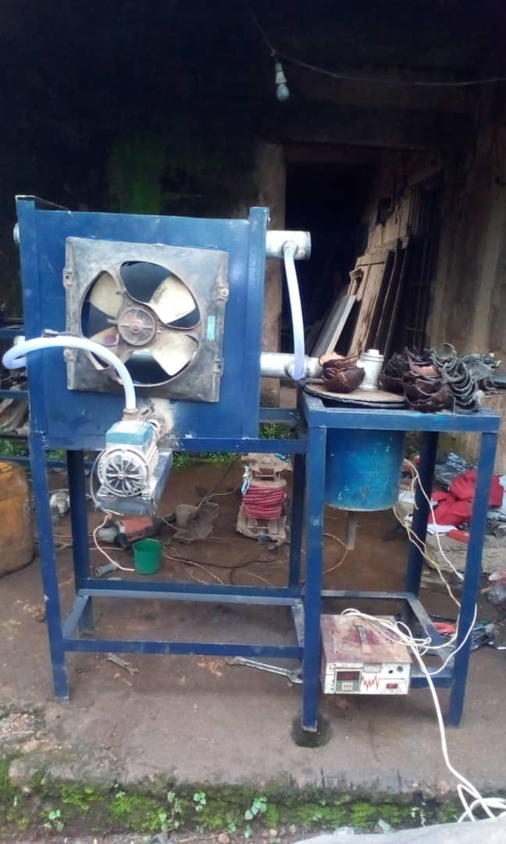
Figure 9: The Developed Pyrolysis Plant
Figure 9 adds a practical dimension to the presentation by showcasing the actual fabricated pyrolysis plant. This real-world representation validates the effectiveness of the design and highlights the successful translation of theoretical concepts into a tangible, functional machine.
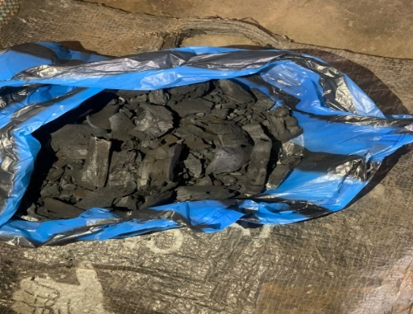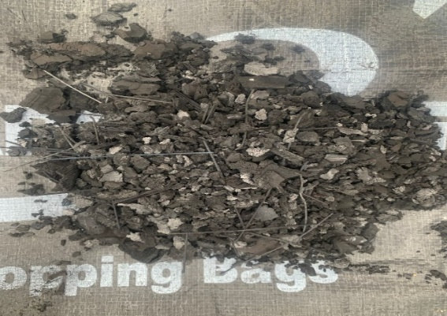
Figure 10: The Extracted Carbon Residues
Figure 10 presents some carbon residues extracted from the waste materials (Biomass and Tire), through the developed pyrolysis plant. The combination of CAD views and the physical plant image underscores the thoroughness of the design process and the practical viability of the pyrolysis plant for waste conversion.

