Original Research Article
Knowledge, Attitudes, and Practice of Basic Life Support among Healthcare Professionals in a Nigerian Tertiary Hospital

ABSTRACT
Background:
Basic Life Support (BLS) is a critical skill for healthcare professionals (HCPs), yet gaps in knowledge and practice persist despite generally positive attitudes. Limited data exist on how these domains interact across professional groups in sub-Saharan Africa. This study assessed BLS knowledge, attitudes, and practice among HCPs, and their associations with demographic and professional factors.
Methods:
A cross-sectional survey was conducted among HCPs at a tertiary hospital using a structured self-administered questionnaire. Data were analyzed descriptively and with inferential statistics to evaluate associations between knowledge, attitude, practice, and participant characteristics.
Results:
A total of 281 HCPs participated, more than half of whom were early-career (≤5 years of experience) and female, with nurses forming the largest group. Most had received prior BLS training (79.7%) and displayed positive attitudes, but only 17.8% demonstrated adequate knowledge. Fewer than one-fifth had attended training within the past year. Knowledge was not significantly associated with demographic or professional factors. Attitudes, however, were significantly associated with marital status (χ² (3) = 13.77, P = .003), prior training (P < .001), and recency of training (χ²(3) = 18.83, P < .001). Although most participants expressed willingness to perform BLS, practice gaps were evident, including unfamiliarity with protocols, infrequent equipment checks, and low confidence, especially in pediatric resuscitation. Doctors and nurses felt more confident and were more likely to have initiated CPR than radiographers and dentists. Radiographers reported the highest proportion of positive attitudes (80.0%).
Conclusion:
While attitudes toward BLS were encouraging, knowledge and practice readiness were inadequate. These findings highlight the need for regular refresher training, inclusion of all professional cadres, and clear institutional protocols reinforced through drills. Greater emphasis on pediatric preparedness is warranted to address professional disparities. Strengthening both individual competence and institutional systems is essential to improve resuscitation capacity and patient outcomes.
Keywords: Basic Life Support (BLS), Cardiopulmonary Resuscitation (CPR), Healthcare Professionals (HCPs), Knowledge Attitude and Practice (KAP)
INTRODUCTION
Basic Life Support (BLS) is a critical emergency procedure delivered to individuals experiencing cardiac arrest, respiratory distress, or airway obstruction. It encompasses immediate cardiopulmonary resuscitation (CPR), airway management, and, where available, early defibrillation (Roshana et al., 2012). Prompt initiation of BLS is associated with improved neurological outcomes and significantly enhances survival rates (Lee et al., 2021; Pearn, 2000; American Heart Association (AHA), 2024).
In Nigeria, while BLS concepts are introduced in healthcare professional training programs, demonstrated proficiency is not a prerequisite for professional certification (Akinbodewa et al., 2023). Within hospital settings, healthcare professionals (HCPs) such as doctors, nurses, and allied health professionals are often the first to respond to cardiac emergencies. Their competence in BLS in these scenarios, especially in pediatric and neonatal cases, which are particularly challenging (Hendy et al., 2023), can significantly influence patient outcomes. A lack of adequate BLS knowledge may lead to hesitation or complete inaction during such emergencies, drastically reducing survival chances within seconds (Bircher et al., 2019). Furthermore, HCPs with a strong BLS foundation can also serve as educators and advocates for bystander CPR training in the community. This makes substantial knowledge and practical competence in BLS not merely advantageous but critically essential. However, existing evidence from low-and-middle-income countries (LMICs), including Nigeria, suggests deficiencies in knowledge, confidence, and practical preparedness, underscoring a widespread deficiency in these essential life-saving skills (Kalu et al., 2022; Akinbodewa et al., 2023; Asferie et al., 2024; Mamgain et al., 2025).
While several studies in Nigeria and other LMICs have evaluated BLS awareness and training exposure among specific professional groups, comprehensive data across diverse cadres within the same setting remain limited. Understanding the current levels of knowledge, attitudes, and self-reported practice provides an essential baseline for institutional training programs and policy development toward improved emergency response capacity.
This study, therefore, aims to provide baseline evidence on the preparedness of Nigerian HCPs for BLS at the Federal Medical Centre (FMC), Owo. Specifically, it seeks to assess their current level of knowledge, examine prevailing attitudes toward BLS, and explore self-reported practices in emergency situations.

MATERIAL AND METHODS

Study Design and Setting

The study employed a descriptive cross-sectional design and was conducted at the Federal Medical Centre (FMC), Owo, a tertiary healthcare institution in Ondo State, Nigeria. Data were collected within the hospital premises, including wards, outpatient clinics, the emergency unit, and administrative offices.

Participants

The study population comprised consenting frontline clinical staff at FMC Owo, specifically licensed doctors, nurses, physiotherapists, dentists, and radiographers, as these groups were directly involved in patient care and likely to be called upon to provide BLS. Eligible participants were required to be currently employed in clinical capacities at FMC Owo, possess a valid professional license or registration, and provide written informed consent. Staff who were on leave during the data collection period, as well as HCPs who were certified BLS instructors, were excluded.
Materials
A structured, self‐administered questionnaire was developed in line with the current American Heart Association (AHA) 2024 Basic Life Support (BLS) Guidelines, with adaptation of selected questions from previously validated instruments (Poudel et al., 2019; Mbada et al., 2013; Mamgain et al., 2025). The questionnaire was divided into five sections:
Section A: Demographic and Professional Information
This section captured respondents’ socio-demographic and occupational characteristics, including age, sex, marital status, profession, and years of clinical experience.
Section B: BLS Training History
Items in this section explored respondents’ prior exposure to BLS training, time since last training, and source of training.
Section C: BLS Knowledge Test
This section consisted of 15 multiple-choice questions (MCQs) assessing theoretical and practical understanding of BLS, including CPR techniques, compression rates, airway management, and protocol sequences, based on the 2024 AHA BLS Guidelines. Each correct answer was awarded one point, with a total score ranging from 0 to 15. Scores were classified into three levels: adequate (≥12 points, >75%), moderate (8–11 points, 50–75%), and inadequate (<8 points, <50%).
Section D: Attitudes Toward BLS
This section included nine dichotomous (Yes/No) statements evaluating healthcare workers’ beliefs, confidence, willingness, and psychological readiness to perform BLS. Positive responses were coded as 1 and negative responses as 0, yielding a maximum score of 9. Respondents scoring ≥5 were classified as having a positive attitude, and <5 as a negative attitude.
Section E: Self-Reported BLS Practice
This section assessed actual BLS-related behaviors and preparedness, including confidence in CPR performance, frequency of emergency equipment checks, and familiarity with institutional BLS protocols. Responses were binary (Yes/No). Each item was analyzed descriptively, and two key practice items; self-reported confidence in performing CPR independently and preparedness for pediatric BLS, were also used as dependent variables in regression analysis.

Sample Size Determination
Based on hospital records, the total number of eligible frontline clinical staff was 814: doctors = 277, nurses = 451, physiotherapists = 44, dentists = 18, radiographers = 24. Using the Yamane formula (Yamane, 1973) at a 95% confidence level and 5% margin of error:
$n = \frac{N}{1 + N(e²)} = \frac{814}{1 + 814(0.0025)} = \frac{814}{2.63} ≈ 268$
The minimum required sample size was therefore 268 participants.

Sampling Technique
A proportionate stratified random sampling technique was employed to ensure representativeness across professional groups. The sample was proportionally distributed as follows: doctors ≈ 91, nurses ≈ 149, physiotherapists ≈ 15, dentists ≈ 6, radiographers ≈ 8. Within each group, participants were selected by simple random sampling.

Procedure for Data Collection
Data were collected over a four-week period using both printed questionnaires and a Google Forms version. Questionnaires were distributed within participants’ professional clusters (wards, clinics, and departments) and completed privately. Responses were either submitted electronically or returned in hard copy to the investigators. Follow-up reminders were employed to improve response rates. All data were anonymized, securely stored, and analyzed only in aggregate form to preserve confidentiality.
Statistical Analysis
Data were analyzed using IBM SPSS Statistics version 25 (IBM Corp., Armonk, NY, USA). Descriptive statistics were generated for socio-demographic characteristics and responses to knowledge, attitude, and practice items. Knowledge was assessed using 15 multiple-choice questions aligned with the 2024 AHA BLS Guidelines, with one point awarded per correct response (maximum score = 15). Scores were categorized as adequate (≥12), moderate (8-11), or inadequate (<8), and reported as medians with interquartile ranges due to non-normal distribution (Shapiro-Wilk, P < .001).
Attitudes were measured using nine dichotomous items, yielding a total score from 0 to 9, and classified as positive (≥5) or negative (<5). Internal consistency was examined using Cronbach’s α. Self-reported practice was assessed through seven dichotomous items and summarized descriptively.
Group differences in knowledge and attitude across professional cadres and socio-demographic categories were explored using chi-square and Fisher’s Exact tests. Results are presented in tables and figures.
All statistical tests were two-tailed, and a p value of < 0.05 was considered statistically significant.
RESULTS
A total of 281 frontline HCPs participated in the study. The majority were aged 25-34 years (41.6%), female (60.1%), and nurses (54.4%). Doctors constituted 33.1% of the respondents, physiotherapists 5.7%, dentists 3.2%, and radiographers 3.6%. More than half (52.7%) had less than five years of clinical experience, while 22.4% had over 15 years. Most respondents (79.7%) reported previous BLS training, although less than one-fifth (17.4%) had attended training within the past year (Table1).

Table 1. Socio-Demographic and Professional Characteristics of Respondents (N = 281)
Variable | Category | Frequency (n) | Percentage (%)
Age group | 18-24 | 39 | 13.9
 | 25-34 | 117 | 41.6
 | 35-44 | 59 | 21.0
 | ≥45 | 66 | 23.5
Sex | Male | 112 | 39.9
 | Female | 169 | 60.1
Profession | Doctor | 93 | 33.1
 | Nurse | 153 | 54.4
 | Physiotherapist | 16 | 5.7
 | Dentist | 9 | 3.2
 | Radiographer | 10 | 3.6
Years of experience | <1 | 45 | 16.0
 | 1-5 | 103 | 36.7
 | 6-10 | 39 | 13.9
 | 11-15 | 31 | 11.0
 | >15 | 63 | 22.4
BLS training history | Yes | 224 | 79.7
 | No | 57 | 20.3
Last BLS trainingª | <1 year ago | 39 | 17.4
 | 1-3 years ago | 99 | 44.2
 | >3 years ago | 86 | 38.4
Note: ª Only respondents with prior BLS training (n = 224)

Overall knowledge of BLS was limited, with only 17.8% of respondents demonstrating adequate knowledge. The median score was 9 (IQR 8-11; range 2-15), with scores not normally distributed (Shapiro-Wilk W = 0.977, P < .001). Performance on individual items varied widely: while most respondents correctly identified the compression-ventilation ratio for adults and the location of chest compressions in adults, less than half knew the correct sequence of BLS steps or the recommended interval for switching rescuers (Table 2).
Across professions, differences in knowledge scores were observed, with radiographers showing the highest proportion of adequate knowledge (40%) and dentists the lowest median scores. However, these differences were not statistically significant (χ² (8) = 13.37, P = .10) (Table 3; Figures 1-2). Similarly, no statistically significant associations were found between knowledge category and other sociodemographic or training variables, including age, sex, marital status, years of clinical experience, religion, prior BLS training, or timing of last training (all P > .05).

Table 2. Overall knowledge of BLS among frontline healthcare professionals
Knowledge Level | Frequency (n) | Percentage (%)
Adequate knowledge (≥ 12) | 50 | 17.8
Moderate knowledge (8-11) | 169 | 60.1
Inadequate knowledge (< 8) | 62 | 22.1
Knowledge score | Median = 9 | (IQR) = 8-11
Item | Correct n (%) | Incorrect n (%)
Maximum recommended time to check responsiveness and breathing before CPR (≤10 seconds) | 143 (50.9) | 138 (49.1)
Recommended compression-to-ventilation ratio for adult CPR (30:2) | 209 (74.4) | 72 (25.6)
Indicator of effective rescue breath (visible chest rise) | 202 (71.9) | 79 (28.1)
Appropriate action if chest does not rise after first rescue breath (give second rescue breath) | 146 (52.0) | 135 (48.0)
Recommended chest compression rate for adults (100-120/minute) | 146 (52.0) | 135 (48.0)
Recommended airway opening technique in unresponsive adult without suspected spinal injury (head tilt-chin lift) | 205 (73.0) | 76 (23.0)
Correct location for chest compressions in adults (center of chest, lower half of sternum) | 208 (74.0) | 73 (26.0)
Action if chest does not inflate during rescue breaths (check airway) | 205 (73.0) | 76 (23.0)
Correct sequence of BLS steps (C-A-B) | 120 (42.7) | 161 (57.3)
Appropriate action for conscious choking patient (abdominal thrusts/Heimlich maneuver) | 199 (70.8) | 82 (29.2)
Technique for chest compressions in an infant (two fingers of one hand) | 166 (59.1) | 115 (40.9)
Immediate action after AED delivers a shock (resume CPR with chest compressions) | 167 (59.4) | 114 (40.6)
First action when alone with an unresponsive, non-breathing adult (activate emergency response, get AED, then start CPR) | 215 (76.5) | 66 (23.5)
Action for patient with pulse but no normal breathing (give 1 breath every 5-6s + pulse check) | 157 (55.9) | 124 (44.1)
Time interval for switching rescuers during compressions to avoid fatigue (every 2 minutes) | 125 (44.5) | 156 (55.5)

Table 3. Association between Sociodemographic and Training Variables with Knowledge Category
Variable | χ² (df) | p-value
Age Group | 5.241 (2) | .513
Sex | .894 (2) | .640
Religion | 4.00 (4) | .405
Marital status | 6.63 (6) | .357
Profession | 13.37 (8) | .100
Years of Clinical Experience | 5.50 (8) | .703
BLS training history | 3.62 (2) | .163
Last BLS training | 7.96 (6) | .241

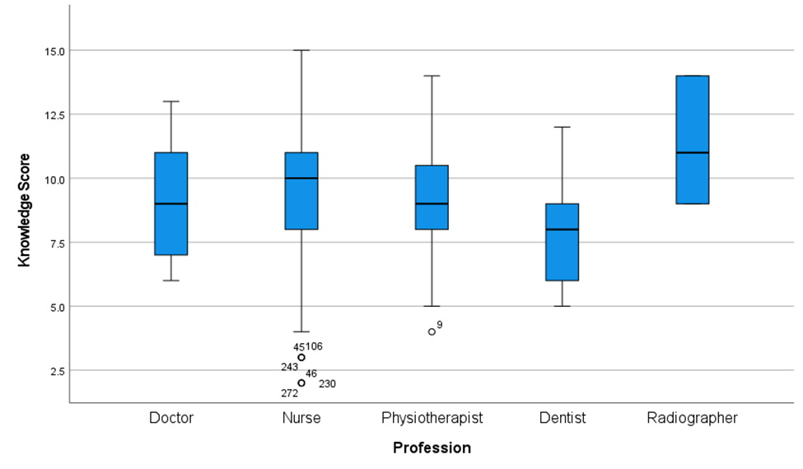Figure 1. Distribution of knowledge scores on BLS among respondents

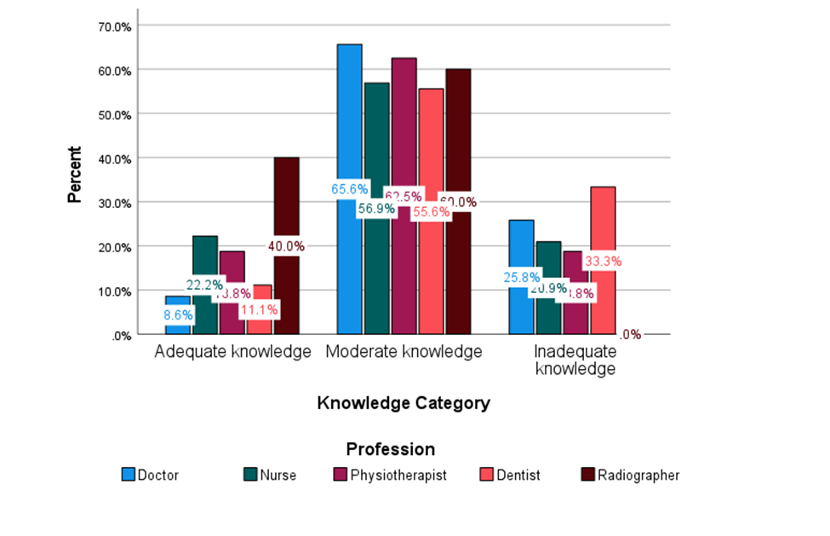
Figure 2. Distribution of knowledge categories regarding BLS among respondents

Overall, attitudes toward BLS were generally positive, with 71.9% of respondents classified as having a positive attitude and 28.1% as negative. The internal consistency of the attitude scale was acceptable (Cronbach’s α = .671). To further explore the construct, individual items were examined. Most respondents expressed willingness to learn CPR (80.4%) and considered it their responsibility to intervene during cardiac arrest. However, fewer felt their current knowledge was sufficient (38.1%), and many indicated they would require protective equipment before acting. While some admitted to feeling nervous or unsure in such situations, attitudes toward BLS remained predominantly positive (Table 4).
Attitudes toward BLS were generally positive across all professions, with proportions ranging from 66.7% among dentists to 80.0% among radiographers, although these differences were not statistically significant (χ²(4) = 0.597, P = .96) (Table 5; Figure 3). In contrast, several sociodemographic and training-related factors were significantly associated with attitudes. Respondents with prior BLS training were more likely to report a positive attitude than those without training (Fisher’s Exact Test, P < .001). Similarly, those who had received training within the past year reported more favorable attitudes (χ² (3) = 18.83, P < .001) (Figure 4). Marital status was also significantly associated with attitude category (χ² (3) = 13.77, P = .003).

Table 4. Attitude Outcomes among Respondents.
Attitude category | Frequency (n) | Percentage (%)
Positive attitude | 202 | 71.9
Negative attitude | 79 | 28.1
Item | Yes n (%) | No n (%)
Feels current knowledge of CPR is sufficient | 107 (38.1) | 174 (61.9)
Willing to learn CPR techniques if training is available | 226 (80.4) | 55 (19.6)
Believes CPR training should be mandatory only for physicians and nurses (not all HCPs) | 86 (30.6) | 195 (69.4)
Would instinctively perform CPR if someone collapsed in their presence | 184 (65.5) | 97 (34.5)
Feels unsure of how to react when present at a CPR situation | 108 (38.4) | 173 (61.6)
Considers it their duty to intervene in a situation requiring CPR | 212 (75.4) | 69 (24.6)
Feels nervous when faced with a CPR situation | 113 (40.2) | 168 (59.8)
Knows what to do if cardiac arrest occurs | 200 (71.2) | 81 (28.8)
Would require gloves, face mask, or other protective items before acting | 146 (52.0) | 135 (48.0)
Attitude scale reliability: Cronbach’s ɑ = .671.

Table 5. Association between Sociodemographic and Training Variables with Attitude Category
Variable | χ² (df)/ Fisher’s Exact Test | p-value
Age Group | 4.40 (3) | .221
Sex | - | .391
Religion | 4.831 (2) | .089
Marital status | 13.77 (3) | .003*
Profession | .597 (4) | .963
Years of Clinical Experience | .858 | .931
BLS training history | - | < .001*
Last BLS training | 18.83 (3) | < .001*
* Significant at P = .05

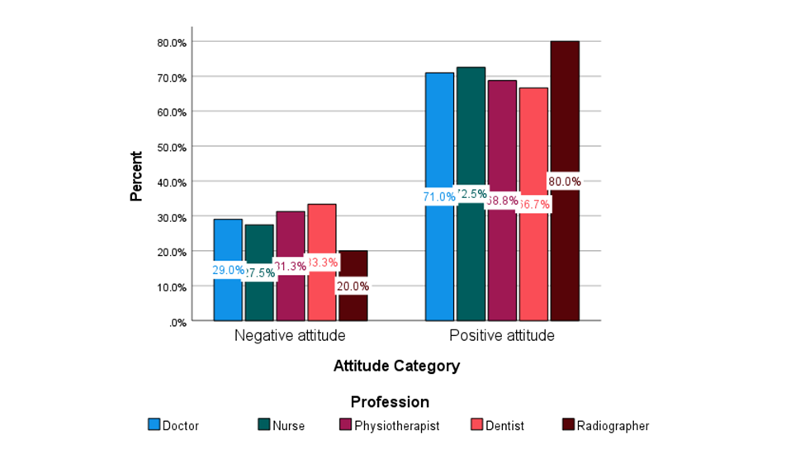Figure 3. Distribution of attitude categories regarding BLS among respondents
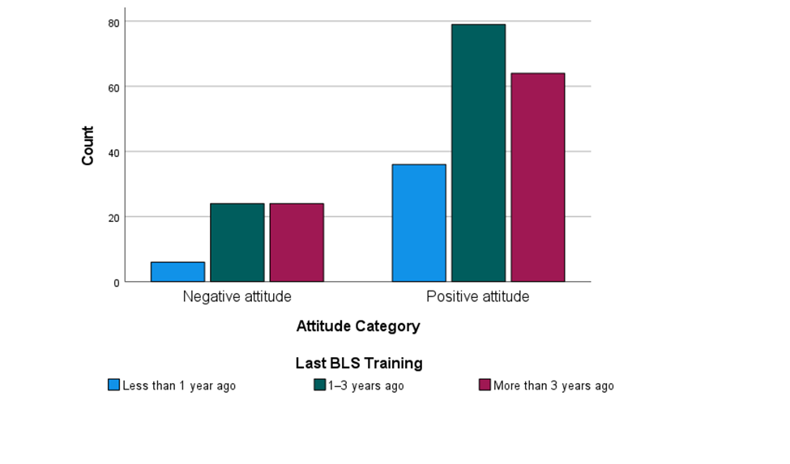
Figure 4: Distribution of Attitude Categories toward BLS by Years of Clinical Experience

Practice outcomes reflected a mixed picture (Table 6). Many respondents reported prior experience initiating CPR (67.6%) and felt confident performing it without supervision. However, routine preparedness behaviors were less common: fewer reported regularly checking emergency equipment or being familiar with workplace BLS protocols. Hesitation due to lack of confidence was also frequently acknowledged. These findings suggest that while frontline HCPs may have some hands-on CPR exposure, gaps in consistent readiness and workplace integration remain prominent.
Significant profession-related differences emerged in practice outcomes (Table 7). Nurses reported the highest levels of confidence and preparedness, with 71.9% feeling confident performing CPR without supervision and 67.3% prepared for pediatric BLS. In contrast, confidence was markedly lower among dentists (33.3%) and radiographers (20.0%), and only 22.2% of dentists and 10.0% of radiographers reported preparedness for pediatric BLS. Other indicators, including routine equipment checks (P < .001), incorporation of refreshers (P = .02), and familiarity with workplace protocols (P = .002), also differed significantly across professions. Overall, nurses demonstrated the most consistent readiness, whereas dentists and radiographers reported substantially lower levels of practice.

Table 6. Frequency distribution of responses to self-reported practice items
Item | Yes n (%) | No n (%)
Has ever initiated CPR in a clinical setting | 190 (67.6) | 91 (32.4)
Feels confident applying CPR skills without supervision | 182 (64.8) | 99 (35.2)
Routinely checks emergency equipment (e.g., AED) in work area | 100 (35.6) | 181 (64.4)
Has hesitated to perform BLS due to lack of confidence | 219 (77.9) | 62 (22.1)
Feels adequately prepared to perform pediatric BLS | 161 (57.3) | 120 (42.7)
Incorporates BLS refreshers into ongoing learning (e.g., videos, peer practice) | 137 (48.8) | 144 (51.2)
Familiar with workplace protocol for BLS emergencies | 85 (30.2) | 196 (69.8)

Table 7. Association between Profession and Practice-related Outcomes
Variable | χ² (df) | p-value
Ever initiated CPR in a clinical setting | 43.21 (4) | < .001*
Confident performing CPR without supervision | 16.83 (4) | .002*
Routinely check AED/emergency equipment | 19.07 (4) | < .001*
Ever hesitated to perform BLS due to lack of confidence | 2.92 | .571
Adequately prepared to perform pediatric BLS | 23.32 (4) | < .001*
Incorporates BLS refreshers into ongoing learning | 11.83 (4) | .019*
Familiar with BLS protocol in workplace | 17.49 (4) | .002*
* Significant at P = .05

DISCUSSION
This study assessed the preparedness of Nigerian healthcare professionals for BLS at FMC Owo, evaluating knowledge, attitudes, and self-reported practice. Over half of respondents were early-career females, mostly nurses, consistent with other KAP studies in healthcare settings (Roshana et al., 2012; Mbada et al., 2013; Majid et al., 2019; Akinbodewa et al., 2023; Mamgain et al., 2025).
Most respondents reported prior BLS training, similar to findings from Jordan (Aljarrah et al., 2025) but higher than reports from Nepal and Southwest Nigeria (Chaudhary et al., 2023; Akinbodewa et al., 2023), possibly due to sampling context in the case of Akinbodewa et al. where healthcare workers attending a refresher course were surveyed, potentially introducing selection bias by capturing individuals who had previously missed training opportunities or were seeking to address knowledge gaps, and differences in resource availability, variability in institutional emphasis on BLS, or limited access to structured training programs, in the Nepali study setting. Despite this, only 17.8% demonstrated adequate knowledge, lower than levels reported in Pakistan, India, and Nigeria (Irfan et al., 2019; Mamgain et al., 2025; Akinbodewa et al., 2023). Such differences likely reflect variations in curriculum, assessment methods, and frequency of refresher courses. Knowledge decay without reinforcement remains a concern, as theoretical training alone often leaves retention gaps (Everett-Thomas et al., 2016; Charlier et al., 2020; Borovnik et al., 2022).
Participants showed stronger knowledge of technical domains (compression ratios, landmarks) than of algorithmic steps or rescuer-switching, consistent with evidence that procedural facts are more easily recalled than sequences requiring practice (Everett-Thomas et al., 2016; Charlier et al., 2020; Borovnik et al., 2022). Unlike our findings, Akinbodewa et al. (2023) reported very low performance across both areas, reflecting probable contextual differences in training emphasis. Knowledge did not differ significantly across sociodemographic or professional groups, in line with Akinbodewa et al. (2023) and Alsabri et al. (2024), though contrasting with reports from Nepal (Poudel et al., 2019). This suggests knowledge deficits cut across cadres, underscoring the need for recurrent, institution-wide, practice-based training to ensure sustained retention and competence across all professional categories.
Attitudes toward BLS were generally positive despite limited knowledge, echoing a recurring pattern in the literature (Majid et al., 2019; Poudel et al., 2019; Ogundele & Okafor, 2020; Prakash et al., 2022; Hasnain et al., 2023). A possible explanation for this knowledge-attitude gap is that while training may have contributed to shaping positive perceptions of BLS and its importance, the persistence of low knowledge levels suggests a decline in knowledge retention over time. In Nepal, however, nurses demonstrated high knowledge but poor attitudes (Gyawali et al., 2024), possibly reflecting workplace stressors and concerns about role expectations despite structured exposure. Many respondents also endorsed extending BLS training beyond doctors and nurses, consistent with recommendations in the literature, for broader inclusion of other HCPs, students, and the general public (Farah et al., 2007; Pande et al., 2014; Saquib et al., 2019; Ihwo, 2022; Shaheen et al., 2023).
Attitudes varied descriptively across professions. Physiotherapists showed higher positivity (68.8%) than in a prior Nigerian study (45%; Mbada et al., 2013), while radiographers reported the highest positivity (80%), consistent with Aljarrah et al. (2025). Radiographers’ frequent work in trauma and acute care may reinforce favorable orientations, though literature on this group remains sparse, especially in sub-Saharan Africa. Attitudes were significantly associated with marital status, prior training, and recency of training. Recent training has been linked with stronger confidence and willingness (Abolfotouh et al., 2017; Abdella et al., 2022). This may be because recent training reinforces knowledge of the steps and builds confidence, highlighting the importance of regular refresher courses. Marital status as a predictor is less frequently reported, though psychosocial factors such as empathy may enhance willingness (Riccò et al., 2020; Chen et al., 2020). By contrast, demographic factors such as age, sex, and years of experience showed no association, differing from findings in Saudi Arabia (Saquib et al., 2019), South Asia (Ralapanawa et al., 2016), and Nigeria (Mbada et al., 2013). This variability suggests demographic effects on attitudes may be context-dependent.
While knowledge and attitude form the foundation for effective resuscitation, competence is ultimately demonstrated through practice (Cheng et al., 2018). In this study, most respondents had initiated CPR, but many lacked familiarity with workplace protocols, hesitated due to low confidence, and reported limited preparedness measures. Nearly two-thirds felt their CPR knowledge insufficient despite willingness to retrain, highlighting a gap between individual effort and institutional support. The absence of clear protocols, structured drills, and standardized refresher training may further undermine effectiveness, suggesting that systemic barriers, rather than lack of motivation, represent the primary challenge to consistent readiness and competence (Farah et al., 2007). Doctors and nurses were more likely to report confidence and experience than radiographers and dentists, reflecting greater exposure, consistent with studies from Saudi Arabia and Sweden (Al-Mohaissen, 2017; Silverplats et al., 2022). Pediatric preparedness was highest among nurses and doctors, but comparative evidence across professions is limited. Available studies indicate confidence improves with pediatric-focused training (Binkhorst et al., 2018; Umuhoza et al., 2021), though cross-cadre differences remain underexplored.
Overall, these findings indicate that despite positive attitudes and some practical exposure, gaps in knowledge retention and institutional preparedness persist. Addressing these requires recurrent, context-specific training, clearer emergency protocols, and pediatric-focused drills to strengthen both individual competence and system readiness.

CONCLUSION
This study showed that while most respondents had received prior BLS training and expressed positive attitudes, only a minority demonstrated adequate knowledge. Attitudes were significantly associated with marital status, prior training, and training recency, while practice outcomes exposed gaps in institutional preparedness. Although many had experience initiating CPR, routine measures such as equipment checks, workplace protocol familiarity, and pediatric-specific readiness were often lacking.
These findings suggest that willingness and attitudinal readiness are encouraging but insufficient without reinforcement and system-level support. Regular refresher training, inclusive of all professional cadres, alongside strengthened emergency protocols and periodic simulation drills, could enhance competence and confidence. Greater emphasis on pediatric resuscitation preparedness is especially warranted given its complexity and professional variations.
Sustained investment in both individual training and institutional systems will be critical to improving resuscitation capacity, reducing hesitation during emergencies, and ultimately enhancing patient survival outcomes.

thical Approval and Consent
Ethical approval for this study was obtained from the Health Research Ethics Committee of the Federal Medical Centre, Owo (FMCOWO/HREC/2025/68). Written informed consent was obtained from all participants prior to questionnaire administration.
References
- Roshana, S., Kh, B., Rm, P., & Mw, S. (2012). Basic life support: knowledge and attitude of medical/paramedical professionals. World journal of emergency medicine, 3(2), 141-145. https://doi.org/10.5847/wjem.j.issn.1920-8642.2012.02.011
- Lee, S. G. W., Park, J. H., Ro, Y. S., Hong, K. J., Song, K. J., & Do Shin, S. (2021). Time to first defibrillation and survival outcomes of out-of-hospital cardiac arrest with refractory ventricular fibrillation. The American Journal of Emergency Medicine, 40, 96-102. https://doi.org/10.1016/j.ajem.2020.12.019
- Pearn, J. (2000). Successful cardiopulmonary resuscitation outcome reviews. Resuscitation, 47(3), 311-316. https://doi.org/10.1016/S0300-9572(00)00310-5
- American Heart Association (2024). Starting bystander CPR within 10 minutes of cardiac arrest may improve survival. Accessed 31/05/2025. Retrieved from https://www.heart.org/en/news/2024/11/11/starting-bystander-cpr-within-10-minutes-of-cardiac-arrest-may-improve-survival
- Akinbodewa, A. ., Gbala, M. ., Ige, O. ., Akinkunmi, F. ., & Odanye, A. . (2023). Knowledge of Basic Life Support Among Doctors and Nurses Attending a Refresher Course in a Teaching Hospital in Southwest Nigeria . Nigerian Medical Journal, 63(4), 304-311.
- Hendy, A., Hassani, R., Ali Abouelela, M., Nuwayfi Alruwaili, A., Abdel Fattah, H. A., Abd Elfattah Atia, et al. (2023). Self-Assessed Capabilities, Attitudes, and Stress among Pediatric Nurses in Relation to Cardiopulmonary Resuscitation. Journal of multidisciplinary healthcare, 16, 603-611. https://doi.org/10.2147/JMDH.S401939
- Bircher, N. G., Chan, P. S., & Xu, Y. (2019). Delays in cardiopulmonary resuscitation, defibrillation, and epinephrine administration all decrease survival in in-hospital cardiac arrest. Anesthesiology, 130(3), 414-422. https://doi.org/10.1097/ALN.0000000000002563
- Kalu, Q., Edentekhe, T., Omoronyia, O., Nakanda, B., Eshiemomoh, R., & Archibong, A. (2022). Basic Life Support skills training among healthcare workers in Nigeria: A state-wide evaluation in the Niger-Delta region. Orient Journal of Medicine, 35(1-2), 29-36. https://doi.org/10.5281/zenodo.7236954
- Asferie WN, Kefale D, Kassaw A, Ayele AS, Nibret G, Tesfahun Y, et al. (2024). Health Professionals’ knowledge and practice on basic life support and its predicting factors in Ethiopia: Systematic review and meta-analysis. Plos one. 19(4):e0297430. https://doi.org/10.1371/journal.pone.0297430
- Mamgain, H., Sivarchaka, O., Jethani, S. L., & Vaibhav. (2025). Assessment of awareness on basic life support among healthcare workers in a tertiary care teaching hospital in northern region of India. Discover Public Health, 22(1), 508. https://doi.org/10.1186/s12982-025-00913-y
- Poudel, M., Bhandari, R., Giri, R., Chaudhary, S., Uprety, S., & Baral, D. D. (2019). Knowledge and attitude towards basic life support among health care professionals working in emergency of BPKIHS. Journal of BP Koirala Institute of Health Sciences, 2(1), 18-24. https://doi.org/10.3126/jbpkihs.v2i1.24962
- Mbada, Chidozie Emmanuel, Bada Olalekan Hakeem, Rufus Adesoji Adedoyin, Taofeek Oluwole Awotidebe, and Adaobi Margaret Okonji. (2013). Knowledge, attitude and practive of cardiopulmonary resuscitation among Nigerian physiotherapists. Journal of Respiratory and Cardiovascular Physical Therapy 2, no. 2: 52-62.
- Yamane, Taro.(1973), Statistics: An Introductory Analysis.London: John Weather Hill, Inc.
- Majid, A., Jamali, M., Ashrafi, M. M., Haq, Z. U., Irfan, R., Rehan, A., et al. (2019). Knowledge and attitude towards cardiopulmonary resuscitation among doctors of a tertiary care hospital in Karachi. Cureus, 11(3). https://doi.org/10.7759/cureus.4182
- Aljarrah, T., Alewaidat, H., Oglat, A., Eltahir, M. A., Almakhadmeh, A., Alawaqla, M. Q., et al. (2025). Heartbeat of Care: Exploring Radiographers’ Insights Into CPR Knowledge and Attitudes in Jordan. Advances in Medical Education and Practice, 16, 265-278. https://doi.org/10.2147/AMEP.S503414
- Chaudhary, G. P., Sah, K., Malla, J., Das, N., Chaudhary, S., Chaudhary, I.,et al. (2023). Knowledge regarding basic life support among health care workers of the hospital of Nepal. Journal of Healthcare Engineering, 2023(1), 9936114.
- Irfan, B., Zahid, I., Khan, M.S. et al. (2019). Current state of knowledge of basic life support in health professionals of the largest city in Pakistan: a cross-sectional study. BMC Health Serv Res 19, 865. https://doi.org/10.1186/s12913-019-4676-y
- Everett-Thomas, R., Turnbull-Horton, V., Valdes, B., Valdes, G. R., Rosen, L. F., & Birnbach, D. J. (2016). The influence of high fidelity simulation on first responders retention of CPR knowledge. Applied Nursing Research, 30, 94-97. https://doi.org/10.1016/j.apnr.2015.11.005 PMID: 27091261.
- Charlier, N., Van Der Stock, L., & Iserbyt, P. (2020). Comparing student nurse knowledge and performance of basic life support algorithm actions: An observational post-retention test design study. Nurse Education in Practice, 43, 102714. https://doi.org/10.1016/j.nepr.2020.102714 PMID: 32109754.
- Borovnik Lesjak, V., Šorgo, A., & Strnad, M. (2022). Retention of knowledge and skills after a basic life support course for schoolchildren: a prospective study. INQUIRY: The Journal of Health Care Organization, Provision, and Financing, 59, 00469580221098755. https://doi.org/10.1177/00469580221098755 PMID: 35652386
- Alsabri, M. A. H., Elsayed, S. M., Elshanbary, A. A., Zaazouee, M. S., Alqeeq, B. F., Zehra,et al. (2024). Knowledge, Attitude and Perceptions of Healthcare Workers in Arab Countries Regarding Basic Life Support: A Systematic Review and Meta-Analysis. Archives of Academic Emergency Medicine, 12(1), e32. https://doi.org/10.22037/aaem.v12i1.2223 PMID: 38721445
- Ogundele, I. G., & Okafor, N. A. (2020). Assessment of knowledge, attitude and skills of health care workers on cardio-pulmonary resuscitation in Ibadan Oyo State, Nigeria. Euro Afro Studies International Journal, 4, 28-43. https://doi.org/10.5281/zenodo.3782546
- Prakash, A., Yadav, A., & Baghel, J. (2022). Basic life support (BLS): knowledge, attitude and practice among health care providers. Central Asian Journal of Medical and Natural Science, 3(5), 97-103. https://doi.org/10.51699/cajmns.v3i5.1053
- Hasnain, S., Hussan, J., Khan, L., Muhammad, S., Kamal, K., Hayat, U., et al. (2023). Factors affecting knowledge and attitude of healthcare workers towards basic life support in Khyber Teaching Hospital, Peshawar, Pakistan: a cross-sectional analysis. BMJ open, 13(9), e073369. https://doi.org/10.1136/bmjopen-2023-073369
- Gyawali, S., Shah, R., & Shah, S. (2024). Knowledge, attitude and practice of basic life support among nursing staffs at a tertiary care hospital: Knowledge, attitude, and practice of BLS among nurses. Journal of General Practice and Emergency Medicine of Nepal, 11(17), 72–77. https://doi.org/10.59284/jgpeman262
- Farah, R., Stiner, E., Zohar, Z., Zveibil, F., & Eisenman, A. (2007). Cardiopulmonary resuscitation surprise drills for assessing, improving and maintaining cardiopulmonary resuscitation skills of hospital personnel. European Journal of Emergency Medicine, 14(6), 332-336. https://doi.org/10.1097/MEJ.0b013e328285d6d6
- Pande, S., Pande, S., Parate, V., Pande, S., & Sukhsohale, N. (2014). Evaluation of retention of knowledge and skills imparted to first-year medical students through basic life support training. Advances in physiology education. https://doi.org/10.1152/advan.00102.2013
- Saquib, S. A., Al-Harthi, H. M., Khoshhal, A. A., Shaher, A. A., Al-Shammari, A. B., Khan, A., et al. (2019). Knowledge and Attitude About Basic Life Support and Emergency Medical Services Amongst Healthcare Interns in University Hospitals: A Cross‐Sectional Study. Emergency Medicine International, 2019(1), 9342892. https://doi.org/10.1155/2019/9342892
- Ihwo, M. I. (2022). Evaluation of Knowledge, Attitudes, and Practice of Basic Life Support Among Laypersons (Master's thesis, University of the Witwatersrand, Johannesburg (South Africa)).
- Shaheen, N., Shaheen, A., Diab, R. A., Mohmmed, A., Ramadan, A., Swed, S., Wael, M., et al. (2023). Basic Life Support (BLS) Knowledge Among General Population; a Multinational Study in Nine Arab Countries. Archives of academic emergency medicine, 11(1), e47. https://doi.org/10.22037/aaem.v11i1.1975
- Abolfotouh, M.A., Alnasser, M.A., Berhanu, A.N. et al. (2017). Impact of basic life-support training on the attitudes of health-care workers toward cardiopulmonary resuscitation and defibrillation. BMC Health Serv Res 17, 674. https://doi.org/10.1186/s12913-017-2621-5
- Abdella, M., & Bekalu, N. (2022). Assessment of knowledge, attitude, practice and associated factors towards basic life support among healthcare professionals working at Jimma University Medical Center, Jimma, Ethiopia, (Thesis). Jimma University Repository. Available at: https://repository.ju.edu.et/handle/123456789/8562
- Riccò M, Berrone M, Vezzosi L, Gualerzi G, Canal C, De Paolis G, et al. (2020). Factors influencing the willingness to perform bystander cardiopulmonary resuscitation on the workplace: a study from North-Eastern Italy. Acta Biomed. 10;91(4):e2020180. https://doi.org/10.23750/abm.v91i4.8593 PMID: 33525292;
- Chen HH, Chiang WC, Hsieh MJ, Lee CH, Yuan ZF, Lin HY, et al. (2020). Experiences and Psychological Influences in Lay Rescuers Performing Bystander Cardiopulmonary Resuscitation: A Qualitative Study. J Acute Med. 1;10(4):138-148. https://doi.org/10.6705/j.jacme.202012_10(4).0002 PMID: 33489737
- Ralapanawa, D.M.P.U.K., Jayawickreme, K.P., Ekanayake, E.M.M. et al. (2016). A study on the knowledge and attitudes on advanced life support among medical students and medical officers in a tertiary care hospital in Sri Lanka. BMC Res Notes 9, 462. https://doi.org/10.1186/s13104-016-2270-5
- Cheng, A., Nadkarni, V. M., Mancini, M. B., Hunt, E. A., Sinz, E. H., Merchant, R. M., et al. (2018). Resuscitation education science: educational strategies to improve outcomes from cardiac arrest: a scientific statement from the American Heart Association. Circulation, 138(6), e82-e122.
- Al-Mohaissen MA. (2017). Knowledge and Attitudes Towards Basic Life Support Among Health Students at a Saudi Women's University. Sultan Qaboos Univ Med J. 17(1):e59-e65. https://doi.org/10.18295/squmj.2016.17.01.011 PMID: 28417030
- Silverplats J, Strömsöe A, Äng B, Södersved Källestedt ML. (2022). Attitudes towards cardiopulmonary resuscitation situations and associations with potential influencing factors-A survey among in-hospital healthcare professionals. PLoS One. 15;17(7):e0271686. https://doi.org/10.1371/journal.pone.0271686 PMID: 35839233
- Binkhorst M, Coopmans M, Draaisma JMT, Bot P, Hogeveen M. (2018). Retention of knowledge and skills in pediatric basic life support amongst pediatricians. Eur J Pediatr. 177(7):1089-1099. https://doi.org/10.1007/s00431-018-3161-7 PMID: 29732502
- Umuhoza C, Chen L, Unyuzumutima J, McCall N. (2021). Impact of structured basic life-support course on nurses' cardiopulmonary resuscitation knowledge and skills: Experience of a paediatric department in low-resource country. Afr J Emerg Med. 11(3):366-371. https://doi.org/10.1016/j.afjem.2021.03.014 PMID: 34367898

