LAND USE AND LAND COVER PATTERN OF THREE FOREST RESERVES IN ONDO STATE, NIGERIA

Abstract
Land use land cover change is a pressing environmental issue affecting forest-dependent communities' livelihoods and the long-term viability of forest ecosystems. The study utilized satellite imagery to identify the primary drivers of land use and land cover (LULC) changes and classify LULC types within the study area, focusing on the rate and trends of change in Ondo State Forest Reserves between 1984 and 2024. The research methodology incorporated the use of a Geographic Positioning System (GPS) and the processing of field data through Geographic Information Systems (GIS) and remote sensing tools, specifically the Integrated Land and Water Information System (ILWIS). These tools enabled the identification of various LULC classes across the three forest reserves in Ondo State. The findings revealed that agricultural expansion was the most significant driver of LULC changes, accounting for the highest percentage (32.7%) of observed changes. Additionally, the Landsat classification results indicated that by 2024, sparse vegetation constituted the dominant LULC class, covering 68.2% of the forest reserves. The study recommends that the Department of Forestry and the Ministry of Physical Planning and Urban Development in Ondo State should implement policies promoting local participation in forestry management and conservation.

Introduction
Forest is defined as a land area that is populated by trees, covering more than 10 percent of its total expanse and exceeding half a hectare in size (1). Forests are essential for human survival and play a significant role in environmental conservation, being critical for the sustenance of life on Earth. Anwadike (2020) further emphasized the acknowledged importance of forests from ecological, social, and cultural perspectives. Presently, forests account for approximately 30% of the Earth's terrestrial surface; however, they are experiencing significant loss at a concerning pace as a result of rapid land use land cover changes (LULCC) (Hansen et al., 2020).
Land use and land cover (LULC) changes have emerged as critical environmental and socioeconomic issues globally, particularly in regions where human activities intersect with natural ecosystems. These changes, characterized by the transformation of natural landscapes into agricultural, urban, or industrial areas, have profound effects on biodiversity, ecosystem services, and human livelihoods (Lambin et al., 2003). Land use and land cover changes are primarily driven by human activities, such as agriculture, urbanization, logging, and infrastructure development. In Nigeria, agricultural expansion is a leading driver, often linked to the growing demand for food and cash crops (Oyeranti & Taiwo, 2023). Studies by Hansen et al. (2020) and Gourmelon (2016) emphasize that rural-to-urban migration and the associated rise in resource consumption exacerbate deforestation and land conversion. Similarly, Curtis et al. (2018) identified commercial agriculture, forest fires, and land conversion for commodity production as significant contributors to global deforestation.
In forest-adjoining communities in Nigeria, the consequences of LULC changes are acutely felt, as the forests provide essential resources and ecological services that underpin their livelihoods (FAO, 2015). Forests in Ondo State have historically served as vital sources of income, food, and cultural identity for adjoining communities. They supply timber, non-timber forest products (NTFPs), and agricultural opportunities, while also regulating local climate, conserving soil, and maintaining biodiversity (Gbiri & Adeoye, 2019). However, unsustainable forestry practices, including illegal logging and land clearing for farming, have accelerated LULC changes (Adejuwon et al., 2013) and the increasing pressures of deforestation, urbanization, and agricultural expansion have significantly altered the land cover in the region, leading to environmental degradation and socioeconomic challenges (Abbass et al., 2022). These changes raise concerns about the sustainability of livelihoods for forest-dependent communities and the long-term viability of the forest ecosystems.
Moreover, the livelihoods of adjoining forest communities are intrinsically tied to the availability and accessibility of forest resources. Agriculture, fishing, hunting, and the collection of NTFPs are key activities that sustain these communities (Ken et al., 2020). However, LULC changes disrupt these practices by reducing the availability of arable land, depleting forest resources, and altering local climate conditions. Birben (2022) highlighted that households reliant on subsistence farming and NTFPs face heightened vulnerability to food insecurity and income loss due to deforestation and land degradation. The LULCC process has become the most significant environmental problem for humanity in recent years due to its detrimental effects on biodiversity, climate, soil, air, and the ecosystem as a whole (Assefa and Singh, 2017). Furthermore, changes in land cover often exacerbate socioeconomic disparities within communities. Wealthier households may benefit from commercial logging or large-scale farming, while poorer households bear the brunt of resource depletion and environmental degradation (Dixon & Garrity, 2022). This dynamic underscore the need for equitable and sustainable land use policies to mitigate the adverse impacts of LULC changes.
The environmental impacts of LULC changes are profound and multifaceted. Deforestation and land degradation contribute to global warming, biodiversity loss, and soil erosion, all of which have cascading effects on human and ecological systems (Chiteculo, 2019; Mahapatra & Kant, 2003). In Ondo State, the conversion of forests to agricultural land has led to significant reductions in tree cover, which compromises carbon sequestration and exacerbates climate change (Mfrekefon & Konwaa, 2014). Oyeranti and Taiwo (2023) noted that these changes also disrupt water cycles and reduce the resilience of ecosystems to environmental shocks. These changes raise concerns about the sustainability of livelihoods for forest-dependent communities and the long-term viability of the forest ecosystems.
Efforts to address these challenges require a comprehensive understanding of the interplay between human activities, environmental changes, and livelihood outcomes. Sustainable land management practices, reforestation initiatives, and community-based conservation programs are critical for balancing developmental needs with environmental preservation (Jayathilake et al., 2021). Anteneh's (2022) study on land use/land cover change in Ethiopia's Dedo Watershed revealed significant changes over 33 years. Five types of LULC were identified: cultivation, settlement, dense forest, light vegetation, and grassland. These changes, driven by resettlement programs and population pressure, resulted in soil erosion, biodiversity loss, and water resource decline.
Effective land utilization requires a thorough understanding of current land use and land cover. It is equally important to have the capability to track the dynamics of land use, which arise from both the growing demands of an increasing population and the natural forces that modify the landscape. Land is subject to ongoing transformation due to a range of natural and human activities. The detection of changes in land use and land cover involves recognizing differences in the condition of an object or phenomenon by observing it at various points in time. This process is essential for the monitoring and management of natural resources and urban development, as it provides a quantitative assessment of the spatial distribution of the population of interest.
According to Jenkins (2018), there are four critical components of change detection that are significant for the oversight of natural resources: first, the identification of changes that have occurred; second, the determination of the nature of these changes; third, the measurement of the extent of the area affected; and fourth, the analysis of the spatial patterns of the changes. The rationale for employing remote sensing data in change detection is based on the understanding that changes in land cover lead to alterations in radiance values, which can be detected remotely. The variety of techniques available for conducting change detection with satellite imagery has expanded significantly due to advancements in digital data processing and increased computational power. Remote Sensing and Geographic Information Systems (GIS) have become essential tools for evaluating and analyzing these changes. Satellite-based Remote Sensing, with its capability to provide comprehensive information on land use and land cover at specific times and locations, has revolutionized the study of these changes (Sobhani et al., 2021). Therefore, gathering information about these changes is crucial for the timely updating of land cover maps, the sustainable management of natural resources, and environmental consequences of LULC changes on the livelihoods of forest-adjoining communities (Jenkins, 2018). Hence, a need to assess the land use and land-cover changes in the reserve to understand the forest deforestation rate and its perceived effects on the rural households, livelihoods in Ondo State, Nigeria. This study aims to explore the effects of LULC changes on the livelihoods of adjoining forest communities in Ondo State by addressing the following objectives:
- To identify the primary drivers of land use and land cover changes in the forest areas of Ondo State.
- to identify land use and land cover class within the study area using satellite imagery (ies)
Materials and Methods
The Study Area
The study was carried out in Ondo State, Nigeria. The study was carried out in selected forest reserves in the three geopolitical zones in the State as shown in Figure 1. Akure forest reserve in Ondo Central, the Oyinmo forest reserve in Ondo North, and the Afforestation plot in Ondo South were purposively selected for the study being the badly deforested reverse due to human activities in the state, according to reports. Akure Forest Reserve (Aponmu) is one of the Strict Nature Forest Reserves in Nigeria located in the tropical rainforest in Ondo State. It covers an area of about 32 hectares and lies between latitude 06.59718° N and longitude 004.49199º E. In this protected area, the mean annual rainfall is about 1700m and the temperature ranges from 20.6 ºC to 33.5 ºC (Iyagin and Adekunle, 2017). Oyinmo forest reserve covers an area of 274 meters (899 ft) and lies between latitude 7° 19' 0" North and longitude 5° 38' 26" East. In this protected area, the mean annual rainfall is about 1500m.
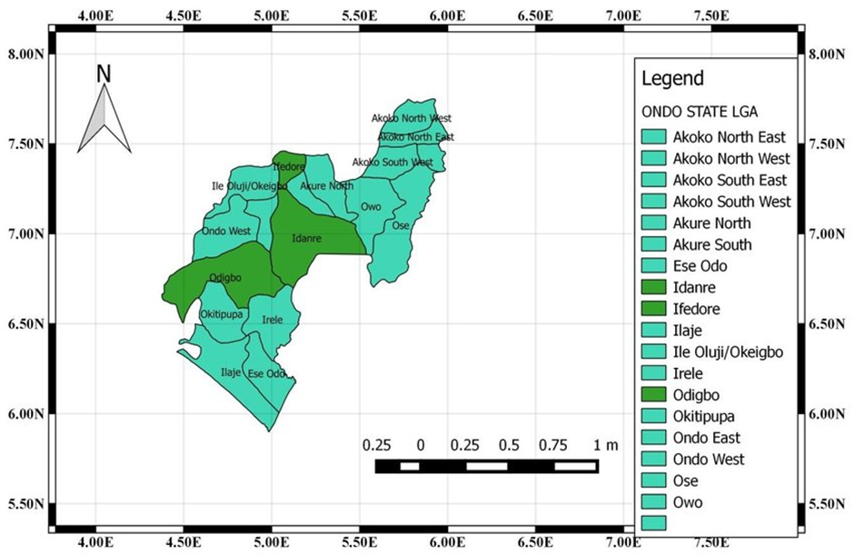
Figure 1: Map of Ondo State Forest Reserve
Source: (Eniola T, 2014)

Results and Discussion
Primary Drivers of Land Use Land Cover
Respondents’ perceptions of the major causes of deforestation in the study area is presented in Figure 2.

Figure 2: Primary Drivers of Land Use Land Cover
Source: Author’s Fieldwork, 2024
Figure 2 shows the percentage of the primary drivers of land use land cover. The result indicates the drivers to agricultural expansion (32.7%), urbanization and infrastructure development (13.3%), factory or industrial activities (4.7%), logging and timber harvesting (14.0%), mining and quarrying (4.0%), land use policy and regulation (6.7%), population growth (12%), climate change (5.3%), natural disaster (2.0%), and soil degradation (5.3%). The result implies that agricultural expansion had the highest percentage (32.7%) and is a major driver of land use land covering the study area.
Land Use Land Cover Classification for Ondo Afforestation Plot (OAP)
The LULC classification maps of 1984, 2002, 2014, and 2024 produced for the Ondo Afforestation Plot are displayed in Figures 3, 4, 5, and 6, respectively. Each of these maps includes five primary classes found in the study area.
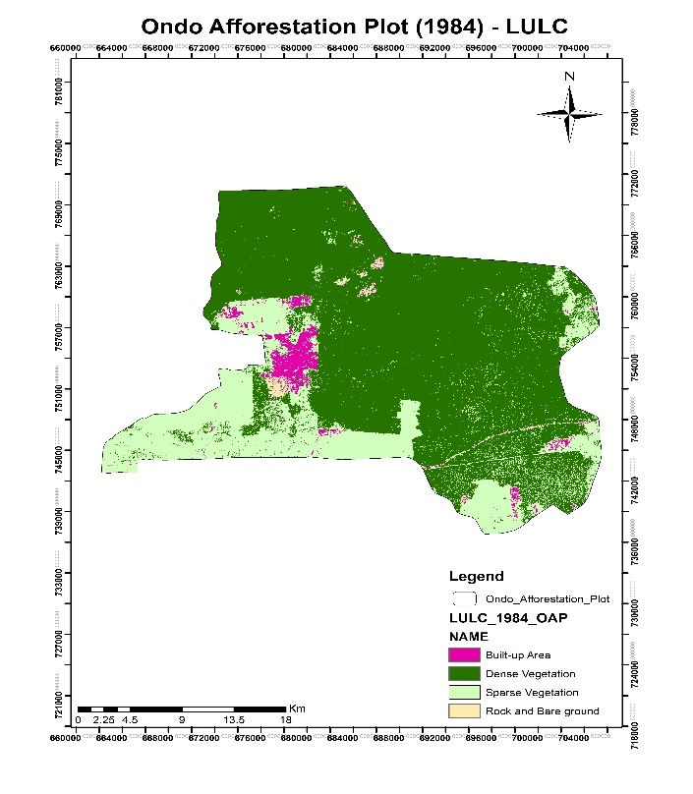
Figure 3: 1984 Classified land use land cover Map of Ondo Afforestation Plot (OAP)
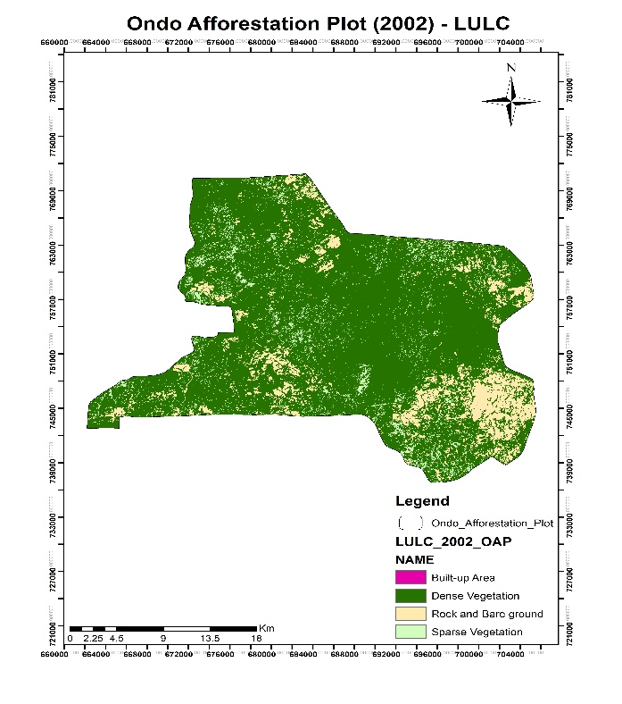
Figure 4:2002 Classified land use land cover Map of Ondo Afforestation Plot (OAP)
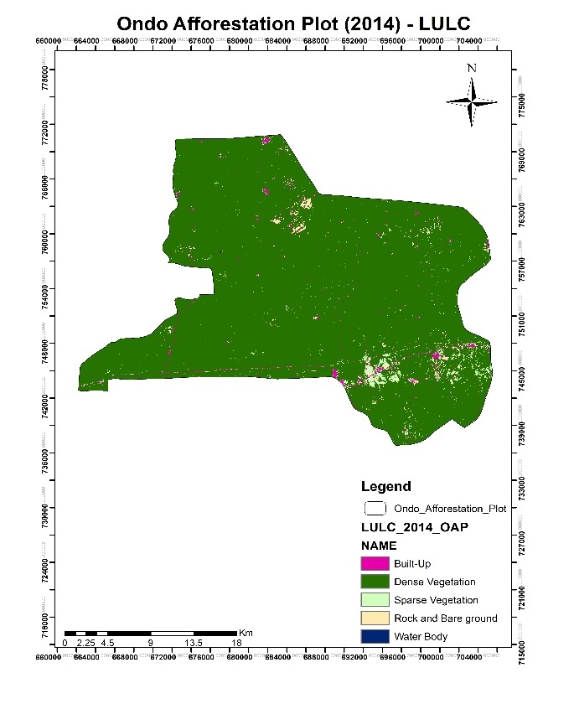
Figure 5:2014 Classified land use land cover Map of Ondo Afforestation Plot (OAP)
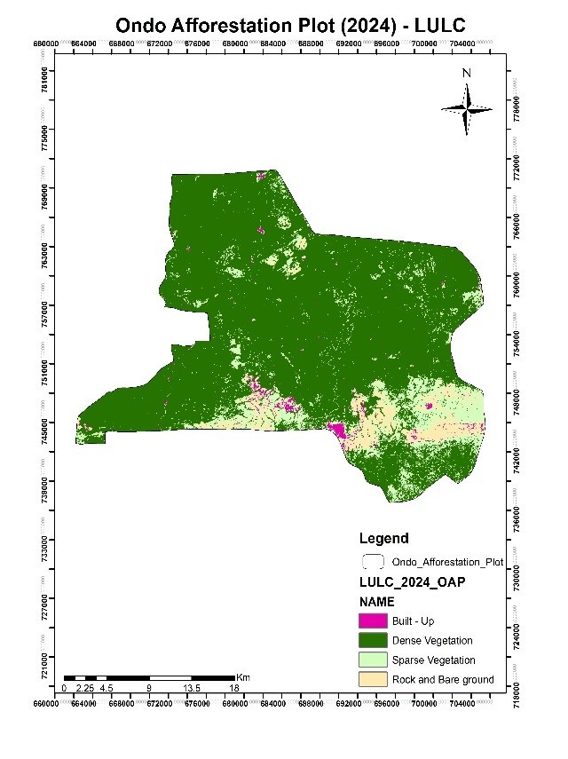
Figure 6:2024 Classified land use land cover Map of Ondo Afforestation Plot (OAP)

Table 1: Land Use/Land Cover Change for Ondo Afforestation Plot (1984-2024)
OAP (1984-2024) |  | Land Use Land Cover Area
Classes | YEAR | 1984 | 2002 | 2014 | 2024 | Change
Dense Vegetation  Sparse Vegetation  Built-Up  Rock and Bare ground  Water Body  Total |  | % | % | % | % | %
 |  | 69.98 | 83.13 | 96.41 | 81.28 | 16.15
 |  | 26.61 | 4.79 | 1.89 | 12.10 | -54.51
 |  | 2.85 | 0.00 | 1.16 | 1.11 | -61.05
 |  | 0.56 | 12.08 | 0.54 | 5.51 | 56.50
 |  | 0.00 | 0.00 | 0.01 | 0.00 | 0.00
 |  | 100.00 | 100.00 | 100.00 | 100.00
Source: Author’s Fieldwork, 2024
Table 1 shows a fluctuation trend in the coverage of five LULC classes in the Ondo afforestation plot. In 1984, the proportion of dense vegetation, sparse vegetation, built-up, rock, and bare ground, and water bodies was 68.98%, 26.61%, 2.85%, 0.56%, and 0.00%, respectively. In 2002, it was 83.13%, 4.79%, 0.00%, 12.08%, and 0.00%. Also, for the year 2014, the dense vegetation, sparse vegetation, built-up, Rock and bare ground, and water body are 96.41%, 1.89%, 1.16%, 0.54%, and 0.01% respectively. Finally, the proportion of coverage of the dense vegetation, sparse vegetation, built-up, Rock and bare ground, and water body for the year 2024 is 83.13%, 4.79%, 0.00%, 12.08%, and 0.00% respectively. This implied that fluctuating negative changes of the LULC classes were detected in the LULC classes in the Ondo afforestation plot.
Land Use/Cover Classification for Oyinmo Forest Reserve (OFR)
The LULC classification maps of the years 1984, 2002, 2014, and 2024 produced for the Oyinmo Forest Reserve are displayed in Figures 7, 8, 9, and 10, respectively. Each of these maps includes the 5 primary classes found in the study area. Furthermore, the proportion of coverage of the 5 LULC primary classes for each year (1984, 2002, 2014, and 2024) is presented in Table 2.
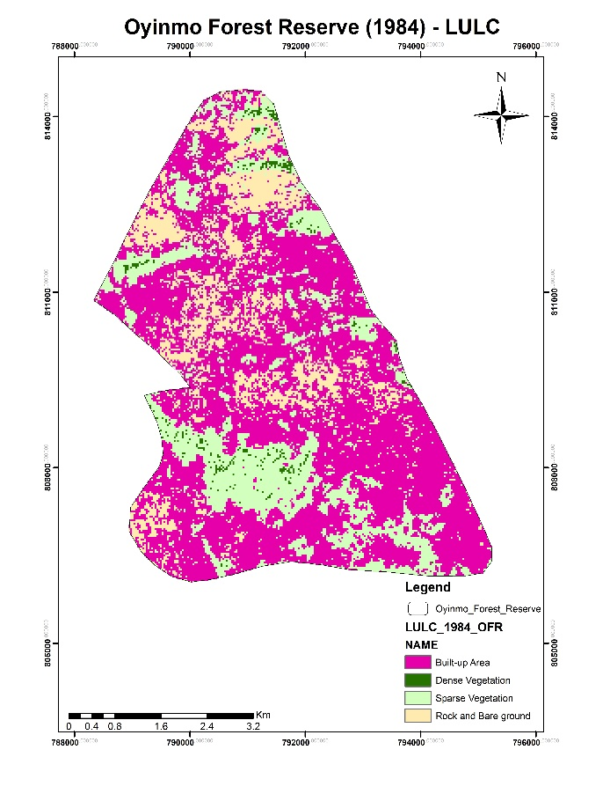
Figure 7: 1984 Classified land use land cover Map of Oyinmo Forest Reserve (OFR)
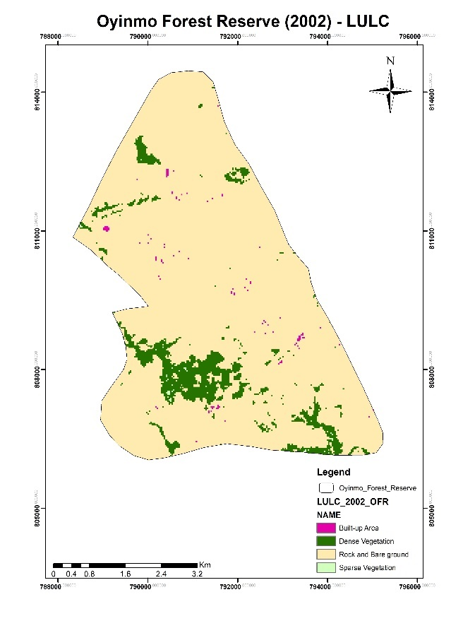
Figure 8: 2002 Classified land use land cover Map of Oyinmo Forest Reserve (OFR)

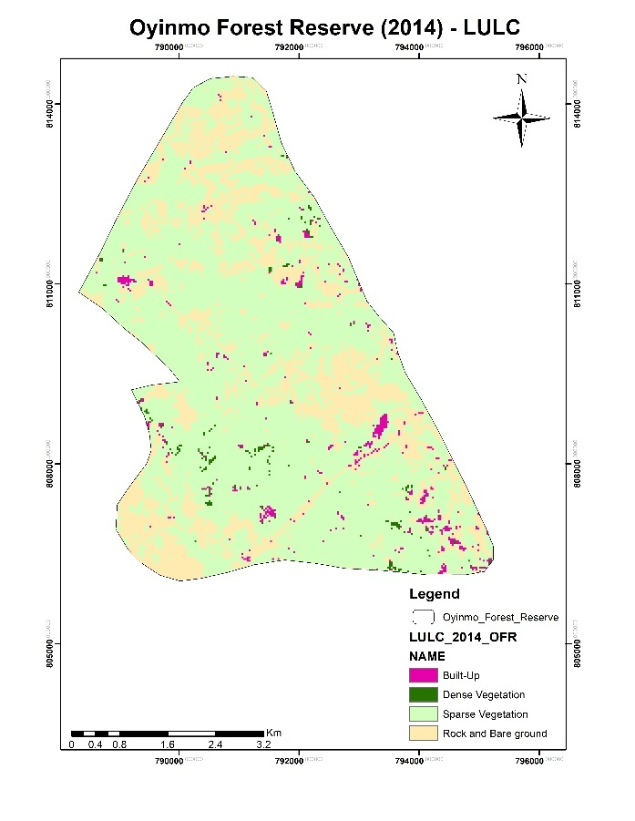
Figure 9: 2014 Classified land use land cover Map of Oyinmo Forest Reserve (OFR)
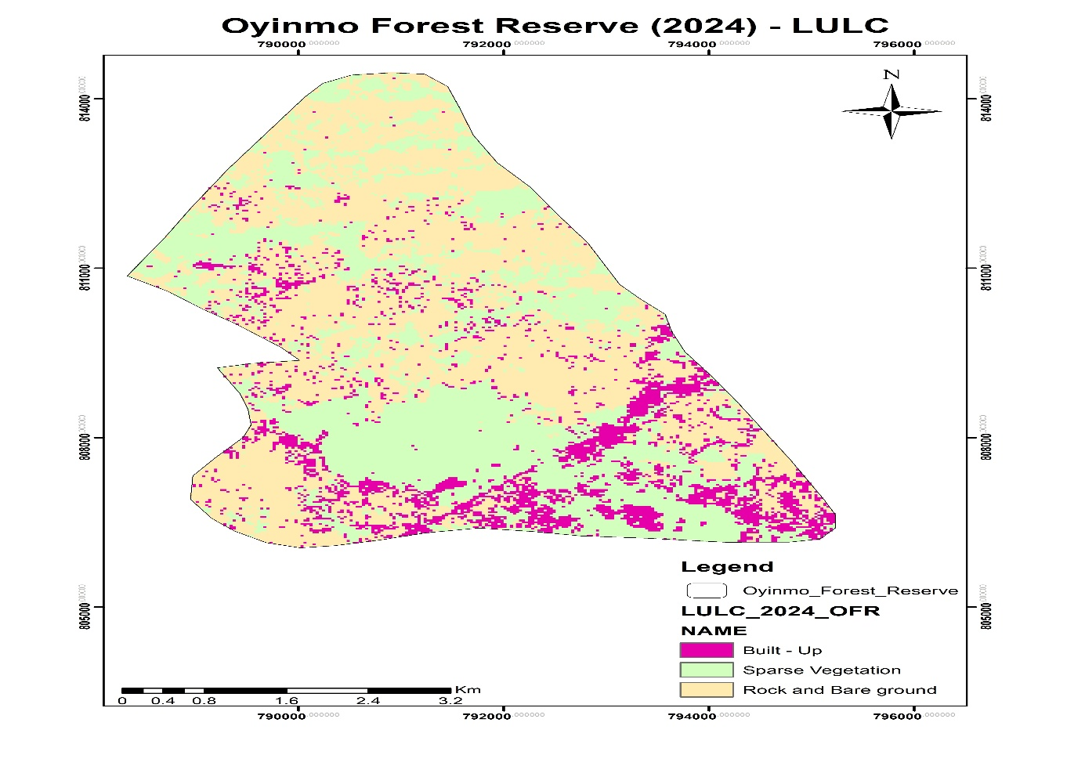
Figure 10: 2024 Classified land use land cover Map of Oyinmo Forest Reserve (OFR)
Table 2: Land Use/Land Cover Changes for Oyinmo Forest Reserve (1984-2024)
OFR |  | Land Use Land Cover Area
Classes | YEAR | 1984 | 2002 | 2014 | 2024 | Change
 |  | % | % | % | % | %
Dense Vegetation  Sparse Vegetation  Built-Up  Rock and Bare ground  Water Body  Total |  | 0.87 | 7.97 | 0.53 | 0 | -100.0
 |  | 21.54 | 0.09 | 71.01 | 36.91 | 71.40
 |  | 60.37 | 0.25 | 1.53 | 11.65 | 54.89
 |  | 17.22 | 91.69 | 26.93 | 51.44 | 67.70
 |  | 0.00 | 0.00 | 0.00 | 0.00 | 0
 |  | 100.00 | 100.00 | 100.00 | 100.00
Source: Author’s Fieldwork, 2024
Land cover proportions in the Oyinmo forest reserve for 1984, 2002, 2014, and 2024 is presented in Table 2. In 1984, built-up areas dominated at 60.37%, followed by sparse vegetation at 21.54%, and smaller proportions of rock and bare ground, dense vegetation, and water bodies. By 2002, dense vegetation had a minimal presence, while built-up areas increased significantly to 91.69%. In 2014, sparse vegetation became predominant at 71.01%, with rock and bare ground also increasing. In 2024, there is a significant decrease of 100% for dense vegetation and a considerable increase of 71.11% for spare vegetation.
Land Use/Cover Classification for Akure Forest Reserve (AFR)
Figures 10, 11, 12, and 13 display the LULC classification maps produced for the Akure Forest Reserve for the years 1984, 2002, 2014, and 2024. Each map includes the 5 primary classes found in the study area. Furthermore, Table 3 presents the proportion of coverage of the 5 LULC primary classes for each year (1984, 2002, 2014, and 2024).
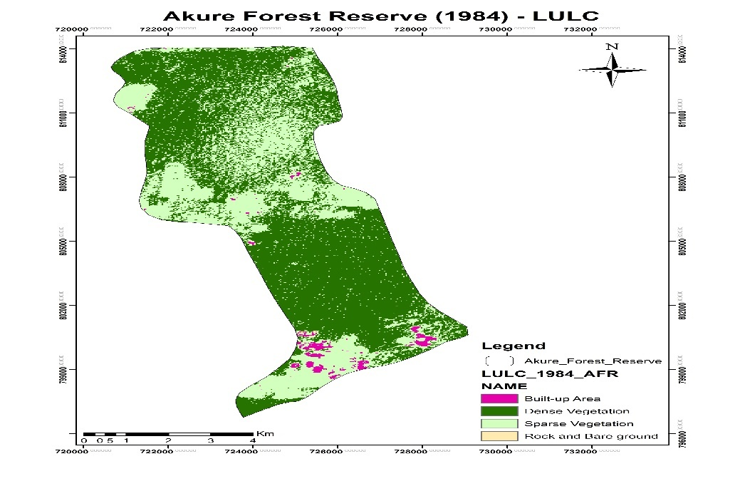
Figure 11: 1984 Classified land use land cover Map of Akure Forest Reserve (OFR)
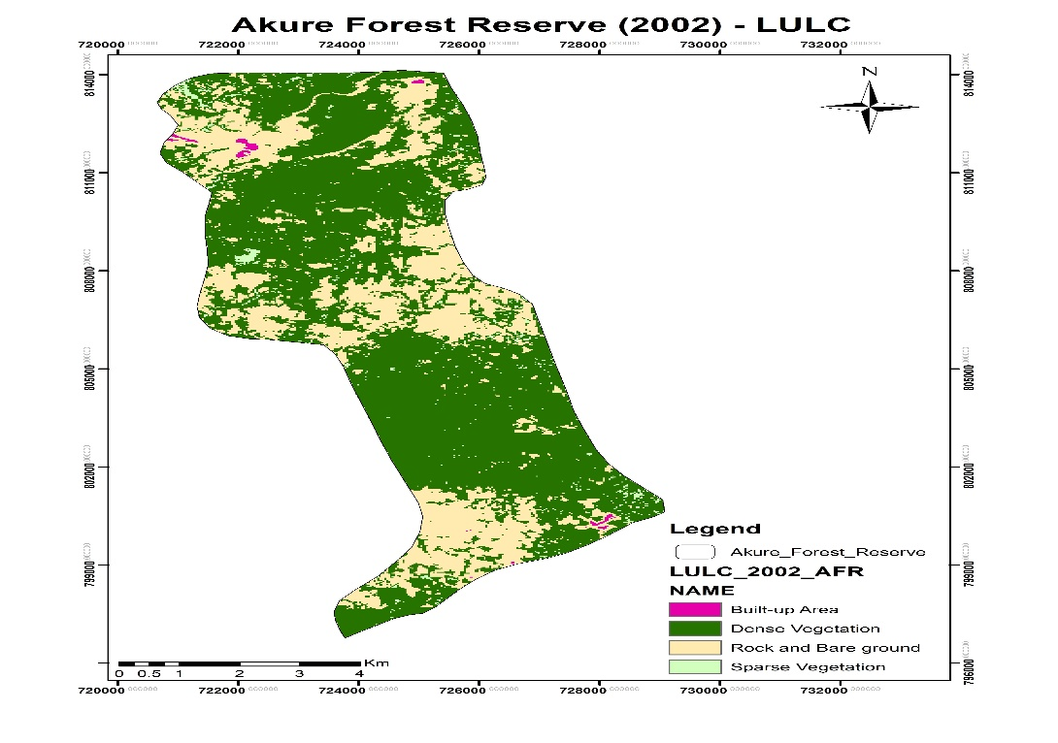
Figure 12:2002 Classified land use land cover Map of Akure Forest Reserve (AFR)
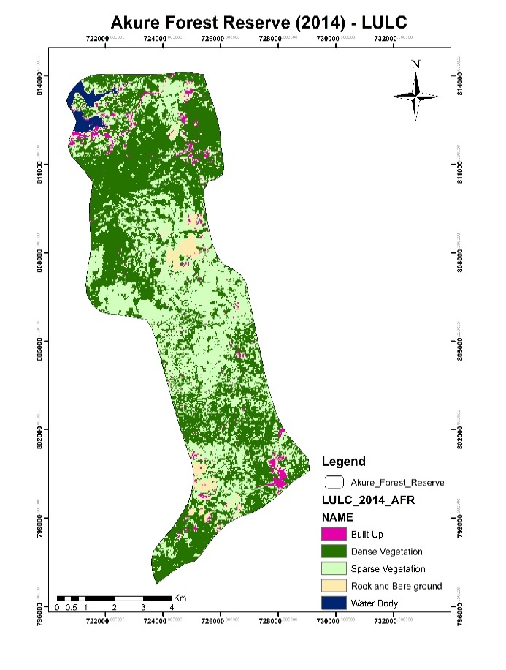
Figure 13:2014 Classified land use land cover Map of Akure Forest Reserve (AFR)
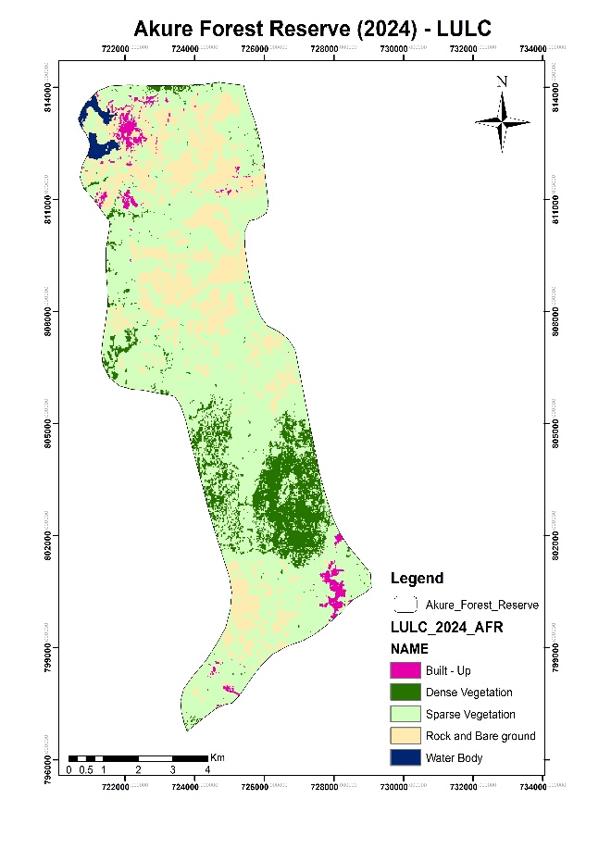
Figure 14:2024 Classified land use land cover Map of Akure Forest Reserve (AFR)

Table 3: Land Use/Land Cover Changes for Akure Forest Reserve (AFR) (1984-2024)
AFR |  | Land Use Land Cover Area
Classes | Year | 1984 | 2002 | 2014 | 2024 | Change
 |  | % | % | % | % | %
Dense Vegetation  Sparse Vegetation  Built-Up  Rock and Bare ground  Water Body  Total |  | 61.52 | 68.09 | 50.83 | 10.44 | -83.03
 |  | 37.07 | 1.46 | 41.51 | 63.43 | 71.11
 |  | 1.33 | 0.30 | 2.62 | 2.06 | 54.89
 |  | 0.08 | 30.14 | 3.52 | 23.09 | 62.70
 |  | 0.00 | 0.00 | 1.52 | 0.98 | 0
 |  | 100 | 100 | 100 | 100
Source: Author’s Fieldwork, 2024
Land cover proportions in the Akure forest reserve for 1984, 2002, 2014, and 2024 is presented in Table 3. In 1984, dense vegetation areas dominated at 61.52%, followed by sparse vegetation at 37.07%, and smaller proportions of rock and bare ground, dense vegetation, and water bodies. By 2014, dense vegetation had a reduced presence, while sparse vegetation areas increased significantly to 41.51%. In 2024, sparse vegetation became predominant at 63.43%, with rock and bare ground also increasing to 23.09% while there was a significant decrease of dense vegetation. This result implied that For Dense Vegetation, there is a significant decrease of −83.03%. For Sparse Vegetation, there's a considerable increase of 71.11%.
Discussion of Findings
The findings revealed that the primary drivers of land use and land cover (LULC) changes include both anthropogenic and natural factors. Human-induced drivers encompass agricultural expansion, urbanization, infrastructure development, industrial activities, logging and timber harvesting, mining and quarrying, inadequate land use policies and regulations, and population growth. Natural drivers include climate change, natural disasters, and soil degradation. These results align with Chiteculo's (2019) assertion that the causes of LULC changes are multifaceted and interconnected. Furthermore, the most predominant drivers of land use land cover were agricultural expansion and urbanization. This is also supported by the findings of Adekugbe et al. (2020) that the level of agricultural activities in the Akure forest reserve is very high. Hence, constitutes a major cause of deforestation in the reserve.
The findings from the Ondo afforestation plot, Oyinmo forest reserve, and Akure forest reserve indicate a persistent pattern of variability in land use and land cover (LULC), highlighting notable environmental and ecological transformations. This finding aligns with the study by Anteneh (2022) in Ethiopia, another African country, indicating that land use and land cover issues are not unique to Nigeria but are also prevalent across other African nations and globally. Dense vegetation has undergone significant reduction across all study areas over the decades. For instance, in the Ondo afforestation plot, dense vegetation peaked in 2014 but decreased significantly by 2024. Similarly, in the Akure forest reserve, dense vegetation decreased significantly between 1984 and 2024. These trends suggest ongoing deforestation and degradation, likely driven by human activities such as logging, agriculture, population growth, and urbanization. Also, sparse vegetation and rock/bare ground have shown considerable increases in coverage, particularly in the Akure and Oyinmo forest reserves. This shift indicates land degradation, likely resulting from deforestation, agricultural expansion, and reduced forest regeneration (Jenkins, 2018).
Conclusion
The study concludes that the observed fluctuations and trends reflect the complex interplay of anthropogenic and natural drivers shaping land use and land cover dynamics. The reduction in dense vegetation and the expansion of sparse vegetation and rock/bare ground suggests diminished ecosystem services, including reduced biodiversity, carbon sequestration, and soil fertility. These changes could adversely affect the livelihoods of forest-dependent communities, exacerbating socioeconomic vulnerabilities and undermining sustainable development efforts.

Recommendations
Based on the findings, the study recommends urgent interventions, such as sustainable land management practices, afforestation, and effective policy enforcement, are necessary to mitigate the negative impacts on ecosystems and local livelihoods.

Ethical Approval
All participants were informed about the purpose of the study, and their participation was entirely voluntary.
References
Abbass, K., Qasim, M. Z., Song, H., Murshed, M., Mahmood, H., & Younis, I. (2022). A review of the global climate change impacts, adaptation, and sustainable mitigation measures. Environmental Science and Pollution Research, 29(31), 42539–42559. https://doi.org/10.1007/s11356-022-19718-6
Adejuwon, O., &Jeje, U. H. (2013). An assessment of deforestation in a lowland forest area of Southwest Nigeria, using remote sensing techniques. University of Ibadan, Nigeria.
Anwadike, J. U. (2020). Assessment of forest resources and their contribution to the livelihoods of rural communities in Anambra State, Nigeria. Journal of Forestry Research and Management, 17(1), 23-35.
Birben, M. (2022). Factors affecting forest land use change: A case study from Turkey. International Journal of Forestry Research, 2022, 1-9.
Chiteculo, V., Abdollahnejad, A., Panagiotidis, D., Surový, P., & Sharma, R. P. (2019). Defining deforestation patterns using satellite images from 2000 and 2017: Assessment of forest management in Miombo Forests – A case study of Huambo province in Angola. Sustainability, 11(1), 98.
Dixon, R. K., & Garrity, D. P. (2022). Non-timber forest products and their role in forest-based livelihoods and conservation: An overview. Agroforestry Systems, 1-10.
FAO. (2015). The State of the World’s Forests 2015. FAO.
Gbiri, K. A., & Adeoye, S. A. (2019). Assessing the impact of deforestation on socio-economic activities in Ondo State, Nigeria. International Journal of Research and Innovation in Social Science, 3(1), 15-22.
Gourmelon, F. (2016). Urbanization and deforestation: A view from the future. Geoforum, 69, 25-36.
Jayathilake, H. M., Prescott, G. W., Carrasco, L. R., & others. (2021). Drivers of deforestation and degradation for 28 tropical conservation landscapes. Ambio, 50(2), 215–228. https://doi.org/10.1007/s13280-020-01325-9
Jenkins, O. G. (2018). Global consequences of land use. Science, 39(570), 570–574.
Hansen, M. C., Potapov, P. V., Moore, R., Hancher, M., Turubanova, S. A., Tyukavina, A., Thau, D., Stehman, S. V., Goetz, S. J., Loveland, T. R., Kommareddy, A., Egorov, A., Chini, L., Justice, C. O., & Townshend, J. R. G. (2020). High-resolution global maps of 21st-century forest cover change. Science, 342(6160), 850-853. https://doi.org/10.1126/science.1244693
Ken, S., Sasaki, N., Entani, T., Ma, H.O., Thuch, P., &Tsusaka, T.W. (2020). Assessment of the Local Perceptions on the Drivers of Deforestation and Forest Degradation, Agents of Drivers, and Appropriate Activities in Cambodia. Sustainability, 12, 9987. https://doi.org/10.3390/su12239987
Lambin, G. G. (2017). Not by bread alone: Forests and rural livelihoods in Sub-Saharan Africa.
Mfrekefon, U. F., &Konwaa, B. S. (2014). Land use/land cover change detection and its impacts in Uyo urban area of Akwa Ibom State, Nigeria. Journal of Geography, Environment and Earth Science International, 3(2), 167-179.
Oyeranti, A. O., & Taiwo, O. J. (2023). Analysis of forest cover loss and degradation in Southwest, Nigeria. Journal of Forest and Environmental Science, 29(1), 83-92.
Singh, U. R. (2015). An assessment of the status of the world's remaining closed forests. Nairobi, Kenya: United Nations Environment Program (UNEP)

