Original Research Article

Harmonization of Periodontal scRNA-seq Reveals Conserved Immune–Stromal Programs in Periodontitis

Abstract
Periodontitis arises from dysregulated crosstalk among epithelial, immune, and stromal compartments, ultimately driving connective-tissue and alveolar-bone loss. While single-cell RNA-seq (scRNA-seq) has mapped this heterogeneity, insights are fragmented across studies with differing cohorts and preprocessing. Here we harmonize two independent gingival scRNA-seq datasets (Chen et al., 2022; Easter et al., 2024) into a unified, patient-aware atlas. We standardize gene identifiers and metadata, then integrate with Harmony while preserving patient labels to minimize batch effects without erasing biological variation. The integrated embedding recovers diverse immune and stromal populations—including fibroblast subsets, macrophages, T cells, endothelial and epithelial lineages—and supports consistent cell-state annotations across cohorts. To identify robust disease signals, we aggregate counts into patient-level pseudobulk profiles and perform differential expression contrasting periodontitis versus non-periodontitis samples. This reveals conserved programs marked by upregulation of inflammatory and tissue-remodeling pathways and downregulation of protective homeostatic processes. Cell type–resolved boxplots highlight lineage-specific shifts across endothelial, fibroblast, keratinocyte, pericyte, plasma-cell, and T-cell compartments, underscoring coordinated immune–stromal remodeling in disease. Collectively, this cross-cohort, patient-preserving harmonization establishes a stable reference for periodontal biology and a framework for biomarker nomination and therapeutic target discovery.
Keywords: Biomarker Nomination, Immune–Stromal Programs Periodontal Biology, Periodontal scRNA-seq, Therapeutic Target Discovery

Introduction
Periodontitis is a chronic inflammatory disease characterized by persistent microbial challenge and aberrant host immune responses that drive destruction of gingival connective tissue and alveolar bone support (Hajishengallis & Chavakis, 2021; Zhang et al., 2024). The pathogenesis is orchestrated by complex cross-talk among epithelial barriers, infiltrating immune cells (neutrophils, macrophages, T cells), and resident stromal populations (fibroblasts, vascular cells), which together mediate inflammation, extracellular matrix remodeling, and osteoclastic activation (Williams et al., 2021). Central to this network is a cytokine milieu—among others, IL-1β, TNF, IL-6, and IL-17—that regulates immune cell recruitment, activation, and the balance between tissue destruction and repair (Kowalski et al., 2022; Pan et al., 2019). In recent years, single-cell RNA sequencing (scRNA-seq) has emerged as a transformative tool for dissecting cellular heterogeneity in complex tissues and inflammatory diseases; by profiling transcriptomes at single-cell resolution, scRNA-seq enables identification of rare subpopulations, cell-state transitions, and intercellular signaling circuits that are masked in bulk assays (Jung & Lee, 2023; Woo & Eyun, 2025). scRNA-seq offers a powerful framework to probe how homeostatic intercellular communication is deranged in periodontitis and to pinpoint candidate pathways driving disease progression.
Although individual scRNA-seq studies have provided important insights into the cellular composition and signaling pathways of periodontal tissues, each dataset is constrained by cohort size, technical variability, and study-specific preprocessing (Luecken & Theis, 2019). These limitations can restrict the generalizability of findings and obscure subtle but consistent disease-associated patterns (Büttner et al., 2019). Integrating multiple independent datasets not only increases statistical power but also enables harmonization across different experimental platforms, patient cohorts, and clinical conditions (Stuart et al., 2019). Such cross-study integration is essential for constructing a more comprehensive atlas of periodontal cell states and for distinguishing robust transcriptional signatures of disease from dataset-specific artifacts (Korsunsky et al., 2019).
Two recent scRNA-seq studies have expanded our understanding of cellular and molecular mechanisms in periodontitis by profiling periodontal tissues at single-cell resolution. The first, Chen et al., provided single-cell profiles of healthy and diseased periodontal tissues, uncovering heterogeneity among fibroblast subsets, immune cell activation states, and epithelial dynamics associated with tissue destruction and repair (Chen et al., 2022). More recently, Easter et al., generated a large-scale single-cell atlas of gingival tissues that revealed diverse immune and stromal populations, characterized ligand–receptor interactions, and highlighted pathways driving inflammatory microenvironments (Easter et al., 2024). Together, these studies offer rich datasets that capture the complexity of cell populations and transcriptional programs underlying periodontitis.
Building on these resources, the present study seeks to harmonize the two available scRNA-seq datasets to generate a unified transcriptional landscape of periodontitis. By applying cross-dataset integration strategies, we aim to mitigate batch effects and consolidate shared cellular states across independent cohorts. Within this harmonized framework, we perform differential expression analyses to identify conserved gene programs associated with disease, with particular attention to immune and stromal populations that drive inflammatory and remodeling processes. This approach not only enhances the robustness of disease-associated transcriptional signatures but also establishes a foundation for future comparative analyses and therapeutic target discovery in periodontitis.

Research Methods
Datasets
We analyzed two publicly available single-cell RNA sequencing (scRNA-seq) datasets profiling gingival tissues in periodontitis. The first dataset, published in Theranostics (2022), includes healthy, periodontitis, and post-treatment samples generated using droplet-based scRNA-seq. The second dataset, from Nature Communications (2024), provides a large-scale atlas of gingival immune and stromal cell states with extensive donor representation. Together, these datasets span healthy and diseased conditions, capturing both treatment-naïve and treated tissues, and were selected to enable cross-cohort harmonization and identification of conserved transcriptional programs in periodontitis.
Data preprocessing and conversion
For the Theranostics dataset, raw gene–cell count matrices were provided as compressed tab-separated files (.counts.tsv.gz) with corresponding cell barcode lists (.cellname.list.txt.gz). We implemented a custom preprocessing script (convert_tsv.py) to construct a unified AnnData object. Briefly, for each sample, we loaded the gene count matrix and matched it to its cell identifiers. Potential mismatches due to header lines in barcode files were corrected by trimming extraneous entries. Gene identifiers were intersected across all samples to ensure comparability, and unique cell identifiers were generated by concatenating sample IDs with original barcodes. Sample-level metadata (condition, sex, age, and patient ID) were appended to cell-level observations. Count matrices were then concatenated across samples, and the resulting dataset was stored in .h5ad format for downstream analysis.
Gene identifier harmonization
The Nature Communications dataset reported expression with Ensembl gene identifiers, whereas the Theranostics dataset used gene symbols. To align these datasets, we implemented a conversion step using the MyGeneInfo API, mapping Ensembl IDs to gene symbols. Duplicated mappings were disambiguated by appending unique suffixes, and only genes with consistent mappings across both datasets were retained. This yielded a common set of genes used for harmonized integration.
Metadata harmonization
To preserve biological granularity, we standardized sample metadata across cohorts. Patient identifiers were extracted or reconstructed depending on dataset structure, and prefixed with dataset-specific tags to avoid collisions. Condition annotations were harmonized into three categories: healthy, periodontitis, and post-treatment. A binary status label (periodontitis vs. non-periodontitis) was also generated for downstream differential expression analysis.
Quality control
Quality control (QC) was performed on each dataset prior to integration. Cells with fewer than 200 detected genes were excluded, and cells exhibiting >25% mitochondrial transcript content were removed where applicable. Following QC, both datasets were filtered to their common gene set, ensuring alignment of feature space.
Data integration
To mitigate batch effects and preserve inter-patient heterogeneity, we performed integration using Harmony. Counts were normalized to 10,000 transcripts per cell and log-transformed. Highly variable genes were identified separately for each batch and retained for integration. Principal component analysis (PCA) was computed, and Harmony was applied using both dataset labels and patient identifiers as covariates to maximize alignment while controlling for individual-specific variation. Harmony-corrected embeddings were then used to compute neighborhood graphs, UMAP embeddings, and Leiden clusters.
Immune cell identification
To focus analyses on immune-mediated mechanisms of disease, immune cell populations were identified using canonical marker-based scoring. Marker panels for T cells, B cells, plasma cells, monocytes, macrophages, NK cells, dendritic cells, and neutrophils were curated from literature. An immune score was calculated for each cell, and cells exceeding the 75th percentile were retained for immune-focused analyses.
Differential expression analysis
Differential expression (DE) testing was performed between periodontitis and non-periodontitis immune cells using a Wilcoxon rank-sum test implemented in Scanpy. Genes were considered significant if they exhibited an absolute log2 fold-change > 0.25 and an adjusted p-value < 0.05. To ensure robust inference, DE analysis was performed with patient identifiers preserved, preventing pseudoreplication across individuals.

Results

Harmonization of independent scRNA-seq datasets
To overcome dataset-specific biases, we harmonized scRNA-seq profiles from the Theranostics (2022) and Nature Communications (2024) studies into a unified transcriptomic atlas of periodontal tissues. Harmony integration with patient-level preservation aligned both datasets into a common latent space, reducing batch-driven segregation while maintaining biological distinctions. Cells grouped according to clinical status and tissue compartments rather than dataset origin, confirming effective cross-cohort harmonization (Figure 1).
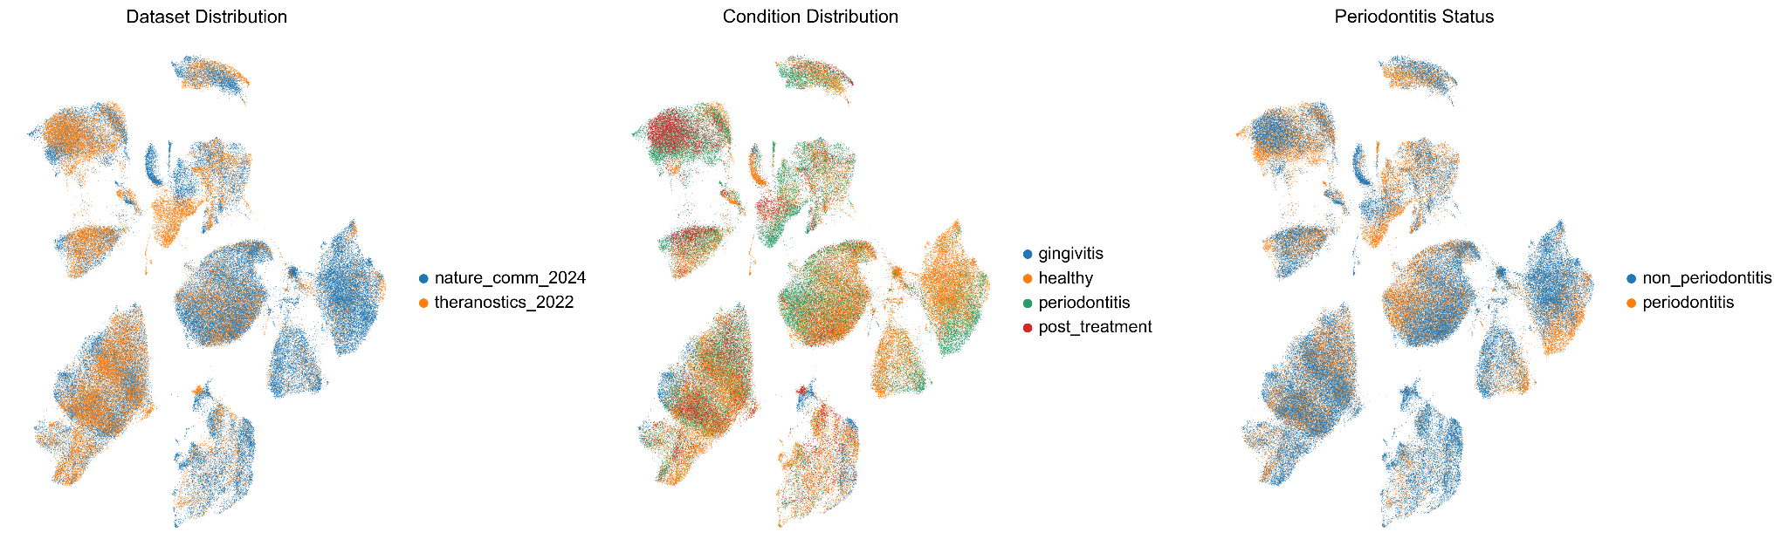
Figure 1. Integration overview of periodontal scRNA-seq datasets. UMAP visualization shows cells from both studies embedded in a harmonized latent space, colored by dataset, condition, and patient identity. Integration reduces batch effects while retaining biological heterogeneity.

Identification of cell populations in the harmonized atlas
Clustering of the integrated dataset revealed distinct cellular compartments, including epithelial, stromal, and immune populations. Fibroblast subsets, macrophages, T cells, and epithelial lineages were robustly recovered, consistent with prior study-specific findings. The harmonized clustering demonstrates that integration preserved fine-grained cell-type resolution and allowed patient-level annotation across cohorts (Figure 2).
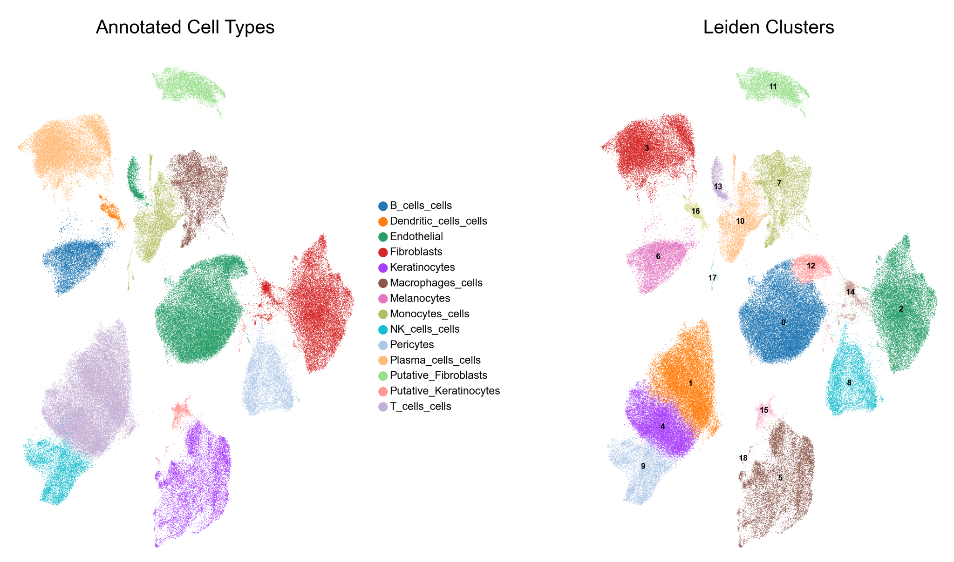
Figure 2. Cell type clustering of harmonized periodontal atlas. UMAP embedding colored by annotated cell types highlights recovery of fibroblast, epithelial, and immune subpopulations. Integration preserved cell identity while aligning datasets.

Differential expression highlights conserved disease-associated programs
To identify conserved transcriptional changes in periodontitis, we performed pseudobulk differential expression analysis across patient-derived samples. Out of more than 13,000 tested genes, several hundred reached significance (adjusted p < 0.05, |log2FC| > 0.5). Both upregulated and downregulated gene sets were observed in periodontitis compared with controls, indicating activation of inflammatory and remodeling programs alongside suppression of homeostatic pathways (Figure 3).
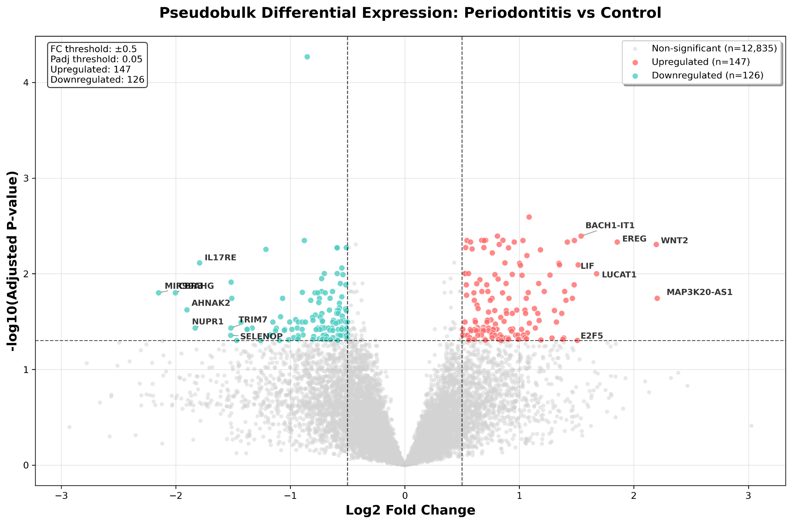
Figure 3. Volcano plot of pseudobulk differential expression. Genes upregulated in periodontitis are highlighted in red, and downregulated genes in blue. Horizontal dashed line marks significance threshold (padj = 0.05); vertical dashed lines indicate log2FC cutoff (±0.5).

Expression validation of top regulated genes
Boxplot analyses of the top 10 upregulated and top 10 downregulated genes confirmed consistent expression changes across patient samples. The upregulated set showed elevated expression in periodontitis compared with controls (Figure 4), while the downregulated set displayed reduced expression in disease (Figure 5). These results confirm that harmonization preserved patient-level variation while enabling robust cross-cohort detection of shared disease signatures.
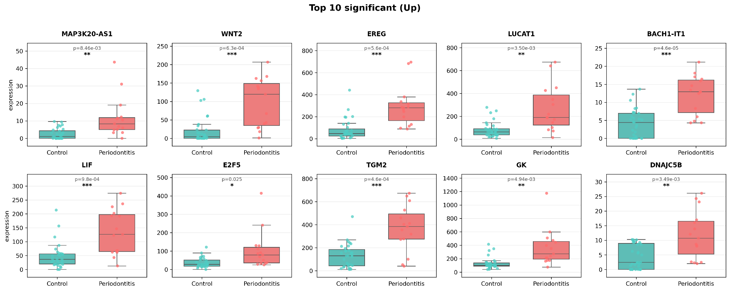
Figure 4. Pseudobulk expression of top upregulated genes. Boxplots show increased expression of the top 10 genes upregulated in periodontitis: MAP3K20-AS1, WNT2, EREG, LUCAT1, BACH1-IT1, LIF, E2F5, TGM2, GK, and DNAJC5B. Individual points represent pseudobulk patient samples.
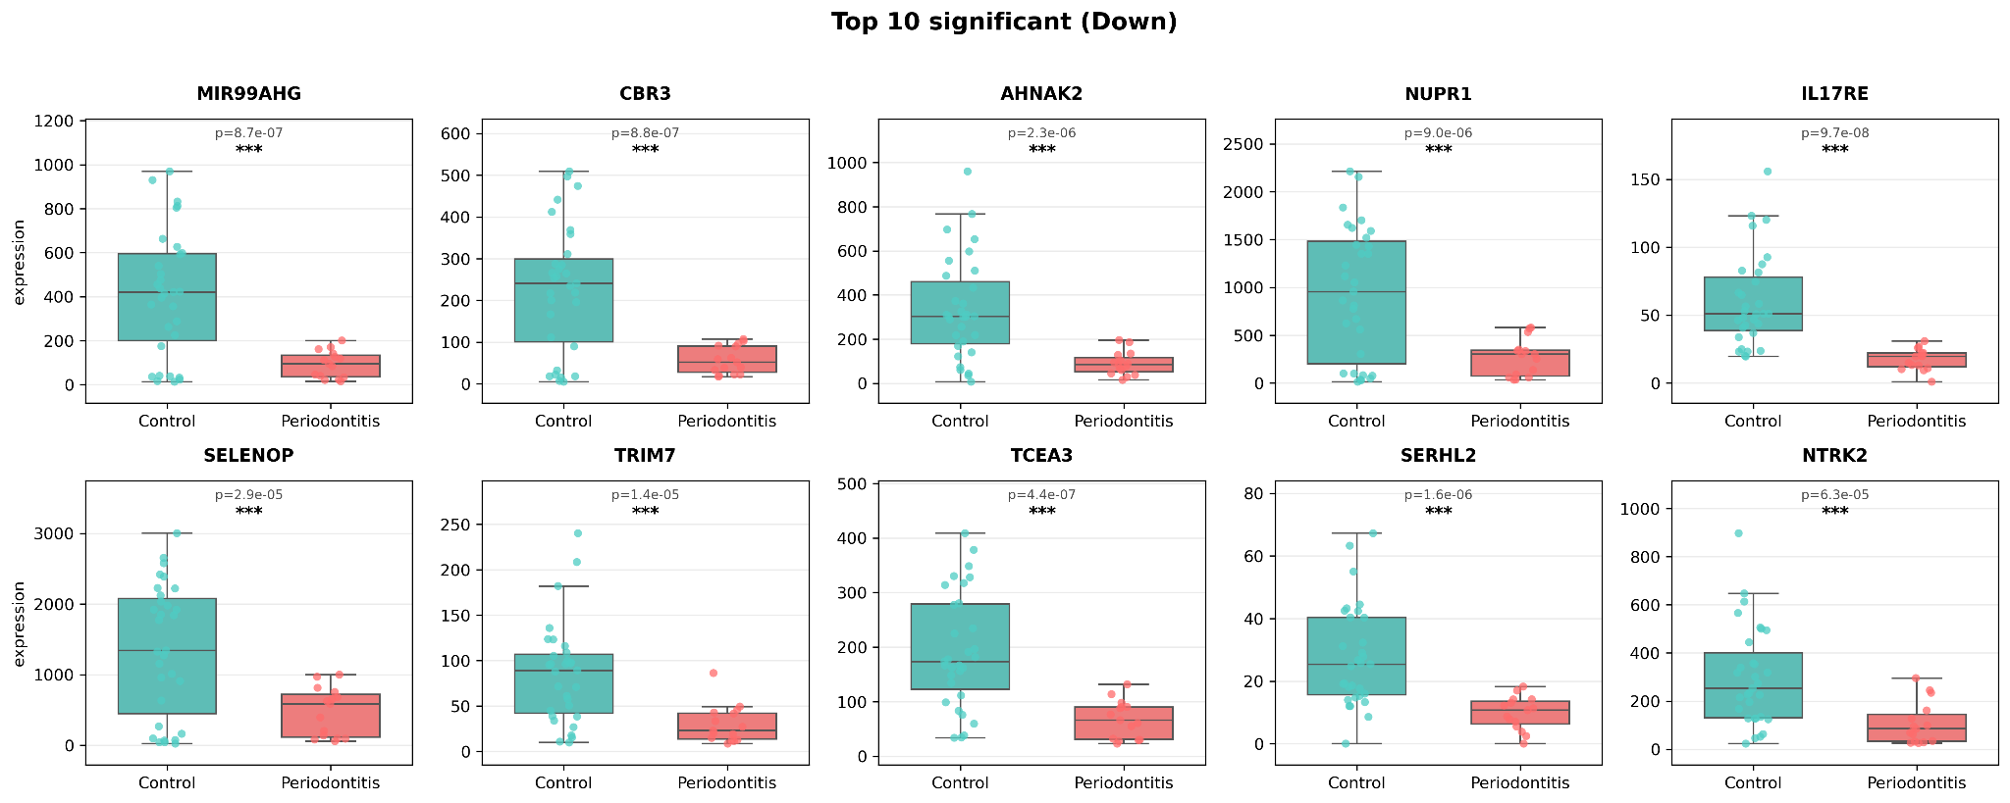
Figure 5. Pseudobulk expression of top downregulated genes. Boxplots highlight reduced expression of the top 10 genes downregulated in periodontitis: MIR99AHG, CBR3, AHNAK2, NUPR1, IL17RE, SELENOP, TRIM7, TCEA3, SERHL2, and NTRK2. Individual points represent pseudobulk patient samples.

Cell type–specific differential expression patterns
To further resolve transcriptional programs associated with periodontitis, we examined differential expression within individual cell populations. For each major stromal and immune lineage, the top five significant genes were visualized in patient-level pseudobulk boxplots. These analyses revealed both upregulated and downregulated genes specific to endothelial cells, fibroblasts, keratinocytes, pericytes, plasma cells, and T cells, highlighting distinct contributions of each cell type to the disease microenvironment (Figures 6–11).
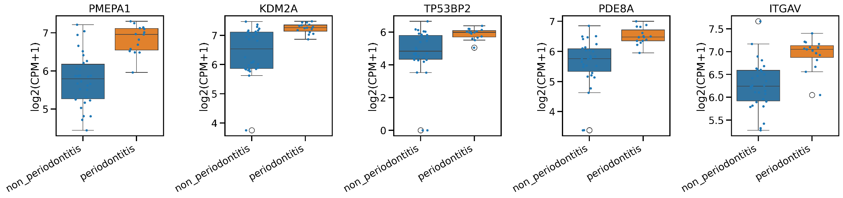
Figure 6. Top differentially expressed genes in endothelial cells. Boxplots show expression changes for the top 5 genes: PMEPA1, KDM2A, TP53BP2, PDE8A, and ITGAV.
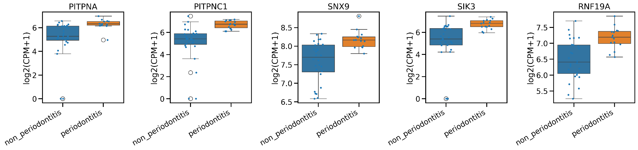
Figure 7. Top differentially expressed genes in fibroblasts. Boxplots show expression changes for the top 5 genes: PITPNA, PITPNC1, SNX9, SIK3, and RNF19A.
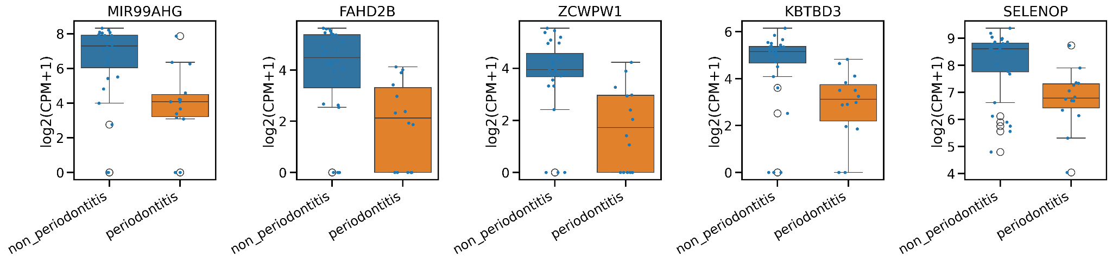
Figure 8. Top differentially expressed genes in keratinocytes. Boxplots show expression changes for the top 5 genes: TAF11, BOLA1, SELENOP, KBTBD3, and ZCWPW1.
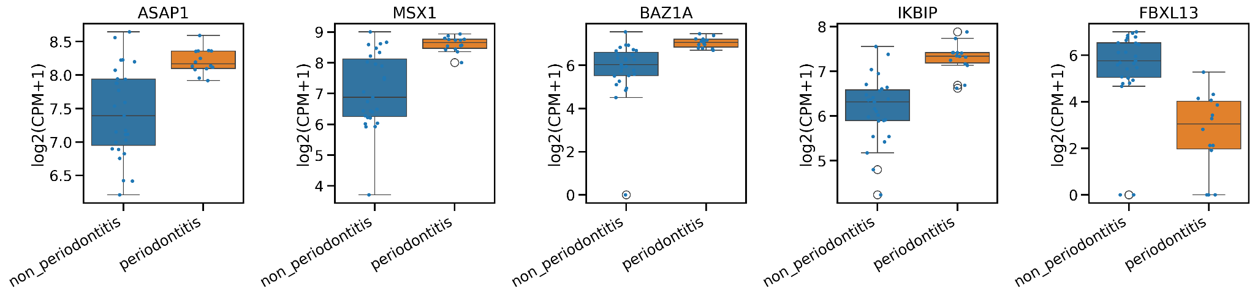
Figure 9. Top differentially expressed genes in pericytes. Boxplots show expression changes for the top 5 genes: ASAP1, MSX1, BAZ1A, IKBIP, and PLEKHG2.
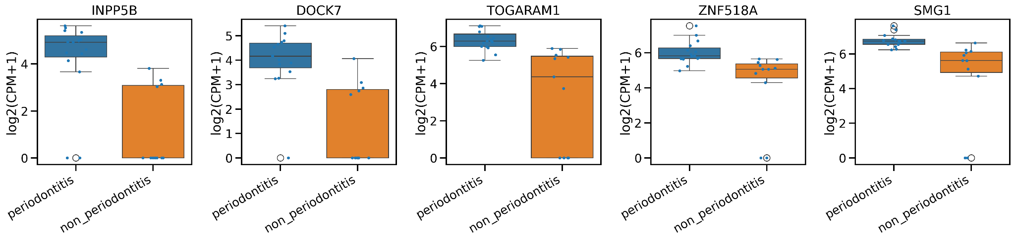
Figure 10. Top differentially expressed genes in plasma cells. Boxplots show expression changes for the top 5 genes: INPP5B, DOCK7, TOGARAM1, ZNF518A, and SMG1.
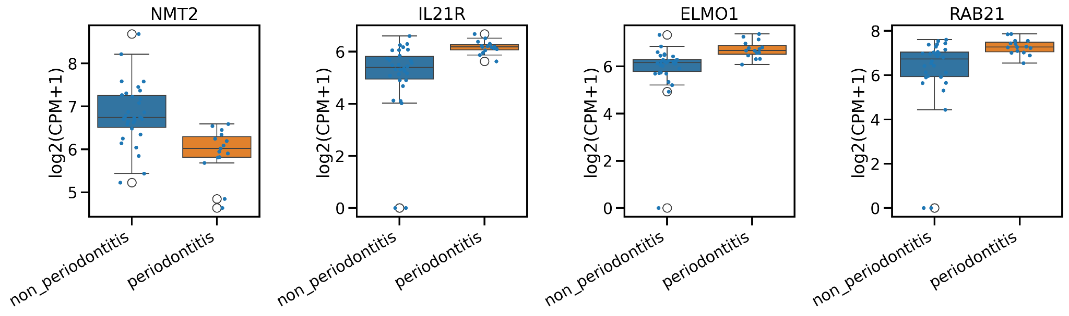
Figure 11. Top differentially expressed genes in T cells. Boxplots show expression changes for the top 5 genes: IL21R, NMT2, ELMO1, and RAB21.
Discussion
By harmonizing two independent scRNA-seq datasets (Korsunsky et al., 2019; Stuart et al., 2019), we generated a unified transcriptional atlas of periodontal tissues that revealed conserved disease-associated programs across patients. The integration preserved fine-grained cellular identities while mitigating dataset-specific biases (Luecken & Theis, 2019; Stuart et al., 2019), enabling robust cross-cohort comparisons (Hao et al., 2021). Differential expression analysis uncovered coordinated shifts in immune and stromal pathways (Crowell et al., 2020; Squair et al., 2021), providing mechanistic insights into the inflammatory remodeling that characterizes periodontitis.
Among the most notable upregulated genes were WNT2, EREG, and LIF, which converge on pathways central to tissue remodeling and chronic inflammation. WNT2 activation implicates the Wnt signaling axis, which regulates bone homeostasis and periodontal fibroblast activity (González-Quintanilla et al., 2021; Lim et al., 2014). EREG, an EGFR ligand, can drive epithelial proliferation and pro-inflammatory signaling (Ezaddoustdar et al., 2025; Homma et al., 2017; Riese & Cullum, 2014). LIF, a pleiotropic cytokine, links immune activation with stromal remodeling in chronic inflammation (Wang et al., 2023). Conversely, downregulation of SELENOP and IL17RE points to impaired host defense and altered cytokine responsiveness: SELENOP encodes the principal selenium transport protein with antioxidant/redox functions, so its suppression may weaken oxidative-stress buffering (Saito, 2021; S. P. Short et al., 2018). Reduced IL17RE expression suggests disruption of the IL-17C–IL-17RE mucosal-defense axis at the gingival barrier (Mills, 2023; Nies & Panzer, 2020).
Cell type–specific analyses provided further resolution. Endothelial cells displayed altered expression of adhesion/signaling genes such as ITGAV, consistent with vascular remodeling and leukocyte recruitment (integrin-mediated endothelial adhesion/barrier regulation and inflammatory leukocyte–endothelial interactions) (Aman & Margadant, 2023; Granger & Senchenkova, 2010; Marchini et al., 2021). Fibroblasts upregulated regulators of intracellular trafficking and signaling (e.g., SNX9, SIK3), aligning with roles for SNX9 in clathrin-mediated endocytosis/actin coupling and for SIK3 in inflammatory signaling and vascular remodeling (Cai et al., 2021; Jarsch et al., 2020; Shi, 2024; B. Short, 2017; Yarar et al., 2007). In keratinocytes, downregulation of antioxidant support (e.g., selenoprotein pathways linked to SELENOP) and stress-response factors suggest weakened epithelial resilience under oxidative stress (Chettouh-Hammas et al., 2023; Papaccio et al., 2022; Pleńkowska et al., 2020; Sengupta et al., 2010). Plasma cells showed modulation of signaling adaptors such as INPP5B, which regulates B-cell receptor clustering and downstream signaling (Droubi et al., 2022). T cells upregulated IL21R, a receptor critical for effector differentiation and T-cell help to B cells/plasmablasts (de Leur et al., 2017; Tian & Zajac, 2016).

Limitations
Several limitations should be considered. First, the harmonization combined datasets generated using different experimental protocols. While Harmony integration minimized batch effects, residual technical variation may persist. Second, pseudobulk differential expression strengthened patient-level comparisons but can obscure subtle transcriptional heterogeneity in rare cell subsets. Third, these datasets represent cross-sectional sampling and therefore cannot capture dynamic changes during disease progression or treatment. Finally, although the analysis identified candidate pathways, functional validation in experimental systems is needed to confirm their causal roles in periodontitis.

Reference
- Aman, J., & Margadant, C. (2023). Integrin-Dependent Cell–Matrix Adhesion in Endothelial Health and Disease. Circulation Research, 132(3), 355–378. https://doi.org/10.1161/CIRCRESAHA.122.322332
- Büttner, M., Miao, Z., Wolf, F. A., Teichmann, S. A., & Theis, F. J. (2019). A test metric for assessing single-cell RNA-seq batch correction. Nature Methods, 16(1), 43–49. https://doi.org/10.1038/s41592-018-0254-1
- Cai, Y., Wang, X.-L., Lu, J., Lin, X., Dong, J., & Guzman, R. J. (2021). Salt-Inducible Kinase 3 Promotes Vascular Smooth Muscle Cell Proliferation and Arterial Restenosis by Regulating AKT and PKA-CREB Signaling. Arteriosclerosis, Thrombosis, and Vascular Biology, 41(9), 2431–2451. https://doi.org/10.1161/ATVBAHA.121.316219
- Chen, Y., Wang, H., Yang, Q., Zhao, W., Chen, Y., Ni, Q., Li, W., Shi, J., Zhang, W., Li, L., Xu, Y., Zhang, H., Miao, D., Xing, L., & Sun, W. (2022). Single-cell RNA landscape of the osteoimmunology microenvironment in periodontitis. Theranostics, 12(3), 1074–1096. https://doi.org/10.7150/thno.65694
- Chettouh-Hammas, N., Fasani, F., Boileau, A., Gosset, D., Busco, G., & Grillon, C. (2023). Improvement of Antioxidant Defences in Keratinocytes Grown in Physioxia: Comparison of 2D and 3D Models. Oxidative Medicine and Cellular Longevity, 2023, 6829931. https://doi.org/10.1155/2023/6829931
- Crowell, H. L., Soneson, C., Germain, P.-L., Calini, D., Collin, L., Raposo, C., Malhotra, D., & Robinson, M. D. (2020). Muscat detects subpopulation-specific state transitions from multi-sample multi-condition single-cell transcriptomics data. Nature Communications, 11(1), 6077. https://doi.org/10.1038/s41467-020-19894-4
- de Leur, K., Dor, F. J. M. F., Dieterich, M., van der Laan, L. J. W., Hendriks, R. W., & Baan, C. C. (2017). IL-21 Receptor Antagonist Inhibits Differentiation of B Cells toward Plasmablasts upon Alloantigen Stimulation. Frontiers in Immunology, 8, 306. https://doi.org/10.3389/fimmu.2017.00306
- Droubi, A., Wallis, C., Anderson, K. E., Rahman, S., de Sa, A., Rahman, T., Stephens, L. R., Hawkins, P. T., & Lowe, M. (2022). The inositol 5-phosphatase INPP5B regulates B cell receptor clustering and signaling. The Journal of Cell Biology, 221(9), e202112018. https://doi.org/10.1083/jcb.202112018
- Easter, Q. T., Fernandes Matuck, B., Beldorati Stark, G., Worth, C. L., Predeus, A. V., Fremin, B., Huynh, K., Ranganathan, V., Ren, Z., Pereira, D., Rupp, B. T., Weaver, T., Miller, K., Perez, P., Hasuike, A., Chen, Z., Bush, M., Qu, X., Lee, J., … Byrd, K. M. (2024). Single-cell and spatially resolved interactomics of tooth-associated keratinocytes in periodontitis. Nature Communications, 15(1), 5016. https://doi.org/10.1038/s41467-024-49037-y
- Ezaddoustdar, A., Kalina, D., Bielohuby, M., Boehm, M., & Wygrecka, M. (2025). dEREGulated pathways: Unraveling the role of epiregulin in skin, kidney, and lung fibrosis. American Journal of Physiology-Cell Physiology, 328(2), C617–C626. https://doi.org/10.1152/ajpcell.00813.2024
- González-Quintanilla, D., Abásolo, N., & Astudillo, P. (2021). Wnt Signaling in Periodontal Disease. Frontiers in Dental Medicine, 2. https://doi.org/10.3389/fdmed.2021.763308
- Granger, D. N., & Senchenkova, E. (2010). Leukocyte–Endothelial Cell Adhesion. In Inflammation and the Microcirculation. Morgan & Claypool Life Sciences. https://www.ncbi.nlm.nih.gov/books/NBK53380/
- Hajishengallis, G., & Chavakis, T. (2021). Local and systemic mechanisms linking periodontal disease and inflammatory comorbidities. Nature Reviews Immunology, 21(7), 426–440. https://doi.org/10.1038/s41577-020-00488-6
- Hao, Y., Hao, S., Andersen-Nissen, E., Mauck, W. M., Zheng, S., Butler, A., Lee, M. J., Wilk, A. J., Darby, C., Zager, M., Hoffman, P., Stoeckius, M., Papalexi, E., Mimitou, E. P., Jain, J., Srivastava, A., Stuart, T., Fleming, L. M., Yeung, B., … Satija, R. (2021). Integrated analysis of multimodal single-cell data. Cell, 184(13), 3573-3587.e29. https://doi.org/10.1016/j.cell.2021.04.048
- Homma, T., Kato, A., Sakashita, M., Takabayashi, T., Norton, J. E., Suh, L. A., Carter, R. G., Harris, K. E., Peters, A. T., Grammer, L. C., Min, J.-Y., Shintani-Smith, S., Tan, B. K., Welch, K., Conley, D. B., Kern, R. C., & Schleimer, R. P. (2017). Potential Involvement of the Epidermal Growth Factor Receptor Ligand Epiregulin and Matrix Metalloproteinase-1 in Pathogenesis of Chronic Rhinosinusitis. American Journal of Respiratory Cell and Molecular Biology, 57(3), 334–345. https://doi.org/10.1165/rcmb.2016-0325OC
- Jarsch, I. K., Gadsby, J. R., Nuccitelli, A., Mason, J., Shimo, H., Pilloux, L., Marzook, B., Mulvey, C. M., Dobramysl, U., Bradshaw, C. R., Lilley, K. S., Hayward, R. D., Vaughan, T. J., Dobson, C. L., & Gallop, J. L. (2020). A direct role for SNX9 in the biogenesis of filopodia. Journal of Cell Biology, 219(4), e201909178. https://doi.org/10.1083/jcb.201909178
- Jung, S., & Lee, J. S. (2023). Single-Cell Genomics for Investigating Pathogenesis of Inflammatory Diseases. Molecules and Cells, 46(2), 120–129. https://doi.org/10.14348/molcells.2023.0002
- Korsunsky, I., Millard, N., Fan, J., Slowikowski, K., Zhang, F., Wei, K., Baglaenko, Y., Brenner, M., Loh, P., & Raychaudhuri, S. (2019). Fast, sensitive and accurate integration of single-cell data with Harmony. Nature Methods, 16(12), 1289–1296. https://doi.org/10.1038/s41592-019-0619-0
- Kowalski, J., Nowak, M., Górski, B., & Górska, R. (2022). What Has Immunology Brought to Periodontal Disease in Recent Years? Archivum Immunologiae et Therapiae Experimentalis, 70(1), 26. https://doi.org/10.1007/s00005-022-00662-9
- Lim, W. H., Liu, B., Cheng, D., Williams, B. O., Mah, S. J., & Helms, J. A. (2014). Wnt signaling regulates homeostasis of the periodontal ligament. Journal of Periodontal Research, 49(6), 751–759. https://doi.org/10.1111/jre.12158
- Luecken, M. D., & Theis, F. J. (2019). Current best practices in single-cell RNA-seq analysis: A tutorial. Molecular Systems Biology, 15(6), e8746. https://doi.org/10.15252/msb.20188746
- Marchini, T., Mitre, L. S., & Wolf, D. (2021). Inflammatory Cell Recruitment in Cardiovascular Disease. Frontiers in Cell and Developmental Biology, 9, 635527. https://doi.org/10.3389/fcell.2021.635527
- Mills, K. H. G. (2023). IL-17 and IL-17-producing cells in protection versus pathology. Nature Reviews Immunology, 23(1), 38–54. https://doi.org/10.1038/s41577-022-00746-9
- Nies, J. F., & Panzer, U. (2020). IL-17C/IL-17RE: Emergence of a Unique Axis in TH17 Biology. Frontiers in Immunology, 11. https://doi.org/10.3389/fimmu.2020.00341
- Pan, W., Wang, Q., & Chen, Q. (2019). The cytokine network involved in the host immune response to periodontitis. International Journal of Oral Science, 11(3), 30. https://doi.org/10.1038/s41368-019-0064-z
- Papaccio, F., D′Arino, A., Caputo, S., & Bellei, B. (2022). Focus on the Contribution of Oxidative Stress in Skin Aging. Antioxidants, 11(6), 1121. https://doi.org/10.3390/antiox11061121
- Pleńkowska, J., Gabig-Cimińska, M., & Mozolewski, P. (2020). Oxidative Stress as an Important Contributor to the Pathogenesis of Psoriasis. International Journal of Molecular Sciences, 21(17), 6206. https://doi.org/10.3390/ijms21176206
- Riese, D. J., & Cullum, R. L. (2014). Epiregulin: Roles in normal physiology and cancer. Seminars in Cell & Developmental Biology, 28, 49–56. https://doi.org/10.1016/j.semcdb.2014.03.005
- Saito, Y. (2021). Selenium Transport Mechanism via Selenoprotein P—Its Physiological Role and Related Diseases. Frontiers in Nutrition, 8, 685517. https://doi.org/10.3389/fnut.2021.685517
- Sengupta, A., Lichti, U. F., Carlson, B. A., Ryscavage, A. O., Gladyshev, V. N., Yuspa, S. H., & Hatfield, D. L. (2010). Selenoproteins Are Essential for Proper Keratinocyte Function and Skin Development. PLoS ONE, 5(8), e12249. https://doi.org/10.1371/journal.pone.0012249
- Shi, F. (2024). Understanding the roles of salt-inducible kinases in cardiometabolic disease. Frontiers in Physiology, 15, 1426244. https://doi.org/10.3389/fphys.2024.1426244
- Short, B. (2017). A three-alarm signal for endocytosis? The Journal of Cell Biology, 216(11), 3425. https://doi.org/10.1083/jcb.201710056
- Short, S. P., Pilat, J. M., & Williams, C. S. (2018). Roles for selenium and selenoprotein P in the development, progression, and prevention of intestinal disease. Free Radical Biology & Medicine, 127, 26–35. https://doi.org/10.1016/j.freeradbiomed.2018.05.066
- Squair, J. W., Gautier, M., Kathe, C., Anderson, M. A., James, N. D., Hutson, T. H., Hudelle, R., Qaiser, T., Matson, K. J. E., Barraud, Q., Levine, A. J., La Manno, G., Skinnider, M. A., & Courtine, G. (2021). Confronting false discoveries in single-cell differential expression. Nature Communications, 12(1), 5692. https://doi.org/10.1038/s41467-021-25960-2
- Stuart, T., Butler, A., Hoffman, P., Hafemeister, C., Papalexi, E., Mauck, W. M., Hao, Y., Stoeckius, M., Smibert, P., & Satija, R. (2019). Comprehensive Integration of Single-Cell Data. Cell, 177(7), 1888-1902.e21. https://doi.org/10.1016/j.cell.2019.05.031
- Tian, Y., & Zajac, A. J. (2016). IL-21 and T cell differentiation: Consider the context. Trends in Immunology, 37(8), 557–568. https://doi.org/10.1016/j.it.2016.06.001
- Wang, J., Chang, C.-Y., Yang, X., Zhou, F., Liu, J., Feng, Z., & Hu, W. (2023). Leukemia inhibitory factor, a double-edged sword with therapeutic implications in human diseases. Molecular Therapy, 31(2), 331–343. https://doi.org/10.1016/j.ymthe.2022.12.016
- Williams, D. W., Greenwell-Wild, T., Brenchley, L., Dutzan, N., Overmiller, A., Sawaya, A. P., Webb, S., Martin, D., Hajishengallis, G., Divaris, K., Morasso, M., Haniffa, M., & Moutsopoulos, N. M. (2021). Human oral mucosa cell atlas reveals a stromal-neutrophil axis regulating tissue immunity. Cell, 184(15), 4090-4104.e15. https://doi.org/10.1016/j.cell.2021.05.013
- Woo, H., & Eyun, S. (2025). Applications and techniques of single-cell RNA sequencing across diverse species. Briefings in Bioinformatics, 26(4), bbaf354. https://doi.org/10.1093/bib/bbaf354
- Yarar, D., Waterman-Storer, C. M., & Schmid, S. L. (2007). SNX9 Couples Actin Assembly to Phosphoinositide Signals and Is Required for Membrane Remodeling during Endocytosis. Developmental Cell, 13(1), 43–56. https://doi.org/10.1016/j.devcel.2007.04.014
- Zhang, M., Liu, Y., Afzali, H., & Graves, D. T. (2024). An update on periodontal inflammation and bone loss. Frontiers in Immunology, 15, 1385436. https://doi.org/10.3389/fimmu.2024.1385436

