Development and Validation of Stability Indicating Method for Simultaneous Determination of Ibuprofen and Famotidine Degradation Products in Tablets by Using RP-UPLC

ABSTRACT

A stability indicating reverse phase ultra-performance liquid chromatographic (RP-UPLC) method was developed and validated for the simultaneous quantitative determination of degradation products of Ibuprofen and Famotidine in the Combination Pharmaceutical Dosage Form.
The efficient chromatographic separation was achieved in gradient elution mode containing mobile phase “A” as buffer with 10 mM Sodium Acetate Trihydrate at pH 6.0 ± 0.02 and mobile phase “B” as mixture of buffer and acetonitrile in the ratio of 93:7, v/v on using Waters Acquity UPLC HSS T3 (30 x100 mm, 1.8 μm) column. The UV detection was set at 265 nm and the flow rate was at 0.5 mL/minute. This method was validated to prove the specificity, linearity, limit of detection, limit of quantitation, precision, accuracy, robustness and solutions stability in accordance with ICH guidelines. The developed method was applied for the simultaneous quantitative determination of degradation products of Ibuprofen and Famotidine in the Combination Pharmaceutical Dosage Form and shelf-life stability studies.

Keywords: UPLC, Famotidine, Ibuprofen, Degradation Products, Combined Dosage Form, Stability Indicating Method, Forced Degradation

1. INTRODUCTION
A stability indicating reverse phase ultra-performance liquid chromatographic (RP-UPLC) method was developed and validated for the simultaneous quantitative determination degradation products of Ibuprofen and Famotidine in the Combination Pharmaceutical Dosage Form. Ibuprofen is a nonsteroidal anti-inflammatory drug (NSAID) and effects by inhibiting the synthesis of prostaglandins by blocking the enzyme1,2. The Ibuprofen is called chemically (RS)-2-(4-(2-methylpropyl) phenyl) propanoic acid3,4 (Figure -1a). The chemical formula of Ibuprofen is C13H18O2, with a molecular weight of 206.2 g/mole.

Famotidine is a histamine H2-receptor antagonist which blocks the action of histamine on stomach cells and reduces acid production5-11. The chemical name is 3-[({2-[(diaminomethylidene)amino]-1,3-thiazol-4-yl}methyl) sulfanyl]-N’-sulfamoyl propanimidamide [12-13] (Figure-1b) and the chemical formula is C8H15N7O2S3 with a molecular weight of 337 g/mole.

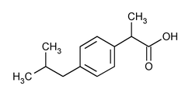  Figure 1a: Ibuprofen | 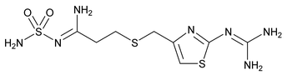  Figure 1b: Famotidine

Ibuprofen and Famotidine is a fixed-dose combination medication and sold in the market for the treatment of rheumatoid arthritis and osteoarthritis. A literature search regarding quantitative determination of the degradation products with stability indicating property to the combination dosage form of ibuprofen and famotidine simultaneously using RP-UPLC were not reported (14–21). However, the US Pharmacopoeia reported separately and listed few degradation products in the Ibuprofen Tablets and Famotidine Tablets [22-23] by using HPLC, monograph of the combined product containing the two active drugs are not included in the pharmacopoeias.

The present study involves to develop and validate a rapid, accurate and reliable stability indicating reverse phase ultra-performance liquid chromatographic (RP-UPLC) method for the quantitative determination of degradation products of Ibuprofen and Famotidine in the combined dosage form simultaneously. In this study, six impurities of Ibuprofen and eight impurities of Famotidine were used during the development of the stability indicating method. The method was validated in according to the International Conference on Harmonization (ICH) Q2(R2) and USP recommendations [24].

Five of ibuprofen impurities are Ibuprofen related compound J, Ibuprofen related compound N, Ibuprofen related compound C, Ibuprofen related compound A and Ibuprofen related compound O (Figure 2a). Two out of six impurities are process related, Ibuprofen related compound A and Ibuprofen related compound O and other four impurities are degradation products. Eight of Famotidine impurities (Figure 2b) are Famotidine Sulfoxide, Famotidine Related Compound A, Famotidine Related Compound B, Famotidine Related Compound C, Famotidine Related Compound D, Famotidine Related Compound E, Famotidine Related Compound F and Famotidine Related Compound G. Two out of eight impurities are process related, Famotidine Related Compound A, Famotidine Related Compound B and other six impurities are degradation products. All degradation products of Ibuprofen and Famotidine found to be increased during the stress and stability studies.

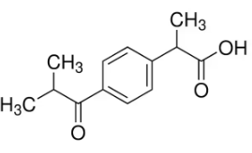  Ibuprofen related compound J  2-(4-Isobutyryl phenyl)-propionic  acid | 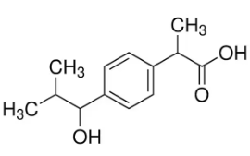  Ibuprofen related compound L  1-Hydroxyibuprofen, 2-[4-(1-Hydroxy-2-methylpropyl)phenyl]propionic acid
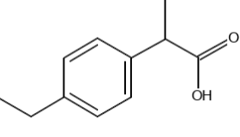  Ibuprofen related compound N  2-(4-Ethylphenyl) propionic acid | 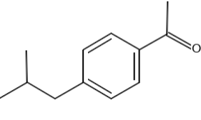  Ibuprofen related compound C  4’-Isobutylacetophenone
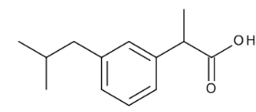  Ibuprofen related compound A  2-(3-Isobutylphenyl) propionic  acid | 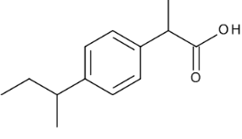  Ibuprofen related compound O  2-(4-Secbutylphneyl) propionic  Acid
Figure 2a: Chemical Structures of Ibuprofen Impurities

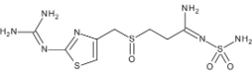  Famotidine Sulfoxide | 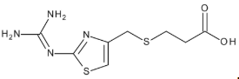  Famotidine Related Compound F
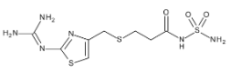  Famotidine Related Compound C | 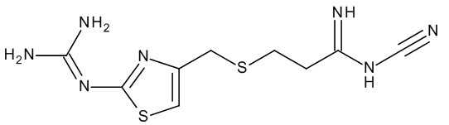  Famotidine Related Compound G
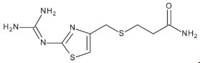  Famotidine Related Compound D | 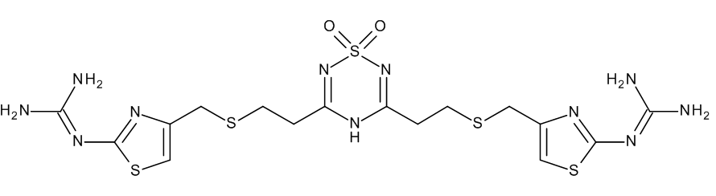  Famotidine Related Compound B
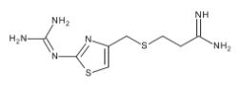  Famotidine Related Compound A | 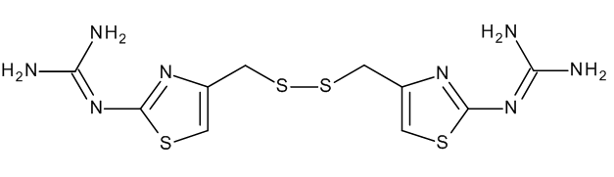  Famotidine Related Compound E
Figure 2b: Chemical Structures of Famotidine Impurities

Method development and optimization for stability indicating method:
The method development studies were conducted for effective and accurately differentiate the both active ingredients, ibuprofen and famotidine in the combined pharmaceutical dosage form, and their specified and unspecified degradation products by simultaneously in one stability indicating method. The method was optimized to separate degradation products formed during the forced degradation of different physicochemical properties of active ingredients in the drug product i.e. acidic ibuprofen and basic famotidine. Method development studies were started initially in isocratic and then gradient modes by using phosphate buffer with various pH’s 3, 5, 6 and organic modifiers like acetonitrile and methanol using various stationary phases like C18, C8, Phenyl, HILIC and CN to separate closely eluted peaks of Famotidine Impurity D to the Famotidine, Famotidine Impurity B to the Ibuprofen Impurity J but not achieved satisfactory separation between Famotidine Impurity D and Famotidine. Hence introduced acetate buffer with different pH of the buffer mobile phases using Acquity UPLC HSS T3 column. Better separation of all the degration products of Famotidine and Ibuprofen were achieved using Sodium Acetate Trihydrate buffer at pH 6.0 ± 0.1 with organic modifier acetonitrile in mobile phase “A” and “B” using Waters Acquity UPLC HSS T3, 30 x100 mm, 1.8 μm column at the flow rate was at 0.5 mL/minute. The final optimized experimental conditions provide the separation of all impurities and active substances in a short time of 40 minutes with stability indicating.

2. MATERIALS AND EXPERIMENTAL:

Reference Standards:
Ibuprofen (USP Reference Standard), Famotidine (USP Reference Standard), Ibuprofen impurity standards (USP and Sigma-Aldrich Pharmaceutical Secondary Standards) and Famotidine impurity standards (Toronto Research Chemicals and Molcan Corporation) were used throughout the experiments.

Chemicals and reagents:
Both solvents, Methanol, Acetonitrile were HPLC grade from Honeywell Chemicals and Sodium Acetate Trihydrate, Sodium Acetate anhydrous, Glacial Acetic acid and Triethylamine were ACS grade, and procured from Sigma-Aldrich. Water is from Milli-Q® Benchtop Lab Water Purification System.

Instrumentation:
The Waters Acquity UPLC H-Class system was used from Waters with UV-Visible detector and chromatographic data were collected and processed using Empower software.

Chromatographic Conditions:
Chromatographic separation was achieved using Acquity UPLC HSS T3, 30 x 100 mm, 1.8-μm column at 35°C column oven temperature. The mobile phase consisted of mobile phase “A” as buffer with 10 mM Sodium Acetate Trihydrate at pH 6.0 ± 0.1 and mobile phase “B” as mixture of buffer and acetonitrile in the ratio of 93:7, v/v. The mobile phase flow rate was maintained
at 0.5 mL/minute (gradient elution, Table-1). The injection volume is set at 5 μL and the analytes were detected at 265 nm with the total run time of 40 minutes.

Table-1: Gradient Conditions
Time (minutes) | Flow (mL/minute) | Mobile phase A (%) | Mobile phase B (%)
0.0 | 0.5 | 100 | 0
3.0 | 0.5 | 100 | 0
9.0 | 0.5 | 65 | 35
20.0 | 0.5 | 55 | 45
30.0 | 0.5 | 10 | 90
32.0 | 0.5 | 10 | 90
34.0 | 0.5 | 100 | 0
40.0 | 0.5 | 100 | 0

Diluent Preparation:
The diluent was prepared by mixing pH 5.5 buffer made with 0.5 M sodium acetate and 2 mL of trimethylamine and methanol in the ratio of 1:1, v/v.

Preparation of Standards Solution:
The standard solution was prepared containing Ibuprofen and Famotidine at 8 µg/mL and 0.0665 µg/mL respectively in diluent.

Preparation of Sensitivity Solution:
Ibuprofen and Famotidine sensitivity solution was prepared at 2 µg/mL and 0.0665 µg/mL respectively in diluent.

Preparation of Sample Solution:
Ten tablets were weighed and finely powdered. A quantity of powder equivalent to 26.6 mg of Famotidine and 800 mg of Ibuprofen was transferred in a 200 mL volumetric flask. To this flask, added 50 mL of diluent and the solution was sonicated for 15 minute with intermittent shaking. Made up the volume with diluent and centrifuged at 5,000 rpm for 10 minute.

Method Validation Study:
The stability indicating method was validated in terms of Specificity, Linearity, Limit of Detection, Limit of Quantitation, Accuracy, Precision (Repeatability and Ruggedness), Robustness and Solutions Stability (standard and sample solution).

Specificity:
Specificity is the ability to assess unequivocally the analyte in the presence of components that may be expected to be present, such as impurities, excipients or degradation products that present in the sample matrix. For selectivity of the method, prepared and injected mobile phase, diluent, each individual impurity solution, sensitivity solution, standard solution, placebo solution, drug Product sample solution and spiked drug product sample solution with all Famotidine and Ibuprofen impurities. The acceptance criteria were no interference should be observed due to diluent, mobile phase and placebo peaks at the retention time of any Impurity, Famotidine and Ibuprofen peaks and all Impurity peaks should be well separated from each other and from the Famotidine as well as Ibuprofen peaks with minimum USP resolution of not less than 1.2.

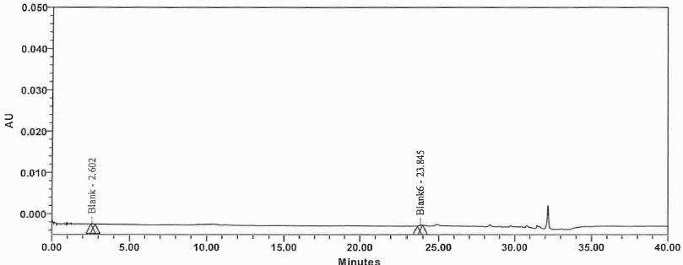
Figure 3a: Diluent Chromatogram
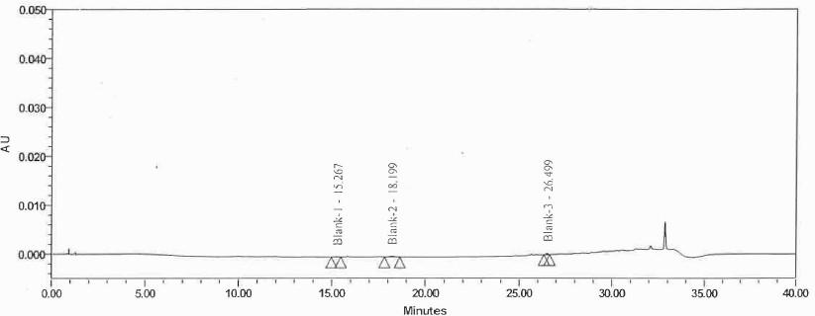
Figure 3b: Placebo Chromatogram
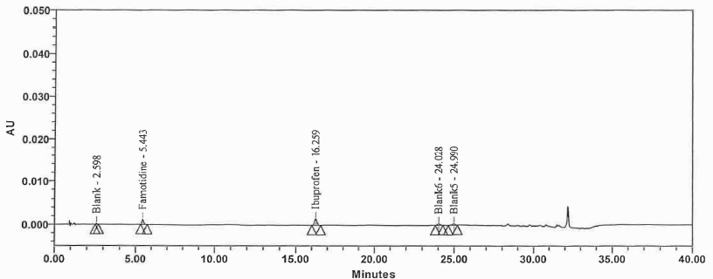
Figure 3c: Standard Chromatogram
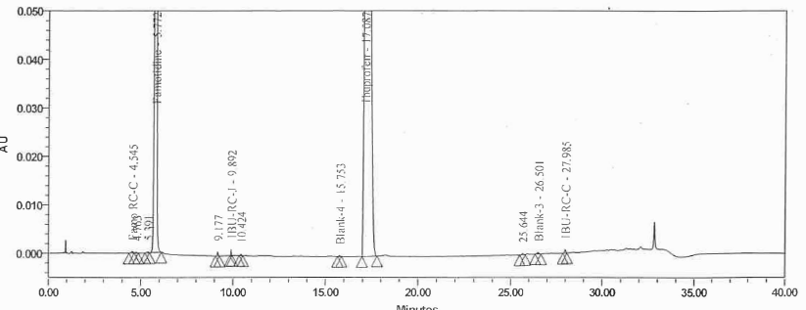
Figure 3d: Drug Product Sample Chromatogram

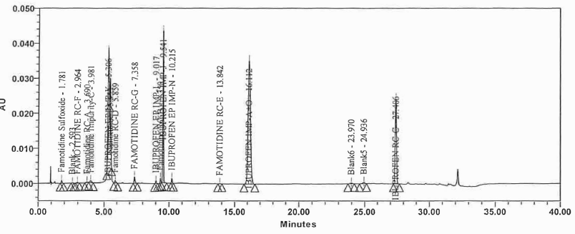
Figure 3e: Spiked Drug Product Sample Chromatogram

Forced Degradation:
The Forced degradation conditions were designed to result in approximately 5 to 20% degradation of the active pharmaceutical ingredients [25]. Overstressing the samples may generate irrelevant degradants which would never be seen in stability studies and under stressing may fail to generate degradants that may be generated in stability studies [26]. Forced degradation sample solutions, placebo, placebo with Famotidine, placebo with Ibuprofen and drug product samples were exposed for acidic (0.1 N HCl at 80°C for 1 hour), alkaline (0.5 N NaOH at 80°C for 1 hour), oxidation (5% H2O2 at 80°C for 1 hour), thermal (80°C for 3 days) and photolytic (1.2 million lux hours) conditions were prepared and injected into the chromatographic system. Calculated %impurity and total impurities of Famotidine and Ibuprofen at the end of the exposure times under each stress conditions.

Table 2a: Stress Study Results for Ibuprofen in the Drug Product
Stress condition | Ibuprofen Impurity C | Ibuprofen Impurity J | Ibuprofen Impurity L | Ibuprofen Impurity N | Ibuprofen Impurity K | Single Largest unknown Impurity | Total Impurities
Control | <LOQ | <LOQ | ND | ND | ND | ND | <LOQ
Acidic | <LOQ | <LOQ | 0.389 | <LOQ | <LOQ | ND | 0.389
Alkaline | <LOQ | 0.865 | ND | ND | <LOQ | ND | 0.865
Oxidation | 5.289 | 2.029 | 1.268 | <LOQ | <LOQ | ND | 6.586
Thermal | 1.265 | 0.529 | ND | <LOQ | <LOQ | 0.086 | 1.880
Photolytic | <LOQ | <LOQ | ND | ND | <LOQ | ND | <LOQ

Table 2b: Stress Study Results for Famotidine in the Drug Product:
Stress condition | Famotidine Impurity C | Famotidine Sulfoxide | Famotidine Impurity  D | Famotidine Impurity  E | Famotidine Impurity F | Famotidine Impurity  G | Single Largest Unknown Impurity | Total Impurities
Control | 0.082 | 0.148 | 0.075 | ND | ND | <LOQ | 0.068 | 0.373
Acidic | 1.562 | 0.262 | <LOQ | ND | ND | 0.956 | <LOQ | 2.780
Alkaline | 1.976 | 2.112 | 1.845 | ND | <LOQ | ND | ND | 5.927
Oxidation | <LOQ | 5.382 | <LOQ | ND | ND | 2.862 | 0.389 | 8.633
Thermal | 0.367 | 1.529 | ND | ND | ND | <LOQ | ND | 1.896
Photolytic | 0.098 | 0.168 | 1.386 | ND | ND | ND | <LOQ | 1.652

Linearity:
Prepared series of diluted solutions containing Famotidine and Ibuprofen, and their Famotidine related degradation products (impurity C, D, E, F, G and Famotidine Sulfoxide) and Ibuprofen related degradation products (Impurity C, J and N) at 6 different concentration levels. The acceptance criteria set were Correlation coefficient between concentrations should be not less than 0.99 and relative standard deviation of replicate injections at each level should be not more than 10.0%.

Table 3a: Linearity and Range Table for Famotidine and Related Degradation Products
Component | %Linearity Level (~) | Conc. (µg/mL) | Correlation coefficient
Famotidine | 0.05 | 0.067 | 0.9992
Famotidine | 0.10 | 0.133 | 0.9992
Famotidine | 0.25 | 0.333 | 0.9992
Famotidine | 0.50 | 0.665 | 0.9992
Famotidine | 1.00 | 1.330 | 0.9992
Famotidine Sulfoxide | 0.05 | 0.063 | 0.9995
Famotidine Sulfoxide | 0.10 | 0.124 | 0.9995
Famotidine Sulfoxide | 0.25 | 0.327 | 0.9995
Famotidine Sulfoxide | 0.50 | 0.658 | 0.9995
Famotidine Sulfoxide | 1.00 | 1.340 | 0.9995
Famotidine Impurity C | 0.05 | 0.065 | 0.9996
Famotidine Impurity C | 0.10 | 0.132 | 0.9996
Famotidine Impurity C | 0.25 | 0.326 | 0.9996
Famotidine Impurity C | 0.50 | 0.659 | 0.9996
Famotidine Impurity C | 1.00 | 1.340 | 0.9996
Famotidine Impurity D | 0.05 | 0.066 | 0.9997
Famotidine Impurity D | 0.10 | 0.129 | 0.9997
Famotidine Impurity D | 0.25 | 0.331 | 0.9997
Famotidine Impurity D | 0.50 | 0.662 | 0.9997
Famotidine Impurity D | 1.00 | 1.331 | 0.9997
Famotidine Impurity E | 0.05 | 0.067 | 0.9994
Famotidine Impurity E | 0.10 | 0.143 | 0.9994
Famotidine Impurity E | 0.25 | 0.339 | 0.9994
Famotidine Impurity E | 0.50 | 0.656 | 0.9994
Famotidine Impurity E | 1.00 | 1.331 | 0.9994
Famotidine Impurity F | 0.05 | 0.068 | 0.9999
Famotidine Impurity F | 0.10 | 0.131 | 0.9999
Famotidine Impurity F | 0.25 | 0.334 | 0.9999
Famotidine Impurity F | 0.50 | 0.662 | 0.9999
Famotidine Impurity F | 1.00 | 1.336 | 0.9999
Famotidine Impurity G | 0.05 | 0.067 | 0.9997
Famotidine Impurity G | 0.10 | 0.128 | 0.9997
Famotidine Impurity G | 0.25 | 0.334 | 0.9997
Famotidine Impurity G | 0.50 | 0.669 | 0.9997
Famotidine Impurity G | 1.00 | 1.336 | 0.9997

Table 3b: Linearity and Range Table for Ibuprofen and Impurities
Component | %Linearity Level (~) | Conc. (µg/mL) | Correlation coefficient
Ibuprofen | 0.05 | 2.008 | 0.9998
Ibuprofen | 0.10 | 4.016 | 0.9998
Ibuprofen | 0.15 | 5.877 | 0.9998
Ibuprofen | 0.25 | 9.879 | 0.9998
Ibuprofen | 0.50 | 20.082 | 0.9998
Ibuprofen Impurity C | 0.05 | 2.058 | 0.9999
Ibuprofen Impurity C | 0.10 | 4.020 | 0.9999
Ibuprofen Impurity C | 0.15 | 5.903 | 0.9999
Ibuprofen Impurity C | 0.25 | 10.780 | 0.9999
Ibuprofen Impurity C | 0.50 | 20.135 | 0.9999
Ibuprofen Impurity J | 0.05 | 2.012 | 0.9999
Ibuprofen Impurity J | 0.10 | 4.078 | 0.9999
Ibuprofen Impurity J | 0.15 | 5.963 | 0.9999
Ibuprofen Impurity J | 0.25 | 10.980 | 0.9999
Ibuprofen Impurity J | 0.50 | 20.075 | 0.9999
Ibuprofen Impurity L | 0.05 | 2.034 | 0.9999
Ibuprofen Impurity L | 0.10 | 4.008 | 0.9999
Ibuprofen Impurity L | 0.15 | 6.063 | 0.9999
Ibuprofen Impurity L | 0.25 | 10.223 | 0.9999
Ibuprofen Impurity L | 0.50 | 20.005 | 0.9999
Ibuprofen Impurity N | 0.05 | 1.986 | 0.9999
Ibuprofen Impurity N | 0.10 | 3.971 | 0.9999
Ibuprofen Impurity N | 0.15 | 5.962 | 0.9999
Ibuprofen Impurity N | 0.25 | 10.726 | 0.9999
Ibuprofen Impurity N | 0.50 | 20.022 | 0.9999
Ibuprofen Impurity K | 0.05 | 2.086 | 0.9998
Ibuprofen Impurity K | 0.10 | 4.076 | 0.9998
Ibuprofen Impurity K | 0.15 | 6.089 | 0.9998
Ibuprofen Impurity K | 0.25 | 10.083 | 0.9998
Ibuprofen Impurity K | 0.50 | 20.541 | 0.9998

Limit of Detection (LOD):
The Limit of Detection (LOD) for Famotidine and Ibuprofen, and its related degradation products were established on the basis of signal-to-noise (S/N) ratio. The signal-to-noise (S/N) ratio of each component should be not less than 3 and not more than 9.

Table 4a: LOD Results for Famotidine and related degradation products
Component | LOD Level (%) | Concentration (mg/mL) | S/N (Average)
Famotidine | 0.02 | 2 × 10⁻² | 5.6
Famotidine Sulfoxide | 0.02 | 2 × 10⁻² | 6.6
Famotidine Impurity C | 0.02 | 2 × 10⁻² | 4.0
Famotidine Impurity D | 0.02 | 2 × 10⁻² | 4.8
Famotidine Impurity E | 0.02 | 2 × 10⁻² | 4.3
Famotidine Impurity F | 0.02 | 2 × 10⁻² | 5.5
Famotidine Impurity G | 0.02 | 2 × 10⁻² | 3.9

Table 4b: LOD Results for Ibuprofen and related degradation products
Component | LOD Level (%) | Concentration (µg/mL) | S/N (Average)
Ibuprofen | 0.005 | 2.0 × 10⁻¹ | 5.4
Ibuprofen Impurity C | 0.000025 | 1.0 × 10⁻³ | 4.8
Ibuprofen Impurity J | 0.000025 | 1.0 × 10⁻³ | 6.2
Ibuprofen Impurity L | 0.015 | 6.3 × 10⁻¹ | 3.9
Ibuprofen Impurity N | 0.015 | 6.0 × 10⁻¹ | 7.1
Ibuprofen Impurity K | 0.00125 | 5.1 × 10⁻² | 4.5

Limit of Quantitation (LOQ):
The Limit of Quantitation (LOQ) for Famotidine and Ibuprofen, and its related degradation products were established on the basis of signal-to-noise (S/N) ratio. The signal-to-noise (S/N) ratio of each component should be not less than 10 and relative standard deviation should be not more than 10%.

Table 5a: LOQ Results for Famotidine and related degradation products:
Component | LOQ Level (%) | Concentration (µg/mL) | Peak Area | %RSD | S/N
Famotidine | 0.05 | 6.65 × 10⁻² | 757 | 2.2 | 16.3
Famotidine Sulfoxide | 0.05 | 5.97 × 10⁻² | 473 | 9.2 | 24.0
Famotidine Impurity C | 0.05 | 5.87 × 10⁻² | 962 | 5.3 | 19.8
Famotidine Impurity D | 0.05 | 6.26 × 10⁻² | 1003 | 7.1 | 18.8
Famotidine Impurity E | 0.05 | 6.97 × 10⁻² | 807 | 3.8 | 17.7
Famotidine Impurity F | 0.05 | 6.68 × 10⁻² | 1151 | 8.3 | 19.8
Famotidine Impurity G | 0.05 | 6.31 × 10⁻² | 912 | 1.9 | 17.4

Table 5b: LOQ Results for Ibuprofen and related degradation products:
Component | LOQ Level (%) | Concentration (µg/mL) | Peak Area | %RSD | S/N
Ibuprofen | 0.05 | 2.008 | 2336 | 4.6 | 15.9
Ibuprofen Impurity C | 0.0125 | 0.497 | 8437 | 1.4 | 21.5
Ibuprofen Impurity J | 0.0125 | 0.486 | 2947 | 0.9 | 23.7
Ibuprofen Impurity L | 0.05 | 2.535 | 2189 | 2.8 | 17.9
Ibuprofen Impurity N | 0.05 | 2.398 | 1841 | 5.9 | 24.4
Ibuprofen Impurity K | 0.0125 | 0.496 | 3686 | 3.2 | 19.8

Accuracy:
The Accuracy solutions were prepared in triplicate by spiking related degradation impurities to the drug product from 0.05% to 0.75% concentration levels for Famotidine Impurities and from 0.05% to 0.3% concentration levels for Ibuprofen impurities.

Table 6a: Accuracy Results for Famotidine related degradation products:
Accuracy Level | Famotidine Sulfoxide | Famotidine Impurity C | Famotidine Impurity D | Famotidine Impurity E | Famotidine Impurity F | Famotidine Impurity G
0.05%-1 | 96.3 | 95.1 | 93.6 | 103.1 | 101.8 | 102.0
0.05%-2 | 92.4 | 98.6 | 107.8 | 98.9 | 96.5 | 107.1
0.05%-3 | 95.5 | 103.0 | 93.1 | 101.4 | 99.2 | 103.5
0.5%-1 | 102.1 | 100.3 | 94.8 | 98.8 | 102.9 | 97.5
0.5%-2 | 104.7 | 101.1 | 93.7 | 96.7 | 102.1 | 98.6
0.5%-3 | 102.8 | 100.9 | 93.0 | 95.8 | 101.8 | 99.6
0.75%-1 | 104.2 | 99.2 | 98.6 | 101.5 | 104.8 | 98.1
0.75%-2 | 103.8 | 96.4 | 98.6 | 100.3 | 103.9 | 97.4
0.75%-3 | 103.1 | 98.9 | 96.4 | 99.3 | 104.4 | 97.1
SD | 4.54 | 2.43 | 4.75 | 2.33 | 2.63 | 3.43
RSD | 4.52 | 2.45 | 4.92 | 2.34 | 2.58 | 3.42

Table 6b: Accuracy Results for Ibuprofen related degradation products:
Accuracy Level | Ibuprofen Impurity C | Ibuprofen Impurity J | Ibuprofen Impurity L | Ibuprofen Impurity N | Ibuprofen Impurity K
0.05%-1 | 95.92 | 103.51 | 97.18 | 94.47 | 99.61
0.05%-2 | 98.85 | 101.84 | 94.39 | 99.29 | 100.13
0.05%-3 | 96.81 | 102.8 | 96.92 | 98.29 | 102.3
0.15%-1 | 101.89 | 97.23 | 98.33 | 95.48 | 101.1
0.15%-2 | 102.84 | 98.07 | 95.7 | 99.58 | 102.6
0.15%-3 | 104.63 | 105.14 | 99.34 | 97.76 | 101.71
0.25%-1 | 103.88 | 98.97 | 98.07 | 100.16 | 99.6
0.25%-2 | 103.01 | 98.4 | 97.97 | 96.63 | 100.74
0.25%-3 | 103.27 | 98.03 | 99.05 | 98.52 | 102.07
SD | 3.21 | 2.90 | 1.59 | 1.92 | 1.15
RSD | 3.17 | 2.88 | 1.64 | 1.97 | 1.14

Precision:
The Precision of method was evaluated by preparing and analyzing the standard solution and six replicate drug product sample solutions spiked with all Famotidine and Ibuprofen degradation impurities. The acceptance criteria set for system precision (standard solution) was theoretical plates for Famotidine and Ibuprofen peaks should be not less than 2000, Tailing factor peaks should be not more than 2.0 and relative standard deviation of Famotidine and Ibuprofen peaks from six replicate of injection should be NMT 5%. The Repeatability and intermediate precision were used to evaluated the method precision. The acceptance criteria set for method precision (sample solution, analyst 1) was relative standard deviation of individual % of impurities from the six sample preparations should be not more than 10.0%. The acceptance criteria set for Intermediate precision was relative standard deviation of individual % all specified impurities from both the chemists should be not more than 10.0% and Relative difference between mean impurities of two analysts should be not more than 20.0%.

Table 7: Precision Results for Ibuprofen related degradation products:
Impurity Name | %Relative Standard Deviation (n=6 samples) |  | Overall %RSD (Analyst 1 & 2) | Relative Difference between Analyst 1 & 2
Impurity Name | Method Precision (Repeatability) | Intermediate Precision | Overall %RSD (Analyst 1 & 2) | Relative Difference between Analyst 1 & 2
Sulfoxide | 1.8 | 1.3 | 3.0 | 4.8
Impurity C | 3.14 | 8.4 | 4.7 | 7.7
Impurity D | 1.45 | 3.7 | 3.3 | 4.4
Famotidine Impurity E | 3.64 | 2.5 | 6.9 | 6.5
Famotidine Impurity F | 1.28 | 5.8 | 6.5 | 3.6
Famotidine Impurity G | 1.36 | 1.7 | 1.6 | 1.9
Ibuprofen Impurity C | 2.9 | 5.0 | 2.0 | 2.7
Ibuprofen Impurity J | 1.9 | 6.7 | 3.4 | 2.6
Ibuprofen Impurity L | 3.6 | 5.1 | 1.7 | 1.4
Ibuprofen Impurity N | 2.9 | 3.2 | 3.4 | 5.9
Ibuprofen Impurity K | 5.6 | 4.8 | 1.32 | 1.6

Robustness:
To demonstrate robustness of method, standard and spiked solution analyses were performed by changing chromatographic conditions and mobile phase composition. The robustness of the developed method was established by changing the column temperature +5°C, mobile phase flow rate +0.05 mL/minute, altering mobile phase “A” and “B” composition with +5% of aqueous and +5% organic, altering buffer pH to +0.1 units. Robustness results should meet the system suitability criteria (Tailing Factor is NMT 2.0 and %RSD is NMT 5.0%) for standard injections and resolution criteria between closest eluting peaks in the spiked sample solution should be not less than 1.2 for each changed parameter.

Table 8: Robustness Results:
Robustness Condition | Ibuprofen |  | Famotidine
Robustness Condition | Retention time | Tailing factor | Retention time | Tailing factor
Normal | 18.965 | 1.1 | 5.353 | 1.0
Column Temp. 30°C | 17.733 | 0.8 | 5.866 | 1.0
Column Temp. 40°C | 16.851 | 0.8 | 5.527 | 0.9
Flow rate 0.45 mL/min | 18.095 | 0.8 | 5.881 | 0.98
Flow rate 0.55 mL/min | 16.899 | 0.8 | 5.529 | 0.9
Buffer pH 5.9 | 18.615 | 1.1 | 5.068 | 1.0
Buffer pH 6.1 | 19.284 | 1.1 | 5.791 | 0.9
-5% Aqueous in mobile phase A | 18.891 | 1.0 | 5.207 | 0.9
+5% Aqueous in mobile phase A | 16.832 | 1.1 | 5.909 | 1.0
-5% Organic in mobile phase A | 19.292 | 1.1 | 5.676 | 0.9
+5% Organic in mobile phase A | 19.395 | 1.1 | 5.763 | 0.9
-5% Aqueous in mobile phase B | 17.266 | 0.8 | 5.715 | 0.9
+5% Aqueous in mobile phase B | 17.276 | 0.8 | 5.727 | 0.9
-5% ACN in mobile phase B | 17.577 | 0.8 | 5.734 | 1.0
+5% ACN in mobile phase B | 16.974 | 0.8 | 5.691 | 0.9
-5% MeOH in mobile phase B | 17.614 | 0.8 | 5.761 | 1.0
+5% MeOH in mobile phase B | 17.504 | 0.8 | 5.737 | 1.0

Solution Stability:
Standard and Spiked Drug Product Sample solution with all Famotidine and Ibuprofen related degradation products were prepared and analyzed at initial after storage at room temperature for 24 hours and 48 h intervals. The acceptance criteria set +5.0% of the initial value for the standard solution and % relative difference of known impurities should not differ by 25% from initial value and unknown impurities generated should not differ by 0.05% from initial value.
Table 9a: Standard solution stability results:
Time | Ibuprofen |  | Famotidine
Time | Assay (%) | Absolute Difference (%) | Assay (%) | Absolute Difference (%)
Initial | 101.1 | n/a | 98.8 | n/a
24 hours | 99.3 | 1.8 | 100.5 | 1.7
48 hours | 99.4 | 1.7 | 99.0 | 0.2

Table 9b: Sample solution stability results:
Impurity Name | %Relative Difference from Initial
Impurity Name | 24 hours | 48 hours
Famotidine Sulfoxide | 5.8 | 8.8
Famotidine Impurity C | 6.7 | 8.4
Famotidine Impurity D | 4.8 | 3.7
Famotidine Impurity E | 3.5 | 2.5
Famotidine Impurity F | 3.8 | 5.8
Famotidine Impurity G | 1.9 | 1.7
Ibuprofen Impurity C | 2.9 | 5.0
Ibuprofen Impurity J | 1.9 | 6.7
Ibuprofen Impurity L | 3.6 | 5.1
Ibuprofen Impurity N | 2.9 | 3.2
Ibuprofen Impurity K | 5.6 | 4.8

Method validation:
Method validation studies were performed on the finally optimized stability indicating RP-UPLC method in according to the International Conference on Harmonization (ICH) Q2(R2) and USP recommendations. The validation parameters such as System Suitability, Specificity, Linearity, Accuracy, Limit of quantitation, Limit of Detection, Precision (Repeatability and Ruggedness), Solutions stability and Robustness.

3. RESULTS AND DISCUSSION:

Speciﬁcity:
Based on the Specificity Study results, no interference was observed due to diluent and Placebo peaks at the retention time of degradation Impurities, and Famotidine and Ibuprofen peaks. All Impurity peaks were well separated from each other and from the Famotidine as well as Ibuprofen peaks (Fig. 3a thru 3c). The System suitability parameters were met the acceptance criteria. The developed method was specific and selective for the quantitation of degradation products of Ibuprofen and Famotidine in the drug Product.

Forced Degradation:
Forced Degradation studies were performed on combination drug product to prove the stability indicating method. All the impurities as well as degradation product (s) generated by induced
forced degradation were well separated from the Famotidine and Ibuprofen peaks, demonstrating that the method can detect any degradation products formed during the forced degradation studies (Tables 2a and 2b). Hence, the method was considered as stability indicating.
Linearity:
The linearity was established from 0.05% to 0.5% of the nominal concentration of Ibuprofen and its related degradation products, and 0.05% to 1.0% of the nominal concentration of Famotidine and its related degradation products. Correlation coefficient between concentrations and areas were greater than 0.99 for all components and results were presented in Tables 3a and 3b.

Limit of Detection (LOD) and Limit of Quantitation (LOQ):
The method sensitivity was represented by LOD and LOQ values of ibuprofen, famotidine and their impurities. The Signal to Noise ratio values of all components from the LOD injections were within the acceptance criteria, refer Tablets 4a and 4b for results. The %RSD and Signal to Noise ratio values of all components from the LOQ injections were within the acceptance criteria, refer Tablets 5a and 5b for results.

Accuracy:
For all components at each level, the recovery values were between 92.4% and 107.1%. The results were consistent with the theoretical values and confirming the accuracy of the proposed method (Table 6a and 6b). Hence it was concluded that the developed and validated test method was accurate from 0.05% to 0.75% of nominal sample concentration for Famotidine degradation products and 0.05% to 0.25% nominal sample concentration for Ibuprofen degradation products.

Precision:
The %RSD values of Famotidine and Ibuprofen peaks obtained from six replicate injections of standard solution were well within the acceptance criteria. The %RSD of each degradation impurities within analyst, and %RSD and %Relative difference of each degradation impurities between 2 analysts (repeatability and intermediate precision) were not greater than 10.0% (Table 7) which demonstrates the method was precise.

Robustness:
From the robustness results, it was concluded that the method was robust in all the deliberate varied chromatographic conditions (Flow rate, Column temperature, mobile phase composition (aqueous and organic variation) and pH of the buffer (Table 8).

Solutions Stability:
From stability of the solutions analysis results, it was demonstrated that standard and spiked sample solutions were stable at room temperature for up to 48 hours at room temperature (Table 9a and 9b).

4. CONCLUSION
A rapid, accurate and reliable stability indicating RP-UPLC method for the simultaneous quantitative determination of degradation products of ibuprofen and famotidine in the combined dosage form was developed. The method validation was completed by performing specificity, linearity, LOD, LOQ, precision, accuracy, robustness and solutions stability parameters. As a result, six impurities belonging to Ibuprofen (Impurity C, Impurity J, Impurity L, Impurity N and Impurity K) and eight impurities belonging to Famotidine (Sulfoxide, Impurity C, Impurity D, Impurity E, Impurity F and Impurity G) were used in the development studies of the stability indicating method and was validated according to the ICH guideline Q2(R2). An analytical method containing degradation products with stability indicating property belonging to the combined drug product of ibuprofen and famotidine by using reverse phase ultra-performance liquid chromatographic (RP-UPLC) method is not available in the literature and this situation constitutes the originality of our study. The method can be used for determination of impurities testing at release and stability studies of the pharmaceutical combined dosage form.

REFERENCES:

- Rang, H.P., Dale, M.M., Ritter, J.M., Moore, P.K.; Pharmacology. Churchill Livingstone, Edinburgh, (2003)
- Bushra, R., Aslam, N.; An overview of clinical pharmacology of ibuprofen; Oman Medical Journal, (2010); 25: 155–161. https:// doi.org/10.5001/omj.2010.49
- O’Neil,M.J.;TheMerckindex:Anencyclopedia of chemicals, drugs,andbiologicals:Diphenyl,Vol13Merck&Co.,Inc.,WhitehouseStation,N.J.,(2001).
- Moffat,A.C.,Widdop,B.,Clarke,E.G.;Clarke’sanalysis of drugs and poisonsin pharmaceuticals;InternationalJournalofToxicol-ogy,(2004);3:533.PharmaceuticalPress:Cornwall,UK.
- Mukherjee, R., Bhattacharya, A., Bojkova, D., Mehdipour, A.R., Shin, D., Khan, K.S., et al.; Famotidine inhibits toll-like receptor 3- mediated inflammatory signaling in SARS-CoV-2 infection; Journal of Biological Chemistry, (2021); 297: 100925. https://doi.o rg/10.1016/j.jbc.2021.100925.
- Humphries T.J. and Merritt G.J., Review article: drug interactions with agents used to treat acid related diseases, Aliment. Pharmacol. Ther., 13, 18-26 (1999)
- Yasufumi H., Isao Y., Yoshi I. and Shinichi T., Guanidinothiazole compounds, process for preparation and gastric inhibiting compositions containing them, US Patent No. 4283408, (1981)
- Smith J.L., Clinical pharmacology of Famotidine, Digestion, 32, 15-23 (1985)
- Reynolds J.C., Famotidine therapy for active duodenal ulcers, A multivariate analysis of factors affecting early healing, Annals of Internal Medicine, 111, 7-14 (1989)
- Taha A.S., Laine L.A. and Grahn A., Reducing the incidence of peptic ulcers with Ibuprofen-Famotidine combined pill, HZT-501 (reduce): phase-III, double-blind multi-centre trials, Gut, 60, A8-A9 (2011)
- M. J. O’Neil, The Merck Index, Merck & Co., Whitehouse Station, NJ, USA, 13th edition, 2001.
- A. C. Moffat, M. D. Osselton, B. Widdop, and E. G. Clarke, Clarke’s, Analysis of Drugs and Poisons in Pharmceuticals, Pharmaceutical Press, Cornwall, UK, 3rd edition, 2004.
- Han, Z., Lu, L., Wang, L., Yan, Z., Wang, X.; Development and validation of an HPLC method for simultaneous determination of ibuprofen and 17 related compounds; Chromatographia, (2017); 80: 1353–1360. https://doi.org/10.1007/s10337-017-3358-3.
- Radi, M., Ramli, Y., Karbane, M., Elalami, A., Karrouchi, K., Bekkali, A., et al.; Optimization and validation of a method for determination of ibuprofen by HPLC in different pharmaceutical forms: Tablet, syrup, gel and suppository; Journal of Chemical and Pharmaceutical Research, (2014); 6: 301–304.
- Alsirawan, M.B., Mohammad, M., Al-kasmi, B., Alhareth, K., El- Hammadi, M.; Development and validation of a simple HPLC method for the determination of ibuprofen sticking onto punch faces; International Journal of Pharmacy and Pharmaceutical Sci- ences, (2013); 5: 227–231.
- Nita, A., Tit, D.M., Copolovici, L., Melinte, C.E., Copolovici, D.M., Bungau, S., et al.; HPLC-UV method for determination of famoti- dine from pharmaceutical products; Revista de Chimie (Bucharest), (2018); 69: 297–299. https://doi.org/10.37358/RC.18.2.6093.
- Reddy, Y.R., Kumar, K.K., Reddy, M.R.P., Mukkanti, K.; RP- UPLC method development and validation for the simultaneous estimation of ibuprofen and famotidine in pharmaceutical dosage form; Pharmaceutical Methods, (2012); 3: 57–61. https://doi.o rg/10.4103/2229-4708.103873.
- Helali N, Tran NT, Monser L, Taverna M. Capillary zone electrophoresis method for the determination of famotidine and related impurities in pharmaceuticals. Talanta 2008; 74: 694-8
- Sajid Husain, Sara Khalid, Nagaraju V, Nageswara Rao R. Highperformance liquid chromatographic separation and determination of small amounts of process impurities of famotidine in bulk drugs and formulations. J Chromatogr A 1996; 743: 328-34.
- Beaulieu N, Graham SJ, Sears RW, Lovering EG. Validation of a method for the assay of related compounds in famotidine raw materials and formulations Original Research Article. J Pharm Biomed Anal 1989; 7: 1705-9.
- Helali N., Darghouth F. and Monser L., RP-HPLC: Determination of Famotidine and its potential impurities in pharmaceuticals, Chromatographia, 60, 455-460 (2000).
- USP Monograph for Famotidine Tablets
- USP Monograph for Ibuprofen Tablets
- ICH Harmonized Guideline: Validation of Analytical Procedures Q2(R2)
- Alsante K.M., Ando A., Brown R., Ensing J., Hatajik T.D., Kong W. and Tsuda Y., The role of degradant profiling in active pharmaceutical ingredients and drug products, Adv. Drug Deliv. Rev., 59, 29-37, (2007)
- Ruan J., Tattersall P., Lozano R. and Shah P., The role of forced degradation studies in stability indicating HPLC method development, Am. Pharmaceut. Rev., 9, 46-53, (2009)

