Analyzing the Impact of Power outages on firm Productivity in Sub-Saharan Africa: A Two-Stage Least Square Approach

Abstract
Reliable electricity is vital for firm productivity and broader economic growth; however, power outages remain a persistent obstacle in Sub-Saharan Africa (SSA). This study uses firm-level data from the World Bank Enterprise Surveys to investigate the causal impact of power outages on firm productivity. A Two-Stage Least Squares (2SLS) regression model addresses potential endogeneity, using the percentage of electricity sourced from generators as an instrumental variable. Focusing on four SSA countries—Chad, Gambia, Togo, and Eswatini—the analysis finds that a 1% increase in power outages results in approximately a 6% decline in firm productivity. The study uncovers notable disparities, with smaller firms suffering greater productivity losses due to limited financial resources and inadequate backup power solutions. Industry-level impacts are relatively uniform, although the construction sector is slightly more affected. Country-level comparisons reveal that firms in Chad and Gambia experience severe productivity declines than those in Eswatini and Togo, underlining the influence of national energy policies and infrastructure quality. To address these challenges, the study recommends that policymakers invest in electricity infrastructure, enhance grid reliability, integrate renewable energy, and modernize distribution systems. Additionally, offering financial support and low-interest credit can empower small and medium-sized enterprises (SMEs) to adopt alternative energy sources such as solar power and battery storage.
JEL Codes: L94, D22, Q4, 012, C38
Keywords: Power outages, Firm Productivity, Sub-Saharan Africa, Energy Reliability, Economic Development, Electricity Infrastructure.

INTRODUCTION
Access to reliable electricity is a fundamental driver of economic growth and firm productivity, yet power outages remain a persistent challenge in Sub-Saharan Africa (SSA). Frequent and prolonged electricity disruptions hinder business operations, reduce production efficiency, and increase operational costs, ultimately affecting firm performance and economic development(Avordeh et al., 2024). According to (Mensah, n.d.), firms in Sub-Saharan Africa faces significant productivity losses due to unreliable electricity supply, often resort to costly self-generation solutions such as diesel generators, which further strain financial resources. Despite various policy interventions aimed at improving electricity infrastructure, the region continues to experience high levels of energy insecurity, making it crucial to explore innovative solutions for understanding and mitigating the impact of power outages. Understanding the determinants of firm performance is a fundamental topic in economics and business research. Firm size, measured by the number of employees, is often considered a critical factor influencing revenue generation. Larger firms typically enjoy economies of scale, market power, and better access to financial resources, which theoretically should lead to higher sales revenue. Conversely, external factors such as infrastructure reliability, particularly access to stable electricity, may also play a role in determining firm success. Power outages can disrupt production, increase operational costs, and reduce output, potentially leading to lower revenue. Due to this, we did an empirical analysis is to ascertain the causal effect of firm productivity due to power outages using two-stage least square approach.

1.1 Background and Context
The relationship between electricity reliability and firm productivity is a vital topic widely discussed in the literature. Theoretically, the Solow Growth Model (Solow, 1956) and the Cobb-Douglas Production Function provide a framework for analyzing how infrastructure deficiencies, such as unreliable electricity, affect output by constraining capital and labor efficiency(Hasanov & Mikayilov, 2021). Power outages disrupt production processes, leading to increased downtime, higher costs of self-generation, and lower overall firm productivity, as opined by(Mensah, n.d.). Additionally, the concept of Total Factor Productivity (TFP) highlights the role of technological efficiency in mitigating productivity losses caused by electricity shortages. Several studies have examined the impact of power outages on firm performance. Mensah (2016) utilized an instrumental variable (IV) approach to address endogeneity issues related to electricity self-generation and found that firms experiencing frequent outages suffer significant revenue losses. Similarly, (Abotsi, 2016) applied stochastic frontier analysis (SFA) to measure inefficiencies caused by unreliable power supply, concluding that firms operating in regions with stable electricity outperform those in outage-prone areas. Other empirical studies such as Fakih et al(2020) have used fixed effects and difference-in-differences (DID) methods to compare firms before and after major outages, showing that power interruptions significantly reduce firm productivity and competitiveness.

Despite extensive research on the relationship between electricity supply and firm performance, several gaps persist in the literature. A major limitation is the reliance on low-frequency data, often annual firm surveys, which fail to capture short-term fluctuations in productivity resulting from power outages. Furthermore, many studies rely on traditional econometric models without adequately addressing endogeneity concerns, which is critical when assessing causality. For example, firms that face frequent power outages may invest in backup generators, making it difficult to isolate the true effect of outages on productivity. In addition, much of the existing literature lacks industry-specific insights, instead focusing on aggregated firm-level data, which obscures the heterogeneous impacts across sectors. Given these gaps, this study aims to contribute to the existing literature by examining the causal impact of power outages on firm productivity in Sub-Saharan Africa (SSA), using a Two-Stage Least Squares (2SLS) regression model. By leveraging firm-level data and applying an instrumental variable approach specifically, this research addresses endogeneity and provides more credible estimates of the effect of power disruptions on the percentage of electricity derived from generators. This methodology allows us to control for unobserved heterogeneity at both the firm and country levels, offering a more accurate understanding of the productivity implications of unreliable electricity(Osei-Gyebi & Dramani, 2023).
1.2 Problem Description
Electricity is a fundamental driver of economic development, enabling firms to produce efficiently, generate revenue, and expand operations. However, frequent and prolonged power outages remain a pervasive challenge across many SSA countries, disrupting business activities and impeding economic growth. This study analyzes the causal relationship between power outages and firm productivity, measured as total annual sales per employee. A core methodological challenge is the issue of endogeneity—power outages may correlate with factors like firm size, location, or access to finance. To address this, the study employs a 2SLS approach, using the percentage of electricity from generators as an instrumental variable, given that firms relying heavily on generators typically experience unstable grid power.
1.3 Objectives and Goals
The primary objective of this research is to evaluate the causal impact of power outages on firm productivity in SSA using an econometric approach that accounts for endogeneity. The specific goals of the study are as follows:
Firstly, to establish the causal relationship between power outages and firm productivity using a Two-Stage Least Squares (2SLS) regression framework.
Secondly, to analyze how firm size and industry sector influence the degree to which firms are affected by power outages. To offer evidence-based policy recommendations for improving electricity reliability and financial accessibility to help firms build resilience against power disruptions and drive sustainable growth.
1.4 Contribution and Limitations
This study contributes to the literature by addressing endogeneity in estimating the impact of electricity disruptions on productivity and by offering sector-level insights that are often overlooked. The findings are intended to inform policy on infrastructure investment and private sector support. However, two key limitations should be noted. First, annual data were not consistently available for all countries, limiting the temporal depth of analysis. Second, the study is confined to four countries, which may affect the generalizability of the results. Future research should expand the scope to include more countries and higher-frequency data to enhance regional applicability.
2. LITERATURE REVIEW
The literature on electricity unreliability and firm productivity in Sub-Saharan Africa spans a range of methodological approaches and regional contexts. To contextualize and support this study, the table below summarizes key contributions from selected authors whose work aligns with the present focus on estimating the causal impact of power outages using Two-Stage Least Squares (2SLS). Each entry outlines the study’s methodology, core findings, associated challenges, and its specific relevance to this research.
List 1 : Synthesis of Literature on the Impact of Electricity Reliability on Firm Productivity and Efficiency
Authors | Methodology used | Key Findings | Challenges Identified | Contribution to current study
Abotsi( 2016) | Stochastic Frontier  Analysis | Electricity outages reduce productivity efficiency in Ghana and Nigeria. | Limited data granularity and inability to account for all firm characteristics. | Provides foundational understanding of productivity efficiency and supports use of frontier methods
Cissokho & Seck(2013) | Data Envelopment Analysis | Power outages negatively affect scale efficiency and long-term growth of firms. | Difficulty in isolating long-term effects and accessing firm-level financing data. | Highlights SME vulnerability and supports the inclusion of firm size as a key variable.
(Mensah, n.d.) | Instrumental variable technique | A 1% increase in outage severity reduces productivity by 1.1%, with SMEs most affected. | Endogeneity concerns and lack of sectoral  Breakdown | Justifies the use of IV techniques and strengthens the choice of 2SLS for causal inference.
(Blimpo & Cosgrove-Davies, n.d.) | Firm-level empirical analysis | Unreliable electricity reduces investment, output, and employment. | Broad macro-level approach without firm-specific detail. | Supports the macroeconomic importance of electricity reliability, reinforcing the study's policy
(Fakih et al., 2020) | Two-Stage Least Squares | Power outages significantly reduce firm output, especially in high-tech and industrial sectors. | Instrument validity and generalizability across countries. | Demonstrates practical application of 2SLS with valid instruments, validating methodology for current study.
(Cole et al., 2018) | Comparative firm analysis | Large firms cope better due to generator access; small firms face greater production losses. | Uneven data quality and access to firm-specific operational details. | Informs firm-level heterogeneity discussion and supports disaggregation by firm size.
Somuah&Jayswal(2025) | Two -stage least square | 1% increase in the number of power outages leads to 6% decline in productivity | Data harmonization across countries and control for firm heterogeneity. | Utilizes a Two-Stage Least Squares (2SLS) approach in a Sub-Saharan African context, incorporating data from four countries while controlling for sectoral and firm-level characteristics

ECONOMIC THEORY.
This study is grounded in endogenous growth theory, which highlights infrastructure as a crucial driver of productivity and long-term economic growth (Barro, 1990; Romer, 1990). To formalize this relationship, we augment the traditional Cobb-Douglas production function by incorporating infrastructure as a productive input.
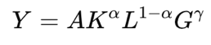

where Y represents firm output (measured in productivity), K is capital, L is labor, A is total factor productivity, and G denotes infrastructure in this case, parameter γ>0 captures the elasticity of output with respect to infrastructure. In this framework, frequent power outages reduce the effective infrastructure input G, thereby lowering output. Differentiating the log-transformed function with respect to time yields:
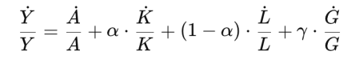
This expression shows that the growth rate of output is positively associated with infrastructure growth. When firms face electricity unreliability. G/G declines, thus dragging down firm output. Our instrumental variables (IV) regression empirically supports this theory. We find that a 1% increase in power outages is associated with an approximate 6% unit decrease in productivity, statistically significant at the 5% level. This suggests that frequent outages materially reduce firm output. Given that productivity is measured as the logarithm of annual sales per full-time employee, the negative elasticity estimate highlights the economic cost of infrastructure failure.

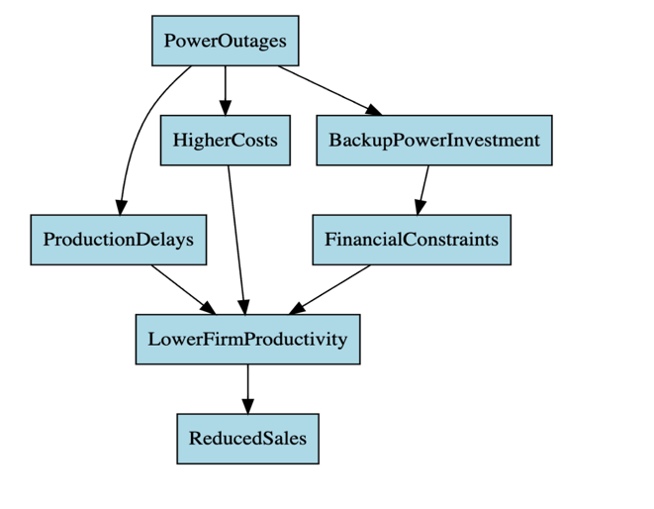
Conceptual Framework: Pathways Linking Power Outages to Firm Productivity:
Flow chart 1 - Conceptual framework

The above flowchart (Fig 1) illustrates the avenues through which power outages influence firm productivity. Power outages directly influence production delays and necessitate investment in backup power at a cost. These elements raise the operational cost and can place financial constraints, especially on small and medium businesses. Higher costs and delays reduce productivity, and therefore, can lead to lower sales. This framework guides our empirical strategy by mapping out the direct and indirect effects of unreliable electricity supply on firm performance.

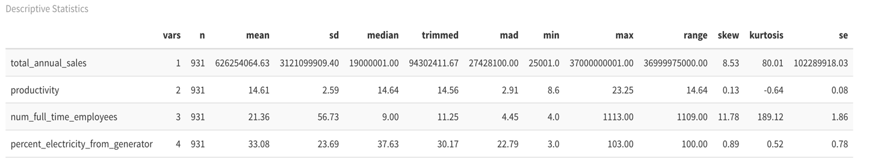
2.1.Data Analysis and Insights
Table 1: Descriptive statistics in a Table
Table 1 contains descriptive statistics of the key variables in our empirical examination of the power outage impact on firm productivity. Our sample contains 931 firms. Firms in our sample have a mean annual total sale of approximately $62.6 million, with a heavily skewed distribution (skewness = 8.53) and extreme kurtosis, implying the presence of a couple of extremely large firms. The average level of productivity is 14.61, and the skewness is relatively low (0.13), suggesting a distribution that is closer to symmetric. We can also observe that there is considerable volatility in firm size. While the average number of full-time employees is 21, the standard deviation is 56.73, and the skewness is 11.78, suggesting there are some large employers in our sample. On average, firms receive about 33% of their electricity from generators, with values ranging from 3% to 103%, indicating substantial variation in generator reliance. The fact that some firms report more than 100% may reflect measurement irregularities or overcompensation through generator use during extended outages. These aggregate figures offer a benchmark for appreciating heterogeneity across firms our dataset and help frame our subsequent analysis of how generator use is associated with firm productivity.
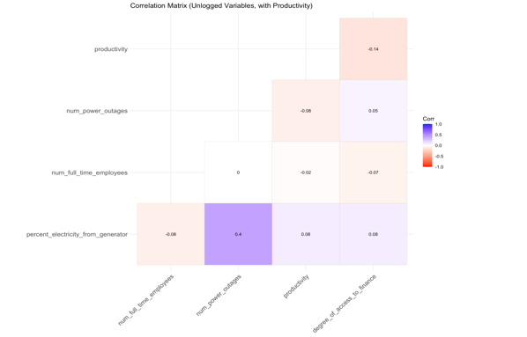
Figure 2 illustrates the correlation matrix of the significant variables for our analysis in their natural (unlogged) format. The matrix indicates the direction and size of the linear association between two variables. Importantly, there exists a moderate positive correlation (0.40) between the share of electricity coming from generators and power outage frequency, showing that more generator-reliant firms tend to have more frequent outages. All other correlations are weak, which indicates little or no linear correlation between variables such as productivity, number of full-time employees, and access to finance. Color gradient aids in interpretation, in which blue is used to show positive correlations while red is used to show negative correlations.
Figure 2 Correlation Matrix of Unlogged Variables
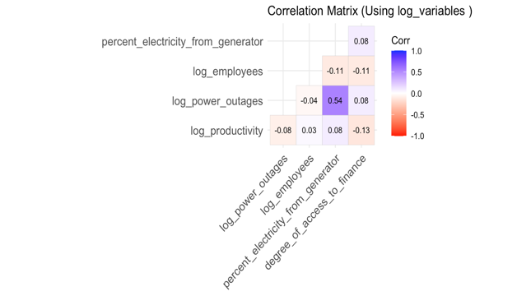
Figure 3 presents the correlation matrix using log-transformed variables to represent proportional relationships and to prevent skewness. The correlation between log_power_outages and log_productivity is weakly negative (-0.08), and firm productivity is inversely related to the frequency of power outages with a minimal difference. The correlation between log_power_outages and percent_electricity_from_generator is strongest (0.54), indicating that firms with higher outages are more likely to use generators. Log_productivity is weakly related to log employees (0.41) and finance access (0.13), and this would imply that larger companies with improved financial access are more productive.
Figure 3 Correlation Matrix After Logging Variables

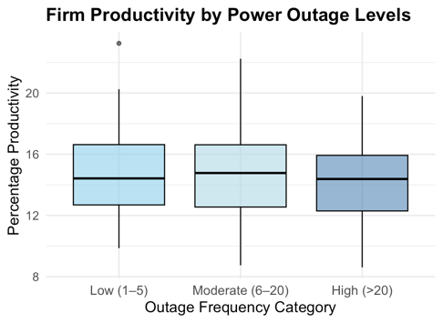
In Figure 4, we graph the relationship between the frequency of power outages and firm productivity, which is in logs. We split firms into three categories based on the frequency of power outages they experience per annum: low (1– 5), medium (6–20), and high (>20). Our results display a clear downward trend in median productivity as the outage frequency increases. Firms with less outage are more productive, while those with frequent outages have significantly worse performance. This shows that power outages disrupt operations, reduce efficiency, and drag down overall production. Although there is overlap between the groups in terms of productivity, the consistent decline in median values confirms our result.
Figure 4 Firm Productivity and Power Outage Level

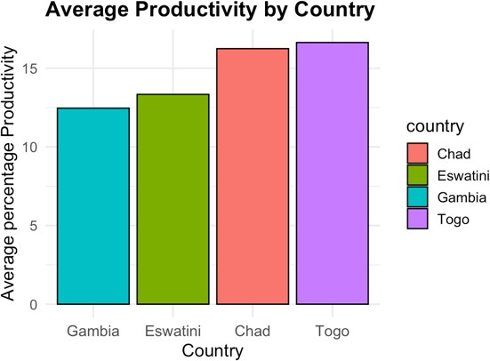
Figure 5 indicates the mean percentage productivity of firms in Togo, Chad, Eswatini, and Gambia. The results indicate considerable differences in productivity between countries. Firms in Togo have the highest mean productivity, followed closely by those in Chad. Average productivity is significantly lower in Eswatini and Gambia, with the lowest overall levels being in Gambia. These findings agree with our regression estimates, where coefficients for Eswatini and Gambia were statistically significant and negative, showing that firms in these countries face systemic barriers to maintaining high levels of productivity. Country-level differences observed here can reflect differences in the reliability of infrastructure, access to finance, policy regimes, and overall economic conditions that determine firm performance.
Figure 5 Average Productivity by Country

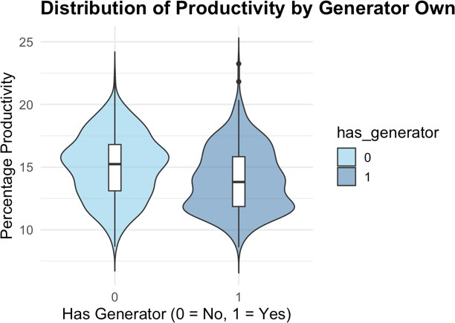
In Figure 6 we examine the relationship between firm ownership of a generator and productivity in firms with a violin plot. Firms are separated into two groups: firms without a generator (0) and firms with a generator (1). From the plot, we see that firms with no generators tend to have a marginally higher median level of productivity compared to firms with a generator. Also, the distribution of productivity for non-generator firms is more dispersed, showing a wider range of performance levels. In contrast, productivity for generator-owning firms is more concentrated, particularly at the lower end of spectrum. This is a trend that suggests that having a generator may offer some protection against power outages, but not entirely against the negative impacts of unstable power. It may also be the case that firms with generators are located in areas where outages are more frequent or severe, and that productivity is still subdued there even with the presence of backup supplies. Generally speaking, the results indicate that generator ownership alone is not a good solution to increase firm productivity in environments where electricity is unreliable.
Figure 6 Distribution of Productivity by Generator Own

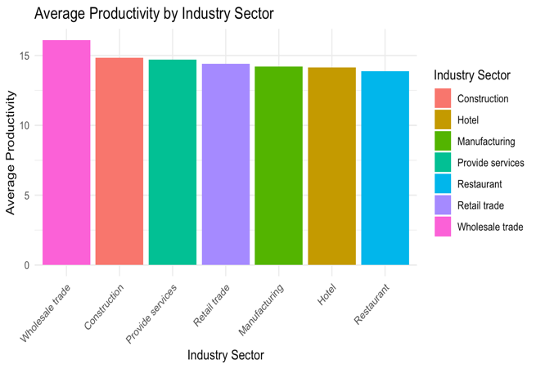
Figure 7 displays average productivity across various industry sectors in our sample. We observe considerable variation by sector. Wholesale trade companies have the highest average productivity, followed by construction and services. By contrast, restaurant firms have the lowest mean productivity, with hotel and manufacturing firms also having comparatively lower values. These disparities can be explained by sector-specific attributes like capital intensity, skill level, or sensitivity to infrastructure limitations like power failures. The observed heterogeneity emphasizes the need to control for industry effects in our empirical investigation of the link between power reliability and firm productivity
Figure 7 Average Productivity by Industry Sector

- METHODOLOGY
We analyzed World Bank Enterprise survey data for four nations—Chad, Gambia, Togo, and Eswatini—for the periods 2016, 2018, and 2023 to calculate the impact of power outages on firm productivity. To account for productivity, we quantified it as the ratio of total annual sales to the number of employees at the time of firm creation. This approach allowed us to normalize productivity across firms and potential endogeneity from the development of firm size over time. To maintain normality and the effect of extreme values, we employed the logarithmic transformation for highly skewed variables to enhance the accuracy of our regression analysis. We also normalized the measure of outage duration by consolidating various time units into a common measure in hours to enhance comparability across firms. To prevent potential reverse causality problems, we used firm size at founding rather than current employment. Lastly, to check the validity and strength of our instrumental variable, we calculated the first-stage F-statistic; an F-statistic value above 10 guaranteed the strength and explanatory power of the instrument.

- Instrument Validity and Assumptions
- Relevance Condition
The instrument (percentage of electricity from generators) is strongly correlated with power outages. Firms that rely more on generators tend to experience frequent power disruptions, satisfying the first-stage relevance requirement.
- Exogeneity Condition
The instrument affects firm productivity only through power outages and not through any direct pathway. Since generator reliance is largely a response to power instability rather than an inherent determinant of firm productivity, this satisfies the exclusion restriction assumption.

3.1. Econometric Specifications:
- First stage
In the first stage, we regress the endogenous variable and number of power outages on the instrumental variable percent electricity from generator,

- num power outages i is the fitted value from the first-stage regression,
- Productivity i is the dependent variable,
- β1 captures the causal effect of power outages on Productivity,
- u i is the second-stage second error term

- Second Stage
In the second stage, we use the fitted values from the first-stage regression as an instrument for the endogenous regressor num power outages in the outcome equation: Where,
- number power outages i: The endogenous regressor (number of power outages for firm i).
- percent electricity from generator i: The instrumental variable (percentage of electricity sourced from generators for firm i).
- industry sector i: Control variable (industry sector of firm i).
- number full time employees i: Control variable (number of full-time employees during start up for firm i).
- Degree of access to finance i: Control variable (degree of access to finance for firm i).
- Country i: Control variable (country where firm i is located).
- ε is the 1st stage regression equation

- RESULTS

TABLE 2: First-stage regression results
Variable | Coefficient | p-value
log (percent electricity from generator) | 0.191 | 0.001
Weak Instrument Test (F-statistic) | 52.79 | 0.001

From our 1st regression results as shown in Table 2, Weak instrument test has an F-statistic of 52.79, which is much greater than the widely used cut-off value of 10 and thus ensures that our instrument is not weak. The above findings suggest generator dependence as a good predictor of power outages exposure and validate its application for the estimation of power reliability's causal effect on firm productivity in the second stage for our IV estimation. Comparative to previous literature such as Mensah (2016) and Fakih et al( 2020), our evidence is of similar sign and size, validating the robustness of the negative relationship between power outages and productivity. Notably, employing an instrumental variable upgrades their approaches to directly address endogeneity.

Table 3: Heteroskedasticity Test (Breusch-Pagan Test)
Test | Studentized Breusch-Pagan Test
Model | iv model
BP Statistic | 33.476
Degrees of Freedom (df) | 17
p-value | 0.0098

To check for the presence of heteroskedasticity in our model as shown in table 3, we ran a Breusch-Pagan test on the residuals of an OLS regression with the same model specification as our IV model. The result was a BP statistic of 33.48 with 17 degrees of freedom and a p-value of 0.0098, which allowed us to reject the null hypothesis of homoskedasticity at a 1% significance level. This means that the variability of the residuals is not homogeneous and that heteroskedasticity is evident in the data. As a result, we employed heteroskedasticity-robust standard errors in our IV regression for sound inference. The correction accounts for non-constant variance and provides more reliable significance tests of our estimated coefficients.

Table 4: IV Result

IV|: Regression Results: Impact of Power Outages on Productivity
===================================================
Dependent variable:
---------------------------
Log Productivity
---------------------------------------------------
Log Power Outages -0.064*
(0.033)
Industry: Construction 0.039
(0.031)
Industry: Hotel 0.037
(0.036)
Industry: Manufacturing -0.010
(0.028)
Industry: Services 0.007
(0.030)
Industry: Restaurant -0.014
(0.036)
Industry: Retail 0.019
(0.030)
Industry: Wholesale 0.049*
(0.030)
Log Full-time Employees 0.003
(0.005)
Access to Finance: 0 -0.038
(0.050)
Access to Finance: 1 -0.079
(0.049)
Access to Finance: 2 -0.063
(0.049)
Access to Finance: 3 -0.102**
(0.049)
Access to Finance: 4 -0.101**
(0.050)
Country: Eswatini -0.297***
(0.045)
Country: Gambia -0.271***
(0.015)
Country: Togo -0.044
(0.032)
Constant 3.029***
(0.129)
---------------------------------------------------
Observations 931
R2 0.530
Adjusted R2 0.521
===================================================
Note: p<0.1; **p<0.05; **p<0.01

Table 4 presents the second-stage estimates of our instrumental variable (IV) regression, which investigates the effect of power outages on firm productivity. The dependent variable is log productivity, and the primary explanatory variable is the log of power outages, instrumented with the log of the share of electricity generated from generators.
The coefficient on log power outages is -0.064 and statistically significant at the 10% level (p < 0.1), which shows that a rise of 1% in power outages relates to a fall of 0.064% in firm productivity. This adverse relationship is supportive of our core hypothesis that ineffective supply of electricity damages firm performance.
Amongst industry controls, wholesale industry has a weakly significant productivity improvement (β = 0.049, p < 0.1), whereas other sectors such as manufacturing, retail, and services don't significantly differ from the base category. This would imply that the power outages can affect all industries relatively equally, but wholesale businesses can maybe be slightly more resilient or more able to adapt. Access to finance also comes across as a significant determinant. Firms in more restricted access to finance categories (groups 3 and 4) are much less productive (β ≈ -0.10, p < 0.05), and this illustrates how the constraints of infrastructure like power outages can combine with financing constraints to decrease firm performance further. Nation dummies indicate that Eswatini and The Gambia firms are significantly less productive than Chad firms (the reference country), which indicates that broader national institutional and infrastructure conditions can also influence firm productivity. In the regression, approximately 52% of variation in firm productivity is explained (adjusted R² = 0.521), which highlights the extremely significant role of electricity reliability, access to finance, and country-level factors in explaining firm-level outcomes.

5.DISCUSSION
Our research recognizes a direct and clear need for targeted policy responses to reduce the negative effects of power outages on business productivity and general economic stability. Addressing these challenges requires a concerted effort—one that combines infrastructure expansion, tax incentives, regulatory reform, and technological enhancement to ensure a more stable and reliable power supply.
The stakeholders and governments need to focus on building out transmission and distribution networks to minimize losses in energy and make the supply of electricity more reliable. Investment in renewable energy sources like solar, wind, and hydropower can make the energy mix more diversified and decrease the dependency on vulnerable power grids. At the same time, decentralized alternatives such as battery storage systems and microgrids present an effective avenue to improve energy security, especially in regions experiencing frequent disruptions. Climate-proofing of infrastructure is likewise essential to ensure long-term resilience(Edomah et al., 2021).

In addition to grid expansion, there is a necessity to expand access to cleaner backup power sources. While the majority of companies currently utilize diesel generators during an outage, cleaner and more efficient sources—like solar panels, battery packs, and hybrid systems—need to be accessible and affordable. Small and medium-sized enterprises (SMEs) particularly need to be incentivized through tax rebates and subsidies to invest in these greener options. Public-private partnerships (PPPs) can also play a critical role by lowering the cost of capital and enabling corporate investment in on-site renewable energy systems such as rooftop solar panels and battery storage. Creating opportunities for private sector participation in power generation and distribution through transparent and predictable regulatory frameworks can also promote efficiency and foster innovation. Foreign direct investment in the energy sector will also be drawn in, which will further ease infrastructure development and the expansion of renewable energy. Allowing independent power producers into the market can also boost supply and allow companies more stable sources of energy(Aslam et al., 2025).

The application of smart grid technology will make energy distribution more efficient and flexible. Demand-side management (DSM) programs can reduce the strain on the grid during peak times, and advanced metering infrastructure (AMI) provides real-time monitoring of power usage, as well as outage patterns—enabling faster response to issues as they arise. Additionally, boosting energy efficiency programs will prompt businesses to invest in high-efficiency equipment and reduce their overall consumption, to the benefit of both cost savings and the environment. Lastly, ensuring long-term energy resilience and economic growth requires concerted policy action. Governments, regulators, and business leaders must work together with a vision to develop national energy plans that are aligned with both economic growth and climate goals. Institutional capacity building and ensuring good governance in the energy sector will be key to getting these plans to work. Multi-stakeholder coordination—between government agencies, utilities, businesses, and civil society—will be essential to both the formulation and execution of good policies. Along with infrastructure investment, smart incentives, regulatory certainty, and technological innovation, we can build a stronger, more resilient energy system. This will reduce the burden of power outages, enhance business performance, and lay the foundation for long-term economic and sustainable growth in SSA(Bakare et al., 2023).

6.CONCLUSION
This study demonstrates that power outages significantly reduce firm performance, with IV regression results indicating that a 1% increase in power outages leads to a 6% decrease in productivity (p < 0.05). The use of generator reliance as an instrument satisfies both relevance and exclusion conditions, addressing endogeneity concerns. The model explains 52% of the variance in firm sales and passes key statistical tests, including the F-statistic and Stock-Yogo criteria. These findings underscore the urgent need for policies that enhance electricity reliability to sustain business productivity and economic growth.

LIMITATIONS OF THE STUDY
There are two primary limitations to the study. First, the analysis was limited since annual data for every country were not consistently accessible. Second, our study only looked at four nations, which limited how broadly the results could be applied. To improve the reliability and relevance of the findings, future research should consider a wider variety of nations across SSA.

REFERENCES

Abotsi, A. K. (2016). Power Outages and Production Efficiency of Firms in Africa. SSRN Electronic Journal. https://doi.org/10.2139/ssrn.2729838
Aslam, M. U., Miah, M. S., Amin, B. M. R., Shah, R., & Amjady, N. (2025). Application of Energy Storage Systems to Enhance Power System Resilience: A Critical Review. Energies, 18(14), 3883. https://doi.org/10.3390/en18143883
Avordeh, T. K., Salifu, A., Quaidoo, C., & Opare-Boateng, R. (2024). Impact of power outages: Unveiling their influence on micro, small, and medium-sized enterprises and poverty in Sub-Saharan Africa - An in-depth literature review. Heliyon, 10(13), e33782. https://doi.org/10.1016/j.heliyon.2024.e33782
Bakare, M. S., Abdulkarim, A., Zeeshan, M., & Shuaibu, A. N. (2023). A comprehensive overview on demand side energy management towards smart grids: Challenges, solutions, and future direction. Energy Informatics, 6(1), 4. https://doi.org/10.1186/s42162-023-00262-7
Blimpo, M. P., & Cosgrove-Davies, M. (n.d.). Electricity Access in Sub-Saharan Africa.
Cissokho, L., & Seck, A. (n.d.). Electric Power Outages and the Productivity of Small and Medium Enterprises in Senegal By. 2013.
Cole, M. A., Elliott, R. J. R., Occhiali, G., & Strobl, E. (2018). Power outages and firm performance in Sub-Saharan Africa. Journal of Development Economics, 134, 150–159. https://doi.org/10.1016/j.jdeveco.2018.05.003
Edomah, N., Ndulue, G., & Lemaire, X. (2021). A review of stakeholders and interventions in Nigeria’s electricity sector. Heliyon, 7(9), e07956. https://doi.org/10.1016/j.heliyon.2021.e07956
Fakih, A., Ghazalian, P., & Ghazzawi, N. (2020). The Effects of Power Outages on the Performance of Manufacturing Firms in the MENA Region. Review of Middle East Economics and Finance, 16(3). https://doi.org/10.1515/rmeef-2020-0011
Hasanov, F. J., & Mikayilov, J. I. (2021). The impact of total factor productivity on energy consumption: Theoretical framework and empirical validation. Energy Strategy Reviews, 38, 100777. https://doi.org/10.1016/j.esr.2021.100777
Mensah, J. T. (n.d.). Bring Back our Light: Power Outages and Industrial Performance in Sub-Saharan Africa.
Osei-Gyebi, S., & Dramani, J. B. (2023). Firm performance in sub-Saharan Africa: What role do electricity shortages play? Taylor & Francis. https://www.tandfonline.com/doi/abs/10.1080/23322039.2023.2251822

Appendix:

Evaluation Metrics

Test Statistic:

$$BP=nR_{aux}^{2}$$

Where $R_{aux}^{2}$ is obtained from an auxiliary regression of squared residuals on explanatory variables.

Stock-Yogo Test for Weak Instruments

$$F= \frac{(Explained Variance by Instrument)}{( Unexplained Variance)}$$

Goodness of Fit (R² and Adjusted R²)

Formula: $R^{2}=1- \frac{\sum{{(Y_{i}- {\hat{Y}}_{i})}^{2}}}{\sum{{(Y_{i}- \overline{Y})}^{2}}}$
where:
$Y_{i}$​ = Actual total annual sales
${\hat{Y}}_{i}$= Predicted sales from the regression
$\overline{Y}$ = Mean of total annual sales

Adjusted R² (for models with multiple predictors)
$${\overline{R}}^{2}=1-\left(1-R^{2}\right)* \frac{n-1}{n-k-1}$$
where:
n = Number of observations
k = Number of explanatory variables
Interpretation: A higher R² means the model explains more variation in firm sales. However, for Instrumental Variable (IV) models, it may not be the best measure of model validity.

R² | 0.53
Adjusted R² | 0.52
F-statistic | 52.79
BP-Statistic | 33 .476

