Extraction and Characterization of Cellulose of Chrysophyllum albidum (African Star Apple) Fruit Waste Using Infrared Spectroscopy

Abstract

The growing demand for plastics in daily applications has intensified concerns about plastic pollution due to their non-biodegradable nature. This has created an urgent need for sustainable alternatives such as bioplastics derived from renewable, non-food feedstocks. To address this challenge, the present study investigates the potential of Chrysophyllum albidum (African star apple) fruit waste, seeds and peels, as a cellulose source for bioplastic production, thereby avoiding competition with food resources. Cellulose was extracted from the seeds and peels using the Kraft pulping method and characterized by Fourier Transform Infrared Spectroscopy (FTIR). The FTIR spectra confirmed the presence of characteristic cellulose functional groups in both seed- and peel-derived samples. Comparative yield analysis showed that 29.2 g of seeds produced 38% cellulose, whereas the same mass of peels yielded 8.6%. These results were consistent across multiple extraction batches, indicating the reliability of the process. The findings demonstrate that the seeds of C. albidum provide a significantly higher cellulose yield than the peels, establishing them as a more viable and productive feedstock for bioplastic development. This study highlights the potential of underutilized agro-waste in advancing sustainable materials while mitigating both plastic pollution and food insecurity concerns.

Graphical abstract

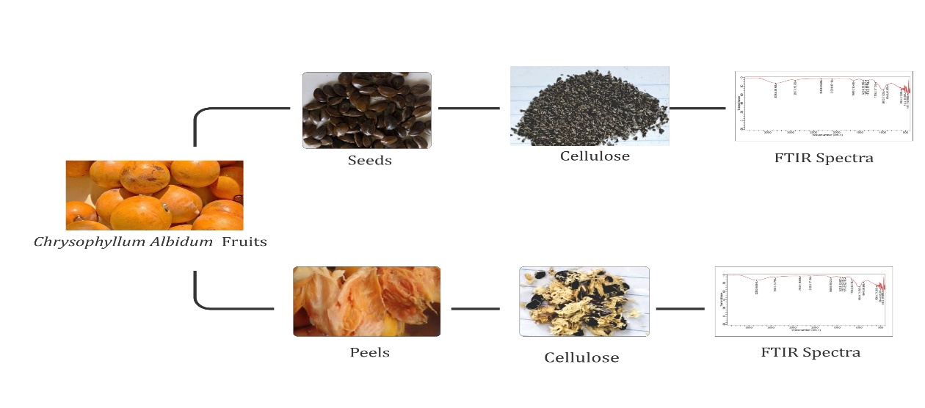
Keywords
Cellulose; Bioplastic; Chrysophyllum albidum; Fourier Transform Infrared Spectroscopy; biodegradable; seeds; peels

- Introduction

Plastics have revolutionized modern society by providing lightweight, durable, and versatile materials for applications ranging from packaging to healthcare. However, their non-biodegradability and dependence on fossil fuels have led to severe environmental consequences. The global production of plastics exceeded 390 million tonnes in 2021, with only about 9% being recycled (UNEP, 2021). The remaining bulk often ends up in landfills, oceans, or as litter in terrestrial ecosystems, contributing to long-term ecological damage. Microplastics, tiny fragments resulting from the degradation of larger plastics, have been detected in the atmosphere, oceans, food chains, and even human biological fluids (Boucher, n.d.). These particles are associated with adverse health outcomes such as reproductive, developmental, and immune system disorders (Smith et al., 2018). This has intensified the urgency for sustainable alternatives.

The search for sustainable alternatives to petroleum-based plastics has not only focused on new polymers but also on the valorization of agricultural wastes. According to the United Nations Environment Programme (2021), mismanaged plastic waste accounts for over 19–23 million tonnes annually, with significant portions leaking into aquatic and terrestrial ecosystems. This crisis has increased interest in renewable biopolymers, particularly cellulose, due to its abundance, biodegradability, and ability to be processed into a variety of useful derivatives such as nanocellulose, cellulose acetate, and cellulose films (Klemm et al., 2005). Unlike synthetic polymers, cellulose-based materials can reintegrate into natural biogeochemical cycles, reducing long-term ecological footprints.

Cellulose, the most abundant biopolymer in nature, offers great promise as a renewable and biodegradable material (Klemm et al., 2005). It is a linear polysaccharide composed of β(1-4)-linked D-glucose units, giving it remarkable tensile strength, chemical stability, and renewability. Traditionally, cellulose is sourced from wood and cotton, but recent studies have shifted toward agricultural wastes to reduce competition with food resources and enhance circular economy practices (Reddy & Yang, 2004). Various lignocellulosic residues, such as sugarcane bagasse, rice husks, banana peels, and corn stover, have been explored for cellulose extraction (John & Thomas, 2008). Despite this, many locally available fruit wastes remain underutilized, presenting opportunities for novel and sustainable raw materials.

Chrysophyllum albidum (African Star Apple) is one such resource with high potential. Native to West and Central Africa, this fruit is widely consumed for its sweet-sour pulp, leaving behind seeds and peels that are often discarded as waste (Odeyemi & Fawole, 2022). Preliminary studies have shown that the seeds contain significant cellulose content alongside proteins, lipids, and fibre (Odeyemi & Fawole, 2022). However, little research has been conducted on systematically extracting and characterizing this cellulose for material applications. This represents a unique research gap, as valorization of African Star Apple waste could not only provide a sustainable cellulose source but also contribute to waste reduction and value addition in local communities.
This study aims to extract cellulose from both the peels and seeds of Chrysophyllum albidum (African Star Apple) fruit waste, compare their respective cellulose yields, and characterize the extracts using Fourier Transform Infrared Spectroscopy (FTIR) to confirm successful cellulose isolation. The novelty of this work lies in its utilization of an underexplored tropical fruit waste as a cellulose source, contributing both to environmental sustainability and the advancement of renewable materials science.

Cellulose extraction from biomass typically involves chemical pretreatments to remove non-cellulosic components such as lignin and hemicellulose. Commonly, an alkali treatment (using sodium hydroxide) is applied to break down hemicellulose, followed by bleaching with sodium hypochlorite or hydrogen peroxide to eliminate lignin and enhance cellulose purity (John & Thomas, 2008). Advanced treatments such as acid hydrolysis may then be used to produce cellulose nanocrystals with improved mechanical and optical properties (Reddy & Yang, 2004). These methods have been successfully applied to various agricultural residues including rice husks, sugarcane bagasse, banana peels, and cassava waste, suggesting similar potential for underutilized fruit wastes like Chrysophyllum albidum.

Fourier Transform Infrared Spectroscopy (FTIR) has become an essential tool in cellulose characterization. It allows researchers to confirm the presence of functional groups associated with cellulose, such as O–H and C–O stretching vibrations, while also indicating the effective removal of lignin and hemicellulose (Poletto et al., 2014). The use of FTIR provides quick, non-destructive verification of cellulose extraction and offers insight into structural modifications introduced during chemical treatments. Employing FTIR in this study ensures that cellulose isolation from both seeds and peels of African Star Apple is validated with accuracy.

While studies have examined cellulose extraction from other tropical fruit wastes, research on Chrysophyllum albidum remains scarce. More importantly, few investigations have compared different anatomical parts of the same fruit, such as seeds and peels, despite their potential differences in cellulose yield and composition. By addressing this gap, the present research not only contributes to waste valorization strategies in West Africa but also provides a comparative framework for selecting optimal sources of cellulose for future biopolymer development. This comparative approach strengthens the novelty of the study and underscores its potential significance for both scientific advancement and sustainable material innovation.

- Experimental
  - Materials

African star apple fruit was purchased from Choba market and consumed while the fruit waste was set aside for this research study. Sodium Hydroxide, Sodium Sulphide and Sodium Hypochlorite were purchased from JeoChem, Nigeria. All the chemicals used were analytical grade.

  - Extraction of Cellulose

The extraction of Cellulose from African star apple waste was done by Kraft pulping method as described by Ikese et al., (2024). 38% and 8.6% cellulose were extracted from the seeds and peels respectively using 18% NaOH, 12% Na₂S.9H₂O and 5% NaOCl. The cellulose was dried and preserved for analysis.
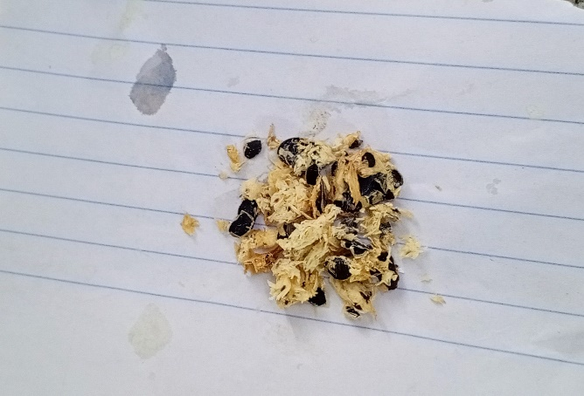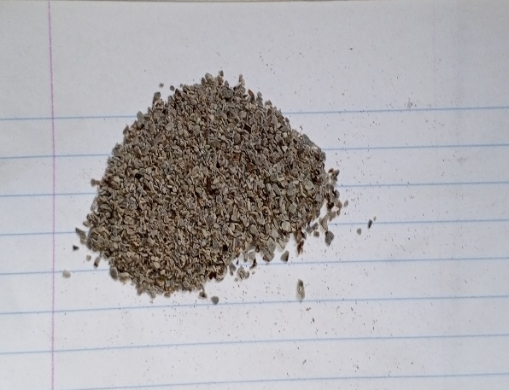
Fig. 1&2; Cellulose extracted from Chrysophyllum albidum peels and seeds respectively

The research flow chart of the work carried out when extracting cellulose from the peels and seeds of C. albidum has been shown in Fig. 3.

Chrysophyllum albidum

Extraction of Waste

Seeds
Peels

Drying
Drying

Blending
Blending

Cellulose extraction – 38%
Cellulose extraction – 8.6%

8

Characterization by FTIR
Characterization by FTIR

Fig. 3. Schematic representation of the study carried out for the abstraction of cellulose from Chrysophyllum albidum fruit waste.

  - Characterization by FTIR

The Fourier Transform Infrared Spectroscopy of the extracted cellulose from peels and seeds of C. albidum fruit were done and their different spectra generated within the range of 4000cm⁻¹ to 400cm-1 at a resolution of 8cm⁻¹ and a total of 32 cumulative Scans were taken.

- Results and Discussion
3.1 Cellulose Yield from Seeds and Peels

The cellulose extraction from both seeds and peels of Chrysophyllum albidum revealed a significant difference in yield. From an initial weight of 29.2g, the seeds produced 38% cellulose, while the peels yielded only 8.6%. This consistent observation across repeated extraction trials highlights that the seeds are a richer and more reliable source of cellulose compared to the peels. The relatively higher cellulose yield from the seeds can be attributed to their dense structural composition and lower proportion of non-cellulosic compounds such as lignin and hemicellulose compared to the peels. Conversely, the lower yield from the peels may be due to the higher content of waxes, pigments, and other extractives that reduce the efficiency of cellulose isolation. These findings suggest that the seeds of C. albidum, which are often discarded as waste, can serve as a more productive feedstock for bioplastic production.

3.2 FTIR Characterization of Extracted Cellulose

Fourier Transform Infrared Spectroscopy (FTIR) analysis was employed to confirm the presence of functional groups characteristic of cellulose in the extracted samples. The cellulose obtained from seeds showed peaks at 3328.5cm⁻¹ (O–H stretching vibration), 2907.3cm⁻¹ (C–H stretching vibration), 1423.8cm⁻¹ and 1315.8cm⁻¹ (CH₂ bending and C–H deformation), 1159.2cm⁻¹ (C–O–C asymmetric stretching), 894.6cm⁻¹ (β-glycosidic linkages), 984.0cm⁻¹ (C–O stretching), and 1640.0cm⁻¹ (absorbed water bending vibration).
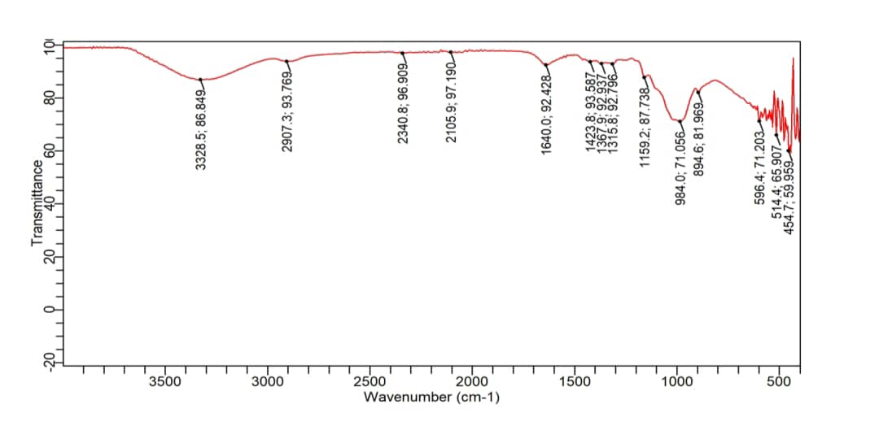Fig. 4. FTIR Spectra for Cellulose extracted from Seeds
Similarly, the cellulose extracted from the peels exhibited peaks at 3354.6 cm⁻¹, 2922.2cm⁻¹, 1457.4cm⁻¹, 1364.2cm⁻¹, 1148.0cm⁻¹, 1095.8cm⁻¹, 905.7cm⁻¹, and 1640.0cm⁻¹, which align with the characteristic absorption bands of cellulose. The presence of these peaks confirms successful cellulose extraction from both sources, with slight variations in wavenumber intensity that may reflect differences in crystallinity, degree of polymerization, or residual non-cellulosic impurities between the two samples.

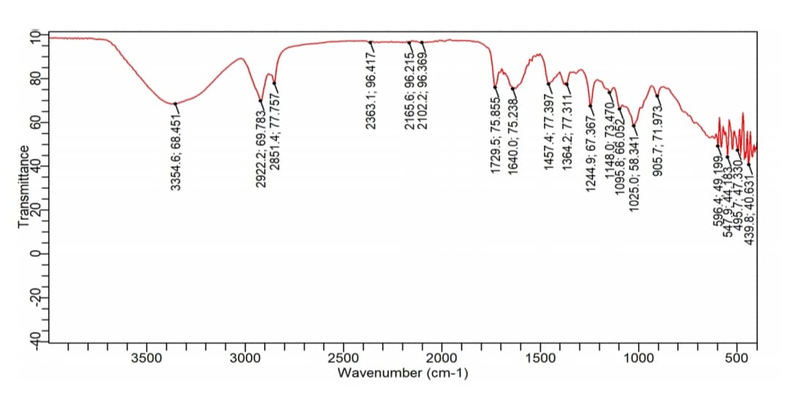
Fig. 5. FTIR Spectra for Cellulose extracted from Peels

3.3 Comparative Suitability of Seeds and Peels as Feedstock

While both seeds and peels were shown to contain extractable cellulose, the higher yield from seeds indicates that they are more suitable as a feedstock for bioplastic production. Importantly, using seeds and peels, which are typically discarded as agricultural waste, addresses the concern of food insecurity since these materials are not staple food sources. This approach aligns with the circular economy model by promoting value addition to fruit waste while reducing environmental burden. The study also demonstrates the potential of C. albidum as a novel and underutilized raw material for sustainable bioplastic production. However, the lower cellulose yield from peels suggests that further pretreatment strategies, such as delignification or chemical modification, may be required to improve their suitability.

3.4 Implications for Bioplastic Development

The findings indicate that seed-derived cellulose from C. albidum is a promising candidate for bioplastic applications, given its higher yield and confirmed chemical composition. This is significant because one of the main challenges in bioplastic production is securing low-cost and sustainable feedstock without compromising food availability. By utilizing non-edible fruit waste, this study offers a pathway to sustainable raw material sourcing. Future studies should focus on evaluating the mechanical and thermal properties of bioplastics synthesized from C. albidum cellulose and exploring possible blends with other biopolymers to optimize performance.

- Conclusions

This study successfully demonstrated the extraction of cellulose from the seeds and peels of Chrysophyllum albidum fruit using the Kraft pulping method and subsequent characterization with FTIR. The FTIR spectra confirmed the presence of characteristic cellulose functional groups in both samples, validating that cellulose was effectively isolated. However, a significant difference in yield was observed: the seeds produced 38% cellulose, while the peels yielded only 8.6% under similar extraction conditions.

These findings establish the seeds of C. albidum as a more reliable and productive feedstock for cellulose-based bioplastic production compared to the peels. Importantly, since both seeds and peels are by-products and not staple food sources, their utilization does not pose any risk of food insecurity. Instead, it promotes the valorization of agricultural waste and contributes to the advancement of eco-friendly alternatives to synthetic plastics. Future research should investigate the conversion of this cellulose into bioplastics and assess its mechanical, thermal, and biodegradability properties to fully establish its industrial potential.

Declaration of Competing Interest

The author declares that there are no known financial or personal competing interests that could have appeared to influence the work reported in this paper.

References
Boucher, J. F. D. (n.d.). Primary microplastics in the oceans. IUCN. https://iucn.org/resources/publication/primary-microplastics-oceans
John, M. J., & Thomas, S. (2008). Biofibres and biocomposites. Carbohydrate Polymers, 71(3), 343–364. https://doi.org/10.1016/j.carbpol.2007.05.040
Klemm, D., Heublein, B., Fink, H., & Bohn, A. (2005). Cellulose: fascinating biopolymer and sustainable raw material. Angewandte Chemie International Edition, 44(22), 3358–3393. https://doi.org/10.1002/anie.200460587
Odeyemi, O. M., & Fawole, O. A. (2022). African Star Apple ( Chrysophyllum albidum ). In CABI eBooks (pp. 376–389). https://doi.org/10.1079/9781789248067.0026
Poletto, M., Ornaghi, H. L., & Zattera, A. J. (2014). Native cellulose: Structure, characterization and thermal properties. Materials, 7(9), 6105–6119. https://doi.org/10.3390/ma7096105
Reddy, N., & Yang, Y. (2004). Biofibers from agricultural byproducts for industrial applications. Trends in Biotechnology, 23(1), 22–27. https://doi.org/10.1016/j.tibtech.2004.11.002
Smith, M., Love, D. C., Rochman, C. M., & Neff, R. A. (2018). Microplastics in seafood and the implications for human health. Current Environmental Health Reports, 5(3), 375–386. https://doi.org/10.1007/s40572-018-0206-z
United Nations Environment Programme (UNEP). (2022). From pollution to solution: A global assessment of marine litter and plastic pollution. UNEP. Retrieved from https://www.unep.org/resources/pollution-solution-global-assessment-marine-litter-and-plastic-pollution
United Nations Environment Programme (UNEP). (2021). From pollution to solution: A global assessment of marine litter and plastic pollution. UNEP. https://www.unep.org/news-and-stories/press-release/comprehensive-assessment-marine-litter-and-plastic-pollution.

