Original Research Article
Effect of Dietary Supplementation of Gotu Kola (Centella asiatica) on Growth, Survival and Gut Histology of common carp (Cyprinus carpio)

Abstract:
Dietary influence of Gotu kola (Centella asiatica) on growth performance, survival and gut histology was assessed in common carp (Cyprinus carpio) in a span of 90 days. Four test diets were formulated (T1, T2, T3, and T0) each containing 30 % protein and Gotu kola powder was added at varying levels: 5 g/kg in T1, 10 g/kg in T2, and 20 g/kg in T3 with each treatment replicated three times. The control diet(T0) contained no gotu kola powder. The significant enhancement (P<0.05) in weight gain, FCR, SGR, PER were recorded in fish fed with 20g/kg gotu kola diet. Administration of gotu kola diet made a greater impact on gut histology of common carp in all the treatments especially T3 group when compared with the control group.
Key Words: Gotu Kola, Centella asiatica, Weight Gain, FCR, PER, SGR, Survival, Gut histology, Common Carp, Cyprinus carpio

INTRODUCTION
In aquaculture, the use of large quantities of antimicrobials and synthetic chemicals for improvement of growth, survival and prevention of diseases have exacerbated the development and spread of antibiotic-resistant bacterial strains and genes which can transfer between human and animal populations and his harming the ecosystem and health of consumers (Hedberg et al., 2018). The frequent and unchecked use of antibiotics and other synthetic growth promoters in fish farms has resulted in the accumulation of chemical residues in fish products leading to risks in the consumer’s health (Lieke et al., 2020). Herbal nutraceuticals are capable of replacing various synthetic chemicals in intensive farming. For centuries, medicinal herbs have been utilized for overall health improvement and these plants including herbs, spices and other extracts have gained popularity due to its low cost and environmentally friendly (Dawood, 2021). Medicinal plants can be administered in aquaculture either as whole plants or specific parts such as leaves, roots or seeds. They can also be given as extracts either in water or as feed additives and individually or in combination with other compounds like prebiotics. One of these feed additives is Gotu kola (Centella asiatica) which is also known as “Brahmi” (the greatest of the great) in Ayurvedic medicine (Pal et al., 2018). Gotu kola is a perennial herb that belongs to the Apiaceae family. It is commonly known as “Manduka parni” in Sanskrit, “brahmi” in Hindi, “Indian pennywort” in English and “Gotu kola” in many others parts of the world and it is distributed over tropical and subtropical countries. It is native to Asia, Africa, America and Oceania (Belwal et al., 2019). Gotu kola consists of various classes of biochemical compounds such as terpenoids, flavonoids, alkaloids, tannins, steroids and phenolic compounds. Gotu kola has got a range of pharmacological and therapeutic properties (Belwal et al., 2019).
The common carp (Cyprinus carpio) is among the most widely farmed fish species globally and holds significant cultural value in aquaculture (FAO, 2024). In recent years, intensive farming of common carp has become increasingly popular as a practical solution to meet the growing global demand for fish. This method involves stocking fish at higher densities and providing controlled feeding often with nutritionally balanced commercial feeds to accelerate growth rates and increase yield. (Hoseinifar et al., 2019). The rapid growth, high yield, wide range of habitat make common carp a more significant species economically in aquaculture (Demirkalp, 1992).
Hence, the present study was conducted to study the effect of dietary supplementation of Gotu kola (Centella asiatica) on the growth performance, survival and and gut histology of common carp.

MATERIALS AND METHODS
The present investigation was carried out to study the effect of dietary Gotu kola (Centella asiatica) on the growth performance, immune response, disease resistance and gut histology of common carp (Cyprinus carpio). The experiment was carried out in cement ponds of 300 L capacity in triplicates for a period of 90 days at Research and Instructional Fish Farm, College of Fisheries, Mangaluru.
Feed ingredients, formulation and analysis
The ingredients used in the formulation of different experimental diets were fishmeal, rice bran, groundnut oil cake, tapioca flour, gotu kola powder, vitamin and mineral premix. All the dry ingredients were purchased from the local market except gotu kola powder. The gotu kola powder was procured from an online platform namely Amala Earth. All the ingredients except gotu kola was ground and sieved to get particles of uniform size. The sieved ingredients were packed in high density polythene bags and stored at room temperature. Vitamin and mineral premix in the form of Chelated Agrimin Forte, a product of Virbac Animal Health Pvt. Ltd, India was procured locally and added.
Proximate composition of the feed ingredients
All the feed ingredients were analysed for proximate composition before the formulation of the test diets employing standard methods (AOAC, 1975). Moisture content was estimated by heating samples at 105°C for 30 min and then cooling and weighing to a constant weight. Crude protein was analysed using FOSS Kjeltec system, fat content by Soxtech system (PELICAN) and fibre content by Fibretech system (PELICAN). Carbohydrate content was calculated as nitrogen free extract (NFE) by the difference method (Hastings, 1976) as given below.
NFE = 100 - (% moisture + % crude protein + % crude fat + % crude fibre + % ash). The ash content was determined by first drying the sample and then heating it in a muffle furnace at 550 ± 10°C for 6 h.
Formulation and preparation of experimental diets
Three test diets namely T₁, T₂ and T₃ were prepared by incorporating gotu kola powder at the rate of 5 g, 10 g and 20 g/ kg feed respectively. A control diet (T₀) without gotu kola powder was prepared.
The required quantities of ingredients were weighed accurately, mixed and hand kneaded to required consistency with just enough water (1: 0.8) to get smooth dough. The dough so obtained was cooked under steam in a pressure cooker at 105 °C for 20 to 30 min. The cooked feed was cooled to room temperature rapidly by spreading in an enamel tray and required dose of gotu kola powder was diluted with water properly and vitamin-mineral premix was added, mixed and blended. The dough was extruded through a pelletizer having 3 mm dia. Pellets were dried in a hot air oven at 60 °C till the moisture content was reduced to less than 10 %. Diets were packed separately in high density polythene bags, labelled and stored in a refrigerator for further use (Plate 1 to Plate 5). The proximate composition of all diets were analysed following standard methods (AOAC, 1975).
Experimental animals
Fry of common carp brought from ADF office, Karkala were reared to fingerling size in 25 m² pond at Research and Instructional Fish Farm, College of Fisheries, Mangaluru. Prior to start of the experiment, fish were acclimatized to experimental condition for two weeks in 1000 L FRP tubs and fed with basal diet.
Experimental set up
The study was conducted in 12 out door cement ponds each with a capacity of 300 L. The experiment was carried out in triplicates under each treatment group in completely randomized design and exchange of water was performed every week to maintain the water quality (Plate 6).
Stocking and rearing
The common carp fingerlings were stocked at the rate of 15 numbers/tank. The experiment was carried out for a period of 90 days. Faecal matter and uneaten food were removed daily in the morning hours.

Feeding
Fish were fed at the rate of 5 % of their body weight till the end of the experiment. The feed was broadcasted over the surface of water twice daily in the morning and evening. After each sampling, the quantity of feed given was re-adjusted based on the increased weight of fish.
Water sampling
Water quality parameters were maintained within the normal range throughout the experimental period. Water samples collected once in a week were analysed for pH, temperature, dissolved oxygen, free carbon dioxide, hardness, NH₃, NO₂, NO₃ and total alkalinity. Digital pH meter model LI 613 was used to record pH. Atmospheric temperature and water temperature were recorded by using standard thermometer. Dissolved oxygen was estimated by Winkler’s method. Total alkalinity, hardness, NH₃ and free carbon dioxide were determined by standard methods (APHA, 1995).
Fish sampling
The fish were sampled fortnightly to assess the growth. The stocked fish were collected during each sampling and measured individually for length and weight. After a rearing period of 90 days all the survived fishes were collected at once and their weight and lengths were measured and recorded.
Growth studies
Mean weight gain
Mean weight gain was calculated by using the following formula:
Mean Weight gain(g) = Mean final weight gain(g) – Mean initial weight gain(g)
Specific growth rate (SGR % /day)
Specific growth rate was calculated by using the following formula:
SGR (% /day) = [ln final weight – ln initial weight/ days] × 100
The calculated value gives the average percentage increase in weight per day over the experimental period.
Feed conversion ratio (FCR)
Feed conversion ratio (FCR) is the amount of dry feed fed per unit of live weight gain, which was calculated using following formula:
FCR = Dry weight of the feed given (g) / Gain in weight of fish (g)
Protein efficiency ratio (PER)
Protein efficiency ratio (PER) is the live weight gain per unit of crude protein fed. It was calculated as:
PER = weight gain / (feed consumed × percentage of protein in feed)
Survival (%)
Survival (%) was calculated as the difference between the number of live animals at the beginning and at the end of the experiment and expressed in percentage.
Histological studies
At the end of the experiment, the fish from each treatment groups were selected and dissected out to get the gut. These organs were fixed whole. In the case of larger sized organs, the tissue blocks from the respective organs were excised and fixed and during cassetting each tissue block was cut into smaller pieces and cassetted separately. The fixed tissues were processed using an automatic tissue processor and embedded in paraffin wax. Sections were cut at 5-6 µm thickness and stained with haematoxylin and eosin. All the histological procedures followed were as detailed by Bullock, 1989.
Statistical analysis
Mean growth, survival, immune responses and disease resistance of fish achieved in response to different formulated test diets was analysed statistically by using one-way ANOVA (P < 0.05) and Duncan's multiple range tests. A value of P < 0.05 was considered statistically significant (SPSS V. 22).
RESULTS
The present study was carried out to analyse the dietary effect of Gotu kola (Centella asisatica) powder on growth performance, survival and gut histology of common carp. Four distinct diets were formulated including basal diet (T₀) and fish were fed for 90 days with diets containing Gotu kola powder at 5 g (T₁), 10 g (T₂) and 20 g / kg(T₃) of feed.
Proximate composition of feed ingredients and formulated experimental diets
Feed ingredients
Proximate composition of the ingredients used for the formulation of pelleted feed is presented in Table 1. The highest moisture content was found in rice bran (13.24 ± 0.16 %) and lowest in the fish meal (6.80 ± 0.11 %). The protein concentration was high in fish meal (64.12 ± 0.24 %) followed by ground nut oil cake (38.22 ± 0.18 %), rice bran (9.13 ± 0.22 %) and tapioca flour (2.57 ± 0.21 %). The rice bran showed fibre content highest (8.24 ± 0.18%) followed by tapioca flour (8.13±0.03 %) ground nut oil cake (2.46 ± 0.20 %) and fish meal (1.39 ± 0.12 %). The composition of ash was between 2.24 ± 0.14 % (tapioca flour) and 14.83 ± 0.13 % (fish meal). The carbohydrate content of the components (nitrogen-free extract) varied from 4.59 ± 0.16 % (fish meal) and 80.86 ± 0.16 % (tapioca flour).
Formulation of diet
The composition of the ingredients used for formulation of different experimental diets are given in the Table 2. Fish meal and groundnut made the largest contribution, each accounting for 26.67 % and followed by tapioca (23.32 %). The rice bran composition ranged between 20.32 % (T₃) and 22.32 % (T₀). Diets were prepared by incorporating gotu kola at 0.5 %, 1 % and 2 % in T₁, T₂ and T₃ respectively and control diet prepared without incorporation of Gotu kola.
The proximate composition of formulated diet is given in Table 3. The moisture content of diet ranged from 8.46 ±0.04 % to 9.46 ± 0.12 %. The highest value was obtained in T₃(9.46 ± 0.12) and lowest value recorded in T₀ (8.46 ± 0.04). The crude protein concentration was 30.48 ± 0.12 % in T₀, 30.56 ± 0.14 % in T₁, 30.64 ± 0.24 % in T₂ and 30.68 ± 0.32 % in T₃. The highest crude fat was obtained in T₀ (6.31 ± 0.14%) followed by T₂ (6.18 ± 0.03 %), T₃ (6.14 ± 0.44 %) and T₁ (6.12 ± 0.03 %). The highest fibre content was observed in T₂ (6.88 ± 0.04 %) and lowest in T₀ (5.24 ± 0.02 %). Ash content ranged between 12.34 ± 0.02 % (T₀) and 14.98 ± 0.04 % (T₃). The carbohydrate content of the components (nitrogen-free extract) varied from 32.66 ± 0.06 % (T₃) to 37.17 ± 0.06 % (T₀).

Effect of Gotu kola on growth of common carp
In the present study, fish growth was decided in terms of weight gain (WG), specific growth rate (SGR), protein efficiency ratio (PER) and feed conversion ratio (FCR). The highest weight gain was recorded in T₃ (10.02 ± 0.290 g) where the fish fed with 20 g/ kg gotu kola incorporated diet and there was no significant difference (p > 0.05) observed in T₁ (8.01 ± 0.226 g) and T₂ (7.77 ± 0.185 g) treatments. Lowest weight gain was found in control (6.47±0.034 g) (Table 5).
Highest SGR was observed in T₃ (1.43 ± 0.011 %) and no significant difference (p>0.05) observed in T₁ (1.28 ± 0.025 %) and T₂ (1.22 ± 0.066 %) treatments. Lowest SGR was observed in control (1.08 ± 0.01 %) (Table 5).
FCR was increased in all the treatments compared to the control. Lowest feed conversion ratio was observed in T₃ treatment (1.98 ± 0.034) compared to other treatments and control. Highest and poor FCR was observed in control (2.91 ± 0.144) (Table 5).
Highest PER was observed in T₃ (1.67 ± 0.024) and no significant difference (p > 0.05) observed between Tı (1.41 ± 0.038) and T₂ (1.38 ± 0.043) treatments and lowest PER was observed in control (1.13 ± 0.020) (Table 5).
Survival Rate-
No mortality was observed in any of the treatment groups and the control during the experimental period.
Water Quality-
The water quality parameters such as water temperature (26.2 -29 °C), pH (6.8 - 7.3), dissolved oxygen (5.2 - 6.3 mg/ l), carbon dioxide (6.43 - 7.50 mg/ l), total alkalinity (74 - 98 mg/ l), hardness (60-80 mg/ l), ammonia-nitrogen (0.004 - 0.008 mg/ l), nitrite – nitrogen (0.045 - 0.054 mg/ l) and nitrate-nitrogen (0.038 - 0.047 mg/ l) observed during the experimental period (Table 4).
Effect of Gotu kola on gut histology of common carp
Mid gut histology of common carp fingerling fed with gotu kola enriched diets showed better villi, lumen diameter, villi height and villi width in all treatments. Whereas the control groups showed shorter villi, villi height and crypt depth (Fig. 1).

Discussion
Medicinal plants can serve as alternatives to antibiotics and have a notable impact on the health, growth and immune system of fish (Adel et al., 2024).
In the present study the effects of gotu kola (Centella asiatica) on growth performance, survival and gut histology of common carp (Cyprinus carpio) was studied for 90 days.
Effect of Gotu kola on growth performance of common carp
The bioactive components present in the herbs are responsible for the enhanced digestibility and availability of nutrients which in turn lead to higher growth and protein synthesis in fish (Citarasu, 2010).
In the present study, dietary supplementation of gotu kola resulted in better weight gain, protein efficiency ratio, specific growth rate and feed conversion ratio. All the growth parameters (weight gain, SGR, PER and FCR) were significantly increased (p < 0.05) in T3 where fish fed with 20 g/ kg gotu kola incorporated diet. Gotu kola is rich in the nutrients like carotenoids, vitamin B and C, amino acids, carbohydrates, phenols and terpenoids and significantly influence the growth in fish (Sarker et al., 2021). The Centella asiatica leaf powder supplementation at 1 g/kg diet significantly increased the specific growth rate (SGR), protein efficiency ratio (PER) and lower feed conversion ratio (FCR) compared to control in Labeo rohita (Sarker et al., 2021). The diet supplemented with C. asiatica at the rate of 0.2 % diet increased weight gain (WG) and SGR in Macrobrachium rosenbergii. This improvement might be attributed to a significant reduction in pathogenic bacteria and also found an enhancement in probiotic bacteria in prawns fed with the experimental diet (Salini et al., 2013). Probiotic bacteria contribute to improved growth by generating essential nutrients and digestive enzymes (Balasubramanian et al., 2006). The daily administration of C. asiatica at the dosage of 500 mg/kg diet for 60 days feeding trail promoted growth and feed utilization in M. rossenbergii (Salini et al., 2014). The highest WG, feed intake, survivability and lowest FCR were observed in the broiler chicken supplemented with 4 % CALM (Centella asiatica leaf meal) compared to control and antibiotic supplemented diet (Ajayi et al., 2020).
The common carp fed with thyme essential oil at the rate of 1 % and 2 % diet enhanced digestive enzymes and growth rate (Ghafarifarsani et al., 2022). The diet supplemented with rosemary leaf powder at the level of 1.5 % and 3 % diet significantly elevated the final body weight, WG, SGR and lower FCR in common carp (Omar et al., 2024). According to Wigraiboon et al. (2024), nut grass tuber extract supplemented at the rate of 0.8 and 1.6 g/kg diet improved WG, SGR and better FCR in Nile tilapia. The combined use of various medicinal plants is beneficial because the bioactive compounds from different herbs can work synergistically and positively influencing nutrient digestion, physiological functions and the immune system of animals (Parasuraman et al., 2014). Dietary administration of lupine, mango and nettle at the level of 1 % and 2 % made a notable improvement in growth performance, particularly in terms of weight gain, (SGR) and digestive enzyme activity (Awad et al., 2012). The higher inclusion level of 2% nut meg diet fed to common carp shown the significantly higher WG, SGR and lower FCR (Rashidian et al., 2022). The final body weight, final body length, average daily weight gain (g), net weight gain (g) and specific growth rate (%) were predominantly higher and poor FCR was observed in 1 % and 2 % aloe vera extract diet supplemented to Nile tilapia (Syed et al., 2022). Several studies proved that the garlic and turmeric powder supplemented at the rate of 1 % and 2 % per kg diet in Nile tilapia significantly improved body weight and FCR (Diaba et al., 2014).
The ginger had a dominant effect on growth performance of Huso huso juveniles was reported by Turan et al. (2016). The sea bass fed with Cissus quadrangularis powder at 0.5 g, 1.0 g and 1.5 g/kg diets made a significant increase in body weight than control diet fed fish (Devakumar and Chinnasamy, 2017). The dietary administration of clove at 0.5 % enhanced digestive ability which was reflected as higher growth rate in Labeo rohita (Asimi et al., 2015). Dietary incorporation of Tinospora cordifolia in all concentrations promoted weight gain, feed conversion ratio, gross conversion efficiency and specific growth rate in Amur carp fingerlings (Anita et al., 2016). The Chinese herbal medicine mixture could significantly improved growth performance of Japanese sea bass fed at 20 g/kg diet (Anle et al., 2020). A dietary mixture of Allium sativum and Spirulina platensis increased weight gain and SGR and improved FCR and PER in Nile tilapia (Elala et al., 2016). Moreover, high growth and better feed utilization parameters were reported in sea bream fry after been fed diets supplemented with herbal mixtures of A. sativum, Zingiber officinale and Thymus vulgaris for 8 weeks (Jahanjoo et al., 2018).

Effect of Gotu kola on Survival of common carp
In the present study, survival percentage of 100% was observed in all the treatment groups. The results of the present study are in agreement with those of Pratama and Mukti (2021) who reported significantly higher survival rate of 98.57% in cat fish (Clarias sp.) fed with a dietary supplement of herbal mixture of Turmeric, Kencur, Ginger and Tamarind.
Effect of Gotu kola on gut histology of common carp
Histological analysis of the gut reveals the fish's overall health and the potential of feed additives (Latif et al., 2021). Gut histology is important in the fish as it directly promotes digestive efficiency, nutrient absorption and overall health. The intestinal structure including villus height, mucosal thickness and glandular development affect the ability of fish to process and absorb nutrients from their diet (Panserat et al., 2009). Herbs have been proved to enhance gut histology in fish by increasing the intestinal lining, promoting beneficial microbial load and finally lead to better absorption of nutrients and growth in fish (Citarasu, 2010)
In the present study, mid gut histology of common carp fingerlings fed with gotu kola enriched diets showed better villi, lumen diameter, villi height and villi width in all treatments. Whereas control groups showed normal villi, villi height and crypt depth (Fig. 1).
The herbal mixture of Foeniculum vulgare and Artemisia annua supplemented in the diet of largemouth bass made notable increase in villus number and goblet cell density, height of intestinal villus, thickness of the muscle layer and affected the intestinal bacterial structure, increased the quantity of Lactobacillus and Enterococcus and decreased the quantity of Plesiomonas in the intestine (He et al., 2022). According to Shi et al. (2022) the dietary incorporation of Astragalus Membranaceus in common carp showed positive effect on growth by influencing height of intestinal villi and modifying the microenvironment of gut. The dietary supplementation with essential oils of clove basil and ginger were given to the Nile tilapia, the width of villi, total perimeter of villi surface and number of goblet cells in the intestinal villi were significantly higher in the 1 % ginger diet compare to basil and control groups (Brum et al., 2018). The Caspian kutum fed with 1 g/kg chitosan supplemented diet for 60 days resulted in the increased intestinal villi length compare to control diet (Kamali et al., 2019). Oregano essential oil at the rate of 15 g/kg diet supplemented to common carp significantly enhanced villus height and villus width which led to increase in the intestinal surface area of absorption and support for the growth of common carp (Latif et al., 2020).
The increased villus length, muscle thickness in foregut, midgut and hindgut were noticed in the hybrid grouper when supplemented with Panax notoginseng extract at the rate of 0.5 -10 g/kg diet (Sun et al., 2018). Diet supplemented with sodium butyrate and Lippia origanoides essential oil blend in increased the villus perimeter in the posterior region of the gut and showed positive effects on the intestinal microbiota and intestinal structure in Nile tilapia (Jesus et al., 2021). The group receiving supplementation with the Plant-Based Mixture (Phyto AquaMeric) showed enhanced gut structure and integrity. There was a notable increase in the length of intestinal folds and the number of goblet cells in the anterior, mid and posterior sections of the gut in Nile tilapia compared to the control group. However, the width of the intestinal folds and the interfold spaces in these same gut sections were significantly reduced in the supplemented group compared to the control (Syed et al., 2024). Mid gut histology of common carp fingerling fed with noni fruit juice incorporated diets showed better villi, lumen diameter, villi height and villi width higher in all treatments. Whereas control groups showed normal villi, villi height and crypt depth (Jyoti et al., 2022).
According to Mohamed et al. (2014), the increase in villi surface indicates improved intestinal health and nutrition absorbing capability which may favour the survival of fish to infection. The number of intestinal folds increased and intestinal surface expanded in silver catfish (Rhamdia quelen) fed with essential oil of lemon verbena (Alloysia triphylla) for 60 days, expanding the intestinal surface (Zeppenfeld et al., 2015). Vallado et al. (2017) found no significant variation in the number of goblet cells in the gut of Nile tilapia fed a diet enriched with peppermint essential oil (Mentha piperita) for 60 days. Additionally, Zahran et al. (2014) observed a slight increase in microvilli height in Nile tilapia when their diet was supplemented with Astragalus polysaccharide compared to the control group.

SUMMARY
The present study was carried out to evaluate the effect of dietary gotu kola (Centell aasiatica) on growth performance, survival and gut histology of common carp (Cyprinus carpio). The gotu kola was incorporated in the diet at 5 g, 10 g, 20 g/ kg and control without gotu kola. The feeding trial ware carried out for a period of 90 days. Dietary gotu kola improved WG, SGR and FCR in common carp. Dose dependent growth was observed in all the treatments. All the growth parameters (WG, SGR and FCR) were significantly improved (p < 0.05) in common carp fed with 20 g/ kg gotu kola incorporated diet. In gut histology, all treatments showed better architecture and control groups showed lesser villi, villi height and crypt depth.
Gotu kola incorporated diets have greatly boosted WG, SGR PER and FCR in common carp fingerlings at a 20 g/kg diet. Hence, from the present study it is evident that incorporation of 20 g/kg Gotu kola in the fish diet, significantly improves growth by greatly improving gut anatomy, physiology and nutrition and improves survival rate of common carp.

COMPETING INTERESTS DISCLAIMER:
Authors have declared that they have no known competing financial interests OR non-financial interests OR personal relationships that could have appeared to influence the work reported in this paper.

References-
Adel, M., Sakhaie, F., Shekarabi, S.P.H., Gholamhosseini, A., Impellitteri, F. and Faggio, C. 2024. Dietary Mentha piperita essential oil loaded in chitosan nanoparticles mediated the growth performance and humoral immune responses in Siberian sturgeon (Acipenser baerii). Fish Shellfish Immunol., 145:109321.
Ajayi, O.A., Olumide, M.D. and Chioma, G.O. 2020. Efficiency of Centella asiatica (Gotu kola) leaf meal as feed additive in broiler chicken diet. Niger. J. Anim. Prod., 47(1):153-160.
Anita, Dubey, M.K., Khati, A. and Chauhan, R.S. 2016. Immunostimulatory and growth promoting potential of Tinospora cordifoliamiers on fingerlings of amur carp. Indian J. Exp. Biol., 54: 659-663.
Anle, X., Jingbo, S.G., Zhongbao, L., Zhan, G., Yong, C. H. and Qiang, C. 2020. Effects of dietary Chinese herbal medicines mixture on feeding attraction activity, growth performance, nonspecific immunity and digestive enzyme activity of Japanese seabass (Lateolabrax japonicus). Aquac. Rep., 20:100304.
AOAC. 1975. Official methods of analysis. AOAC International, Washington, DC.
APHA, 1995. Standard Methods for the Examination of Water and Wastewater, 19th ed., APHA, Washington, DC.
Asimi, O.H., Sahu, N.P. and Pal, A.K. 2015. Immunomodulatory and growth response of L. rohita to dietary fortification of clove and/cardamom extract. Glob, J. Fish. Aquac., 3(5): 230-237.
Awad, E., Austin, B. and Lyndon, A. 2012. Effect of dietary supplements on digestive enzymes and growth performance of rainbow trout (Oncorhynchus mykiss, Walbaum). Am. J. Sci., 8(12):858-864.
Balasubramanian, G. Sarathi, S., Rajesh Kumar, A. S. and Sahul, H. 2006. Screening the antiviral activity of Indian medicinal plants against white spot syndrome virus in shrimp. Aquacu., 263: 15-19.
Belwal, T., Andola, H.C., Atanassova, M.S., Joshi, B., Suyal, R., Thakur, S., Bisht, A., Jantwal, A., Bhatt, I.D. and Rawal, R.S. 2019. Gotu kola (Centella asiatica). In Nonvitamin and nonmineral nutritional supplements., 265-275. Academic Press.
Brum, A., Cardoso, L., Chagas, E.C., Chaves, F.C.M., Mouriño, J.L.P. and Martins, M.L. 2018. Histological changes in Nile tilapia fed essential oils of clove basil and ginger after challenge with Streptococcus agalactiae. Aquac., 490: 98-107.
Bullock, A.M. 1989. Laboratory methods. In: Fish Pathology Edt. Roberts, R.J. Bailliere Tindall, London, 374-402.
Citarasu, T. 2010. Herbal biomedicines: a new opportunity for aquaculture industry. Aquac. Int., 18(3): 403-414.
Dawood, M.A.O. 2021. Nutritional Immunity of Fish Intestines: Important Insights for Sustainable Aquaculture. Rev. Aquac., 13: 642–663.
Demirkalp, F. Y. 1992. The role of common carp (Cyprinus carpio) in subsistence and commercial aquaculture: A global perspective. Aquac. Int., 10(4): 275-290.
Devakumar, C. and Chinnasamy, A, 2017. Dietary administration of natural immunostimulants on growth performance, haematological, biochemical parameters and disease resistance of Asian Sea bass Lates calcarifer (Bloch, 1790). Aquac. Res., 48(3): 1131-1145.
Diaba, A. M., Saker, O. A., Eldakrouryc, M, F. and Elseifyd, M. M. 2014. Effects of Garlic (Allium sativum) and Curcumin (Turmeric, Curcuma longa Linn) on Nile Tilapia Immunity. Vet. Med. J. Giza., 60: 1-19.

FAO.2024. The State of World Fisheries and Aquaculture (SOFIA). Rome, Italy.
Ghafarifarsani, H., Hoseinifar, S.H., Sheikhlar, A., Raissy, M., Chaharmahali, F.H., Maneepitaksanti, W., Faheem, M. and Van Doan, H. 2022. The effects of dietary thyme oil (Thymus vulgaris) essential oils for common carp (Cyprinus carpio): growth performance, digestive enzyme activity, antioxidant defense, tissue and mucus immune parameters, and resistance against Aeromonas hydrophila. Aquacu. Nutr., 2022(1): 7942506.
Hastings, W. H. 1976. Fish nutrition and fish feed manufacture, FAO Fisheries Report No. 188. FAO Technical Conference on Aquaculture, 26 May to 2 June 1976, Kyoto, Japan, p. 13.
He, G., Sun, H., Liao, R., Wei, Y., Zhang, T., Chen, Y. and Lin, S. 2022. Effects of herbal extracts (Foeniculum vulgare and Artemisia annua) on growth, liver antioxidant capacity, intestinal morphology and microorganism of juvenile largemouth bass, Micropterus salmoides. Aquac. Rep., 23:101081.
Hedberg, N., Stenson, I., Pettersson, M.N., Warshan, D., Nguyen-Kim, H., Tedengren, M. and Kautsky, N. 2018. Antibiotic use in Vietnamese fish and lobster sea cage farms; implications for coral reefs and human health. Aquac., 495: 366-375.
Hoseinifar, S.H., Hosseini, M., Paknejad, H., Safari, R., Jafar, A., Yousefi, M., Van Doan, H. and Mozanzadeh, M.T. 2019. Enhanced mucosal immune responses, immune related genes and growth performance in common carp (Cyprinus carpio) juveniles fed dietary Pediococcus acidilactici MA18/5M and raffinose. Dev Comp Immunol., 94 :59-65.
Jesus, G.F.A., Owatari, M.S., Pereira, S.A., Silva, B.C., Syracuse, N.M., Lopes, G.R., Addam, K., Cardoso, L., Mouriño, J.L.P. and Martins, M.L. 2021. Effects of sodium butyrate and Lippia origanoides essential oil blend on growth, intestinal microbiota, histology, and haemato-immunological response of Nile tilapia. Fish Shellfish Immunol., 117:62-69.
Jyoti, 2022, Effect of noni (Morinda citrifolia) on growth performance, immune response, disease resistance and gut histology of common carp (Cyprinus carpio). Karnataka Veterinary, Animal and Fisheries Sciences University, Bidar.
Kamali N., M., Imanpoor, M.R., Taghizadeh, V. and Alishahi, A. 2019. Effect of dietary chitosan on growth performance, hematological parameters, intestinal histology and stress resistance of Caspian kutum (Rutilus frisii kutum Kamenskii, 1901) fingerlings. Fish Physiol. Biochem., 42:1063-1071.
Latif, H. M., Abdel-Tawwab, M., Khafaga, A. F and Dawood, M. A. 2021. Dietary oregano essential oil improved the growth performance via enhancing the intestinal morphometry and hepato renal functions of common carp (Cyprinus carpio L.) fingerlings. Aquac., 526 :735432.
Lieke, T., Meinelt, T., Hoseinifar, S.H., Pan, B., Straus, D.L and Steinberg, C.E.W. 2020. Sustainable Aquaculture Requires Environmental-Friendly Treatment Strategies for Fish Diseases. Rev. Aquac., 12: 943–965.
Mohamed, S. H., Ibrahim, A. A. and El-Murr, A. E. 2014. Influence of dietary additives on gut morphology and health status in cultured fish: Implications for disease resistance. Aquac. Res., 45(6): 1025-1035.
Omar, S., Abdulla, S. and Anwar, A. 2024. Effects of rosemary enriched diet on physiological parameters in common carp Cyprinus carpio. L reared in cages culture. Journal of Kerbala for Agricultural Sciences, 11(1):99-113.
Pal, D., Anil, A. and Chanchal, M.K. 2018. Centella Asiatica (Brahmi): A Herbal Medicince Plant. Int. J. Sci. Res. Arch., 7(7):21-29.
Panserat, S., Bled, J. and Kaushik, S. J.2009. Nutritional modulation of gut histology and function in fish. Aquac. Res, 40(11):1369-1383.
Parasuraman, S., Thing, G.S. and Dhanaraj, S.A. 2014. Polyherbal formulation: concept of ayurveda. Phcog Rev., 8:73-80.
Pratama, S. N. and Mukti, R.C.(2021). Utilization of herbal supplements on feed on growth and survival rate of catfish (Clarias sp.) IOP Conf. Series: Earth and Environmental Science, 883:1-8.
Rashidian, G., Shahin, K., Elshopakey, G.E., Mahboub, H.H., Fahim, A., Elabd, H., Prokić, M.D. and Faggio, C. 2022. The dietary effects of nutmeg (Myristica fragrans) extract on growth, hematological parameters, immunity, antioxidant status, and disease resistance of common carp (Cyprinus carpio) against Aeromonas hydrophila. J.Mar. sci. Eng.,10(3)325.
Salini, M.P., Thomas, A.A. and Anand, J. 2013. Alterations in the microbial load at certain non-specific immune sites of Macrobrachium Rosenbergii supplemented with Centella asiatica. The Bioscan., 8 (2):701-704.
Salini, M.P., Thomas, A.A. and Anand, J. 2014. Alterations in the microbial load at certain non-specific immune sites of Macrobrachium rosenbergii supplemented with Centella asiatica. The Bioscan, 8(Supplement 2): 701-704.
Sarker, S., Singha, J. and Abraham, T.J. 2021. Effect of dietary supplementation of Indian pennywort Centella asiatica leaf powder on the growth performance of Labeo rohita (Hamilton 1822). J. Med Herb., 2(3):31-37.
Shi, H.T., Zhao, S.Z., Wang, K.L., Fan, M.X., Han, Y.Q. and Wang, H.L. 2022. Effects of dietary Astragalus Membranaceus supplementation on growth performance, and intestinal morphology, microbiota and metabolism in common carp (Cyprinus carpio). Aquac. Rep., 22:100955.
Sun, Z., Tan, X., Ye, H., Zou, C., Ye, C. and Wang, A. 2018. Effects of dietary Panax notoginseng extract on growth performance, fish composition, immune responses, intestinal histology and immune related genes expression of hybrid grouper (Epinephelus lanceolatus♂× Epinephelus fuscoguttatus♀) fed high lipid diets. Fish Shellfish Immunol., 73:234-244.
Syed, R., Masood, Z., Hassan, H.U., Khan, W., Mushtaq, S., Ali, A., Gul, Y., Jafari, H., Habib, A., Shah, M.I.A. and Gabol, K. 2022. Growth performance, haematological assessment and chemical composition of Nile tilapia, Oreochromis niloticus (Linnaeus, 1758) fed different levels of Aloe vera extract as feed additives in a closed aquaculture system. Saudi journal of biological sciences, 29(1): 296-303.
Syed, A.F.M., Fagnon, M.S., Hamdan, A.M., Chabrillat, T., Araujo, C., Bouriquet, J., Kerros, S. and Zeid, S.M., 2024. Dietary Effect of a Plant-Based Mixture (Phyto AquaMeric) on Growth Performance, Biochemical Analysis, Intestinal Histology, Gene Expression and Environmental Parameters of Nile Tilapia (Oreochromis niloticus). Fishes, 9(9):358.
Turan, F. and D. Yiğitarslan. 2016. The effects of rosemary extract (Rosemaria officinalis) as a feed additive on growth and whole-body composition of the African catfish (Clarias gariepinus (Burchell, 1822)). Nat Eng Sci.1(3):49-55.
Vahideh, J., Yahyavi, M., Akrami, R. and Bahri, A.H. 2018. Influence of adding garlic (Allium sativum), Ginger (Zingiber officinale), thyme (Thymus vulgaris) and their combination on the growth performance, haemato immunological parameters and disease resistance to Photobacterium damselae in sobaity sea bream (Sparidentex hasta) Fry. Turkish Journal of Fisheries and Aquatic Sciences, 18(4):633-645.
Valladão, G.M., Gallani, S.U., Pala, G., Jesus, R.B., Kotzent, S., Costa, J.C., Silva, T.F. and Pilarski, F. 2017. Practical diets with essential oils of plants activate the complement system and alter the intestinal morphology of Nile tilapia. Aquac. Res., 48(11):5640-5649.
Wigraiboon, S., Panchan, R., Luang-In, V., Ounjit, W., Panase, P., Sookying, S. and Sutthi, N.2024. Effects of Dietary Tuber Ethanolic Extract of Nut Grass (Cyperus rotundus Linn.) on Growth, Immune Response, and Disease Resistance in Nile Tilapia (Oreochromis niloticus). Anim., 14(3):503.
Zahran, E., Risha, E., AbdelHamid, F., Mahgoub, H.A. and Ibrahim, T. 2014. Effects of dietary Astragalus polysaccharides (APS) on growth performance, immunological parameters, digestive enzymes, and intestinal morphology of Nile tilapia (Oreochromis niloticus). Fish Shellfish Immunol., 38(1):149-157.
Zeppenfeld, C.C., Hernández, D.R., Santinón, J.J., Heinzmann, Β.Μ., Cunha, M.A., Schmidt, D. and Baldisserotto, B. 2015. Essential oil of Alloysia triphylla as feed additive promotes growth of silver catfish (Rhamdia quelen). Aquac. Nutr., 22(4):933-940.

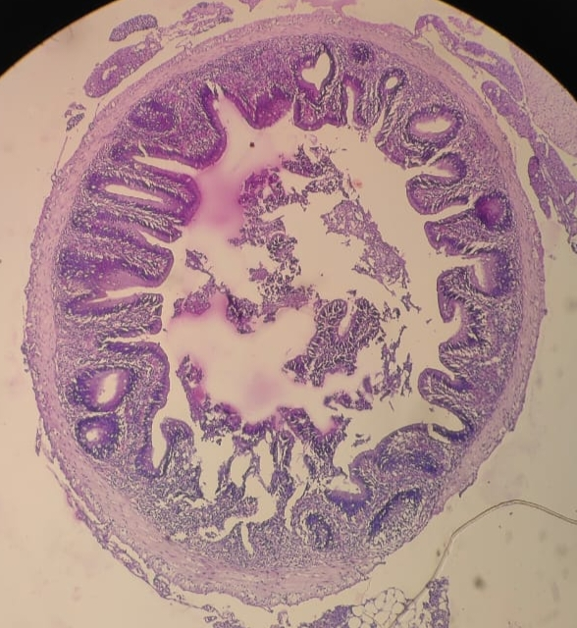
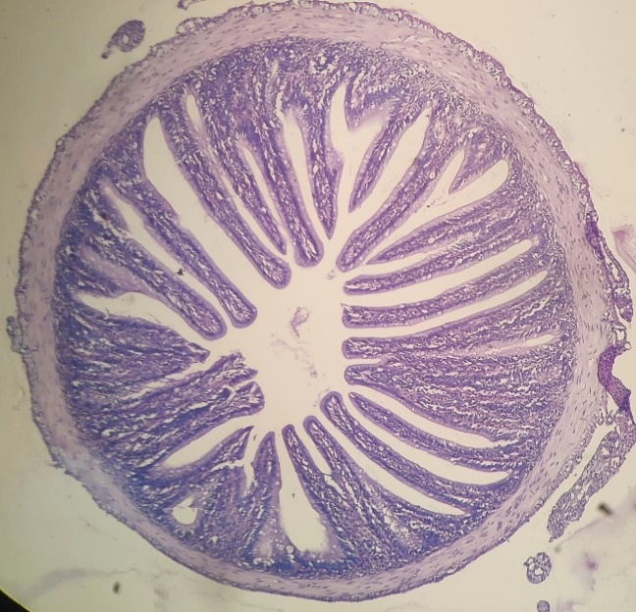
B
A

1
2

+

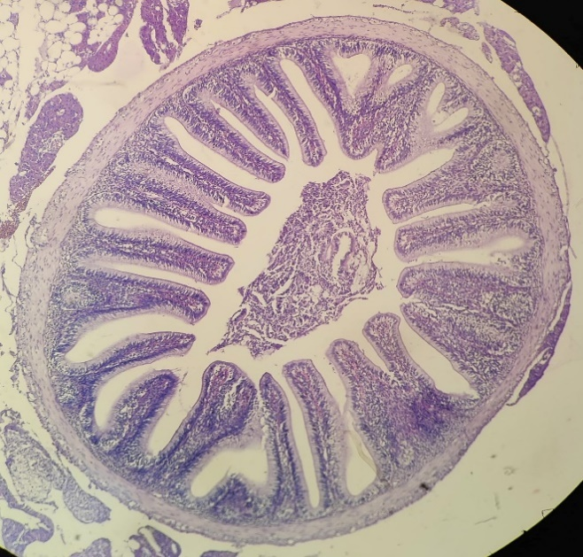
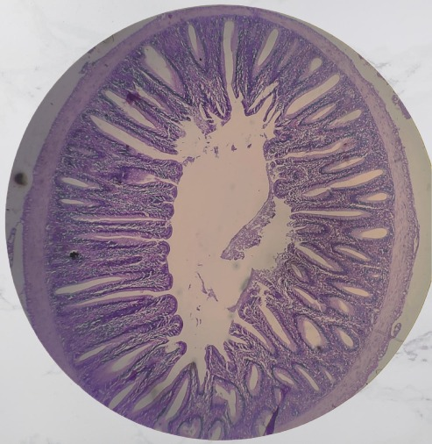
D
C

3
4

Fig. 1. Gut histology of fish fed with control(A) and Gotu kola supplemented diets
(B-D: 10X).
All the treatments showed higher villi height (2), lumen diameter (3), villi width (4) and in control group showed shorter villi height, villi width (1).

Table 1. Details of proximate composition (%) of ingredients used for preparation of experimental diets (Dry weight basis).
Parameters | Fish meal | Groundnut oil cake | Rice bran | Tapioca flour
Moisture | 6.80 ± 0.11 | 8.22 ± 0.12 | 13.24 ± 0.16 | 7.06 ± 0.16
Protein | 64.12 ± 0.24 | 38.22 ± 0.18 | 9.13 ± 0.22 | 2.57 ± 0.21
Fat | 8.18 ± 0.07 | 1.24 ± 0.13 | 10.65 ± 0.06 | 1.02 ± 0.22
Crude fibre | 1.39 ± 0.12 | 2.46 ± 0.20 | 8.24 ± 0.18 | 8.13 ± 0.03
Ash | 14.83 ± 0.13 | 7.60 ± 0.26 | 11.16 ± 0.02 | 2.24 ± 0.14
NFE | 4.59 ± 0.16 | 42.02 ± 0.06 | 49 ± 0.28 | 80.86 ± 0.16
Values in Mean ±SE.

Table 2. Details of composition (%) of ingredients used for preparation of different experimental diets and control.
Ingredients | Control(T₀) | T₁ | T₂ | T₃
Fish meal | 26.67 | 26.67 | 26.67 | 26.67
Groundnut oil cake | 26.67 | 26.67 | 26.67 | 26.67
Rice bran | 22.32 | 21.82 | 21.32 | 20.32
Tapioca | 23.32 | 23.32 | 23.32 | 23.32
Vitamin-mineral mixture | 1 | 1 | 1 | 1
Gotu kola | 0 | 0.5 | 1 | 2
Total | 99.98 | 99.98 | 99.98 | 99.98

Table 3. Details of proximate composition (%) of experimental diets and control (Dry weight basis).
Parameters | Treatments
Parameters | T₀ | T₁ | T₂ | T₃
Protein | 30.48 ± 0.12 | 30.56 ± 0.14 | 30.64 ± 0.24 | 30.68 ± 0.32
Fat | 6.31 ± 0.14 | 6.12 ± 0.03 | 6.18 ± 0.03 | 6.14 ± 0.44
Fibre | 5.24 ± 0.02 | 5.49 ± 0.08 | 6.88 ± 0.04 | 6.12 ± 0.02
Moisture | 8.46 ± 0.04 | 9.32 ± 0.32 | 8.68 ± 0.11 | 9.46 ± 0.12
Ash | 12.34 ± 0.02 | 13.65 ± 0.09 | 14.34 ± 0.07 | 14.98 ± 0.04
NFE | 37.17 ± 0.06 | 34.86 ± 0.05 | 33.28 ± 0.22 | 32.66 ± 0.06

Table 5. Weight gain, Specific Growth Rate (SGR), Food Conversion Ratio (FCR) and Protein Efficiency Ratio (PER) of Common Carp under different treatments and control
Treatments  Growth  Parameters | T₀ | T₁ | T₂ | T₃
Weight gain (g) | 6.47 ± 0.034^{c} | 8.01 ± 0.226^{b} | 7.77 ± 0.185^{b} | 10.02 ± 0.290ª
Specific growth rate | 1.08 ± 0.015^{d} | 1.28 ± 0.025^{b} | 1.22 ± 0.066^{c} | 1.43 ± 0.011ª
Feed conversion ratio | 2.91 ± 0.144ª | 2.33 ± 0.043^{c} | 2.48 ± 0.005^{b} | 1.98 ± 0.034^{d}
Protein efficiency ratio | 1.13 ± 0.020^{d} | 1.41 ± 0.038^{b} | 1.38 ± 0.043^{c} | 1.67 ± 0.024ª
Data presented as Mean ± Standard Error (M ± SE). Values within the same column bearing different superscript letters indicate a significant difference (p < 0.05).

Table 4. Details of water quality parameters observed during experimental period.
Sl. No. | Water quality parameters | Range of values
1 | Water temperature | 26.2 - 29⁰C
2 | pH | 6.8 - 7.3
3 | DO | 5.2 - 6.3 mg/l
4 | CO₂ | 6.43 - 7.50 mg/l
5 | Total alkalinity | 74 - 98 mg/l
6 | Ammonia-Nitrogen | 0.004 - 0.008 mg/l
7 | Hardness | 60 - 85 mg/l
8 | Nitrite-Nitrogen | 0.045 - 0.054 mg/l
9 | Nitrate-Nitrogen | 0.038-0.047 mg/l

