Minireview Article

Role of Puntius sophore (Hamilton, 1822) in Small-Scale Fisheries, Rural Livelihoods, and Traditional Knowledge Systems

Abstract
Puntius sophore (pool barb) is a small indigenous fish species widely distributed across South and Southeast Asian countries, where it plays an important role in small-scale fisheries, rural livelihoods, and traditional food systems. Its ecological adaptability, high reproductive capacity, and year-round availability makes it an important fish resource for small and marginalized fisher’s communities. P. sophore is a good source of essential proteins and micronutrients such as calcium, iron, and vitamin A, thereby addressing nutrient deficiencies and enhancing food security. It also supports rural economies through local market sales and gender-inclusive value chains, with women significantly takes part in post-harvest processing and trade. Traditional ecological knowledge surrounding fishing practices and culinary diversity underscores its cultural significance and intergenerational importance. However, increasing anthropogenic pressures such as overfishing, habitat degradation, and global warming pose threats to population stability and the livelihoods dependent on this species. Although listed as Least Concern by the International Union for Conservation of Nature (IUCN), localized declines in P. sophore populations highlight the urgent need for sustainable management strategies. This review highlights P. sophore current knowledge on the biology, ecological role, socio-economic contributions, and traditional importance while emphasizing conservation and community based approaches to ensure its continued availability as a vital resource for food, livelihood security and income generation of the rural communities.
Keywords: Small scale fisheries, rural livelihoods, food security, cultural significance, conservation

1. Introduction
Small indigenous fish species (SIFS) of freshwater fisheries play a pivotal role in sustaining inland fisheries, food security, and rural livelihoods across South and Southeast Asia (Thilsted and Wahab, 2014). These species are known by their small body size, high reproductive rates, and availability in diverse aquatic habitats including rivers, wetlands, floodplains and ponds. SIFS contribute substantially to household food supply and income generation despite their small size, particularly among small and marginalized communities (Roos et al., 2007; Roos et al., 2002). SIFS are often through low-cost and traditional fishing methods unlike the larger, commercially cultured freshwater fish species, thereby making them accessible to the poor households (Prasad et al., 2013).

Among this SIFS, Puntius sophore (commonly known as pool barb) occupies a special place due to its ecological adaptability and socio-economic importance. Figure 1 shows the typical morphology of P. sophore, a small indigenous fish commonly found and harvested in Manipur and other parts of South and Southeast Asia. P. sophore is commonly distributed widely across India, Bangladesh, Nepal, Bhutan, Myanmar, Pakistan, and southern China (Ahamed et al., 2012). It is the most abundant SIFS species harvested from inland water bodies. Its availability throughout the year, fast growth, and its ability to thrive in both lotic and lentic ecosystems enhance its importance as a reliable nutritious food source (Hasan et al., 2018). P. sophore is not only the source of protein but also essential micronutrients such as calcium, iron, and vitamin A, which are critical in addressing malnutrition in rural areas (Roos et al., 2002).

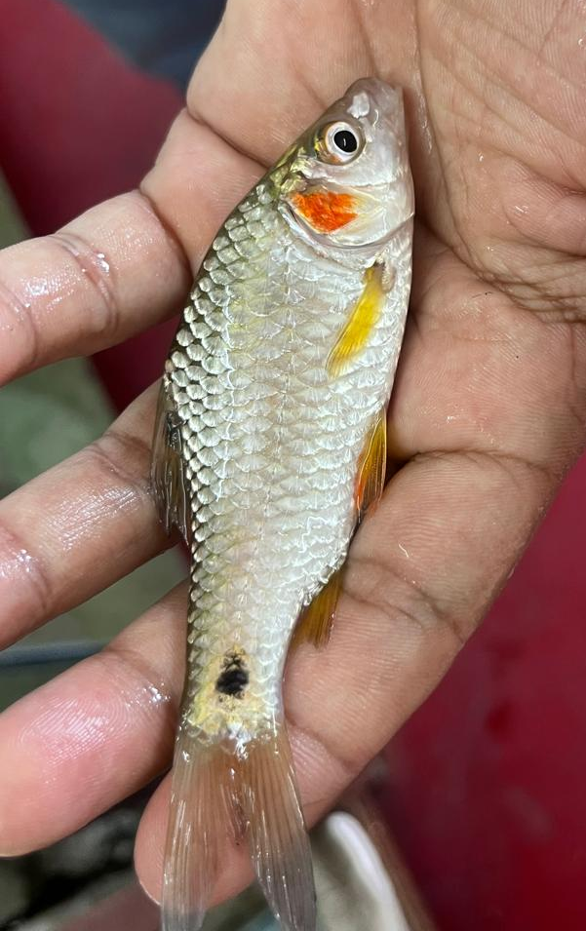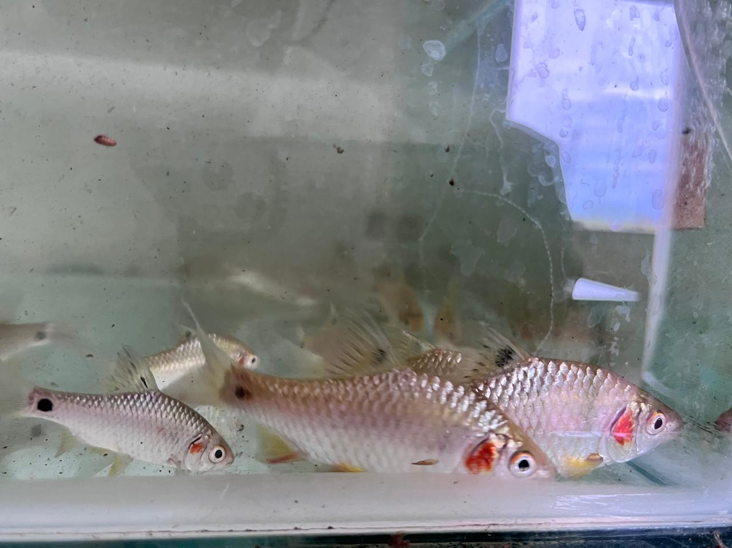

Figure 1. Adult P. sophore (pool barb) commonly found in rivers, ponds, and floodplains of Manipur and other regions of South and Southeast Asia.

The socio-economic contribution of P. sophore extends beyond food security. It plays an important role in small-scale fisheries, which are central to the livelihoods of rural households mainly in South Asian countries (Solo, 2025). Its low market price and high demand make it affordable for low-income fish consumers and profitable for small-scale and marginal fishers and traders. Women are found to be actively engaged in post-harvest activities such as drying, fermenting, and marketing of P. sophore across many regions in India, particularly the north eastern parts of India, hence reinforcing its importance in the gendered dimensions of rural livelihood activities (Ahamed et al., 2012; Kakati et al., 2018; Solo, 2025). Furthermore, traditional ecological knowledge associated with the capture, processing, and consumption of P. sophore underscores its cultural and community-level significance across South and Southeast Asia (Edwards et al., 2002).

P. sophore faces growing threats from anthropogenic activities despite its nutritional and rural livlihood importance. Overfishing during peak breeding seasons, has contributed to the declines in P. sophore abundance, while habitat degradation due to pollution, siltation, and wetland loss further constrains its natural recruitment (Hasan et al., 2018). Climate change, through altered rainfall patterns and global warming, further poses additional threats to its reproductive biology and distribution. P. sophore is currently categorized as Least Concern on the IUCN Red List (Dahanukar, 2010), however, its ecological and socio-economic roles warrant further research attention and conservation action plan to safeguard its continued contribution to food and rural livelihood security.
This review focus on existing knowledge on the ecological, nutritional, socio-economic, and cultural importance of P. sophore, with special importance on its role in small-scale fisheries, rural livelihoods, and traditional knowledge systems. This review further aims to inform conservation management strategies and policy frameworks that can ensure the continued resilience of P. sophore populations, distribution and the rural communities dependent on them by highlighting both opportunities and challenges.

2. Species Overview: Distribution, Ecology, and Life History
P. sophore is considered one of the most widely distributed SIFS in South and Southeast Asia, occurring naturally across diverse freshwater habitats in India, Bangladesh, Nepal, Bhutan, Myanmar, Pakistan, and southern China (Ahamed et al., 2012). It can thrives in both lotic environments such as rivers and streams, as well as lentic ecosystems including ponds, floodplains, and wetlands. Puntius spp. usually shows a preference for shallow waters where it can form shoals, an adaptive strategy that provides protection from predators and enhances foraging efficiency. This ecological capabilities allows this fishes to colonize a variety of aquatic niches, ensuring availability throughout the year to fisher’s folks and consumers.

From a reproductive point of view, P. sophore has relatively short breeding cycle, high fecundity, and asynchronous oocyte development. Studies conducted in Bangladesh have shown that spawning season of P. sophore typically extends from March to July, with peak breeding varying according to local rainfall and temperature (Hasan et al., 2018). Females usually produce between 7951 to 23053 eggs, which are released in batches, thus enabling extended reproduction across the season. Early maturation and fast growth of P. sophore make this fish species well-suited to sustaining open-water fisheries. Moreover, its capability to adapt in fluctuating water conditions, mainly in floodplain-river ecosystems, highlights its ecological role as both a forage fish and a major contributor to aquatic biodiversity.

3. Contribution to Small-Scale Fisheries
Small-scale fisheries in South Asian countries are largely dependent on SIFS such as P. sophore, which contribute to food security and for rural livelihoods (Thilsted and Wahab, 2014). This fish is harvested using low-cost, traditional gears such as cast nets, traps, and gillnets in rural communities, with maximum catches during the monsoon season when rivers and floodplains are inundated (Ahmed et al., 2012). These seasonal floods helps in the dispersal and breeding of SIFS, thereby allowing P. sophore presence in abundant and easily accessible fish resource for subsistence fishers.
This species is highly valued for its contribution to both macronutrient and micronutrient intake nutritionally. Consumption of small whole fish, including bones and viscera, ensures high levels of bioavailable calcium, iron, zinc, and vitamin A in household diets (Sarojnalini and Devi, 2014). Nutrient-rich fish like P. sophore are particularly important for vulnerable groups, including women and children, in addressing food security and in preventing malnutrition. P. sophore seasonal abundance often coincides with periods of food scarcity in rural areas, thereby acting as a nutritional safety net during critical periods. Hence, P. sophore not only provides protein but also plays a direct role in reducing nutritional deficiencies among low-income populations (Hasan et al., 2018).

4. Socio-Economic Value and Market Dynamics
P. sophore supports market and income-generating activities in South and Southeast Asian countries. In local fish markets across India, Bangladesh, and Nepal, P. sophore is sold in fresh form and as a processed product (dried or fermented), often commanding good prices due to its nutritional value and consistent consumer demand (Hossain and Wahab, 2010). Unlike larger, high-value commercial fish species that are often exported or consumed by urban communities, P. sophore remains accessible to rural communities, reinforcing its importance as a “fish for the poor.”
The species’ contribution to household livelihood and economies extends to its role in gendered livelihood strategies. Women are mainly involved in post-harvest activities such as drying, fermenting, and small-scale marketing of P. sophore, often selling good catches in village markets to supplement family income (Ferdous et al., 2023). Such activities encourage and enhance women’s participation in fisheries value chains, while also diversifying livelihood opportunities. Although individual P. sophore, are small, bulk catches during the monsoon season provide significant returns to households, particularly when market prices rise due to increased demand for small dried fish during lean fishing periods (Hossain and Wahab, 2010). P. sophore affordability and availability further reinforce economic resilience in rural communities by ensuring that even the most marginalized households can access and benefit from fisheries resources.

5. Traditional Knowledge and Cultural Significance
Traditional ecological knowledge plays an important role in the sustainable use and cultural integration of P. sophore. Fishing communities across South Asian countries rely on indigenous knowledge systems to time their fishing activities with ecological cues such as rainfall patterns, physico-chemicals parameters of water, turbidity, and lunar cycles. This knowledge helps ensure optimal harvests while allowing the species sufficient time for reproduction, thereby contributing to long-term sustainability.
Culturally, P. sophore is deeply embedded in the diets and food traditions of rural households. In India’s northeastern states and Bangladesh, the species is consumed in multiple culinary forms, including curries, fried dishes, dried fish preparations, and fermented products (Goswami and Manna, 2019; Kakati and Goswami, 2013). Fermented fish, in particular, plays a critical role in traditional food systems, where P. sophore and similar SIFS are preserved for consumption during lean seasons (Farhana et al., 2025; Goswami et al., 2024; Nongmaithem et al., 2023; Thaosen and Sarma, 2024). These cultural practices enhance food security and also preserve biodiversity by encouraging the utilization of a wide range of SIFS in daily diets.
Ethnobiological studies highlight that P. sophore is not just a dietary staple but also represents a culturally important resource linked to festivals, traditional medicine, and community identity (Chutia et al., 2024). In the state of Manipur, dried and fermented forms of P. sophore are traded across village networks, contributing to local economies while strengthening social ties. Such cultural embeddedness ensures that the knowledge and practices associated with P. sophore are pass down across generations, reinforcing both ecological and social sustainability.

6. Threats to Populations and Livelihoods
P. sophore faces multiple anthropogenic threats despite its resilience particularly the overfishing, during breeding seasons, has been reported to reduce population abundance in natural waters bodies (Hasan et al., 2018). Habitat degradation from pollution, agricultural runoff, and wetland loss further limits recruitment and growth opportunities (Hossain et al., 2010). Climate change, particularly variability in monsoon rainfall and rising temperatures, may disrupt breeding cues and floodplain connectivity essential for reproduction. These stressors collectively threaten both the ecological sustainability of P. sophore and the livelihoods of the rural poor who depend on it.

7. Conservation and Management Approaches
Conservation of P. sophore requires integration of biological knowledge with community-based fisheries management. Seasonal fishing bans during peak spawning months have been suggested to sustain recruitment (Hasan et al., 2018). In situ measures such as habitat restoration, wetland conservation, and riparian buffer zones are crucial to maintaining nursery habitats. Community based management strategies, which involve local fisher’s population in decision making, have been effective in other SIFS fisheries and can be adapted for P. sophore (Ahmed et al., 2010; Ahamed et al., 2012). Furthermore, integrating P. sophore into nutrition-sensitive aquaculture systems alongside Indian major carps and exotic carps could enhance local food and income generation.

8. Conclusion
P. sophore is a small fish of importance, bridging ecology, nutrition, economy, and culture. It plays an important role in enhancing the livelihoods of rural communities across South and Southeast Asian countries, yet faces growing threats from overexploitation, habitat loss, and climate change. Addressing these challenges requires both scientific understanding of its reproductive biology and ecology and the incorporation of traditional knowledge and community based management. Future studies should prioritize on conservation, sustainable utilization, and integration into aquaculture, ensuring that P. sophore continues to support food and livelihood security for rural communities.

References
Ahamed, F., Ahmed, Z. F., Hossain, M. Y., & Ohtomi, J. (2012). Growth study of the pool barb Puntius sophore (Cyprinidae: Barbinae) through multi-model inferences. Zoological Studies, 51(7), 1077-1085.
Ahmed, N., Allison, E. H., & Muir, J. F. (2010). Rice fields to prawn farms: a blue revolution in southwest Bangladesh. Aquaculture International, 18(4), 555-574.
Chutia, D., Talukdar, M., Deka, A., Nath, J. K., Saikia, A., & Sarma, D. (2024). Exploring the Nutritional, Ornamental, and Conservation Aspects of a Few Indigenous SmallFishes (ISFs) Belonging to the Genera Puntius and Pethia from Northeast India. In Perspectives and Applications of Indigenous Small Fish in India: An Introduction (pp. 351-361). Singapore: Springer Nature Singapore.
Dahanukar, N. (2010). Puntius sophore. The IUCN Red List of Threatened Species 2010: e. T166623A6249514.
Edwards, P., Little, D. C., & Demaine, H. (2002). Issues in rural aquaculture. Rural aquaculture, 323-340.
Farhana, J. A., Schoustra, S. E., Ahamed, F., Zwaan, B., & van Mastrigt, O. (2025). The production process of chepa shutki: A traditional Bangladeshi fermented fish product. Heliyon, 11(2).
Ferdous, M. J., Islam, M. S., Alam, M. S., Khan, M. G. Q., Bari, M. R., Hasan, I., & Khandakar, J. (2023). Exploring the Market Value Chain Dynamics of Chepa (Semi-Fermented Fish): A Promising Solution to Alleviate Nutritional Deficiency. Research in Agriculture Livestock and Fisheries, 10(3), 353-366.
Goswami, S., & Manna, K. (2019). Nutritional analysis and overall diet quality of fresh and processed (sun-dried and fermented) Puntius sophore. Current Research in Nutrition and Food Science Journal, 7(2), 360-368.
Goswami, S., Bala, A., Gandla, K., Debnath, B., Singh, W. S., Repudi, L., & Manna, K. (2024). A study of the effects of fresh and processed fish oils of Tenualosa ilisha, Mystus bleekeri, and Puntius sophore on Experimental Model on Atherosclerosis. DOI: https://doi.org/10.21203/rs.3.rs-5363237/v1.
Hasan, T., Hossain, M. F., Mamun, M., Alam, M. J., Salam, M. A., & Rafiquzzaman, S. M. (2018). Reproductive biology of Puntius sophore in Bangladesh. Fishes, 3(2), 22.
Hossain, M. A., & Wahab, M. A. (2010). The diversity of cypriniforms throughout Bangladesh: present status and conservation challenges (pp. 143-182). New York, NY, USA: Nova Science Publishers.
Kakati, B. K., & Goswami, U. C. (2013). Characterization of the traditional fermented fish product Shidol of Northeast India prepared from Puntius sophore and Setipinna phasa. Indian Journal of Traditional Knowledge, 12(1), 85-90.
Kakati, B. K., Sarma, P., Ahmed, S., & Goswami, U. C. (2018). Nutritional, microbial and sensory quality evaluation of fermented Puntius sophore Hamilton, 1822 (Puthi shidal) marketed in North-east India. Journal of Applied and Natural Science, 10(1), 316.
Nongmaithem, B. D., Ngangbam, A.K., Lenin, L., Niswal, N., & Sharma, N. (2023). A review on the potential scope towards industrial development and cultural conservation of the fermented fish products of India. Asian Jr. of Microbiol. Biotech. Env. Sc. 25(2): 293-306
Prasad, L., Jalaj, R., Pandey, S., & Kumar, A. (2013). Few indigenous traditional fishing method of Faizabad district of eastern Uttar Pradesh, India. Indian journal of traditional knowledge, 12(1), 116-122.
Roos, N., Thilsted, S. H., & Wahab, M. A. (2002). Culture of small indigenous fish species in seasonal ponds in Bangladesh: the potential for production and impact on food and nutrition security. In Rural aquaculture (pp. 245-252). Wallingford UK: CABI Publishing.
Roos, N., Thorseng, H., Chamnan, C., Larsen, T., Gondolf, U. H., Bukhave, K., & Thilsted, S. H. (2007). Iron content in common Cambodian fish species: perspectives for dietary iron intake in poor, rural households. Food Chemistry, 104(3), 1226-1235.
Sarojnalini, C., & Devi, W. S. (2014). Antioxidant properties and nutritive values of raw and cooked pool barb (Puntius sophore) of Eastern Himalayas. International Journal of Agricultural, Biosystems Science and Engineering, 8(1), 13-17.
Solo, B. (2025). Economic importance, ecological significance, and distribution of Puntius fish species in major rivers of the Kolodyne drainage system, Mizoram, North-Eastern India. Zoological and Entomological Letters. 5(2): 16-22
Thaosen, N., & Sarma, D. (2024). An Important Ingredient of Traditional Fermented Fish in Northeast India, Puntius sophore: A Mini Review. Perspectives and Applications of Indigenous Small Fish in India: An Introduction, 511-525.
Thilsted, S. H., & Wahab, M. A. (2014). Production and conservation of nutrient-rich small fish (SIS) in ponds and wetlands for nutrition security and livelihoods in South Asia. WorldFish.

