Review Article
Artificial diets for mulberry silkworm Bombyx mori L.

Abstract
The silkworm, Bombyx mori L., is typically nourished with a natural diet consisting of fresh mulberry leaves. Nevertheless, to address the significant challenges associated with mulberry leaves, including the high costs of land for mulberry cultivation, the construction of rearing facilities, the housing of farmers, the necessity for efficient transportation, and the demand for intensive labor, various artificial diets rich in essential nutrients have been formulated. The initial use of artificial diets in sericulture occurred in Japan in 1977, aimed at the rearing of young silkworms within cooperative rearing facilities. The implementation of artificial diets in sericulture has significantly reduced the labor required for silkworm rearing, leading to a rapid increase in the rearing of young and healthy larvae.

Keywords: Muberry, Silkworm Bombyx mori, Artificial diets, Essential nutrients.
INTRODUCTION

The silkworm (Bombyx mori L.) is an extraordinary monophagous lepidopteran insect that holds a unique position among insect species that are suitable for various scientific investigations. Its traditional diet primarily consists of mulberry (Morus sp.) leaves (Saviane et al., 2014), which are more appealing than other vegetable leaves, as they are preferred due to the volatile compounds they contain (Paudel et al., 2020). The rearing success and productivity of silkworms are influenced by the nutritional composition and quality of mulberry leaves, which tend to be superior in the spring compared to autumn (Manjula et al., 2011; Lee and Choi, 2012). Other factors that affect the nutritional and functional properties of mulberry leaves include the cultivar, the timing of harvest, and the maturity level of the leaves (Iqbal et al., 2012; Lee & Choi, 2012). However, Hu et al. (2013) observed that the location of the leaves on the mulberry tree also impacts their nutritional quality, with the upper leaves exhibiting higher nutritional content than the mature leaves. Mulberry leaves possess an excellent nutrient profile, comprising proteins, carbohydrates, sugars, lipids, vitamins, and microminerals (Zhou et al., 2015; Yu et al., 2018). Additionally, mulberry leaves demonstrate a greater capacity for carbon sequestration (Hăbeanu et al., 2023). The bioactive compounds found in mulberry leaves, such as flavonoids, polysaccharides, and alkaloids, exhibit hypoglycaemic, immunoregulatory, antioxidant, and anticoagulant properties (Wang et al., 2010; Devi et al., 2013; Wen et al., 2020; Zhang et al., 2022). Utilizing invertebrates like the silkworm as a biological model is more feasible due to their short generation time, which allows for low-cost breeding and eliminates the need for ethical approval (Panthee et al., 2017). This review aims to consolidate the existing literature regarding the significance of nutrition as a critical factor in silkworm rearing and the efficacy of employing an artificial diet composed of various ingredients to enhance silkworm productivity and health.

REQUIREMENTS IN FORMULATIONS OF ARTIFICIAL DIETS FOR THE SILKWORM

There are a minimum of four primary criteria that must be considered when formulating artificial diets for silkworms:
Picture 1 : To meet both qualitative and quantitative nutritional requirements
The qualitative nutritional needs have been examined using the synthetic or semi-synthetic diets listedn below. 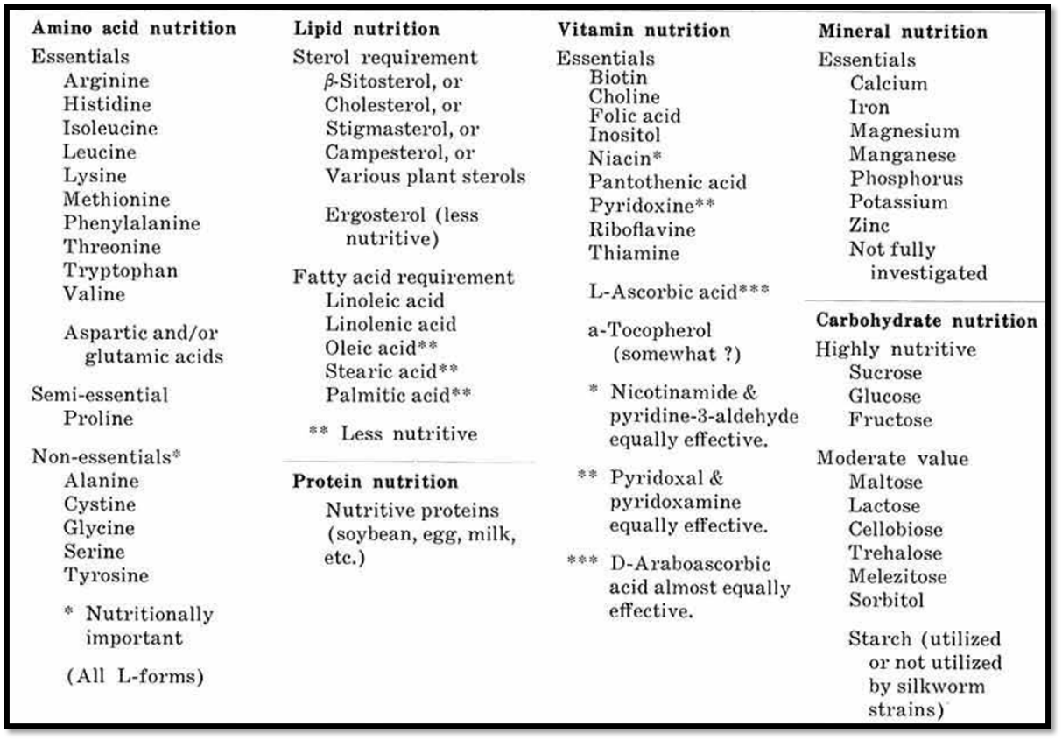
- Another significant factor is the quantitative requirements, as the nutritional balance greatly influences the growth rate and silk production.

- Minimum optimal levels of essential nutrients have been established, and it has been observed that these values align closely with the analytical data of mulberry leaves. Consequently, mulberry leaves are deemed to meet the nutritional needs, both qualitatively and quantitatively.

- The dosage and balance of dietary components are crucial in diet formulation.

- To achieve higher silk production, the dietary level of the amino acid mixture or soybean meal must be elevated to a certain extent.

- Moreover, the composition of the amino acid mixture has a direct impact on larval growth and silk production.

- An increased level of non-essential amino acids (such as alanine, cystine, glycine, serine, and tyrosine) or acidic amino acids (aspartic and glutamic acids) promotes growth acceleration and enhances silk production, while a higher concentration of essential amino acids has a negative effect on these processes.

- The ratio of fibroin to sericin in the cocoon layer also varies based on the aforementioned amino acid composition. There exists a preferred ratio for the two acidic amino acids in the diet.

- Additionally, the quantitative requirements for amino acids differ somewhat between male and female larvae.

2. To possess the suitable physical properties
- Physical factors frequently play a significant role in maintaining the quality of diets.

- Water content is a primary factor, with an optimal level of approximately 75% being advantageous.

- Nevertheless, the appropriate water content must be assessed for each specific diet, as certain dietary components, such as agar, sugar, and cellulose powder, are closely linked to the hardness or softness of the diets.

- The physical properties of the diet can be altered by adding cellulose powder or by increasing its concentration within the diet.

- The rate of food consumption tends to increase with higher levels of dietary cellulose powder, which in turn accelerates growth, even when larvae are consuming a less nutritious diet.

- Given that silkworms are unable to digest cellulose, incorporating an optimal amount of cellulose powder into the diet is believed to enhance its physical properties. Additionally, dietary agar also plays a crucial role.

3.To be free from the microbial contamination
- Artificial diets break down rapidly unless an appropriate antimicrobial agent is incorporated.
- The larvae that have consumed the highly contaminated diet will perish, with few exceptions.
- Certain types of antimicrobial agents can be detrimental to the silkworm, thus their concentrations in the diet must remain at safe levels.
- Typically, a combination of two or more substances is preferred; however, it remains impossible to entirely prevent diet decomposition under conventional rearing conditions.
- In diets utilizing sorbic acid, propionic acid, and chloramphenicol, these are included at their optimal concentrations.
- While bacterial contamination can be avoided under aseptic conditions, this approach is impractical for large-scale sericulture rearing.
- It should not contain any potential deterrents or repellents.
- Given that most nutritional compounds possess distinct flavors, the role of nutrients as either feeding stimulants or inhibitors is significant.
- For example, certain sugars greatly enhance silkworm feeding, while some amino acids considerably reduce it. The taste is more crucial than the odor for larvae to accept the diet.
- Soybean meal, a primary ingredient, contains a water-soluble deterrent substance that can be easily extracted by washing with 90% ethanol.
- Practical diets include a specific amount of dried mulberry leaf powder, which promotes both feeding and growth.
CLASSIFICATION OF ARTIFICIAL DIETS AND THEIR COMPOSITIONS

Based on the composition of the diet three artificial diet have been developed
- Amino acid diet
- Diet containing mulberry leaf powder
- Diet without mulberry leaf powder/Semi- synthetic diet

Table 1. Composition of amino acid diet (Toshio Ito, 1980)

Substance | % in dry diet
Potato starch | 7.50
Sucrose | 12.50
Amino acid mixture | 20.00
Soyabean oil, refined | 3.00
β-sitosterol | 0.50
Werson’s salt mixture | 4.50
Ascorbic acid | 2.00
Citric acid | 0.50
Cellulose powder | 34.20
Morin | 0.30
Agar | 15.00
Total | 100.00
Vitamin B mixture | Traces
Distilled water | 3ml/g dry weight

Amino acid-based diets support larval growth to a certain degree, allowing the larvae to spin cocoons. This type of diet is utilized for essential nutritional research, but it is not intended for commercial applications.

Table 2. Composition of artificial diet containing mulberry leaf powder ( Yasuhiro Horie 1980)
Substance | Diet for 1st -4th instar(g) | Diet for 5th instar(g)
Mulberry leaf powder | 25.00 | 25.00
Soyabean oil | 1.50 | 3.00
Defatted soyabean meal | 36.00 | 45.00
Cholesterol | 0.20 | 0.20
Citric acid | 4.00 | 4.00
Ascorbic acid | 2.00 | 2.00
Sorbic acid | 0.20 | 0.20
Agar | 7.50 | 5.00
Salt mixture | 3.00 | 3.00
Glucose | 8.00 | 10.00
Potato starch | 7.50 | 15.00
Cellulose powder | 20.80 | -
Vitamin B mixture | Traces | Traces
Antiseptic | Traces | Traces
Total | 115.70 | 112.40
Distilled water | 300ml | 220ml

This diet is used for commercial rearing of silkworm

Table 3. Composition of semi-synthetic diet (Toshio Ito,1980)
Substance | Dry diet (g)
Substance | Starter  (1st instar) | Grower  (II-IV instar) | Producer  (V instar)
Potato starch | 10.00 | 10.00 | 20.00
Sucrose | 10.00 | 10.00 | -
Glucose | - | - | 12.00
Soyabean meal, defatted | 30.00 | 40.00 | 60.00
Soyabean oil, refined | 3.00 | 3.00 | 3.00
β-sitosterol | 0.50 | 0.50 | 0.50
Salt mixture | 3.50 | 3.50 | 2.00
K₂HPO₄ | 1.00 | 1.00 | -
Ascorbic acid | 2.00 | 2.00 | 2.00
Cellulose powder | 34.00 | 34.00 | -
Agar | 15.00 | 15.00 | 5.00
Citric acid | 0.50 | 0.50 | 0.50
Sorbic acid | 0.20 | 0.10
Total | 109.90 | 119.80 | 105.20
Vitamin B mixture | Traces | Traces | Traces
Antiseptic | Traces | Traces | Traces
Distilled water | 300ml | 300ml | 260ml

EFFECT OF ARTIFICIAL DIET ON SILKWORM
- The favorable Feeding Response (FR) observed in the strains studied on an artificial diet can be linked to the inclusion of mulberry leaf powder in the diet formulation, which significantly enhances the FR in silkworms.
- Nihmura et al. (1977) indicated that it is highly beneficial to incorporate mulberry leaf powder or extracts from mulberry leaves as a feeding stimulant in the artificial diet to elicit a consistent and rapid FR in newly hatched larvae.
- Strains were successfully developed that accepted the diet and exhibited strong performance regarding their economic traits, nearly matching that of counterparts reared on mulberry.

ADVANTAGES AND DISADVANTAGES OF ARTIFICIAL DIET

Advantages:
- Balanced nutrition can be provided to silkworms, according to their age.
- The growth and development of silkworms occur uniformly.
- Maintaining aseptic conditions aids in the prevention of pathogens.
- An optimal approach for examining the nutritional impact on silkworms.
Disadvantages:
•The expense associated with raising silkworms on artificial diets is four times greater than that of raising them on mulberry leaves.
•Maintaining aseptic conditions in the farmers' fields presents a significant challenge.
•Artificial diets are prone to bacterial contamination.
•Specialized conditions are necessary for the preparation and storage of artificial diets.

Artificial diets for mulberry silkworm

The Receptivity of breeds silkworm, Bombyx mori L. to artificial diet low in mulberry Powder (Guncheva, 2016)
The use of silk moth, as an object of biological research, raises the need to create alternative sources of cheap food. The objective of this study was to determine the susceptibility of species Bombyx mori L. to artificial diets with reduced content of dried mulberry leaf.
- 70% survival rate when reared with artificial diet, comprising 25% mulberry powder in its composition.
- In the experiment for feeding silkworms we used artificial diet with 15 % content of dried mulberry leaf produced in SAES - Vratsa pulverized.
- The preparation of the diet to feed the silkworms was done by methods developed by the manufacturer, whereby 250g dry substance and 675ml of distilled water are homogenized using a mixer.
- Placed in a box with a lid, the mixture is treated thermally in MW for 10'at ~800W.
- The cooked food was stored in a refrigerator at temperature 2-5°C until using it for feeding.
Table 4. Criteria for assessing the degree of receptivity of silkworms to artificial food
Degree of receptivity | Vitality (%)
Very high | Over 90
High | 85-90
Normal | 70-85
Low | 60-70
Very low | Under 60

The receptivity of silkworms to artificial food, one of the main signs is the number of normally developing specimens, calculated as percentage of vitality. The data analysis was carried out based on the criteria specified in Table 4 defining the degree of receptivity of larvae to artificial diet.

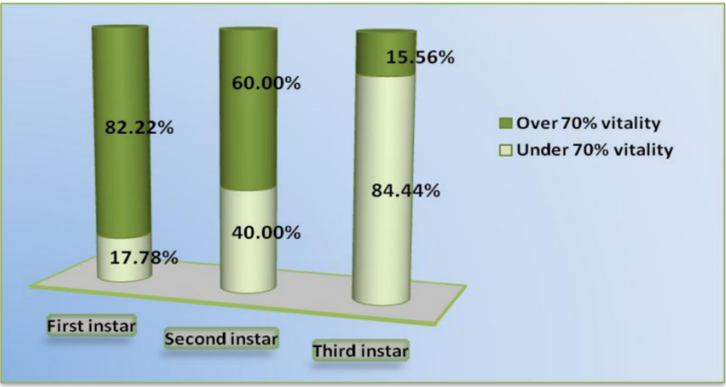
Fig 1. Percentage of Breeds with High (> 70%) and Low (< 70%) receptivity to artificial diet with low mulberry powder content

The data in Fig. 1 showed that when silkworm reared with artificial diet with 15 % content of dried mulberry leaf 70% have 82.22%, 60% and 15.56% vitality, respectively for first, second and third instar. Therefore, the majority of breeds retain high affinity to artificially prepared diet despite the lowered content of mulberry powder in it (Guncheva, 2016).

Effect of diet with or without ascorbic acid on larval mortality (%) in the different larval instars of the double-cross larvae [(119×118) × (120×121)]
The absolute values of mortality in the different instars were slightly different in the two strains, but the same general trend was observed. In the first and second instars, in the negative control, ascorbic acid deficiency in the diet did not affect larval mortality, while from the third instar, mortality increased substantially in comparison to the positive control. Furthermore, deprivation of ascorbic acid in the diet did not affect larval mortality directly in the same instar when deprivation occurred, but after two or three instars that followed, significant effects was observed.

larval weights of moulted larvae fed a diet with ascorbic acid or without ascorbic acid (single-cross larvae 118×120)

larval weight at the various moults observed in the single-cross larvae (118×120). It is worth noting that no significant differences in weight were recorded at the first and second moults. A decreasing trend was already visible at the second moult, but differences began to be significant from the third moult, when deprived larvae were lighter than larvae fed on the diet containing ascorbic acid. With regard to the double-larvae, results concerning the weight at the first moult were rather unclear. In fact, the experiment was repeated many times, obtaining contradictory data. Specimens belonging to the group of negative. Controls showed mostly lighter weight or, in some cases, the same weight as specimens belonging to the positive controls. According to Cui et al. (2003), a suitable concentration of ascorbic acid in the diet would increase the weight of the silkworm body.

Comparison of cocoon weight, shell weight and silk ratio among different larval groups of the single-cross larvae 118×120 reared on a diet with or without ascorbic acid
The economic parameters, measured in terms of silk production, obtained for the single-cross larvae. Prolonged deprivation of ascorbic acid from the silkworm diet negatively affected the economic parameters of silk production both in the male and female (see group “-1”). The study reported that feeding silkworms with a diet containing ascorbic acid from the first instar did not significantly increase silk production either in the male or female. Particularly, the groups deprived of ascorbic acid from the beginning of the fourth and fifth instars (group “-4” and “-5”) were completely comparable to the positive control, with regard to their silk production both in the male and female. Furthermore, both groups “+2” in the single-cross larvae.

Develop an alternative food recipe by incorporating varying concentrations of bee pollen into a commercial artificial diet, and evaluate its effects on larval length, weight, and silk production (Moise et al., 2020)

The aim of the study was to evaluate the effectiveness of an artificial diet on silkworms and to assess the impact of incorporating bee pollen at varying concentrations into their daily feed.

The biological material utilized in this research comprised four breeds of silkworm (Bombyx mori L.): C122, JH3, AO33, and B1, which were sourced from the genetic repository of the Global Centre of Excellence for Advanced Research in Sericulture and Promotion of Silk Production at UASVM CN. These breeds exhibit a variety of genetic backgrounds—C122 originates from Uzbekistan, JH3 from Japan, while AO33 (Alb Orșova line 33) and B1 (Băneasa line 1) are from Romania. The dried artificial diet was procured from the Agricultural Academy Scientific Centre on Sericulture located in Vratsa, Bulgaria. The bee pollen incorporated into the experimental diets was gathered from the apiary of the Apiculture Department within the Faculty of Animal Science and Biotechnologies at UASVM CN.
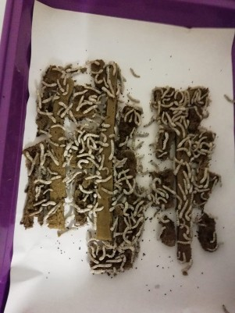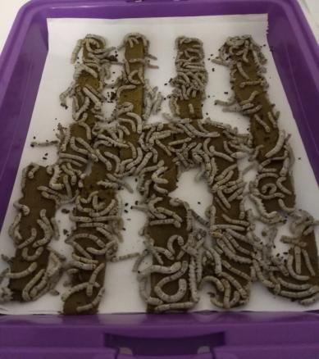
- Third-instar larvae B. Larvae during the final stage of the fourth instar
Fig 2. Romanian silkworm breed (B1) fed with artificial diet

The silkworm eggs were incubated under regulated conditions, specifically in an incubator set to 240°C, with hatching observed after a duration of 12 days. For the first and second larval instars, the incubator temperature was consistently maintained at 290°C, while it was set to 270°C during the third instar, 260°C for the fourth instar, and 240°C in the final instar. Throughout the cocoon spinning phase, the temperature remained at 240°C. Following hatching, the larvae were maintained in plastic containers (Figure 2 A and 1B), under the previously mentioned conditions, with the lids securely fitted during the initial three stages, after which the lids of the boxes were taken off.

The powder moisturizing was performed using distilled water in a ratio of 1:2.4, and the resulting mixture was microwaved and stored prior to serving, in accordance with the producers' guidelines.The food was provided ad libitum, and the containers were cleaned daily through levigation with a 1% formaldehyde solution, with the paper beneath the silkworms being replaced each day.The artificial diet was created by combining 250 grams of dried powder with 600 ml of water, microwaving it for 5 minutes, and then storing it in a refrigerator at 40°C (V1 variant, which served as the control group).For the V2 and V3 recipes, dried bee pollen was incorporated to achieve concentrations of 1% and 5% (dry weight), respectively.The parameters monitored included larvae length (mm), larvae weight (g), silk middle gland weight (g), and cocoon weight (g).

The biological parameter was evaluated for 20 randomly selected larvae or cocoons from the experimental group, which consisted of 200 larvae per box. Regarding larvae length (mm), the JH3 breed demonstrated the most substantial growth at 69.37 mm within the experimental group that received a 1% bee pollen supplement in the artificial diet. Furthermore, this same experimental group (JH3/V2) recorded the highest larvae weight at 4.1g. These two parameters exhibit a positive correlation. The addition of bee pollen to the artificial diet has a beneficial effect on nearly all parameters, with the exception of larvae length and the C122 breed.

The larvae length in the AO33 breed indicated that fresh mulberry leaves yield superior results compared to the artificial diet, with a recorded difference of 10.09 mm. Furthermore, this length decreases by 3.46 mm when 5% bee pollen is incorporated into the artificial diet. Comparable findings are observed for the same characteristic in the C122 breed, showing lengths of 12.8 mm and 8.78 mm, thereby reaffirming the significant impact of bee pollen in artificial diets. (Moise et al., 2020).

.
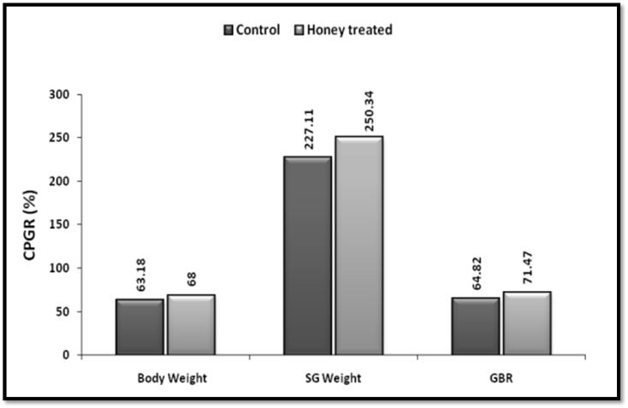
Fig3.The impact of 2% honey on body weight(BW), weight of the silk gland(SG) and gland body ratio in B. mori during the fifth stage of larval growth (Thulasi and
Sivaprasad, 2015).

Honey is a natural sweetener and a nutrient-rich food made by honeybees from the nectar of flowers. It is a valuable source of nutrients and contains different types of sugars proteins enzymes vitamins and minerals. Its chemical makeup and features can change based on where it comes from the environment it grows in and the type of plant it is. Additionally honey comes from insects and has important health benefits. It is used in both human and animal medicines for its nourishing healing and preventive qualities. Many enrichment studies have used costly commercial nutrients but no one has looked into how an insect product like honey which is a complete nutrient affects the growth metabolism and economic features of silkworm farming. This study looks at how adding honey to the diet of silkworms affects their growth and protein levels. Given honey's many health benefits and nutrients we wanted to see if it could help silkworms grow better.

This study focused on the PM x CSR2 hybrid variety of the silkworm (B.mori) which was raised in standard conditions of 28°C and 85% humidity following the methods described by Krishnaswami in 1986. Once the worms hatched they were fed M5 variety mulberry leaves five times a day at 6 AM 10 AM 2 PM 6 PM and 10 PM. They were raised in a setting with 12 hours of light and 12 hours of darkness. The experimental design was divided into four phases, namely honey feeding pattern, study of growth patterns, assay of tissue proteins and analysis of economic parameters of sericulture.

Under natural conditions, the larval weight of the control batch grew maximally by ~128% on day-3, ~67% on day-5 and minimally by ~15% on day-7 with an overall increase of 334% and a CPGR of 63.18%. At the same time, the SG grew maximally by ~411% on day-3, ~98% on day-5 and ~92% on day-7, representing an overall increase of ~1844% during fifth instar with a CPGR of 227.11%. The computed gland- body ratio showed an increase of ~125% on day-3, ~19% on day-5 and ~92% on day-7 with an overall increase of 334% and a CPGR of ~64.82% in the control batch. Under the influence of 2%, minimum effective concentration of honey, the larval body weight recorded an increase of ~155% on day-3, ~58% on day-5 and ~18% on day-7 with an overall increase of 374% and a CPGR of ~68% during fifth instar larval development. At the same time, the SG grew by ~483% on day-3, ~167% on day-5 and ~53% on day-7, with an overall increase of 2289% and a CPGR of 250.34%. The gland- body ratio recorded an increase of ~129% on day-3, ~69% on day-5 and ~31% on day-7, representing an overall growth of ~404%, and a CPGR of ~71.47% (Fig.3).

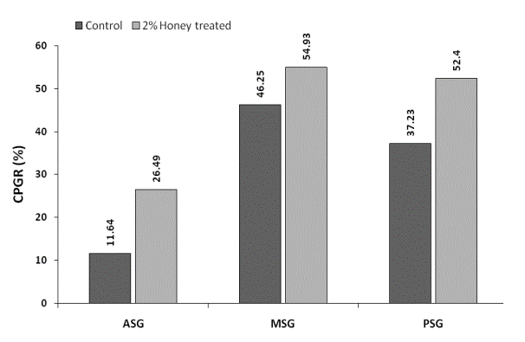
Fig 4. The impact of 2% honey on the total protein levels (mg/g) in various parts of the silk gland in the fifth-stage larvae of B. mori

Since the honey caused significant improvement in the whole SGP, it is necessary to find as to which region of SG responds more effectively to this exogenous factor. Hence, protein levels were estimated separately in the three regions namely, anterior silk gland (ASG), middle silk gland (MSG) and posterior silk gland (PSG) and the relevant data are presented in fig.4. The protein profiles of ASG in the control and honey treated batch were elevated respectively by ~16% and 51% on day-3, ~3% and 31% on day-5 and just by 17% and 16% on day-7. In the MSG, the corresponding elevations were ~44% and 101% on day-3, ~45% and 9% on day-5 and ~51% and 69% on day-7. While those in PSG were ~41% and 103% on day-3, ~21% and 6% on day-5 and ~51% and 64% on day-7. During the entire period of fifth instar, the overall growth trends in the total protein levels of control and experimental batches were ~39% and 102% in ASG, ~213% and ~272% in MSG and ~158% and 254% in PSG. Similarly, the corresponding CPGRs were 11.64% and 26.49% in ASG, ~46.25% and 54.93% in MSG and 37.23% and 52.40% in PSG (Fig.4). It is due to the high nutritional status of honey in terms of its vitamin and mineral profiles.

Seri Nutrid - A well-balanced nutrient diet designed for the rearing of chawki silkworms

Sericare disclosed that the performance of silkworms is enhanced when they are raised on SeriNutrid during the chawki rearing phase, as opposed to being reared on leaves. According to these studies, chawki rearing on SeriNutrid seems to provide numerous benefits to farmers,Getting stable cocoon crops by providing balanced nutrition
- Maintaining proper hygiene to prevent early infections.
- Limiting the number of feedings to 4, compared to 13 feedings in traditional leaf rearing during the initial two instars.
- Reducing the number of missing larvae in the first two instars, as there is no bed cleaning required during the SeriNutrid fed chawki stage.
- Implementing chawki rearing without reliance on a mulberry garden.

The PM x CSR2 hybrid layings were utilized for the research and were raised until the second moult on both SeriNutrid and mulberry leaves for comparative analysis. A total of four replications were conducted, each containing 1000 dfls. Following the second moult, the silkworms were distributed to adjacent villages by the CRC, and the parameters of the cocoons along with their valuation were observed.(Mondal et al.,2018).

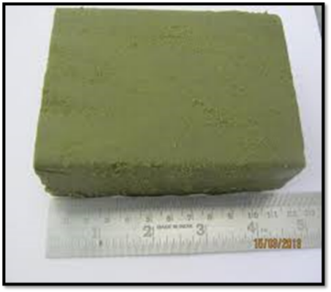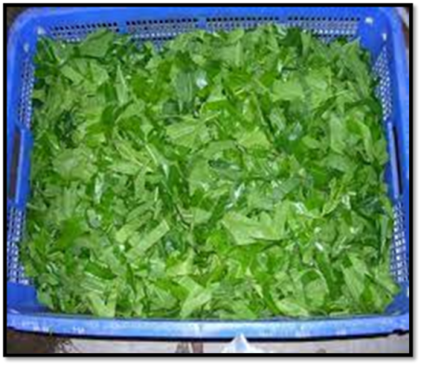
Fig 5. SeriNutrid –Feed for silkworm Fig 6. Mulberry leaves for silkworm

A comparative analysis of the manpower needed for 100 DFL's chawki silkworms
It was discovered that approximately 80 active minutes were necessary to rear 100 dfls to the II instar stage when using SeriNutrid for chawki feeding, while at least 135 active minutes were required for chawki fed with leaves. Additionally, there was no need for mulberry gardens or labor time for harvesting and obtaining mulberry leaves when rearing chawki fed with SeriNutrid (Mondal et al.,2018).

Influence of SeriNutrid and mulberry leaf on cocoon yield and cocoon rate

In the current research, the yield of cocoons was found to be 3-5% greater in SeriNutrid batches compared to those reared on leaves, with the former also demonstrating superior quality, resulting in a price increase of 5-10%. The average yield for SeriNutrid chawki was recorded at 73 kg, while the yield for leaf reared chawki was 69 kg for every 100 DFL. Farmers indicated that the prices for cocoons were higher in SeriNutrid reared chawki (Cake-Mari) batches, priced at Rs. 400/kg, compared to Rs. 393/kg for leaf reared batches. In the present study cocoon yield was 3-5% more in SeriNutrid batches than leaf reared batches and former showed better quality, bringing in 5-10% higher price. The average yield obtained for SeriNutrid chawki was 73 kg whereas in leaf reared chawki it was 69 kg for every 100DFL. The farmers reported that cocoon prices were higher in SeriNutrid reared chawki (Cake-Mari) reared batches (Rs. 400/kg) than leaf reared batches (Rs. 393/kg)(Mondal et al.,2018)..

Influence of SeriNutrid and mulberry leaf on cocoon weight, Shell weight and shell ratio

In the Cake-Mari batches, the average weights of the cocoon and shell, along with the shell ratio, were recorded at 1.884 g, 0.349 g, and 18.554%, respectively. In contrast, the leaf chawki reared batches exhibited lower averages, with cocoon weight at 1.813 g, shell weight at 0.327 g, and a shell ratio of 18.018%, respectively(Mondal et al.,2018).

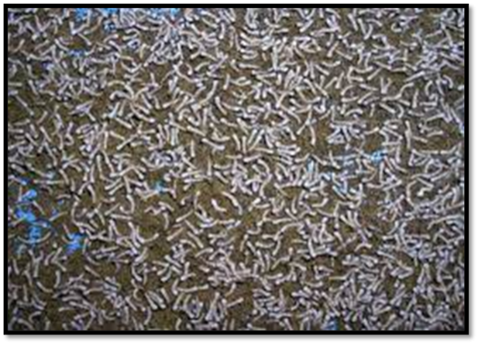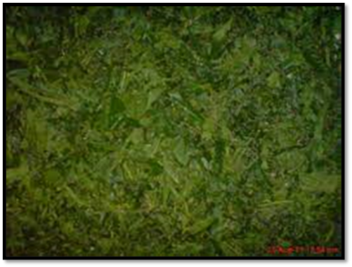
Fig 7. First moult silkworm larvae Fig 8. First moult silkworm on leaf larvae on SeriNutrid

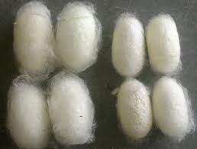
Mulberry cocoons
SeriNutrid cocoons
Fig 9. Silkworm cocoons reared on SeriNutrid and Mulberry leaves

- Seri Nutrid offers a highly effective alternative for chawki rearing, enhancing both the yield and quality of the cocoons.
- It was also noted that there was a 5-10% premium on the price for batches reared with Seri Nutrid(Mondal et al.,2018).

Natural and artificial diets' effects on silkworm growth parameters (Kolar Gold) (Thamidela et al., 2021)

There are three kinds of artificial diets namely, Artificial diet1 Artificial diet2 and Artificial diet3 were used to raise the Kolar Gold breed of mulberry silkworm Bombyx mori L. The diets were given to the first three stages of the insects and then the next two stages were raised on a natural diet of untreated leaves. Authors compared specially made diets to a natural diet and noted the growth results.

Treatment details:
Treatment | Details
T1 | Artificial diet1
T2 | Artificial diet 2
T3 | Artificial diet 3
T4 | Natural diet

Table 5. The impact of natural and artificial diets on the average weight of silkworm larvae (KolarGold)

Treatment | Mean larval weight(g)
Treatment | Initial instars |  |  | Later instars
Treatment | First | Second | Third | Fourth | Fifth
Treatment | Mean + SD | Mean + SD | Mean + SD | Mean + SD | Mean + SD
T1 | 0.005+0.00032 | 0.057+0.0017 | 0.383+0.0024 | 1.288+0.010 | 4.338+0.025
T2 | 0.005+0.00022 | 0.050+0.0027 | 0.359+0.0085 | 1.045+0.064 | 3.996+0.101
T3 | 0.005+0.00021 | 0.055+0.0005 | 0.379+0.0021 | 1.205+0.021 | 4.213+0.115
T4 | 0.006+0.00010 | 0.058+0.0017 | 0.382+0.0008 | 1.140+0.018 | 4.033+0.052
SE + | 0.00011 | 0.0009 | 0.0022 | 0.017 | 0.040
C.D @5% | 0.00035 | 0.0029 | 0.0070 | 0.054 | 0.125
C.V. % | 4.13 | 3.38 | 1.21 | 3.01 | 1.97

In the T4 group, which was fed a natural diet, the average larval weights for the first through fifth stages were 0.006, 0.058, 0.382, 1.140, and 4.033 grams, respectively. During the first stage, all other groups—T1, T2, and T3 had the same larval weight of 0.005 grams. In the second stage, T4 had the highest larval weight at 0.058 grams, which was very close to T1 at 0.057 grams, with T3 following at 0.055 grams.

During the third instar, the highest weight was observed in T1 (0.383 g), which was nearly the same as T4 (0.382 g), and closely followed by T3 (0.379 g). In the fourth instar, T2 recorded the lowest weight (1.045 g), while T1 had the highest weight (1.288 g), followed by T3 (1.205 g). In the fifth instar, T1 (4.338 g) had the highest weight among all treatments, with T3 (4.213 g) and T4 (4.033 g) following in statistical order, and T2 showing the lowest weight (3.996 g). In the first two instars, larvae fed on formulated diets generally weighed less compared to those on T4 (the natural diet). By the third instar, their weights were nearly the same as those fed naturally. However, in the later two instars, larvae fed with T1 leaves showed a considerable increase in weight compared to both T4 and the other formulated diets, as shown in Table 5.

It is concluded that silkworm larvae fed an artificial diet during their early stages had a higher weight compared to those fed mulberry leaves.

Table 6. Impact of natural and synthetic diets on the average larval length of silkworms
Treatment | Mean larval length (cm)
Treatment | Initial instars |  |  | Later instars
Treatment | First | Second | Third | Fourth | Fifth
Treatment | Mean + SD | Mean + SD | Mean + SD | Mean + SD | Mean + SD
T1 | 0.500 + 0.008 | 1.334 + 0.011 | 1.400 + 0.041 | 5.00 + 0.183 | 7.25 + 0.041
T2 | 0.452 + 0.005 | 0.950 + 0.035 | 1.200 + 0.058 | 4.50 + 0.041 | 6.50 + 0.041
T3 | 0.500 + 0.014 | 1.313 + 0.003 | 1.390 + 0.013 | 4.90 + 0.082 | 7.00 + 0.183
T4 | 0.500 + 0.008 | 1.352 + 0.003 | 1.550 + 0.030 | 4.85 + 0.041 | 7.00 + 0.183
SE + | 0.004 | 0.009 | 0.019 | 0.052 | 0.066
C.D @5% | 0.014 | 0.02 | 0.059 | 0.160 | 0.203
C.V. % | 1.93 | 1.50 | 2.80 | 2.16 | 1.90

The average larval length for the first, second, third, fourth, and fifth instars were measured in T4 (natural diet) as 0.500, 1.352, 1.550, 4.85, and 7.00 cm, respectively. In the first instar, the larval length was found to be identical in T1, T3, and T4 (0.50 cm). For the second instar, a significantly greater length was noted in T4 (1.352 cm), which was comparable to T1 (1.334 cm), followed by T3 (1.313 cm), while the shortest length was recorded in T2 (0.950 cm). In the third instar, a significantly greater length was observed in T4 (1.550 cm), followed by T1 (1.400 cm), which was comparable to T3 (1.390 cm), with T2 recording the least length (1.200 cm). In the fourth instar, the longest length was recorded in T1 (5.00 cm), which was comparable to T3 (4.90 cm), followed by T4 (4.85 cm). In the fifth instar, the longest length was noted in T1 (7.25 cm), followed by T3 and T4, both measuring the same length (7.00 cm), while the shortest length was recorded in T2 (6.50 cm). Across all silkworm races, the larval lengths in the initial two instars were observed to be shorter, while in the intermediate instar, they were within a similar range as the natural diet, and in the later two instars, they were significantly greater than those in T4 (natural diet) (Table 6).

Table 7. Impact of natural and synthetic diets on the average larval duration of silkworms
Treatments | Mean larval duration (hr)
Treatments | Initial instars |  |  | Later instars
Treatments | First | Second | Third | Fourth | Fifth
Treatments | Mean + SD | Mean + SD | Mean + SD | Mean + SD | Mean + SD
T₁ | 121 + 0.82 | 92 + 1.63 | 112 + 2.45 | 120 + 1.63 | 144 + 1.83
T₂ | 131+1.15 (59) | 94+0.82(10) | 120+1.63(24) | 130+1.41(16) | 148+1.63(8)
T₃ | 124 + 2.31 | 91 + 2.58 | 114 + 0.82 | 124 + 2.16 | 147 + 0.82
T₄ | 72 + 1.63 | 84 + 1.63 | 96 + 1.63 | 114 + 2.45 | 140 + 1.63
SE + | 0.790 | 0.889 | 0.866 | 0.978 | 0.763
C.D @ 5% | 2.44 | 2.74 | 2.67 | 3.01 | 2.35
C.V. % | 1.41 | 1.97 | 1.56 | 1.60 | 1.05

In Table 7, the mean larval duration for the first, second, third, fourth, and fifth instars was significantly lowest in T4 (natural diet), with durations of 72, 84, 96, 114, and 140 hours, respectively. For the first instar, the duration was significantly prolonged in T2 (131 hours), an increase of 59 hours, followed by T3 (124 hours), which was extended by 52 hours. In the second instar, the duration was significantly increased by 10 hours in T2 (94 hours), which was comparable to T1 (92 hours), extended by 8 hours, and T3 (91 hours), extended by 7 hours. In the third instar, a significant enhancement in larval duration was noted in T2 (120 hours), extended by 24 hours, followed by T3 (114 hours), which was extended by 18 hours, and T1 (112 hours), extended by 16 hours. In the fourth instar, the duration was significantly extended by 16 hours in T2 (130 hours), followed by T3 (124 hours), extended by 10 hours, and T1 (120 hours), extended by 6 hours. In the fifth instar, the duration was significantly extended by 8 hours in T2 (148 hours), which was comparable to T3 (147 hours), extended by 7 hours, and T1 (144 hours), extended by 4 hours. In the initial two instars, the larval duration of the treatments was found to be extended compared to T4 (natural diet), and a similar trend was observed in the third instar. However, in the later two instars, the duration was not significantly extended or prominently increased in T1 when compared to T4 (natural diet). It was found that the larval duration was extended for larvae reared on semi-synthetic diets in comparison to the natural diet.

Table 8. Impact of natural and synthetic diets on the average moulting duration of silkworms
Treatment | Mean moulting period (hr)
Treatment | First | Second | Third | Fourth
Treatment | Mean + SD | Mean + SD | Mean + SD | Mean + SD
T₁ | 25 + 1.41 | 26 + 0.81 | 27 + 1.08 | 27 + 0.81
T₂ | 28 + 0.81(4) | 30 + 1.25(4) | 34 + 1.63(6) | 36 + 1.63(6)
T₃ | 27 + 1.08 | 28 + 1.15 | 28 + 0.50 | 28 + 1.15
T₄ | 24 + 1.63 | 26 + 0.81 | 28 + 1.15 | 30 + 1.41
SE + | 0.637 | 0.515 | 0.581 | 0.645
C.D @ 5% | 1.96 | 1.59 | 1.79 | 1.99
C.V. % | 4.90 | 3.73 | 3.96 | 4.26

In T4 (natural diet), the duration required for the first, second, third, and fourth moults was documented as 24, 26, 28, and 30 hours, respectively. During the first moult, the duration necessary for moulting was significantly prolonged by 4 hours in T2 (28 hours), which was comparable to T3 (27 hours), extended by 3 hours, while T1 (25 hours) was only extended by 1 hour in comparison to the natural diet. In the second moult, the required time was increased by 4 hours in T2 (30 hours), followed by T3 (28 hours), which was extended by 2 hours, and T1 reported the same duration as the natural diet (26 hours). For the third moult, the required time was increased by 6 hours in T2 (34 hours), whereas T3 (28 hours) recorded a duration similar to that of the natural diet. In contrast, the time required for moulting in T1 (27 hours) was reduced by 1 hour. In the fourth moult, the required time was increased by 6 hours in T2 (36 hours), while it was reduced by 2 and 3 hours in T3 (28 hours) and T1 (27 hours), respectively. The moulting period was generally extended in nearly all treatments, except in T1, where it was notably reduced in the last two moults compared to T4 (natural diet). The required duration for moulting was observed to be generally extended across all treatments when compared to the natural diet, with the exception of T1 (Table 8).

Table 9. Impact of natural and synthetic diets on the incidence of diseases in silkworms

Treatment | Disease occurrence (%)
Treatment | Initial three instars | Later two instars
T1 | 0.75 (4.96) | 2.53 (09.15)
T2 | 1.75 (7.60) | 4.60 (12.39)
T3 | 1.00 (5.73) | 2.55 (09.19)
T4 | 1.50 (7.00) | 3.01 (10.00)
SE + | 0.007 | 0.016
C.D @ 5% | 0.02 | 0.05
C.V. % | 1.18 | 1.01

In Table 9, the occurrence of flacherie disease in initial instars was significantly lowest in T1 at 0.75%, followed by T3 at 1.00%, and T4 at 1.50%. Conversely, the highest occurrence of the disease in initial instars was observed in T2 at 1.75%. In later instars, T2 exhibited the highest disease occurrence at 4.60%, followed by T4 at 3.01%, then T3 at 2.55%, while the minimum disease occurrence was noted in T1 at 2.53%.

It is concluded that among the three formulated diets for all the races, namely Kolar Gold, FC1 x FC2, and FC2 x FC1, T1 (artificial diet 1) demonstrated superior performance. Throughout all instars, the incidence of disease was minimal. In comparison to the natural diet, both larval weight and larval length were observed to be lower in the initial instars, while significantly higher in the later instars. The duration of the larval stage was extended in silkworms that were fed the artificial diet (Thamidela et al., 2021).

The impact of artificial diet rearing throughout all instars on silk production and gene expression in Bombyx mori (Lepidoptera: Bombycidae)

Silkworms (Bombyx mori L.) raised on artificial diets throughout all instars offer advantages such as simplicity and efficiency, continuous production throughout the year, and a diminished risk of poisoning. Nevertheless, the low silk yield continues to pose a challenge, restricting its industrial use. To tackle this problem, the spinning behavior, nutrient absorption, and transcriptomics of silkworms were examined. In comparison to silkworms raised on mulberry leaves during all instars, those that were fed artificial diets exhibited significantly lower cocoon weight, cocoon shell weight, cocoon shell rate, and silk gland tissue somatic index by the conclusion of the fifth instar (P < 0.01). Additionally, the spinning duration and crawling distance of silkworms on artificial diets were markedly less than those of silkworms on mulberry leaves (P < 0.01). In terms of nutrient absorption, the dietary efficiency indexes of silkworms on artificial diets were significantly lower than those of silkworms on mulberry leaves, with the exception of the efficiency conversion of digesta to cocoon (P < 0.01). Further RNA-Seq analysis identified 386 differentially transcribed genes between the two groups, comprising 242 upregulated and 144 downregulated genes. GO enrichment analysis indicated that the differentially transcribed genes were primarily enriched in organic acid metabolism, oxidation-reduction processes, and drug catabolism. KEGG enrichment analysis revealed that the differentially transcribed genes were mainly concentrated in pathways related to genetic information processing and metabolism. Our results offer new perspectives on silk secretion and can act as a reference for future studies and applications involving silkworms fed with artificial diets (Xingcan Yin et al., 2023).
CONCLUSION

It was generally considered that artificial diets could not be used for silkworm rearing throughout all the larval instars for silk production, due to the cost of the diet. However, with the breeding of silkworms and the development of low-cost artificial diets may at become possible. The new method of rearing of silkworms on artificial diets is renovated technique and its rapid expansion is expected in sericulture.

DISCLAIMER (ARTIFICIAL INTELLIGENCE)
Author(s) hereby declares that NO generative AI technologies such as Large Language Models (ChatGPT, COPILOT, etc.) and text-to-image generators have been used during the writing or editing of this manuscript.

COMPETING INTERESTS
Authors have declared that no competing interests exist.

REFERENCES

Cappellozza, L., Cappellozza, S., Alessio Saviane, S. Giovanni Sbrenna, G. (2005). Artificial diet rearing system for the silkworm Bombyx mori (Lepidoptera: Bombycidae): effect of vitamin C deprivation on larval growth and cocoon production. Appl. Entomol. Zool., 40 (3), 405–412.

Devi, B., Sharma, N., Kumar, D., Jeet, K. (2013) Morus Alba Linn: A phytopharmacological review. . Journal Pharmaceutical Sciences, 5(2), 14–18.

Hăbeanu, M., Gheorghe, A., Mihalcea, T. (2023). Nutritional value of silkworm pupae (Bombyx mori) with emphases on fatty acids profile and their potential applications for humans and animals. Insects, 14, 254.

Hu, X. Q., Jiang, L., Zhang, J. G., Deng, W., Wang, H. L., Wei, Z. J. (2013). Quantitative determination of 1-deoxynojirimycin in mulberry leaves from 132 varieties. Industrial Crops and Products, 49, 782– 784.

Iqbal, S., Younas, U., Chan, K. W., Sarfraz, R. A., Uddin, M. K. (2012). Proximate composition and antioxidant potential of leaves from three varieties of mulberry (Morus Sp.): A comparative study. International Journal Molecular Sciences, 13(6), 6651–6664.

Lee, W. J., Choi, S. W. (2012). Quantitative changes of polyphenolic compounds in mulberry (Morus alba L.) leaves in relation to varieties, harvest period, and heat processing. Prevention Nutritional Food Sciences, 17(4), 280–285.

Manjula, S., Sabhanayakam, S., Mathivanan, V., Saravanan, N. (2011). Studies on the nutritional supplement of mulberry leaves with Cowpea (Vigna unguiculata) to the silk worm Bombyx mori L. (Lepidoptera: Bombycidae) upon the activities of midgut digestive enzymes. International Journal of Nutrition, Pharmacology, Neurological Diseases, 1(2), 157–162.
- Moise, A. R., Pop, L. L., Vezeteu, T. V., Agoston, B. D., Pasca, C.Dezmirean, D. S. (2020). Artificial diet of silkworms (Bombyx mori) improved with bee pollen - biotechnological approach in global centre of excellence for advanced research in sericulture and promotion of silk production. Bull. UASVM Anim. Sci. Biotech., 77(1), 51-57.

- Mondal, M., Tandon, B. Radhakrishna, P. M. (2018). SeriNutrid- A balanced nutrient diet for silkworm (Bombyx mori L.) chawki rearing. Int. J. Adv. Res. Ideas Innov. Tech., 4(2), 42-47.

- Panthee, S., Paudel, A., Hamamoto, H., Sekimizu, K. (2017). Advantages of the silkworm as an animal model for developing novel antimicrobial agents. Frontiers in Microbiology, 8, 373.
- Paudel, A., Panthee, S., Hamamoto, H., Sekimizu, K. (2020). A simple artificial diet available for research of silkworm disease models. Drug Discoveries & Therapeutics, 14(4), 177–180.

- Radostina Peneva Guncheva, (2016). Study on the Receptivity of Breeds Silkworm, Bombyx mori L. to Artificial Diet low in Mulberry Powder. Int. J. Curr. Microbiol. App. Sci, 5(5), 10-18.

- Saviane, A., Toso, L., Righi, C., Pavanello, C., Crivellaro, V., Cappellozza, S. (2014). Rearing of monovoltine strains of Bombyx mori by alternating artificial diet and mulberry leaf accelerates selection for higher food conversion efficiency and silk productivity. Bulletin of Insectology, 67(2), 167–174.

- Thamidela, M. D., Bagde, A. S., Hole, U. B., Jadhav, P. S. (2021). Effect of natural and artificial diets on growth parameters of Kolar Gold, Silkworm. Int. J. Curr. Microbiol. App. Sci., 10(3), 1725-1732.

Thulasi, N., Sivaprasad, S. (2015). Larval growth, silk production and economic traits of Bombyx mori under the influence of honey-enriched mulberry diet. J. Appl. Nat. Sci., 7 (1), 286 – 292.

Toshio Ito, 1980. Application of Artificial Diets in Sericulture.JARQ, 14(3), 10-15.

Wang, F., Li, J., Jiang, Y. (2010). Polysaccharides from mulberry leaf in relation to their antioxidant activity and antibacterial ability. Journal of Food Process Engineering, 33(1), 39–50.

Wen, L., Shi, D., Zhou, T., Tu, J., He, M., Jiang, Y., Yang, B. (2020). Identification of two novel prenylated flavonoids in mulberry leaf and their bioactivities. Food Chemistry, 315, 126-236.

Xingcan Yin, Yuli Zhang, Dongliang Yu, Guoli Li, Xilei Wang, Yuting Wei, Chunhui He,Yanwei Li, Yizhe Li, Kaizun Xu and Guizheng Zhang, 2023.Effects of artificial diet rearing during all instars on silk secretion and gene transcription in Bombyx mori (Lepidoptera:Bombycidae). J. Econ Entomol.116(4), 1379-1390.

Yasuhiro Horie, 1980. Advances in Sericulture. Ann. Rev. Entomol.25:49-71.

Yu, Y., Li, H., Zhang, B., Wang, J., Shi, X., Huang, J., Yang, J., Zhang, Y., Deng, Z. (2018). Nutritional and functional components of mulberry leaves from different varieties: Evaluation of their potential as food materials. International Journal of Food Properties, 21, 1495–1507.

Zhang, B., Wang, Z., Huang, C., Wang, D., Chang, D., Shi, X., Chen, Y., Chen, H. (2022). Positive effects of mulberry leaf extract on egg quality, lipid metabolism, serum biochemistry, and antioxidant indices of laying hens. Frontiers in Veterinary Science, 9, 100-105.

- Zhou, L., Li, H., Hao, F., Li, N., Liu, X., Wang, G., Wang, Y., & Tang, H. (2015). Developmental changes for the hemolymph metabolome of silkworm (Bombyx mori L.). Journal of Proteome Research, 14(5), 2331–2347.

