Original Research Article

CYTOLOGICAL ASSESSMENT OF NUCLEAR ABNORMALITIES IN THE BUCCAL EPITHELIAL CELLS OF WASTE HANDLERS AT ESUTH TEACHING HOSPITAL AND ESUT COLLEGE OF MEDICINE PARKLANE, ENUGU, NIGERIA

ABSTRACT
Background: Environmental and occupational exposures to hazardous agents are a growing public health concern, as they can cause genomic damage and increase the risk of developing long-term health problems. In regions like Enugu, Nigeria, waste handlers are particularly vulnerable to these exposures. The micronuclei (MN) assay, along with other nuclear abnormalities such as binucleated cells, nuclear buds, and karyorrhexis, serves as a reliable and minimally invasive biomarker for assessing this cellular damage
Aim: This cross-sectional, observational, and analytical study was conducted at the Enugu State University Teaching Hospital and Enugu State University College of Medicine to investigate cytological abnormalities in the exfoliated buccal cells of waste handlers.
Methods: A total of 60 participants were recruited, comprising 30 healthy controls and 30 waste handlers from three distinct groups: Enugu State Waste Management Authority (ESWAMA), hospital, and hostel. After obtaining ethical clearance and informed consent, buccal smears were collected, stained using the Papanicolaou procedure, and analyzed for nuclear abnormalities. Data were assessed using SPSS, with a significance level of p<0.05.
Results: The results revealed that waste handlers, as a collective group, had significantly higher mean frequencies of micronuclei (p=0.00), binucleated cells (p=0.03), nuclear buds (p=0.00), and karyorrhexis (p=0.00) compared to the control group. Sub-group analysis showed that ESWAMA waste handlers exhibited the most severe cytological damage, with significantly elevated levels of all four nuclear abnormalities (p<0.001 for MN, BN, NB; p=0.01 for KH). Conversely, while hospital cleaners showed a significant increase in micronuclei (p<0.001), their rates of other nuclear changes were not statistically significant, and hostel cleaners showed no significant difference from the control group. Furthermore, lifestyle factors, including smoking and alcohol consumption, were independently associated with a significant increase in multiple nuclear abnormalities.
Conclusion: These findings suggest that occupational exposure to waste, particularly for ESWAMA workers, poses a significant genotoxic risk and highlights the critical need for improved health and safety protocols for this population.

Keywords: Waste handlers, Micronuclei (MN) assay, Genotoxicity, Occupational exposure, Buccal cytology, Health and safety

INTRODUCTION
The health of human beings is influenced by a variety of factors, with environmental and occupational threats emerging as a growing concern. Exposure to agents that can cause congenital defects, mutations, and even cancer has been linked to numerous occupations [1]. These hazardous substances can enter the body through inhalation, ingestion, and dermal absorption, leading to genomic damage [2]. Specific types of cancer affecting the skin, pancreas, and urinary tract have been attributed to occupational exposures [3].
Damage to DNA or chromosomes can be identified through tissue biopsies or assays of blood lymphocytes and erythrocytes [4]. However, the micronuclei (MN) assay has gained popularity as a biomarker of genetic damage due to its minimal invasiveness and effectiveness [5]. The information provided by this assay can serve as an early warning of the potential risk for developing long-term health problems [6]. In recent years, there has been a significant resurgence of interest in oral cytology as a diagnostic and prognostic tool, particularly for monitoring patients with potentially malignant disorders. The buccal mucosal micronuclei assay was initially proposed to evaluate genetic damage and instability [7]. Gradual increases in micronuclei counts from normal buccal mucosa to potentially malignant disorders suggest a link between this biomarker and neoplastic progression [8]. Due to the pain associated with invasive techniques, there has been a growing shift toward non-invasive diagnostic testing [9][10]. In this context, exfoliative cytology, defined as the procurement and characterization of cells from the oral mucosa, is a safe and effective procedure that can be used for early screening of high-risk populations [11]. Micronuclei are microscopically visible, round to oval chromatin masses in the cytoplasm, representing chromosome fragments or whole chromosomes that were delayed during cell division [12]. Other nuclear abnormalities, such as binucleated cells, karyorrhexis, and nuclear buds, are also evaluated as indicators of cellular damage [13]. The presence of these markers is often linked to environmental and occupational exposure to pollutants [14].
Waste handlers are a specific group occupationally exposed to complex mixtures of organic solvents and metals that are known to be potential toxic, mutagenic, and carcinogenic agents [15][16]. The present study was justified by the exposure of waste handlers at the Enugu State University Teaching Hospital and Enugu State University College of Medicine to such hazardous compounds, including trichloroethylene, a known carcinogen found in cleaning materials [17]. Given that waste handlers are vital for maintaining environmental cleanliness, it is crucial to assess the positive or negative cytological effects of these exposures on their health [18].
The aim of this study was to investigate the cytological abnormalities in the exfoliated buccal cells of waste handlers at Enugu State University Teaching Hospital and Enugu State University College of Medicine.

MATERIAL AND METHODS
This investigation was designed as a cross-sectional, observational, and analytical study. It was conducted at the Enugu State University Teaching Hospital and Enugu State University College of Medicine. A total of 60 participants were recruited, which included 30 apparently healthy non-waste handlers who formed the control group, and 30 waste handlers. The control group individuals were recruited from the general hospital population, matched by age and gender as much as feasible, and had no known history of occupational exposure to hazardous waste, chronic diseases, or recent medication use that could influence cellular integrity. The waste handlers were further subdivided into three distinct cohorts of 10 participants each: Enugu State Waste Management Authority (ESWAMA) workers, hospital waste handlers, and hostel waste handlers. To minimize observer bias, the assessment of cellular damage was conducted by experienced cytologists who were blinded to the participant groups (waste handler vs. control, and specific waste handler subgroups) during microscopic analysis. This blind assessment ensures that the evaluation of micronuclei and other nuclear abnormalities was objective and unbiased.
Prior to the commencement of the study, ethical approval was secured from the Enugu State Teaching Hospital's Health Research and Ethics Committee. Furthermore, written informed consent was obtained from all participants to ensure their voluntary involvement and understanding of the study procedures. As an observational and cross-sectional study, its design and reporting generally align with the principles outlined in the STROBE (Strengthening the Reporting of Observational Studies in Epidemiology) guidelines. Inclusion criteria for waste handlers included active employment in waste management at the specified locations for at least six months, and willingness to participate. Exclusion criteria for both waste handlers and controls included known chronic diseases (e.g., diabetes, hypertension), current medication use, recent exposure to X-rays or chemotherapy, and known genetic disorders that could affect nuclear morphology. The study locations, Enugu State University Teaching Hospital and Enugu State University College of Medicine, Parklane, were chosen due to their representation of diverse waste handling environments and the identified occupational exposure of their workers to potentially hazardous compounds, including trichloroethylene found in cleaning materials.
For sample collection, buccal smears were carefully collected from the inner cheeks of each participant using a sterile wooden spatula. These smears were then immediately applied onto frosted slides and fixed with 95% alcohol to preserve cellular morphology. The prepared slides were subsequently authenticated by both a cytologist and a histopathologist [19]. Following this, the slides were stained using the Papanicolaou (Pap) procedure for optimal visualization of cellular structures. The assessment of cellular damage involved the evaluation of micronuclei (MN) and other nuclear abnormalities, including binucleated cells, nuclear buds, and karyorrhexis. These cellular changes were meticulously assessed under a light microscope at x40 magnification. Data analysis was performed utilizing the Statistical Package for Social Sciences (SPSS). Comparative analyses, specifically the t-test and ANOVA, were employed to compare the mean ± standard deviation of the assessed parameters across the different groups. A significance level was predetermined at p = 0.05 for all statistical tests.

RESULTS
3.1 The summary of the general characteristics of the studied population
Based on information obtained from the questionnaires of the studied population, a summary of participant’s demographics and occupational exposure are highlighted in Tables 1. This table details the distribution of participants across ESWAMA, hospital, hostel waste handlers, and the control group by gender, marital status, age groups, years in occupation, use of Personal Protective Equipment (PPE), and lifestyle habits (smoking and alcohol consumption), as well as exposure to X-rays and medication status. For instance, all ESWAMA waste handlers were male, while all hospital and hostel cleaners were female. The control group consisted of both males (31.7%) and females (18.3%). A majority of the waste handlers (ESWAMA, hospital, and hostel) were married, whereas a larger proportion of the control group was single. ESWAMA workers, in particular, showed no use of PPE, unlike hospital cleaners where all (33.3%) reported using PPE. All ESWAMA workers (16.67%) reported alcohol consumption, and 4 (6.67%) of them were smokers, compared to 0 smokers among hospital and hostel cleaners
Table 1-Summary of the general characteristics of the participating individuals
Characteristics | GROUPS [n/% of total]
Characteristics | ESWAMA | Hosp. Cleaners | Hostel cleaners | Control
Gender
Male | 10 (16.7%) | 0 (0.0%) | 0 (0.0%) | 19 (31.7%)
Female | 0 (0.0%) | 10 (16.7%) | 10 (16.7%) | 11 (18,3%)
Total | 10 (16.7%) | 10 (16.7%) | 10 (16.7%) | 30 (50.0%)
Marital status
Single | 2 (3.33%) | 0 (0.0%) | 0 (0.0%) | 19(31.7%)
Married | 8 (13.33%) | 10 (16.7%) | 10 (16.7%) | 11 (18.3%)
Total | 10 (16.6%) | 10 (16.7%) | 10 (16.7%) | 30 (50.0%)
Age groups
18-30 years | 2 (3.3%) | 0 (0.0%) | 1 (6.67%) | 19 (31.7%)
31-42 years | 4 (6.7%) | 0 (0.0%) | 9 (15%) | 6 (10%)
43-54 years | 4 (6.7%) | 10 (16.7%) | 0 (0.0%) | 4 (6.67%)
>54 years | 0 (0.0%) | 0 (0.0%) | 0 (0.0%) | 1 (6.67%)
Total | 10 (16.7%) | 10 (16.7%) | 10 (16.7%) | 30 (50.0%)
Years in occupation
>6months | 0 (0.0%) | 0 (0.0%) | 0 (0.0%) | -----
1-3years | 2 (6.7%) | 5 (16.7%) | 10 (33.3%) | -----
4-9years | 8 (26.7%) | 5 (16.7%) | 0 (0.0%) | -----
>10years | 0 (0.0%) | 0 (0.0%) | 0 (0.0%) | -----
Total | 10 (33.4%) | 10 (33.4%) | 10 (33.3%) | -----
Use of PPE
Yes | 0 (0.0%) | 10 (33.3%) | 0 (0.0%) | ----
No | 10 (33.3%) | 0 (0.0%) | 10 (33.3%) | ----
Total | 10 (33.3%) | 10 (33.3%) | 10 (33.3%) | ----
Lifestyle
Smoking
Yes | 4 (6.67%) | 0 (0.0%) | 0 (0.0%) | 4 (6.67%)
No | 6 (10.0%) | 10 (16.7%) | 10 (16.7%) | 26 (43.33%)
Total | 10 (16.67%) | 10 (16.7%) | 10 (16.7%) | 30 (50.0%)
Alcohol consumption
Yes | 10 (16.67%) | 3 (5.0%) | 2 (3.33%) | 14 (23.33%)
No | 0 (0.0%) | 7 (11.67%) | 8 (13.33%) | 16 (26.67%)
Total | 10 (16.67%) | 10 (16.67%) | 10 (16.66%) | 30 (50.0%)
Exposure to X-ray
Yes | 0 (0.0%) | 0 (0.0%) | 0 (0.0%) | 0 (0.0%)
No | 10 (16.67%) | 10 (16.67%) | 10 (16.67%) | 30 (50.0%)
Total | 10 (16.67%) | 10 (16.67%) | 10 (16.67%) | 30 (50.0%)
On Medication
Yes | 1(1.67%) | 0 (0.0%) | 0 (0.0%) | 0 (0.0%)
No | 9 (15.0%) | 10 (16.67%) | 10 (16.67%) | 30 (50.0%)
Total | 10 (16.67%) | 10 (16.67%) | 10 (16.67%) | 30 (50.0%)

3.2 Effects of waste exposure on buccal cell nuclei

Nuclear change indices assessed in the buccal cells of study participants included micronuclei (MN), binucleated cells (BN), nuclear buds (NB), and karyorrhexic cells (KH). Table 2 summarizes the mean frequencies of these parameters in waste disposal workers and control subjects. Waste disposal workers, as a collective group, showed significantly higher mean frequencies of micronuclei (16.33±5.07 vs. 8.10±3.06, P < .001), binucleated cells (9.60±5.91 vs. 3.67±2.43, P = .03), nuclear buds (9.40±6.08 vs. 4.07±2.00, P < .001), and karyorrhexic cells (1.33±3.72 vs. 0.00±0.00, P < .001) compared to the control group.

Table 2: shows mean frequencies Micronuclei (M) Binucleate cells (BN), Nuclear buds (NB) and Karyorrhexic cells (KH) in waste disposal workers and control subjects.
GROUPS |  | Parameters (Mean ± Standard deviation)
GROUPS | Micronuclei |  | Binucleate cells | Nuclear buds | Karyorrhexic cells
Waste disposal workers | 16.33±5.07* |  | 9.60±5.91* | 9.40±6.08* | 1.33±3.72*
Control | 8.10±3.06 |  | 3.67±2.43 | 4.07±2.00 | 0.00±0.00
F-ratio | 7.62 |  | 9.27 | 15.93 | 17.01
P-value | 0.00 |  | 0.03 | 0.00 | 0.00
Data expressed as Mean ± Standard deviation. *p value < .05 significant level when compared with control
Further sub-group analysis, presented in Table 3, revealed distinct patterns among different types of waste handlers. ESWAMA workers exhibited significantly increased frequencies across all nuclear abnormalities compared to the control group, including micronuclei (19.60±5.10, P < .001), binucleated cells (15.20±7.18, P < .001), nuclear buds (15.60±6.50, P < .001), and karyorrhexic cells (3.60±5.93, P = .01). Hospital cleaners showed a significant increase in micronuclei (17.50±3.95, P < .001) but their frequencies of binucleated cells, nuclear buds, and karyorrhexic cells were not significantly different from the control group. Hostel cleaners did not show any significant differences in the frequencies of any nuclear abnormalities when compared to the control group.
Table 3: Mean Frequencies of Micronuclei, Binucleate cells, nuclear buds and Karyorrhexic cells in control and various waste disposal workers
GROUPS |  | Parameters (Mean ± Standard deviation)
GROUPS | Micronuclei |  | Binucleate cells | Nuclear buds | Karyorrhexic cells
ESWAMA | 19.60± 5.10* |  | 15.20±7.18* | 15.60±6.50* | 3.60±5.93*
Hosp. cleaners | 17.50± 3.95* |  | 6.40±2.01 | 5.30±2.00 | 0.20±0.63
Hostel cleaners | 11.90± 2.42 |  | 7.20±2.04 | 7.30±2.54 | 0.20±0.63
Control | 8.10± 3.05 |  | 3.67±2.43 | 4.07±2.00 | 0.00±0.00
F-ratio | 35.64 |  | 26.40 | 32.35 | 5.99
P-value | 0.00 |  | 0.00 | 0.00 | 0.01
Data expressed as Mean ± Standard deviation. *p value<0.05 significant level when compared with control.
Table 4 displays the mean frequencies of nuclear changes according to gender. Males had higher frequencies of micronuclei (14.41±5.55 vs. 7.47±3.13, P < .001), binucleated cells (7.59±7.21 vs. 5.74±2.60, P = .19), nuclear buds (7.83±6.97 vs. 5.71±2.51, P = .12), and karyorrhexic cells (1.24±3.79 vs. 0.13±0.50, P = .11) than females. However, the increases in binucleated cells, nuclear buds, and karyorrhexic cells in males were not statistically significant.
Table 4: Mean frequencies of nuclear changes in studied population according to Gender
GENDER |  | Parameters (Mean ± Standard deviation)
GENDER | Micronuclei |  | Binucleate cells | Nuclear buds | Karyorrhexic cells
Males | 14.41± 5.55* |  | 7.59±7.21 | 7.83±6.97 | 1.24±3.79
Females | 7.47± 3.13 |  | 5.74±2.60 | 5.71±2.51 | 0.13±0.50
F-ratio | 5.08 |  | 19.77 | 21.09 | 13.00
P-value | 0.00 |  | 0.19 | 0.12 | 0.11
Data expressed as Mean ± Standard deviation.
In terms of marital status, Table 5 shows that single participants had micronuclei frequencies of 4.05±2.30 compared to 2.25±2.27 for married participants, with a significant difference (P = .006). However, there was no significant difference in the frequencies of binucleated cells, nuclear buds, and karyorrhexic cells between single and married participants (P = .09, P = 3.72, P = .77 respectively for binucleated cells, nuclear buds and karyorrhexic cells)
Table 5: Mean frequencies of nuclear changes in waste disposal workers according to marital status
Marital Status |  | Parameters (Mean ± Standard deviation)
Marital Status | Micronuclei |  | Binucleate cells | Nuclear buds | Karyorrhexic cells
Single | 4.05 ± 2.30 |  | 5.00±6.14 | 5.90±5.18 | 0.52±2.40
Married | 2.25 ± 2.27 |  | 7,51±4.78 | 7.18±5.27 | 0.74±2.87
F-ratio | 2.873 |  | 0.01 | 0.36 | 0.27
P-value | 0.006 |  | 0.09 | 3.72 | 0.77
Data expressed as Mean ± Standard deviation.
The use of personal protective equipment (PPE) did not significantly influence the frequencies of nuclear abnormalities among waste disposal workers, as detailed in Table 6. There was no significant difference in the frequencies of micronuclei (P = .69), binucleated cells (P = .88), nuclear buds (P = .35), and karyorrhexic cells (P = .55) between those who used PPE and those who did not.
Table 6: Mean frequencies of nuclear changes in waste disposal workers according to the use of Personal protective equipment (PPE).
Use of PPE |  | Parameters (Mean ± Standard deviation)
Use of PPE | Micronuclei |  | Binucleate cells | Nuclear buds | Karyorrhexic cells
Yes | 3.67 ± 3.16 |  | 6.40±2.01 | 5.30±2.00 | 0.20±0.63
No | 3.38 ± 2.17 |  | 6.68±5.84 | 7.02±5.63 | 0.76±2.93
F-ratio | 0.397 |  | 4.52 | 4.34 | 1.60
P-Value | 0.693 |  | 0.88 | 0.35 | 0.55
Data expressed as Mean ± Standard deviation.
There was no significant difference in the frequencies of binucleate cells, nuclear buds and karyorrhexic cells among the waste disposal workers who use personal protective equipment and those who don’t use as shown in table 6.
  - Effect of waste exposure and lifestyle habits on buccal cell nuclei of the study population
Lifestyle habits, specifically smoking, significantly impacted nuclear abnormalities as shown in Table 7. Smokers exhibited a significant increase in the frequencies of micronuclei (12.75±5.82 vs. 5.94±3.54), binucleated cells (14.25±7.85 vs. 5.46±3.82, P < .001), nuclear buds (12.50±8.42 vs. 5.85±3.99, P < .001), and karyorrhexic cells (2.63±4.87 vs. 0.37±2.11, P = .03) when compared with non-smokers.
Table 7: Mean frequencies of nuclear changes in the study population based on their lifestyle habits (Smoking).
Lifestyle (Smoking) |  | Parameters (Mean ± Standard deviation)
Lifestyle (Smoking) | Micronuclei |  | Binucleate cells | Nuclear buds | Karyorrhexic cells
Smokers | 12.75 ±5.82* |  | 14.25±7.85* | 12.50±8.42* | 2.63±4.87*
Non-smokers | 5.94± 3.54 |  | 5.46±3.82 | 5.85±3.99 | 0.37±2.11
F-ratio | 0.35 |  | 8.61 | 11.74 | 17.45
P-Value | 0.73 |  | 0.00 | 0.00 | 0.03
Data expressed as Mean ± Standard deviation. *p value<0.05 significant level when compared with Non-smokers.
Similarly, alcohol consumption was associated with significant increases in some nuclear abnormalities, as presented in Table 8. Alcohol consumers showed a significant increase in the frequencies of binucleated cells (8.79±6.74 vs. 4.61±2.43, P < .001) and nuclear buds (8.55±6.75 vs. 5.03±2.24, P = .01) compared to non-alcohol consumers. However, micronuclei (P = .45) and karyorrhexic cells (P = .07) frequencies were not significantly different between these two groups.

Table 8: Mean frequencies of Alcohol consumption habits in the study population
Lifestyle (Alcohol consumption) |  | Parameters (Mean ± Standard deviation)
Lifestyle (Alcohol consumption) | Micronuclei |  | Binucleate cells | Nuclear buds | Karyorrhexic cells
Yes | 3.67 ± 2.68 |  | 8.79±6.74* | 8.55±6.75* | 1.31±3.78
No | 3.19 ± 2.10 |  | 4.61±2.43 | 5.03±2.24 | 0.06±3.59
F-ratio | 0.763 |  | 14.84 | 23.28 | 15.59
P-value | 0.449 |  | 0.00 | 0.01 | 0.07
Data expressed as Mean ± Standard deviation. *p value<0.05 significant level when compared with non-alcohol consumers.
3.4 Effect of waste disposal on age groups in the study population
Table 9 shows the mean frequencies of nuclear changes across different age groups. There was no significant change in the frequencies of micronuclei (P = .20), binucleated cells (P = .18), nuclear buds (P = .38), and karyorrhexic cells (P = .96) based on the various ages of the participants.
Table 9: shows the mean frequency of nuclear changes in the study population according to various ages
Age groups |  | Parameters (Mean ± Standard deviation)
Age groups | Micronuclei |  | Binucleate cells | Nuclear buds | Karyorrhexic cells
18-30 years | 3.82 ± 2.24 |  | 4.95±6.00 | 5.86±5.01 | 0.50±2.34
31-42 years | 3.00 ± 2.60 |  | 8.26±4.95 | 8.37±6.54 | 0.63±5.31
43-54 years | 2.00 ± 1.50 |  | 7.22±4.67 | 6.28±3.61 | 3.59±0.83
F-ratio | 1.711 |  | 1.67 | 1.04 | 0.11
P-value | 0.196 |  | 0.18 | 0.38 | 0.96
Data expressed as Mean ± Standard deviation
3.5 BUCCAL CELL PHOTOMICROGRAPHS
Nuclear damage indices assessed in the buccal cells of study participants included binucleated cells, nuclear buds, and karyorrhectic cells. Figures 1-4 are representative photomicrographs illustrating these findings. Figure 1 shows a light photomicrograph of exfoliated buccal mucosal cells from a control subject, displaying normal cytoplasm (Cyt) and nuclei (N). In contrast, Figure 2, taken from an ESWAMA waste disposal worker, illustrates the presence of binucleated cells (BN) and cells with nuclear buds (NB). Figure 3 from a hospital waste disposal worker, reveals normal cells (NC), binucleated cells (BN), and cells undergoing karyorrhexis (thick arrows). Finally, Figure 4 from a hostel waste disposal worker, shows normal cells (NC) and cells undergoing karyorrhexis (thick arrows).

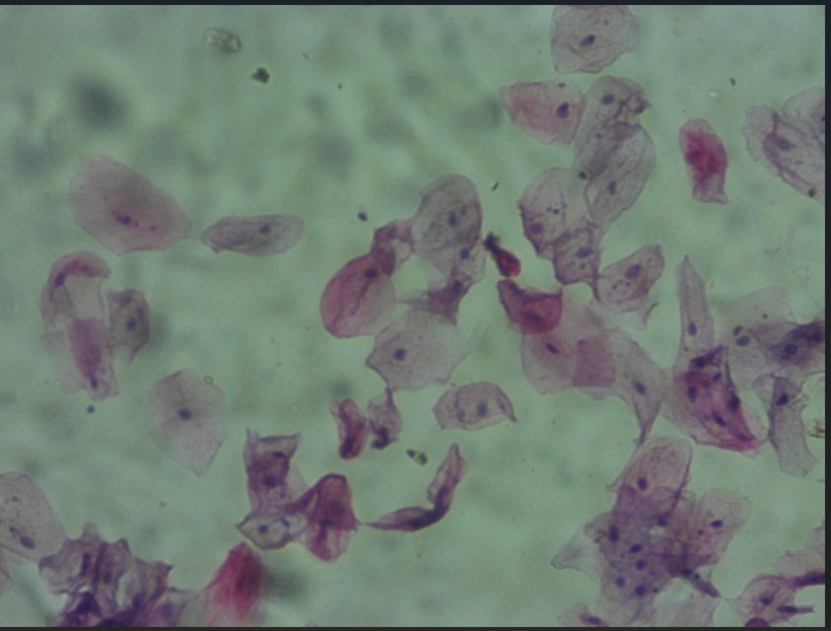
Cyt
N
Figure 1 – Light photomicrograph of exfoliated buccal mucosal cells of control subject showing normal cytoplasm (Cyt) and nuclei (N). [Stain: Papanicolau/Mag: x100]

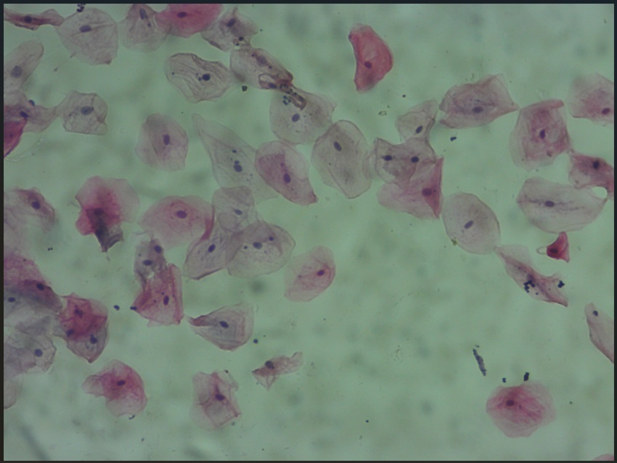
NB
BN
Figure 2: Light photomicrograph of exfoliated buccal mucosal cells obtained from ESWAMA waste disposal worker showing presence of binucleated cells (B) and cells with nuclear buds (N) [Stain: Papanicolau/Mag: x100]
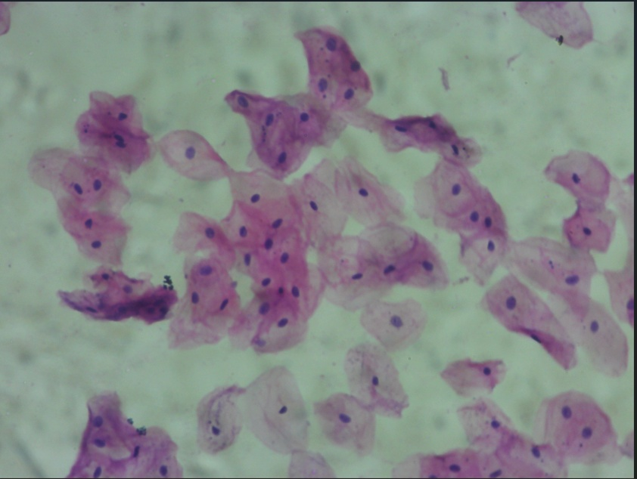
BN
NC
NC
Figure 3 - Light photomicrograph of exfoliated buccal mucosal cells obtained from a Hospital waste disposal worker showing presence of normal cells (NC), binucleated cells (BN) and cells undergoing karyohexis (thick arrows). [Stain: Papanicolau/Mag: x100]
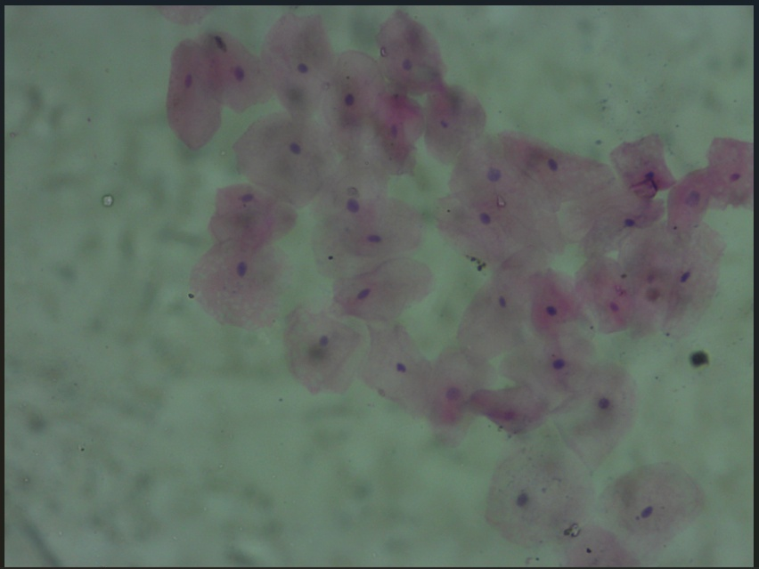
NC
Figure 4: Light photomicrograph of exfoliated buccal mucosal cells obtained from Hostel waste disposal worker showing presence of normal cells (NC), and cells undergoing karyohexis (thick arrows) [Stain: Papanicolau/Mag: x100]

DISCUSSION
Occupational and environmental exposure to toxic chemical agents represents a significant risk to human health, a concern that has gained global attention [20]. Buccal epithelial cytogenetic damage due to environmental and occupational exposure, are monitored by micronucleus (MN) assay [21]. Disposing and managing of waste has an inherent capacity to produce dust, which without effective control can lead to respiratory disease [22]. This study was performed to assess the occupational health of waste handlers using MN assay. While acknowledging the limitation of a relatively small sample size, especially within subgroups, our findings demonstrate statistically significant differences in nuclear abnormalities between waste handlers and controls, and among different waste handler categories. This suggests a strong indication of genotoxic risk that warrants further large-scale investigations. Higher frequencies of micronuclei, binucleate cells, nuclear bud and karyorrhexis were observed in ESWAMA waste handlers when compared to the other groups and controls. This finding is similar to the report documented by a previous study which observed an increased level of micronuclei (p=0.00), nuclear bud (p=0.00), binucleate cells (p=0.03) and karyorrhexis in buccal epithelial cells of waste management workers when compared to the controls. Our findings also align with studies demonstrating nuclear abnormalities in other occupationally exposed groups, such as agricultural farmers [23]. Comparing the various categories of waste handlers, it was observed that ESWAMA had the highest frequency of micronuclei, binucleate cells, nuclear bud and karyorrhexis while hostel waste handlers and hospital waste handlers had the least frequency of micronuclei, binucleate cells, nuclear bud and karyorrhexis. This may be attributed to the fact that these hospital waste handlers do use their personal protective equipment (PPE) while the ESWAMA waste handlers don't. Moreover, the ESWAMA waste handlers are more inevitably in direct contact with waste and inhalation during loading and sorting of waste respectively is inevitable, unlike the hospital waste handlers and hostel waste handlers who just sweep and pack the waste into waste bins. This finding is similar to the findings of a previous study which documented a similar statistically higher frequency of micronuclei, binucleate cells, nuclear bud and karyorrhexis in waste handlers involved in the various stages of waste management, such as; sorting, loading, crushing and burning when compared with the control group [24]. A previous study also documented that worker who have spent more years in waste handling are subjected to greater risks of developing oral pathological changes which may lead to cancer on prolonged exposure to toxic substances [25]. However, in the present study, there was significant difference in the frequency of nuclear abnormalities between workers who have spent more years handling waste and workers who just started waste handling; this is similar to the finding documented by a previous study involving gas station attendants ¹⁵. The increase in MN in participants who have worked longer in occupation requiring them to handle cement suggests that most direct and indirect genotoxic substances require chronic exposure to exert its damaging effect as opined by Benedetti [26]. The use of personal protective equipment (PPE) such as boots, gloves, face masks and overalls, did not significantly affect the frequency of nuclear abnormalities, although the majority of workers sampled in this study did not strictly adhere to the use of PPE when working. Nevertheless, in preventing work related hazards due to occupational genotoxins, adequate use of Personal Protective Equipment (PPE) is very necessary. According to some authors [27] [28], lifestyle factors such as alcohol consumption and smoking habits are considered as contributing factors for elevated levels of nuclear anomalies in individuals who are exposed to other environmental genotoxic substances. As observed in the present study, alcohol consumption and cigarette smoking were implicative factors to the significantly higher MN and BNC observed in waste handlers exposed to occupational genotoxins. Our analysis of these confounding factors (Tables 7 and 8) demonstrates their independent association with nuclear abnormalities, providing a more robust interpretation of the occupational exposure effects. Similarly, Khan and Sudha reported a higher degree of micronuclei and nuclear changes among cigarette smokers who were occupationally exposed to Polycyclic aromatic hydrocarbons (PAH). A previous study also showed a direct relationship between buccal mucosa nuclear anomalies and exposure to cigarette smoke and alcohol [29]. The cytological assessment clearly revealed significant nuclear abnormalities in the buccal cells of waste handlers, particularly ESWAMA workers, indicating substantial potential genotoxic effects due to occupational exposure to hazardous waste. These findings, while not directly assessing malignancy prevalence, serve as crucial biomarkers of early cellular damage, which are recognized indicators of increased risk for various long-term health problems, including potentially malignant disorders and cancer, as highlighted in the introduction. It also show the critical need for improved health and safety protocols for this vulnerable population. The relevance of these findings cannot be overemphasized, as they highlight the necessity of biomonitoring for semiskilled and unskilled workers who are often unprotected from toxic substances, and the urgent need to develop strategies to ensure their health and safety. Regular health monitoring and the stringent implementation of safety measures are crucial to protect waste handlers from occupational hazards
CONCLUSION
ESWAMA waste handlers in Enugu State University Teaching Hospital may be occupationally exposed to substances capable of inducing genotoxic changes which manifested as increased frequencies of buccal cell micronuclei, binucleate cells, nuclear bud and karyorrhexis. The cytological assessment of buccal smear from waste handlers revealed significant nuclear abnormalities, indicating potential genotoxic effects due to occupational exposure to hazardous waste. This study highlights the importance of regular health monitoring and implementation of safety measures to protect waste handlers from occupational hazards.
Disclaimer (Artificial intelligence)
Author(s) hereby declare that NO generative AI technologies such as Large Language Models (ChatGPT, COPILOT, etc.) and text-to-image generators have been used during the writing or editing of this manuscript.

REFERENCES
- Hirvonen, A. (2021). Genetic factors in individual responses to environmental exposures. Journal of Occupational and Environmental Medicine, 1, 37-43.
- Benites, C. I., Amado, L. L., Vianna, R. A. P., & Martino-Roth, M. G. (2016). Micronucleus test on gas station attendants. Genetic and Molecular Research, 5(45), 45-54.
- Santos-Mello, R., & Cavalcante, B. (2022). Cytogenetic studies on gas station attendants. Mutation Research/Genetic Toxicology, 280(4), 285-290.
- Holland, N., Bolognesi, C., Kirsch-Volders, M., Bonassi, S., Zeiger, E., & Knasmueller, S. (2018). The micronucleus assay in human buccal cells as a tool for biomonitoring DNA damage: The HUMN project perspective on current status and knowledge gaps. Mutation Research/Reviews in Mutation Research, 659(1), 93-108.
- Majer, B. J., Laky, B., Knasmüller, S., & Kassie, F. (2017). Use of the micronucleus assay with exfoliated epithelial cells as a biomarker for monitoring individuals at elevated risk of genetic damage and chemoprevention trials. Mutation Research/Reviews in Mutation Research, 489(2), 147–172.
- Au, W. W. (2019). Cytogenetic assays in monitoring human exposure and prediction of risk. Environmental Mutagenesis, Carcinogenesis, and Teratogenesis, 23, 236-245.
- Manjunath, G. S., Shashikala, R., Indira, A. P., Rao, K., & Akshatha, B. K. (2015). Role of micronucleus in oral exfoliative cytology. Dental Science. 18(9)26-28
- Shashikala, R., Indira, A. P., Manjunath, G. S., Rao, K. A., & Akshatha, B. K. (2015). Role of micronucleus in oral exfoliative cytology. Journal of Public Health Dentistry, 9(2), 163472.
- Borkar, S., Reche, A., Paul, P., Deshpande, A. and Deshpande, M. 2023. Noninvasive Technique for the Screening and Diagnosis of Oral Squamous Cell Carcinoma. Cureus 15(9), p. e46300. Available at: https://pmc.ncbi.nlm.nih.gov/articles/PMC10616636/
- Tayebi-Hillali, H. et al. 2025. Accuracy of Cytological Methods in Early Detection of Oral Squamous Cell Carcinoma and Potentially Malignant Disorders: A Systematic Review and Meta‐Analysis. Journal of Oral Pathology & Medicine 54(7), p. 507. Available at: https://pmc.ncbi.nlm.nih.gov/articles/PMC12344227/
- Kazanowska, A., Zawada, M., & Kowalski, T. P. (2014). Exfoliative cytology in oral cancer screening. Oral Oncology, 50(3), 213-219.
- Sabharwal, R., Verma, P., Syed, M.A., Sharma, T., Subudhi, S.K., Mohanty, S. and Gupta, S. 2015. Emergence of micronuclei as a genomic biomarker. Indian Journal of Medical and Paediatric Oncology : Official Journal of Indian Society of Medical & Paediatric Oncology 36(4), p. 212. Available at: https://pmc.ncbi.nlm.nih.gov/articles/PMC4711219/
- Fenech, M., & Crott, J. W. (2022). Chromosomal instability, DNA damage and micronuclei in nutritional deficiency and ageing. Mechanisms of Ageing and Development, 123(8), 1041-1064.
- Bansal, H., Sandhu, V. S., Bhandari, R., & Sharma, D. (2012). Evaluation of micronuclei in tobacco users: A study in Punjabi population. Contemporary Clinical Dentistry, 3(2),184-187
- Benites, C. I., Amado, L. L., Vianna, R. A. P., & Martino-Roth, M. G. (2016). Micronucleus test on gas station attendants. Genetic and Molecular Research, 5(45), 45-54.
- International Agency for Research on Cancer. (2021). Some organic solvents, resi monomers and related compounds, pigments and occupational exposures in paint manufacture and painting. IARC Monographs on the Evaluation of Carcinogenic Risks to Humans, 47, 1-442.
- Çelik, A., Çava, T., & Ergene-Gözükara, S. (2023). Cytogenetic biomonitoring in petrol station attendants: Micronucleus test in exfoliated buccal cells. Mutagenesis, 18, 417-421.
- Pastor, S., Gutiérrez, S., Creus, A., Xamena, N., Piperakis, S., & Marcos, R. (2021). Cytogenetic analysis of Greek farmers using the micronucleus assay in peripheral lymphocytes and buccal cells. Mutagenesis, 16, 539-545.
- Kumar, N., Gupta, R., & Gupta, S. (2020). Whole Slide Imaging (WSI) in Pathology: Current Perspectives and Future Directions. Journal of digital imaging, 33(4), 1034–1040.
- Franco, S.S., Nardocci, A.C., Gunther, W.M. (2018): PAH biomarkers for human health risk assessment: A review of the state-of-the-art. Cad. Saude Publica 24, 569–580
- Arul, P., Smitha, S., Masilamani, S., Akshatha, C. (2018): Micronucleus assay in exfoliated buccal epithelial cells using liquid based cytology preparations in building construction workers. Iran Journal Of Pathology. 13(1), 31–38
- Papageorgiou, C. V, Savourdos, P., Douna, E., Georgakopoulou, V.E., Makrodimitri, S. and Dounias, G. 2021. Respiratory Symptoms and Pulmonary Function of Workers in the Waste Management Industry. Cureus 13(8), p. e17027. Available at: https://pmc.ncbi.nlm.nih.gov/articles/PMC8425493/
- Abdul Hamid, Z., Mohd Zulkifly, M. F., Hamid, A., Lubis, S. H., Mohammad, N., Ishak, I., ... & Rajab, N. F. (2016). The association of nuclear abnormalities in exfoliated buccal epithelial cells with the health status of different agricultural activities farmers in Peninsular Malaysia. Genes and Environment, 38(1), 7.
- Afesi-Dei, C., Appiah-Brempong, M., & Awuah, E. (2023). Health-care waste management practices: The case of Ho Teaching Hospital in Ghana. Heliyon, 9(4), e15514. https://doi.org/10.1016/j.heliyon.2023.e15514
- Singh, S., Saini, M., Singh Yadav Professor, A. and Singh Yadav, A. 2015. Elevated frequencies of micronuclei and other nuclear anomalies in alcoholic subjects. ~ 243 ~ Journal of Entomology and Zoology Studies 3(2), pp. 243–245
- Benedetti, D., Nunes, E., Sarmento, M., Porto, C., dos Santos, C.E.I., Dias, J.F., da Silva, J.(2023): Genetic damage in soybean workers exposed to pesticides: evaluation with the comet and buccal micronucleus cytome assays. Mutation. Research./Genetic Toxicology. Environment. Mutagenesis. 752(22), 28–33.
- Holland, N., Bolognesi, C., Kirsch-Volders, M., Bonassi, S., Zeiger, E., & Knasmueller, S. (2018). The micronucleus assay in human buccal cells as a tool for biomonitoring DNA damage: The HUMN project perspective on current status and knowledge gaps. Mutation Research/Reviews in Mutation Research, 659(1), 93-108.
- Diler, S.B., Ergene, S. (2022): Nuclear anomalies in the buccal cells of calcite factory workers. Genetic. Molecular. Biology. 33(2), 374–378
- Jyoti, S., Siddiquea, Y.H., Khan, S.(2015): Effect on micronucleus frequency and DNA damage in buccal epiththelial cells of various factors among pan masala and gutkhaoral science. International. Journal of Oral Science. 12, 9–14

