Original Research Article

IMPACT OF A 6-WEEK AEROBIC EXERCISE REGIMEN ON CARDIOVASCULAR HEALTH AND PERCEIVED STRESS AMONG HEALTHCARE WORKERS IN A TERTIARY HEALTH INSTITUTION, SOUTH WESTERN NIGERIA

.
ABSTRACT

Background: Cardiovascular diseases are the leading cause of global mortality, with healthcare workers also at risk due to occupational stress and physical inactivity. Aerobic exercise is recognized for its cardiovascular and psychological benefits, yet limited studies have evaluated structured workplace interventions among Nigerian healthcare workers.
Aims: This study aims to evaluate the impact of a six-week aerobic exercise regimen on cardiovascular health and perceived stress among healthcare workers at Federal Medical Centre, Owo, Ondo state, Nigeria.
Study Design: A pretest-posttest experimental study
Place and Duration of Study: The study took place at the Physiotherapy Department of the Federal Medical Center, Owo between April 2025 and June, 2025
Material and Methods: This study involved 38 healthcare workers selected by convenience sampling. Participants engaged in supervised aerobic exercise sessions three times weekly for six weeks, each lasting 60 minutes. Baseline and post-intervention data were collected using a cardiovascular health proforma (systolic/diastolic blood pressure, mean arterial pressure, resting heart rate, and six-minute walk distance) and Perceived Stress Scale (PSS-10). Data were analyzed using IBM SPSS 27 and R (v4.5.1). Paired t-tests and Wilcoxon signed-rank tests were used depending on normality, with significance set at p < 0.05.
Results: Thirty-eight participants (mean age 25.7 ± 2.3 years; 52.6% male) completed the study. Significant reductions were observed in systolic blood pressure (p < 0.05), diastolic blood pressure (p = 0.001), mean arterial pressure (p < 0.05), resting heart rate (p < 0.05), and perceived stress (p < 0.05) and mean six-minute walk distance increased significantly (+87.2 m; p < 0.05. Categorical analysis showed an increase in low-stress prevalence from 50% to 86.8%.
Conclusion: A structured six-week aerobic exercise regimen significantly improved cardiovascular health and reduced stress among healthcare workers. Workplace-based aerobic exercise programs are recommended to enhance both health and productivity. They not only safeguard staff health but also indirectly improve patient care outcomes by fostering more resilient workforce

Keywords: Aerobic exercise, cardiovascular health, stress, healthcare workers

1. INTRODUCTION

Cardiovascular diseases remain the leading cause of death worldwide, accounting for approximately 17.9 million deaths annually (Luo et al.,2024). These diseases encompass a range of disorders affecting the heart and blood vessels, including coronary artery disease and hypertension. The major risk factors for cardiovascular diseases include physical inactivity, unhealthy diet, smoking, and excessive consumption alcohol (Ghodeshwar et al., 2023). Among these, physical inactivity is particularly common among healthcare workers, primarily due to the demands of long working hours and shift duties, which significantly restrict their time for regular exercise (Smith et al.,2021). In 2014, World Health Organization (WHO) identified physical inactivity as an issue warranting attention from international public health agencies, and declared that over14 million individuals die from chronic disease resulting from physical inactivity WHO (2015). According to a 2014 survey by the US Centers for Disease Control, adults without regular physical activity have a higher risk of early death and heart disease, stroke, type 2 diabetes, depression and cancer WHO (2014).
Report from literature have shown that individuals who engaged in adequate levels of exercise throughout their lives: at least 150 min of moderate-intensity aerobic physical activity (PA) per week or at least 75 min of vigorous PA per week for adults and at least 60 min of moderate-to vigorous-intensity daily PA for children aged 5 to 17reduces the risk of cardiovascular disease and diabetes, colon and breast cancer (WHO,2011). Similarly, regular aerobic exercise has been shown to improve cardiovascular health by enhancing cardiorespiratory fitness, reducing blood pressure, and improving lipid profiles (Chandrasekaran et al.,2019). Studies have shown that workplace exercise programs can significantly enhance employees' health by reducing body weight, waist circumference, resting heart rate, and blood pressure, while also improving lipid profiles, enhancing insulin sensitivity, and promoting overall cardiovascular efficiency (Colino et al. ,2023). A study by Bolarinde et al. (2024a) among undergraduate students in Nigeria, demonstrated that active sports participation was associated with lower systolic and diastolic blood pressure, reduced resting heart rate, and improved cardiovascular indices, underscoring the protective role of physical activity against cardiovascular risks. Another study by Murray et al. (2023) recognizes aerobic exercises as one of the most effective interventions to prevent and treat the effects of aging on cardiovascular dysfunction.
Findings from previous studies have also shown the effects of physical exercises on stress management thereby improving productivity, for instance, a study by Colino et al., (2023) revealed that workplace aerobic exercise programs can positively impact employees' health, stress outcomes and productivity. A similar study by Bolarinde et al. (2024b) reported that a six-week aerobic exercise program significantly improved body composition but showed no statistically significant reduction in perceived stress among healthcare workers, suggesting that exercise duration and population characteristics may influence stress outcomes. Furthermore, Bolarinde et al, (2024b) reported that, workplace-based fitness interventions among Nigerian health workers were found to enhance awareness, motivate individualized exercise routines, and improve perceived physical fitness, which may contribute to better stress management and cardiovascular resilience. Collectively, these findings highlight the dual benefits of exercise in improving cardiovascular efficiency while potentially mitigating perceived stress levels in healthcare populations.
Healthcare workers often experience long working hours, irregular shifts and high occupational stress that limits the time to engage in physical activity contributing to higher risk of hypertension, cardiovascular disease and burnout compared to the general population. Despite existing evidence, limited research has examined the combined effects of aerobic exercise on cardiovascular health and perceived stress among healthcare workers in Nigeria. Given their high workload, irregular shifts, and stressful work environment, this population is particularly vulnerable to both cardiovascular risks and stress-related disorders. It is therefore necessary to investigate whether a structured six-week aerobic exercise program can improve these outcomes among health care workers in tertiary health facility in Nigeria, thereby filling a critical knowledge gap and guiding workplace health interventions for healthcare professionals.

2. material and methods

This experimental study was conducted among health workers at the Federal Medical Centre (FMC), Owo, a tertiary health facility in South-western region in Nigeria. Participants were selected through convenience sampling. Inclusion criteria included apparently healthy adults who are active staff member at FMC Owo, on 8 hours daily work schedule, adjudged to be physically fit for the study following preliminary assessment of heart rate, pulse rate and blood pressure by the assessing physiotherapist and ready to provide informed consent. Health workers with a history of cardiovascular disease disease (prior myocardial infarction, heart failure), uncontrolled hypertension, musculoskeletal disorders limiting participation or contraindications to exercise were excluded.
The study took place at the Physiotherapy Department of FMC Owo. Ethical approval for this study was obtained from the Health Research Ethics Committee (HREC) of the Federal Medical Center, Owo with an approval number of FMCOWO/HREC/2025/16.
Instruments for data collection included the Cardiovascular Health Assessment Proforma (blood pressure, mean arterial pressure, resting heart rate, oxygen saturation, and six-minute walk test (6MWT) and the Perceived Stress Scale (PSS-10) to measure occupational stress. Additional instruments included a sphygmomanometer, stethoscope, pulse oximeter, and stopwatch.
A total of 38 participants completed a 6-week aerobic program (3 sessions/week, 60 min each). In both the pre and post sessions, participants’ resting HR and BP were measured after a 5-minute seated rest prior to administering the 6MWT. These baseline measurements were taken to establish resting cardiovascular status. The aerobic sessions included: warm-up (3–5 min), aerobic activities (50 min: aerobic dance at 60–75% HRmax, rope skipping with 2.8–3.0 m ropes in 2–3 min intervals, stair climbing on steps 15–18 cm high, 28–30 cm deep), and cool-down (3–5 min) (Bolarinde et al, 2025). Participants maintained their normal routines and all sessions were monitored for safety.
Data were collected at baseline and post-intervention using the study instruments. Cardiovascular parameters and stress levels were assessed. Data were analyzed using SPSS version 27 and R (v4.5.1). Normality was tested with Shapiro–Wilk. Paired t-tests were applied to normally distributed variables, while Wilcoxon signed-rank tests were used otherwise. Changes in categorical stress levels were analyzed with the Stuart–Maxwell marginal homogeneity test. Statistical significance was set at p < 0.05.

3. results and discussion

A total of 38 healthcare workers participated in the study, with a mean age of 25.7 ± 2.3 years (range: 21–33 years). Males constituted 52.6% of participants, while females made up 47.4%. Physiotherapists were the largest occupational group (39.5%), followed by medical laboratory scientists and radiographers (18.4% each). Almost half (47.4%) had ≤1 year of work experience, and only 34.2% engaged in regular physical exercise prior to the intervention as shown in Table 1 below.

Table 1: Sociodemographic Characteristics of Participants (N=38)

Variable | Min-Max | Mean(SD)
Age | 21-33 | 25.71(2.27)
Variable | Frequency | Percent
Sex
Male | 20 | 52.6
Female | 18 | 47.4
Occupation
Doctor | 2 | 5.3
Nurse | 3 | 7.9
Physiotherapist | 15 | 39.5
Pharmacist | 4 | 10.5
MLS | 7 | 18.4
Radiographer | 7 | 18.4
Year of Experience
≤1 year | 18 | 47.4
2 years | 9 | 23.7
≥3 years | 11 | 28.9
Engages in Regular Exercise
No | 25 | 65.8
Yes | 13 | 34.2

Table 2 below summarises the baseline cardiovascular and stress measures of participants. The mean Systolic Blood Pressure (SBP), Diastolic Blood Pressure (DBP), and Mean Arterial Pressure (MAP) were 122.5 ± 11.3 mmHg, 78.2 ± 6.8 mmHg, and 92.95 ± 7.28 mmHg, respectively, while the mean resting heart rate was 84.6 ± 10.6 bpm. The mean Six-Minute Walk Distance (6MWD) was 355.0 ± 79.0 m, and the mean total weekly MET-minutes was 1560.3 ± 1260.6.
Regarding blood pressure category, the majority (68.4%) were in Stage 1 hypertension, with smaller proportions in the normal (13.2%), elevated (10.5%), and Stage 2 hypertension (7.9%) categories. Perceived stress scores averaged 13.3 ± 8.3 at baseline, with half of participants classified as having low stress, 44.7% moderate stress, and 5.3% high stress.

Table 2: Baseline Cardiovascular and Stress Parameters of Participants

Variable | Mean ± SD | Min-Max
SBP (mmHg) | 122.47 ± 11.33 | 100-170
DBP (mmHg) | 78.18 ± 6.82 | 60-100
MAP (mmHg) | 92.95 ± 7.28 | 76.7-123.3
Resting Heart Rate (bpm) | 84.61 ± 10.58 | 70-110
Six-Minute Walk Distance (m) | 354.97 ± 78.99
PSS_Total | 13.34 ± 8.32
Variable | Frequency | Percentage (%)
Blood Pressure Category
Normal | 5 | 13.2
Elevated | 4 | 10.5
Stage 1 Hyperstension | 26 | 68.4
Stage 2 Hypertension | 3 | 7.9
Perceived Stress Category
Low Stress | 19 | 50.0
Moderate Stress | 17 | 44.7
High Stress | 2 | 5.3

In Table 3 below, before hypothesis testing, Shapiro–Wilk tests indicated that the difference scores for Six MWD were normally distributed, while other variables were not. Accordingly, paired t-tests were applied to normally distributed outcomes, and Wilcoxon signed-rank tests to non-normal outcomes. Following the 6-week aerobic exercise programme, there were statistically significant reductions in SBP (Z = -4.80, p < 0.05), DBP (Z = -3.18, p = 0.001), MAP (Z = -4.58, p < 0.05), resting heart rate (Z = -5.31, p < 0.05), and PSS Total (Z = -5.02, p < 0.05). The median change direction was uniformly towards improvement, with no participants showing higher SBP, RHR, or PSS scores post-intervention.
For the normally distributed outcomes, mean 6MWD increased significantly from 355.0 ± 79.0 m to 442.2 ± 77.4 m (mean difference = 87.2 m; t (37) = -9.00, p < 0.001).
The graph representation of results are presented in Figure 1-3

Table 3: Changes in Cardiovascular and Stress Parameters after Intervention

Parameter | Pre, Median Score (IQR) | Pre, Median Score (IQR) | Mean Rank  Diff. (Post-Pre) | Sum of Ranks | Z | p-value
SBP (mmHg) | 120 (118-128) | 115 (110-120) | 15.50 | 465 | -4.80 | <0.05
DBP (mmHg) | 80 (74-80) | 75 (70-80) | 12.10 | 242 | -3.18 | 0.001
MAP (mmHg) | 93.3 (90-95) | 88 (83-93) | 18.58 | 594 | -4.58 | <0.05
Resting HR (bpm) | 80 (77-92) | 75 (70-77) | 19.00 | 703 | -5.31 | <0.05
PSS_Total | 14(6-20) | 6.5 (3-12) | 17.00 | 561 | -5.02 | <0.05
Parameter |  |  | Pre (Mean ± SD) | Post (Mean ± SD) | t(df) | p-value
SixMWD (m) |  |  | 354.97 ± 78.99 | 442.18 ± 77.41 | -9.00(37) | <0.05

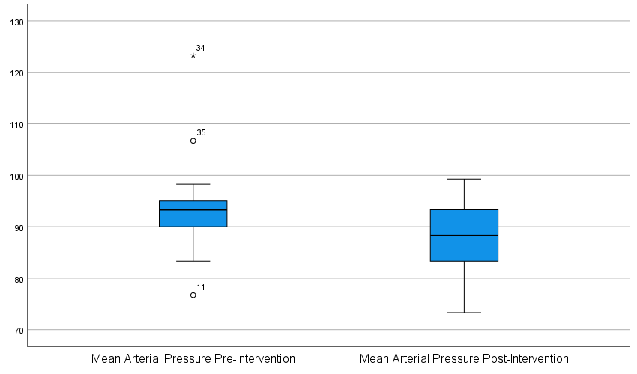

Figure 1: Median Mean Arterial Pressure Pre & Post Intervention

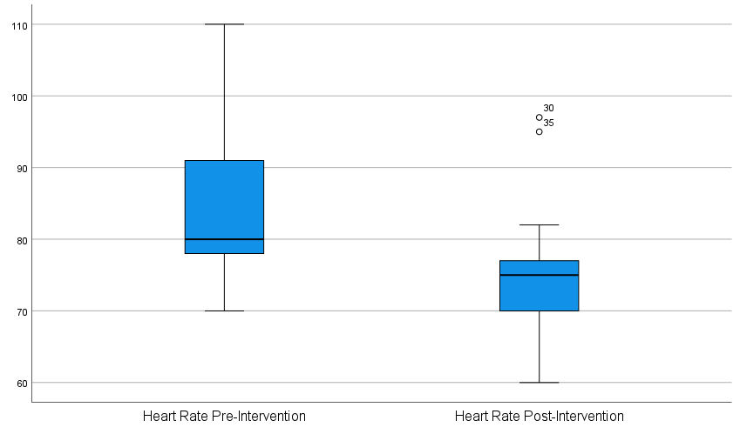

Figure 2: Median Heart Rate Pre & Post Intervention

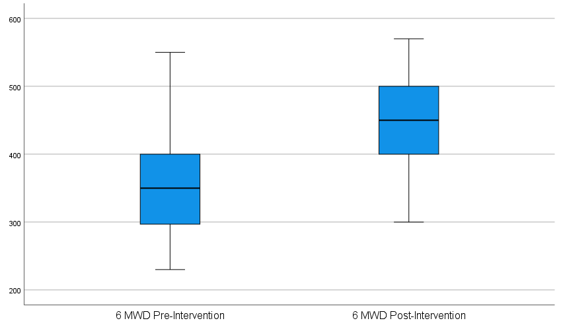

Figure 3: Median 6MWD Pre & Post Intervention

Table 4 below shows a marked post-intervention shift in stress categories. The proportion of participants in the low-stress category increased from 50.0% to 86.8%, while moderate stress decreased from 44.7% to 13.2% and high stress from 5.3% to 0%. No participants worsened in category, and 36.8% improved by at least one category. The Stuart–Maxwell test confirmed that this shift was statistically significant (χ²(2) = 14.00, p <0.05).

Table 4: Changes in Categorical Stress Levels after Intervention

 |  |  | Post Intervention
 | Category | Low Stress n (%) | Moderate Stress n (%) | High Stress n (%) | Total
 | Low Stress | 19 (100.0) | 0 (0.0) | 0 (0.0) | 19 (50%)
Pre Intervention | Moderate Stress | 12 (70.6) | 5 (29.4) | 0 (0.0) | 17 (44.7%)
 | High Stress | 2 (100.0) | 0 (0.0) | 0 (0.0) | 2 (5.3%)
 | Total | 33 (86.8%) | 5 (13.2%) | 0 (0.0) | 38 (100%)
 | Stuart–Maxwell test | χ²(2) = 14.00 | p = <0.001 | - | -

Overall, the 6-week aerobic exercise regimen produced significant improvements in blood pressure, heart rate, cardiovascular endurance and perceived stress. The changes were both statistically significant and clinically relevant, with clear shifts towards healthier cardiovascular and stress profiles.

Discussion

This study evaluated the impact of six-weeks aerobic exercise regimen on cardiovascular health and work productivity among healthcare workers at FMC Owo. The findings from this study showed significant improvements in systolic and diastolic blood pressure, mean arterial pressure, resting heart rate, Six-minute Walk Distance (6MWD) and perceived stress scores. These results proved that structured aerobic exercise not only improves cardiovascular fitness but it also affects perceived stress outcomes which affects work productivity among healthcare positively.
The results from this study identified significant reduction in systolic blood pressure following the 6-week aerobic exercise. This result is in agreement with the study by Cornelissen and Smart (2013) which reported that at least four weeks of aerobic training significantly reduces systolic blood pressure. The consistent post intervention reduction in the systolic blood pressure reinforces the impact exercise has on vascular function in the body. This reduction might be as a result of improvement in vascular compliance.
Similarly, the result from this present study showed a significant reduction in the diastolic blood pressure of the participants. This is in line with prior evidence supporting that aerobic exercise lowers diastolic blood pressure by improving arterial elasticity. A study by Cornelissen and Smart (2013) shows that aerobic exercises improve endothelial function and reduces peripheral vascular resistance. 68.4% of participants had stage 1 hypertension at baseline, which made the reduction in diastolic blood pressure of relevance in the long-term cardiovascular risk management.
A study by Williamson et al (2022) however did not record meaningful reductions in systolic and diastolic blood pressure in adults with normal blood pressure in his study, this could be because the margin for change is limited. Nevertheless, the reductions recorded in our study shows the importance of aerobic exercises on the blood pressure.
The present study also revealed a significant decrease in mean arterial pressure which shows its role as a sensitive indicator of vascular adaptation to aerobic training. Mean arterial pressure shows the average perfusion pressure across the cardiac cycle unlike the systolic blood pressure and the diastolic blood pressure which can fluctuate due to stress and other factors. The mean arterial pressure is particularly sensitive to aerobic exercise because it shows the improvement in both cardiac output and peripheral vascular resistance. It is also regarded as a more reliable predictor of cardiovascular adaptation compared to systolic or diastolic blood pressure in isolation.
This result is similar to the study by Ramirez-Jimenez et al. (2021) who found that aerobic exercise combined with medication reduced 24-hour mean arterial pressure more effectively than medication alone. The consistent reduction in mean arterial pressure among the participants shows the effectiveness of the six-week aerobic program in lowering systemic vascular load even in relatively young population with prehypertension and stage 1 hypertension. This suggest that mean arterial pressure may serve as more sensitive and clinically meaningful outcome for evaluating early cardiovascular benefits of work place exercise intervention among healthcare workers.
The reduction in resting heart rate from this study was similar to that of Reimers et al. (2018) which concluded that regular aerobic exercise lowers resting heart rate, as well as improves cardiac efficiency and autonomic regulation. Soogard et al. (2017) in their study highlighted that short term aerobic interventions improve autonomic balance which supports current findings. Since an elevated resting heart rate is an independent predictor of cardiovascular morbidity, its reduction highlights an important preventive benefit for healthcare workers exposed to occupational stress.
In this study, no participant experienced an increase in resting heart rate further reenforcing the evidences that exercise generally benefits cardiac function immensely. Since elevated resting heart rate is an independent risk factor for cardiovascular disease, this finding is particularly valuable for young healthcare workers since they are exposed to high level of occupational stress.
The obvious increase in 6MWD in the present study further supports previous findings, showing improved cardiovascular endurance. The study by Lee (2024) reported that regular aerobic exercise in sedentary office workers improves cardiovascular health as well as heart function, while that of Wahlstrom et al. (2025) highlighted that aerobic activity reduces cardiovascular load in physically demanding occupations, confirming the protective effect of exercise among healthcare workers. The benefits are especially noticeable if there are properly structured routines around this in place. This claim was supported by a study done by Marin-Farrona et al. (2023) as diverse worker population confirmed that aerobic interventions are both effective and sustainable means of enhancing cardiovascular endurance.
The result of this present study revealed a significant reduction in perceived stress with half of the participants moving from moderate to low- stress categories after the intervention. This report is consistent with findings from Mohebbi et al. (2019) where an eight-week aerobic exercise program significantly reduced occupational stress in nurses. The obvious decline in moderate and high stress prevalence highlights exercise as a practical intervention for stress management in demanding healthcare settings.
Recent studies suggests that workplace exercise interventions not only reduce stress but also improve overall mental well-being, sleep quality and job satisfaction (Heuel et al, 2024). This is especially important in the healthcare sector where a lot of workers are prone to all forms of stress, fatigue burnout as well as other occupational risks. This study achieved a complete adherence across participants representing an optimal outcome in comparison to a larger population where adherence rates might be lower.

4. Conclusion

In conclusion, the six-week aerobic exercise program produced statistically and clinically significant improvements in cardiovascular health and occupational wellbeing among healthcare workers
These findings align with both classical and recent literature, reinforcing the importance of structured aerobic exercise in promoting cardiovascular fitness, reducing occupational stress and enhancing overall productivity in healthcare settings. Implementing such programs in work places can be a practical and effective strategy for supporting the health and performance of healthcare professionals.

5. LIMITATIONS
Certain limitations in this study must be acknowledged. The relatively small sample size and single-center design may limit the generalizability of the findings to broader healthcare worker populations. The absence of a control group restricts the ability to attribute all observed changes solely to the intervention, as other unmeasured influences may have contributed.

6. RECOMMENDATIONS
It is recommended that workplace wellness policies integrate regular aerobic exercise programs for healthcare workers. The positive outcomes observed in this study emphasizes the importance of incorporating structured aerobic exercise programs into healthcare workplace wellness programs. Studies have shown that these programs can particularly improve not just the physical health but reduce perceived stress as well by contributing to increased productivity and employee engagement among healthcare workers (Singh et al,2024).
Contrary to popular misconception that exercise must be long to be effective which has played a role in discouraging participation, short sessions of consistent activity like a daily 15-minute exercise challenge or promoting stair use can yield significant health benefits. This makes encouraging such interventions feasible and impactful in busy healthcare environments
Further research with larger multi-center samples and longer follow-up periods is encouraged to establish long-term benefits and sustainability of such programs.

Consent

Written informed consent was obtained from all participants prior to their inclusion in the study. Participants were informed about the purpose, procedures, potential risks, and benefits of the study, and their right to withdraw at any time without penalty.

Ethical approval

Ethical approval for this study was obtained from the Health Research Ethics Committee (HREC) of the Federal Medical Center, Owo. The Health Research Committee assigned number is NHREC/FMCOWO-HREC/04/01/2025 and an approval number of FMCOWO/HREC/2025/16. The study was conducted in accordance with the ethical standards of the Helsinki Declaration.

DISCLAIMER (ARTIFICIAL INTELLIGENCE)

Author(s) hereby declare that NO generative AI technologies such as Large Language Models (ChatGPT, COPILOT, etc.) and text-to-image generators have been used during the writing or editing of this manuscript.

References

1. Luo Y, Liu J, Zeng J, Pan H. 2024. Global burden of cardiovascular diseases attributed to low physical activity: An analysis of 204 countries and territories between 1990 and 2019. Am J Prev Cardiol. Feb 6;17:100633. doi: 10.1016/j.ajpc.2024.100633. PMID: 38380078; PMCID: PMC10877163.
2. Ghodeshwar GK, Dube A, Khobragade D. (2023) Impact of Lifestyle Modifications on Cardiovascular Health: A Narrative Review. Cureus. Jul 28;15(7):e42616. doi: 10.7759/cureus.42616. PMID: 37641769; PMCID: PMC10460604.
3. Smith A, Brown J, Adeyemi T. ( 2021) Physical activity patterns among healthcare workers: A Nigerian perspective. BMC Public Health.;21(1):1234.
4. World Health Organization (WHO): Noncommunicable diseases. Geneva 2015
5. World Health Organization (WHO): A health telematics policy in support of WHO’s Health-For-All strategy for global health development: Report of the WHO group consultation on health telematics, Geneva. 2014
6. World Health Organization Global recommendations on physical activity for health. 2011. https://www.who.int/dietphysicalactivity/publications/physical-activity-recommendations-5-17years.pdf?ua=1 [PubMed]
7. Chandrasekaran, A. M., Katthula, V., & Gao, L. (2019). Effect of workplace physical activity interventions on the cardio-metabolic health markers: A systematic review and meta-analysis. International Journal of Behavioral Nutrition and Physical Activity, 16(1), 134.
8. Colino, E., Garcia-Unanue, J., Gallardo, L., Felipe, J. L., & López-Fernández, J. (2023). Impact of Physical Activity-Based Workplace Wellness on Improving Health and Productivity: A Systematic Review. Chemical Engineering Transactions, 111, 601-606
9. Bolarinde, S.O., Akeredolu, E.O., Adeboye, E.O., Nzeakuba, I.C., & Ojo-Ogun, A.K. (2024). Effect of sports participation on selected cardiovascular and adiposity indices among undergraduate students of University of Benin, Edo State. Journal of Biomedical Investigation, 12(2), 61–72
10. Murray, K. O., Mahoney, S. A., Venkatasubramanian, R., Seals, D. R., & Clayton, Z. S. (2023). Aging, aerobic exercise, and cardiovascular health: Barriers, alternative strategies and future directions. Experimental gerontology, 173, 112105. https://www.sciencedirect.com/science/article/pii/S0531556523000268
11. Bolarinde, S.O, Ayodele, D.D., Obode, D.O., & Akinsete, F.H. (2024). Effect of aerobic exercises on body composition, perceived stress level and sleep quality among workers at Federal Medical Centre, Owo. International Journal of Advanced Multidisciplinary Research and Studies, 4(4), 433–438.
12. ⁠ Bolarinde Samuel Olufemi, Adesida Adesope Faith, Olagoke Temitope Johnson, Dare Mercy Korede, Oledibe Juliet Ogechi, Awosiku Temitope Precious (2025). Effect of Aerobic Exercises on Job Performance, Mental Health and Sleep Quality among Interns in Nigerian Tertiary Health Institution. J Adv Sport Phys Edu, 8(7): 137-141.
13. Cornelissen VA, Smart NA. (2013). Exercise training for blood pressure: a systematic review and meta-analysis. J Am Heart Assoc. 2013;2(1):e004473.
14. ⁠Williamson W, Foster C, Reid H, Kelly P, Lewandowski AJ, Boardman H, et al .(2022) Effect of moderate to high-intensity aerobic exercise on blood pressure in young adults (TEPHRA): a randomized controlled trial. EClinicalMedicine. 2022;44:101270.
15. ⁠Ramirez-Jimenez M, Morales-Palomo F, Moreno-Cabañas A, Álvarez-Jimenez L, Ortega JF, Mora-Rodríguez R. (2021). Exercise and antihypertensive medication: effects on ambulatory blood pressure in resistant hypertension. J Am Heart Assoc. 2021;10(16):e021212.
16. ⁠Reimers AK, Knapp G, Reimers C. (2018). Effects of exercise on the resting heart rate: a systematic review and meta-analysis of interventional studies. J Clin Med. 2018;7(12):503.
17. ⁠Søgaard K, Blangsted AK, Herodotou M, Lund Rasmussen C, Sjøgaard G, Holtermann A .(2017). Effect of an aerobic exercise intervention on cardiac autonomic regulation: a worksite RCT among cleaners. Physiol Behav. 2017;169:90–7.
18. ⁠Lee J(2024). Effects of 12-week resistance and aerobic exercise on cardiovascular function and body composition in sedentary office workers. Asian J Kinesiol. 2024;26(1):47–56.
19. ⁠Wahlström E, Lindberg LG, Öhberg F, Gerdle B, Angquist KA, Ang BO (2025). A 3-month endurance training intervention in young wheel loader operators reduces cardiovascular load. Int J Environ Res Public Health.
20. ⁠Marín-Farrona M, Wipfli B, Thosar SS, Colino E, Garcia-Unanue J, Gallardo L, et al. (2023). Effectiveness of worksite wellness programs based on physical activity to improve workers’ health and productivity: a systematic review. Int J Environ Res Public Health. 2023;20(13):6234.
21. ⁠Mohebbi Z, Dehghan H, Babakhani N. (2019). The effect of aerobic exercise on occupational stress among nurses: a randomized clinical trial. J Educ Health Promot. 2019;8:197.
22. ⁠Heuel L, Otto A-K, Wollesen B. (2024). Physical exercise and ergonomic workplace interventions for nursing personnel—effects on physical and mental health: a systematic review. Ger J Exerc Sport Res. 2024;54:291–324.
23. ⁠Singh, B.; Ferguson, T.; Deev, A.; Deev, A.; Maher, C.A. (2024). Evaluation of the “15 Minute Challenge”: A Workplace Health and Wellbeing Program. Healthcare 2024, 12, 1255.

