Original Research Article
Anthropometric Assessment of Earlobe Patterns Among the Indigenous People of Ibadan, Nigeria

Abstract
Background: Earlobe morphology is a distinct and heritable trait that varies among populations and has applications in anthropology, genetics, and forensic identification. Despite its relevance, limited data exist on the distribution of earlobe patterns among the indigenous population of Ibadan, Nigeria.
Aim: This study investigated the distribution of earlobe attachment patterns among the indigenous people of Ibadan, with a focus on age and gender associations.
Method: A cross-sectional descriptive study was conducted among 320 respondents aged 18–37 years. Participants were categorised into four age groups: 18–22, 23–27, 28–32, and 33–37 years old. Earlobe patterns were classified as attached or detached, and their distribution was analyzed by age and gender using descriptive statistics. Multi-stage random sampling was used. A questionnaire was administered and retrieved. Data analysis was performed using the Statistical Package for Social Sciences (IBM SPSS version 23). Chi-square test was used as an inferential statistic.
Results: The majority of respondents were in the 18–22 age group (62.5%), followed by 23–27 years (21.3%), 28–32 years (11.6%), and 33–37 years (4.7%). Overall, attached earlobes were more prevalent (58.1%) than detached earlobes (41.9%). By age, attached earlobes were most frequent among respondents aged 33–37 years (73.3%), while detached earlobes were more common among younger groups (18–32 years, ~42%). Gender analysis revealed no significant difference: 55.6% of males and 60% of females had attached earlobes.
Conclusion: The findings indicate that attached earlobes are the dominant phenotype among the indigenous people of Ibadan, with no gender differences observed. The study underscores the value of earlobe morphology as a simple, non-invasive anthropometric marker with potential applications in population genetics and forensic anthropology.
Key Words: Earlobe Patterns, Anthropometry, Ibadan, Attached Earlobe, Detached Earlobe, Forensic Anthropology.

INTRODUCTION
The earlobe is the soft tissue area at the lower part of the outer ear, which lacks cartilage but is rich in blood vessels and nerve endings [1, 2]. It also consists of the tough areola and adipose (fatty) connective tissues, lacking the firmness and elasticity of the rest of the pinna [3, 4]. Additionally, earlobe attachment varies among individuals; it can be detached and hang freely to the side of the head, or it can be directly attached to the head [5,6,7]. Although this trait is believed to be influenced by genetics, it has been widely studied in genetics, anthropology, and forensic science for its potential to reveal inheritance patterns, population diversity, and evolutionary processes [8].
Earlobe attachment serves as a simple yet informative phenotypic marker that reflects genetic variation within and between populations [9, 10]. Examining the distribution and frequency of this trait across different ethnic or regional groups can offer insights into genetic connections, historical migrations, and adaptation. Several studies have explored earlobe attachment patterns; for example, Irozulike et al. [11] found that attached earlobes are more common among the Hausa ethnic group in Nigeria. Francis and Okoseimiema [12] reported that detached earlobes are more prevalent among the Kalabari people. A case study in Shah Alam, Malaysia, by Attalla et al. [13], observed that males tend to have more attached earlobes than females.
In Nigeria, a country with remarkable ethnic diversity, anthropometric studies have been conducted across different populations to document distinctive morphological traits [14]. This trait offers a valuable focus for study, as it can aid in understanding population genetics, inheritance, and biological diversity. Investigating earlobe attachment among the indigenous people of Ibadan enhances the growing body of anthropometric and genetic data in Nigeria.

2.0 MATERIALS AND METHODS
2.1 Study Design
The study adopted a cross-sectional descriptive design, and qualitative data were collected using the observational research method. A total of 320 respondents (160 males and 160 females) were selected within the age interval of 18-37 years. The respondents were drawn from the indigenous people of Ibadan, Oyo State, Nigeria. The city of Ibadan was used as the study area, and a multi-stage random sampling technique was employed to ensure that all respondents had an equal chance of being selected.
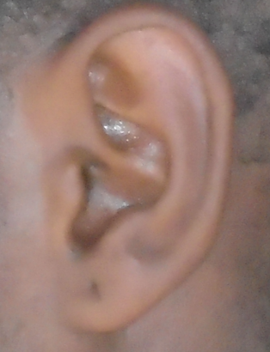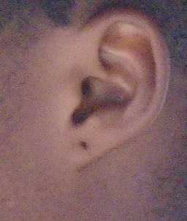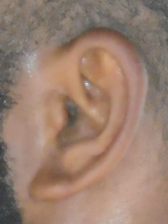
Fig. 1 the Attached Earlobe Pattern

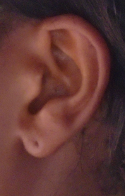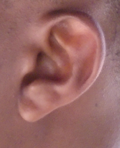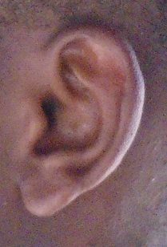
Fig. 2: the Detached Earlobe Pattern
2.2 Study Criteria
2.2.1 Inclusion criteria
This study included individuals whose parents and grandparents are indigenous people of Ibadan, Nigeria. Also, only those aged between 18 and 37 years, with no history of ear surgery, were selected.
2.2.2 Exclusion criteria
Those who did not meet the inclusion criteria were all omitted from the study.
2.3 Methods of Data Collection
A written consent form was distributed among the respondents, followed by a personal interview. Data were collected using a closed observational approach where trained personnel took observations of the earlobe. The data obtained were documented in a spreadsheet (Microsoft Excel Document).
2.4 Methods of Data Analysis
The data collected from the study were analysed using the International Business Machines Statistical Package for the Social Sciences (IBM SPSS version 23), with the Chi-square test employed as an inferential statistic. A probability of less than 0.05 (p<0.05) was deemed statistically significant.
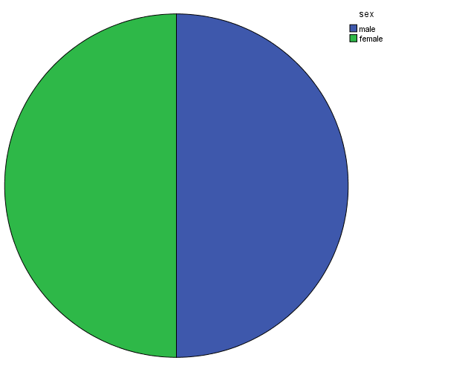
Fig. 3: pie chart Showing the Gender
Table 1. Age Interval of the Subjects
Age | Frequency %
18-22 | 200 (62.5%)
23-27 | 68 (21.3%)
28-32 | 37 (11.6%)
33-37 | 15 (4.7%)

Table 2. Association of Earlobe Attachment among the Genders
Sex | Detached lobe | Attached lobe | X² | df | p-value | Inference
Male | 71 (44.4%) | 89 (55.6%) | 0.628 | 1 | 0.428 | NS
Female | 64 (40%) | 96 (60%)
X² = Chi-square, NS = Not Significant, df = Degree of freedom

Table 3. Association of Earlobe Attachment across Age
Age | Detached lobe | Attached lobe | X² | df | p-value | Inference
18-22 | 86 (43%) | 114 (57%) | 1.558 | 1 | 0.669 | NS
23-27 | 29 (42.6%) | 39 (57.4%)
28-32 | 16 (43.2%) | 21 (56.8%)
33-37 | 4 (26.7%) | 11 (73.3%)
X² = Chi-square, NS = Not Significant, df = Degree of freedom
3. RESULTS
The present study involved 320 subjects (160 males and 160 females) (Fig. 3). Only respondents between the ages of 18 and 37 years were recruited for the study. As shown in Table 1, the most common age group was 18–22 years, with 200 respondents (62.5%). This was followed by the 23–27 years group with 68 respondents (21.3%), and the 28–32 years group with 37 respondents (11.6%). The least represented age group was 33–37 years, with 15 respondents (4.7%). Table 2 illustrates the association of earlobe attachment by gender, where 44.4% of males and 40% of females exhibited a detached earlobe pattern. Conversely, 55.6% of males and 60% of females had attached earlobes. The relationship between earlobe pattern and gender showed no significant difference. The findings from Table 3 indicate the distribution of earlobe attachment across different age groups of the indigenous people of Ibadan. Detached earlobes were observed in 43% of respondents aged 18–22, 42.6% of those aged 23–27, 43.2% of the 28–32 age group, and 26.7% of respondents aged 33–37. Conversely, attached earlobes were more frequent, with 57% prevalence among 18–22, 57.4% among 23–27, 56.8% among 28–32, and a notable increase to 73.3% among the 33–37 age group, it shows no gender difference.

.4. DISCUSSION
The present study examines earlobe patterns among the indigenous people of Ibadan, Nigeria. It found that 55.6% of males and 60% of females had attached earlobes. There was no significant difference in this relationship. This outcome supports the established understanding that earlobe morphology is not influenced by sex but is rather determined by autosomal genetic inheritance [15]. The present study found that females had more attached earlobes than males, a result that contrasts with some earlier reports. For instance, Irozulike et al. [11] observed that males exhibited more attached earlobes among the Hausa ethnic group in Nigeria, while Ese et al. [16] also reported that males in the Ika ethnic group of Delta State were more likely to have attached lobes, with females showing a higher prevalence of free lobes. Similarly, Gaya and Yahaya [17] noted a high occurrence of attached earlobes among both sexes at Bayero University, Kano. Conversely, Asiwe et al. [18] demonstrated that among the Igbo ethnic group, females had a greater frequency of attached lobes, which aligns more closely with the findings of the present study. In addition, Munir et al. [19] reported from Quetta, Pakistan, that the most common earlobe pattern among females was attached lobes, and males were more likely to exhibit free lobes, further corroborating the present results. These inconsistencies across studies may be attributed to genetic variability between ethnic groups, as earlobe morphology is a polygenic trait influenced by both hereditary and population-specific factors [20]. Differences in sample size, methodology, and age distribution of respondents may also contribute to the divergent outcomes. Taken together, these findings highlight that earlobe attachment exhibits both sexual dimorphism and ethnic specificity, and therefore, no single pattern can be generalised across populations.
Moreover, this study revealed that attached earlobe patterns are more prevalent among the indigenous people of Ibadan, Nigeria. This concurs with Paul et al. [21], who found that attached earlobes are more common than detached earlobes among the Idoma people of Benue State, Nigeria. However, these results differ from those of Francis and Okoseimiema [12], who stated that free (or detached) earlobes are more frequently observed than attached earlobes among the Kalabari people. Ebeye et al. [22] reviewed existing literature and reported that detached earlobes are more common among the Esan ethnic group of Nigeria. They also noted that earlobe patterns showed no gender differences, which agrees with our study. Conversely, Fakorede et al. [23] and Kapile et al. [24] found that detached (free) earlobes are more prevalent than attached earlobes, which contradicts the findings of this study. The observation shows that earlobe attachment is an autosomal trait, inherited independently of sex chromosomes. Unlike sex-linked traits that vary between males and females, earlobe morphology is determined during embryonic development and is not influenced by hormonal or sexual dimorphism [25]
The findings from Table 3 reveal important insights into the distribution of earlobe attachment among the indigenous people of Ibadan. Overall, attached earlobes were more prevalent across all age categories, with frequencies consistently above 50%. Detached earlobes, in contrast, were less common, ranging between 26.7% and 43.2%. Among the younger age groups (18–32 years), the frequency of detached earlobes remained relatively stable (42–43%), with attached earlobes maintaining complementary frequencies (57–57.4%). However, in the oldest age category (33–37 years), there was a marked decline in detached earlobes (26.7%) and a corresponding increase in attached earlobes (73.3%).
While this could suggest that attached earlobes become more pronounced in older individuals, it is more likely attributable to sampling variation, since earlobe morphology is a genetically determined trait rather than an age-dependent characteristic [26]. The absence of gender differences in earlobe attachment in this study further reinforces the understanding that earlobe type is not sex-linked. Rather, it is influenced by autosomal genetic inheritance, meaning both males and females have equal chances of exhibiting either phenotype [27]. This finding aligns with previous anthropological and genetic studies, which found no significant sexual dimorphism in earlobe attachment [28].
From a broader perspective, the predominance of attached earlobes in this Ibadan sample is consistent with reports from other Nigerian populations, where attached earlobes were frequently observed at higher rates than detached earlobes [21]. However, the relatively high proportion of detached earlobes among younger individuals suggests considerable genetic variability within the population. This heterogeneity could be explained by factors such as population admixture, gene flow, or random genetic drift, which are common in urban and culturally diverse populations' earlobes [29]. This study demonstrates that attached earlobes are the dominant phenotype among the indigenous people of Ibadan, with a slightly higher prevalence in older age groups. The lack of gender differences underscores the autosomal inheritance of the trait. These findings contribute valuable anthropometric data that can be useful for population genetics, forensic identification, and anthropological research in Nigeria and beyond.
5. CONCLUSION
This study has provided valuable insights into the distribution of earlobe attachment among the indigenous people of Ibadan, Nigeria. The findings revealed that attached earlobes are the predominant phenotype, with higher frequencies observed across all age categories and a notable increase among older respondents. Detached earlobes, although present, were less common and more evenly distributed among the younger age groups. Importantly, the study also established that there is no significant gender difference in earlobe attachment, reaffirming that the trait is genetically determined and not sex-linked. These outcomes are consistent with previous anthropological and genetic research, thereby strengthening the evidence that earlobe patterns are a stable and gender-neutral morphological marker.
The results contribute to the growing body of anthropometric data on Nigerian populations and highlight the potential utility of earlobe morphology in population genetics, anthropological classification, and forensic identification. Future research with larger and more diverse samples across different ethnic groups in Nigeria is recommended to further validate these findings and explore possible population-level variations.
ETHICAL APPROVAL
The study was approved by the research and ethics committee of the University of Port Harcourt, Port Harcourt, Nigeria.
CONSENT
A written consent was distributed to all the subjects explaining the nature of the research, and only those who consented were allowed to participate in the study. The consents were retrieved and preserved by the authors.
COMPETING INTERESTS
The authors have declared that no competing interests exist.
Disclaimer (Artificial intelligence)
Author(s) hereby declare that NO generative AI technologies such as Large Language Models (ChatGPT, COPILOT, etc.) and text-to-image generators have been used during the writing or editing of this manuscript.

REFERENCE
- Clare C. The Ears and Eyes. Fundamentals of Applied Pathophysiology for Paramedics. 2024 Mar 11:380-405.
- Ladani P. Ear reconstruction. Oral and Maxillofacial Surgery for the Clinician. 2021:731-45.
- Puneeth PJ. A Comparative Study of Efficacy of Fat Plug Myringoplasty and Conventional Myringoplasty in Chronic Suppurative Otitis Media with Small Perforation (Master's thesis, Rajiv Gandhi University of Health Sciences (India)
- Ordu KS, Didia BC, Egbunefu N. Inheritance pattern of earlobe attachment amongst Nigerians. Greener Journal of Human Physiology and Anatomy. 2014;2(1):1-7..
- Yadav M, Nigam K, Srivastava A, Yadav VK. A Preliminary Study on Frequency Distribution & Inheritance Pattern of Different Characteristics of Ear among Population of Moth Region of Jhansi District. International Journal for Research in Applied Science and Engineering Technology. 2017;5.
- Agrawal M, Yadav MM, Harshey A, Srivastava A, Yadav VK. A Study of External Ear Morphological Variation in Central Indian Population for Genealogical Purposes.
- Saloom JE, Al-Joubori SK, Al-Mashhdany SM. The Relation between Some Genetic Traits (Ptc Tasting, Tongue Rolling, Earlobe Attachment and Dental Occlusion in Iraqi Adults. Indian Journal of Public Health Research & Development. 2019 Oct 1;10(10).
- Ross AH, Pilloud M. The need to incorporate human variation and evolutionary theory in forensic anthropology: A call for reform. American Journal of Physical Anthropology. 2021 Dec;176(4):672-83.
- Balaresque P, King TE. Human phenotypic diversity: An evolutionary perspective. Current topics in developmental biology. 2016 Jan 1;119:349-90.
- Patra AP, Arthy A, Rajesh DR, Neithiya T. Establishing the identity of the individual. InMedical jurisprudence & clinical forensic medicine 2023 Aug 9 (pp. 81-101). CRC Press.
- Irozulike FC, Uchechukwu CG, Nwofor PN, Filima PL, Selekekeme TB. Assessment of Earlobe Patterns and Ear Shapes in Hausa Ethnic Group of Nigeria: Implications for Forensic and Clinical Applications. Asian Journal of Medical Principles and Clinical Practice. 2024 Dec 12:502-8.
- Francis GI, Okoseimiema SC. Distribution of earlobe attachment among Kalabari people of Southern Nigeria. Sch J App Med Sci. 2022 Nov;11:1884-6.
- Attalla SM, Kumar KA, Hussain N. Study of the Ear Shape and the Lobule Attachement among the Adult Malaysian Population at Shah Alam. European Journal of Molecular & Clinical Medicine. 2020;7(3):5417-25.
- Kapil V, Bhawana J, Vikas K. Morphological variation of ear for individual identification in forensic cases: a study of an Indian population. Res J Forensic Sci. 2014 Jan;2(1):1-8.
- Krishan K, Kanchan T, Thakur S. A study of morphological variations of the human ear for its applications in personal identification. Egyptian Journal of Forensic Sciences. 2019 Dec;9(1):1-1.
- Ese A, Emmanuel ON, Charity I, Enoh O. Pattern of earlobe attachment among the Ika ethnic group in Delta State, Nigeria. GSC Advanced Research and Reviews. 2021;7(3):054-7.
- Gaya AA, Yahaya AI. Sub-Saharan human morphological variations in the external ear (pinna): a potential tool for human identification. EC Clin Exp Anat. 2019;2:175-84.
- Asiwe N, Irozulike FC, Filima PL, Wedeh MS, Yirate BN. Pattern of Earlobe Attachment among Igbo Ethnic Group of Nigeria. Asian J. Adv. Res. Rep. 2023;17(11):344-9.
- Munir S, Sadeeqa A, Nergis B, Tariq N, Sajjad N. Assessment of morphogenetic inherited traits; earlobe attachment, bent little finger and hitchhiker’s thumb in Quetta, Pakistan. world Journal of Zoology. 2015;10(4):252-5.
- Alshehhi A, Mousa M, Tay GK, Werghi N, AlSafar H. Genome wide association study reveals novel associations with face morphology. PloS one. 2025 Feb 10;20(2):e0299660.
- Paul, J. N., Ochai, J., Dimkpa, G. C., Ogba, A. A., & Ohanenye, C. A. (2022, December). Pattern of earlobes attachment among the Idoma people of Benue State, Nigeria. Scholars Journal of Applied Medical Sciences, 12, 2419-2423. https://doi.org/ 10.21276/sjams.2022.12.12.2456
- Ebeye OA, Chris-Ozoko LE, Ogeneovo P, Onoriode A. A study of some morphogenetic traits among the Esan ethnic group of Nigeria. East African Medical Journal. 2014;91(11):420-2.
- Fakorede, S. T., Adekoya, K. O., Fasakin, T. P., Odufisan, J. O., & Oboh, B. (2021, December). Ear morphology and morphometry as potential forensic tools for identification of the Hausa, Igbo, and Yoruba populations of Nigeria. Bulletin of the National Research Centre, 45, 1-9. https://doi.org/10.1186/s42269-021-00510-2
- Adetona, M. O., & Shokunbi, M. T. (2019). Quantitative anthropometric and dermatoglyphic variation of the major ethnic populations in Nigeria. Journal of Experimental and Clinical Anatomy, 18, 55-62.
- Kotturan AD. Morphometry of the External Ear in an Urban Cosmopolitan Bangalore Population Using Digital Photography (Doctoral dissertation, Rajiv Gandhi University of Health Sciences (India)).
- Germain DP, Jurca-Simina IE. Principles of human genetics and Mendelian inheritance. InNeurometabolic hereditary diseases of adults 2018 Feb 28 (pp. 1-28). Cham: Springer International Publishing.
- Relethford JH. Human population genetics. John Wiley & Sons; 2012 Feb 15.
- Rani D, Krishan K, Sahani R, Baryah N, Kanchan T. Evaluation of morphological characteristics of the human ear in young adults. Journal of Craniofacial Surgery. 2020 Sep 1;31(6):1692-8.
- Chen A, Zhao X, Zhao X, Wang G, Zhang X, Ren X, Zhang Y, Cheng X, Yu X, Wang H, Guo M. Genetic foundation of male spur length and its correlation with female egg production in chickens. Animals. 2024 Jun 13;14(12):1780.

