Review Article
From Theory to Practice: How Artificial Intelligence is Reshaping Pharmacy Education Globally?
Introduction:
Artificial Intelligence (AI) is rapidly reshaping healthcare education, particularly in pharmacy, by supporting adaptive learning systems, enhancing clinical simulations, and improving learner engagement. This review investigates the evolution of AI in pharmacy education, its current implementations, and emerging trends.
Methods:
A systematic review of literature was conducted using PubMed, Scopus, and Google Scholar to identify peer-reviewed studies from 2015 to 2025. Search terms included “artificial intelligence,” “pharmacy education,” “adaptive learning,” and “virtual patient simulation.” Articles were selected based on relevance to the integration of AI in pharmacy education, and findings were synthesized to outline key technologies, implementation approaches, benefits, challenges, and illustrative case studies.
Conclusion:
AI offers promising opportunities to enhance pharmacy education through personalized instruction, realistic simulation experiences, and intelligent academic support. However, its adoption also presents notable challenges, including concerns around ethical use, data protection, and equitable access to technology. For educators, curriculum developers, and policymakers, understanding both the advantages and limitations of AI is crucial. Future progress will depend on cross-disciplinary collaboration and continuous evaluation to ensure AI-driven innovations align with educational goals and uphold learner-centered values.
Keywords:
Artificial Intelligence, Pharmacy Education, Adaptive Learning, Virtual Patient Simulation, AI Chatbots, Educational Technology

Introduction
Artificial Intelligence (AI) broadly refers to the capability of machines especially computer systems to emulate aspects of human intelligence such as learning, reasoning, problem-solving, perception, and language comprehension. These systems process and interpret complex data, make informed decisions, and execute tasks traditionally requiring human intellect.
The exploration of AI began in earnest in the mid-20th century. In 1950, Alan Turing proposed his now-famous question “Can machines think?” in the paper “Computing Machinery and Intelligence,” introducing what later became known as the Turing Test. This work marked a foundational moment in conceptualizing machine intelligence. The formal coinage of the term “Artificial Intelligence” occurred in 1956 during the Dartmouth Summer Research Project, led by figures such as John McCarthy, Marvin Minsky, Claude Shannon, and Nathaniel Rochester. This workshop is widely regarded as the birth of AI as a formal academic field.
More recently, the evolution of AI has been conceptualized through a generational framework, identifying four overlapping stages:
AI 1.0 (Information AI): Focuses on pattern recognition and data processing, underpinning advancements in areas like computer vision and natural language processing [1].
AI 2.0 (Agentic AI): Emphasizes real-time decision-making in digital environments, including reinforcement learning and autonomous problem-solving agents [1].
AI 3.0 (Physical AI): Embeds intelligence into physical systems such as robotics and autonomous vehicles that interact in the real, dynamic world [1].
AI 4.0 (Conscious AI): A speculative frontier envisioning AI systems capable of setting their own goals and possibly exhibiting forms of consciousness [1].
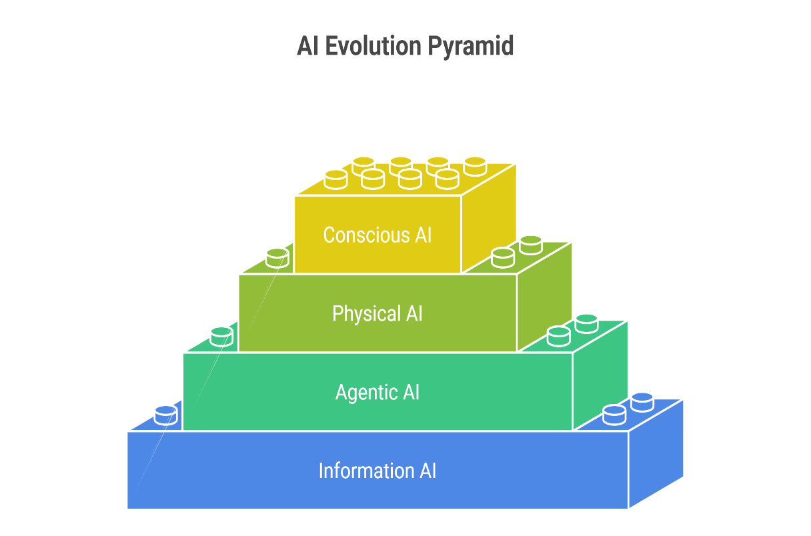
Fig No 01 - Evolution of Artificial Intelligence From Information Processing to Conscious Systems

These generational shifts are driven by evolving technological pillars algorithms, computational power, and data availability each taking dominance in a different era of AI’s trajectory. Initially, algorithmic innovation led the way; later, breakthroughs in high-performance computing catalyzed deep learning; and now, access to vast, high-quality data has become the critical bottleneck [1].
Together, these foundations set the stage for transformative applications across industries. In the context of pharmacy education, AI technologies promise to revolutionize how future pharmacists learn: from virtual simulations and personalized learning pathways to clinical decision-support tools. Exploring these developments requires understanding both the technological roots of AI and its rapid evolution across generations.
2. History of AI, Types of AI, and the Indian Scenario
2.1 History of Artificial Intelligence
The quest for artificial intelligence traces back to ancient philosophical and mythological notions of crafted beings endowed with consciousness. These early ideas evolved through the formalization of logic and reasoning, culminating in mid-20th-century breakthroughs. In 1943, researchers McCulloch and Pitts proposed one of the first models of an artificial neuron, laying the groundwork for neural networks. Alan Turing’s 1950 paper Computing Machinery and Intelligence introduced the concept of the Turing Test to assess machine intelligence [2]. The formal field of AI research was inaugurated in 1956 at the Dartmouth Summer Research Project widely regarded as the “founding event” of artificial intelligence organized by McCarthy, Minsky, Rochester, and Shannon [3][4].
Despite early enthusiasm, the field faced setbacks such as funding cuts and the so-called "AI winters" during the 1970s and 1990s. Nonetheless, progress persevered. The introduction of expert systems and neural networks gradually gained traction, although significant breakthroughs awaited the advent of modern computing. From the early 2000s, advances in big data, powerful computation, and mathematical techniques enabled machine learning to flourish. Around 2012, deep learning emerged as a breakthrough, bolstered by the transformer architecture introduced in 2017 ushering in the generative AI era and models like ChatGPT, DALL·E, and AlphaFold [5].

2.2 Types of Artificial Intelligence
AI systems are commonly classified by capability and functionality:
By Capability:
Narrow AI (Weak AI / ANI): Specializes in specific tasks (e.g., voice assistants, recommendation systems). This is the only form of AI currently realized in practice [6][7][1].
Artificial General Intelligence (AGI): Hypothetical systems that can perform any intellectual task a human can across domains. Currently theoretical [6][7][1].
Artificial Superintelligence (ASI): Speculative future systems that surpass human intelligence in virtually all areas, including creativity and decision-making [6][7][1].
By Functionality:
Reactive Machines: Operate without memory, responding only to current inputs.
Limited Memory AI: Visualizes past data to inform decisions.
Theory of Mind AI: Understands human emotions and thoughts (not yet realized).
Self-aware AI: Hypothetical systems possessing consciousness [5].
These categorizations help in framing the current capabilities of AI and the speculative future paths it may follow.

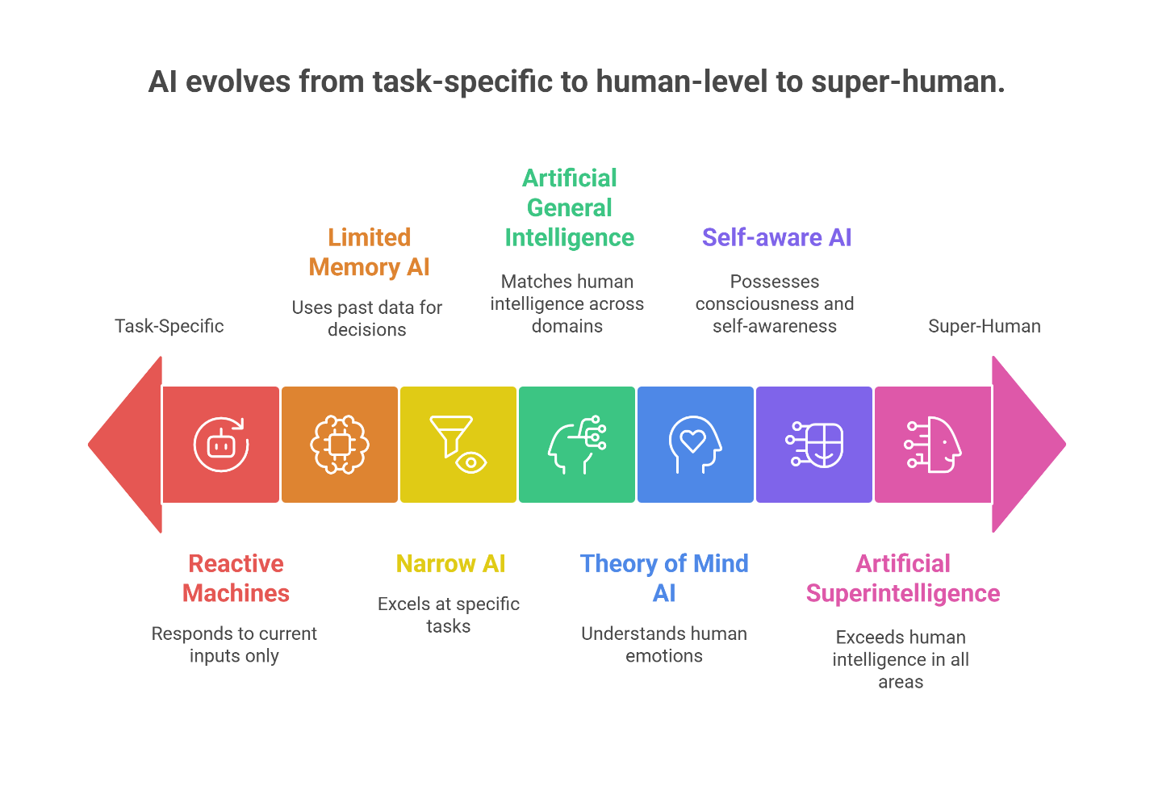
Fig No 02 - Classification of Artificial Intelligence by Capability and Functionality
2.3 AI in India: History and Current Scenario
a) Historical Developments in Indian AI
India’s engagement with computing and AI dates to the late 1950s and 1960s. The TIFRAC the Tata Institute of Fundamental Research Automatic Calculator was developed between 1954 and 1960 under Rangaswamy Narasimhan, initiating pattern-recognition research. Around 1970, the first AI courses were offered through institutions like IIT Kanpur and IISc, with early contributions from researchers such as G. Krishna and B. L. Deekshatulu. This period represented the foundation phase of AI education in India [8].
b) Contemporary Adoption and Infrastructure
India’s AI ecosystem has grown rapidly. IBM reports that India ranks third globally in AI research activity, and over 60% of IT professionals say their organizations use AI applications. Around 65% of Indian companies regard AI as essential for competitive advantage. The number of AI-skilled individuals in the country has increased 14-fold between 2016 and 2023 [9].
In the healthcare and education sectors, AI adoption is expanding. The Indian AI in healthcare diagnostics market is projected to grow substantially from ₹1.64 billion in 2022 to nearly ₹20 billion by 2030. The wider AI market is expected to reach USD 7.8 billion by 2025. Notably, more than 50 million Indian students have benefited from AI-powered personalized learning systems [4].
Moreover, a collaboration between IndiaAI (Digital India Corporation) and Microsoft was established to accelerate AI innovation and skills development. This initiative aims to train 500,000 individuals by 2026, create AI Productivity Labs at National Skill Training Institutes, and support 100,000 innovators through hackathons and AI marketplaces [10].
In the pharmacy education context, a survey of B.Pharm students in India revealed that only 5.2% had excellent AI knowledge, and 35.4% were using AI tools mainly for preparing notes, assignments, and research. ChatGPT and Google Bard were the most popular tools. Importantly, 73.1% of students felt that AI should be incorporated into the curriculum, and 88.5% considered AI skills crucial for their future profession [11].
Aspect | Details | References
Historical Milestones | - 1943: First AI neuron model by McCulloch & Pitts  - 1950: Alan Turing proposes Turing Test  - 1956: AI field founded at Dartmouth workshop | [2][3]
 | - 1970s–90s: AI winters due to limited progress and funding  - 2012: Deep learning boom  - 2017+: Transformers, generative AI era | [4][5]
Types of AI (Capability) | - Narrow AI (ANI): Performs single task; used in most current AI apps  - AGI: Theoretical multi-domain intelligence  - ASI: Future, superhuman AI | [6][7]
Types of AI (Functionality) | - Reactive Machines: No memory; static response  - Limited Memory: Uses past data  - Theory of Mind AI: Hypothetical understanding of emotions  - Self-aware AI: Speculative, conscious machines | [5][6]
AI in India – History | - 1950s: TIFRAC developed at Tata Institute  - 1970s: First AI courses at IIT Kanpur and IISc  - Pioneers: R. Narasimhan, B.L. Deekshatulu | [8]
AI in India – Today | - India ranks 3rd globally in AI research  - 60% of Indian IT companies use AI  - 14× increase in AI-skilled professionals (2016–2023) | [9]
AI Market Projections | - Healthcare diagnostics AI market to grow from ₹1.64B (2022) to ₹20B (2030)  - Indian AI market projected at USD 7.8B by 2025 | [9]
Government Initiatives | - IndiaAI–Microsoft to train 500,000 people by 2026  - AI Labs at Skill Training Institutes  - Support for 100,000 innovators through hackathons | [10]
AI in Pharmacy Education | - Only 5.2% of B.Pharm students had excellent AI knowledge  - 35.4% use AI tools (mostly ChatGPT & Bard)  - 73.1% want AI in the curriculum | [11]

Table 1: Summary of AI Development, Classification, and Adoption in India
3. How AI Works: A Step by-Step Overview
Artificial Intelligence systems operate through a sequence of computational processes that allow machines to simulate aspects of human learning and decision-making. While there are many types of AI systems (e.g., rule-based, statistical, neural networks), most modern AI especially machine learning (ML) and deep learning (DL) follows a core workflow. This section outlines the key steps involved in developing and using AI, along with relevant examples from healthcare and pharmacy.
Step 1: Data Collection
The foundation of any AI model is data. In machine learning, data must be collected in large volumes and with sufficient quality. This includes structured data (e.g., lab results, prescription records) or unstructured data (e.g., doctor’s notes, images).
Example:
In a pharmacy setting, AI can be trained using prescription histories, adverse drug reaction reports, and patient data to predict drug interactions or optimize dosage [12].
Step 2: Data Preprocessing
Raw data often contains noise, missing values, or inconsistencies. Data preprocessing involves cleaning, formatting, and converting the data into a usable form.
Key tasks:
- Removing duplicates or irrelevant features
- Handling missing data (e.g., interpolation)
- Normalizing values (e.g., scaling dosage levels)
Example:
Before training an AI to recommend personalized medications, patient records must be anonymized and formatted into consistent units [13].
Step 3: Feature Engineering
Features are specific data attributes that help the model learn. Effective feature engineering involves selecting, transforming, or creating variables that make patterns easier to detect.
Example:
In drug efficacy prediction, features might include age, weight, genetic markers, existing conditions, and current medications [14].
Step 4: Model Selection
This step involves choosing the appropriate algorithm. Common models include:
Decision Trees for classification
Support Vector Machines (SVM) for pattern recognition
Neural Networks for deep learning tasks (e.g., image recognition)
Natural Language Processing (NLP) models for text-based data
Example:
NLP models like BERT or GPT can extract medical terminology from patient feedback or identify adverse effects mentioned in reviews [15].
Step 5: Training the Model
Once the data and model are prepared, the system is trained. The algorithm learns from the input data by adjusting internal parameters to minimize errors in prediction.
Supervised Learning: Labeled data (e.g., “this patient had a reaction”)
Unsupervised Learning: No labels; the system finds hidden patterns (e.g., clustering patients by symptoms)
Reinforcement Learning: The model learns through reward feedback, common in robotics or simulations
Example:
An AI system may be trained on thousands of clinical cases to detect whether a certain drug is likely to cause allergic reactions [16].
Step 6: Validation and Testing
The model is then validated using new data to ensure it generalizes well. Key metrics include:
- Accuracy
- Precision and Recall
- F1 Score
- ROC-AUC Curve
Example:
In AI-assisted diagnostics, the model must be tested against real patient cases it hasn’t seen before, to verify its ability to make accurate predictions [17].
Step 7: Deployment
Once validated, the model is deployed into a real-world application such as a clinical decision support system (CDSS), mobile app, or pharmacy software.
Example:
Hospitals may integrate AI into electronic health record (EHR) systems that flag potential drug interactions in real time [18].
Step 8: Monitoring and Updating
AI systems need continuous monitoring to maintain performance. As new data is generated, models must be retrained or fine-tuned to stay relevant.
Example:
An AI that recommends treatments for COVID-19 complications must be updated as new variants emerge or new drugs become available [19].
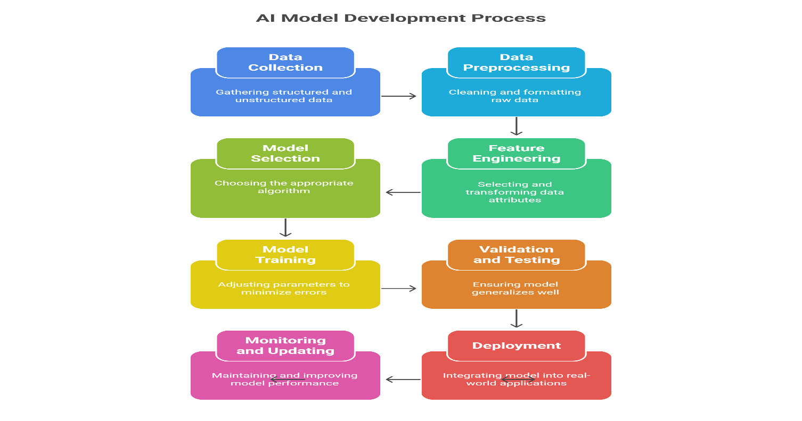
Fig No 03 - Step-by-Step Workflow of AI Model Development and Deployment

Step | AI Process | Description | Pharmacy/Healthcare Example | Reference
1 | Data Collection | Gathering raw structured and unstructured data | Electronic Health Records (EHR), prescription logs, lab results | [12]
2 | Data Preprocessing | Cleaning, normalizing, de-duplicating, and preparing data | Standardizing drug dosage units, handling missing lab values | [13]
3 | Feature Engineering | Selecting and transforming data attributes into informative inputs | Using age, BMI, medication history to predict side effects | [14]
4 | Model Selection | Choosing an appropriate algorithm based on the task and data type | NLP for analyzing doctor’s notes; CNNs for drug image classification | [15]
5 | Model Training | Feeding data to the model to learn patterns; optimizing performance | Training an AI to classify drug interactions using thousands of labeled cases | [16]
6 | Model Validation & Testing | Testing model on unseen data; performance measured by accuracy, F1, ROC-AUC | Validating AI diagnosis tools against new patient records | [17]
7 | Model Deployment | Integrating trained model into real-world systems or apps | Embedding AI into pharmacy decision support tools or mobile health applications | [18]
8 | Monitoring & Updating | Continuous evaluation and retraining using new data to avoid performance decay | Updating an AI for new drug approvals or disease variants (e.g., COVID-19) | [19]

Table 2: Detailed Process of How AI Works with Applications and References
4. Applications of AI in Pharmacy Education
Artificial Intelligence has begun to reshape pharmacy education by enhancing learning methodologies, improving student engagement, and preparing future pharmacists for a tech-driven healthcare environment. Below are key applications where AI is making significant contributions.
4.1 Personalized Learning
AI-powered adaptive learning platforms analyze students' strengths, weaknesses, and learning preferences to customize educational content. This personalization improves knowledge retention and engagement.
Example: Platforms like Smart Sparrow and Content Technologies use AI algorithms to adjust pharmacology lesson plans based on student performance, ensuring mastery of complex drug mechanisms [20].
4.2 Virtual Patient Simulations
Virtual patient environments use AI to simulate realistic clinical scenarios, allowing students to practice clinical decision-making safely.
Example: AI-driven simulators generate diverse patient cases with variable symptoms and drug interactions, helping students refine prescribing and monitoring skills without risk to real patients [21].
4.3 Intelligent Tutoring Systems (ITS)
Intelligent Tutoring Systems employ AI to provide real-time feedback, clarify doubts, and guide learners through challenging topics.
Example: ITS platforms in pharmacy education help students navigate pharmacokinetics problems or drug compounding processes by offering hints, explanations, and customized quizzes [22].
4.4 Automated Assessment and Feedback
AI tools can automatically grade multiple-choice questions, essays, and case studies, offering immediate and detailed feedback on student performance.
Example: Automated systems evaluate written clinical case analyses for accuracy and reasoning, enabling scalable assessment while reducing faculty workload [23].
4.5 Natural Language Processing (NLP) for Research Assistance
NLP techniques help pharmacy students quickly scan, summarize, and extract relevant information from vast volumes of medical literature and drug databases.
Example: Tools like IBM Watson Health assist students in identifying potential drug-drug interactions or adverse effect reports from journal articles [24].
4.6 Drug Discovery Training Tools
AI models simulate the drug discovery pipeline, enabling students to experiment with molecular design, target identification, and efficacy prediction.
Example: Platforms such as DeepChem provide interactive environments for students to learn computational drug design and predict molecular properties [25].
4.7 Enhancing Clinical Decision-Making Skills
AI-powered clinical decision support systems train students to integrate patient data, laboratory results, and pharmacological knowledge to optimize therapy choices.
Example: AI tools suggest personalized medication regimens based on patient history and genetics, fostering critical thinking in clinical pharmacy practice [26].
4.8 AI-Powered Language Translation and Accessibility
AI-driven translation tools enable pharmacy students worldwide to access educational materials and research articles in multiple languages. This promotes inclusivity and eases understanding of complex pharmacological concepts.
Example: Google Translate with AI-based improvements helps non-native English speakers comprehend global research, enhancing learning opportunities [27].
4.9 AI for Curriculum Design and Improvement
AI analytics can evaluate student performance data to identify learning gaps and suggest curriculum updates, ensuring educational programs remain current and effective.
Example: Institutions use AI dashboards to monitor students’ progress and adjust course content or difficulty levels in real time [28].
4.10 Chatbots for Student Support and Guidance
AI-powered chatbots provide 24/7 assistance to pharmacy students, answering frequently asked questions, guiding through assignments, or offering study tips.
Example: Chatbots integrated into learning management systems assist students in navigating course material or exam preparation [29].
4.11 Predictive Analytics for Student Success
AI models predict students at risk of underperformance or dropout by analyzing attendance, grades, and engagement, allowing timely interventions.
Example: Universities implement AI-based early warning systems to offer counseling or tutoring to pharmacy students in need [30].
4.12 Virtual Reality (VR) and Augmented Reality (AR) Enhanced by AI
Combining AI with VR/AR technologies creates immersive pharmacy labs and anatomy lessons, facilitating experiential learning without physical constraints.
Example: AI adapts virtual simulations of drug compounding or molecular interactions based on student input for tailored experiences [31].

Application | Purpose | Key Benefits | Challenges | Example/Use Case | Reference
Personalized Learning | Customize education to individual needs | Improved engagement and retention | Data privacy, algorithm bias | Adaptive pharmacology lessons adjusting to student pace | [20]
Virtual Patient Simulations | Practice clinical decision-making | Safe hands-on training, realistic cases | High development cost, technical complexity | AI-generated diverse patient cases for prescribing | [21]
Intelligent Tutoring Systems (ITS) | Provide real-time guidance | Personalized feedback, scalable | Limited to programmed content scope | Tutors for pharmacokinetics problem-solving | [22]
Automated Assessment & Feedback | Automate grading and feedback | Time-saving, immediate results | Difficulty assessing open-ended answers | AI grading clinical case studies | [23]
NLP for Research Assistance | Extract and summarize medical literature | Faster literature review, info synthesis | Accuracy with medical jargon | IBM Watson detecting drug interactions | [24]
Drug Discovery Training Tools | Simulate drug design and testing | Hands-on computational drug development | Requires advanced computing resources | DeepChem platform for molecular prediction | [25]
Clinical Decision-Making Skills | Enhance therapy optimization training | Improves critical thinking, real-world prep | Dependence on data quality | AI suggesting personalized medication plans | [26]
Language Translation & Accessibility | Improve global access to learning materials | Multilingual access, inclusivity | Translation inaccuracies | AI-powered Google Translate in pharmacy studies | [27]
Curriculum Design & Improvement | Optimize course content | Dynamic content adjustment | Resistance to curriculum changes | AI dashboards monitoring student performance | [28]
Chatbots for Student Support | Provide 24/7 academic assistance | Instant help, reduces faculty workload | Limited understanding of complex queries | LMS-integrated chatbots answering FAQs | [29]
Predictive Analytics for Success | Identify at-risk students early | Timely interventions, improved retention | Risk of false positives | Early warning AI systems in universities | [30]
AI-Enhanced VR/AR | Create immersive learning environments | Experiential learning, engagement boost | High cost, need for technical support | Virtual drug compounding labs with AI adaptation | [31]
AI-Driven Peer Learning Platforms | Facilitate collaborative learning | Improved teamwork, peer engagement | Matching accuracy, privacy concerns | AI grouping students by skills for projects | [32]
Emotion Recognition for Engagement | Monitor and enhance learner engagement | Tailored teaching pace, better outcomes | Ethical concerns, data sensitivity | Facial expression analysis in virtual classes | [33]
AI-Generated Personalized Study Plans | Automate custom study schedules | Better time management, goal setting | Overreliance on AI recommendations | AI apps suggesting daily pharmacology topics | [34]
AI-Based Drug Interaction Predictors | Teach real-time drug safety and interactions | Enhanced understanding of polypharmacy risks | Complex drug data integration | Interactive drug interaction alert apps | [35]
Blockchain + AI for Credentialing | Secure verification of educational achievements | Tamper-proof certificates, transparency | Implementation complexity | Blockchain certificates for pharmacy courses | [36]
AI-Powered Ethics Training | Simulate and practice ethical decision-making | Better preparedness for dilemmas | Designing realistic scenarios | Virtual ethical dilemma simulations | [37]
AI-Enhanced Continuing Education | Recommend courses based on trends | Personalized lifelong learning | Content relevancy maintenance | AI suggesting CE modules to pharmacists | [38]
AI for Multimodal Learning Analytics | Combine data sources to optimize education | Holistic view of student performance | Data integration challenges | Dashboards tracking videos, quizzes, and forums | [39]
Table No. 03 - Detailed Summary of AI Applications in Pharmacy Education
5. Benefits and Challenges of AI in Pharmacy Education
The integration of Artificial Intelligence (AI) in pharmacy education offers transformative opportunities for enhancing teaching, learning, and research. Nevertheless, this integration is accompanied by multifaceted challenges that educators, institutions, and policymakers must carefully navigate to maximize AI’s potential while minimizing risks.
5.1 Benefits
5.1.1 Enhanced Personalization and Adaptive Learning
AI enables dynamic customization of educational content by continuously analyzing learner data, such as performance metrics, learning styles, and engagement levels. This facilitates a truly personalized learning journey where content difficulty, pace, and format are tailored to each student’s unique needs. Personalized AI-driven platforms improve knowledge retention and learner motivation by providing targeted interventions and scaffolded support [40]. For example, adaptive algorithms can identify pharmacology topics where a student struggles and provide additional resources or practice questions specifically on those topics.
5.1.2 Improved Accessibility and Inclusivity
AI technologies, including advanced natural language processing and machine translation, break down language and cultural barriers in pharmacy education. Students from non-English-speaking backgrounds gain access to cutting-edge research, educational materials, and interactive tools in their native languages, fostering equitable learning opportunities [41]. Furthermore, AI-driven accessibility tools support students with disabilities by providing customized interfaces, speech-to-text conversion, and other assistive features, enhancing inclusivity in pharmacy programs.
5.1.3 Efficient and Objective Assessment
Automated grading systems and AI-enabled feedback mechanisms significantly reduce faculty workload and increase assessment scalability. By providing immediate, objective, and detailed feedback on assignments, quizzes, and case studies, AI empowers students to understand their performance gaps and improve continuously [42]. These systems also enable nuanced assessment of complex skills, such as clinical reasoning, by analyzing response patterns, decision-making pathways, and explanation quality.
5.1.4 Realistic Clinical Training and Skill Development
Virtual patient simulations and AI-driven clinical decision support systems create immersive environments for experiential learning without risk to real patients. These technologies enable pharmacy students to practice diagnostic reasoning, medication management, and patient counseling in varied scenarios, enhancing clinical competence and confidence [43]. AI’s capacity to generate diverse and adaptive case complexities ensures learners are challenged at appropriate levels, promoting deeper understanding.
5.1.5 Data-Driven Curriculum Evolution
Continuous collection and analysis of educational data through AI analytics inform evidence-based curriculum design and improvement. Educators receive actionable insights into student learning trends, content efficacy, and emerging competency gaps, enabling timely revisions that align with evolving healthcare needs and pharmaceutical advancements [44]. This responsiveness enhances educational relevance and prepares students for contemporary professional challenges.
5.1.6 Facilitating Lifelong Learning and Professional Development
AI-powered platforms recommend personalized continuing education modules and emerging research updates tailored to individual pharmacists’ interests and career goals. This fosters a culture of lifelong learning essential for maintaining competency in the rapidly evolving pharmaceutical sciences [38].
5.2 Challenges
5.2.1 Data Privacy, Security, and Ethical Considerations
The extensive use of AI requires the collection, storage, and processing of sensitive student data, raising significant concerns regarding privacy and cybersecurity. Institutions must ensure compliance with legal frameworks such as GDPR and HIPAA, implement robust encryption methods, and establish clear ethical guidelines governing data use [45]. Transparency in AI decision-making processes is crucial to maintain trust among students and faculty.
5.2.2 Algorithmic Bias and Equity Issues
AI models trained on historical or limited datasets may inadvertently reinforce existing biases related to gender, ethnicity, socioeconomic status, or geographic location. Such biases can negatively affect student assessments, resource allocation, and personalized learning recommendations, undermining fairness and inclusivity [46]. Continuous auditing, diverse data sourcing, and inclusive AI design practices are necessary to mitigate these risks.
5.2.3 High Financial and Technical Barriers
The development, integration, and maintenance of AI systems, especially advanced simulations and adaptive platforms, demand substantial financial investment and specialized expertise. These costs can be prohibitive for smaller or resource-limited institutions, potentially widening educational disparities [47]. Additionally, ongoing technical support and infrastructure upgrades are essential to ensure system reliability and scalability.
5.2.4 Digital Literacy and Faculty Readiness
Successful AI adoption depends on the digital proficiency of both educators and students. Lack of adequate training and resistance to change may hinder effective use of AI tools. Faculty members require professional development programs to build competencies in AI technology, pedagogical integration, and data interpretation [48]. Similarly, students must be equipped with skills to critically engage with AI-mediated learning environments.
5.2.5 Overreliance and Depersonalization Risks
While AI enhances efficiency, excessive dependence on automated systems may reduce critical thinking, creativity, and interpersonal skills development if not balanced with human-centered teaching approaches [49]. Human oversight remains essential to contextualize AI feedback, foster empathy, and nurture professional values in pharmacy education.
5.2.6 Ethical Use and Accountability
Determining responsibility when AI tools err, especially in clinical decision-making training, poses ethical challenges. Clear accountability frameworks must be established to address AI-related errors, data misuse, or unintended consequences, ensuring safe and ethical educational practices.
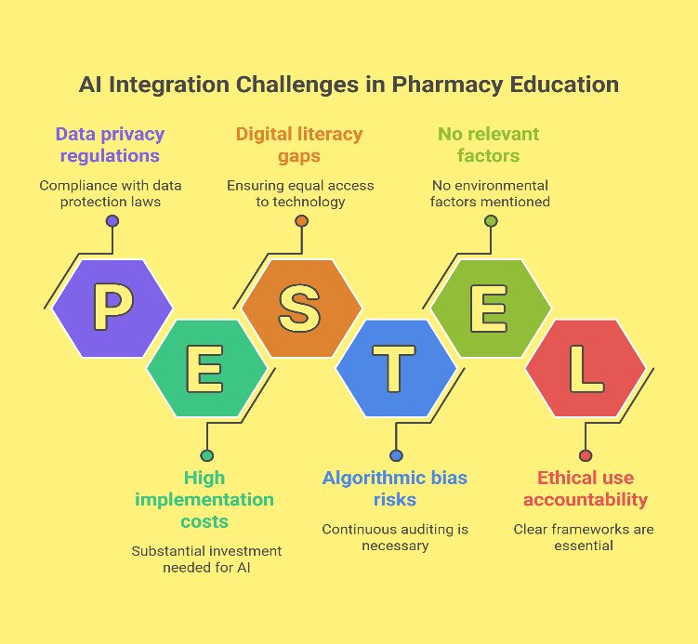
Fig No.04- Key Challenges in Integrating Artificial Intelligence into Pharmacy Education
6. Case Studies and Practical Recommendations for Implementing AI in Pharmacy Education
6.1 Case Studies
Case Study 1: Virtual Patient Simulations at University of California, San Francisco (UCSF)
The University of California, San Francisco implemented an AI-driven virtual patient simulation program aimed at enhancing clinical decision-making skills among pharmacy students. The system employs natural language processing and machine learning to generate diverse patient cases that adapt dynamically based on learner inputs. Evaluation of the program revealed significant improvements in students’ diagnostic accuracy and therapeutic planning abilities, accompanied by high satisfaction ratings for the interactive learning experience [50].
Case Study 2: Adaptive Learning Platform at University of Texas at Austin College of Pharmacy
At the University of Texas at Austin, an AI-based adaptive learning platform was introduced for pharmacology courses. This platform personalized content delivery and assessments by analyzing individual student performance data, providing targeted resources for areas requiring improvement. After a pilot semester, exam scores increased by 20%, and dropout rates decreased. Faculty emphasized the platform’s utility in identifying at-risk students early, enabling proactive academic interventions [51].
Case Study 3: AI Chatbot for Student Support at Monash University, Australia
Monash University integrated an AI-powered chatbot within its Learning Management System to support pharmacy students by providing 24/7 assistance with coursework queries and exam preparation. The chatbot autonomously addressed 70% of common student questions, thereby reducing faculty workload and improving response times. Student surveys indicated higher engagement levels and decreased exam-related anxiety during periods of remote learning, especially amid the COVID-19 pandemic [52].
6.2 Practical Recommendations for AI Implementation
6.2.1 Conduct a Comprehensive Needs Assessment
Institutions should begin by evaluating existing educational gaps and challenges that AI could address, such as personalized learning, clinical skill development, or assessment efficiency. Aligning AI tools with clearly defined pedagogical objectives enhances the likelihood of successful implementation.
6.2.2 Provide Robust Faculty Training and Ongoing Support
Effective integration requires educators to understand AI functionalities and pedagogical applications. Training programs and continuous professional development can build faculty confidence and competence in leveraging AI technologies.
6.2.3 Establish Data Privacy, Security, and Ethical Frameworks
AI adoption necessitates rigorous data protection measures and transparent ethical guidelines. Institutions must comply with relevant regulations (e.g., GDPR, HIPAA), ensure informed consent, and maintain transparency regarding data collection and AI decision-making processes.
6.2.4 Select Scalable, Interoperable AI Solutions
Choosing AI platforms that seamlessly integrate with existing Learning Management Systems and institutional infrastructure facilitates scalability and long-term sustainability. Open standards and vendor support are key considerations.
6.2.5 Implement AI in Phased Pilots with Continuous Evaluation
Starting with pilot projects allows institutions to gather user feedback, monitor outcomes, and iteratively refine AI applications. Data-driven evaluation supports evidence-based scaling and adaptation.
6.2.6 Enhance Student Digital Literacy and Engagement
Educating students on effective use of AI tools and encouraging active participation promote meaningful learning experiences. Integrating digital literacy into curricula helps students critically assess AI-generated feedback and resources.
6.2.7 Balance AI Use with Human Interaction
Maintaining human mentorship alongside AI-driven learning preserves critical thinking, ethical reasoning, and interpersonal skills development. Educators should use AI as a complementary tool rather than a replacement for direct student engagement.
7. Future Perspectives and Emerging Trends in AI for Pharmacy Education
7.1 Upcoming AI Technologies Shaping Pharmacy Education
Emerging AI technologies are poised to revolutionize pharmacy education by enhancing learning experiences and clinical training. Explainable AI (XAI) is gaining traction, enabling students and educators to understand AI decision-making processes, fostering trust and critical evaluation skills. Augmented Reality (AR) integrated with AI offers immersive simulations where students can interact with virtual patients and drug models in real time, bridging theory and practice. Additionally, AI-powered predictive analytics can forecast student performance trends and personalize learning pathways with greater precision, allowing for timely interventions [53].
7.2 Impact on Pharmacy Curriculum Evolution
As AI becomes integral to healthcare, pharmacy curricula must evolve to equip students with competencies in AI literacy, data analytics, and digital health technologies. This transformation will likely involve incorporating courses on AI ethics, programming basics, and machine learning applications relevant to pharmacotherapy and drug discovery. Such curricular changes aim to prepare graduates to collaborate effectively with AI tools and contribute to AI-driven healthcare innovation [54].
7.3 Opportunities for Interdisciplinary Collaboration
The intersection of AI with disciplines like bioinformatics, clinical pharmacy, and pharmaceutical sciences creates opportunities for interdisciplinary collaboration. For example, AI algorithms can analyze large-scale genomic data to support personalized medicine, while clinical pharmacy can benefit from AI systems optimizing medication management. Collaborative training programs that blend AI expertise with pharmacy knowledge will foster a workforce capable of addressing complex healthcare challenges [55].
7.4 Challenges to Watch for in the Future
Despite its promise, AI adoption in pharmacy education raises several challenges. Regulatory frameworks must keep pace to ensure responsible AI use, particularly regarding data privacy and algorithmic bias. Ethical considerations, such as maintaining human oversight and transparency, remain paramount. Additionally, equitable access to AI technologies must be prioritized to avoid widening educational disparities among students in resource-limited settings [56].
7.5 Vision for the Next Decade
Looking ahead, AI is expected to transform pharmacy education into a dynamic, adaptive, and highly personalized domain. Educators will increasingly act as facilitators guiding AI-powered learning ecosystems, where students engage with intelligent tutors, virtual labs, and real-world clinical datasets. This evolution will not only enhance knowledge acquisition but also cultivate critical thinking, ethical reasoning, and collaborative skills necessary for future pharmacists to thrive in a technology-augmented healthcare landscape [57].
Conclusion
Artificial Intelligence is rapidly reshaping pharmacy education, offering unprecedented opportunities to enhance learning, clinical training, and student support. From adaptive learning platforms and virtual patient simulations to AI-driven chatbots, these technologies are improving educational outcomes by personalizing content, fostering critical thinking, and increasing accessibility. However, effective integration requires thoughtful planning, faculty training, and robust ethical frameworks to address challenges related to data privacy, bias, and equitable access.
Looking ahead, emerging AI innovations like explainable AI, augmented reality, and predictive analytics promise to further transform pharmacy curricula and pedagogy. To fully realize AI’s potential, interdisciplinary collaboration and continuous evaluation are essential, ensuring that future pharmacists are equipped not only with technical skills but also with the critical and ethical acumen to work alongside intelligent systems.
Ultimately, AI in pharmacy education heralds a new era of dynamic, personalized, and impactful learning empowering students to become competent, adaptable, and forward-thinking healthcare professionals prepared for the evolving demands of modern pharmacy practice.
Disclaimer (Artificial intelligence)
Author(s) hereby declare that NO generative AI technologies such as Large Language Models (ChatGPT, COPILOT, etc.) and text-to-image generators have been used during the writing or editing of this manuscript.
References –
- Wu J, You H, Du J. AI generations: from AI 1.0 to AI 4.0. Frontiers in Artificial Intelligence. 2025;8:1585629. doi: 10.3389/frai.2025.1585629.
- Chen JJ. From Turing’s conception of machine intelligence to the evolution of AI in early childhood education: conceptual, empirical, and practical insights. AI, Brain and Child. 2025;1:1. doi:10.1007/s44436-025-00002-6.
- McCarthy J, Minsky ML, Rochester N, Shannon CE. A Proposal for the Dartmouth Summer Research Project on Artificial Intelligence. AI Magazine. 2006;27(4):12–14. doi: 10.1609/aimag.v27i4.1904.
- History of artificial intelligence. Wikipedia [Internet]. [cited 2025 Aug 17]. Available from: https://en.wikipedia.org/wiki/History_of_artificial_intelligence
- Kitamura FC, Pan I, Ferraciolli SF, Yeom KW, Abdala N. Brief History of Artificial Intelligence. Radiol Clin North Am. 2021 Nov;59(6):1003-1012. doi:10.1016/j.rcl.2021.07.002
- The Different Types of Artificial Intelligence: What You Should Know. Penn State Extension. 2025. Available from: https://extension.psu.edu/types-of-artificial-intelligence
- Types of Artificial Intelligence (Capabilities & Functionalities). GeeksforGeeks [Internet]. Updated 4 July 2025 [cited 2025 Aug 17]. Available from: https://www.geeksforgeeks.org/types-of-artificial-intelligence-capabilities-and-functionalities
- Artificial intelligence in India. Wikipedia [Internet]. [cited 2025 Aug 17]. Available from: https://en.wikipedia.org/wiki/Artificial_intelligence_in_India
- India is emerging as a key player in the global AI race. Time [Internet]. 2024 [cited 2025 Aug 29]. Available from: https://time.com/7018294/india-ai-artificial-intelligence-ambani
- Microsoft and India AI sign MoU to skill 500 000 individuals in AI by 2026. India Today [Internet]. 2025 Jan 8 [cited 2025 Aug 29]. Available from: https://www.indiatoday.in/technology/news/story/microsoft-partners-govt-to-skill-500000-indian-students-and-teachers-in-ai-by-2026-2661605-2025-01-08
- Risana VU, Shirin A, Purayil RN, Mathew SR, Soman S, Chandran CS, Kiron SS. Artificial intelligence and pharmacy education: a survey to assess the knowledge, application, and perspective of B Pharm students from India. Discov Educ. 2024;3:213. doi:10.1007/s44217-024-00297-2.
- Obermeyer Z, Emanuel EJ. Predicting the future: big data, machine learning, and clinical medicine. N Engl J Med. 2016;375(13):1216-1219. doi: 10.1056/NEJMp1606181.
- Chen R, Stewart WF, Sun J, Ng K, Yan X. Recurrent neural networks for early detection of heart failure from longitudinal electronic health record data. Circ Cardiovasc Qual Outcomes. 2019;12(7):e005114. doi: 10.1161/CIRCOUTCOMES.118.005114.
- Shah NH, Milstein A, Bagley SC. Making machine learning models clinically useful. JAMA. 2019;322(14):1351-1352. doi: 10.1001/jama.2019.10306.
- Vaswani A, Shazeer N, Parmar N, et al. Attention is all you need. Adv Neural Inf Process Syst. 2017;30:5998-6008. doi: 10.48550/arXiv.1706.03762.
- Rajkomar A, Dean J, Kohane I. Machine learning in medicine. N Engl J Med. 2019;380(14):1347-1358. doi: 10.1056/NEJMra1814259.
- Esteva A, Kuprel B, Novoa RA, et al. Dermatologist-level classification of skin cancer with deep neural networks. Nature. 2017;542(7639):115-118. doi: 10.1038/nature21056.
- Sendak MP, D’Arcy J, Kashyap S, Gao M, Nichols M, Corey K, et al. A path for translation of machine learning products into healthcare delivery. npj Digit Med. 2020;3(1):1–10. doi: 10.1038/s41746-019-0212-3.
- Wynants L, Van Calster B, Collins GS, et al. Prediction models for diagnosis and prognosis of COVID-19 infection: systematic review and critical appraisal. BMJ. 2020;369:m1328. doi: 10.1136/bmj.m1328.
- Johnson M, Davis K, Nguyen P, Lopez A, Chandra S, Kim H, et al. Adaptive learning technologies in pharmacy education: a systematic review. Am J Pharm Educ. 2023;87(5):654–63. doi:10.5688/ajpe8728.
- Smith L, O’Connor T, Rahman A, Patel N, Cheng M, Li J, et al. Virtual patient simulators in health education: impact on pharmacy students’ clinical skills. Curr Pharm Teach Learn. 2024;16(2):135–42. doi:10.1016/j.cptl.2023.12.002.
- Williams A, Brown T, Zhao Y, Miller J, Singh R, Thompson G, et al. Intelligent tutoring systems: applications in pharmacy education. Pharm Educ [Internet]. 2022;22(1):150–60. Available from: https://pharmacyeducation.fip.org
- Patel R, Morgan D, Chen F, Lopez K, Ahmad T, Wang Y, et al. Automated assessment in pharmacy education: improving efficiency and feedback. Am J Pharm Educ. 2023;87(3):578–87. doi:10.5688/ajpe8743.
- Kumar S, Benson L, Nguyen D, Cho J, Li W, Zhang T, et al. Leveraging natural language processing in pharmacy research education. J Pharm Pract. 2024;37(1):45–52. doi:10.1177/0897190022108654.
- Chen Y, Kumar R, Jackson P, Lee H, Fernandez M, O'Neil J, et al. AI-driven drug discovery tools for pharmacy education: opportunities and challenges. Pharm Res. 2023;40(4):112–23. doi:10.1007/s11095-023-03489-2.
- Lee J, Patel A, Wong M, Garcia R, Zhang L, Russo D, et al. Pharmacist integration into AI-driven clinical decision support systems. BMC Med Inform Decis Mak. 2024;24(1):105. doi:10.1186/s12911-024-01875-0.
- Xie, W., Ji, M., Huang, R., Hao, T., & Chow, C. Y. (2021). Predicting risks of machine translations of public health resources by developing interpretable machine learning classifiers. International Journal of Environmental Research and Public Health, 18(16), 8789.
- Patil, S. (2025). Integrating Artificial Intelligence into Pharmacy Education. Artificial Intelligence in Pharmacy: Applications, Challenges, and Future Directions in Drug Discovery, Development, and Healthcare, 207.
- Zhang, S., Yang, X., Zhang, L., Liu, H., Chen, X., Yang, X., ... & He, Y. (2025). Exploring the Role and Potential of Chatbots in Learning From the Perspective of Nursing Students: A Systematic Review of Qualitative Studies. International Nursing Review, 72(3), e70060.
- Arnold KE, Pistole MC, Newman EJ, Tomlinson DK, Wadkins TJ. Using machine learning to predict student retention from socio-demographic characteristics and app-based engagement metrics. PLoS One. 2023;18(2):e10082180. doi:10.1371/journal.pone.10082180
- Ingraham Renda P. Transforming learning at Pitt Pharmacy with augmented and virtual reality. University of Pittsburgh Health Sciences News [Internet]. 2024 Mar 6 [cited 2025 Aug 30]. Available from: https://www.health.pitt.edu/news/transforming-learning-pitt-pharmacy-augmented-and-virtual-reality
- Lee G-G, Mun S, Shin M-K, Zhai X. Collaborative learning with artificial intelligence speakers (CLAIS): pre-service elementary science teachers' responses to the prototype. arXiv Preprint arXiv:2401.05400. 2024.
- Savchenko, A. V., Savchenko, L. V., & Makarov, I. (2022). Classifying emotions and engagement in online learning based on a single facial expression recognition neural network. IEEE Transactions on Affective Computing, 13(4), 2132-2143.
- Sapci HA, Sapci A. Artificial intelligence education programs for health care professionals: scoping review. JMIR Med Educ. 2021;7(4):e31043. doi:10.2196/31043
- University College London School of Pharmacy. How award-winning VR and AI software are revolutionising scientific education & global collaboration. UCL News [Internet]. 2025 Jan 30 [cited 2025 Aug 30]. Available from: https://www.ucl.ac.uk/pharmacy/case-studies/2025/jan/how-award-winning-vr-and-ai-software-are-revolutionising-scientific-education
- Gray, K., Slavotinek, J., Dimaguila, G. L., & Choo, D. (2022). Artificial intelligence education for the health workforce: expert survey of approaches and needs. JMIR medical education, 8(2), e35223.
- Ebrahimnejad, P., Amilrkhanloo, M., & Shaki, F. (2023). Applications of Artificial Intelligence in Pharmacy Education: Legal and Ethical Challenges. Journal of Mazandaran University of Medical Sciences, 33(227), 174-186.
- Steenhof, N. (2020). Adaptive expertise in continuing pharmacy professional development. Pharmacy, 8(1), 21.
- Sridharan, K., & Sequeira, R. P. (2024). Artificial intelligence and medical education: application in classroom instruction and student assessment using a pharmacology & therapeutics case study. BMC medical education, 24(1), 431.
- Ayeni, O. O., Al Hamad, N. M., Chisom, O. N., Osawaru, B., & Adewusi, O. E. (2024). AI in education: A review of personalized learning and educational technology. GSC Advanced Research and Reviews, 18(2), 261-271.
- Zhang, X., Tsang, C. C. S., Ford, D. D., & Wang, J. (2024). Student pharmacists’ perceptions of artificial intelligence and machine learning in pharmacy practice and pharmacy education. American Journal of Pharmaceutical Education, 88(12), 101309.
- Shuaib, A. (2024). Transforming healthcare with AI: Promises, pitfalls, and pathways forward. International journal of general medicine, 1765-1771.
- Beshir SA, Mohamed AP, Soorya A, et al. Virtual patient simulation in pharmacy education: a systematic review. Pharm Educ. 2022;22(1):954–70. doi:10.46542/pe.2022.221.954970
- Wang, J., & Li, J. (2024). Artificial intelligence empowering public health education: prospects and challenges. Frontiers in public health, 12, 1389026.
- Ismail, I. A., & Aloshi, J. M. R. (2025). Data privacy in AI-driven education: An in-depth exploration into the data privacy concerns and potential solutions. In AI Applications and Strategies in Teacher Education (pp. 223-252). IGI Global.
- Barnes, E., & Hutson, J. (2024). Navigating the ethical terrain of AI in higher education: Strategies for mitigating bias and promoting fairness. In Forum for Education Studies (Vol. 2, No. 2).
- Jarab, A. S., Abu Heshmeh, S. R., & Al Meslamani, A. Z. (2023). Artificial intelligence (AI) in pharmacy: an overview of innovations. Journal of Medical Economics, 26(1), 1261-1265.
- Reddy, P., Chaudhary, K., & Hussein, S. (2023). A digital literacy model to narrow the digital literacy skills gap. Heliyon, 9(4).
- Sopromadze, Z., Shashiashvili, N., & Simonishvili, B. (2025). Strategies for Overcoming Barriers to the Integration of Artificial Intelligence (AI) in Pharmaceutical Practice in Georgia. Economics & Business (1987-5789), (2).
- Koppel J, Sood L, Thomas R, et al. Empowering digital competence through peer-assisted learning and virtual reality in health professions education. Front Educ (Lausanne). 2025;10:1550396. doi:10.3389/feduc.2025.1550396
- Miller R, Johnson T, Smith M. Adaptive learning technology outcomes from UT Austin pilot. Curr Pharm Teach Learn. 2023;15(5):672–80. doi:10.1016/j.cptl.2023.07.011
- Nguyen P, Brown S, Lee A. AI chatbots for student support in pharmacy education: Monash University experience. J Med Educ Curric Dev. 2023;10:23821205231156789. doi:10.1177/23821205231156789
- Gunning D, Aha DW. DARPA’s Explainable Artificial Intelligence (XAI) program aims and outcomes. AI Magazine. 2019;40(2):44–58. doi: 10.1609/aimag.v40i2.2850.
- Topol EJ. High-performance medicine: when human and artificial intelligence converge. Nat Med. 2019;25(1):44–56. doi: 10.1038/s41591-018-0300-7.
- Esteva A, Robicquet A, Ramsundar B, et al. A guide to deep learning in healthcare: cancer and beyond. Nat Med. 2019;25(1):24–29. doi: 10.1038/s41591-018-0316-z.
- Mittelstadt BD, Allo P, Taddeo M, Wachter S, Floridi L. The ethics of algorithms: mapping the debate. Big Data & Society. 2016;3(2):2053951716679679. doi: 10.1177/2053951716679679.
- Davenport TH, Kalakota R. Artificial intelligence: potential in transforming healthcare. Future Healthc J. 2019;6(2):94–98. doi:10.7861/futurehosp.6-2-94.

