AMBIENT AIR PARTICULATE MATTER LEVELS IN SOME INDUSTRIAL COMMUNITIES IN RIVERS STATE, NIGERIA

ABSTRACT
This study evaluates the ambient air quality in selected communities in Port Harcourt, Eleme and Okrika Local Government Areas (LGA) of Rivers State, Nigeria, by quantitatively measuring the concentrations of key pollutants. Utilizing an experimental approach, the research involved systematic sampling and analysis of particulate matter (PM) across multiple residential and industrial areas. The data collection aimed to capture both seasonal and spatial variations. The study also assessed the meteorological parameters such as temperature, humidity, and wind speed, highlighting how these influence particulate matter across different locations. The results indicate that pollutant levels frequently exceed both national and international air quality standards, in the study areas. The results showed that pollutant levels were higher during the dry season and that there were significant spatial differences among industrial zones. PM_{2.5} concentrations were highest at Onne Industrial Area, Eleme (95.8 µg/m³) and lowest at Aleto, Eleme (36.7 µg/m³), with Old GRA (Control) recording 34.3 µg/m³. The highest PM₁₀ concentration was observed at the Okrika Refinery Area (185.1 µg/m³) and the lowest at Aleto, Eleme (158.2 µg/m³), with Old GRA (Control) recording 129.1 µg/m³. PM_{2.5} concentrations also reduced, with the highest at Onne Industrial Area, Eleme (95.8 µg/m³) and the lowest at Aleto, Eleme (36.7 µg/m³), while Old GRA (Control) recorded 32.2 µg/m³. These elevated levels of particulate matter exceeded the National Ambient Air Quality Standards (NAAQS). The study recommends stringent enforcement of environmental regulations, adoption of advanced emission control technologies, and enhanced public awareness initiatives. These findings provide critical insights for policymakers and health professionals, contributing to the development of effective air quality management strategies tailored to the unique spatial dynamics of industrial regions.

Keywords: Ambient Air, Eleme, Industrial Areas, Okrika, Particulate Matter, Port Harcourt

INTRODUCTION
Air quality is a major environmental and public health concern, especially in developing countries where rapid urbanisation, industrialization, and population growth have led to increased emissions of air pollutants (WHO, 2018). Air pollution can cause various adverse effects on human health, such as respiratory diseases, cardiovascular diseases, cancer, and premature mortality (Landrigan et al., 2018). According to WHO (2018), more than 90% of the world’s population lives in areas where air quality exceeds the guideline limits. Air pollution is responsible for about 7 million deaths annually.

Nigeria is one of the countries that face serious air quality challenges, due to its dependence on fossil fuels, oil and gas exploration, biomass burning, vehicular emissions, and waste disposal (Sekar, 2021). Several studies have reported high levels of air pollutants, such as particulate matter (PM), nitrogen dioxide (NO₂), sulphur dioxide (SO₂), carbon monoxide (CO), Methane (CH₄), ground-level ozone (O₃) and volatile organic compounds (VOCs), in different regions of Nigeria, especially in the Niger Delta area where most of the oil and gas activities are concentrated (Abdul-Wahab et al., 2015; Gobo et al., 2012; Ideriah et al., 2007). These pollutants can pose significant risks to the environment and the health of the local communities, which are often exposed to multiple sources of pollution without adequate protection and regulation (Sekar, 2021).

Rivers State, located in the heart of the Niger Delta region of Nigeria, is an area of significant industrial activity, particularly in the oil and gas sector. The state’s industrial areas, including Port Harcourt, Eleme, and Okrika LGA, have been the subject of increasing environmental concern due to the emission of various pollutants into the atmosphere. These pollutants, which include particulate matter, carbon monoxide (CO), nitrogen dioxide (NO₂), sulphur dioxide (SO₂), ground-level ozone (O₃), Methane (CH₄) and volatile organic compounds (VOCs), pose a threat not only to the environment but also to public health.

The ambient air quality in these regions has been a growing concern, with studies indicating that the levels of certain pollutants exceed both national and international guidelines. For instance, the appearance of soot pollution in Rivers State has drawn attention to the adverse environmental public health impacts and the need for coping strategies among residents (Jackson, 2020). The soot pollution, characterized by the presence of particulate matter, has been associated with respiratory and cardiovascular diseases, prompting calls for government action and intervention (Yakubu, 2018).

Furthermore, the health effects of air pollution in Rivers State have been documented, with correlations found between particle pollution and a range of morbidities, as well as an increased risk of mortality among exposed populations (Yakubu, 2018). This underscores the importance of rigorous implementation of environmental legislation and the need for strategic action, including effective environmental risk communication, environmental audit, and monitoring (Yakubu, 2018).

The current study aims to assess the ambient air quality around the industrial areas in Rivers State by measuring the concentrations of key pollutants and analysing them using the Air Quality Index (AQI) and Health Risk Index (HRI). This assessment is crucial for understanding the extent of air pollution and its potential health impacts, as well as for informing policy decisions and mitigation strategies.

The Study Area
The study area encompasses four major industrial regions within Rivers State, Nigeria, each with distinct geographical and industrial characteristics. Situated in the southern part of Nigeria.

Port Harcourt is the capital city of Rivers State and lies within the Niger Delta region. It is geographically positioned at approximately 4.8156° N latitude and 7.0498° E longitude. The city is a pivotal centre for industrial activities, notably the oil and gas industry, and hosts numerous refineries, petrochemical plants, and other related industries. Port Harcourt’s industrial zones contribute significantly to the nation’s economy but also pose environmental challenges due to emissions from these heavy industries (Okoye & Ibeto, 2013) (Figure 1).

Eleme LGA is located to the southeast of Port Harcourt and is an integral part of the Port Harcourt metropolitan area. It is known for its extensive petrochemical and refining industries. The geographical coordinates of Eleme are approximately 4.7435° N latitude and 7.2006° E longitude. The area is characterized by its dense industrial activities, which have been associated with various environmental and air quality concerns (Okoye & Ibeto, 2013).

Onne is renowned for its Oil and Gas Free Zone, which is one of the largest of its kind globally. It is strategically located at the eastern edge of the Niger Delta, with coordinates around 4.6717° N latitude and 7.1868° E longitude. The Onne port complex serves as a significant hub for maritime and industrial activities, especially for the oil and gas sector, and plays a crucial role in the economic development of the region.

Okrika LGA is situated to the southwest of Port Harcourt and is closely linked to the city’s industrial activities. It lies at approximately 4.7422° N latitude and 7.0833° E longitude. The area is influenced by the industrial operations from the neighbouring regions, including emissions from refineries and manufacturing plants, which have implications for the local air quality and health of the residents .
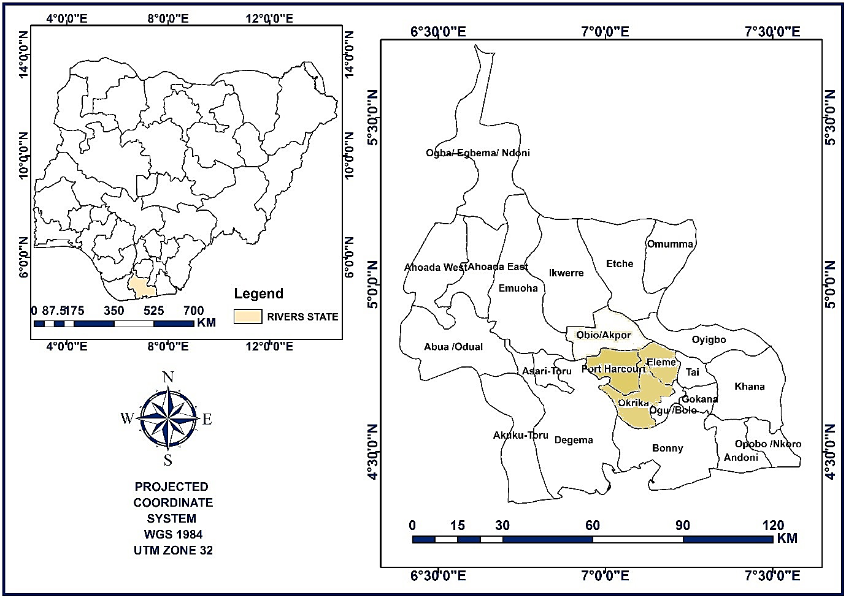
Figure 1: Rivers Sta/te showing Study Area
(Source: Google Maps)
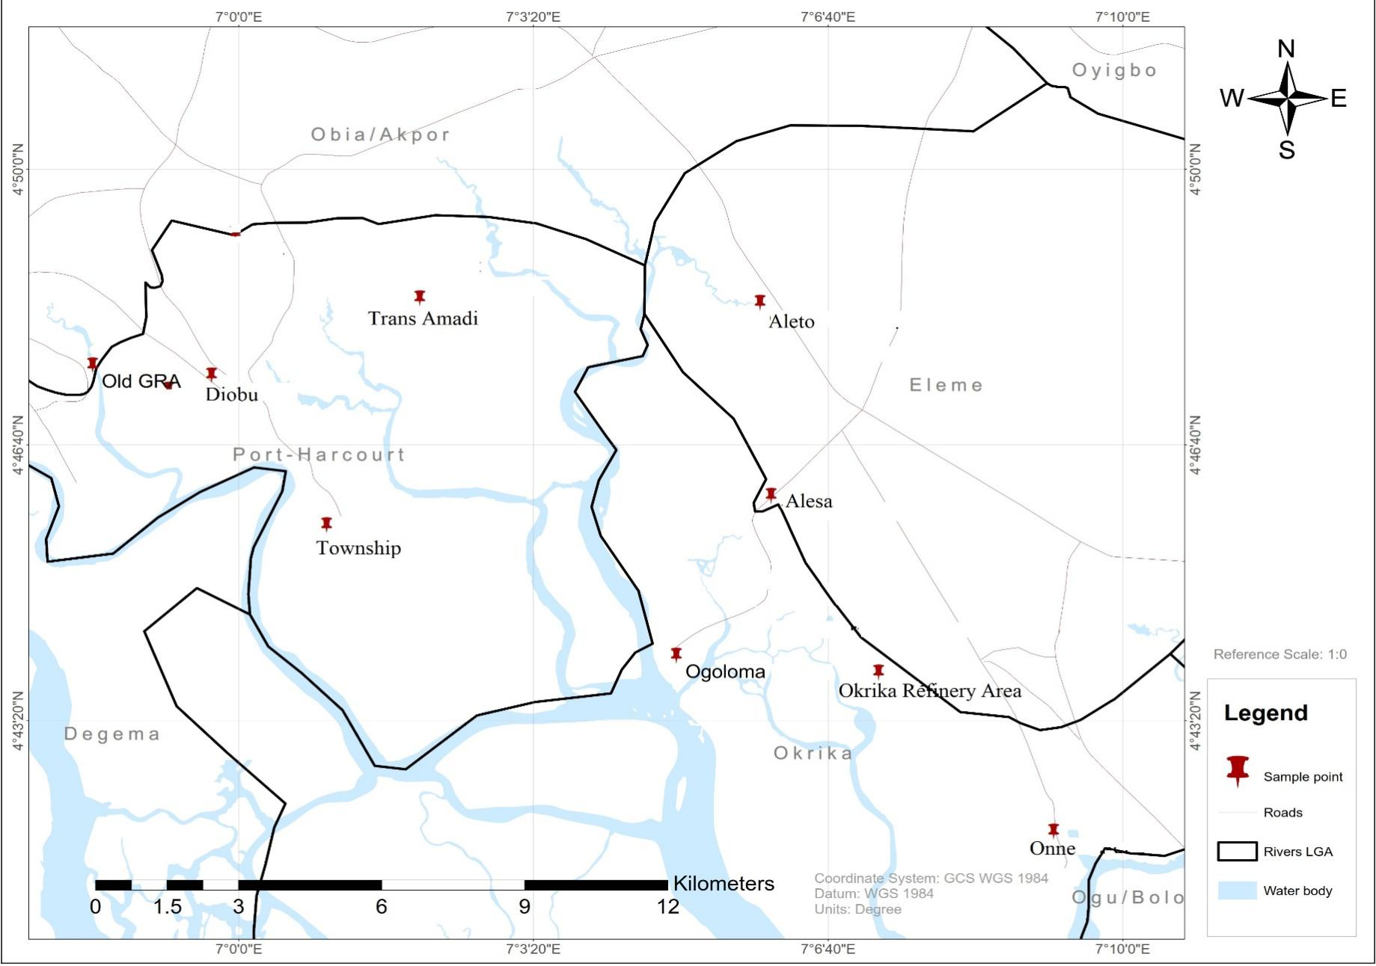
Figure 2: Map of the Sampling Locations

Okrika’s socio-economic activities are closely tied to the industrial operations of neighbouring regions. The area benefits from the economic spill over of Port Harcourt’s industries, with many residents engaged in ancillary services that support the larger industrial complexes (Ikechukwu, 2015).

The socio-economic activities in these areas are dynamic and complex, reflecting the interplay between industrial growth and community development. While these activities contribute to the economic prosperity of Rivers State, they also bring about socio-economic challenges that need to be addressed to ensure sustainable development.

The climate of these LGAs is tropical, with a wet season from April to October and a dry season from November to March. The annual rainfall ranges from 2000 mm to 3000 mm, and the mean annual temperature is about 27°C. The months of April to October have the heaviest precipitation occurring from June to September with an average of 3920mm of rainfall, and relative humidity is around 81% (Ikechukwu, 2015).

METHODOLOGY
Sampling Technique
The sampling technique used in this study involves selecting the locations for the air quality and weather measurements, to ensure that each location has an equal chance of being selected and to avoid bias. The study selected seven (7) sampling sites around the study areas, based on the proximity to the sources of pollution. The purposive sampling technique was also used to select the sampling points within each of the LGAs to ensure a representative coverage of the area.

To cover the entire study area, the equipment was located in sampling stations that were pre-selected and strategically distributed. The stations spanned across different sources of pollution. The pollutants in the study area were detected and logged by the gas-sensing monitor and the particle counter. The logged data were transferred to a personal computer for analysis using the software provided by Aeroqual, MET One, and the weather centre. The sampling stations were georeferenced using a Garmin etrex GPS receiver, which is a device that uses the Global Positioning System (GPS) to determine the location.

RESULTS
The result of particulate matter measurements in the study area was compared with the National Ambient Air Quality Standard (NAAQS) and National Environmental (Air Quality Control) Regulations (NER), 2014. The results from the study area indicate variations in particulate matter (PM) mean concentrations across different locations and seasons as shown in Figures 3 -7. During the dry season, the highest PM10 concentration was recorded at the Okrika Refinery area (562.2 µg/m³), while the lowest was at Aleto, Eleme (164.8 µg/m³). The PM₁₀ concentration in Old GRA (Control) was 148.9 µg/m³. Similarly, PM_{2.5} concentrations were highest at Onne Industrial Area, Eleme (95.8 µg/m³) and lowest at Aleto, Eleme (36.7 µg/m³), with Old GRA (Control) recording 34.3 µg/m³. These elevated levels of particulate matter, especially PM₁₀ and PM_{2.5}, exceed the National Ambient Air Quality Standards (NAAQS) and pose significant health risks to the local population, including respiratory and cardiovascular diseases. In addition, the mean PM₁, PM_{2.5}, PM₄, PM₇ and PM₁₀ during the dry season was 13.70 µg/m³, 64.35 µg/m³, 134.20 µg/m³, 216.26 µg/m³ and 279.70 µg/m³ respectively. The pattern of the concentration of PM shows that as the size of the PM is increasing, the concentration is also increasing during the dry season.

In the wet season, there is a noticeable reduction in PM concentrations across all locations. The highest PM₁₀ concentration was still observed at the Okrika Refinery Area (185.1 µg/m³) and the lowest at Aleto, Eleme (158.2 µg/m³), with Old GRA (Control) recording 129.1 µg/m³. PM_{2.5} concentrations also reduced, with the highest at Onne Industrial Area, Eleme (95.8 µg/m³) and the lowest at Aleto, Eleme (36.7 µg/m³), while Old GRA (Control) recorded 32.2 µg/m³.

Furthermore, the mean PM₁, PM_{2.5}, PM₄, PM₇ and PM₁₀ during the wet season was 7.2 µg/m³, 32.92 µg/m³, 89.03 µg/m³, 134.33 µg/m³ and 165.70 µg/m³ respectively. Similar to the dry season situation, the pattern of the concentration of PM shows that as the size of the PM is increasing, the concentration is also increasing during the wet season. It was also observed that the concentrations of PMs were higher in the dry season than the wet season. The reduction in PM levels during the wet season can be attributed to the cleansing effect of rainfall, which helps to settle airborne particles. However, even during the wet season, PM concentrations remain above the national regulations except at the control location, indicating persistent air quality issues.

The variation of PMs among the locations shows that PM₁ (F=7.736; p=0.005) and PM_{2.5} (F=9.933; p=0.002). The levels of PM₄, PM₇, and PM₁₀ did not vary significantly among the locations because their p levels were higher than 0.05 significant levels.

Figure 3: PM₁ Concentration in the Study Area

Figure 4: PM _{2.5} Concentration in the Study Area

Figure 5: PM₄ Concentration in the Study Area

Figure 6: PM ₇ Mean Concentration in the Study Area

Figure 7: PM₁₀ Mean Concentration in the Study Area

The significant variation of particulate matters due to season is displayed in Table 1. It is shown that there is significant variation in the concentration of PM₁ between the dry season and wet season (t=10.183; p=0.000). Similarly, the concentrations of PM_{2.5} had significant variations between both seasons. (t= 3.851; p=0.005); PM₄ (t=3.015; p=0.017, and PM₇ (t=2.509; p=0.036. Meanwhile PM₁₀ did not vary significantly between the dry and wet seasons in the study location. The null hypothesis is accepted for PM₁₀ while the alternative hypothesis is accepted for PM₁, PM_{2.5}, PM₄, and PM₇.

Meteorological Conditions
Table 1 presents the meteorological conditions in the study locations during the air quality assessment period. It details the temperature, humidity, wind speed, and wind direction for both dry and wet seasons across various locations.

The temperature ranged from 32.9°C to 34.1°C during the dry season and 27.8°C to 30.6°C during the wet season. Humidity levels were higher in the wet season, ranging from 73% to 82%, compared to 47% to 56% in the dry season. Higher temperatures can increase the formation of ground-level ozone, while higher humidity can affect the concentration of particulate matter. The temperature was highest in Trans Amadi in both seasons with 34.1°C during the dry season and 30.6°C during the wet season while the least 33.1°C during the dry season and 28°C during the wet season in Ogoloma Okrika. Comparing the temperature during the dry and wet seasons from the experimental sites to that of the control, it is found that at the control, the temperature during the dry season is 32.9 °C and 27.8 °C during the wet season. The mean dry season temperature in the entire study location was 33.56°C and 28.62 °C in the wet season; suggesting that the temperature observed during the dry season was higher than that of the wet season. There was just a slight variation in the temperature between the sampled locations and the control sites but it was lower in the control site than the experimental site slightly.

The humidity in the study area ranged from 47% to 56% in the dry season while it ranged from 73% to 82% during the wet season. It is also shown that the mean humidity during the dry season was 51.44% and 79.67% during the wet season. Location specifically analysis showed that the highest humidity during the dry season was observed at Ogoloma Okrika having 56% and Old GRA also having 56% while during the wet season, the highest 82% was observed in Old GRA.

Wind speed varied from 0.0 m/s to 0.3 m/s in the dry season and 0.0 m/s to 1.3 m/s in the wet season. Wind direction shifted from predominantly North eastern (NE) and East-north eastern (ENE) in the dry season to south-southeast (SSE), and south (S) in the wet season. It is thus noted that in the dry season, the mean wind speed was 0.17 m/s and 0.39 m/s during the wet season. Locational specific, the wind speed was higher at Trans Amadi, Okrika Refinery Area, Township, Alesa and Old GRA while it was calm in Onne Industrial Area, Diobu, Aleto, and Ogoloma Okrika. During the wet season, the wind was calm in Trans Amadi, and Ogoloma Okrika with 0 m/s.

The analysis of variance shows that there was a significant seasonal variation in temperature among the study locations (F=38.547; p=0.000); and humidity (F=50.681; p=0.000); while that of the wind speed was insignificantly varied (F=2.081; p=0.159). Thus, the null hypothesis stating that there is no seasonal variation in the meteorological parameters is rejected on temperature and humidity while accepted for wind speed at p<0.05 significant level.

In a general term, the correlations among the meteorological parameters reveal that temperature and humidity exhibited significant negative correlation (r=0.991; p=0.000). Furthermore, the temperature exhibited an insignificant negative correlation with wind speed (r= -0.336, p=0.173). Meanwhile, humidity had positive but insignificant correlation with wind speed (r=0.350; p=0.154).

Table 1: Weather Conditions in the Study Area
Location/Season | Temperature (ºC) |  | Humidity (%) |  | Wind Speed (m/s) |  | Wind Direction
Location/Season | Dry | Wet | Dry | Wet | Dry | Wet | Dry | Wet
Trans-Amadi Layout | 34.1 | 30.6 | 47 | 73 | 0.3 | 0.0 | NE | S
Onne Industrial Area | 33.9 | 29.2 | 47 | 79 | 0.0 | 0.7 | ENE | SSE
Okrika Refinery Area | 33.9 | 28.9 | 48 | 79 | 0.3 | 1.3 | E | SSE
Township | 33.8 | 28.6 | 49 | 80 | 0.3 | 0.3 | NE | SW
Diobu, PH | 33.7 | 28.3 | 51 | 81 | 0.0 | 0.3 | NE | S
Aleto, Eleme | 33.4 | 28.1 | 54 | 81 | 0.0 | 0.3 | ESE | SW
Alesa, Eleme | 33.3 | 28.1 | 55 | 81 | 0.3 | 0.3 | ENE | SW
Ogoloma, Okirika | 33.1 | 28 | 56 | 81 | 0.0 | 0.3 | SE | S
Old GRA (Control) | 32.9 | 27.8 | 56 | 82 | 0.3 | 0.0 | NE | S
Range | 32.9 – 34.1 | 27.8 – 30.6 | 47 – 56 | 73 – 82 | 0.0 – 0.3 | 0.0 – 1.3 | – | –
Mean (°C) | 33.56 | 28.62 | 51.44 | 79.67 | 0.17 | 0.39 | - | -
SD | 0.40 | 0.87 | 3.84 | 2.69 | 0.16 | 0.39 | - | -
Source: Researcher’s Analysis, 2025

Table 2: Correlations between Meteorological Parameters and Particulate Matters
 |  | PM₁ | PM_{2.5} | PM₄ | PM₇ | PM₁₀
Temperature (°C) | Pearson Correlation | .750* | .711* | .578* | .507* | .518*
Temperature (°C) | Sig. (2-tailed) | .000 | .001 | .012 | .032 | .028
Temperature (°C) | N | 18 | 18 | 18 | 18 | 18
Humidity (%) | Pearson Correlation | -.766* | -.754* | -.586* | -.548* | -.569*
Humidity (%) | Sig. (2-tailed) | .000 | .000 | .011 | .019 | .014
Humidity (%) | N | 18 | 18 | 18 | 18 | 18
Windspeed (m/s) | Pearson Correlation | -.177 | -.258 | -.133 | .000 | -.068
Windspeed (m/s) | Sig. (2-tailed) | .482 | .302 | .600 | 1.000 | .788
Windspeed (m/s) | N | 18 | 18 | 18 | 18 | 18
*. Correlation is significant at the 0.05 level (2-tailed).

Figure 8: Scatter Diagram between PM₁ and Temperature

Figure 9: Scatter Diagram between PM_{2.5} and Temperature

Figure 10: Scatter Diagram between PM₄ and Temperature

Figure 11: Scatter Diagram between PM₇ and Temperature

Figure 12: Scatter Diagram between PM₁₀ and Temperature

Figure 13: Scatter Diagram between PM₁ and Humidity

Figure 14: Scatter Diagram between PM_{2.5} and Humidity

Figure 15: Scatter Diagram between PM₄ and Humidity

Figure 16: Scatter Diagram between PM₇ and Humidity

Figure 17: Scatter Diagram between PM₁₀ and Humidity

The multiple regression between the combination of temperature, humidity and wind
speed and PM₁ show that the regression coefficient was 0.776 while the R square was 0.602 suggesting that the combination of the meteorological parameters could contribute 60.2% to the variation of PM₁ concentration in the study area. Also that the combination of the meteorological parameters significantly influenced the variation of PM₁ (F=7.044; p=0.004).

The multiple regression between the combination of temperature, humidity and wind speed and PM_{2.5} shows that the regression coefficient was 0.801 while the R square was 0.642 suggesting that the combination of the meteorological parameters contributed 64.2% to the variation of PM_{2.5} concentrations in the study area. The combination of the meteorological parameters significantly influenced the variation of PM_{2.5} (F= 8.376; p=0.002).

The multiple regression between the combination of temperature, humidity and wind speed and PM₄ shows that the regression coefficient was 0.591 while the R square was 0.350 suggesting that the combination of the meteorological parameters contributed 35% to the variation of PM₄ concentration in the study area. The combination of the meteorological parameters insignificantly influenced the variation of PM₄ (F= 2.509; p=0.101); thus there is no regression model to represent the relationship.

The multiple regression between the combination of temperature, humidity and wind speed and PM₇ shows that the regression coefficient was 0.652 while the R square was 0.425 suggesting that the combination of the meteorological parameters contributed 42.5% to the variation of PM₇ concentration in the study area. The combination of the meteorological parameters significantly influenced the variation of PM₇ (F= 3.444; p=0.046).

DISCUSSION
Particulate matter consists of tiny solid or liquid particles suspended in the air from both natural and human activities. These particles can significantly impact climate, precipitation, and human health, with effects that go beyond mere inhalation (Plainiotis et al., 2010). The types of particulate matter include suspended particulate matter, thoracic and respirable particles, inhalable coarse particles (PM₁₀) with diameters of 10 μm or less, fine particles (PM_{2.5}) with diameters of 2.5 μm or less, ultrafine particles with diameters of 100 nm or less, and soot (Brown et al., 2013).

The study on particulate matter (PM) in the study area revealed significant variations in PM concentrations across different locations and seasons. The highest concentration of PM₁₀ was recorded at the Okrika Refinery Area during the dry season, which exceeded national standards and posed severe health risks. This finding aligns with previous research indicating that industrial areas often have elevated levels of particulate matter due to emissions from various industrial activities (U.S. EPA, 2019). The dry season exacerbates this issue as the lack of rainfall allows particulate matter to remain suspended in the air for longer periods (NASA, 2023).

In addition to PM₁₀, the study also measured PM₁, PM_{2.5}, PM₄, and PM₇. The concentrations of these smaller particles were also notably high in industrial areas, particularly during the dry season. PM_{2.5}, in particular, is known for its ability to penetrate deep into the lungs and enter the bloodstream, causing various cardiovascular and respiratory issues (Harvard, 2024). The elevated levels of PM_{2.5} in the study area suggest a significant public health concern, especially for vulnerable populations such as children, the elderly, and individuals with pre-existing health conditions.

The health risk assessment conducted as part of the study highlighted the severe implications of these elevated PM levels. The assessment indicated that the high concentrations of PM_{2.5} and PM₁₀ in certain locations, especially industrial areas, could increase respiratory and cardiovascular disease incidences. This is consistent with findings from numerous studies that have established a strong link between exposure to fine particulate matter and adverse health outcomes, including heart attacks, strokes, and premature death (U.S. EPA, 2019; NASA, 2023). The study’s findings underscore the urgent need for effective air quality management strategies to mitigate these health risks.

Previous studies on particulate matter (PM) in industrial and residential areas of Rivers State have consistently highlighted significant pollution levels and their adverse health impacts. Yakubu (2018) conducted a comprehensive study on particle (soot) pollution in Port Harcourt, revealing a “double air pollution burden” due to both widespread air pollution and the emergence of soot particles. The study found that PM_{2.5} and PM₁₀ levels were significantly higher than WHO standards, particularly in industrial areas. This pollution was linked to increased respiratory and cardiovascular diseases among residents, emphasizing the urgent need for effective environmental policies and rigorous implementation of existing regulations to protect public health (Yakubu, 2018).

Another study by Ogaji et al. (2021) assessed particulate matter, volatile organic compounds (VOCs), and suspended solids in settlements around Port Harcourt. The research indicated that PM₁₀ and PM_{2.5} concentrations were higher in industrial areas compared to residential zones, with significant variations between indoor and outdoor environments. The study also found that pollutant levels were generally higher during the dry season, correlating with increased industrial activities and reduced rainfall. These findings underscore the importance of continuous air quality monitoring and the implementation of pollution control measures to mitigate the health risks associated with particulate matter exposure in both industrial and residential areas (Ogaji et al., 2021).

Meteorological parameters
The weather conditions during the air quality assessment significantly influenced the results, highlighting the complex interplay between meteorological factors and pollutant concentrations. During the dry season, temperatures ranged from 32.9°C to 34.1°C, while in the wet season, they ranged from 27.8°C to 30.6°C. Higher temperatures, particularly during the dry season, can enhance the formation of ground-level ozone (O₃) due to increased photochemical reactions driven by sunlight (U.S. EPA, 2023). This phenomenon was evident in the study, where O₃ levels were higher during the dry season, especially in industrial areas. Conversely, the lower temperatures in the wet season likely contributed to reduced ozone formation, resulting in lower O₃ concentrations. Humidity levels also played a crucial role in shaping air quality. The study recorded higher humidity levels during the wet season, ranging from 73% to 82%, compared to 47% to 56% in the dry season.

Wind speed and direction are critical factors in the dispersion and accumulation of air pollutants. During the dry season, wind speeds varied from 0.0 m/s to 0.3 m/s, while in the wet season, they ranged from 0.0 m/s to 1.3 m/s. The relatively low wind speeds during the dry season contributed to the accumulation of pollutants, as stagnant air conditions limited the dispersion of contaminants. In contrast, the higher wind speeds during the wet season aided in dispersing pollutants, reducing their concentrations in the atmosphere. Wind direction also shifted from predominantly north eastern (NE) and east-north eastern (ENE) in the dry season to south-southeast (SSE) and south (S) in the wet season, influencing the transport and distribution of pollutants across the study area.

Impact of Weather Conditions
High humidity can affect the concentration of particulate matter (PM) by promoting the aggregation of particles and enhancing their removal from the atmosphere through processes such as wet deposition (Seinfeld & Pandis, 1998). This was reflected in the study’s findings, where PM_{2.5} and PM₁₀ levels were generally lower during the wet season. The increased humidity likely facilitated the removal of particulate matter from the air, improving overall air quality during this period.

The interplay between temperature, humidity, and wind conditions highlights the importance of considering meteorological factors in air quality assessments. For instance, the higher temperatures and lower humidity during the dry season not only facilitated the formation of ground-level ozone but also hindered the removal of particulate matter, leading to poorer air quality. Conversely, the cooler temperatures and higher humidity during the wet season improved air quality by reducing ozone formation and enhancing the removal of particulate matter. These findings align with previous research indicating that weather conditions significantly impact air pollutant concentrations and distribution (Burrows, 2016).

Furthermore, CO shows marginal significance, implying that temperature might moderately affect its concentration. With regards to humidity, none of the pollutants individually show strong significance, but the R² indicates that humidity might have an overarching impact when considered as part of a combined dataset. However, the Adjusted R² of 0.698158 suggests a slightly less precise fit when accounting for the number of predictors, compared to the temperature model. The Standard Error, at 2.112001, is larger than that of the temperature regression, pointing to greater variability in the pollutant levels as explained by humidity.

In conclusion, the weather conditions during the air quality assessment had a profound impact on the results, highlighting the need for continuous monitoring and adaptive air quality management strategies. By understanding the influence of temperature, humidity, and wind on pollutant levels, policymakers and environmental managers can develop more effective measures to mitigate air pollution and protect public health. Future studies should continue to explore the complex interactions between meteorological factors and air quality to enhance our understanding and improve air quality management practices.

CONCLUSION
The study on the ambient air quality in the industrial areas of Rivers State, Nigeria, reveals significant insights into the environmental and public health challenges posed by air pollution. The research highlights that the concentrations of particulate matter (PM) exceeded both national and international guidelines, particularly in the industrial areas like Port Harcourt, Eleme, and Okrika.

The study also emphasizes the impact of meteorological conditions on the particulate matter, with higher temperatures and lower humidity during the dry season contributing to poorer air quality. Conversely, the wet season’s higher humidity and rainfall help reduce pollutant concentrations. This seasonal variation highlights the importance of continuous monitoring and adaptive management strategies to mitigate air pollution and attendant health risks.

Furthermore, the research highlights the necessity for stringent enforcement of environmental regulations and the implementation of advanced emission control technologies in industrial areas. The study provides valuable insights for policymakers, health professionals, and the local community. The research highlights the critical need for effective air quality management strategies to safeguard public health and promote sustainable development in the area.
Disclaimer (Artificial intelligence)
Author(s) hereby declare that NO generative AI technologies such as Large Language Models (ChatGPT, COPILOT, etc.) and text-to-image generators have been used during the writing or editing of this manuscript.

REFERENCES
Abdul-Wahab, S. A., Fgaier, H., Elkamel, A., & Chan, K. (2015). Air quality assessment for the proposed Miller Braeside quarry expansion in Canada: TSP. Air Quality, Atmosphere & Health, 8(6), 573-589.
Brown, S. K., Sim, M. R., Abramson, M. J., & Gray, C. N. (1994). Concentrations of volatile organic compounds in indoor air–a review. Indoor Air, 4(2), 123-134.
Burrows, L. (2016, April 21). The complex relationship between heat and ozone. Harvard Gazette. Retrieved March 20, 2025, from https://news.harvard.edu/gazette/story/2016/04/the-complex-relationship-between-heat-and-ozone/
Gobo, A. E., Ideriah, T. J. K., Francis, T. E., & Stanley, H. O. (2012). Assessment of Air Quality and Noise around Okrika Communities, Rivers State, Nigeria. Journal of Applied Sciences and Environmental Management, 16(1), 75-83. https://www.ajol.info/index.php/jasem/article/download/90759/80192
Harvard (T.H. Chan School of Public Health) (2024). Air pollution exposure in infancy may limit economic mobility in adulthood. Retrieved March 19, 2025, from https://hsph.harvard.edu/news/air-pollution-exposure-in-infancy-may-limit-economic-mobility-in-adulthood/
Ideriah, T. J. K., Herbert, S. O., & Ideriah, J. B. (2007). Assessment of Indoor Air Quality in a Chemical Fertilizer Company, Onne, Nigeria. Research Journal of Applied Sciences, 2(3), 310-313.
Ideriah, T. J. K., Konne, J. L., Jama, J. D. & Orlu, H. (2020). Assessment of Air Quality and Noise Levels Around Indoor and Outdoor Welding Workshops in Port Harcourt Nigeria. IOSR Journal of Applied Chemistry, 13(11), 45-56.
Ikechukwu, E.E. (2015) The Socio-Economic Impact of the Greater Port Harcourt Development Project on the Residents of the Affected Areas. Open Journal of Social Sciences, 3, 82-93.
Landrigan, P. J., Fuller, R., Acosta, N. J. R., Adeyi, O., Arnold, R., Basu, N., & Zhong, M. (2018). The Lancet Commission on pollution and health. The Lancet, 391(10119), 462-512.
NASA. (2023). Getting to the Heart of the (Particulate) Matter. Retrieved from https://science.nasa.gov/earth/earth-atmosphere/aerosols/getting-to-the-heart-of-the-particulate-matter/
Ogaji, F. M., Obafemi, A., Numbere, A. O., & Ogaji, D. S. (2021). Assessment of Particulate Matter, Volatile Organic Compounds, and Suspended Solids in Some Settlements around Port Harcourt Metropolis, Rivers State Nigeria. Journal of Environmental Pollution and Control, 4(1), 105.
Oladipo, O. E. (2019). Air pollution in Nigeria: Causes, effects and solutions. Journal of Geography, Environment and Earth Science International, 21(1), 1-15.
Plainiotis S., Pericleous K. A., Fisher B. E., Shier L. (2010). Application of Lagrangian particle dispersion models to air quality assessment in the Trans – Manche region of Nord – Pas – de – Calas and Kent [Conference session]. Proceedings of the 10th International Conference on Harmonisation within Atmospheric Dispersion Modelling for Regulatory purpose, 398 – 403.
Seinfeld, J. H., & Pandis, S. N. (1998). From air pollution to climate change. Atmospheric Chemistry and Physics (2nd ed.). John Wiley & Sons, Inc.
Sekar A, Binoy BV, Alshetty D, et al. Health risk associated with exposure to particulate matter and volatile organic compounds among two-wheeler delivery personnel in Ghaziabad, India. Atmos Pollut Res 2023; 14: 101806.
U.S. EPA (United States Environmental Protection Agency) (2019). Criteria air pollutants. https://www.epa.gov/criteria-air-pollutants
U.S. EPA (United States Environmental Protection Agency) (2023). Volatile Organic Compounds’ Impact on Indoor Air Quality. Retrieved from https://www.epa.gov/indoor-air-quality-iaq/volatile-organic-compounds-impact-indoor-air-quality
Ukoha-Onuoha, E., Kewve, E. C., Fubara-Manuel, I., & Igoni, A. H. (2023). Estimation of air pollution load exerted by selected industries in Trans-Amadi Industrial Layout, Port Harcourt. Journal of Newviews in Engineering and Technology, 5(3), 1–13.
WHO (World Health Organization) (2018). WHO air quality guidelines for Asia. Manila, Philippines: WHO Regional Office for the Western Pacific.
Yakubu, O. H. (2018). Particle (Soot) Pollution in Port Harcourt Rivers State, Nigeria—Double Air Pollution Burden? Understanding and Tackling Potential Environmental Public Health Impacts. Environments, 5(1), 2.

