Case report
UNDER PEER REVIEW
Physiotherapy And Functional Recovery In A Rare Case of Herpes Simplex Encephalitis.

ABSTRACT
Background: Herpes simplex encephalitis (HSE) is the most common cause of sporadic viral encephalitis. It typically presents with fever, seizures, and altered mental status. If untreated, mortality can reach 70%, and among survivors, 20–60% experience long-term cognitive or functional impairment.

Case Study: A 49-year-old female with well-controlled hypertension presented with sudden quadriparesis and aphasia, initially raising concern for a cerebrovascular event. However, her
course evolved atypically for stroke, with progressive confusion, seizures, and cognitive decline. MRI showed temporal lobe hyperintensities, and CSF PCR confirmed HSV-1 infection, establishing herpes simplex virus encephalitis. Following acute medical management, she received an eight-week structured physiotherapy and cognitive rehabilitation program.
Interventions included gait and balance training, strengthening, and functional retraining.
Outcome measures such as Mini-Mental State Examination (MMSE), Berg Balance Scale (BBS), Dynamic Gait Index (DGI), and Barthel Index (BI) demonstrated marked improvements in mobility, independence, and cognition.

Conclusion: This case highlights the diagnostic challenge of HSE, which can mimic stroke and Parkinsonism, while also demonstrating the potential of structured physiotherapy to achieve meaningful functional and cognitive recovery. The co-occurrence of acute cognitive changes, motor deficits, and behavioral disturbances with temporal lobe MRI abnormalities should alert clinicians to this potentially treatable disease, particularly in regions with limited diagnostic resources.
Keywords: Herpes encephalitis, physiotherapy, rehabilitation, case report.

INTRODUCTION
Herpes Simplex Virus Encephalitis (HSVE), or herpes simplex encephalitis(HSE), is a rare but
serious neurological condition caused mostly by HSV-1, leading to acute brain inflammation and significant neurological impairments (Bradshaw & Venkatesan, 2016; Whitley & Baines, 2018).

Its global incidence is 2-4 cases per million annually, with older adults and immunocompromised individuals at higher risk (Armangue et al., 2015; Rohani et al., 2023).
UNDER PEER REVIEW
HSE affects brain regions controlling memory, emotions, and behavior, often resulting in long-term activity limitations and highlighting the critical role of rehabilitation in restoring function (Gnann et al., 2017; Kwakkel et al., 2015).
The condition is underresearched, particularly in Africa, due to diagnostic challenges and scarce data, with clinical features including altered consciousness, psychiatric symptoms, seizures, memory loss, hemiparesis, and cranial nerve deficits.
Therefore, we present a case of a woman with acute cognitive and motor deficits who was diagnosed with HSVE, highlighting the importance of prompt recognition, timely antiviral therapy, and supportive rehabilitation in improving patient outcomes.

CASE PRESENTATION
This is a case report of a 49-year-old female admitted in 2025 to a tertiary teaching hospital with Herpes Simplex Virus Encephalitis (HSVE). Patient biodata was obtained from hospital records. Relevant literature was reviewed using PubMed, Google Scholar, and ResearchGate. Patient information was anonymized to protect confidentiality, and ethical principles of case reporting were strictly followed.
The patient, with a six-year history of well-controlled hypertension, presented on December 12, 2024, with sudden-onset quadriparesis and loss of speech. She was previously independent in daily activities and employed as a civil servant. She was admitted to a tertiary teaching hospital, where it was regarded as a case of stroke and discharged on December 27, 2024, after partial recovery.
However, her clinical course evolved atypically for stroke, as she developed seizures and
progressive confusion. On February 13, 2025, she was readmitted with memory loss, impaired balance, poor coordination, and speech difficulty. She had controlled hypertension and no relevant family history of viral encephalitis. Her shuffling gait and bradykinesia initially suggested Parkinsonism. However, MRI showed temporal lobe hyperintensities, EEG revealed lateralized epileptiform discharges, and CSF PCR confirmed HSV-1, establishing HSVE. She received intravenous acyclovir (10 mg/kg every 8 hours for 21 days) with renal monitoring and levetiracetam, and continued outpatient care until June 2025.
The patient, a 49-year-old female with a six-year history of well-controlled hypertension, presented on December 12, 2024, with sudden-onset quadriparesis and loss of speech. These acute neurological deficits initially raised concern for a cerebrovascular event. However, her clinical course evolved atypically for stroke, as she developed seizures and progressive confusion. She was admitted to a tertiary teaching hospital and discharged on December 27, 2024, after partial recovery.

On February 13, 2025, she was readmitted with memory loss, impaired balance, poor coordination, and speech difficulty. Her shuffling gait and bradykinesia suggested a Parkinsonian syndrome, but further evaluation revealed temporal lobe hyperintensities on MRI, lateralized epileptiform discharges on EEG, and HSV-1 detection on CSF PCR, confirming herpes simplex virus encephalitis (HSVE). She received intravenous acyclovir (10 mg/kg every 8 hours for 21 days) with renal monitoring and levetiracetam, and continued outpatient care until June 2025.
UNDER PEER REVIEW
On neurological examination at admission, she was conscious but confused, with a Mini-Mental State Examination (MMSE) score of 15/30. Coordination was impaired, as demonstrated by
positive finger-to-nose and heel-to-shin testing, and balance was poor, with a positive Romberg sign and four backward steps on retropulsion. Muscle strength was reduced in both upper and lower limbs, and her gait was markedly shuffling. Functional outcome measures reflected severe disability: Berg Balance Scale (BBS) score of 23/56, Dynamic Gait Index (DGI) of 10/24, and Barthel Index (BI) of 30/100, indicating severe dependence in daily activities. Functional
independence was measured with the Barthel Index, cognition with the Mini-Mental State Examination, and balance and gait with the Berg Balance Scale and Dynamic Gait Index. These tools were chosen because encephalitis commonly affects daily function, cognition, balance, and mobility.

Physiotherapy commenced alongside medical management. The program combined physical and cognitive rehabilitation and was delivered five days per week for eight weeks. Interventions included passive mobilization, tactile stimulation, soft tissue mobilization, assisted-active and strengthening exercises, balance and gait re-education, and therapeutic positioning to prevent complications. Cognitive rehabilitation consisted of orientation exercises in time, place, and person, short-term memory recall tasks, problem-solving activities, and sequencing of daily living tasks. Progression was individualized based on tolerance and functional gains. The following figures demonstrate the main exercises used in the patient’s physiotherapy regimen to improve cognitive, balance, and gait functions following HSVE.

UNDER PEER REVIEW

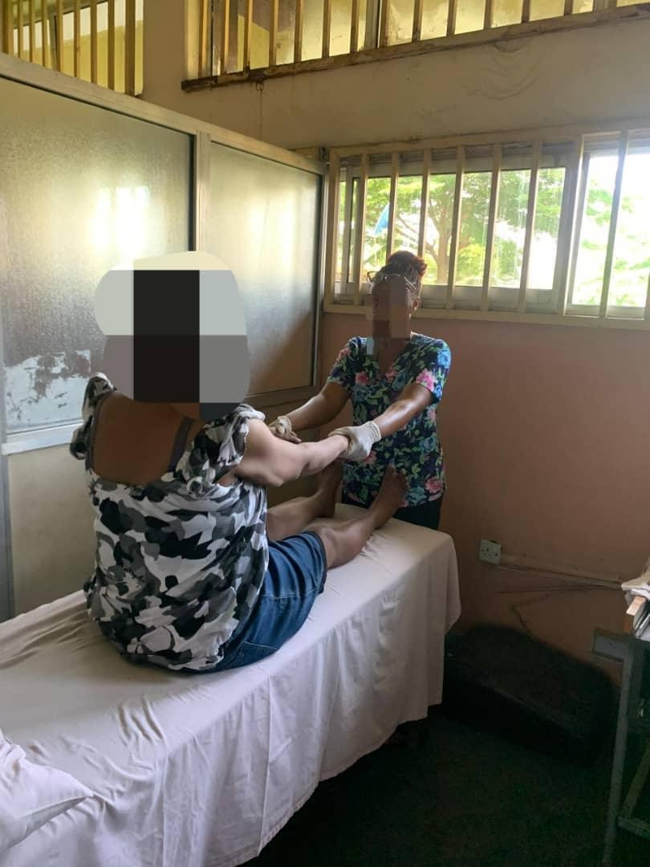
Figure 1: Curl-up exercise protocol for trunk muscle strengthening.

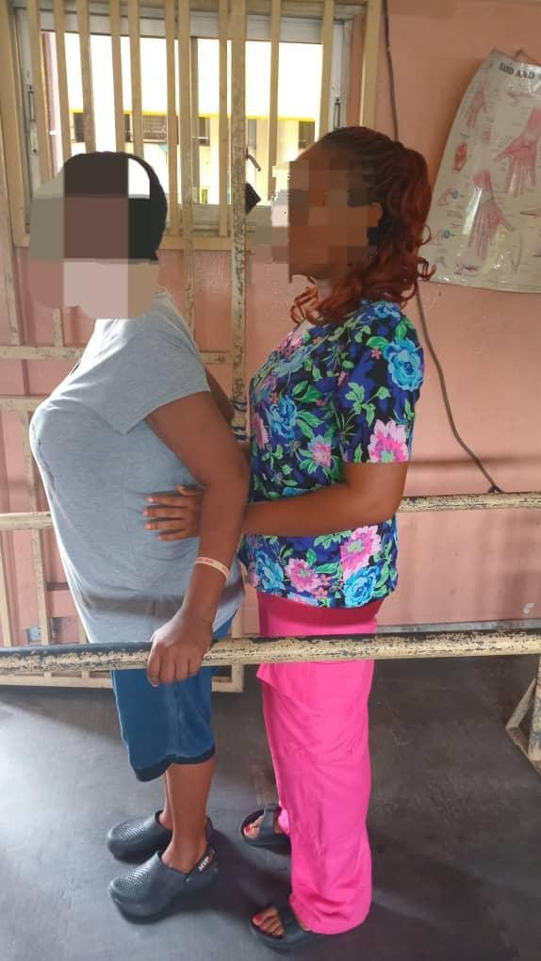
UNDER PEER REVIEW

Figure 2: Standing re-education protocol with biofeedback for balance and functional mobility
UNDER PEER REVIEW

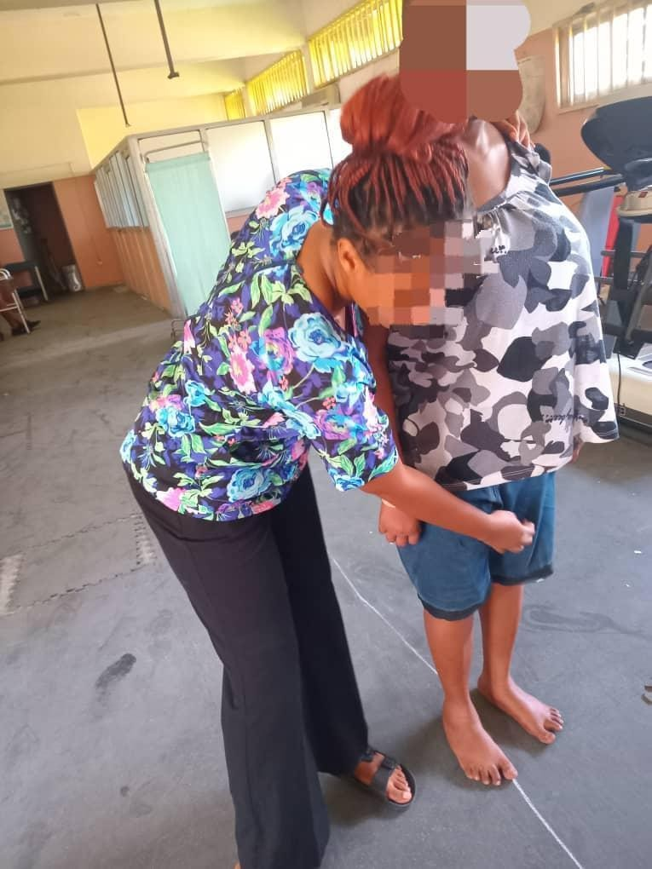
UNDER PEER REVIEW

Figure 3: Tandem walking on a straight line to improve gait and facilitate walking re-education.
UNDER PEER REVIEW

Functional outcomes demonstrated clinically meaningful recovery. Her Mini-Mental State Examination improved from 15/30, indicating severe cognitive impairment, to 30/30, reflecting full cognitive recovery. The Berg Balance Scale improved from 23/56 (high fall risk) to 44/56 (functional independence in balance). The Dynamic Gait Index rose from 10/24 (unsafe community ambulation) to 16/24 (moderate community ambulation). The Barthel Index also improved from 30/100 to 75/100, showing a transition from severe dependence to moderate
independence in activities of daily living.
Written informed consent for publication was obtained from the patient.

DISCUSSION
Herpes simplex encephalitis (HSE) is a rare but devastating neurological condition, primarily caused by HSV-1 in adults and HSV-2 in neonates (Gnann & Whitley, 2017). Its global incidence is 2–4 cases per million annually, with untreated mortality up to 70% (Kumar et al., 2024). Older adults and immunocompromised individuals are particularly vulnerable.
Pathophysiologically, HSV-1 targets the temporal and limbic structures, including the
hippocampus and amygdala, explaining symptoms such as seizures, psychiatric disturbances, memory loss, hemiparesis, and cranial nerve deficits (Forbes et al., 2019).
In this case, the patient’s presentation was distinctive. Her sudden quadriparesis and speech loss led to an initial diagnosis of stroke, while later shuffling gait, bradykinesia, and balance deficits mimicked Parkinsonism. Only after CSF PCR confirmed HSV-1 did the true diagnosis of HSE become clear. This highlights the diagnostic challenge and the potential for HSE to masquerade as other neurological disorders (Gnaan &Whitley, 2017).
According to the International Encephalitis Consortium (IEC) criteria, encephalitis requires an altered mental status ≥24 hours plus supportive features such as fever, seizures, focal neurological deficits, CSF pleocytosis, or neuroimaging abnormalities (Kennedy et al., 2017). Our patient mirrored these, and with virological confirmation fulfilled the IEC definition of a confirmed case. A recent validation has updated this framework by weighting clinical, laboratory, and imaging variables, strengthening its diagnostic accuracy (Staal et al., 2024).

Longitudinal studies indicate that long-term neurological deficits are common following herpes simplex encephalitis, including cognitive impairment, motor deficits, and behavioral disturbances, even with timely antiviral therapy (Abbuehl et al., 2023). In our patient, these
deficits persisted, with significant motor and cognitive impairments despite early antiviral treatment, highlighting that pharmacological therapy alone is insufficient and that structured, multidisciplinary rehabilitation was central to her functional recovery (Whitley & Baines, 2018).

Recent guidance and patient-focused reviews emphasize the critical role of structured, multidisciplinary rehabilitation after encephalitis to address persistent cognitive, behavioral, and functional deficits (Encephalitis Society, 2024). In line with these recommendations, physiotherapy targeted both motor and cognitive impairments, promoting functional recovery
UNDER PEER REVIEW
across multiple domains. Early sessions focused on passive mobilization, positioning, and soft tissue techniques to prevent contractures and bedsores. As she improved, therapy progressed to
trunk stabilization, gait and balance retraining, strengthening, and cognitive exercises, including orientation, memory, attention, and problem-solving tasks.
The interventions are shown in Table 1 and Table 2 below:

Interventions | Week 1 | Week 2 | Week 3 | Week 4
Soft Tissue Mobilization (kneading) | 7 minutes, 4 times weekly | 7 minutes 4 times weekly | 5 minutes 4 times weekly | 5 minutes 4 times weekly
Passive Mobilization | 10 minutes, 4 times weekly | 10 minutes 4 times weekly | 15 minutes 4 times weekly | 15 minutes 4 times weekly
Therapeutic Positioning (supine and side lying) | Every 2 hours | Every 2 hours | Every 2 hours | Every 2 hours
Bridging Exercise | 10 counts × 2  reps, 4 times weekly | 10 counts × 3 reps,  4 times weekly | 15 counts ×3 reps, 4 times weekly | 15 counts × 3reps, 4 times weekly.
Cognitive Exercise (orientation training, memory recall, attention tasks) | 10 minutes daily | 10 minutes daily | 12 minutes daily | 12 minutes daily
Table 1: Physiotherapy and cognitive interventions in the treatment plan from week 1 to week 4.

Interventions | Week 5 | Week 6 | Week 7 | Week 8
Curl-up Exercise | 2 sets × 10 reps, 4x weekly | 3 sets × 10 reps, 4x weekly | 4 sets × 10 reps 4x weekly | 5 sets × 10 reps 4x weekly
Grip-Strengthening Exercise | 2 sets × 10 reps, daily (moderate) | 2 sets × 10reps, daily (moderate) | 2 sets × 15 reps, daily (moderate) | 3 sets × 15 reps, daily (moderate)
Quadriceps strengthening | 2 sets × 8 reps, 30s rest | 3 sets × 8 reps, 30s rest | 3 sets × 10reps, 30s rest | 4 sets × 10 reps, 30s rest

Tandem walking | 2 min × 2 reps 30 secs rest 4x weekly | 2 min × 5 reps 30 secs rest 4x weekly | 2 min × 6 reps 30 secs rest 4x weekly | 2 min × 6 reps  30 secs rest 4x weekly
Standing re-education | 3 minutes, 4x weekly | 5 minutes  4 times weekly | 7 minutes 4 times weekly | 10 minutes  4 times weekly
Cognitive Exercise (problem-solving tasks and divided attention tasks) | 10 minutes daily | 15 minutes daily | 15 minutes daily | 15 minutes daily
Table 2: Physiotherapy and cognitive interventions in the treatment plan from week 1 to week 4.
UNDER PEER REVIEW

Rehabilitative interventions in encephalitis survivors have been linked to measurable
improvements in function and strength, supporting the use of standardized outcome measures (Kim et al., 2021). Early mobilization plays a crucial role in promoting neuroplasticity and recovery. Task-specific physiotherapy, adapted from brain injury protocols, further facilitated functional gains. Outcome measures such as the Barthel Index, MMSE, BBS, and DGI effectively captured progress in daily activities, cognition, balance, and gait.

Improvements in the Barthel Index, MMSE, BBS, and DGI reflected recovery in function, cognition, balance, and gait. These measures are relevant as HSE commonly impairs all four domains. Many survivors of herpes simplex encephalitis experience persistent neurological deficits, often requiring multidisciplinary care (Abbuehl et al., 2023). In this case, early
task-specific physiotherapy adapted from brain injury protocols was critical in promoting neuroplasticity and functional recovery in the patient.

The patient’s recovery illustrates the effectiveness of this integrated approach. These outcomes align with previous findings that physiotherapy combined with medical treatment accelerates functional recovery in encephalitic and brain injury populations (Francisco et al., 2021).

CONCLUSION

This case illustrates how HSE can mimic both stroke and Parkinsonism, highlighting a diagnostic challenge. It also demonstrates how physiotherapy, integrated with medical treatment, can lead to remarkable neurological recovery in HSVE. Raising clinician awareness, even for atypical presentations, is essential for improving prognosis.
Physiotherapy should be recognized not only as supportive but as a central component of recovery, bridging the gap between medical stabilization and functional independence.

DISCLAIMER (ARTIFICIAL INTELLIGENCE)
UNDER PEER REVIEW
Author(s) hereby declare that NO generative AI technologies such as Large Language
Models (ChatGPT, COPILOT, etc) and text-to-image generators have been used during the writing or editing of the manuscript

CONSENT
As per international standards or university standards, written informed consent for publication was obtained from the patient, and all identifying information has been anonymized to preserve confidentiality.

ETHICAL APPROVAL
In line with international ethical standards and common institutional practice, single case reports are exempt from formal Institutional Review Board/Ethics Committee approval.

REFERENCES

1. Bradshaw MJ, Venkatesan A. Herpes Simplex Virus-1 Encephalitis in Adults: Pathophysiology, Diagnosis, and Management. Neurotherapeutics. 2016 Jul;13(3):493–508. doi:10.1007/s13311-016-0433-7.

2 Whitley R, Baines J. Clinical management of herpes simplex virus infections: past, present, and future. F1000Research. 2018;7:1726. https://doi.org/10.12688/f1000research.16157.1

- Armangué T, Morís G, Cantarín-Extremera V, et al. Autoimmune post–herpes simplex encephalitis of adults and teenagers. Neurology. 2015;85(20):1736–1743. https://doi.org/10.1212/WNL.0000000000002125

- Ajith Kumar AK, Bhutta BS, Mendez MD. Herpes Simplex Encephalitis. In: StatPearls [Internet]. Treasure Island (FL): StatPearls Publishing; 2024 Jan–. Updated 2024 Jan 19. Available from: https://www.ncbi.nlm.nih.gov/books/NBK557643

- Rohani H, Arjmand R, Mozhgani SH, Shafiee A, Amini MJ, Forghani-Ramandi M. The
worldwide prevalence of herpes simplex virus encephalitis and meningitis: a systematic review and meta-analysis. Turk Arch Pediatr. 2023;58(6):580–587. doi:10.5152/TurkArchPediatr.2023.23007

- Gnann Jr, W. J., & Whitley, R. J. (2017). Herpes simplex encephalitis: An update. Current Infectious Disease Reports, 19(3), 13. https://doi.org/10.1007/s11908-017-0560-z
UNDER PEER REVIEW
- Kwakkel G, Veerbeek JM, van Wegen EEH, Wolf SL. Constraint-induced movement therapy after stroke: systematic review of randomized controlled trials. Lancet Neurol. 2015 Feb;14(2):224–234. doi:10.1016/S1474-4422(14)70160-7.
- Forbes HJ, Warne B, Doelken L, et al. Risk factors for herpes simplex virus type 1 infection and reactivation: EPIC-Norfolk study. PLoS One. 2019;14(5):e0215553. doi:10.1371/journal.pone.0215553.
- Kennedy PGE, Steiner I. Recent advances in herpes simplex encephalitis. Curr Opin Neurol. 2017;30(3):268-274. https://doi.org/10.1097/WCO.0000000000000443
- Staal SL, Olie SE, Ter Horst L, van Zeggeren IE, van de Beek D, Brouwer MC; I-PACE Study Group. Validation of the encephalitis criteria in adults with a suspected central nervous system infection: an updated score. J Infect. 2024;89(4):106239. doi:10.1016/j.jinf.2024.07.006.
- Abbuehl F, Schwarz E, Mariani L, Heldner MR. Long-term outcome after herpes simplex encephalitis: a systematic literature review. Front Neurol. 2023;14:1130090. doi:10.3389/fneur.2023.1130090
- Encephalitis Society. Encephalitis: After-Effects, Recovery, and Rehabilitation. London: Encephalitis Society; 2024. Available from:
https://www.encephalitis.info/effects-of-encephalitis/after-effects-of-encephalitis/
- Kim T, Lee J, Lee Y, et al. Changes in function and muscle strength of encephalitis survivors after inpatient rehabilitation. J Rehabil Res Dev. 2021;58(5):775–784. Available from: https://pmc.ncbi.nlm.nih.gov/articles/PMC8743845
- Francisco GE, Yozbatiran N, Berlin D, et al. Post-encephalitic rehabilitation: outcomes and evidence. NeuroRehabilitation. 2021;49(2):153-162. https://doi.org/10.3233/NRE-210052
ss

