Case report

INTEGRATING BEHAVIOURAL INTERVENTION AND PHARMACOLOGICAL THERAPY IN THE MANAGEMENT OF ORAL SUBMUCOUS FIBROSIS: A CASE REPORT

abstract
Oral Submucous Fibrosis (OSMF) is a chronic, progressive, potentially malignant disorder of the oral cavity strongly associated with areca nut and smokeless tobacco use. This report presents the case of a 22-year-old male patient with Stage III OSMF, who reported chronic gutkha chewing and complained of reduced mouth opening and burning sensation on eating spicy food. Clinical examination revealed blanching of the buccal mucosa, restricted tongue movements, and palpable fibrous bands. Management included structured weekly behavioural counselling sessions for tobacco cessation, pharmacological treatment with antioxidants and intralesional corticosteroid–hyaluronidase injections, and reinforcement of oral hygiene practices. Over five weeks, the patient demonstrated significant improvement, with mouth opening increasing from 14 mm to 27 mm, improved tongue protrusion, and a marked reduction in burning sensation as measured by the Visual Analogue Scale (VAS). This case highlights the importance of integrating behavioural counselling with pharmacological management for OSMF. Early incorporation of behavioural interventions not only supports sustained habit cessation but may also reduce malignant transformation risk and improve long-term prognosis.

Keywords: Areca, Behavior Therapy, Oral Submucous Fibrosis, Mouth Neoplasms, Smokeless Tobacco.

1. INTRODUCTION

Oral submucous fibrosis (OSMF) is a chronic, insidious, and potentially malignant disorder of the oral mucosa characterized by progressive fibrosis, blanching, burning sensation, and restricted mouth opening. First described by Schwartz in 1952, OSMF is now a major health problem in the Indian subcontinent due to widespread areca nut and smokeless tobacco use (Rao et al., 2020). The malignant transformation rate is estimated at 7–13%, making it one of the most significant premalignant oral conditions (Passi et al., 2017).
Habitual use of areca nut and smokeless tobacco is the primary cause. Alkaloids, tannins, flavonoids, and copper stimulate collagen synthesis and inhibit degradation, leading to progressive fibrosis (Berwal et al., 2014). Nutritional deficiencies, genetic predisposition, and immunological factors also contribute (Gupta et al., 2021).
Tobacco consumption in India is alarming, with 28.6% of adults using it, mostly in smokeless forms. Nearly 200,000 annual deaths are attributed to smokeless tobacco, accounting for 74% of global SLT-related mortality (Bharati et al., 2023). The global urgency of this problem is underscored by the WHO Report on the Global Tobacco Epidemic of 2023, which highlights the critical need for comprehensive cessation support as part of international tobacco control efforts (WHO., 2023). Products like gutkha and pan masala remain popular due to affordability and social acceptance, making cessation difficult (Nayak & Mishra, 2018; Patel & Damor, 2018).
Management includes pharmacological therapy, complementary approaches, and surgery for advanced trismus. However, habit cessation through behavioural counselling—using models like Prochaska’s, the 5A’s and 5R’s, motivational interviewing, and digital tools—remains central (Li et al., 2019; Lu & Jian, 2019; Al-Maweri et al., 2019; Sukanya et al., 2022; Manjula et al., 2018).
This case report presents the management of a young male with Stage III OSMF using pharmacological therapy and structured counselling.

2. CASE PRESENTATION

A 22-year-old male reported to a dental college in Pune, with complaints of reduced mouth opening and burning sensation on consuming spicy food for six months. Initially able to insert three fingers intraorally, his mouth opening gradually reduced to one finger. Burning, mild at onset, worsened and affected diet and comfort.
Habit history revealed gutkha use since age 18, consuming 10–15 packets daily (RMD, Rajnigandha, Panparag). He typically retained the quid in the buccal vestibule for 10–15 minutes before spitting, with a monthly expenditure of ₹500–550. He denied alcohol use and expressed willingness to quit, placing him in the contemplation stage of Prochaska’s behaviour change model. Past medical, dental, and family histories were non-contributory. Oral hygiene practices included once-daily brushing with a horizontal scrubbing technique.
On general examination, he was afebrile with stable vitals (pulse 82/min, BP 110/80 mmHg, respiratory rate 17/min). He had a mesomorphic build, was well oriented, and showed no systemic abnormalities.
Intraoral examination revealed an interincisal opening of 14 mm and tongue protrusion of 18 mm (Figure 1). Diffuse blanching of the buccal mucosa and soft palate with greyish-black pigmentation was noted (Figure 2). Vertical fibrous bands, tongue depapillation, restricted mobility, gingival inflammation, calculus deposits, stains, spacing, and anterior crowding were evident. Burning sensation was scored 7 on the Visual Analogue Scale (VAS).

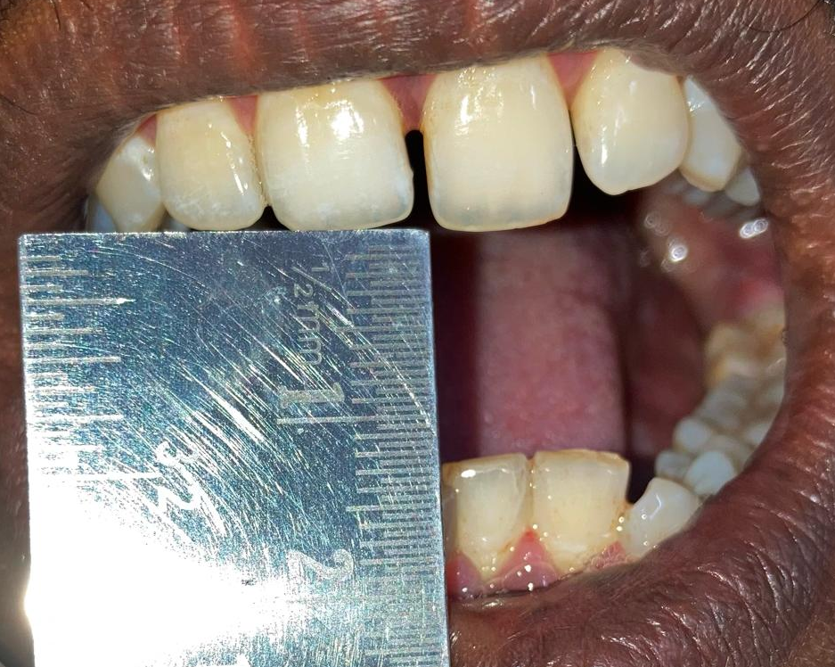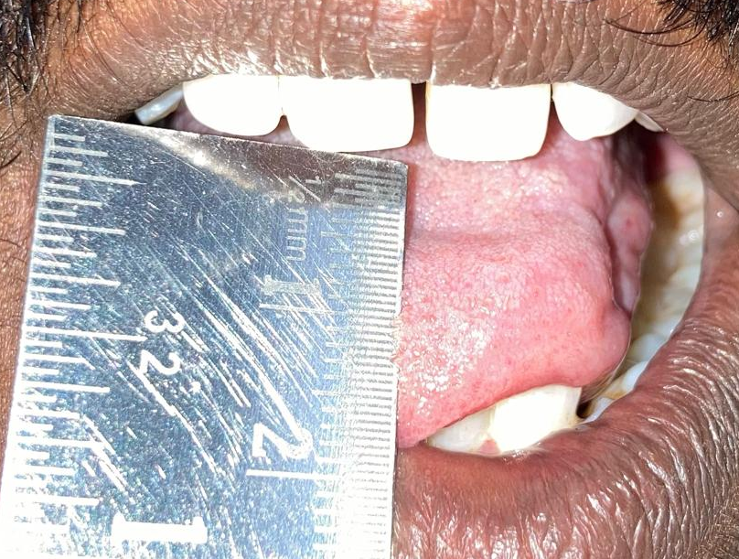
- (B)
Figure 1 – Baseline restricted mouth opening: (A) Mouth Opening (B) Tongue Protrusion

A clinical diagnosis of Stage III OSMF with habit-induced melanosis and chronic generalized gingivitis was made, based on characteristic features including blanching, palpable fibrous bands, and restricted mouth opening. Routine blood investigations were within normal limits, and gingival index scores were recorded. As biopsy was not performed, the diagnosis was established clinically, which is considered sufficient in such cases.
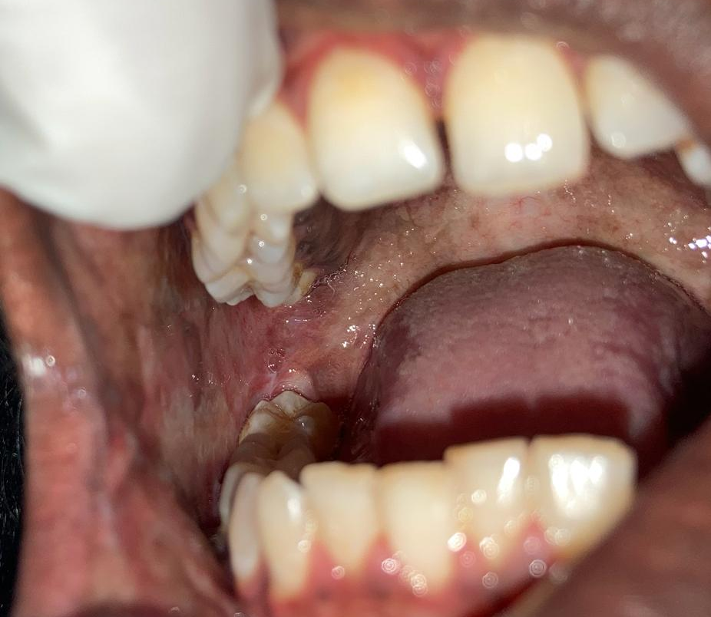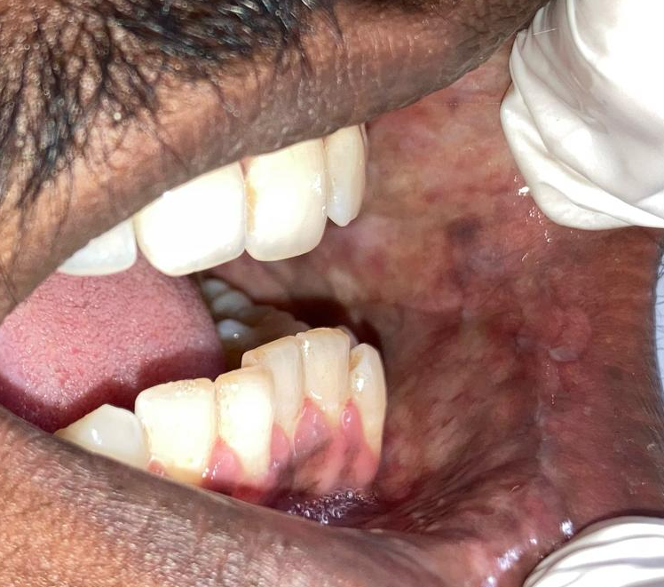
(A) (B)
Figure 2 – Baseline intraoral mucosal changes (A, B: Blanching on Buccal Mucosa)

2.1 Management

The treatment plan began with elimination of the causative habit. The patient was counselled on the harmful effects of gutkha, including its malignant potential. Scaling and oral prophylaxis were performed to improve hygiene, and positive reinforcement was given to support habit cessation.
Pharmacological therapy aimed at symptom relief and functional improvement. The patient was prescribed Cap. SM Fibro (antioxidants and micronutrients) twice daily for one month and topical Kenacort oral paint (Triamcinolone acetonide 0.1%) thrice daily for 15 days. Weekly intralesional injections were administered for six weeks, consisting of dexamethasone (4 mg), hyaluronidase (1500 IU), and 0.5 ml lignocaine, delivered bilaterally into the buccal mucosa, retromolar region, and soft palate. Daily mouth-opening exercises were advised to aid rehabilitation.
Behavioural interventions formed a central component. Counselling sessions (weekly) (20–30 minutes) were based on Prochaska’s six-stage model, using the 5A’s and 5R’s strategies to enhance motivation (Figure 3). Motivational videos were shown at alternate visits, and the WHO Quick Start App was introduced as a digital support tool. Evidence also supports this approach, as systematic reviews have demonstrated the effectiveness of mobile and app-based interventions in sustaining tobacco cessation (Whittaker et al., 2019). Telephonic counselling was provided for missed appointments. A structured five-day quit plan encouraged the patient to list personal reasons for quitting, replace tobacco with healthier alternatives, practice relaxation methods like yoga, and reward progress through self-appreciation.
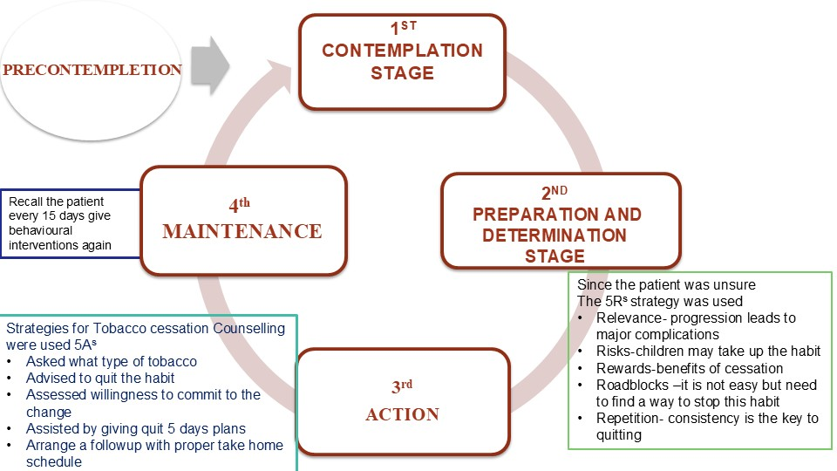

Figure 3: Behavioural intervention illustration (Prochaska’s model)

Regular follow-up demonstrated progressive improvement. At day 7, mouth opening increased to 18 mm, tongue protrusion to 24 mm, and burning sensation reduced to a VAS score of 6. By day 21, the mouth opening had improved to 23 mm, tongue protrusion to 28 mm, and VAS reduced to 4. At day 35, significant clinical improvement was achieved, with mouth opening reaching 27 mm, tongue protrusion 35 mm, and VAS score reduced to 2. To minimize bias, two independent authors recorded the clinical parameters, including mouth opening, tongue protrusion, and burning sensation (VAS score). (Figure 4 and Figure 5)
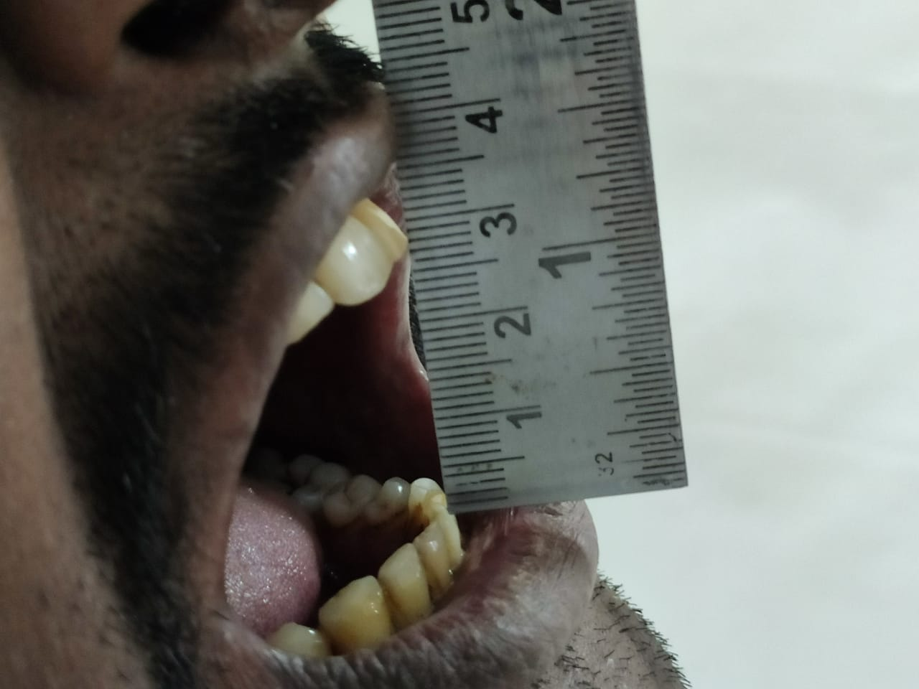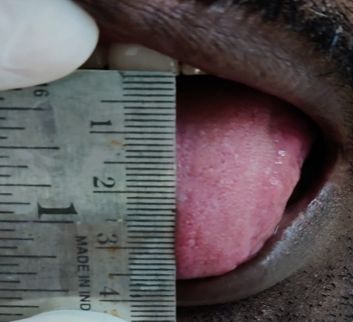
(A) (B)
Figure 4: Follow-up clinical image (Day 35): (A) Mouth Opening (B) Tongue Protrusion

Figure 5: Graph showing progressive improvement in mouth opening, tongue protrusion, and reduction in burning sensation (VAS score) during follow-up.

3. DISCUSSION

Tobacco dependence remains a major global health challenge. Nearly one-third of cancer-related deaths are linked to tobacco, and in India, tobacco-related cancers account for about 27% of the total burden (Bharati et al., 2023). The GATS-2 survey reported 28.6% adult tobacco use, predominantly in smokeless forms due to affordability and social acceptance. India contributes nearly 74% of global smokeless tobacco mortality, with 200,000 annual deaths (Bharati et al., 2023).
OSMF is a chronic premalignant condition with a malignant transformation rate of 7–13% (Passi et al., 2017). Pathogenesis involves juxtaepithelial inflammation, excessive collagen synthesis, and fibroelastic changes, largely driven by areca nut alkaloids and nitrosamines, resulting in fibrosis, epithelial atrophy, restricted mouth opening, and malignant risk (Shafer et al., 2012; Berwal et al., 2014). A recent systematic review also highlights the overexpression of transforming growth factor-β (TGF-β) as a central molecular event in OSMF progression, reinforcing its role as both a biomarker and therapeutic target in disease management (Bansal et al., 2023). More recently, a novel hypothesis has proposed fluoride as a potential contributory factor in OSMF pathogenesis, adding a new dimension to the multifactorial nature of the disease (Arakeri et al., 2023).
Conservative therapy with corticosteroid–hyaluronidase, antioxidants, and micronutrients improve symptoms (Li et al., 2019; Lu & Jian, 2019). Adjuncts like Aloe vera (Al-Maweri et al., 2019) and photobiomodulation (Sukanya et al., 2022) show promise. In this case, intralesional corticosteroid–hyaluronidase with antioxidants provided marked benefit within five weeks.
Habit elimination remains central, as pharmacological benefits relapse without behavioural change. Structured counselling models, including Prochaska’s stages, 5A’s, 5R’s, motivational interviewing, and digital aids like the WHO Quick Start App, significantly aid cessation (Manjula et al., 2018).
An important consideration in OSMF management is the potential for malignant transformation, reported to range between 7–13% (Passi et al., 2017). This underscores the significance of initiating early intervention that not only targets symptomatic relief but also addresses underlying risk behaviours. Conservative pharmacological approaches, such as corticosteroid–hyaluronidase combinations, can improve function and reduce discomfort (Li et al., 2019; Lu & Jian, 2019), but sustained benefit is most likely when paired with habit cessation. In this context, behavioural counselling assumes a dual role—improving immediate treatment compliance and potentially reducing long-term cancer risk. Thus, beyond symptomatic management, such interventions have profound implications for prognosis and survival.
This case highlights the importance of integrating pharmacological management with behavioural support through a multidisciplinary approach.

4. Conclusion

OSMF is a debilitating premalignant disorder strongly linked to areca nut and smokeless tobacco use. This case demonstrates that combining intralesional corticosteroid–hyaluronidase, antioxidants, and structured behavioural counselling provides significant improvement. Sustained habit cessation through counselling underscores the importance of integrating medical and behavioural strategies for long-term management.

Consent

A written informed consent was obtained from the patient for publication of this case report and accompanying images.

Ethical approval

All authors hereby declare that an approval was obtained from the Institutional Ethics Committee of Sinhgad Dental College and Hospital, Pune with Approval No.: SDCH/IEC/OUT/2024/29 and it has been preserved by the authors.

DISCLAIMER (ARTIFICIAL INTELLIGENCE)

Authors hereby declare that NO generative AI technologies such as Large Language Models (ChatGPT, COPILOT, etc.) and text-to-image generators have been used during the writing or editing of this manuscript.

References

- Al-Maweri, S. A., Ashraf, S., Lingam, A. S., Alqutaibi, A., Abdulrab, S., Alaizari, N., & Halboub, E. (2019). Aloe vera in treatment of oral submucous fibrosis: A systematic review and meta-analysis. Journal of Oral Pathology & Medicine, 48(2), 99–107. https://doi.org/10.1111/jop.12789
- Arakeri, G., US, V. R., Patil, S., Krishnan, M., & Brennan, P. A. (2023). Fluoride as a potential contributory factor in pathogenesis of oral submucous fibrosis: A novel hypothesis. Medical Hypotheses, 181, 111216.
- Bansal, S. P., Pereira, T., Desai, R. S., Jena, A., & Mehta, V. (2023). Expression of transforming growth factor-β in oral submucous fibrosis: A systematic review. Journal of Oral and Maxillofacial Pathology, 27(2), 348–358. https://doi.org/10.4103/jomfp.jomfp_536_22
- Berwal, V., Khangwal, M., Solanki, R., Khandeparker, R., Savant, K., & Shetye, O. (2014). Classification systems for oral submucous fibrosis – From past to present: A review. International Journal of Dental Health Sciences, 1, 900–913.
- Bharati, B., Sahu, K. S., & Pati, S. (2023). Prevalence of smokeless tobacco use in India and its association with various occupations: A LASI study. Frontiers in Public Health, 11, 1176521. https://doi.org/10.3389/fpubh.2023.1005103.
- Glick, M., & Fehrenbach, M. J. (2015). Burket’s oral medicine (12th ed.). Hoboken, NJ: Wiley-Blackwell.
- Gupta, S., Gupta, S., Chaudhary, C., Ghosh, S., Singh, R., & Bansal, P. (2021). Novel treatment approach of oral submucous fibrosis in a 6-year-old girl: A case report. International Journal of Clinical Pediatric Dentistry, 14(4), 575–579. https://doi.org/ 10.5005/jp-journals-10005-1999.
- Li, Y. H., Chang, W. C., Chiang, T. E., Tsai, C. C., Chen, H. H., & Chen, Y. J. (2019). Mouth-opening device as a treatment modality in trismus patients with head and neck cancer and oral submucous fibrosis: A prospective study. Clinical Oral Investigations, 23(1), 469–476. https://doi.org/ 10.1007/s00784-018-2456-4.
- Lu, C., & Jian, X. (2019). Efficacy for combined injection of salvianolic acid B with triamcinolone acetonide on the treatment of the soft palate with oral submucous fibrosis. Zhong Nan Da Xue Xue Bao Yi Xue Ban, 44(7), 801–804. https://doi.org/10.11817/j.issn.1672-7347.2019.180570.
- Manjula, D. C., Shekar, V., & Reddy, J. R. (2018). Effect of behavioural counselling in tobacco cessation. Journal of Scientific Dentistry, 8(2), 58–60. https://dx.doi.org/10.5005/jsd-8-2-58
- Nayak, S., & Mishra, A. (2018). Prevalence and factors affecting tobacco use among urban adolescents in Bhilai city, central India. International Journal of Community Medicine and Public Health, 5(4), 1492–1498. https://doi.org/10.18203/2394-6040.ijcmph20181223
- Passi, D., Bhanot, P., Kacker, D., Chahal, D., Atri, M., & Panwar, Y. (2017). Oral submucous fibrosis: Newer proposed classification with critical updates in pathogenesis and management strategies. National journal of maxillofacial surgery, 8(2), 89-94. https://doi.org/10.4103/njms.njms_32_17
- Patel, A. S., & Damor, R. D. (2018). A cross-sectional study on tobacco consumption practice in school-going adolescent males of Jamnagar city, Gujarat, India. International Journal of Community Medicine and Public Health, 5(3), 933–938. https://doi.org/10.18203/2394-6040.ijcmph20180478
- Rao, N. R., Villa, A., More, C. B., Jayasinghe, R. D., Kerr, A. R., & Johnson, N. W. (2020). Oral submucous fibrosis: A contemporary narrative review with a proposed inter-professional approach for early diagnosis and clinical management. Journal of Otolaryngology – Head & Neck Surgery, 49(3), 1–9. https://doi.org/10.1186/s40463-020-0399-7
- Shafer, W. G., Hine, M. K., & Levy, B. M. (2012). Shafer’s textbook of oral pathology (7th ed.). New Delhi: Elsevier.
- Sukanya, D., Upasana, L., Deepak, T. A., Abhinethra, M. S., & Choudary, S. (2022). Determination of effectiveness of photobiomodulation in the treatment of oral submucous fibrosis. Journal of Pharmacy and Bioallied Sciences, 14(Suppl 1), S475–S478.https://doi.org/10.4103/jpbs.jpbs_673_21
- World Health Organization. (2023). WHO report on the global tobacco epidemic, 2023: Protect people from tobacco smoke. Geneva: World Health Organization.
- Whittaker, R., McRobbie, H., Bullen, C., Rodgers, A., Gu, Y., & Dobson, R. (2019). Mobile phone text messaging and app-based interventions for smoking cessation. Cochrane Database of Systematic Reviews, 2019(10). https://doi.org/10.1002/14651858.cd006611.pub5

