Capillary-based electrophoresis method for the quantification of stachyose in Stachys affinis Bunge (Lamiaceae) tubers

.
ABSTRACT

Aims: Stachyose, a tetrasaccharide comprising approximately 80% of vacuolar carbohydrates, is a characteristic marker of the genus Stachys and is reported to exhibit various pharmacological benefits, including blood glucose reduction, immune enhancement, and constipation relief. This study aimed to develop and validate a CE-DAD method for stachyose quantification in Stachys affinis tubers in accordance with ICH (2005) and AOAC (2012) guidelines to support raw material quality control.
Study Design: Experimental laboratory-based method development and validation study.Place and Duration of Study: Stachys affinis tubers were provided by the City Biotechnology Center, Ho Chi Minh City, Vietnam. The study was conducted at Ho Chi Minh City University of Pharmacy from June 2021 to July 2022.
Methodology: A CE-DAD method was established for stachyose quantification in Stachys affinis rhizomes. The capillary column was pretreated and equilibrated using a standardized NaOH–water–buffer sequence, with daily and inter-run conditioning to ensure consistent performance. Electrophoresis parameters—including BGE type, pH, Na₂HPO₄ concentration, temperature, injection time, and voltage—were optimized using JMP10 Pro and a 15-run experimental design. Method validation followed ICH and AOAC guidelines, evaluating system suitability, specificity, linearity, sensitivity (LOD, LOQ), precision, and recovery.
Results: The optimized procedure employed a CE-7100 Agilent system with a bare-silica capillary column (effective length 65 cm), 35 mM Na₂HPO₄ (pH 12.4) as BGE, a voltage of 8 kV, a column temperature of 30°C, sample injection at 50 mbar for 3 s, and detection at 270 nm using lactose as the internal standard.
Conclusion: The CE-DAD method for stachyose quantification in Stachys affinis was validated according to ICH and AOAC (2012) guidelines, confirming its suitability for raw material quality control. The method showed system suitability, high selectivity, wide linearity (4.46–89.18 µg/mL), and high sensitivity (LOD 5.00 µg/mL; LOQ 15.00 µg/mL). It also demonstrated good repeatability and intermediate precision (RSD 1.77% [n=6] and 1.94% [n=12]) with recovery ranging from 99.01% to 102.10%.

Keywords: Stachys affinis Bunge, stachyose, internal standard, capillary electrophoresis.

1. INTRODUCTION

Stachys affinis Bunge., Lamiacaea (Stachys sieboldii, Stachys tuberifera), often known as Chinese artichoke, is a perennial herbaceous plant native to China and found in Gansu, Hebei, and Huu provinces. North, Nei Mongol, Ningxia, Qinghai, Shaanxi... In ancient times, they were produced as food roots in China and Japan.(Lim, 2016)
Stachys affinis tubers have a high carbohydrate content (36.94%), delivering a significant quantity of kcal (195 kcal/100 g dried tubers). The amount of sugar (14.07%) in tubers is especially significant because it is primarily stachyose (80-90%), which has considerable pharmacological value. (Venditti et al., 2017), (Yin et al., 2006), (Wiśniewski and Harasym, 2024). This content is much higher than the amount of stachyose found in legume seeds, 0.6–5.8% (dry weight) (Hymowitz and Collins, 1974). Stachyose is less sweet, about 28% of the sweetness of sucrose per unit mass, and is used as a sweetener or as an oligosaccharide (Nakakuki, 2005).
Many countries have approved foods and herbs that include oligosaccharides, like stachyose and raffinose, as special health foods. The primary oligosaccharide found in S.affinis tubers is strachyose, which helps to supply vitamins, proteins, and other oligosaccharides for use as food by humans (Yin et al., 2006). Stachyose exhibits a significant hypoglycemic effect in mice. Findings from studies on its mechanism in the treatment of type 2 diabetes indicate that stachyose can improve insulin concentration, lower low-density lipoprotein cholesterol (LDL-C), and reduce triglyceride levels. Moreover, its therapeutic effects may be partly attributed to the regulation of energy metabolism and modulation of the intestinal microbiota (Liang et al., 2020). These results suggest that stachyose is a promising alternative sugar source for diabetic patients.
As can be shown, Stachys affinis is a possible source of stachyose that can be used as a raw material to make dieter-friendly products and snacks. Currently, no research has been conducted to establish and validate stachyose measurement methodologies in S.affinis. Thus, creating and testing a process for quantifying stachyose in Stachys affinis tubers is critical for assessing raw material quality.

2. MATERIAL AND METHODS

2.1 Object

The City Biotechnology Center in Ho Chi Minh City delivered Stachy affinis tubers, which were harvested on November 21, 2021, rinsed, and dried at 60°C until the weight remained constant (moisture content 8.01%). Grind to fine powder with a sieve size of 180/125; keep at room temperature.

2.2 Equipment:

CE-DAD Agilent system – made in US, Agilent Bare silica capillary (65 cm ⨯ 75 μm i.d., 60 cm effective length); analytical scales Sartorius CP-225D (accuracy to 0.01 mg); ultrasonic tank DH-Elma T840.

2.3 Chemicals:

Sodium dodecyl sulfat (SDS), C₁₂H₂₅NaO₄S, M= 288,378 g/mol (J.T.Baker TM – USA); Disodium tretraborat decahyrat (Na₂B₄O₇.10H₂O), M = 281,37 g/mol (Merck – KGaA); Disodium hydrogenphosphat (Na₂HPO₄), M = 141,96 g/mol (Merck – KGaA); Sodium hydroxyd (NaOH), M= 40,00 g/mol (Merck – KGaA); Methanol (MeOH), acetonitril (ACN) (Merck – KGaA); Deionized water (NTT High Technology Institute - Nguyen Tat Thanh University, Ho Chi Minh City, Vietnam).

2.4 Reference Materials:

Stachyose hydrate isolated from Stachys tuberifera (Sigma-Aldrich), lot number: MFCD00149457, content: 98%, moisture content: 9%; D- lactose monohydrate (Sigma-Aldrich), lot number: MFCD00166994, content calculated on anhydrous preparation: 100.0%, moisture content: 5.3%.

2.5 Research method

2.5.1 Prepare a capillary column

The new capillary column is activated in this order: 1 M NaOH (30 minutes), demineralized water (30 minutes), and electrolyte buffer solution (60 minutes). Every day, balance the column by adding demineralized water (15 minutes), 0.1 M NaOH solution (30 minutes), demineralized distilled water (15 minutes), and electrophoresis buffer (10 minutes). Re-equilibrate the column between runs using 0.1 M NaOH (5 minutes), demineralized water (5 minutes), and a background electrolyte solution (5 minutes). Wash at the end of the day with demineralized distilled water for 30 minutes, then air dry (10 minutes).

2.5.2 Investigation of electrophoresis conditions

Investigate the electrophoresis conditions and sample preparation conditions based on separation parameters of the sample (the signal of stachyose is the highest, its asymmetry is in range 0.8-2.0, its number of theoretical plates is greater than 2000). Electrophoresis conditions include the type of BGE solution (borate, acetate, tris, ammonium, Na₂HPO₄), buffer solution pH (11.5; 12.0; 12.4; 12.6), concentration of Na₂HPO₄ buffer solution (10, 30, 36, 40, 50 mM), presence of organic solvents in BGE (methanol, ethanol, acetonitrile), temperature (25, 30, 35 ºC), sample injection time (2, 3, 5, 8 s), and voltage (6, 8, 9 kV). Sample preparation conditions: extraction method (ultrasonic extraction, extraction combined with temperature at 60 or 80 ºC), ratio of extraction solvent (1: 5, 1:10, 1:15, 1:20 w/v), extraction time (10 - 15 - 20 minutes) and number times of extractions.

In turn, pick the optimal settings so that the stachyose peak meets the electrophoretic characteristics using the criteria (Bộ Y tế, 2017): chirality coefficient: 0.8 ≤ As ≤ 1.5; resolution: Rs ≥ 1.5 (for stachyose with impurities); quick analytical time; high repeatability.
Using JMP10 Pro 3, optimize electrophoresis settings such as Na₂HPO₄ salt concentration, column temperature, and pH of the background electrolyte solution to achieve the quickest analysis time and best resolution. Design with 15 experiments, three key experiments with the following conditions: highest resolution coefficient and lowest electrophoresis duration.
The model has the form:
Y = b₀ + b₁X₁ + b₂X₂ + b₃X₃ + b₁₁X₁² +b₂₂X₂² +b₃₃X₃² +b₁₂(X₁X₂) + b₁₃(X₁X₃) + b₂₃(X₂X₃)
Where, X₁ is the concentration of Na₂HPO₄ (mM), X₂ is the pH, and X₃ is the column temperature (ºC). Create an experimental matrix table using the experimental levels provided, based on those found in Table 1.
Table 1. Experimental levels employed in the model.
Level | Concentration of Na₂HPO₄ (mM) | pH | Column temperature (ºC)
Original level  Variation range  Upper level  Lower level | 35  5  40  30 | 12.4  0,2  12.6  12.2 | 30  2  32  28

The ICH (International Conference on Harmonisation of Technica Requirements for Registration of Pharmaceuticals for Human Use (ICH), 2005) and AOAC (Association of Official Analytical Chemists, 2012) recommendations were followed in evaluating the process for detecting stachyose in Stachys affinis whole root extract in terms of system appropriateness, specificity, linearity, limit of detection, quantitative limit, repeatability, intermediate precision, and precision.

3. RESULTS AND DISCUSSION

3.1 Results

3.1.1 Investigation of electrophoresis conditions

Survey of buffer types: 36 mM concentration of borate, acetate, tris, ammonium, and Na₂HPO₄ at pH 11.5. When a Na₂HPO₄ buffer solution was used for analysis, the electrophoresis revealed two peaks. Na₂HPO₄ buffer was thus chosen to study the following circumstances.

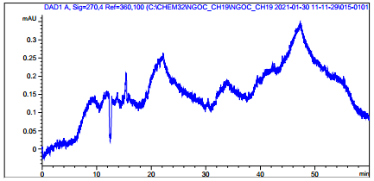 | 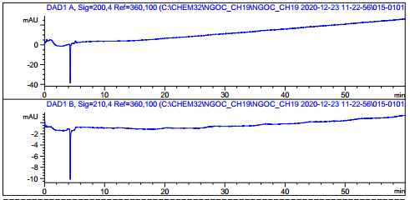 | 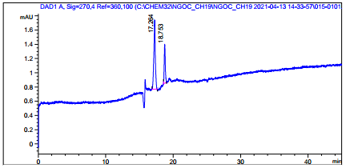
Borat | Acetat | Na₂HPO₄
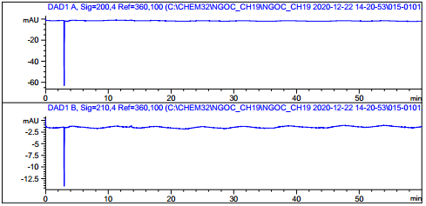 | 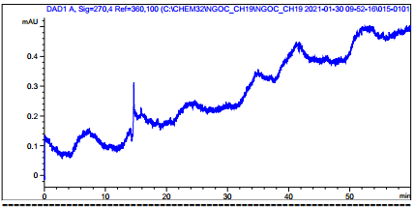
TRIS | Amoni
Figure 1. Electrophoresis results of survey of buffer types
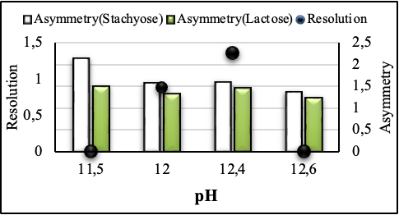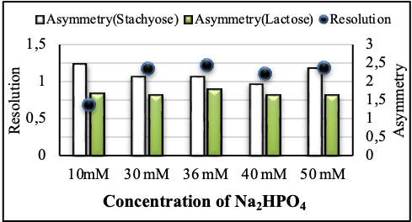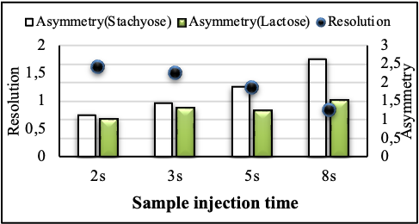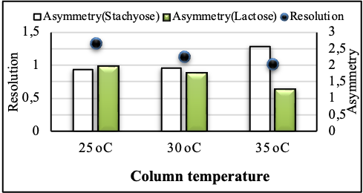Figure 2. Electrical survey results affect resolution and asymmeter

Figure 2 shows how pH, Na₂HPO₄ concentration, column temperature, and sample injection time all influence the resolution of stachyose and impurity peaks, as well as the asymmetry of the peaks (stachyose and lactose). The survey results indicated that a pH of 12.4, a 36 mM Na₂HPO₄ solution, a column temperature of 30 ºC, and a sample injection period of 3 seconds were chosen. The pH, Na₂HPO₄ concentration, and column temperature are specifically chosen as elements to include in the optimization model.
Additionally, the voltage level influences the analysis time. The analysis duration at 6 kV is 51 minutes; at 8 kV and 9 kV, the difference is not significant, at 39 minutes and 37 minutes, respectively (Figure 3). It can be shown that increasing the voltage reduces analysis time. Electrophoresis generates 219 µA of current at 8 kV and 256 µA at 9 kV. To avoid joule heating, set the voltage to 8 kV.
Figure 3. Electrophoresis results investigating the influence of voltage

3.1.2 Process optimization

Independent Variables: X₁ (Na₂HPO₄ concentration); X₂ (pH); X₃ (temperature); and two dependent variables: Y₁ (resolution) and Y₂ (electrophoresis duration).
According to JMP analysis, the curve equation of the response surface model takes the following form:
Y₁ = 2,36 – 1,44X₂ – 0,24X₃ + 0,01X₂²
Y₂= 40,67+ 33,25X₂ – 5,88X₃ + 20,67X₂²

where Y₁ and Y₂ are the independent variables' responses to resolution and electrophoresis time, respectively.
"pH" is the most important factor influencing resolution and electrophoresis time.The graph can be used to establish the appropriate chromatographic settings (Figure 4). Na₂HPO₄ concentration: 35 mM; pH: 12.4; column temperature: 30°C; predicted results: resolution (Rs): 2.36; electrophoresis time: 40.67 minutes.
Experimental results show no significant difference from expected results (p > 0.05). (Figure 4, Table 2)

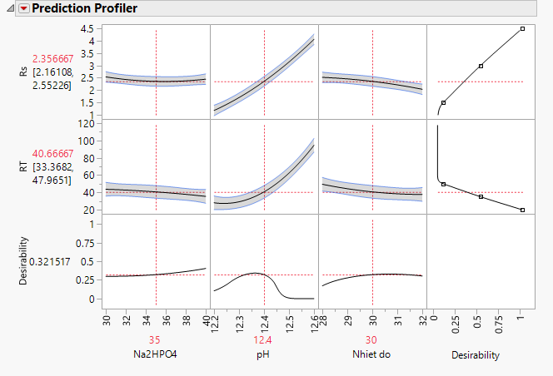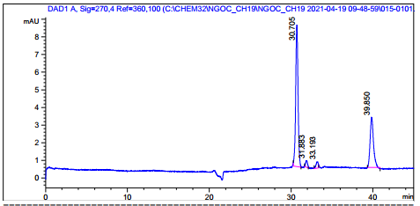
Figure 4. Graph showing the influence of electrophoresis conditions and electrophoresis

Table 2. Experimental results
n | Rs | Electrophoresis time | Results of statistical processing
1 | 2,36 | 39,85 | n = 6
2 | 2,47 | 41,53 | Rs _{TB}= 2,33; Tg = 40,37
3 | 2,38 | 40,05 | SD_{Rs} = 0,11; SD_{tg}= 1,49
4 | 2,13 | 42,61 | RSD_{Rs}= 4,9 %; RSD_{tg} = 3,7 %
5 | 2,35 | 40,05 | n = 6; p= 0,95; t_{Rs} = 2,57; t_{tg} = 2,57
6 | 2,3 | 38,34 | e_{Rs} = ±0,12; e_{tg} = ± 1,6
Average | 2,33 | 40,37 | Confidence interval: 2,36 ±0,12; 40,37 ± 1,6

So the optimal conditions are as follows: Na₂HPO₄ concentration: 35 mM; pH: 12.4; Temperature: 30 ºC; Voltage: 8 kV; Injection time: 3 s; wavelength: 270 nm

3.1.3 Extraction methods

Continuing with extraction methods (Figure 5), after selecting the most appropriate parameter for each factor, the following factors were evaluated in turn: extraction solvent, extraction temperature, solvent ratio, extraction time, and number of extractions. The study found that ultrasonic techniques at room temperature with a solvent: H₂O ratio of 1:15 (w/v) in 10 minutes yielded the maximum efficiency (42.04%).

Figure 5: The result of investigating chromatographic conditions of the quantitative analytical procedure for stachyose in Stachys affinis rhizomes. The parameters of every investigated factor were shown in below:

 | Solvent | Method | Time (minutes) | Ratio of extraction | Number of extraction time
Parameter 1 | H₂O | RT | 10 | 01:05 | 1
Parameter 2 | H₂O-MeOH (7:3) | 60°C | 15 | 01:10 | 2
Parameter 3 | H₂O-MeOH (5:5) | 80°C | 20 | 01:15 | -
Parameter 4 | H₂O-MeOH (3:7) | - | - | 01:20 | -
Parameter 5 | MeOH | - | - | - | -
The final procedure for quantifying stachyose in Stachys affinis was developed as follows:
- Internal standard stock solution: The solution contains 1000 µg/mL lactose in water.
Stachyose standard stock solution: The solution contains 1000 µg/ml of stachyose in water.
Standard sample: Dilute the stock standard solution and internal standard stock solution to generate a mixture of 50 µg/ml stachyose and 50 µg/ml lactose. Before doing CE-DAD analysis, filter through a 0.22 µm filter.
- Test sample Disperse 100.0 mg of the test sample in 1.5 ml of distilled water, then sonicate for 10 minutes. Centrifuge for 5 minutes at 5000 r/m and dilute to 1000 µg/ml in water (Solution A). Fill a 10 ml volumetric flask with 500 µl of solution A and 250 µl of the internal standard stock solution. Add 10 ml of distilled water. Before doing CE-DAD analysis, filter through a 0.22 µm filter.
- Capillary electrophoresis conditions: CE-DAD Agilent system – made in US, Agilent Bare silica capillary (65 cm ⨯ 75 μm i.d., 60 cm effective length), a 35 mM sodium hydro phosphate buffer at pH 12.4; the samples were injected hydrodynamically at 50 mbar for 3 second, the temperature is 30ºC, and the applied voltage was +8 kV; detection wavelength was set at 270 nm.
The quantification process was satisfactory in the direction of ICH and AOAC guidelines (Table 3 and Figure 5).

Table 3. Result of specificity of the quantification process of stachyose in Stachys affinis rhizomes
 | Stachyose |  | Fosfomycin |  | T_{R} _{Stachyose/IS} | S _{Stachyose/IS}
 | T_{R} (min) | S (IC×min) | T_{R} (min) | S (IC×min) | T_{R} _{Stachyose/IS} | S _{Stachyose/IS}
Blank | - | - | - | - | 0 | 0
Lactose | - | - | 35,524 | 112,231 | - | -
Stachyose | 28,181 | 112,231 | - | - | - | -
Sample | 28,172 | 496,564 | - | - | - | -
Stachyose + lactose | 28,512 | 68,989 | 36,591 | 94,826 | 0,779 | 0,728
Sample + lactose | 28,599 | 73,020 | 36,824 | 73,020 | 0,777 | 0,958
Sample + stachyose + lactose | 27,818 | 157,431 | 35,465 | 103,244 | 0,784 | 1,525

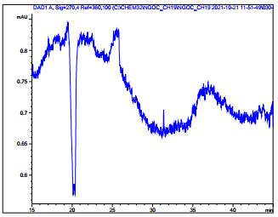  A  A | 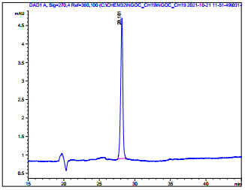  Stachyose  B  B
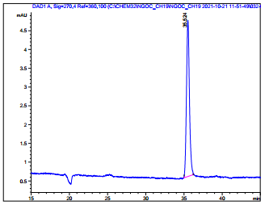  Lactose  C  C | 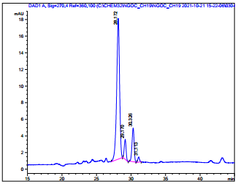  Stachyose  D  D
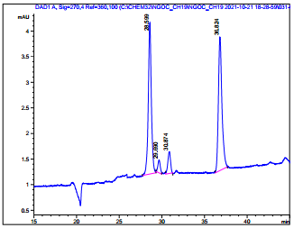  Stachyose  Lactose  E  E | 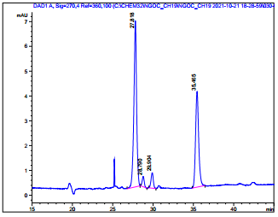  Stachyose  Lactose  F
Figure 6: Electrophoresis results to test specificity (A: Blank sample, B: Stachyose standard, C: Lactose internal standard, D: Test, E: Test + IS, F: Test + Standard + IS)

Table 4. Validation the quantification process of stachyose in Stachy affinis rhizomes
Criterion | Requirement | Result of validation of CE-DAD process
System compatibility | The RSD of the retention time and the peak area of the principal peak to be analyzed in the standard and test samples are both ≤ 2 %; tail drag coefficient (T) is in the range of 0.8-2.0; apparent theoretical disk number (≥ 2000) | RSD_{tR}= 0.363%;  RSD_{Spic}= 0.813%;  T= 1.22; N_{bk}= 42354
Specificity | Mass spectrometry corresponds to standard samples and has been shown to be unaffected by excipients with respect to retention time and the software's peak purity check feature. The mass spectra of the peak in the sample and in the standard chromatogram were the same. | Complied (Figure 6, Table 3)
Linearity range | Use regression analysis with t-test to check the significance of coefficients in the regression equation and F-test to check the appropriateness of the regression equation. R > 0,98 | ŷ = 0.0147x;  R² = 0.9995  Range: 4.46 – 89.18 µg/mL
Accuracy | The recovery range in 3 levels 80, 100, 120 % is 98-102 %. RSD ≤ 2 % | Recovery (Confidence Level 95.0%): 100.72 ± 1.01%; RSD% (n=9): 1,01%
Repeatability | RSD ≤ 2 % | Mean of stachyose content: 42.20%. RSD% (n=6): 1.77%.
Intermediate Precision | The results obtained should not be significantly different (using F-test with 95 % confidence interval to test). RSD ≤ 2 % | Mean of stachyose content: 42.49%; RSD% (n=12): 1.94%
LOD -LOQ | Determine the minimum concentration at which the analyte response can be read | LOD = 5.00 µg/mL  LOD = 15.00 µg/mL

3.2 Discussion

The absence of chromophores and fluorophores in carbohydrate molecules makes quantitative detection of carbohydrate problematic. To address the aforementioned issue, numerous approaches have been devised, including indirect photometry, amperometric measurement, derivatization, and so on (Hase, 1996), (Volpi, 2011). In this study, hydroxyl groups are ionized at a high pH.
Carbohydrates in alkaline solutions can participate in a series of ionization, denaturation, enolization, and isomerization reactions leading to the formation of the enediolate anion. These enediolate anions are intermediates in the alkaline degradation of carbohydrates. In NaOH buffer pH = 12.4, the Na⁺ cation interacts with enediolate anions to prevent the formation of carboxylic acids. Typical alkaline decomposition products of glucose and other hexoses have conjugated enol carbonyls that absorb ultraviolet light at 265 nm. In addition, enediolate can participate in a reduction reaction to produce adicarbonyl compounds. For example, enediolate derived from glucose through reduction produces 3-deoxy-derythro-hexos-2-ulose, which, thanks to the conjugated carbonyl group of the product, has UV spectral absorption at 265 nm (Rovio et al., 2007). Correspondingly, in this study, the maximum absorption peak of stachyose was 270 nm.
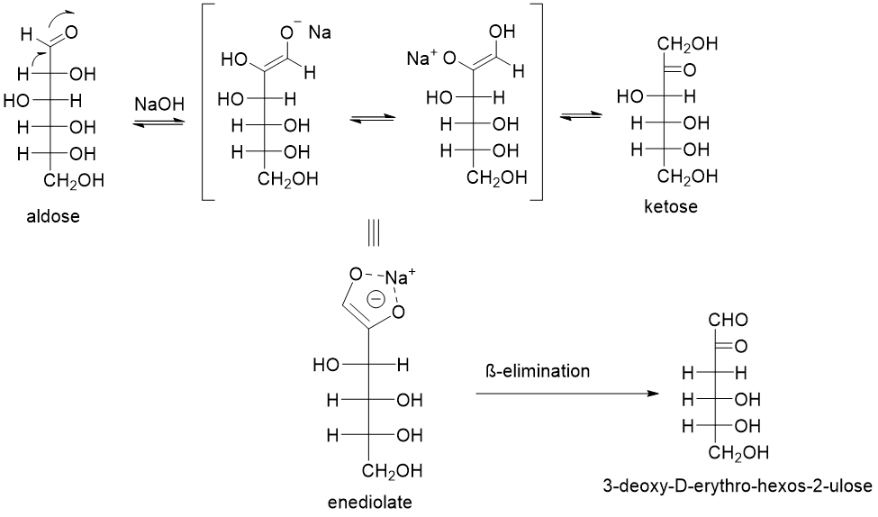
In the capillary electrophoresis method, a capillary column is used as an analytical channel to perform the separation of substances. During analysis, the inner surface of the glass capillary wall becomes negatively charged due to the silanol groups releasing H⁺ ions into the buffer, and the positively charged stachyose and internal standard are affected by electrostatic attraction. into the negatively charged capillary wall, creating a double layer of charge. When a voltage is applied, the electrodialysis current moves to the cathode, dragging the substances to the probe. Substances with large molecular masses will move faster than substances with smaller molecular masses.
Figure 7: Reaction mechanism for enediolate formation and β-elimination reaction
The degree of ionization of the silanol group on the capillary wall depends mainly on the pH of the working buffer and the modifiers added to the electrolyte. When increasing the pH to 12.4, the silanol group becomes more ionized, and the EOF current increases, increasing the signal of the peaks. The substances move more slowly, helping to separate them more clearly.
In some cases, organic solvents such as methanol or acetonitrile are added to the buffer solution to increase the solubility of solutes and additives or to influence the degree of ionization of the sample. However, stachyose is a polar substance that is easily soluble in water, so adding organic solvents is not necessary. On the other hand, adding organic modifiers will reduce the level of ionization and EOF current, resulting in a non-UV-Vis absorber. In this analysis, when organic solvents were added, no signals of stachyose and lactose were recorded.
Na₂HPO₄ in the buffer solution impacts peak resolution because it increases the viscosity of the buffer, resulting in a longer time to move the compounds and greater resolution. Furthermore, the addition of Na₂HPO₄ in the buffer solution improves baseline stability and lowers noise (Rovio et al., 2007).
In addition, capillary and capillary column temperatures influence the analysis results. Increasing the voltage improves separation efficiency and resolution, but it is critical to manage and keep the voltage below the level where Jun heat dissipation occurs. The viscosity of the buffer solution varies as the temperature rises or falls. Electroosmotic current and electrophoretic mobility are inversely related to buffer solution viscosity, therefore as the viscosity changes, so do the electrophoretic mobility and electroosmotic current …
A substance selected as an internal standard must match the following criteria: physical and chemical qualities similar to the substance of interest, non-reactivity with the analyte, stability in solution, accessible on the market. High purity with maximal absorption at the required wavelength. As a result, you can choose from sugars like glucose, fructose, sucrose, lactose, and so on. Stachyose is a tetrasaccharide made up of two α-D-galactose, one α-D-glucose, and one β-unit. D-fructose should be used as the internal standard to avoid stachyose hydrolysis interfering with the chromatographic results (Gilardi and Flippen, 1975).

CONCLUSION

The process for quantifying stachyose in Stachys affinis rhizomes using CE-DAD has been verified and meets the standards of the ICH and AOAC recommendations, allowing it to be used for input material quality control. The technique has system compatibility, good selectivity, a wide linearity range (4.46-89.18 µg/ml), and high sensitivity (LOD and LOQ of 5.00 and 15.00 µg/ml, respectively). According to AOAC guidelines (2012), the technique achieved repeatable precision, intermediate precision with RSD 1.77% (n = 6) and 1.94% (n = 12), as well as recovery of 99.01-102.1%.

Disclaimer (Artificial intelligence)
Option 1:
Author(s) hereby declare that NO generative AI technologies such as Large Language Models (ChatGPT, COPILOT, etc.) and text-to-image generators have been used during the writing or editing of this manuscript.

REFERENCE

ASSOCIATION OF OFFICIAL ANALYTICAL CHEMISTS 2012. Appendix K: Guidelines for Dietary Supplements and Botanicals. AOAC Offical Methods Analysis. 19th ed.
BỘ Y TẾ 2017. Dược điển Việt Nam V, Hà Nội, Nhà xuất bản Y học.
GILARDI, R. D. & FLIPPEN, J. L. 1975. Conformation of the tetrasaccharide stachyose. Journal of the American Chemical Society, 97, 6264-6266.
HASE, S. 1996. Precolumn derivatization for chromatographic and electrophoretic analyses of carbohydrates. Journal of Chromatography A, 720, 173-182.
HYMOWITZ, T. & COLLINS, F. I. 1974. Variability of Sugar Content in Seed of Glycine max (L.) Merrill and G. soja Sieb. and Zucc.1. Agronomy Journal, 66, 239-240.
INTERNATIONAL CONFERENCE ON HARMONISATION OF TECHNICA REQUIREMENTS FOR REGISTRATION OF PHARMACEUTICALS FOR HUMAN USE (ICH) 2005. Validation of analitical procedures: Text and methodology Q2(R1). 1 - 17.
LIANG, L., LIU, G., YU, G., ZHANG, F., LINHARDT, R. J. & LI, Q. 2020. Urinary metabolomics analysis reveals the anti-diabetic effect of stachyose in high-fat diet/streptozotocin-induced type 2 diabetic rats. Carbohydr Polym, 229, 115534.
LIM, T. 2016. Edible Medicinal and Non-Medicinal Plants.
NAKAKUKI, T. 2005. Present Status and Future Prospects of Functional Oligosaccharide Development in Japan. Journal of Applied Glycoscience, 52, 267-271.
ROVIO, S., YLI-KAUHALUOMA, J. & SIRÉN, H. 2007. Determination of neutral carbohydrates by CZE with direct UV detection. ELECTROPHORESIS, 28, 3129-3135.
VENDITTI, A., FREZZA, C., CELONA, D., BIANCO, A., SERAFINI, M., CIANFAGLIONE, K., FIORINI, D., FERRARO, S., MAGGI, F., LIZZI, A. R. & CELENZA, G. 2017. Polar constituents, protection against reactive oxygen species, and nutritional value of Chinese artichoke (Stachys affinis Bunge). Food Chemistry, 221, 473-481.
VOLPI, N. 2011. Capillary electrophoresis of carbohydrates: From Monosaccharides to complex polysaccharides.
WIŚNIEWSKI, R. & HARASYM, J. 2024. Chinese Artichoke (Stachys affinis Bunge): The Nutritional Profile, Bioactive Profile and Food Applications-A Review. 29.
YIN, J., YANG, G., WANG, S. & CHEN, Y. 2006. Purification and determination of stachyose in Chinese artichoke (Stachys Sieboldii Miq.) by high-performance liquid chromatography with evaporative light scattering detection. Talanta, 70, 208-12.

