Original Research Article

Impact of salt stress on seed germination and seedling growth of Cicer arietinum L.

Abstract
Salt stress is a major abiotic constraint affecting crop productivity worldwide, particularly in arid and semi-arid regions where soil salinization is intensifying due to poor irrigation practices and climatic variability. This study evaluates the impact of salt stress on seed germination and early seedling growth of Cicer arietinum L. (chickpea), a legume moderately sensitive to salinity during its initial developmental stages. Two salts—sodium chloride (NaCl) and potassium chloride (KCl)—were applied at four concentrations: 0% (control), 0.5%, 1%, and 2%. Surface-sterilized seeds were sown in cotton-lined Petri dishes and treated with 2 ml of the respective salt solution every two days over a seven-day period under controlled laboratory conditions. Physiological parameters including germination percentage (GP), mean germination time (MGT), and seed vigor indices (SVI-1 and SVI-2) were measured to assess seedling performance and stress tolerance. Results indicated that both NaCl and KCl significantly inhibited germination and seedling growth at 1% and 2% concentrations, with complete suppression observed at these levels. At 0.5%, seeds showed delayed germination, reduced root and shoot lengths, and lower vigor compared to the control. Notably, KCl-treated seeds exhibited slightly higher GP and vigor indices than those exposed to NaCl, suggesting that potassium ions are less phytotoxic than sodium ions under equivalent osmotic stress. The findings confirm that elevated salinity adversely affects early chickpea development, with NaCl exerting a more detrimental effect. This underscores the importance of breeding salt-tolerant chickpea varieties and implementing sustainable soil and water management strategies in saline-prone agricultural zones. Additionally, the methodology and quantitative indicators employed offer a reliable framework for screening salinity tolerance in other leguminous crops.
Keywords: Salt stress, Seed germination, Cicer arietinum, NaCl, KCl, Seedling growth, Germination percentage

- INTRODUCTION
Seed germination is a vital developmental stage in the life cycle of higher plants. It signifies the transition from a quiescent seed to an actively growing seedling. This phase begins with water adsorption (imbibition) and ends with the emergence of the radicle, which marks the completion of germination and the onset of seedling development (Bewley, 1997; Nonogaki et al., 2010). The success of this early stage is crucial for plant establishment, especially under stressful environmental conditions.
Environmental factors influencing seed germination include both biotic (e.g., microbial interactions) and abiotic (e.g., temperature, moisture, light, and salinity) stresses. Among these, salinity is particularly significant in arid and semi-arid environment, where it poses a major limitation to crop productivity and natural vegetation growth (Buchanan et al., 2005; Munns & Tester, 2008). The severity of salt stress is due to both osmotic effects, which limit water availability, and ionic toxicity caused by excessive sodium (Na⁺) and chloride (Cl⁻) ions (Zhu, 2001; Cherifi et al., 2016).
Salinity adversely affects multiple physiological processes, including seed germination and seedling development. These effects include reduced water uptake, disruption of metabolic activities, and damage to cellular structures, ultimately resulting in delayed germination, lower germination percentage, and reduced seedling vigor (Huang et al., 2021; Hasanuzzaman et al., 2013). Salt stress also leads to the production of reactive oxygen species (ROS), which cause oxidative damage to proteins, lipids, and nucleic acids unless neutralized by antioxidant defence systems (Apel & Hirt, 2004).
Chickpea (Cicer arietinum L.) is one of the most important pulse crops grown in tropical and subtropical regions. Despite being moderately salt-tolerant, chickpea is particularly sensitive during its early growth stages. High salinity has been reported to significantly reduce germination percentage, delay germination time, and impair both root and shoot elongation in chickpea seedlings (Flowers et al., 2010; Turner et al., 2013). Physiological mechanisms such as osmotic adjustment, ion exclusion, and activation of antioxidant enzymes are involved in chickpea’s response to salt stress (Ashraf & Foolad, 2007). Furthermore, the use of plant growth-promoting rhizobacteria (PGPR) has been shown to enhance salt tolerance in chickpea by improving nutrient uptake and stimulating hormonal responses (Egamberdieva et al., 2019).
Globally, over 900 million hectares of land are affected by salinity, accounting for approximately 20% of the total cultivable land (FAO, 2007). In this context, the ability of seeds to germinate under saline conditions is critical for agricultural sustainability, especially in regions prone to salinization. Studies show that seeds germinating rapidly under both normal and salt-stressed conditions are more likely to establish robust seedlings and yield better crops (Munns, 2002; Cuartero et al., 2006).
This study seeks to investigate the effects of salt stress on seed germination and early seedling growth of chickpea using two common salts, NaCl and KCl, at varying concentrations. Through controlled laboratory experiments and assessment of physiological parameters such as germination percentage (GP), mean germination time (MGT), and seed vigor indices (SVI-1 and SVI-2).
Materials and Methods
2.1 Study Area and Climatic Conditions
The experimental work was conducted in the Botany Laboratory of Anchal College, Padampur, Odisha, situated at 20.98°N latitude and 80.04°E longitude. The region lies in the tropical zone, with an average annual rainfall of approximately 1527 mm, relative humidity of 62%, and an average temperature of 27°C (80.6°F). These agro-climatic conditions provide a suitable environment for assessing the effect of abiotic stress, particularly salinity, on early plant development.
2.2 Seed Selection and Sterilization
Healthy, uniform-sized seeds of Cicer arietinum L. (chickpea) were procured from a certified agricultural supplier. To eliminate surface-borne pathogens and ensure aseptic conditions, the seeds were surface-sterilized by immersion in 70% ethanol for 1–2 minutes, followed by thorough rinsing with sterile distilled water (ISTA, 2021; Nonogaki et al., 2010). This standard sterilization protocol prevents microbial contamination during germination tests.

2.3 Preparation of Salt Solutions
Two types of salt were used as abiotic stress agents:
Sodium chloride (NaCl) salt company name
Potassium chloride (KCl)
For each salt, four concentrations were prepared in distilled water: 0% (control), 0.5%, 1%, and 2% (w/v). These concentrations were selected based on prior literature indicating mild to severe salinity stress levels that affect seed physiology (Munns & Tester, 2008; Flowers et al., 2010).
2.4 Experimental Design for Germination Assay
The experiment followed a completely randomized design (CRD) with five seeds per replicate, and at least three replicates per treatment. Sterile Petri dishes (9 cm diameter) were lined with double layers of cotton and moistened initially with 5–10 ml of the respective salt solution. Seeds were evenly placed on the cotton and incubated in a controlled environment chamber set at optimal temperature and light conditions for chickpea germination (approximately 25–27°C and 12 h light/12 h dark photoperiod). Salt treatments were reapplied every two days using 2 ml of freshly prepared solution to maintain consistent salinity (ISTA, 2021).

2.5 Germination Monitoring and Growth Measurement
Germination was recorded daily for 7 days. A seed was considered germinated when the radicle protruded at least 2 mm. The daily observations made it possible to calculate not only the germination percentage, which reflects the proportion of seeds that successfully germinate, but also other important parameters such as mean germination time (MGT), which represents the average time taken for germination to occur. Recording germination over multiple days further enabled the assessment of germination speed, uniformity, and seed vigor. Seeds that exhibited early and synchronized germination with a high final germination percentage were considered more vigorous and of better physiological quality, whereas delayed or irregular germination indicated reduced seed performance.
2.5.1 Germination Percentage (GP): This standard index reflects seed viability under stress (ISTA,2021). A higher germination percentage indicates good seed health, vigor, and better chances of establishment in the field, whereas a lower percentage suggests poor seed quality, dormancy issues, or unfavorable storage and environmental conditions. Therefore, germination percentage serves as a fundamental measure in seed testing, crop improvement, and agricultural research.
Germination Percentage = (Number of seeds germinated / Total number of seeds) × 100

2.5.2 Mean Germination Time (MGT):MGT indicates the speed and uniformity of germination (Bewley, 1997). Mean germination time is a parameter that indicates the average time taken for a group of seeds to germinate under specific conditions. It is calculated by considering both the number of seeds germinated each day and the time taken for their germination. MGT reflects the speed and uniformity of germination, with a lower value indicating faster and more vigorous germination.
MGT = ∑ (n × d) / N
Where n = number of seeds germinated, d=number of days, and N = total number of seeds germinated.

2.6 Seedling Growth Parameters:
On the 7th day, germinated seedlings were carefully removed and measured for: Root length (radicle), Shoot length (plumule), Total seedling length (root + shoot), Dry biomass (after oven-drying at 60°C for 24 hours), Seed Vigor Index – I (SVI-1) and Seed Vigor Index – II (SVI-2).
2.6.1 Seed Vigor Index – I (SVI-1)
SVI-1 = Germination Percentage × Average Seedling Length (cm)
This index indicates early vigor under stress conditions (Abdul-Baki & Anderson, 1973).
2.6.2 Seed Vigor Index – II (SVI-2):
SVI-2 = Germination Percentage × Average Seedling Dry Weight (mg)
This parameter assesses seedling robustness based on biomass accumulation.
- Results
The experimental results demonstrate the significant impact of salt stress on seed germination and seedling growth in Cicer arietinum L. (chickpea). The data, presented across three tabulations, reveal clear trends corresponding to different concentrations of NaCl and KCl.
Germination Percentage :
In both NaCl and KCl treatments, control conditions (0% salt) supported optimal germination. Seeds exposed to 0% NaCl exhibited progressive germination from Day 1, reaching 100% by Day 3(Table1a). A similar pattern was observed in 0% KCl, though germination initiated slightly later, achieving full germination by Day 4(Table1b). At 0.5% concentration, germination was delayed in both salt treatments. For NaCl, germination was only 40% by Day 3 and reached 100% by Day 4. For KCl, germination followed a slower progression but reached 100% by Day 5(Table 1a and Table1b). No germination was recorded at 1% and 2% concentrations of either salt, indicating that elevated salinity exerts a strongly inhibitory effect on seed emergence(Table1a and Table 1b).
These results indicate that while low levels of salt stress may delay germination, higher concentrations completely inhibit it. Seeds treated with KCl at 0.5% performed slightly better than those treated with NaCl, suggesting that potassium ions may exert less toxicity than sodium ions at similar concentrations.
This finding aligns with prior research indicating that sodium ions are more disruptive to cellular ion homeostasis and water uptake during early germination (Munns & Tester, 2008; Van Zelm et al., 2023; Wang et al., 2008).
Mean Germination Time (MGT):
MGT values further confirmed the inhibitory effect of salt stress. Under control conditions, seeds treated with NaCl and KCl germinated efficiently, with MGT values of 3.08 and 3.22 days, respectively. However, at 0.5% salt concentration, MGT increased to 3.66 days for NaCl and 3.64 days for KCl, indicating delayed germination under stress. No germination was observed at 1% and 2% concentrations(Table2), resulting in no calculable MGT. The rise in MGT at 0.5% confirms that even moderate salt stress can delay the physiological processes involved in germination, such as water imbibition, enzyme activation, and radicle emergence (Atta et al., 2023; Jamil et al., 2006).
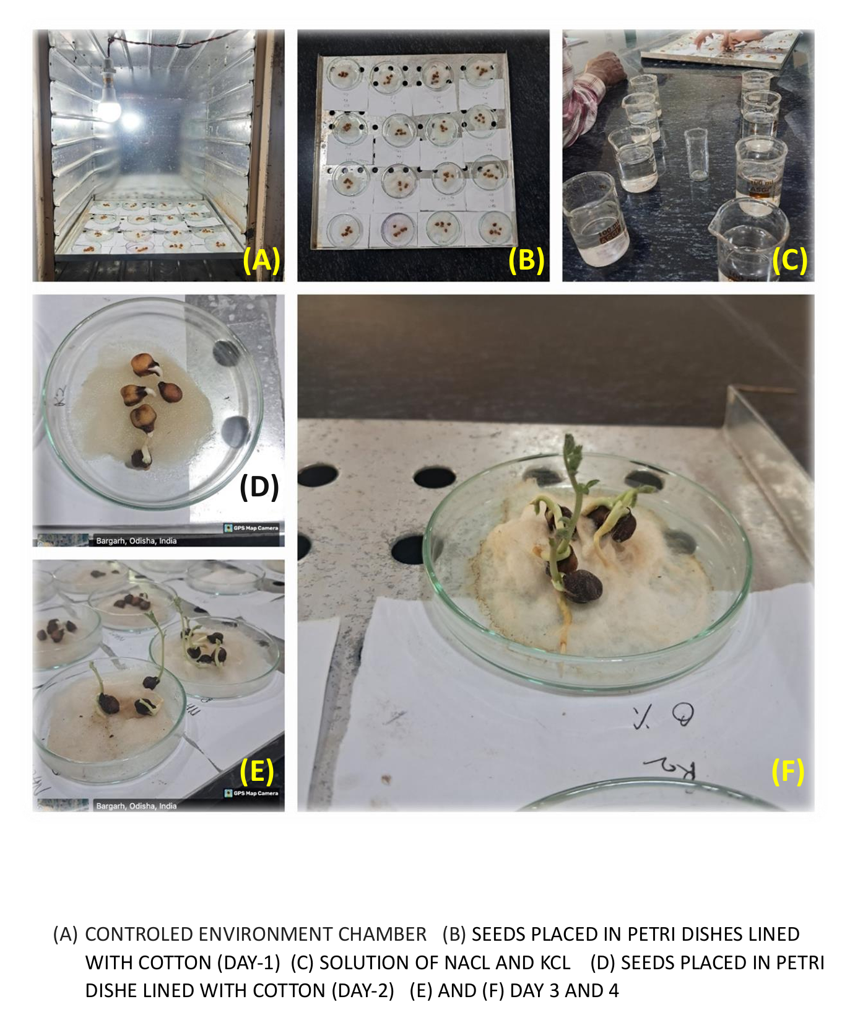
Fig. 1: Germination of chickpea seeds under different concentrations of NaCl and KCl

Seed Vigor Index (SV1 and SV2):
Seed vigor indices provided further insights into the quality and strength of emerging seedlings. Under non-stressed conditions (0% salt), both salts supported healthy seedling development with high root and shoot lengths(Table3). The total seedling length and dry biomass were comparable between NaCl and KCl, leading to high SVI values in both treatments.
However, at 0.5% concentration, although the germination percentage remained 100%, a notable decline in root and shoot lengths, as well as dry weight, was recorded(Table3). This reduction translated to lower SVI-1 and SVI-2 values, indicating that even low salt stress compromises seedling vigor. Once again, seedlings under KCl stress showed slightly better vigor than those under NaCl at 0.5%, supporting the observation that potassium chloride may be less harmful during early growth stages. At 1% and 2% concentrations, no germination occurred, resulting in SVI values of zero. These findings confirm that Cicer arietinum is highly sensitive to salt stress during the germination phase, with a clear threshold beyond which both germination and seedling development are entirely inhibited.
Figure 3 shows that seeds under control conditions (NaCl 0%, KCl 0%) reached maximum germination more quickly than those under saline treatments. Both NaCl 0.5% and KCl 0.5% delayed germination onset, with NaCl-treated seeds recovering faster than KCl-treated ones, though all treatments achieved 100 % germination by the final day.

Number of days | NaCl Concentrations (%)
Number of days | 0 | 0.5 | 1 | 2
1 | 60 | 0 | 0 | 0
2 | 80 | 20 | 0 | 0
3 | 100 | 40 | 0 | 0
4 | 100 | 100 | 0 | 0
5 | 100 | 100 | 0 | 0
Table 1a. Percentage of germination in C. arietinum L. seeds subjected to different concentrations of NaCl

Number of days | KCl Concentrations (%)
Number of days | 0 | 0.5 | 1 | 2
1 | 40 | 0 | 0 | 0
2 | 60 | 20 | 0 | 0
3 | 100 | 40 | 0 | 0
4 | 100 | 80 | 0 | 0
5 | 100 | 100 | 0 | 0
Table 1b. Percentage of germination in C. arietinum L. seeds subjected to different concentrations of KCl

Table 2. Mean Germination Time (MGT)

Day (d) | NaCl 0% | NaCl 0.5% | NaCl 1% | NaCl 2% | KCl 0% | KCl 0.5% | KCl 1% | KCl 2%
Day 1 | 4 | 1 | 0 | 0 | 3 | 1 | 0 | 0
Day 2 | 5 | 2 | 0 | 0 | 4 | 2 | 0 | 0
Day 3 | 5 | 3 | 0 | 0 | 5 | 4 | 0 | 0
Day 4 | 5 | 4 | 0 | 0 | 5 | 5 | 0 | 0
Day 5 | 5 | 5 | 0 | 0 | 5 | 5 | 0 | 0
Total seeds  Germinated  (N) | 24 | 15 | 0 | 0 | 22 | 17 | 0 | 0
MGT (days)  Ʃ(n×d)/N | 3.08 | 3.66 | – | – | 3.22 | 3.64 | – | –

Table 3. Seed Vigor Index (SVI) 1 and 2 againt NaCl and KCl
Treatment | Salt Type | Conc (%) | No. of Seeds Germinated | Germination (%) | Avg. Root Length (Radicle) | Avg. Shoot Length (Plumule) | Total Seedling Length (Shoot + Root) | Seed Vigor Index (SVI-I) | Avg. Seedling Dry Weight (mg) | Seed Vigor Index (SVI-II)
01 | NaCl | 0 | 5 | 100% | 9.2 | 14.94 | 24.14 | 2414 | 300.2 | 5020
02 | NaCl | 0.5 | 5 | 100% | 7.1 | 4.3 | 11.4 | 1140 | 223.8 | 2230
03 | NaCl | 1 | 0 | 0% | 0 | 0 | NG* | 0 | 0 | NG
04 | NaCl | 2 | 0 | 0% | 0 | 0 | NG | 0 | 0 | NG
05 | KCl | 0 | 5 | 100% | 8.9 | 14.96 | 23.96 | 2396 | 310 | 3100
06 | KCl | 0.5 | 5 | 100% | 8.3 | 10.8 | 19.1 | 1910 | 242.2 | 2422
07 | KCl | 1 | 0 | 0% | 0 | 0 | NG | 0 | 0 | NG
08 | KCl | 2 | 0 | 0% | 0 | 0 | NG | 0 | 0 | NG

*NG= No Germination

- Discussion
The present study highlights the pronounced inhibitory effects of salinity on the germination and early seedling growth of Cicer arietinum. Even moderate concentrations (0.5% NaCl ≈ 85.6 mM; 0.5% KCl ≈ 67.1 mM) delayed germination, increased mean germination time (MGT), and reduced seed vigor indices (SVI-I and SVI-II). At higher salt levels (≥1%), germination was completely inhibited, indicating a critical threshold beyond which chickpea seeds cannot initiate successful germination. These results agree with recent studies reporting that chickpea germination is highly sensitive to salinity stress, particularly during the initial developmental stages (Gaid et al., 2021; Policepatil et al., 2024).
At 0.5% salt concentration, germination percentage reached 100%, but seedlings showed stunted growth and reduced vigor indices. This suggests that osmotic stress slowed water uptake and enzyme activation, while ionic toxicity impaired metabolic functions essential for elongation. Similar reductions in root and shoot length under moderate salinity have been reported in chickpea by Kundu et al. (2023), who found significant declines in vigor despite relatively high germination percentages. Artificial neural network modeling of chickpea response to 6.25–125 mM NaCl also demonstrated progressively lower root and shoot performance, confirming that vigor traits are more reliable indicators of salt sensitivity than germination percentage alone (Artificial neural network modeling, 2023).
A comparative analysis between NaCl and KCl treatments revealed that sodium salts exerted stronger inhibitory effects than potassium salts at equivalent osmotic strengths. This supports the view that sodium disrupts ion homeostasis, membrane stability, and enzyme activity, whereas potassium is an essential nutrient that contributes to osmotic adjustment and protein synthesis (Zhu, 2001; Ashraf & Foolad, 2007). The slightly higher SVI values under KCl stress in this study are consistent with the findings of Dadach et al. (2023) and Bouzroud et al. (2023), who emphasized the relatively lower phytotoxicity of potassium compared with sodium.
The observed differences in tolerance thresholds across studies are likely linked to genotype variation, seed lot vigor, and methodological differences in salinity exposure. For example, Policepatil et al. (2024) identified genotypes such as WR-315 that maintained nearly 100% germination and high vigor at 120 mM NaCl, while others were more sensitive. Similarly, Gaid et al. (2021) observed that although germination percentage was not drastically reduced at 170 mM NaCl in some genotypes, root length was significantly affected. These findings underline that both genotype and vigor indices should be considered when screening chickpea under saline conditions.
Overall, our study reinforces that chickpea is highly vulnerable to salinity during germination, with sodium salts exerting stronger toxicity than potassium salts. The combined use of germination percentage, MGT, and vigor indices proved to be effective in assessing seed performance under stress. Future efforts should focus on screening and breeding salt-tolerant genotypes (Policepatil et al., 2024; Kundu et al., 2023) and adopting mitigation strategies such as seed priming and bio-inoculants (Paul et al., 2023; Egamberdieva et al., 2019) to enhance establishment in saline environments.
Fig-1: 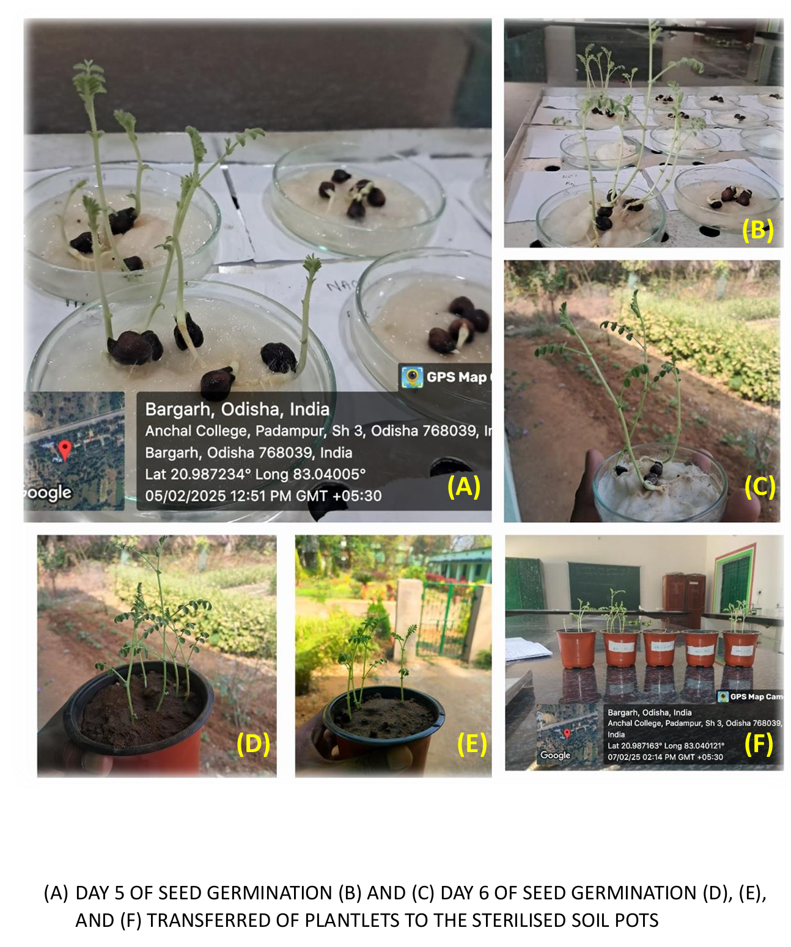
Fig-2: Seeds under different germination stages
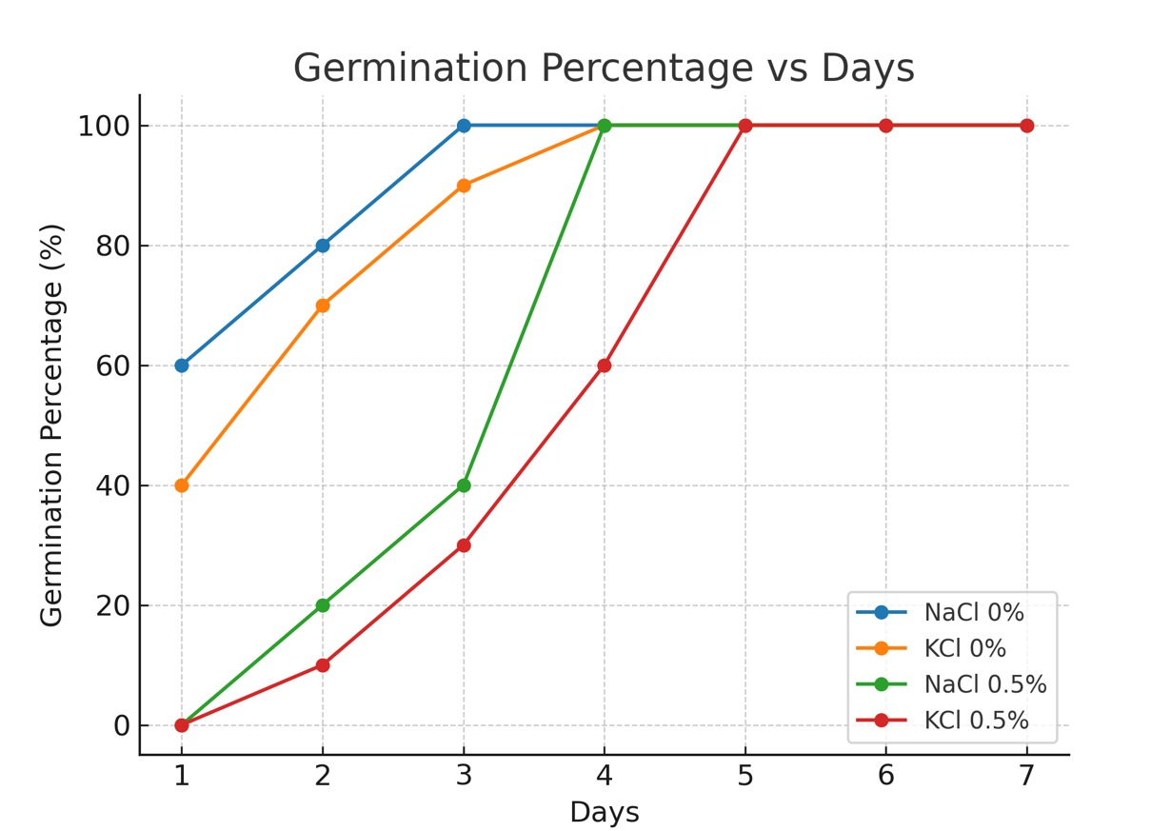
Fig-3 Germination percentage vs Days

- Conclusion
This study conclusively shows that salt stress, induced by both sodium chloride (NaCl) and potassium chloride (KCl), significantly impairs the germination and early seedling development of Cicer arietinum L. (chickpea). Under control conditions, seeds achieved rapid and complete germination, while exposure to moderate salinity (0.5%) resulted in delayed germination, increased mean germination time (MGT), and reduced seed vigor indices (SVI-I and SVI-II), despite attaining 100% germination. At higher salt concentrations (1% and 2%), germination and seedling growth were completely suppressed, demonstrating a clear toxicity threshold beyond which chickpea seeds cannot establish.
Comparative analysis further revealed that NaCl exerted stronger inhibitory effects than KCl, consistent with the disruptive role of sodium ions in ion homeostasis and metabolic functions, whereas potassium ions are essential for osmotic regulation and physiological activity. These findings reinforce that chickpea is highly vulnerable to salinity during the germination stage, with sodium salts being particularly detrimental.
The results underscore the urgent need for integrated strategies to enhance chickpea performance in saline-prone regions. These include screening and breeding salt-tolerant genotypes, adopting seed priming and bio-inoculant technologies, and implementing sustainable soil and water management practices to mitigate salt accumulation. The physiological indicators employed in this study—germination percentage, MGT, and seed vigor indices—provide a reliable framework for evaluating salt tolerance in chickpea and may be extended to other legumes for targeted improvement under salinity stress. Further research should focus on identifying salt-tolerant chickpea genotypes using molecular markers, investigating antioxidant defense mechanisms, and exploring biotechnological interventions such as transgenic and genome-editing approaches to improve resilience against salinity stress.
DISCLAIMER (ARTIFICIAL INTELLIGENCE)Author(s) hereby declare that NO generative AI technologies such as Large Language Models (ChatGPT, COPILOT, etc.) and text-to-image generators have been used during the writing or editing of this manuscript.
COMPETING INTERESTS Authors have declared that no competing interests exist
References
Abdul-Baki, A. A., & Anderson, J. D. (1973). Vigor determination in soybean seed by multiple criteria. Crop Science, 13(6), 630–633.
Apel, K., & Hirt, H. (2004). Reactive oxygen species: Metabolism, oxidative stress, and signal transduction. Annual Review of Plant Biology, 55, 373–399.
Artificial neural network modeling for deciphering the in vitro induced salt stress tolerance in chickpea (Cicer arietinum L.). Physiology and Molecular Biology of Plants, 29, 289–304 (2023). https://doi.org/10.1007/s12298-023-01282-z
Ashraf, M., & Foolad, M. R. (2007). Roles of glycine betaine and proline in improving plant abiotic stress resistance. Environmental and Experimental Botany, 59(2), 206–216.
Atta, K., et al. “Impacts of salinity stress on crop plants: improving salt tolerance.” Frontiers in Plant Science (2023). Frontiers
Bewley, J. D. (1997). Seed germination and dormancy. The Plant Cell, 9(7), 1055–1066.
Bouzroud, S., Djillali, A., Hamidi, Y., & Benhassaini, H. (2023). Germination response of chickpea (Cicer arietinum L.) genotypes under salt stress conditions. Plants, 12(5), 1013. https://doi.org/10.3390/plants12051013
Buchanan, B., Gruissem, W., & Jones, R. (Eds.). (2005). Biochemistry and Molecular Biology of Plants. American Society of Plant Biology.
Cherifi, K., Boufous, E. H., Boubaker, H., & Msanda, F. (2016). Comparative salt tolerance study of some Acacia species at seed germination stage. Asian Journal of Plant Sciences, 15(3–4), 66–74.
Cuartero, J., Bolarin, M. C., Asins, M. J., & Moreno, V. (2006). Increasing salt tolerance in tomato. Journal of Experimental Botany, 57(5), 1045–1058.
Dadach, M., Meftah, M., Benaissa, A., & Hannachi, A. (2023). Effect of different chloride salts on seed germination and early seedling growth of legumes. Legume Research, 46(8), 1045–1052. https://doi.org/10.18805/LR-6492
Egamberdieva, D., Wirth, S., Dorothea, S., Mishra, J., & Arora, N. K. (2019). Salt-Tolerant Plant Growth Promoting Rhizobacteria for Enhancing Crop Productivity of Saline Soils. Frontiers in Microbiology, 10, 469278. https://doi.org/10.3389/fmicb.2019.02791fao
FAO. (2007). Land and Plant Nutrition Management Service. Food and Agriculture Organization of the United Nations.
Flowers, T. J., Gaur, P. M., Gowda, C. L., Krishnamurthy, L., Samineni, S., Siddique, K. H., ... & Colmer, T. D. (2010). Salt sensitivity in chickpea. Plant, Cell & Environment, 33(4), 490–509.
Gaid, S., Megherbi, A., & Belkhodja, M. (2021). Effect of salt stress on the germination of chickpea (Cicer arietinum L.). International Journal of Research in BioSciences, 10(1), 17–24.
Hasanuzzaman, M., Hossain, M. A., & Fujita, M. (2013). Plant responses and tolerance to abiotic oxidative stress: Antioxidant defense is a key factor. In V. Ahmad et al. (Eds.), Oxidative Damage to Plants (pp. 261–315). Springer.
Huang, Y., Zhou, J., Li, Y., Quan, R., Wang, J., Huang, R., & Qin, H. (2021). Salt Stress Promotes Abscisic Acid Accumulation to Affect Cell Proliferation and Expansion of Primary Roots in Rice. International Journal of Molecular Sciences, 22(19), 10892. https://doi.org/10.3390/ijms221910892
ISTA (International Seed Testing Association). (2021). International Rules for Seed Testing. Zurich, Switzerland.
Jamil, M., Lee, D. B., Jung, K. Y., Ashraf, M., Lee, S. C., & Rha, E. S. “Effect of salt (NaCl) stress on germination and early seedling growth of four vegetable species.” Journal of Central European Agriculture 7, 2 (2006): 273–282. Journal of Cen
Kundu, V., Sarkar, M., & Kundagrami, S. (2023). Screening of chickpea (Cicer arietinum L.) germplasms under salt stress. Journal of Eco-Friendly Agriculture, 18(2), 279–285.
Munns, R. (2002). Comparative physiology of salt and water stress. Plant, Cell & Environment, 25, 239–250.
Munns, R., & Tester, M. (2008). Mechanisms of salinity tolerance. Annual Review of Plant Biology, 59, 651–681.
Nonogaki, H., Bassel, G. W., & Bewley, J. D. (2010). Germination—Still a mystery. Plant Science, 179(6), 574–581.
Paul, P., Nath, R., & Debnath, M. (2023). Seed priming as an effective strategy to mitigate salinity stress in pulses: A review. Frontiers in Sustainable Food Systems, 7, 112233. https://doi.org/10.3389/fsufs.2023.112233
Policepatil, B., Doddagoudar, S., Gowda, B., Macha, S. I., & Lakshmikanth, L. (2024). Salinity tolerance in chickpea genotypes during germination. Seed Research, 49(1), 1–7. https://ebook.icar.gov.in/index.php/SR/article/view/152663
Turner, N. C., Colmer, T. D., Quealy, J., Pushpavalli, R., Krishnamurthy, L., Kaur, J., Singh, G., Siddique, K. H. M., & Vadez, V. (2013). Salinity tolerance and ion accumulation in chickpea (Cicer arietinum L.) subjected to salt stress. Plant and Soil, 365(1-2), 347-361.
Van Zelm, E., Bugallo-Alfageme, S., Behrouzi, P., Meyer, A. J., Testerink, C., & Gommers, C. M. M. (2023). Natural variation in salt-induced root growth phases and their contribution to root architecture plasticity. Plant, cell & environment, 46(7), 2174–2186. https://doi.org/10.1111/pce.14583
Wang, Y., Zhang, W., Li, K., et al. (2008). Salt-induced plasticity of root hair development is caused by ion disequilibrium in Arabidopsis thaliana. Journal of Plant Research, 121, 87–96.
Zhu, J. K. (2001). Plant salt tolerance. Trends in Plant Science, 6(2), 66–71.

