Co-application of Silicon and Beneficial Microbes Enhances Antioxidant Defense and Physiological Traits in Wheat
Abstract
Wheat (Triticum aestivum L.), a global staple crop, contributes ~18% of dietary calories and 19% of protein intake. However, excessive use of chemical fertilizers, soil degradation, and salinity stress are threatening its productivity and sustainability. The present study evaluated the effect of silicon (Si), silicate-solubilizing bacteria (SSB), and phosphate-solubilizing bacteria (PSB) on two wheat varieties, Golden Sharbati 306 and HD 2967, under pot culture conditions. Five treatments, including basal NPK and combinations of Si, SSB, and PSB, were applied, and their effects on physiological, photosynthetic pigments, and antioxidant parameters were assessed.
Significant improvements were observed under combined applications (DMRT, p < 0.05). In Golden Sharbati 306, leaf relative water content (RWC) increased by up to 15.8% (T2), and root RWC by 9.1% (T3). In HD 2967, the maximum increases were 10.6% (leaves, T3) and 9.0% (roots, T4). Electrolyte leakage was reduced by 41% in Golden Sharbati 306 (T3) and 43% in HD 2967 (T3), indicating improved membrane stability. Photosynthetic pigments also showed significant enhancement: chlorophyll a increased by 41% in HD 2967 (T3), while chlorophyll b reached 0.178 mg/g FW in Golden Sharbati 306. Carotenoid content rose by 35.7% in HD 2967 (T3), and the chlorophyll stability index (CSI) remained 41% higher in combined Si + SSB + PSB treatments compared with P-deficient ones. Antioxidant enzymes were markedly enhanced, with catalase (CAT) activity increasing by 97% and peroxidase (POX) activity by 288% in HD 2967 roots under T3.
Overall, the results demonstrate that Si, SSB, sand PSB act synergistically to improve water relations, pigment stability, and antioxidant defense, thereby enhancing stress tolerance in wheat. This integrated nutrient management approach represents an eco-friendly and sustainable strategy to strengthen wheat resilience and productivity under stress-prone environments.
Keywords:Wheat, Silicon, Phosphate-solubilizing bacteria (PSB), Silicate-solubilizing bacteria (SSB), Antioxidant enzymes, Stress tolerance
.
Introduction:
One of the world’s primary staple crops—cultivated mainly for human consumption—is wheat (Triticum aestivum L.). It plays a crucial role in global nutrition security, accounting for approximately 18% of global dietary calories and 19% of daily protein intake (Global Trends in Wheat Production, Consumption and Trade, Springer, 2022).According to some estimates, climate change, poor irrigation techniques, inadequate drainage systems, and chemical fertilizers will endanger over 60% of arable lands by 2050. During the years 1970–2020, fertilizer application has increased by nearly 13 times (FAI, 2020). Plant breeding, modern agronomy practices, and usage of agrochemicals in the form of fertilizers and pesticides have tremendously led to an increase in crop yield but also caused environmental and ecological damage at a large scale. Long-term usage of these fertilizers is changing the soil chemistry and resulting in soil degradation, soil compaction, a decrease in microbial diversity, and a reduction in soil organic matter.
According to the report of the Parliamentary Standing Committee of Agriculture (2015–2016) “Impact of Chemical Fertilizer and Pesticides on Agriculture and Allied Sectors in the Country,” soil fertility of states like Haryana and Punjab has decreased due to overuse of NPK fertilizers. Furthermore, ecosystems and human health are seriously threatened by the careless use of chemical pesticides and stimulants. To lessen the negative effects of agrochemicals, it is crucial to use environmentally safe techniques ( Poveda, 2021).
The use of soil microorganisms is recognized as an effective, eco-friendly strategy to enhance crop productivity. Beneficial microbes, particularly silicate- and phosphate-solubilizing bacteria (SSB and PSB), play a vital role in mobilizing insoluble silicates and phosphates to plant-available forms. Recent studies have demonstrated that integrating PSB with wheat significantly enhances phosphorus availability, phosphatase enzyme activity, and growth parameters such as shoot and root biomass (Wang et al., 2022). In durum wheat, the combination of Si fertilization with PSB markedly improved phosphorus uptake and plant biomass in calcareous soils, highlighting the synergy between Si and microbial P solubilization (Plant and Soil, 2022). Additionally, indigenous PSB strains identified as Pantoea spp. and Lelliottia amnigena efficiently increased soil phosphorus availability and promoted wheat growth metrics including plant height, leaf area, and biomass (Sustainable Journal, 2023). Collectively, these findings confirm the critical role of PSB (and their combinations with Si) in promoting nutrient mobilization and crop growth under challenging soil conditions.
Silicon fertilizers are environmentally friendly and play a significant role in improving soil health and providing resistance to plants under various abiotic and biotic stresses through diverse mechanisms. Application of silicon fertilizers has been shown to enhance soil fertility by improving physical and chemical properties, nutrient availability, and ultimately crop yield (Tayade et al., 2022). With 28% of the lithosphere made up of silicon, it is one of the most prevalent elements in the Earth’s crust. Si is referred to as a "quasi-essential" element by the International Plant Nutrition Institute (IPNI), which acknowledges its importance in plants under stress (Liu et al., 2019). By forming a silica film on the leaf’s epidermis, Si application reduces transpiration and enhances photosynthetic activity, thereby maintaining plant water status (Abdelaal et al., 2020). Moreover, silicon (Si) supplementation is increasingly recognized as an eco-friendly strategy for mitigating salinity stress in cereals. Recent studies report that Si enhances antioxidant enzyme activity (such as catalase, peroxidase, and superoxide dismutase), helps maintain reactive oxygen species (ROS) homeostasis, sustains ionic balance, and improves the K⁺/Na⁺ ratio in salt-stressed plants (Aouz et al., 2023; Xu et al., 2022; Cereal Research Communications, 2024).
In wheat cultivated under saline environments, silicon (Si) supplementation plays a vital role in stress mitigation by enhancing antioxidant defenses, improving relative water content (RWC), and reducing electrolyte leakage. Recent studies have demonstrated these benefits across different wheat varieties under varying salinity levels (Singh et al., 2022; Singh et al., 2023).However, the positive effects of Si are further amplified when combined with beneficial soil microbes. For instance, the co-application of Si and phosphate-solubilizing bacteria (PSB) has been shown to improve phosphorus uptake and overall nutrient acquisition in wheat grown in calcareous soils (as compared to Si or PSB alone)
Moreover, in saline–alkaline contexts, halotolerant PGPR in conjunction with Si and native microbiota effectively enhanced wheat’s biomass, antioxidant enzyme activities, nutrient content, and rhizosphere microbial community structure (Xu et al., 2022) .These beneficial interactions are likely driven by enhanced Si and nutrient availability, improved ion homeostasis (e.g., reduced Na⁺ accumulation, better K⁺ uptake), osmotic adjustment, and microbiome-mediated stress buffering..
Therefore, a great deal of research has been undertaken to determine how Si supplementation, in combination with microbial nutrients, affects the regulation of antioxidant enzymes, photosynthetic pigments, electrolyte leakage, and RWC in different wheat genotypes.
2. Material and Methods
2.1. Experimental site :
The present study was carried out between October and November 2023 in the Department of Botany, Baba Mastnath University, Ashtal Bohar, Rohtak, Haryana, India. Ashtal Bohar village is situated in Rohtak district, covering an area of 1668 km², and lies between 28°40'30" N to 29°05'35" N latitudes and 76°13'22" E to 76°51'20" E longitudes. The region is characterized by hot summers and an arid to semi-arid climate. The soil of the study site was loamy sand in texture, slightly alkaline in reaction (pH 7.5), with low organic carbon content (0.12%). Nutrient availability included high potassium (321.0 kg/ha), medium phosphorus (22.2 kg/ha), and medium nitrogen (177 kg/ha).
The climate is semi-arid, with an average annual temperature of 24.8°C and an annual rainfall of 443 mm. Nearly 90% of this rainfall occurs from May to October due to the Southwest monsoon. The highest mean maximum temperature is observed in May, while the lowest is recorded in January. Humidity generally remains low, except during the monsoon months. Agriculture in the district is practiced during both the Rabi and Kharif seasons. The main Rabi crops include wheat, mustard, and peas.
2.1.Fertilizer treatment table:
Treatment | N (g) | P (g) | K (g) | Si (g) | SSB (g) | PSB (g) | Description
Control | 5 | 5 | 5 | – | – | – | Basal NPK only
Treatment 1 | 5 | 5 | 5 | 5 | 2.5 | – | NPK + Si + SSB
Treatment 2 | 5 | – | 5 | 5 | 5 | – | NK + Si + SSB
Treatment 3 | 5 | 5 | 5 | 5 | 7.5 | 7.5 | NPK + Si + SSB + PSB
Treatment 4 | 5 | – | 5 | 5 | 10 | 10 | NK + Si + SSB + PSB
Table 1. Fertilizer treatments table
Note: N( Urea for Nitrogen), P ( Diammonium Phosphate (DAP) for Phosphorus) K ( Potash for Potassium ) Si ( Silicon ) SSB ( Silicon solubilizing bacteria ) PSB ( Phosphate solubilizing bacteria).g ( g for gram in weight ).
2.2. Collection of wheat crop seeds
Golden Sharbati 306 was acquired from CCS Haryana Agricultural University, Hisar, and HD2967 was acquired from the Central Soil Salinity Research Institute (CSSRI), Karnal. In order to prevent contamination, seeds were kept in sterile bags made of polythene.
2.3 Fertilisers :
Basel fertilizer (Urea for nitrogen, Diammonium phosphate (DAP) for phosphorous and potash for potassium) was purchased from Indian farmer fertilizer cooperative limited , Delhi and Silicon fertilizer, was purchased from kisan chemical and fertilizer, Bhadra ,and SSB from Sonkul agro industries private Limited and PSB was purchased from Akshar chem. private limited, Mumbai.
2.4. Pot experiment
For the pot experiment, local wheat cultivars were grown under five treatments, including a control, each replicated three times. Earthen pots of approximately 25 cm height and 20 cm diameter, each filled with 7.0 kg of sandy soil, were used. Silicon (Si) fertilizer, along with silicate-solubilizing bacteria (SSB) and phosphate-solubilizing bacteria (PSB), was thoroughly mixed with the soil prior to sowing. Basal fertilizers—urea (N), diammonium phosphate (DAP, P), and potash (K)—were applied in the control pots.
Seeds were surface-sterilized with 0.5% sodium hypochlorite solution, rinsed thoroughly with deionized water, and four seeds were sown in each pot. The pots were maintained weed-free by hand hoeing, irrigated as required, and protected from fungal infection. Nutrient supplementation was carried out using Hoagland and Arnon’s [59] solution, applied at 10-day intervals after germination until harvest. Fifty days after germination, leaves and roots were collected for physiological, biochemical, and antioxidant analyses.
2.6.Methodology:
2.6(A)Water Content of Roots and Leaves
The technique outlined by Ghoulam et al. [60] was used to measure the RWC of leaves and roots. Three randomly selected plants from each treatment were used to provide fresh leaves and roots as a sample in triplicate. Initially, each sample's fresh weight was noted. Samples were divided into pieces and put in petri dishes with purified water. There was a turgid weight after four hours of dipping.
After that, samples were maintained for two days at 85 °C in an oven to maintain a consistent dry weight (DW). The RWC of leaves and roots was calculated using the following formula (by percentage):
RWC (%) = (FW− DW)/ (TW-DW)×100s
2.6.(B). Root and Leaf Electrolyte Leakage
Using the technique suggested by Dionisio-Sese and Tobita [61], the electrolyte leakage (EL) of leaves and roots was quantified (as a percentage). Fresh samples were stored in a test tube with 10 milliliters of distilled water after being thinly sliced. A conductivity meter (Microprocessor Conductivity/TDS Meter 1601, ESICO Company) was used to measure the initial electrical conductivity (EC1) after five hours. Following one hour of heating the samples in a water bath, the final electrical conductivity (EC2) was measured. The following formula was used to estimate electrolyte leakage:
EL (%) = EC1/ EC2 ×100
2.6(C) Photosynthetic pigments (Chlorophyll a, b and carotenoid)
The contents of various photosynthetic pigments were estimated using fresh leaves. With minor adjustments, the technique put forth by Hiscox and Israelstam [62] was applied to calculate the amount of chlorophyll.In short, leaves were cut into small pieces and placed in tubes containing DMSO in order to extract the chlorophyll.4–5 hours later, the absorbance Dimethyl Sulfoxide (DMSO) was measured at 665, 645, and 480 nm using a UV spectrophotometer (UV2450, Shimadzu).
2.6. (D)CSI, or the Chlorophyll Stability Index
The CSI was evaluated using the methodology put forth by Kaloyereas .In summary, the difference in the percentage of light transmission was used to estimate the CSI between samples of heated and non-heated leaves. There were two sets ready. 100 leaf samples were stored in test tubes with room temperature water in the first set, and leaf samples were stored in water at 55 degrees Celsius in the second set. Water was removed from each test tube after an hour, and DMSO was added. The samples were then allowed to wait for 4 hr. A UV spectrophotometer was used to measure absorbance at 652 nm following the full extraction of the chlorophyll pigment. The CSI was measured using the following formula:
CSI (%) = OD of heated sample/ OD of non heated sample
2.7. (E). Activity of Antioxidant Enzymes
Antioxidant enzymes such as POX, CAT, and SOD were measured using 0.1 g of fresh leaves and roots. The samples were centrifuged for 15 minutes at 15,000 rpm after being crushed with 2 mL of sodium phosphate buffer (pH 7.8) at 4 C. According to Abdelaal et al. , antioxidant enzyme activity was measured using a supernatant in a spectrophotometer. Aebi was used to estimate CATactivity. The absorbance was recorded at 240 nm every 15 seconds for 1 minute.
The Hammerschmidt et al. method was used to estimate POX activity. For one minute, the absorbance at 470 nm was recorded every two seconds. The expression for enzyme activity was min 1 mg 1 FW.
2.8. Analysis of Statistics
All the data will be subjected to statistical analysis (one-way ANOVA) using SPSS Software. Differences between the treatments will be performed by Duncan’s Multiple Range Test (DMRT) at 5% confidence interval.
3. Result and Discussion :
3.1. Effect of Si Supplementation along with SSB and PSB on RWC and Electrolyte Leakage of Leaves and Roots
The RWC of leaves and roots was significantly increased under supplementation of silicon and SSB and PSB in (Figure 1A,B; DMRT, p < 0.05). Supplementation of SSB and PSB affected both wheat varities when the concentration was increased from 2.5 to 10 g.
Compared with the control, root RWC in the Golden Sharbati 306 variety increased by 9.09% in T3, 5.19% in T1, 1.3% in T2, and 2.6% in T4. In the HD 2967 variety, the increase was 6.41% in T1, 1.28% in T2, 2.56% in T3, and a maximum of 8.97% in T4. Furthermore, the application of Si, SSB, and PSB improved leaf RWC, showing increments of 5.88% (T1), 7.06% (T2), 10.59% (T3), and 8.24% (T4) in HD 2967. In Golden Sharbati 306, leaf RWC increased by 14.65% (T1), 15.85% (T2), 10.98% (T3), and 9.76% (T4).
Moreover the electrolytic leakage of roots and leaves was increased by up to 97% (T1) and 102% (T3) in Golden Sharbati 306 and 102% (T1) and 113% (T3) in HD 2967 under high concentration of SSB and PSB when compared to the control. However, Si supplementation along with SSB and PSB partially alleviated the electrolyte leakage of leaves and roots by up to 21% (T1) and 41% (T3) in Golden Sharbati 306 variety and 26% (T1) and 43% (T3) in HD 2967 variety (DMRT, p < 0.05).

- Relative Water Content ( Leaves) B. Relative Water Content (Roots)

.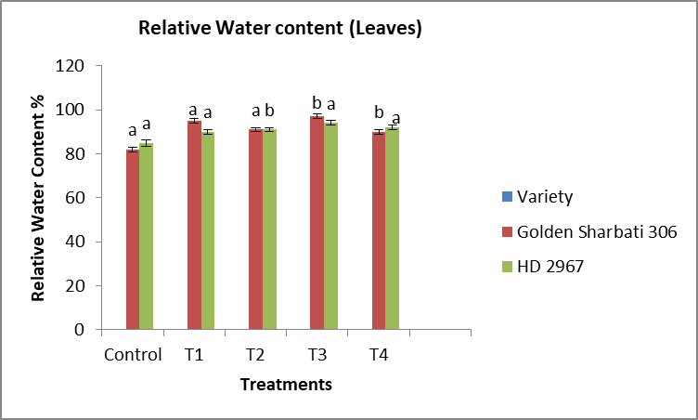 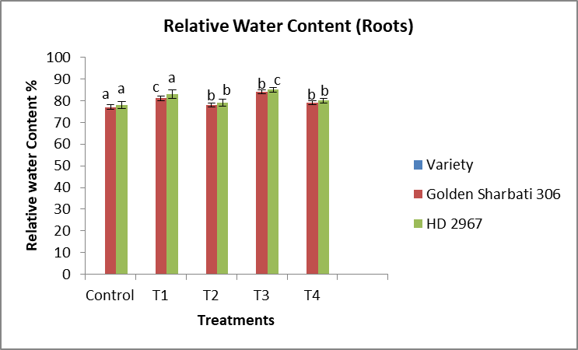

- Electrolytic Leakage (Leaves) D. Electrolytic Leakage (Roots)
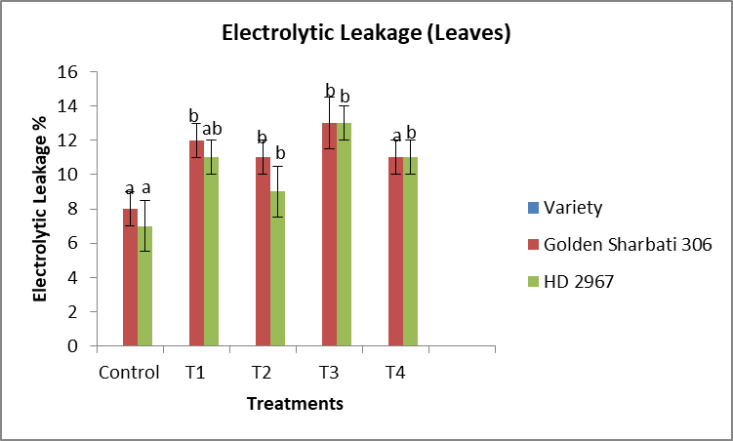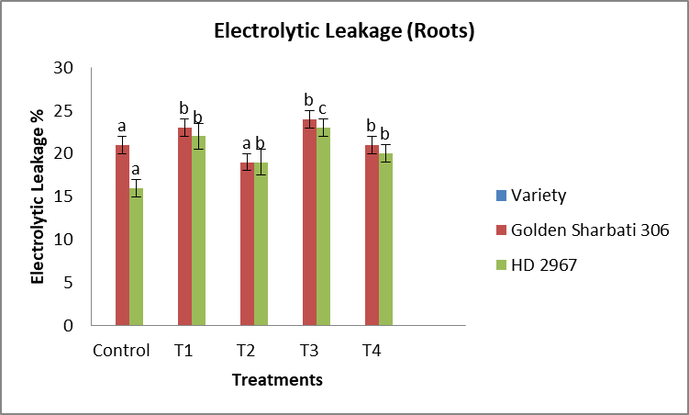

Figure1. Influence of Si, SSB and PSB on RWC of Leaves (A) RWC of Roots (B), Electrolytic Leakage of Leaves(C)and Electrolytic Leakage of Roots(D) of wheat plants . Data shown in the figure indicates Mean ± SE; One way ANOVA analysis by Duncan’s Multiple Range Test (DMRT) post hoc test; Each bar having different alphabets was significantly different between treatments (p < 0.05).The symbols in the figure represent Control: NPK (5g) each, T1: control +Si (5g) +SSB(2.5g) , T2: NK(5g) +Si(5g)+SSB(5g), T3: control+ Si (5 g) + SSB(7.5 g)+ PSB ( 7.5 g ), T4: NK (5g)+Si (5 g)+ SSB ( 10 g ) + PSB ( 10 g )

3.2. Effect of Si supplementation along with SSB and PSB on Chlorophyll ‘a’ and Chlorophyll ‘b’ Content
Results showed that chlorophyll ‘a’ and chlorophyll ‘b’ were significantly increased under SSB (10 g) and PSB (10 g) supplementation in both wheat varieties (Figure 2A,B; DMRT, p < 0.05). Chlorophyll ‘a’ increased from 0.567 ± 0.024 (T1) mg/g FW to 0.642 ± 0.030 mg/g FW (T3) in Golden Sharbati 306 and from 0.402 ± 0.012 (T1) to 0.567 ± 0.017 mg/g FW (T3) in WH-1105 variety as compared to control plants (Figure 2A; DMRT, p < 0.05). Similarly, a significant rise was observed in chlorophyll ‘b’ by up to 0.178 ± 0.005 mg/g FW (T3) in Golden Sharbati 306 and 0.120 ± 0.009 mg/g FW (T1) in HD 2967 when compared with control (Figure 2B; DMRT, p < 0.05).
A. Chlorophyll ‘a’ Content B. Chlorophyll ‘b’ Content
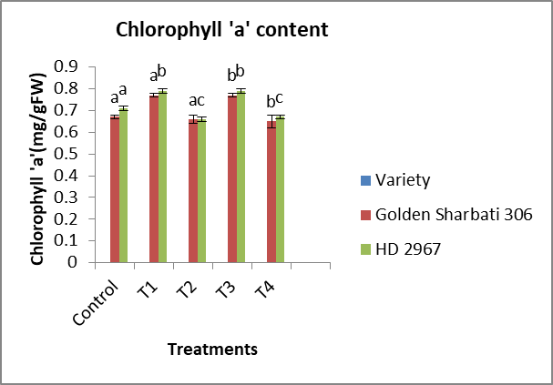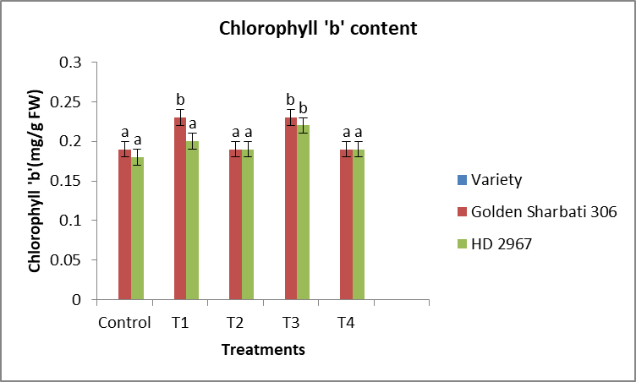
Figure 2. Influence of Si, SSB and PSB on Chlorophyll ‘a’ Content (A) Chlorophyll ‘ b ‘ Content (B) of wheat plants . Data shown in the figure indicates Mean ± SE; One way ANOVA analysis by Duncan’s Multiple Range Test (DMRT) post hoc test; Each bar having different alphabets was significantly different between treatments (p < 0.05).The symbols in the figure represent Control: NPK (5g) each, T1: control +Si (5g) +SSB(2.5g) , T2: NK(5g) +Si(5g)+SSB(5g), T3: control+ Si (5 g) + SSB(7.5 g)+ PSB ( 7.5 g ), T4: NK (5g)+Si (5 g)+ SSB ( 10 g ) + PSB ( 10 g )
3.3. Effect of Si supplementation along with SSB and PSB on Total Chlorophyll Content, Carotenoid Content,Chlorophyll Stability Index (CSI)
The total chlorophyll and carotenoid contents differed significantly among treatments (Duncan’s test, p < 0.05). In Golden Sharbati 306, Treatment 4 (NK + Si + high SSB + PSB) caused marked reductions of 35% and 22% in chlorophyll and carotenoids, respectively, compared with the control. In HD 2967, the decreases were even greater, reaching 42% and 31%.
In contrast, Si application with basal P and microbial inoculants significantly improved pigment levels. Treatment 1 (NPK + Si + SSB) enhanced chlorophyll by 13.7% in Golden Sharbati 306 and 19.5% in HD 2967 relative to the control. The maximum improvement was observed in Treatment 3 (NPK + Si + SSB + PSB), where chlorophyll and carotenoid contents increased by 31% and 35.7% in Golden Sharbati 306 and HD 2967, respectively.
The chlorophyll stability index (CSI) also varied significantly among treatments (p < 0.05). In Golden Sharbati 306, CSI decreased by 19.7% in Treatment 2 (NK + Si + SSB) and by 41% in Treatment 4. In HD 2967, reductions ranged from 22% (T2) to 60% (T4). By contrast, Treatment 3 maintained significantly higher CSI values than treatments without basal P, confirming the synergistic role of Si, SSB, and PSB.

- Total Chlorophyll Content B. Total Carotenoid Content
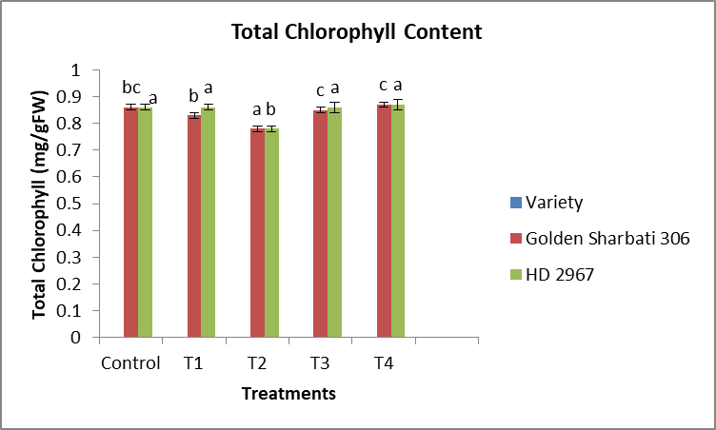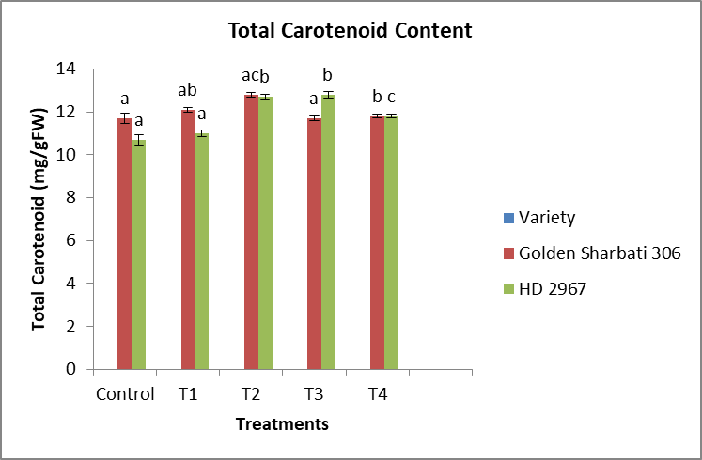
C. Chlorophyll Stability Index (CSI)
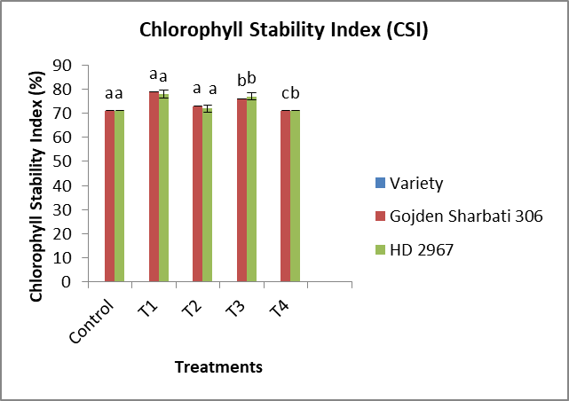
Figure3. Influence of Si, SSB and PSB on Total Chlorophyll Content (A) Total Carotenoid Content (B) Chlorophyll Stability Index(CSI) (C) of wheat plants . Data shown in the figure indicates Mean ± SE; One way ANOVA analysis by Duncan’s Multiple Range Test (DMRT) post hoc test; Each bar having different alphabets was significantly different between treatments (p < 0.05).The symbols in the figure represent Control: NPK (5g) each, T1: control +Si (5g) +SSB(2.5g) , T2: NK(5g) +Si(5g)+SSB(5g), T3: control+ Si (5 g) + SSB(7.5 g)+ PSB ( 7.5 g ), T4: NK (5g)+Si (5 g)+ SSB ( 10 g ) + PSB ( 10 g )
3.4. Effect of Si supplementation along with SSB and PSB on the Antioxidant Enzymes Activity (CAT, POX, and SOD)
The CAT activity of leaves and roots was found to increase with increased in Si supplementation along with SSB and PSB level (Figure 4A,B; Duncan’s test, p < 0.05), i.e., in leaves and roots, improvements of 39.4% (T1) and 60.5% (T3) in Golden Sharabati 306 variety and 54.6% (T1) and 97% (T3) in HD 2967 variety were observed at the high concentration of SSB and PSB compared to the control.
Similarly, the POX activity of leaves and roots also increased in (Figure 4C,D; Duncan’s test, p < 0.05) by up to 42% (T1) and 174% (T3) in Golden Sharbati 306 variety and 91% (T1) and 288% (T3) in HD 2967 variety when compared with control.
- CAT Activity ( Leaves) B. CAT Activity (Roots)

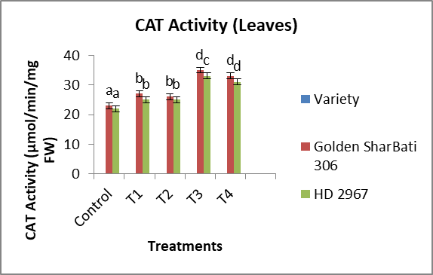
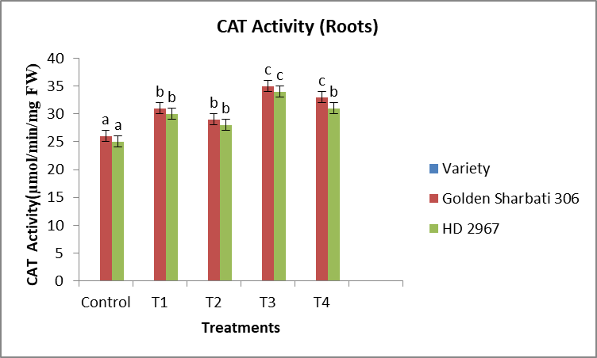
C. POX Activity ( Leaves) D. POX Activity ( Roots)
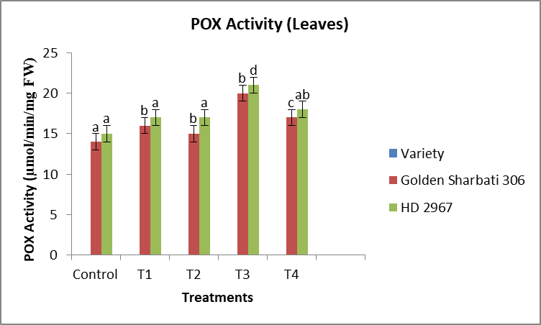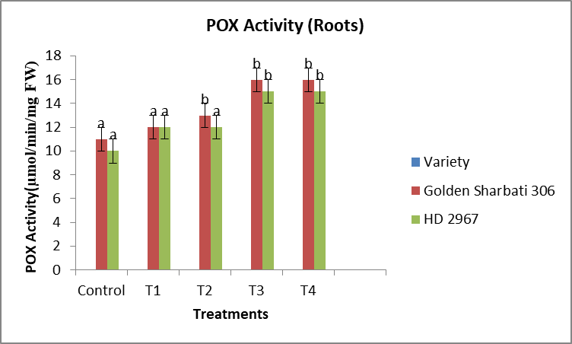
Figure 4. Influence of Si, SSB and PSB on CAT Activity of Leaves (A), CAT Activity of Roots(B), POX Activity of Leaves(C) and POX Activity of Roots (D) of wheat plants . Data shown in the figure indicates Mean ± SE; One way ANOVA analysis by Duncan’s Multiple Range Test (DMRT) post hoc test; Each bar having different alphabets was significantly different between treatments (p < 0.05).The symbols in the figure represent Control:NPK (5g) each, T1: control +Si (5g) +SSB(2.5g) , T2: NK(5g) +Si(5g)+SSB(5g), T3: control+ Si (5 g) + SSB(7.5 g)+ PSB ( 7.5 g ), T4: NK (5g)+Si (5 g)+ SSB ( 10 g ) + PSB ( 10 g )
5.Conclusion:
This study demonstrates that silicon (Si) supplementation, in combination with silicate-solubilizing bacteria (SSB) and phosphate-solubilizing bacteria (PSB), markedly improves the physiological and biochemical performance of wheat. Golden Sharbati 306 responded more strongly than HD 2967, indicating varietal differences in tolerance and defensive capacity. The combined treatments enhanced relative water content (RWC), chlorophyll stability index (CSI), photosynthetic pigments, and carotenoids, while sustaining antioxidant enzyme activities that declined under control conditions. These improvements highlight the potential of Si–microbe synergy to strengthen plant defense mechanisms, maintain physiological stability, and promote sustainable yield improvement.
Future research should validate these findings under field conditions and across diverse wheat cultivars. Molecular and anatomical studies are also needed to clarify the underlying mechanisms, particularly how Si–microbe interactions influence nutrient solubilization, ion homeostasis, and stress signaling. Such insights will be essential for designing integrated nutrient management strategies that exploit Si and beneficial microbes as eco-friendly tools to enhance crop resilience and productivity in wheat cultivation.

Disclaimer (Artificial intelligence)
Option 1:
Author(s) hereby declare that NO generative AI technologies such as Large Language Models (ChatGPT, COPILOT, etc.) and text-to-image generators have been used during the writing or editing of this manuscript.
Option 2:
Author(s) hereby declare that generative AI technologies such as Large Language Models, etc. have been used during the writing or editing of manuscripts. This explanation will include the name, version, model, and source of the generative AI technology and as well as all input prompts provided to the generative AI technology
Details of the AI usage are given below:
1.
2.
3.

References:
- Abdelaal, K. A. A., Mazrou, Y. S. A., & Hafez, Y. M. (2020). Silicon foliar application mitigates salt stress in sweet pepper plants by enhancing water status, photosynthesis, antioxidant enzyme activity and fruit yield. Plants, 9(6), 733.
- Aouz, M., Ben-Amor, M., Slatni, T., & Abdelly, C. (2023). Silicon improves salt tolerance in wheat by modulating antioxidant defense and ion homeostasis. Journal of Plant Physiology, 284, 153992.
- FAO Fertiliser Association of India (FAI). (2020). Fertiliser statistics 2019–2020. The Fertiliser Association of India, New Delhi.
- Global Trends in Wheat Production, Consumption and Trade. (2022). In Wheat: Global Production, Consumption and Trade. Springer.
- Liu, J., Zhu, J., Zhang, P., Han, L., & Reynolds, O. L. (2019). The role of silicon in physiology of the horticultural crops: A review. Horticulture Research, 6(1), 106.
- Parliamentary Standing Committee of Agriculture. (2016). Impact of chemical fertilizer and pesticides on agriculture and allied sectors in the country (2015–2016). Ministry of Agriculture, Government of India.
- Poveda, J. (2021). Trichoderma as biocontrol agent against pests: New uses for a mycoparasite. Biological Control, 159, 104634.
- Singh, A., Sharma, P., & Singh, R. (2022). Silicon supplementation enhances growth and antioxidant defense in wheat under salinity stress. Environmental and Experimental Botany, 195, 104764.
- Singh, R., Kumar, V., & Sharma, P. (2023). Role of silicon in wheat under abiotic stress: Physiological and biochemical insights. Plants, 12(5), 1002.
- Sustainable Journal. (2023). Indigenous phosphate-solubilizing bacteria improve phosphorus availability and wheat growth. Sustainable Agriculture Journal, 7(2), 145–156.
- Tayade, R., Kulkarni, M., & Gupta, S. (2022). Role of silicon fertilization in sustainable agriculture: Impacts on soil properties, nutrient availability, and crop yield. Frontiers in Sustainable Food Systems, 6, 873451.
- Wang, X., Liu, Y., Zhang, J., & Chen, Y. (2022). Phosphate-solubilizing bacteria improve wheat growth and phosphorus uptake in calcareous soils. Applied Soil Ecology, 174, 104430.
- Xu, C., Zhang, Y., Wang, M., & Li, H. (2022). Halotolerant plant growth-promoting rhizobacteria and silicon improve wheat growth under saline–alkaline stress. Applied Microbiology and Biotechnology, 106(13), 4875–4889.
- Cereal Research Communications. (2024). Silicon-mediated stress tolerance in cereals: Antioxidant and ionic balance regulation.
- Plant and Soil. (2022). Co-application of silicon and phosphate-solubilizing bacteria enhances phosphorus uptake and growth of durum wheat in calcareous soils. Plant and Soil, 474(1–2), 321–335.

