
Journal of Economics and Trade

Volume XXX, Issue XX, Page XX-XX, 20YY; Article no.JET.13681
ISSN: 2456-8821

AI Literacy in Business: Preparing Executives for Augmented

Decision-Making

Authors’ Name……………………………………………………

Affiliations……………………………………………………….………………

Authors’ contributions

This work was carried out in collaboration among all authors. ‘Author A’ designed the study, performed the statistical analysis, wrote the protocol, and wrote the first draft of the manuscript. ‘Author B’ and ‘Author C’ managed the analyses of the study. ‘Author C’ managed the literature searches. All authors read and approved the final manuscript.

Article Information

DOI: 10.56557/JET/2025/XXXX

Open Peer Review History:
This journal follows the Advanced Open Peer Review policy. Identity of the Reviewers, Editor(s) and additional Reviewers, peer review comments, different versions of the manuscript, comments of the editors, etc are available here:

Received: DD/MM/20YY
Accepted: DD/MM/20YY
Review Article
Published: DD/MM/20YY

ABSTRACT

This review examines the significance of AI literacy for corporate executives, highlighting its impact on enhanced decision-making and organisational leadership. As AI technologies are increasingly incorporated into business operations, leaders must cultivate the requisite abilities to utilise AI for strategic decision-making, competitive advantage, and operational efficiency. The study consolidates 38 papers published from 2020 to 2025, emphasizing the benefits of AI literacy, including greater data-driven decision-making, optimised resource allocation, and increased innovation. Nonetheless, obstacles such as the absence of standardised executive training, organisational reluctance, and time limitations hinder the extensive use of AI by business leaders. The review advocates for customised training programs, ongoing learning opportunities, and interdepartmental collaboration to enhance AI literacy among CEOs, thereby ensuring their adaptability in a swiftly changing technological environment. This study addresses the inadequately examined domain of executive AI literacy and offers practical recommendations for organisations aiming to incorporate AI into their leadership development initiatives.

Keywords: AI Literacy; business executives; augmented decision-making; AI adoption; leadership.

1. INTRODUCTION

1.1 Overview

AI has gone beyond just automating tasks and is now an important part of making strategic decisions in all kinds of businesses. As AI tools become more common in business, CEOs who want to use AI to be more innovative and competitive need to know what they can do. This article emphasises the significance of AI literacy for business leaders, underscoring its influence on organisational decision-making. It will talk about important problems, like the absence of standardised AI education, and provide leaders with ideas on how to leverage AI tools to help their businesses grow strategically and run more efficiently (Rashid and Kausik, 2024, Peretz-Andersson et al., 2024).

1.2 Scope of the Review

This review investigates the field of AI literacy in business leadership. The article investigates the impact of CEOs' AI literacy on their data-driven decision-making and organisational initiatives. This article evaluates academic research and case studies to investigate the impact of AI on the decision-making of corporate executives. The review will also investigate the literature gaps in AI literacy and their direct correlation with the efficacy of modern organisational leadership.

1.3 Significance

Executives require AI literacy to use AI insights to improve leadership and projects. CEOs must master AI tools to stay competitive as they become more integrated into company operations. Leaders who understand AI can innovate, foresee trends, improve processes, and make faster, more accurate decisions. AI literacy helps executives build and lead AI-savvy teams, establishing a data-driven culture. AI literacy is a strategic and technological leadership skill that can shape an organisation.

1.4 Research Gap

AI literacy has been examined in technology, but not in business leadership and decision-making. Most AI research focuses on organisational adoption or technical capabilities, but few study how CEOs, who often lack technical skills, may use AI in decision-making. A limited study on executive AI literacy and leadership decisions implies that more research is needed.

1.5 Road Map

- The Importance of AI Literacy in Business: An Overview and Its Implications for Leadership.

- Theoretical foundations and models: Frameworks for Executive AI Literacy.

- Obstacles to AI Adoption: Obstacles that business executives encounter.

- Case Studies: Examples of AI-driven decisions and real-world applications.

- Suggestions: Practical approaches to cultivating AI literacy among executives.

2. LITERATURE REVIEW

2.1 Method of Literature Selection

The literature for this review was selected using a systematic approach to ensure a comprehensive understanding of the topic. Studies were sourced primarily from academic databases such as Google Scholar, Scopus, and Web of Science. The following criteria were used to include studies in the review:

- Time Frame: Only studies published between 2020 and 2025 were considered to ensure the review reflects the most current research on AI literacy and its application in business leadership.

- Keywords: Key terms such as "AI literacy", "executive education", "AI adoption", "leadership", and "organizational performance" were used in search queries to identify relevant articles. These keywords were chosen based on their relevance to the central themes of AI literacy and leadership in business settings.

- Inclusion Criteria: The review focused on empirical studies, theoretical articles, and case studies that examine AI literacy within leadership contexts, particularly those that highlight its impact on decision-making, organizational performance, and executive training. Articles discussing sector-specific AI applications in various industries, such as healthcare, e-commerce, and manufacturing, were also included to provide diverse perspectives.

- Exclusion Criteria: Studies that were not directly related to AI literacy or leadership, or those that focused solely on technical aspects of AI without addressing its role in business decision-making or leadership, were excluded from the review. Articles not published in peer-reviewed journals or conferences were also excluded.

- Quality Assessment: To ensure the reliability and relevance of the selected literature, studies were assessed based on their methodological rigor and contribution to the understanding of AI literacy and its influence on leadership and organizational outcomes.

By following these criteria, a total of 38 studies were included in the review, offering a broad and nuanced perspective on the intersection of AI literacy and leadership across multiple sectors.

Theme 1: Executive Training and AI Literacy

A central theme in the literature is the lack of executive training in AI literacy. While numerous studies focus on the technical aspects of AI, very few provide frameworks for training business leaders. The importance of AI literacy for executives is widely acknowledged, with studies by Biagini (2025) and Yang et al. (2024) suggesting that understanding AI is key for executives to strategically integrate these tools into their organizations (Biagini, 2025). However, these studies highlight a significant gap: while AI education for IT professionals is robust, executive-focused AI education remains largely absent, leading to inconsistencies in AI adoption at the leadership level. This gap emphasizes the underexplored area of executive AI literacy and the need for more targeted, practical training programs for decision-makers (Yang et al., 2024).

Theme 2: Organizational Resistance to AI Adoption

Another prevalent theme is the resistance to AI adoption within organizations, particularly among executives. Murire (2024) argues that many executives are hesitant to embrace AI due to the perceived threat to organizational structures, roles, and workflows. Resistance is also amplified by fears of job displacement and the complexity of AI tools. For example, while e-commerce and tech-driven companies like Amazon and GE embrace AI, more traditional industries such as healthcare and manufacturing are slower to adopt it (Jamarani et al., 2024). This points to a contradiction: why are some sectors, with less technological maturity, able to adopt AI more quickly than others? The reasons may lie in organizational culture, technological infrastructure, and risk aversion. Understanding these factors is crucial to overcoming resistance to AI and fostering a culture of adoption (Daios et al., 2025, Kumar et al., 2024).

Theme 3: Strategic Integration of AI in Decision-Making

The integration of AI into strategic decision-making remains another critical area explored in the literature. AI's potential to enhance decision-making by providing insights into market trends, consumer behavior, and operational efficiencies is well-documented. However, AI’s strategic integration into leadership decision-making processes is less frequently addressed. Companies in industries like e-commerce and manufacturing have successfully implemented AI to optimize operations and improve resource allocation (Murire, 2024). In contrast, sectors such as healthcare and finance struggle to use AI to drive strategic decisions. This suggests that while AI's operational benefits are widely recognized, its role in shaping long-term business strategies remains underutilized in many sectors (Perifanis and Kitsios, 2023).

2.2 Barriers to AI Literacy
Despite its potential, AI adoption faces several barriers, including time constraints, resistance to change, and poor comprehension of AI’s capabilities. Executives often struggle to dedicate time to AI training due to their demanding roles. Additionally, the technical jargon associated with AI can be a barrier, and organizational resistance may arise when AI threatens established processes or job roles. Overcoming these barriers requires clear communication, ongoing training, and a culture that embraces change (Ahmed et al., 2023, Ritala et al., 2024).

2.3 Benefits of AI Literacy
AI literacy empowers executives to make data-driven decisions, improve operational efficiencies, and foster innovation. Leaders who understand AI can integrate it into business strategies, optimizing processes and reducing costs. For instance, AI-savvy leaders can leverage predictive models to improve forecasting, reduce risk, and increase competitiveness. Additionally, AI helps executives identify inefficiencies in their organizations, improving performance and profitability (Perifanis and Kitsios, 2023).

2.4 Case Studies and Real-World Examples

Numerous case studies show how AI literacy affects leadership and decision-making. For example, General Electric (GE) has utilized AI for predictive maintenance, leading to reduced downtime and increased operational efficiency. The company’s leadership, well-versed in AI technologies, can make better strategic decisions, improving resource allocation and boosting profits. Additionally, in healthcare, AI is being used for patient diagnostics and resource management, with GE Healthcare implementing AI-driven systems that allow hospital leaders to make more informed decisions about patient care and treatment prioritization.

- General Electric (GE): GE’s use of AI for predictive maintenance has significantly reduced downtime and improved operational efficiency. The leadership team’s understanding of AI has enabled them to make strategic decisions that enhance resource allocation and increase profitability (Machucho and Ortiz, 2025).

- Amazon: Amazon’s executives leverage AI to personalize the customer experience, predict consumer preferences, and optimize logistics. This integration of AI into business operations has been pivotal in maintaining Amazon’s competitive edge in the e-commerce industry (Li, 2024).
- Healthcare: AI-savvy executives improve patient care and efficiency. Through predictive analytics for patient diagnostics, resource allocation, and pharmaceutical development, AI-savvy health staff improve service delivery and cost (Lawal et al., 2025).

3. AI LITERACY FRAMEWORKS AND APPROACHES FOR EXECUTIVES

3.1 Frameworks for AI Literacy

Companies need frameworks to boost CEOs' AI literacy as AI technologies evolve. These frameworks link complex AI systems to leadership teams that must adopt these systems into organisational strategies. Several theories and methodologies assist CEOs in understanding and making AI-driven decisions (Yang et al., 2024).
Popular paradigms like the AI Competency Model educate strategic thinking, technological understanding, and business application of AI. This model highlights that executives need technical knowledge and the ability to work with data scientists, engineers, and others to truly transform firms with AI. It was observed that such frameworks help CEOs understand how AI can solve business problems and create value (Yang et al., 2024, Perifanis and Kitsios, 2023).
The AI Leadership Framework recommends mastering AI principles and tools and making sure the executive understands how AI fits into business strategy and goals. This paradigm promotes continuous learning because AI is evolving swiftly. It suggests leaders iteratively study AI technologies and applications (Dwivedi et al., 2023).

3.2 Executive Education and Training
Effective AI literacy programs are essential for executives to fully understand and apply AI. These programs, including short courses and in-house workshops, focus on teaching business leaders the strategic applications of AI rather than its technical aspects. Research shows that hands-on learning and mentorship from AI experts can enhance executives' understanding of AI tools and their business implications. Continuous learning, such as participation in AI-focused industry conferences, is also necessary to stay up-to-date with rapidly advancing technologies (Yang et al., 2024).
Corporations often develop AI literacy programs in-house. In-house training sometimes involves workshops where executives use AI technologies for their company. This training works because it addresses company issues and AI. Executives may work with data scientists or AI consultants to understand (Ng et al., 2021).
Short courses and in-house training help, but studies suggest continual learning is necessary. AI literacy requires continual interaction with developing AI technology and its business leadership effects.

3.3 Best Practices for Building AI Literacy

Best practices can help executives learn AI in addition to formal training. These strategies promote self-directed learning, cooperation, and a growth mindset that recognises AI education's ongoing nature.
Executives may learn AI literacy best independently. MOOCs, seminars, podcasts, and specialised reading can help executives follow AI trends. Executive-specific AI courses for non-technical audiences from Coursera, edX, and Udacity discuss commercial AI applications. Research suggests that proactive learning aids CEO AI acceptance and deployment (Kamalov et al., 2023).

Mentorship: Another useful activity. AI professionals or people familiar with AI can mentor senior leaders. In informal interactions, CEOs might learn about AI tools' commercial implications. Mentorship programs let CEOs learn about complex AI ideas without pressure (Nguyen and Barbieri, 2025).
Collaborating with peers in the same business or organisation can also increase AI literacy. Conversations, conferences, and AI forums and working groups allow executives to share AI implementation knowledge. Executives may learn AI faster by seeing how other leaders use it in their operations and strategies (Florea and Croitoru, 2025).

3.4 Role of External Expertise

Although training and self-education are important, many CEOs benefit from outside experience. AI practitioners, consultants, and data scientists can provide technical insights that executive training programs lack. When the management team lacks technical skills, other experts fill in. AI Consultants and Specialists: Many companies hire AI strategy consultants to help leaders implement AI. These experts can help CEOs overcome technology obstacles and achieve AI project goals. Consultants can tailor executive training to organizations (Abdullah and Almaqtari, 2024).

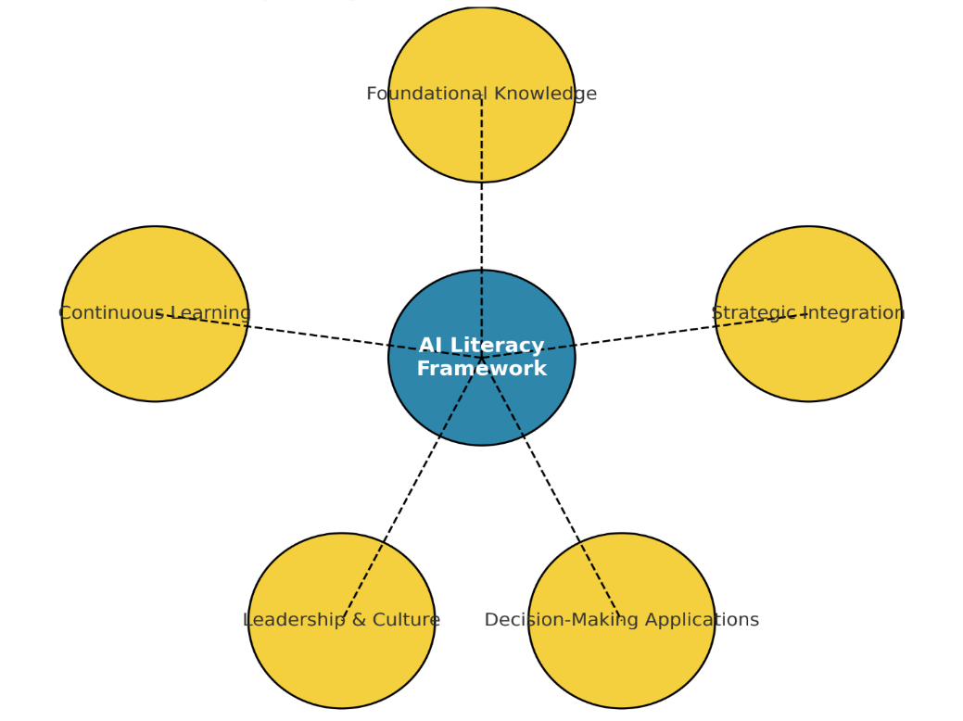

Fig. 1. AI literacy competency framework for executives
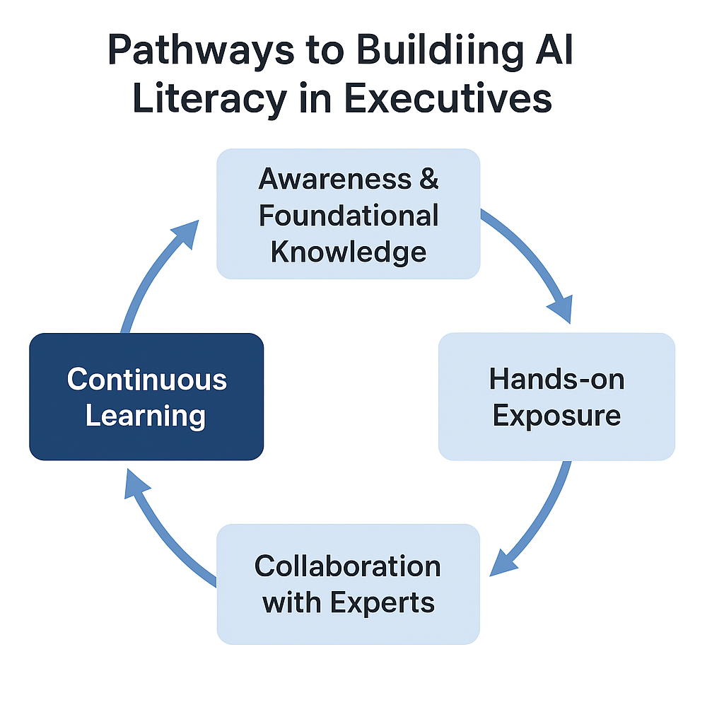

Fig. 2. Executive AI Literacy Pathways. Business executives learn AI literacy in cycles, as shown in this figure. It covers five stages: awareness and basic knowledge, hands-on exposure, expert cooperation, strategic decision-making integration, and ongoing learning. Effective leadership in an AI-driven business context requires constant AI literacy growth, as the cycle shows

Executives and data scientists must collaborate to use AI in decision-making. Executives provide strategic insights, while data scientists supply technical skills. They can ensure AI solutions are technically sound and meet business goals by working together. This cooperative strategy teaches CEOs AI and data-driven insights (Machucho and Ortiz, 2025).

Corporate executives must learn AI through formal education, self-learning, mentorship, peer collaboration, and external expertise. These solutions let CEOs use AI, integrate it into operations, and make data-driven choices. Managers of AI-driven companies need this comprehensive plan. The Fig. 1 AI literacy competence framework for corporate executives stresses the skills needed to integrate AI into decision-making and leadership. CEO AI literacy is rising, as seen in Fig. 2 (Golgeci et al., 2025).

This approach shows CEOs the multiple skills needed to integrate AI into organisational strategy. Foundational AI knowledge, strategic integration with business goals, application in decision-making, leadership and cultural transformation, and ongoing technology adaptation are its five domains.

4. CHALLENGES AND GAPS IN AI LITERACY FOR EXECUTIVES

4.1 Lack of Standardized AI Education

Executives struggle with AI literacy without standardised training and customised education. Academic and technical schools offer AI education; however, most programs are for engineers and technicians, not business leaders. Many executives never learn about AI or acquire it piecemeal and inconsistently due to a lack of executive-specific education. Executives may misread AI's capabilities and weaknesses (Walter, 2024).
Lack of a uniform framework or curriculum for executive AI literacy confuses executives about AI's practical application, resulting in mismatched expectations and inefficient decision-making. For instance, a CEO may oversimplify choices or underestimate AI. Filling this gap requires standardised technical and strategic AI education for business leaders. A standard, executive-focused education can reduce confusion and help leadership teams make smart AI decisions (Walter, 2024).

4.2 Organizational Resistance

Organisational resistance to new technology hinders business AI literacy. Many companies face resistance from employees and leadership when AI proves disruptive. AI may scare executives because of the unknown. This hesitancy is typically exacerbated by job displacement and organisational restructuring concerns (Madanchian and Taherdoost, 2025).

Technology that changes workflows may be resisted by traditional companies. If AI adoption threatens long-standing processes or generates staff conflict, executives, who must guarantee new projects fit organisational culture, may be reluctant to push for it. In industries with low technological maturity, organisations may oppose AI due to a lack of understanding of its long-term benefits or a fear that it is too advanced (Golgeci et al., 2025).
This opposition hinders executive AI adoption. Internal resistance makes it impossible for leadership to prioritise AI integration and foster executive AI skills. Communicating AI's benefits, aligning business goals, and providing a conducive learning environment for employees and management to transition to AI can overcome this hesitation (Yang et al., 2024).

4.3 Varying Levels of AI Understanding

AI understanding is difficult for executives to disseminate within their organisations. Diverse departments and teams have diverse AI knowledge, which explains this. While some leaders understand AI's potential, others struggle with the basics. This lack of communication can impair departmental collaboration, especially between leadership teams and technical workers like data scientists and engineers (Florea and Croitoru, 2025).
In many organisations, technical professionals utilise specialised terminology that non-technical executives cannot grasp, hindering information transfer. As a result, leaders may struggle to fully interact with their staff or make AI-driven decisions. If AI is perceived as the sole duty of IT or data science, executives in marketing, finance, or operations may not feel empowered to adopt AI tools (Babashahi et al., 2024).

To overcome this difficulty, organisations must promote shared learning, where AI information is shared across departments and technical jargon is simplified. Cross-functional training, collaborative workshops, and clear explanations of AI's strategic benefits to executives and other staff can achieve this.

4.4 Integration with Business Strategy

A major gap in executive AI literacy is the challenge of combining AI insights with corporate strategy. Even if CEOs comprehend AI, they may struggle to use its technical skills in strategic decisions. The gap exists because AI tools are often not directly linked to business goals, or executives may lack the expertise to understand AI-driven data strategically.

Executives typically use AI to improve operational efficiency or minimise costs rather than create long-term, imaginative strategies that support the company's growth. Failure to integrate AI insights into company planning misses innovation and competitive advantage chances (Bollaert, 2025).

Strategic AI decision-making includes knowing AI's capabilities and projecting how AI tools will affect the competitive environment, customer behaviour, and market dynamics.
Executives must learn AI technologies and their strategic implications to close this gap. Executives should learn foresight, scenario planning, and how AI-driven advancements may affect industry trends and business structures. The executive must integrate AI understanding into their strategy and leadership (Machucho and Ortiz, 2025).

4.5 Need for Continuous Learning

Executives must continuously learning to stay competitive in AI, which is always improving. Even the most knowledgeable executives struggle to keep up with AI technologies and applications. AI literacy is an ongoing practice that requires regular updates and involvement because of its constant progress.

This ongoing learning task is difficult for executives. Executives may struggle to find time to learn about new AI trends, tools, and best practices due to their busy schedules. Neglecting continual learning can result in an outdated executive team, which could lead to poor decision-making or failure to implement cutting-edge AI advancements (Babashahi et al., 2024).

AI literacy should be part of executives' professional growth, with frequent learning
Table 1. Barriers and enablers of AI literacy for business executives

Barrier | Description | Enabler/Strategy
Lack of Standardized AI Education | Absence of tailored executive training programs | Develop executive-focused AI curricula and certifications (Sinha and Lee, 2024)
Time Constraints | Executives have limited time for continuous learning | Short modular courses, flexible online training (Mukhtar et al., 2020)
Organizational Resistance | Fear of disruption and job loss hampers adoption | Transparent communication, pilot AI projects to show value (Ivchyk, 2024)
Varying AI Understanding Across Departments | Misalignment between leaders and technical teams | Cross-functional workshops, simplified AI communication (Kassa and Worku, 2025)
Integration with Business Strategy | Difficulty translating AI insights into strategy | Executive–data scientist collaboration, strategic foresight training (Olaitan et al., 2025)

sessions, industry events, and targeted updates on developing AI uses. Creating a culture of continuous learning can also assist executives in staying current on AI (Kamalov et al., 2023).

Executives face a lack of standardised education, organisational resistance, departmental differences in knowledge, issues integrating AI with corporate strategy, and the necessity for continuing learning. Organisations must create customised training programs, encourage cross-functional learning, and integrate AI literacy into executive professional development to close these gaps. Overcoming these hurdles will help leaders make strategic, AI-powered decisions. Table 1 lists the main executive AI literacy barriers and the enablers organisations can use to overcome them (Sebihi et al., 2025).

5. RESULTS AND DISCUSSION

The findings from this review unequivocally show how crucial AI literacy is for company executives, yet little is known about how AI literacy affects leadership and strategic decision-making. AI-literate executives are more able to use AI for innovation, data-driven decision-making, and operational efficiency. In contrast to organisational adoption, executive AI literacy is not as well studied. This understudied gap indicates that although a lot of studies focus on the technical aspects of AI, more work is desperately needed to understand how CEOs may be trained to successfully incorporate AI into business plans (Dwivedi et al., 2021).

The disparities in AI adoption rates among industries are one contradiction that shows up in the research. AI adoption is slower in sectors like government and banking than in e-commerce, healthcare, and manufacturing, which have started integrating AI for operational efficiencies. A number of factors, such as organisational culture, perceived risks, and technology maturity, could be responsible for this disparity. Executives in industries with less technological maturity, for instance, can be less eager to embrace new technologies and more risk-averse. What aspects of particular businesses encourage or impede the adoption of AI, and how can executives get beyond these obstacles to fully realise AI's strategic potential, is still an open subject. To respond to this query and comprehend the part that industry-specific obstacles play in the adoption of AI, more investigation is required (Vieriu and Petrea, 2025).

Organisational opposition to AI adoption, which is present at both the executive and employee levels, is another crucial problem. Many business leaders worry that AI will upend established hierarchies, eliminate jobs, and erode their power. Adoption of AI is severely hampered by these worries as well as the apparent complexity of AI tools. To overcome these anxieties, leaders must adopt a new viewpoint in which AI is viewed as an enabler rather than a disruptor. Reducing opposition and promoting an AI adoption culture within organisations can be accomplished by clear communication, customised training, and an emphasis on the long-term advantages of AI (Bollaert, 2025).

The literature concludes by emphasising the necessity of incorporating AI into long-term strategic decision-making. Although AI is acknowledged for its operational advantages, such as bettering customer experience and
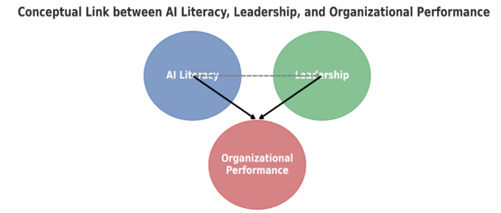

Fig. 3. Conceptual model linking AI literacy, leadership, and organizational performance
Illustrates the conceptual model linking AI literacy with leadership outcomes, showing how literacy strengthens leadership capacity, which in turn drives organizational performance.

allocating resources optimally, its strategic potential is frequently disregarded. Understanding AI's technological capabilities is only one aspect of CEOs' AI literacy; another is incorporating AI insights into business plans. Predictive analytics can be used by executives with an understanding of artificial intelligence to predict market trends, adjust to customer behaviour, and spot new business prospects. Therefore, companies looking to stay competitive in a world that is becoming more and more data-driven must cultivate AI literacy at the executive level (Madanchian, 2024, Medlama, 2025).

To illustrate the interconnections highlighted in this review, a conceptual model linking AI literacy, leadership, and organizational performance is presented Fig.3

6. LIMITATIONS OF CURRENT LITERA-TURE

While this review provides valuable insights into the impact of AI literacy on leadership and organizational performance, several limitations must be acknowledged. One significant limitation is the challenge of generalizing the findings across industries. The studies included in this review primarily focus on sectors such as e-commerce, healthcare, and manufacturing. However, the application and impact of AI literacy may vary considerably in different industries due to distinct organizational structures, technological maturity, and market dynamics (Cao et al., 2021).

For example, while e-commerce companies like Amazon have successfully integrated AI for customer personalization and inventory management, manufacturing firms such as General Electric focus on predictive maintenance and operational efficiency. These differences in application suggest that AI literacy may have diverse implications depending on the sector's unique needs and challenges (Pinski et al., 2024).

Additionally, the pace of AI adoption and the level of executive engagement with AI may differ across industries. Tech-driven industries may see quicker integration and higher AI literacy, while sectors like finance or government may face slower adoption due to regulatory constraints, workforce resistance, or existing technological infrastructures. Future research could benefit from more industry-specific studies to explore how AI literacy influences leadership outcomes in various contexts and whether industry-specific frameworks for executive training are necessary.

7. FUTURE SCOPE

While this research provides valuable insights into AI literacy for business executives, there are several avenues for future exploration and innovation. As AI technologies continue to evolve, there are emerging opportunities to further refine the methods and frameworks discussed in this paper.

- Industry-Specific AI Literacy: Future research could explore how AI literacy frameworks can be tailored to specific industries, such as healthcare, finance, or manufacturing, to address unique challenges and opportunities in each sector. Understanding the industry-specific implications of AI literacy could lead to more effective executive training programs and better alignment of AI tools with organizational goals.

- Longitudinal Studies on AI Literacy: Long-term studies examining the impact of AI literacy on leadership effectiveness and organizational performance over time would provide deeper insights into the sustained benefits of AI education. Such studies could track executives' progress in AI adoption and decision-making skills, offering a comprehensive view of its long-term impact on businesses.

- AI Literacy in Non-Tech-Driven Industries: While this paper focuses on tech-driven sectors, there is significant potential for AI literacy in non-tech industries. Future work could explore the barriers and opportunities for AI adoption in industries with slower AI integration, such as traditional manufacturing or public sector organizations.

- Integration of AI with Leadership Development Programs: Further research can examine how AI literacy can be integrated into existing leadership development programs, assessing its effectiveness in enhancing decision-making skills and fostering a data-driven culture in organizations.

- Cross-Cultural AI Literacy: AI literacy could also be examined across different cultural contexts to understand how global businesses adapt AI technologies and training for executives in diverse regions. This would offer a broader understanding of how AI literacy is perceived and adopted in different cultural and organizational environments.

By addressing these areas, future research could not only deepen our understanding of AI literacy but also contribute to the development of more targeted, effective, and scalable AI education strategies for executives worldwide.

8. CONCLUSION

This review illustrates the essential importance of AI literacy in influencing business leadership. Executives proficient in AI are more capable of making educated, data-driven decisions that promote innovation, enhance operational efficiencies, and secure long-term organisational success. AI literacy among business leaders is frequently impeded by inadequate educational programs, organisational opposition, and a scarcity of time for ongoing learning, despite its significance. Confronting these difficulties is crucial for enabling leaders to fully leverage AI's strategic potential (Jorzik et al., 2024).

8.1 Implications for Businesses

For Business, investing in AI literacy is not only a technical obligation; it is a strategic need. Executives possessing a comprehensive understanding of AI may spearhead transformation initiatives, guaranteeing that AI technologies are congruent with corporate objectives. This subsequently augments an organization's capacity to innovate, adjust to market fluctuations, and sustain a competitive advantage. Organisations that emphasise AI literacy among their leadership will be more adept at navigating the changing technology environment, enhancing decision-making, and maximising performance in all domains (Perifanis and Kitsios, 2023).

8.2 Limitations of the Review

Though limited, executive AI literacy literature is valuable. Research rarely has an industry-specific perspective; thus, its conclusions may not apply everywhere. AI literacy studies usually focus on short-term improvements rather than long-term executive decision-making and organisational performance. Limited geographical diversity may limit the generalisability of some studies across AI adoption and maturity levels.

9. FUTURE RESEARCH DIRECTIONS

AI literacy across industries and executive jobs should be studied to better understand how AI might be employed in diverse sectors. Longitudinal research on AI literacy's effects on organisational performance and innovation would also be useful. AI literacy and organisational culture studies may demonstrate how AI affects leadership, decision-making, and innovation. Companies that want AI literacy to be a leadership skill must grasp these dynamics.

10. RECOMMENDATION

For executives:

- Make formal education a top priority by enrolling in executive education courses or programs that concentrate on the strategic uses of artificial intelligence (MIT, Harvard, etc.).

- A dedication to lifelong learning: To keep up with AI advances, take part in self-directed learning using resources like Coursera, edX, or Udacity.

- Make use of mentorship: To increase knowledge and implementation of AI technology, ask AI specialists for advice or attend industry conferences.

- Cooperate with technical teams: To include AI in business plans and decision-making procedures, work closely with data scientists and engineers.

For Organisations:

  - Create customised programs for AI literacy: To close the gap between AI capabilities and business strategy, provide executive-specific in-house training workshops.

  - Encourage a culture of education: Encourage lifelong learning and give CEOs the tools they need to participate in continual AI training.

  - Assist cross-functional teams: To promote a better comprehension of AI's strategic value, executives, data scientists, and AI specialists should collaborate (Babashahi et al., 2024).

For policy makers:

- Encourage financing for executive AI training: Executive AI training might be subsidised by public funds, assisting companies in preparing their leadership teams for the digital era.

- Encourage cooperation: Promote collaborations between government, business, and academia to develop standardised frameworks for business leaders' AI literacy (Perifanis and Kitsios, 2023).

DISCLAIMER (ARTIFICIAL INTELLIGENCE)

Author(s) hereby declare that NO generative AI technologies such as Large Language Models (ChatGPT, COPILOT, etc.) and text-to-image generators have been used during the writing or editing of this manuscript.

Competing interests

Authors have declared that no competing interests exist.

REFRENCES

Abdullah, A. A. H., & Almaqtari, F. A. (2024). The impact of artificial intelligence and Industry 4.0 on transforming accounting and auditing practices. Journal of Open Innovation: Technology, Market, and Complexity, 10(1), 100218.
Ahmed, M. I., Spooner, B., Isherwood, J., Lane, M., Orrock, E., & Dennison, A. (2023). A systematic review of the barriers to the implementation of artificial intelligence in healthcare. Cureus, 15(10), e46454.
Babashahi, L., Barbosa, C. E., Lima, Y., Lyra, A., Salazar, H., Argôlo, M., et al. (2024). AI in the workplace: A systematic review of skill transformation in the industry. Administrative Sciences, 14(6), 127.
Biagini, G. (2025, March 12). Towards an AI-literate future: A systematic literature review exploring education, ethics, and applications. International Journal of Artificial Intelligence in Education. Retrieved September 13, 2025, from https://doi.org/10.1007/s40593-025-00466-w
Bollaert, L. (2025). Artificial intelligence: Objective or tool in the 21st-century higher education strategy and leadership? Education Sciences, 15(6), 774.
Cao, G., Duan, Y., Edwards, J. S., & Dwivedi, Y. K. (2021). Understanding managers’ attitudes and behavioral intentions towards using artificial intelligence for organizational decision-making. Technovation, 106, 102312.
Daios, A., Kladovasilakis, N., Kelemis, A., & Kostavelis, I. (2025). AI applications in supply chain management: A survey. Applied Sciences, 15(5), 2775.
Dwivedi, Y. K., Ismagilova, E., Hughes, D. L., Carlson, J., Filieri, R., Jacobson, J., et al. (2021). Setting the future of digital and social media marketing research: Perspectives and research propositions. International Journal of Information Management, 59, 102168.
Dwivedi, Y. K., Kshetri, N., Hughes, L., Slade, E. L., Jeyaraj, A., Kar, A. K., et al. (2023). Opinion paper: “So what if ChatGPT wrote it?” Multidisciplinary perspectives on opportunities, challenges, and implications of generative conversational AI for research, practice, and policy. International Journal of Information Management, 71, 102642.
Florea, N. V., & Croitoru, G. (2025). The impact of artificial intelligence on communication dynamics and performance in organizational leadership. Administrative Sciences, 15(2), 33.
Golgeci, I., Ritala, P., Arslan, A., McKenna, B., & Ali, I. (2025). Confronting and alleviating AI resistance in the workplace: An integrative review and a process framework. Human Resource Management Review, 35(2), 101075.
Ivchyk, V. (2024). Overcoming barriers to artificial intelligence adoption. Three Seas Economic Journal, 5(4), 14–20.
Jamarani, A., Haddadi, S., Sarvizadeh, R., Haghi Kashani, M., Akbari, M., & Moradi, S. (2024). Big data and predictive analytics: A systematic review of applications. Artificial Intelligence Review, 57(7), 176.
Jorzik, P., Klein, S. P., Kanbach, D. K., & Kraus, S. (2024). AI-driven business model innovation: A systematic review and research agenda. Journal of Business Research, 182, 114764.
Kamalov, F., Santandreu Calonge, D., & Gurrib, I. (2023). New era of artificial intelligence in education: Towards a sustainable multifaceted revolution. Sustainability, 15(16), 12451.
Kassa, B. Y., & Worku, E. K. (2025). The impact of artificial intelligence on organizational performance: The mediating role of employee productivity. Journal of Open Innovation: Technology, Market, and Complexity, 11(1), 100474.
Kumar, B., Lorusso, E., Fosso, B., & Pesole, G. (2024). A comprehensive overview of microbiome data in the light of machine learning applications: Categorization, accessibility, and future directions. Frontiers in Microbiology, 15, 1343572.
Lawal, O., Elechi, K., Adekunle, F., Farinde, O., Kolapo, T., Igbokwe, C., et al. (2025). A review on artificial intelligence and point-of-care diagnostics to combat antimicrobial resistance in resource-limited healthcare settings like Nigeria: Review article. Journal of Pharma Insights and Research, 3(2), 166–175.
Li, Z. (2024). Review of application of AI in Amazon warehouse management. Advances in Economics, Management, and Political Sciences, 144, 1–8.
Machucho, R., & Ortiz, D. (2025). The impacts of artificial intelligence on business innovation: A comprehensive review of applications, organizational challenges, and ethical considerations. Systems, 13(4), 264.
Madanchian, M. (2024). From recruitment to retention: AI tools for human resource decision-making. Applied Sciences, 14(24), 11750.
Madanchian, M., & Taherdoost, H. (2025). Barriers and enablers of AI adoption in human resource management: A critical analysis of organizational and technological factors. Information, 16(1), 51.
Medlama, M. (2025). The impact of artificial intelligence on leadership decision-making: Opportunities and challenges. Communications on Applied Nonlinear Analysis, 32(9s), 1878–1885.
Mukhtar, K., Javed, K., Arooj, M., & Sethi, A. (2020). Advantages, limitations, and recommendations for online learning during the COVID-19 pandemic era. Pakistan Journal of Medical Sciences, 36(COVID19-S4), S27–S31.
Murire, O. T. (2024). Artificial intelligence and its role in shaping organizational work practices and culture. Administrative Sciences, 14(12), 316.
Ng, D. T. K., Leung, J. K. L., Chu, S. K. W., & Qiao, M. S. (2021). Conceptualizing AI literacy: An exploratory review. Computers and Education: Artificial Intelligence, 2, 100041.
Nguyen (Ruby), N. N., & Barbieri, W. (2025). Mentorship in the age of generative AI: ChatGPT to support self-regulated learning of pre-service teachers before and during placements. Education Sciences, 15(6), 642.
Olaitan, O. F., Akatakpo, O. N., Victor, C. O., Emejulu, C. J., Ayoola, T. M., Olayiwola, D. E., et al. (2025). Secure and resilient industrial IoT architectures for smart manufacturing: A comprehensive review. Journal of Engineering Research and Reports, 27(6), 331–344.
Peretz-Andersson, E., Tabares, S., Mikalef, P., & Parida, V. (2024). Artificial intelligence implementation in manufacturing SMEs: A resource orchestration approach. International Journal of Information Management, 77, 102781.
Perifanis, N. A., & Kitsios, F. (2023). Investigating the influence of artificial intelligence on business value in the digital era of strategy: A literature review. Information, 14(2), 85.
Pinski, M., Hofmann, T., & Benlian, A. (2024). AI literacy for the top management: An upper echelons perspective on corporate AI orientation and implementation ability. Electronic Markets, 34(1), 24.
Rashid, A. B., & Kausik, M. A. K. (2024). AI revolutionizing industries worldwide: A comprehensive overview of its diverse applications. Hybrid Advances, 7, 100277.
Ritala, P., Aaltonen, P., Ruokonen, M., & Nemeh, A. (2024). Developing industrial AI capabilities: An organisational learning perspective. Technovation, 138, 103120.
Sebihi, A., Schoelen, L., & Uwamwezi, B. (2025). Unveiling AI’s impact in Rwandan higher education: Navigating trends, challenges, and imperatives at the University of Rwanda. Discover Education, 4(1), 166.
Sinha, S., & Lee, Y. M. (2024). Challenges with developing and deploying AI models and applications in industrial systems. Discover Artificial Intelligence, 4(1), 55.
Vieriu, A. M., & Petrea, G. (2025). The impact of artificial intelligence (AI) on students’ academic development. Education Sciences, 15(3), 343.
Walter, Y. (2024). Embracing the future of artificial intelligence in the classroom: The relevance of AI literacy, prompt engineering, and critical thinking in modern education. International Journal of Educational Technology in Higher Education, 21(1), 15.
Yang, J., Blount, Y., & Amrollahi, A. (2024). Artificial intelligence adoption in a professional service industry: A multiple case study. Technological Forecasting and Social Change, 201, 123251.

Disclaimer/Publisher’s Note: The statements, opinions and data contained in all publications are solely those of the individual author(s) and contributor(s) and not of the publisher and/or the editor(s). This publisher and/or the editor(s) disclaim responsibility for any injury to people or property resulting from any ideas, methods, instructions or products referred to in the content.
_________________________________________________________________________________
© Copyright (2025): Author(s). The licensee is the journal publisher. This is an Open Access article distributed under the terms of the Creative Commons Attribution License (http://creativecommons.org/licenses/by/4.0), which permits unrestricted use, distribution, and reproduction in any medium, provided the original work is properly cited.

