Review Article
AI Literacy in Business: Preparing Executives for Augmented Decision-Making

Abstract
This article talks about how important it is for business leaders to know about artificial intelligence (AI), especially when it comes to making better decisions. As AI technologies are getting better, businesses need to use them to stay competitive and come up with new ideas. This review stresses how important it is for people to be able to use AI to make better decisions, run their businesses more effectively, and be better leaders. The paper talks about some of the biggest problems that CEOs face, such as the lack of standardised AI education, opposition from employees, and the difficulty of adding AI to long-term business plans. It talks about how AI literacy helps executives make decisions based on data, make better predictions, use resources more efficiently, and lead changes that are driven by AI. The review also gives organisations useful advice on how to improve executive AI literacy by creating training programs that are specific to each person, encouraging a culture of learning all the time, and making it easier for people from different departments to work together. The survey finds that organisations need to provide their CEOs AI capabilities so they can make better decisions, stay ahead of the competition, and keep up with the fast-changing world of technology.
Keywords: AI Literacy, Business Executives, Augmented Decision-Making, AI Adoption, Leadership
- Introduction

Overview
AI has gone beyond just automating tasks and is now an important part of making strategic decisions in all kinds of businesses. As AI tools become more common in business, CEOs who want to use AI to be more innovative and competitive need to know what they can do. This article emphasises the significance of AI literacy for business leaders, underscoring its influence on organisational decision-making. It will talk about important problems, like the absence of standardised AI education, and provide leaders ideas on how to leverage AI tools to help their businesses grow strategically and run more efficiently[1],[2].

Scope of the Review
This review investigates the field of AI literacy in business leadership. The article investigates the impact of CEOs' AI literacy on their data-driven decision-making and organisational initiatives. This article evaluates academic research and case studies to investigate the impact of AI on the decision-making of corporate executives. The review will also investigate the literature gaps in AI literacy and their direct correlation with the efficacy of modern organisational leadership.

Significance
Executives require AI literacy to use AI insights to improve leadership and projects. CEOs must master AI tools to stay competitive as they become more integrated into company operations. Leaders who understand AI can innovate, foresee trends, improve processes, and make faster, more accurate decisions. AI literacy helps executives build and lead AI-savvy teams, establishing a data-driven culture. AI literacy is a strategic and technological leadership skill that can shape an organisation.

Research Gap
AI literacy has been examined in technology, but not in business leadership and decision-making. Most AI research focusses on organisational adoption or technical capabilities, but few study how CEOs, who often lack technical skills, may use AI in decision-making. Limited study on executive AI literacy and leadership decisions implies more research is needed.

Road Map
1. The Importance of AI Literacy in Business: An Overview and Its Implications for Leadership.
2. Theoretical foundations and models: Frameworks for Executive AI Literacy.
3. Obstacles to AI Adoption: Obstacles that business executives encounter.
4. Case Studies: Examples of AI-driven decisions and real-world applications.
5. Suggestions: Practical approaches to cultivating AI literacy among executives.

2. Literature Review
Method of Literature Selection
The literature for this review was selected using a systematic approach to ensure a comprehensive understanding of the topic. Studies were sourced primarily from academic databases such as Google Scholar, Scopus, and Web of Science. The following criteria were used to include studies in the review:
- Time Frame: Only studies published between 2020 and 2025 were considered to ensure the review reflects the most current research on AI literacy and its application in business leadership.
- Keywords: Key terms such as "AI literacy", "executive education", "AI adoption", "leadership", and "organizational performance" were used in search queries to identify relevant articles. These keywords were chosen based on their relevance to the central themes of AI literacy and leadership in business settings.
- Inclusion Criteria: The review focused on empirical studies, theoretical articles, and case studies that examine AI literacy within leadership contexts, particularly those that highlight its impact on decision-making, organizational performance, and executive training. Articles discussing sector-specific AI applications in various industries, such as healthcare, e-commerce, and manufacturing, were also included to provide diverse perspectives.
- Exclusion Criteria: Studies that were not directly related to AI literacy or leadership, or those that focused solely on technical aspects of AI without addressing its role in business decision-making or leadership, were excluded from the review. Articles not published in peer-reviewed journals or conferences were also excluded.
- Quality Assessment: To ensure the reliability and relevance of the selected literature, studies were assessed based on their methodological rigor and contribution to the understanding of AI literacy and its influence on leadership and organizational outcomes.
By following these criteria, a total of 38 studies were included in the review, offering a broad and nuanced perspective on the intersection of AI literacy and leadership across multiple sectors.
Defining AI Literacy
AI literacy refers to the ability to understand, interpret, and strategically apply AI technologies in decision-making and organizational processes. It goes beyond technical know-how, encompassing a leader's ability to link AI capabilities with business goals and use them to drive innovation and efficiency. As AI continues to advance, understanding its strategic implications is critical for executives, who must integrate AI into their decision-making to maintain a competitive edge[3], [4].
AI in Decision-Making
AI tools have become essential for modern decision-making, offering executives insights into market trends, consumer behavior, and operational efficiencies. For example, predictive analytics in AI enables executives to foresee future trends and adapt proactively. AI-driven optimization improves resource allocation, and data visualization tools help leaders make evidence-based decisions quickly, improving both accuracy and speed. The ability to leverage AI for decision-making can lead to more agile, informed, and strategic leadership[5],[6]. The rise of big data has transformed commercial decision-making. By revealing patterns and relationships, AI tools help executives understand massive datasets. These insights help leaders make data-driven, evidence-based decisions without intuition, improving accuracy. AI technologies for data visualisation and reporting are being incorporated into business intelligence platforms to give leaders real-time insights[7].
Business Executive's Role in AI Adoption
Executives play a central role in AI adoption, as they set the strategy, allocate resources, and oversee AI integration. However, many leaders lack the technical knowledge needed to assess AI tools effectively. This gap in AI literacy can hinder successful adoption and use. As AI becomes integral to business operations, executives must drive AI initiatives and ensure alignment with organizational objectives[8], [9].
Barriers to AI Literacy
Despite its potential, AI adoption faces several barriers, including time constraints, resistance to change, and poor comprehension of AI’s capabilities. Executives often struggle to dedicate time for AI training due to their demanding roles. Additionally, the technical jargon associated with AI can be a barrier, and organizational resistance may arise when AI threatens established processes or job roles. Overcoming these barriers requires clear communication, ongoing training, and a culture that embraces change[10],[11].
Benefits of AI Literacy
AI literacy empowers executives to make data-driven decisions, improve operational efficiencies, and foster innovation. Leaders who understand AI can integrate it into business strategies, optimizing processes and reducing costs. For instance, AI-savvy leaders can leverage predictive models to improve forecasting, reduce risk, and increase competitiveness. Additionally, AI helps executives identify inefficiencies in their organizations, improving performance and profitability[9].
Case Studies and Real-World Examples
Numerous case studies show how AI literacy affects leadership and decision-making. For example, General Electric (GE) has utilized AI for predictive maintenance, leading to reduced downtime and increased operational efficiency. The company’s leadership, well-versed in AI technologies, can make better strategic decisions, improving resource allocation and boosting profits. Additionally, in healthcare, AI is being used for patient diagnostics and resource management, with GE Healthcare implementing AI-driven systems that allow hospital leaders to make more informed decisions about patient care and treatment prioritization.
1. General Electric (GE): GE’s use of AI for predictive maintenance has significantly reduced downtime and improved operational efficiency. The leadership team’s understanding of AI has enabled them to make strategic decisions that enhance resource allocation and increase profitability[12] .
2.Amazon: Amazon’s executives leverage AI to personalize the customer experience, predict consumer preferences, and optimize logistics. This integration of AI into business operations has been pivotal in maintaining Amazon’s competitive edge in the e-commerce industry.[13].
3. Healthcare: AI-savvy executives improve patient care and efficiency. Through predictive analytics for patient diagnostics, resource allocation, and pharmaceutical development, AI-savvy health staff improve service delivery and cost[14].

4. AI Literacy Frameworks and Approaches for Executives

Frameworks for AI Literacy
Companies need frameworks to boost CEOs' AI literacy as AI technologies evolve. These frameworks link complex AI systems to leadership teams that must adopt these systems into organisational strategies. Several theories and methodologies assist CEOs understand and make AI-driven decisions[4].
Popular paradigms like the AI Competency Model educate strategic thinking, technological understanding, and business application of AI. This model highlights that executives need technical knowledge and the ability to work with data scientists, engineers, and others to truly transform firms with AI. It was observed that such frameworks help CEOs understand how AI can solve business problems and create value[4,9].
The AI Leadership Framework recommends mastering AI principles and tools and making sure the executive understands how AI fits into business strategy and goals. This paradigm promotes continuous learning because AI is evolving swiftly. It suggests leaders iteratively study AI technologies and applications[15].
Executive Education and Training
Effective AI literacy programs are essential for executives to fully understand and apply AI. These programs, including short courses and in-house workshops, focus on teaching business leaders the strategic applications of AI rather than its technical aspects. Research shows that hands-on learning and mentorship from AI experts can enhance executives' understanding of AI tools and their business implications. Continuous learning, such as participation in AI-focused industry conferences, is also necessary to stay up-to-date with rapidly advancing technologies[4].
Corporations often develop AI literacy programs in-house. In-house training sometimes involves workshops where executives use AI technologies for their company. This training works because it addresses company issues and AI. Executives may work with data scientists or AI consultants to understand [16].
Short courses and in-house training help, but studies suggest continual learning is necessary. AI literacy requires continual interaction with developing AI technology and their business leadership effects.

Best Practices for Building AI Literacy
Best practices can help executives learn AI in addition to formal training. These strategies promote self-directed learning, cooperation, and a growth mindset that recognises AI education's ongoing nature.
Executives may learn AI literacy best independently. MOOCs, seminars, podcasts, and specialised reading can help executives follow AI trends. Executive-specific AI courses for non-technical audiences from Coursera, edX, and Udacity discuss commercial AI applications. Research suggests that proactive learning aids CEO AI acceptance and deployment[17] .
Mentorship: Another useful activity. AI professionals or people familiar with AI can mentor senior leaders. In informal interactions, CEOs might learn about AI tools' commercial implications. Mentorship programs let CEOs learn about complex AI ideas without pressure[18].
Collaborating with peers in the same business or organisation can also increase AI literacy. Conversations, conferences, and AI forums and working groups allow executives to share AI implementation knowledge. Executives may learn AI faster by seeing how other leaders use it in their operations and strategies[19].

Role of External Expertise
Although training and self-education are important, many CEOs benefit from outside experience. AI practitioners, consultants, and data scientists can provide technical insights that executive training programs lack. When the management team lacks technical skills, other experts fill in.
AI Consultants and Specialists: Many companies hire AI strategy consultants to help leaders implement AI. These experts can help CEOs overcome technology obstacles and achieve AI project goals. Consultants can tailor executive training to organisations[20].
Executives and data scientists must collaborate to use AI in decision-making. Executives provide strategic insights, while data scientists supply technical skills. They can ensure AI solutions are technically sound and meet business goals by working together. This cooperative strategy teaches CEOs AI and data-driven insights[12].

Corporate executives must learn AI through formal education, self-learning, mentorship, peer collaboration, and external expertise. These solutions let CEOs use AI, integrate it into operations, and make data-driven choices. Managers of AI-driven companies need this comprehensive plan. The Figure 1 AI literacy competence framework for corporate executives stresses the skills needed to integrate AI into decision-making and leadership. CEO AI literacy is rising, as seen in Figure 2[21].

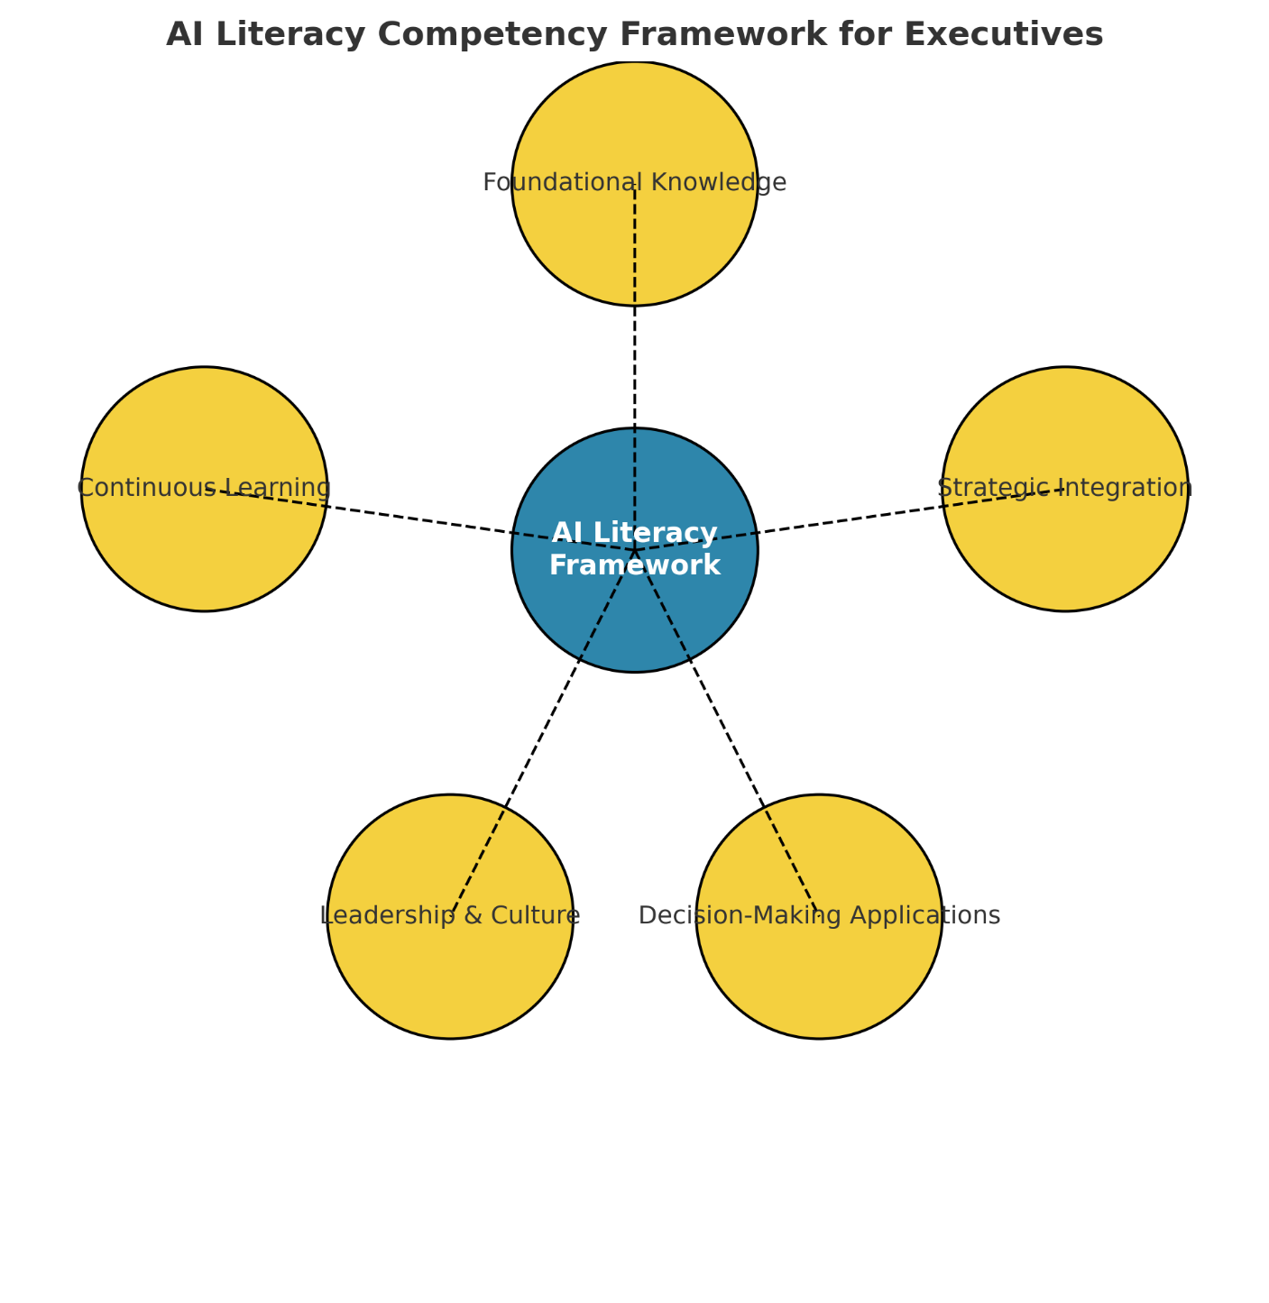
Figure 1. AI Literacy Competency Framework for Executives
This approach shows CEOs the multiple skills needed to integrate AI into organisational strategy. Foundational AI knowledge, strategic integration with business goals, application in decision-making, leadership and cultural transformation, and ongoing technology adaptation are its five domains.
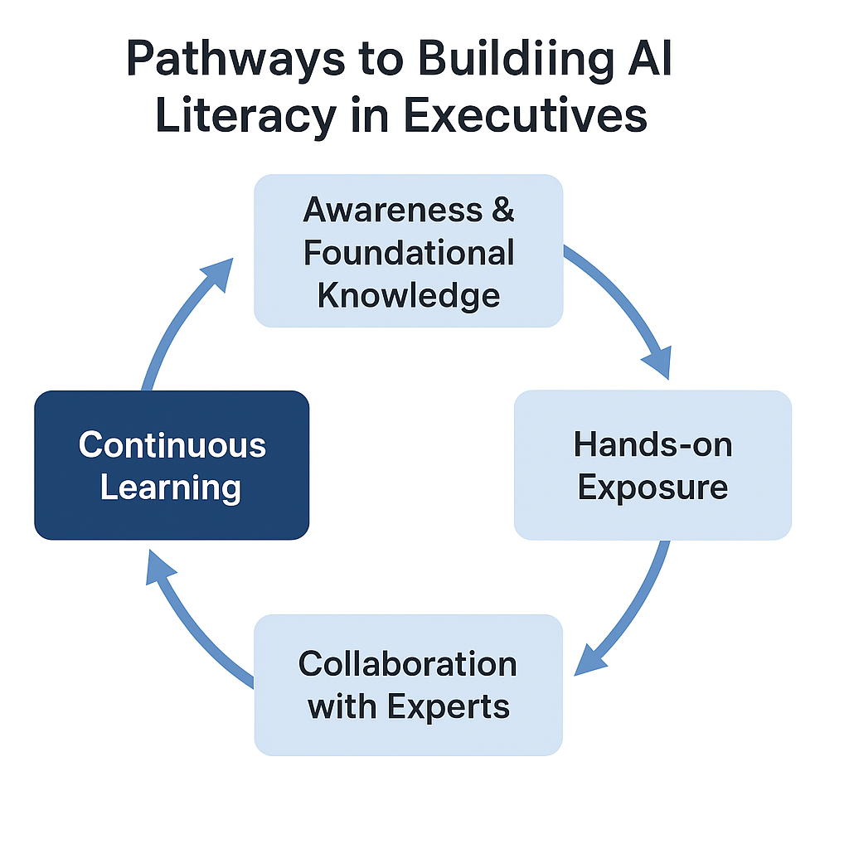
Fig 2: Executive AI Literacy Pathways. Business executives learn AI literacy in cycles, as shown in this figure. It covers five stages: awareness and basic knowledge, hands-on exposure, expert cooperation, strategic decision-making integration, and ongoing learning. Effective leadership in an AI-driven business context requires constant AI literacy growth, as the cycle shows.

5. Challenges and Gaps in AI Literacy for Executives

Lack of Standardized AI Education
Executives struggle with AI literacy without standardised training and customised education. Academic and technical schools offer AI education, however most programs are for engineers and technicians, not business leaders. Many executives never learn about AI or acquire it piecemeal and inconsistently due to a lack of executive-specific education. Executives may misread AI's capabilities and weaknesses[22].
Lack of a uniform framework or curriculum for executive AI literacy confuses executives about AI's practical application, resulting to mismatched expectations and inefficient decision-making. For instance, a CEO may oversimplify choices or underestimate AI. Filling this gap requires standardised technical and strategic AI education for business leaders. A standard, executive-focused education can reduce confusion and help leadership teams make smart AI decisions[22]

Organizational Resistance
Organisational resistance to new technology hinders business AI literacy. Many companies face resistance from employees and leadership when AI proves disruptive. AI may scare executives because of the unknown. This hesitancy is typically exacerbated by job displacement and organisational restructuring concerns[23].
Technology that changes workflows may be resisted by traditional companies. If AI adoption threatens long-standing processes or generates staff conflict, executives, who must guarantee new projects fit organisational culture, may be reluctant to push for it. In industries with low technological maturity, organisations may oppose AI due to a lack of understanding of its long-term benefits or a fear that it is too advanced[21].
This opposition hinders executive AI adoption. Internal resistance makes it impossible for leadership to prioritise AI integration and foster executive AI skills. Communicating AI's benefits, aligning business goals, and providing a conducive learning environment for employees and management to transition to AI can overcome this hesitation[4].

Varying Levels of AI Understanding
AI understanding is difficult for executives to disseminate inside their organisations. diverse departments and teams have diverse AI knowledge, which explains this. While some leaders understand AI's potential, others struggle with the basics. This lack of communication can impair departmental collaboration, especially between leadership teams and technical workers like data scientists and engineers[19].
In many organisations, technical professionals utilise specialised terminology that non-technical executives cannot grasp, hindering information transfer. As a result, leaders may struggle to fully interact with their staff or make AI-driven decisions. If AI is perceived as the sole duty of IT or data science, executives in marketing, finance, or operations may not feel empowered to adopt AI tools[24].
To overcome this difficulty, organisations must promote shared learning, where AI information is shared across departments and technical jargon is simplified. Cross-functional training, collaborative workshops, and clear explanation of AI's strategic benefits to executives and other staff can achieve this.

Integration with Business Strategy
A major gap in executive AI literacy is the challenge of combining AI insights with corporate strategy. Even if CEOs comprehend AI, they may struggle to use its technical skills to strategic decisions. The gap exists because AI tools are often not directly linked to business goals, or executives may lack the expertise to understand AI-driven data strategically.
Executives typically use AI to improve operational efficiency or minimise costs rather than create long-term, imaginative strategies that support the company's growth. Failure to integrate AI insights into company planning misses innovation and competitive advantage chances[25].

Strategic AI decision-making includes knowing AI's capabilities and projecting how AI tools will affect the competitive environment, customer behaviour, and market dynamics.
Executives must learn AI technologies and their strategic implications to close this gap. Executives should learn foresight, scenario planning, and how AI-driven advancements may affect industry trends and business structures. The executive must integrate AI understanding into their strategy and leadership[12].

Need for Continuous Learning
Executives must continuously learning to stay competitive in AI, which is always improving. Even the most knowledgeable executives struggle to keep up with AI technologies and applications. AI literacy is an ongoing practice that requires regular updates and involvement because to its constant progress.
This ongoing learning task is difficult for executives. Executives may struggle to find time to learn about new AI trends, tools, and best practices due to their busy schedules. Neglecting continual learning can result in an outdated executive team, which could lead to poor decision-making or failure to implement cutting-edge AI advancements[24].
AI literacy should be part of executives' professional growth, with frequent learning sessions, industry events, and targeted updates on developing AI uses. Creating a culture of continuous learning can also assist executives stay current on AI[17] .
Executives face a lack of standardised education, organisational resistance, departmental differences in knowledge, issues integrating AI with corporate strategy, and the necessity for continuing learning. Organisations must create customised training programs, encourage cross-functional learning, and integrate AI literacy into executive professional development to close these gaps. Overcoming these hurdles will help leaders make strategic, AI-powered decisions. Table 1 lists the main executive AI literacy barriers and the enablers organisations can use to overcome them[26].

Table 1. Barriers and Enablers of AI Literacy for Business Executives
Barrier | Description | Enabler/Strategy
Lack of Standardized AI Education | Absence of tailored executive training programs | Develop executive-focused AI curricula and certifications[27]
Time Constraints | Executives have limited time for continuous learning | Short modular courses, flexible online training[28]
Organizational Resistance | Fear of disruption and job loss hampers adoption | Transparent communication, pilot AI projects to show value[29]
Varying AI Understanding Across Departments | Misalignment between leaders and technical teams | Cross-functional workshops, simplified AI communication[30]
Integration with Business Strategy | Difficulty translating AI insights into strategy | Executive–data scientist collaboration, strategic foresight training[31]

6. Results and Discussion

Key Findings from the Literature
Several themes emerge from the literature on AI literacy for corporate executives. The most notable is the link between AI literacy and better business decisions. Numerous studies show that CEOs who grasp AI tools can make data-driven decisions, improving organisational performance. AI literacy helps leaders understand AI-driven insights, match them with strategic corporate goals, and make growth and innovation-promoting decisions[32] . Leadership effectiveness and AI literacy enable executives to lead AI-driven initiatives, cultural change, and innovation.
A crucial finding is that AI literacy drives innovation. AI-savvy executives can recognise technical advances, new company models, and process improvements. This AI knowledge often gives a company an edge. Leaders who grasp AI's predictive capabilities can use data-driven decision-making to improve forecasting and operational efficiency[1].
The literature also shows that AI literacy affects organisational agility. AI experts are better at leading their firms through technology transitions, including AI adoption and integration into key business processes. This adaptability to technical advances makes organisations long-term market leaders. As AI technologies improve, corporate executives' capacity to adapt and learn new skills is crucial to AI integration success[4].

Comparing AI Literacy Approaches
The literature suggests numerous strategies to teach executives AI literacy, each with merits and cons. Executive education and university courses are popular. These programs teach executives AI fundamentals and applications. MIT Artificial Intelligence: Implications for Business Strategy teaches AI theory and practise to executives[33].

Formal education may be too slow for executives' fast-paced decision-making. Technical AI education programs make it challenging for CEOs to apply this knowledge to business goals.
On-the-job training and coaching boosted AI literacy. These tools show CEOs how AI influences real-world decision-making and organisational effectiveness. On-the-job learning allows executives to work with data scientists and AI experts. This hands-on learning method bridges theory and experience, making AI solutions more accessible to corporate executives[25].
On-the-job learning may not fully prepare CEOs for AI's effects. They may master AI tools without understanding their strategic value or long-term repercussions. Mentorship programs, in which AI experts guide executives through decision-making, can provide context and strategic insight but are resource-intensive. Instead, blended learning—formal schooling with hands-on experiences and mentorship—works best. These hybrid methodologies teach CEOs AI basics and practical insights for AI-driven strategy[34].

Impact of AI Literacy on Business Outcomes
Revenue growth, operational efficiency, and competitive advantage depend on AI literacy. AI-savvy executives may lead strategic AI integration into key business activities. Understanding AI's predictive analytics potential helps executives make more accurate estimates, increasing planning and financial performance. AI literacy also helps leaders detect operational inefficiencies and optimise operations with AI tools, saving money and enhancing productivity[9]
Leadership improves with AI-driven decisions. AI-savvy leaders may reduce intuition and improve strategic decisions with real-time data. By better segmenting customers, AI helps CEOs design customised marketing plans that increase customer engagement and loyalty. AI-driven insights accelerate and improve decision-making, enabling organisations react to market changes
Organisational strategy is affected by AI literacy. AI helps long-term planners uncover new revenue streams, manage supply networks, and boost product development. AI helps companies meet customer needs, enter new markets, and improve products and services to compete. AI literacy allows strategic vision, forward-thinking leadership, and operational improvements[35].

Barriers and Solutions
AI literacy has many challenges despite its benefits. Organisational resistance is a major issue. Overcoming resistance requires a cultural shift regarding AI as a development driver rather than a threat. This can be achieved by proving AI's strategic value through experiments, freely discussing its benefits, and fostering continuous learning. Proof of AI's performance in other companies reduces anxiety and hostility[21].
Since many executive education programs are too technical or unrelated to business, standardisation is another issue. Executive-focused AI education should mix technical and strategic expertise. Customised, in-house AI training programs that target the organization's unique challenges and goals can make AI education more relevant and applicable.
Time constraints make learning difficult for executives. Organisations should include AI training in senior leadership development programs rather than as a one-time session[27]. To illustrate the interconnections highlighted in this review, a conceptual model linking AI literacy, leadership, and organizational performance is presented below.
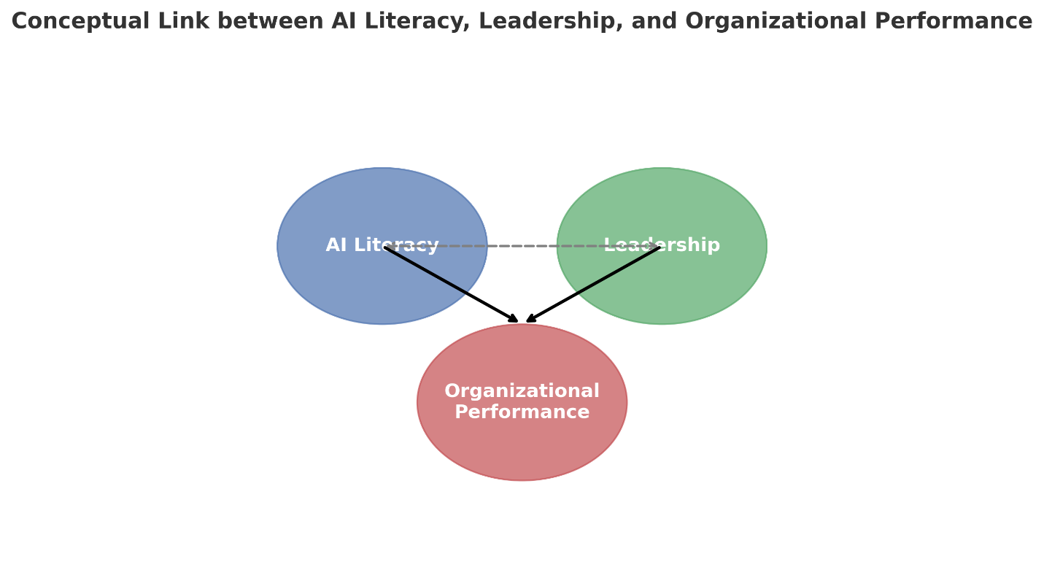
Figure 3. Conceptual Model Linking AI Literacy, Leadership, and Organizational Performance. This figure demonstrates the dynamic relationship between AI literacy, leadership, and organizational performance. AI literacy provides executives with the knowledge and skills to integrate AI into decision-making, which strengthens leadership capacity. Effective leadership, in turn, fosters organizational culture, strategy alignment, and innovation. Together, AI literacy and leadership drive organizational performance, enhancing efficiency, competitiveness, and long-term success.

Limitations of Current Literature
While this review provides valuable insights into the impact of AI literacy on leadership and organizational performance, several limitations must be acknowledged. One significant limitation is the challenge of generalizing the findings across industries. The studies included in this review primarily focus on sectors such as e-commerce, healthcare, and manufacturing. However, the application and impact of AI literacy may vary considerably in different industries due to distinct organizational structures, technological maturity, and market dynamics[36].
For example, while e-commerce companies like Amazon have successfully integrated AI for customer personalization and inventory management, manufacturing firms such as General Electric focus on predictive maintenance and operational efficiency. These differences in application suggest that AI literacy may have diverse implications depending on the sector's unique needs and challenges[37].
Additionally, the pace of AI adoption and the level of executive engagement with AI may differ across industries. Tech-driven industries may see quicker integration and higher AI literacy, while sectors like finance or government may face slower adoption due to regulatory constraints, workforce resistance, or existing technological infrastructures. Future research could benefit from more industry-specific studies to explore how AI literacy influences leadership outcomes in various contexts and whether industry-specific frameworks for executive training are necessary.

Future Scope
While this research provides valuable insights into AI literacy for business executives, there are several avenues for future exploration and innovation. As AI technologies continue to evolve, there are emerging opportunities to further refine the methods and frameworks discussed in this paper.
- Industry-Specific AI Literacy: Future research could explore how AI literacy frameworks can be tailored to specific industries, such as healthcare, finance, or manufacturing, to address unique challenges and opportunities in each sector. Understanding the industry-specific implications of AI literacy could lead to more effective executive training programs and better alignment of AI tools with organizational goals.
- Longitudinal Studies on AI Literacy: Long-term studies examining the impact of AI literacy on leadership effectiveness and organizational performance over time would provide deeper insights into the sustained benefits of AI education. Such studies could track executives' progress in AI adoption and decision-making skills, offering a comprehensive view of its long-term impact on businesses.
- AI Literacy in Non-Tech-Driven Industries: While this paper focuses on tech-driven sectors, there is significant potential for AI literacy in non-tech industries. Future work could explore the barriers and opportunities for AI adoption in industries with slower AI integration, such as traditional manufacturing or public sector organizations.
- Integration of AI with Leadership Development Programs: Further research can examine how AI literacy can be integrated into existing leadership development programs, assessing its effectiveness in enhancing decision-making skills and fostering a data-driven culture in organizations.
- Cross-Cultural AI Literacy: AI literacy could also be examined across different cultural contexts to understand how global businesses adapt AI technologies and training for executives in diverse regions. This would offer a broader understanding of how AI literacy is perceived and adopted in different cultural and organizational environments.
By addressing these areas, future research could not only deepen our understanding of AI literacy but also contribute to the development of more targeted, effective, and scalable AI education strategies for executives worldwide.

7. Conclusion

Summary of Key Insights
Business leaders require AI literacy, according to research. AI literacy boosts organisational innovation, leadership, and decision-making. Executives can make data-driven decisions, improve operations, and lead AI-driven growth projects by understanding AI technologies and their strategic implications. Executives with AI literacy can adapt to new technology, providing the organisation an edge. The review examined formal schooling, on-the-job learning, and mentorship as AI literacy-boosting methods, each with merits and cons. Even with these developments, organisational resistance, a lack of executive-specific education, and time constraints might slow AI adoption and business strategy integration[38].

Implications for Businesses
Businesses need AI literacy from CEOs to succeed in a fast-changing technology ecosystem. From forecasting accuracy and operational efficiency to strategic innovation, executives' AI knowledge and application effect company performance. Prioritising AI education can help leadership teams make educated decisions that improve operations, sustain growth, and acquire a competitive edge. Promoting AI literacy helps companies integrate AI into their culture, resulting in smoother AI adoption and a more creative, data-driven workplace[9].

Limitations of the Review
Though limited, executive AI literacy literature is valuable. Research rarely has an industry-specific perspective, thus its conclusions may not apply everywhere. AI literacy studies usually focus on short-term improvements rather than long-term executive decision-making and organisational performance. Limited geographical diversity may limit the generalisability of some studies across AI adoption and maturity levels.

Future Research Directions
AI literacy across industries and executive jobs should be studied to better understand how AI might be employed in diverse sectors. Longitudinal research on AI literacy's effects on organisational performance and innovation would also be useful. AI literacy and organisational culture studies may demonstrate how AI affects leadership, decision-making, and innovation. Companies that want AI literacy to be a leadership skill must grasp these dynamics.

8. Recommendations

For Executives
To promote AI literacy, executives should aggressively pursue formal and informal education. MIT and Harvard executive education programs teach business leaders AI. Leaders should prioritise self-directed learning on Coursera, edX, and Udacity to stay current on AI. Using mentorship programs or industry conferences to network with AI experts can assist executives understand AI applications. Finally, CEOs will learn about AI technologies' strategic value through cooperative projects with data scientists and AI professionals.

For Organizations
Companies should encourage executive AI literacy. If the organisation needs fundamental AI training and advanced applications, leadership development programs can include AI literacy workshops. Companies should offer suitable tools, courses, and seminars to promote learning. AI consultants and partners can design real-world AI applications that satisfy organisational requirements. Cross-functional executive-data scientist teams boost AI understanding and acceptance[24].

For Policymakers
Public funding for business leader-specific AI training can increase business AI literacy. Executive AI education might be subsidised and organisations that train their leadership teams using AI rewarded. Policymakers can also encourage academia, industry, and government to collaborate on AI literacy frameworks to give all business executives high-quality training. National educational programs that promote AI literacy can help train corporate leaders for AI concerns[9].

"For executives in manufacturing, incorporating AI tools for predictive maintenance and inventory optimization can lead to significant cost reductions. Leaders in retail should focus on understanding AI for personalized customer experiences and inventory management to stay ahead of consumer demands. By engaging in sector-specific AI training, executives can better align their AI literacy with business objectives and drive industry-specific innovations.

Disclaimer (Artificial intelligence)
Option 1:
Author(s) hereby declare that NO generative AI technologies such as Large Language Models (ChatGPT, COPILOT, etc.) and text-to-image generators have been used during the writing or editing of this manuscript.

REFRENCES

1. Rashid AB, Kausik MAK. AI revolutionizing industries worldwide: A comprehensive overview of its diverse applications. Hybrid Advances. 2024 Dec 1;7:100277.
2. Peretz-Andersson E, Tabares S, Mikalef P, Parida V. Artificial intelligence implementation in manufacturing SMEs: A resource orchestration approach. International Journal of Information Management. 2024 Aug 1;77:102781.
3. Biagini G. Towards an AI-Literate Future: A Systematic Literature Review Exploring Education, Ethics, and Applications. Int J Artif Intell Educ [Internet]. 2025 Mar 12 [cited 2025 Sep 13]; Available from: https://doi.org/10.1007/s40593-025-00466-w
4. Yang J, Blount Y, Amrollahi A. Artificial intelligence adoption in a professional service industry: A multiple case study. Technological Forecasting and Social Change. 2024 Apr 1;201:123251.
5. Jamarani A, Haddadi S, Sarvizadeh R, Haghi Kashani M, Akbari M, Moradi S. Big data and predictive analytics: A systematic review of applications. Artif Intell Rev. 2024 Jun 17;57(7):176.
6. Daios A, Kladovasilakis N, Kelemis A, Kostavelis I. AI Applications in Supply Chain Management: A Survey. Applied Sciences. 2025 Jan;15(5):2775.
7. Kumar B, Lorusso E, Fosso B, Pesole G. A comprehensive overview of microbiome data in the light of machine learning applications: categorization, accessibility, and future directions. Front Microbiol. 2024 Feb 13;15:1343572.
8. Murire OT. Artificial Intelligence and Its Role in Shaping Organizational Work Practices and Culture. Administrative Sciences. 2024 Dec;14(12):316.
9. Perifanis NA, Kitsios F. Investigating the Influence of Artificial Intelligence on Business Value in the Digital Era of Strategy: A Literature Review. Information. 2023 Feb;14(2):85.
10. Ahmed MI, Spooner B, Isherwood J, Lane M, Orrock E, Dennison A. A Systematic Review of the Barriers to the Implementation of Artificial Intelligence in Healthcare. Cureus. 15(10):e46454.
11. Ritala P, Aaltonen P, Ruokonen M, Nemeh A. Developing industrial AI capabilities: An organisational learning perspective. Technovation. 2024 Dec 1;138:103120.
12. Machucho R, Ortiz D. The Impacts of Artificial Intelligence on Business Innovation: A Comprehensive Review of Applications, Organizational Challenges, and Ethical Considerations. Systems. 2025 Apr;13(4):264.
13. Li Z. Review of Application of AI in Amazon Warehouse Management. Advances in Economics, Management and Political Sciences. 2024 Dec 26;144:1–8.
14. Lawal O, Elechi K, Adekunle F, Farinde O, Kolapo T, Igbokwe C, et al. A Review on Artificial Intelligence and Point-of-Care Diagnostics to Combat Antimicrobial Resistance in Resource-Limited Healthcare Settings like Nigeria: Review Article. Journal of Pharma Insights and Research. 2025 Apr 5;3(2):166–75.
15. Dwivedi YK, Kshetri N, Hughes L, Slade EL, Jeyaraj A, Kar AK, et al. Opinion Paper: “So what if ChatGPT wrote it?” Multidisciplinary perspectives on opportunities, challenges and implications of generative conversational AI for research, practice and policy. International Journal of Information Management. 2023 Aug 1;71:102642.
16. Ng DTK, Leung JKL, Chu SKW, Qiao MS. Conceptualizing AI literacy: An exploratory review. Computers and Education: Artificial Intelligence. 2021 Jan 1;2:100041.
17. Kamalov F, Santandreu Calonge D, Gurrib I. New Era of Artificial Intelligence in Education: Towards a Sustainable Multifaceted Revolution. Sustainability. 2023 Jan;15(16):12451.
18. Nguyen (Ruby) NN, Barbieri W. Mentorship in the Age of Generative AI: ChatGPT to Support Self-Regulated Learning of Pre-Service Teachers Before and During Placements. Education Sciences. 2025 Jun;15(6):642.
19. Florea NV, Croitoru G. The Impact of Artificial Intelligence on Communication Dynamics and Performance in Organizational Leadership. Administrative Sciences. 2025 Feb;15(2):33.
20. Abdullah AAH, Almaqtari FA. The impact of artificial intelligence and Industry 4.0 on transforming accounting and auditing practices. Journal of Open Innovation: Technology, Market, and Complexity. 2024 Mar 1;10(1):100218.
21. Golgeci I, Ritala P, Arslan A, McKenna B, Ali I. Confronting and alleviating AI resistance in the workplace: An integrative review and a process framework. Human Resource Management Review. 2025 Jun 1;35(2):101075.
22. Walter Y. Embracing the future of Artificial Intelligence in the classroom: the relevance of AI literacy, prompt engineering, and critical thinking in modern education. International Journal of Educational Technology in Higher Education. 2024 Feb 26;21(1):15.
23. Madanchian M, Taherdoost H. Barriers and Enablers of AI Adoption in Human Resource Management: A Critical Analysis of Organizational and Technological Factors. Information. 2025 Jan;16(1):51.
24. Babashahi L, Barbosa CE, Lima Y, Lyra A, Salazar H, Argôlo M, et al. AI in the Workplace: A Systematic Review of Skill Transformation in the Industry. Administrative Sciences. 2024 Jun;14(6):127.
25. Bollaert L. Artificial Intelligence: Objective or Tool in the 21st-Century Higher Education Strategy and Leadership? Education Sciences. 2025 Jun;15(6):774.
26. Sebihi A, Schoelen L, Uwamwezi B. Unveiling AI’s impact in Rwandan higher education: navigating trends, challenges, and imperatives at the University of Rwanda. Discov Educ. 2025 Jun 12;4(1):166.
27. Sinha S, Lee YM. Challenges with developing and deploying AI models and applications in industrial systems. Discov Artif Intell. 2024 Aug 16;4(1):55.
28. Mukhtar K, Javed K, Arooj M, Sethi A. Advantages, Limitations and Recommendations for online learning during COVID-19 pandemic era. Pak J Med Sci. 2020 May;36(COVID19-S4):S27–31.
29. Ivchyk V. OVERCOMING BARRIERS TO ARTIFICIAL INTELLIGENCE ADOPTION. Three Seas Economic Journal. 2024 Dec 27;5(4):14–20.
30. Kassa BY, Worku EK. The impact of artificial intelligence on organizational performance: The mediating role of employee productivity. Journal of Open Innovation: Technology, Market, and Complexity. 2025 Mar 1;11(1):100474.
31. Olaitan OF, Akatakpo ON, Victor CO, Emejulu CJ, Ayoola TM, Olayiwola DE, et al. Secure and Resilient Industrial IoT Architectures for Smart Manufacturing: A Comprehensive Review. Journal of Engineering Research and Reports. 2025 Jun 21;27(6):331–44.
32. Dwivedi YK, Ismagilova E, Hughes DL, Carlson J, Filieri R, Jacobson J, et al. Setting the future of digital and social media marketing research: Perspectives and research propositions. International Journal of Information Management. 2021 Aug 1;59:102168.
33. Vieriu AM, Petrea G. The Impact of Artificial Intelligence (AI) on Students’ Academic Development. Education Sciences. 2025 Mar;15(3):343.
34. Madanchian M. From Recruitment to Retention: AI Tools for Human Resource Decision-Making. Applied Sciences. 2024 Jan;14(24):11750.
35. Medlama M. The Impact of Artificial Intelligence on Leadership Decision-Making: Opportunities and Challenges. Communications on Applied Nonlinear Analysis. 2025 Mar 19;32(9s):1878–85.
36. Cao G, Duan Y, Edwards JS, Dwivedi YK. Understanding managers’ attitudes and behavioral intentions towards using artificial intelligence for organizational decision-making. Technovation. 2021 Aug 1;106:102312.
37. Pinski M, Hofmann T, Benlian A. AI Literacy for the top management: An upper echelons perspective on corporate AI orientation and implementation ability. Electron Markets. 2024 Apr 1;34(1):24.
38. Jorzik P, Klein SP, Kanbach DK, Kraus S. AI-driven business model innovation: A systematic review and research agenda. Journal of Business Research. 2024 Sep 1;182:114764.

