Review Article

Advances in Green Synthesis of Nanoparticles from Crop Residues and Their Application in Sustainable Agriculture: A Review

.
ABSTRACT

The vast abundance of crop residues, amounting to millions of tonnes annually, remains a largely underutilized resource, underscoring the urgent need for sustainable valorization strategies. This review provides a comprehensive evaluation of the green synthesis and application of nanoparticles derived from a wide range of crop residues, including leaves, husks, straw, bagasse, and seeds. We explore the efficacy of various green pre-treatment methods—such as the use of organosolvents, steam explosion, and deep eutectic solvents—for their potential to enhance nanoparticle yield while minimizing energy consumption and aligning with the principles of green chemistry. The applications of these crop residue-derived nanoparticles (CRNs) are extensive, spanning critical sectors such as sustainable agriculture, where they are used to improve crop protection, enhance nutrient delivery, and promote soil health. Special attention is given to their role in active food packaging and as controlled-release carriers for agrochemicals like fungicides and pesticides. While CRNs hold considerable promise, significant challenges related to the heterogeneity of raw materials, scalability of production, and potential nanotoxicity must be addressed to ensure consistent quality and safe application. This review synthesizes current research, highlights existing gaps, and emphasizes the critical role of CRNs in fostering a circular economy and supporting global sustainability goals.

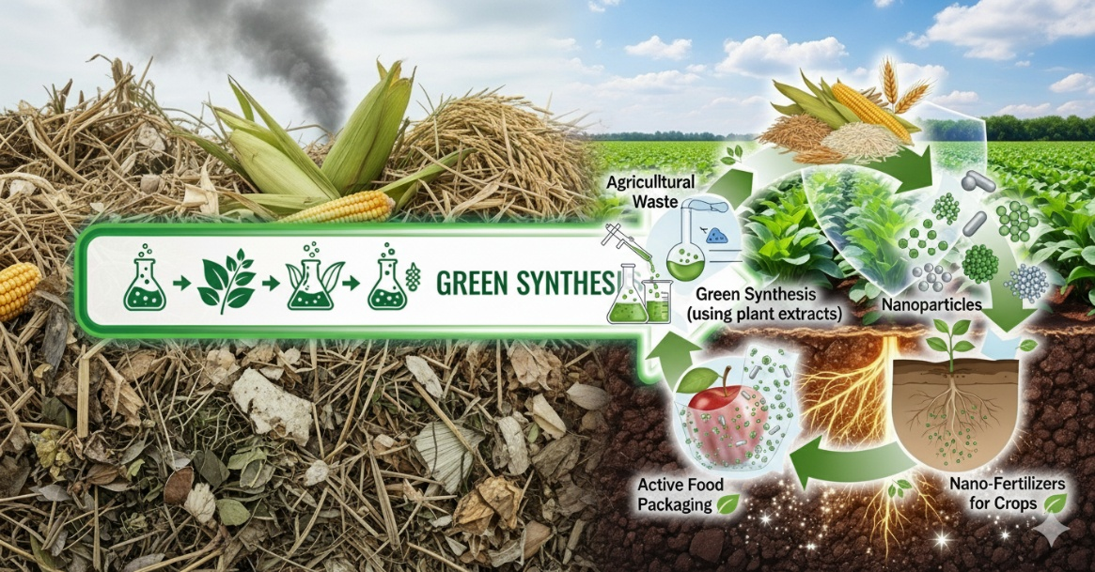
Graphical Abstract

Keywords: Waste Valorization, Nanoparticles, Sustainable Agriculture, Food Preservation.

1. INTRODUCTION

The global agri-food system stands at the center of profound economic, environmental, and social challenges. With the world population projected to reach 9.7 million by 2050, crop productivity must increase by 60-100% to meet the rising demand for food (Sidhu et al., 2025). This intensification of agriculture, however, contributes heavily to climate change and resource scarcity, while simultaneously generating vast quantities of agro-industrial waste. This waste, which accounts for approximately 30% of worldwide agricultural production, surpasses two billion tons annually (Sadh et al., 2018; Duque-Acevedo et al., 2020). Historically, the improper disposal of these residues through burning or decomposition has led to significant greenhouse gas emissions—including CO₂​, CH₄​, and N₂​O—and the degradation of delicate ecosystems (Olaniyan et al., 2025). To address this unsustainable cycle, a paradigm shift towards a circular economy is essential. This approach reframes "waste" as a valuable resource, employing biorefinery technologies to convert agricultural byproducts into value-added products such as biofuels, bioplastics, and biofertilizers, thereby aligning with the United Nations' Sustainable Development Goals to substantially reduce waste through prevention, reduction, recycling, and reuse (Olaniyan et al., 2025).

Within this circular framework, nanotechnology offers a transformative and innovative pathway for the valorization of agricultural waste. Nanomaterials, defined as materials possessing at least one dimension within the 1–100 nm range, exhibit unique physicochemical properties—such as high surface area-to-volume ratios and enhanced reactivity—that differ markedly from their bulk counterparts. These properties make them exceptionally suited for converting low-cost agricultural feedstocks into high-performance materials (Palanisamy, Kumar, et al., 2025). Abundant agricultural wastes like leaves, stems, seeds, pulp, bagasse, and husks serve as rich precursors for a diverse array of nanoparticles, including organic materials like cellulose and pectin, and inorganic structures based on silica and various metals (Flores-Contreras et al., 2024; Melenia et al., 2024; Olaniyan et al., 2025; Pratama, Addy, et al., 2024; Pratama, Piluharto, et al., 2024). The ability to engineer materials at the nanoscale opens up novel applications in medicine, environmental remediation, and agriculture that were previously unattainable with raw biomass.

The synthesis of CRNs is widely considered a green approach, presenting a sustainable alternative to conventional physical and chemical manufacturing methods that often rely on hazardous solvents and produce toxic residues (Sidhu et al., 2025). This green synthesis significantly reduces the carbon footprint, energy consumption, and use of harsh chemicals, aligning perfectly with the principles of green chemistry (Kurul et al., 2025). The resulting CRNs are being increasingly explored for a wide range of applications in sustainable agriculture. Among the most promising of these is their use in active food preservation and as delivery systems for agrochemicals. Polymeric nanoparticles, for example, can encapsulate fertilizers and pesticides, enabling controlled-release systems that can reduce agrochemical usage by up to 40% while improving crop yield (Sidhu et al., 2025). This review will provide a comprehensive analysis of the synthesis, characterization, and application of these novel nanomaterials, with a particular focus on their mechanisms of action and the critical challenges—including scalability, toxicity, and regulatory hurdles—that must be overcome for their successful implementation.

2. SYNTHESIS AND CHARACTERIZATION OF NANOPARTICLES

The conversion of raw crop residue into functional nanomaterials is a sophisticated, multi-stage process that begins with essential pre-treatments to overcome the natural recalcitrance of lignocellulosic biomass. Before nano-synthesis, residues must be processed through physical methods like grinding, chemical techniques such as acid and alkaline hydrolysis, or biological routes using enzymes and microbes. Advanced green pre-treatment methods are gaining prominence, including the use of organosolvents (e.g., ethanol, acetic acid) which effectively fractionate biomass into cellulose, lignin, and hemicellulose with high purity and ease of solvent recovery (Olaniyan et al., 2025). Other innovative methods include steam explosion, which uses rapid decompression to break down biomass structure, and the use of Deep Eutectic Solvents (DESs), which are eco-friendly solvents that efficiently dissolve lignin and hemicellulose under mild conditions (Olaniyan et al., 2025). The choice of pre-treatment is vital; for instance, alkaline treatment is a common step for rice husk to remove organic impurities before the extraction of high-purity nanosilica. Following this, nanoparticle synthesis occurs via two main strategies: top-down and bottom-up approaches (Figure 1).

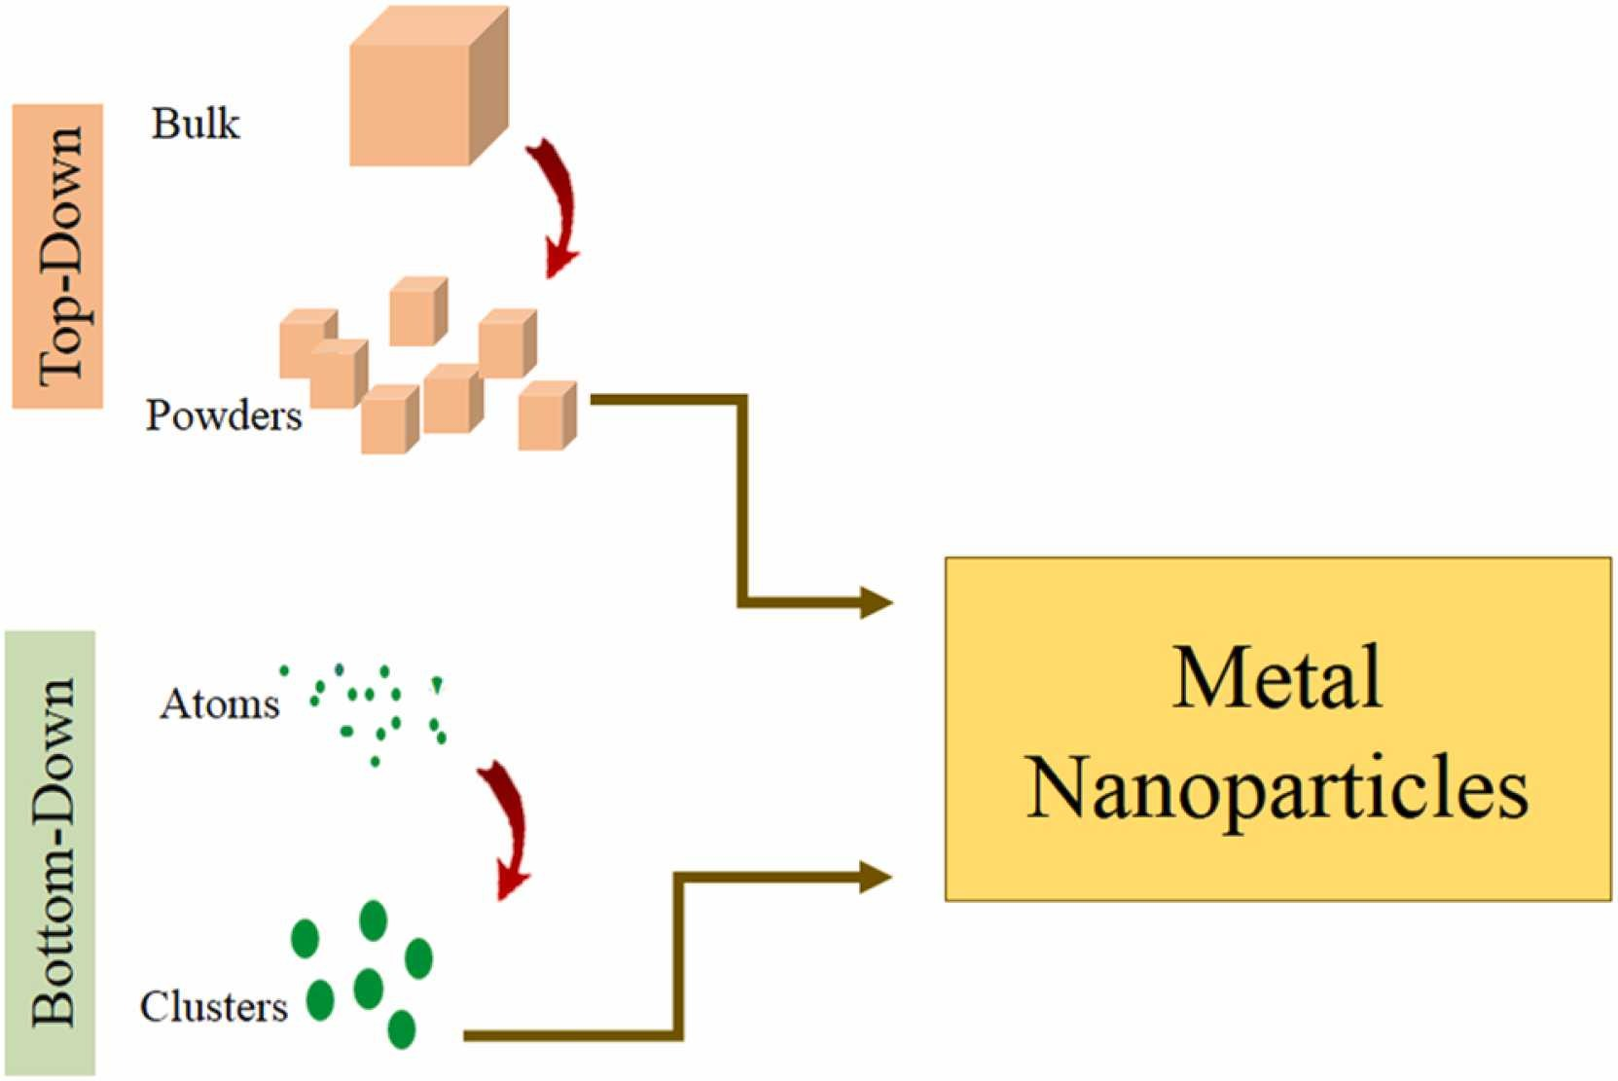
Fig 1. Schematic of top-down and bottom-up approaches for nanoparticle synthesis. [Adapted with permission from Riseh & Vazvani, 2024] (Riseh & Vazvani, 2024)
Top-down technologies involve the mechanical or chemical breakdown of bulk material into nanoscale particles. Key techniques include ball milling, a mechanical process that applies kinetic energy via rolling balls to wear down materials like wheat straw into nanocellulose, and electrospinning, which applies a high voltage to a polymer solution derived from biowaste, causing it to elongate into a conical "Taylor cone shape" and form nanofibers with high surface area (Sidhu et al., 2025). Bottom-up technologies, in contrast, construct nanoparticles from atomic or molecular units through controlled chemical and physical processes. Common methods include pyrolysis, a thermochemical process that degrades raw materials like groundnut shells in an oxygen-free environment to produce carbon-based nanoparticles; the hydrothermal technique, where synthesis of materials like carbon dots from corn cobs occurs in autoclaves under specific conditions of high temperature (120°C–550°C) and pressure (20–150 bar); and the sol-gel method, which produces a nano-scaled product like silica through hydrolysis and condensation reactions. A particularly promising bottom-up method is green synthesis, where aqueous extracts from fruit peels or leaves (e.g., avocado peel) act as natural reducing and capping agents to synthesize metallic nanoparticles like silver (Ag) and gold (Au) (Adebayo et al., 2019). Table 1 summarizes several key examples of nanomaterials synthesized from various crop residues.

Table 1. Nanoparticle Synthesis from Various Crop Residues

Sources | Synthesis Method | Resulting Nanoparticle | Application | Reference
Rice Husk | Thermo-chemical / Sol-gel | Nanosilica  (SiO₂​) | Battery | (Shen, 2017)
Sugarcane Bagasse | Acid Hydrolysis, Homogenization | Nanocellulose (CNCs/CNFs) | Food packaging films, drug delivery | (Reddy et al., 2021)
Groundnut Shell | Pyrolysis | Carbon Nanoparticles | Antimicrobial agents | (Yallappa et al., 2017)
Avocado Peel Extract | Green Synthesis (Reduction) | Silver (Ag) & Gold (Au) | Antimicrobial coatings, sensors | (Adebayo et al., 2019)
Potato Peel | Alkaline treatment, Hydrolysis | Cellulose Nanoparticles | Active packaging films | (Ramesh & Radhakrishnan, 2019)
Corn Cob | Hydrothermal Carbonization | Carbon Dots (CDs) | Bioimaging, heavy metal sensing | (Li et al., 2021)
Mulberry Leaves | Green Synthesis (Reduction) | Titanium Dioxide (TiO₂) | Functionalization of fabrics, photocatalysis | (Akram et al., 2024)
Palm oil boiler ash | Calcination and Ball Mill | Nanosilica  (SiO₂​) | Functionalization of fabrics, photocatalysis | (Frida et al., 2024)

Once synthesized, rigorous characterization is required to understand the nanoparticles' properties. This involves using techniques like Transmission Electron Microscopy (TEM) and Atomic Force Microscopy (AFM) to directly visualize morphology and crystalline structure. Dynamic Light Scattering (DLS) is used to measure the particle size distribution in a liquid medium, while spectroscopic methods like Fourier-Transform Infrared Spectroscopy (FTIR) and UV-Vis Spectroscopy analyze the chemical functional groups and optical properties, respectively. Furthermore, X-ray Diffraction (XRD) is crucial for determining the crystallinity and phase purity of the synthesized nanomaterials.

3. APPLICATION IN FOOD PRESERVATION AND SUSTAINABLE AGRICULTURE

The unique properties of CRNs make them highly suitable for a range of applications aimed at improving agricultural sustainability. While there is growing interest in their use as nanofertilizers and for soil remediation, their most extensively researched and developed application is in the field of food preservation through the creation of advanced nanocomposites for active packaging (Salama et al., 2020).

3.1 Active Food Packaging with Nanocomposites

The primary application for these CRNs is their incorporation as functional fillers into biopolymer matrices to create active food packaging (Palanisamy, Saravana Kumar, et al., 2025). These nanocomposites are designed to go beyond passive containment, actively interacting with the food or its environment to extend shelf-life and improve safety (Figure 2). Nanoparticles such as nanocellulose, nanosilica, and metallic nanoparticles are embedded into matrices like chitosan, cellulose, or polyvinyl alcohol (PVA) (Huang et al., 2024; Lu et al., 2022; Palanisamy et al., 2024; Rahmawati et al., 2024). The resulting films or edible coatings exhibit significantly enhanced properties. For instance, the high aspect ratio and crystalline nature of nanocellulose from sugarcane bagasse can create a tortuous path for gas molecules, drastically improving the oxygen and water vapor barrier properties of the film. Similarly, inorganic nanoparticles like titanium oxide (TiO₂​) and zinc oxide (ZnO) are excellent UV blockers, protecting food from light-induced degradation. Beyond barrier properties, the addition of these nanoparticles enhances the mechanical strength, flexibility, and thermal stability of the biopolymer films, making them more robust for practical packaging applications (Hu et al., 2022). The most critical function, however, is the potent antimicrobial activity conferred by many of these nanoparticles, which directly inhibits the growth of spoilage and pathogenic microorganisms.

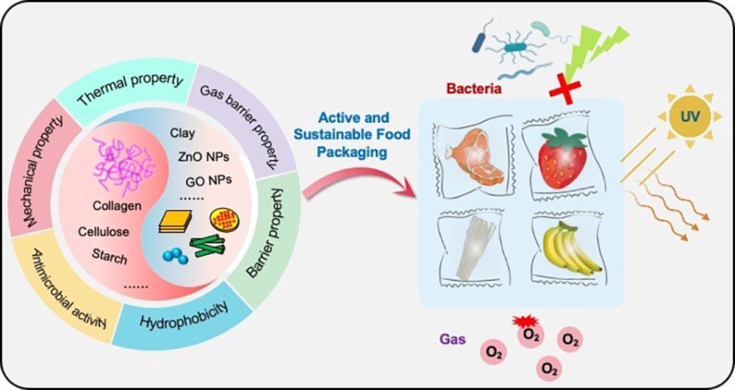
Fig 2. Illustration of nanoparticle fillers enhancing the film's barrier, mechanical, and antimicrobial properties to extend food shelf life and improve safety in an active and sustainable food packaging system [Adapted with permission from Shi et al., 2023] (Shi et al., 2023).

3.2 Specific Applications in Agrochemical Delivery and Crop Protection

The versatility of these nanocomposites extends to the controlled delivery of agrochemicals, offering a more sustainable approach to crop protection. Polymeric nanoparticles made from biopolymers like chitosan and alginate can encapsulate fungicides, insecticides, and herbicides, providing a slow and sustained release of the active ingredients. This targeted delivery minimizes the amount of chemical needed, reduces environmental leaching, and improves efficacy. For example, nano-fungicides have shown significant promise. Chitosan-lactide copolymer nanoparticles loaded with the fungicide pyraclostrobin exhibited up to 85.1% inhibition against Colletotrichum gossypii (Xu et al., 2014). Similarly, nano-insecticides have proven more effective than their conventional counterparts. A nanoformulation of methomyl and pyridalyl in a carboxymethyl chitosan and sodium alginate matrix resulted in only 1.6-2.3% fruit damage in tomatoes, compared to 3.5-7.4% damage with commercial formulations (Saini et al., 2015). Nano-herbicides also benefit from this technology; paraquat encapsulated in chitosan/tripolyphosphate nanoparticles showed high efficiency with delayed release and less soil penetration, making it more environmentally friendly (Grillo et al., 2014). Table 2 provides a summary of recent studies highlighting these applications.

Table 2. Applications of Nanocomposites Derived from CRNs in Agrochemicals and Food Preservation

Nanomaterials Source | Nanocomposite | Application | Results | Reference
Chitosan (from crustacean shells) | Chitosan-lactide copolymer NPs with pyraclostrobin | Nano-fungicide for cotton | Showed 52.2-85.1% inhibition against Colletotrichum gossypii. | (Xu et al., 2014)
Grape Seed Extract | Chitosan/AgNPs composite film | Grape preservation | Reduced decay percentage and weight loss; maintained titratable acidity; inhibited mold growth. | (Zhao et al., 2022)
Chitosan/Alginate | Polymeric NPs with methomyl and pyridalyl | Nano-insecticide for tomatoes | Reduced fruit damage to 1.6-2.3% compared to 3.5-7.4% with commercial formulations. | (Saini et al., 2015)
Rice Husk (implied source) | Chitosan film with Nanosilica and Hop Extract | Active packaging film | Improved tensile strength, enhanced barrier against UV and water vapor, excellent antioxidant and antibacterial capability. | (Cheng et al., 2021)
Chitosan/Pectin | Polymeric NPs with paraquat | Nano-herbicide for corn/brassica | Showed high herbicidal activity with delayed release and reduced soil penetration. | (Grillo et al., 2014)

3.3 Other Applications in Sustainable Agriculture

Beyond food packaging and crop protection, these sustainably sourced nanomaterials are poised to make significant contributions to other areas of agriculture (Figure 3). Nanofertilizers, for example, utilize nanoparticles like nanosilica from rice husks or chitosan from crustacean shells as carriers for essential nutrients (N, P, K). This nano-encapsulation allows for a slow, controlled release of nutrients directly to the plant, improving nutrient use efficiency and significantly reducing the runoff that causes water pollution. Similarly, polymeric nanoparticles can be used to manage abiotic stress. For example, O-Carboxymethyl chitosan nanoparticles have been shown to enhance water stress tolerance in maize by increasing chlorophyll content and antioxidant enzyme activity (Wu et al., 2024). Furthermore, carbon-based nanomaterials like biochar, produced from the pyrolysis of various biomass, are being used for soil remediation. Their high porosity and surface area enable them to effectively adsorb and immobilize heavy metals and organic pollutants, cleaning contaminated soils and improving overall soil health.

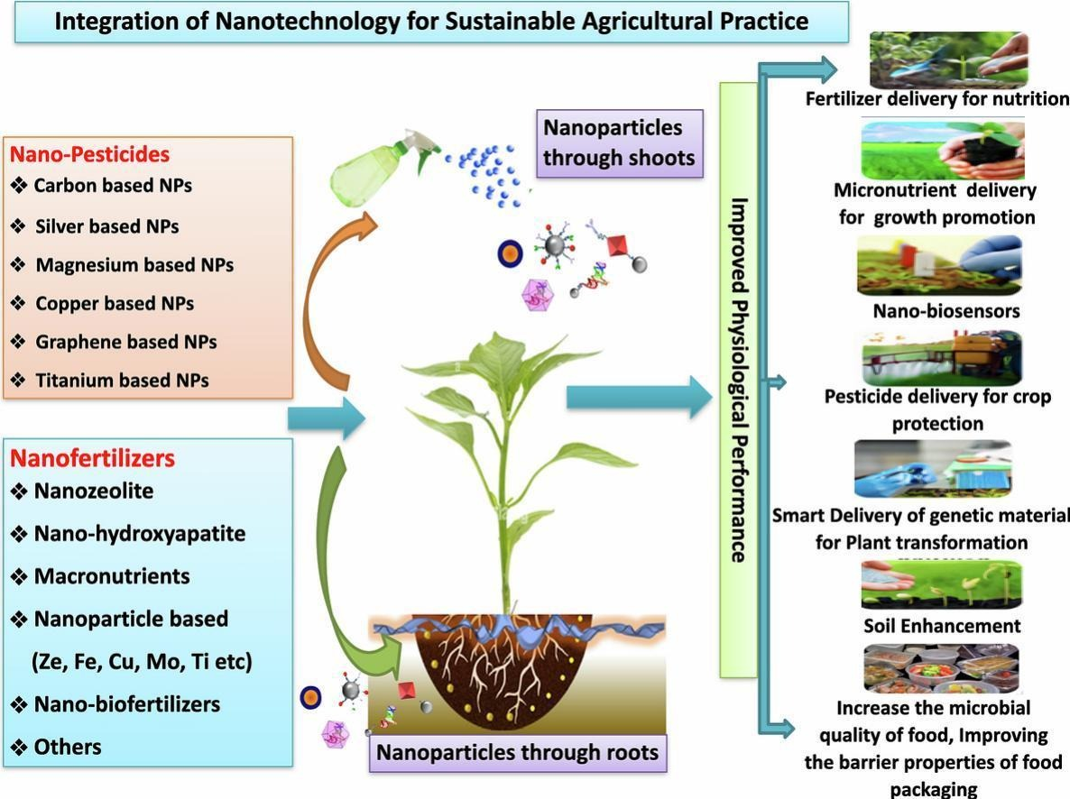
Fig 3. An overview of CRNs applications in sustainable agriculture, including nanofertilizers, nanopesticides, and nanosensors, which improve crop performance through targeted delivery [Adapted with permission from Shah et al., 2024] (Shah et al., 2024)

4. MOLECULAR MECHANISMS OF ANTIMICROBIAL ACTION

The efficacy of CRNs in food preservation stems from their ability to inhibit microbial growth through several molecular mechanisms, often acting on multiple cellular targets simultaneously, which helps prevent the development of antimicrobial resistance. A primary mechanism is the induction of oxidative stress through the generation of reactive oxygen species (ROS), which damage critical biomolecules like DNA, disrupt ATP synthesis, and ultimately lead to cell death. CRNs also cause direct physical damage to microbial cells. Inorganic metallic nanoparticles, for instance, often possess a positive surface charge that facilitates an electrostatic interaction with the negatively charged bacterial cell wall, leading to membrane destabilization, increased permeability, and the leakage of essential intracellular contents (Sánchez-López et al., 2020). In addition to direct contact, many metallic nanoparticles release metal ions that can inactivate key enzymes and proteins, thereby disrupting vital metabolic pathways. While inorganic nanoparticles like silver (Ag), zinc oxide (ZnO), and titanium oxide (TiO_{2​}) exhibit strong, broad-spectrum antimicrobial activity on their own, organic nanoparticles such as pectin and cellulose often possess weak antimicrobial properties and must be conjugated with other active agents, like essential oils or metals, to be effective. The mechanisms by which these various CRNs are taken up by plants are illustrated in Figure 4.

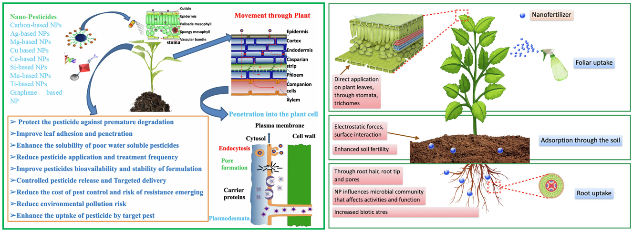
Fig 4. Mechanisms of CRNs uptake and transport in plants for agricultural applications [Adapted with permission from Shah et al., 2024] (Shah et al., 2024).

5. CHALLENGES, SAFETY, AND FUTURE PROSPECTS

Despite their immense potential, the widespread application of CRNs faces significant hurdles, particularly concerning synthesis, safety, and regulation. A major challenge is the heterogeneity of the raw material; agro-industrial waste has a highly variable chemical composition, which makes it difficult to standardize synthesis methods and obtain CRNs with consistent and predictable properties (Olaniyan et al., 2025). Scaling up production from the lab to an industrial level in a cost-effective manner while achieving high yields also remains a formidable obstacle. The most critical concern, however, is the potential toxicity and risk to human health and the environment. CRNs possess unique properties different from their bulk forms, and their small size allows them to migrate from packaging into food, be absorbed by plants, and potentially enter the food chain. Reports suggest that higher doses of some CRNs could lead to a 10-15% reduction in soil microbial diversity (Sidhu et al., 2025). Nanoparticle toxicity is complex and depends on multiple factors, including size, shape, surface charge, and concentration. For example, studies have shown that spherical ZnO nanoparticles can be more toxic than their nanorod counterparts (Medici et al., 2021).

Due to these risks, there is a pressing need for clear regulatory frameworks. Currently, guidelines for the use of nanomaterials in agriculture vary significantly across regions. In the United States, the EPA, FDA, and USDA oversee safety assessments and labeling. The European Union has a strict framework requiring mandatory labeling and traceability through agencies like EFSA and ECHA. Similarly, countries like India and China have established guidelines for the safety assessment and management of agricultural nanoproducts (Sidhu et al., 2025). However, these regulations often lag behind the rapid pace of innovation. Future research must prioritize the development of standardized green synthesis methods alongside comprehensive, long-term studies on the environmental fate and toxicological profiles of these promising materials to ensure their safe and sustainable integration into agricultural practices.

6. CONCLUSION

The valorization of crop residue through nanotechnology presents a powerful and sustainable solution to concurrent challenges in waste management, food security, and environmental protection. Green synthesis methods offer an eco-friendly and economically viable route to producing a wide array of organic, inorganic, and hybrid nanoparticles with significant potential to revolutionize agrotechnology. Their application in active food packaging and as controlled-release systems for agrochemicals can drastically improve food preservation, reduce waste, enhance crop protection, and promote soil health. However, the path to widespread commercialization is fraught with challenges. Issues of production scalability, cost-effectiveness, and, most importantly, the potential for nanotoxicity must be thoroughly addressed through continued interdisciplinary research and the establishment of clear, harmonized regulatory guidelines. Overcoming these hurdles will be key to unlocking the full potential of these materials and advancing a truly circular economy in the agricultural sector, contributing to a more sustainable and resilient global food system.

Declaration of Generative AI

During the preparation of this work, the author used Gemini AI in order to refine the English. After using this tool/service, the authors reviewed and edited the content as needed and take full responsibility for the content of the publication.

References

Adebayo, A. E., Oke, A. M., Lateef, A., et al. (2019). Biosynthesis of silver, gold and silver-gold alloy nanoparticles using Persea americana fruit peel aqueous extract for their biomedical properties. Nanotechnology for Environmental Engineering, 4(1), 13. https://doi.org/10.1007/s41204-019-0060-8
Akram, W., et al. (2024). Simultaneous synthesis and application of TiO₂ nanoparticles using mulberry leaves for functionalization of organic cotton fabric. Journal of Cleaner Production, 440, 140939. https://doi.org/10.1016/j.jclepro.2024.140939
Cheng, J., Tian, B., Wang, J., Wang, Z., & Liu, Y. (2021). Development of multifunctional films based on chitosan, nano silica and hops extracts. European Polymer Journal, 161, 110816. https://doi.org/10.1016/j.eurpolymj.2021.110816
Duque-Acevedo, M., Belmonte-Ureña, L. J., Cortés-García, F. J., & Camacho-Ferre, F. (2020). Agricultural waste: Review of the evolution, approaches and perspectives on alternative uses. Global Ecology and Conservation, 22, e00902. https://doi.org/10.1016/j.gecco.2020.e00902
Flores-Contreras, E. A., González-González, R. B., Pablo Pizaña-Aranda, J. J., Parra-Arroyo, L., Rodríguez-Aguayo, A. A., Iñiguez-Moreno, M., González-Meza, G. M., Araújo, R. G., Ramírez-Gamboa, D., Parra-Saldívar, R., & Melchor-Martínez, E. M. (2024). Agricultural waste as a sustainable source for nanoparticle synthesis and their antimicrobial properties for food preservation. Frontiers in Nanotechnology, 6, 1346069. https://doi.org/10.3389/FNANO.2024.1346069
Frida, E., Ratnawulan, Bukit, N., Bukit, B. F., Taufiq, A., Pratama, A. W., Rahmawati, I., & Bukit, F. R. A. (2024). Superhydrophilic and self-cleaning properties of cotton fabric coated with oil palm boiler ash and titanium dioxide. Case Studies in Chemical and Environmental Engineering, 10, 100946. https://doi.org/10.1016/J.CSCEE.2024.100946
Grillo, R., Pereira, A. E. S., Nishisaka, C. S., De Lima, R., Oehlke, K., Greiner, R., & Fraceto, L. F. (2014). Chitosan/tripolyphosphate nanoparticles loaded with paraquat herbicide: An environmentally safer alternative for weed control. Journal of Hazardous Materials, 278, 163–171. https://doi.org/10.1016/J.JHAZMAT.2014.05.079
Hu, W., Zou, Z., Li, H., Zhang, Z., Yu, J., & Tang, Q. (2022). Fabrication of highly transparent and multifunctional polyvinyl alcohol/starch based nanocomposite films using zinc oxide nanoparticles as compatibilizers. International Journal of Biological Macromolecules, 204, 284-292. https://doi.org/10.1016/j.ijbiomac.2022.02.020
Huang, X., Wang, F., Hu, W., Zou, Z., Tang, Q., Li, H., & Xu, L. (2024). Smart packaging films based on corn starch/polyvinyl alcohol containing nano SIM-1 for monitoring food freshness. International Journal of Biological Macromolecules, 256, 128373. https://doi.org/10.1016/J.IJBIOMAC.2023.128373
Kurul, F., Doruk, · Beyzanur, Seda, ·, & Topkaya, N. (2025). Principles of green chemistry: building a sustainable future. Discover Chemistry 2(1), 1–25. https://doi.org/10.1007/S44371-025-00152-9
Li, Z., Wang, Q., Zhou, Z., Zhao, S., Zhong, S., Xu, L., Gao, Y., & Cui, X. (2021). Green synthesis of carbon quantum dots from corn stalk shell by hydrothermal approach in near-critical water and applications in detecting and bioimaging. Microchemical Journal, 166, 106250. https://doi.org/10.1016/J.MICROC.2021.106250
Lu, P., Zhao, H., Zheng, L., Duan, Y., Wu, M., Yu, X., & Yang, Y. (2022). Nanocellulose/Nisin Hydrogel Microparticles as Sustained Antimicrobial Coatings for Paper Packaging. ACS Applied Polymer Materials, 4(4), 2664–2673. https://doi.org/10.1021/ACSAPM.2C00001
Medici, S., Peana, M., Pelucelli, A., & Zoroddu, M. A. (2021). An updated overview on metal nanoparticles toxicity. Seminars in Cancer Biology, 76, 17-26. https://doi.org/10.1016/j.semcancer.2021.06.020
Melenia, A. T., Jovita, S., Utami, D. I., Tamim, R., Holilah, H., Bahruji, H., Hamid, Z. A. A., Mubarok, F., Widiyastuti, W., Wibisono, A. T., Suprapto, S., Jalil, A. A., & Prasetyoko, D. (2024). Nanocrystalline cellulose from Calophyllum inophyllum shells waste by adjusting organic acid hydrolysis and optimization of reaction parameters using response surface methodology. International Journal of Biological Macromolecules, 281, 135705. https://doi.org/10.1016/J.IJBIOMAC.2024.135705
Olaniyan, O. F., Ariwaodo, C. A., Ibrahim, S. O., Atolani, O., & Kambizi, L. (2025). Advances in green synthesis and application of nanoparticles from crop residues: A comprehensive review. Scientific African, 28, e02654. https://doi.org/10.1016/j.sciaf.2025.e02654
Palanisamy, S., Kumar, B. K. S., Senthilkumar, D., Ajith, S. J., Sreedharan, S., Pathrose, J. M., Pitchumani, G. L., Ganesan, N., Venkatachalam, S., Saravanan, B., Lee, J., & Bharathi, D. (2025). Enhancing tomato shelf life using isolated cellulose fibers from Asian Palmyra palm coated with garlic oil. Food Chemistry, 466, 142163. https://doi.org/10.1016/J.FOODCHEM.2024.142163
Palanisamy, S., Saravana Kumar, B. K., Sivakumar, G., Selvan, S., Lee, J., & Bharathi, D. (2025). Advancing marine cellulose-based packaging: A review on sustainable biorefinery perspectives. Biomass and Bioenergy, 197, 107849. https://doi.org/10.1016/J.BIOMBIOE.2025.107849
Palanisamy, S., Selvaraju, G. D., Selvakesavan, R. K., Venkatachalam, S., Bharathi, D., & Lee, J. (2024). Unlocking sustainable solutions: Nanocellulose innovations for enhancing the shelf life of fruits and vegetables – A comprehensive review. International Journal of Biological Macromolecules, 261, 129592. https://doi.org/10.1016/J.IJBIOMAC.2024.129592
Pratama, A. W., Addy, H. S., Widiastuti, N., Widyanto, A. R., Ratnasari, A., Indarti, D., & Piluharto, B. (2024). Cellulose Nanofibrils from Corncobs and Their Nanocomposite with Alginate : Study of Swelling Behavior. Biointerface Research in Applied Chemistry, 14(1), 4–21. https://doi.org/10.33263/BRIAC141.004
Pratama, A. W., Piluharto, B., Mahardika, M., Widiastuti, N., Firmanda, A., & Norrrahim, M. N. F. (2024). Comparative study of oxidized cellulose nanofibrils properties from diverse sources via TEMPO-mediated oxidation. Case Studies in Chemical and Environmental Engineering, 10, 100823. https://doi.org/10.1016/J.CSCEE.2024.100823
Rahmawati, I., Pratama, A. W., Pratama, S. A., Khozin, M. N., Firmanda, A., Irawan, F. H., Asranudin, Ansori, A. N. M., & Sucipto, T. H. (2024). Gallic acid: A promising bioactive agent for food preservation and sustainable packaging development. Case Studies in Chemical and Environmental Engineering, 10, 100776. https://doi.org/10.1016/J.CSCEE.2024.100776
Ramesh, S., & Radhakrishnan, P. (2019). Cellulose nanoparticles from agro-industrial waste for the development of active packaging. Applied Surface Science, 484, 1274-1281. https://doi.org/10.1016/j.apsusc.2019.04.003
Reddy, K. O., Maheswari, C. U., & Shukla, M. (2021). A review on the valorization of sugarcane bagasse for the production of nanocellulose and its applications. Carbohydrate Polymers, 261, 117892. https://doi.org/10.1016/j.jece.2024.114900
Riseh, R., & Vazvani, M. (2024). Green synthesis of metal nanoparticles using plant growth promoting rhizobacteria and application in agriculture. Plant Nano Biology, 10, 100111. https://doi.org/10.1016/J.PLANA.2024.100111
Sadh, P. K., Duhan, S., & Duhan, J. S. (2018). Agro-industrial wastes and their utilization using solid state fermentation: a review. Bioresources and Bioprocessing, 5(1), 1-15. https://doi.org/10.1186/s40643-017-0187-z
Saini, P., Gopal, M., Kumar, R., Gogoi, R., & Srivastava, C. (2015). Bioefficacy evaluation and dissipation pattern of nanoformulation versus commercial formulation of pyridalyl in tomato (Solanum lycopersicum). Environmental Monitoring and Assessment, 187(8), 1–9. https://doi.org/10.1007/S10661-015-4767-0
Salama, H. E., & Abdel Aziz, M. S. (2020). Optimized carboxymethyl cellulose and guanidinylated chitosan enriched with titanium oxide nanoparticles of improved UV barrier properties for the active packaging of green bell pepper. International Journal of Biological Macromolecules, 165, 1187-1197. https://doi.org/10.1016/j.ijbiomac.2020.09.254
Sánchez-López, E., Gomes, D., Esteruelas, G., Bonilla, L., Lopez-Machado, A. L., Galindo, R., ... & Souto, E. B. (2020). Metal-based nanoparticles as antimicrobial agents: an overview. Nanomaterials, 10(2), 292. https://doi.org/10.3390/nano10020292
Shah, M. A., Shahnaz, T., Zehab-ud-Din, Masoodi, J. H., Nazir, S., Qurashi, A., & Ahmed, G. H. (2024). Application of nanotechnology in the agricultural and food processing industries: A review. Sustainable Materials and Technologies, 39, e00809. https://doi.org/10.1016/J.SUSMAT.2023.E00809
Shen, Y. (2017). Rice Husk Silica-Derived Nanomaterials for Battery Applications: A Literature Review. Journal of Agricultural and Food Chemistry, 65(5), 995–1004. https://doi.org/10.1021/ACS.JAFC.6B04777
Shi, J., Zhang, R., Liu, X., Zhang, Y., Du, Y., Dong, H., Ma, Y., Li, X., Cheung, P. C. K., & Chen, F. (2023). Advances in multifunctional biomass-derived nanocomposite films for active and sustainable food packaging. Carbohydrate Polymers, 301, 120323. https://doi.org/10.1016/J.CARBPOL.2022.120323
Sidhu, A. K., Verma, N., Kaushal, P., Agrawal, S. B., & Bhatia, S. (2025). Green synthesis of polymeric nanoparticles: agricultural applications and toxicological implications. Discover Applied Sciences, 7, 505. https://doi.org/10.1007/s42452-025-06877-7
Xu, L., Cao, L. D., Li, F. M., Wang, X. J., & Huang, Q. L. (2014). Utilization of Chitosan-Lactide Copolymer Nanoparticles as Controlled Release Pesticide Carrier for Pyraclostrobin Against Colletotrichum gossypii Southw. Journal of Dispersion Science and Technology, 35(4), 544–550. https://doi.org/10.1080/01932691.2013.800455
Yallappa, S., Deepthi, D. R., Yashaswini, S., et al. (2017). Natural biowaste of Groundnut shell derived nanocarbons: synthesis, characterization and its in vitro antibacterial activity. Nano-Structures & Nano-Objects, 12, 84-90. https://doi.org/10.1016/j.nanoso.2017.09.009
Zhao, X., Tian, R., Zhou, J., & Liu, Y. (2022). Multifunctional chitosan/grape seed extract/silver nanoparticle composite for food packaging application. International Journal of Biological Macromolecules, 207, 152-160. https://doi.org/10.1016/j.ijbiomac.2022.02.180

