Eco-Friendly Activated Eggshell Adsorbent for Acid Red 87 Dye Removal: A Kinetic Studies
Abstract
This study investigates the synthesis and application of activated eggshell adsorbent (AESA) for the effective removal of Acid Red 87 (AR 87) dye from simulated wastewater, offering a sustainable alternative for wastewater treatment. The AESA was characterized using physicochemical analysis alongside advanced techniques including Fourier Transform Infrared Spectroscopy (FTIR), Scanning Electron Microscopy (SEM), and Energy Dispersive Spectroscopy (EDS). The influence of adsorbent dosage on dye removal efficiency was evaluated. Kinetic adsorption data were analyzed using both linear and non-linear forms of Pseudo-First-Order (PFO) and Pseudo-Second-Order (PSO). The AESA exhibited favorable properties, including a neutral pH (7.80), moisture content (12.90%), ash content (5.80%), volatile matter (9.90%), fixed carbon (71.40%), bulk density (1.33 g/cm³), particle size (300 µm), and a high surface area (800 m²/g). These properties, particularly the high carbon content and large surface area in addition to surface functional groups, contributed to the material’s strong adsorption capacity. Dye removal was found to increase with adsorbent dosage, achieving a maximum recovery efficiency of 87.33% at an optimal contact time of 60 minutes. The adsorption kinetic was best described by the Pseudo-Second-Order model, with high correlation coefficients in both linear (R² = 0.9952) and non-linear (R² = 0.9914) regressions. Overall, the findings highlight AESA as an effective, environmentally friendly, and cost-efficient adsorbent for the remediation of dye-contaminated wastewater, promoting water reuse and environmental sustainability.
Keywords: Eggshell, Activated adsorbent, Kinetic Evaluation, Acid Red 87, Characterization

Introduction
In recent times, with the fast expansion in industrialization and population explosion, the consumption of various types of synthetic dyes has increased rapidly (Giwa et al., 2015). It necessitates a constant production of large quantities of dyes to meet the needs of various industrial sectors, nearly 700,000 million tons of several types of synthetic dyes are produced annually. These products are largely used in beverage, food, leather, plastics, pharmaceutical, cosmetics, paper and pulp, and textile industries (Alhawtali et al., 2023).
“Dyeing processes, especially in textile industries consume a large quantity of water to colour their products, which generates a large amount of countless hazardous coloured wastewater to be disposed in most cases into the environment without definite treatment. It is reported that about 20% of aquatic pollution is traceable to wastewater from the textile industries” (Baharim et al., 2023). “The presence of dyes in water causes damage to the aquatic environment, it reduces the penetration of sunlight, affecting the process of photosynthesis, incessant fluctuation in water temperature, change the potentials of hydrogen ions, it increases the water turbidity and altering the food chain. Furthermore, synthetic dyes are classified as toxic, mutagenic, and carcinogenic to man and aquatic organisms” (Sangoremi et al., 2024). “As a result of the harmful and dangerous effects of dyes, several conventional techniques have been adopted in treatment of dyes from wastewater before reaching aquatic life” (Baharim et al., 2023), such as chemical oxidation, chemical precipitation, membrane filtration, coagulation, electrochemical and photo-catalysis. “These methods are effective, but with certain limitations such as cost, high skilled technicians, the use of chemicals and high energy consumption. On the other hand, adsorption proves to be efficient and promising due to its low-cost, simplicity of design, ease of operation, eco-friendliness and fast adsorption kinetics” (Sangoremi et al., 2024; Kuang et al., 2020; Rabeie et al., 2021; Rabeie et al., 2022).
The chemical formula for Acid Red 87 dye (AR 87), the commonest form of AR 87 employed in histology is C₂₀H₆Br₄Na₂O₅. ES-Y, is also identified as Eosine Y (ES Y), is a fluorescent dye, commonly used in histology and cytology as a stain, dyeing of fabrics in textile industry, fluorescent labeling in various biomedical applications, and its potential use in photodynamic therapy due to its ability to generate reactive oxygen species under light exposure.
“The egg shell (EGS) is the outer covering of egg, which is usually thin, fragile, and brittle. It is primarily composed of calcium carbonate, along with small amounts of protein and other minerals” (Ahmed et al., 2021). The colour of an EGS varies, depending on the species of bird that laid it, but it is commonly white or off-white (Ahmed et al., 2021). “The EGS serves as a protective barrier that encases the egg’s content, providing support and shielding the delicate internal structure. Despite its delicate appearance, the EGS is actually quite strong and capable of withstanding the weight of an incubating bird sitting on it” (Ahmed et al., 2019a). However, it is still susceptible to cracking or breaking under pressure (Ahmed et al., 2019a, Ahmed et al., 2021). “The surface of an EGS is covered with tiny pores that allow for the exchange of gases. These pores enable the developing embryo inside the egg to breathe by allowing oxygen to enter and carbon dioxide exits. In terms of texture, the outer surface of an EGS can feel smooth, but it may also have a slight roughness or a grainy texture” (Ahmed et al., 2019a). “The texture can vary depending on the species of bird and individuals. Eggshells (EGS) have been utilized for various purposes beyond their role in protecting the developing embryos. They are sometimes crushed into a fine powder and used as a calcium supplement or fertilizer. EGSs have also been employed in art and craft, as well as in traditional remedies and folk practices” (Ahmed et al., 2021). Finally, “EGSs have been employed. in various environmental remediation technologies such as removal of heavy metals, adsorption of radioactive meals, adsorption of total nitrogen, fluoride and phosphorus from wastewater” (Lu et al., 2017; Ahmed et al., 2021; Onawumi et al., 2021). The research focuses on the kinetic determination on the efficacy of activated eggshell adsorbent in removing Acid Red 87 dye from wastewater.

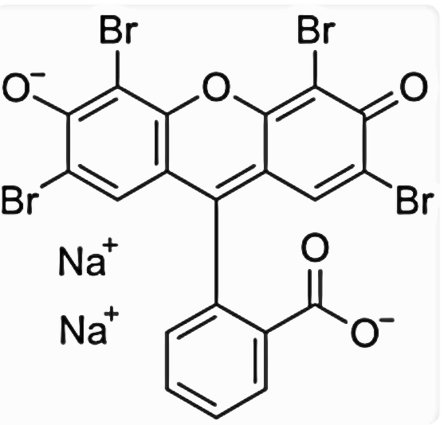

Figure 1: Molecular Structure of Acid Red 87 Dye

Materials and methods
Procurement and Preparation of Eggshell
Eggshell (ES) was obtained from fast food joints Otuoke, Ogbia LGA, Bayelsa State, and was authenticated by Mr. Okpata Sunday (Voucher’s number FUO-082), Department of Biological Sciences, Federal University Otuoke, Bayelsa State, Nigeria. The ES was washed thoroughly to get rid of dirt, debris and stones, followed by sun-drying to remove excess moisture. The ES was further oven dried at a temperature of 100 ºC until a constant weight was attained. The oven-dried ES was subjected to crushing, and further ground to the desired particle size based on our previous works (Onawumi et al., 2021; Sangoremi et al., 2024). The modification was carried out according to the method described by Bello et al. (2017) with slight modification, and resultant product is regarded as activated eggshell adsorbent (AESA). The modification was carried out by increasing the molarity of orthophosphoric acid (H₃PO₄) from 0.3 M to 0.5 M. A precisely weighed 14.0 g of crude sample of ES was placed in a conical flask containing 250 ml of 0.5 M H₃PO₄. The substance of the container was entirely ground and warmed on a hot plate until a thick paste was formed. The past of ES was moved into the crucible which was set in a furnace and warmed at 500 ºC for 600 minutes. The sample was allowed to cool and washed severally with distilled water to a pH of 7.10 and further oven-dried at 100 ºC for 4 h, and the resultant sample is code named, AESA. This was put in an air-tight sealed glass bottle for further usage.

Characterization of MESBA
The Scanning Electron Microscope (SEM) of AESA) adsorbent was taken with a ThermoFisher Scientific (Axia ChemiSEM, 120 x 120 mm² 5-axis motorized eucentric, USA). The surface of the AESA) was considered with the microscope run at 10.0 kV. The samples were coated with a 10 nm thick layer of gold.
Fourier Transform Infrared Spectrometer (FTIR) (Thermo Fisher Scientific, Nicolet iS50, USA) technique of analysis was employed to study the functional groups in AESA. The infrared spectra of AESA were obtained by using AESA mixed with potassium bromides at ratio 1:100 in a mortar and pestle. The mixture was taken in a disc of specific dimension to form pellet by pressing with a handpress machine, placed on the sample holder of IR spectrometer (Agilent Technologies, 4100 ExoScan, California, USA) operated at spectra range 4000 – 400 cm⁻¹.
The physicochemical properties and proximate composition of AESA that were determined include: pH, moisture content (MC), volatile matter (VM), ash content (AC), fixed carbon (FC), bulk density (BD), surface area (SA), particle size (PS) by employing the ASTMD-3838-80, and methods by (Onawumi et al., 2021; Sangoremi et al., 2024).
Preparation of Eosine Y Dye (ES-Y)
Furthermore, AR 87 was procured from Sigma Aldrich Chemical, Germany. AR 87 (1000 mg) was correctly weighed into 250 ml conical flask, and small quantity of distilled water was added and stirred uninterruptedly for total dissolution. The dissolved dye solution was transferred into 1000 cm³ standard volumetric flask and carefully made up to mark with distilled water to make 1000mg/L. The aqueous AR 87 solution was standardized on a UV-visible spectrophotometer (Agilent Technologies, Agilent 8453, California, USA). The AR 87 wavelength at maximum (λ_{max}) was found to be 525 nm, and was used to determine the absorbance of the serially working solutions of dye prepared from the stock solutions are: (10, 20, 30, 40, 50 mg/L). In addition, the absorbance of the AR 87 effluent solution after the adsorption processes was measured to provide means of evaluating the percentage dye removal (% R) by the adsorbent at a particular at equilibrium.
Effect of Contact time on the adsorption process
A batch adsorption study was carried out on the influence of contact on AR 87 dye removal using 100 ml dye solution in a 250 ml conical flask placed on a water bath shaker at a shaking speed of 150 rpm. The optimum initial dye concentration was 30 mg/L, 0.8 g dosage, and temperature at 60 ºC, and the contact time was varied from (10 to 80 minutes) g at 10 minutes interval. After the adsorption experiments, the adsorbent was separated from dye effluent by centrifugation using centrifuge at room temperature at 2000 rpm.
The absorbance of aliquot part of dye effluent was read on UV-visible spectrophotometer and the concentration was interpolated from the working graph. Further, the percentage of AR 87 adsorbed on the surface of was determined according to Jabar et al. (2020) as reported by Sangoremi et al. (2024) as shown in equation 1.
% = (1)
The amount of AR 87 adsorbed per unit weight of AESA was calculated as shown in equation 2 and 3 respectively:
= (2)
= (3)
% R = Percentage AR 87 dye removed
C_{o} = Initial dye concentration (mg/mg)
C_{e} = Equilibrium dye concentration (mg/g)
C_{t} = Concentration at time (t)
V = Volume of dye solution (L)
W = Weight of the adsorbent (AESA) (g)
Pseudo-first order
For Pseudo first order nonlinear equation is given as;
4
) 5
The linear form is given as;
6
The plot of log (q_{e}-q_{t}) against t gives the slope k₁/2.303 and intercept log q_{e}
Pseudo-second order
Pseudo second order nonlinear equation is given thus;
7
8
The linear form of pseudo second order is given as;
9
The plot of t/q_{t} against t gives a slope 1/q_{e} and intercept (1/k₂q_{e}²)
List 1: Kinetic models indicating the linear, non-linear aspects and the corresponding plots
kinetic  models | Linear | Nonlinear | Plots | Reference
Pseudo-First-Order |  |  | log(q_{e}-q_{t}) vs t | Sangoremi et al. (2024)
Pseudo-Second-Order |  |  | t/q_{t} vs t | Ayawei et al. (2017)

Results and Discussion
Table 1 presents the physicochemical and proximate properties of the prepared adsorbent (AESA) under study with the following outcomes: pH (7.80), moisture content (12.90%) volatile matter, (9.90%) ash content (5.80%), fixed carbon (71.40%), bulk density (1.33 g/cm³), surface area (800 m²/g), and particle size (300.00 µm). The physicochemical properties conform to those reported in the literature (Ajala and Ali, 2020; Onawumi et al., 2021; Abdullahi et al., 2022; Sangoremi et al., 2024), and as well in agreement with quality threshold range of the adsorbents as recommended by National Industrial Standard of Indonesia (SII) No. 0258-79, and National Standard of Indonesia (SNI) No. 06-3730-1995.
Table 1: Physicochemical Properties and Proximate Compositions of Modified Eggshell-Based Adsorbent (AESA)
S/no Parameters | MeanSE
1 pH | 7.80
2 Moisture content (%) | 12.90
3 Volatile matters (%) | 9.90
4 Ash content (%) | 5.80
5 Fixed carbons (%) | 71.40
6 Bulk density (g/cm³) | 1.33
7 Surface area (m²/g)  8 Particle size (µm) | 800.00  300.00

Figure 2 shows the FTIR spectra of AESA. The characteristic functional groups on the adsorbent’s surface were identified from the spectra. The peak at 3865.48 cm⁻¹ indicates the presence of an O-H stretching vibration of phenol or alcohols in lignin and cellulose of AESA. Other peaks in the spectrum of the adsorbent are 3441.12, 3362.29, 2345.52, 1689.70, 1450.52, 1003.02, and 933.58 cm⁻¹. These are due to N-H, N-H, C≡N, C=O, CH₃, C-H, and CCl stretch respectively (Nandiyanto et al., 2019; Sangoremi et al., 2024).
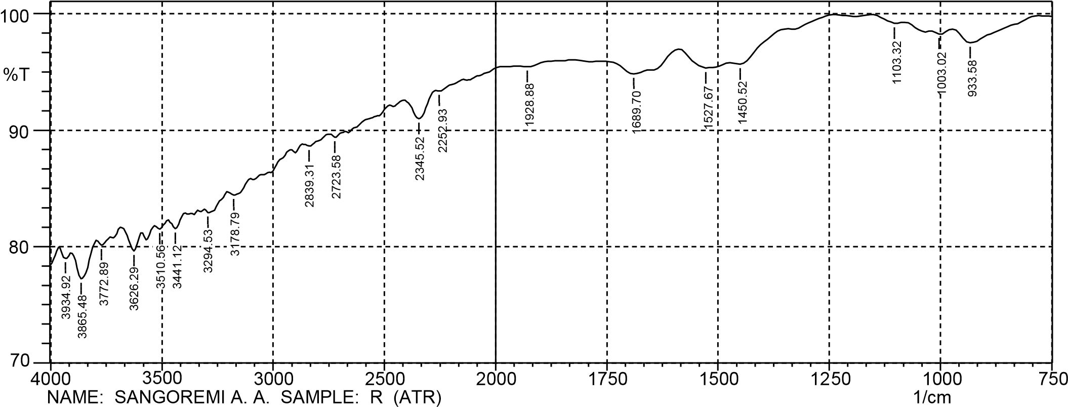

Figure 2: FTIR of modified eggshell-Based Adsorbent (MESBA)

Scanning Electron Micrographs (SEM)
Figure 3 shows the Scanning Electron Micrograph of the AESA. The SEM image of the prepared adsorbent reveals the presence of holes on its surface. These cavities are available pores at the surface, where AR 87 dye molecules are captured from aqueous solution. “The captured dye molecules traveled to fill the available pores on the adsorbent by diffusion of molecules from the aqueous solution to the AESA’s surface through the boundary layer. This was followed by migration of dye molecules from the adsorbent surface to the inner pores and finally adsorbed at the available vacant active sites on its surface. The adsorption of AR 87 on the surface of AESA might be physical adsorption (physisorption), through mechanical adhesion of adsorbates on adsorbent. This agrees with our previous observations and that of other researchers” (Sangoremi et al., 2024; Unuabonah et al., 2017).

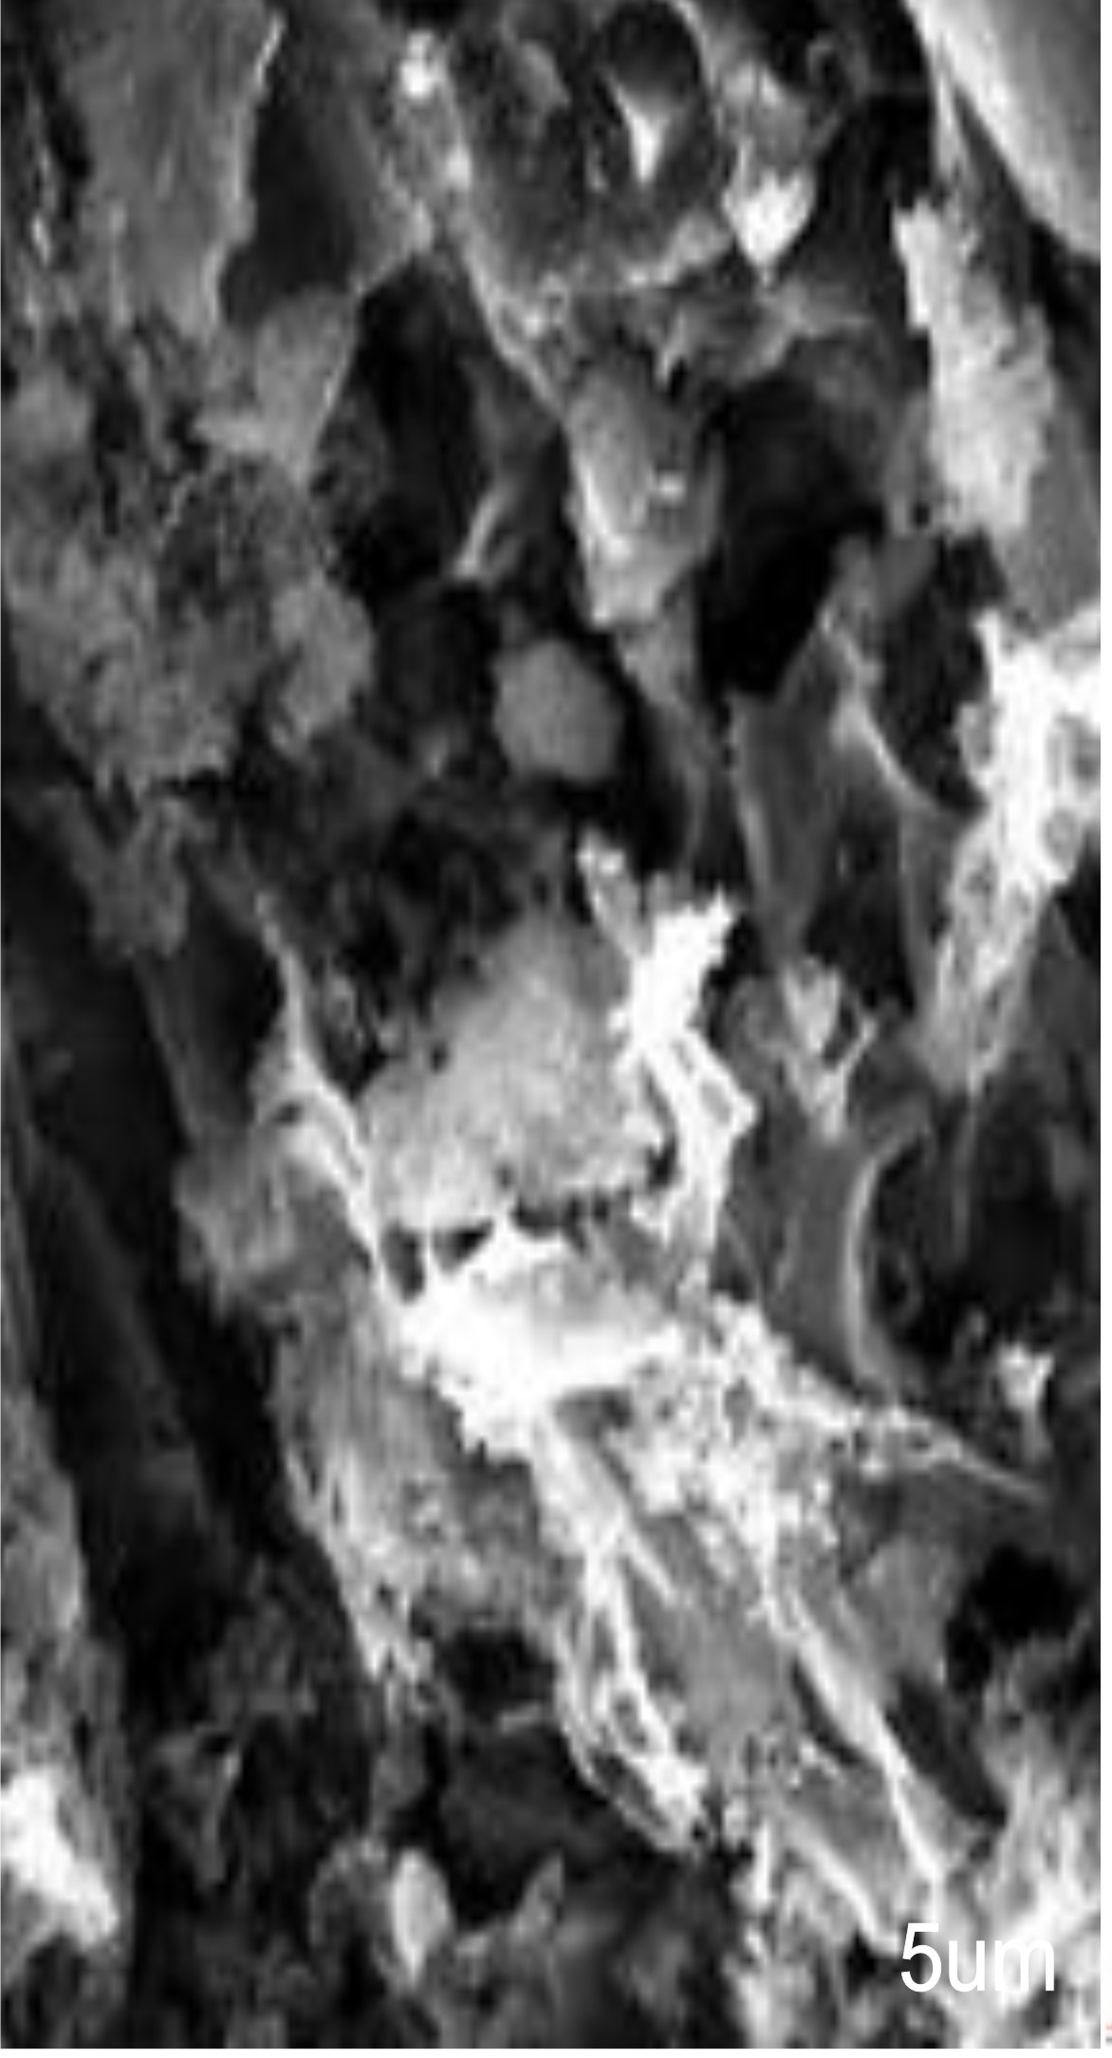

Figure 3: SEM Micrograph of AESA

Electron Dispersive X-ray Spectroscopy Analysis (EDX)

The EDX analysis is a method of elemental analysis associated with electron microscopy based on the generation of characteristic x-rays that divulges the presence of element present in a sample (Scimeca et al., 2018). Figures 4 reveals the EDX spectra of AESA, while Tables 2 reveals the elemental composition of the prepared adsorbents respectively. The carbon content was 84.43% which demonstrates that the process of activation has enriched the carbon contents in the adsorbent. Other elements present in percentage atomic weight include: calcium (5.63 %), poshorus, potassium and silicon are 1.99, 1.98 and 1.71% respectively, while others are in trace amount) (Ushedo et al., 2022; Sangoremi et al., 2024).

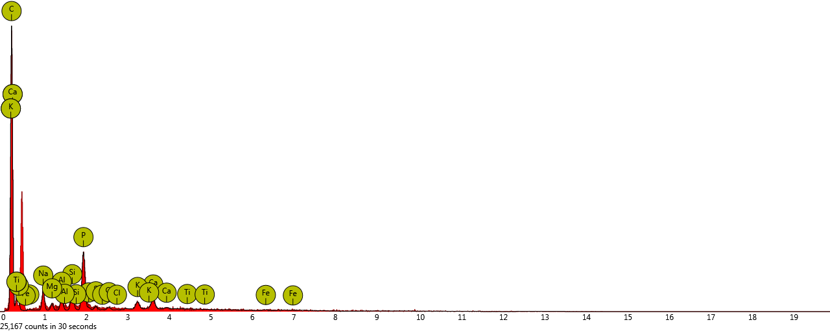

Figure 4: EDX spectra of AESA

Table 2: Elemental composition of modified egg shell adsorbent
Element  Number | Element  Symbol | Element  Name | Atomic  Conc. | Weight  Conc.
6 | C | Carbon | 93.67 | 84.43
20 | Ca | Calcium | 2.41 | 5.63
15 | P | Phosphorus | 1.15 | 1.99
19 | K | Potassium | 0.65 | 1.98
14 | Si | Silicon | 0.81 | 1.71
13 | Al | Aluminum | 0.58 | 1.18
12 | Mg | Magnesium | 0.32 | 0.58
26 | Fe | Iron | 0.12 | 0.49
16 | S | Sulfur | 0.17 | 0.41
17 | Cl | Chlorine | 0.13 | 0.35
22 | Ti | Titanium | 0.00 | 0.00

Effect of contact time on dye removal and dye-uptake
The quantity of dye removed from the aqueous solution by AESA increased as the time of adsorption increased up to 60 minutes of the adsorption process (Figures 5 & 6). After 60 minutes of adsorbate-adsorbent interaction, the percentage removal of AR 87 dye molecules and the adsorption capacity at time (t), (q_{t}) in mg/g declined marginally, this was an indication that the optimum time of adsorption is 60 minutes. This observation agreed with our previous work, Sangoremi et al. (2024), on the adsorptive kinetic mechanisms of Bromocresol Green Dye removal from wastewater using modified groundnut shell adsorbent. The rapid increase in AR 87 removal at the initial stage up to 60 min might be because of availability of active adsorption vacant sites on the surface of AESA. After 60 minutes of adsorption process, the active vacant sites got filled up by AR 87 dye molecules. This might have resulted in repulsive force between the dye molecules on AESA and those in solution (Sangoremi et al., 2024). The repulsive force might result into reduction in quantity of dye adsorbed after 60 minutes. This observation is in line with the findings of Jabar et al. (2022), when African almond (Terminalia catappah) leaves biochar prepared through pyrolysis using H₃PO₄ was used as chemical activation for sequestration of methylene blue dye. The same trend of adsorbate-adsorbent interaction was observed on the effects of contact time on AR 87 removal from aqueous solution as seen in (Figure 5 & 6). The maximum adsorption capacity and percentage recovery of AR 87 dye molecules from wastewater was 3.28 mg/g and 87.33% respectively.

Figure 5: Plots of Contact time against % Recovery Efficiency of ESAC on AR-87 Dye

Figure 6: Plot of Adsorption Capacity against Contact Time

Adsorption Studies
Kinetic Investigation
Figure 7 and 8 reveal linear the kinetic models respectively, while Figure 9 shows the nonlinear kinetic model used for the experimental data fittings, which are Pseudo-First-Order (PFO) and Pseudo-Second-Order (PSO) respectively. PSO kinetic model best described the adsorption process with the coefficient of determination (linear: R² = 0.9952), and (nonlinear: R² = 0.9914). Additionally, since PSO best fitted the adsorption of AR 87 dyes than PFO which suggests that the adsorption process is second rate controlled, which is more of chemisorption rather than physisorption (Sangoremi et al., 2024). Also, PSO provides a better fit of experimental data than other kinetic models based on Normalized Chi-square Error (0.0111) and Sum Square of Error (0.0782) values obtained from the non-linear regression modeling of experimental data from the kinetic models. This implies that the adsorption of AR 87 dye molecules onto the AESA involves a complex adsorption phenomenon which may include simultaneous chemical interaction between the solute and chemical interaction between the dye molecules and chemical functional groups on the surface of the adsorbent via electrostatic interactions, Van der Waals, hydrogen bonding, complexation and ligand exchange (Unuabonah et al., 2017). This might also suggest that the surface nature of the adsorbent is heterogeneous.

Figure 7: The plots of Pseudo-First-Order Kinetic Model of AR-87 dye onto ESAC

Figure 8: The plots of Pseudo-Second-Order Kinetic Model of AR-87 dye onto ESAC

Figure 9: The plots of Pseudo-First-Order and Pseudo-Second-Order Kinetic Models of AR-87 dye onto ESAC

Conclusion
The prepared adsorbent possesses high carbon content, low inorganic content, high surface area, and heterogenous pore structures that make a viable precursor for the removal of AR 87 from aqueous solution. The dye removal from the wastewater was time-dependent with maximum removal efficiency of 87.33 % within 60 minutes. The kinetic model that best described the removal of AR 87 dye from the wastewater was Pseudo-Second-Order kinetic model with coefficients of determination for linear (R² = 0.9952) and nonlinear (R² = 0.9914). The prepared adsorbent was efficient in remediating the dye polluted wastewater to useable status.

Disclaimer (Artificial intelligence)
The author hereby declares that no generative AI technologies, such as large language models (ChatGPT, Copilot) or text-to-image generators, were used during the writing or editing of this manuscript.

References
Abdullahi, A., Tsafe, A.I., Liman, M.G., and Ibrahim, N. (2022). Characterization and Modification of Activated Carbon Generated from Annogeissus leiocarpus. Caliphate Journal of Science and Technology (CaJoST) 2, 151-159.

Ahmed, T.A.E., Kulshreshtha, G., and Hinke, M. (2019a). Value-added uses of eggshell and eggshell membranes “in Eggs as functional food and Nutraceuticals for human Health, ed. J.Wu (London). Journal of Royal Society of Chemistry 2019, 359-397.

Ahmed, T.A.E., Wu, L., Younes, M., and Hincke, M. (2021). Biotechnological Application of Eggshell: Recent Advances. Frontiers in Bioengineering and Biotechnology, 6 (2021):675364. https://doi.org/10.3389/fbioe.2021.675364

Ajala, LO., & Ali, EE. (2020). Preparation and Characterization of Groundnut Shell-Based Activated Charcoal. Journal of Applied Sciences and Environmental. Management, 24 (12):2139-2146.

Alhawtali, S., El-Harhawi, M., Al-Harbawi, A.S., El Blidi, L., Alrashed, M., & Yin, C.Y. (2023). Enhanced adsorption of methylene blue using phosphoric acid-activated hydrothermal carbon microspheres synthesized from a variety of palm-based biowastes. Coating 13(7): 1287.
Baharim, N. H., Sjahrir, F., Taib, R. M., Idris, N., & Daud, T.A.T. (2023). Methylene blue adsorption by acid posttreated low temperature biochar derived from banaba (Musa acuminata) pseudo stem. Sains Malaysiana, 52(2): 547-561.
Bello, O.S., Awojuyigbe, E.S., Babatunde, M.A. and Folaranmi, F.E. (2017). Sustainable conversion of agro-wastes into useful adsorbent. Applied Water Science 7, 3561-
Gherbia, A., Sahel, D., Bouabidi, A., & Chergui, A. (2024). A kinetic and thermodynamic study of cationic thiazine dye removal from aqueous solution by date stones variety Ghars an agricultural waste.
Giwa, AA., Olajire, AA., Adeoye, DO., & Ajibola, TA. (2015). Kinetics and Thermodynamic of Ternary Dye System Adsorption onto Melon (Citrilluslanatus) Seed Husk. American Chemical Science Journal 7 (1):7-25.

Jabar, J.M., and Odusote, Y.A. (2020). Removal of cibdcron blue 3G-A (CB) dye from aqueous solution using chemophysically activated biochar from palm empty fruit bunch fiber. Arabian Journal of Chemistry 13, 5417-5429.
Kuang, Y., Zhang, X., & Zhou, S. (2020). Adsorption of methylene blue in water onto activated carbon by surfactant modification. Water 12(2): 587.
Lu, G., Qu, L., Lin, Z., Dang, Z., Yang, C., Xie, Y. (2017). A kind of method using the acid agricultural land soil of eggshell heavy metal pollution to carry out improving. State intellectual Property office of the People’s Republic of China, CN106269841A. Inventor; south China University of technology, assignee.1-10.

Nandiyanto, ABD., Oktiani, R., & Ragadhita, R. (2019). How to Read and Interpret FTIR Spectroscope of Organic Material. Indonesian Journal of Science and Technology, 4 (1):97-118.

Onawumi, OOE., Sangoremi, AA. & Bello, OS. (2021). Production and Characterization of Groundnut and Egg Shells Activated Carbon (AC) as Viable Precursors for Adsorption. Journal of Applied Science and Environmental Management, 25(9):1707-1713.

Rabeie, B., Mahkam, M., Mahmoodi, M.N., & Lan, C.Q. (2021). Graphene Quantum Dot incorporation in Zeolitic imidazole framework with sodalite (SOD) topology: Synthesis and improving the adsorption ability in liquid phase. Journal of environmental Chemical Engineering, 9(6): 106303.
Rabeie, B., Mahmoodi, M., & Mahkam, M. (2022). Morphological diversity effect of Graphene quantum Dot/MILSSA (Fe) composite on dye and pharmaceuticals (Tetracycline and Doxycycline) Removal. Journal of Environmental Chemical Engineering, 10(5): 108321.
Sangoremi, A. A., Adeyeye, J. A., & Isaac, I. U. (2024). Adsorptive Kinetic Mechanisms of Bromocresol Green Dye Removal from Wastewater Using Modified Groundnut Shell Adsorbent. Science World Journal 19 (4): 1049-1054.

Sangoremi, A. A. (2025). Equilibrium Isotherm studies of Bromocresol Green Dye Removal from Wastewater Using Modified Coconut Shell Adsorbent. International Journal for Research in applied Science and Engineering Technology 13(5): 1-12.

Sangoremi, A. A., Adeyeye, J. A., & Isaac, I. U. (2024). Adsorptive Kinetic Mechanisms of Bromocresol Green Dye Removal from Wastewater Using Modified Groundnut Shell Adsorbent. Science World Journal 19 (4): 1049-1054.

Unuabonah, EI., Agunbiade, FO., Alfred, MO., Adewumi, TA., Okoli., CP, Omorogie, MO., Akanbi, MO., Ofomaja, AE., & Taubert, A. (2017). Facile synthesis of new amino-functionalized agrogenic hybrid Composite Clay adsorbents for phosphate capture and recovery from water. Journal of Cleaner Production 164, 652-663.

Ushedo, T.R., Adeyemi, O.G., Adewuyi, A., and Lau, W. (2022). Synthesis of N, N(1,3-Phenylene) dimethanimine. A useful resource for the removal of free fatty acid in waste vegetable oil. Scientific African 16, e01188. https://doi.org/10.1016/j.sciaf.2022.e01188

