MICROBIOLOGICALLY INFLUENCED CORROSION OF GALVANISED STEEL BY SULPHATE-REDUCING BACTERIA IN MARINE ENVIRONMENTS

ABSTRACT
Corrosion is a pervasive phenomenon on offshore metallic structures, driven by chemical, physical, and biological processes. The pivotal role of sulfate-reducing bacteria in accelerating microbiologically influenced corrosion of galvanized steel in marine environments, thereby enhancing the scientific community’s understanding of biocorrosion mechanisms. The findings also contribute to the development of predictive models and practical preventive strategies, opening interdisciplinary research avenues in materials science, engineering, and microbiology. This study investigated the isolation and identification of sulphate-reducing bacteria (SRB) associated with MIC of galvanized steel in seawater environments, with implications for seafood-processing infrastructure. Seawater samples were obtained from the Nigerian Institute for Oceanography and Marine Research (NIOMR), and galvanized steel bars from the Industrial Microbiology Department, University of Lagos. Steel bars were submerged in seawater for 180 days, with sampling every 90 days to monitor bacterial load and physicochemical parameters (pH, TDS, TSS, DO). Corrosion rates were quantified by weight-loss and thickness-reduction analyses, enabling correlation with microbiological activity and aqueous chemistry. SRB strains were isolated using Baar’s medium and characterised via biochemical methods. Results showed that increased bacterial activity corresponded with reduced pH, elevated TDS/TSS, and higher corrosion rates. Identified SRB included Aeromonas and Mycobacterium, capable of biofilm formation on food-contact surfaces and accelerating galvanic and pitting corrosion through sulphur reduction. Corrosion rates in seawater were 2% higher than in sterile distilled water controls, with microstructural zinc layer degradation most pronounced after 180 days. From a materials science and engineering perspective, these findings emphasize the importance of integrating microbial risk analysis into alloy design, protective coating optimization, and electrochemical corrosion modeling.
Keywords: Microbiologically Influenced Corrosion (MIC), Sulphur-Reducing Bacteria (SRB), Galvanized steel, seawater.

INTRODUCTION
Corrosion is a natural process that converts a refined metal into a more chemically stable oxide. It is the gradual deterioration of materials (usually a metal) by chemical or electrochemical reaction with their environment (Xu et al., 2023). It is an electrochemical process that consists of a cathodic reaction based on the reduction of a chemical species and an anodic reaction involving the ionization (oxidation) of the metal (the corrosion reaction) (Dorothy et al., 2021). Metal corrosion is an electrochemical reaction that happens on metal surfaces due to its contact with the nearby environment (content moisture, humidity, type of soil) (Smith et al., 2023).
Corrosion-induced material degradation turns into a financial liability and causes unfavourable environmental issues in vital areas of the automotive, energy, marine, and aerospace industries (Muhammad et al., 2025). Bio-corrosion occurs as a result of synergetic interactions between the metal surface, abiotic corrosion products, bacterial cells, and their metabolites (Salami et al., 2015). Microorganisms implicated in the biocorrosion of metals such as steel, iron, copper, and aluminum and their alloys are physiologically diverse. Microbiologically influenced corrosion is caused by the metabolic reaction products of microorganisms that are capable of colonizing metal or steel surfaces. Microbially influenced corrosion (MIC) is an electrochemical reaction that enhances the corrosion process due to primary or secondary metabolites (such as organic acids, inorganic acids, sulfides, and ammonia). The environmental factors (such as acidity, oxidation, pH, reduction, and oxygen concentration) around metal surfaces can be altered by bacterial metabolites, which causes corrosion on the metallic materials' surfaces (Pal and Lavanya, 2022).
This study reveals how sulfate-reducing bacteria corrode galvanized steel in seawater, helping improve marine infrastructure durability (Immanuel et al., 2016). By identifying key corrosive bacteria, it enables better anti-corrosion solutions for engineers and industries. The findings bridge microbiology and materials science, offering practical insights for combating microbial corrosion. The formation of microbiologically influenced corrosion on galvanized steel in sea medium is influenced by the presence of microorganisms and biofilms on the metallic surfaces (Omar et al., 2021). The physical properties of the galvanized steel, mild steel, and the sea medium were evaluated before and after experimentation (Shetata et al., 2023). It is a natural phenomenon that occurs when a metal is exposed to water; the waterborne microorganisms colonize its surface, forming biofilm through a series of steps. Problems that occur when the biofilm builds up are termed biofouling (Mary et al., 2015). Steels are known to undergo Biocorrosion, a phenomenon that happens in seawater or in any activity involving freshwater sediments and, generally speaking, anywhere there are lots of bacteria (such as the sea) (Di et al., 2023). Moreover, elevated temperatures, high chloride and sulfate concentrations, and changes in the water's pH can all hasten corrosion (Xu et al., 2023).
Biofilm generation on galvanized steel surfaces is a complex process influenced by a variety of physical, chemical, and biological factors (Pal and Lavanya, 2022). Understanding the mechanisms that drive biofilm growth and the implications for MIC is critical for developing successful corrosion control techniques. Future study should focus on understanding the relationships between microorganisms, zinc coatings, and environmental conditions in order to create tailored ways for preventing biofilm formation and reducing MIC on galvanized steel (Smith et al., 2023).
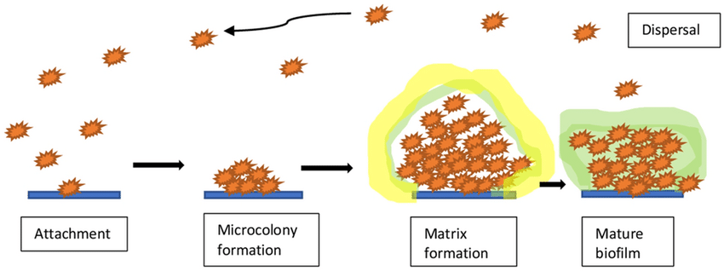
Figure1: Stages of biofilm formation (Pal and Lavanya, 2022)
Biofilm formation, including Sulphur-reducing bacteria (SRB) on galvanized steel surfaces, as well as microbiologically induced corrosion (MIC) of galvanized steel, were found in seawater over 180 days (Little et al., 2023). A biofilm with a diverse structure developed on galvanized steel coupons. Biofilms on galvanized steel surfaces can significantly accelerate corrosion processes through a variety of mechanisms, including the formation of localized differential equations aeration cells, the generation of corrosive compounds called metabolites and the facilitation of galvanic coupling between the steel and the zinc coating (Liu et al., 2023). Biofilm formation on galvanized steel can be influenced by several factors, including nutrient availability, pH, temperature, and hydrodynamic conditions. (Xu et al., 2016).

METHODS
2.1 STUDY AREA
The study was carried out in Microbiology main laboratory Federal University Oye Ekiti, Ekiti state Nigeria.
2.2 SAMPLE COLLECTION
The sea water sample used for this experiment was collected from the Nigerian Institute for Oceanography and Marine Research (NIOMR) which is located at number 3, wilmot point road, off Ahmadu Bello way, Victoria Island, Lagos. P.M.B 12729 Lagos Nigeria. The steel samples were industrially manufactured at the Department of Materials and Metallurgical engineering, University of Lagos, Nigeria. All samples were aseptically transported to the lab for analysis and the galvanised steel was aseptically placed in the sea water for 90-180 days.
2.3 ISOLATION OF SULPHUR REDUCING BACTERIA ON BAAR’S MEDIUM
The bacteria were isolated by measuring 2.0g of MgSO4, 5.0g of sodium citrate, 1.0g of CaSO4 x 2H20, and 1.0g of NH4Cl into a sterile conical flask and mixing with 400ml of distilled water and was labelled component I. 0.5g of K2HPO4 was measured in 200ml of distilled water and labelled as component II. 3.5g of Sodium Lactate and 1.0g of Yeast Extract were added to 400ml of distilled water and thoroughly mixed before being labelled as component III. Each component was adjusted to a pH of 7.5 before being autoclaved at 121 for 15 minutes at 15 PSI. Each component was mixed together and 5% Fe(NH4)2 (SO4)2 was added to the solution. 10ml of the solution was placed into a sterile test tube. the test tubes were agitated and autoclaved for 15minutes at 121℃ and 15psi.
2.4 ENUMERATION FOR TOTAL BACTERIA COUNT.
11g of the nutrient agar was measured using the analytical balance, and poured into a conical flask, then 2g of agar powder was added to the nutrient agar. 200ml of distilled water was measured using the graduated cylinder and poured inside the conical flask and mixed properly until no lump is observed. Then the conical flask is placed in the autoclave for sterilization at 121°C for 15 minutes at 15 PSI. After autoclaving the agar is allowed to cool for few minutes.
2.4.1 Pour-Plate Method
The sample was serially diluted, and 1ml of diluent 5 and 7 of the sea sample was poured into two labelled Petri-dishes, respectively. 20ml of the MacConkey agar was poured in each petri-dish, and the plates were incubated in an anaerobic condition for 16-18 hours, as the sulphate-reducing bacteria tend to thrive in the absence of oxygen.
2.4.2 Counting of colonies
After 18 hours, colonies of microbes was observed. With the use of colony counter, the number of colonies was estimated to be the bacteria count.
2.5 ANALYSIS OF TOTAL DISSOLVED SOLID (TDS) IN SEA WATER
The crucible was sterilized by washing and cleaning it with 70% ethanol then placed in the hot-air oven and allowed to dry. The crucible was allowed to cool for few minutes, the dry weight was measured using the analytical balance and recorded. The sea water was properly and evenly stirred and 150ml of the sea water was measured using the graduated cylinder and filtered using the filter paper through the funnel into the conical flask. The filtered sea water was then poured into the crucible and placed into the hot-air oven at 103-105°C and allowed to dry completely. After allowing the crucible to heat to dryness in the oven, the crucible is allowed to cool to room temperature inside the desiccator. Then the crucible was weighed again using the analytical balance and recorded. The total dissolved solid of the sea water was determined by the following steps
Weight of the residue = W2(g) – W1(g) Where;
W2 = Weight of the crucible with residue
W1 = Initial dry weight of the crucible
Total dissolved solids = weight of the residue(mg) / the volume of the sea water in litres
In other words, Total Dissolved Solid = (W2 - W1) X 1000
Vol. of the sample
2.6. ANALYSIS OF TOTAL SUSPENDED SOLID (TSS) IN SEA WATER
A dust-free filter paper was placed in the oven and heated to dryness in order to remove moisture acquired from the environment by the filter paper and to get the actual net-weight of the filter paper. The filter paper was then weighed on the analytical balance and recorded. The sea water was properly mixed together and 150ml of the sea water was filtered using the folded filter paper.
At the end of the filtration, it was observed that sediment from the sea water couldn’t pass through the filter paper, The wet filter paper was placed on a foil paper, and placed inside the oven at 105°C then allowed to heat to dryness for one hour, The filter paper was places in the desiccator in order for it to cool, Using the analytical balance, the weight of the filter paper was weighed and recorded. The Total Suspended Solids was determined by calculating the weight
Weight of the residue = W2(g) – W1(g)
Where;
W2 = Weight of the filter paper with dried residue
W1 = Initial dry weight of the filter paper
Total Suspended Solids = weight of the residue(mg) / the volume of the sea water in litres
In other words, Total Suspended Solid = (W2 - W1) X 1000
Vol. of sample

2.7. CHARACTERIZATION AND IDENTIFICATION OF BACTERIAL ISOLATES
The morphological and biochemical characteristics of the isolates in pure cultures were determined using general microbiological techniques such as Gram Staining Technique, oxidase test, catalase test, Starch hydrolysis test, citrate utilization test, Mr-Vp test, indole test, Triple sugar iron test, Sugar fermentation test, Acid Fast staining, Spore Staining, Urease test, Haemolysis test,
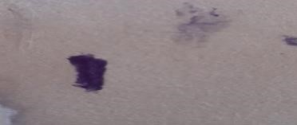

Positive

negative

A

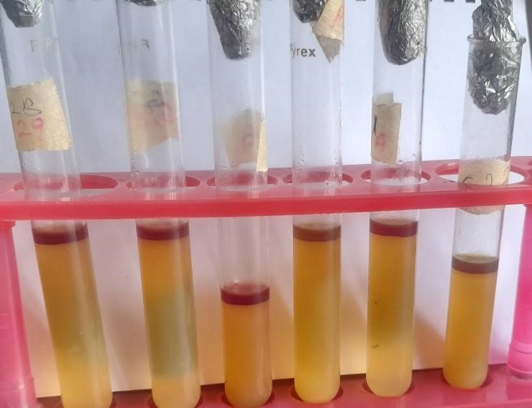
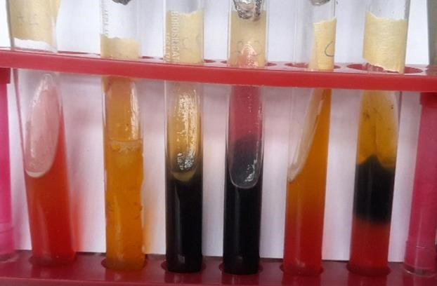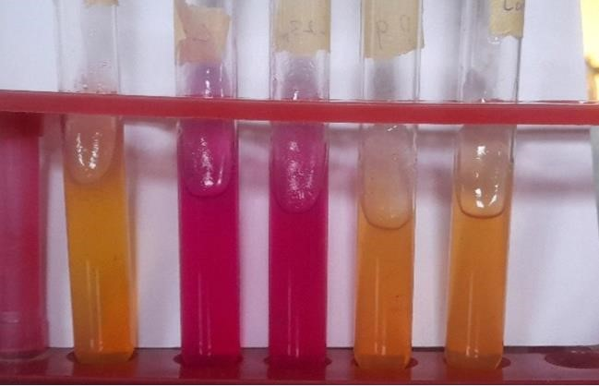

B

C

Plate1: Biochemical tests of bacterial isolates: oxidase test (A), triple iron sugar test (B), urease test (C), and indole test (D)

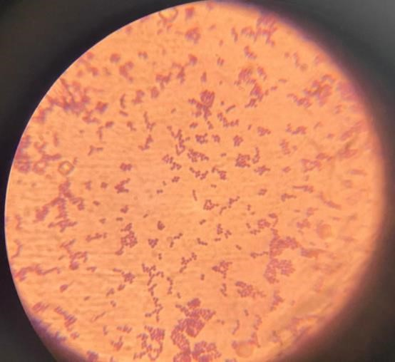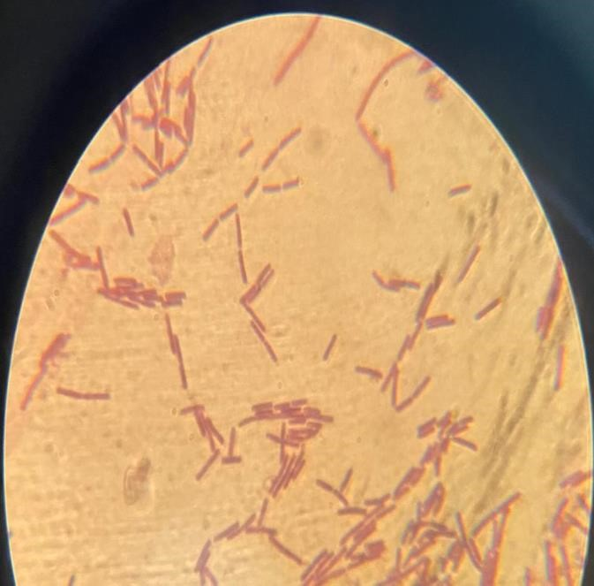
B

A
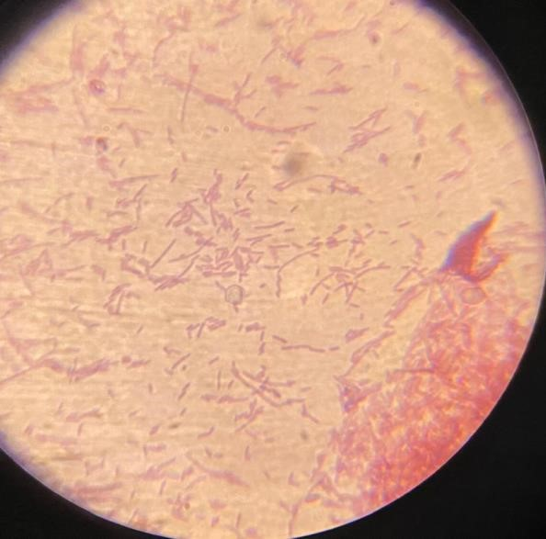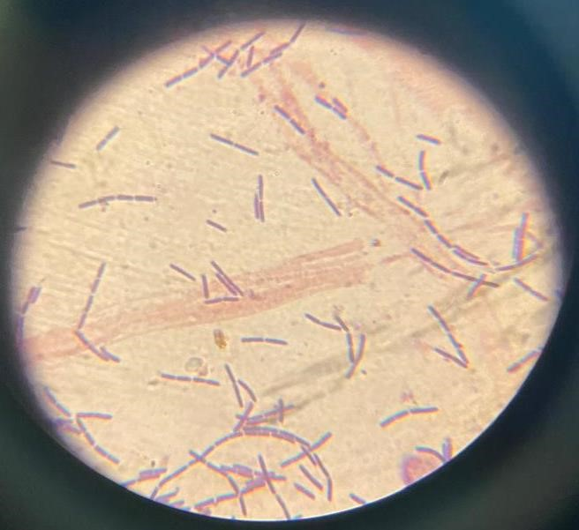
D

C

Plate2: Photomicrograph of bacterial isolates: GS3BAN (A), GS5BAE (B), GS3BAN (C), and GS5BAE(D)
3.8 PHYSIOCHEMICAL ANALYSIS OF THE SEA WATER, GALVANIZED STEEL
After placing the galvanized steel in the bucket filled with sea water, the following parameter were observed, analyzed and recorded after 90 days and 180 days
Determination of the Thickness of the Galvanised steel: This is actualized by using the vernier caliper to check for the diameter of both the galvanized and mild steel
PH: pH of water is the measure of how acidic or basic water is. Acidic water contains extra hydrogen ions (H+) while basic water contains extra hydroxyl ions (OH-). This was observed by making use of the digital pH meter. The pH meter was pipped inside the sea water sample for 15 minutes before taking the final record.
Temperature: The temperature is the degree of coldness or hotness of an object, The temperature of the sea water was determined by dipping the thermometer in the sea water for 5 minutes. Until the mercury ring stopped moving and the final record was taken.
Total Dissolved Oxygen: The solubility of oxygen in water is dependent on the water temperature, salinity and atmospheric pressure. The Dissolved oxygen was measured using a dissolved oxygen meter.
Weight: The weight of the steel was measured using an analytical weighing balance and was recorded for day 0, 90 and 180 (Treese, 2018).

RESULT
3.1.1 BACTERIOLOGICAL ENUMERATION
The total bacteria count from sea water shows the results on Nutrient Agar (NA), for day 0, 90 and 180 days of aerobic and anaerobic environmental conditions. The graph explains that as the day increases the total bacteria count increases which depicts that the microorganisms that causes corrosion tends to increase because they form biofilm with other microorganism in order to deteriorate the galvanized steel.
Figure2: Total bacterial count from sea water samples for aerobic and anaerobic condition
List 1: PHYSIOCHEMICAL ANALYSIS
Parameters | Day 0 | Day 90 | Day 180
pH | 7.1 | 6.5 | 7.5
Temperature(⁰C) | 27 | 27.4 | 27.8
Total Suspended Solid (Mg) | 40.4 | 17.2 | 15.38
Total Dissolved Solids (Mg) | 77.24 | 63.97 | 26.9
Total Dissolved Oxygen | 3.6 | 3.8 | 5

The pH of the sea water containing the galvanized steel was observed to fluctuate using the pH meter, it was observed to be 7.1 at day 0 it decreased to 6.8 at day 90 and increased to 7.5 at day 180. The fermentation of glucose and pyruvate in a liquid media can be examined using pH indicators and acidity (pH reaction). The strains were able to digest certain amino acids in addition to alcohol and organic acids with varying carbon chains (Huang et al., 2022).
According to this study, the total dissolved solid in the seawater increased during the incubation period. For galvanized steel samples, the amount of total dissolved solids (TDS) in seawater increased with exposure time. Throughout the 180 days, the TDS levels increase gradually, suggesting that the galvanized steel bar sample gradually disintegrated to increase the quantity of dissolved solids in the seawater sample (Sundjono et al., 2017). TDS and TSS levels represent the concentration of dissolved and suspended particles in seawater, respectively. TDS levels as high as 63.92 mg/L on Day 90 and 26.9 mg/L on Day 180 can increase water's ionic strength, improving electrical conductivity and corrosion potential. Similarly, TSS provides a measure of particles that can house and protect SRB colonies, hence promoting biofilm formation (Carolyn et al., 2023).
Table 1 : Corrosion progression of GS and GD samples over 180 days, with GS showing slightly higher weight loss and corrosion rate than GD
Sample | Time (Day) | Weight loss (mg) | Diameter  (mm) | Rate of corrosion (mm/year)
GS | Day 0 | 0 | 2.9 | 0
GD |  | 0 | 2.8 | 0
GS | Day 90 | 95.1 | 2.8 | 8.23
GD |  | 84.0 | 2.4 | 7.27
GS | Day 180 | 205.8 | 2.9 | 8.91
GD |  | 189.8 | 2.8 | 8.22
GS- Galvanised steel in sea water, GD-Galvanised steel in Distilled water
Picture 1 : The relationship between rate of corrosion and dissolved oxygen

The weight of the galvanized steel was observed to decrease as the rate of corrosion and day increases. it was observed that the diameter of the galvanized steel was initially 2.9 then dropped to 2.8 and increased to 2.9. It was also observed that the control galvanized steel did not change (Carolyn et al., 2023). The deterioration of galvanized steel in sea water over 180 days is accompanied by changes in the water's composition, which cause variations in total dissolved oxygen. The relationship between rate of corrosion and dissolved oxygen, from this description it can be deduced that the rate of corrosion increases as the dissolved oxygen increases, no corrosion was observed at day 0 but it was evident at day 90 and day 180.

Bacteria strains isolated in this study were characterized morphologically. The isolates M. smegmatis, S. aureus, Aeromonas sp., S. aureus, E. coli, A. veronii were observed macroscopically to be circular, small, smooth and the elevation is convex with an entire margin and Irregular, Small, Smooth, Blue, Convex and Entire respectively. The SRB cells are spherical, oval, rod-shaped, spiral, or vibrio-shaped with a diameter of 0.4 –3.0 μm. The cells can be either single or in pairs or aggregates also may form a single row of multicellular filaments. Most cells of SRB genera are Gram-negative, although the filamentous and acid-fast microorganisms are Gram-positive.
This table demonstrate the reaction of the microorganisms on biochemical test, M. smegmatis, S. aureus, Aeromonas sp., S. aureus, E. coli, A. veronii. it was observed that M. smegmatis and S. aureus are the only bacteria involved in the production of H₂S and gas

Table2 : Biochemical test of the Sulphur-reducing bacteria isolates
Isolate | Gram rxn | TSI | Oxidase |  | Starch | Acid fast staining | Spore staining | Urease | MR | VP | Catalase | Gas | H  2  S | Glu  cos  e | Lac  tose | Mann  itol | Motility | Indole  test | Citrate | Heamolysis  Suspected  Org  anism
GS5BAE | +/rod | + | _ |  | - | + | - | + | + | + | + | + | + | + | + | + | + | + | - | Ɣ | M. smegmatis
GS3BAE | +/Cocci | + | - |  | - | - | - | + | + | + | + | + | + | + | + | + | + | + | - | Ɣ | S. aureus
GS3BAN | -/rod | + | + |  | + | - | - | + | + | + | + | + | - | + | + | + | - | - | - | α | Aeromonas sp.
GS3BAN | +/cocci | + | _ |  | - | + | - | + | + | + | + | - | + | + | + | + | - | - | - | Ɣ | S. aureus
GS5BAN | -/rod | + | - |  | - | + | - | - | + | + | + | + | - | + | + | + | + | + | - | Ɣ | E. coli
GS5BAE | -/rod | + | + |  | - | + | - | + | + | + | + | + | - | + | + | + | + | - | - | α | A.veronii

KEY: MR- Methyl red test, VP- Vogue’s proskaeur test, Gram rxn- Gram staining test
G- Galvanised steel, S-sea water, B- Baar’s Medium, AE- Aerobic, AN-Anaerobic
3 - Diluent 3, 5 - Diluent 5

DISCUSSION
The isolation and identification of sulfur-reducing bacteria in seawater, their correlation with the corrosion rates of galvanized steel, and the connections between these processes and physicochemical properties such as pH, total dissolved solids (TDS), total suspended solids (TSS), and dissolved oxygen are all covered in this discussion. We learned that the seawater's temperature increases during the day from the results, which detail the physicochemical parameters of the seawater and galvanized steel employed for the study (Rahman et al., 2023). The fabricated weighted galvanized steel coupon was submerged in each seawater sample for 90 and 180 days. Weight loss and corrosion rate were computed. This suggests that because of the galvanized steel's temperature differential, the rate of corrosion increased with increased exposure to the corrosive environment.
Using a pH meter, the pH of the seawater containing the galvanized steel was found to vary; it was 7.1 on day 0 and dropped to 6.8 on day 90 and 7.5 on day 180. It is also crucial to test the SRB strains' ability to metabolize several electron donors and a carbon source in addition to lactate or H2. The ultimate concentration should be one percent (1 %) of each component. Acidity (pH reaction) and pH indicators can be used to analyze the fermentation of glucose and pyruvate in a liquid medium. The ability of SRB isolated strains to grow by chemolithoheterotrophic processes is confirmed by this experiment. Along with alcohol and organic acids, the strains may also break down certain amino acids (Huang et al., 2022).
It was found that as the corrosion rate and day grow, the weight of the galvanized steel decreases. Table shows that the galvanized steel's diameter was 2.9 at first, then decreased to 2.8 and finally increased to 2.9. Depending on the steel substrate, its composition, the galvanizing process, and the requirements of the specific application, the diameter and thickness of galvanized steel coatings are not consistent. Additionally, it was noted that the control galvanized steel remained unchanged (Xu et al., 2023).
The bacterial strains that were identified for this investigation were described morphologically, When examined macroscopically, the isolates M. smegmatis, S. aureus, Aeromonas sp., S. aureus, E. coli, and A. veronii were found to be irregular, small, smooth, blue, convex, and entire, respectively, and to be round, small, and smooth with a convex elevation and an entire edge. Plocin et al. (2024) state that the SRB cells have a diameter of 0.4 to 3.0 μm and can be spherical, oval, rod-shaped, spiral, or vibrio-shaped. The cells may form a single row of multicellular filaments, or they may be single, in pairs, or aggregated. While the filamentous and acid-fast microorganisms in the SRB genera are Gram-positive, the majority of their cells are Gram-negative.
Hydrogen sulfide (H2S) gas was found to be produced by Aeromonas sp. and S. aureus. Together with other microorganisms, they form biofilm on the corrosion's surface, which aids in the fermentation of sugar. The resulting H2S has been demonstrated to be corrosive to metal and to accelerate metal corrosion (Smith et al., 2023). The bacterial isolates were found to be oxidase negative based on the results of the laboratory oxidase test. The catalase test detects the presence of the enzyme catalase, which breaks down hydrogen peroxide into oxygen and water. Catalase is typically found in bacteria. We can see from the table that the sulfur-reducing bacteria that were isolated were capable of converting hydrogen peroxide into oxygen and water (Sundjono et al., 2017). SRB does not undergo alpha or beta hemolysis and may or may not hydrolyze starch. It also fails the biofilm test.
The results of the investigation demonstrate a direct correlation between the corrosion rates of galvanized steel and SRB activity. Measurements of weight loss over 180 days showed a considerable deterioration of the metal, with corrosion rates rising in proportion to the growth of SRBs. According to the correlation between these data and physicochemical characteristics, MIC in marine environments may be lessened or increased by preserving specific environmental factors. The isolation and identification of sulfur-reducing bacteria in a variety of settings, including saltwater, has verified the existence of M. smegmatis (Xu et al., 2023).
M. smegmatis is a component of a complex microbial community rather than operating alone. It can accelerate corrosion rates through its interactions with other microorganisms, particularly sulfate-reducing bacteria (SRB). For instance, SRB can convert sulfate to sulfide, which can then combine with iron to produce iron sulfide, a chemical that is known to induce corrosion, even if M. smegmatis decreases sulfur (Smith et al., 2023). Mycobacterium smegmatis is a key player in the intricate mechanisms behind corrosion caused by microbes. It has a significant role in metal corrosion due to its ability to reduce iron, form biofilms, generate corrosive metabolites, and interact with other bacteria (Płocin et al., 2024).

CONCLUSION
Sulfate-reducing bacteria (SRB) were effectively identified and described from seawater samples containing galvanized steel in this experiment. The SRB strains eventually contributed to the microbiologically induced corrosion (MIC) of the galvanized steel because they were able to grow and thrive in the seawater environment (Muhammad et al., 2025). The presence of the SRB aids in the construction of a biofilm, which accelerates corrosion through a variety of mechanisms, including the synthesis of corrosive chemicals, the alteration of the solution's anion ratios, and the development of a differential concentration of microbial cells.
The study shows a clear link between SRB activity and galvanized steel corrosion rates. Over 180 days, weight loss measurements revealed significant metal degradation, with corrosion rates increasing in tandem with SRB proliferation. The relationship between these measurements and physicochemical parameters suggests that maintaining particular environmental variables can either mitigate or contribute to MIC in marine settings. The presence of M. smegmatis has been confirmed through the isolation and identification of sulphur-reducing bacteria in various environments, including seawater

REFERENCES
Carolyn, M. H. (2023). Galvanized Steel, In Corrosion of Steel in Concrete Structures, 9, 748; doi:10.3390/ma9090748
Di, W., Tuba, Unsal, S., Kumseranee, S., Punpruk, M., Saleh, A., Mohammed, D., Alotaibi, D., Xu1, B. and Tingyue, Gu. (2022). Mitigation of carbon steel biocorrosion using a green biocide enhanced by a nature-mimicking anti-biofilm peptide in a flow loop. Bioresour. Bioprocess. 9:, 67-81. https://doi.org/10.1186/s40643-022-00553-z
Dorothy, R., Sasilatha, T. and Rajendran, S. (2021). Corrosion resistance of mild steel (hull plate) in sea water in the presence of a coating of an oil extract of plant materials. Int. J. Corros. Scale Inhib., 10(2): 676–699.
Huang, H., Celine, B., Sherry, S., Randall, E. H., and Mikael H. E. (2022). Field testing of an enzymatic quorum quencher coating additive to reduce biocorrosion of steel, Spectrum. 10:2890-3010. Doi: 05178-22-S0001.
Immanuel, O. M., Abu, G. O., & Stanley, H. O. (2016). Inhibition of biogenic sulphide production and biocorrosion of carbon steel by sulphate-reducing bacteria using Ocimum gratissimum essential oil. J. Adv. Biol. Biotechnol, 10(2), 1-12.
Little, B.J., Hinks, J. and Blackwood, D.J. (2020). Microbially influenced corrosion: towards an interdisciplinary perspective on mechanisms. Int Biodeterior Biodegradat. 154:105062. https://doi.org/ 10.1016/j.ibiod.2020.105062
Liu, P. Zhang, H. Fan, Y. and Xu, D. (2023). Microbially influenced corrosion of steel in marine environments: A Review from Mechanisms to Prevention. Microorganisms. 11, 2299. https://doi.org/10.3390/ microorganisms11092299
Mary, A., Rajendran, S., Al-Hashem, H., Rathish, R.J., Umasankareswari, T. and Jeyasundari, J. (2015). Corrosion resistance of mild steel in simulated produced water in presence of sodium potassium tartrate, Int. J. Nano Corr. Sci. Eng., 2(1): 42– 50.
Muhammad Yelwa, J., Musa, H., Fasanya, O. O., & Yusuf Yahaya, J. (2025). Corrosion-resistant coatings: advances in deposition methods, nanostructures, and self-healing films. Academia Materials Science, 2(3). https://doi.org/10.20935/AcadMatSci7829
Omar, S.H., Khalil, N.E., EL-Ahwany, A.M.D., El-Sayed, H.A.E. and Arafat, S.O.Y. (2021). Mitigation of Microbiologically induced corrosion (mic) and preventive strategies. Research Trends of Microbiology, Med Docs Publishers. Vol. 3, Chapter 1, pp. 1-11.
Pal, M. and Lavanya, M. (2022). Microbial influenced corrosion: understanding bioadhesion and biofilm formation. Journal of Bio- and Tribo-Corrosion. 8. 10.1007/s40735-022-00677-x.
Płocin, R., Strus, K., Korycka-Machała, M., Płocin,. P, Kuzioła, M., Z˙aczek, A., Słomka, M. and Dziadek, J. (2024). MnoSR removal in Mycobacterium smegmatis triggers broad transcriptional response to 1,3-propanediol and glucose as sole carbon sources. Front. Cell. Infect. Microbiol. 14:1427829
Rahman, M. S. (2023). Experimental Investigation on the Effect of Physio-Chemical Properties of Water on Galvanic Corrosion and Turbidity Due to Iron Oxidation. Environmental Processes, 10(2), 37.
Salami, L., Fadayini, O., Oso, O. A. and Samuel, D. O. (2015). Biocorrosion Study of Mild Steel in Dumpsite Leachates. Current Journal of Applied Science and Technology, 11(2), 1–10. https://doi.org/10.9734//BJAST/2015/16703.
Shehata, M.F. and El-Shamy, A.M. (2023). Hydrogen-based failure in oil and gas pipelines a review. Gas Sci Eng. 115:204994
Smith, J. A., (2023). "Biofilm formation on galvanized steel surfaces: mechanisms and implications for microbiologically influenced corrosion. Corrosion Science, 115, 109879.
Sundjono, S., Priyotomo, B., Gadang, N. L. and Prifiharni, S. (2017). Corrosion behavior of mild steel in seawater from northern coast of java and southern coast of bali, indonesia. Journal of Engineering and Technological Sciences. 49: 770-784.
Xu, D., Gu, T. and Lovley, D.R. (2023). Microbially mediated metal corrosion. Nat Rev Microbiol 21, 705–718. https://doi.org/10.1038/s41579-023-00920-3
Xu, D., Li, Y., and Gu, T. (2016). Mechanistic modeling of biocorrosion caused by biofilms of sulfate reducing bacteria and acid producing bacteria. Bioelectrochemistry, 110, 52–58. https://doi.org/10.1016/j.bioelechem.2016.03.003

