Original Research Article
EFFICIENT IN PLANTA GENETIC TRANSFORMATION OF TOMATO SEEDS cv. ANAND ROMA (Solanum lycopersicum L.) THROUGH PIERCING AND Agrobacterium-MEDIATED INCUBATION

ABSTRACT
Tomato (Solanum lycopersicum L.) is a globally important crop and a model plant for genetic and biotechnological studies. Conventional tissue culture-based transformation is often limited by genotype dependency, high cost, and somaclonal variation. In this study, an optimized in planta Agrobacterium-mediated transformation protocol was developed for tomato cv. Anand Roma using the binary vector pCAMBIA 1301. Competent Agrobacterium tumefaciens (EHA105) cells harboring the construct were prepared and confirmed by colony PCR with hptII gene-specific primers. The results showed that transformation efficiency peaked at 200 mM acetosyringone (23%), 30 min soaking in Agrobacterium culture (17%), 48 hrs dark incubation (14%), and 30 mg/L hygromycin (20%). Molecular analysis of putative transformants confirmed stable integration of the hptII gene. This protocol offers a simplified, cost-effective, and genotype-specific transformation approach, providing a reliable platform for tomato improvement programs and functional genomics studies while reducing reliance on tissue culture regeneration.

Key words: In planta, Anand Roma, Genetic Transformation, Piercing, Agrobacterium-mediated, Electroporation

1. INTRODUCTION
The Solanaceae family, comprising approximately 3000-4000 species distributed across nearly 90 genera, includes tomato as one of its most significant crop species of global economic importance. The taxonomic placement of tomato has historically been contentious; it was initially classified under Solanum by Linnaeus (1753) and subsequently reassigned to Lycopersicon by Miller (1754) based on anther morphology. This debate persisted for centuries until comprehensive analysis integrating morphological traits with molecular phylogenetic data conclusively reinstated tomato within the genus Solanum (Peralta et al., 2008). Tomato (Solanum lycopersicum L.) ranks as the second most important dicotyledonous vegetable crop after potato, and serves as a model system for studies in plant genetics, genomics, and biotechnology. Tomato belongs to the family Solanaceae (nightshade family), having a chromosome complement of 2n = 2x = 24 and possesses a medium-sized genome of ~782 Mb (Hosmani et al., 2019).
In the world, India ranks as the second largest producer after China. Within India, tomato holds third place in priority after potato and onion, and its cultivation is widely distributed across diverse agro-climatic regions. The top five major tomato-producing states of India include Madhya Pradesh, Andhra Pradesh, Karnataka, Gujarat, and Odisha (Anonymous, 2024). Beyond its agronomic and economic relevance, the tomato has also emerged as a model plant species in diverse areas of biological research, including genetics (Chetelat et al., 2000), evolutionary studies (Peralta and Spooner, 2005; Moyle, 2008), and reproductive biology. Among vegetable crops, the genetics of tomato have been studied most extensively, contributing to the successful exploitation of hybrid vigour throughout the twentieth century. The species exhibits considerable heterosis potential, particularly for traits such as earliness, overall yield, disease resistance, and fruit uniformity (Baria et al., 2025; Chattopadhyay and Paul, 2023). Consequently, hybrid tomato varieties dominate high-input farming systems and are increasingly gaining importance in low-input systems where their advantages are being realized (Foolad, 2007).
However, the growing demand for hybrid seeds poses a challenge for large-scale commercial seed production. Currently, most hybrid seeds are generated manually through hand emasculation and pollination, which is labor-intensive and costly (Sharma et al., 2010). Advances in genetic emasculation technologies and biotechnological innovations can enhance the efficiency and cost-effectiveness of hybrid seed production, ensuring accessibility to farmers at affordable prices (Kaul, 1988; Rai et al., 2016). Integrating conventional breeding with modern tools such as genetic transformation, marker-assisted selection, molecular mapping, and genome editing technologies holds promise for accelerating tomato improvement. These combined approaches will not only support sustainable hybrid seed production but also contribute to the genetic enhancement of tomato for yield stability, stress tolerance, and nutritional quality.
Plant genetic transformation represents a cornerstone of modern biotechnology, enabling the stable introduction and integration of foreign DNA into the plant genome (Samal et al., 2018). This technique has profoundly advanced agricultural biotechnology by supporting the development of crop varieties with improved tolerance to biotic and abiotic stresses, enhanced yield potential, and superior nutritional quality (Sanagala et al., 2017; Baltes et al., 2017). The first successful demonstration of Agrobacterium-mediated transformation in tobacco cells by De Block et al. (1984) marked a major breakthrough, paving the way for continuous innovations in gene delivery systems over the past three decades. Among these, in planta genetic transformation approaches have emerged as promising alternatives to conventional tissue culture-based methods. Such strategies involve the direct inoculation of seedlings, meristems, flowers, or even seeds with Agrobacterium tumefaciens, thereby bypassing labour-intensive regeneration steps and minimizing somaclonal variation (Bechtold et al., 1993; Ratanasut et al., 2017). In planta methods are particularly attractive for species or genotypes that are recalcitrant to in vitro regeneration, offering a relatively simple, cost-effective, and genotype-independent platform for stable gene integration. These approaches continue to evolve with modifications such as floral dip, vacuum infiltration, and piercing-based inoculation, extending their applicability across a wide range of crop species.
Several in planta transformation strategies have been reported, such as injection of Agrobacterium into meristematic tissues or fruits in tomato (Orzaez et al., 2006; Vinoth et al., 2013), infection of germinating seeds in cotton (Keshamma et al., 2008), floral DNA application in Arabidopsis (Tague and Mantis, 2006), shoot apical inoculation in alfalfa (Weeks et al., 2008), and vacuum infiltration of leaves (Ben-Amar et al., 2013). Among these, germinating seeds have proven to be efficient explants in crops like Medicago truncatula, radish, and brinjal (Trieu et al., 2000; Park et al., 2005; Subramanyam et al., 2013). In tomato, first time reported by Shah et al. (2015), who achieved overexpression of the DREB1A gene for cold resistance in cv Rio Grande, Moneymaker, and Roma. This method is especially useful for species recalcitrant to in vitro regeneration (Keshamma et al., 2012), though issues of chimerism persist, which can be minimized by stringent selection systems (Mayavan et al., 2013; Subramanyam et al., 2013).
Selection markers play a crucial role in transgenic plant production by enabling the identification of transformed cells (Yau and Stewart, 2013). Transformation efficiency is strongly influenced by Agrobacterium cell density, as excessive bacterial load induces stress and hampers regeneration, while low density reduces T-DNA transfer (Dutt and Grosser, 2009; Mondal et al., 2001; Wroblewski et al., 2005). Acetosyringone, a phenolic compound that activates vir genes, enhances T-DNA delivery by reprogramming bacterial competence and modulating plant defense responses (Kumria et al., 2001; Kumar et al., 2013). The duration of infection and co-cultivation also critically affect efficiency: shorter periods limit bacterial attachment, whereas prolonged exposure damages explants, leading to necrosis (Carvalho et al., 2004; Orzaez et al., 2006; Duan et al., 2013). Optimizing these factors is therefore essential for achieving high and reproducible transformation rates (Mayavan et al., 2013).
The objective of this study was to establish an in planta genetic transformation system of the pCAMBIA 1301 (from Addgene) vector in tomato seeds (cv. Anand Roma) through piercing and Agrobacterium-mediated incubation. We optimized several key factors influencing in planta transformation efficiency, establishing a method that enables tomato transformation within a shorter duration and at reduced cost. Moreover, this approach minimizes somaclonal variations commonly associated with conventional in vitro regeneration systems.
2. MATERIALS AND METHODS
2.1 Plant Materials
The present research work was conducted at the Central of Excellence in Biotechnology, Anand Agricultural University, Anand, Gujarat, India. The seeds of the Anand Roma variety come from the Main Vegetable Research Station, Anand Agricultural University, Anand, Gujarat, India.
2.2 Prepared competent cells and vector transformation in A. tumefaciens
Competent cells of Agrobacterium tumefaciens strain EHA105 were prepared using a CaCl₂-based method to ensure high transformation efficiency. Overnight-grown cultures were chilled on ice, centrifuged, and resuspended in ice-cold 20 mM CaCl₂ solution under sterile and low-temperature conditions. The final suspension was aliquoted (20 µL), snap-frozen in liquid nitrogen, and stored at -80°C, enabling long-term use with minimal loss of competency.
Electrocompetent cells of Agrobacterium tumefaciens strain EHA105 were transformed with the pCAMBIA 1301 vector using electroporation at 1900 V for 5 µs. Following recovery in 1 mL sterile YEB medium (prepared with 5.0 g tryptone, 1.0 g yeast extract, 5.0 g Luria Bertani, 5.0 g sucrose and 0.49 g MgSO₄ in one litre) and allow grow of Agrobacterium for 4-5 hrs. After incubation, 200 µL of the recovered culture along with the remaining pellet was plated onto LB agar plates (31 capsules in one litre; Cat No. 3001-231, MP Biomedicals) supplemented with kanamycin (50 mg/L; Cat No. K0126, Duchefa), rifampicin (50 mg/L; Cat No. R7382, Duchefa), and streptomycin (50 mg/L; Cat No. S0148, Duchefa). The LB plates were incubated at 28°C for 48 hrs in an incubator.
2.3 Identification of positive colonies and plasmid isolation of A. tumefaciens
Colony PCR was performed using hptII (Hygromycin Phosphotransferase II) gene-specific primers to confirm the positive colonies of Agrobacterium. Each 10 µl PCR reaction consisted of 5.0 µL CloneAmp HiFi PCR master mix (2×; Cat No. 639298, Takara), 0.5 µl of each primer (10 pmol: forward; 5’ TTCTTTGCCCTCGGACGAGTG 3’ and reverse; 5’ ACAGCGTCTCCGACCTGATG 3’ primers), and 4 µL nuclease-free water. The colonies were picked up on the LB plates (after 48 hrs electroporation) using a 10 µL sterile tip and individually transferred into a PCR tube, while the remaining cells from each colony were sticking on the LB agar plate followed by overnight incubation at 28°C.
Amplification was carried out with the following thermal cycling profile: initial denaturation at 98°C for 5 min; 35 cycles of denaturation at 95°C for 45 sec, annealing at 58°C for 50 sec, and extension at 72°C for 1 min and 30 sec; followed by a final extension at 72°C for 10 min. The PCR products were electrophoresed on a 1.5% agarose gel (stained with 1 mg/10 mL ethidium bromide solution) alongside a 1 Kb DNA ladder. The confirmed positive colonies were cultured overnight in YEB broth at 28°C and 200 rpm in an orbital shaker. The next day, glycerol stocks of the confirmed colonies were prepared and stored at -80°C. Plasmid DNA was isolated from 4-6 mL overnight-grown positive Agrobacterium cultures using the NEB Monarch kit (Cat No. T1010, NEB). Cell pellets were lysed with 200 µL of B1 buffer and 200 µL of B2 buffer, then neutralized with 400 µL of B3 buffer. The lysate was purified through spin columns using 200 µL of wash buffer 1 and 400 µL of wash buffer 2 (ethanol-based). DNA was eluted in 30 µL elution buffer, quantified using NanoQuant (Infinite F200 Pro), and stored at -20°C. The isolated plasmid was confirmed using the colony PCR procedure described in the above paragraph.
2.4 Agrobacterium culture preparation
Positive A. tumefaciens (EHA105) glycerol stocks were inoculated into YEB broth (pH 7.0) containing streptomycin, rifampicin, and kanamycin (50 mg/L each) and incubated overnight at 28°C with shaking at 200 rpm. Cells were harvested (7500 rpm, 2-3 min), washed twice with infection medium [prepared by half-strength of MS media with sucrose (Hi-media, Cat. No. PT010) and different concentrations of Acetosyringone (50, 100, 150, 200 and 250 mM) were added after autoclaving], and resuspended to OD₆₀₀ = 1.0 (Clough and Bent, 1998). This inoculum density was selected because it provides an optimal balance between bacterial viability and transformation efficiency, while also ensuring effective T-DNA delivery.
2.5 Seed Sterilization
The procured seeds were sterilized using 5% (V/V) Tween-20 solution for 10 min, followed by Bavistin (150 mg in 100 mL sterile distilled water) for 15 min, immersion in 70% ethanol for 1 min, and then 0.4% sodium hypochlorite solution (in 100 mL) for 5 min. After each treatment step, seeds were immediately rinsed 3-4 times with sterile Milli-Q water to remove residual chemicals.
2.6 In planta transformation in tomato cv. Anand Roma
After sterilizing the seeds, drying them on sterile filter paper, and gently pinching them on both surfaces with a sterile needle. The pinched seeds were immediately soaked in Agrobacterium (prepared in 2.4 section) infection media for 10, 15, 20, 30, and 45 min, then dried, and placed on germination paper moistened with sterile infection media (without Agrobacterium) in Petri plates. Plates were sealed and incubated in the dark at 25-28°C for 24, 36, 48, 60, and 72 hrs. After various incubated periods, seeds were washed 2-3 times with sterile water to remove excess bacteria, dried, and transferred to sterile test tubes containing Whatman filter paper soaked in liquid half-strength MS medium with vitamins and sucrose, containing various concentrations of hygromycin (10, 20, 30, 40, and 50 mg/L). Tubes were incubated in the dark at 25-27°C until radicle emergence (5-6 days), followed by transfer to a 16 h light/8 h dark cycle under cool white LED at 25°C. Data on germination percentage were recorded 8-12 days post-inoculation. The transformed seedlings were first transferred to a small pot, and the positive transformed plants were transferred to the greenhouse.
2.7 Confirmation of Putative Transgenic Plants
Genomic DNA was extracted from young leaves of putative transgenic plants using the CTAB method with minor modifications (Doyle, 1990). PCR amplification was performed using hptII (Hygromycin Phosphotransferase II) gene-specific primers (same as described in section 2.3) to confirm the integration of the transgene.
2.8 Statistical Analysis
Statistical analysis of seed germination percentages under different incubation and dark period, Acetosyringone and hygromycin concentrations were performed using a completely randomized design (CRD) with four replications (Fisher, 1935). The transformation efficiency is carried out by the ratio of the number of transformed plants or seedlings/ total number of seeds used in transformation, multiplied by hundred.

3. RESULTS AND DISCUSSIONS
3.1 Agrobacterium transformation
Competent cells of Agrobacterium tumefaciens strain EHA105 were prepared efficiently using the calcium chloride method. Following cultivation in liquid medium, cells were harvested by centrifugation, producing a dense pellet that was subsequently resuspended in ice-cold sterile water to obtain a uniform suspension. Treatment with calcium chloride enhanced membrane permeability, thereby inducing competence and ensuring suitability for downstream transformation experiments (Fig. 1). Similar approaches for the preparation of competent Agrobacterium cells have also been reported earlier, demonstrating the reliability of this method for transformation studies (Benny et al., 2022; Liu et al., 2023).
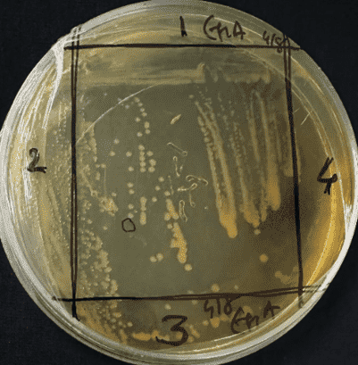  (A) | 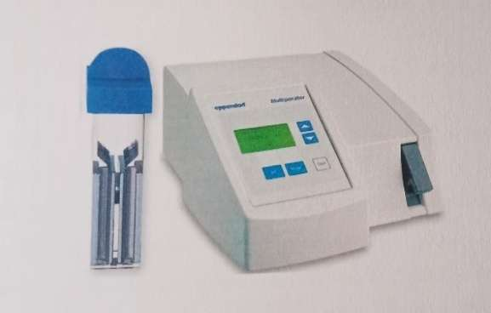  (B) | 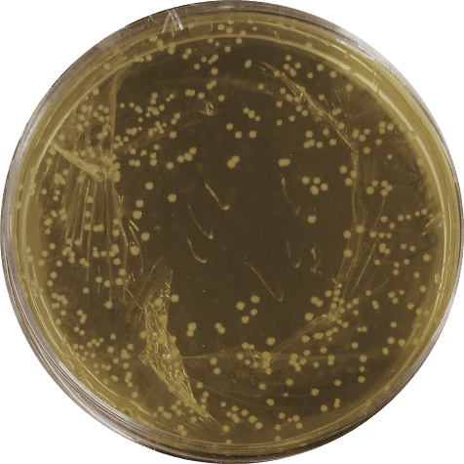  (C)
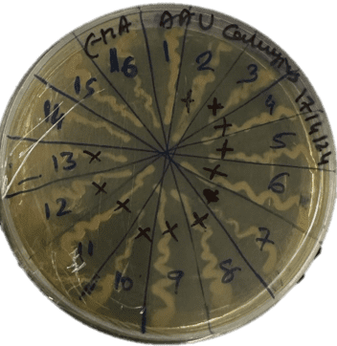  (D) | 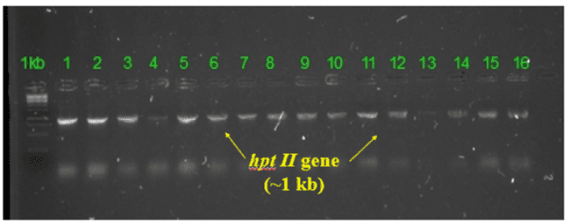  (E)
Fig 1. Confirmation of pCAMBIA 1301 vector integration in Agrobacterium (EHA105) cells (A) Selection of Agrobacterium (EHA 105) competent cells B) Multiporater (Eppendorf) for transformation C) and D) Transformed Agrobacterium cells, and (E) Colony PCR of transformed Agrobacterium cells using hptII gene-specific primers
The successful integration of the pCAMBIA1301 vector into Agrobacterium tumefaciens strain EHA105 was confirmed using colony PCR. Sixteen randomly selected colonies (Fig. 1D) were screened with hptII gene-specific primers, and all colonies produced the expected amplification product, confirming the presence of the construct in the transformed Agrobacterium cells. These results indicate the stable maintenance of the binary vector in Agrobacterium, which is a prerequisite for efficient plant transformation. Similar approaches for confirming plasmid integration in Agrobacterium using colony PCR with marker gene-specific primers have been widely reported in tomato and other crops (Hiei et al., 1994; Kapila et al., 1997; Prihatna et al., 2019).
3.2 Effect of Acetosyringone Concentration
The addition of acetosyringone significantly influenced (CD at 1% = 1.04) transformation fficiency (TE) and total transformation efficiency (TOE) in tomato cv. Anand Roma (Table 1A). At 50 mM acetosyringone, no transformation was recorded. A gradual increase in TE and ToE was observed with increasing concentrations, reaching the maximum at 200 mM (TE= 23% and ToE= 12%) (Fig 2). Beyond this concentration (250 mM), a decline was observed (TE= 19% and ToE= 8%). This reduction at higher concentrations may be due to phytotoxic effects and impaired seedlings survival (29.77%) (Fig 3). Similar findings have been reported in tomato and other Solanaceae members, where acetosyringone enhanced Agrobacterium-mediated transformation by stimulating vir gene expression (Olhoft et al., 2001; Rao et al., 2009; Shah et al., 2015; Sandhya et al., 2022 and Marapaka et al., 2025).
3.3 Effect of Soaking Duration in Agrobacterium suspension
Different soaking durations showed a significant influence (CD at 1% = 1.08; CV = 5.93%) on transformation efficiency (Table 1B). Short soaking periods of 10-15 min produced very low transformation (TE= 2.5%). The highest transformation was observed at 30 min (TE= 17%, ToE= 10%), and the transformation was reduced at longer durations (45 min and 23.88%) with no transformants (Fig. 2). This suggests that 30 min is optimal for infection, while prolonged exposure leads to bacterial overgrowth and tissue necrosis. The observation aligns with Van Eck et al. (2006), who reported that extended Agrobacterium contact decreases regeneration due to bacterial stress on explants, while controlled exposure improves transformation.
3.4 Effect of Dark Incubation Period
The incubation of seeds in dark conditions showed significant variation (CD at 1% = 0.84; CV = 4.97%) in both survival and transformation frequency (Table 1C). Although maximum germination (83.92%) occurred at 24 hrs, no transformants were obtained. Transformation peaked at 48 hrs (TE = 14% and ToE =8%) (Fig 2), while longer durations (60-72 hrs) drastically reduced seedlings' survival (11.78-29.82%) and failed to produce transformants (Fig 3). This indicates that moderate dark incubation enhances stress-induced susceptibility, which facilitates T-DNA integration, but prolonged darkness is detrimental. Similar trends were observed in tomato by Hamza & Chupeau (1993), Dan et al. (2006 and reconfirmed in recent studies where 48 hours of dark incubation enhanced Agrobacterium-mediated transformation efficiency (Prihatna et al., 2019).
3.5 Effect of Hygromycin Concentration on Selection
Hygromycin selection also showed significant differences (CD at 1% = 0.81; CV = 4.89%) among treatments (Table 1D). No transformants were observed at 10 mg/L, despite high germination (75.91%). Transformation peaked at 30 mg/L (TE = 20%, ToE = 10%) (Fig 2), where selection pressure was stringent enough to eliminate escapes but still allowed regeneration. At higher concentrations (40-50 mg/L), germination of seedlings dropped drastically (16.25-36.08%) with very low transformation (Fig 3). This trend indicates that stringent selection is necessary to eliminate escapes, but excessively high levels reduce regeneration. The corroborating reports by McCormick (1991) and Ling et al. (1998). Similar dose-dependent effects of hygromycin were reported in tomato cv. Rio Grande (Prihatna et al., 2019).
3.6 Molecular Analysis of Transformed Tomato Plants
Genomic DNA was extracted from leaves of both putative T₀ tomato transformants and non-transformed wiled type control plants. DNA concentrations ranged from 430-680 ng/µL in transformants and 515-725 ng/µL in controls, confirming sufficient quality and quantity for used in molecular analysis. Samples were standardized to 100 ng/µL for uniform PCR input. PCR using hptII gene specific primers confirmed the presence of the transgene in hygromycin-resistant plants (Fig 4). The number of positive plants varied markedly with acetosyringone concentration, Agrobacterium soaking duration, dark incubation period, and hygromycin selection pressure. Maximum transformants were obtained at 200 mM acetosyringone (six positive plants), with no transformants at 50 mM, consistent with reports that moderate acetosyringone concentrations markedly improve Agrobacterium vir gene induction and transformation success while very low levels yield few or no events (Cordeiro et al., 2023).
Optimal infection time was observed at 30 min of soaking, which produced five positive plants, both shorter (10-15 min) and excessively long (45 min) exposures resulted in one or no positive plants. The supporting findings that controlled infection periods maximize T-DNA delivery while prolonged exposure increases bacterial overgrowth and tissue damage (Yang et al., 2024). Dark incubation of treated seeds for 48 hrs yielded four positive plants, whereas 24 hrs and longer durations (60-72 hrs) produced no transformants, indicating that a moderate dark period enhances susceptibility to Agrobacterium without compromising seedling viability (Belanger et al., 2024). Selection with 30 mg/L hygromycin recovered the highest number of positive plants (five), while lower (10 mg/L) or higher (50 mg/L) concentrations failed to recover transformants.
Table 1. Influence of acetosyringone, hygromycin, soaking duration, and dark incubation on Agrobacterium-treated tomato seeds
(A) Various concentrations of acetosyringone (mM)
Sr. No. | Treatments | No. of seeds were treated | No. of seedling survived* | Germination (%) * | No. of positive plants | TE (%) | ToE (%)
1 | 50 | 55 | 45.0 | 81.8 | 0 | 0 | 0
2 | 100 | 55 | 44.0 | 80.17 | 1 | 2.5 | 2
3 | 150 | 55 | 35.2 | 64.05 | 3 | 9.3 | 6
4 | 200 | 55 | 28.6 | 52.16 | 6 | 23 | 12
5 | 250 | 55 | 16.3 | 29.77 | 4 | 19 | 8
CD 1% |  |  |  | 1.04 | 4 | 19 | 8
CV% |  |  |  | 5.59 | 4 | 19 | 8
(B) Different socking duration in Agrobacterium (min)
1 | 10 | 55 | 42.8 | 77.95 | 1 | 2.5 | 2
2 | 15 | 55 | 41.7 | 75.8 | 1 | 2.6 | 2
3 | 20 | 55 | 33.9 | 61.79 | 2 | 6 | 4
4 | 30 | 55 | 31.8 | 57.83 | 5 | 17 | 10
5 | 45 | 55 | 13.1 | 23.88 | 0 | 0 | 0
CD 1% |  |  |  | 1.08 | 0 | 0 | 0
CV% |  |  |  | 5.93 | 0 | 0 | 0
(C) Different dark incubation period of treated seeds (hrs)
1 | 24 | 55 | 46.1 | 83.92 | 0 | 0 | 0
2 | 36 | 55 | 40.7 | 74.12 | 1 | 2.7 | 2
3 | 48 | 55 | 30.4 | 55.41 | 4 | 14 | 8
4 | 60 | 55 | 16.4 | 29.82 | 0 | 0 | 0
5 | 72 | 55 | 6.4 | 11.78 | 0 | 0 | 0
CD 1% |  |  |  | 0.84 | 0 | 0 | 0
CV% |  |  |  | 4.97 | 0 | 0 | 0
(D) Various concentrations of hygromycin (mg/L)
1 | 10 | 55 | 41.7 | 75.91 | 0 | 0 | 0
2 | 20 | 55 | 36.3 | 66.01 | 1 | 3 | 2
3 | 30 | 55 | 27.5 | 50.02 | 5 | 20 | 10
4 | 40 | 55 | 19.8 | 36.08 | 2 | 11 | 4
5 | 50 | 55 | 8.9 | 16.25 | 0 | 0 | 0
CD 1% |  |  |  | 0.81 | 0 | 0 | 0
CV% |  |  |  | 4.89 | 0 | 0 | 0
TE = Transformation Efficiency, ToE= Total transformation efficiency, *= Mean value from four replications
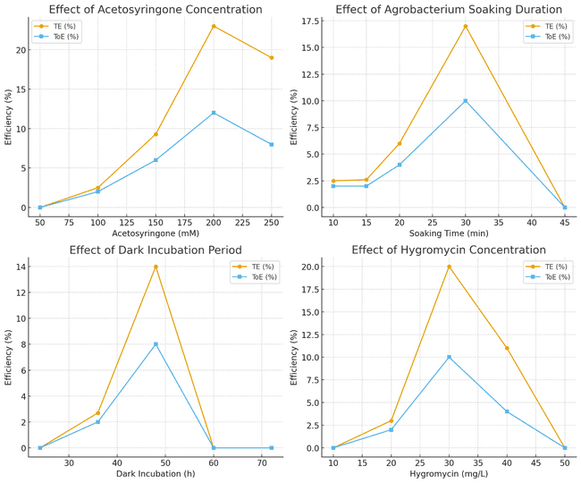
Fig 2. Effect of acetosyringone concentration, Agrobacterium soaking duration, dark incubation period, and hygromycin concentration on transformation efficiency (TE) and total transformation efficiency (ToE) in tomato cv. Anand Roma

This highlights the importance of optimizing selection pressure to minimize escapes while preventing excessive phytotoxicity, a finding consistent with recent tomato transformation studies that stress the need for cultivar-specific calibration of antibiotic concentrations (Sandhya et al., 2022).

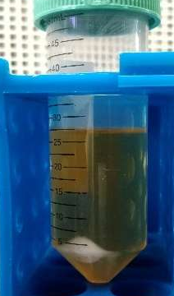  (A) | 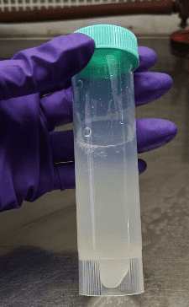  (B) | 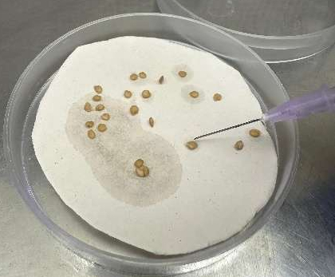  (C) | 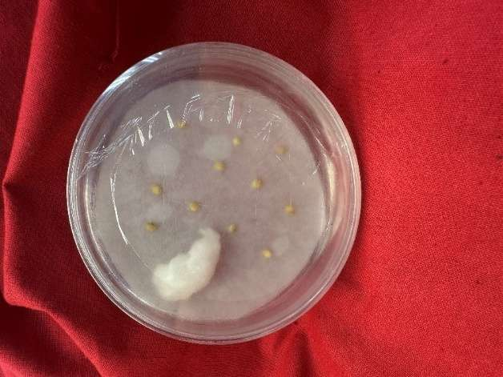  (D) | 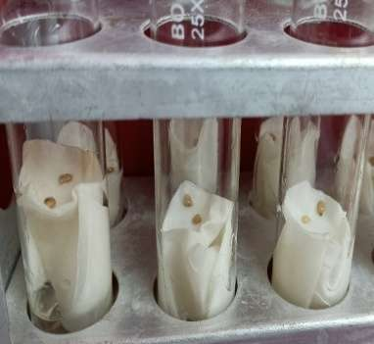  (E) | 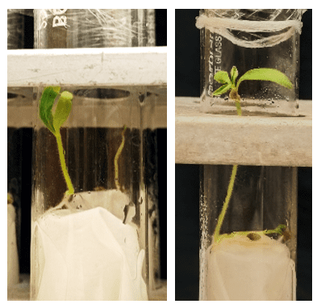  (F)
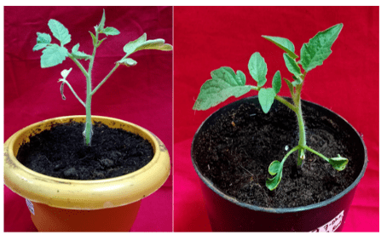  (G) |  |  | 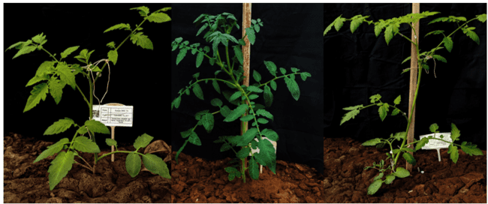  (H)
Fig 3. In-planta transformation of tomato cv. Anand Roma (A) & (B) Preparation of Agrobacterium culture for in planta transformation (C) Pinching of seeds using sterile needle (which containing Agrobacterium) (D) Co-cultivated of pinched seeds with Agrobacterium for 48 hrs in dark (E) Transfer pinched seeds into half-strength MS liquid media with antibiotic (hygromycin 30 mg/L) (F) Germination and seedling of pinched seeds (G) Primary hardening of transformed plants and (H) Secondary hardening of transformed plants in green house
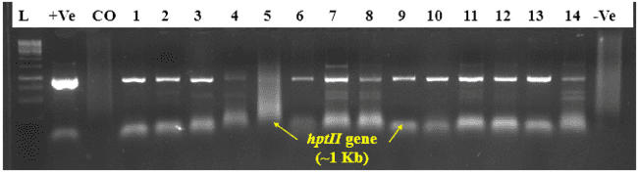
Fig 4. Confirmation of tomato transformants through PCR amplification using hptII gene primer (L = 1Kb DNA ladder, +Ve = Positive control of pCAMBIA 1301 plasmid, CO = Anand Roma non-transformed (Control), -Ve = Negative control)
4. CONCLUSION
This study successfully established an optimized in planta Agrobacterium-mediated transformation system for tomato cv. Anand Roma using the pCAMBIA 1301 plant expression vector. Key factors such as acetosyringtone concentration, soaking duration, dark incubation and hygromycin selection were systematically evaluated, revealing that 200 mM acetosyringone, 30 min soaking, 48 hrs dark incubation, and 30 mg/L hygromycin provided the highest transformation efficiency. The approach minimizes tissue culture dependency, reduces cost and duration, and limits somaclonal variation. These results provide a reproducible, genotype-specific framework for efficient tomato genetic transformation and improvement.

Declarations
Ethics approval and consent to participate:
Not applicable
Consent for publication:
By submitting this research paper for publication, all authors consent to its dissemination and acknowledge that it has not been previously published nor is it under consideration elsewhere.
Availability of data and material:
The data that has been used is confidential and raw data available as supplementary file.
Declaration of competing interest:
The authors declare that they have no known competing financial interests or personal relationships that could have appeared to influence the work reported in this paper.

Disclaimer (Artificial intelligence)
The authors declare that they have used generative AI technologies for the writing or editing of manuscripts.
Details of the AI usage are given below:
1. Chat GPT – (GPT-5), version 5.1
Details of the AI used in the manuscript are given below:
1. Some writing or grammar was used in introduction part (5-6 sentences).
2. The graph (fig 2) was edited in AI (Chat GPT).

REFERENCES
Anonymous (2024). National Horticulture Board 2024. www.nhb.gov.in.
Baltes, N. J., Gil-Humanes, J., & Voytas, D. F. (2017). Chapter one - Genome engineering and agriculture: opportunities and challenges. In: Weeks DP, Yang B (eds) Progress in Molecular Biology and Translational Science, vol-149. Academic Press, Cambridge, pp 1–26.
Baria, K., Acharya, R. R., Pandya, H., Chaudhary, K. B., Chaudhary, N., & Rathava, R. (2025). Comparative analysis of heterosis, inbreeding depression and its component traits for yield and its attributing traits in tomato (Solanum lycopersicum L.). Journal of Experimental Agriculture International, 47(7), 277-288. https://doi.org/10.9734/jeai/2025/v47i73567.
Bechtold, N., Ellis, J., & Pelletier, G. (1993). In planta Agrobacterium-mediated gene transfer by infiltration of adult Arabidopsis thaliana plants. Comptes Rendus de l’Académie des Sciences — Series III, Life Sciences, 316, 1194-1199.
Belanger, J. G., Copley, T. R., Hoyos-Villegas, V., Charron, J.-B., & O’Donoughue, L. (2024). A comprehensive review of in planta stable transformation strategies. Plant Methods, 20, Article 79.
Ben-Amar, A., Cobanov, P., Buchholz, G., Mliki, A., & Reustle, G. (2013). In planta agro-infiltration system for transient gene expression in grapevine (Vitis spp.). Acta Physiologiae Plantarum, 35(11), 3147-3156.
Benny, A., Alex, S., Soni, K. B., Anith, K. N., Kiran, A. G., & Viji, M. M. (2022). Improved transformation of Agrobacterium assisted by silver nanoparticles. BioTechnologia, 103(3), 311.
Carvalho, C. H. S., Zehr, U. B., Gunaratna, N., Anderson, J., Kononowicz, H. H., Hodges, T. K., et al. (2004). Agrobacterium-mediated transformation of sorghum: factors that affect transformation efficiency. Genetics and Molecular Biology, 27(2):259–269.
Chattopadhyay, A., & Paul, A. (2023). Studies on heterosis in tomato (Solanum lycopersicum L.). International Journal of Bio-resource and Stress Management, 14(2), 163–170.
Chetelat, R. T., Meglic, V., & Cisneros, P. (2000). A genetic map of tomato based on Lycopersicon esculentum × L. hirsutum cross. Theoretical and Applied Genetics, 100, 762–768.
Cordeiro, D., Alves, A., Ferraz, R., Casimiro, B., Canhoto, J., & Correia, S. (2023). An efficient Agrobacterium-mediated genetic transformation method for Solanum betaceum Cav. embryogenic callus. Plants, 12(5), 1202. https://doi.org/10.3390/plants12051202.
Dan, Y., Yan, H., Munyikwa, T., Dong, J., Zhang, Y., & Armstrong, C. L. (2006). MicroTom – A high-throughput model transformation system for functional genomics. Plant Cell Reports, 25, 432–441.
De Block, M., Herrera-Estrella, L., Van Montagu, M., Schell, J., & Zambryski, P. (1984). Expression of foreign genes in regenerated plants and in their progeny. European Molecular Biology Organization Journal, 3(8):1681.
Doyle, J. J. (1990). Isolation of plant DNA from fresh tissue. Focus, 12, 13-15.
Duan, H. Y., Ding, X. S., Song, J. Y., He, Y. L., & Zhou, Y. Q. (2013). Plant regeneration and Agrobacterium-mediated transformation of Achyranthes bidentata using cotton EREBP gene. Brazilian Archives of Biology and Technology, 56(3):349–356.
Dutt, M., & Grosser, J. W. (2009). Evaluation of parameters affecting Agrobacterium-mediated transformation of citrus. Plant Cell, Tissue and Organ Culture (PCTOC), 98(3), 331-340.
Fisher, R. A. (1935). The Design of Experiments. Oliver & Boyd, Edinburgh.
Foolad, M. R. (2007). Genome mapping and molecular breeding of tomato. International Journal of Plant Genomics, 64358.
Hamza, S., & Chupeau, Y. (1993). Re-evaluation of conditions for plant regeneration and Agrobacterium-mediated transformation from tomato. Journal of Experimental Botany, 44(5), 1837-1845.
Hiei, Y., Ohta, S., Komari, T., & Kumashiro, T. (1994). Efficient transformation of rice (Oryza sativa L.) mediated by Agrobacterium and sequence analysis of the boundaries of the T-DNA. Plant Journal, 6(2), 271–282.
Hosmani, P. S., Flores-Gonzalez, M., van de Geest, H., Maumus, F., Bakker, L. V., Schijlen, E., et al. (2019). An improved de novo assembly and annotation of the tomato reference genome using single-molecule sequencing, Hi-C proximity ligation and optical maps. Biorxiv. 767764.
Kapila, J., De Rycke, R., Van Montagu, M., & Angenon, G. (1997). An Agrobacterium-mediated transient gene expression system for intact leaves. Plant Science, 122(1), 101–108.
Kaul, M. L. H. (1988). Male sterility in higher plants. Springer-Verlag.
Keshamma, E., Sreevathsa, R., Kumar, A. M., Reddy, K. N., Manjulatha, M., Shanmugam, N. B. et al. (2012). Agrobacterium-mediated in planta transformation of field bean (Lablab purpureus L.) and recovery of stable transgenic plants expressing the cry 1AcF gene. Plant Molecular Biology Reporter, 30(1), 67-78.
Kumar, T., Uzma, K. M., Abbas, Z., & Ali, G. M. (2013). Genetic improvement of sugarcane for drought and salinity stress tolerance using Arabidopsis vascuolar pyrophosphatase (AVP1) gene. Molecular Biotechnology, 56(3):199–209.
Kumria, R., Waie, B., & Rajam, M. V. (2001), Plant regeneration from transformed embryogenic callus of an elite Indica rice via Agrobacterium. Plant Cell, Tissue and Organ Culture (PCTOC), 67:63–71.
Ling, H. Q., Kriseleit, D., & Ganal, M. W. (1998). Effect of ticarcillin/potassium clavulanate on callus growth and shoot regeneration in Agrobacterium-mediated transformation of tomato (Lycopersicon esculentum Mill.). Plant Cell Reports, 17, 843–847.
Linnaeus, C. (1753). Species plantarum (Vol. 1): Impensis G. C. Nauk (1st ed.), Stockholm.
Liu, X., Miceli III, J. F., Patton, S., Murray, M., Evans, J., Wei, X., & Wang, P. (2023). Agrobacterial transformation enhancement by improved competent cell preparation and optimized electroporation. Life, 13(11), 2217.
Marapaka, V., Gande, K., Banoth, R., Sandhya, D., & Peddaboina, V. (2025). Development of herbicide-resistant transgenic tomato plants with Agrobacterium-mediated genetic transformation using bar gene. Discover Plants, 2(1), 114.
Mayavan, S., Subramanyam, K., Arun, M., Rajesh, M., Dev, G. K., Sivanandhan, G., et al. (2013) Agrobacterium tumefaciens-mediated in planta seed transformation strategy in sugarcane. Plant Cell Reports, 32:1557–1574.
McCormick, S. (1991). Transformation of tomato with Agrobacterium tumefaciens. In D. G. Lindsey, & B. G. Glick (Eds.), Plant Tissue Culture Manual (pp. 1–9). Dordrecht: Springer. https://doi.org/10.1007/978-94-009-2075-0_1.
Miller, P. (1754). The Gardener’s dictionary, Abridged 4th Ed. John and James. Rivington, London, UK.
Mondal, T. K., Bhattacharya, A., Ahuja, P. S, Chand, P. K. (2001). Transgenic tea [Camellia sinensis (L.) O. Kuntze cv. Kangra Jat] plants obtained by Agrobacterium-mediated transformation of somatic embryos. Plant Cell Reports, 20:712–720.
Moyle, L. C., & Nakazato, T. (2008). Comparative genetics of hybrid incompatibility: sterility in two Solanum species crosses. Genetics. 179, 1437-1453.
Olhoft, P. M., Flagel, L. E., Donovan, C. M., & Somers, D. A. (2001). Efficient soybean transformation using hygromycin B selection in the cotyledonary-node method. Planta, 210, 215–224.
Orzaez, D., Mirabel, S., Wieland, W. H., Granell, A. (2006). Agroinjection of tomato fruits. A tool for rapid functional analysis of transgenes directly in fruit. Plant Physiology, 140:3–11.
Park, B. J., Liu, Z., Kanno, A., & Kameya, T. (2005). Transformation of radish (Raphanus sativus L.) via Sonication and vacuum infiltration of germinated seeds with Agrobacterium harboring a group 3 LEA gene from B. Napus. Plant Cell Reports, 24:494–500.
Peralta, I. E., & Spooner, D. M. (2005). Relationship and morphological characterization of wild tomatoes (Solanum L. Section lycopersicon (Mill.) wettst. Subsection lycopersicon). Systematic Botany Monographs, 30, 227-257.
Peralta, I. E., Spooner, D. M., & Knapp, S. (2008). Taxonomy of wild tomatoes and their relatives (Solanum sect. Lycopersicoides, sect. Juglandifolia, sect. Lycopersicon; Solanaceae). Systematic Botany Monographs, 84, 1-186.
Prihatna, C., Chen, R., Barbetti, M. J., & Barker, S. J. (2019). Optimisation of regeneration parameters improves transformation efficiency of recalcitrant tomato. Plant Cell, Tissue and Organ Culture, 137(3), 473–483.
Rai, M., Kumar, S., & Singh, M. (2016). Male sterility systems and their exploitation in hybrid seed production of tomato. Vegetable Science, 43(1), 1–12.
Rao, K. V., Reddy, V. D., & Kumar, P. A. (2009). Agrobacterium-mediated genetic transformation of pigeon pea (Cajanus cajan L.) and development of transgenic plants via direct organogenesis. Plant Cell Reports, 28, 1071–1081.
Ratanasut, K., Rod-In, W., & Sujipuli, K. (2017). In planta Agrobacterium-mediated Transformation of Rice. Rice Science, 24(3), 181-186.
Samal, K. C., Rout, G. R. (2018). Chapter 10 - Genetic improvement of vegetables using transgenic technology. In: Rout GR, Peter KV (eds) Genetic Engineering of Horticultural Crops. Academic Press, Cambridge, pp 193–224.
Sanagala, R., Moola, A. K., Bollipo Diana, R. K. (2017). A review on advanced methods in plant gene targeting. Journal of Genetic Engineering and Biotechnology, 15(2):317–321. https://doi.org/10.1016/j.jgeb.2017.07.004.
Sandhya, D., Jogam, P., Venkatapuram, A. K., Savitikadi, P., Peddaboina, V., Allini, V. R., et al. (2022). Highly efficient Agrobacterium-mediated transformation and plant regeneration system for genome engineering in tomato. Saudi Journal of Biological Sciences, 29(6), 103292.
Shah, S. H., Ali, S., Jan, S. A., & Ali, G. M. (2015). Piercing and incubation method of in planta transformation producing stable transgenic plants by overexpressing DREB1A gene in tomato (Solanum lycopersicum Mill.). Plant Cell, Tissue and Organ Culture (PCTOC), 120(3), 1139-1157.
Sharma, H. C., Singh, A. K., & Kumar, S. (2010). Hybrid seed production in tomato: Constraints and prospects. Vegetable Science, 37(2), 123–135.
Subramanyam, K., Rajesh, M., Jaganath, B., Vasuki, A., Theboral, J., Elayaraja, D., et al. (2013). Assessment of factors influencing the Agrobacteium-mediated in planta seed transformation of brinjal (Solanum melongena L.). Applied Biochemistry and Biotechnology, 171:450–468.
Tague, B. W., & Mantis, J. (2006). In planta Agrobacterium-mediated transformation by vacuum infiltration. Methods in Molecular Biology, 323:215–223.
Trieu, A. T., Burleigh, S. H., Kardailsky, I. V., Maldonado-Mendoza, I. E., Versaw, W. K., Blaylock, L. A., et al. (2000). Transformation of Medicago truncatula via infiltration of seedlings or flowering plants with Agrobacterium. Plant Journal, 22(6):531–541.
Van Eck, J., Kirk, D. D., & Walmsley, A. M. (2006). Tomato (Lycopersicon esculentum). In: Wang, K. (Ed.), Agrobacterium Protocols. Springer, pp. 459-474.
Vinoth, V., Gurusaravanan, P., & Jayabalan, N. (2013). Optimization of factors influencing microinjection method for Agrobacterium tumefaciens-mediated transformation of tomato. Applied Biochemistry and Biotechnology, 169:1173–1187.
Weeks, J. T., Ye, J., & Rommens, C. M. (2008). Development of an in-planta method for transformation of alfalfa (Medicago sativa). Transgenic Research, 17(4):587–597.
Wroblewski, T., Tomczak, A., & Michelmore, R. (2005). Optimization of Agrobacterium-mediated transient assays of gene expression in lettuce, tomato and Arabidopsis. Plant Biotechnology Journal, 3:259–273.
Yang, Y., Chen, Z., Zhao, J., Zheng, G., Wang, F., Li, S., et al. (2024). Establishment and validation of an efficient Agrobacterium tumefaciens-mediated transient transformation system for Salix Psammophila. International Journal of Molecular Sciences, 25(23), 12934.
Yau, Y., & Stewart, C. N. (2013). Less is more: strategies to remove marker genes from transgenic plants. BMC Biotechnology, 13:36.

