Original Research Article
Anthropometric Assessment of Earlobe Patterns Among the Indigenous People of Ibadan, Nigeria

Abstract
Background: The pattern of earlobe attachment is a notable phenotypic trait that varies among human populations and is often used in genetic, anthropological, and forensic studies
Aim: The study aimed to assess the pattern of earlobe attachment among the indigenous people of Ibadan.
Method: A total of 160 male and 160 female subjects between the ages of 18 and 37 years were recruited for the study. Multi-stage random sampling was used. A questionnaire was administered and retrieved. Data analysis was performed using the Statistical Package for Social Sciences (IBM SPSS version 23). Chi-square test was used as an inferential statistic.
Results: This study shows that 55.6% of males and 60% of females had attached lobes, while 44.4% of males and 40% of females had detached lobes.
Conclusion: This study indicated that the most common earlobe pattern among both genders was the attached earlobe.
Key word: Earlobe; Anthropometric; Ibadan

INTRODUCTION
The earlobe is the soft tissue area at the lower part of the outer ear, which lacks cartilage but is rich in blood vessels and nerve endings [1, 2]. It also consists of the tough areola and adipose (fatty) connective tissues, lacking the firmness and elasticity of the rest of the pinna [3, 4]. Additionally, earlobe attachment varies among individuals; it can be detached and hang freely to the side of the head, or it can be directly attached to the head [5, 6, 5,6,7]. Although this trait is believed to be influenced by genetics, it has been widely studied in genetics, anthropology, and forensic science for its potential to reveal inheritance patterns, population diversity, and evolutionary processes.
Earlobe attachment serves as a simple yet informative phenotypic marker that reflects genetic variation within and between populations [8, 9]. Examining the distribution and frequency of this trait across different ethnic or regional groups can offer insights into genetic connections, historical migrations, and adaptation. Several studies have explored earlobe attachment patterns; for example, Irozulike et al. [10] found that attached earlobes are more common among the Hausa ethnic group in Nigeria. Francis and Okoseimiema [11] reported that detached earlobes are more prevalent among the Kalabari people. A case study in Shah Alam, Malaysia, by Attalla et al. [12], observed that males tend to have more attached earlobes than females. Ibadan, Nigeria, a major city in southwestern Nigeria, is home to the indigenous Yoruba people. This trait offers a valuable focus for study, as it can aid in understanding population genetics, inheritance, and biological diversity. Investigating earlobe attachment among the indigenous people of Ibadan enhances the growing body of anthropometric and genetic data in Nigeria.
2.0 MATERIALS AND METHODS
2.1 Study Design
The study adopted a cross-sectional descriptive design, and qualitative data were collected using the observational research method. A total of 300 respondents (160 males and 160 females) were selected within the age interval of 18-37 years. The respondents were drawn from the ingenious people of Ibadan, Oyo State, Nigeria. The city of Ibadan was used as the study area, and a multi-stage random sampling technique was employed to ensure that all respondents had an equal chance of being selected.
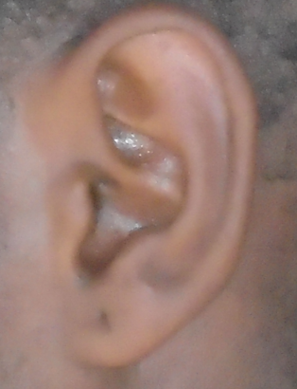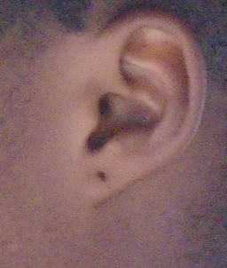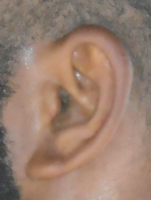
Fig. 1 shows the Attached Earlobe Pattern

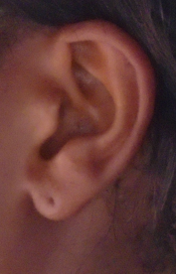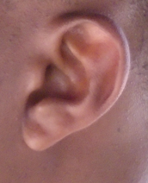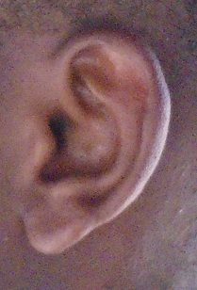
Fig. 2: Shows the Detached Earlobe Pattern
2.2 Study Criteria
2.2.1 Inclusion criteria
This study included individuals whose parents and grandparents are indigenous people of Ibadan, Nigeria. Also, only those aged between 18 and 37 years, with no history of ear surgery, were selected.
2.2.2 Exclusion criteria
Those who did not meet the inclusion criteria were all omitted from the study.
2.3 Methods of Data Collection
A written consent form was distributed among the respondents and followed by a personal interview. Data were collected using a closed observational approach where trained personnel took observations of the earlobe. The data obtained were documented in a spreadsheet (Microsoft Excel Document).
2.4 Methods of Data Analysis
The data obtained from the study were subjected to statistical analysis using the International Business Machines Statistical Package for the Social Sciences (IBM SPSS version 23), and the Chi-square test was used as an inferential statistic. A probability less than 0.05 (p<0.05) was considered statistically significant.
3. RESULTS
The present study is made up of three hundred and twenty subjects (160 males and 160 females) (Fig. 3). The present study only recruited respondents between 18-37 years, and the ages were categorized into classes of 18-22, 23-27, 28-32, and 33-37. Fig. 4 showed that age intervals of 18-22 were observed (200%), 23-27 (68%), 28-32 (37%), and the least observed within the age interval of 34-37 (15%).
Table 1 illustrates the association of earlobe attachment among gender, where 44.4% of the male population and 40% of the female population were observed to have a detached earlobe pattern. Moreover, 55.6% of the male population and 60% of the female population have an attached earlobe pattern. The association of earlobe pattern and gender showed no gender difference.

4. DISCUSSION
The present study assesses the relationship of earlobe patterns among the indigenous people of Ibadan, Nigeria. The study found that 55.6% of males and 60% of females had attached earlobe patterns. This relationship showed no significant gender difference. The findings align with those of Irozulike et al., [10], who reported that the Hausa ethnic group in Nigeria has attached earlobes in both genders. Gaya and Yahaya [13] also observed that students at Bayero University, Kano, Nigeria, exhibit a higher prevalence of attached earlobes among both sexes. However, these findings contrast with Asiwe et al., [14], who indicated that detached earlobe patterns are more common in males, while attached earlobes are more prevalent in females among the Igbo ethnic group in Nigeria. Ese et al. [15] confirmed that, within the Ika ethnic group of Delta State, Nigeria, females typically have free earlobes, whereas males tend to have more attached earlobes. Munir et al. [16] noted that, in Quetta, Pakistan, the most common earlobe pattern in males was free earlobes, while in females it was attached earlobes.
Moreover, this study revealed that attached earlobe patterns are more prevalent among the indigenous people of Ibadan, Nigeria. This concurs with Paul et al. [17], who found that attached earlobes are more common than detached earlobes among the Idoma people of Benue State, Nigeria. However, these results differ from those of Francis and Okoseimiema [11], who stated that free (or detached) earlobes are more frequently observed than attached earlobes among the Kalabari people. Ebeye et al. [18] reviewed existing literature and reported that detached earlobes are more common among the Esan ethnic group of Nigeria. They also noted that earlobe patterns showed no gender differences, which supports the current study. Conversely, Fakorede et al. [19] and Kapile et al. [20] found that detached (free) earlobes are more prevalent than attached earlobes, which contradicts the findings of this study.
Table 1. Association of Earlobe Attachment among the Genders
Sex | Detached lobe | Attached lobe | X² | df | p-value | Inference
Male | 71 (44.4%) | 89 (55.6%) | 0.628 | 1 | 0.428 | NS
Female | 64 (40%) | 96 (60%)

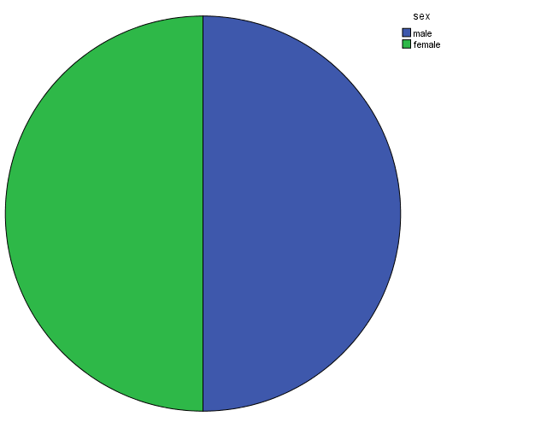
Fig. 3: Shows the Gender
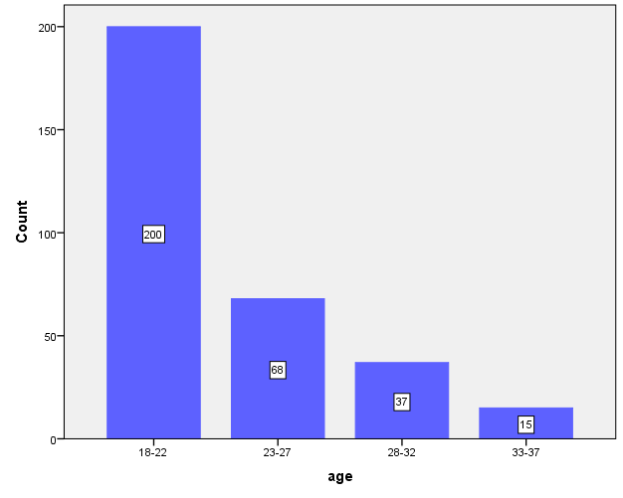
Fig. 4: Shows the age range of the subjects
5. CONCLUSION
In conclusion, this study found that 55.6% of males and 60% of females had attached lobes, while 44.4% of males and 40% of females had detached lobes, with no gender differences. This study also indicated that the most common earlobe pattern among both genders was the attached earlobe.
ETHICAL APPROVAL
The study was approved by the research and ethics committee of the University of Port Harcourt, Port Harcourt, Nigeria.
CONSENT
A written consent was distributed to all the subjects explaining the nature of the research, and only those who consented were allowed to participate in the study. The consents were retrieved and preserved by the authors.
COMPETING INTERESTS
The authors have declared that no competing interests exist.
REFERENCE
- Clare C. The Ears and Eyes. Fundamentals of Applied Pathophysiology for Paramedics. 2024 Mar 11:380-405.
- Ladani P. Ear reconstruction. Oral and Maxillofacial Surgery for the Clinician. 2021:731-45.
- Puneeth PJ. A Comparative Study of Efficacy of Fat Plug Myringoplasty and Conventional Myringoplasty in Chronic Suppurative Otitis Media with Small Perforation (Master's thesis, Rajiv Gandhi University of Health Sciences (India)
- Ordu KS, Didia BC, Egbunefu N. Inheritance pattern of earlobe attachment amongst Nigerians. Greener Journal of Human Physiology and Anatomy. 2014;2(1):1-7..
- Yadav M, Nigam K, Srivastava A, Yadav VK. A Preliminary Study on Frequency Distribution & Inheritance Pattern of Different Characteristics of Ear among Population of Moth Region of Jhansi District. International Journal for Research in Applied Science and Engineering Technology. 2017;5.
- Agrawal M, Yadav MM, Harshey A, Srivastava A, Yadav VK. A Study of External Ear Morphological Variation in Central Indian Population for Genealogical Purposes.
- Saloom JE, Al-Joubori SK, Al-Mashhdany SM. The Relation between Some Genetic Traits (Ptc Tasting, Tongue Rolling, Earlobe Attachment and Dental Occlusion in Iraqi Adults. Indian Journal of Public Health Research & Development. 2019 Oct 1;10(10).
- Balaresque P, King TE. Human phenotypic diversity: An evolutionary perspective. Current topics in developmental biology. 2016 Jan 1;119:349-90.
- Patra AP, Arthy A, Rajesh DR, Neithiya T. Establishing the identity of the individual. InMedical jurisprudence & clinical forensic medicine 2023 Aug 9 (pp. 81-101). CRC Press.
- Irozulike FC, Uchechukwu CG, Nwofor PN, Filima PL, Selekekeme TB. Assessment of Earlobe Patterns and Ear Shapes in Hausa Ethnic Group of Nigeria: Implications for Forensic and Clinical Applications. Asian Journal of Medical Principles and Clinical Practice. 2024 Dec 12:502-8.
- Francis GI, Okoseimiema SC. Distribution of earlobe attachment among Kalabari people of Southern Nigeria. Sch J App Med Sci. 2022 Nov;11:1884-6.
- Attalla SM, Kumar KA, Hussain N. Study of the Ear Shape and the Lobule Attachement among the Adult Malaysian Population at Shah Alam. European Journal of Molecular & Clinical Medicine. 2020;7(3):5417-25.
- Gaya AA, Yahaya AI. Sub-Saharan human morphological variations in the external ear (pinna): a potential tool for human identification. EC Clin Exp Anat. 2019;2:175-84.
- Asiwe N, Irozulike FC, Filima PL, Wedeh MS, Yirate BN. Pattern of Earlobe Attachment among Igbo Ethnic Group of Nigeria. Asian J. Adv. Res. Rep. 2023;17(11):344-9.
- Ese A, Emmanuel ON, Charity I, Enoh O. Pattern of earlobe attachment among the Ika ethnic group in Delta State, Nigeria. GSC Advanced Research and Reviews. 2021;7(3):054-7.
- Munir S, Sadeeqa A, Nergis B, Tariq N, Sajjad N. Assessment of morphogenetic inherited traits; earlobe attachment, bent little finger and hitchhiker’s thumb in Quetta, Pakistan. world Journal of Zoology. 2015;10(4):252-5.
- Paul, J. N., Ochai, J., Dimkpa, G. C., Ogba, A. A., & Ohanenye, C. A. (2022, December). Pattern of earlobes attachment among the Idoma people of Benue State, Nigeria. Scholars Journal of Applied Medical Sciences, 12, 2419-2423. https://doi.org/ 10.21276/sjams.2022.12.12.2456
- Ebeye OA, Chris-Ozoko LE, Ogeneovo P, Onoriode A. A study of some morphogenetic traits among the Esan ethnic group of Nigeria. East African Medical Journal. 2014;91(11):420-2.
- Fakorede, S. T., Adekoya, K. O., Fasakin, T. P., Odufisan, J. O., & Oboh, B. (2021, December). Ear morphology and morphometry as potential forensic tools for identification of the Hausa, Igbo, and Yoruba populations of Nigeria. Bulletin of the National Research Centre, 45, 1-9. https://doi.org/10.1186/s42269-021-00510-2
- Kapil V, Bhawana J, Vikas K. Morphological variation of ear for individual identification in forensic cases: a study of an Indian population. Res J Forensic Sci. 2014 Jan;2(1):1-8.

