Integration of 3D Pageflip Media in the Development of Editing Skills Teaching Materials to Enhance Students’ Learning Autonomy: A Design and Development Research

ABSTRACT

This research was conducted to design and test digital teaching materials for the Editing Skills course using the 3D Pageflip Professional application, intended as a self-learning tool for Indonesian Language and Literature Education students at Medan State University. Product development was carried out using the 4D model approach (Define, Design, Develop, Disseminate), which includes needs analysis, initial design, expert validation, limited implementation, and dissemination stages. Research data were collected through needs questionnaires, validation sheets, and student perceptions, then analyzed using a combination of percentage-based quantitative techniques and qualitative interpretation. The findings indicate that students have high enthusiasm for the use of multimedia-based digital teaching materials, supported by adequate technological devices. Validation by material, language, and media experts resulted in an average score of 86.10% (very appropriate), while the effectiveness test through the perceptions of 90 students obtained an average score of 88.77%, with the highest scores in the aspects of media influence (90.52%) and media presentation (90.20%). These results indicate that interactive teaching materials can increase student motivation, engagement, and learning independence. The novelty of this research lies in the application of 3D Pageflip media in the context of language learning in higher education, particularly in editing skills courses that have different characteristics from the exact sciences. In addition, the resulting product is not only a digital teaching material, but also includes a meeting-based instructional design that integrates text analysis activities, editing practices, radio drama production, and mini-field research. Thus, this research confirms that the editing skills teaching material assisted by 3D Pageflip media is valid, practical, and effective, and provides a new contribution to the development of digital learning innovation in higher education in the 21st century.

Keywords: Digital teaching materials; editing skills; 3D Pageflip Professional; independent learning; instructional design

1. INTRODUCTION

The transformation of digital systems in the era of the digital revolution 4.0 is both a necessity and a challenge for all education providers in Indonesia. This transformation demands adaptability and strong skills, which every educator must possess in mastering digital technology (Fonna, N., 2019). Minister of Education, Culture, Research, and Technology Nadiem Makarim also stated in his speech at the launch of the 2023 Technology, Information, and Communication-Based Learning (PembaTIK) program, that digital transformation is key to advancing Indonesia's education system. Therefore, educators are required to utilize digital technology to provide meaningful learning.

Digital transformation in education offers significant convenience in sharing and accessing various knowledge sources. This ease of sharing and accessing various digital-based knowledge sources has encouraged the emergence of new learning patterns at various levels, including higher education, by implementing a heutagogical learning approach based on self-determined learning. Self-determined learning is a concept within the constructive learning approach, which allows learners the freedom to reconstruct their own knowledge through active participation in the learning process (Demin, T.B.A., & Mohamad, M.M., 2023).

Similarly, Muhid (2021) stated that heutagogical learning based on self-determined learning is an approach that aligns with the characteristics of students in the digital revolution era and supports their freedom to learn. This finding is also evident in research conducted by Ettyani et al. (2023), which states that the characteristics of Generation Z, who possess the ability to utilize information and communication technology devices, strongly support the implementation of a self-determined learning approach. This approach allows students to autonomously use and utilize digital technology devices as learning media and resources needed to improve their skills and achieve learning success.

These findings align with research by Yuhdi, A., et al., (2024), which emphasizes that the development of research-based teaching materials can enhance student learning independence, particularly in Indonesian Language and Literature study programs. Thus, the heutagogical approach, which emphasizes independent learning, is strongly justified by concrete efforts to develop innovative teaching materials integrated with student needs in the digital age. Furthermore, Yuhdi, A., et al., (2025), using a sociopragmatic perspective on ethnic minority communities in the Lake Toba tourist area, also demonstrated that the social and cultural context influences how students and the younger generation utilize technological devices and communication patterns to support successful learning.

To address the challenges of the digital revolution, which has given rise to a self-determined learning approach, lecturers, as the vanguard in higher education, must be able to improve their competencies to face the era of Republic of Indonesia 4.0. This is because the students lecturers currently encounter are a generation of "digital natives" who are familiar with the digital world. Research conducted by Demir, B., & Sonmez, G. (2021) indicates that students demonstrate dissatisfaction with traditional learning methods and tend to prefer the use of digital technology to meet their academic needs. Furthermore, several studies related to students' learning material needs, conducted by Kaso, N., & Rahmadani, E. (2023), Pamungkas, I., (2021), Suroto, S., et al., (2019), and Sutiyo, S., et al., (2022), indicate that overall students prefer digital learning materials that are practical and flexible.

The results of this research demonstrate the construction of digital learning materials for the Indonesian Text Editing Skills course using 3D Page Flip media to enhance the learning independence of students in the Indonesian Language and Literature Education Study Program. This research seeks to provide digital-based learning materials to facilitate student independent learning. The teaching materials were developed in the form of a 3D e-book designed with images and videos related to Indonesian language editing skills. This study assumes that the development of teaching materials for the Editing Skills course using 3D Page Flip media can improve students' learning independence.

Previous studies have consistently demonstrated that the development of 3D Pageflip and E-Flip PDF-based teaching materials is valid, practical, and effective in improving the quality of learning across various courses and educational levels. Studies conducted by Lestari and Fitria (2023), Jhoni et al. (2023), and Harefa and Laoli (2022) demonstrated high validation results in terms of material, language, and media, with a rating of "very suitable for use." Takdir et al. (2023) reported a significant increase in learning outcomes through the implementation of interactive flipbooks, while Susanti and Prasetyo (2020) confirmed their contribution to elementary school students' learning motivation.

Furthermore, studies by Yelianti et al. (2020), Izar (2023), and Rino et al. (2022) demonstrated the effectiveness of this media across fields of study, including physics, science, and language and literature, in strengthening learning engagement and academic completion. Similarly, several other studies have also demonstrated the success of 3D Pageflip media in the context of higher education learning, such as those conducted by Yelianti et al. (2018) in the Plant Physiology course, Akhsan et al. (2020) in the Physical Relativity course, Handayani and Lestariningsih (2020) in the Ethnobotany course, Oktarina et al. (2021) in the Operating Systems course, and Andayani (2020) in the Basic Physics course. The overall empirical evidence confirms that 3D Pageflip-based innovation not only improves the quality of learning outcomes but also serves as a relevant digital strategy to meet the demands of 21st-century education.

A preliminary study conducted in the Indonesian Language and Literature Education Study Program found that most lecturers and students lack digital-based teaching materials, particularly 3D Pageflip media. Students still rely on conventional teaching materials, such as textbooks related to the course, which are often purchased off-campus. Therefore, this study aims to develop teaching materials using 3D Pageflip media to enhance student learning independence. The results of this study have been implemented in an editing skills course in the Indonesian Language and Literature Department, Faculty of Languages ​​and Arts, State University of Medan.

The research problem focuses on designing and testing the development of teaching materials for an editing skills course using 3D Pageflip media. Specifically, this study begins with an analysis of student needs for interactive digital teaching materials relevant to the characteristics of 21st-century learning. Furthermore, this study explores the form and design of 3D Pageflip-based editing skills teaching materials, which are expected to provide a more engaging and meaningful learning experience. The next stage emphasizes product feasibility testing through validation by material, language, and media experts to ensure content suitability and instructional quality. Finally, this study examines the effectiveness and implementation of these teaching materials in learning practices, with a focus on their contribution to improving student learning independence.

2. RESEARCH METHOD

This study uses a Research and Development (R&D) approach with reference to the 4D model developed by Thiagarajan, et al., (1974), which consists of four main stages, namely Define, Design, Development, and Disseminate. This model was chosen because it is relevant for the development of digital technology-based teaching materials, enabling comprehensive needs analysis, appropriate prototype design, tested product development, and dissemination in a broader learning context.

This research was conducted at the Indonesian Language and Literature Education Study Program, Faculty of Languages ​​and Arts, Medan State University, with the consideration that this study program has direct relevance in equipping students with language and literature competencies. The research data includes quantitative data in the form of expert validation scores on the material, language, and design of teaching materials, as well as qualitative data in the form of descriptions of the development results. Data collection techniques include questionnaires given to students to evaluate learning independence, expert validation instruments in the form of questionnaires to assess the feasibility of teaching materials, and student trial evaluations through tests and non-tests to assess the quality of the learning process and learning outcomes. Quantitative data analysis was conducted by calculating the percentage of expert validation scores and student responses, which were then interpreted based on product feasibility categories. Meanwhile, qualitative data analysis was conducted through reduction, presentation, and drawing conclusions from descriptions of development results to obtain an in-depth picture of the effectiveness of the teaching materials. With this approach, the development of teaching materials for editing skills assisted by 3D Pageflip media is expected to produce products that are valid, practical, and effective, and capable of improving student learning independence.

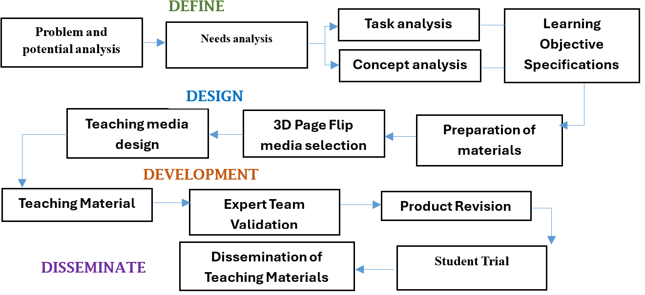

Figure 1. Research Stage Flow Chart

3. RESULTS AND DISCUSSION

1. Needs Analysis
This section presents the results of a needs analysis for developing digital teaching materials for the Editing Skills course using 3D Pageflip. The analysis was conducted by examining several key aspects: student perceptions, teaching material resources, learning competencies, and teaching material design. First, the analysis of student perceptions aimed to assess their views on the potential use of 3D Pageflip-based digital teaching materials, while ensuring the alignment of user needs with the product design (Abidah et al., 2023). Second, the analysis of teaching material resources focused on the availability and utilization of learning resources accessed by students, including people, objects, methods, and the environment, so that the developed content could be tailored to students' real-world situations (Stone et al., 2020). Third, the analysis of learning competencies focused on mapping course outcomes and materials by identifying the skills students must possess during and after the learning process, in accordance with the objectives of the Editing Skills course (Martin et al., 2022). Fourth, the analysis of teaching material design was conducted to identify respondents' preferences regarding the form, structure, and presentation of digital teaching materials, so that a product design was obtained that was in accordance with contextual learning needs (Sari et al., 2020).

Table 1. Results of the Analysis of Teaching Material Needs for 3D Pageflip-Assisted Editing Skills
Analysis Aspects | Indicator | Description | Score | Value | Interpretation
Student Perception | Student knowledge | Knowledge of the use of various types of digital teaching materials | 505 | 4,04 | Good
 | Student habits | Habits of using digital teaching materials (e-books/e-modules) | 520 | 4,16 | Good
 | Motivation | Interest in using digital teaching materials | 582 | 4,65 | Very Good
 | Perception of teaching materials | Positive views on the use of digital teaching materials | 567 | 4,53 | Very Good
 | Potential for development | Interest in 3D Pageflip e-book-based teaching materials | 607 | 4,85 | Very Good
Average |  |  |  | 4,49 | Very Good
Teaching Material Resources | Material resources | The substance of the teaching materials is connected to journals, books, and the surrounding environment. | 573 | 4,58 | Very Good
 | Technology availability | Ownership of gadgets/laptops to support digital teaching materials. | 610 | 4,88 | Very Good
 | Technology understanding | Ability to use/operate digital teaching materials. | 514 | 4,11 | Good
 | Ease of access | Ability to access digital teaching materials on campus and in learning locations. | 480 | 3,84 | Fair
Average |  |  |  | 4,35 | Good–Very Good
Learning Competencies | Basic editing concepts | Understanding basic editing concepts as the basis for teaching materials. | 560 | 4,48 | Very Good
 | Editing ethics and tools | Teaching materials support understanding codes of ethics and editing tools. | 523 | 4,18 | Good
 | Skills development | Teaching materials support developing editing skills. | 527 | 4,21 | Good
 | Learning simulations | Independent editing practice through learning simulations. | 540 | 4,32 | Good–Very Good
Average |  |  |  | 4,29 | Good–Very Good
Teaching Material Design | Physical form | A combination of audio, text, images, and video media in a 3D Pageflip e-book. | 527 | 4,21 | Good
 | Learning material format | Electronic presentation with HTML links. | 524 | 4,19 | Good
 | Learning material content | Complete structure (introduction, main body, conclusion) for each topic. | 515 | 4,12 | Good
 | Type and size of text | League Spartan and Sans-Serif fonts with custom sizes. | 543 | 4,34 | Good–Very Good
 | Cover | Cover with a dark color combination (gray, navy blue, black, dark green). | 495 | 3,96 | Fair
Average |  |  |  | 4,16 | Good

The results of the needs analysis show that students' perceptions of the development of digital teaching materials using 3D Pageflip obtained an average score of 4.49, categorized as very good. The indicators with the highest scores were development potential (4.85) and student motivation (4.65), confirming the high level of student interest in utilizing interactive digital teaching materials. This is in line with the findings of Abidah et al. (2023) who emphasized the importance of student perceptions in determining the success of implementing digital-based learning media. In the aspect of teaching material resources, the average score was 4.35, categorized as good–very good.
The technology availability indicator received the highest score (4.88), indicating that students have adequate devices to support digital learning. However, the ease of access indicator only obtained a score of 3.84, thus it is important to note that even though technological facilities are available, the accessibility of digital teaching materials still faces certain limitations. The learning competency aspect obtained an average score of 4.29, also categorized as good–very good. The highest score was shown in the indicator of understanding basic editing concepts (4.48), which confirms the relevance and importance of theoretical foundations in learning editing skills.
However, the indicators of skill development (4.21) and learning simulation (4.32) indicate the need to strengthen the practical aspect through more applicable digital teaching materials. Meanwhile, the design aspect of teaching materials obtained an average score of 4.16, which is categorized as good. The highest indicator is the type and size of the font (4.34), indicating that the aesthetic and readability aspects of the teaching materials are sufficiently considered. In contrast, the cover indicator only received a score of 3.96, indicating that the visual design of the cover still needs to be improved to be more attractive and in line with student expectations.
Overall, the results of this analysis confirm that the development of teaching materials for editing skills assisted by 3D Pageflip media has excellent opportunities for implementation. High student motivation and the availability of technology support the effectiveness of this innovation, although improvements in the accessibility and visual design aspects still need to be made to achieve more optimal quality.
2. Instructional Design for 3D Pageflip-Based Editing Skills Teaching Materials
These editing skills teaching materials were designed using 3D Pageflip Professional software, which integrates text, images, animation, audio, and video. They were supported by Microsoft Word and PowerPoint for the initial design. The final product, an interactive digital textbook, includes a cover, introduction, content, evaluation questions, and a bibliography. It also includes structured learning instructions for each session. In the initial session, students were guided to understand the RPS (Lesson Plan), read the chapter material on the Nature of Editing, and complete routine assignments. Subsequent sessions included resume presentations, news analysis, and practice editing books and scientific articles.
The fourth and fifth sessions emphasized group work through script writing and radio drama performances. This was further developed in the sixth session through a mini-research project at school, resulting in a video coverage of the lesson. Next, students learned technical materials such as editing tools, spelling, diction, and effective sentences through concept maps, exercises, and reading summaries from additional sources. Learning was evaluated through a mid-semester exam and resume assignments based on standard literature, such as Standard Indonesian Grammar.
In the final stage, students are divided into groups to develop text-based presentations (explanations, procedures, expositions, persuasive, descriptive, negotiation, news, anecdotes, and discussions), while also designing evaluation instruments in the form of HOTS-based digital quizzes using Google Forms. Thus, these digital teaching materials not only present interactive content but also guide students through a series of systematic, contextual, and hands-on learning activities.
The learning flow in the Editing Skills course is systematically designed by integrating teaching materials with 3D Pageflip media. Each session is structured to accommodate learning objectives, from understanding basic concepts, developing analytical and practical editing skills, to application in the form of creative projects and mini-research. The series of activities emphasizes not only mastery of theory but also fosters independent learning through individual assignments, group discussions, and the use of interactive digital media. This learning structure provides a gradual, measurable, and applicable learning experience, enabling students to develop both editing competencies and digital literacy skills. A detailed learning flow for this course can be seen in Table 2 below.

Table 2. Learning Flow for the Editing Skills Course
Meeting | Main Material / Activities | Forms of Learning Activities | Student Products/Assignments
1 | RPS, Chapter 1: The Nature of Editing, Chapter 2: The Scope of Editing. | Reading the material, initial discussion, compiling a resume. | Week 1 routine assignment: Chapter 2 summary
2 | Resume presentation, News analysis. | 30-minute presentation, identifying news elements, rewriting the news (e.g., TNI Commander: Centralized Isolation Center…). | Resume, news analysis results & rewriting
3 | Editing books and scientific articles. | Reading the material, compiling a resume, presenting the results, practicing questions (p. 30). | Resume, independent practice
4 | Writing radio drama scripts. | Group discussion (max. 4 people), writing a radio drama script on a chosen theme | Radio play script
5 | Radio drama practice | 30-minute class performance, mini-research discussion, and developing research questions | Radio play recording, research questionnaire
6 | Mini-research at school | Teacher observation and interviews, video documentation, and interview transcription | Video coverage (YouTube), interview transcription
7 | Editing Tool III: Spelling & Diction | Reading material, creating concept maps, and practicing exercises | Concept map, exercise results
8 | Mid-Semester Exam | Mid-semester test | Nilai UTS
9 | Diction, Effective Sentences, Language Error Analysis | Creating a resume from teaching materials and standard Indonesian grammar (Hasan Alwi et al.) | Summary of material and end-of-chapter exercises
10 | Editing Indonesian Texts | Reading scientific articles from Sinta 3–4 journals, creating a resume, and discussing | Summary of scientific articles
11–15 | Editing various types of texts: explanation, procedure, exposition, persuasion, description, negotiation, news, anecdote, discussion | Group presentation, HOTS evaluation question preparation (Google Form) | Group presentations, HOTS digital quizzes
16 | Final Semester Exam | Final semester test | Final Exam Score

Product Presentation of Teaching Materials
This 3D Pageflip-assisted editing skills teaching material is developed in the form of an interactive digital book containing several main components. Each section is designed to support students' independent learning experiences while facilitating classroom learning activities. The presentation of the teaching materials can be seen in the following image.
1. Cover Page
The cover page is designed with a bold color combination and modern typography to convey a professional impression while attracting readers' interest. This section includes the title, course description, author's name, and institutional logo (See Figure 2).
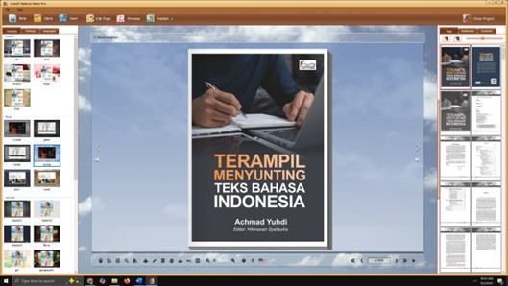
Figure 2. Cover Page
2. Introduction
The introduction provides the background, learning objectives, and instructions for using the digital learning materials. This section serves as an initial orientation for students to understand the function and targeted learning outcomes (See Figure 3).
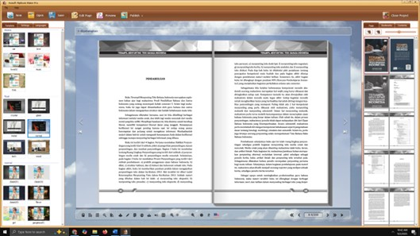Figure 3. Introduction Page
3. Content
The content section contains the main chapters as outlined in the lesson plan (RPS), supplemented by text, illustrations, animations, and relevant external links. The integration of multimedia in this section aims to strengthen conceptual understanding while increasing student engagement (See Figure 4).
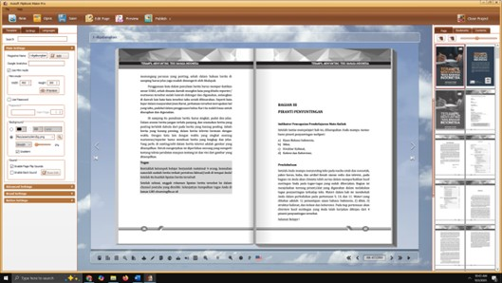Figure 4. Contents
4. Practice and Evaluation
Each chapter includes practice questions, including multiple-choice questions, essay questions, and project assignments. Interactive evaluation is provided through a digital quiz feature so students can independently assess their learning outcomes (See Figure 5).
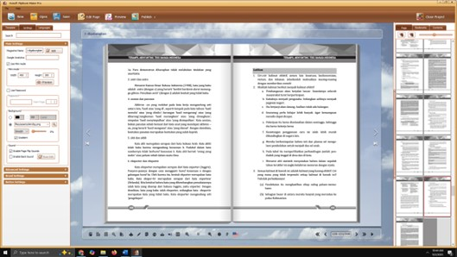
Figure 5. Practice and Evaluation
5. Bibliography and Appendices
The final section contains a bibliography used as references in compiling the teaching materials, as well as appendices in the form of articles, journal links, and other supporting materials that students can access to expand their knowledge (See Figure 6).
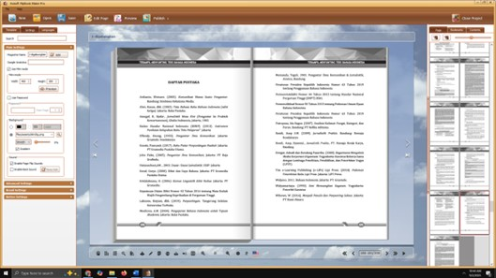
Figure 6. Bibliography and Appendices

3. Feasibility Testing of Teaching Materials
The feasibility testing process for teaching materials was conducted to ensure that the developed product met academic standards and was suitable for use in Editing Skills courses for students in the Indonesian Language and Literature Education Study Program. Validation was conducted by two experts, each with expertise in learning materials and media. Assessments were based on an instrument designed using a Likert scale (1–4), covering aspects of material relevance, language clarity, media presentation, and design interactivity. The scores obtained were then processed to determine the feasibility level of the teaching materials, with categories ranging from "not feasible" to "very feasible." The results of the feasibility test for the editing skills teaching materials using 3D Pageflip are presented in the following table.

Table 3. Results of the Feasibility Test of Teaching Materials for Editing Skills Assisted by 3D Pageflip Media
No | Aspects | Assessment Indicators (Summary) | V1 | V2 | Total Value (%) | Criteria
1 | Material | The material's suitability to the CPMK; the source and accuracy of the material; project-based; presentation techniques; support, coherence, and contextuality of the material. | 3–4 | 3–4 | 86,10 | Very Eligible
2 | Language | Sentence structure and effectiveness; standardization of terms; spelling accuracy; comprehension of information; motivation; suitability to students' intellectual development. | 3–4 | 3–4 | 87,49 | Very Eligible
3 | Media | Cover design; completeness of the introduction, content, and conclusion; readability of the writing; the function of images, audio, video, and links; and practicality. | 3–4 | 3–4 | 84,72 | Very Eligible
 | Average |  |  |  | 86,10 | Very Worthy

The validation results show that the material aspect obtained a total score of 86.10% with a very appropriate category, which means that the substance of the content is in accordance with the learning outcomes, although there is still room for improvement in the coherence and contextuality indicators. The language aspect received a higher score (87.49%), indicating that the sentence structure, standardization of terms, and clarity of information were assessed as good by the validator, although there were notes on spelling and motivation.

The media aspect obtained a score of 84.72% with a very appropriate category, mainly because the design, readability, and function of the supporting media were considered quite good, although some visual and audio elements still need to be improved. Overall, the average percentage of 86.10% confirms that the teaching materials for editing skills assisted by 3D Pageflip media are in the very appropriate category for use in learning.
4. Teaching Material Effectiveness Test
The teaching material effectiveness test was conducted using an instrument in the form of a student perception sheet regarding the use of 3D Pageflip media-assisted editing skills teaching materials. This instrument was distributed to 90 students taking the Editing Skills course as research respondents. Assessments were conducted on several indicators covering aspects of usefulness, interestingness, ease of use, and contribution to student learning independence.
The scale used was a Likert scale of 1–4, with categories ranging from disagree to strongly agree. The questionnaire data were then processed to obtain an average score for each indicator, which was then interpreted into effectiveness categories. The results of the student perception assessment of the teaching materials are presented in the following table.

Table 4. Results of Student Perceptions of the Effectiveness of 3D Pageflip-Assisted Editing Skills Teaching Materials
No | Assessment Aspects | Indicators (Summary) | Value (%) | Category*
1 | Media Interest | Increases variety of learning resources; facilitates independent learning; accelerates understanding; is engaging to use | 87,70 | Very Good
2 | Media Function | Time efficiency; ease of access; portability; increases self-confidence; facilitates interaction | 86,65 | Very Good
3 | Media Presentation | Material readability; engaging illustrations; video/link access; color and typography combinations | 90,20 | Very Good
4 | Media Influence | Activates curiosity; motivates competence; broadens insight; improves editing skills | 90,52 | Very Good
 | Average |  | 88,77 | Very Good

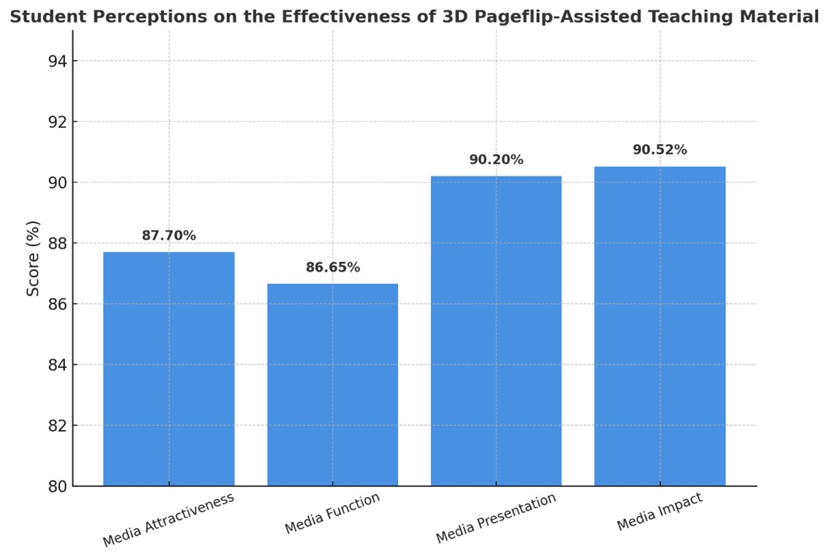
Figure 7. Student Perceptions on the Effectiveness of 3D Pageflip-Assisted Teaching Material
The effectiveness test results show that students' perceptions of the 3D Pageflip-assisted editing skills teaching materials are in the very good category with an average score of 88.77%. The aspect with the highest score is media influence (90.52%), which confirms that this teaching material is able to increase students' curiosity, motivation, insight, and editing skills. The media presentation aspect also received a high score (90.20%), indicating that the combination of text, illustrations, colors, and the integration of videos and learning links were considered very interesting and easy to understand. Meanwhile, the media interest aspect (87.70%) and media function (86.65%) indicate that this teaching material is considered to facilitate students' independent learning, is efficient, easily accessible, and supports learning interactions. Overall, these findings confirm that 3D Pageflip-based digital teaching materials are not only effective in supporting learning outcomes but also contribute to increasing students' learning independence.

4. CONCLUSION

This research resulted in the development of digital teaching materials for the Editing Skills course using 3D Pageflip Professional media, referring to the 4D model (Define, Design, Develop, Disseminate). The needs analysis identified that students are highly motivated to use digital teaching materials, supported by the availability of technological devices, and have a preference for contextual, interactive teaching material designs. This condition emphasizes the need for digital media-based innovation to enrich learning resources while fostering student independence. The instructional design of this teaching material integrates the principles of needs analysis, competency-based content development, and active learning strategies.

The Define stage ensures that the material content is in line with the learning outcomes of the course; the Design stage emphasizes the design of digital teaching materials with interactive multimedia-based formats (text, images, audio, video, and learning links); the Develop stage produces a prototype validated by material, language, and media experts; while the Disseminate stage ensures that the product can be widely used through digital distribution.

This design is combined with meeting-based learning activities, which connect theory with practice, ranging from resume writing, news analysis, academic manuscript editing, radio drama production, to mini-field research. This approach demonstrates continuity between conceptual mastery and practical skills, while fostering project-based and collaborative learning experiences. The results of the feasibility test showed an average score of 86.10% with a very appropriate category, which indicates that the content, language, and media have met academic standards. The effectiveness test through the perception of 90 students gave an average score of 88.77% (very good). The aspects with the highest scores were media influence (90.52%) and media presentation (90.20%), which indicates that multimedia integration not only enriches the appearance of teaching materials, but also increases students' motivation, curiosity, and editing skills. Analytically, the conclusion of this study confirms that the teaching materials for editing skills assisted by 3D Pageflip media have a high level of validity, practicality, and effectiveness. Validity is indicated by the suitability of the content to the learning outcomes; practicality is reflected in ease of use and accessibility; Meanwhile, effectiveness is proven through increased student independence, motivation, and learning outcomes. With a proven 4D-model-based instructional design, this teaching material not only contributes to digital learning innovation in higher education but can also serve as a reference for developing interactive learning instruments in other courses, in line with the demands of 21st-century education.

REFERENCES

Abidah, L., Askangela, M. L., Berlianty, D., Herliana, N. A., Qomariah, N. N., Teladan, R. P., & Sabilah, F. (2023). A study on the needs to design English teaching materials at vocational schools. Journal of English Language Teaching Innovations and Materials (Jeltim), 5(1). https://doi.org/10.26418/jeltim.v5i1.58372
Akhsan, H., Rianti, S., Muslim, M., & Ariska, M. (2020). Development of digital handouts on general relativity and special relativity using the 3D Pageflip application. Journal of Physics and Its Learning (JIFP), 4(2), 43–51.
Andayani, M. (2020). Basic Physics I e-module based on 3D Pageflip Professional. Schrödinger: Journal of Physics Education, 1(2), 44–47.
Arikunto, S. (2010). Research Procedures: A Practical Approach. Jakarta: Rineka Cipta.
Demin, T. B. A., & Mohamad, M. M. (2023). Heutagogy Conceptual Approach in Vocational Learning. Online Journal for TVET Practitioners, 8(2), 60–68.
Demir, B., & Sonmez, G. (2021). Generation Z Students' Expectations from English Language Instruction. Journal of Language and Linguistic Studies, 17(S1), 683–701.
Ettyani, E., Fadilah, E., & Sabat, Y. (2023). Heutagogy as a Training Approach for Teachers in the Era of Society 5.0. Magister Scientiae, 51(2), 133–143.
Fonna, N. (2019). Development of the Industrial Revolution 4.0 in Various Fields. Bogor: Guepedia.
Handayani, I. S., & Lestariningsih, N. (2020). The validity of integrated Islamic ethnobotany textbooks based on the 3D PageFlip application. Biosfer: Jurnal Tadris Biologi, 11(2), 129–138.
Harefa, T., & Laoli, T. M. (2022). E-module development using professional 3D PageFlip on negotiation materials. Edumaspul: Jurnal Pendidikan, 6(2), 2108–2114.
Izar, S. L. (2023). The development of teaching materials in the 3D PageFlip-based Indonesian Literature History course for students of the Indonesian Education Study Program. Edumaspul: Jurnal Pendidikan, 7(2), 2941–2946.
Jhoni, M., Afrizah, T., & Rahma, N. (2023). Development of flipbook physics learning media using 3D Pageflip Professional for momentum and impulse. ORBITA: Jurnal Kajian, Inovasi dan Aplikasi Pendidikan Fisika, 9(1), 141–146.
Kaso, N., & Rahmadani, E. (2023). Character education e-module with local wisdom, supported by the Sigil application, as an innovation in strengthening student character. Jurnal Sinestesia, 13(2), 1001–1012.
Lestari, R., & Fitria, Y. (2023). Development of RADEC-based e-books supported by 3D Pageflip Professional in fifth grade elementary school. Journal of Education Research, 4(3), 1339–1344.
Martin, F., Chen, Y., Oyarzun, B., & Lee, M. (2022). Learning and development roles and competency domains in higher education: A content analysis of job announcements. Journal of Computing in Higher Education, 34(2). https://doi.org/10.1007/s12528-021-09290-2
Muhid, A. (2021). Heutagogy: Freeing students to learn in the era of the digital revolution. Malang: Media Intelligence.
Oktarina, R., Ambiyar, A., Giatman, M., Fadhilah, F., Muskhir, M., & Effendi, H. (2021). The effect of the use of multimedia flip books with the flipped classroom approach in vocational school. Journal of Educational Technology, 5(1), 159–166.
Pamungkas, I. N. A. (2021). Communication between lecturers and digital-native students in higher education. Avant Garde, 9(01), 79–99.
Rino, R., Astuti, R., & Muchtadi, M. (2022). Development of an e-flip PDF e-book with guided independent learning based on problem posing using the creative idea of ​​SCAMPER. Journal of Research in Mathematics and Natural Sciences Cluster (JURRIMIPA), 1(2), 119–132.
Sari, Y. I. H., Wienanda, W. K., & Nugraheni, N. E. (2020). Needs analysis to develop teaching materials at Vocational College UGM. Journal of Vocational Education, 10(2). https://doi.org/10.21831/jpv.v10i2.27934
Stone, B., Kay, D., Reynolds, A., & Brown, D. (2020). 3D printing and service learning: Accessible open educational resources for students with visual impairments. International Journal of Teaching and Learning in Higher Education, 32(2).
Sugiyono. (2017). Quantitative, qualitative, and R&D research methods. Bandung: Alfabeta.
Suroto, S., Rahmawati, R., & Hestiningtyas, W. (2019). Students' learning media needs: An analysis of economics education students. Economic Education and Entrepreneurship Journal, 2(2), 74–83.
Susanti, D., & Prasetyo, Z. K. (2020, January). The effects of an online-based 3D Page Flip science module on elementary school students' learning motivation in Indonesia. In Proceedings of the 2020 11th International Conference on E-Education, E-Business, E-Management, and E-Learning (pp. 141–144).
Sutiyo, S., Nugraha, M. P. Y., Anes, A. M., & Ramdhani, S. (2022). Analysis of cadet needs for the development of digital teaching materials for aircraft familiarization courses based on the learning management system platform of the Palembang Aviation Polytechnic. Airman: Journal of Transportation Engineering and Safety, 5(2), 40–45.
Takdir, M., Ferdiansyah, H., & Zulkfil i, N. (2023). The effect of using Pageflip Professional 3D interactive media on the learning outcomes of crafts and entrepreneurship of Grade X students SMA Muhammadiyah Pangsid School. Innovative: Journal of Social Science Research, 3(4), 5028–5037.
Thiagarajan, S., Semmel, D., & Semmel, M. (1974). Instructional development for training teachers of exceptional children: A source book. Indiana: ERIC.
Thoifah, I. (2015). Statistika pendidikan dan metode penelitian kuantitatif. Malang: Madani.
Yelianti, U., Anggereini, E., & Irfan, M. K. (2020, February). Developing electronic learning media using 3D Pageflip on the material of classification of living things for the 7th grade students of junior high school. In Journal of Physics: Conference Series (Vol. 1464, No. 1, p. 012039). IOP Publishing.
Yelianti, U., Muswita, M., & Sanjaya, M. E. (2018). Development of electronic learning media based 3D Pageflip on subject matter of photosynthesis in plant physiology course. Biodik, 4(2), 121–134.
Yuhdi, A., Lubis, F., & Rosmaini, R. (2024). Development of research-based teaching materials to increase independent learning for students majoring in Indonesian language and literature. Journal of Education, Teaching and Learning, 9(1), 133-143.
Yuhdi, A., Transliova, L. ., Barus, F. L., Wasilah, A., & Harahap, S. H. (2025). Minang oral discourse in minority ethnic communities in developing Lake Toba tourism area, Indonesia: A sociopragmatic perspective. Research Journal in Advanced Humanities, 6(1). https://doi.org/10.58256/w1mp6777

