Original Research Article

Impact of salt stress on seed germination and seedling growth of Cicer arietinum L.

Abstract
Salt stress is one of the most significant abiotic stresses affecting crop productivity globally, particularly in arid and semi-arid regions where soil salinization is rapidly increasing due to poor irrigation practices and climatic factors. The present study investigates the influence of salt stress on seed germination and seedling growth of Cicer arietinum L. (Chickpea), an important legume crop moderately sensitive to salinity during early developmental stages. Two salts, sodium chloride (NaCl) and potassium chloride (KCl) were used to maintain salinity conditions at four different concentrations: 0% (control), 0.5%, 1%, and 2%.
Seeds were surface-sterilized with 70% ethanol and sown in Petri dishes lined with cotton. Each dish was provided with 2 ml of the respective salt solution every two days and was observed for seven consecutive days under controlled laboratory conditions. The experiment focused on key physiological parameters such as germination percentage (GP), mean germination time (MGT), and seed vigor indices (SVI-1 and SVI-2), which integrate both seedling length and dry biomass to assess overall seedling health and stress tolerance.
Results revealed that both NaCl and KCl significantly inhibited seed germination and seedling growth at concentrations of 1% and 2%, with complete suppression of germination observed at these levels. In contrast, at 0.5% concentration, seeds exhibited delayed and reduced germination, shorter root and shoot lengths, and decreased seedling vigor compared to the control group. Notably, KCl-treated seeds displayed slightly higher germination percentages and vigor indices than those exposed to NaCl, suggesting that potassium ions are less toxic to seedling development than sodium ions under similar osmotic conditions.
This study confirms that elevated salt concentrations adversely affect the early growth stages of Cicer arietinum, with NaCl exerting a more detrimental effect than KCl. The findings highlight the need for developing salt-tolerant chickpea varieties and adopting sustainable soil and water management practices in saline-prone agricultural regions. The methodology and quantitative indicators used in this research also provide a reliable screening approach for assessing salt tolerance in other leguminous crops.
Keywords: Salt stress, Seed germination, Cicer arietinum, NaCl, KCl, Seedling growth, Germination percentage

- INTRODUCTION
Seed germination is a vital developmental stage in the life cycle of higher plants. It signifies the transition from a quiescent seed to an actively growing seedling. This phase begins with water adsorption (imbibition) and ends with the emergence of the radicle, which marks the completion of germination and the onset of seedling development (Bewley, 1997; Nonogaki et al., 2010). The success of this early stage is crucial for plant establishment, especially under stressful environmental conditions.
Environmental factors influencing seed germination include both biotic (e.g., microbial interactions) and abiotic (e.g., temperature, moisture, light, and salinity) stresses. Among these, salinity is particularly significant in arid and semi-arid environment, where it poses a major limitation to crop productivity and natural vegetation growth (Buchanan et al., 2005; Munns & Tester, 2008). The severity of salt stress is due to both osmotic effects, which limit water availability, and ionic toxicity caused by excessive sodium (Na⁺) and chloride (Cl⁻) ions (Zhu, 2001; Cherifi et al., 2016).
Salinity adversely affects multiple physiological processes, including seed germination and seedling development. These effects include reduced water uptake, disruption of metabolic activities, and damage to cellular structures, ultimately resulting in delayed germination, lower germination percentage, and reduced seedling vigor (Huang et al., 2021; Hasanuzzaman et al., 2013). Salt stress also leads to the production of reactive oxygen species (ROS), which cause oxidative damage to proteins, lipids, and nucleic acids unless neutralized by antioxidant defence systems (Apel & Hirt, 2004).
Chickpea (Cicer arietinum L.) is one of the most important pulse crops grown in tropical and subtropical regions. Despite being moderately salt-tolerant, chickpea is particularly sensitive during its early growth stages. High salinity has been reported to significantly reduce germination percentage, delay germination time, and impair both root and shoot elongation in chickpea seedlings (Flowers et al., 2010; Turner et al., 2013). Physiological mechanisms such as osmotic adjustment, ion exclusion, and activation of antioxidant enzymes are involved in chickpea’s response to salt stress (Ashraf & Foolad, 2007). Furthermore, the use of plant growth-promoting rhizobacteria (PGPR) has been shown to enhance salt tolerance in chickpea by improving nutrient uptake and stimulating hormonal responses (Egamberdieva et al., 2019).
Globally, over 900 million hectares of land are affected by salinity, accounting for approximately 20% of the total cultivable land (FAO, 2007). In this context, the ability of seeds to germinate under saline conditions is critical for agricultural sustainability, especially in regions prone to salinization. Studies show that seeds germinating rapidly under both normal and salt-stressed conditions are more likely to establish robust seedlings and yield better crops (Munns, 2002; Cuartero et al., 2006).
This study seeks to investigate the effects of salt stress on seed germination and early seedling growth of chickpea using two common salts, NaCl and KCl, at varying concentrations. Through controlled laboratory experiments and assessment of physiological parameters such as germination percentage (GP), mean germination time (MGT), and seed vigor indices (SVI-1 and SVI-2). This study aims to evaluate the effect of different salt concentrations on seed germination and growth performance of chickpea.
- Materials and Methods
2.1 Study Area and Climatic Conditions
The experimental work was conducted in the Botany Laboratory of Anchal College, Padampur, Odisha, situated at 20.98°N latitude and 80.04°E longitude. The region lies in the tropical zone, with an average annual rainfall of approximately 1527 mm, relative humidity of 62%, and an average temperature of 27°C (80.6°F). These agro-climatic conditions provide a suitable environment for assessing the effect of abiotic stress, particularly salinity, on early plant development.
2.2 Seed Selection and Sterilization
Healthy, uniform-sized seeds of Cicer arietinum L. (chickpea) were procured from a certified agricultural supplier. To eliminate surface-borne pathogens and ensure aseptic conditions, the seeds were surface-sterilized by immersion in 70% ethanol for 1–2 minutes, followed by thorough rinsing with sterile distilled water (ISTA, 2021; Nonogaki et al., 2010). This standard sterilization protocol prevents microbial contamination during germination tests.

2.3 Preparation of Salt Solutions
Two types of salt were used as abiotic stress agents:
Sodium chloride (NaCl)
Potassium chloride (KCl)
For each salt, four concentrations were prepared in distilled water: 0% (control), 0.5%, 1%, and 2% (w/v). These concentrations were selected based on prior literature indicating mild to severe salinity stress levels that affect seed physiology (Munns & Tester, 2008; Flowers et al., 2010).
2.4 Experimental Design for Germination Assay
The experiment followed a completely randomized design (CRD) with five seeds per replicate, and at least three replicates per treatment. Sterile Petri dishes (9 cm diameter) were lined with double layers of cotton and moistened initially with 5–10 ml of the respective salt solution. Seeds were evenly placed on the cotton and incubated in a controlled environment chamber set at optimal temperature and light conditions for chickpea germination (approximately 25–27°C and 12 h light/12 h dark photoperiod). Salt treatments were reapplied every two days using 2 ml of freshly prepared solution to maintain consistent salinity (ISTA, 2021).

2.5 Germination Monitoring and Growth Measurement
Germination was recorded daily for 7 days. A seed was considered germinated when the radicle protruded at least 2 mm. The following germination and growth parameters were evaluated:
Germination Percentage (GP):
GP = (Number of seeds germinated / Total number of seeds) × 100
This standard index reflects seed viability under stress (ISTA, 2021).
Mean Germination Time (MGT):
MGT = ∑ (n × d) / N
Where n = number of seeds germinated on day d, and N = total number of seeds germinated. MGT indicates the speed and uniformity of germination (Bewley, 1997).

2.6 Seedling Growth Parameters:
On the 7th day, germinated seedlings were carefully removed and measured for: Root length (radicle), Shoot length (plumule), Total seedling length (root + shoot), Dry biomass (after oven-drying at 60°C for 24 hours), Seed Vigor Index – I (SVI-1) and Seed Vigor Index – II (SVI-2).
Seed Vigor Index – I (SVI-1)
SVI-1 = Germination Percentage × Average Seedling Length (cm)
This index indicates early vigor under stress conditions (Abdul-Baki & Anderson, 1973).
Seed Vigor Index – II (SVI-2):
SVI-2 = Germination Percentage × Average Seedling Dry Weight (mg)
This parameter assesses seedling robustness based on biomass accumulation.

- Results
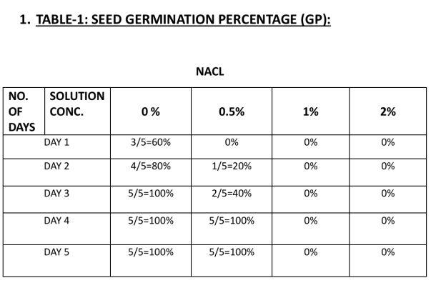
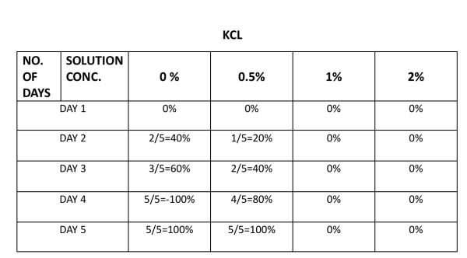
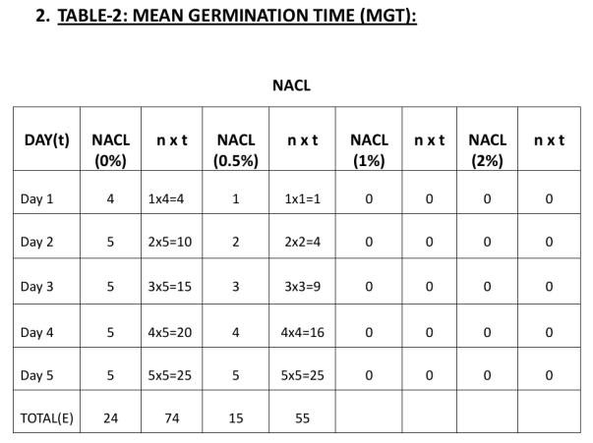
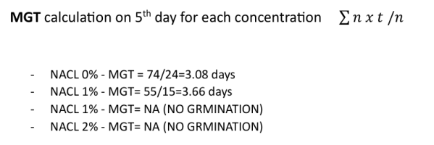
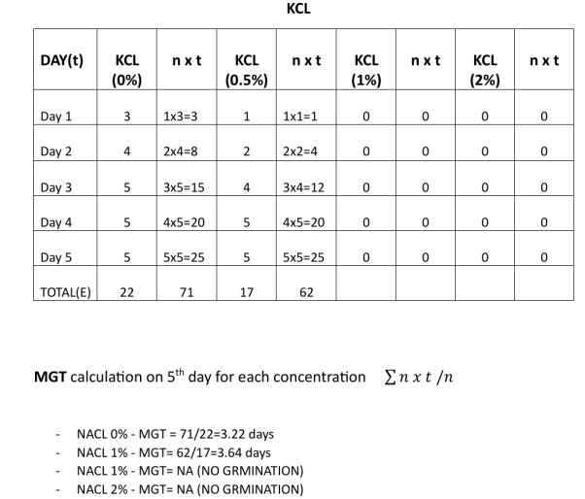
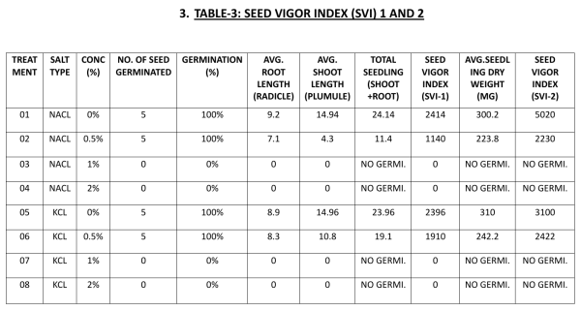
- Discussion
The experimental results demonstrate the significant impact of salt stress on seed germination and seedling growth in Cicer arietinum (chickpea). The data, presented across three tabulations, reveal clear trends corresponding to different concentrations of NaCl and KCl.
Germination Percentage (Table-1):
In both NaCl and KCl treatments, control conditions (0% salt) supported optimal germination. Seeds exposed to 0% NaCl exhibited progressive germination from Day 1, reaching 100% by Day 3. A similar
pattern was observed in 0% KCl, though germination initiated slightly later, achieving full germination by Day 4. At 0.5% concentration, germination was delayed in both salt treatments. For NaCl, germination was only 40% by Day 3 and reached 100% by Day 4. For KCl, germination followed a slower progression but reached 100% by Day 5. No germination was recorded at 1% and 2% concentrations of either salt, indicating that elevated salinity exerts a strongly inhibitory effect on seed emergence.
These results indicate that while low levels of salt stress may delay germination, higher concentrations completely inhibit it. Seeds treated with KCl at 0.5% performed slightly better than those treated with NaCl, suggesting that potassium ions may exert less toxicity than sodium ions at similar concentrations.
This finding aligns with prior research indicating that sodium ions are more disruptive to cellular ion homeostasis and water uptake during early germination (Munns & Tester, 2008; van Zelm et al., 2023; Wang et al., 2008).
Mean Germination Time (Table-2):
MGT values further confirmed the inhibitory effect of salt stress. Under control conditions, seeds treated with NaCl and KCl germinated efficiently, with MGT values of 3.08 and 3.22 days, respectively. However, at 0.5% salt concentration, MGT increased to 3.66 days for NaCl and 3.64 days for KCl, indicating delayed germination under stress. No germination was observed at 1% and 2% concentrations, resulting in no calculable MGT. The rise in MGT at 0.5% confirms that even moderate
salt stress can delay the physiological processes involved in germination, such as water imbibition, enzyme activation, and radicle emergence.

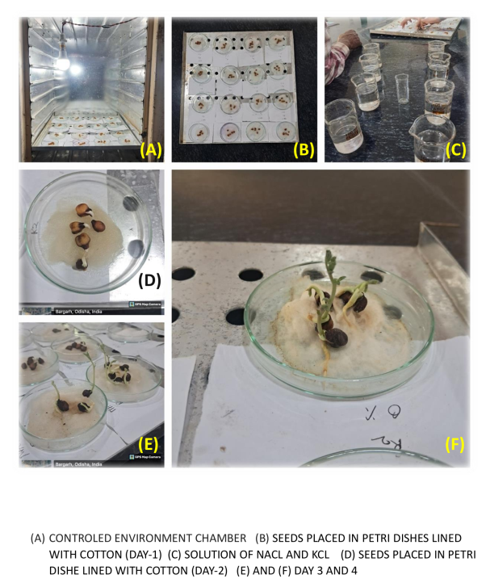
Fig-1: Germination of seeds under different conditions
Seed Vigor Index (Table-3):
Seed vigor indices (SVI-1 and SVI-2) provided further insights into the quality and strength of emerging seedlings. Under non-stressed conditions (0% salt), both salts supported healthy seedling development with high root and shoot lengths. The total seedling length and dry biomass were comparable between NaCl and KCl, leading to high SVI values in both treatments.
However, at 0.5% concentration, although the germination percentage remained 100%, a notable decline in root and shoot lengths, as well as dry weight, was recorded. This reduction translated to lower SVI-1 and SVI-2 values, indicating that even low salt stress compromises seedling vigor. Once again, seedlings under KCl stress showed slightly better vigor than those under NaCl at 0.5%, supporting the observation that potassium chloride may be less harmful during early growth stages. At 1% and 2% concentrations, no germination occurred, resulting in SVI values of zero. These findings confirm that Cicer arietinum is highly sensitive to salt stress during the germination phase, with a clear threshold beyond which both germination and seedling development are entirely inhibited.
Figure 3 shows that seeds under control conditions (NaCl 0%, KCl 0%) reached maximum germination more quickly than those under saline treatments. Both NaCl 0.5% and KCl 0.5% delayed germination onset, with NaCl-treated seeds recovering faster than KCl-treated ones, though all treatments achieved 100 % germination by the final day.

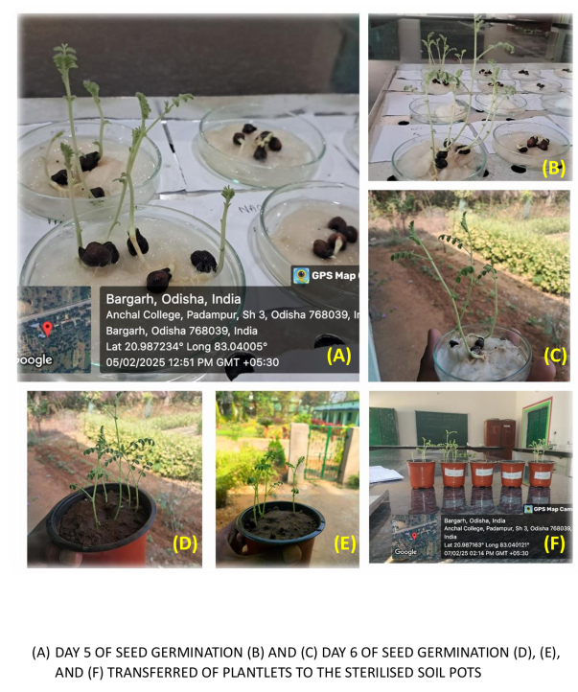
Fig-2: Seeds under different germination stages
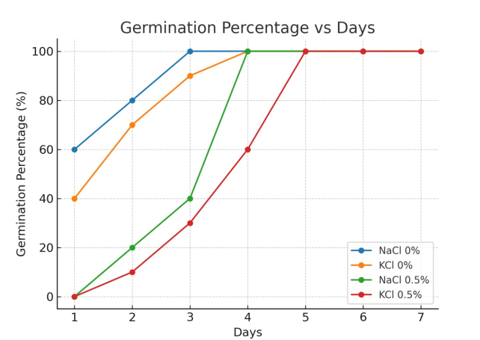
Fig-3 Germination percentage vs Days

- Conclusion
This study conclusively demonstrates that salt stress, induced by both sodium chloride (NaCl) and potassium chloride (KCl), significantly affects the seed germination and early seedling development of Cicer arietinum (chickpea). The results show that while seeds can tolerate and germinate under mild saline conditions (0.5% concentration), higher levels of salinity (1% and 2%) completely inhibit germination and seedling growth.
The germination percentage (GP) and mean germination time (MGT) were both sensitive indicators of salt-induced stress. Although seeds exposed to 0.5% salt solutions managed to germinate completely, their rate of germination was delayed, and seed vigor indices (SVI-1 and SVI-2) revealed reduced seedling quality compared to the control group. The absence of germination at 1% and 2% concentrations clearly illustrates the toxicity threshold beyond which Cicer arietinum cannot initiate successful germination.
Between the two salts tested, KCl showed slightly lesser inhibitory effects on both germination and seedling vigor at low concentrations compared to NaCl. This suggests that potassium ions may be relatively less harmful than sodium ions in the early growth phase, possibly due to their roles in osmotic regulation and enzyme activation in plant cells.
These findings are significant for agricultural practices in saline-prone areas. The early growth stage of chickpea is highly vulnerable to salinity, and exposure to even moderate salt stress can result in delayed and weaker seedlings. Consequently, improving soil and water management to limit salt accumulation is essential for successful chickpea cultivation in marginal lands.
Additionally, the standardized methodology and physiological markers used in this study—such as GP, MGT, SVI-1, and SVI-2—can serve as reliable screening tools for identifying salt-tolerant genotypes of chickpea and potentially other leguminous crops. Future research should focus on breeding salt-tolerant varieties and exploring synergistic effects of bio-inoculants and osmoprotectants to mitigate salt stress.
We reached the conclusion that salt stress poses a serious threat to chickpea establishment during the germination phase, and proactive agronomic strategies are needed to sustain crop productivity in saline environments.
DISCLAIMER (ARTIFICIAL INTELLIGENCE)Author(s) hereby declare that NO generative AI technologies such as Large Language Models (ChatGPT, COPILOT, etc.) and text-to-image generators have been used during the writing or editing of this manuscript.
COMPETING INTERESTS Authors have declared that no competing interests exist

References

Abdul-Baki, A. A., & Anderson, J. D. (1973). Vigor determination in soybean seed by multiple criteria. Crop Science, 13(6), 630–633.
Apel, K., & Hirt, H. (2004). Reactive oxygen species: Metabolism, oxidative stress, and signal transduction. Annual Review of Plant Biology, 55, 373–399.
Ashraf, M., & Foolad, M. R. (2007). Roles of glycine betaine and proline in improving plant abiotic stress resistance. Environmental and Experimental Botany, 59(2), 206–216.
Bewley, J. D. (1997). Seed germination and dormancy. The Plant Cell, 9(7), 1055–1066.
Buchanan, B., Gruissem, W., & Jones, R. (Eds.). (2005). Biochemistry and Molecular Biology of Plants. American Society of Plant Biology.
Cherifi, K., Boufous, E. H., Boubaker, H., & Msanda, F. (2016). Comparative salt tolerance study of some Acacia species at seed germination stage. Asian Journal of Plant Sciences, 15(3–4), 66–74.
Cuartero, J., Bolarin, M. C., Asins, M. J., & Moreno, V. (2006). Increasing salt tolerance in tomato. Journal of Experimental Botany, 57(5), 1045–1058.
Egamberdieva, D., Wirth, S., Dorothea, S., Mishra, J., & Arora, N. K. (2019). Salt-Tolerant Plant Growth Promoting Rhizobacteria for Enhancing Crop Productivity of Saline Soils. Frontiers in Microbiology, 10, 469278. https://doi.org/10.3389/fmicb.2019.02791fao
FAO. (2007). Land and Plant Nutrition Management Service. Food and Agriculture Organization of the United Nations.
Flowers, T. J., Gaur, P. M., Gowda, C. L., Krishnamurthy, L., Samineni, S., Siddique, K. H., ... & Colmer, T. D. (2010). Salt sensitivity in chickpea. Plant, Cell & Environment, 33(4), 490–509.
Hasanuzzaman, M., Hossain, M. A., & Fujita, M. (2013). Plant responses and tolerance to abiotic oxidative stress: Antioxidant defense is a key factor. In V. Ahmad et al. (Eds.), Oxidative Damage to Plants (pp. 261–315). Springer.
Huang, Y., Zhou, J., Li, Y., Quan, R., Wang, J., Huang, R., & Qin, H. (2021). Salt Stress Promotes Abscisic Acid Accumulation to Affect Cell Proliferation and Expansion of Primary Roots in Rice. International Journal of Molecular Sciences, 22(19), 10892. https://doi.org/10.3390/ijms221910892
ISTA (International Seed Testing Association). (2021). International Rules for Seed Testing. Zurich, Switzerland.
Munns, R. (2002). Comparative physiology of salt and water stress. Plant, Cell & Environment, 25, 239–250.
Munns, R., & Tester, M. (2008). Mechanisms of salinity tolerance. Annual Review of Plant Biology, 59, 651–681.
Nonogaki, H., Bassel, G. W., & Bewley, J. D. (2010). Germination—Still a mystery. Plant Science, 179(6), 574–581.
Van Zelm, E., Bugallo-Alfageme, S., Behrouzi, P., Meyer, A. J., Testerink, C., & Gommers, C. M. M. (2023). Natural variation in salt-induced root growth phases and their contribution to root architecture plasticity. Plant, cell & environment, 46(7), 2174–2186. https://doi.org/10.1111/pce.14583
Wang, Y., Zhang, W., Li, K., et al. (2008). Salt-induced plasticity of root hair development is caused by ion disequilibrium in Arabidopsis thaliana. Journal of Plant Research, 121, 87–96.
Zhu, J. K. (2001). Plant salt tolerance. Trends in Plant Science, 6(2), 66–71.

