ANALYSIS OF SENSORY AND NUTRITIONAL PARAMETERS OF VEGAN ICE CREAM MADE FROM COTTON SEED MILK AND COCONUT MILK

ABSTRACT:
Worldwide intake of vegan merchandise has extensively accelerated within the ultimate decade, as purchasers turn out to be greater privy to the health, environmental and moral outcomes of eating animal products.Ice cream is a frozen sweetened product made out of warmth dealt with blend including fit to be eaten fats and milk solids without or with other components and approved additives.Ice cream became and is the maximum famous dessert of all times.In this study,cottonseed milk was used as the main substrate, and coconut milk was used as the vegan version of whipped cream.The ice creamwas prepared with the help of an instant ice cream machine, which was set to run for 30 minutes.The objectives of this study was to develop cottonseed milk ice cream with 2 flavors (vanilla and ginger), to determine the overall acceptance of vanilla-flavored and ginger-flavored ice cream (sensory evaluation), to determine the overall acceptance of the treated ice cream, and to find out the proximate composition of the vegan ice cream by FSSAI and AOAC methods. The vegetable milks might also provide ice cream producers an opportunity supply of cow milk as a purposeful ice cream.It also gave a lead towards developing a non-dairy/ vegan delicacy on nutrient-rich cotton seed.

KEYWORDS:
Cottonseed milk, Coconut milk, Whipped cream, HPLC

- INTRODUCTION:
Ice cream is a scrumptious and nutritious frozen dairy dessert with excessive calorie meals value.Ice cream is a frozen dairy product made by freezing a combination with agitation to incorporate air and ensureuniform of consistency.By definition “ice cream is a liquid aggregate that becomes a paste after concurrently shaking and cooling”, even though the definition of ice cream varies from u .s . to u .s .due to differing regulations and traditions of composition.The estimated size of the worldwide ice cream market is around 15 billion litres.The ice-cream enterprise in India is really well worth Rs. 2000 core. This industry can be divided into branded market & the unbranded market. The branded marketplace at gift is one hundred Million litres in line with annum worth Rs. 800 core. The marketplace is sent inconsistently throughout the globe due to the fact the intake sample varies notably among international locations and regions.The highest consumption is found in the USA at around 26 litres per capita and year, for instance, while in Europe this rate is around 10 litres [22].In the ice cream blend that turns into ice cream are such a lot of factors of various nature as sugars, fats, dairy, stabilizers, water, amongst others.And all of them should be efficiently combined and emulsified collectively so there's not anything left at the back of which could lessen the best of the very last product.
Making this possible, considering the characteristics and behaviours of each ingredient and the relationships between them, is what is known as the balancing exercise.We can make it stable and spreadable at negative temperatures from - 11 to -18℃ (standard ice cream serving temperatures) [14].According to different authors a popular ice cream is set 5% fats and 15% sugar answer via way of means of volume.The composition for a standard ice cream is; Fat 7–15%, and sugars 12– 16% [5].Also the variety in composition can be fat, 8 – 20%, sugar, 13 – 20% stabilizer emulsifier, 0 – 0.7%; and general solids, 36 – 43% and anaverage ice cream contains 3–4 times more fat and about 12–16% more protein than milk does [9].This excessive fats comes from the addition of oil (emulsifiers) and the fats already found in milk used for ice production.It was diagnosed with the aid of using a few studies that the LDL cholesterol content of ice cream is ready 45mg/100.It may be expected that from one portions of ice cream an excessive quantity of LDL cholesterol is consumed.It is obvious that consumption of foods consist of low cholesterol level has no effects on individual health but in products like ice cream it seems a very hugeamount that may leads to different diseases such as cardiovascular disease and hypertension [15].
Ice cream is an important supplement to the normal diet, especially for children and other age groups.But it's miles dealt with as a junk meals and deleterious for coronary heart sufferers because of excessive calories and cholesterol.Ice cream could be made more nutritious and health beneficial by adding fruits and other protein-rich ingredients [19].“Veganism is a manner of residing which seeks to exclude, as a long way as is feasible and practicable, all sorts of exploitation of, and cruelty to, animals for food, apparel or any other purpose”. Based on this definition, it is possible to state that veganism is much more 3 than following a plant-based diet, but a lifestyle that aims to reduce animal sufferingand environmental damage.Worldwide consumption of vegan products has substantially increased in the last decade, as consumers become more aware of the health, environmental and ethical consequences of consuming animal products.Vegan eating regimen is described as warding off the intake and/or use of meat, fish, hen or any animal-derived product.Vegans commonly have a decrease serum cholesterol, frame mass index, blood pressure, and threat of coronary heart ailment than meat eaters.It is important to use fat substitutions such as dairy and/or egg replacements with vegan recipes [8].Observation of popular trends in the food industry has revealed a surge of consumer interest in many naturalistic diets. In the look for a sustainable manner to higher their ingesting habits, clients flip to those diets, greater an increasing number of the vegan diet.Many associate this animal-product free diet with overall health benefits and weight loss.This is because the vegan diet is limited to plant based foods, and thus it increases the quantity of fruits, vegetables, whole grains, legumes, nuts, and seeds consumed, leading tostrongly appealing health benefits. Faced with the increasing demand for vegan products, many companies started creating alternatives for those who adopted this lifestyle, satisfying at the same time those who for health reasons are not able to consume animal-based products or the ones who believe “vegan” is a synonym of “healthy”.
One of the categories in which the vegan offer has grown is the ice-cream category. There are various new brands emerging worldwide in this specific market under the signal of veganism [8]. Although ice cream from cow’s milk is an important source of nutrients, many people suffer from cow’s milk allergy and lactose intolerance. Additionally, the clients pick plant’s products, as opposed to milk ones due to different elements consisting of the presence of cholesterol, fitness and surroundings consideration. The solution to this problematic issue can be the consumption of plant based milk instead of cow’s milk. In vegan ice cream, a product mainly composed of: cream, milk solids, sugar, and water, vegetable fat substitutions are often utilized [14]. An increased demand for non-dairy probiotic products also have come mainly from vegetarianism, milk cholesterol content, and lactose intolerance [1]. According to the U.S. National Library of Medicine (2020), a discount withinside the digestion of lactose has regarded in 65% of the sector population. In East Asia, 70–100% of human beings be afflicted by lactose intolerance. Of late, non-dairy or plant primarily based totally milk reassets along with soy, coconut and almond have turn out to be extra popular. Plant-primarily based totally milk substitutes are used as an vital factor in lots of vegan meals merchandise along with plant-primarily based totally ice cream, yogurt, cheese, kefir, butter, etc. Among them, soy primarily based totally merchandise which include soy milk, ice cream, yogurt were explored well. However, confined numbers of research had been executed on the usage of coconut milk and its solids to update cow milk and milk solids withinside the dairy products especially in ice cream The not unusualplace elements of ice cream are milk fat (brought withinside the shape of milk and cream or butter), milk solids-non-fat (skim milk powder), sucrose (subtle sugar), water, stabilizers & emulsifiers, flavour and colour.
Milk fats interacts with different substances and enriches the flavor other than giving body, easy texture, mouth sense and creaminess to ice cream. During freezing/whipping, approximately two-thirds of the fats may be solid (the alternative 0.33 nevertheless liquid), and this performs an exceedingly vital function in fats structuring. Blends of non-dairy fats often mimic this two-thirds solid at 4℃. Coconut milk may be the great alternative for dairy milk withinside the Asian nations specially in India in which coconut is plentiful and is an essential a part of the every day diet. Incorporation of coconut merchandise in ice cream and different frozen dessert is being practiced in nations like Thailand, Malaysia and Indonesia. In India, gentle coconut pulp is brought to ice cream and bought as top rate product with the aid of using numerous brands. There is a massive scope for coconut milk as a dairy substitute. Both coconut milk and dairy milk are technically oil in water emulsion where, fat is certainly stabilized with proteins in it. Majority of the fatty acids present in both are of saturated in nature [1].
Interestingly, coconut milk is simple to digest and it incorporates abundance of minerals and antioxidants. Majority of the proteins in coconut milk are with crucial amino acids. Various researchers have additionally discovered conclusive proof that intake of coconut milk can boom the HDL (high-density lipoprotein) levels, which assist in lowering the damaging LDL (low density lipoprotein). However, even as changing dairy milk fats with coconut milk, it desires to simulate the perfect attributes of dairy milk mainly fats globules, as they make a contribution to the perfect creamy Appearance, texture, and mouth experience which itself is a incredible challenge. Similarly, the melting charge of coconut fats in ice cream might be better in comparison to dairy milk which is also every other challenge. Coconut milk can offer creamy taste, smooth, and fragrant flavour to delicacies. Coconut fat does not contain trans- fatty acids but contains mono glycerides, which is readily absorbed by the body and converted into energy shortly after it is consumed [3]. Plant-based ice cream are prepared by using plant-based milk, such as almond milk, coconut milk, soy milk, cashew milk, and oat milk. Rich vegan ice creams are used plant-based milks that contain substantial amounts of fat, similarly as dairy-based ice cream. Here are few things to know about when you are choosing the vegan ice cream section. If you consume dairy, there is a chance to get higher amount of fat. Even if you choose low calorie or non-fat milk or ice cream, this will still be a problem for a few people. By choosing plant based ice cream, you’ll have the less chance to get any possible issues. Then you will be able to make the best choices around your diet and health. Vegan ice cream has medical advantages such as:
- Effortless weight reduction
- Less bloating
- Clear skin
- Fewer sinus issues

Lactose Intolerance People (Dairy Allergens) :
Dairy allergies are common to all ages of people. Some people have them as children, while others develop a dairy allergy later in life.Eating dairy not a good option for someone, whom having dairy allergies. Hives, diarrhea, vomiting, and stomach problems are some of the problems associated with dairy allergy.By switching to non-dairy alternatives, you can enjoy the foods you love without worrying about allergic problems. If you have lactose intolerance problem it is the best and simplest ways to enjoy the foods you love.A few people produce an excessive amount of mucus when they eat dairy products. It’s better to switch to eat plant-based ice cream if you’ve problems associated to sinus issues, breakouts, or similar issues that make themselves known after consuming milk products. Lactose intolerance refers to signs associated with the intake of lactose- containing dairy foods, which can be the maximum not unusualplace supply for this disaccharide
While 4 reasons are described, the maximum not unusualplace is the genetically-decided grownup onset lactose maldigestion because of lack of intestinal lactase ruled through manipulate of the gene through a 14,000 kb promoter region on chromosome 2. Gastrointestinal signs and symptoms from lactose have elevated to consist of systemic consequences and feature additionally been confounded with the aid of using different meals intolerances or practical gastrointestinal disorders.Partly due to the fact lactose maldigestion is frequently interpretedAs lactose intolerance (signs), cognizance of remedy for those signs begins offevolved with lactose restriction.However, withholding of dairy foods completely is not appropriate due to a more favourable impact on health.
Vegan Society:
The term “vegan” modified into decided on with the resource of the usage of combining the number one and final letters of “vegetarian.The term “vegan” was instituted in 1944 by a small group of vegetarians who broke away from the Leicester Vegetarian Society in England to form the Vegan Society. They decide now no longer to devour dairy, eggs, or some other merchandise of animal origin, further to refraining from meat, as do vegetarians. Veganism is at present defined as a method of living that attempts to exclude all forms of animal abuse and cruelty, be it from food, garments, or some otherreason.A vegan diet contains only plants (such as vegetables, grains, nuts and fruits) and foods made from plants.Many vegan ice creams are available in the market and they are made with coconut milk, almond milk, soy milk, cashew milk, peanut milk, etc.We are tried to make the vegan ice cream from cotton seed milk, which is cost effective one. Also packed with many nutrients. We want to satisfy the vegan society with the low cost and nutrient rich ice cream.

II MATERIALS AND METHODS:
This section deals with the methods followed to prepare and standardize the formulation of vegan ice cream made from cotton seed milk and coconut milk. The materials and methods used for the preparation of vegan ice cream and analysis of vegan ice cream are also explained.

Raw Materials:
Cotton seed milk is extracted from cotton seed and it as a high nutritional value. After popularisation of beneficial effects of cottonseed milk, various edible products have been developed indigenously by localities of Tamil Nadu state.The proximate analysis of cottonseed reported to have 23.1 g of protein, 22.9 g fat, 43.2 g carbohydrates, 7.3 g moisture and 3.5 g of minerals per 100 g of cottonseed.Paruthi Paal is a completely nutritious drink this is very lots famous withinside the Tamil Nadu country of India.It is made of cottonseed milk, ginger, cardamom and almonds.Paruthi Paal is favored a supply for treating bloodless and cough in Tamil Nadu.Paruthi Paal is appeared as “triple-nutrient” as it's miles a totally wealthy supply of protein, critical fatty acids and sugars and may be referred to as as an electricity drink.
The records of intake cottonseed as a supply of power or Paruthi Paal isn't always so rich.However, on the time of World War II because of the unavailability of maximum of the alternative fit to be eaten sources, diverse merchandise crafted from the cottonseed had been served to the soldiers.This began out using the cottonseed intake withinside the cutting-edge era.This article will provide an explanation for the targeted protocol for the coaching of Paruthi Paal and additionally approximately its useful effects.These useful results are specifically mentioned primarily based totally at the conventional understanding of neighborhood people.The gossypol, a poisonous phenolic compound having anti-nutritive cost gift withinside the cottonseeds, have to be eliminated to make cottonseed milk healthy for human consumption.So, it is preferred to use glandless seed which do not have the risk of gossypol [12].
Coconut milk is a milky fluid acquired through guide or mechanical extraction of clean coconut kernel without or with addition of water.Coconut milk (with no addition of water) contains 56.3% moisture, 33.4% fat, 4.1% protein, 1.2% minerals and 5.0% carbohydrates [10].It is a white opaque protein-oil-water emulsion and essentially free from fibre.Coconut milk performs an vital component withinside the weight-reduction plan in coconut generating countries.It is valued specially for its feature nutty flavour and for its dietary content.It has been pronounced that 25% of the world’s output of coconut is ate up as coconut milk.There is a growing demand for coconut milk and is now being used in ice cream, ices, confectionaries etc.Ice cream by definition is a frozen sweetened product made out of heat treated mix consisting of edible fat and milk solids with or without other ingredients and permitted additives.Coconut milk-primarily based totally ice cream is good for individuals who are vegans and it's far a ldl cholesterol unfastened product.However, it has not yet been prepared on a large scale [11].

2.1 FORMULATIONFORVEGANICECREAM:
The following table shows the ingredients used to standardize the preparation of vegan ice cream.

S.NO | INGREDIENTS | SAMPLE-1 | SAMPLE-2
1 | Cottonseedmilk | 58.3ml | 58.3ml
2 | Coconutmilk | 350ml | 350ml
3 | Xanthan gum | 0.81g | 0.81g
4 | Powderedsugar | 102g | 102g
5 | Corn flour | 1.2g | 1.2g
6 | Glucosesyrup | 1.02g | 1.02g
7 | Vanilla | 2.9g | -
8 | Salt | 1g | 1g
9 | Gingerextract | - | 1g
10 | Finalweightof ice cream | 400g | 400g

Table:1 Formulationforpreparedveganicecream
2.2 COTTONSEEDMILK PREPARATION:
Cotton seed milk was prepared according to the procedure described by Kumar, M. 2019 [12]. Clean the dry cotton seeds and soak the cottonseeds overnight and wash them in running water by picking out the cotton and mud sticking to them.Continue cleansing in jogging water for three to four times.Extract milk from cottonseeds through including a bit water to it and mixing withinside the blender for a minute.Strain the milk from it the use of a muslin fabric or strainer.
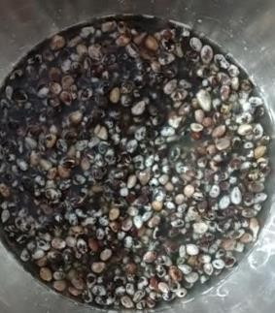
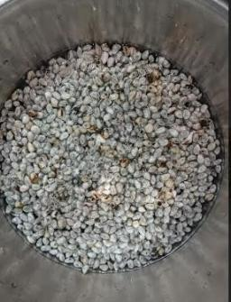
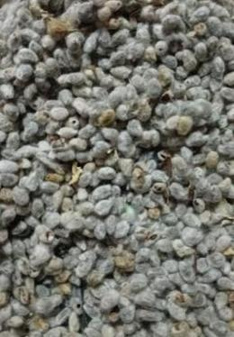
fig .1 Milk preparation from Cotton seed
COTTONSEED
WASHING
SOAKED-OVERNIGHT

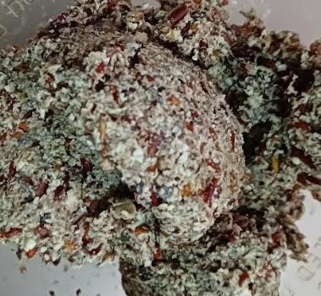
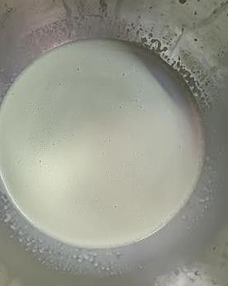
COTTONSEEDMEAL
COTTONSEEDMILK

2.3 COCONUTMILKPREPARATION:
Coconuts were split and they were scraped with the use of knife.Milk was extracted by blending the scraped coconut with water to get the consistency of cow’s milk. Strain the milk from it using a muslin cloth or strainer [11].

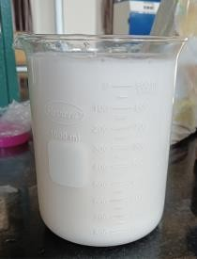
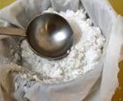
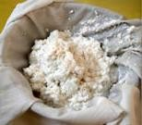
GRINDED COCONUT
COCONUT MILK
COCONUT

Fig .2 The process of coconut milk preparation
2.4 PREPARATION OF VEGAN ICE CREAM:
Heat the coconut milk till it reaches the temperature 72℃.Heat the cotton seed milk till it reaches the temperature 72℃. Set a water bath temperature at 90℃. After reaching the set temperature, the two milks were pasteurized at 90℃ for 20 minutes.Cool both the milk till it reaches the temperature 4℃.Beat the coconut milk for 5 minutes by using electronic beater, then slowly add the cotton seed milk into it.Weigh all the dry ingredients.Blend all the ingredients by using hand beater for 5 minutes.Slowly add all the dry ingredients to the milk at a temperature 4℃.Before adding the dry ingredients, make sure that all the ingredients were blended well.It prevents the lump formation in ice cream.
Continue to beating for 10 minutes by using electronic beater. This helps to incorporate the air to the ice cream. Pre – freeze the ice cream bowl for 8 hours. Then pour the mixture to the ice cream maker as shown in the figure. Switch on the ice cream maker. Note down the starting time. Run the ice cream maker for 30 minutes. After reaching 30 minutes, switch off the machine. Transfer the cream to the bowl and wrap it using aluminium foil so there is no air trapped in between the ice cream and an aluminium foil wrapping. This step prevents the ice crystal growth in ice cream. For ageing process, put the ice cream in a freezer. Freezing is done at a temperature -18℃ for 6 to 8 hours.

Fig .3 ThePreparation Of Vegan Ice Cream

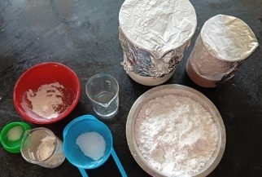

ExtractCottonSeedMilk&CoconutMilk
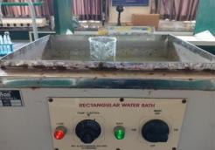
Measure theDryIngredients
Waterbath
Blend theDryIngredients andMix it Well
Measureddry ingredients
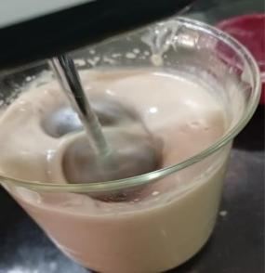
Heat theCottonSeedMilk&CoconutMilk(upto72℃)
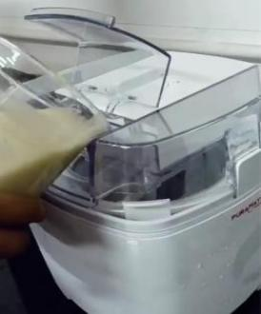
Put theMilk in aWaterBath at90℃ for20Minutes
Cool theMilk toRoom Temperature
Beating
BlendCottonSeedMilk andCoconutMilk
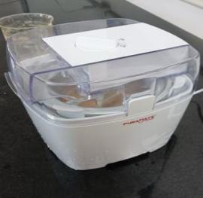
Blend theDryIngredients with theMixture
Icecream maker
AddFlavour
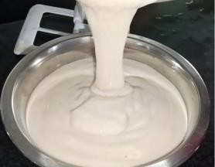
Pour theMixture toIceCream Maker
Icecream maker

Run theIceCreamMakingMachine for30Minutes
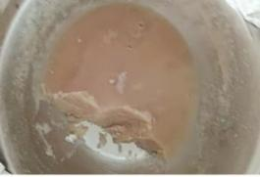
Transfer theCream to the Bowl
Creamaftertakingfromicecreammaker
Freezing(At-18℃ for6 to8Hrs)
Veganicecream

- RESULTS AND DISCUSSION:

3.1 SENSORY ANALYSIS:
The freshly prepared vegan ice cream were presented to fifty members to evaluate their sensory attributes. Each treatment was evaluated for appearance, flavour, texture, mouth feel and overall acceptability attributes as perceived by the panelists. For every sample, panelists scored their liking of those traits the use of the 9-factor Hedonic Scale. The score of 9 indicated a “very desirable” trait, which gradually decreases with a reduction in acceptability. The score of 5 shows “neither desirable nor undesirable” trait. The characteristics with mean scores of 7 and above were considered acceptable. (1 – dislike extremely, 2 – dislike very much, 3 – dislike moderately, 4 – dislike slightly, 5 – neither like nor dislike, 6 – like slightly, 7 – like moderately, 8 – like very much, and 9 – like extremely). The mean scores obtained after the evaluation of different samples for each trait were calculated.
The total number of panelist was 50. Samples have been coded with 3 digit random numbers and briefed earlier than sensory evaluation.The ice cream cups were served immediately after withdrawing the cups from freezer after 12 hours of storage and promptly offered to the panelists. Water was provided to the panelists as taste neutralizer [13].
Median value of the scores obtained for sensory attributes such as appearance, texture, flavour, mouth feel and overall acceptability against the two formulations judged by panelist is shown in graph 1 Sample 1(vanilla flavour) acquired some positive rating with respect to flavour and taste and Sample 2 (ginger flavour) obtained some positive rating in its mouth feel. The mean overall acceptance by the panelists according to product preferences indicated that sample 1 (vanilla flavoured vegan ice cream) were highly accepted by the panelists. Sample 1 (vanilla flavour) and 2 (ginger flavour) received some negative reviews on the ice cream texture. The panelists stated that, the ice cream structure needs to be developed. Many trials are required to obtain the ice cream texture.

Graph : 1 Sensoryevaluationforstandardizedveganicecream

3.2 PROXIMATEANALYSIS:
In this chapter moisture, protein, fat, carbohydrate, fiber, energy, sodium, total solids, total ash, pH and overrun of the ice cream formulations were discussed.

3.2.1 Qualityevaluationofpreparedmilk:
The result of quality evaluation of prepared milk was shown in Table 2.
S.NO | SAMPLE | pH | ACIDITY
1 | COTTONSEEDMILK | 3.51 | 0.04
2 | COCONUTMILK | 4.39 | 0.008

Table:2Qualityevaluationofpreparedmilk

3.2.2 Physio-ChemicalQualityEvaluation:
The results of physio-chemical quality evaluation of the standardized vegan ice cream was shown in table 3.
S.NO | TESTINGPARAMETERS | UNITS | RESULTS
1 | ENERGY | Kcal/100g | 286.2
2 | MOISTURE | % | 64.15
3 | PROTEIN | % | 4.05
4 | FAT | % | 8.65
5 | CRUDEFIBER | % | 13.6
6 | CARBOHYDRATE | % | 25.05
7 | TOTALASH | % | 0.10
8 | SODIUM | mg/100g | 9.2
9 | TOTALSOLIDS | % | 35.85

Table:3Proximateanalysisof standardizedveganicecream.

The considered necessary samples of evolved vegan ice-cream have been subjected for the proximate evaluation viz.acidity, pH, total solids, moisture, ash and over run.The results obtained on account of this parameter were presented below.

3.4.1 Acidity:
The acidity content of standardized vegan ice cream sample 1 and 2 were 0.014 and 0.005 % respectively. Sample 1 was acceptable based on the sensory score [20].

3.4.2 pH:
The pH of standardized vegan ice cream for sample 1 and 2 were 3.83 and 3.80 respectively. All the 2 samples have almost same pH. The pH of cotton seed milk and coconut milk were 3.51 and 4.39 respectively. Addition of cotton seed milk and coconut milk was the reason for acidity of vegan ice cream [20].

3.4.3 Total solids:
The total solids content of standardized vegan ice cream was 35.85 %. The total solids of vegan ice cream was compared with commercially available ice cream. The total solids of commercial ice cream was 32.3 % which was less than vegan ice cream [20].

3.4.4 Moisture:
Moisture content refers to how much water is in a food product. It establishes a food product's shelf life. The food product's shelf life is increased by a decrease in moisture, and the opposite is true for an increase in moisture. It has an impact on the food products' weight, texture, flavor, and appearance [19].The moisture content of control, standardized vegan ice cream was 64.15 %.The results were given in the findings of Namrata Sutar 2009 which ranges from 65.18 to 68.53.

3.4.5 Ash:
The ash was an inorganic deposit that was obtained by heating in the presence of oxidizing agents after water and natural count number were removed. The ash content of standardized vegan ice cream was 0.10 %. The overall amount of mineral in the food is determined by the ash level found in the samples [21]. There was no difference seen in the ash cost outcome between the manipul and examine samples.

3.4.6 Overrun:
Ice cream was sold in large quantities, and as such, its excess was a valuable commodity from both a regulatory and a product quality perspective [22]. An essential component of ice cream's volume was air. The air content was defined as "overrun," which is the portion of the ice cream mixture's volume that increases before freezing and is achieved by whipping in air. The overrun percentage of standardized vegan ice cream for sample 1 and 2 were 58.2 and 58.5 % respectively.

3.2.3 Nutritivevalueofcommercialice cream:
The vegan ice cream was compared with commercially available ice cream based on the testing parameters given in the table 4.
S.NO | TESTINGPARAMETERS | VALUE
1 | FAT | 12%
2 | PROTEIN | 4 %
3 | CARBOHYDRATE | 20.7%
4 | TOTALSOILDS | 32.3%
5 | ENERGY | 204Kcal

Table:4Nutritivevalueofcommercialice cream

3.2.4 Qualityevaluationoficecream:
Quality evaluation of vegan ice cream for sample 1 and sample 2 were given below.
ICECREAMMIX FORMULATIONS | pH | ACIDITY | OVERRUN
SAMPLE1(Vanilla flavour) | 3.83 | 0.014% | 58.2%
SAMPLE2(Ginger flavour) | 3.80 | 0.005% | 58.5%

Table:5Qualityevaluationoficecream

Compared to commercial ice cream, formulated vegan ice cream has higher energy, protein and total solids value of 286.2 Kcal, 4.05%, and 35.85% respectively. There was no significant difference in values. Compared to commercial ice cream, standardised vegan ice cream was high in carbohydrate and fat content of 25.05% and 8.65% respectively [9,19]. Ash, sodium and moisture content in standardised vegan ice cream were 0.1%, 64.15% and 9.2 mg respectively. Formulated vegan ice cream has 13.6 % fibre content. Table:5 shows that, there is no significant difference was found in pH, acidity and overrun between sample 1 (Vanilla flavour) 1 and 2 (Ginger flavour). Sample 1 was accepted based on the sensory analysis and proximate analysis.
IV CONCLUSION:
The investigation was carried out to study the feasibility and effect of incorporating cotton seed milk in vegan ice cream. Given the results obtained from the chemical, rheological, textural, and sensory determinations, it can be concluded that a vegan ice cream can be formulated by incorporating cotton seed milk and coconut milk. Fromatechnologicalpointofview,thismodificationoftherecipecanbeallowedwithout hindering the technological process and without significantly changing the recipe of conventional ice cream. There is an growing fashion for the intake of plant primarily based totally milk ice cream and thru this take a look at precise outcomes had been obtained.The useof xanthan gumand coconut milk forthisvegan ice cream improved the physical properties of the ice cream, increasing the viscosity and consistency, taste and the appearance of the ice cream. Addition of coconut milk in this ice cream gives better acceptability with functional and nutritional contents. Significant effects were observed in terms of physio-chemical quality of mix and ice cream. The drawback was the texture of formulated vegan ice cream, which could be corrected by moreresearchesoncottonseedmilk.Therheologicalbehaviorandthetexturalproperties could be improved by the addition of several vegan - based raw materials. Consumer awareness, therefore, is crucial whilst plant-primarily based totally substitutes are used to completely update cow’s milk withinside the diet.

REFERENCES:

- Aboulfazli, Fatemeh, et al. “Effect of Vegetable Milks on the Physical and Rheological Properties of Ice Cream.” Food Science and Technology Research, vol. 20, no. 5, Jan. 2014, pp. 987–96. https://doi.org/10.3136/fstr.20.987.
- Bahramparvar, M., & Mazaheri Tehrani, M. (2011). Application and functions of stabilizers in ice cream. Food reviews international, 27(4), 389-407.
- Beegum, P. P., Nair, J. P., Manikantan, M. R., Pandiselvam, R., Shill, S., Neenu, S., & Hebbar, K. B. (2021). Effect of coconut milk, tender coconut and coconut sugar on the physico-chemical and sensory attributes in ice cream. Journal of Food Science and Technology, 1-12.
- Bisla, G., Archana, P. V., & Sharma, S. (2012). Development of ice creams from Soybean milk & Watermelon seeds milk and Evaluation of their acceptability and Nourishing potential. Adv Appl Sci Res, 3(1), 371-6.
- Cao, H., &Sethumadhavan, K. (2020, May). Cottonseed bioactive compounds and peptides. In Proceedings of the 2020 Beltwide Cotton Conferences, Austin, Texas (pp. 270-281). National Cotton Council of America.
- Dogan, M., Kayacier, A., Toker, Ö. S., Yilmaz, M. T., & Karaman, S. (2013). Steady, dynamic, creep, and recovery analysis of ice cream mixes added with different concentrations of xanthan gum. Food and Bioprocess Technology, 6(6), 1420-1433.
- Fabro, M. A., Milanesio, H. V., Robert, L. M., Speranza, J. L., Murphy, M., Rodríguez, G., & Castañeda, R. (2006). Determination of acidity in whole raw milk: comparison of results obtained by two different analytical methods. Journal of dairy science, 89(3), 859-861.
- Franco, M. C. V. S. (2020). Vegan ice-cream: a consumer trend or the future? (Doctoral dissertation).
- Gadelha, I. C. N., Fonseca, N. B. S., Oloris, S. C. S., Melo, M. M., & Soto-Blanco,
- Góral, M., Kozłowicz, K., Pankiewicz, U., Góral, D., Kluza, F., &Wójtowicz, A. (2018). Impact of stabilizers on the freezing process, and physicochemical and organoleptic properties of coconut milk-based ice cream. LWT, 92, 516-522.
- Jayasundera, M., & Fernando, K. (2014). Development and quality evaluation of coconut milk based soft ice cream. Annals Food Science and Technology, 15(2), 227-230.
- Kumar, M. (2019). Paruthi Paal, a nutrient-rich healthy drink from cottonseed: An Indian delicacy. Journal of ethnic foods, 6(1), 1-6.
- Lawless, H.T. and Heymann, H. (1998) Sensory Evaluation of Food: Principles and Practices. Chapman & Hall, New York [15].
- Leahu, A., Ropciuc, S., & Ghinea, C. (2022). Plant-Based Milks: Alternatives to the Manufacture and Characterization of Ice Cream. Applied Sciences, 12(3), 1754.
- Legassa, O. (2020). Ice Cream Nutrition and Its Health Impacts.
- Lusas, E. W., & Jividen, G. M. (1987). Glandless cottonseed: a review of the first 25 years of processing and utilization research. Journal of the American Oil Chemists Society, 64(6), 839-854.
- Nistor, O. V., Pohrib, E., Mocanu, G. D., Constantin, O. E., &Ceclu, L. An overview on the earliest representative of today vegan and vegetarian ice cream.
- P. J., Calhoun, M. C., ... & Wilkinson, N. S. (2002). Effects of gossypol from cottonseed meal and dietary vitamin E on the reproductive characteristics of superovulated beef heifers. Journal of animal science, 80(9), 2485-2492.
- Perera, K. D. S. S., & Perera, O. D. A. N. (2021). Development of Coconut Milk- Based Spicy Ice Cream as a Nondairy Alternative with Desired Physicochemical and Sensory Attributes. International Journal of Food Science, 2021.
- Riaz, T., Iqbal, M. W., Mahmood, S., Yasmin, I., Leghari, A. A., Rehman, A., ... & Bilal, M. (2021). Cottonseed oil: A review of extraction techniques, physicochemical, functional, and nutritional properties. Critical Reviews in Food Science and Nutrition, 1-19.
- Schmidt, K. A. (2004). Dairy: ice cream. Food processing–Principles and applications, 287-296.
- Soukoulis, C., Chandrinos, I., &Tzia, C. (2008). Study of the functionality of selected hydrocolloids and their blends with κ-carrageenan on storage quality of vanilla ice cream. LWT-Food Science and Technology, 41(10), 1816-1827.
- Velasquez-Pereira, J., Aréchiga, C. F., McDowell, L. R., Hansen, P. J., Chenoweth,

