Original Research Article
Moisture Regimes and Phosphobacteria Modulated Solubility of Labile and Non-Labile Phosphorus in Paddy soils

Abstract
A pot culture experiment was conducted to study the solubilization of soil P without external fertilizer application to rice ADT(R) 45 as test crop. The experiment was laid out in complete randomized design with three factors and three replications. Four soil samples (low labile and non-labile P, low labile high non-labile P, high labile low non-labile P and high labile and non-labile P) were collected from PAJANCOA & RI, Karaikal Institute farm fields and tested under two moisture regimes (Continuous submergence and Alternate wetting and drying) and two levels of P solubilizers (Without and with Phosphobacteria). It was figured out that low and high non-labile P in rice plants resulted in taller plants with more tillers and high dry matter production (DMP), while soils with low labile and high non-labile P remained similar. The application of P-solubilizers like phosphobacteria with alternate wetting and drying led to higher number of filled grains/panicle and higher grain yield, in soils with low labile and high non-labile P in comparison with continuous submergence condition. The study found that nutrient P availability, solubilization, absorption, and translocation within plants are a factor-driven phenomenon, affecting plant growth and yield. Soil with low labile and high non-labile P showed a higher response during early growth stages, while high labile and non-labile P showed equal responses at later stages. The study suggests that continuous P fertilization over and above crop demand alters nutrient availability, plant growth, and yield. Rethinking P fertilization and implementing agronomic practices can improve plant growth and yield.

Keywords: Labile, Non labile, Phosphobacteria, Phosphorus, Solubilization.
1. Introduction
The world population is expected to reach 8.6 billion in 2030 with a significant increase in the developing countries like India, Pakistan, Indonesia, Philippines etc. (UN, 2017). It is the prime thing to feed the day by day growing population with self-sufficiency and if any deficiency occurs, no life could exist. The conservative estimate showed that the demand for food grains would increase to 355 million tonnes by 2030 (Dey, 2016). This increase in demand must be met from the fixed available arable land (141 million ha) with less scope for further horizontal expansion. Out of which, 120 million hectares is estimated to be suffering from different forms of land degradation. Contrary to increasing food demand, the factor productivity and rate of response of crops to applied fertilizers under intensive cropping system are declining every year (Reference?).
Rice is the staple food for nearly half of the world’s population, most of them live in developing countries. Rice is the only major food crop that can be grown under a wide range of climatic and geographical conditions. The world’s total area occupied by the rice is one-third to the total area planted under cereals (FAOSTAT, 2006). Globally rice is cultivated in an area of 162.3 M ha with a production of 738.1 Mt (FAO, 2013). The nutrient management in rice is one of the important inputs for the better yield. The nutrient management technology is important for the soil health and soil fertility. The balanced use of nitrogen (N), phosphorus (P) and potassium (K) fertilizers is essential for sustaining the soil fertility and to make a lift in the food grain production. Phosphorus is naturally occurring element that can be found in the earth’s crust, water, and all living organisms. Phosphorus is an indispensable plant nutrient.
Phosphorus is the second major element among the 17 essential elements for crop growth. It has a key role in metabolic processes such as photosynthesis, energy transfer, signal transduction, nitrogen fixation in legumes, crop quality and resistance to plant diseases are the main features associated with phosphorous nutrition (Sperber, 1958a; Khan et al, 2014). Phosphorus is highly mobile in plants and when the phosphorus is deficient, it may be translocated from old plant tissues to young actively growing areas. Plants can absorb phosphorus either as H₂PO₄⁻or HPO₄²⁻ depending on the soil pH. Phosphorus availability in soil is closely related to soil P content and also to soil physico-chemical and biological properties, which are closely associated with P sorption and biochemical transformations (Guo et al., 2009). Primary P minerals including apatites, strengite and variscite are stable, and release of available P from these minerals by weathering is too slow to meet the crop demand and relatively efficient for crop growth in acidic soils. Secondary minerals including calcium (Ca), iron (Fe) and aluminium (Al) phosphates vary in dissolution rates, depending on the size of mineral particles and soil pH (Pierzynski et al., 2005; Oelkers and Valsami-Jones, 2008). The total P content of most surface soil is low i.e., 0.005 to 0.15 per cent.
The unique characteristic of P is its low availability due to slow diffusion and high fixation in soils. Application of phosphatic fertilizer is one of the most important management strategies for higher crop yields (Bünemannet al., 2011). However, a significant fraction of fertilizer P is often fixed into insoluble forms via a range of soil–dependant reactions. This results in low utilization by plants. As the fertilizer P has been added continuously more than the crop demand, it resulted in an accumulation in soil over time (Withers et al., 2001) which is often referred as non-labile P. In addition, some amount of P can be lost in both dissolved forms and particulate forms via overland flow and subsurface pathways triggering water quality problems and ecological issues in ground and surface water bodies (Zedong Teng et al., 2019). It is, therefore, desirable to reduce P fertilizer inputs and attempt to use non-labile P resources in agriculture. The amount of non-labile P in some soils are higher that it could be effectively mobilized and could reduce the inorganic fertilizer P requirement by 50 per cent (Sattari et al., 2012 and Owen et al., 2015). To mobilize the availability of phosphorus from insoluble forms, there is a need of phosphate solubilizing microorganism. Several heterotrophic microorganisms especially Phosphobacteria excretes organic acids which solubilize P that chelate cationic partners of P ions and release the P directly into solution (He et al., 2002).
Traditionally rice cultivation is practiced in flooded soils which demands higher water inputs than other cereal crops. With the increasing threat of water scarcity, it is crucial to develop agronomic practices with the potential to reduce water use while maintaining or increasing yield to support the growing population. One such irrigation management practice is Alternate Wetting and Drying (AWD) (Carrijo et al., 2016) in which fields are subjected to intermittent flooding where irrigation is interrupted, and water is allowed to subside until the soil reaches a certain moisture level after which the field is reflooded. AWD has been reported to reduce water inputs by 23 per cent (Bouman and Tuong, 2011) compared to continuous submergence of rice, besides conducive for microorganism growth (Wassmannet al., 2010).
However, it is realized in the recent time from the soil analytical data that most of the fields of Pandit Jawaharlal Nehru College of Agriculture and Research Institute (PAJANCOA&RI) Institute farm reported a very high values of available P with great variation and erratic response to applied P fertilizers. This necessitated an investigation on the possible utility of labile and non-labile soil P in the farm soils of PAJANCOA & RI
2. Materials and Method
To achieve the objectives formulated for the present study, soil samples with different levels of labile and non- labile pool of phosphorous were collected from selected fields of the PAJANCOA & RI farm. This work is a continuation of the research work carried out by a former post graduate student of this department Ashna Susan Joseph during 2017. The entire farm fields were analyzed for P-fractions and were categorized into various labile and non-labile P. Also, it was concluded that the solubility of non-labile pool of P is a force driven reaction and therefore it needs to be carried out under restricted P supply which triggers the P solubility (Ashna Susan Joseph, 2017). In this context, to know the solubility of non-labile pool of P without external P supply in the farm soils of low and high labile and non-labile pools, this study is taken up for investigation as a continuation of the same.
The details relating to the location of the study area, conduct of pot culture experiments, the treatments, soil and plant samples collection, observations recorded during crop growth period and the analytical methods followed for soil and plant samples are detailed in this chapter below:
2.1. Description of the study area

The Pandit Jawaharlal Nehru College of Agriculture and Research Institute is situated about 9 km northwest of Karaikal town that lies between 10º 49' and 11º 01' N latitude and between 78º43' and 79º52' E longitude. The study area is nearly flat 4 m above mean sea level (MSL) situated at the tail end of river Cauvery as a deltaic zone bounded on the north by Serumavilangai, south by Sorakudy, east by Melakasakudi and west by Pathakudy villages.

Karaikal comes under the eleventh Agro climatic zone of India and it is classified as PC 2 - Coastal deltaic alluvial plain zone as per the Agro-ecological region classification. Karaikal enjoys a tropical climate with long term mean maximum and minimum air temperature of 31.95º and 25.52º C. The region receives an annual average rainfall of 1437.17 mm in 55.83 rainy days mostly during Northeast monsoon (75.04 per cent) received during October-December. The South-West monsoon contributes 16.58 per cent during June-September while winter rains (January-February) accounts for 2.96 per cent and summer rains (March-May) accounts for 5.58 per cent of total annual rainfall.

Identification of Institute farm field with different P levels of labile and non-labile pool for study

The entire farm surface soil samples were collected and analyzed for phosphorus fractions by Ashna Susan Joseph during 2017. Based on the analytical values of the P fractions, the surface soil samples were categorized depending based on labile and non- labile P contents.
Accordingly, the soils of field numbers EA 9 and WD 6 were found to contain low levels of both labile and non-labile P. The soils of field numbers EA 5, EB 5, EC 4, EC 11 and ED 2 were found to contain low levels of labile P with high levels of non- labile P. Nine fields were found to record high levels of labile P with low levels of non- labile P (ED 8, ED 9, EE 2, EE 3, EE 5, WA 0, WA 4, WC 1 and WC 5). And the only field which contained both labile and non- labile pool at high level was WB 5.

From the above four category of fields, four fields one from each category was selected viz. WD 6 with low levels of both labile and non- labile P, EC 4 with low level of labile P and high level of non- labile P, ED 8 with high level of labile P and low level of non- labile P and WD 5 with high levels of both labile and non- labile P to undertake the present study.

2.2. Collection of soil samples for pot culture experiment

The detailed soil survey of PAJANCOA & RI farm had indicated the presence of four fields with., (i) Low labile and non-labile pool of P (ii) Low labile and high non-labile pool of P (iii) High labile and Low non-labile pool of P (iv) High labile and non-labile pool of P (Ashna Susan Joseph, 2017). Soil representing all the four categories of labile and non-labile pool of P were collected for pot culture study from the respective field as given in Table 1

2.3. Details of the pot culture experiment

To investigate the response of P under various agronomic conditions and treatments, a pot culture experiment was conducted during kharif, 2018 at the pot culture yard of the Department of Soil Science and Agricultural Chemistry, Pandit Jawaharlal Nehru College of Agriculture and Research Institute, Karaikal with the following treatments (Fig. 1).

2.3.1. Treatment details
Factor I - Soil types
S₁ - Low level of Labile P and low level of non-labile P (WD6)
S₂ - Low level of Labile P and high level non-labile P (EC4)
S₃ - High level of Labile P and Low level of non-labile P (ED8)
S₄ ₋ High level of Labile P and high level of non-labile P (WB5)
Factor II - Moisture regimes
I₁ - Continuous submergence
I₂ - Alternate wetting and drying
Factor III - Phosphorous solubilizers
P₁- Without Phosphobacteria
P₂- With Phosphobacteria
Total treatments = 16
Number of Replications = 3
Total number of pots = 48
Design = Completely Randomized Design (CRD)
Crop = Rice Var. ADT (R) 45

2.3.2. Filling up the pots

Fourty-eight numbers of square shaped pots of dimension 35x35x35 cms length, breadth and depth were taken for study. The bottom holes in each pot were plugged to arrest drainage and simulate puddled rice field. Each pot was filled with 20 kg of processed soil sample, and it was mixed with water to create a puddled condition on the day before transplanting.

2.3.3. Fertilizer application

The fertilizer dose adopted was 150 kg of N and 50 kg of K₂O ha⁻¹. Nitrogen was applied as urea (156.48 g per pot) in three equal splits i.e., 50 per cent as basal, and remaining 50 per cent in two equal splits at active tillering stage (28 days after transplanting) and panicle initiation (56 days after transplanting). Potassium was supplied in the form of MOP (39.84 g per pot) in two equal splits i.e., at basal and at panicle initiation stage. Zinc sulphate at the rate 25 kg ha⁻¹(19.44 g per pot) was applied at basal to all pots.

With respect to “P” fertilization, no “P” fertilizer was applied. Instead, Phosphobacteria (P solubilizing microorganisms) was added as per the treatments, to solubilize the native soil P and to make them available to plants. Recommended amount of Phosphobacteria @ 2 kg ha⁻¹ (200 g) was thoroughly mixed with (5 kg) FYM and applied as soil application one day prior to transplanting as per the treatments (CPG, 2020).

2.3.4. Test crop
The pot culture study was conducted with short duration rice variety ADT (R) 45 as test crop during kharif (June - August). Two seedlings (28 days old) per hill were transplanted on 26.06.2018. Four hills at a spacing 20 x 15 cm were planted diagonally in each pot. The other agronomic practices like gap filling, weeding, pest managements were followed as per CPG, 2020.

2.4. Collection of soil and plant samples
2.4.1. Collection of soil samples

The soil samples were collected from individual pots after harvest of the rice crop. The collected post-harvest soil samples were dried in shade, powdered, passed through 2 mm sieve and preserved for further analysis of soil parameters viz., pH, EC, organic carbon, available-P and P-Fractions following the standard procedures.

2.4.1.1. Phosphorus fractions

The different P fractions in soil were determined as suggested by Bolan and Hedley (1989) following a modified P fractionation technique. One gram soil was pre-treated with 40 ml of 0.5 M NaCl buffered with 0.5 M triethanolamine (TEA) and shaken for 30 minutes in a 50 ml centrifuge tube. This pre-treated soil was included to remove both the solution P and exchangeable calcium, which otherwise may form Ca (OH)₂ and CaCO₃ during extraction with 1 M NaOH and reabsorb or co-precipitate with some of the dissolved P. After centrifuging at 8000 rpm for 10 minutes, the supernatant solution was filtered and analyzed for solution P following Murphy and Riley (1962) method.

The soil residue was subsequently shaken end-over-end with 1M NaOH (at 1:40 soil: solution ratio) for 16 hours. After centrifuging and filtering, the solution was analyzed for P which include both solution and adsorbed P. To the residue in the tube, 40 ml of 1M HCl was added and shaken for further 16 hours and then centrifuged and filtered. The P was determined in the solution as acid soluble or apatite-P. The soil residue was then transferred to a 100 ml conical flask and digested using 10 ml of triacid at 260˚C for 45 minutes and the total P was determined as residual P.

2.4.2. Collection of plant samples

Plant samples were collected at three stages viz., active tillering, panicle initiation and at harvest stage. The plant samples obtained at different stages were dried in shade and subsequently oven dried at 60ºC. The dried samples were powdered in Willey mill and preserved in butter paper cover for further analysis.

2.4.2.1. Nutrient uptake:

The plant samples collected during active tillering, panicle initiation and at harvest stages (grain and straw) were subjected to P content analysis as per the standard procedure. The nutrient content (P) in per cent and the dry matter production recorded at each stage were used to compute the P uptake of plants at respective stages by using the following formula to express as g pot ⁻¹
$$P uptake \left({g pot}^{-1}\right)= \frac{P content \left(\%\right) × DMP ({g pot}^{-1})}{100}$$

2.5. STATISTICAL ANALYSIS

The biometric observations, yield parameters and yield obtained from the pot culture study and the laboratory analytical data emanated were subjected to statistical scrutiny following the procedures outlined by Rangaswamy (2016). Critical differences were worked out wherever the results were found to be significant with 95 per cent probability level and wherever the results are found to be non-significant, it was noted as “NS”.
3. Result and Discussion
3.1. Characterization of soils with varying levels of labile and non- labile P

As described in the previous section, soil samples were collected from four fields with (i) Low levels of both labile and non-labile P (ii) Low level of labile P and high level of non-labile P (iii) High level of labile P and low level of non-labile P and (iv) High levels of both labile P and non-labile P and analyzed for their properties.

3.2. Growth parameters

3.2.1. Plant height

The average plant height was recorded at active tillering (28 days), panicle initiation (60days) and harvest stages (100 days) which shows different levels of P in soils had influenced the plant height significantly at active tillering (AT) and harvest stages (Table 2; Fig. 2). The average plant height for all treatments showed that the soils with low labile and non-labile P registered significantly taller plants (53.81 cm) in the active tillering stage, while the soils with high non-labile P registered taller plants (69.14 cm) in the harvest stage and 50.10 cm in the active tillering stage and there was a substantial interaction impact between the moisture regimes and the administration of phosphobacteria on plant height.

Significantly higher plants (52.12 cm) were seen under the alternate wetting and drying conditions with the application of phosphobacteria. This could be because the rice's aerobic scavenging mechanism effectively preserved the biological system (Yadav et al., 2010).Soils with low labile and high non-labile pools of P from the early stage till maturity, rice growth performed consistently regardless of moisture regimes and Phosphobacteria administration at both active tillering and harvest stages. This might be caused by the application of phosphobacteria, submergence, or both, which increased the availability of soluble phosphate from the non-labile pool. Conversely, during the active tillering and harvest periods, the plants in the soil with high labile and low non-labile P registered considerably shorter plants, measuring 40.33 cm and 58.58 cm, respectively.

3.2.2. Number of tillers per hill⁻¹

The number of tillers per hill⁻¹ registered at various stages of rice in all the treatments did not show any marked variation in producing the tillers per hill except due to the interaction effect of levels of P in soils with phosphobacteria application at active tillering phase and at harvest stage.The soils of low labile and high non-labile P with phosphobacteria application recorded higher number of tillers per hill (12.5) during active tillering and harvest stage (25.0) which was on par with low labile and high non-labile P without phosphobacteria (11.3) and (23.7) in different stages because of the presence of phosphobacteria produced more number of tiller per hill ⁻¹ by solubilizing inorganic phosphate from the non-labile pool where a high reserve pool of fixed P (Table 3; Fig. 3). This result was confirmed by Satyaprakash et al., 2017 that the increased mineralization of non-labile P by release of organic anions, production of siderophores and acid phosphatase by phosphobacteria that hydrolyses organic and inorganic P resulting in increased P availability.

High labile and non-labile P with (9.5) and without (10.5) phosphobacteria application. The absence of P solubilizers in high and low pools of both labile and non-labile P also favoured in producing more tillers per hill ⁻¹ in the initial stage of crop growth which proved that submerged condition benefit rice crop by providing more conducive environment for rice roots and P availability by increased hydrolysis due to alteration of pH and Eh in reduced soil condition (Mariano et al., 2002 and Sahrawat, 2014).

3.2.3. Dry Matter Production (DMP)

At active tillering, the soils with low labile and high non-labile P registered significantly higher DMP (20.62 g pot⁻¹) which was on par with soil with low labile and non-labile P (19.13 g pot⁻¹) which was due to the solubilization of phosphate from non–labile pool and made available to crop plants (Table 4). The least DMP was recorded in soils with high labile P and low non-labile P (8.19 g pot⁻¹). Similarly, alternate wetting and drying recorded significantly higher DMP (21.66 g pot⁻¹) when coupled with application of phosphobacteria and was significantly higher than continuous submergence without phosphobacteria application (14.87 g pot⁻¹) at active tillering stage which implies that phosphobacteria in the presence of oxygen is not only in solubilizing the P but also capable of producing physiologically active auxins that may have pronounced effect on plant growth. This result corroborates with the findings of Ponmurugan and Gopi, 2006; and Satyaprakash et al., 2017.

At panicle initiation stage, the interaction effect of all the three factors showed significant DMP and was more pronounced (41.45 g pot⁻¹) in soils with low labile and high non-labile P when applied with phosphobacteriaat alternate wetting and drying moisture regime and continuously recorded significantly higher DMP (77.49 g pot⁻¹) and was on par with soils containing both high labile and non-labile P (65.83 g pot⁻¹) due to the reduced soil system and low level of fixed phosphate and labile phosphates could have counter triggered absorption of other essential cations and anions thereby made available to rice plants for growth (Ponnamperuma, 1972).At maturity stage, the soils with high labile and non- labile P favoured higher DMP of rice. It is obvious that better performance of rice at higher release of soluble phosphate from both labile and non- labile pool of P would have favoured more DMP which might be due to the availability of soluble phosphates from the non-labile pool and positive correlation with mineralization under aerobic condition (Kader et al., 2013).

Also, the faster re-mobilization of carbon and root enlargement in rice during drying increases the nutrient uptake thereby increasing the DMP (Daniela and Carrijo, 2017). On the other hand, the soils with high labile and non-labile P as well as with low labile and non-labile P under continuous submergence recorded higher DMP indicate that the submergence might have increased the dissolved reactive P from labile pools to meet the crop demand by hydrolyses and anaerobic decomposition of organic matter (Tian et al., 2017).

3.3. Yield attributes

3.3.1. Number of productive tillers hill⁻¹

The P levels in soils under varied moisture regimes were statistically significant in registering productive tiller numbers in rice crop. Soils with low labile and high non-labile P (8.5), soils with both high labile and non-labile P (7.5) and soils with both low labile and non-labile P (7.0) have registered significantly higher number of productive tillers hill⁻¹ whereas, the soils with high labile and low non-labile P registered the lowest (4.5) (Table 9; Fig. 4). The response of low labile P and high non-labile P (9.6) at alternate wetting and drying was significantly higher and produced more productive tillers hill ⁻¹ which was comparable with soils with low labile and non-labile P under continuous submergence of (9.0) and soils with both high labile and non-labile P (8.5) under alternate wetting & drying condition. Better performance of low labile and high non-labile pool of P in producing more productive tillers along with lengthier and heavier panicles were observed.

3.3.2. Panicle length

Soils with low level of labile and high level of non-labile P had registered lengthier panicle in rice (21.04 cm) which was statistically on par with soils having both low labile and non-labile P (19.93 cm). The shortest panicle length was recorded in soils having high labile and low non-labile P (18.13 cm). All the other factors and their interaction effects did not show any marked variation in panicle length.

3.3.3. Panicle weight

The panicle weight had shown considerable variation among levels of P in soils and their individual interaction with moisture regimes and phosphobacteria. Heavier panicles (2.61 g) were produced by soils possessing low labile and high non-labile P which was comparable with soils having both high levels of labile and non-labile P (2.46 g) and with both low levels of labile and non-labile P (2.42 g). The lowest panicle weight was observed with high labile and low non-labile P (1.19 g) in soils. In case of heavier panicles irrespective of labile pool of P under alternate wetting and drying condition soils with high non-labile pool of P had clearly indicated that alternate oxidative-reductive soil condition could increase the yield parameters by promoting faster remobilization of carbon, mineralization of essential nutrients and absorption (Yang and Zhang, 2006).

Due to the significant interaction between levels of P in soils with moisture regimes, it could be concluded that soils with both low labile and non-labile P under continuous submergence managed to produce significantly heavier panicles (3.41g) which was comparable with soils with low labile and high non-labile P at continuous submergence (2.78 g) and at alternate wetting and drying condition (2.54 g) due to the response of rice to the soluble phosphates released due to submergence.When the soil labile pool of P is low and irrespective of high or low non-labile pool, the phosphobacteriaexhibited their predominance by producing more heavier panicles by solubilizing insoluble phosphate. The solubilization of insoluble phosphates by phosphobacteria is due to production of organic acids and also due to production of amino acids, vitamins, Indole acetic acid (IAA) and Gibbrellic acids (GA₃) that help in better growth of plants.

3.3.4. Number of filled grains/Ill filled grains per panicle

The number of ill-filled/ filled grains panicle⁻¹ remained statistically uninfluenced by any of the factors or their interactions under the levels of P in soils, moisture regimes and P solubilizers.Soils with low labile and high non-labile P when coupled with phosphobacteriaapplicationat alternate wetting and drying condition registered significantly higher number of filled grains panicle⁻¹ (90.1) (Table 5). This was followed by soils with both low labile and non-labile P at alternate wetting and drying condition without phosphobacteriaapplication (75.7). The number of filled grains panicle⁻¹ was significantly lower (9.7) in soils with both low labile and non-labile P under continuous submergence condition without phosphobacteriaapplication.

3.4. Rice yield

3.4.1. Grain yield

The soils with low labile and high non-labile P produced significantly higher grain yield (143.72 g pot⁻¹) which was statistically comparable with soils having both high labile and non-labile P (93.75 g pot⁻¹). Among the soils, lowest grain yield was registered in the soil with high labile and low non-labile P (27.39 g pot⁻¹) (Table 6; Fig. 5). The partial soil dryness during crop growth, reproductive and grain filling stages could result in increased grain yield by promoting faster remobilization of carbon, root enlargement, favourable redox etc. for maximum nutrient uptake (Li et al., 2016).

Alternate wetting & drying in the presence of phosphobacteriaregistered significantly higher grain yield (118.47 g pot⁻¹) and was also found to be at par with continuous submergence without phosphobacteria (87.81 g pot⁻¹). Soils with low labile and high non-labile P (327.90 g pot⁻¹) when combined with phosphobacteriaunder alternate wetting & drying registered significantly more pronounced effect on the grain yield. Similarly, the grain yield in high labile and low non-labile P registered lower grain yield (4.02 g pot⁻¹) under continuous moisture regimes without phosphobacteria application.

3.4.2. Straw yield

The straw yield was more pronounced in soils with low labile and high non-labile P (292.96 g pot⁻¹) when applied with phosphobacteriaunder alternate wetting & drying moisture regime (Fig. 5). This was on par with soils having both low labile and non-labile P under alternate wetting and drying condition without phosphobacteria application (211.55 g pot⁻¹) and soils with both high labile and non-labile P under continuous submergence with (206.63 g pot⁻¹) and without phosphobacteria (172.60 g pot⁻¹) application. Straw yield of crop is closely related to vegetative growth viz., plant height, number of tillers and dry matter production of rice crop. The individual factors effect viz. levels of P in soil, moisture regimes and phosphobacteria did not influence in producing straw yield. However, their combined effect produced more pronounced straw yield.

Soils with low labile P with high or low non-labile pool showed their better performance under alternate wetting and drying condition in the presence of P-solubilizers. In contrast, when the soils possess labile and non-labile pool at high level, continuous submergence showed better performance in the presence or absence of P solubilizers by producing higher straw yield. This confirms that continuous submergence of soil alone had the ability to convert insoluble to soluble phosphates by electrochemical changes in soils, whereas, under alternate wetting and drying condition that would have been performed by phosphobacteria.

3.5 P uptake in rice plants

3.5.1 P uptake in crop growth stages

At active tillering and at PI stages, none of the individual factors or their interaction show any significant variation in mean uptake of P and showed significant difference with the treatments only after panicle initiation stage (Table 11; Fig. 6). The magnitude of P uptake was more conspicuous with high level of non-labile P irrespective of level of labile P had clearly showed that the solubility of P from the high non-labile pool is plant root driven phenomenon based on the plants necessity, growth etc.

Among the moisture regimes, the alternate wetting and drying condition increased the P uptake which would have resulted in plants with higher efficient scavenging mechanisms offered by alternate anaerobic and aerobic conditions and maintaining the biological system that ultimately helped in increasing the P uptake (Yadav et al., 2010).

3.5.2. Grain P uptake

The soil P levels registered significant variation in uptake of P in grains. The soil with high labile and non-labile P (0.60 g pot⁻¹) followed by soils with low labile and high non-labile P (0.42 g pot⁻¹) were at par and higher (Table 12). The interaction effect of soil P levels and moisture regimes had registered significant variations on the uptake of grain P. The soils with high labile and non-labile P under continuous submergence (0.74 g pot⁻¹) had registered higher grain uptake of P. The soils with high labile and non-labile P and soils with low labile and high non- labile P under alternate wetting and drying moisture regime have also registered statistically at par uptake of grain P (0.46 g pot⁻¹).

Similarly, the interaction effect of moisture regimes and Phosphobacteria also registered significant variations. The continuous submergence recorded significantly higher grain uptake of P without Phosphobacteria (0.74 g pot⁻¹) followed by alternate wetting and drying condition with Phosphobacteria application (0.52 g pot⁻¹).The result had proved that the soil condition is not only required for the solubilization and absorption of nutrients like P but also essential in translocation of the same across different pathways to sink. The efficiency of phosphobacteria was more pronounced under AWD condition and non-application of phosphobacteria under continuous submergence in soils having high labile and non-labile pool of P by increasing the P-solubilization due to change in pH and redox condition.

3.5.3. Straw P uptake

The soils with low labile and high non-labile P and soils with high labile and low non-labile P recorded significantly equal and higher uptake of straw P (0.13 g pot⁻¹) (Table 12). Similarly, Phosphobacteria application registered higher P uptake in straw (0.12 g pot⁻¹) when compared to the other treatment. This result clearly indicates that the solubilization and uptake of P might be plant root driven phenomenon based on the plants necessity, growth etc.

The interaction effect of moisture regimes and phosphobacteria application showed significant variation in uptake of straw-P. Higher uptake (0.15 g pot⁻¹) was observed under continuous submergence with Phosphobacteria application. Similarly, soils with high labile and low non- labile P with phosphobacteria application had registered significantly more uptake of straw P (0.15 g pot⁻¹).

3.6. Post-harvest soil properties

3.6.1. Soil pH and EC

The post-harvest soil pH and EC was significant only with levels of P in soils. The soil pH after the harvest of rice got significantly increased in soils with high labile and low non-labile P (8.39) which was on par with soils having low levels of labile and non-labile P (8.29). The soils with high labile and non- labile P registered significantly lower pH of 7.67 (Table 7).

The observed increase in soil solution pH from the initial value was more pronounced in soils with high labile and low non-labile P and less pronounced in soils with both high labile and non-labile P. The increase or decrease in soil pH could be attributed to the chemical condition in the rhizosphere region which can be changed due to root exudations, nutrient uptake, microbial activity and differences in water relations mainly continuous submergence and alternate wetting and drying conditions (Darrah, 1993; Heinsenger, 2001; Marschner, 1995; Wang et al., 2005).

Similarly, the post-harvest soil EC of was higher in soils with low labile and non-labile P (0.35 dSm⁻¹) while high labile and low non-labile P of soils (0.18 dSm⁻¹) registered the least (Table 7). The EC of the soil solution found to increase from the initial level after a rice crop which could be due to the release of cations from the soil by rhizosphere activity for crop growth (Norsratollah and Towfigh, 2008).

3.6.2. Organic Carbon
In post-harvest soil, the organic carbon did not show any significant variation with the different levels of P but varied with moisture regimes and phosphobacteria application. Continuous submergence significantly increased the organic carbon (2.09 g kg⁻¹) than the alternate wetting & drying (1.45 g kg⁻¹) might be the preferential accumulation of organic matter and reduced soil condition might have been the major reason for increasing organic carbon content (Ponnamperuma, 1972 and Sahrawat, 2014) (Table 7). On the other hand, the soils without phosphobacteria application had registered significantly higher organic carbon (2.01 g kg⁻¹) than the soils that received phosphobacteria (1.53 g kg⁻¹). Soil organic matter helps to maintain the soil nutrient pool and hence considered to be the heart of soil (Fageria, 2000) and environment quality (Smith, 2000).

3.6.3. Olsen’s – P

In post-harvest soil, the available P had shown significant variation among the P levels of soils. The higher available P was noticed in soils with high labile and non-labile P (43.32 kg ha⁻¹) while the soils with low labile and high non-labile P recorded significantly lower available P in the post-harvest soil (20.78 kg ha⁻¹) (Table 8; Fig. 7). Similarly, application of P- solubilizer viz. phosphobacteriahad registered statistically higher post-harvest soil available P (29.39 kg ha⁻¹) whereas it was lower in soils (25.19 kg ha⁻¹) which did not receive phosphobacteria. This indicates that more phosphorus would have been released to the solution and utilized by rice crop in other levels of P in soils. Such findings of P uptake by wetland rice crop from labile P fractions and their depletion leading to mineralization and transformation of P from non-labile pool of P was reported by (Shah et al., 2007).Soils with high labile and non-labile P under alternate wetting and drying condition registered significantly higher post-harvest soil available P (51.34 kg ha⁻¹). On the other hand, alternate wetting and drying condition in the presence of Phosphobacteria had registered significantly lower soil available P of 9.60 kg ha⁻¹ whereas, continuous submergence with phosphobacteriaregistered higher available P (40.77 kg ha⁻¹).

The P-solubilizers registered low Olsen-P which indicated that phosphobacteriahave profoundly solubilized the insoluble phosphates to soluble form by several mechanisms thereby leading to lower Olsen’s P. The soils with low labile P and high non-labile P showed low Olsen-P both under continuous submergence and AWD condition which indicated that conversion of insoluble phosphates to soluble form happened either by continuous submergence because of electrochemical changes or by aerobic situation in AWD condition.The phosphobacteria at AWD condition reduced the Olsen-P which would be due to more conversion of soluble phosphates and utilization by rice crop. In post-harvest soils with high labile and non-labile P under both moisture regimes, with or without P-solubilzers recorded higher Olsen-P after a rice crop that might be ascribed to conversion of more soluble phosphates from the labile and non-labile pool in soil.

3.6.4. Fractions of P in post-harvest soil

P-fractions provides an indication of source - sink in soil plant system. Depletion of native P fertility may occur from different soil pools because of rice cropping without P fertilization. However, fractionation of P in soils might provide information regarding depletion or accumulation of P in soils. Among the P-fractions, the NaCl-P and NaOH-P constitute labile pool of P and HCl- P constitutes the non-labile pool of P (Fig. 8).

The NaCl fraction of P significantly varied only between the levels of P in soils. The highest NaCl-P fraction was recorded in soils with high labile and low non-labile P (37.58 mg kg⁻¹) which was statistically on par with soils having high labile and non-labile P (34.80 mg kg⁻¹) and soils with low labile and high non-labile P (34.31 mg kg⁻¹). The lowest NaCl-P fraction was registered in soil having both low labile and non-labile P (27.88 mg kg⁻¹).

The HCl – P fractions did not show any significant difference with the levels of P in soils and moisture regimes under study. However, the treatments with and without P-solubilizers had produced significant variations in the HCl-P of post-harvest soil. The treatment with phosphobacteria application in soils had recorded significantly higher HCl-P (41.83 mg kg⁻¹) and without phosphobacteria recorded lower value of 33.70 mg kg⁻¹ (Table 10). The interaction effect within treatments on HCl-P remained non-significant while HCl-P was influenced by phosphobacteria and other two fractions did not respond to the treatments. The NaCl-P was more pronounced in all the soils except the soils with both low labile and non-labile P. This result was in confirmation with Shah, 2007 who observed a positive correlation of NaCl–P with solution P. When the labile P is low, the P from high non-labile fraction was found to be released in this study which might be due to either submergence or due to the presence of P-solubilizers under AWD condition.

The HCl-P fractions which is the non-labile pool was higher due to the production of phosphatase enzyme by phosphobacteria (Hilda and Fraga, 2000) and release of organic anions by production of siderophores (Yadav and Tarafdar, 2001). The fractions of NaOH–P remained statistically uninfluenced by any of the factors under study.The residual –P content remained statistically uninfluenced by any of the treatments under study.
4. Conclusion
From the study, response of treatments without P fertilization to various growth, yield parameters and yield, it could be concluded that the nutrient P availability, solubilization, absorption and translocation within the plants is a factor driven phenomenon and alters the availability and absorption of other cationic and anionic nutrients essential for the growth of the plants. The significant higher response of soils with low labile and high non-labile P during the early growth stages of the crop and the statistically equal response of high labile and non-labile P at the late growth stages had clearly indicate the above. Further, the counter response of P solubilizers and moisture regimes like alternate wetting and drying to soils with low labile and high non-labile P and submergence to soils with high labile and non-labile P also had concluded that the P solubility and availability as per demand of the crop is a factor driven phenomenon. Hence, it was suggested that due to continuous P fertilization over and above the demand of the crops, the labile and non- labile P status changes altering the other nutrient availability, plant growth and yield. It was high time to rethink the P fertilization rather managing its availability by agronomic practices like alternate wetting and drying along with P-solubilizer application to soils with low labile and high non-labile P and submergence without P solubilizers to soils with high labile and non-labile P.
8. References
Ashna Susan John. 2017. Dynamics of soil phosphorus and its impact on the yield and uptake of paddy crop in the soils of Pandit Jawaharlal Nehru College and Agricultural research institute farm. M. Sc. (Ag.) Thesis, TNAU.
Bolan,N.S.andM.J.Hedley.,1989.Dissolutionofphosphaterocksinsoil.1.Evaluationofextractionmethodsforthemeasurementofphosphate dissolution.Fert.Res.,19:65-75.
Bouman, B.A.M. and T.P. Tuong, 2011. Field water management to save water and increase its productivity in irrigated lowland rice. Agric. Water Manage., 49: pp. 11-30.
Bünemann, E.K., D.A. Bossio, P.C. Smithson, E. Frossard and A. Oberson. 2004. Microbial community composition and substrate use in a highly weathered soil as affected by crop rotation and P fertilization. Soil Biology and Biochemistry, 36(6): 889–901.
Carrijo, D. R., M.E. Lundy and B.A. Linquist. 2016. Rice yields and water use under alternate wetting and drying irrigation: A meta-analysis. Field Crops Research., 203: 173-180.
Crop Production Guide. 2020. Directorate of Agriculture, TNAU, Coimbatore.
Dey, P. 2016. Soil health management. Bull. Indian Soc. Soil Sci., 13: 79-97.

FAO. 2013. Statistical year book. http://fao.org.

FAOSTAT. 2006. http:// faostat.fao.org.
Guo, B., Y. Liang, Z. Li and F. Han. 2009. Phosphorus adsorption and bioavailability in a paddy soil amended with pig manure compost and decaying rice straw. Commun. Soil Sci. Plant Anal., 40: 13-14.
He, Y., K. Kozaki, T. Karpanen, K. Koshikawa, S. Yla-Herttuala, T. Takahashi and K. Alital. 2002. Suppression of tumor lymphangiogenesis, and lymph node metastasis by blocking VEGFR-3 signalling., J. Natl. Cancer. Inst.
Khan, M.I.R. and N.A. Khan. 2014. Ethylene reverses photosynthetic inhibition by nickel and zinc in mustard through changes in PS II activity, photosynthetic nitrogen use efficiency, and antioxidant metabolism. Protoplasma.
Murphy, J., and J.P. Riley. 1962. A modified single solution method for the determination of phosphate in natural waters. Anal. Chem. Acta, 27: 31-36.
Oelkers, E.H. and E. Valsami-Jones. 2008. Phosphate mineral reactivity and global sustainability. Elements, 4: 83-87.
Owen, D., A. P. Williams, G. W. Griffith and P. J. A. Withers 2015. Use of commercial bio-inoculants to increase agricultural production through improved phosphorus acquisition. Appl. Soil Ecol., 86: pp.41-54.
Pierzynski, G.M., R.W. McDowell and J.T. Sims. 2005. Chemistry, cycling, and potential moment of inorganic phosphorus in soils. In JT Sims, AN Sharpley, eds, Phosphorus: Agriculture and the Environment.
Rangaswamy, V. and K. Venkateswarlu. 2016. Phosphatase activity in groundnut soils as influenced by selected insecticides. J. Environ. Biol., 17(2):115–119.
Sattari, E., C.R. Wymer, D. Federici and M. Giannett. 2012. Technological Adoption with Imperfect Markets in the Italian Economy. Studies in Nonlinear Dynamics &Econometrics, 16 (2).
Sperber. J. I. 1958a. The incidence of apatite-solubilizing organisms in the rhizosphere and soil. Aust. J. Agric. Res. 9:778-781.
United Nations. 2017. The Sustainable Development Goals Report, United Nations: New York.
Wassmann, R., S.V.K. Jagadesh, K. Sumfleth, H. Pathak, G. Howell, A. Ismail, R. Serraj, E. Redona, R.K. Singh and S. Heuer. 2010. Regional vulnerability of rice production in Asia to climate change impacts and scope for adaptation. Adv. Agron., 102: 91-133.
Withers, P.J.A., A.C. Edwards and R.H. Foy. 2001. Phosphorus cycling in UK agriculture and implications for phosphorus loss from soil. Soil Use Manage., 17:139–149.
Zedong, T., W. Shao, K. Zhang, Y. Huo and M. Li. 2019. Characterization of phosphate solubilizing bacteria isolated from heavy metal contaminated soils and their potential for lead immobilization. J. Environ. Management 231, 189–197.

Tables
Table 1. Selection of soils for the pot culture experiment with varying P levels of labile and non-labile pool from their P fractions (mg kg⁻¹)

S. No | Field No. | Labile –P  (NaCl-P + NaOH-P) | Level of P in labile pool | Non-Labile-P  (HCl-P) | Level of P in non-labile pool
1 | WD 6 | 370.14 | Low | 155.77 | Low
2 | EC 4 | 207.44 | Low | 515.64 | High
3 | ED 8 | 574.97 | High | 207.70 | Low
4 | WB 5 | 541.52 | High | 623.09 | High
(Ashna Susan Joseph, 2017)

Table 2. Effect of varying levels of labile and non-labile P, moisture regimes and phosphobacteria on plant height (cm) at different growth stages of rice crop

Treatments |  | Active Tillering |  |  |  |  |  |  | Panicle Initiation |  |  |  |  |  |  | Harvest
 |  | P₁ | P₂ | I₁ |  | I₂ | Mean |  | P₁ | P₂ |  | I₁ | I₂ | Mean |  | P₁ | P₂ | I₁ |  | I₂ | Mean
S₁ – Low labile & Low Non-labile P |  | 53.08 | 54.53 | 50.37 |  | 57.25 | 53.81 |  | 59.30 | 67.17 |  | 66.83 | 59.63 | 63.23 |  | 61.15 | 67.30 | 66.90 |  | 61.55 | 64.23
S₂ ₋ Low labile & High Non-labile P |  | 46.20 | 54.00 | 50.15 |  | 50.05 | 50.10 |  | 60.33 | 60.50 |  | 58.67 | 62.17 | 60.42 |  | 67.45 | 70.83 | 67.95 |  | 70.33 | 69.14
S₃ ₋ High labile &Low Non-labile P |  | 36.73 | 43.92 | 40.87 |  | 39.78 | 40.33 |  | 49.75 | 59.33 |  | 55.67 | 53.42 | 54.54 |  | 58.67 | 58.50 | 54.22 |  | 62.95 | 58.58
S₄ ₋ High labile & High Non-labile P |  | 47.75 | 45.50 | 46.65 |  | 46.60 | 46.63 |  | 63.62 | 58.17 |  | 57.87 | 63.92 | 60.89 |  | 69.65 | 61.08 | 66.50 |  | 64.23 | 65.37
I_{1 –} Continuous submergence |  | 47.16 | 44.73 | - |  | - | 45.94 |  | 58.68 | 57.82 |  | - | - | 58.25 |  | 64.18 | 64.28 | - |  | - | 64.23
I₂ ₋ Alternate wetting and drying |  | 46.86 | 52.12 | - |  | - | 49.49 |  | 60.83 | 61.75 |  | - | - | 61.29 |  | 63.61 | 65.25 | - |  | - | 64.23
Mean |  | 47.01 | 48.43 | - |  | - | 47.71 |  | 59.76 | 59.79 |  | - | - | 59.77 |  | 63.90 | 64.77 | - |  | - | 64.33
Sources | S .Ed |  |  |  | CD (p=0.05) |  |  | S .Ed |  |  | CD (p=0.05) |  |  |  | S .Ed |  |  |  | CD (p=0.05)
Soil (S)  Irrigation (I)  Phosphobacteria (P)  S x I  I x P  S x P  S x I x P | 2.38  1.61  0.61  3.36  3.36  3.36  4.74 |  |  |  | 4.02  NS  1.07  NS  4.02  NS  NS |  |  | 4.20  2.98  2.98  5.96  4.20  5.94  8.41 |  |  | NS  NS  NS  NS  NS  NS  NS |  |  |  | 2.71  1.90  1.90  3.83  2.71  3.83  5.40 |  |  |  | 4.58  NS  NS  NS  NS  NS  NS
P₁ - Without phosphobacteria P₂ ₋ With phosphobacteria
Table 3. Effect of varying levels of labile and non-labile P, moisture regimes and phosphobacteria on No. of tillers hill⁻¹ at different growth stages of rice crop
Treatments | Active tillering |  |  |  |  | Panicle Initiation |  |  |  |  | Harvest
Treatments | P₁ | P₂ | I₁ | I₂ | Mean | P₁ | P₂ | I₁ | I₂ | Mean | P₁ | P₂ | I₁ | I₂ | Mean
S₁ – Low labile & Low Non-labile P | 11.3 | 7.8 | 9.3 | 9.8 | 9.5 | 12.6 | 12.5 | 14.0 | 11.1 | 12.6 | 17.6 | 26.0 | 24.1 | 19.5 | 21.8
S₂ ₋ Low labile & High Non-labile P | 6.1 | 12.5 | 9.3 | 9.3 | 9.3 | 9.3 | 14.0 | 11.8 | 11.5 | 11.7 | 25.1 | 25.0 | 21.5 | 28.6 | 25.0
S₃ ₋ High labile &Low Non-labile P | 7.0 | 7.0 | 6.8 | 7.1 | 7.0 | 9.1 | 9.3 | 8.8 | 9.6 | 9.3 | 18.0 | 17.6 | 17.5 | 18.1 | 17.8
S₄ ₋ High labile & High Non-labile P | 10.5 | 9.5 | 10.0 | 10.0 | 10.0 | 15.1 | 11.3 | 13.8 | 12.6 | 13.3 | 26.1 | 21.3 | 23.5 | 24.0 | 23.7
I_{1 –} Continuous submergence | 9.0 | 8.5 | - | - | 9.0 | 11.8 | 11.3 | - | - | 11.6 | 20.9 | 22.5 | - | - | 21.7
I₂ ₋ Alternate wetting and drying | 8.7 | 9.6 | - | - | 9.1 | 12.4 | 11.1 | - | - | 11.8 | 22.4 | 22.5 | - | - | 22.5
Mean | 8.9 | 9.0 | - | - | 9.0 | 12.1 | 11.2 | - | - | 11.7 | 21.6 | 22.5 | - | - | 22.1

Sources | S .Ed | CD (p=0.05) | S. Ed | CD (p=0.05) | S. Ed | CD (p=0.05)
Soil (S)  Irrigation (I)  Phosphobacteria (P)  S x I  I x P  S x P  S x I x P | 1.56  1.10  1.10  2.23  1.56  2.23  3.15 | NS  NS  NS  NS  NS  3.77  NS | 1.77  1.25  1.25  2.51  1.77  2.51  3.57 | NS  NS  NS  NS  NS  NS  NS | 2.57  1.83  1.83  3.64  2.57  3.64  5.15 | 4.37  NS  NS  NS  NS  NS  NS
P₁ - Without phosphobacteria P₂ ₋ With phosphobacteria
Table 4. Effect of varying levels of labile and non-labile P, moisture regimes and phosphobacteria on Dry Matter Production (g pot⁻¹) at different growth stages of rice crop
Treatments |  | Active Tillering |  |  |  |  |  |  | Panicle Initiation
 |  | P₁ | P₂ | I₁ |  | I₂ | Mean |  | P₁ | P₂ | I₁ |  | I₂ | Mean
S₁ – Low labile & Low Non-labile P |  | 21.50 | 16.75 | 13.51 |  | 24.74 | 19.13 |  | 76.39 | 78.58 | 82.76 |  | 72.21 | 77.49
S₂ ₋ Low labile & High Non-labile P |  | 13.85 | 27.40 | 16.89 |  | 24.36 | 20.62 |  | 45.98 | 69.74 | 51.01 |  | 64.71 | 57.86
S₃ ₋ High labile &Low Non-labile P |  | 5.52 | 10.86 | 9.22 |  | 7.16 | 8.19 |  | 40.07 | 39.25 | 38.49 |  | 40.83 | 39.66
S₄ ₋ High labile & High Non-labile P |  | 13.02 | 11.63 | 13.43 |  | 11.22 | 12.32 |  | 64.27 | 67.39 | 76.72 |  | 54.95 | 65.83
I_{1 –} Continuous submergence |  | 14.87 | 12.08 | -- |  | -- | 13.47 |  | 60.16 | 53.20 | -- |  | -- | 56.68
I₂ ₋ Alternate wetting and drying |  | 11.66 | 21.66 | -- |  | -- | 16.66 |  | 64.33 | 63.15 | -- |  | -- | 63.74
Mean |  | 13.47 | 16.66 | 13.26 |  | 16.87 | 15.07 |  | 56.68 | 63.74 | 62.25 |  | 58.18 | 60.21
Sources | S.Ed |  |  |  | CD (p=0.05) |  |  | S.Ed |  |  |  | CD (p=0.05)
Soil (S)  Irrigation (I)  Phosphobacteria (P)  S x I  I x P  S x P  S x I x P | 3.568  2.523  2.523  5.046  3.568  5.046  7.135 |  |  |  | 6.05  NS  NS  NS  6.05  NS  12.11 |  |  | 12.504  8.842  8.842  17.684  12.504  17.684  25.009 |  |  |  | 21.22  NS  NS  NS  NS  NS  NS
P₁ - Without phosphobacteria P₂ ₋ With phosphobacteria
Table 5.Effect of varying levels of labile and non-labile P, moisture regimes, phosphobacteria on No. of filled and ill-filled grains of rice crop
Treatments | Filled grains panicle ⁻¹ |  |  |  |  | Ill-filled grains panicle⁻¹
Treatments | P₁ | P₂ | I₁ | I₂ | Mean | P₁ | P₂ | I₁ | I₂ | Mean
S₁ – Low labile & Low Non-labile P | 42.7 | 37.2 | 27.9 | 51.9 | 39.9 | 92.33 | 105.67 | 101.17 | 96.33 | 99.00
S₂ ₋ Low labile & High Non-labile P | 33.9 | 67.8 | 43.2 | 58.5 | 50.9 | 92.33 | 157.00 | 109.00 | 140.33 | 124.67
S₃ ₋ High labile &Low Non-labile P | 9.7 | 37.2 | 23.9 | 23.1 | 23.5 | 68.33 | 113.17 | 95.33 | 86.17 | 90.75
S₄ ₋ High labile & High Non-labile P | 39.2 | 40.2 | 51.0 | 28.4 | 39.7 | 152.33 | 178.83 | 208.50 | 122.67 | 165.58
I_{1 –} Continuous submergence | 28.4 | 34.4 | -- | -- | 31.4 | 117.83 | 84.83 | - | - | 101.33
I₂ ₋ Alternate wetting and drying | 44.7 | 46.5 | -- | -- | 45.6 | 139.17 | 138.17 | - | - | 138.67
Mean | 42.7 | 37.2 | -- | -- | 38.5 | 128.50 | 111.25 | - | - | 120.00

Sources | S.Ed | CD (p=0.05) | S.Ed | CD (p=0.05)
Soil (S)  Irrigation (I)  Phosphobacteria (P)  S x I  I x P  S x P  S x I x P | 9.63  6.81  6.81  13.62  9.63  13.62  19.26 | NS  NS  NS  NS  NS  NS  32.7 | 37.77  26.70  26.70  53.41  37.77  53.41  75.54 | NS  NS  NS  NS  NS  NS  NS
P₁ - Without phosphobacteria P₂ ₋ With phosphobacteria
Table 6.Effect of varying levels of labile and non-labile P, moisture regimes, phosphobacteria on Grain yield and Straw yield (g pot⁻¹) of rice crop
Treatments |  | Grain yield (g pot ⁻¹) |  |  |  |  |  |  | Straw yield (g pot ⁻¹)
 |  | P₁ | P₂ | I₁ |  | I₂ | Mean |  | P₁ | P₂ | I₁ |  | I₂ | Mean
S₁ – Low labile & Low Non-labile P |  | 52.74 | 49.45 | 47.91 |  | 54.28 | 51.10 |  | 124.83 | 106.58 | 83.73 |  | 147.67 | 115.70
S₂ ₋ Low labile & High Non-labile P |  | 97.94 | 189.50 | 100.38 |  | 187.06 | 143.72 |  | 100.76 | 215.53 | 134.52 |  | 181.78 | 158.15
S₃ ₋ High labile &Low Non-labile P |  | 14.22 | 40.55 | 9.17 |  | 45.61 | 27.39 |  | 34.36 | 125.28 | 90.17 |  | 68.74 | 79.82
S₄ ₋ High labile & High Non-labile P |  | 118.68 | 68.82 | 129.53 |  | 57.98 | 93.75 |  | 139.32 | 151.78 | 189.62 |  | 101.48 | 145.55
I_{1 –} Continuous submergence |  | 87.81 | 53.99 | - |  | - | 70.90 |  | 100.84 | 98.80 | - |  | - | 99.82
I₂ ₋ Alternate wetting and drying |  | 55.69 | 118.47 | - |  | - | 87.08 |  | 148.45 | 151.54 | - |  | - | 149.79
Mean |  | 70.90 | 87.08 | - |  | - | 78.99 |  | 124.65 | 125.17 | - |  | - | 124.81
Sources | S.Ed |  |  |  | CD (p=0.05) |  |  | S.Ed |  |  |  | CD (p=0.05)
Soil (S)  Irrigation (I)  Phosphobacteria (P)  S x I  I x P  S x P  S x I x P | 32.198  22.768  22.768  45.535  32.198  45.535  64.397 |  |  |  | 54.64  NS  NS  NS  54.64  NS  109.28 |  |  | 37.150  26.271  26.270  52.541  37.154  52.542  74.308 |  |  |  | NS  NS  NS  NS  NS  NS  126.10
P₁ - Without phosphobacteria P₂ ₋ With phosphobacteria
Table 7.Effect of varying levels of labile and non-labile P, moisture regimes, phosphobacteria on pH, EC & Organic Carbon at Post-harvest soil after rice crop
Treatments |  | pH |  |  |  |  |  |  | EC (dSm⁻¹) |  |  |  |  |  | Organic Carbon (g kg⁻¹)
 |  | P₁ |  | P₂ | I₁ | I₂ |  | Mean | P₁ | P₂ | I₁ | I₂ |  | Mean | P₁ |  | P₂ | I₁ | I₂ |  | Mean
S₁ – Low labile & Low Non-labile P |  | 8.3 |  | 8.3 | 8.2 | 8.3 |  | 8.2 | 0.34 | 0.37 | 0.33 | 0.38 |  | 0.35 | 1.70 |  | 1.73 | 1.67 | 1.77 |  | 1.72
S₂ ₋ Low labile & High Non-labile P |  | 7.9 |  | 8.1 | 7.9 | 8.1 |  | 8.0 | 0.29 | 0.33 | 0.35 | 0.27 |  | 0.31 | 2.73 |  | 1.57 | 2.67 | 1.63 |  | 2.15
S₃ ₋ High labile &Low Non-labile P |  | 8.3 |  | 8.4 | 8.3 | 8.4 |  | 8.3 | 0.20 | 0.17 | 0.19 | 0.18 |  | 0.18 | 1.63 |  | 1.50 | 2.03 | 1.10 |  | 1.57
S₄ ₋ High labile & High Non-labile P |  | 7.5 |  | 7.7 | 7.6 | 7.6 |  | 7.6 | 0.35 | 0.29 | 0.37 | 0.26 |  | 0.32 | 2.30 |  | 1.00 | 1.67 | 1.63 |  | 1.65
I_{1 –} Continuous submergence |  | 7.9 |  | 8.1 | - | - |  | 8.0 | 0.31 | 0.27 | - | - |  | 0.29 | 2.18 |  | 2.00 | - | - |  | 2.09
I₂ ₋ Alternate wetting and drying |  | 8.2 |  | 8.1 | - | - |  | 8.1 | 0.31 | 0.27 | - | - |  | 0.29 | 1.83 |  | 1.07 | - | - |  | 1.45
Mean |  | 8.0 |  | 8.1 | - | - |  | 8.1 | 0.31 | 0.27 | - | - |  | 0.29 | 2.01 |  | 1.53 | - | - |  | 1.77
 | Sources |  | S .Ed |  |  |  | CD (p=0.05) |  |  | S. Ed |  |  | CD (p=0.05) |  |  | S. Ed |  |  |  | CD (p=0.05)
 | Soil (S)  Irrigation (I)  Phosphobacteria (P)  S x I  I x P  S x P  S x I x P |  | 0.16  0.07  0.07  0.14  0.09  0.14  0.19 |  |  |  | 0.17  NS  NS  NS  NS  NS  NS |  |  | 0.02  0.02  0.02  0.04  0.02  0.04  0.05 |  |  | 0.05  NS  NS  NS  NS  NS  NS |  |  | 0.302  0.213  0.213  0.427  0.302  0.427  0.603 |  |  |  | NS  0.36  0.36  NS  NS  NS  NS
P₁ - Without phosphobacteria P₂ ₋ With phosphobacteria

Table 8.Effect of varying levels of labile and non-labile P, moisture regimes, phosphobacteria on NaCl –P, NaOH –P and Olsen-P in post- harvest soil after rice crop
Treatments |  | Olsen – P (kg ha ⁻¹) |  |  |  |  |  |  |  |  | NaCl – P (mg kg⁻¹) |  |  |  |  | NaOH – P (mg kg⁻¹)
 |  | P₁ |  | P₂ |  | I₁ |  | I₂ |  | Mean | P₁ | P₂ | I₁ | I₂ | Mean | P₁ | P₂ | I₁ | I₂ | Mean
S₁ – Low labile & Low Non-labile P | 32.87 |  | 26.87 |  | 34.93 |  | 24.81 |  | 29.87 |  | 25.2 | 30.4 | 29.6 | 29.6 | 27.8 | 106.17 | 127.68 | 108.02 | 125.83 | 116.93
S₂ ₋ Low labile & High Non-labile P | 24.19 |  | 17.37 |  | 17.37 |  | 19.71 |  | 20.78 |  | 32.7 | 35.8 | 36.1 | 36.1 | 34.3 | 128.63 | 133.17 | 118.55 | 143.25 | 130.90
S₃ ₋ High labile &Low Non-labile P | 30.69 |  | 19.69 |  | 19.69 |  | 24.89 |  | 25.19 |  | 37.5 | 37.6 | 37.7 | 37.4 | 37.5 | 90.62 | 108.48 | 79.05 | 119.75 | 99.40
S₄ ₋ High labile & High Non-labile P | 57.15 |  | 29.48 |  | 29.48 |  | 51.34 |  | 43.32 |  | 34.4 | 35.1 | 33.2 | 36.3 | 34.8 | 113.02 | 145.45 | 139.90 | 118.57 | 129.23
I_{1 –} Continuous submergence | 40.77 |  | 31.68 |  | - |  | - |  | 36.23 |  | 30.2 | 34.7 | - | - | 32.4 | 109.68 | 109.39 | - | - | 109.53
I₂ ₋ Alternate wetting and drying | 9.60 |  | 27.10 |  | - |  | - |  | 23.35 |  | 34.4 | 35.1 | - | - | 34.7 | 113.08 | 144.31 | - | - | 128.70
Mean | 25.19 |  | 29.39 |  | - |  | - |  | 29.79 |  | 32.3 | 34.9 | - | - | 33.6 | 111.38 | 126.85 | - | - | 119.16

Sources | S Ed | CD (p=0.05) | S Ed | CD (p=0.05) | S Ed | CD (p=0.05)
Soil (S)  Irrigation (I)  Phosphobacteria (P)  S x I  I x P  S x P  S x I x P | 4.19  2.96  1.96  5.92  4.19  5.92  8.38 | 7.11  NS  3.02  10.05  7.11  NS  14.22 | 2.06  1.46  1.46  2.92  2.06  2.92  4.13 | 3.51  NS  NS  NS  NS  NS  NS | 14.67  10.37  10.37  20.75  14.67  20.75  29.34 | NS  NS  NS  NS  NS  NS  NS
P₁ - Without phosphobacteria P₂ ₋ With phosphobacteria
Table 9. Effect of varying levels of labile and non-labile P, moisture regimes and phosphobacteria on No. of productive tillers hill⁻¹, Panicle length (cm) and Panicle weight (g panicle⁻¹) of rice crop
Treatments |  | Productive tillers hill ⁻¹ |  |  |  |  |  |  | Panicle length (cms) |  |  |  |  |  |  | Panicle weight (g panicle⁻¹)
 |  | P₁ | P₂ | I₁ |  | I₂ | Mean |  | P₁ | P₂ | I₁ |  | I₂ | Mean |  | P₁ | P₂ | I₁ | I₂ | Mean
S₁ – Low labile & Low Non-labile P |  | 5.3 | 8.8 | 9.0 |  | 5.1 | 7.0 |  | 20.60 | 19.25 | 19.77 |  | 20.08 | 19.93 |  | 1.94 | 2.90 | 3.41 | 1.42 | 2.42
S₂ ₋ Low labile & High Non-labile P |  | 7.1 | 9.8 | 7.3 |  | 9.6 | 8.5 |  | 21.25 | 20.83 | 20.00 |  | 22.08 | 21.04 |  | 2.56 | 2.65 | 2.78 | 2.44 | 2.61
S₃ ₋ High labile & Low Non-labile P |  | 4.5 | 4.6 | 2.8 |  | 6.3 | 4.5 |  | 17.17 | 19.10 | 18.45 |  | 17.82 | 18.13 |  | 1.37 | 1.00 | 0.49 | 1.89 | 1.19
S₄ ₋ High labile & High Non-labile P |  | 8.5 | 6.5 | 6.5 |  | 8.5 | 7.5 |  | 19.48 | 18.47 | 20.20 |  | 17.75 | 18.98 |  | 3.54 | 1.39 | 2.38 | 2.54 | 2.46
I_{1 –} Continuous submergence |  | 5.3 | 7.4 | - |  | - | 6.3 |  | 19.92 | 19.33 | - |  | - | 19.63 |  | 2.23 | 2.47 | - | - | 2.35
I₂ ₋ Alternate wetting and drying |  | 7.5 | 7.4 | - |  | - | 7.4 |  | 19.29 | 19.53 | - |  | - | 19.41 |  | 2.30 | 1.67 | - | - | 1.99
Mean |  | 6.4 | 7.4 | - |  | - | 6.9 |  | 19.61 | 19.43 | - |  | - | 19.52 |  | 2.27 | 2.07 | - | - | 2.17
Sources | S Ed |  |  |  | CD (p=0.05) |  |  | S Ed |  |  |  | CD (p=0.05) |  |  | S Ed |  |  | CD (p=0.05)
Soil (S)  Irrigation (I)  Phosphobacteria (P)  S x I  I x P  S x P  S x I x P | 1.05  0.75  0.75  1.49  1.05  1.49  2.11 |  |  |  | 1.8  NS  NS  2.5  NS  NS  NS |  |  | 0.949  0.671  0.671  1.342  0.949  1.342  1.898 |  |  |  | 1.60  NS  NS  NS  NS  NS  NS |  |  | 0.424  0.300  0.300  0.600  0.424  0.600  0.849 |  |  | 0.71  NS  NS  1.02  NS  1.02  NS
P₁ - Without phosphobacteria P₂ ₋ With phosphobacteria
Table 10.Effect of varying levels of labile and non-labile P, moisture regimes and phosphobacteria on HCl-P and Residual-P in post-harvest soil
Treatments |  | HCl –P (mg kg⁻¹) |  |  |  |  |  |  | Residual –P (mg kg⁻¹)
 |  | P₁ |  | P₂ | I₁ | I₂ |  | Mean | P₁ |  | P₂ | I₁ |  | I₂ | Mean
S₁ – Low labile & Low Non-labile P |  | 20.32 |  | 50.09 | 30.13 | 40.28 |  | 35.21 | 20.33 |  | 15.52 | 3.37 |  | 12.48 | 17.92
S₂ ₋ Low labile & High Non-labile P |  | 26.55 |  | 54.96 | 23.74 | 57.77 |  | 40.76 | 6.42 |  | 25.25 | 13.77 |  | 17.90 | 15.83
S₃ ₋ High labile &Low Non-labile P |  | 41.24 |  | 38.83 | 43.01 | 37.06 |  | 40.03 | 12.78 |  | 12.03 | 13.33 |  | 11.49 | 12.41
S₄ ₋ High labile & High Non-labile P |  | 25.52 |  | 44.57 | 37.90 | 32.31 |  | 35.05 | 13.47 |  | 9.21 | 16.77 |  | 5.91 | 11.34
I_{1 –} Continuous submergence |  | 31.02 |  | 25.81 | - | - |  | 28.41 | 18.33 |  | 8.17 | - |  | - | 13.25
I₂ ₋ Alternate wetting and drying |  | 36.37 |  | 57.85 | - | - |  | 47.11 | 15.29 |  | 15.72 | - |  | - | 15.50
Mean |  | 33.68 |  | 41.83 | - | - |  | 37.76 | 16.81 |  | 11.95 | - |  | - | 14.38
 | Sources |  | S Ed |  |  |  | CD (p=0.05) |  |  | S Ed |  |  | CD (p=0.05)
 | Soil (S)  Irrigation (I)  Phosphobacteria (P)  S x I  I x P  S x P  S x I x P |  | 10.752  3.602  3.602  15.205  10.752  15.205  21.504 |  |  |  | NS  NS  6.90  NS  NS  NS  NS |  |  | 5.099  3.606  3.606  7.212  5.099  7.212  10.199 |  |  | NS  NS  NS  NS  NS  NS  NS
P₁ - Without phosphobacteria P₂ ₋ With phosphobacteria
Table 11.Effect of varying levels of labile and non-labile P, moisture regimes andphosphobacteria on P Uptake(g pot ⁻¹) at different growth stages of rice crop
Treatments |  | Active Tillering |  |  |  |  |  |  |  | Panicle Initiation
 |  | P₁ |  | P₂ | I₁ |  | I₂ | Mean |  | P₁ | P₂ | I₁ |  | I₂ | Mean
S₁ – Low labile & Low Non-labile P |  | 0.99 |  | 0.71 | 0.65 |  | 1.05 | 0.85 |  | 0.06 | 0.10 | 0.07 |  | 0.09 | 0.08
S₂ ₋ Low labile & High Non-labile P |  | 0.95 |  | 1.66 | 0.92 |  | 1.69 | 1.30 |  | 0.10 | 0.11 | 0.09 |  | 0.11 | 0.10
S₃ ₋ High labile &Low Non-labile P |  | 0.36 |  | 0.44 | 0.43 |  | 0.36 | 0.46 |  | 0.09 | 0.12 | 0.10 |  | 0.11 | 0.11
S₄ ₋ High labile & High Non-labile P |  | 0.91 |  | 0.66 | 0.86 |  | 0.70 | 0.78 |  | 0.08 | 0.11 | 0.09 |  | 0.12 | 0.10
I_{1 –} Continuous submergence |  | 0.85 |  | 0.75 | -- |  | -- | 0.80 |  | 0.03 | 0.10 | - |  | - | 0.07
I₂ ₋ Alternate wetting and drying |  | 0.58 |  | 1.15 | -- |  | -- | 0.87 |  | 0.10 | 0.12 | - |  | - | 0.11
Mean |  | 0.72 |  | 0.95 | -- |  | -- | 0.83 |  | 0.07 | 0.11 | - |  | - | 0.09
 | Sources |  | S Ed |  |  | CD (p=0.05) |  |  | S Ed |  |  |  | CD (p=0.05)
 | Soil (S)  Irrigation (I)  Phosphobacteria (P)  S x I  I x P  S x P  S x I x P |  | 0.244  0.173  0.173  0.345  0.244  0.345  0.488 |  |  | NS  NS  NS  NS  NS  NS  0.83 |  |  | 0.001  0.008  0.008  0.016  0.011  0.016  0.023 |  |  |  | 0.016  0.011  0.011  NS  NS  NS  NS
P₁ - Without phosphobacteriaP₂ ₋ With phosphobacteria
Table 12.Effect of varying levels of labile and non-labile P, moisture regimes and phosphobacteria on P uptake by Grain and Straw (g pot ⁻¹) at harvest stage of rice crop
Treatments | Grain- P |  |  |  |  |  |  | Straw- P
Treatments | P₁ |  | P₂ | I₁ |  | I₂ | Mean | P₁ |  | P₂ | I₁ |  | I₂ | Mean
S₁ – Low labile & Low Non-labile P | 0.20 |  | 0.58 | 0.36 |  | 0.42 | 0.38 | 0.07 |  | 0.12 | 0.09 |  | 0.09 | 0.09
S₂ ₋ Low labile & High Non-labile P | 0.26 |  | 0.60 | 0.40 |  | 0.46 | 0.42 | 0.14 |  | 0.12 | 0.12 |  | 0.15 | 0.13
S₃ ₋ High labile &Low Non-labile P | 0.12 |  | 0.56 | 0.38 |  | 0.30 | 0.34 | 0.10 |  | 0.15 | 0.14 |  | 0.11 | 0.13
S₄ ₋ High labile & High Non-labile P | 0.40 |  | 0.80 | 0.74 |  | 0.46 | 0.60 | 0.11 |  | 0.13 | 0.13 |  | 0.11 | 0.12
I_{1 –} Continuous submergence | 0.74 |  | 0.28 | - |  | - | 0.52 | 0.12 |  | 0.09 | - |  | - | 0.10
I₂ ₋ Alternate wetting and drying | 0.20 |  | 0.52 | - |  | - | 0.36 | 0.11 |  | 0.15 | - |  | - | 0.13
Mean | 0.48 |  | 0.40 | - |  | - | 0.44 | 0.11 |  | 0.12 | - |  | - | 0.12
Sources |  | S.Ed |  |  | CD (p=0.05) |  |  |  | S.Ed |  |  | CD (p=0.05)
Soil (S)  Irrigation (I)  Phosphobacteria (P)  S x I  I x P  S x P  S x I x P |  | 0.006  0.004  0.004  0.008  0.006  0.008  0.012 |  |  | 0.01  NS  NS  NS  0.01  0.01  NS |  |  |  | 0.013  0.009  0.009  0.019  0.013  0.019  0.027 |  |  | 0.02  NS  0.02  NS  0.02  NS  NS
P₁ - Without phosphobacteria P₂ ₋ With phosphobacteria

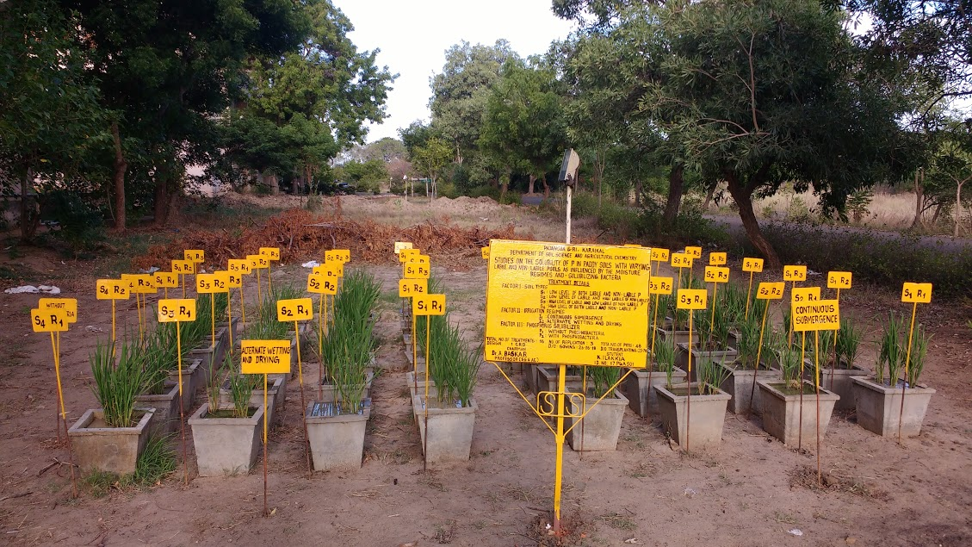
Figures

Fig. 1. General view of the pot culture experiment
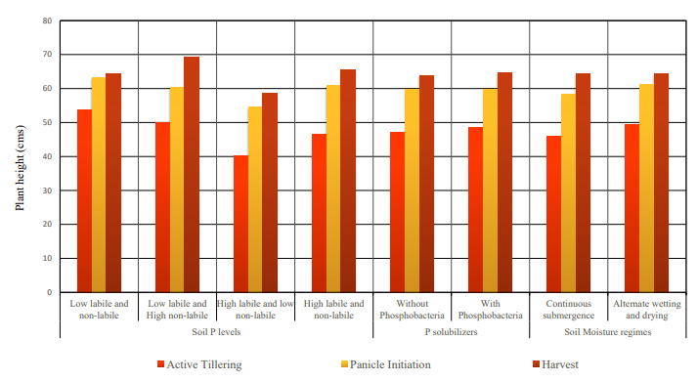

Fig. 2. Effect of varying labile and non-labile P, moisture regimes, phosphobacteriaon Plant height (cms) at different growth stages of rice crop

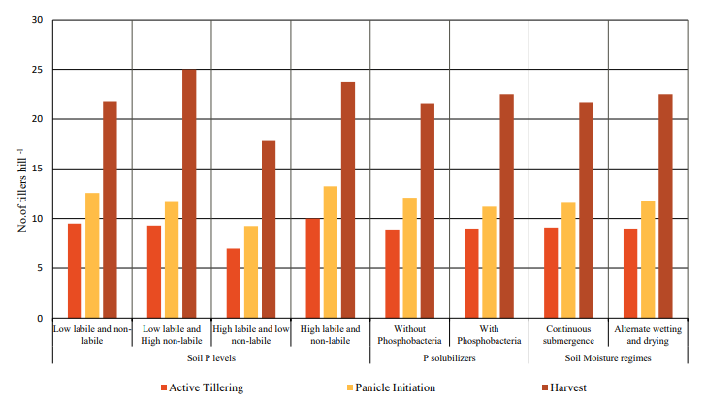

Fig. 3. Effect of varying labile and non-labile P, moisture regimes and phosphobacteria on Number of tillers per hill⁻¹ at different growth stage of rice crop
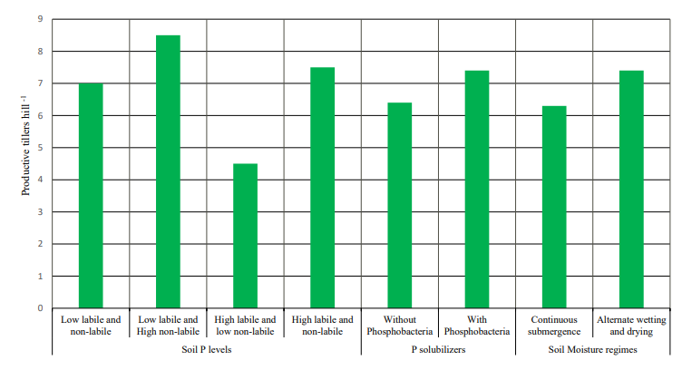

Fig. 4. Effect of varying labile and non-labile P, moisture regimes and phosphobacteria on Number of productive tillers per hill⁻¹ at harvest stage of rice

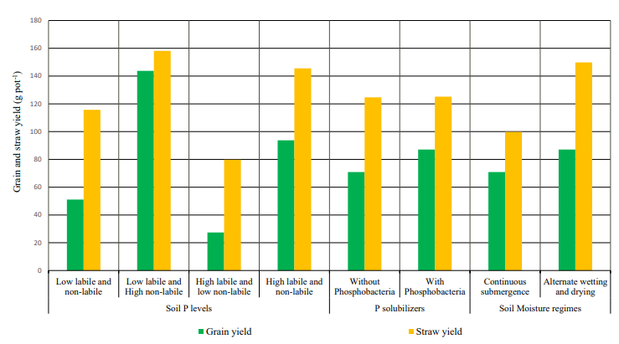

Fig. 5. Effect of varying labile and non-labile P, moisture regimes and phosphobacteria on Grain yield and Straw yield (g pot⁻¹) of rice
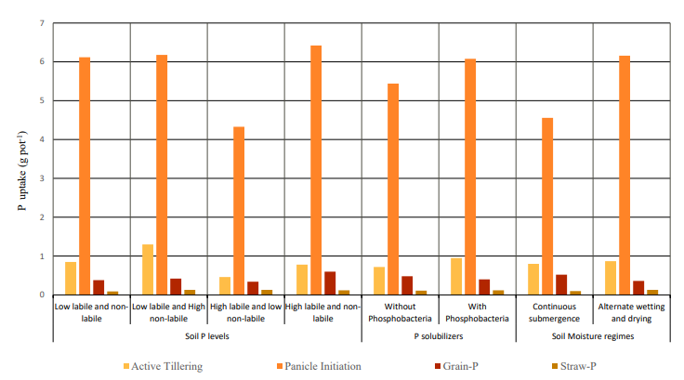

Fig. 6. Effect of varying labile and non-labile P, moisture regimes and phosphobacteria on P Uptake of rice at active tillering, panicle initiation, grain and straw (g pot⁻¹)

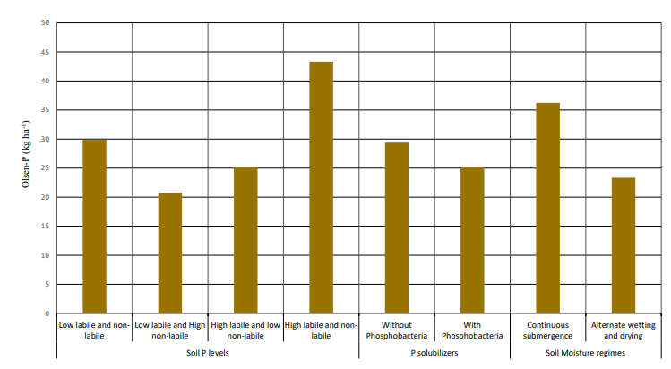

Fig. 7. Effect of varying labile and non-labile P, moisture regimes and phosphobacteria on post- harvest soil available Olsen-P
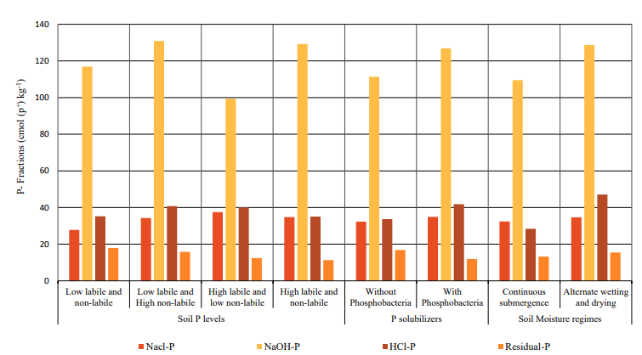

Fig. 8. Effect of varying labile and non-labile P, moisture regimes and phosphobacteria on P- Fractions in post- harvest soil after rice crop

