Case report

Single Puppy Syndrome in a Bitch: A Rare Case Report

Abstract
Singleton pregnancies in bitches are rare and often associated with obstetrical complications due to inadequate endocrine and mechanical stimuli for parturition. This report describes a case of Single Puppy Syndrome in a four-year-old primiparous Labrador Retriever, which presented with failure to initiate whelping on the expected date of delivery. Diagnosis was confirmed through radiography, revealing a single fetus in anterior presentation. Medical management with oxytocin, calcium, and supportive therapy resulted in expulsion of a stillborn fetus. The case highlights the clinical significance of early recognition and management of singleton pregnancies in bitches.
Keywords
Canine dystocia; Uterine inertia; Single Puppy Syndrome; Labrador Retriever; Singleton pregnancy
Introduction
Reproduction in canines is a complex physiological process influenced by maternal, fetal, genetic, and environmental factors. Bitches are polytocous animals, typically delivering multiple pups per pregnancy. However, deviations in litter size, particularly singleton pregnancies, are rare and often associated with parturition difficulties. The condition, termed Single Puppy Syndrome, refers to gestation with only one fetus developing in the uterus. Singleton pregnancies are clinically significant because the absence of multiple fetuses reduces the mechanical and endocrine stimuli necessary to initiate normal parturition. Inadequate fetal cortisol secretion and poor uterine distension may result in primary uterine inertia, leading to delayed whelping, dystocia, or fetal death. Furthermore, singleton fetuses often grow larger due to the excess intrauterine space and maternal nutrition, predisposing the dam to obstructive dystocia. This report describes a rare case of Single Puppy Syndrome in a Labrador Retriever bitch, focusing on clinical presentation, diagnosis, therapeutic management, and outcome.
Case Presentation
A four-year-old, primiparous, female Black Labrador Retriever weighing 29 kg was presented to the Veterinary Clinical Complex, Ranchi Veterinary College, Ranchi (Jharkhand), with a history of natural breeding 65 days earlier and failure to whelp on the expected date of delivery. The owner reported nesting behavior and mammary secretion prior to presentation.
Clinical examination revealed restlessness, lateral recumbency, and greenish vaginal discharge. The rectal temperature was 102.2 °F. A lateral abdominal radiograph confirmed the presence of a single fetus in anterior presentation, dorso-pubic posture, with the head engaged in the birth canal( Fig 1). Based on clinical and radiographic findings, a diagnosis of uterine inertia associated with Single Puppy Syndrome was made ( Domoslawska et al 2011).
Medical management was initiated with intramuscular injection of Syntocinon (Oxytocin 5 IU), intravenous administration of Calcium Sandoz 10% (10 ml), Dextrose 10% (300 ml), Polybion (2 ml), and antibiotic therapy with Amoxrium forte (300 mg; 20 mg/kg b.wt BID). A second dose of oxytocin was administered 30 minutes later. Approximately 20 minutes following the second oxytocin dose, the bitch delivered a dead fetus enveloped within the placenta.
Post-parturition, injection Methergin (0.2 ml IM) was administered to facilitate uterine clearance. The bitch was subsequently maintained on antibiotics (Amoxrium forte – 300 mg BID for 5 days) and analgesics (Melonex 0.2 mg/kg IM for 3 days). The dam recovered uneventfully.
Discussion
Canine parturition is initiated by a cascade of hormonal events, with fetal cortisol playing a central role in stimulating maternal prostaglandin and oxytocin release. In singleton pregnancies, the lack of multiple fetuses results in insufficient endocrine signaling and inadequate uterine stretch, predisposing to primary uterine inertia (England & Russo, 2006; Pretzer, 2008).
The present case demonstrated typical features of Single Puppy Syndrome—failure to whelp at term (Fig 2), placental separation indicated by greenish discharge, and radiographic confirmation of a single fetus ( Fig 1) (Suresh, 2018). Singleton fetuses are prone to oversize due to excessive uterine nutrition, further complicating delivery (Jayakumar et al 2017 and Evans & Anderton, 1992). In this case, medical management successfully induced uterine contractions and led to expulsion of the fetus, although it was stillborn—likely due to hypoxia from prolonged intrauterine retention (Ayana etal 2024).
Literature indicates that cesarean section is often the treatment of choice in singleton pregnancies, particularly in predisposed breeds like Labrador Retrievers (Jackson. 2004 and Groppetti et al., 2010). However, timely medical intervention may suffice when the fetus is appropriately positioned. Supportive therapy with calcium, glucose, and ecbolics plays a crucial role in stimulating myometrial activity and preventing postpartum complications ( Balamurugan and Maurya 2022).
This case underscores the importance of early pregnancy monitoring through ultrasonography and radiography, particularly in breeds predisposed to dystocia. Anticipating singleton pregnancies enables veterinarians to plan timely obstetric intervention, including elective cesarean section when warranted, thereby reducing perinatal mortality.
Clinical Significance
Single Puppy Syndrome is an uncommon but clinically important reproductive disorder in bitches, often resulting in uterine inertia and perinatal loss. Early recognition through pregnancy monitoring and timely obstetric intervention are essential to ensure maternal survival and improve fetal outcomes. This case emphasizes the need for routine use of ultrasonography and radiography to anticipate singleton pregnancies and plan appropriate clinical management.
Conclusion
Single Puppy Syndrome, though rare, is an important cause of dystocia and perinatal mortality in bitches. Veterinary practitioners should consider this condition in cases of prolonged gestation or failure of parturition. Early diagnosis, vigilant monitoring, and prompt obstetrical intervention are critical to ensure maternal survival and optimize fetal outcome.

Conflict of interest
None

References
Ayana, C.I., Jayakumar, C., Simon, S., Becha, B. and Kariyil, B.J.(2024).Medical management of canine high-risk pregnancies with single pup syndrome. J. Vet. Anim. Sci.,55(2):374-379.
Balamurugan.,B. and Maurya, Vipin (2022) Canine Reproductiuon- A text book for Practicing Veterinarians and students. pp. 148-150.Jaya Publishing House, New Delhi.
Concannon, P. W. (2011). Reproductive cycles of the domestic bitch. Animal ReproductionScience,124(3–4),200–210 (https://doi.org/10.1016/j.anireprosci.2010.08.028)
Domoslawska A, JurczakA, andJanowski T. (2011) A one-foetus pregnancy monitored by ultrasonography and progesterone blood levels in a German Shepherd bitch: a case report. VeterinarniMedicina. 56:55-57
England, G. C. W., & Russo, M. (2006). Uterine inertia in the bitch: A review. Journal of Small Animal Practice,47(3),145–150.[https://doi.org/10.1111/j.1748-5827.2006.00067.x
Evans, J. M., &Anderton, T. L. (1992). Singleton pregnancy in the bitch: Report of three cases. Journal of Small Animal Practice, 33(12), 574–577. [https://doi.org/10.1111/j.1748-5827.1992.tb01080.x
Groppetti, D., Pecile, A., Arrighi, S., & Di Giancamillo, M. (2010). Breed-specific maternal dystocia in the bitch. Reproduction in Domestic Animals, 45(6), 1182–1185. [https://doi.org/10.1111/j.1439-0531.2009.01492.x]
Jackson., P.G.G. (2004). Dystocia in the dog In: Hand book of Veterinary Obstetrics (ed), Saunders and Imprint of Elsevier Ltd. Edinbourgh, 2:141-166.
Jayakumar C, Chinu PV, Amritha A. (2017). Challenges in management of canine high-risk pregnancies with single pup syndrome. Indian journal of canine practice. 22-26.
Johnston, S. D., Root Kustritz, M. V., & Olson, P. N. S. (2001). Canine and Feline Theriogenology. Philadelphia: W\.B. Saunders Company.
Pretzer, S. D. (2008). Medical management of canine dystocia. Theriogenology, 70(3), 332–336. [https://doi.org/10.1016/j.theriogenology.2008.04.038]
Suresh A. (2018). Did you know about single puppy syndrome? Dogs and Pups magazine.pp. 14.

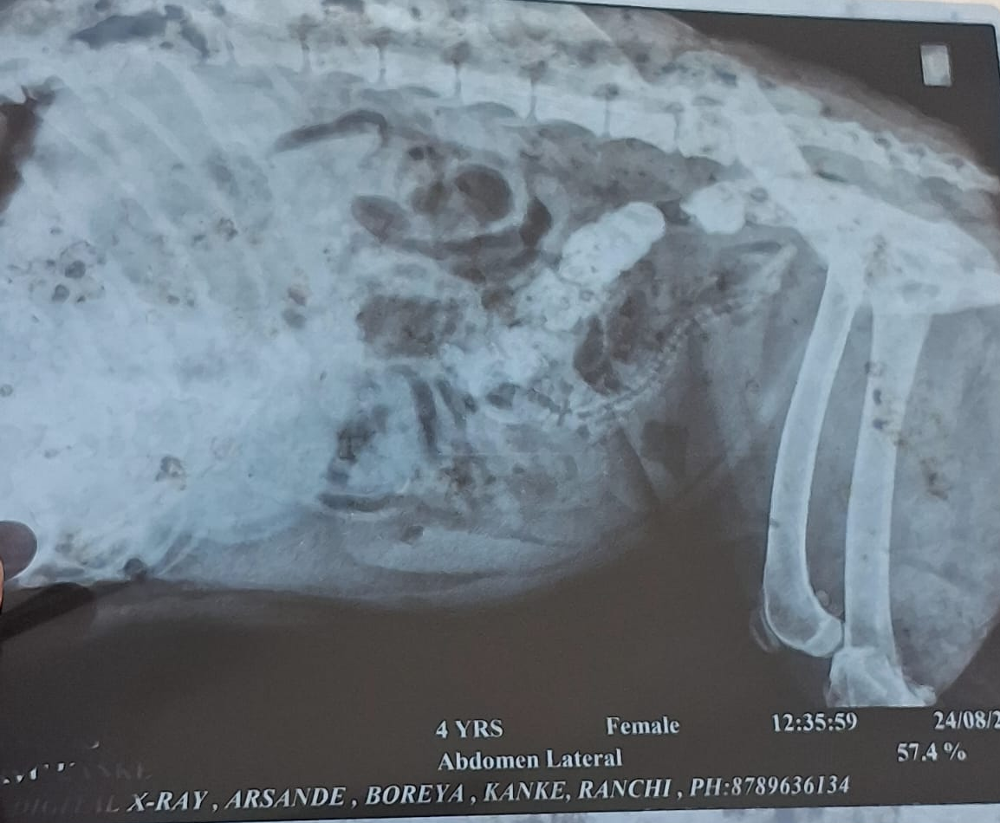
Fig 1. X- ray image reveal single puppy.
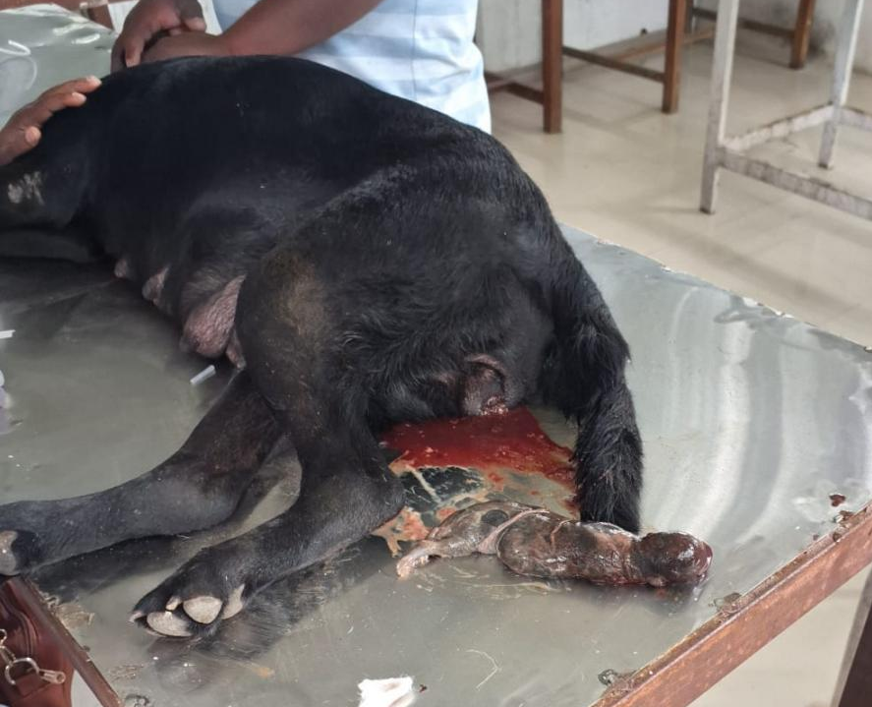
Fig 2: Image of single whelped puppy after treatment.

