Review Article

Recognition Mechanism and Signal Transduction During Plant-Pathogen Interaction

Abstract
Plants are constantly exposed to broad spectrum of pathogens, ranging from bacteria and fungi to viruses and nematodes. Unlike animals, plants lack an adaptive immune system and instead depend on a complex, multilayered innate defense framework to counteract pathogenic attacks. This review delves into the intricate biological processes by which plants sense invading pathogens and transduce those signals to mount appropriate immune responses. The frontline of this inducible defense, termed Pattern-Triggered Immunity (PTI), is initiated when pattern recognition receptors (PRRs) located on the cell surface detect conserved molecular patterns unique to pathogens, known as PAMPs. Well-characterized receptors like FLS2 and CERK1 recognize microbial cues such as bacterial flagellin and fungal chitin, respectively. Once triggered, this recognition sets off a cascade of early immune responses marked by calcium ion fluxes, bursts of reactive oxygen species (ROS), and the activation of mitogen-activated protein kinases (MAPKs) which collectively drive large-scale transcriptional changes aimed at fortifying plant defense. However, many pathogens have evolved mechanisms to overcome PTI by secreting specialized effector molecules into the host, thereby promoting Effector-Triggered Susceptibility (ETS). To combat this, plants possess intracellular immune receptors, notably nucleotide-binding leucine-rich repeat (NLR) proteins, which detect these effectors directly or indirectly and activate a secondary, often more potent response known as Effector-Triggered Immunity (ETI). ETI frequently involves localized cell death at the infection site, termed the hypersensitive response (HR), which restricts pathogen spread. Additionally, immune activation often culminates in Systemic Acquired Resistance (SAR) a long-lasting, broad-spectrum defense response that primes distal, uninfected tissues against future infections. entral to the regulation and fine-tuning of these immune layers are hormonal pathways involving salicylic acid, jasmonic acid, and ethylene, which help determine the specificity, strength, and duration of immune responses.
Keywords: Pattern-Triggered Immunity (PTI), Effector-Triggered Immunity (ETI), Pathogen-Associated Molecular Patterns (PAMPs), Nucleotide-binding Leucine-rich Repeat (NLR) proteins and Systemic Acquired Resistance (SAR).

Introduction:
Plants constantly face threats from a diverse range of pathogens present in their surroundings. When infection occurs successfully, it can severely impact both the quality and quantity of crop yields. As a result, effective disease management has become a vital aspect of modern agricultural practices. With the global population steadily increasing, there is a growing need to boost agricultural productivity in order to ensure sufficient food supply for future generations (Hofstra & Vermeulen, 2016). In this way, protection of plant particularly against plant diseases plays a important role in maintaining crop productivity and food security (Strange & Scott, 2005). The diseases are not only threatening yield stability but also contribute to rhe significant economic losses globally. Currently, worldwide crop losses due to disease are estimated to exceed $100 billion (Brears, T., & Ryals, J. (1994). Plant disease susceptibility and resistance are due to the combined genotypes of host and pathogen which depend on a complex communication of signals and responses occurring under certain environmental conditions; during the long process of host-pathogen co-evolution, plants have evolving by developing various elaborate mechanisms to ward off pathogen attack, whereas some of these defense mechanisms are preformed and provide the chemical and physical barriers to reduce pathogen infection, others are induced only after pathogen attack (Yang et al., 1997).
In plants, the first layer of defense against pathogenic organisms and herbivores is formed by physical structures namely, the cuticle and cell wall which serve as passive barriers that prevent the initial entry of invaders (Stael et al., 2015). However, when these structural defenses are compromised, plants are capable of sensing disruptions in the cuticle, which can activate a cascade of defense signaling events (Chassot et al., 2007). Once the integrity of this outer barrier is breached, plants shift to deploying inducible immune responses that function to contain the threat and limit further tissue damage. These secondary defense mechanisms are often localized and involve the detection of distinct molecular cues—such as proteins or elicitors—released by invading pathogens or herbivores (Malik et al., 2020).
A robust immune response in plants initiates with the capacity to detect invading pathogens via specialized surveillance mechanisms. This recognition is mediated by host-encoded receptors that detect either conserved microbial signatures or specific pathogen-derived effectors McDowell, J. M., & Dangl, J. L. (2000). The plant immune system is fundamentally composed of two distinct but interconnected branches. PTI is mediated by transmembrane like pattern recognition receptors (PRRs) such as FLS2 or CERK1, which recognize conserved microbial features known as pathogen-associated molecular patterns (PAMPs) or microbe-associated molecular patterns (MAMPs), including flagellin of bacterial and fungal chitin at cell surface (Zipfel, C., & Felix, G. 2005). The second branch functions predominantly within the cytoplasm and involves highly polymorphic nucleotide-binding leucine-rich repeat (NB-LRR) proteins encoded by resistance (R) genes Dangl, J. L., & Jones, J. D. (2001). These intracellular receptors are defined by their conserved NB and LRR domains and are responsible for detecting pathogen-secreted effector molecules Pattern-Triggered Immunity (PTI) and Effector-Triggered Immunity (ETI). PTI is typically initiated at cell surface by the recognition of pathogen-associated molecular patterns (PAMPs) through pattern recognition receptors (PRRs), while ETI is activated inside cell upon detection of effector proteins by resistance (R) proteins. Together, these layers form a robust defense framework that allows plants to detect a wide range of microbial threats and activate appropriate defense responses.
Though once considered distinct, PTI and ETI are now viewed as overlapping and synergistic branches of plant immunity, with shared signaling components such as Ca²⁺ influx, reactive oxygen species (ROS), mitogen-activated protein kinases (MAPKs) and transcription factors like WRKYs. Hormonal pathways, including jasmonic acid (JA), salicylic acid (SA) and ethylene (ET), further modulate these immune responses. Understanding pathways related to this offers critical insights for developing durable, broad-spectrum resistance in crops through both traditional breeding and modern biotechnological tools.

Pattern Recognition and Pattern-Triggered Immunity (PTI)
The first layer of inducible plant defense is initiated through the perception of conserved pathogen-derived molecules known as pathogen-associated molecular patterns (PAMPs) or microbe-associated molecular patterns (MAMPs) (Nürnberger, T. and Kemmerling, B., 2009). These PAMPs are typically essential microbial structures /molecules/ compouds that are conserved across a wide range of taxa and unlikely to mutate due to functional constraints. The recognition of these molecules occurs at the cell surface through transmembrane pattern recognition receptors (PRRs), triggering a robust basal immune response referred to as pattern-triggered immunity (PTI). PTI is considered the foundational defense layer in plants and plays a vital role in preventing infection by non-adapted or weakly virulent pathogens (Hou et al., 2019).

Pattern Recognition Receptors (PRRs)
Numerous microbes associate with plants and establish complex interactions. PAMPs are conserved molecular structures derived from microbes, which are sensed by plant cell surface-localized PRRs to trigger an immune response and prevent microbial infection (Ausubel, 2005; Bittel and Robatzek, 2007; Boller and Felix, 2009; Zipfel, 2009; Sun et al., 2017). PRRs are typically divided into two main structural categories: receptor-like kinases (RLKs) and receptor-like proteins (RLPs). RLKs possess an extracellular domain for binding of ligand, a transmembrane domain, and an intracellular threonine/serine kinase domain required for downstream signaling. One of the best-characterized PRRs is FLS2 (Flagellin Sensing 2), an RLK that recognizes a conserved 22-amino acid epitope of bacterial flagellin known as flg22. Another well-known PRR is EFR (EF-Tu Receptor), which detects the elf18 epitope of elongation factor-Tu, another bacterial protein. In fungal interactions, CERK1 (Chitin Elicitor Receptor Kinase 1) plays a central role in detecting chitin, a key component of fungal cell walls. These PRRs can detect PAMPs at nanomolar concentrations, enabling plants to mount a rapid immune response (Fröhlich, K., 2020).

In many cases, pattern recognition receptors (PRRs) do not perform function alone but instead rely on co-receptors to achieve full signaling competence. A well-known example is BAK1 (BRI1-Associated Receptor Kinase 1), which forms ligand-induced complexes with surface-localized PRRs such as FLS2 and EFR upon perception of their respective PAMPs, flg22 and elf18 (Roux, 2010; Yu et al., 2021). BAK1 is not limited to immunity alone; it also plays crucial roles in developmental processes, underscoring the multifunctionality of certain signaling components. Another key co-receptor, SOBIR1 (Suppressor of BIR1-1), is essential for the activation of receptor-like proteins (RLPs), which lack intracellular kinase domains. For instance, SOBIR1 is required for the signaling activity of RLP42, a receptor involved in recognizing fungal endopolygalacturonases and initiating downstream immune responses (Gust & Felix, 2014).

PAMPs: Diverse Triggers of Defense
PAMPs encompass a wide range of molecular structures that include proteins, carbohydrates and lipopolysaccharides. These molecules must meet certain criteria: which are highly conserved across a broad group of microbes, essential for microbial fitness, and absent in host plants. These are key traits which make them ideal molecules for the plant immune system to target, as pathogens cannot easily mutate them without incurring a fitness cost.

Examples of bacterial PAMPs include:
Flagellin (flg22) detected by FLS2, EF-Tu (elf18) detected by EFR and Cold shock proteins (csp22) recognized by CORE in tomato (Wang, L. 2018). Fungal and oomycete PAMPs include: Chitin fragments recognized by CERK,1 β-glucans recognized by yet-unidentified receptors and necrosis and ethylene-inducing peptide 1-like proteins (NLPs) recognized by RLP23 in Arabidopsis (Wang'ombe, 2019). Fungal and oomycete PAMPs include: Chitin fragments recognized by CERK,1 β-glucans recognized by yet-unidentified receptors and necrosis and ethylene-inducing peptide 1-like proteins (NLPs) recognized by RLP23 in Arabidopsis (Wang'ombe, M. W. 2019). An example of bacteria flagellin and the chitin fragment is shown in the figure is show in the Fig. 1
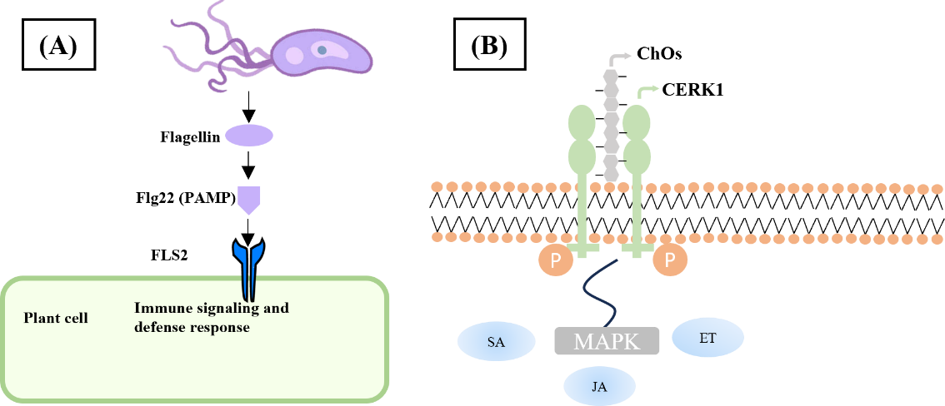
Fig 1: Examples for PAMPs and their receptors (A) Flg22(Flagellin 22) from bacteria flagellin. (B) Cho’s (chitin oligosaccharides) from fungi
Early PTI Signaling Events
Upon PAMP recognition, PRRs undergo rapid conformational changes and phosphorylation, initiating intracellular signal transduction cascades. One of the earliest responses is the activation towards cytoplasmic kinases, especially receptor-like cytoplasmic kinases (RLCKs) such as BIK1 (Botrytis-induced kinase 1). BIK1 associates with the FLS2–BAK1 complex and becomes phosphorylated, after which it phosphorylates reduces the targets that lead to calcium influx and ROS production (Macho & Zipfel, 2014). Within minutes of PRR activation, plants exhibit: Calcium influx into the cytosol via calcium-permeable channels like CNGCs (cyclic nucleotide-gated channels). Burst of reactive oxygen species (ROS), primarily via activation of NADPH oxidases such as RBOHD. Activation of MAP kinase (MAPK) cascades, particularly MPK3, MPK6, and MPK4 (Demidchik & Shabala, 2017).

Transcriptional Reprogramming and Defense Output
A key downstream consequence of PTI activation is the extensive shift in gene expression patterns across the plant transcriptome. Upon detection of PAMPs, a wide array of genes is either upregulated or repressed, with many contributing directly to the plant’s defensive arsenal. This includes genes involved in strengthening the cell wall, such as those mediating callose deposition through enzymes like PMR4. Others direct the biosynthesis of antimicrobial secondary metabolites, notably phytoalexins such as camalexin, which play a role in limiting pathogen spread. Additionally, genes encoding defense-related proteins including pathogenesis-related (PR) proteins, protease inhibitors, and chitin-degrading enzymes are significantly induced as family of the immune response (Wang et al., 2021; Chen et al., 2024).
Several transcription factors play a key role in orchestrating defense responses for plant during pattern-triggered immunity. Among these, members of the WRKY family, such as WRKY22 and WRKY33, are particularly seen for their involvement in activating immune-related genes. TGA transcription factors work alongside NPR1, especially within the salicylic acid signaling pathway, to promote systemic acquired resistance. Additionally, factors from the MYB and ERF families contribute to regulating genes involved with jasmonic acid and ethylene-mediated defense mechanisms (Vidhyasekaran & Vidhyasekaran, 2016; Sultana et al., 2025).

PTI in Non-Model and Crop Plants

While much of the current understanding of PTI derives through the model plants like Arabidopsis thaliana, similar mechanisms have been seen in other crop species. Tomato (Solanum lycopersicum) has PRRs like Cf proteins that confer resistance to Cladosporium fulvum (Zhao et al., 2019). Rice (Oryza sativa) utilizes OsCERK1 and CEBiP to detect chitin (Shimizu et al., 2010). Grapevine PRRs responds to flg22 and harpin proteins, showing conservation of PTI across angiosperms (Chang & Nick, 2012).

Effector Recognition and Effector-Triggered Immunity (ETI)

Although pattern-triggered immunity (PTI) forms the initial inducible defense barrier in plants, many adapted pathogens have evolved strategies to bypass or dampen this response. To counter such strategies, plants have developed a second, more specialized layer of immune defense known as Effector-Triggered Immunity (ETI). This response is initiated when plant-encoded resistance (R) proteins, mainly belonging to the nucleotide-binding leucine-rich repeat (NLR) family, recognize specific pathogen-derived effector molecules (Nabi et al., 2024). Unlike the relatively mild and transient PTI, ETI tends to be a stronger and longer-lasting immune response, often divided by a localized response towards cell death at the site of infection, described as the hypersensitive response (HR).

Pathogen Effectors: Tools for Immune Suppression

To establish a successful infection, pathogens deploy effector proteins into host plant cells using highly specialized secretion systems. For instance, bacterial pathogens rely on Type III secretion systems (T3SS), while fungi and oomycetes use haustoria or similar invasive structures (Puhar & Sansonetti, 2014). Once delivered, these effectors manipulate the host's cellular processes to promote infection. Some effectors interfere with immune signaling directly for example, Pseudomonas syringae effectors such as AvrPto and AvrPtoB can bind to key immune receptors like FLS2 and its co-receptor BAK1, thereby blocking downstream defense signaling. Others, such as HopAI1, target MAP kinases, disabling them through dephosphorylation to suppress transcription of immune genes (Li et al., 2016).
Plants recognize effector activity through a specialized class of intracellular immune receptors known as nucleotide-binding leucine-rich repeat (NLR) proteins. These receptors typically consist of an N-terminal domain either a coiled-coil (CC) or a Toll/interleukin-1 receptor (TIR) type a central NB-ARC domain that binds and hydrolyzes ATP or GTP, and a C-terminal LRR region involved in effector recognition (Förderer & Kourelis, 2023). NLRs serve as intracellular sentinels, capable of detecting either the effector itself or its impact on host targets. Based on their mode of action, NLRs operate through direct effector binding, as seen with RPS2 recognizing AvrRpt2; through guarding host proteins, like RPM1 monitoring RIN4; or by employing molecular decoys that mimic effector targets to bait the pathogen and trigger immune activation (Qi & Innes, 2013).
The signaling cascade activated during ETI closely mirrors that of PTI, involving calcium ion fluxes, ROS production via RBOHD, MAP kinase activation, and WRKY-mediated transcription responses previously described in PTI. However, during ETI, these defenses are amplified and sustained for longer periods. NLR activation, such as ZAR1 forming a resistosome, leads to stronger immune output, often culminating in localized cell death. Salicylic acid (SA) levels also rise sharply, reinforcing both local resistance and systemic acquired resistance (SAR).

Hypersensitive Response (HR): Programmed Cell Death as Defense

A hallmark of effector-triggered immunity (ETI) is the hypersensitive response (HR). A localized version of programmed cell death (PCD) that halts biotrophic pathogens by sacrificing infected and neighbouring cells (Dalio et al., 2021). This process is orchestrated through a sequence of tightly regulated events, including the rapid accumulation of ROS and NO, leading to disrupting the plasma membrane integrity, activation of proteases such as metacaspases, and nuclear breakdown leading to DNA fragmentation. HR acts as a containment strategy, but to prevent unintended tissue damage, it is kept in check by negative regulators like certain NLR repressors and ubiquitin-mediated pathways (Shlapakova et al., 2020). Furthermore, the interplay of defense hormones particularly salicylic acid (SA), jasmonic acid (JA), and ethylene (ET) modulates the strength and extent of HR based on the pathogen’s lifestyle and environmental cues.

ETI Across Model and Crop Species

The ETI mechanism is highly conserved and widely documented across various plant taxa. In the model plant Arabidopsis thaliana, key NLRs such as RPM1, RPS2, RPP1, and ZAR1 have been instrumental in dissecting ETI pathways. Similarly, numerous crop species rely on NLR-mediated immunity for pathogen resistance. Examples include: Rice: the Pi-ta gene, which detects the effector AVR-Pita from Magnaporthe oryzae (Xiao et al., 2024); Tomato: Pto, which perceives AvrPto from Pseudomonas syringae (Lin & Martin, 2005); and Potato: R3a, effective against Phytophthora infestans(Chapman et al., 2014).

Zig-Zag Model of Plant Immunity: Integrating PTI, ETS, and ETI

The evolving interaction between plants and pathogens is well illustrated by the zig-zag model, which outlines the fluctuating strength of immune responses during the course of infection. Initially, plants recognize conserved microbial signatures known as PAMPs, leading to the activation of pattern-triggered immunity (PTI) a moderate but effective defense response. However, adapted pathogens deploy effector proteins that suppress PTI, resulting in effector-triggered susceptibility (ETS) and allowing colonization to proceed. This is depicted in the model as a dip in defense amplitude following the initial PTI peak (Jones & Dangl, 2006).

In response, plants counter this suppression by evolving R proteins (often NLRs) that specifically recognize avirulence (Avr) effectors. This interaction triggers effector-triggered immunity (ETI), a heightened immune reaction that often surpasses the threshold required for hypersensitive response (HR) a form of localized programmed cell death (Wu et al., 2014). The Fig. 2 further illustrates how pathogens may again evolve novel effectors to evade recognition, temporarily regaining virulence and causing a subsequent drop in defense. However, the plant immune system continues to adapt, recognizing newer effectors and re-establishing ETI. This back-and-forth dynamic is reflected in the zig-zag pattern of immune intensity, underscoring the co-evolutionary race between host defense mechanism and pathogen offense tactics.
Early Events: Calcium Influx, ROS Burst and Kinase Activation

Upon sensing pathogen-derived molecules, plants trigger rapid intracellular signals to translate detection into an effective immune response. One of the earliest shifts is a transient rise in cytosolic calcium (Ca²⁺), which acts as a central secondary messenger. Calcium sensors such as calmodulins (CaMs) and calcium-dependent protein kinases (CDPKs) decode these changes and initiate phosphorylation cascades that lead to altered gene expression and defense mobilization (Kameswaran et al., 2024).
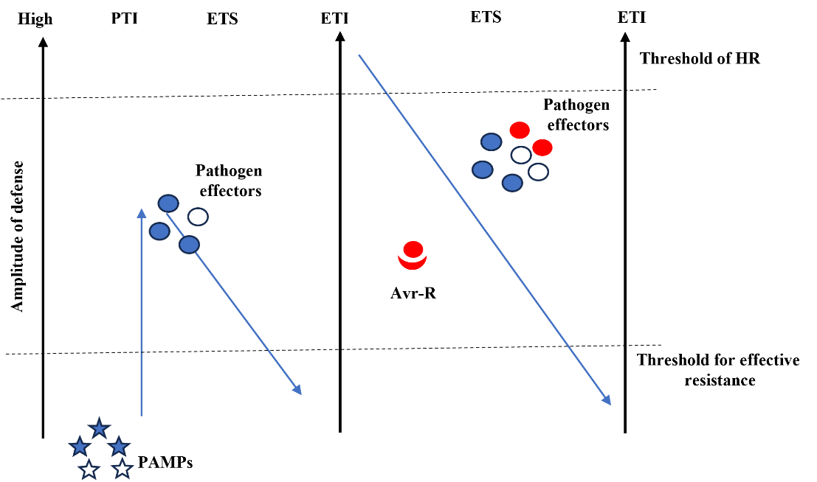
Fig 2. The Zig-Zag Model of Plant Immunity: Integration of Pattern-Triggered Immunity (PTI), Effector-Triggered Susceptibility (ETS), and Effector-Triggered Immunity (ETI)
Signal Transduction in Plant Immunity
At the same time, a burst of reactive oxygen species (ROS), largely catalyzed by NADPH oxidase RBOHD, is unleashed at the site of infection. These ROS serve dual functions direct antimicrobial action and amplification of downstream signaling. Interestingly, Ca²⁺ and ROS often reinforce themselves through positive feedback loops, ensuring robust signal propagation (Zhang et al., 2018). Simultaneously, mitogen-activated protein kinase (MAPK) cascades particularly involving MPK3, MPK4 and MPK6—are activated. These cascades, organized in a three-tiered structure (MAPKKK → MAPKK → MAPK), transmit signals to the nucleus, where it is regulated by transcription factors and enzymes central to defense, including those involved in phytoalexin synthesis and PR gene induction (Bai, 2018).
Following the early waves of calcium influx and ROS generation, plant immune signaling relies on an array of secondary messengers to fine-tune and amplify the response. Among the most prominent are nitric oxide (NO) and inositol phosphates, which act in tandem with Ca²⁺ and ROS to coordinate downstream defense outputs. Nitric oxide is rapidly synthesized upon PAMP or effector recognition, often via nitric oxide synthase-like (NOS-like) enzymes or nitrate reductase pathways. NO functions both as a diffusible signaling molecule and a modulator of redox homeostasis. It interacts synergistically with ROS to induce programmed cell death (HR) and can modify proteins through S-nitrosylation, altering the activity of transcription factors and kinases involved in defense (Delledonne et al., 1998). Its tight spatial and temporal regulation ensures that the immune responses are confined and effective.
Inositol phosphates, particularly inositol triphosphate (IP₃) and phosphatidylinositol-4,5-bisphosphate (PIP₂), play a key role in calcium mobilization from intracellular stores. The cleavage of PIP₂ by phospholipase C (PLC) generates IP₃, which binds to IP₃ receptors on the endoplasmic reticulum, triggering the release of stored Ca²⁺ and further amplifying cytosolic calcium signaling. This mechanism not only boosts the early calcium wave but also enables spatial propagation of the immune signal across tissues. Additionally, cyclic nucleotides (cAMP and cGMP) and phosphatidic acid (PA) have been footprinted in plant immunity, though their roles are less clearly defined (Torti & Lapetina, 2002). PA is known to interact with NADPH oxidases and protein kinases, potentially bridging lipid signaling and oxidative bursts. Together, these secondary messengers create a dynamic signaling network that ensures precise coordination towards immune responses across cellular compartments.
Hormonal Integration and Crosstalk in Plant Immunity
Phytohormones function as key regulators that integrate immune signals and coordinate appropriate defense responses based on the pathogen’s lifestyle. Among them, salicylic acid (SA), jasmonic acid (JA), and ethylene (ET) form the core hormonal triad that modulates plant immunity. SA is primarily associated with defense against biotrophic pathogens, which require living host cells for survival (Yang et al., 2015). Upon recognition of PAMPs or effectors, SA levels increase locally and systemically, promoting the expression of genes related to pathogenesis-related (PR) and the establishment of systemic acquired resistance (SAR). Central to this pathway is NPR1 (non-expressor of pathogenesis-related genes 1), a redox-sensitive regulator that modulates SA-responsive transcriptional programs (Pieterse et al., 2012). NPR1 translocates to the nucleus in its monomeric form, where it interacts with transcription factors to activate PR gene expression.
A striking feature of plant hormonal signaling is the SA–JA antagonism. These pathways can suppress each other, ensuring that energy is allocated to the most relevant defense arm. For instance, SA can suppress JA-mediated defenses during biotroph attack, while JA may dampen SA responses under necrotroph infection. Certain pathogens exploit this antagonism to their advantage—for example, Pseudomonas syringae produces coronatine, a JA mimic, to suppress SA-mediated resistance and facilitate colonization.
Transcriptional Reprogramming in Defense Signaling
Following recognition of PAMPs or effectors, hundreds of genes are differentially regulated, enabling the plant to mount tailored responses that restrict pathogen growth and spread. This transcriptional remodeling is orchestrated by a diverse network of transcription factors (TFs) that act downstream of MAPK cascades, calcium signaling, and hormone pathways. Among the most prominent TF families are the WRKY proteins, which bind to W-box motifs in promoter regions of defense-related genes. Notably, WRKY33 plays a pivotal role in defense against necrotrophs by regulating camalexin biosynthesis and other antimicrobial pathways, while WRKY22 and WRKY29 function downstream of MAPKs like MPK3/MPK6 in PTI (Birkenbihl et al., 2017). The TGA family of transcription factors like bZIP also plays a central role, particularly in SA-mediated defense. In assosciation to elevated SA levels, NPR1 monomerizes and translocates to the nucleus, where it interacts with TGA TFs to activate PR genes, reinforcing both local and systemic resistance (Zhang & Zhou, 2010). Meanwhile, MYB and ERF transcription factors are heavily involved in JA and ET signaling. MYB TFs often regulate phenylpropanoid pathways, contributing to lignin, flavonoid and phytoalexin production, while ERFs activate genes which are required for resistance against necrotrophs and herbivory, such as PDF1.2 (Thilakarathne et al., 2003).
Systemic Acquired Resistance (SAR)
Upon localized infection, plants not only mount a site-specific defense but also activate long-lasting immunity throughout the entire organism a process termed Systemic Acquired Resistance (SAR). This broad-spectrum resistance enables distal, uninfected tissues to mount a quicker and more robust response upon future pathogen challenge. SAR is typically initiated during Effector-Triggered Immunity (ETI), especially when accompanied by a hypersensitive response (HR) (Consonni et al., 2009). Among the earliest events one is the accumulation of key compounds like salicylic acid (SA) at the infection site. Though SA itself may not efficiently move across long distances, it is converted into methyl salicylate (MeSA) a volatile derivative that acts as a mobile signal. Upon reaching distal tissues, MeSA is converted back into active SA by methyl esterase enzymes, triggering defense gene expression in remote organs (Park et al., 2007).
A central regulator of SAR is NPR1 (Nonexpresser of Pathogenesis-Related Genes 1), a redox-sensitive transcriptional coactivator. In systemic tissues, the intracellular redox environment changes, leading to the reduction of NPR1 oligomers into monomers. These monomeric forms translocate into the nucleus, where NPR1 interacts with transcription factors to promote the expression of pathogenesis-related (PR) genes, including PR-1, PR-2, and PR-5, which enhance the plant’s defensive capacity (Durrant & Dong, 2004).
In addition to SA and MeSA, recent discoveries have highlighted the key role of lipid-derived signals in SAR. Molecules like azelaic acid (AzA) and glycerol-3-phosphate (G3P) have been implicated in systemic signal transmission. These molecules may travel through the vascular system or plasmodesmata to prime distal tissues and amplify the SAR response (Jung et al., 2009). Furthermore, DIR1 (Defective in Induced Resistance 1), a lipid transfer protein, plays a vital role in the mobilization of SAR signals from the site of the infection to the rest of the host plant.
Importantly, SAR provides long-lasting and broad-spectrum protection not just against the primary pathogen but also against unrelated secondary invaders. This enhanced immunological memory without continuous defense activation makes SAR a critical trait of plant immunity (Roychowdhury et al., 2024). Additionally, SAR is a target for crop protection strategies. For instance, benzothiadiazole (BTH), a chemical analog of SA, can be used to artificially induce SAR in plants without pathogen infection, offering a sustainable and pathogen-independent disease management tool.
The sequential and interconnected layers of plant immune responses as illustrated in the Fig. 3. Pattern-Triggered Immunity (PTI) is the first line of inducible defense activated when Pattern Recognition Receptors (PRRs) on the cell surface detect conserved pathogen-associated molecular patterns (PAMPs), such as bacterial flagellin. This triggers early cellular signaling and local immune responses to halt pathogen invasion. However, evolved pathogens secrete effectors to suppress PTI, leading to Effector-Triggered Susceptibility (ETS). Plants overcome this by evolving intracellular Resistance (R) proteins, mainly NLRs, that recognize these effectors directly or indirectly, activating Effector-Triggered Immunity (ETI)—a more robust and often HR-associated immune response. Signals from PTI and ETI (including salicylic acid, pipecolic acid, and ROS) travel systemically to prime uninfected tissues, leading to Systemic Acquired Resistance (SAR). SAR enhances the plant’s ability to respond faster and stronger upon future attacks, providing long-lasting immunity. SAR is mediated by natural inducers (SA, Pip, NHP) and can also be artificially triggered by chemical analogs (BTH, INA, Probenazole).
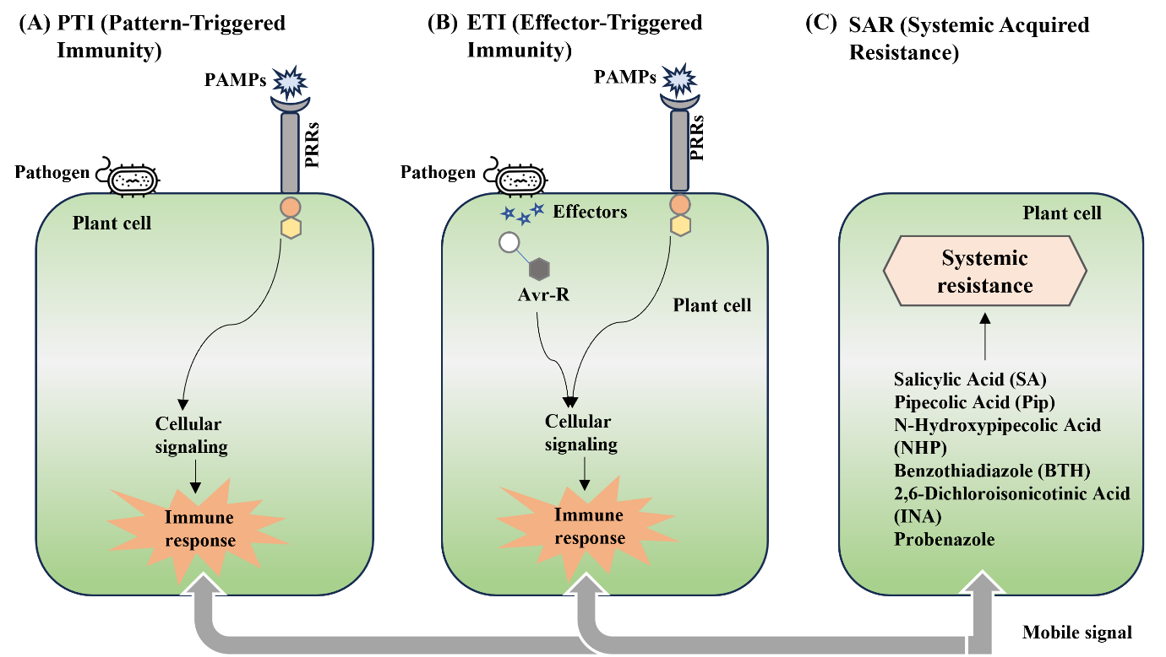Fig. 3 Interconnected pathways of plant immunity: (A) PTI (Pattern-Triggered Immunity), (B) ETI (Effector-Triggered Immunity) and (C) SAR (Systemic Acquired Resistance).
Conclusion
Plant immunity is far from passive; it is a dynamic, finely tuned system shaped by millions of years by coevolution with pathogens. From the recognition of extracellular microbial signatures to the intracellular sensing of stealthy effectors, plants demonstrate remarkable sophistication in perceiving and responding to threats. The interplay of PTI and ETI is not only sequential but also synergistic, reinforcing immune responses and providing robustness against a broad spectrum of pathogens. Signal transduction pathways involving ROS, calcium signaling, MAPKs, and hormonal crosstalk ensure that the defense response is both rapid and context-appropriate. Beyond localized defense, the establishment of SAR equips the plant with systemic preparedness, underscoring the importance of long-term immune memory. As global agriculture faces increasing disease pressures amid climate change and intensive cultivation, leveraging this deepened understanding of plant immune mechanisms can revolutionize crop protection. Future research must continue to decode the complexities of immune signaling and effector recognition, thereby enabling the rational design of crops that are both high-yielding and resilient to emerging pathogens.

References:
Abdul Malik, N. A., Kumar, I. S., & Nadarajah, K. (2020). Elicitor and receptor molecules: orchestrators of plant defense and immunity. International Journal of Molecular Sciences, 21(3), 963.
Ausubel, F. M. (2005). Are innate immune signaling pathways in plants and animals conserved?. Nature immunology, 6(10), 973-979.
Bai, F. (2018). The roles of the small pMEKK subfamily comprising MAPKKK19, 20 and 21 in Arabidopsis thaliana.
Birkenbihl, R. P., Kracher, B., Roccaro, M., & Somssich, I. E. (2017). Induced genome-wide binding of three Arabidopsis WRKY transcription factors during early MAMP-triggered immunity. The Plant Cell, 29(1), 20-38.
Bittel, P., & Robatzek, S. (2007). Microbe-associated molecular patterns (MAMPs) probe plant immunity. Current opinion in plant biology, 10(4), 335-341.
Boller, T., & Felix, G. (2009). A renaissance of elicitors: perception of microbe-associated molecular patterns and danger signals by pattern-recognition receptors. Annual review of plant biology, 60(1), 379-406.
Brears, T., & Ryals, J. (1994). Genetic engineering for disease resistance in plants.
Chang, X., & Nick, P. (2012). Defence signalling triggered by Flg22 and Harpin is integrated into a different stilbene output in Vitis cells. PLoS One, 7(7), e40446.
Chapman, S., Stevens, L.J., Boevink, P.C., Engelhardt, S., Alexander, C.J., Harrower, B., Champouret, N., McGeachy, K., Van Weymers, P.S., Chen, X. and Birch, P.R., 2014. Detection of the virulent form of AVR3a from Phytophthora infestans following artificial evolution of potato resistance gene R3a. PLoS One, 9(10).
Chassot, C., Nawrath, C., & Métraux, J. P. (2007). Cuticular defects lead to full immunity to a major plant pathogen. The Plant Journal, 49(6), 972-980.
Chen, J., Xu, X., Liu, W., Feng, Z., Chen, Q., Zhou, Y., ... & Xuan, Y. (2024). Plasmodesmata function and callose deposition in plant disease defense. Plants, 13(16), 2242.
Consonni, C., Humphry, M., & Panstruga, R. (2009). Defence responses in plants. In Plant Relationships (pp. 363-385). Berlin, Heidelberg: Springer Berlin Heidelberg.
Dalio, R.J., Paschoal, D., Arena, G.D., Magalhães, D.M., Oliveira, T.S., Merfa, M.V., Maximo, H.J. and Machado, M.A., 2021. Hypersensitive response: From NLR pathogen recognition to cell death response. Annals of Applied Biology, 178(2), pp.268-280.
Dangl, J. L., & Jones, J. D. (2001). Plant pathogens and integrated defence responses to infection. nature, 411(6839), 826-833.
Delledonne, M., Xia, Y., Dixon, R. A., & Lamb, C. (1998). Nitric oxide functions as a signal in plant disease resistance. Nature, 394(6693), 585-588.
Demidchik, V., & Shabala, S. (2017). Mechanisms of cytosolic calcium elevation in plants: the role of ion channels, calcium extrusion systems and NADPH oxidase-mediated ‘ROS-Ca2+ Hub’. Functional Plant Biology, 45(2), 9-27.
Durrant, W. E., & Dong, X. (2004). Systemic acquired resistance. Annu. Rev. Phytopathol., 42(1), 185-209.
Förderer, A. and Kourelis, J., 2023. NLR immune receptors: structure and function in plant disease resistance. Biochemical Society Transactions, 51(4), 1473-1483.
Fröhlich, K., 2020. Functional characterization of the immune receptor RLP32 and its ligand IF1 (Doctoral dissertation, Universität Tübingen).
Gust, A. A., & Felix, G. (2014). Receptor like proteins associate with SOBIR1-type of adaptors to form bimolecular receptor kinases. Current opinion in plant biology, 21, 104-111.
Hofstra, N., & Vermeulen, L. C. (2016). Impacts of population growth, urbanisation and sanitation changes on global human Cryptosporidium emissions to surface water. International journal of hygiene and environmental health, 219(7), 599-605.
Hou, S., Liu, Z., Shen, H. and Wu, D., 2019. Damage-associated molecular pattern-triggered immunity in plants. Frontiers in plant science, 10, p.646.
Jones, J. D., & Dangl, J. L. (2006). The plant immune system. nature, 444(7117), 323-329.
Jung, H. W., Tschaplinski, T. J., Wang, L., Glazebrook, J., & Greenberg, J. T. (2009). Priming in systemic plant immunity. Science, 324(5923), 89-91.
Kameswaran, S., Pitchika, G., Ramesh, B., Bangeppagari, M., Swapna, B., Ramakrishna, M., & Reddy, P. S. (2024). Disease-Resistant Genes and Signal Transduction Pathways and Their Applications in Disease Management. In Molecular and Biotechnological Tools for Plant Disease Management (pp. 427-463). Singapore: Springer Nature Singapore.
Li, L., Kim, P., Yu, L., Cai, G., Chen, S., Alfano, J. R., & Zhou, J. M. (2016). Activation-dependent destruction of a co-receptor by a Pseudomonas syringae effector dampens plant immunity. Cell host & microbe, 20(4), 504-514.
Lin, N.C. and Martin, G.B., 2005. An avrPto/avrPtoB mutant of Pseudomonas syringae pv. tomato DC3000 does not elicit Pto-mediated resistance and is less virulent on tomato. Molecular Plant-Microbe Interactions, 18(1), 43-51.
Macho, A. P., & Zipfel, C. (2014). Plant PRRs and the activation of innate immune signaling. Molecular cell, 54(2), 263-272.
McDowell, J. M., & Dangl, J. L. (2000). Signal transduction in the plant immune response. Trends in biochemical sciences, 25(2), 79-82.
Nabi, Z., Manzoor, S., Nabi, S.U., Wani, T.A., Gulzar, H., Farooq, M., Arya, V.M., Baloch, F.S., Vlădulescu, C., Popescu, S.M. and Mansoor, S., 2024. Pattern-Triggered Immunity and Effector-Triggered Immunity: crosstalk and cooperation of PRR and NLR-mediated plant defense pathways during host–pathogen interactions. Physiology and Molecular Biology of Plants, 30(4),.587-604.
Nürnberger, T. and Kemmerling, B., 2009. Pathogen-associated molecular patterns (PAMP) and PAMP-triggered immunity. Annual Plant Reviews, 34.
Park, S. W., Kaimoyo, E., Kumar, D., Mosher, S., & Klessig, D. F. (2007). Methyl salicylate is a critical mobile signal for plant systemic acquired resistance. Science, 318(5847), 113-116.
Pieterse, C. M., Van der Does, D., Zamioudis, C., Leon-Reyes, A., & Van Wees, S. C. (2012). Hormonal modulation of plant immunity. Annual review of cell and developmental biology, 28(1), 489-521.
Puhar, A., & Sansonetti, P. J. (2014). Type III secretion system. Current Biology, 24(17), R784-R791.
Qi, D., & Innes, R. W. (2013). Recent advances in plant NLR structure, function, localization, and signaling. Frontiers in Immunology, 4, 348.
Roychowdhury, R., Mishra, S., Anand, G., Dalal, D., Gupta, R., Kumar, A., & Gupta, R. (2024). Decoding the molecular mechanism underlying salicylic acid (SA)‐mediated plant immunity: an integrated overview from its biosynthesis to the mode of action. Physiologia Plantarum, 176(3), e14399.
Roux, M. (2010). Identification and characterization of EFR-interacting proteins (Doctoral dissertation, University of East Anglia).
Shimizu, T., Nakano, T., Takamizawa, D., Desaki, Y., Ishii‐Minami, N., Nishizawa, Y., Minami, E., Okada, K., Yamane, H., Kaku, H. and Shibuya, N., 2010. Two LysM receptor molecules, CEBiP and OsCERK1, cooperatively regulate chitin elicitor signaling in rice. The Plant Journal, 64(2), 204-214.
Shlapakova, T. I., Kostin, R. K., & Tyagunova, E. E. (2020). Reactive oxygen species: participation in cellular processes and progression of pathology. Russian Journal of Bioorganic Chemistry, 46(5), 657-674.
Stael, S., Kmiecik, P., Willems, P., Van Der Kelen, K., Coll, N. S., Teige, M., & Van Breusegem, F. (2015). Plant innate immunity–sunny side up?. Trends in plant science, 20(1), 3-11.
Strange, R. N., & Scott, P. R. (2005). Plant disease: a threat to global food security. Annu. Rev. Phytopathol., 43(1), 83-116.
Sultana, R., Imam, Z., Kumar, R.R., Banu, V.S., Nahakpam, S., Bharti, R., Bharadwaj, C., Singh, A.K., Pasala, R.K., Singh, D.R. and Siddiqui, M.W., 2025. Signaling and defence mechanism of jasmonic and salicylic acid response in pulse crops: role of WRKY transcription factors in stress response. Journal of Plant Growth Regulation, 44(1), 5-21.
Sun, L., Qin, J., Wang, K., & Zhang, J. (2017). Expansion of pathogen recognition specificity in plants using pattern recognition receptors and artificially designed decoys. Science China Life Sciences, 60, 797-805.
Thilakarathne, A. S., Liu, F., & Zou, Z. (2003). Plant Signaling Hormones and Transcription Factors: Key Regulators of Plant Responses to Growth, Development, and Stress. Plants 2025, 14, 1070. Cell.
Torti, M. and Lapetina, E.G., 2002. Roles of phospholipase C and phospholipase D in receptor-mediated platelet activation. Platelets in Thrombotic and Non-Thrombotic Disorders: Pathophysiology, Pharmacology and Therapeutics, p.238.
Vidhyasekaran, P., & Vidhyasekaran, P. (2016). Role of plant immune signals and signaling systems in plant pathogenesis. Switching on Plant Innate Immunity Signaling Systems: Bioengineering and Molecular Manipulation of PAMP-PIMP-PRR Signaling Complex, 27-90.
Wang, L. (2018). Tomato Receptors of the Bacterial Cold Shock Protein and the Plant Peptide Signal Systemin (Doctoral dissertation, Universität Tübingen).
Wang, Y., Li, X., Fan, B., Zhu, C., & Chen, Z. (2021). Regulation and function of defense-related callose deposition in plants. International Journal of Molecular Sciences, 22(5), 2393.
Wang'ombe, M. W. (2019). Identification of plant recognition receptors for nematode derived molecular patterns (Doctoral dissertation, Universitäts-und Landesbibliothek Bonn).
Wu, L., Chen, H., Curtis, C., & Fu, Z. Q. (2014). Go in for the kill: How plants deploy effector-triggered immunity to combat pathogens. Virulence, 5(7), 710-721.
Xiao, G., Laksanavilat, N., Cesari, S., Lambou, K., Baudin, M., Jalilian, A., Telebanco-Yanoria, M.J., Chalvon, V., Meusnier, I., Fournier, E. and Tharreau, D., 2024. The unconventional resistance protein PTR recognizes the Magnaporthe oryzae effector AVR-Pita in an allele-specific manner. Nature Plants, 10(6), pp.994-1004.
Yang, Y. X., J Ahammed, G., Wu, C., Fan, S. Y., & Zhou, Y. H. (2015). Crosstalk among jasmonate, salicylate and ethylene signaling pathways in plant disease and immune responses. Current Protein and Peptide Science, 16(5), 450-461.
Yang, Y., Shah, J., & Klessig, D. F. (1997). Signal perception and transduction in plant defense responses. Genes & development, 11(13), 1621-1639.
Yu, T. Y., Sun, M. K., & Liang, L. K. (2021). Receptors in the induction of the plant innate immunity. Molecular Plant-Microbe Interactions, 34(6), 587-601.
Zhang, J., & Zhou, J. M. (2010). Plant immunity triggered by microbial molecular signatures. Molecular plant, 3(5), 783-793.
Zhang, M., Chiang, Y.H., Toruño, T.Y., Lee, D., Ma, M., Liang, X., Lal, N.K., Lemos, M., Lu, Y.J., Ma, S. and Liu, J., 2018. The MAP4 kinase SIK1 ensures robust extracellular ROS burst and antibacterial immunity in plants. Cell host & microbe, 24(3), 379-391.
Zhao, T., Liu, W., Zhao, Z., Yang, H., Bao, Y., Zhang, D., Wang, Z., Jiang, J., Xu, Y., Zhang, H. and Li, J., 2019. Transcriptome profiling reveals the response process of tomato carrying Cf-19 and Cladosporium fulvum interaction. BMC plant biology, 19, 1-12.
Zipfel, C. (2009). Early molecular events in PAMP-triggered immunity. Current opinion in plant biology, 12(4), 414-420.
Zipfel, C., & Felix, G. (2005). Plants and animals: a different taste for microbes?. Current opinion in plant biology, 8(4), 353-360.

