Stress Biology in Agriculture: A Comprehensive Review of Abiotic and Biotic Challenges

Abstract
Stress biology in agriculture encompasses the diverse physiological, biochemical, and molecular responses of plants to environmental challenges that directly influence crop productivity and food security. Both abiotic (non-living) stressors such as drought, salinity, and temperature extremes and biotic (living) stressors, including pests, pathogens, and weeds, cause significant yield losses while disrupting plant growth and metabolism. Their impacts are often compounded, as one stress can intensify vulnerability to another; for example, drought frequently increases susceptibility to pest attacks, reflecting the complexity of plant stress responses. Research in this field has revealed a wide array of tolerance mechanisms, ranging from genetic and epigenetic regulation to intricate signalling pathways that coordinate stress perception and adaptation. Advances in molecular breeding and biotechnology have accelerated the development of stress-resilient crops, with tools such as Marker-Assisted Selection (MAS), Quantitative Trait Loci (QTL) mapping, and genomic selection already applied successfully in maize, sorghum, and cotton. These approaches demonstrate the potential of integrating genomic insights with conventional breeding to strengthen crop resilience. Sustainable practices further complement genetic innovations, with strategies such as integrated pest management (IPM), precision agriculture, and the application of beneficial microorganisms offering ecologically sound alternatives to heavy chemical use. By enhancing plant defences and promoting resource efficiency, these approaches provide an essential foundation for resilient and environmentally responsible farming. Together, they highlight the need for a systems-level and interdisciplinary framework. Furthermore, the review emphasizes the critical role of sustainable agricultural practices, such as integrated pest management (IPM) and precision agriculture. These approaches reduce reliance on chemical inputs while bolstering a plant's natural defences. The review concludes that a multifaceted, interdisciplinary approach is essential for developing agricultural systems that can withstand the compounding pressures of climate change and a growing global population. By integrating advances in molecular breeding, beneficial microorganisms, and sustainable farming methods, we can enhance crop resilience and ensure a more stable and secure food supply for the future.
Keywords: Crop resilience, Sustainable agriculture, Molecular breeding, Food security, Drought tolerance, Pest management, Genomic technologies.

Introduction
Abiotic and biotic stresses are posing a growing threat to agriculture globally, with significant implications for agricultural productivity and food security. Abiotic stresses mainly include things like drought, extreme temperatures, and salty soils, while pests, diseases, and pesky weeds present biotic challenges. Managing agriculture is made harder by the intricate ways these factors interact; stressors can make each other worse, underscoring the need for innovative approaches to boost crop resilience. Genomic technologies are being incorporated into research programs, speeding up genetic progress and leading to crop varieties that can handle these problems more effectively (Gedil et al., 2020). These improvements are vital for satisfying current agricultural needs and tackling future threats from climate change (Vita D et al., 2018). Comprehending these diverse stresses and their consequences is essential for developing sustainable agricultural strategies that safeguard food security in increasingly unpredictable environments. The aim of this review is to synthesize current knowledge of abiotic and biotic stress biology, highlight emerging tools and practices, and emphasize integrated approaches for building resilient agricultural systems capable of meeting future global food security challenges.
- Definition of stress biology in agriculture
Stress biology in agriculture is a critical area of research that focuses on understanding how plants respond to a wide range of stressors that threaten their growth and productivity. This field encompasses both abiotic factors, such as drought, salinity, and temperature extremes, as well as biotic factors, including pests and diseases. Given the vital role of crop plants in ensuring global food security, comprehending their stress responses is essential for developing resilient agricultural systems. Such insights enable the implementation of sustainable practices, such as the use of allelopathy, which harnesses chemical plant interactions to mitigate stress effects and enhance crop resilience (Ali et al., 2019). Additionally, maintaining a diverse germplasm base is critical for adapting crops to changing environmental conditions and supporting the evolution of traits that promote survival (Bellon et al., 2017). These elements are interconnected, highlighting the importance of adopting a comprehensive approach to stress biology. This approach is crucial for improving agricultural resilience in the face of ongoing global challenges.

Importance of understanding stress factors
Understanding how plants respond to various stress factors is crucial for developing resilient agricultural systems capable of meeting future food demands. As climate variability becomes increasingly unpredictable, crop plants face a wide array of stressors that can severely impact their growth and productivity. These stressors include abiotic factors, such as water scarcity and soil salinity, as well as biotic factors, including pests and diseases. The effects of these stressors can be detrimental to crop yield and quality, making it essential to investigate how different plant species respond to these challenges. Research has shown that different crops exhibit varying degrees of resilience to stress, with certain varieties demonstrating a greater capacity to withstand adverse conditions. For instance, studies on sorghum and maize have identified specific cultivars that naturally perform better under stress, offering valuable insights for crop breeding programs aimed at enhancing stress tolerance (Baker et al., 2019; Gedil et al., 2020). Visual representations of stress-related damage further highlight the diversity of challenges that crops must contend with, reinforcing the need for a multi-faceted approach to stress management. Ultimately, a deep understanding of plant stress responses is essential for developing farming systems that can sustain high productivity in the face of ongoing environmental challenges.
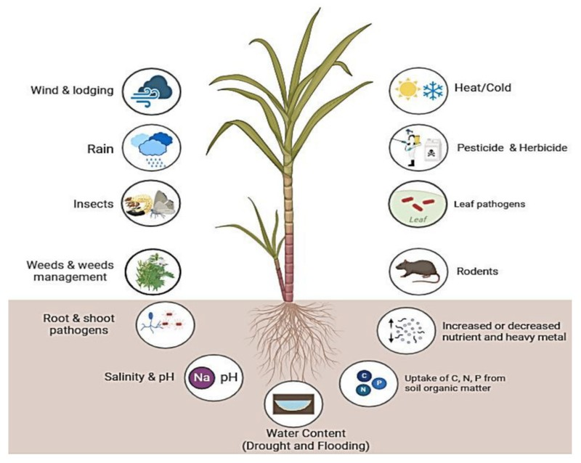
Figure 1. Environmental stressors that affect plant health.

Overview of abiotic and biotic challenges
Agricultural productivity is significantly influenced by a broad spectrum of abiotic and biotic stressors, which can severely affect plant growth and yield. Abiotic stresses, such as drought, soil salinity, extreme temperatures, and exposure to heavy metals, present major challenges to plant survival and productivity. These environmental factors induce oxidative stress and disrupt plant metabolism, ultimately compromising the plant's ability to thrive (Giménez Caminero et al., 2018). In addition to abiotic stresses, biotic factors—including pests, pathogens, and weeds—further complicate agricultural systems by depleting plant resources and reducing crop yield. These biotic stressors not only threaten food security but also exacerbate the difficulty of maintaining sustainable farming practices (Gedil et al., 2020). Understanding how abiotic and biotic stressors interact is essential for the development of resilient crop varieties and effective management strategies. Visual aids, such as diagrams, are invaluable tools in conveying the complex nature of stress biology and the interplay between these various factors in agriculture.

Objectives of the review
The primary aim of this review is to comprehensively examine the challenges agriculture faces due to both abiotic and biotic stressors. The objective is to synthesize current knowledge and identify innovative strategies to enhance crop resilience. This review will incorporate recent advances in molecular breeding and the genetic characterization of plant traits, emphasizing the importance of cutting-edge techniques such as genomic tools and big data analysis (Gedil et al., 2020; Vita et al., 2018). Moreover, the review highlights the critical need for climate-resilient crops capable of withstanding the growing unpredictability of environmental conditions. Ultimately, this review seeks to provide a comprehensive understanding of stress biology, with the goal of laying the groundwork for future research and the development of sustainable agricultural practices. These efforts are essential for meeting the increasing global demand for food while mitigating the adverse impacts of climate change.

Structure
To effectively address the diverse challenges associated with crop resilience, a well-organized structure is crucial for an essay like "Stress Biology in Agriculture: A Comprehensive Review of Abiotic and Biotic Challenges." The essay typically begins with an introduction that underscores the importance of understanding both abiotic and biotic stresses in the context of agricultural productivity. Following the introduction, the subsequent sections are organized thematically, each focusing on specific stressors such as drought, salinity, and pest damage. This thematic approach allows for a detailed exploration and analysis of each stressor. In each section, recent advancements in research and emerging technologies are highlighted, such as next-generation sequencing and high-throughput phenotyping, which are pivotal for exploring genetic diversity in crops (D'Agostino et al., 2017). The essay also emphasizes the critical role of in situ conservation methods in preserving genetic variability, serving as a safeguard against escalating environmental challenges and promoting sustainable farming practices (Bellon et al., 2017). To aid in the comprehension of these complex interactions, visual aids, such as figures, are often employed, providing a clearer understanding of the intricate relationships between stress factors.

Abiotic Stress Factors
Abiotic stressors are critical constraints on how much we can actually grow, impacting plant health across different environments. Factors such as drought, salt, really hot or cold weather, and even heavy metals create tough growing conditions, which, at the physiological and molecular levels in plants, can trigger stress responses. Generally speaking, you'll often see this manifest as stunted growth, a reduction in how efficiently they photosynthesize, and difficulties with nutrient uptake, leading to quite significant losses in yield. It's essential to understand the complex interplay between these abiotic stresses and how plants adapt; this is key for developing effective strategies for managing them. As depicted in, the visual representation of these stressors and their impacts effectively illustrates the interconnected challenges faced in agriculture today, highlighting the critical need for innovative solutions in sustainable crop production. Advances in areas like genomics and molecular breeding offer some particularly promising ways to boost plant resilience against these challenges (Giménez Caminero et al., 2018) (Gedil et al., 2020).
Abiotic stressors represent significant constraints on agricultural productivity, affecting plant health across diverse environments. Factors such as drought, soil salinity, extreme temperatures, and heavy metal contamination create adverse growing conditions, which, at both the physiological and molecular levels, trigger various stress responses in plants. These responses typically manifest as stunted growth, reduced photosynthetic efficiency, and impaired nutrient uptake, all of which can lead to substantial yield losses. Understanding the complex interactions between these abiotic stressors and plant adaptation mechanisms is essential for developing effective strategies to mitigate their impacts. This underscores the urgent need for innovative solutions to ensure sustainable crop production. Recent advances in genomics and molecular breeding, for instance, offer promising avenues for enhancing plant resilience to these environmental stressors (Giménez Caminero et al., 2018; Gedil et al., 2020).

Abiotic Stress Factor | Impact on Crop Productivity | References
Drought | 45% of arable lands are subjected to drought, leading to significant yield reductions. | Godoy et al., 2021
Soil Salinity | Soil salinization leads to an estimated reduction of 40–80 % in crop yields under saline conditions | Atta et al., 2023
Heat Stress | A 3 to 4°C increase in temperature could cause crop yields to fall by 15–35% in Africa and Asia. | Tadele et al., 2018
Cold Stress | One-third of global land is ice-free, with 42% having temperatures below −20°C, affecting plant growth and yield. | Soualiou et al., 2022
Soil Acidity | About 30% of global land has acidic soils, with 50% of arable land being acidic, leading to reduced crop productivity. | Du et al., 2024

Table 1: Impact of Abiotic Stress Factors on Crop Productivity

Definition and types of abiotic stress
Abiotic stress refers to non-living environmental factors that negatively impact plant growth and development, thereby significantly affecting agricultural productivity. Stressors such as extreme temperatures, drought, soil salinity, pH imbalances, and heavy metal toxicity trigger physiological changes that impair plant health and, ultimately, reduce crop yield. For example, during drought conditions, water scarcity leads to a reduction in photosynthetic efficiency, severely compromising crop viability. Similarly, high salinity disrupts nutrient uptake and induces osmotic stress, further complicating agricultural systems. With climate change intensifying these challenges, particularly through rising temperatures and shifting precipitation patterns, the need to understand and mitigate the effects of these stressors has become increasingly urgent for ensuring sustainable food production (Zee et al., 2025). The complex interactions between these stressors highlight the necessity of adopting advanced breeding strategies and technological innovations to enhance crop resilience (Vita et al., 2018). Visual aids, such as diagrams, are valuable tools for illustrating the impacts of these stressors on plant health, emphasizing their critical role in agricultural practice.
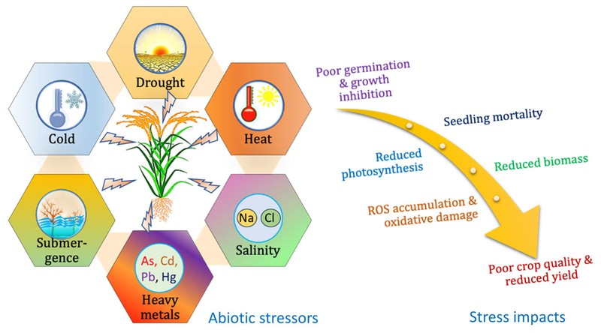
Figure 2. Impact of Abiotic Stressors on Crop Yield and Quality

Impact of drought on crop yield
Drought is a major abiotic stressor, particularly in rain-fed agricultural regions, where it significantly reduces crop yield. Insufficient water availability hampers plant growth and decreases photosynthetic efficiency, which in turn leads to lower productivity. For example, in West and Central Africa, maize production is severely affected not only by drought but also by foliar diseases and parasitic weeds. While substantial progress has been made in developing genetically improved maize varieties that exhibit greater drought tolerance, the unpredictability of climate patterns complicates efforts to ensure consistent crop performance (Gedil et al., 2020). Moreover, the integration of modern breeding techniques, including genomic tools and molecular breeding, offers promising approaches for developing drought-resistant varieties by enhancing our understanding of plant stress physiology (Vita et al., 2018). As drought events become more frequent and severe due to climate change, it is crucial to develop innovative farming strategies that not only mitigate yield loss but also enhance crop resilience, enabling plants to better withstand future climate challenges.
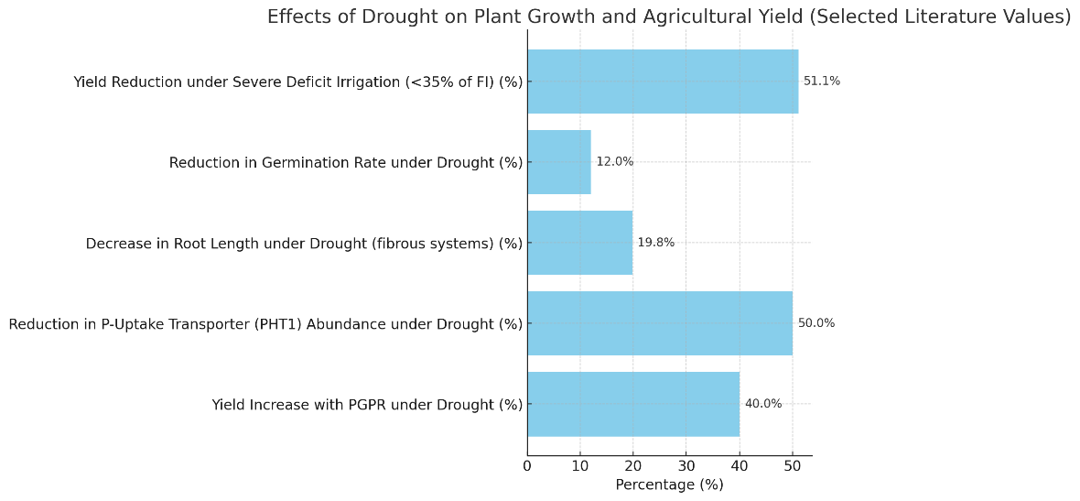
Figure 3: Effects of drought on plant growth and highlights of beneficial microorganisms positively influencing plant growth under drought conditions.

Effects of salinity on plant growth
Salinity represents a major constraint for agricultural productivity, severely affecting plant growth and overall crop performance. Excess salt in the soil disrupts water uptake, creating osmotic stress that impairs cellular function and metabolism. As a result, seed germination is inhibited, root development is restricted, and nutrient acquisition becomes inefficient, ultimately leading to reduced biomass accumulation and yield losses. Furthermore, salinity often exacerbates other abiotic stresses, such as drought and heat, creating a compounded challenge for plants (Zandalinas et al., 2021). Recent studies, however, highlight the potential role of beneficial microorganisms in mitigating salinity stress. Certain microbial inoculants have been shown to enhance plant growth and physiological performance under saline conditions, thereby improving crop productivity even in marginal soils (Sangiorgio et al., 2023). Understanding the physiological and molecular effects of salinity—particularly on root development and growth dynamics is therefore critical for devising strategies to alleviate its impact and to promote sustainable agricultural practices.
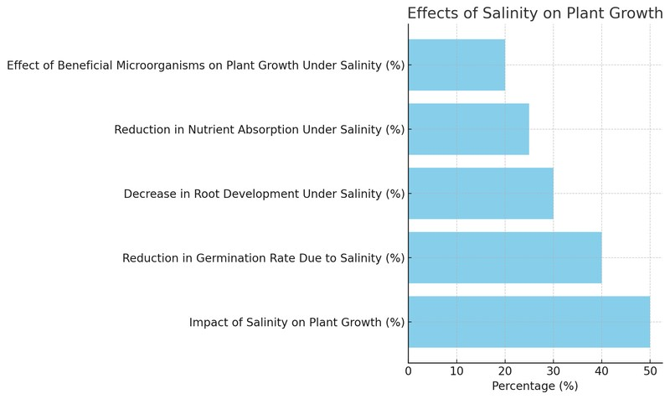
Figure 4: Effects of salinity on various aspects of plant growth and highlights of how beneficial microorganisms can positively influence plant growth even under saline conditions.

Temperature extremes and their consequences
Temperature extremes represent a significant abiotic challenge that affects both crop productivity and plant resilience, leading to alterations in plant physiology. High temperatures can induce cellular stress, impairing critical processes such as photosynthesis, respiration, and the synthesis of essential defense compounds (Upadhyay et al., 2024). With climate change exacerbating the frequency of extreme temperature events, these conditions pose a risk not only to agricultural productivity but also to species survival, potentially causing local extinctions, even as favorable growing conditions emerge in other regions (Bijlsma et al., 2012). This paradox highlights the importance of considering both broad climate factors and biotic interactions, which play a crucial role in shaping species distribution and survival. A comprehensive understanding of the effects of temperature extremes and their cascading impacts is vital for developing strategies to mitigate their consequences on agriculture, promoting sustainable farming practices that enhance plant resilience in the face of a changing climate.

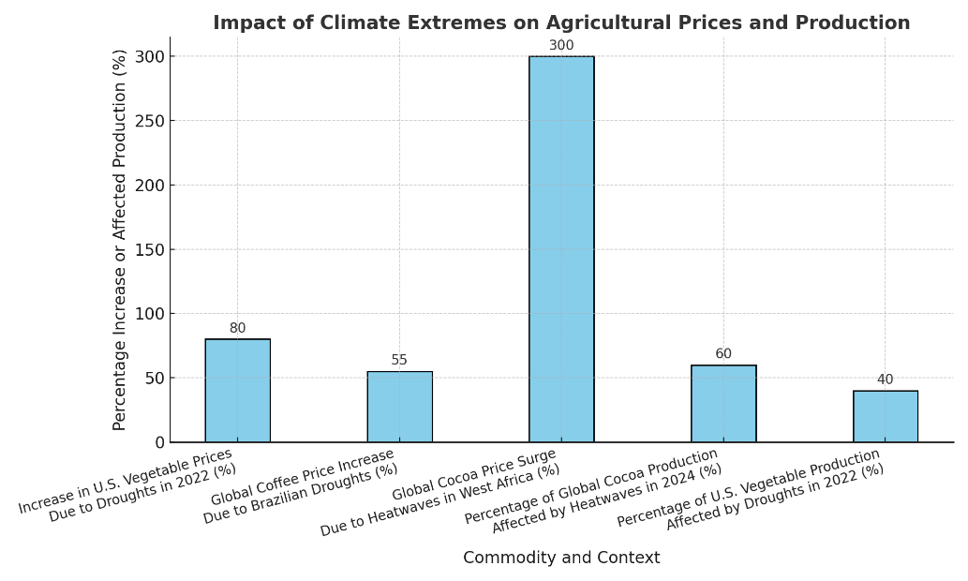
Figure 5: The significant percentage increases in prices and production affected by climate extremes across various agricultural commodities.

Role of soil quality in abiotic stress
In agricultural systems, soil health plays a critical role in mitigating abiotic stresses such as drought and salinity, both of which severely constrain crop productivity. Nutrient-rich soils with high water-holding capacity strengthen plant resilience by supplying essential resources that enable crops to withstand unfavorable conditions. Equally important is the role of diverse soil microorganisms, which contribute to nutrient cycling, soil structure, and overall plant growth. Given the projected rise in soil salinization and water scarcity under climate change, the development of crop varieties capable of thriving in suboptimal soils has become a pressing priority. Recent studies highlight the effectiveness of integrating both conventional and modern breeding tools, such as Marker-Assisted Selection (MAS) and Quantitative Trait Loci (QTL) mapping, in enhancing tolerance to soil-related stresses. For instance, these approaches have shown promise in rice—one of the world’s most vital staple crops by enabling the identification and deployment of stress-resilient traits (Jahan et al., 2016). Such strategies not only improve plant performance under adverse soil conditions but also contribute to long-term food security through the promotion of sustainable, climate-resilient agriculture.
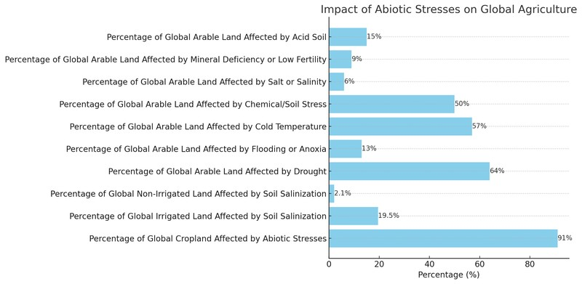
Figure 6: Impact of various abiotic stresses on global agriculture. It shows that a significant 91% of global cropland is affected by abiotic stresses, with other stresses like drought, flood, salanity and other abiotic stresses highlighting the critical need for improving soil quality to mitigate these challenges and ensure food security.

Biotic Stress Factors
Biotic stressors represent significant challenges in agriculture, as diverse organisms such as fungi, bacteria, insects, and nematodes can severely compromise plant health. These stressors often disrupt physiological processes, triggering metabolic alterations that reduce both yield and quality. To withstand such threats, plants rely on complex defense mechanisms, making resilience a critical trait. Increasingly, research has highlighted the genetic basis of this resilience, underscoring the importance of genetic engineering and selective breeding for the development of resistant crop varieties (Gantet et al., 2012). Moreover, the accompanying diagram illustrates the wide range of biotic stressors and their distinct impacts on root and shoot systems, emphasizing the need for integrated strategies to manage these challenges sustainably (Giménez Caminero et al., 2018).

Overview of biotic stress in agriculture
Biotic stress remains a major constraint to agricultural productivity, driven by complex interactions with pathogens, pests, and weeds. These factors cause substantial crop losses and often increase reliance on chemical control measures. For instance, outbreaks of arthropod pests can drastically reduce yields if not effectively monitored and managed, highlighting the need for innovative pest management strategies. Advanced imaging technologies, when integrated into monitoring systems, offer new possibilities for early detection and targeted interventions (de Lange et al., 2020). Historically, crop improvement programs have prioritized enhancing resistance to such stresses, and recent advances in genomics and breeding are accelerating the development of resilient crop varieties. In maize, for example, novel approaches are supporting the creation of lines better adapted to the diverse stress factors prevalent in West and Central Africa (Gedil et al., 2020). As agriculture advances, deepening our understanding of crop–biotic stressor interaction is essential for designing sustainable and resilient farming systems (Garg et al., 2025).

Common pests and their impact on crops
Common agricultural pests exert a profound influence on crop yields, not only through the direct damage they inflict but also by triggering complex ecological interactions. Insects such as aphids and caterpillars, for example, reduce yields directly while also serving as vectors of plant diseases, thereby compounding the challenges faced by crops already stressed by environmental factors (Fones et al., 2017). The economic burden of pest infestations is immense, with annual global losses amounting to billions of dollars, particularly in staple crops (Gedil et al., 2020). To mitigate these effects, integrated pest management (IPM) strategies are increasingly promoted, combining effective pest control with environmentally sustainable practices. Visual representations can be especially useful in illustrating the multiple ways pests interact with crops. For instance, schematic summaries that link pest activity with abiotic stressors highlight the interconnected nature of agricultural challenges and underscore the importance of holistic crop management strategies that address both biotic and abiotic stresses.
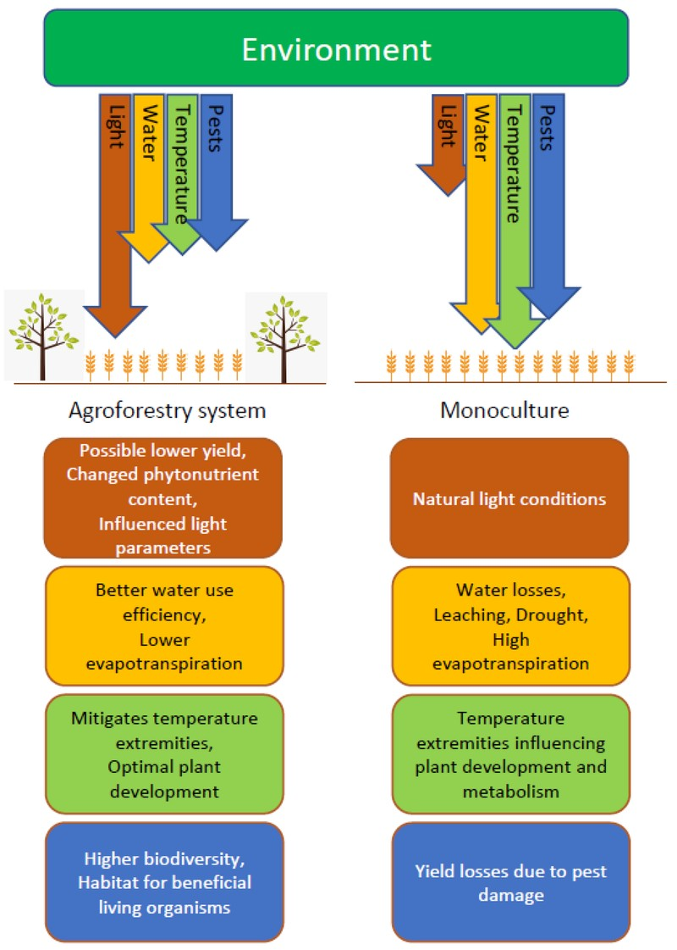
Figure 7. Comparison of Agroforestry Systems and Monoculture in Environmental Impact
Pest | Impact
Colorado Potato Beetle | Without effective management, control costs and yield losses could return to the levels seen in the early 1990s - $10-14 million/year, which would have serious impacts on the viability of the Michigan potato industry.
Onion Thrips | Insecticide resistance is a serious problem for management of onion thrips and many of the currently registered products are no longer effective.
Tomato Spotted Wilt Virus (TSWV) | TSWV causes millions of dollars in crop losses in North Carolina each year.
Two-spotted Spider Mite | Economic loss in tomato occurs when populations of twospotted spider mite exceed eight per leaf.
Fall Armyworm | Fall armyworm infestations in maize production areas of Kenya have led to significant yield losses.
Fusarium oxysporum | Fusarium oxysporum causes a severe fungal disease that adversely affects chickpea yield, resulting in reductions of 10 to 90% in many chickpea producing nations

Table 2: Economic Impact of Common Crop Pests in the United States

Diseases caused by pathogens
Pathogens represent one of the most significant biotic stressors in agriculture, threatening both crop productivity and the sustainability of farming systems (Giménez Caminero et al., 2018). A wide range of organisms—including fungi, bacteria, viruses, and nematodes can cause severe yield losses, reduce crop quality, and impose major economic costs on farmers. Since plants are immobile, they rely on highly sophisticated defense mechanisms to counter these threats. These defenses often involve complex metabolic adjustments that enhance resilience against pathogen attack. Emerging research highlights the pivotal role of oxidative stress responses, where redox potential and pH dynamics strongly influence plant health and susceptibility to disease (Audebert et al., 2019). Visual models mapping the interactions between pathogens and environmental factors can provide valuable insights into these processes. Ultimately, effective disease management will depend on innovative strategies that integrate genetic improvements with ecological and agronomic approaches.

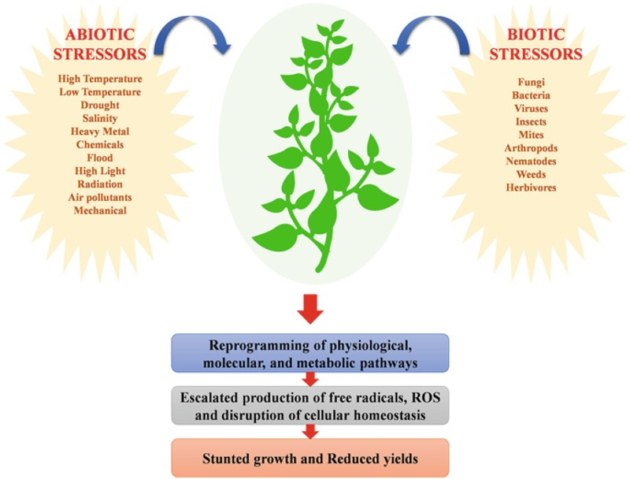
Figure 8. Impact of Abiotic and Biotic Stressors on Plant Growth

Competition with weeds
Weeds present a major challenge in agriculture by competing with crops for essential resources such as light, water, and nutrients. Their rapid adaptability often allows them to establish and grow more aggressively than cultivated plants, thereby intensifying yield losses. For many farmers, especially in regions with poor soil conditions, weeds remain a significant barrier to achieving optimal harvests (Gerpacio et al., 2025). Effective weed management is therefore crucial for maximizing food production. Importantly, weed control is closely linked to soil health and nutrient dynamics, which are strongly influenced by beneficial soil organisms such as mycorrhizal fungi (Gollotte et al., 2008). Consequently, sustainable approaches to weed management extend beyond the application of herbicides and emphasize practices that enhance soil quality and ecological balance. Such strategies not only suppress weed pressure but also contribute to resilient agricultural systems capable of maintaining productivity under challenging conditions.

Effects of invasive species on agriculture
Invasive species pose a significant threat to agricultural systems worldwide, as they often outcompete native plants and disrupt crop production. By destabilizing local ecosystems, invasive species contribute to reduced biodiversity and altered nutrient cycles—both critical for maintaining healthy and fertile soils. For example, certain invasive plants can increase soil salinity and degrade its structure, thereby exacerbating abiotic stresses such as drought and nutrient deficiencies in crops (Alfaro et al., 2015). In addition, invasive pests and pathogens can directly diminish yields by introducing new diseases or competing for limited resources, thereby intensifying biotic stresses (Ali et al., 2019). Effective management of invasive species is therefore essential to sustaining agricultural productivity and enhancing resilience to environmental pressures. Visual summaries that depict the combined effects of these invasions underscore the complex array of stress factors impacting agriculture and highlight the urgent need for comprehensive, integrated management strategies.

Mechanisms of Stress Response in Plants
Plants are continually exposed to a wide range of abiotic and biotic stressors and have evolved sophisticated strategies to withstand them, which is vital for sustaining agricultural productivity. These strategies involve adjustments at multiple levels—physiological, biochemical, and molecular—that collectively enhance survival. One example is phenotypic plasticity, where plants alter their growth and function in response to environmental fluctuations. Over longer timescales, genetic adaptation enables species to persist under changing climatic conditions (Giménez Caminero et al., 2018). In addition, plants possess highly specialized defense mechanisms against biotic stressors such as pathogens and pests, highlighting the importance of agricultural genetics research for minimizing crop losses. Understanding these processes is particularly critical as climate change and ecological disturbances increasingly challenge species’ adaptive limits, raising the risk of local extinctions (Alfaro et al., 2015). Thus, insights into plant stress responses are not only essential for improving crop resilience but also for guiding sustainable farming practices.

Physiological responses to abiotic stress
Plant resilience and agricultural productivity under increasingly challenging environments depend largely on physiological responses to abiotic stresses. Exposure to stressors such as drought, salinity, and temperature extremes triggers a variety of adaptive responses. For instance, plants often enhance antioxidant enzyme activity to mitigate oxidative damage and regulate stomatal conductance to optimize water use (Jahan et al., 2016). Understanding these mechanisms is critical for developing crop varieties capable of withstanding the intensifying pressures of climate change. Advances in molecular biology have provided insights into the metabolic and genetic pathways underlying stress tolerance, which in turn inform biotechnological applications for crop improvement. For example, the integration of Quantitative Trait Loci (QTL) mapping with Marker-Assisted Selection (MAS) enables breeders to more effectively target traits associated with abiotic stress resilience (Jahan et al., 2016). A deeper understanding of these physiological responses therefore offers pathways toward sustainable agricultural solutions. Visual models summarizing the effects of abiotic stress on crop physiology further emphasize the intricate interplay between environmental factors and plant adaptation strategies.

Molecular mechanisms of stress tolerance
Improving agricultural productivity under challenging conditions—such as drought, salinity, and extreme temperatures—depends on understanding plant stress responses at the molecular level. Plants have evolved highly complex signaling networks that enable them to perceive and respond to adverse conditions, activating protective mechanisms such as the synthesis of osmolytes, antioxidants, and heat shock proteins. Advances in molecular breeding are now enabling researchers to incorporate these stress-tolerance traits into crop improvement programs, thereby enhancing resilience. Genomic tools play a key role in dissecting these molecular responses, offering valuable insights that support sustainable farming strategies and yield stability in the face of climate change (Gedil et al., 2020). Furthermore, insights from forest genetics provide important lessons on how trees adapt to environmental stress, contributing to ecosystem stability—an aspect closely tied to long-term agricultural success (Alfaro et al., 2015). This integration of molecular biology with resilience-focused breeding strategies underscores the critical importance of developing crop varieties capable of withstanding abiotic stress. Visual representations that map the connections between drought, salinity, and heat stress serve as effective tools for illustrating the complex molecular interactions underlying plant adaptation.

Role of signaling pathways in stress response
Plant stress biology represents a highly complex field, with signaling pathways playing a central role in mediating plant responses to both abiotic and biotic challenges. These pathways orchestrate molecular, metabolic, and physiological adjustments that collectively enable plants to withstand adverse conditions. For instance, the interaction between jasmonic acid (JA) and abscisic acid (ABA) has been shown to strongly influence plant defense mechanisms against both environmental stressors and pathogenic attacks, highlighting the intricate regulatory balance underlying stress signaling (Demeestere et al., 2017). Similarly, studies in sorghum have provided valuable insights into drought tolerance mechanisms, demonstrating that active signaling pathways involving key drought-responsive genes regulate protective processes and modulate reactive oxygen species (ROS) homeostasis, thereby enhancing plant resilience (Baker et al., 2019). This complex signaling network underscores the critical importance of understanding stress-response pathways, particularly for the development of crop varieties that can withstand increasing biotic pressures and climate variability.

Genetic adaptations to stress
For agriculture to remain sustainable, plants depend on genetic adaptations that enable them to withstand diverse abiotic and biotic stresses. Sorghum, for instance, has evolved genetic mechanisms that enhance drought tolerance, particularly under fluctuating environmental conditions. Evidence from large-scale field experiments indicates significant differential expression of sorghum genes associated with photosynthesis and reactive oxygen species (ROS) regulation under drought, thereby emphasizing the genetic basis of stress responses (Baker et al., 2019). Similarly, in chickpea, genetic adaptations have been linked to variations in key agronomic traits such as yield stability and time to maturation under stress conditions, demonstrating the importance of genetic diversity for improving crop performance (Bulyntsev et al., 2017). A deeper understanding of such adaptive mechanisms offers opportunities for developing innovative breeding strategies aimed at enhancing stress tolerance, thereby ensuring more stable crop yields despite escalating environmental challenges. These insights further underscore the indispensable role of genetic adaptations in shaping sustainable agricultural systems.

Importance of epigenetics in stress biology
Epigenetics, particularly in the context of stress responses, has emerged as a critical area of plant science. It provides valuable insights into how plants adapt to diverse abiotic and biotic challenges in agricultural systems. Epigenetic mechanisms, which regulate gene expression without altering the underlying DNA sequence, enable plants to mount flexible and dynamic responses to environmental stressors, thereby facilitating phenotypic plasticity. A notable example is transgenerational priming, in which enhanced defense responses not only improve the resistance of individual plants but are also inherited by their progeny, conferring increased tolerance to pests and diseases (Roberts et al., 2015). Such heritable modifications underscore the potential of epigenetic regulation as a tool in crop biotechnology, with significant implications for optimizing crop performance under changing climatic conditions (Dunwell et al., 2010). Collectively, these findings highlight the importance of integrating epigenetic research into agricultural practices to accelerate the development of stress-resilient crop varieties. The complexity of these mechanisms further illustrates the multifaceted nature of plant responses to environmental stress, emphasizing the challenges and opportunities for improving agricultural sustainability.

Strategies for Mitigating Stress in Agriculture
Addressing the multiple stressors faced by agricultural systems requires the adoption of strategies that enhance crop resilience. Among these, biotechnological innovations particularly the development of genetically modified organisms (GMOs) have been pivotal in improving tolerance to adverse conditions such as salinity and drought. As previously discussed, the debate surrounding GMOs underscores the urgent need to reconfigure agricultural practices to meet the challenges posed by climate change, highlighting the importance of cultivating crops capable of rapid adaptation (Fernández et al., 2010). Complementary to genetic engineering, high-throughput plant phenotyping (HTPP) provides powerful tools for identifying and selecting genotypes with desirable stress-tolerant traits. The integration of such technologies not only accelerates crop improvement but also contributes to the long-term sustainability and productivity of agricultural systems under both abiotic and biotic pressures. This integrated approach is particularly critical in vulnerable regions such as the Mediterranean, where climate variability poses a significant risk to food security.

Breeding for stress-resistant crops
Promoting sustainable agriculture increasingly depends on breeding crop varieties that can withstand diverse environmental and biological pressures. Recent advances in genomics and molecular breeding are transforming the way crop improvement is achieved, offering new opportunities to enhance stress resilience. A notable example is the maize improvement program at the International Institute of Tropical Agriculture (IITA), which employs advanced genomic tools to enhance resistance to drought and foliar diseases, two major constraints in West and Central Africa (Gedil et al., 2020). More broadly, the application of marker-assisted selection and genome-wide selection enables breeders to accelerate genetic gains related to yield, nutritional quality, and resilience. Such approaches are particularly valuable for smallholder farmers, who are disproportionately affected by climate variability and limited resources (Dunwell et al., 2010). Collectively, these efforts underscore the critical importance of developing stress-tolerant varieties to ensure food security and advance sustainable agricultural practices in the face of escalating environmental challenges.
Program | Crops Targeted | Focus | Impact | Source
Cornell University's Vegetable Breeding Program | Cucurbits (squash, pumpkin, melon, cucumber), Capsicum (pepper) | Disease resistance, insect resistance, abiotic stress tolerance | Development of disease-resistant breeding lines and varieties with improved flavor and yield, reducing environmental consequences and production costs, and enhancing food quality and safety for consumers. | National Institute of Food and Agriculture (USDA)
Cornell University's Corn Breeding Program | Corn (Zea mays) | Pest resistance, abiotic stress tolerance | Identification and development of corn hybrids with resistance to European corn borer, anthracnose stalk rot, gray leaf spot, and multiple diseases, leading to more sustainable production systems. | National Institute of Food and Agriculture (USDA)
USDA ARS Plant Stress and Germplasm Development Research | Cotton (Gossypium spp.) | Climate resilience, stress tolerance | Development of climate-resilient germplasm and management tools for sustainable row crop production, enhancing stress tolerance and yield in cotton. | Agricultural Research Service (USDA)
Table 3. Breeding Programs for Stress-Resistant Crops

Use of biotechnology in stress management
Biotechnology has emerged as a central tool in addressing agricultural stress, enabling the development of crops capable of withstanding both abiotic and biotic pressures. Through molecular approaches, genetic enhancements can introduce traits such as drought tolerance, improved disease resistance, and salinity tolerance, thereby contributing to yield stability under challenging conditions. Transgenic crops, in particular, have demonstrated enhanced resilience to environmental stresses, reinforcing their role in strengthening global food security under a changing climate (Vijesh et al., 2014). The Food and Agriculture Organization (FAO) Biotechnology Forum has further emphasized the potential of biotechnology in addressing critical issues such as water scarcity, underscoring its value in advancing sustainable agricultural research and practices (Sonnino, 2008). Additionally, visual representations of stress impacts on crops can be powerful in communicating the extent of yield losses caused by abiotic constraints, further highlighting the urgent need for biotechnological solutions. Collectively, these advances illustrate how biotechnology is reshaping agricultural systems and enhancing crop productivity in the face of mounting environmental challenges.
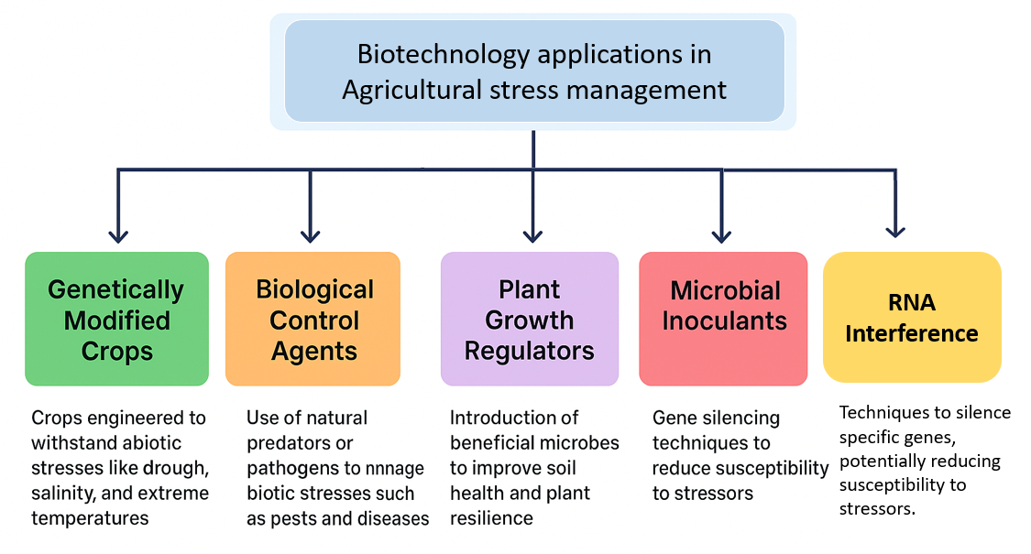
Figure 9. Biotechnology Applications in Agricultural Stress Management

Sustainable agricultural practices
Biotechnology has emerged as a central tool in addressing agricultural stress, enabling the development of crops capable of withstanding both abiotic and biotic pressures. Through molecular approaches, genetic enhancements can introduce traits such as drought tolerance, improved disease resistance, and salinity tolerance, thereby contributing to yield stability under challenging conditions. Transgenic crops, in particular, have demonstrated enhanced resilience to environmental stresses, reinforcing their role in strengthening global food security under a changing climate (Vijesh et al., 2014). The Food and Agriculture Organization (FAO) Biotechnology Forum has further emphasized the potential of biotechnology in addressing critical issues such as water scarcity, underscoring its value in advancing sustainable agricultural research and practices (Sonnino, 2008). Additionally, visual representations of stress impacts on crops can be powerful in communicating the extent of yield losses caused by abiotic constraints, further highlighting the urgent need for biotechnological solutions. Collectively, these advances illustrate how biotechnology is reshaping agricultural systems and enhancing crop productivity in the face of mounting environmental challenges.

Role of precision agriculture in stress mitigation
The integration of precision agriculture represents a significant advancement in mitigating the pressures currently facing crop production systems. By employing technologies such as remote sensing, soil moisture sensors, and targeted irrigation, farmers can more effectively monitor environmental conditions and manage stressors. These tools enhance the capacity to address abiotic stresses, including drought and heat, as well as biotic threats such as pests and diseases, thereby reducing their overall impact on productivity. Furthermore, innovations such as high-throughput phenotyping and next-generation sequencing have greatly expanded our understanding of crop responses to stress, facilitating the development of more targeted strategies to enhance resilience (Gedil et al., 2020; D’Agostino et al., 2017). Precision agriculture also optimizes resource utilization by ensuring that inputs such as water and fertilizers are applied with greater spatial and temporal accuracy. This not only minimizes waste and reduces environmental burdens but also enhances yield stability. Collectively, these advances underscore the dual role of precision agriculture in improving crop productivity and promoting sustainability an imperative in addressing the intertwined challenges of food security and climate change (Sindhu et al., 2024).

Importance of integrated pest management
Integrated pest management (IPM) plays a pivotal role in mitigating biotic stresses that significantly constrain crop productivity. As a holistic approach, IPM combines biological control agents, cultural practices, and mechanical measures with judicious use of chemical pesticides, thereby reducing negative impacts on beneficial organisms and the environment. This integrated strategy not only enhances crop resilience to pest pressures but also promotes long-term sustainability by minimizing chemical dependency, conserving soil health, and maintaining biodiversity (Benito et al., 2010). Beyond pest suppression, effective IPM practices can indirectly strengthen crop tolerance to abiotic stresses, such as drought and salinity, as healthier plants are better equipped to withstand environmental fluctuations (Gedil et al., 2020). Consequently, IPM is a critical component of sustainable agriculture, simultaneously safeguarding food security and ecosystem integrity in the context of rapid global change. These insights underscore the interconnectedness of pest management, plant health, and resilience under stress, reinforcing the importance of IPM as a cornerstone of modern agricultural systems.

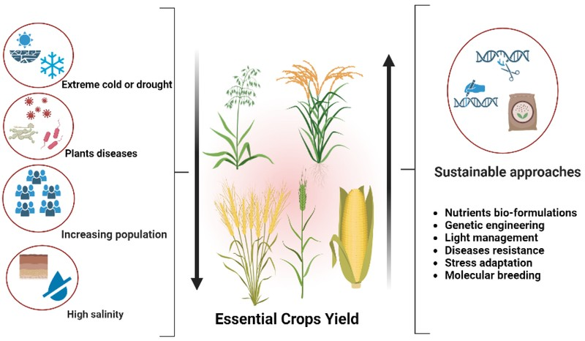
Figure 10. Factors Influencing Crop Yield and Sustainable Approaches

Conclusion
In conclusion, the persistent challenges posed by abiotic and biotic stresses underscore the need for a comprehensive understanding of plant responses and adaptive mechanisms in agricultural systems. Environmental factors such as drought, salinity, and extreme temperatures, together with threats from pests and pathogens, continue to drive the search for innovative strategies that enhance the sustainability of crop production. Beneficial microorganisms, for instance, have shown considerable potential in improving plant resilience, thereby offering nature-based solutions for stress management. Moreover, the establishment of clear ecological guidelines, such as those proposed by the Society for Ecological Restoration (SER), provides critical frameworks for implementing effective restoration practices that address both environmental and biological pressures (Gann et al., 2019). Ultimately, adopting an integrative approach to plant stress biology—one that combines ecological, molecular, and biotechnological perspectives—will be essential for strengthening agricultural sustainability and ensuring food security in the face of accelerating climate change. This highlights the critical importance of integrating fundamental research with applied science to develop farming systems capable of withstanding future climatic and biological challenges.

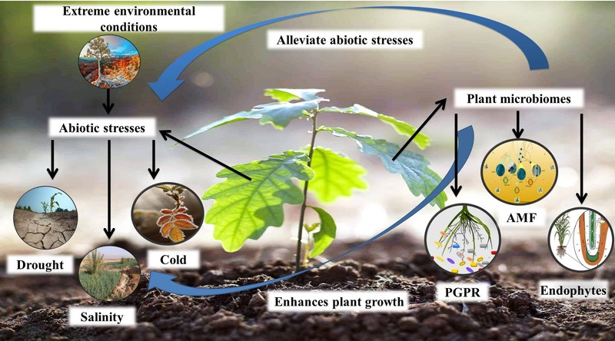
Figure 11. Impact of Environmental Stress on Plant Growth and Microbiomes

Summary of key findings
A detailed examination of stress biology in agriculture reveals the wide array of challenges imposed by both abiotic and biotic stressors. Environmental constraints such as drought, salinity, and extreme temperatures severely reduce crop growth and productivity, while biotic pressures—including pests, diseases, and weeds—further compromise yield potential and increase economic losses for farmers (Gedil et al., 2020; Giménez Caminero et al., 2018). Encouragingly, advances in molecular biology and genomics are providing new opportunities to enhance crop resilience. For instance, visual representations of the diverse stressors affecting plants illustrate the complexity of breeding efforts aimed at developing more robust varieties. To achieve meaningful progress, it is essential to integrate insights from genetics, plant physiology, and environmental interactions. Such integration is vital for designing agricultural systems capable of withstanding multiple stress factors while maintaining productivity under changing climatic conditions. Ultimately, by advancing our understanding of plant stress biology, agriculture can be transformed into a more resilient and sustainable enterprise, ensuring global food security in the face of ongoing environmental change.

Implications for future agricultural practices
Looking ahead, agricultural practices are increasingly prioritizing resilience as a central strategy to address abiotic and biotic pressures, which are expected to intensify under climate change. To meet these challenges, the adoption of cutting-edge approaches such as advanced genetic breeding, high-throughput screening, and bioinformatics is essential for developing stress-resistant crop varieties (Vita et al., 2018). At the same time, sustainable practices, including agroforestry, provide dual benefits by mitigating stress impacts while enhancing biodiversity and improving soil health (Gerpacio et al., 2025). The complexity of current agricultural challenges, as illustrated in accompanying schematic representations, highlights the multifaceted nature of stress factors and underscores the necessity of comprehensive, integrated strategies. Collectively, these approaches are crucial not only for improving crop productivity but also for safeguarding global food security in the context of changing environmental conditions and the socio-economic realities that shape farming systems worldwide. Importantly, integrating multi-omics approaches including genomics, transcriptomics, proteomics, and metabolomics offers unprecedented opportunities to unravel stress-response networks, identify key regulatory genes, and accelerate the development of climate-resilient crop varieties, thereby reinforcing the role of science-driven innovation in advancing sustainable agriculture (Verma et al., 2024).
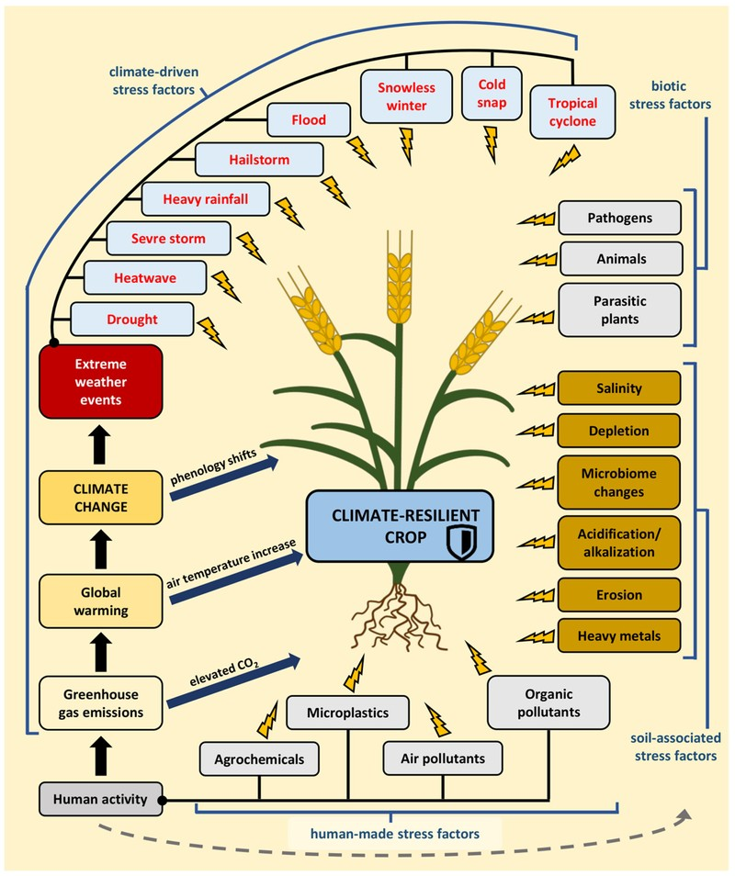
Figure 12. Factors impacting climate-resilient crops related to climate change and human activity.

Need for continued research in stress biology
Agriculture is increasingly confronted with a range of challenges, including climate variability and rising pest pressures, which underscores the growing importance of research in plant stress biology. Crop productivity is strongly influenced by the complex interplay of abiotic and biotic stressors, highlighting the need for a deeper understanding of these interactions to guide the development of more resilient varieties. For instance, drought and salinity remain significant constraints on maize production in regions such as West and Central Africa, despite notable genetic improvements in yield (Gedil et al., 2020). To accelerate further genetic gains, breeding programs must increasingly integrate advanced genomic tools and modern technologies (Zee et al., 2025). Collectively, research into plant stress responses provides the foundation for breeding crops capable of withstanding diverse adversities, thereby contributing directly to global food security. This ongoing academic effort is central to the development of innovative strategies that enhance agricultural resilience to the multiple stressors illustrated in accompanying figures, which visually summarize the environmental challenges facing crops.

Importance of interdisciplinary approaches
Advancing agricultural resilience to both abiotic and biotic stresses requires interdisciplinary approaches that acknowledge the complexity of these challenges. By integrating expertise from plant biology, environmental science, biotechnology, and computational disciplines, researchers are better positioned to generate innovative solutions that sustain crop productivity under adverse conditions. For example, bioinformatics has become indispensable for analyzing large-scale datasets, thereby enhancing the integration of computational techniques with traditional plant breeding methods (Vita et al., 2018). Similarly, studies of root morphology and its environmental interactions demonstrate the importance of cross-disciplinary collaboration in improving water and nutrient uptake efficiency (Abbas-Zadeh et al., 2014). Visual representations of these concepts further illustrate how climate change intensifies biotic interactions, reinforcing the need for comprehensive and collaborative strategies. Taken together, these examples underscore the central role of interdisciplinary research in addressing the multifaceted challenges confronting modern agriculture.

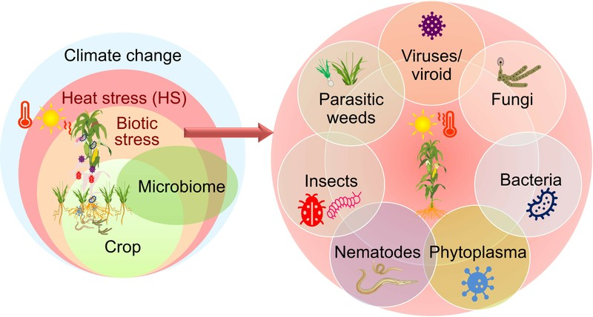
Figure 13. Climate Change Effects on Crop Biotic Stressors

Final thoughts on enhancing agricultural resilience
To sum up, boosting agricultural resilience calls for a complex strategy, one weaving together sophisticated breeding methods, a deep grasp of stress biology, and eco-friendly approaches. The use of genomic tools in efforts to improve crops, as seen in maize production studies, shows real promise for big gains in both yield and tolerance to stress, particularly in areas prone to drought and pests (Gedil et al., 2020). Also, tackling several stress factors at once like drought and Striga, can really boost how well crops adjust and perform in shifting environments (Bossey et al., 2020). Visual representations, like those in, shed light on the complex links between different abiotic and biotic stresses, along with their impact on how crops work. By using new tech alongside tried-and-true farming practices, agriculture can build systems that better handle the pressures of climate change and rising food needs, which will ensure food security down the road.

References
- A Gollotte, A Heggo, A Hodge, A Liu, A Manjunath, A Mollier, A Mozafar, et al. (2008) Agronomic Management of Indigenous Mycorrhizas. doi: https://core.ac.uk/download/62455716.pdf
- Abbas-Zadeh, Adu, al Hagrey, Amato, Armengaud, Asseng, Bailey, et al. (2014) Challenges and opportunities for quantifying roots and rhizosphere interactions through imaging and image analysis. doi: https://core.ac.uk/download/228177374.pdf
- Alfaro, R.I., Baldinelli, G., Dawson, Ian K., El-Kassaby, et al. (2015) The role of forest genetic resources in responding to biotic and abiotic factors in the context of anthropogenic climate change. doi: https://core.ac.uk/download/132676287.pdf
- Ali, Hazart, Inayat, Naila, Majeed, Abdul, Muhammad, et al. (2019) Allelopathy and Agricultural Sustainability: Implication in weed management and crop protection—an overview. doi: https://core.ac.uk/download/286664182.pdf
- Andrea Sonnino, Christine Deane, John Ruane, Pasquale Steduto (2008) Coping with Water Scarcity: What Role for Biotechnologies?. doi: https://core.ac.uk/download/71360152.pdf
- Anita Verma, Bharat Garg, Shilpi R. Sindhu, Reena Rani and Shikha Yashveer (2024). Transcriptomics: Advancement in Plant Science, In book: Advances in Genetics and Plant Breeding (Volume - 24), Publisher: AkiNik Publications®, DOI: 10.22271/ed.book.2625
- Audebert, A., Benada. J., Boulakia, S., Bousset, L., et al. (2019) Leaf Eh and pH: A Novel Indicator of Plant Stress. Spatial, Temporal and Genotypic Variability in Rice (Oryza sativa L.). doi: https://core.ac.uk/download/220111512.pdf
- Baker, Christopher R, Blow, Matthew J, Cole, Benjamin, Coleman-Derr, et al. (2019) Transcriptomic analysis of field-droughted sorghum from seedling to maturity reveals biotic and metabolic responses. doi: https://core.ac.uk/download/286361368.pdf
- Barón, Matilde, Centritto, Mauro, Costa, Joaquim Miguel, Haworth, et al. (2019) Opportunities and limitations of crop phenotyping in southern european countries. doi: https://core.ac.uk/download/250589841.pdf
- Bellon, M.R., Burdon, J.J., Dulloo, Ehsan, Sardos, et al. (2017) In situ conservation—harnessing natural and human-derived evolutionary forces to ensure future crop adaptation. doi: https://core.ac.uk/download/141675214.pdf
- Benito, Patricia, de Toni, Arianna, Labouze, Eric, Lavelle, et al. (2010) Soil biodiversity: functions, threats and tools for policy makers. doi: https://core.ac.uk/download/pdf/29245351.pdf
- Bharat Garg, Anita Verma, and Jyoti Duhan (2025) Mapping Genes and Approaches for Climate-Resilient Agriculture in Agricultural Crops, DOI: 10.1007/978-3-031-84802-5_6, In book: Innovations in Climate Resilient Agriculture.
- Bijlsma, Rienk-Jan, Hickler, Thomas, Kramer, Koen, Thuiller, et al. (2012) Why would plant species become extinct locally if growing conditions improve?. doi: https://core.ac.uk/download/14524864.pdf
- Bossey, B., Coulibaly, M., Crossa, J., Haruna, et al. (2020) Stacking tolerance to drought and resistance to a parasitic weed in tropical hybrid maize for enhancing resilience to stress combinations. doi: https://core.ac.uk/download/288633847.pdf
- Bulyntsev, Sergey, Carrasquilla-Garcia, Noelia, Chang, Peter L, Cook, et al. (2017) Genomic and phenotypic analysis of Vavilov's historic landraces reveals the impact of environment and genomic islands of agronomic traits. doi: https://core.ac.uk/download/323070311.pdf
- Comparison of Agroforestry Systems and Monoculture in Environmental Impact [FIGURE]. (2025). Retrieved from https://www.mdpi.com/stresses/stresses-02-00018/article_deploy/html/images/stresses-02-00018-g001.png
- D'Agostino, Nunzio, Tripodi, Pasquale (2017) NGS-based genotyping, high-throughput phenotyping and genome-wide association studies laid the foundations for next-generation breeding in horticultural crops. doi: https://core.ac.uk/download/195736463.pdf
- Daniela Sangiorgio, Antonio Cellini, Francesco Spinelli, Irene Donati (2023) Promoting Strawberry (Fragaria × ananassa) Stress Resistance, Growth, and Yield Using Native Bacterial Biostimulants. Volume (13), 529-529. Agronomy. doi: https://doi.org/10.3390/agronomy13020529
- de Lange, Elvira S, Heldens, Wieke B, Iost Filho, Fernando H, Kong, et al. (2020) Drones: Innovative Technology for Use in Precision Pest Management. doi: https://core.ac.uk/download/286361618.pdf
- De Vita, Pasquale, D’Agostino, Nunzio, Nicolia, Alessandro, Pavan, et al. (2018) Biotechnological and digital revolution for climate-smart plant breeding. doi: https://core.ac.uk/download/195736457.pdf
- Demeestere, Kristof, Gheysen, Godelieve, Haeck, Ashley, Kyndt, et al. (2017) Interplay between carotenoids, abscisic acid and jasmonate guides the compatible rice-Meloidogyne graminicola interaction. doi: https://core.ac.uk/download/147045776.pdf
- Diagram of Climate Change Effects on Crop Biotic Stressors [FIGURE]. (2025). Retrieved from https://pub.mdpi-res.com/plants/plants-13-02022/article_deploy/html/images/plants-13-02022-ag.png?1721983823
- Diagram of environmental stressors affecting plant health. [FIGURE]. (2025). Retrieved from https://www.mdpi.com/plants/plants-13-01739/article_deploy/html/images/plants-13-01739-g001.png
- Dr. Amit Upadhyay, Dr. Ashish Lambat, Dr. Madhusmita Borthakur, Dr. Mrs. Prachi Lambat (2024) Secondary Metabolite Production in Plants: In Response to Biotic and Abiotic Stress Factors. doi: https://core.ac.uk/download/603897634.pdf
- Dunwell, J. M. (2010) Crop biotechnology: prospects and opportunities. doi: https://core.ac.uk/download/9050.pdf
- Factors impacting climate-resilient crops related to climate change and human activity. [FIGURE]. (2025). Retrieved from https://pub.mdpi-res.com/plants/plants-13-00490/article_deploy/html/images/plants-13-00490-g001.png?1707388597
- Factors Influencing Crop Yield and Sustainable Approaches [FIGURE]. (2025). Retrieved from https://pub.mdpi-res.com/agronomy/agronomy-13-01709/article_deploy/html/images/agronomy-13-01709-g001.png?1687777942
- FIGURE Biswa R Acharya, Satwinder Pal Gill, Amita Kaundal, Devinder Sandhu (2024). Strategies for combating plant salinity stress: the potential of plant growth-promoting microorganisms. *Frontiers in Plant Science*. Retrieved from https://pmc.ncbi.nlm.nih.gov/articles/PMC11284086/ *Note.* Adapted from Strategies for combating plant salinity stress: the potential of plant growth-promoting microorganisms, by Biswa R Acharya, Satwinder Pal Gill, Amita Kaundal, Devinder Sandhu, 2024, Frontiers in Plant Science, Frontiers in Plant Science, 15:1406913. Retrieved from https://pmc.ncbi.nlm.nih.gov/articles/PMC11284086/. Arshad Jalal, Carlos Eduardo da Silva Oliveira, Poliana Aparecida Leonel Rosa, Fernando Shintate Galindo, Marcelo Carvalho Minhoto Teixeira Filho (2023). Beneficial Microorganisms Improve Agricultural Sustainability under Climatic Extremes. *MDPI*. Retrieved from https://pmc.ncbi.nlm.nih.gov/articles/PMC10222584/ *Note.* Adapted from Beneficial Microorganisms Improve Agricultural Sustainability under Climatic Extremes, by Arshad Jalal, Carlos Eduardo da Silva Oliveira, Poliana Aparecida Leonel Rosa, Fernando Shintate Galindo, Marcelo Carvalho Minhoto Teixeira Filho, 2023, MDPI, Life, 13(5), p. 1102. Retrieved from https://pmc.ncbi.nlm.nih.gov/articles/PMC10222584/. Katja Witzel, José Ramón Acosta Motos, Ersin Atay, Nuray Çiçek, Veronika Mistríková, Signem Oney-Birol, Sebastian Rodas Soto, Katalin Solymosi, Cengiz Yücedağ, Jutta Papenbrock (2025). Leveraging microorganisms and biostimulants: mitigating salinity stress in crops with agricultural biologicals. **. Retrieved from https://link.springer.com/article/10.1007/s11104-025-07578-1 *Note.* Adapted from Leveraging microorganisms and biostimulants: mitigating salinity stress in crops with agricultural biologicals, by Katja Witzel, José Ramón Acosta Motos, Ersin Atay, Nuray Çiçek, Veronika Mistríková, Signem Oney-Birol, Sebastian Rodas Soto, Katalin Solymosi, Cengiz Yücedağ, Jutta Papenbrock, 2025, Plant and Soil. Retrieved from https://link.springer.com/article/10.1007/s11104-025-07578-1.
- FIGURE Genome-Wide Identification and Functional Analysis of the TIFY Family Genes in Response to Abiotic Stresses and Hormone Treatments in Tartary Buckwheat (Fagopyrum tataricum) (2025). Genome-Wide Identification and Functional Analysis of the TIFY Family Genes in Response to Abiotic Stresses and Hormone Treatments in Tartary Buckwheat (Fagopyrum tataricum). **. Retrieved from https://www.mdpi.com/1422-0067/24/13/10915 *Note.* Adapted from Genome-Wide Identification and Functional Analysis of the TIFY Family Genes in Response to Abiotic Stresses and Hormone Treatments in Tartary Buckwheat (Fagopyrum tataricum), by Genome-Wide Identification and Functional Analysis of the TIFY Family Genes in Response to Abiotic Stresses and Hormone Treatments in Tartary Buckwheat (Fagopyrum tataricum), 2025. Retrieved from https://www.mdpi.com/1422-0067/24/13/10915. Response of Yam (Dioscorea alata) to the Application of Rhizophagus irregularis and Potassium Silicate under Salinity Stress (2025). Response of Yam (Dioscorea alata) to the Application of Rhizophagus irregularis and Potassium Silicate under Salinity Stress. **. Retrieved from https://www.mdpi.com/2673-7140/2/2/16 *Note.* Adapted from Response of Yam (Dioscorea alata) to the Application of Rhizophagus irregularis and Potassium Silicate under Salinity Stress, by Response of Yam (Dioscorea alata) to the Application of Rhizophagus irregularis and Potassium Silicate under Salinity Stress, 2025. Retrieved from https://www.mdpi.com/2673-7140/2/2/16. Tools for In Vitro Propagation/Synchronization of the Liverwort Marchantia polymorpha and Application of a Validated HPLC-ESI-MS-MS Method for Glutathione and Phytochelatin Analysis (2025). Tools for In Vitro Propagation/Synchronization of the Liverwort Marchantia polymorpha and Application of a Validated HPLC-ESI-MS-MS Method for Glutathione and Phytochelatin Analysis. **. Retrieved from https://www.mdpi.com/1501294 *Note.* Adapted from Tools for In Vitro Propagation/Synchronization of the Liverwort Marchantia polymorpha and Application of a Validated HPLC-ESI-MS-MS Method for Glutathione and Phytochelatin Analysis, by Tools for In Vitro Propagation/Synchronization of the Liverwort Marchantia polymorpha and Application of a Validated HPLC-ESI-MS-MS Method for Glutathione and Phytochelatin Analysis, 2025. Retrieved from https://www.mdpi.com/1501294.
- FIGURE Mendy Diop (2012). UN relief coordinator warns over humanitarian crisis in Africa's drought-hit Sahel. *UN News Centre*. Retrieved from https://en.wikipedia.org/wiki/2012_Sahel_drought *Note.* Adapted from UN relief coordinator warns over humanitarian crisis in Africa's drought-hit Sahel, by Mendy Diop, 2012, UN News Centre. Retrieved from https://en.wikipedia.org/wiki/2012_Sahel_drought. A Study of the Relationship Among Radon, Thoron and Radioactive Aerosol Particle Distribution in PM2.5 Risk Areas in Kanchanaburi Province, Thailand (2025). A Study of the Relationship Among Radon, Thoron and Radioactive Aerosol Particle Distribution in PM2.5 Risk Areas in Kanchanaburi Province, Thailand. **. Retrieved from https://www.mdpi.com/2073-4433/15/12/1438 *Note.* Adapted from A Study of the Relationship Among Radon, Thoron and Radioactive Aerosol Particle Distribution in PM2.5 Risk Areas in Kanchanaburi Province, Thailand, by A Study of the Relationship Among Radon, Thoron and Radioactive Aerosol Particle Distribution in PM2.5 Risk Areas in Kanchanaburi Province, Thailand, 2025. Retrieved from https://www.mdpi.com/2073-4433/15/12/1438.
- Fones, HN, Gurr, SJ (2017) NOXious gases and the unpredictability of emerging plant pathogens under climate change. doi: https://core.ac.uk/download/83924561.pdf
- Gabriele Berg, Daria Rybakova, Doreen Fischer, Tomislav Cernava, Marie-Christine Champomier Vergès, Trevor C. Charles, Xiaoyulong Chen, et al. (2020) Microbiome definition re-visited: old concepts and new challenges. Volume(8). Microbiome. doi: https://doi.org/10.1186/s40168-020-00875-0
- Gantet, Pascal, Guiderdoni, Emmanuel, Khong, Ngan Giang, Morel, et al. (2012) Stress-resistant plants and their production. doi: http://agritrop.cirad.fr/572970/6/ID572970_WO.pdf
- Gedil, M., Menkir, A. (2020) An integrated molecular and conventional breeding scheme for enhancing genetic gain in maize in Africa. doi: https://core.ac.uk/download/286455309.pdf
- George D. Gann, Tein McDonald, Bethanie Walder, James Aronson, Cara R. Nelson, Justin Jonson, James G. Hallett, et al. (2019) International principles and standards for the practice of ecological restoration. Second edition. Volume(27). Restoration Ecology. doi: https://doi.org/10.1111/rec.13035
- Gerpacio, Roberta V., Pingali, Prabhu L. (2025) Tropical and Subtropical Maize in Asia: Production Systems, Constraints, and Research Priorities. doi: https://core.ac.uk/download/pdf/6499382.pdf
- Giménez Caminero, Estela, Manzano Agugliaro, Francisco, Salinas Navarro, María (2018) Worldwide Research on Plant Defense against Biotic Stresses as Improvement for Sustainable Agriculture. doi: https://core.ac.uk/download/286590774.pdf
- Giménez Caminero, Estela, Manzano Agugliaro, Francisco, Salinas Navarro, María (2018) Worldwide Research on Plant Defense against Biotic Stresses as Improvement for Sustainable Agriculture. doi: https://core.ac.uk/download/286590774.pdf
- Impact of Abiotic and Biotic Stressors on Plant Growth [FIGURE]. (2025). Retrieved from https://media.springernature.com/lw685/springer-static/image/chp%3A10.1007%2F978-3-031-75678-8_9/MediaObjects/609178_1_En_9_Fig1_HTML.png
- Impact of Abiotic Stressors on Crop Yield [FIGURE]. (2025). Retrieved from https://www.mdpi.com/plants/plants-12-03948/article_deploy/html/images/plants-12-03948-g001.png
- Impact of Abiotic Stressors on Crop Yield and Quality [FIGURE]. (2025). Retrieved from https://pub.mdpi-res.com/plants/plants-12-03948/article_deploy/html/images/plants-12-03948-g001.png?1700749621
- Impact of Environmental Stress on Plant Growth and Microbiomes [FIGURE]. (2025). Retrieved from https://pub.mdpi-res.com/agronomy/agronomy-12-02069/article_deploy/html/images/agronomy-12-02069-ag.png?1661854537
- Jahan, N. (Nusrat), Javed, M. A. (Muhammad), Khan, S. (Samiullah), Manan, et al. (2016) A Short Review on the Development of Salt Tolerant Cultivars in Rice. doi: https://core.ac.uk/download/480549642.pdf
- Krishna Vijesh, Qaim, Matin, Zilberman, David (2014) Transgenic crops, production risk, and agrobiodiversity. doi: https://www.econstor.eu/dspace/bitstream/10419/98224/1/779983025.pdf
- Molina Fernández, Antonio (2010) Plant biotechnology. doi: http://oa.upm.es/8408/2/INVE_MEM_2010_82312.pdf
- Roberts, Michael R., Singh, Prashant (2015) Keeping it in the family: transgenerational memories of plant defence. doi: https://core.ac.uk/download/42415027.pdf
- Sara I. Zandalinas, Felix Fritschi, Ron Mittler (2021) Global Warming, Climate Change, and Environmental Pollution: Recipe for a Multifactorial Stress Combination Disaster. Volume(26), 588-599. Trends in Plant Science. doi: https://doi.org/10.1016/j.tplants.2021.02.011
- Shilpi R. Sindhu, Anita Verma, Bharat Garg, Reena Rani and Shikha Yashveer (2024). Pioneering Agricultural Transformation: Unleashing The Power Of IoT And Ai For Smart Farming And Sustainable Harvests, Plant Archieves 24 (Special Issue (GABELS)):255-265 ,DOI: 10.51470/PLANTARCHIVES.2024.v24.SP-GABELS.038
- TABLE 3, Cornell University (2012). Breeding Pest Resistant and Stress Tolerant Corn for More Sustainable Production Systems. *National Institute of Food and Agriculture*. Retrieved from https://portal.nifa.usda.gov/web/crisprojectpages/0220859-breeding-pest-resistant-and-stress-tolerant-corn-for-more-sustainable-production-systems.html *Note.* Adapted from Breeding Pest Resistant and Stress Tolerant Corn for More Sustainable Production Systems, by Cornell University, 2012, National Institute of Food and Agriculture. Retrieved from https://portal.nifa.usda.gov/web/crisprojectpages/0220859-breeding-pest-resistant-and-stress-tolerant-corn-for-more-sustainable-production-systems.html. Development of Climate Resilient Germplasm and Management Tools for Sustainable Row Crop Production (2023). Development of Climate Resilient Germplasm and Management Tools for Sustainable Row Crop Production. *U.S. Department of Agriculture, Agricultural Research Service*. Retrieved from https://www.ars.usda.gov/research/project/?accnNo=443543 *Note.* Adapted from Development of Climate Resilient Germplasm and Management Tools for Sustainable Row Crop Production, by Development of Climate Resilient Germplasm and Management Tools for Sustainable Row Crop Production, 2023, U.S. Department of Agriculture, Agricultural Research Service. Retrieved from https://www.ars.usda.gov/research/project/?accnNo=443543.
- TABLE Evelyn B Parr, Brooke L Devlin, Bridget E Radford, John A Hawley (2020). A Delayed Morning and Earlier Evening Time-Restricted Feeding Protocol for Improving Glycemic Control and Dietary Adherence in Men with Overweight/Obesity: A Randomized Controlled Trial. *MDPI*. Retrieved from https://www.ncbi.nlm.nih.gov/pmc/articles/PMC7071240/ *Note.* Adapted from A Delayed Morning and Earlier Evening Time-Restricted Feeding Protocol for Improving Glycemic Control and Dietary Adherence in Men with Overweight/Obesity: A Randomized Controlled Trial, by Evelyn B Parr, Brooke L Devlin, Bridget E Radford, John A Hawley, 2020, MDPI, Nutrients, 12(2), p. 505. Retrieved from https://www.ncbi.nlm.nih.gov/pmc/articles/PMC7071240/. Weiya Xu, Wensi Tang, Chunxiao Wang, Linhao Ge, Jianchang Sun, Xin Qi, Zhang He, Yongbin Zhou, Jun Chen, Zhaoshi Xu, You-Zhi Ma, Ming Chen (2020). SiMYB56 Confers Drought Stress Tolerance in Transgenic Rice by Regulating Lignin Biosynthesis and ABA Signaling Pathway. *Frontiers in Plant Science*. Retrieved from https://www.frontiersin.org/articles/10.3389/fpls.2020.00785/full *Note.* Adapted from SiMYB56 Confers Drought Stress Tolerance in Transgenic Rice by Regulating Lignin Biosynthesis and ABA Signaling Pathway, by Weiya Xu, Wensi Tang, Chunxiao Wang, Linhao Ge, Jianchang Sun, Xin Qi, Zhang He, Yongbin Zhou, Jun Chen, Zhaoshi Xu, You-Zhi Ma, Ming Chen, 2020, Frontiers in Plant Science, Frontiers in Plant Science, Vol. 11. Retrieved from https://www.frontiersin.org/articles/10.3389/fpls.2020.00785/full.
- TABLE Zerihun Tadele (2018). African Orphan Crops under Abiotic Stresses: Challenges and Opportunities. *Scientifica*. Retrieved from https://pmc.ncbi.nlm.nih.gov/articles/PMC5829434/ *Note.* Adapted from African Orphan Crops under Abiotic Stresses: Challenges and Opportunities, by Zerihun Tadele, 2018, Scientifica, Scientifica (Cairo), 2018, p. 1451894. Retrieved from https://pmc.ncbi.nlm.nih.gov/articles/PMC5829434/. Francisca Godoy, Karina Olivos-Hernández, Claudia Stange, Michael Handford (2021). Abiotic Stress in Crop Species: Improving Tolerance by Applying Plant Metabolites. *MDPI*. Retrieved from https://pmc.ncbi.nlm.nih.gov/articles/PMC7908993/ *Note.* Adapted from Abiotic Stress in Crop Species: Improving Tolerance by Applying Plant Metabolites, by Francisca Godoy, Karina Olivos-Hernández, Claudia Stange, Michael Handford, 2021, MDPI, Plants, 10(2), p. 186. Retrieved from https://pmc.ncbi.nlm.nih.gov/articles/PMC7908993/.
- Zee, S.E.A.T.M., van der (2025) Preserving and adapting functions to limited fresh water supply. doi: https://core.ac.uk/download/pdf/29237446.pdf
- Godoy F, Olivos-Hernández K, Stange C, Handford M. Abiotic Stress in Crop Species: Improving Tolerance by Applying Plant Metabolites. Plants (Basel). 2021 Jan 20;10(2):186. doi: 10.3390/plants10020186. PMID: 33498148; PMCID: PMC7908993.
- Atta, K., Mondal, S., Gorai, S., Singh, A. P., Kumari, A., Ghosh, T., ... & Jespersen, D. (2023). Impacts of salinity stress on crop plants: improving salt tolerance through genetic and molecular dissection. Frontiers in Plant Science, 14, 1241736.
- Tadele Z. African Orphan Crops under Abiotic Stresses: Challenges and Opportunities. Scientifica (Cairo). 2018 Jan 17;2018:1451894. doi: 10.1155/2018/1451894. PMID: 29623231; PMCID: PMC5829434.
- Soualiou, S., Duan, F., Li, X., & Zhou, W. (2022). Crop production under cold stress: An understanding of plant responses, acclimation processes, and management strategies. Plant physiology and biochemistry, 190, 47-61.
- Du, L., Zhang, Z., Chen, Y., Wang, Y., Zhou, C., Yang, H., & Zhang, W. (2024). Heterogeneous impact of soil acidification on crop yield reduction and its regulatory variables: A global meta-analysis. Field Crops Research, 319, 109643.

