SSR Marker-Based Insights into Genetic Diversity and Population Structure of Rice (Oryza sativa L.) Germplasm.

Abstract:
Genetic diversity represents the heritable variation within and between populations of organisms and is a pre-requisite for improvement of any crop species. Genetic diversity defines all the available variability and desirable alleles in any crop species/ population which may be exploited in crop breeding programs. Hence, the objective of this study was to assess the genetic diversity and population structure of 48 rice accessions using 31 simple sequence repeats (SSR) markers to identify the diverse and useful genotypes for further breeding programmes. The mean polymorphic information content (PIC), major allele frequency and gene diversity were 0.48, 0.56 and 0.54 respectively, suggesting the high polymorphism of the SSR markers used for genotyping of the rice accessions. The population structure revealed two major sub-populations based on their morphological differences. UPGMA algorithm and genetic dissimilarity coefficient based Dendrogram as well as principal component analysis also grouped the rice genotypes into two groups with wide variation among the accessions and strongly supported the outcomes of population structure analysis. Moreover, analysis of molecular variance (AMOVA) detected a significant genetic differentiation between two sub-populations. Total molecular variance was partitioned into two, of which, 6% explained variation among populations and the remaining 94% explained variation within the populations. The study established the existence of considerable genetic diversity among the tested 48 accessions. The selected genetic resources will be useful in further rice breeding activities.

Key words- Rice, SSR markers, Genetic Diversity, Germplasm, Population Structure, AMOVA.
Introduction
Rice (Oryza sativa L.) is one of the world's most commonly cultivated crops. It is a versatile crop due to its adaptation to various geographical, ecological, and climatic regions. The majority of the world's rice is grown and consumed in Asia, which is home to the majority of the world's population. In Chhattisgarh state, rice (Oryza sativa L.; 2n=2x = 24) has become a pivotal crop in ensuring food security and in sustaining the livelihoods of people. In Chhattisgarh, rice is the first most important food crop. Chhattisgarh ranks second in the world after IRRI, Philippines having rich source of rice germplasm accessions. The majority of rice production in the state is carried out by small-scale farmers using landrace varieties. Traditional rice landraces are important genetic resources for crop improvement since they are well suited to a variety of agro-ecological settings. Despite their low yield, they have significant allelic diversity for stress tolerance, grain quality, aroma, seedling vigor, and input efficiency (Roy et al., 2023). Farmers typically prefer them because they have better taste and quality than new cultivars (Mogga et al., 2018). As therefore, developing superior varieties that combine high yield with farmer- and consumer-preferred features is essential for protecting the rice value chain.
Several studies on rice focused on evaluations for morphological and agronomic performance with less emphasis on breeding for improved yield and related traits (Mligo and Msuya 2015; Ansah et al. 2017). Success in rice breeding programs is strongly correlated with the genetic variations available within the germplasm resources (Yan et al. 2016). The rice germplasm constitutes a huge reservoir of economically important and useful genes for the important traits viz., yield, grain quality, biotic and abiotic resistance, wider adaptability etc., which can be explored by the rice scientists for their improvement. Moreover, those indigenous crop varieties are traditionally cultivated and maintained by the farmers from last several years therefore, possesses huge genetic diversity for all the economically useful traits (Mandel et al., 2011, Vung et al., 2012, Bidhan, 2013). Worldwide, characterization and genetic diversity of rice germplasm is progressing well, yet there is considerable lack in the knowledge of the amount of geographic-specific phenotypic and genotypic variation that will enable effective breeding programs to achieve high productivity. Morphological traits have traditionally been used for assessing distinctiveness and for determining broad description of rice varieties (Meesang et al. 2001). Since, the varieties which grow in different agro-climatic regions differ substantially in agronomic characteristics; they are difficult to characterize using only morphological characteristics recommended by the International Union for the Protection of New Varieties of Plants (UPOV) descriptors (Bonow et al. 2009). Morphological variation does not always represent true genetic variation due to genotype x environment interactions and the relatively unexplained genetic control of morphological and agronomic polygenic traits (Smith and Smith, 1992). Molecular characterization provides us the means to find out the genetic basis of the observed phenotypic variation in the present material and thus, used in estimating the genetic diversity (Govindaraj et al., 2009).Molecular markers have proved to be effective tool for the assessment of genetic diversity and of genetic correlations within and between organisms the genotypes. Several molecular markers viz. RFLP, RAPD, SSRs, ISSRs, AFLP and SNPs are presently available to assess the diversity among the genotypes at molecular level (Kulsum et al., 2011). Among the available molecular markers, SSRs are one of the most effective and reliable tool for the identification of variation among the germplasms due to their multi-allelic nature, high reproducibility, co-dominant inheritance, abundance, stability, and extensive genome coverage and thus widely used in genetic diversity analysis and in identification of closely related species (Devi et al., 2012). With the high level of polymorphism SSR markers helps to establish the relationship among the individuals even with less number of markers (McCouch et al.1997). Using molecular markers, the diversity of Indian rice germplasms has been assessed with the contributions of different researchers. In cases where morphological markers are unreliable, taxonomic classification using molecular markers is a required step in determining population structure. Studies on genetic diversity, relationships, and population structure among rice genotypes are useful for a variety of purposes including selecting parental combinations to produce progenies that are phenotypically superior and have significantly higher yield potential than their parents. (Mohammadi and Prasanna 2003, Ndjiondjop et al. 2018). The current investigation aimed at molecular characterization along with genetic diversity and population structure analysis in a set of 48 rice genotypes so that the outcome of the investigation can be further utilized for strategic conservation and utilization of rice germplasm in various breeding programs.

Materials and Methods:

Experimental plant materials
The study used total 48 rice genotypes including 45 germplasm accessions acquired from ICAR-National Bureau of Plant Genetic Resources (NBPGR), New Delhi and three checks namely Swarna, IGKV-R1244 (Maheshwari) and Indira Sugandhit dhan acquired from the Department of Genetics and Plant Breeding, Indira Gandhi Krishi Vishwavidyalaya, Raipur (Table-1).

Table 1. List of the rice genotypes used in the study along with their grouping based in population structure.

S. No. | Germplasm Accessions Number | Source of genotypes | Population Structure |  | Sub Group
S. No. | Germplasm Accessions Number | Source of genotypes | (Inferred ancestry) |  | Sub Group
S. No. | Germplasm Accessions Number | Source of genotypes | Q1 | Q2 | Sub Group
1 | IC0538217 | ICAR-NBPGR, New Delhi | 0.996 | 0.004 | 1
2 | IC0538227 | ICAR-NBPGR, New Delhi | 0.997 | 0.003 | 1
3 | IC0538350 | ICAR-NBPGR, New Delhi | 0.813 | 0.187 | 1
4 | IC0115346 | ICAR-NBPGR, New Delhi | 0.996 | 0.004 | 1
5 | IC0115414 | ICAR-NBPGR, New Delhi | 0.997 | 0.003 | 1
6 | IC0115385 | ICAR-NBPGR, New Delhi | 0.997 | 0.003 | 1
7 | IC0115427 | ICAR-NBPGR, New Delhi | 0.997 | 0.003 | 1
8 | IC0115469 | ICAR-NBPGR, New Delhi | 0.995 | 0.005 | 1
9 | IC0115512 | ICAR-NBPGR, New Delhi | 0.996 | 0.004 | 1
10 | IC0115691 | ICAR-NBPGR, New Delhi | 0.995 | 0.005 | 1
11 | IC0115707 | ICAR-NBPGR, New Delhi | 0.995 | 0.005 | 1
12 | IC0115758 | ICAR-NBPGR, New Delhi | 0.995 | 0.005 | 1
13 | IC0115824 | ICAR-NBPGR, New Delhi | 0.934 | 0.066 | 1
14 | IC0116090 | ICAR-NBPGR, New Delhi | 0.671 | 0.329 | Admixture
15 | IC0116077 | ICAR-NBPGR, New Delhi | 0.557 | 0.443 | Admixture
16 | IC0116088 | ICAR-NBPGR, New Delhi | 0.361 | 0.639 | Admixture
17 | IC0116083 | ICAR-NBPGR, New Delhi | 0.142 | 0.858 | 2
18 | EC0545411 | ICAR-NBPGR, New Delhi | 0.301 | 0.699 | Admixture
19 | IC0461104 | ICAR-NBPGR, New Delhi | 0.082 | 0.918 | 2
20 | EC0290802 | ICAR-NBPGR, New Delhi | 0.004 | 0.996 | 2
21 | EC0290950 | ICAR-NBPGR, New Delhi | 0.003 | 0.997 | 2
22 | EC0290871 | ICAR-NBPGR, New Delhi | 0.004 | 0.996 | 2
23 | EC0291283 | ICAR-NBPGR, New Delhi | 0.003 | 0.997 | 2
24 | IC0134873 | ICAR-NBPGR, New Delhi | 0.016 | 0.984 | 2
25 | IC0134999 | ICAR-NBPGR, New Delhi | 0.003 | 0.997 | 2
26 | IC0134976 | ICAR-NBPGR, New Delhi | 0.004 | 0.996 | 2
27 | IC0135015 | ICAR-NBPGR, New Delhi | 0.003 | 0.997 | 2
28 | IC0135170 | ICAR-NBPGR, New Delhi | 0.003 | 0.997 | 2
29 | IC0135552 | ICAR-NBPGR, New Delhi | 0.004 | 0.996 | 2
30 | IC0135772 | ICAR-NBPGR, New Delhi | 0.004 | 0.996 | 2
31 | IC0135883 | ICAR-NBPGR, New Delhi | 0.004 | 0.996 | 2
32 | IC0139938 | ICAR-NBPGR, New Delhi | 0.006 | 0.994 | 2
33 | IC0142533 | ICAR-NBPGR, New Delhi | 0.025 | 0.975 | 2
34 | IC0142543 | ICAR-NBPGR, New Delhi | 0.008 | 0.992 | 2
35 | IC0142540 | ICAR-NBPGR, New Delhi | 0.02 | 0.98 | 2
36 | IC0142541 | ICAR-NBPGR, New Delhi | 0.087 | 0.913 | 2
37 | IC0089251 | ICAR-NBPGR, New Delhi | 0.252 | 0.748 | Admixture
38 | IC0098713 | ICAR-NBPGR, New Delhi | 0.457 | 0.543 | Admixture
39 | IC0146047 | ICAR-NBPGR, New Delhi | 0.426 | 0.574 | Admixture
40 | IC0134134 | ICAR-NBPGR, New Delhi | 0.539 | 0.461 | Admixture
41 | EC0268881 | ICAR-NBPGR, New Delhi | 0.47 | 0.53 | Admixture
42 | EC0544860 | ICAR-NBPGR, New Delhi | 0.584 | 0.416 | Admixture
43 | IC0264137 | ICAR-NBPGR, New Delhi | 0.899 | 0.101 | 1
44 | IC0443805 | ICAR-NBPGR, New Delhi | 0.994 | 0.006 | 1
45 | EC0205191 | ICAR-NBPGR, New Delhi | 0.993 | 0.007 | 1
46 | Swarna | G&PB, IGKV, Raipur | 0.996 | 0.004 | 1
47 | Maheshwari | G&PB, IGKV, Raipur | 0.996 | 0.004 | 1
48 | Indira Sugandhit dhan | G&PB, IGKV, Raipur | 0.994 | 0.006 | 1

Genomic DNA extraction and Marker Selection
Prior to DNA extraction, seeds of 48 rice genotypes were planted under glasshouse conditions. Young and healthy leaves from vigorous plants were randomly selected and collected for DNA extraction. The DNA was extracted by following the Cetyl-tetramethyl ammonium bromide (CTAB) method. Approximately 200 mg of ground plant tissue combined with 500 μL of CTAB buffer, was incubated for one hour at 65°C, and subjected to centrifugation at 3500 rpm for 10 min. The supernatant was then transferred into new 1.5ml micro-tubes, and 400-μl chloroform: iso-amyl alcohol (24:1) was added into the tubes and mixed gently. After a second centrifugation (centrifuged at 3500 rpm for 30 min), the DNA was precipitated from the aqueous layer by the addition of salt and ethanol. The upper aqueous phase containing DNA was transferred to a clean microfuge tube. The resulting pellet was dried and re-suspended in TE buffer. The concentration of the working DNA sample was kept 20ηg diluted using on Nano drop spectroscopy (NANODROP,2000c).
Total 31 markers were selected from the panel of 50 standard SSR markers of Generation Challenge Program of Gramene: a genomics and genetics resource for rice marker database’ (https://www.gramene.org/markers/microsat/) for the current study. These markers were distributed throughout the genome (Table-2).

PCR amplification and electrophoresis analysis:-
The PCR amplification reaction contained a total volume of 10μl of PCR mix. The PCR mix contained 1.0μl of DNA (50ng/μl), 1.0μl PCR buffer (10X), 1.0μl dNTPs (1mM), 1.0μl Primer (5pM), 0.5μl Taq polymerase (1 unit/μl) and 5.5 μl distilled water. A PCR profile of initial denaturation for 5 min at 95°C, and 35 cycles of denaturation for 0:30 min at 95°C, an annealing temperature of 58°C for 0:30 min, and an extension for 1 min at 72°C and at last a final extension for 7 min at 72°C was used. The PCR products (DNA samples) were fluorescently analyzed using Ethidium Bromide and separated on CBS Scientific vertical PAGE gel electrophoresis and the image was recorded on BIORAD gel doc. The marker data was presented as fragment sizes in an Excel spreadsheet.

Genetic diversity parameters and informativeness of molecular markers
Genetic diversity parameters such as total number of alleles per locus, major allele frequency, gene diversity and Polymorphic Information Content (PIC) value were determined using the software POWERMARKER v3.25 (Liu and Muse, 2005).

Analysis of population structure and genetic differentiation among the accessions
The population structure of the 48 rice accessions was established using the Bayesian clustering method in STRUCTURE v 2.3.4 (Pritchard et al. 2000). Further, Delta K values were calculated and the appropriate K value was estimated by implementing Evanno et al. (2005) method using STRUCTURE Harvester program (Earl and von Holdt, 2012). The genotypes with the probability of more than or equal to 0.80 scores were considered as pure and less than 0.80 scores as an admixture.
Genetic differentiation among subpopulation was estimated by analysis of molecular variance (AMOVA) using software GenAlEx 6. 503 (Smouse et al. 2015). The genetic relationships or relatedness among the 48 genotypes were estimated using the jaccard similarity coefficients and the dendrogram were drawn using the unweighted pair group method (UPGMA) algorithm in software PAST 3.14. A principal component analysis (PCA) for assessing genetic diversity among accessions was conducted based on variance-covariance matrix using PAST v 3.14 software. The principal component axes were drawn according to eigen values.

Results
Considering the ability of molecular markers to differentiate the genotypes based on the difference in the genomic regions, total 31 SSR markers (Table-2) covering whole genome of the rice were used for the molecular characterization and for differentiating all the 48 germplasm accessions of rice under study.

Genetic Diversity parameters and informativeness of molecular markers
After molecular analysis the data generated from 31 SSR markers revealed that, only 29 SSR markers were polymorphic and rest 2 (RM- 124 and RM-484) were monomorphic. A total of 116 alleles were amplified and range of number of alleles per locus was 1 to 7 with a mean of 3.74 alleles per locus. It was also reported that maximum number of alleles (7) was amplified on the locus RM-447, RM-11 & RM-341 and the minimum number of alleles (1) was found on the locus RM-124 and RM-484 (Table-2 and Fig.1).The major allele frequency ranged from 0.29 (RM-11 and RM-307) to 1(RM-124 and RM-484) with a mean major allele frequency of 0.56.The gene diversity ranged from 0 (RM-124 and RM-484) to 0.80 (RM-11) with an average value of 0.54.The average PIC value was found to be 0.480 with a range of 0.00 to 0.766. The maximum PIC value 0.766 was observed for the marker RM-11 (0.766) on chromosome 7 followed by PIC value 0.742 for the marker RM-341 on chromosome 2 (Table-2).

Table:2 List of 31 markers used for molecular characterization, their chromosome number, number of alleles, alleles number, major allele frequency, gene diversity and PIC value

S.no | Marker | Chromosome number | Number of alleles | Major Allele Frequency | Gene Diversity | PIC value
1 | RM-341 | 2 | 7 | 0.33 | 0.78 | 0.74
2 | RM-495 | 1 | 4 | 0.38 | 0.69 | 0.63
3 | RM-1 | 1 | 5 | 0.33 | 0.75 | 0.71
4 | RM-154 | 2 | 5 | 0.44 | 0.69 | 0.64
5 | RM-452 | 2 | 2 | 0.60 | 0.48 | 0.36
6 | RM-413 | 5 | 4 | 0.63 | 0.55 | 0.50
7 | RM-161 | 5 | 5 | 0.40 | 0.72 | 0.68
8 | RM-307 | 4 | 4 | 0.29 | 0.75 | 0.70
9 | RM-124 | 4 | 1 | 1.00 | 0.00 | 0.00
10 | RM-338 | 3 | 2 | 0.71 | 0.41 | 0.33
11 | RM-55 | 3 | 3 | 0.44 | 0.64 | 0.57
12 | RM-133 | 6 | 2 | 0.65 | 0.46 | 0.35
13 | RM-510 | 6 | 3 | 0.56 | 0.53 | 0.42
14 | RM-447 | 8 | 7 | 0.31 | 0.76 | 0.72
15 | RM-433 | 8 | 5 | 0.50 | 0.64 | 0.58
16 | RM-536 | 11 | 3 | 0.56 | 0.55 | 0.47
17 | RM-287 | 11 | 3 | 0.52 | 0.57 | 0.47
18 | RM-19 | 12 | 4 | 0.44 | 0.70 | 0.65
19 | RM-125 | 7 | 3 | 0.85 | 0.25 | 0.23
20 | RM-11 | 7 | 7 | 0.29 | 0.80 | 0.77
21 | RM-316 | 9 | 5 | 0.33 | 0.73 | 0.68
22 | RM-283 | 1 | 2 | 0.56 | 0.49 | 0.37
23 | RM-431 | 1 | 3 | 0.63 | 0.53 | 0.46
24 | RM-271 | 10 | 3 | 0.83 | 0.29 | 0.27
25 | RM-507 | 5 | 3 | 0.54 | 0.51 | 0.40
26 | RM-44 | 8 | 2 | 0.83 | 0.28 | 0.24
27 | RM-484 | 10 | 1 | 1.00 | 0.00 | 0.00
28 | RM-171 | 10 | 4 | 0.78 | 0.38 | 0.35
29 | RM-237 | 1 | 3 | 0.83 | 0.28 | 0.25
30 | RM-474 | 10 | 6 | 0.44 | 0.72 | 0.69
31 | RM-105 | 9 | 5 | 0.35 | 0.73 | 0.68

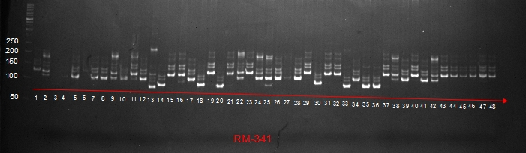

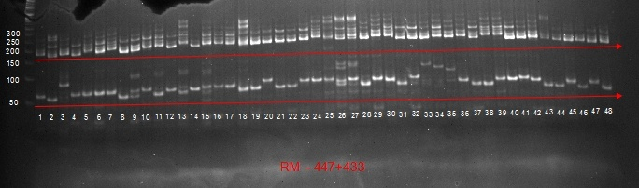

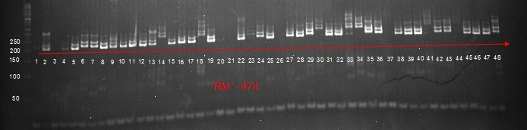

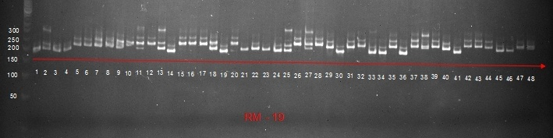

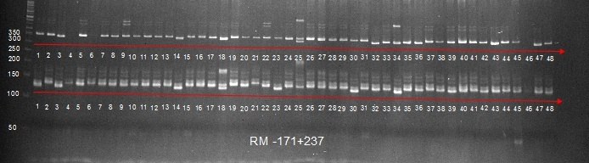

Fig.1 PCR amplification of 48 rice germplasm accessions using primers RM 341 and RM 447+433, RM 474, RM 19 and RM 171+237.

Population structure
Analysis of all 48 germplasm accessions based on Bayesian approach revealed that the estimated membership fraction was found to be K=2 (Fig.2a) and the maximum of adhoc measure ∆k as determined by the structure was found to be K=2 thus, indicating that the entire population can be divided into 2 subgroups (SG1 and SG2) (Fig.2b). Based on membership fractions, the accessions with probability of ≥ 80% (Pritchard et al. 2000) were assigned to corresponding subgroups while others were categorized as admixtures. Both SG1 and SG2 consisted of 19 germplasm accessions equally and rest 10 accessions were admixtures (Table-1).

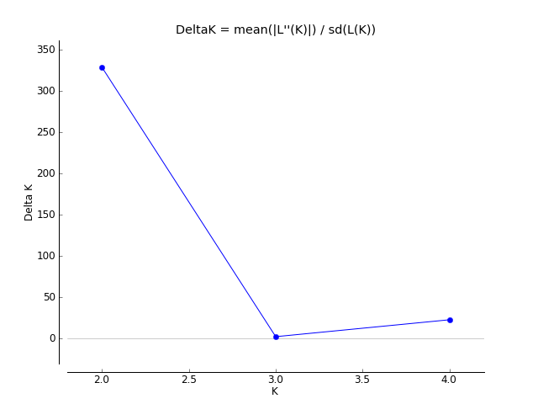
Fig.2 (a) Graph of estimated membership fraction for K = 2

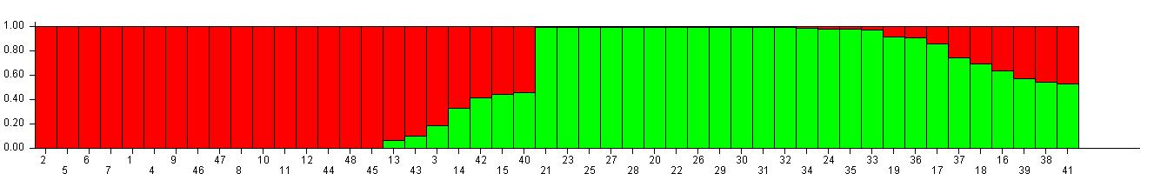
Fig.2(b) Population structure of 48 rice genotypes based on 31 SSR markers.

Genetic diversity analysis based on Cluster Analysis and principal component analysis:
Dendogram formed by cluster analysis based on genetic dissimilarity coefficient and UPGMA algorithm revealed formation of 2 major clusters, 1st cluster with 24 genotypes and 2nd cluster also with 24 genotypes and both the clusters being about 83% dissimilar from each other.
These 2 clusters/groups were further clustered into smaller sub groups. Group 1 consisting of 24 genotypes was further subdivided into 2 subgroups/sub clusters. Subgroup -1 (SG1) consisted of 22 genotypes whereas Subgroup-2 (SG2) consisted only 2 genotypes. Group 2 with 24 genotypes was again sub clustered into 2 subgroups. Subgroup-1 consisting of 4 genotypes and subgroup-2 consisting of rest 20 genotypes (Fig.3).
Germplasm accessions IC0538217 and IC0461104 were found to be most diverse from each other thus, can be effectively used for hybridization programme and accessions IC0115385 and IC0115427 were found to be 100% similar with each other.
Similarly, principal component analysis also revealed two most diverse principal components. PC1 has 19 genotypes whereas PC2 has 29 genotypes. The result of Principal component analysis and cluster analysis are clearly supported to the results of population structure analysis (Fig.4).
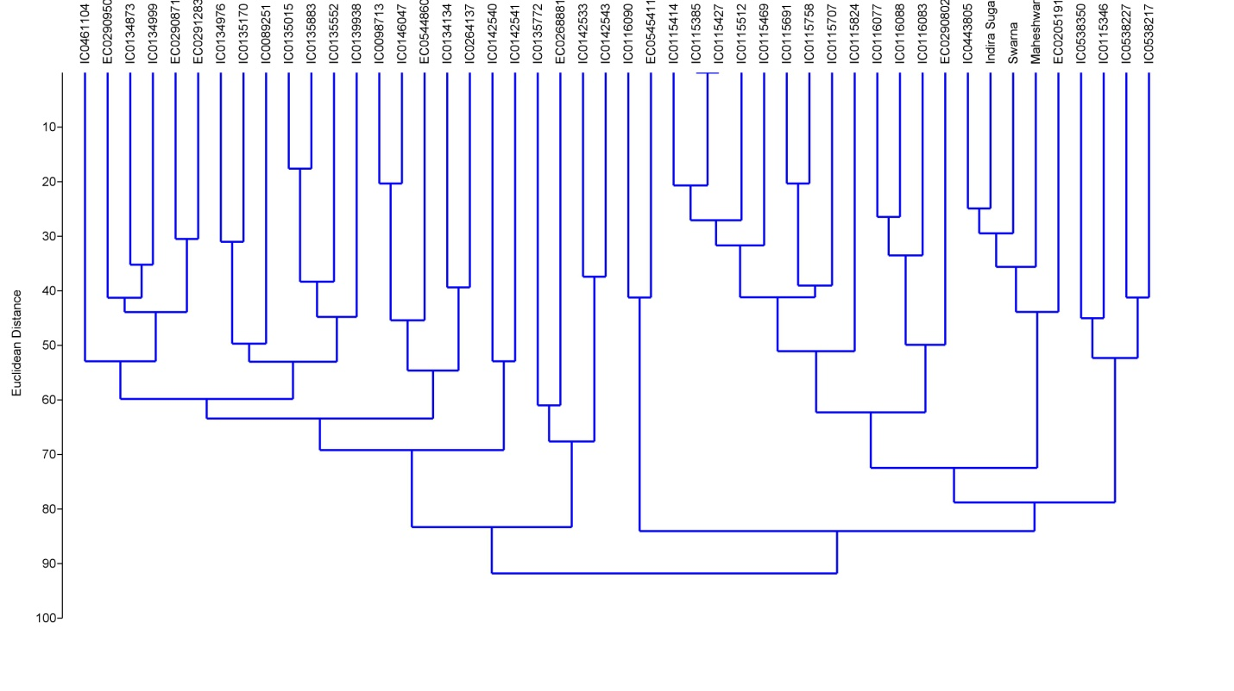
Fig.3 UPGMA-based molecular dendogram of SSR marker showing 48 rice germplasm.

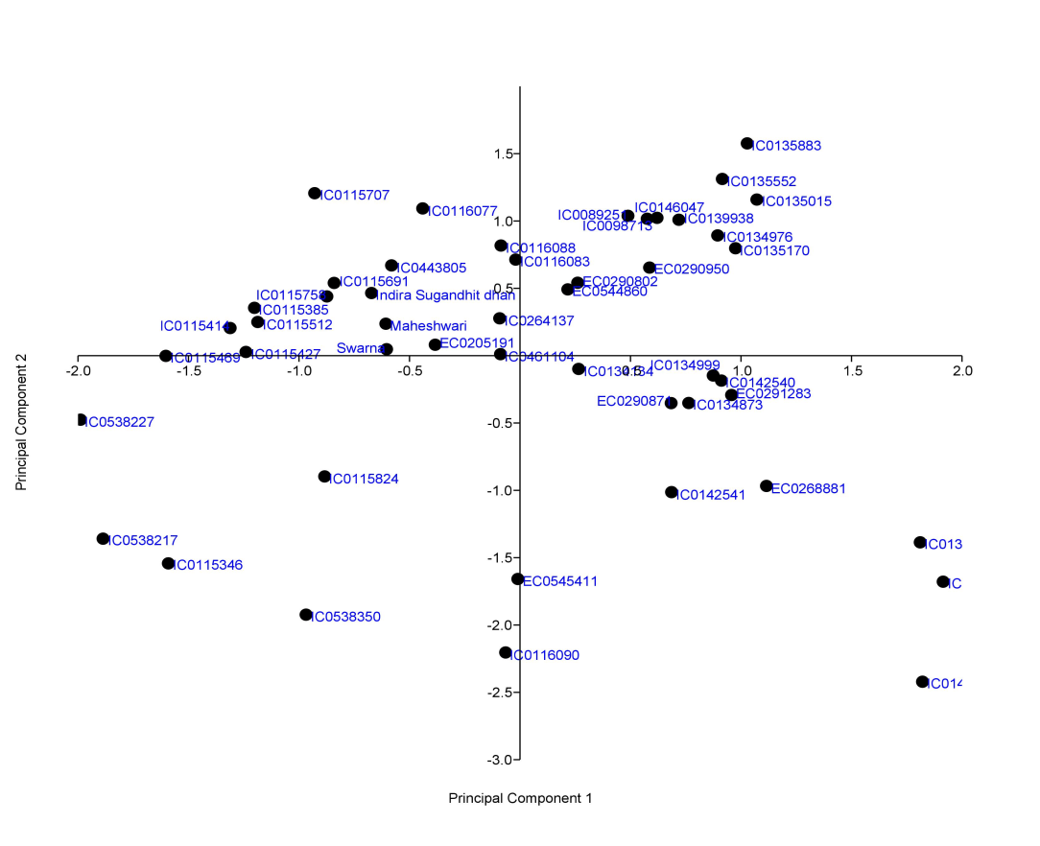

Fig.4 Distribution of 48 genotypes among two different Principal Components.

Genetic differentiation based on analysis of molecular variance (AMOVA)
Analysis of molecular variance revealed significant differences among the population and within individuals. Of the total genetic variation only 6% of the variation was attributed to population differences while 94% of the variation was due to differences within individual, respectively (Table 3).

Table:- 3 Analysis of molecular variance (AMOVA)

Source | Degree of freedom | Sum of squares | Mean Sum of squares | Est. Var. | % variation
Among Pops | 1 | 50.250 | 50.250 | 0.952 | 6%
Among Indiv | 46 | 213.010 | 4.631 | 0.000 | 0%
Within Indiv | 48 | 671.500 | 13.990 | 13.990 | 94%
Total | 95 | 934.760 |  | 14.942 | 100%

Discussion-
Genetic diversity is fundamental for crop improvement, providing the basis for broadening the genetic pool in breeding programs (Malik et al., 2020; Singh et al., 2023; Singh et al., 2024). Morphological trait–based diversity analysis, though useful, is often influenced by genotype × environment interactions and the complex inheritance of polygenic traits (Smith & Smith, 1992). In contrast, DNA-based markers which are among the most robust tools for assessing genetic variation and population structure (Hassan & Ali, 2023) and provide precise insights into genetic relationships and have been widely applied to both cultivated and wild rice germplasm (Samarajeewa et al., 2004; Horst & Wenzel, 2007; Wong et al., 2009; Huang et al., 2010; Marie et al., 2010; Malik et al., 2010).In this study, 48 rice germplasm accessions were analyzed using 31 simple sequence repeat (SSR) markers, The effectiveness of population structure analysis is largely influenced by the number of molecular markers employed. Although earlier studies used larger marker sets—72 SSRs for 150 varieties (Zhang et al., 2011) and 37 SSRs for 62 genotypes (Hassan & Ali, 2023)—the present set of 31 markers proved adequate for revealing genetic diversity and population structure among the accessions studied. Ultimately, the central goal of genetic diversity studies is to classify genotypes into distinct groups and identify diverse accessions for their effective utilization in crop improvement programs.
The mean number of alleles per locus investigated under the study was comparable with the reports of Nachimuthu et al. (2015) which represents presence of allelic diversity important for assessment of genetic diversity in the materials. But this allelic diversity was lower than mean alleles per locus 7.48 as reported by Suvi et al.(2020) and Siddique et al.(2016) and higher than 2.11 alleles per locus as reported by Mishra et al. (2019). The mean major allele frequency of 0.56. The average gene diversity of the current study was in close association with the reports of Nachimuthu et al. (2015) but lower than reports of Suvi et al. (2020) and Siddique et al. (2016).
PIC value represents the relative informativeness of each marker and is the probability of the marker to be detected in the progeny and is a good measure of a marker’s usefulness for linkage analysis. It is also a reflection of allelic diversity among varieties (Meti et al. 2013). In the present study the average PIC value of 0.480 was comparable with 0.32, 0.37, 0.48 and 0.468 as reported by Bordoloi et al. (2024), Ashfaqa and Khan (2012), Chemutai et al. (2016) and Nachimuthu et al. (2015), respectively. However, higher 0.60, 0.62, 0.66, 0.69, 0.79 and 0.904 PIC values were reported by Meti et al. (2013), Ashraf et al. (2016), Touthang et al. (2025), Burman et al. (2023), Kumbhar et al. (2015), Siddique et al.(2016) and Roy et al. (2023). respectively which are quite higher than the results of present study. The differences in PIC values maybe linked to the selection of different markers and the diversity of test genotypes (Suvi et al.2020). Markers with a PIC value range of 0.40-0.60 are considered to be the finest and can be further used in QTL mapping and molecular analysis (Sahu et al., 2020).
Population structure analysis revealed two sub-populations indicating that the rice genotypes were divided into two major groups. Similar findings were reported by Nachimuthu et al. (2015) and Sahu et al. 2017. Earlier, several studies confirm the existence of two to five subgroups in the population of rice and believed the evolutionary trend and environmental adaptation behavior as the key explanation for differentiation (Agrama et al 2007, Zhao et al. 2011, Kumbhar et al. 2015, Swamy et al 2017, Juan et al. 2018, Kadam et al. 2018, Zhang et al. 2019, Sahu et al 2020, Pradhan et al., 2023, Sedah et al., 2023).The results of population structure was found supporting the results of UPGMA based clustering and principal component analysis.. Similar findings were also reported by Nachimuthu et al. 2015 and Sahu et al. (2017) and Sahu et al. (2020) Thus, selection of diverse genotypes from these different clusters or sub-groups will be useful to be used as parents in hybridization programme.
However, AMOVA revealed significant differences among the population and within individuals. Of the total variation, 94% variation was due to differences present within individuals and a small portion of variation i.e. 6% was contributed by among population differences. Greater degree of variability in individuals with higher (80%) variation within populations than among populations (20%) was reported by Malik et al. (2022), Choudhury et al. (2021) and Pradhan et al. (2023), Sedah et al. (2023). AMOVA results suggest that a small collection within a given source will capture the genetic diversity present in the test genotypes. The presence of variability within and between the populations represents the possibility of making wide crosses for population development and to enhance genetic divergence in rice and further use of the diversity captured in rice breeding programme.

Conclusion
The current study found that there was a fair amount of diversity between the rice genotypes that could be used for potential breeding. Genetic diversity assessment based on SSR markers displayed genetic dissimilarity coefficients and grouped the genotypes into two major clusters. The principal component analysis and genetic population structure obtained was predominantly associated with UPGMA clustering. The genotypes of different subgroups may carry diverse genes for different traits. Thus, Strategic use of diverse genotypes in the breeding programme would allow judicious explanation of these genes complexes for improvement of existing rice germplasms to develop biotic and abiotic stress resistant cultivars. The genetic diversity of the accessions can be used as sources of novel genes in rice breeding and also can be utilized for parental line selection in breeding programs and hybrid development for exploiting the natural genetic variation that exists in this population.

References

Agrama H, Eizenga G, Yan W. (2007). Association mapping of yield and its components in rice cultivars. Mol Breed 19(4):341-356.
Ansah T, Dogbe W, Cudjoe S, Abdul-Basit IAR, Eseoghene AS. (2017). Agronomic performance of five rice varieties and nutritive value of the straw from these varieties. West African J Appl Ecol. 25:1–10.
Ashfaqa M, Khan AS. (2012). Genetic diversity in basmati rice (Oryza sativa L.) germplasm as revealed by microsatellite (SSR) markers. Russ J Genet. 48(1):53–62.
Ashraf H, Husaini AH, Bhat MA, Parray GA, Khan S, Ganai NA. (2016). SSR based genetic diversity of pigmented and aromatic rice (Oryza sativa L.) genotypes of the western Himalayan region of India. PhysMol Bio Plants. 22:547–555
Bidhan Roy. (2013). Genetic Diversity in Farmers’ Varieties and some Advance lines of aromatic rice (Oryza sativa L.) from West Bangal. Indian J. Plant Genet. Resour. 26(3): 215-219.
Bonow S, Von Pinho EVR, Vieira MGC, Vosman B. (2009). Microsatellite markers in and around rice genes, Applications in variety identification and DUS testing. Crop Sci.,49:880-886.
Bordoloi D, Sarma D, Sarma Barua N, Das R, Das BK. (2024). Morpho- molecular and nutritional profiling for yield improvement and value addition of indigenous aromatic Joha rice of Assam. Sci Rep, 14(1):3509
Burman M, Nair SK, Sao A, Gauraha D, Sharma D. (2023). SSR markerbased genetic diversity and marker trait association analysis in aromatic rice (Oryza sativa) landraces. Indian J Agric Sci 93(4):365–370
Chemutai LR, Musyoki MA, Kioko WF, Mwenda NS, Muriira KG. (2016). Genetic diversity studies on selected rice (Oryza sativa L.) genotypes based on gel consistency and alkali digestion. J Rice Res. 4:192.
Choudhury DR, Kumar R, Singh K, Singh NK, Singh R .(2021). Identification of a diverse core set panel of rice from the east coast region of India using SNP markers. Front Genet 12:726152
Devi CB, Lal GM, Singh CM and Yadav P. (2012). Genetic architecture, interrelationship and path analysis for yield improvement in Exotic rice (Oryza sativa L.) IJAEB 5(4):387-392.
Earl DA, von Holdt BM. (2012). STRUCTURE HARVESTER: a website and program for visualizing STRUCTURE output and implementing the Evanno method. Conserv Genetic Res. 4:359–361
Evanno G, Regnaut S, Goudet J. (2005). Detecting the number of clusters of individuals using the software STRUCTURE: a simulation study. Mol Ecol. 14:2611–2620.
Govindaraj P, Vinod KK, Arumugachamy S, Maheswaran M. (2009). Analyzing genetic control of cooked grain traits and gelatinization temperature in a double haploid population of rice by quantitative trait loci mapping. Euphytica.166:165-176.
Hassan DA, Hama-Ali EO. (2023). Evaluation of gene flow and genetic diversity in rice accessions across Kurdistan region-iraq using SSR markers. Mol Biol Rep;49(2):1007-1016.
Horst L, Wenzel G. (2007). Molecular marker systems in plant breeding and crop improvement, vol 55. Springer, Berlin
Huang X., Wei X., Sang T., Zhao Q., Feng Q., Zhao Y., Li C. et al. (2010). Genome-wide association studies of 14 agronomic traits in rice landraces. Nat. Genet. 42, 961–967.
Juan LR, Marques L, Talon M, Domingo C. (2018). Genome-wide aasociation study of agronomic traits in rice cultivated in Temperate regions. BMC Plant Biol 19:706.
Kadam NN, Struik PC, Rebolledo CM, Yin X, Jagadish SVK. (2018). Genome-wide association reveals novel genomic loci controlling rice grain yield and its component traits under water-deficit stress during the reproductive stage. J Exp Bot 69(16):4017-4032.
Kulsum MU, Hasan MJ, Begum H, Billah MM and Rahman H. (2011). Genetic diversity of some restorer lines for hybrid rice development. Bangladesh J. Agric. Res 36(1): 21-28.
Kumbhar SD, Kulwal PL, Patil JV, Sarawate CD, Gaikwad AP and Jadhav AS. (2015). Genetic Diversity and Population Structure in Landraces and Improved Rice Varieties from India. Rice Science 22(3):99-107.
Liu K, Muse SV. (2005). Power Marker: an integrated analysis environment for genetic marker analysis. Bioinformatics 21(9):2128-2129. http://doi.org/10.1093/bioinformatics/bti282
Malik A. R., Muhammad S. M., Zabta K. S. and Kazuko Y. S. (2010). Genetic analysis of basmati and non-basmati Pakistan rice (Oryza sativa L.) cultivars using microsatellite markers. Pak. J. Bot. 42, 2551–2564.
Malik P, Huang M, Neelam K, Bhatia D, Kaur R, Yadav B, Singh K. (2022). Genotyping-by-sequencing based investigation of population structure and genome wide association studies for seven agronomically important traits in a set of 346 Oryza rupogon accessions. Rice 15(1):1–23
Malik, N.; Kumar, D.; Babu, B.K. (2020). Analysis of genetic divergence and population structure through microsatellite markers in normal and quality protein maize genotypes from NW Himalayan region of India. Vegetos, 33, 194–202.
Mandel JR, Dechaine JM, Marek LF and Burke JM. (2011). Genetic diversity and population structure in cultivated sunflower and a comparison to its wildprogenitor, Helianthus annuus L. TheorAppl Genet 123: 693-704.
Marie N. N., Fousseyni C., Gezahegn G., Mounirou S., Roland B., Gustave D. et al. (2010). Morpho-agronomic and molecular characterization of Oryzaglaberrima germplasm from Mali. Afr. J. Biotechol. 9, 7409–7417.
McCouch SR, Chen X, Panaud O, Temnykh S, Xu Y, Cho YG, Huang N, Ishii T, Blair M. (1997). Microsatellite marker development, mapping and applications in rice genetics and breeding. Plant MolBiol 35(1-2):89–99
Meesang N, Ranamukharachi SL, Peterson MJ, Anderson SB. 2001. Soybean cultivar identification and genetic purity analysis using microsatellite DNA markers. Seed Sci Technol.,29(3):637-645.
Meti N, Samal KC, Bastia DN, Rout GR. (2013). Genetic diversity analysis in aromatic rice genotypes using microsatellite based simple sequence repeats (SSR) marker. African J Bio Technol. 12(27):4238–4250.
Mishra, A., Kumar, P., Shamim, MD., Tiwari, K.P., Fatima, P., Srivastava, D., Singh, R. and Yadav, P. (2019). Genetic diversity and population structure analysis of Asian and African aromatic rice (Oryza sativa L.) genotypes. Journal of Genetics. 98:92
Mligo FEI, Msuya CP. (2015). Farmer’s adoption of recommended rice varieties: A case of Kilombero district of Morogoro region of Tanzania. Southern African J AgriExtens. 43(1):41–56.
Mogga M, Sibiya J, Shimelis H, Lamo J, Ochanda N. (2018). Appraisal of major determinants of rice production and farmers choice of rice ideotypes in South Sudan: implications for breeding and policy interventions. Exp Agric. 55:1–14.
Mohammadi S. A. and Prasanna B. M. (2003). Analysis of genetic diversity in crop plants - salient statistical tools and considerations. Crop Sci. 43, 1235–1248.
Nachimuthu, V.V., Muthurajan, R., Duraialaguraja, S., Sivakami, R., Pandian, B.A, Ponniah, G., Gunasekaran, K., Swaminathan, M., Suji, K.K. and Sabariappan, R. (2015). Analysis of population structure and genetic diversity in rice germplasm using SSR markers: an initiative towards association mapping of agronomic traits in Oryza sativa. Rice 8:30-37
Ndjiondjop M. N., Semagn K., Sow M., Manneh B., Gouda A. C., Kpeki S. B. et al. (2018). Assessment of genetic variation and population structure of diverse rice genotypes adapted to lowland and upland ecologies in Africa using SNPs. Front. Plant Sci. 9, 446.
Pradhan AK, Vemireddy LNR, Tanti B. (2023). Assessment of the genetic variability and population structure in boro rice cultivars of Assam, India using candidate gene based SSR markers. Genet Resour Crop Evol 70(6):1747–1765
Pritchard JK, Stephens M, Donnelly P.(2000). Inference of population structure using multilocus genotype data. Genetics; 155: 945±959. PMID: 10835412
Roy, P. S., Nayak, S., Samanta, S., Chhotaray, A., Mohanty, S., Dhua, S., Dhua, U., Patra, B. C., Tiwari, K. K., Mithra, S. V. A. C. R., Sah, R. P., Behera, L., & Mohapatra, T. (2023). Assessment of allelic and genetic diversity, and population structure among farmers’ rice varieties using microsatellite markers and morphological traits. Gene Reports, 30, Article 10171.
Sahu PK, Mondal S, Sao R, Vishwakarma G, Kumar V, Das BK, Sharma D. (2020). Genome-wide association mapping revealed numerous novel genomic loci for grain nutritional and yield-related traits in rice (Oryza sativa L.) Landraces. 3 Biotech 10:487.
Sahu, P.K., Mondal, S., Sharma, D., Vishwakarma, V., Kumar, V., Das, B.K. (2017). InDel marker based genetic differentiation and genetic diversity in traditional rice (Oryza sativa L.) landraces of Chhattisgarh, India. PLoS ONE 12(11): e0188864.
Samarajeewa P. K., Nitanthi R. M. and Lyanage A. S. (2004). Morphological and molecular characterization of locally collected wild rice germplasm. Ann. Sri Lanka Dept. Agri. 6, 177–186.
Sedah, P., Djedatin, L.G., Loko, L.Y.E. et al. (2023). Agro-morphological and structural diversity of rice germplasm revealed by SSR markers in Benin Republic. Mol Biol Rep 50, 10207–10217.
Siddique, M.A., Khalequzzaman, M., Fatema, K., Islam, M.Z., Islam, M.M. and Chowdhury, M.A.Z. (2016). Bangladesh Rice J. 20 (2) : 1-11.
Singh, A.K.; Dwivedi, D.K.; Kumar, D.; Singh, A.; Dixit, S.; Khan, N.A.; Kumar, A. (2023). Genetic variability, character association and path coefficient analysis in rice (Oryza sativa) genotypes of semi-arid region of India. Indian J. Agric. Sci., 93, 844–849.
Singh, A.K.; Kumar, D.; Gemmati, D.; Ellur, R.K.; Singh, A.; Tisato, V.; Dwivedi, D.K.; Singh, S.K.; Kumar, K.; Khan, N.A.; et al. (2024). Investigating Genetic Diversity and Population Structure in Rice Breeding from Association Mapping of 116 Accessions Using 64 Polymorphic SSR Markers. Crops, 4, 180–194.
Smith JSC, Smith OS. (1992). Fingerprinting crop varieties. Advances Agron.,47:85-140.
Smouse PE, Whitehead MR, Peakall R. (2015). An informational diversity framework, illustrated with sexually deceptive orchids in early stages of speciation. MolEcolResour 15(6):1375-1386.
Suvi, W.T., Shimelis, H., Laing, M., Mathew, Isack, M. and Shayanowako, A.I.T. (2020). Assessment of the genetic diversity and population structure of rice genotypes using SSR markers. ActaAgriculturaeScandinavica, Section B — Soil &PlantScience, 70:1, 76-86.
Swamy BPM, Shamsudin NAA, Rahman SNA, MAuleon R, Ratnam W, Cruz MTS, Kumar A. (2017). Association mapping of yield and yield related traits under reproductive stage drought stress in rice (Oryza sativa L.). Rice 10(21):1-13.
Touthang, L., Kumar, A., Philanim, W.S., Kaur, S., Angami, T. and Makdoh, B. (2025). Analysis of Genetic Diversity and Population Structure of Indian Aromatic Short‑Grain Rice (Oryza sativa L.) Landraces. Plant Molecular Biology Reporter; 43:1380–1396.
Vung O, Lal CY and Rai PHC. (2012). Studies on genetic diversity in rice (Oryza sativa L.) Journal of Agricultural Technology 8: 1059-1065.
Wong S. C., Yiu P. H., Bong S. T. W., Lee H. H., Neoh P. N.P. and Rajan A. (2009). Analysis of sarawakbario rice diversity using microsatellite markers. Am. J. Agri Bio. Sci. 4, 298–304.
Yan AO, Yong X, Xiao-fen C, An W, Fei T, Li-qun S, Qiao-quan L. (2016). A genetic diversity assessment of starch quality traits in rice landraces from the Taihu basin, China. J Integrative Agri.15(3):493–501.
Zhang P, Li J, Li X, Liu X, Zhao X, Lu Y. 2011. Population structure and genetic diversity in a rice core collection (Oryza sativa L.) investigated with SSR markers. PLoS ONE.;6(12):e27565.
Zhang P, Zhong K, Zhong Z, Tong H. (2019). Genome wide association study of important agronomic traits within a core collection of rice (Oryza sativa L.). BMC Plant Biol 19:259.
Zhao K, Tung CW, Eizenga GC, Wright MH, Ali ML, Price AH, Norton GJ, Islam MR, Rynolds A, Mezey J, McClung AM, Bustamante CD, McCouch SR. (2011). Genome-wide association mapping reveals a rich genetic architechture of complex traits in Oryza sativa L. Nat Common2(467):1-10.

