Case report

Restoring Function After Viral Brain Injury: Physiotherapy In A Rare Case Of Herpes Simplex Encephalitis

ABSTRACT

Background: Herpes simplex encephalitis (HSE) is the leading cause of sporadic viral encephalitis, characterized by fever, seizures, and altered mental status, with up to 70% mortality if untreated and long-term cognitive impairment in 20–60% of survivors.

Case Study: A 49-year-old female with well-controlled hypertension presented with sudden quadriparesis and aphasia, initially raising concern for a cerebrovascular event. However, her course evolved atypically for stroke, with progressive confusion, seizures, and cognitive decline. MRI showed temporal lobe hyperintensities, and CSF PCR confirmed HSV-1 infection, establishing herpes simplex virus encephalitis.

Conclusion: Herpes Simplex Virus Encephalitis remains an under-researched condition, especially in Africa. The co-occurrence of acute cognitive changes, motor deficits, and behavioral disturbances with temporal lobe MRI abnormalities should alert clinicians to this potentially treatable disease, particularly in regions with limited diagnostic resources.

Keywords: Herpes encephalitis, physiotherapy, rehabilitation, case report.

1. INTRODUCTION

Herpes Simplex Virus Encephalitis (HSVE), or herpes simplex encephalitis(HSE), is a rare but serious neurological condition caused mostly by HSV-1, leading to acute brain inflammation and significant neurological impairments (Bradshaw & Venkatesan, 2016; Whitley & Baines, 2018).

Its global incidence is 2-4 cases per million annually, with older adults and immunocompromised individuals at higher risk (Armangue et al., 2015; Tunkel et al., 2018; Rohani et al., 2023).

HSE affects brain regions controlling memory, emotions, and behavior, often resulting in long-term activity limitations and highlighting the critical role of rehabilitation in restoring function (Gnann et al., 2017; Kwakkel et al., 2015).

The condition is underresearched, particularly in Africa, due to diagnostic challenges and scarce data, with clinical features including altered consciousness, psychiatric symptoms, seizures, memory loss, hemiparesis, and cranial nerve deficits.

Therefore, we present a case of a woman with acute cognitive and motor deficits who was diagnosed with HSVE, highlighting the importance of prompt recognition, timely antiviral therapy, and supportive rehabilitation in improving patient outcomes.

2. CASE PRESENTATION

This is a case report of a 49-year-old female admitted in 2025 to a tertiary teaching hospital with Herpes Simplex Virus Encephalitis (HSVE). Patient biodata was obtained from hospital records. Relevant literature was reviewed using PubMed, Google Scholar, and ResearchGate. Patient information was anonymized to protect confidentiality, and ethical principles of case reporting were strictly followed.

The patient, with a six-year history of well-controlled hypertension, presented on December 12, 2024, with sudden-onset quadriparesis and loss of speech. She was previously independent in daily activities and employed as a civil servant. She was admitted to a tertiary teaching hospital where it was regarded as a case of stroke and discharged on December 27, 2024, after partial recovery.

However, her clinical course evolved atypically for stroke, as she developed seizures and progressive confusion. On February 13, 2025, she was readmitted with memory loss, impaired balance, poor coordination, and speech difficulty. She had controlled hypertension and no relevant family history of viral encephalitis. Her shuffling gait and bradykinesia initially suggested Parkinsonism. However, MRI showed temporal lobe hyperintensities, EEG revealed lateralized epileptiform discharges, and CSF PCR confirmed HSV-1, establishing HSVE. She received intravenous acyclovir (10 mg/kg every 8 hours for 21 days) with renal monitoring and levetiracetam, and continued outpatient care until June 2025.

The patient, a 49-year-old female with a six-year history of well-controlled hypertension, presented on December 12, 2024, with sudden-onset quadriparesis and loss of speech. These acute neurological deficits initially raised concern for a cerebrovascular event. However, her clinical course evolved atypically for stroke, as she developed seizures and progressive confusion. She was admitted to a tertiary teaching hospital and discharged on December 27, 2024, after partial recovery.

On February 13, 2025, she was readmitted with memory loss, impaired balance, poor coordination, and speech difficulty. Her shuffling gait and bradykinesia suggested a parkinsonian syndrome, but further evaluation revealed temporal lobe hyperintensities on MRI, lateralized epileptiform discharges on EEG, and HSV-1 detection on CSF PCR, confirming herpes simplex virus encephalitis (HSVE). She received intravenous acyclovir (10 mg/kg every 8 hours for 21 days) with renal monitoring and levetiracetam, and continued outpatient care until June 2025.

On neurological examination at admission, she was conscious but confused, with a Mini-Mental State Examination (MMSE) score of 15/30. Coordination was impaired, as demonstrated by positive finger-to-nose and heel-to-shin testing, and balance was poor, with a positive Romberg sign and four backward steps on retropulsion. Muscle strength was reduced in both upper and lower limbs, and her gait was markedly shuffling. Functional outcome measures reflected severe disability: Berg Balance Scale (BBS) score of 23/56, Dynamic Gait Index (DGI) of 10/24, and Barthel Index (BI) of 30/100, indicating severe dependence in daily activities.

Physiotherapy commenced alongside medical management. The program combined physical and cognitive rehabilitation and was delivered five days per week for eight weeks. Interventions included passive mobilization, tactile stimulation, soft tissue mobilization, assisted-active and strengthening exercises, balance and gait re-education, and therapeutic positioning to prevent complications. Cognitive rehabilitation consisted of orientation exercises in time, place, and person, short-term memory recall tasks, problem-solving activities, and sequencing of daily living tasks. Progression was individualized based on tolerance and functional gains. The following figures demonstrate the main exercises used in the patient’s physiotherapy regimen to improve cognitive, balance, and gait functions following HSVE.

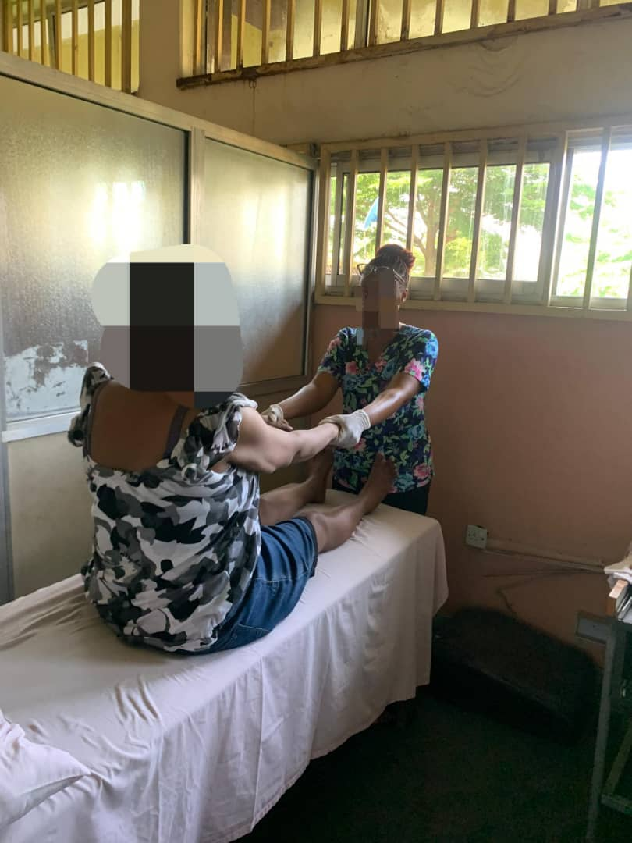

Figure 1: Curl-up exercise protocol for trunk muscle strengthening.

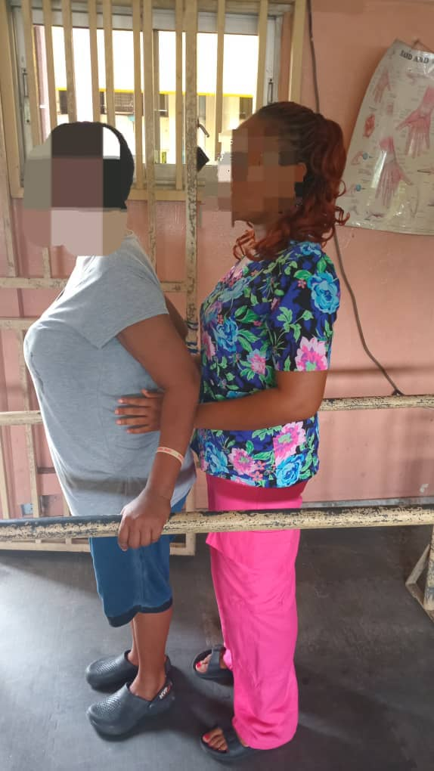

Figure 2: Standing re-education protocol with biofeedback for balance and functional mobility

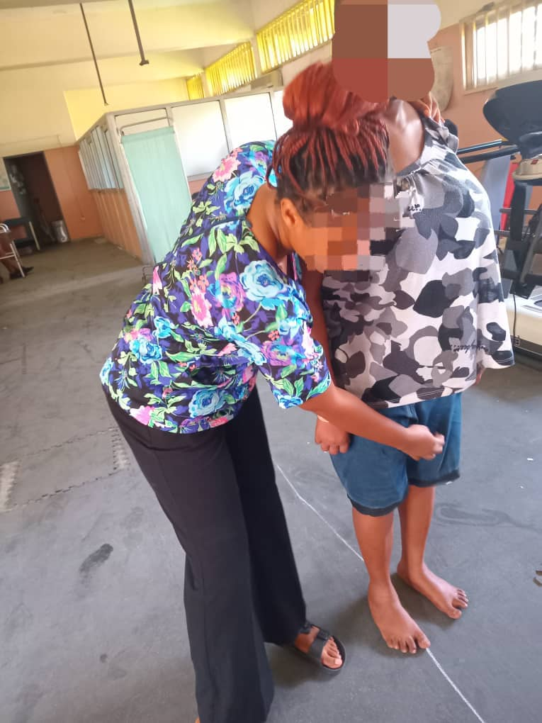

Figure 3: Tandem walking on a straight line to improve gait and facilitate walking re-education.

Functional outcomes demonstrated clinically meaningful recovery. Her Mini-Mental State Examination improved from 15/30, indicating severe cognitive impairment, to 30/30, reflecting full cognitive recovery. The Berg Balance Scale improved from 23/56 (high fall risk) to 44/56 (functional independence in balance). The Dynamic Gait Index rose from 10/24 (unsafe community ambulation) to 16/24 (moderate community ambulation). The Barthel Index also improved from 30/100 to 75/100, showing a transition from severe dependence to moderate independence in activities of daily living.
Written informed consent for publication was obtained from the patient.

3. DISCUSSION

Herpes simplex encephalitis (HSE) is a rare but devastating neurological condition, primarily caused by HSV-1 in adults and HSV-2 in neonates (Gnann et al., 2017). Its global incidence is 2–4 cases per million annually, with untreated mortality up to 70% (Tunkel et al., 2008). Older adults and immunocompromised individuals are particularly vulnerable.

Pathophysiologically, HSV-1 targets the temporal and limbic structures, including the hippocampus and amygdala, explaining symptoms such as seizures, psychiatric disturbances, memory loss, hemiparesis, and cranial nerve deficits (Forbes et al., 2019).

In this case, the patient’s presentation was distinctive. Her sudden quadriparesis and speech loss led to an initial diagnosis of stroke, while later shuffling gait, bradykinesia, and balance deficits mimicked Parkinsonism. Only after CSF PCR confirmed HSV-1 did the true diagnosis of HSE become clear. This highlights the diagnostic challenge and the potential for HSE to masquerade as other neurological disorders.

According to the International Encephalitis Consortium (IEC) criteria, encephalitis requires altered mental status ≥24 hours plus supportive features such as fever, seizures, focal neurological deficits, CSF pleocytosis, or neuroimaging abnormalities (Venkatesan et al., 2013). Our patient mirrored these, and with virological confirmation fulfilled the IEC definition of a confirmed case. A recent validation has updated this framework by weighting clinical, laboratory, and imaging variables, strengthening its diagnostic accuracy (Staal et al., 2024).

Despite timely initiation of antiviral therapy, significant neurological deficits persisted, underscoring that pharmacological treatment alone is insufficient to restore function. Rehabilitation therefore became central to her recovery
(Whitley & Baines, 2018).

Physiotherapy targeted both motor and cognitive deficits. Early sessions focused on passive mobilization, positioning, and soft tissue techniques to prevent contractures and bedsores. As she improved, therapy progressed to trunk stabilization, gait and balance retraining, strengthening, and cognitive exercises including orientation, memory, attention, and problem-solving tasks.

The interventions are shown in Table 1 and Table 2 below:

Interventions | Week 1 | Week 2 | Week 3 | Week 4
Soft Tissue Mobilization (kneading) | 7 minutes, 4 times weekly | 7 minutes 4 times weekly | 5 minutes 4 times weekly | 5 minutes 4 times weekly
Passive Mobilization | 10 minutes, 4 times weekly | 10 minutes 4 times weekly | 15 minutes 4 times weekly | 15 minutes 4 times weekly
Therapeutic Positioning (supine and side lying) | Every 2 hours | Every 2 hours | Every 2 hours | Every 2 hours
Bridging Exercise | 10 counts × 2 reps, 4 times weekly | 10 counts × 3 reps, 4 times weekly | 15 counts ×3 reps, 4 times weekly | 15 counts × 3reps, 4 times weekly.
Cognitive Exercise (orientation training, memory recall, attention tasks) | 10 minutes daily | 10 minutes daily | 12 minutes daily | 12 minutes daily
Table1: Physiotherapy and cognitive interventions in the treatment plan from week 1 to week 4.

Interventions | Week 5 | Week 6 | Week 7 | Week 8
Curl up Exercise | 2 sets × 10 reps, 4x weekly | 3 sets × 10 reps, 4x weekly | 4 sets × 10 reps  4x weekly | 5 sets × 10 reps  4x weekly
Grip strengthening exercise | 2 sets × 10 reps, daily (moderate) | 2 sets × 10reps, daily (moderate) | 2 sets × 15 reps, daily (moderate) | 3 sets × 15 reps, daily (moderate)
Quadriceps strengthening | 2 sets × 8 reps, 30s rest | 3 sets × 8 reps, 30s rest | 3 sets × 10reps, 30s rest | 4 sets × 10 reps, 30s rest
Tandem walking | 2 min × 2 reps 30 secs rest 4x weekly | 2 min × 5 reps  30 secs rest 4x weekly | 2 min × 6 reps  30 secs rest 4x weekly | 2 min × 6 reps  30 secs rest 4x weekly
Standing re-education | 3 minutes, 4x weekly | 5 minutes  4 times weekly | 7 minutes 4 times weekly | 10 minutes  4 times weekly
Cognitive Exercise  (problem solving tasks and divided attention tasks) | 10 minutes daily | 15 minutes daily | 15 minutes daily | 15 minutes daily
Table 2: Physiotherapy and cognitive interventions in the treatment plan from week 1 to week 4.

Functional outcomes showed significant recovery. While many HSVE survivors have lasting deficits requiring multidisciplinary care (Venkatesan et al., 2013), physiotherapy adapted from brain injury protocols was central to this patient’s improvement, with early mobilization and task-specific exercises promoting neuroplasticity and functional recovery.

The patient’s recovery illustrates the effectiveness of this integrated approach. These outcomes align with previous findings that physiotherapy combined with medical treatment accelerates functional recovery in encephalitic and brain injury populations (Francisco et al., 2021).

CONCLUSION

This case illustrates how HSE can mimic both stroke and Parkinsonism highlighting a diagnostic challenge. It also demonstrates how physiotherapy, integrated with medical treatment, can lead to remarkable neurological recovery in HSVE. Raising clinician awareness, even for atypical presentations, is essential for improving prognosis.
Physiotherapy should be recognized not only as supportive but as a central component of recovery, bridging the gap between medical stabilization and functional independence.

DISCLAIMER (ARTIFICIAL INTELLIGENCE

Author(s) hereby declare that NO generative AI technologies such as Large Language Models (ChatGPT, COPILOT, etc) and text-to-image generators have been used during writing or editing of the manuscript

CONSENT
As per international standards or university standards, patient(s) written consent has been collected and preserved by the author(s).

ETHICAL APPROVAL
As per international standards or university standards written ethical approval has been collected and preserved by the author(s).

REFERENCES

1 Bradshaw MJ, Venkatesan A. Herpes Simplex Virus-1 Encephalitis in Adults: Pathophysiology, Diagnosis, and Management. Neurotherapeutics. 2016 Jul;13(3):493–508. doi:10.1007/s13311-016-0433-7.

2 Whitley R, Baines J. Clinical management of herpes simplex virus infections: past, present, and future. F1000Research. 2018;7:1726. https://doi.org/10.12688/f1000research.16157.1

3. Armangué T, Morís G, Cantarín-Extremera V, et al. Autoimmune post–herpes simplex encephalitis of adults and teenagers. Neurology. 2015;85(20):1736–1743. https://doi.org/10.1212/WNL.0000000000002125

4. Tunkel AR, Glaser CA, Bloch KC, Sejvar JJ, Marra CM, Roos KL, Hartman BJ, Kaplan SL, Scheld WM, Whitley RJ. The management of encephalitis: clinical practice guidelines by the Infectious Diseases Society of America. Clin Infect Dis. 2008;47(3):303–327. https://doi.org/10.1086/589747

5. Rohani H, Arjmand R, Mozhgani SH, Shafiee A, Amini MJ, Forghani-Ramandi M. The worldwide prevalence of herpes simplex virus encephalitis and meningitis: a systematic review and meta-analysis. Turk Arch Pediatr. 2023 Nov;58(6):580–587. doi:10.5152/TurkArchPediatr.2023.23007

6. Gnann JW Jr, Whitley RJ. Herpes Simplex Encephalitis: an Update. Curr Infect Dis Rep. 2017 Mar;19(3):13. doi:10.1007/s11908-017-0568-7

7. Kwakkel G, Veerbeek JM, van Wegen EEH, Wolf SL. Constraint-induced movement therapy after stroke: systematic review of randomized controlled trials. Lancet Neurol. 2015 Feb;14(2):224–234. doi:10.1016/S1474-4422(14)70160-7.

8. Forbes HJ, Warne B, Doelken L, et al. Risk factors for herpes simplex virus type 1 infection and reactivation: EPIC-Norfolk study. PLoS One. 2019;14(5):e0215553. doi:10.1371/journal.pone.0215553.

9. Kennedy PGE, Steiner I. Recent advances in herpes simplex encephalitis. Curr Opin Neurol. 2017;30(3):268-274. https://doi.org/10.1097/WCO.0000000000000443

10. Venkatesan A, Tunkel AR, Bloch KC, et al. Case definitions, diagnostic algorithms, and priorities in encephalitis: consensus statement of the International Encephalitis Consortium. Clin Infect Dis. 2013;57(8):1114-1128. https://doi.org/10.1093/cid/cit458

11. Staal SL, Olie SE, Ter Horst L, van Zeggeren IE, van de Beek D, Brouwer MC; I-PACE Study Group. Validation of the encephalitis criteria in adults with a suspected central nervous system infection: an updated score. J Infect. 2024;89(4):106239. doi:10.1016/j.jinf.2024.07.006.

12. Francisco GE, Yozbatiran N, Berlin D, et al. Post-encephalitic rehabilitation: outcomes and evidence. NeuroRehabilitation. 2021;49(2):153-162. https://doi.org/10.3233/NRE-210052

