Case report

BEHAVIOURAL INTERVENTION FOR TOBACCO CESSATION IN THE PREVENTION AND MANAGEMENT OF ORAL SUBMUCOUS FIBROSIS: A CASE REPORT.

abstract
Oral Submucous Fibrosis (OSMF) is a chronic, progressive, potentially malignant disorder of the oral cavity strongly associated with the use of areca nut and smokeless tobacco. This report presents the case of a 22-year-old male patient with stage iii osmf, who reported with complaints of reduced mouth opening and burning sensation on eating spicy food. Clinical examination revealed blanching of the buccal mucosa, restricted tongue movements, and palpable fibrous bands. the patient had a significant history of gutkha chewing, with high dependence confirmed by the fagerstrom nicotine dependence scale for smokeless tobacco. management included structured behavioural counselling for habit cessation, pharmacological treatment with antioxidants and intralesional corticosteroid–hyaluronidase injections, and reinforcement of oral hygiene practices. over five weeks, the patient demonstrated significant clinical improvement, with increased mouth opening from 14 mm to 27 mm, improved tongue protrusion, and reduction in burning sensation. This case highlights the importance of integrating behavioural interventions with pharmacological management for effective treatment of OSMF.

Keywords: Areca, Behavior Therapy, Oral Submucous Fibrosis, Mouth Neoplasms, Smokeless Tobacco.

1. INTRODUCTION

Oral submucous fibrosis (OSMF) is a chronic, insidious, and potentially malignant disorder of the oral mucosa characterized by progressive fibrosis, blanching, burning sensation, and restricted mouth opening. First described by Schwartz in 1952, OSMF is now a major health problem in the Indian subcontinent due to widespread areca nut and smokeless tobacco use (Rao et al., 2020). The malignant transformation rate is estimated at 7–13%, making it one of the most significant premalignant oral conditions (Passi et al., 2017).
Habitual use of areca nut and smokeless tobacco is the primary cause. Alkaloids, tannins, flavonoids, and copper stimulate collagen synthesis and inhibit degradation, leading to progressive fibrosis (Berwal et al., 2014). Nutritional deficiencies, genetic predisposition, and immunological factors also contribute (Gupta et al., 2021).
Tobacco consumption in India is alarming, with 28.6% of adults using it, mostly in smokeless forms. Nearly 200,000 annual deaths are attributed to smokeless tobacco, accounting for 74% of global SLT-related mortality (Bharati et al., 2023). Products like gutkha and pan masala remain popular due to affordability and social acceptance, making cessation difficult (Nayak & Mishra, 2018; Patel & Damor, 2018).
Management includes pharmacological therapy, complementary approaches, and surgery for advanced trismus. However, habit cessation through behavioural counselling—using models like Prochaska’s, the 5A’s and 5R’s, motivational interviewing, and digital tools—remains central (Li et al., 2019; Lu & Jian, 2019; Al-Maweri et al., 2019; Sukanya et al., 2022; Manjula et al., 2018).
This case report presents the management of a young male with stage III OSMF using pharmacological therapy and structured counselling.

2. CASE PRESENTATION

A 22-year-old male reported to Sinhgad Dental College and Hospital, Pune, with complaints of reduced mouth opening and burning sensation on consuming spicy food for six months. Initially able to insert three fingers intraorally, his mouth opening gradually reduced to one finger. Burning, mild at onset, worsened and affected diet and comfort.
Habit history revealed gutkha use since age 18, consuming 10–15 packets daily (RMD, Rajnigandha, Panparag). He typically retained the quid in the buccal vestibule for 10–15 minutes before spitting, with a monthly expenditure of ₹500–550. He denied alcohol use and expressed willingness to quit, placing him in the contemplation stage of Prochaska’s behaviour change model. Past medical, dental, and family histories were non-contributory. Oral hygiene practices included once-daily brushing with a horizontal scrubbing technique.
On general examination, he was afebrile with stable vitals (pulse 82/min, BP 110/80 mmHg, respiratory rate 17/min). He had a mesomorphic build, was well oriented, and showed no systemic abnormalities.
Intraoral examination revealed an interincisal opening of 14 mm and tongue protrusion of 18 mm (Figure 1). Diffuse blanching of the buccal mucosa and soft palate with greyish-black pigmentation was noted (Figure 2). Vertical fibrous bands, tongue depapillation, restricted mobility, gingival inflammation, calculus deposits, stains, spacing, and anterior crowding were evident. Burning sensation was scored 7 on the Visual Analogue Scale (VAS).

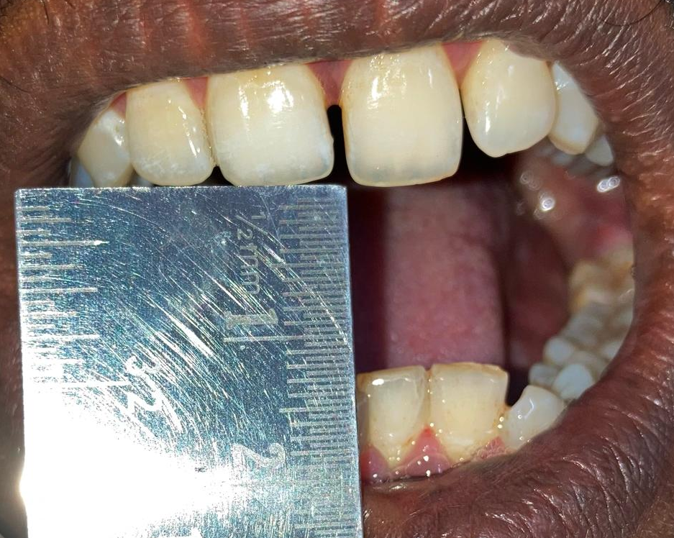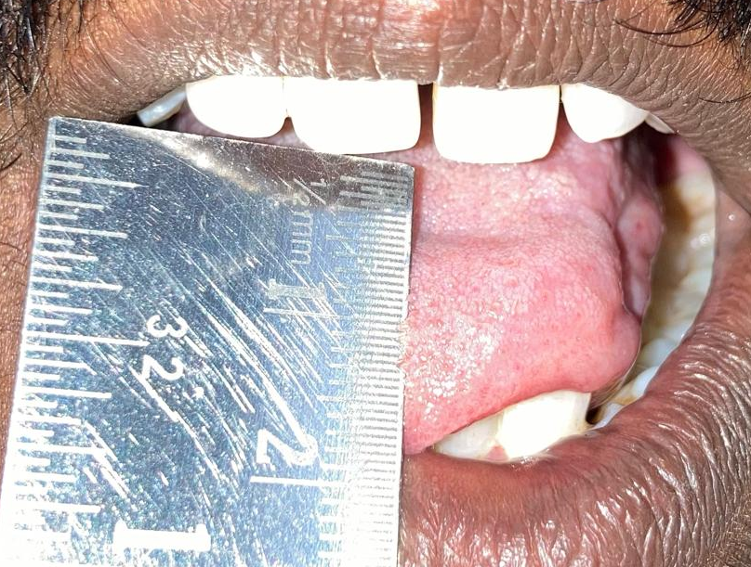
- (B)
Figure 1 – Baseline restricted mouth opening: (A) Mouth Opening (B) Tongue Protrusion

A provisional diagnosis of stage III OSMF, habit-induced melanosis, and chronic generalized gingivitis was made. Routine blood investigations were within normal limits, and gingival index scores were recorded. The final diagnosis confirmed stage III OSMF with associated gingivitis and melanosis.
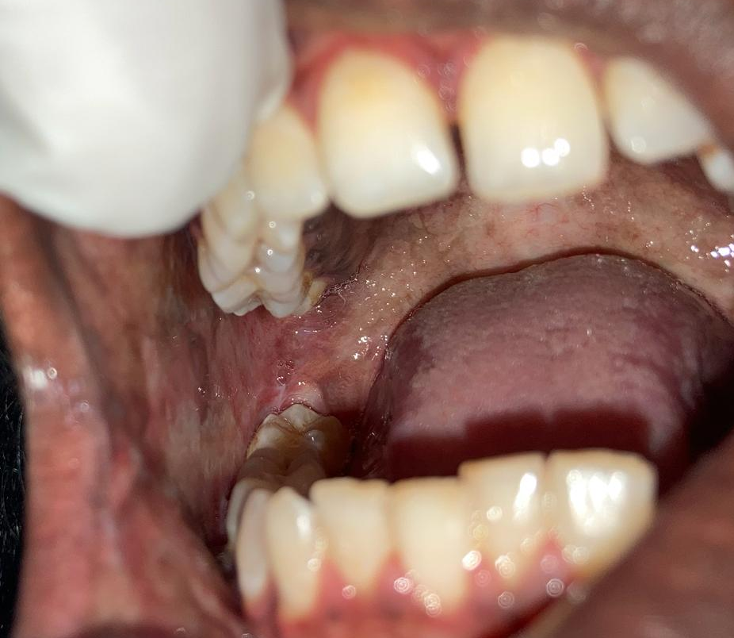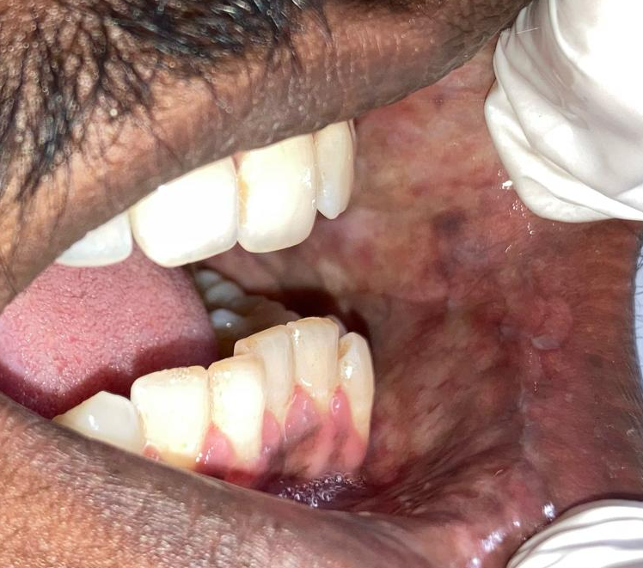
(A) (B)
Figure 2 – Baseline intraoral mucosal changes (A, B: Blanching on Buccal Mucosa)

2.1 Management

The treatment plan began with elimination of the causative habit. The patient was counselled on the harmful effects of gutkha, including its malignant potential. Scaling and oral prophylaxis were performed to improve hygiene, and positive reinforcement was given to support habit cessation.
Pharmacological therapy aimed at symptom relief and functional improvement. The patient was prescribed Cap. SM Fibro (antioxidants and micronutrients) twice daily for one month and topical Kenacort oral paint (Triamcinolone acetonide 0.1%) thrice daily for 15 days. Weekly intralesional injections were administered for six weeks, consisting of dexamethasone (4 mg), hyaluronidase (1500 IU), and 0.5 ml lignocaine, delivered bilaterally into the buccal mucosa, retromolar region, and soft palate. Daily mouth-opening exercises were advised to aid rehabilitation.
Behavioural interventions formed a central component. Counselling sessions (20–30 minutes) were based on Prochaska’s six-stage model, using the 5A’s and 5R’s strategies to enhance motivation (Figure 3). Motivational videos were shown at alternate visits, and the WHO Quick Start App was introduced as a digital support tool. Telephonic counselling was provided for missed appointments. A structured five-day quit plan encouraged the patient to list personal reasons for quitting, replace tobacco with healthier alternatives, practice relaxation methods like yoga, and reward progress through self-appreciation.
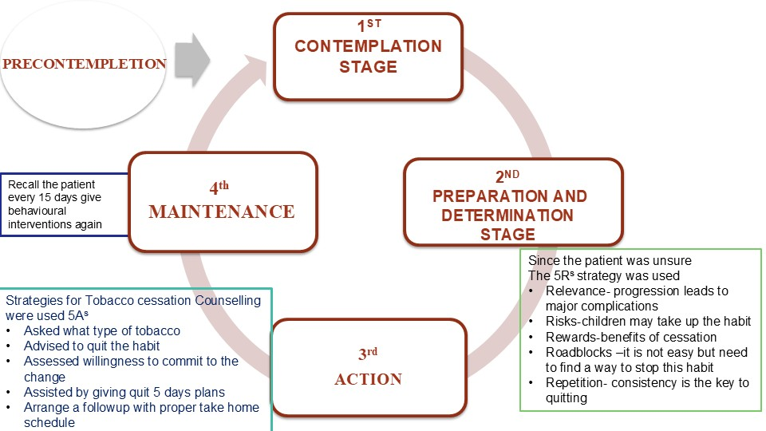

Figure 3: Behavioural intervention illustration (Prochaska’s model)

Regular follow-up demonstrated progressive improvement. At day 7, mouth opening increased to 18 mm, tongue protrusion to 24 mm, and burning sensation reduced to a VAS score of 6. By day 21, the mouth opening had improved to 23 mm, tongue protrusion to 28 mm, and VAS reduced to 4. At day 35, significant clinical improvement was achieved, with mouth opening reaching 27 mm, tongue protrusion 35 mm, and VAS score reduced to 2. (Figure 4 and Figure 5)
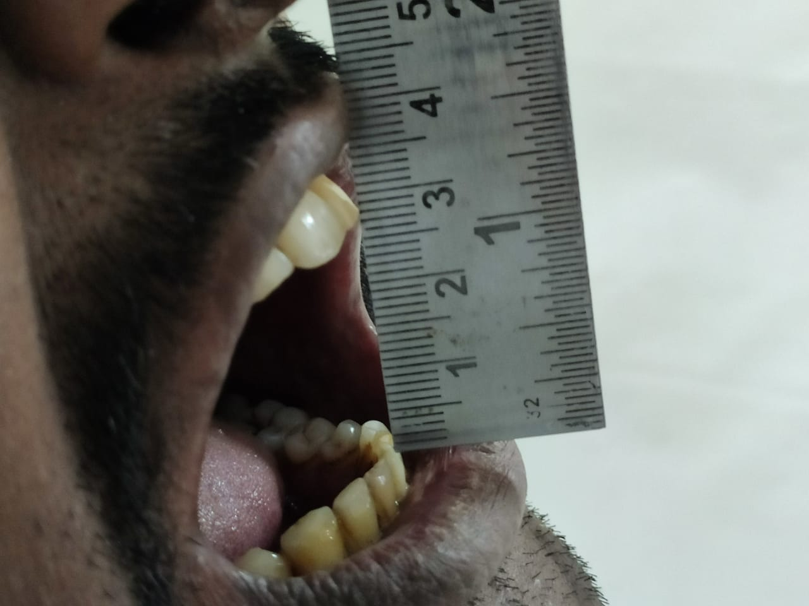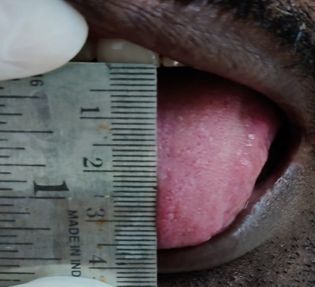
(A) (B)
Figure 4: Follow-up clinical image (Day 35): (A) Mouth Opening (B) Tongue Protrusion

Figure 5: Graph showing progressive improvement in mouth opening, tongue protrusion, and reduction in burning sensation (VAS score) during follow-up.

3. DISCUSSION

Tobacco dependence remains a major global health challenge. Nearly one-third of cancer-related deaths are linked to tobacco, and in India, tobacco-related cancers account for about 27% of the total burden (Bharati et al., 2023). The GATS-2 survey reported 28.6% adult tobacco use, predominantly in smokeless forms due to affordability and social acceptance. India contributes nearly 74% of global smokeless tobacco mortality, with 200,000 annual deaths (Bharati et al., 2023).
OSMF is a chronic premalignant condition with a malignant transformation rate of 7–13% (Passi et al., 2017). Pathogenesis involves juxtaepithelial inflammation, excessive collagen synthesis, and fibroelastic changes, largely driven by areca nut alkaloids and nitrosamines, resulting in fibrosis, epithelial atrophy, restricted mouth opening, and malignant risk (Shafer et al., 2012; Berwal et al., 2014).
Conservative therapy with corticosteroid–hyaluronidase, antioxidants, and micronutrients improves symptoms (Li et al., 2019; Lu & Jian, 2019). Adjuncts like Aloe vera (Al-Maweri et al., 2019) and photobiomodulation (Sukanya et al., 2022) show promise. In this case, intralesional corticosteroid–hyaluronidase with antioxidants provided marked benefit within five weeks.
Habit elimination remains central, as pharmacological benefits relapse without behavioural change. Structured counselling models, including Prochaska’s stages, 5A’s, 5R’s, motivational interviewing, and digital aids like the WHO Quick Start App, significantly aid cessation (Manjula et al., 2018).
This case highlights the importance of integrating pharmacological management with behavioural support through a multidisciplinary approach.

4. Conclusion

OSMF is a debilitating premalignant disorder strongly linked to areca nut and smokeless tobacco use. This case demonstrates that combining intralesional corticosteroid–hyaluronidase, antioxidants, and structured behavioural counselling provides significant improvement. Sustained habit cessation through counselling underscores the importance of integrating medical and behavioural strategies for long-term management.

Consent

A written informed consent was obtained from the patient for publication of this case report and accompanying images.

Ethical approval

All authors hereby declare that an approval was obtained from the institutional ethics committee and it has been preserved by the authors.

References

- Al-Maweri, S. A., Ashraf, S., Lingam, A. S., Alqutaibi, A., Abdulrab, S., Alaizari, N., & Halboub, E. (2019). Aloe vera in treatment of oral submucous fibrosis: A systematic review and meta-analysis. Journal of Oral Pathology & Medicine, 48(2), 99–107. https://doi.org/10.1111/jop.12789
- Berwal, V., Khangwal, M., Solanki, R., Khandeparker, R., Savant, K., & Shetye, O. (2014). Classification systems for oral submucous fibrosis – From past to present: A review. International Journal of Dental Health Sciences, 1, 900–913.
- Bharati, B., Sahu, K. S., & Pati, S. (2023). Prevalence of smokeless tobacco use in India and its association with various occupations: A LASI study. Frontiers in Public Health, 11, 1176521. https://doi.org/10.3389/fpubh.2023.1005103.
- Glick, M., & Fehrenbach, M. J. (2015). Burket’s oral medicine (12th ed.). Hoboken, NJ: Wiley-Blackwell.
- Gupta, S., Gupta, S., Chaudhary, C., Ghosh, S., Singh, R., & Bansal, P. (2021). Novel treatment approach of oral submucous fibrosis in a 6-year-old girl: A case report. International Journal of Clinical Pediatric Dentistry, 14(4), 575–579. https://doi.org/ 10.5005/jp-journals-10005-1999.
- Li, Y. H., Chang, W. C., Chiang, T. E., Tsai, C. C., Chen, H. H., & Chen, Y. J. (2019). Mouth-opening device as a treatment modality in trismus patients with head and neck cancer and oral submucous fibrosis: A prospective study. Clinical Oral Investigations, 23(1), 469–476. https://doi.org/ 10.1007/s00784-018-2456-4.
- Lu, C., & Jian, X. (2019). Efficacy for combined injection of salvianolic acid B with triamcinolone acetonide on the treatment of the soft palate with oral submucous fibrosis. Zhong Nan Da Xue Xue Bao Yi Xue Ban, 44(7), 801–804. https://doi.org/10.11817/j.issn.1672-7347.2019.180570.
- Manjula, D. C., Shekar, V., & Reddy, J. R. (2018). Effect of behavioural counselling in tobacco cessation. Journal of Scientific Dentistry, 8(2), 58–60. https://dx.doi.org/10.5005/jsd-8-2-58
- Nayak, S., & Mishra, A. (2018). Prevalence and factors affecting tobacco use among urban adolescents in Bhilai city, central India. International Journal of Community Medicine and Public Health, 5(4), 1492–1498. https://doi.org/10.18203/2394-6040.ijcmph20181223
- Passi, D., Bhanot, P., Kacker, D., Chahal, D., Atri, M., & Panwar, Y. (2017). Oral submucous fibrosis: Newer proposed classification with critical updates in pathogenesis and management strategies. National journal of maxillofacial surgery, 8(2), 89-94. https://doi.org/10.4103/njms.njms_32_17
- Patel, A. S., & Damor, R. D. (2018). A cross-sectional study on tobacco consumption practice in school-going adolescent males of Jamnagar city, Gujarat, India. International Journal of Community Medicine and Public Health, 5(3), 933–938. https://doi.org/10.18203/2394-6040.ijcmph20180478
- Rao, N. R., Villa, A., More, C. B., Jayasinghe, R. D., Kerr, A. R., & Johnson, N. W. (2020). Oral submucous fibrosis: A contemporary narrative review with a proposed inter-professional approach for early diagnosis and clinical management. Journal of Otolaryngology – Head & Neck Surgery, 49(3), 1–9. https://doi.org/10.1186/s40463-020-0399-7
- Shafer, W. G., Hine, M. K., & Levy, B. M. (2012). Shafer’s textbook of oral pathology (7th ed.). New Delhi: Elsevier.
- Sukanya, D., Upasana, L., Deepak, T. A., Abhinethra, M. S., & Choudary, S. (2022). Determination of effectiveness of photobiomodulation in the treatment of oral submucous fibrosis. Journal of Pharmacy and Bioallied Sciences, 14(Suppl 1), S475–S478.https://doi.org/10.4103/jpbs.jpbs_673_21

